
BSCS-F20-023
03-134172-012 | ZUBAIR TALIB
03-134172-052 | MEER SALAL

HomeFix: A Cross Platform Application for Providing Home Services

In partial fulfilment of the requirements for the degree of
Bachelor of Science in Computer Science
Supervisor: Sarah Chaudhry
Department of Computer Sciences
Bahria University, Lahore Campus
July 2021

© Bahria University, 2021

Certificate

We accept the work contained in the report titled
“HomeFix: A Cross Platform Application for Providing Home Services”
written by
ZUBAIR TALIB
MEER SALAL
as a confirmation to the required standard for the partial fulfilment of the degree of
Bachelor of Science in Computer Science.

Approved by:
Supervisor: Sarah Chaudhry
(Signature)

July 14, 2021

DECLARATION

We hereby declare that this project report is based on our original work except for citations and quotations which have been duly acknowledged. We also declare that it has not been previously and concurrently submitted for any other degree or award at Bahria University or other institutions.

Enrolment | Name | Signature
03-134172-012 | ZUBAIR TALIB
03-134172-052 | MEER SALAL

Date : July 14, 2021

Specially dedicated to
my beloved grandmother, mother and father
(ZUBAIR TALIB)
my beloved grandmother, mother and father
(MEER SALAL)

ACKNOWLEDGEMENTS

We would like to thank everyone who had contributed to the successful completion of this project. We would like to express our gratitude to my research supervisor, Miss SARAH CHAUDHRY for her invaluable advice, guidance and her enormous patience throughout the development of the research.

In addition, we would also like to express my gratitude to our loving parent and friends who had helped and given me encouragement.

ZUBAIR TALIB
MEER SALAL

HomeFix: A Cross Platform Application for Providing Home Services

ABSTRACT

Tired of searching for household workers to get your home jobs done? HomeFix brings the perfect solution by bringing all the household workers at one platform Now no need to run here and there to find your carpenter, electrician, plumber etc. to get your job done. HomeFix is a cross platform application that allow its users to find the appropriate person to get his household issues solved. The application will search for the required category worker as selected by the user which are present in a radius of 5 to 10 km and get them notified. Once the worker accepts the job user would be able to track the worker so that he could determine the time of his arrival. The application would save both time and travel as well as provide new job opportunities to the workers.
The proposed application will be built using React Native Framework. Moreover, JavaScript libraries of React, Node.js and two major APIs of Google Maps and MySQL will be utilized for the application development.

TABLE OF CONTENTS

DECLARATION ii
ACKNOWLEDGEMENTS iv
ABSTRACT v
TABLE OF CONTENTS vi
LIST OF TABLES ix
LIST OF FIGURES x
LIST OF SYMBOLS / ABBREVIATIONS xii

CHAPTERS
1 INTRODUCTION 1
1.1 Background 1
1.2 Problem Statements 2
1.3 Aims and Objectives 2
1.4 Scope of Project 3
2 LITERATURE REVIEW and SRS 4
2.1 Introduction 4
2.2 User classes and characteristics 5
2.2.1 User 5
2.2.2 Worker 5
2.2.3 Admin 5
2.3 Operating Environment 6
2.4 Design and implementation Constraints 6
2.5 Assumptions and Dependencies 6
2.6 Use-Case Diagrams 7
2.6.1 Registration Use Case 8
2.6.2 Sign in Use Case 9
2.6.3 Select Worker Type Use Case 10
2.6.4 Hire Worker Use Case 11
2.6.5 Accept/Reject Job Use Case 12
2.6.6 Settings Use Case 13
2.6.7 Sign out Use Case 14
2.7 Use-Case Description 15
2.7.1 Registration Use Case 15
2.7.2 Sign in Use Case 16
2.7.3 Select Worker Type Use Case 17
2.7.4 Hire Worker Use Case 18
2.7.5 Accept/Reject Job Use Case 19
2.7.6 Settings Use Case 20
2.7.7 Sign out Use Case 21
2.8 Non-functional requirements 22
2.8.1 Performance Requirements 22
2.8.2 Software Quality Attributes 22
2.9 System Requirements Chart 23
3 DESIGN AND METHODOLOGY 24
3.1 Introduction 24
3.2 Sequence Diagram 24
3.2.1 Registration Sequence Diagram 25
3.2.2 Sign in Sequence Diagram 26
3.2.3 Hire Worker Sequence Diagram 27
3.2.4 Settings Sequence Diagram 28
3.2.5 Job offer Sequence Diagram. 29
3.2.6 Sign Out Sequence Diagram 30
3.3 Class Diagram 31
3.4 Domain Model Diagram 32
3.5 Entity Relation Diagram 33
4 DATA AND EXPERIMENTS (and/or IMPLMENTATION) 34
4.1 Languages used for Implementation. 34
4.1.1 React.js. 34
4.1.2 JavaScript. 34
4.1.3 PHP. 35
4.2 Framework. 35
4.2.1 React-Native. 35
4.2.2 CodeIgniter. 35
4.3 Implementation. 35
5 RESULTS AND DISCUSSIONS (or USER MANUAL) 37
5.1 Sign Up 37
5.2 One Time Password (OTP) Generation 38
5.3 Sign In 39
5.4 Home Screen 40
5.5 Selecting Subcategory 41
5.6 Hire Worker 42
5.7 Mark Location 43
5.8 Search Worker 44
5.9 Accept/ Reject Job offer 45
5.10 Location Tracking 46
5.11 Chat Box 47
5.12 Receive Payment 48
5.13 Rating 49
5.14 Completed Orders 50
5.15 Pending Orders 51
5.16 Admin Panel 52
5.17 MySQL Database 53
5.18 iOS Build and Folder 54
6 CONCLUSION AND RECOMMENDATIONS 55
6.1 Conclusion 55
6.2 Recommendation 55

LIST OF TABLES

TABLE TITLE PAGE
Table 2.1: Software Details for building the application 6
Table 2.2: Registration Use Case Description 15
Table 2.3: Sign in Use Case Description 16
Table 2.4: Select Worker Use Case Description 17
Table 2.5: Hire Worker Use Case Description 18
Table 2.6: Job Offer Use Case Description 19
Table 2.7: Settings Use Case Description 20
Table 2.8: Sign out Use Case Description 21

LIST OF FIGURES

FIGURE TITLE PAGE
Figure ‎2.1: Complete system Use Case Diagram 7
Figure ‎2.2: Registration Use Case Diagram 8
Figure ‎2.3: Sign in Use Case Diagram 9
Figure ‎2.4: Select Worker Type Use Case Diagram 10
Figure ‎2.5: Hire Worker Use Case Diagram 11
Figure ‎2.6: Job Offer Use Case Diagram 12
Figure ‎2.7: Settings Use Case Diagram 13
Figure ‎2.8: Sign out Type Use Case Diagram 14
Figure ‎3.1: Registration Sequence Diagram 25
Figure ‎3.2: Sign In Sequence Diagram 26
Figure ‎3.3: Hire Worker Sequence Diagram 27
Figure ‎3.4: Settings Sequence Diagram 28
Figure ‎3.5: Job Offer Sequence Diagram 29
Figure ‎3.6: Sign Out Sequence Diagram 30
Figure ‎3.7: Class Diagram 31
Figure ‎3.8: Domain Model Diagram 32
Figure ‎3.9: Entity Relation Diagram 33
Figure ‎5.1: Sign Up Screen 37
Figure ‎5.2: One Time Password (OTP) 38
Figure ‎5.3: Sign In Screen 39
Figure ‎5.4: Home Screen 40
Figure ‎5.5: Subcategory Screen 41
Figure ‎5.6: Hire Worker 42
Figure ‎5.7: Mark Location 43
Figure ‎5.8: Search Worker 44
Figure ‎5.9: Accept/Reject Job Offer 45
Figure ‎5.10: Location Tracking 46
Figure ‎5.11: Chat Box 47
Figure ‎5.12: Payment 48
Figure ‎5.13: Rating 49
Figure ‎5.14: Completed Orders 50
Figure ‎5.15: Pending Screen 51
Figure ‎5.16: Admin Panel 52
Figure ‎5.17: MySQL database 53
Figure ‎5.18: iOS Folder And Files 54

LIST OF SYMBOLS / ABBREVIATIONS

App Application
e.g., for example
ERD Entity Relation Diagram
OTP One Time Password

INTRODUCTION

Background

Our project will be a cross platform application which will allow users to hire desired skilled worker to get their household chores done. Every now and then we face different problems in our home for e.g., the fan stops working or there is a leakage in sewerage system or there is a door that needs to be fixed etc. Now to fix these problems we need to find the appropriate person and must go for in search of them which demand both time and effort. Our project will allow its user to hire the household worker just by being at home which would save time for both the worker as well as the customer. Now get your household chores done just by making a few click from your smartphone. First the user will login into the application by providing mobile number and password and if the user is new then he would register his account first. Once the user completes his login, he will be directed to the home screen. From here the user can choose the main category of the worker for e.g., Electrician. Then he can choose a specific subcategory linked to the main category for e.g., in this case he chooses an electrician who can fix a fan. Then the user can select his current location or enter a location by himself and click the search button. The application will then search for that specific worker in that area within a radius of 5-10 km. The worker will receive this request on his phone and can accept or reject the request. Once the worker accepts the request their information will be shared with each other, and they can either chat with each other or call each other and share the details of the task with each other. If the worker is not able to perform that task the user will be able to cancel the request and could search for a new worker. If the worker agrees to do the job the application would show the live location and time of arrival of the worker to the user. Once the worker completes the job the user would pay the worker and end the task and in case if the worker does not have change available at that time the extra amount could be added to customer’s wallet which can be used next time. User and worker would be able to give rating to each other and if the rating goes down a certain level their account gets blocked.

Problem Statements

Every now and then we have problems in our home which needs to get fixed for example any electrical appliance may stop working or there is a leakage or damage in the sewerage system. Now to get them fixed the women must rely on the men to go and get the desired worker to get things fixed which takes a lot of time. Our project aims at building an application which could resolve this problem and you could hire the appropriate worker just by sitting at your home.

Aims and Objectives

The objectives of the thesis are shown as following:
- To provide user with all the household facilities at a single platform.
- To save both time and effort of the user for getting their household chores done.
- To create more job opportunities.
- Provide women to easily hire a worker without depending on the male family members.

Scope of Project

The project will provide a cross platform application to the user where they will be able to hire the desired worker to get his household chores done. The application would make it easier for the user to find the respective household worker present near his region by getting his geological coordinates which will remove the hassle of going out and finding it by himself. User will have the option to share his current location or enter a location by himself and once the worker accepts the job the application will show the workers live location and his estimated time of arrival to the user. The inbuilt chat module would enable the customer and worker to discuss about the task in detail and give a precise idea about the job to be done. The wallet module removes the hassle of payment as you can save an extra amount for future purposes or in case there is no change available with the worker, he could add the remaining amount in your wallet. The reviewing system would help to monitor the working of the application as it would block the account if the ratings went below a certain level. This will save both time and efforts of the user as the application would provide all services under one roof.

LITERATURE REVIEW and SRS

Introduction

The propound project is a cross platform mobile application which would allow its user to hire the appropriate household worker within a radius of 5 to 10 km. The use of smartphones has become very common in today’s world. Technology has advanced so rapidly that all the work can be done by just making a few clicks on your smart phone whether it is to order food or book an uber to your desired destination. Our project aims at providing the user with appropriate household worker so that they can get their household works done on the spot without getting out of their homes to look for the appropriate worker hence saving time as well as making the job hassle free. The application would allow live location tracking once the relevant worker accepts the given job and show the estimated time of arrival of the worker to the user. To make the payment process easier a wallet system has been added which will allow to save the remaining amount if there is no change available at that time which can be used for future services by the user. The application would make it easier for the women to get their homes fixed without relying on their men and make them independent. By making a cross application both the android and iOS user would be able to use this application.

User classes and characteristics

User

User would be able to hire the desired household worker to get his required job done. The user would be able to register himself to the app is he is new and doesn’t has an account already else if he has already made an account, he would be able to sign in with his unique username and password. After the user signs in he would be able to select the relevant household worker he is looking for to get his problem fixed. The user would be able to enter his location and search for the relevant worker who is within the radius of 5 to 10 km. Once the worker accepts his job, he would be able to contact the worker or have a chat with him in the built-in chat service of the application where he can give the brief description about the job which he wants to get done. The user would be able to track the live location and the estimated time of his arrival through the application. User would also be able to update his information or password in the settings menu.

Worker

The worker is the one who would provide the home service. If the worker is new to the app, he will be able to create a new account through registration and if the user already has an account, he would be able to sign into the app through his username and password. Once he signs in, he would be able to receive job requests which fall within a range of 5 to 10 km of his location. Accepting or rejecting the job request depends on the worker. If he accepts the job, he would be able to contact the user or have a chat with the user to get further information related to the job. Once he accepts the job, he would be able to view the user’s location and can get to the location with the help of built-in map functionality. Once he finishes the job the user would pay him the amount of the job. The worker can also update his information in the settings menu.

Admin

The admin would be able to manage the accounts of the user and worker. He would be able to remove or delete the accounts in case of any inappropriate behaviour or action.

Operating Environment

The software details that will be used to develop the application are listed below in the table.

Table 2.1: Software Details for building the application
Operating System | Windows 10
Languages | React native, JavaScript, MySQL
Tools | Expo Cli, Visual Studio Code

Table 2.1 contains all the information about the Operating System, Languages and tools that will be used to develop the application.

Design and implementation Constraints

The design of the application would be kept user friendly so that it is feasible for all types of users to easily use the app without creating any difficulty. The application would be responsive so that the interface remains same for every type of smartphone and screens. The application is only constrained to the users having android version 5.0 or higher and iOS version 11.0 or higher.

Assumptions and Dependencies

The app requires an active internet connection and won’t be able to work without an internet connection and it also depends on the android and iOS versions of smartphones respectively (i.e., Android version 4.0 or higher and iOS 11.0 or higher.)

Use-Case Diagrams

The following figures show the use case diagrams of the project.

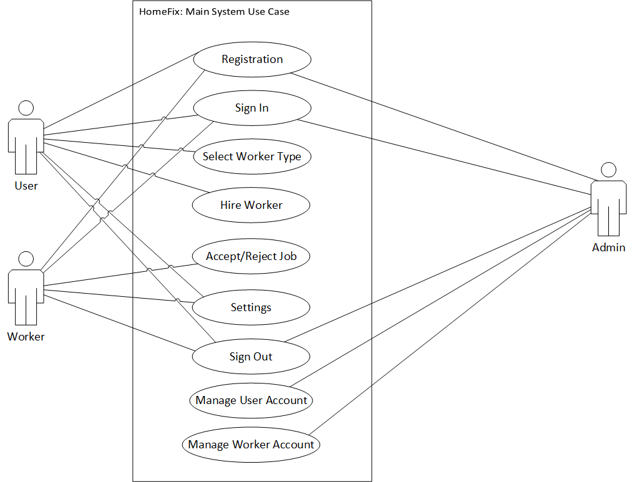
Figure ‎2.1: Complete system Use Case Diagram

Figure 2.1 shows the simple details and representation of the user’s and worker’s interaction with the system.

Registration Use Case

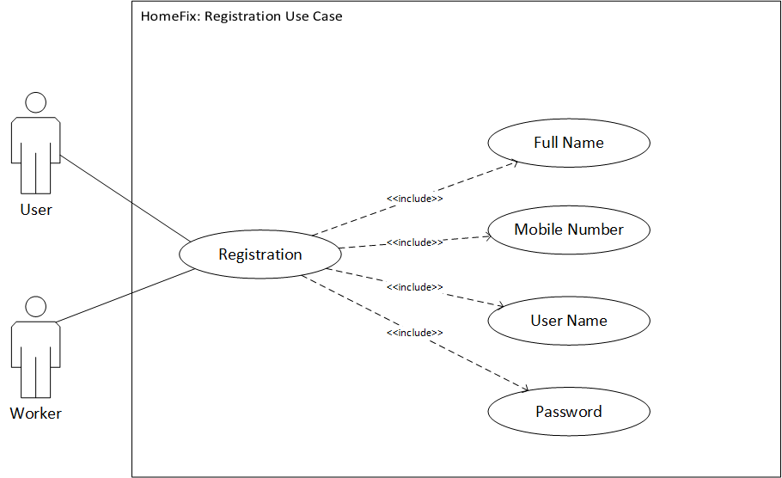
Figure ‎2.2: Registration Use Case Diagram

Figure 2.2 shows that the user and worker need to enter their respective information in order to create their account to use the application.

Sign in Use Case

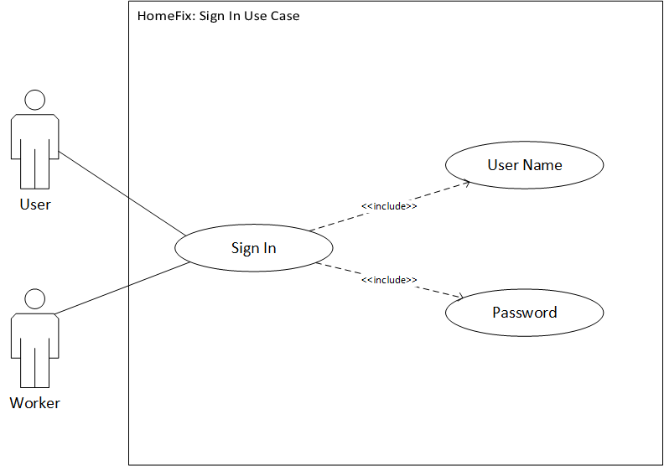
Figure ‎2.3: Sign in Use Case Diagram

Figure 2.3 shows that the user and worker must enter their username and password to sign in the application after they have successfully created their accounts.

Select Worker Type Use Case

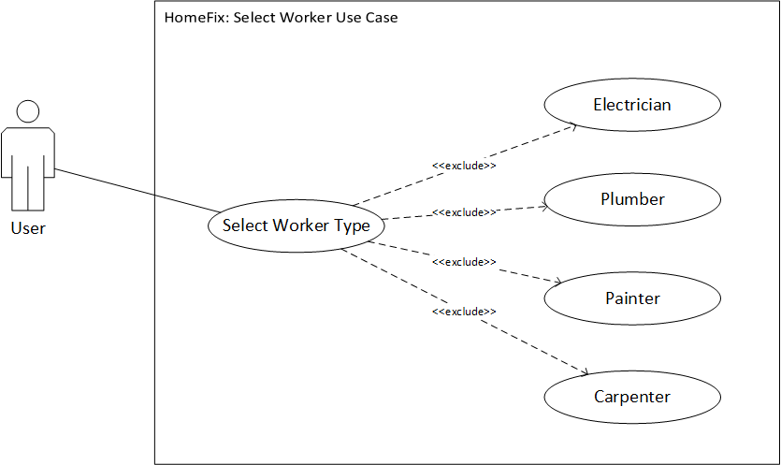
Figure ‎2.4: Select Worker Type Use Case Diagram

Figure 2.4 shows the different types of workers the user can select to get his job done after he successfully sign in the application.

Hire Worker Use Case

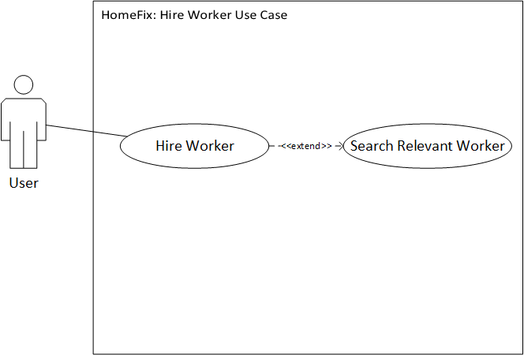
Figure ‎2.5: Hire Worker Use Case Diagram

Figure 2.5 shows that after selecting the type of worker the app would search for that relevant worker near your area who are within a radius of 5 to 10 km.

Accept/Reject Job Use Case

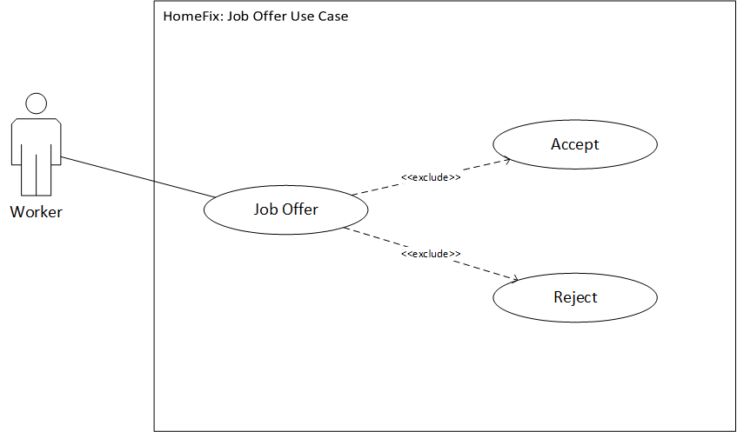
Figure ‎2.6: Job Offer Use Case Diagram

Figure 2.6 shows that after the user selects the worker the application searches for the relevant worker and send them notification either to accept or reject the job offer being offered from that area. The worker is free to either accept or reject the job offer.

Settings Use Case

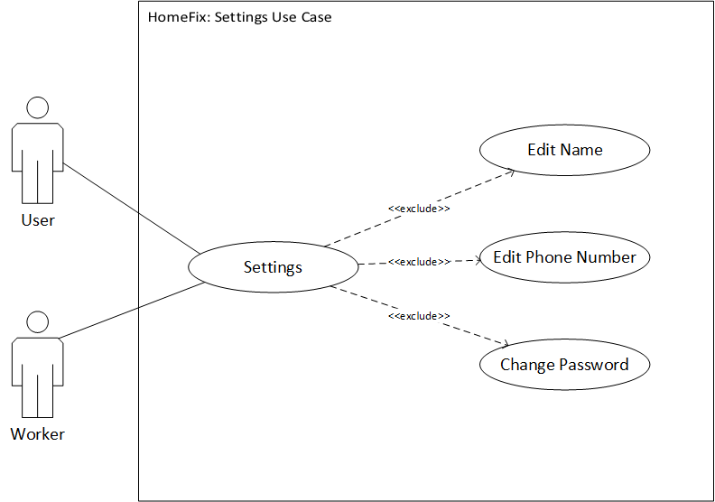
Figure ‎2.7: Settings Use Case Diagram

Figure 2.7 shows that the user and worker can change or update their information by going to the settings menu and change their password.

Sign out Use Case

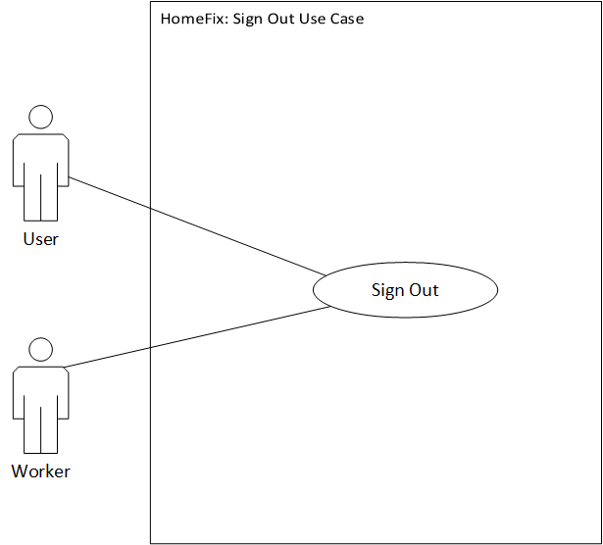
Figure ‎2.8: Sign out Type Use Case Diagram

Figure 2.8 shows that the user and worker can sign out from the application whenever they like, or they can explore other services of the application for future use.

Use-Case Description

Following are the use cases implemented in this project.

Registration Use Case

This use case contains the following parts.

Table 2.2: Registration Use Case Description
ID: | U1
Name: | Register
Actor: | User, Worker
Entry Conditions | HomeFix app must be installed on the smart phone and an active internet connection
Basic Flow or Happy Path: | - Welcome to Home Page  - Select Registration  - User and Worker will simply enter their information and create a unique username and password to create an account.
Alternative Flow | No alternative flow.
Exit Conditions: | User and worker must complete the registration process in order to sign in the app to use its services.

Sign in Use Case

This use case contains the following parts.

Table 2.3: Sign in Use Case Description
ID: | U2
Name: | Sign In
Actor: | User, Worker
Entry Conditions | U1.
Basic Flow or Happy Path: | - Welcome to Home Page  - Click Sign In  - Enter Username and Password  - Sign In
Alternative Flow: | User and worker may forget their username or password which can be reset by them through the reset password option.
Exit Conditions: | User and worker successfully sign in the app.

Select Worker Type Use Case

This use case contains the following parts.

Table 2.4: Select Worker Use Case Description
ID: | U3
Name: | Select worker type
Actor: | User
Entry Conditions | User must enable the GPS tracking of the smart phone and U2.
Basic Flow or Happy Path: | - Welcome to Home Page.  - Click Sign In.  - Enter Username and Password.  - Sign In.  - Welcome to Dashboard.  - User will be able to select the desired worker he is looking for.
Alternative Flow: | No alternative flow.
Exit Conditions: | User must select the type of the worker.

Hire Worker Use Case

This use case contains the following parts.

Table 2.5: Hire Worker Use Case Description
ID: | U4
Name: | Hire Worker
Actor: | User
Entry Conditions | U3.
Basic Flow or Happy Path: | - Welcome to Home Page.  - Click Sign In.  - Enter Username and Password.  - Sign In.  - Welcome to Dashboard.  - User or Admin will be able to select the desired worker he is looking for.  - User or Admin will be able to hire the desired worker he is looking for in his region.
Alternative Flow: | No alternative flow.
Exit Conditions: | User may search for the worker or go back to the previous screen to change the type of worker.

Accept/Reject Job Use Case

This use case contains the following parts.

Table 2.6: Job Offer Use Case Description
ID: | U5
Name: | Accept / Reject Job
Actor: | Worker
Entry Conditions | U2.
Basic Flow or Happy Path: | - Welcome to Home Page.  - Click Sign In.  - Enter Username and Password.  - Sign In.  - Welcome to Dashboard.  - Select Job Offers  - Worker will accept the job request if he interested in it.
Alternative Flow: | No alternative flow.
Exit Conditions: | Worker must accept or reject the job.

Settings Use Case

This use case contains the following parts.

Table 2.7: Settings Use Case Description
ID: | U6
Name: | Settings
Actor: | User, Worker
Entry Conditions | U2.
Basic Flow or Happy Path: | - Welcome to Home Page.  - Click Sign In.  - Enter Username and Password.  - Sign In.  - Welcome to Dashboard.  - Select Settings  - User and worker can update their password and information if they want to and view their username and other information.
Alternative Flow: | No alternative flow.
Exit Conditions: | None.

Sign out Use Case

This use case contains the following parts.

Table 2.8: Sign out Use Case Description
ID: | U7
Name: | Sign out
Actor: | User, Worker
Entry Conditions | U2.
Basic Flow or Happy Path: | - Welcome to Home Page.  - Click Sign In.  - Enter Username and Password.  - Sign In.  - Welcome to Dashboard.  - User and worker log out whenever they wish to.
Alternative Flow: | User can explore other services for future use.
Exit Conditions: | None.

Non-functional requirements

The following subsections give details about the non-functional requirements of the project app.

Performance Requirements

The application shall perform all the required tasks assigned correctly and efficiently. The response time of the application depends on smartphone processor, ram and internet speed. Without an internet connection user and worker wont, be able use the application services.

Software Quality Attributes

- Availability

The application would be available 24/7 to the user and worker having a stable internet connection.
- Flexibility

The application is flexible for all type of users having android version higher than 4.0 and iOS version 11.0.

- Usability

The application would be user friendly for the user and worker which could be easily used and understood by the user. The app would have an interactive interface which would attract the user.

- Maintainability

The application would be easy to maintain and if there is any report of bugs/error they can be removed, and new functionalities and services can be added in future with the help of upgrade of application.

System Requirements Chart

ID | Type | Priority | Source | Contained in Use Case | Description
FR1 | Functional | High | User, Worker | Register (U1) | The use case design is to register new user and worker.
FR2 | Functional | High | User, Worker | Sign in (U2) | The use case design is to sign in the user and worker.
FR3 | Functional | High | User | Select Worker Type (U3) | The use case design is for selecting the type of worker for the job.
FR4 | Functional | High | User | Hire Worker (U4) | The use case design is for searching the relevant worker selected by the user
FR5 | Functional | High | Worker | Accept/Reject Job (U5) | The use case design is for the worker to accept or reject the job offer.
FR6 | Functional | High | User, Worker | Settings (U6) | The use case design is for settings menu where user can edit data and password
FR7 | Functional | High | User, Worker | Sign Out (U7) | The use case design is to sign out user from the app.
NFR1 | Non-Functional | High | User, Worker | N/A | Performance Requirement
NFR2 | Non-Functional | High | User, Worker | N/A | Availability
NFR3 | Non-Functional | High | User, Worker | N/A | Flexibility
NFR4 | Non-Functional | High | User, Worker | N/A | Usability
NFR5 | Non-Functional | High | User, Worker | N/A | Maintainability

DESIGN AND METHODOLOGY

Introduction

In this chapter we would be discussing the different diagram models of UML which would help to model software solutions, application structures, system behaviour and business processes in our project. Following is the list of diagrams:
- Sequence Diagram
- Class Diagram
- Domain Model Diagram
- Entity Relation Diagram (ERD)

With the help of these diagrams, we will be able to visually represent a system along with its main actors, roles, actions, classes to better understand, alter maintain or document the information about the system.

Sequence Diagram

A sequence diagram shows object interactions arranged in time sequence. It depicts the objects involved in the scenario and the sequence of messages exchanged between the objects needed to carry out the functionality of the scenario. The following subsections show the various sequence diagram of our project.

Registration Sequence Diagram

Figure 3.1 shows the Registration Sequence Diagram through which the user and workers can create their accounts to use the app if they are new and don’t have an account already.

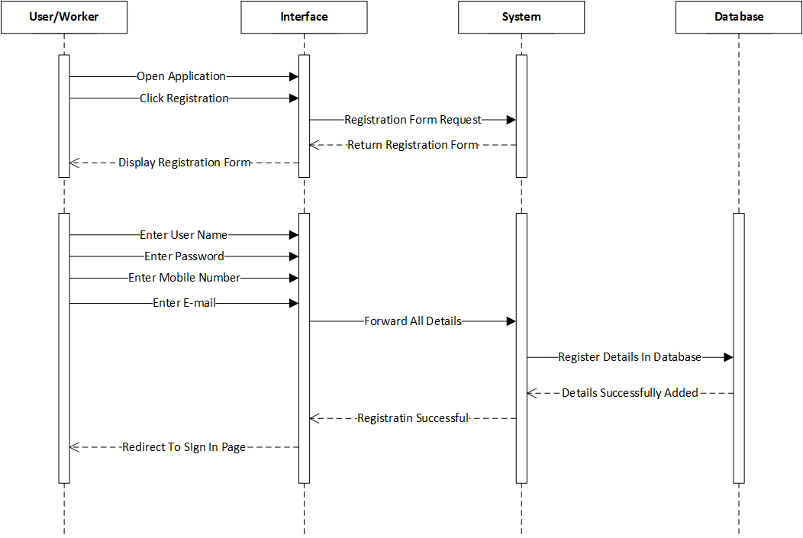
Figure ‎3.1: Registration Sequence Diagram

Sign in Sequence Diagram

After the user or worker has successfully completed registration and created an account, they will be able to sign in the app. Figure 3.2 shows the sequence diagram for the user and worker to sign in the application.

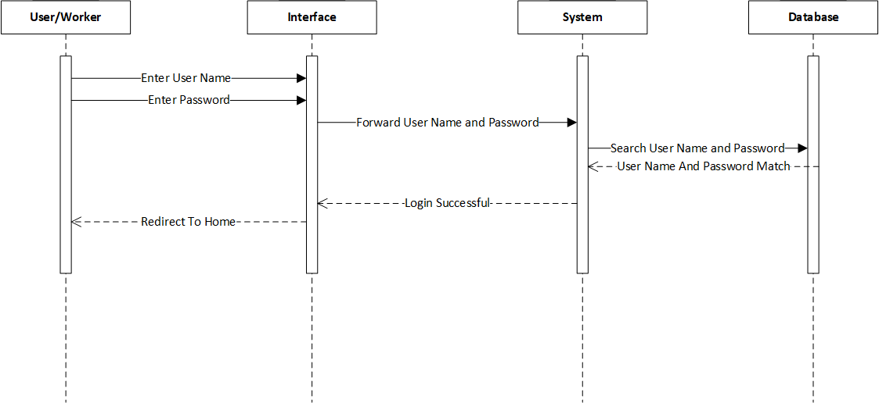
Figure ‎3.2: Sign In Sequence Diagram

Hire Worker Sequence Diagram

Figure 3.3 shows the Hire Worker Sequence Diagram. Once the user has successfully signed into the application it will allow them to use the app to hire the desired worker to get their job fulfilled.

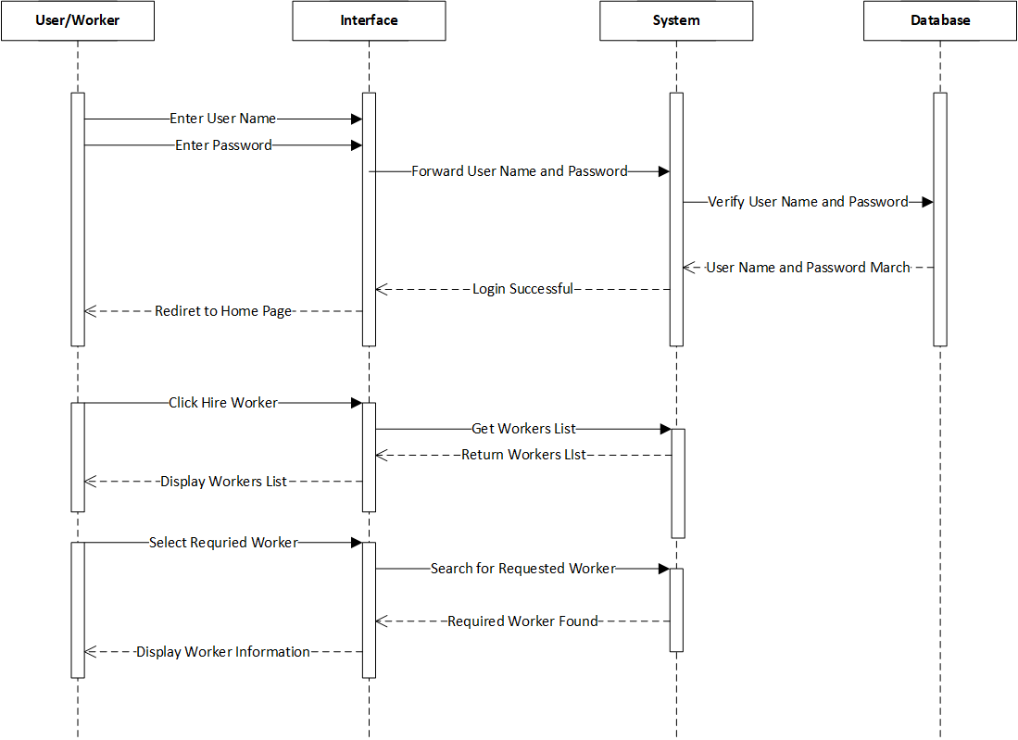
Figure ‎3.3: Hire Worker Sequence Diagram

Settings Sequence Diagram

Figure 3.4 shows the Settings Sequence Diagram. After successful signing into the app the user and worker can view settings to view or change the details of theirs as per their needs.

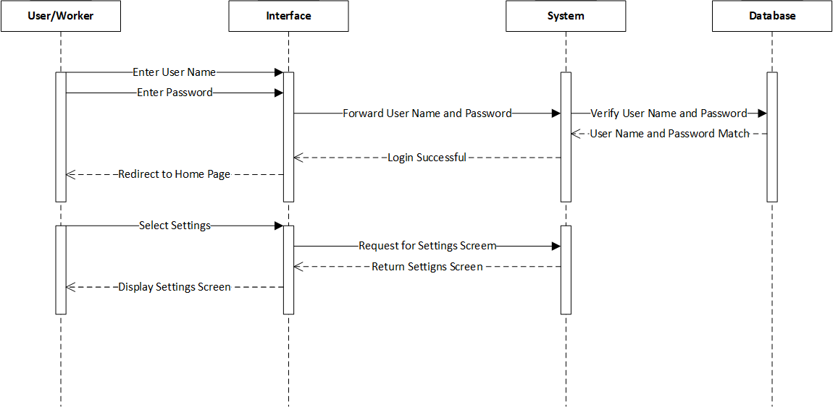
Figure ‎3.4: Settings Sequence Diagram

Job offer Sequence Diagram.

Figure 3.5 shows the Job Offer Sequence Diagram. After the worker successfully sign into the app, he would be able to receive job offers and accept or reject them.

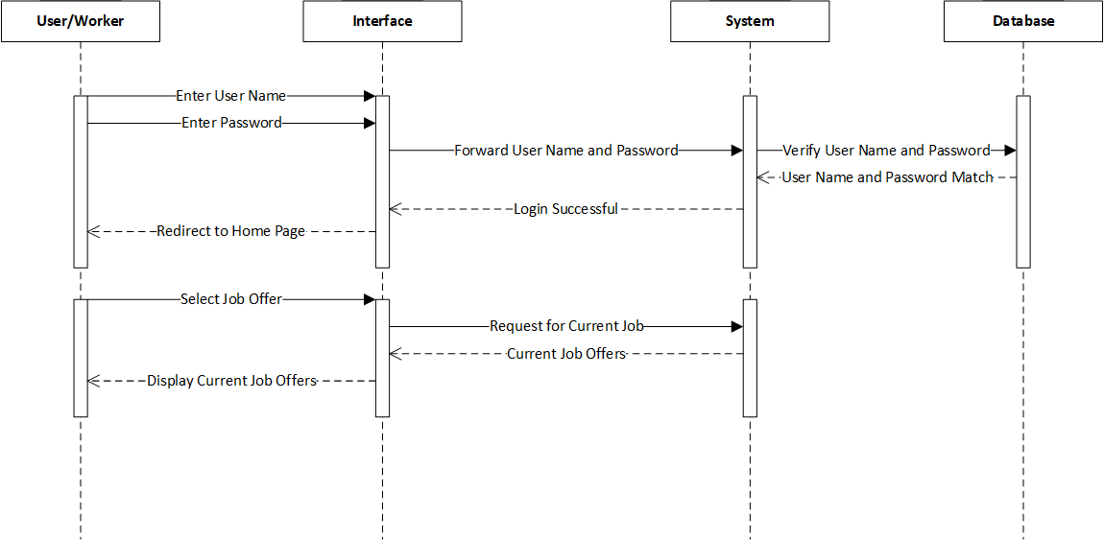
Figure ‎3.5: Job Offer Sequence Diagram

Sign Out Sequence Diagram

Figure 3.6 shows the Sign out sequence diagram. After getting or completing the job the user and worker can sign out of the application if they would like else, they could look for another job or view the other features of the application.

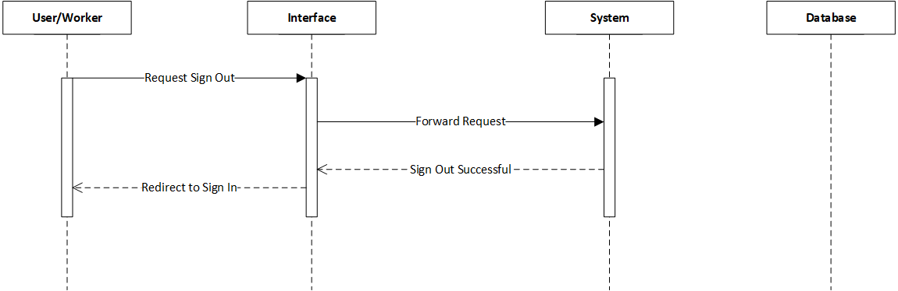
Figure ‎3.6: Sign Out Sequence Diagram

Class Diagram

Class Diagrams are the main building block of object-oriented solution. It shows the classes in a system, attributes, and operations of each class and the relationship between them. Figure 3.7 shows the Class Diagram of our project.

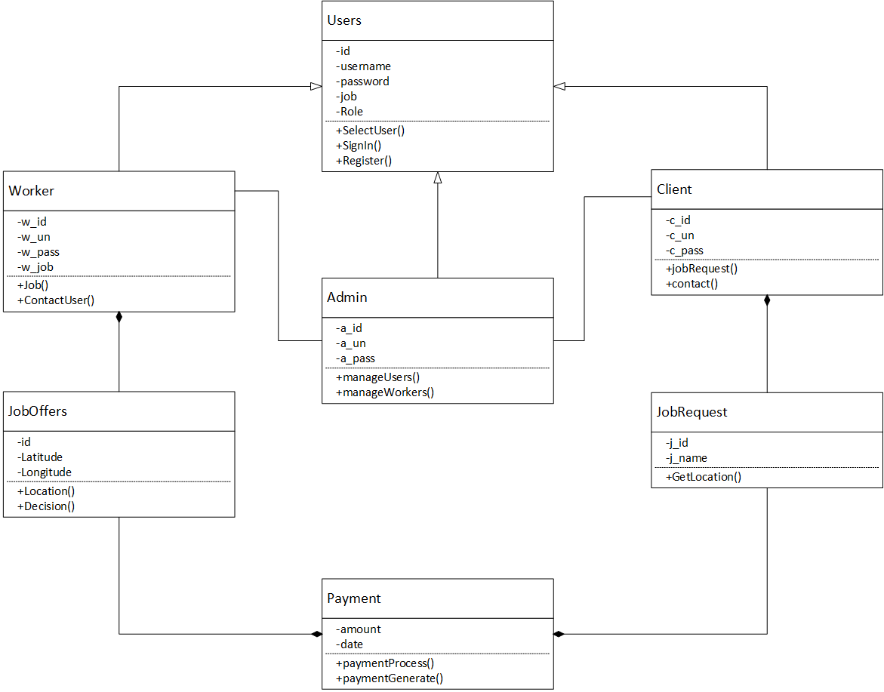
Figure ‎3.7: Class Diagram

Domain Model Diagram

Domain Model Diagram is a way to describe and model real world entities and the relationships between them, which collectively describe the problem domain space. Figure 3.3.8 shows domain model diagram of HomeFix.

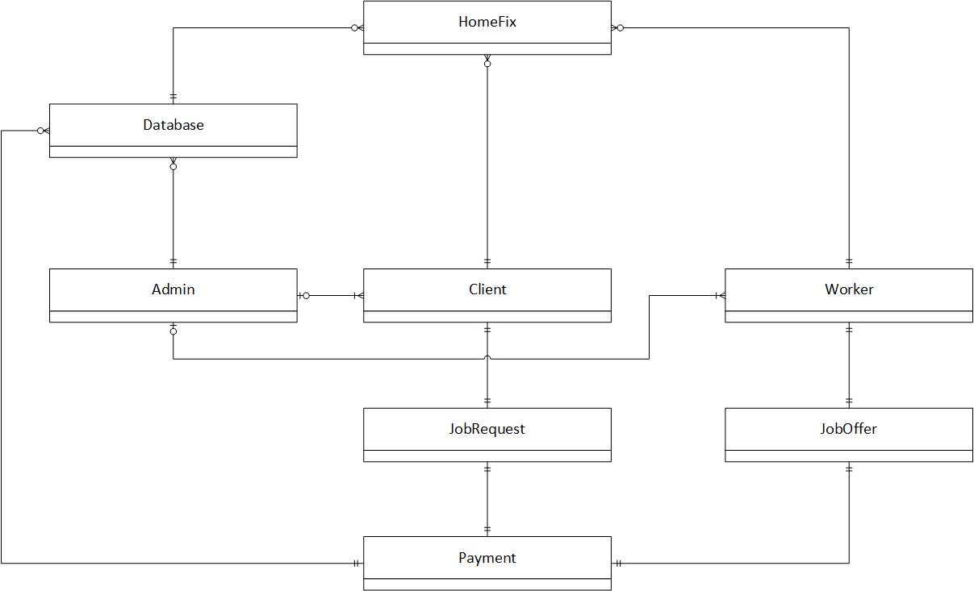
Figure ‎3.8: Domain Model Diagram

Entity Relation Diagram

The entity relation diagram (ERD) describes the structure of a database with the help of a diagram. Figure 3.9 shows the ERD of our project.

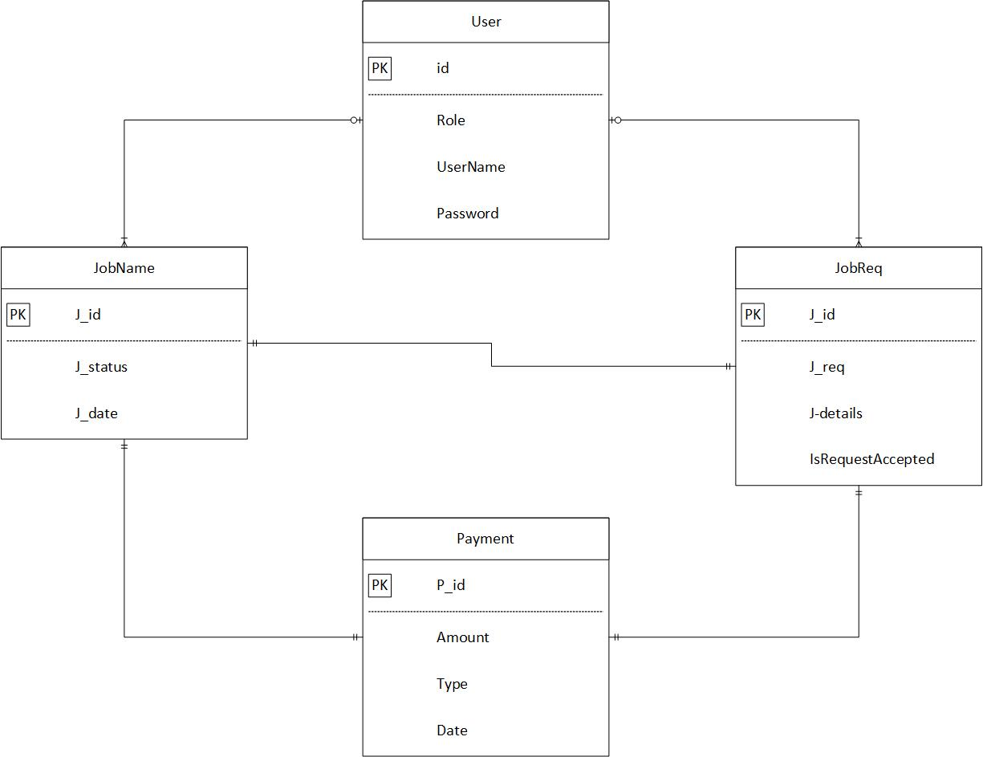
Figure ‎3.9: Entity Relation Diagram

DATA AND EXPERIMENTS (and/or IMPLMENTATION)

Languages used for Implementation.

Following languages were used for the implementation of the application:

React.js.

React Native combines the best parts of native development with React, a best-in-class JavaScript library for building user interfaces. React components wrap existing native code and interact with native APIs via React’s declarative UI paradigm and JavaScript which enables native app development and let you and your team work much faster.

JavaScript.

With the help of JavaScript, React Native lets you iterate at lightning speed and lets you see your changes as soon as you save it which means you don’t to wait for the build to finish and you can see changes as soon as you save it.

PHP.

It is a general-purpose scripting language which we have used in back-end for our management website. It is a fast, flexible, and pragmatic language.

Framework.

Following are the frameworks used in our project:

React-Native.

React native is an open-source mobile application framework which is created by Facebook and is used to develop application for android and iOS by enabling developers to use React’s framework along with native capabilities. React Native lets you iterate at lightning speed and lets you see your changes as soon as you save it which means you don’t to wait for the build to finish and you can see changes as soon as you save it.

CodeIgniter.

CodeIgniter is an open-source software rapid development web framework which is used in building dynamic web sites with the help of PHP.

Implementation.

First the user and vendor need to install the application in their device. Once they have installed the applications, they will be welcomed by the Sign In page on opening the application. If the user is new to the application, they will first create their account by sharing their details required by the application for e.g., your name, password etc. After successfully creating the account, the user can sign into their account and will be redirected to the home screen. From the home screen the user can select from various major categories of services provided. After selecting the major category, the user will be directed to subcategories screen where he can select a specific category which he wants to get fixed. After selecting the user will be asked to give a brief description of the problem which needs to be fixed and the date and time for the job. After selecting all the details, the application will search for the appropriate worker near the user and will notify the vendor about the job and if he wishes to do that job, he will accept the offer else simply reject it. Once the job is accepted the user can chat with the vendor with the help of the chat box or he can call the vendor if he wishes to discuss in detail about the job. Once the job is accepted the vendor will be shared the location of the customer so that he can reach there without any difficulty and complete the job. After the job is completed, the customer will pay the vendor and the vendor will finish the job. If the customer doesn’t have change, he can get the remaining amount in his wallet which can be used next times while using the application. After the job is completed the user and vendor would be able to rate each other.

RESULTS AND DISCUSSIONS (or USER MANUAL)

Sign Up

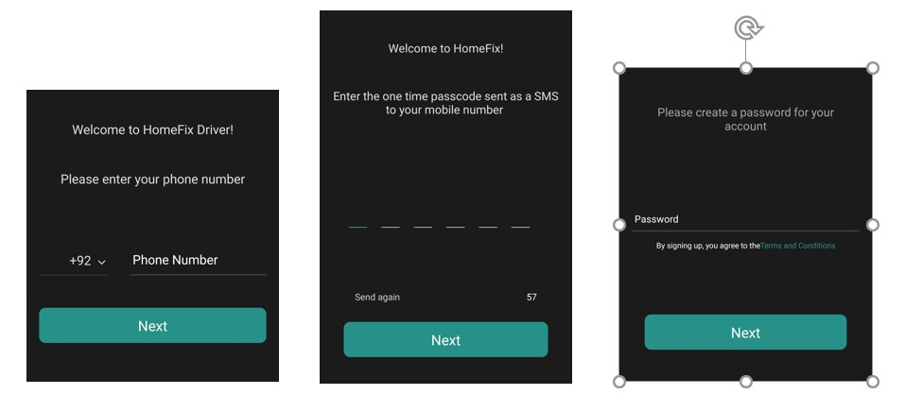
When the user opens the application, he will be brought to the sign in screen. If the user is new to the application, he can select sign up which will direct him to the sign-up screen to create his new account.
Figure ‎5.1: Sign Up Screen

In Figure 5.1 the user is asked to enter his phone no., OTP, and password so that he can create a new account to sign into the application.

One Time Password (OTP) Generation

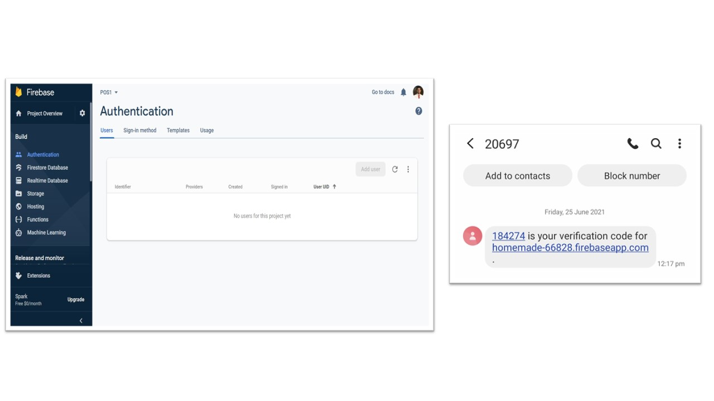
When the user enters his mobile number for sign up the application will send an OTP which is generated with the help of firebase authentication to the user’s number for which he will enter in the application to proceed further for signing up in the application.

Figure ‎5.2: One Time Password (OTP)

Figure 5.2 shows the OTP generated when the user enters his mobile number for the first time in the application to create a new account. The user is required to enter the OTP in the application to proceed further for sign up process.

Sign In

When the user opens the application, he will be brought to the sign in screen.
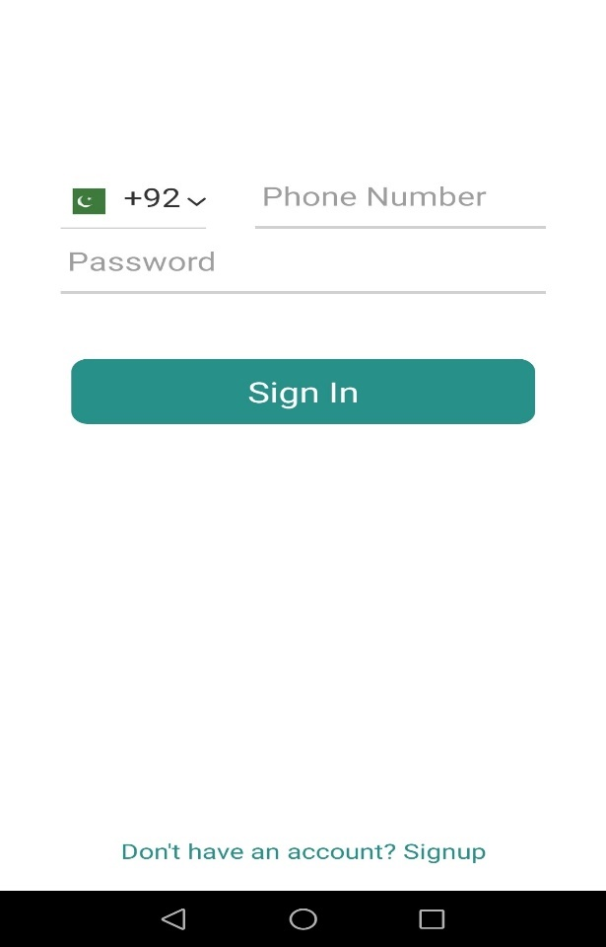
Figure ‎5.3: Sign In Screen

In Figure 5.3 the user is asked to enter his phone no. and password so that he can sign into the application.

Home Screen

When the user successfully logins into the application he will be directed to the home screen.

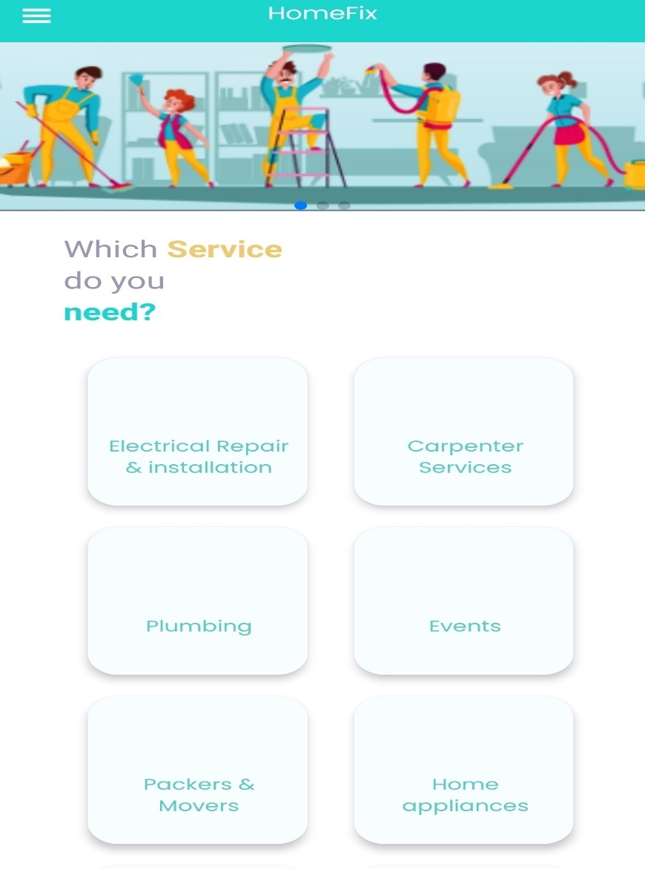
Figure ‎5.4: Home Screen

The figure 5.4 shows the home screen of the application which contains all the services which are provided by the application to the user.

Selecting Subcategory

After selecting a major category from the home screen, the user will be directed to the subcategory screen consisting of specific appliances related to the parent category.

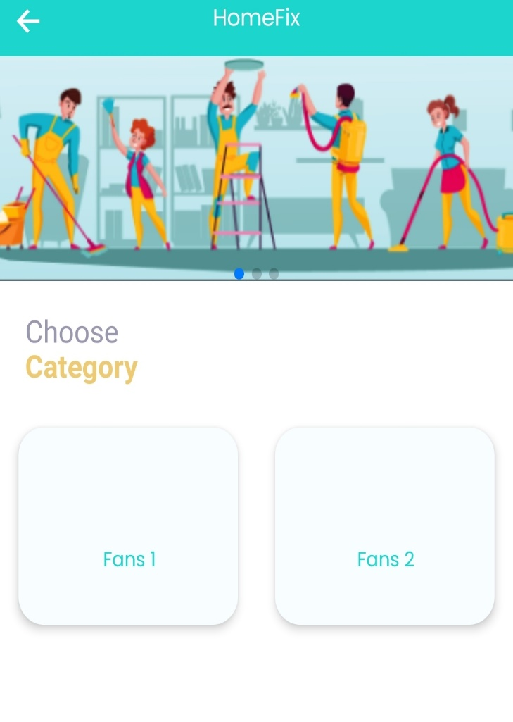
Figure ‎5.5: Subcategory Screen

Figure 5.5 shows the subcategories screen of the application which allows the user to be more specific about the appliance which he wants to get fixed.

Hire Worker

After selecting the subcategory of the worker from the subcategory screen the user will be directed to the hire worker screen.

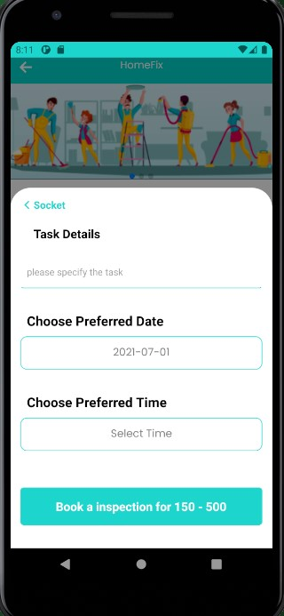
Figure ‎5.6: Hire Worker

The figure 5.6 shows the screen where the user is required to enter the task in detail and select the time and date when the job is needed to be done.

Mark Location

After entering all the essential details, the user will be directed to the map screen where they would be able to mark their location.

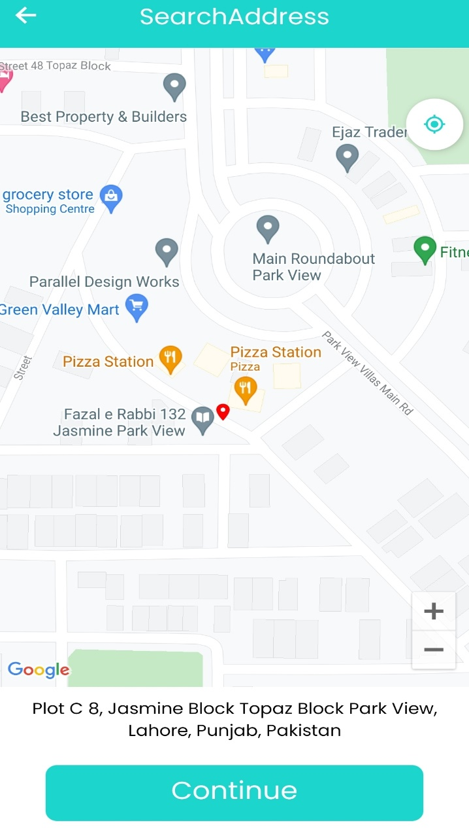
Figure ‎5.7: Mark Location

The figure 5.7 shows the map screen where the user will mark his current location where his located and wants the job to be done.

Search Worker

After the user marks his location, the application will search for the worker available in that location near to the user.

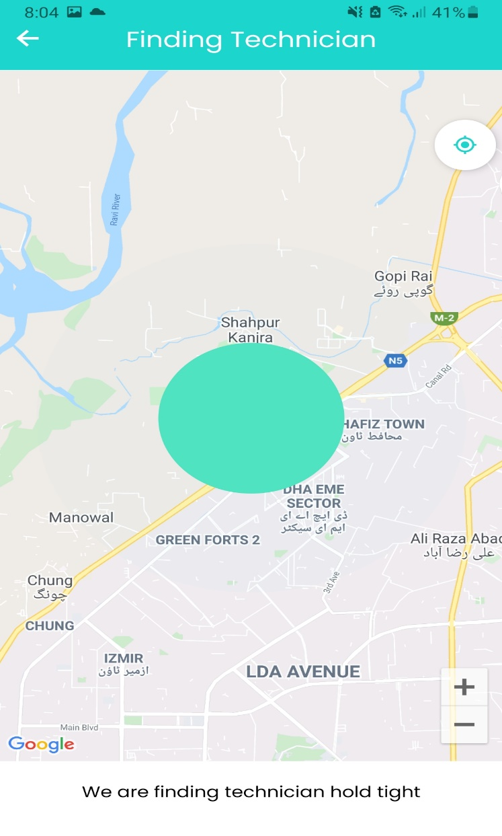
Figure ‎5.8: Search Worker

Figure 5.8 shows the screen where the application is looking for a nearby worker.

Accept/ Reject Job offer

The application will send notification to different workers near the user location and share the details of the job with the worker.

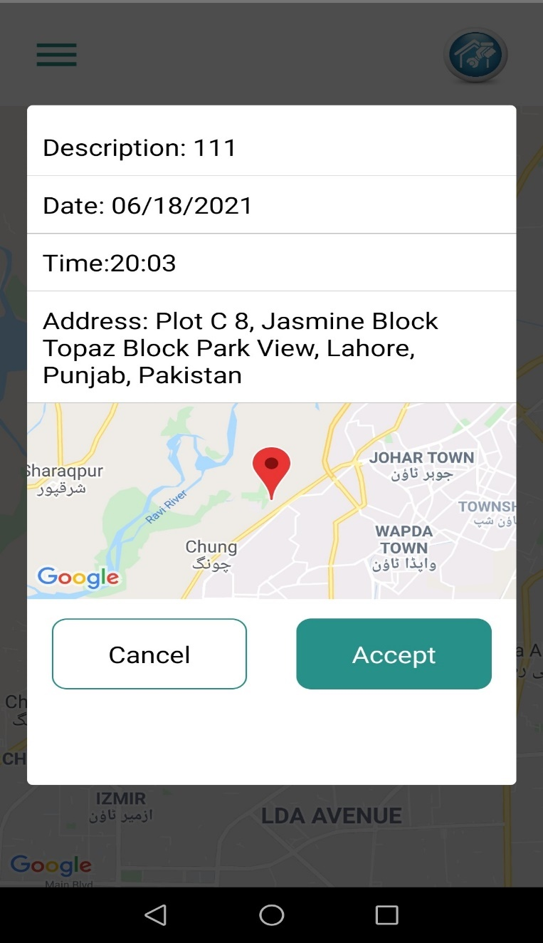
Figure ‎5.9: Accept/Reject Job Offer

Figure 5.9 shows the worker screen where the worker is allowed either to accept or reject the job after reading the job details.

Location Tracking

Once the worker accepts the job the user and worker would be able to see each other’s location and track their locations.

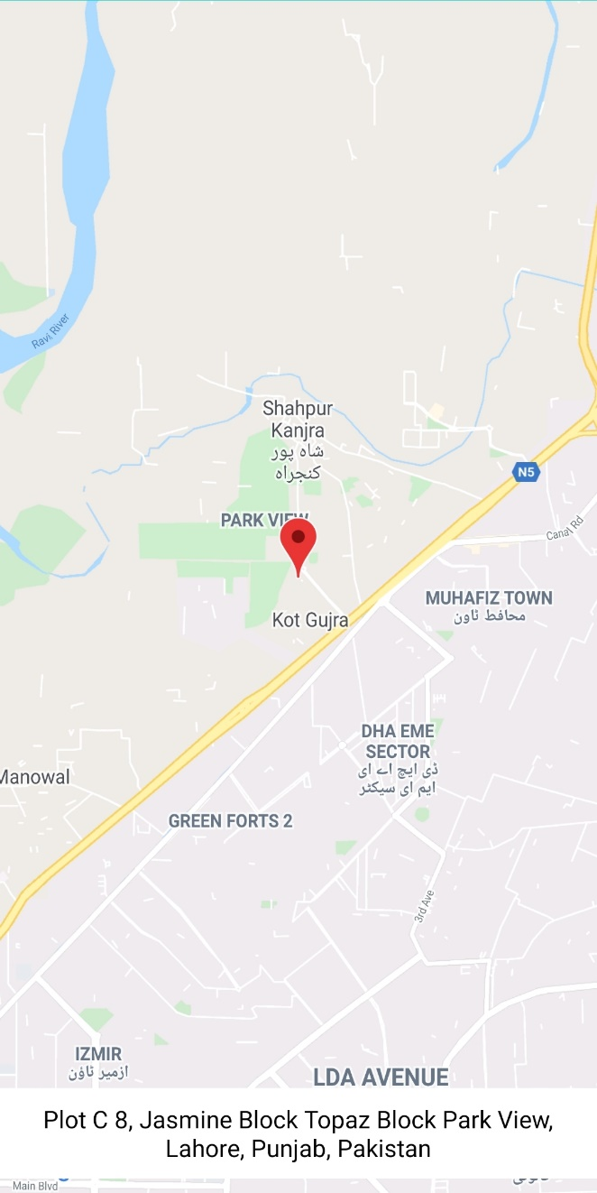
Figure ‎5.10: Location Tracking

Figure 5.10 shows the user screen where is he able to track the workers location and know his location where he is now.

Chat Box

After the worker accepts the job the user and worker will be directed to the chat box where they can chat.

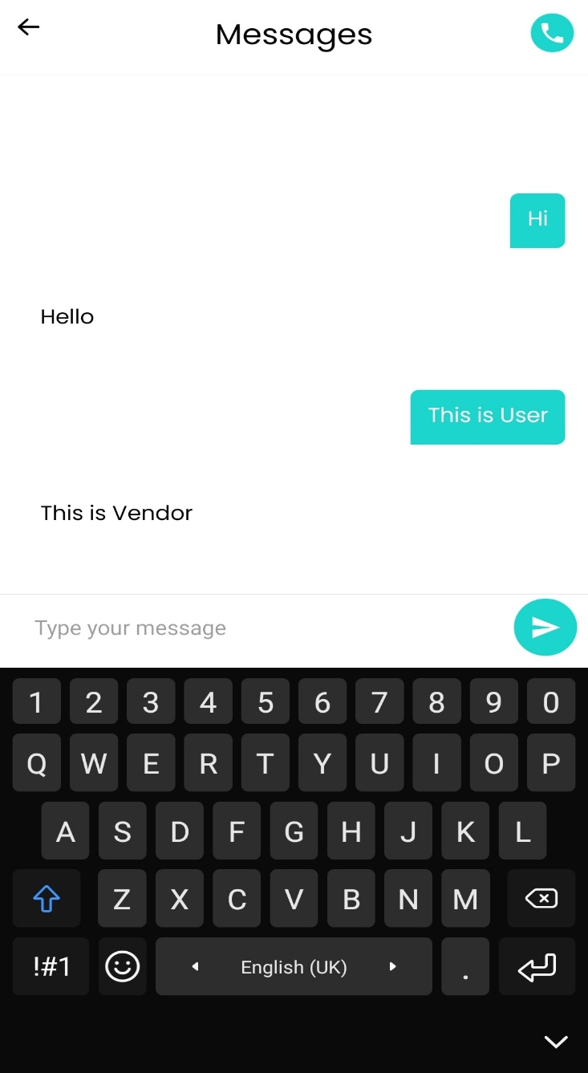
Figure ‎5.11: Chat Box

Figure 5.11 shows the screen where the user and worker can chat and discuss in detail the job which needs to be done. If need be, the user can also call the vendor and discuss the problem with him in detail.

Receive Payment

After the job is done, the worker is directed to the payment screen where he would be able to enter the amount received from the user.

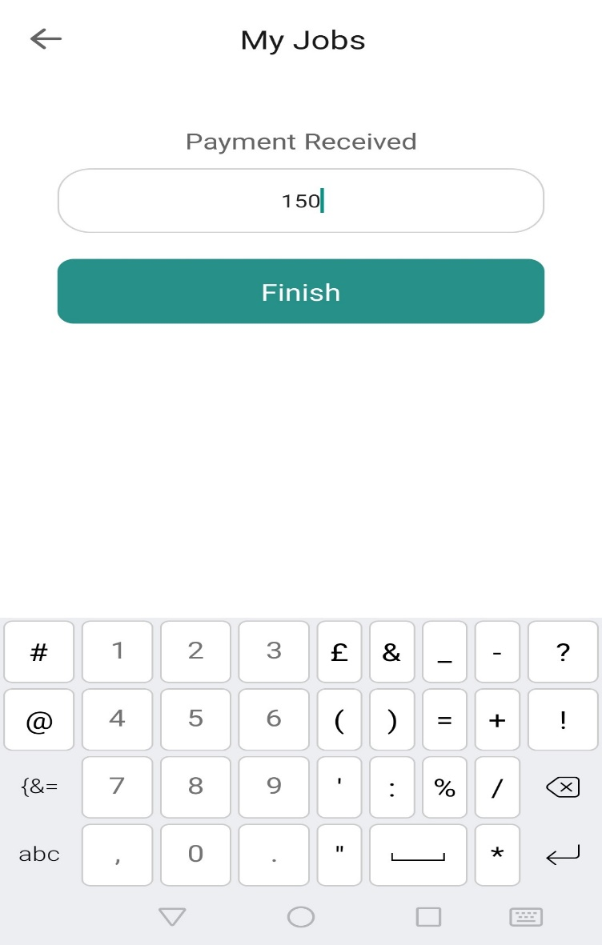
Figure ‎5.12: Payment

Figure 5.12 shows the payment screen where the worker would be able to enter the amount paid by the customer after finishing the job.

Rating

After the payment is done by the user the user and worker will give rating to each other based on the task done. They can view the job details and the amount paid for the specific task.

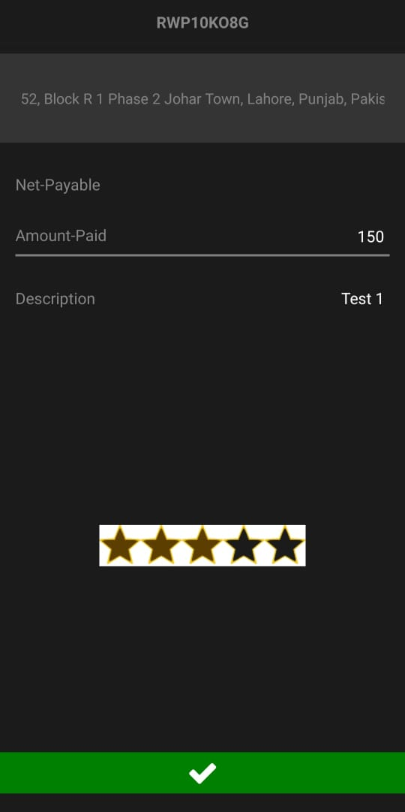
Figure ‎5.13: Rating

Figure 5.13 shows the rating screen where the user and worker can view the job details and rate each other according to the job done.

Completed Orders

Once the job is completed the user and worker can view the jobs list which got completed in the completed section of the list. The screen shows all the jobs which were done by the worker and its detail like the amount paid for that job.

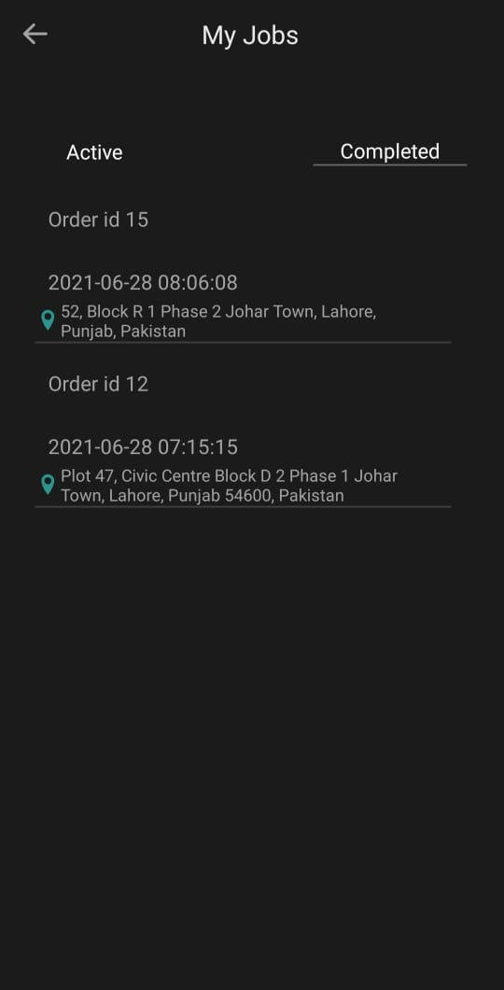
Figure ‎5.14: Completed Orders

Figure 5.14 shows the completed order screen. From here the user and worker can see their completed orders and their details of the job.

Pending Orders

If there is no worker available at that time for the user, the request will be sent to pending order list where the request will be shown to the worker once he is online, and he would be able to accept the job from this list and the user will be notified that the worker has accepted his job.
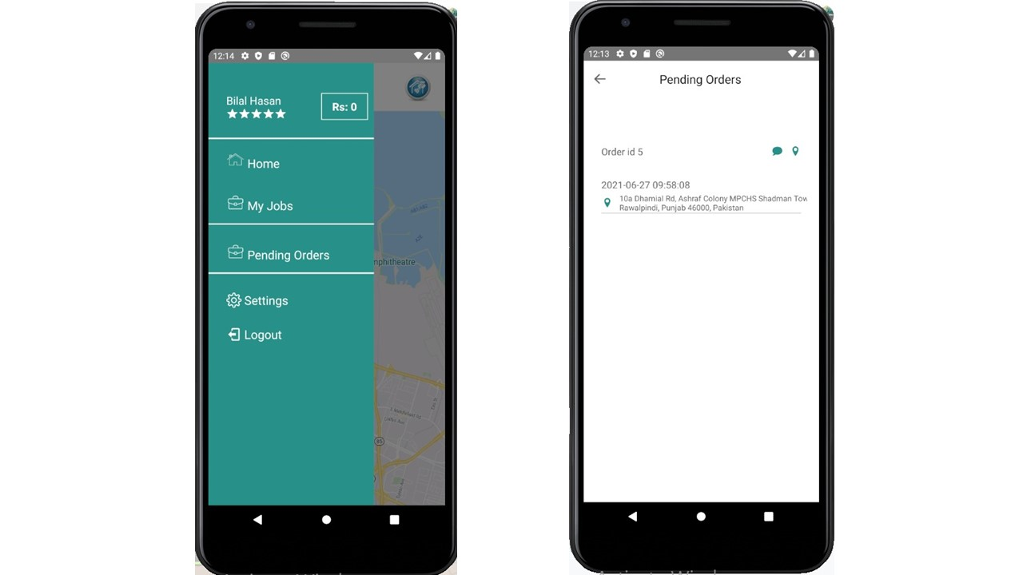

Figure ‎5.15: Pending Screen

Figure 5.15 shows the pending screen from where the worker can see the tasks which are pending and can be done by him. The worker would be able to accept these offers and get them completed.

Admin Panel

The admin panel is authorized to view and manage the user and worker’s account. The admin has the access to activate or deactivate the accounts and even delete them. The admin can view user and workers information if need be. The worker account is only created when the admin panel verifies the CNIC copies uploaded and sets the status to active else the workers account won’t be created, and he won’t be able to receive job requests.

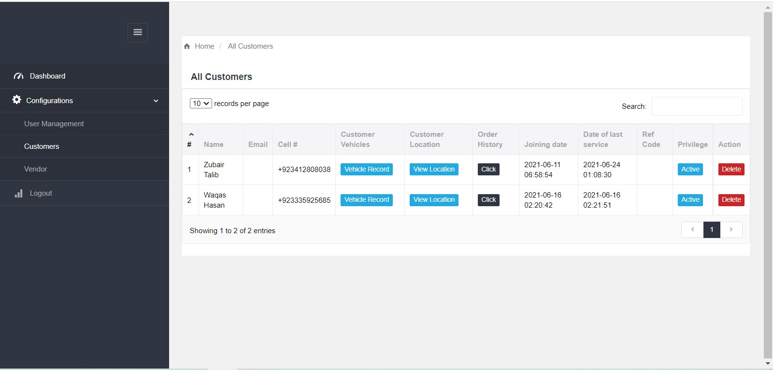
Figure ‎5.16: Admin Panel

Figure 5.16 shows the users accounts page in the admin panel. The page consists of all the required information about the customer and the admin can also activate or deactivate the user’s account. The admin can also delete the user and worker’s account.

MySQL Database

Following figure shows the database of the project which is created in MySQL.

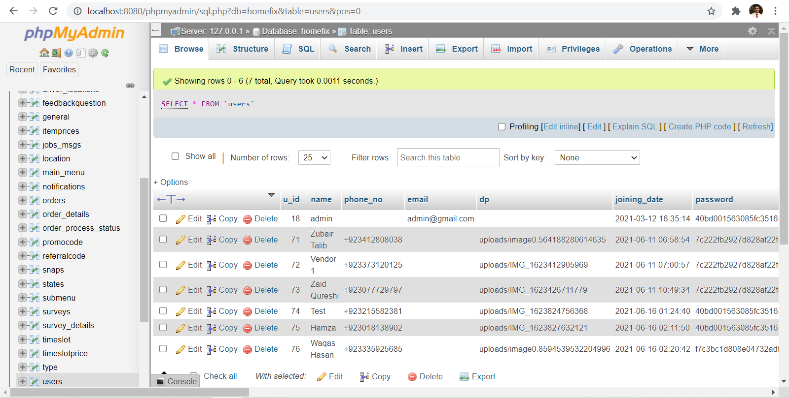
Figure ‎5.17: MySQL database

Figure 5.17 shows the users accounts stored in MySQL database and other tables created in the database.

iOS Build and Folder

Following figure shows all the folder and file required to the run the application on Mac devices. The application can be built through X code on any Mac device.

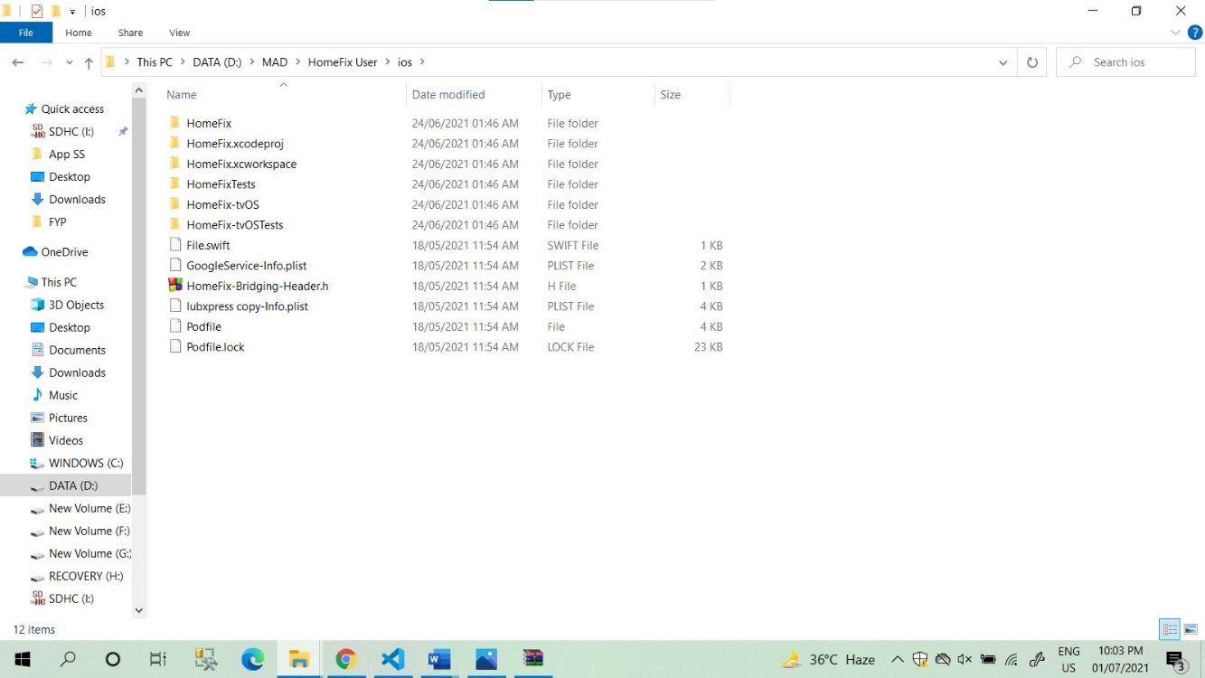
Figure ‎5.18: iOS Folder And Files

Figure 5.18 shows all the required files and build which are needed to run on X code on any Mac device and emulator.

CONCLUSION AND RECOMMENDATIONS

Conclusion

Our application allows the user to hire a worker to get their household jobs done by just sitting at home. They longer need to go out and search for a specific one to get their jobs done. It will make women independent and let them get the house jobs done by themselves instead of relying on the men to get them done. The application also saves a lot of time and energy of the people. The application will create new job opportunities and will help people to earn easily. This application is beneficial for both the user and the worker.

Recommendation

In future furthermore new categories of services can be added into the application. To avail discounts to the customer the functionality of promo codes can be added in the application. The promo code functionality would provide customers the services on low prices than the normal ones. The people with promo codes will only be able to access those prices at get benefits from it.

