

BSCS-F20-020

03-134172-080 | NABEEL AWAIS
03-134172-088 | AHMAD IMAM

AR Based Barber Booking Mobile App

In partial fulfilment of the requirements for the degree of
Bachelor of Science in Computer Science

Supervisor: Junaid Nasir Qureshi

Department of Computer Sciences Bahria University, Lahore Campus

July 2021

© Bahria University, 2021

C e r t i f i c a t e

We accept the work contained in the report titled “AR Based Barber Booking Mobile App” written by
NABEEL AWAIS AHMAD IMAM

As a confirmation to the required standard for the partial fulfillment of the degree of Bachelor of Science in Computer Science.

Approved by:
Supervisor: Junaid Nasir Qureshi

(Signature)

July 14, 2021

DECLARATION

We hereby declare that this project report is based on our original work except for citations and quotations which have been duly acknowledged. We also declare that it has not been previously and concurrently submitted for any other degree or award at Bahria University or other institutions.

Enrolment | Name | Signature
03-134172-080 | NABEEL AWAIS
03-134172-088 | AHMAD IMAM

Date : July 14, 2021

Specially dedicated to
My beloved mother, and father (NABEEL AWAIS)
My beloved mother, and father (AHMAD IMAM)

ACKNOWLEDGEMENTS

We would like to thank everyone who had contributed to the successful completion of this project. We would like to express our gratitude to my research supervisor, Mr. Junaid Nasir for his invaluable advice, guidance, and his enormous patience throughout the development of the research.

In addition, we would also like to express my gratitude to our loving parent and friends who had helped and given me encouragement.

NABEEL AWAIS
AHMAD IMAM

AR Based Barber Booking Mobile App

ABSTRACT

In this modern era, people are very conscious about their looks, and they are not sure what would look good on them. So, people who are concerned about fashion want from this technology to be advanced enough to let them experience different fashions on them virtually. Due to the hectic life of the modern era, these people are busy or tired enough to go to barbershops and wait for their turn to get their required hairstyle. Also, these people often face bad experiences from different barbers because there is no proper community to guide them and recommend them highly rated barbers with their prices.
The major goal of this React Native based application is to provide these people with the facility to try different hairstyles on them virtually using Augmented Reality technology. It will also provide the facility to its users to choose their desired barber according to their ratings. Users will also be able to book their appointment for a specific date and time online. Booked appointment can also be cancelled by both barber and costumer. Barber can cancel the appointment if he is busy.

TABLE OF CONTENTS

DECLARATION ii
ACKNOWLEDGEMENTS iv
ABSTRACT v
TABLE OF CONTENTS vi
LIST OF FIGURES ix
LIST OF TABLES x

CHAPTERS
1 INTRODUCTION 1
1.1 Background 1
1.2 Problem Statements 2
1.3 Aims and Objectives. 2
1.4 Scope of Project 3
2 Software Specification Requirement 4
2.1 User Classes and Characteristics 4
2.2 Operation Environment 5
2.3 Design and Implementation Constraints 6
2.4 Assumptions and Dependencies 6
2.5 External interface Requirements 6
2.6 User Interfaces 6
2.7 Software Interfaces 6
2.7.1 Table 1: Software Interfaces 7
2.8 System Use Case 8
2.8.1 Table 2: Sign-Up as a Barber 9
2.8.2 Table 3: Sign-Up as a Customer 10
2.8.3 Table 4: Sign-In as a Barber 11
2.8.4 Table 5: Sign-In as a Customer 12
2.8.5 Table 6: Request for Booking 13
2.8.6 Table 7: Accept Booking 14
2.8.7 Table 8: Augmented Reality 15
2.8.8 Table 9: Product Booking Status 16
2.8.9 Table 10: Delete and Update 17
2.8.10 Table 11: Logout 18
2.9 Other Non-functional Requirements 19
2.9.1 Performance Requirements 19
2.9.2 Safety Requirements 19
2.9.3 Security Requirements 19
2.10 Software Quality Attributes 20
3 DESIGN AND METHODOLOGY 21
3.1 Sequence Diagram 21
3.2 Work Breakdown Structure 25
3.3 Operation Contracts 25
3.3.1 Operation Contract Signup 25
3.3.2 Operation Contract Login 26
3.3.3 Operation Contract AR 26
3.3.4 Operation Contract Request for Booking 26
3.3.5 Operation Contract Accept Booking 26
3.3.6 Operation Contract View Booking Status 26
3.3.7 Operation Contract View Record 27
3.3.8 Operation Contract View Update and Delete 27
3.3.9 Operation Contract Logout 27
3.4 Domain Model Diagram 28
3.5 Design Class Diagram 29
3.6 Collaboration Diagram 29
3.6.1 Costumer collaboration diagram 30
3.6.2 Barber collaboration diagram 31
3.6.3 Admin collaboration diagram 31
3.7 Data Model 32
4 IMPLMENTATION 33
4.1 Screen Shots: 33
4.1.1 Login 33
4.1.2 Sign Up: 34
4.1.3 Gender Screen: 35
4.1.4 Hairstyle Screen: 36
4.1.5 AR: 37
4.1.6 Barber List: 38
4.1.7 Booking Screen: 39
4.1.8 Request Status Screen: 40
4.1.9 AR Side App: 41
4.1.10 Barber Side APP: 42
5 RESULTS AND DISCUSSIONS 43
5.1 Face Mode Survey 2021: 43
5.1.1 FaceMode Customers Survey: 43
6 CONCLUSION AND RECOMMENDATIONS 44
6.1 Conclusion: 44
REFERENCES 45

LIST OF FIGURES

FIGURE TITLE PAGE
Figure 2.1: System Use Case 8
Figure 3.1: Sequence Diagram Sign-up 21
Figure 3.2: Sequence Diagram Sign In 21
Figure 3.3: Sequence Diagram for booking request 22
Figure 3.4: Sequence Diagram for accept booking 22
Figure 3.5: Sequence Diagram for booking status 23
Figure 3.6: Sequence Diagram for View Record 23
Figure 3.7: Sequence Diagram for update and delete 23
Figure 3.8: Sequence Diagram for logout 24
Figure 3.9: Sequence Diagram for AR 24
Figure 3.10: Diagram of work break down structure 25
Figure 3.11: Domain model diagram 28
Figure 3.12: Design Class Diagram 29
Figure 3.13: Collaboration of Customer 30
Figure 3.14: Barber collaboration Diagram 31
Figure 3.15: Admin Collaboration diagram 31
Figure 3.16: Data Model Diagram 32

LIST OF TABLES

TABLE TITLE PAGE
2.7.1 Table 1: Software Interfaces 7
2.8.1 Table 2: Sign-Up as a Barber 9
2.8.2 Table 3: Sign-Up as a Customer 10
2.8.3 Table 4: Sign-In as a Barber 11
2.8.4 Table 5: Sign-In as a Customer 12
2.8.5 Table 6: Request for Booking 13
2.8.6 Table 7: Accept Booking 14
2.8.7 Table 8: Augmented Reality 15
2.8.8 Table 9: Product Booking Status 16
2.8.9 Table 10: Delete and Update 17
2.8.10 Table 11: Logout 18

INTRODUCTION

Background

We are developing Augmented Reality based mobile application which will let people do home shopping of hairstyles. The application will let them try various hairstyles through augmented reality from anywhere in the world. The application will save time and make it easy for them to choose what hairstyle will look good on them. The application will make it possible through hairstyle face filters. The application will also give them the details of barbers and their ratings to select the hairstylist of their desire.
The registered user can access the account with valid credentials and set an appointment for a specific date and time after choosing their desired style. The user can also cancel the appointment in case if they change their mind. If user cancel the appointment barber will get a notification. Appointment will be cancelled automatically after 24 hours in case of costumer’s unavailability.
The barber can update/edit his biography. Barber portfolio feature lets customers select the barber of their choice by checking their portfolios. Customers can choose the barber for any service they want. Barbers can promote their portfolio, showcase their specialties, rates, and experience through this app and target clients with similar tastes and choices. This feature also helps to monetize the app. [1] He can see the pending appointments also, he can confirm and reject the appointment request. If barber cancel the request the user will get a notification.

Problem Statements

Our mobile app will solve these problems by latest technology (Augmented Reality). Today, more than 1 billion smartphones and tablet devices can deliver augmented experiences, and within the next year, 100 million consumers are expected to shop using AR either online or in-store.[2] Providing the users to try hairstyles on them using a mobile camera and booking the appointment online will ease the people.

Aims and Objectives.

The objectives of the project are shown as following:

    - To provide users with the convenience of online hairstyle selection.
    - To try different hairstyle on users virtually.
    - To let users, book their appointment online.
    - To provide a list of barbers according to their ratings.
    - To help barbers to sell their services online.

Scope of Project

The scope of our application is to provide convenience to the users who are concerned about looks by letting them try fashion on them virtually. It has been observed in our society that people are facing various difficulties in choosing their hairstyles which suits their face cut and finding the best barber for that hairstyle is even more confusing because the market is so big. This situation leads people to face really bad experiences with different barbers and in result, they have to compromise with their looks. The appropriate solution for this problem is providing a mobile app to such users. Our mobile app will solve these problems by latest technology (Augmented Reality). Today, more than 1 billion smartphones and tablet devices can deliver augmented experiences, and within the next year, 100 million consumers are expected to shop using AR either online or in-store.[2] Providing the users to try hairstyles on them using a mobile camera and booking the appointment online will ease the people.

Software Specification Requirement

User Classes and Characteristics

Following are the user classes and characteristics:
    - Admin
    - Barber
    - Client/Customer

Administrator – Admin will be the developer who will be able to perform the following activities.
    - Admin Sign-up
    - Admin Sign-in
    - Change credentials
    - Maintain Profile
    - Maintain Record
    - Order history
    - Sign-out

Barber – Any person who wants a platform to sell Barber Services.
    - Sign-up
    - Sign-in/Login
    - Maintain Profile
    - Receive order

    - Accept order
    - Sign-out

Client/Customer – Any person who wants to Book Barber.
    - Sign-up
    - Sign-in/Login
    - Select Barber
    - Booking Barber
    - View Profile of Barber
    - Sign-out

Operation Environment

Following are the operating environment are required:

Android-Based Requirements:
- Android version (minimum Android Marshmallow-6.0)
- Android version for AR (minimum Android Q-10.0)
- Latest Google play Services for AR

Database Management System
- Firebase

Android Development System
- Android studio 4.1.1
- VS code 4.0
- React Native CLI
- ViroReact CLI for AR
- Git (for version control)

Design and Implementation Constraints

FACEMODE is a hybrid application therefore front-end of application will be developed using JavaScript and back-end will be developed using Firebase. It will be developed using Feature Driven Development which divide complex structures into sub parts. This model recurrence last two phases i.e. Design by feature and Develop by Feature until all features will complete.

Assumptions and Dependencies

FaceMode is a Hybrid application therefore it involves following features:
- Google play services is required to run Google applications. So, user need to have this feature to interact with our application. Without Google play services, features like Google maps cannot be used.
- The application requires camera for AR system.
- Both end users need to have an active internet connection.

External interface Requirements
Following are the external interface requirements of this project:

User Interfaces
Every user should have Android smart phone with minimum of android version of 6.0 so that they can use our App. To use AR minimum android 10 version is required with latest Google AR services otherwise it will show a black screen while viewing product on AR.

Software Interfaces
Following are the required software interfaces:

Table 1: Software Interfaces
Android Version | 6.0+ | This app will run on mobiles that are running android version 6.0+ and if you want to use AR service Then its mandatory to have Android 10 with latest Google AR.  core.
Database | Fire Base | Fire Base will be used to save record of the users.
Tools | Android Studio | Android studio and Visual Studio Code are the development platform that will be used to develop this application. React Native CLI/Viro React CLI are the packages.  Git for version Control.

System Use Case

System use case diagram of this project shows in figure 2.1:
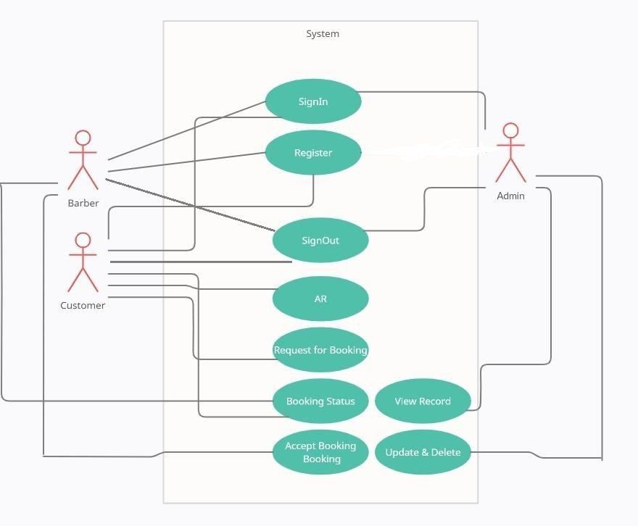
Figure 2.1: System Use Case

Table 2: Sign-Up as a Barber

 | Name | Sign-Up as a Barber
1. | Use-Case ID | U1
2. | Objective | Barber will Sign-Up with the valid credentials.
3. | Priority | High
4. | Source | Barber Community.
5. | Actors | Barber
6. | Flow of Events | - Open App  - Click on Sign-Up Button  - Enter Required Credentials  - Press Sign-up button
6.1 | Basic Flow | Same as Flow of Events.
6.2 | Alternate Flow(s) | - If user already exists in the database. User will be asked to login if his record already exists  - If all required fields are not filled. Error message is displayed to fill all the fields.
6.3 | Exception Flow(s) | - Invalid Username  - Invalid Password
7. | Includes | No other use case
8. | Preconditions | User must be not already registered.
9. | Post conditions | User gets registered.
10. | Notes/Issues | None.

Table 3: Sign-Up as a Customer

 | Name | Sign-Up as a Customer.
1. | Use-Case ID | U2
2. | Objective | Customer will Sign-Up with the valid credentials.
3. | Priority | High
4. | Source | Customer Community.
5. | Actors | Customer
6. | Flow of Events | - Open App  - Click on Sign-Up Button  - Enter Required Credentials  - Press Sign-up button
6.1 | Basic Flow | Same as Flow of Events.
6.2 | Alternate Flow(s) | - If user already exists in the database. User will be asked to login if his record already exists  - If all required fields are not filled. Error message is displayed to fill all the fields.
6.3 | Exception Flow(s) | - Invalid Username  - Invalid Password
7. | Includes | No other use case
8. | Preconditions | User must be not already registered.
9. | Post conditions | User gets registered.
10. | Notes/Issues | None.

Table 4: Sign-In as a Barber

 | Name | Sign-In as a Barber
1. | Use-Case ID | U3
2. | Objective | Barber will Sign-In with the valid credentials.
3. | Priority | High
4. | Source | Barber Community.
5. | Actors | Barber
6. | Flow of Events | - Open App  - Enter Required Credentials  - Press Sign-In button
6.1 | Basic Flow | Same as Flow of Events.
6.2 | Alternate Flow(s) | - If User’s record does not exist in the database. User will be asked to Sign-up first.  - If wrong credentials are entered during sign in it will ask to sign in with right credentials.  - If user enters wrong password press forgot password  - Send PIN to email  - User will reset the password using email
6.3 | Exception Flow(s) | If all required fields are not filled error message is displayed to fill all the fields.
7. | Includes | U1
8. | Preconditions | User must be already registered.
9. | Post conditions | User gets registered.
10. | Notes/Issues | None.

Table 5: Sign-In as a Customer

 | Name | Sign-In as a Customer
1. | Use-Case ID | U4
2. | Objective | Customer will Sign-In with the valid credentials.
3. | Priority | High
4. | Source | Customer Community.
5. | Actors | Customer
6. | Flow of Events | - Open App  - Enter Required Credentials  - Press Sign-In button
6.1 | Basic Flow | Same as Flow of Events.
6.2 | Alternate Flow(s) | - If User’s record does not exist in the database. User will be asked to Sign-up first.  - If wrong credentials are entered during sign in it will ask to sign in with right credentials.  - If user enters wrong password press forgot password  - Send PIN to email  - User will reset the password using email
6.3 | Exception Flow(s) | If all required fields are not filled error message is displayed to fill all the fields.
7. | Includes | U1
8. | Preconditions | User must be already registered.
9. | Post conditions | User gets registered.
10. | Notes/Issues | None.

Table 6: Request for Booking

 | Name | Request for Booking
1. | Use-Case ID | U5
2. | Objective | Customer can request for booking.
3. | Priority | High
4. | Source | Customer Community.
5. | Actors | Customer
6. | Flow of Events | - Open App  - Enter Required Credentials  - Press Sign-In button  - Browse product.  - Order a Product
6.1 | Basic Flow | Same as Flow of Events.
6.2 | Alternate Flow(s) | - If User’s record does not exist in the database. User will be asked to Sign-up first.  - If wrong credentials are entered during sign in it will ask to sign in with right credentials.  - If the required product isn’t in list it will show item not available.
6.3 | Exception Flow(s) | - If all required fields are not filled error message is displayed to fill all the fields.  - If user enters wrong password press forgot password  - Send PIN to email  - User will reset the password using email
7. | Includes | U2, U4
8. | Preconditions | User must be Signed-In.
9. | Post conditions | User Booking.
10. | Notes/Issues | None.

Table 7: Accept Booking

 | Name | Accept Booking
1. | Use-Case ID | U6
2. | Objective | Barber can accept customer request to his service.
3. | Priority | High
4. | Source | Barber Community.
5. | Actors | Barber
6. | Flow of Events | - Open App  - Login  - View product order list.  - Accept order request.
6.1 | Basic Flow | Same as Flow of Events.
6.2 | Alternate Flow(s) | - If User’s record does not exist in the database. User will be asked to Sign-up first.  - If wrong credentials are entered during sign in it will ask to sign in with right credentials.  - If the required product isn’t in list, it will show item not available.
6.3 | Exception Flow(s) | - If all required fields are not filled error message is displayed to fill all the fields.  - If user enters wrong password press forgot password  - Send PIN to email  - User will reset the password using email
7. | Includes | U3, U5
8. | Preconditions | User must be Signed-In.
9. | Post conditions | User ordered request has been accepted.
10. | Notes/Issues | None.

Table 8: Augmented Reality

 | Name | Augmented Reality
1. | Use-Case ID | U7
2. | Objective | Customers can view Hairstyle using Augmented Reality technology to have a virtual experience.
3. | Priority | High
4. | Source | Customer Community.
5. | Actors | Customer
6. | Flow of Events | - Open App  - Login  - Browse for product.  - Tap on Product to View it on Augmented Reality
6.1 | Basic Flow | Same as Flow of Events.
6.2 | Alternate Flow(s) | - If User’s mobile does not have android 10 and latest Google AR service than a blank screen is displayed instead of product in AR.  - If User’s record does not exist in the database. User will be asked to Sign-up first.  - If wrong credentials are entered during sign in it will ask to sign in with right credentials.  - If the required product isn’t in list it will show item not available.
6.3 | Exception Flow(s) | - If all required fields are not filled error message is displayed to fill all the fields.  - If user enters wrong password press forgot password  - Send PIN to email  - User will reset the password using email
7. | Includes | U2, U5
8. | Preconditions | User must be Signed-In and have latest Google AR Core services
9. | Post conditions | User have viewed the Hairstyle virtually.
10. | Notes/Issues | None.

Table 9: Product Booking Status

 | Name | Product Booking Status
1. | Use-Case ID | U8
2. | Objective | Barber can view the history of his bookings.
3. | Priority | High
4. | Source | Barber Community.
5. | Actors | B
6. | Flow of Events | - Open App  - Login  - Browse for product.  - Tap on Product to View it on Augmented Reality
6.1 | Basic Flow | Same as Flow of Events.
6.2 | Alternate Flow(s) | - If User’s mobile doesn’t have android 10 and latest Google AR service than a blank screen is displayed instead of product in AR.  - If User’s record does not exist in the database. User will be asked to Sign-up first.  - If wrong credentials are entered during sign in it will ask to sign in with right credentials.  - If the required product isn’t in list it will show item not available.
6.3 | Exception Flow(s) | - If all required fields are not filled error message is displayed to fill all the fields.  - If user enters wrong password press forgot password  - Send PIN to email  - User will reset the password using email
7. | Includes | U2, U6
8. | Preconditions | User must be Signed-In and have latest Google AR Core services
9. | Post conditions | User have viewed the product virtually.
10. | Notes/Issues | None.

Table 10: Delete and Update

 | Name | Delete and Update
1. | Use-Case ID | U9
2. | Objective | Admin can monitor and control both users.
3. | Priority | High
4. | Source | Admin Panel.
5. | Actors | Admin
6. | Flow of Events | - Admin Login  - List of users is displayed  - Admin can delete or update record.
6.1 | Basic Flow | Same as Flow of event
6.2 | Alternate Flow(s) | If user is not exist Admin can’t Update or Delete Record.
6.3 | Exception Flow(s) | If user is not exist Admin can’t Update or Delete Record.
7. | Includes | U1, U2
8. | Preconditions | Users should be logged in.
9. | Post conditions | None
10. | Notes/Issues | None.

Table 11: Logout

 | Name | Logout
1. | Use-Case ID | U10
2. | Objective | Customer, Barber and admin can logout from application.
3. | Priority | High
4. | Source | All Community.
5. | Actors | Customer ,Barber and Admin
6. | Flow of Events | - User opens the application  - User registers/login.  - From the drop down menu on left select the logout button.
6.1 | Basic Flow | Same as Flow of event
6.2 | Alternate Flow(s) | If the user record does not exist in database. User will be asked to sign up on the application first
6.3 | Exception Flow(s) | If the user record does not exist in database. User will be asked to sign up on the application first
7. | Includes | U1, U2,U3,U4
8. | Preconditions | Users should be logged in.
9. | Post conditions | Users will be logged out.
10. | Notes/Issues | None.

Other Non-functional Requirements

Non-functional requirements of this project are:

Performance Requirements

The mobile device requires a minimum of android version 10.0 to run this application. The system also requires a good internet connection for fast and better performance. The Hybrid application should perform all actions correctly and efficiently. The application should give a response with in a time. Internet is very important for this android application to connect with the database. For the best performance of this Hybrid application the mobile has a good processor and ram. By using these specifications of the mobile the Hybrid application performance for fetching the data from database, manipulate the data will become fast and it will show on time.

Safety Requirements

In order to provide the users with the best application experience we will bring time to time updates in our application to prevent any bugs and try to fix that bugs and errors.

Security Requirements
Once a customer creates an account their data will be kept secure and they can use any service securely without any security risk. The users provide their name, email, etc. for the register and for login the users provide the user name and password. Database must be secure because it contains the all the data of the users. It should be prevented from the external user because a small changing in a database may cause loss of an important information.

Software Quality Attributes

Software quality attributes of this project is:

      - Availability: The application will be available for the user 24/7. But booking facility is available for 9am to 11pm.
      - Flexibility: The application would be flexible for the any type of user.
      - Usability: The application should be user friendly for the user. The users easily understand how to use the application.
      - Testability: The application should be easy to test at each level and find the bugs/defect at each level of development and remove the defects easily.
      - Reusability: The application is divided into different modules of coding. These modules can be used in across the application.
      - Maintainability: The application will be easy to maintain and removing bugs/errors and upgrade the application features, functionalities time to time.

DESIGN AND METHODOLOGY

Sequence Diagram
Sign-up:
Sequence diagram of Sign-up is given by figure 3.1:
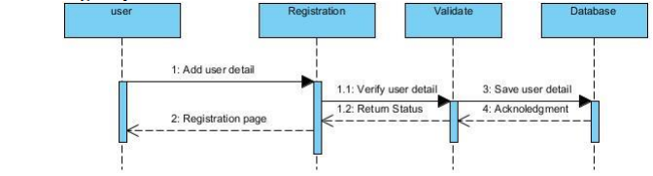
Figure 3.1: Sequence Diagram Sign-up

Sign In:
Sequence diagram of Sign-In is given by figure 3.2:

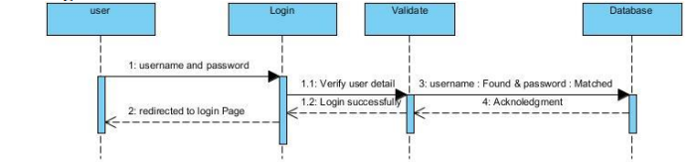
Figure 3.2: Sequence Diagram Sign In

Request for booking:
Sequence diagram of Request for booking is given by figure 3.3:

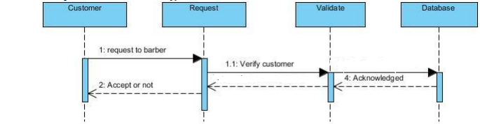
Figure 3.3: Sequence Diagram for booking request

Accept Booking:
Sequence diagram of Accept Booking is given by figure 3.4:

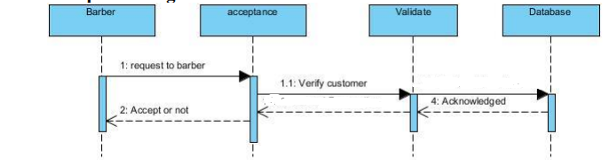
Figure 3.4: Sequence Diagram for accept booking

Booking Status:
Sequence diagram of Booking Status is given by figure 3.5:

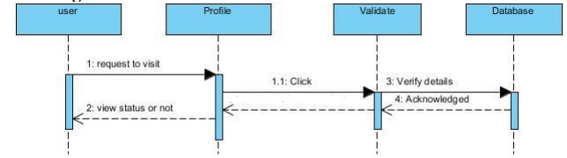
Figure 3.5: Sequence Diagram for booking status

View Record:
Sequence diagram of View Record is given by figure 3.6:

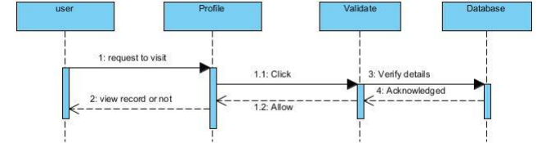
Figure 3.6: Sequence Diagram for View Record
Update and Delete:
Sequence diagram of Update and Delete is given by figure 3.7:
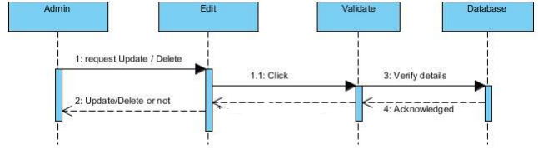
Figure 3.7: Sequence Diagram for update and delete

Logout:
Sequence diagram of Logout is given by figure 3.8:

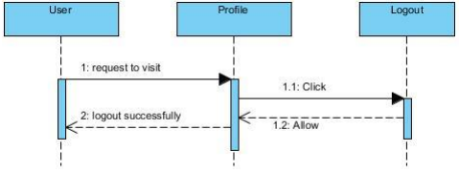
Figure 3.8: Sequence Diagram for logout
AR:
Sequence diagram of AR is given by figure 3.9:
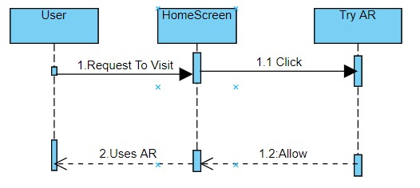
Figure 3.9: Sequence Diagram for AR

Work Breakdown Structure
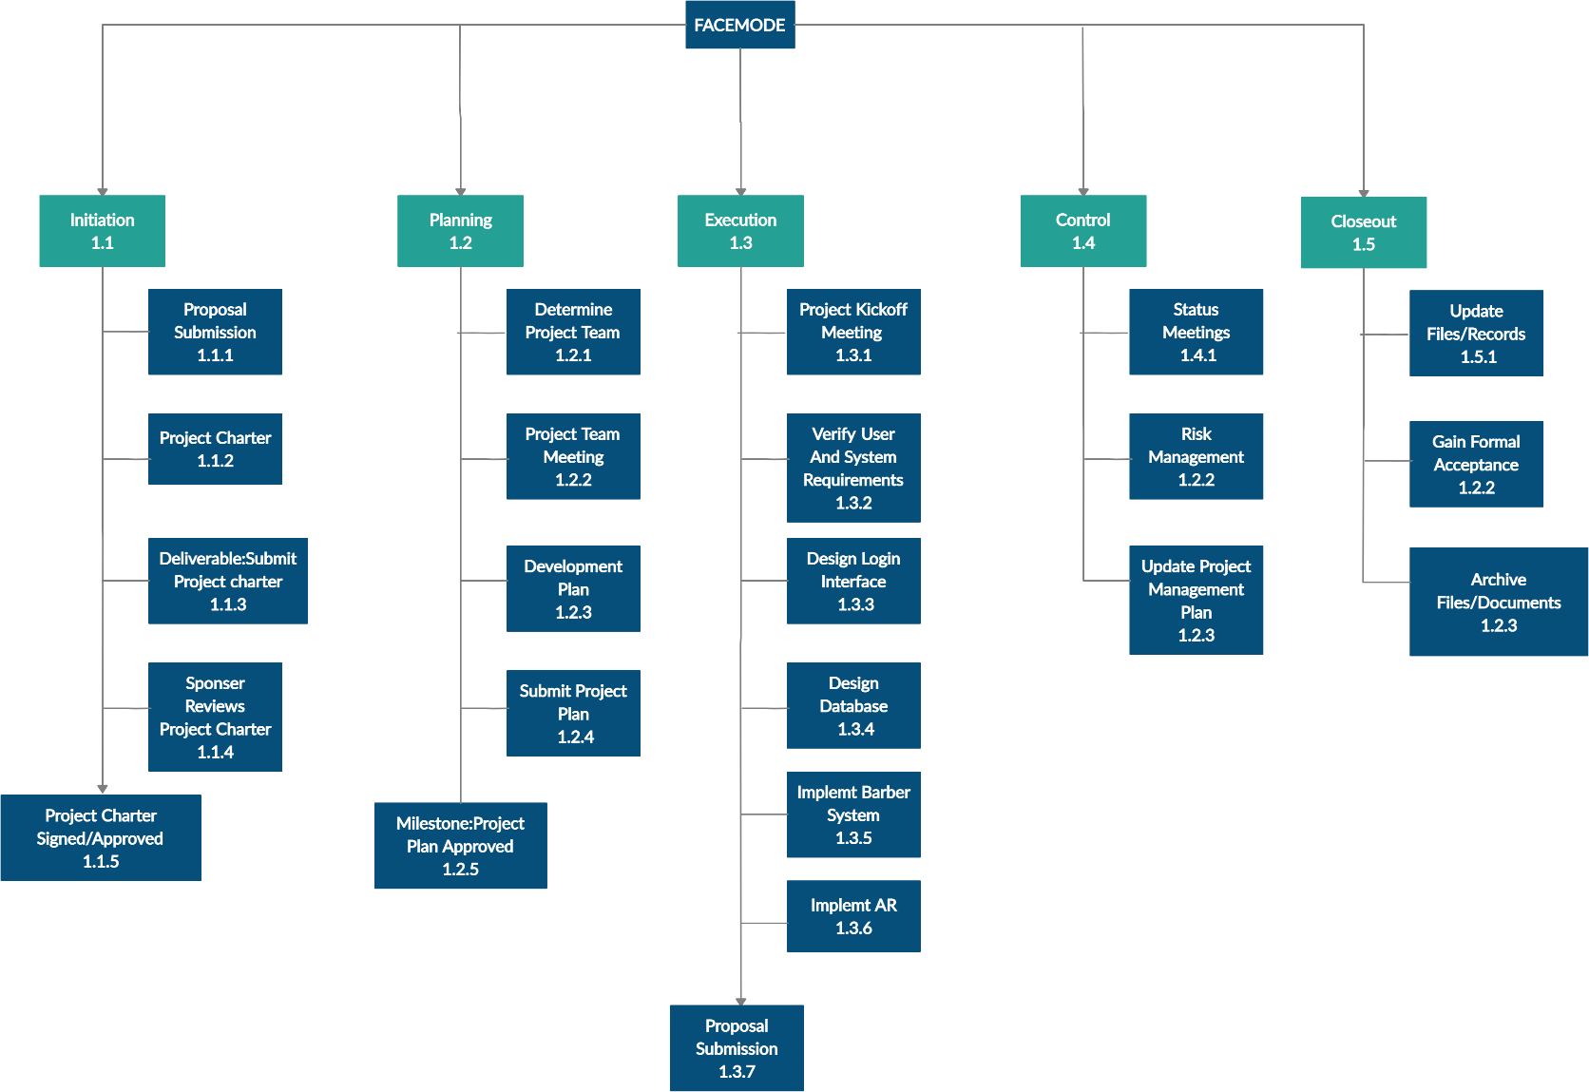
Work Breakdown structure of this project is shown below figure 3.10:
Figure 3.10: Diagram of work break down structure

Operation Contracts

Operation Contract Signup
Name: Signup Responsibilities: Users need to Signup to have their record saved and to interact with this app.
Cross References: U1, U3
Exceptions: None
Preconditions: Users in not already registered.
Post conditions: Users will register.

Operation Contract Login
Name: Login
Responsibilities: Registered users can login
Cross References: U2, U4
Exceptions: User entered wrong credentials
Preconditions: User should be registered.
Post conditions: User was logged in.

Operation Contract AR
Name: AR
Responsibilities: Customers can use AR
Cross References: U7
Exceptions: Bad camera
Preconditions: User should be registered.
Post conditions: User used AR.

Operation Contract Request for Booking
Name: Request for Booking
Responsibilities: To search required Barber.
Cross References: U5
Exceptions: none

Operation Contract Accept Booking
Name: Accept Booking
Responsibilities: Barber have to accept customer request to give his services.
Cross References: U6
Exceptions: User entered wrong credentials
Preconditions: User should be logged in

Operation Contract View Booking Status
Name: Booking Status
Responsibilities: After request get accepted, Customer and Barber can view Booking status
Cross References: U8
Exceptions: none
Preconditions: Both User should be logged in.

Operation Contract View Record
Name: Record
Responsibilities: Barber can view their own record.
Cross References: U8
Exceptions: User entered wrong credentials.
Preconditions: User was logged in.

Operation Contract View Update and Delete
Name: Update and Delete
Responsibilities: Admin can update and delete.
Cross References: U9
Exceptions: User entered wrong credentials
Preconditions: Admin should have authorities.

Operation Contract Logout
Name: Logout
Responsibilities: All users can logout
Cross References: U10
Exceptions: none
Preconditions: Users should be logged in.

Domain Model Diagram
Domain models represent the set of requirements common to a product line's systems. In our domain model, the requirements represented include:
- Definition of scope for the domain.
- Information or objects
- Features or use-cases, including factors that lead to variation
- Operational/behavioral characteristics
Domain model of our application is shown below figure 12:

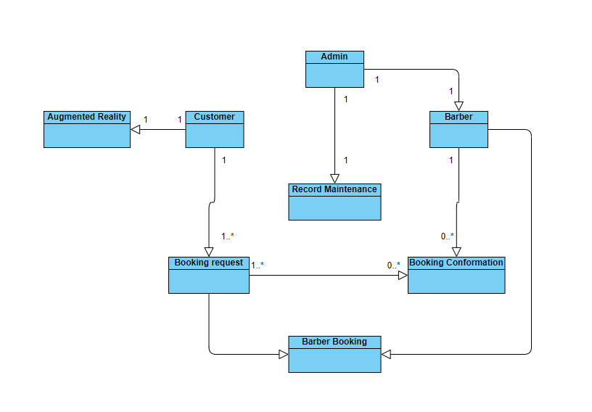
Figure 3.11: Domain model diagram

Design Class Diagram
Classes are the work-horses of the design effort, who carry out the system's real work. Subsystems, packages and collaborations, the other design components, simply explain how classes are grouped or how they interoperate.
In real-time systems, capsules are often stereotyped classes, used to represent simultaneous execution threads. Other design classes are 'passive' classes in such situations, used within the execution framework given by the 'active' capsules. It is still possible to model concurrent actions using 'active' classes when the software architect and designer chose not to use a capsule-based design approach. Active classes are design classes that organize and drive the passive class behaviour - an active class is a class whose instances are active objects that have their control thread.
Class diagram of our application is given by the figure:

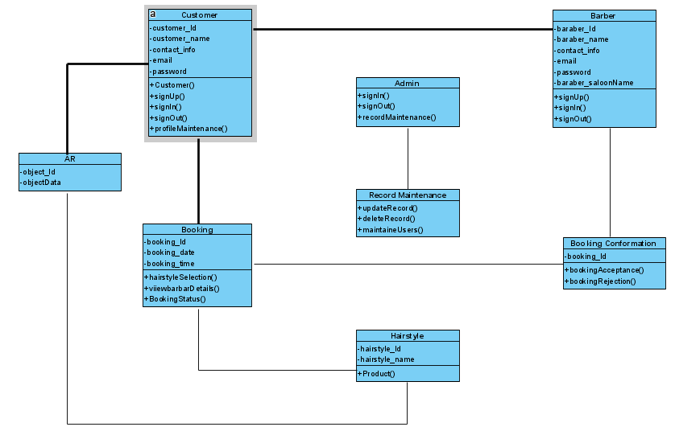
Figure 3.12: Design Class Diagram

Collaboration Diagram
A collaboration diagram explains the pattern of interaction between objects; it demonstrates the objects involved in the interaction by linking to each other and the messages they send to each other. Collaboration diagrams are used to illustrate how objects communicate to execute the actions of a particular use-case or a part of a use-case. In addition to sequence diagrams, collaborations are used by designers to define and clarify the roles of objects performing a particular flow of use-case events. They are the primary source of information used to identify class responsibilities and interfaces.

Collaboration diagrams of this project are:

Costumer collaboration diagram
Collaboration diagram of a customer is given by figure 3.13:
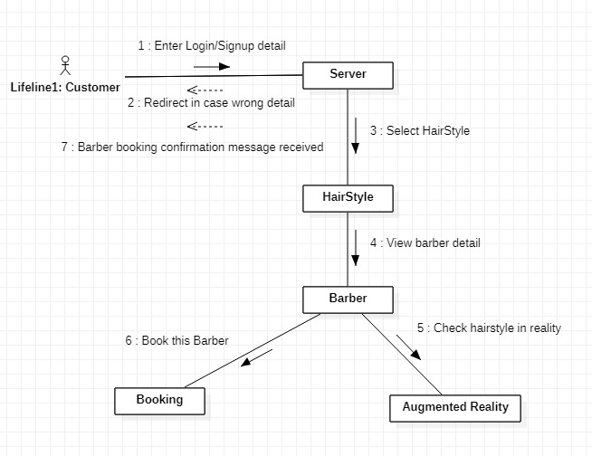
Figure 3.13: Collaboration of Customer

Barber collaboration diagram
Collaboration diagram of barber is given by figure 3.14:

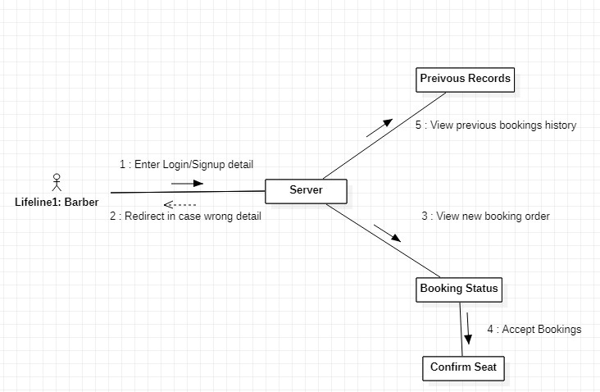
Figure 3.14: Barber collaboration Diagram

Admin collaboration diagram
Collaboration diagram of admin is given by figure 3.15:

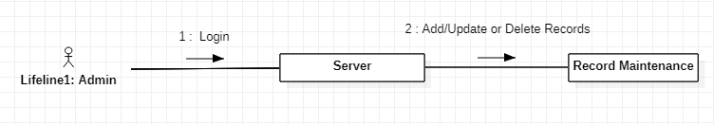
Figure 3.15: Admin Collaboration diagram

Data Model
The data model describes the logical and physical representation of persistent data in the system as a subset of the implementation model.
Data Model diagram of our application is given by the figure 3.16:

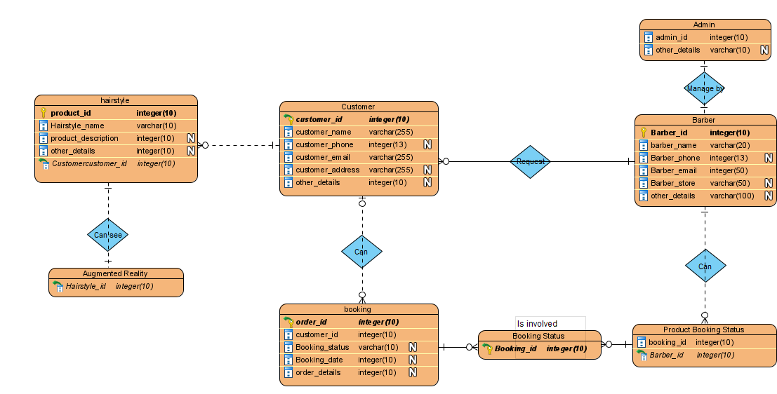
Figure 3.16: Data Model Diagram

IMPLMENTATION

Screen Shots:
Here are the screen shots of our application’s UI.

Login
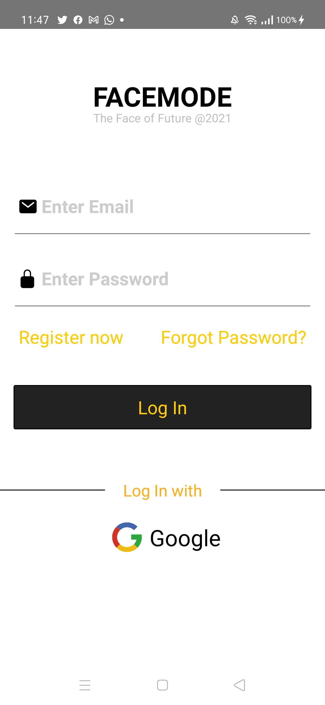

Sign Up:
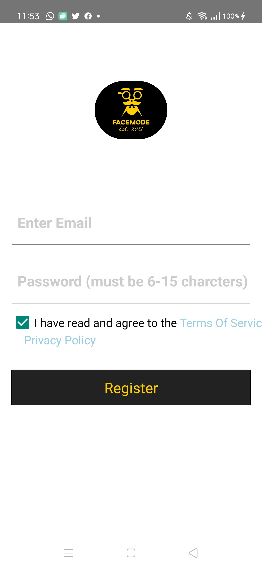

Gender Screen:
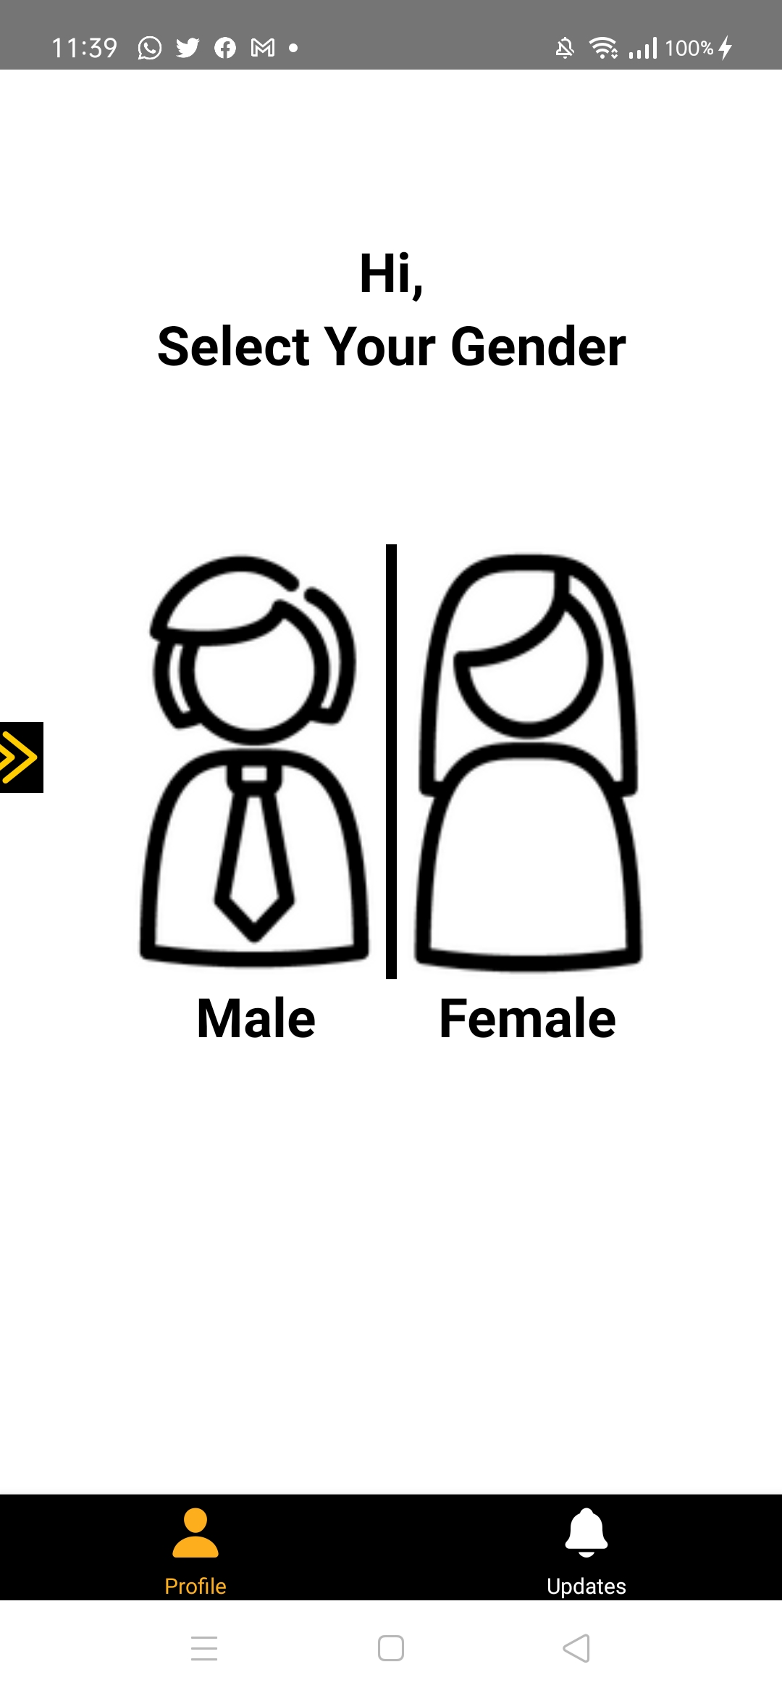

Hairstyle Screen:
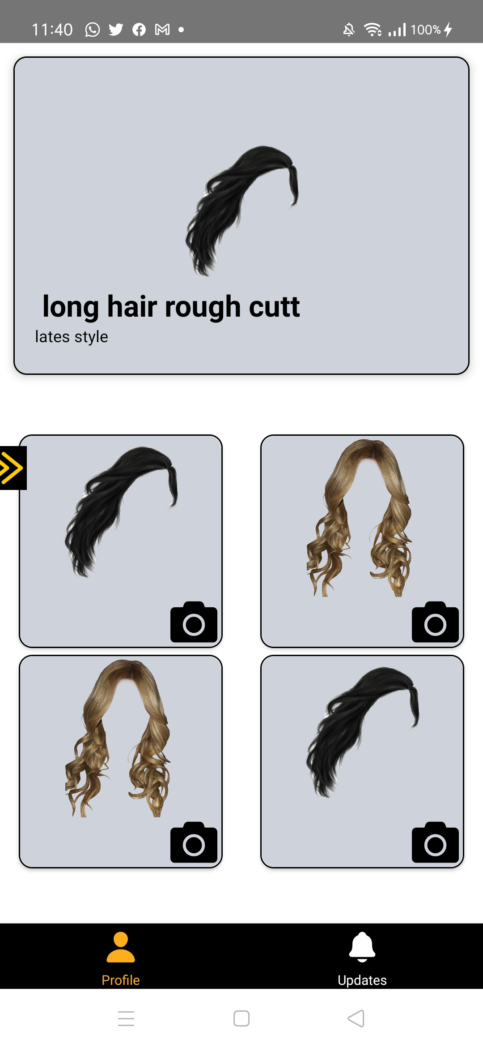

AR:
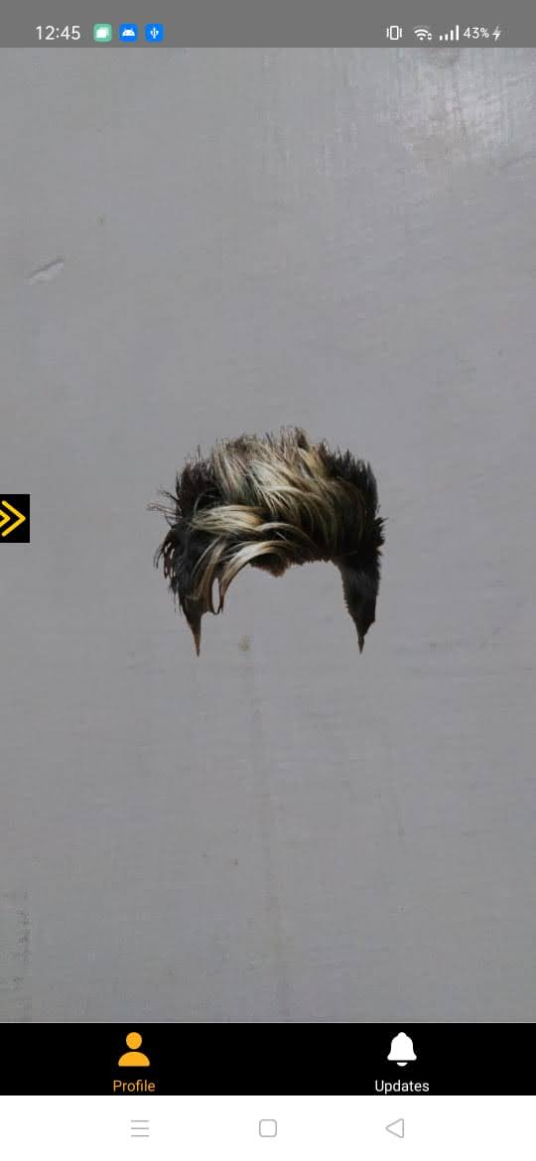

Barber List:
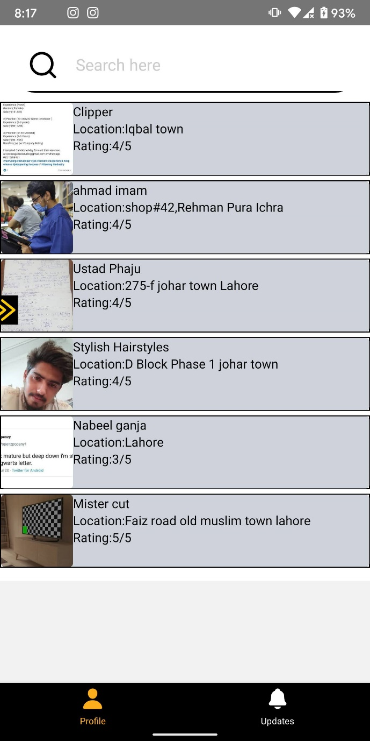

Booking Screen:
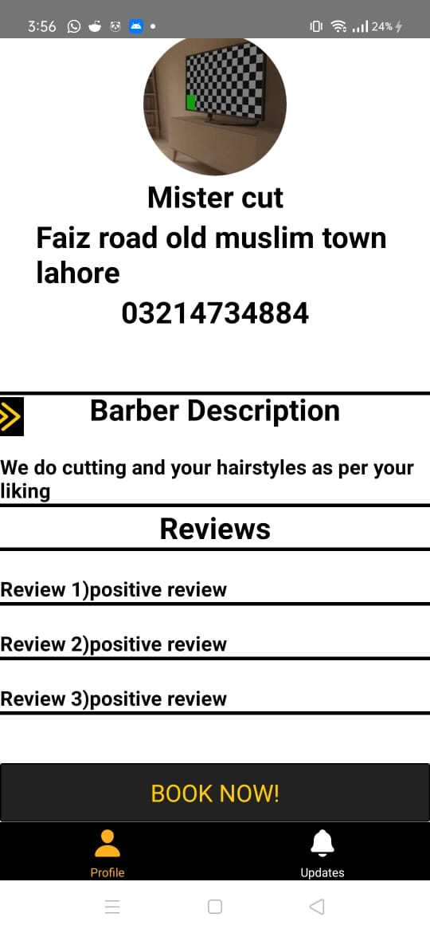

Request Status Screen:
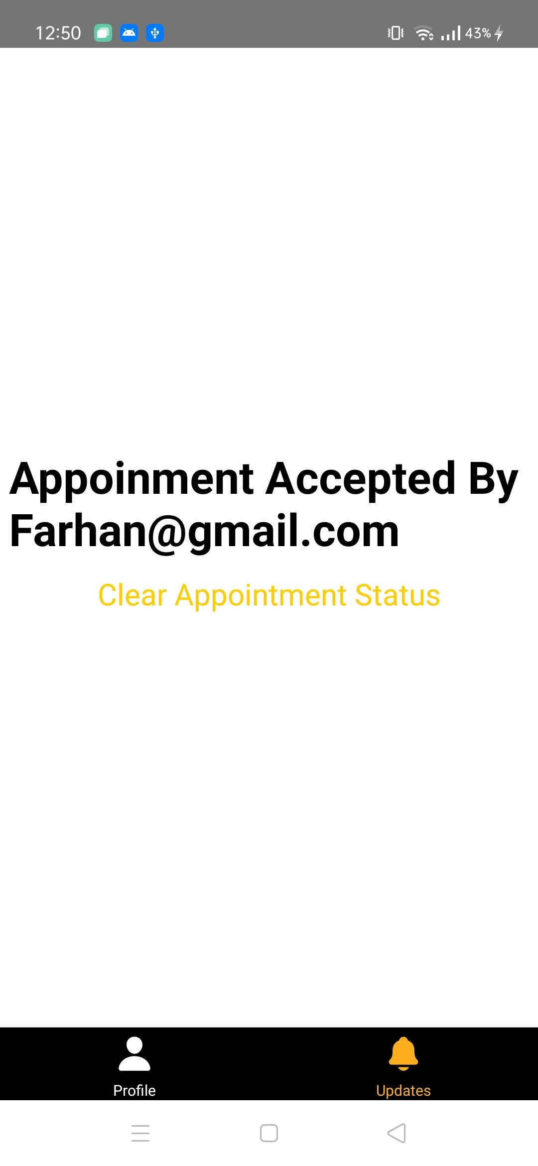

AR Side App:

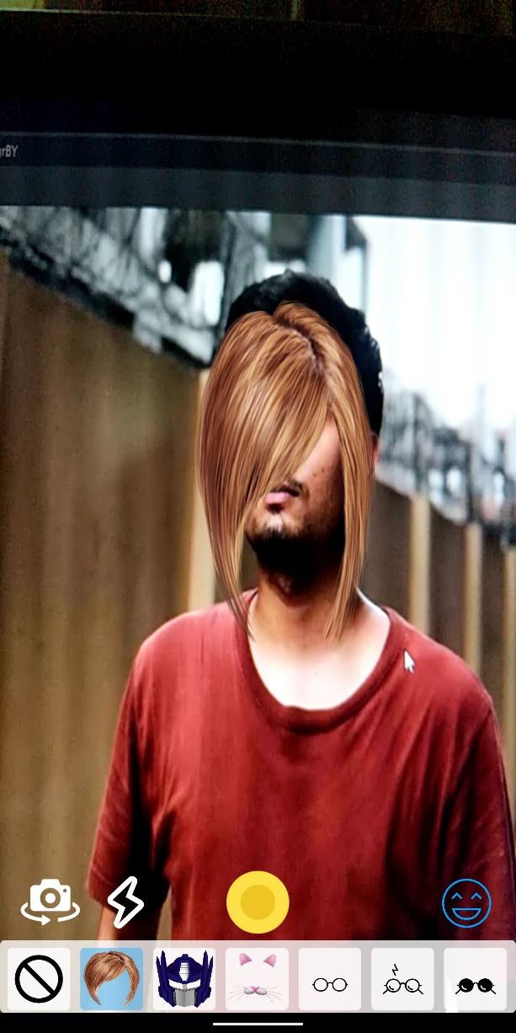

Barber Side APP:

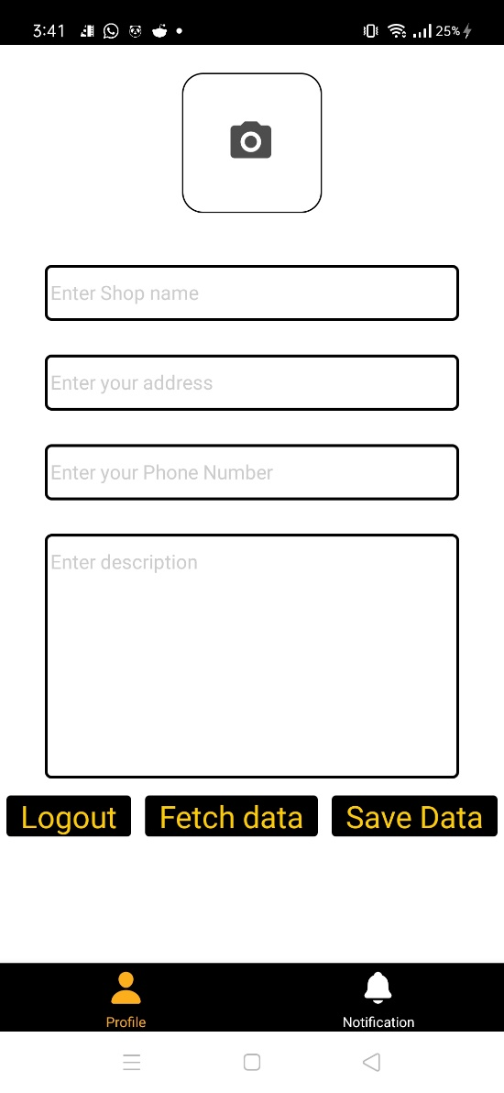

RESULTS AND DISCUSSIONS

Face Mode Survey 2021:

In the way to get successful results from our project, our team decides to take surveys from customers. In this event we use google form for that purpose and market both forms on WhatsApp, Facebook, and Instagram.

FaceMode Customers Survey:
These are the columns that we have added in our survey.
Email
Name
Salon Name
Salon Location
Barber Name
Is Barber (Owner / Partner)

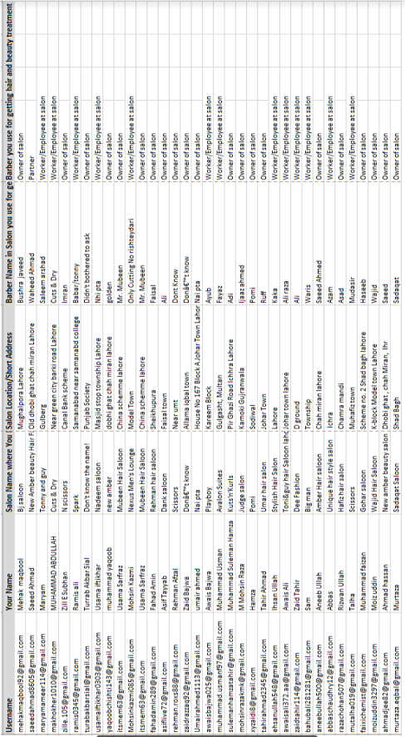

CONCLUSION AND RECOMMENDATIONS

Conclusion:
Now we are concluding that facemode app is a solution towards time saving for people who have no time to wait on barber shops for appointment. In addition, users will be able to see their desired hairstyle on real time environment and get the unique experience of online hairstyle shopping. Our app will also help barber community to expand their business in online world as many order businesses are working.

REFERENCES

- Shaw, Norman, and Ksenia Sergueeva. "The non-monetary benefits of mobile commerce: Extending UTAUT2 with perceived value." International Journal of Information Management 45 (2019): 44-55.
- Mayerle, Jochen, Udo Klein, Clemens Jacob, Sanu Koshy, Timo Hoyer, and Steffen Tatzel. "Augmented-reality shopping using a networked mobile device." U.S. Patent 9,449,343, issued September 20, 2016.

