
BSCS-S20-021
03-134171-005 | Aqsa Gulzar
03-134171-043 | Syed Ghazi Hussain Zaidi

Traffic Signs Recognition

In partial fulfilment of the requirements for the degree of
Bachelor of Science in Computer Science
Supervisor: Asad Kamal

Department of Computer Sciences
Bahria University, Lahore Campus
January 2021

© Bahria University, 2021

Certificate

We accept the work contained in the report titled
“Traffic Signs Recognition”
written by
Aqsa Gulzar
Syed Ghazi Hussain Zaidi

as a confirmation to the required standard for the partial fulfilment of the degree of
Bachelor of Science in Computer Science.

Approved by:
Supervisor: Asad Kamal
(Signature)

January 18, 2021

DECLARATION

We hereby declare that this project report is based on our original work except for citations and quotations which have been duly acknowledged. We also declare that it has not been previously and concurrently submitted for any other degree or award at Bahria University or other institutions.

Enrolment | Name | Signature
03-134171-005 | Aqsa Gulzar
03-134171-043 | Syed Ghazi Hussain Zaidi

Date : January 18, 2021

ACKNOWLEDGEMENTS

We would like to thank everyone who had contributed to the successful completion of this project. We would like to express our gratitude to our research supervisor, Mr. Asad Kamal for his invaluable advice, guidance and his enormous patience throughout the development of the research.

In addition, we would also like to express my gratitude to our loving parent and friends who had helped and given us encouragement.

AQSA GULZAR
SYED GHAZI HUSSAIN ZAIDI

Traffic Signs Recognition

ABSTRACT

There are many factors that are very essential to make a vehicle self-driving and also for driver's assistance. One of them is to recognize and identify the traffic signs present on the road to make the driving more efficient and safer. Traffic sign recognition system has a prominent and essential role in our modern real-world application such as autonomous driving, traffic surveillance, driver safety and assistance, road network maintenance, and analysis of traffic scenes [1].
To recognize those traffic signs, it is necessary to make the machine to learn about those traffic signs. An "automatic traffic sign recognition system" is very essential and helpful for autonomous vehicles. To achieve this goal, we will use machine learning algorithms and techniques [2].

TABLE OF CONTENTS

DECLARATION ii
ACKNOWLEDGEMENTS iii
ABSTRACT iv
TABLE OF CONTENTS v
LIST OF TABLES viii
LIST OF FIGURES ix

CHAPTERS
1 INTRODUCTION 1
1.1 Background 1
1.2 Data Set 2
1.3 Problem Statements 2
1.4 Aims and Objectives 3
1.5 Scope of Project 3
2 LITERATURE REVIEW 4
2.1 Introduction 4
2.2 User Classes and Characteristics 5
2.3 Operating Environment 5
2.4 Design and Implementation Constraints 5
2.5 User Interfaces 5
2.6 Software Interfaces 6
2.7 Comparison 6
3 DESIGN AND METHODOLOGY 7
3.1 Methodology 7
3.2 Feasibility Plan 8
3.2.1 Technical Feasibility 8
3.2.2 Operational Feasibility 8
3.2.3 Economic Feasibility 8
3.3 Resource Requirement 9
3.3.1 Expertise of the Team 9
3.3.2 Tools / Technology 9
3.3.3 Risks Involved 9
3.4 Use-case Model 10
3.5 Use-case Description 11
3.5.1 Start application 11
3.5.2 Detect signs 12
3.5.3 Classify signs 13
3.5.4 Show message 14
3.5.5 Stop detection 15
3.5.6 Update setting 16
3.5.7 Exit Application 17
3.6 Sequence Diagram 18
3.7 Collaboration Diagram 19
3.7.1 Start detection by start button 19
3.7.2 Classification and message to user 20
3.7.3 Stop detection 21
3.7.4 Update settings 22
3.7.5 Exit application 22
3.8 Design Class Diagram 23
4 DATA AND IMPLMENTATION 24
4.1 Dataset 24
4.2 Implementation 24
4.2.1 Model 25
4.2.2 Mobile Application 27
5 RESULTS AND USER MANUAL 28
5.1 RESULTS 28
5.1.1 Accuracy 28
5.2 MANUAL 29
6 CONCLUSION AND RECOMMENDATIONS 31
6.1 Conclusion 31
6.2 Future Recommendations 31
REFERENCES 32

LIST OF TABLES

TABLE TITLE PAGE
Table 3.1: TSR-Usecase-start application 11
Table 3.2: TSR-Usecase-detect signs 12
Table 3.3: TSR-Usecase-classify sign 13
Table 3.4: TSR-Usecase-show message 14
Table 3.5: TSR-Usecase-stop detection 15
Table 3.6: TSR-Usecase-settings 16
Table 3.7: TSR-Usecase-exit 17

LIST OF FIGURES

FIGURE TITLE PAGE
Figure 1.1: No heavy traffic 2
Figure 1.2: Speed limit indicator 2
Figure 1.3: Caution Sign 2
Figure 1.4: Under Construction 2
Figure 3.1 : Feature-driven development 7
Figure 3.2: TSR use case diagram 10
Figure 3.3 : TSR Sequence Diagram 18
Figure 3.4: Collaboration diagram for start detection 19
Figure 3.5: Collaboration diagram for classification and alert 20
Figure 3.6: Collaboration diagram for stop detection 21
Figure 3.7: Collaboration diagram for update settings 22
Figure 3.8: Collaboration diagram for exit application 22
Figure 3.9: TSR Class diagram 23
Figure 4.1: Dataset sample 24
Figure 4.2: Slippery area prediction 25
Figure 4.3: 60 speed limit prediction 25
Figure 4.4: 70 speed limit prediction 26
Figure 4.5: Stop sign prediction 26
Figure 4.6: GUI 27
Figure 5.1: Accuracy Score 28
Figure 5.2: Training and Validation Accuracy 28
Figure 5.3: Training and Validation Loss 29
Figure 5.4: User Manual 30

INTRODUCTION

Background

In modern era technologies are heading towards their automation using Artificial intelligence. Following this trend vehicles are also heading towards their automation as per modern need. Driver's assistance and self-driving are most important parts to make the modern vehicles fully automated. A traffic sign recognition system is one of the needs for a vehicle to become a self drivable and driver assistant. The problem of real-time trafﬁc sign recognition has to be solved to meet the growing need of automatic driving and safe driving. The trafﬁc sign recognition usually consists of two steps: trafﬁc sign detection and trafﬁc sign classiﬁcation [3].
Sometimes driver distracts from the concentration on road and can overlook the sign present on the road. It can cause any mishap because road signs are present on the road for safety. To remain known of every traffic sign in the way is very essential part of efficient and safe driving. For the same reason traffic sign recognition system is a very important part for our auto driving and for driver’s assistance [4].

Data Set

Data set is taken from Kaggle. It consists of more than 50,000 images of 40 different classes. All the images are coloured images in different sizes and shapes [5]. The sample images of data are given below.

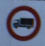  Figure 1.1: No heavy traffic | 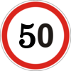  Figure 1.2: Speed limit indicator
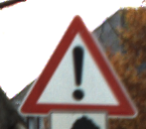  Figure 1.3: Caution Sign | 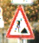  Figure 1.4: Under Construction

Problem Statements

The primary scope of our work is to design an automatic traffic sign recognition system to assist drivers through mobile application.

Aims and Objectives

The objectives of this project are shown as following:
- To make driving safer.
- To assist drivers while driving.

Scope of Project

In our modern world things around us has become automated or heading towards their automation. Modern vehicles of our generation are also heading towards their automation even to become fully auto drive-able. There are numerous components that are very supportive to achieve driving assistance and auto driving capabilities. Traffic signs recognition system is one of them. Our primary focus is to develop a mobile application for traffic sign recognition system that will prove very supportive for the vehicles in getting auto, efficient and safe driving. This work can be done if the machine will be able to recognize different traffic signs present on roads. We will use a machine learning architecture to achieve this goal [6].

LITERATURE REVIEW

Introduction

In the modern era technologies are heading towards their automation using Artificial intelligence. Following this trend vehicles are also heading towards their automation as per modern need. Driver's assistance and self-driving are the most important parts to make modern vehicles fully automated. A traffic sign recognition system is one of the needs for a vehicle to become a self-drivable and driver assistant. The problem of real-time trafﬁc sign recognition must be solved to meet the growing need of automatic driving. The trafﬁc sign recognition usually consists of two steps: trafﬁc sign detection and trafﬁc sign classiﬁcation [3].
Sometimes a driver distracts from the concentration on the road and can overlook the sign present on the road. It can cause any mishap because road signs are present on the road for safety. To remain known of every traffic sign in the way is a very essential part of efficient and safe driving. For the same reason traffic sign recognition systems are a very important part for our auto driving and for driver’s assistance [4].

User Classes and Characteristics

The primary users of this product are drivers. As it is a mobile application which can detect and classify traffic signs (like speed limit, construction areas, etc.) and will tell the driver about the signs through a message and voice alert. The message will display in English, so it is necessary for the driver to know how to read it.

Operating Environment

This mobile application needs some specifications of the device to operate precisely. Like the camera of the device should be working accurately to get the accurate result. Two primary specifications of the device are its Android and camera. It is better to have Android 8 or more updated and the camera should be eight (8) megapixels or better for better results.

Design and Implementation Constraints

To train a convolutional neural network model with almost 55000 images, developers needed a system which had a high GPU. This process was also a time taking process. Developers trained the model again and again with different parameters until the desired output was not achieved which was the accuracy of model more than 90 percent.

User Interfaces

User will be able to interact with application through mobile application interface, there will be different options like ‘start’, ’stop’, etc.

Software Interfaces

There will be not such a connection between this software with any other software. The integration will be done on the trained model in mobile application. Ultimately there will be a single mobile application in which the trained model will be integrated. The storage of mobile will be used for storing data related to mobile application. There will be no need for any external database or any other thing.

Comparison

Our application is not directly embedded in cars like other giant companies working on it like Tesla and BMW, but this application will cost cheaper to ordinary peoples. Peoples don’t have to buy Tesla or BMW cars to get driving assisting environment while traveling, they just will have to install this application in their mobile to keep notify from traffic signs coming in their way, that is why this application will be proved as a cheaper source for driving assistance for ordinary peoples.

DESIGN AND METHODOLOGY

Methodology

In this project we will be using the ‘Feature-driven development’ (FDD).
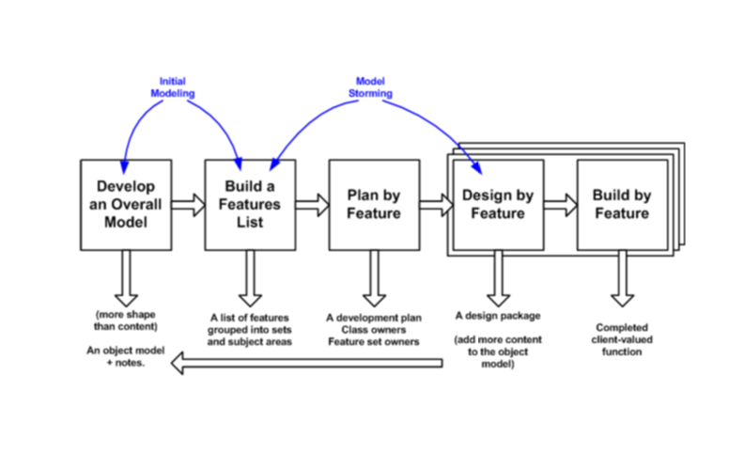
Figure 3.1 : Feature-driven development

Feasibility Plan

Feasibility study conducted on following levels:

Technical Feasibility

As per modern need technically there is a huge scope of auto driving and driver's assisting cars in which this technology is essential.

Operational Feasibility

It will hopefully operational as many researches has conducted on this.

Economic Feasibility

It will generate a good amount of profit if implemented successfully.

Resource Requirement

Following are the resource requirements.

Expertise of the Team

The team is consisting of two members, each member has concepts of programming and willing to learn maximum related to machine learning and other techniques that will use in this project for both completion of project and to enhance our knowledge for upcoming carrier.

Tools / Technology
1. A fast processing machine (GPU).
2. Python and Java will be used as a programming language.
3. Jupiter notebook.
4. Machine learning algorithms and techniques will be used to achieve our primary goal.
5. Android Studio.

Risks Involved
The detection of signs on run time also depends on quality of image/video as an input. It may affect the result if the quality of input is not good.

Use-case Model

Following is the use-case diagram of “Traffic signs recognition” project. There are different actors and functionalities in the project. ‘Include’ is something without it the respective actor can’t perform other tasks.

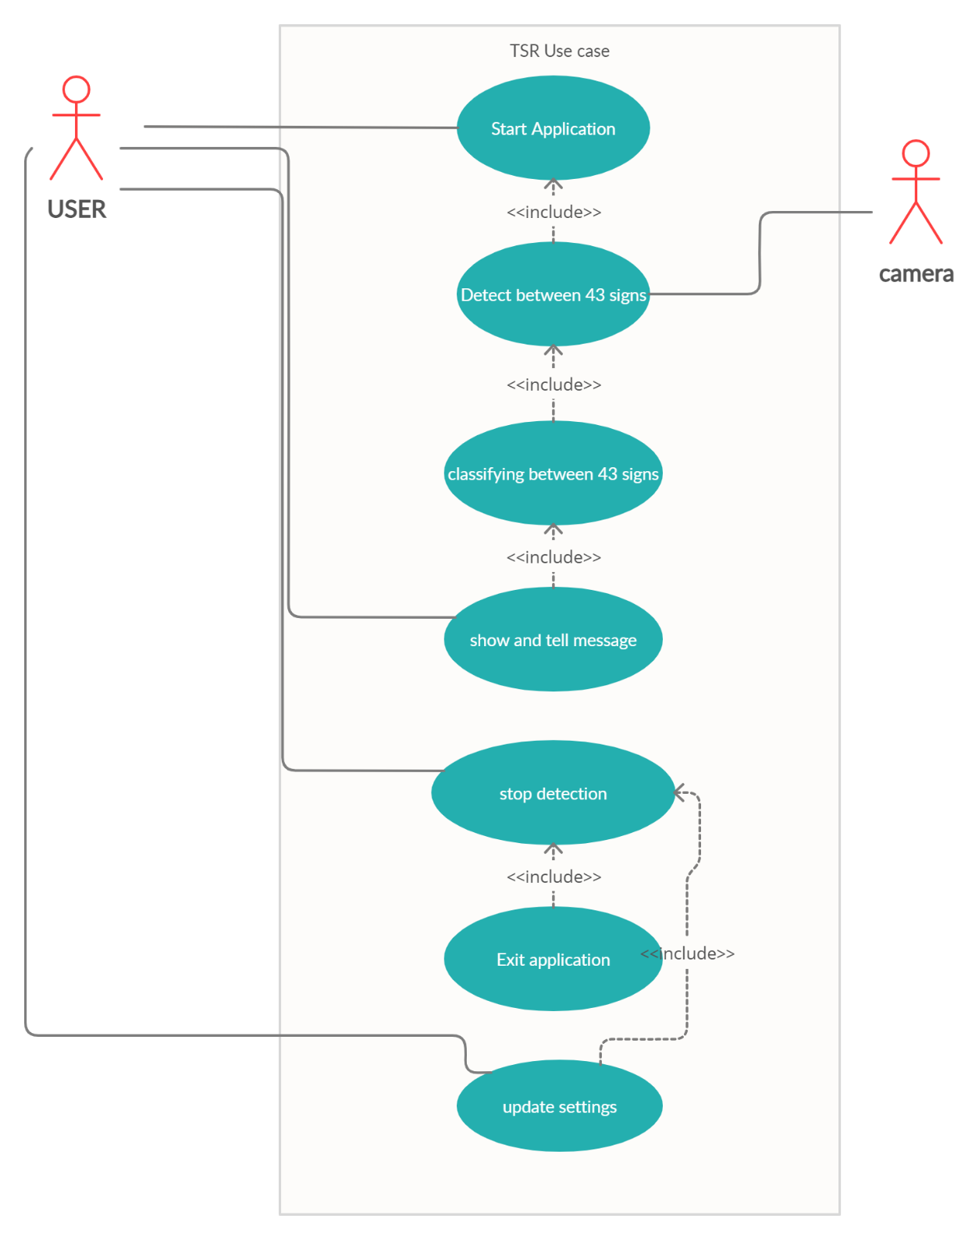
Figure 3.2: TSR use case diagram

Use-case Description

Start application

This use case is about starting the application.

Table 3.1: TSR-Usecase-start application
Name and ID | Start Application, TSR-UC-01
Brief description | This use case is to start functionalities of the application to detect signs present in the way.
Preconditions | Application should be installed and running.
Basic flow or Happy path | Application should be running, User will press start button, Application’s functionalities for detection signs will be enabled.
Trigger | Start button.
Alternate flows | None.
Post conditions | Detection functionality should be implemented.

Detect signs

This use case is about detecting the signs present in the way.

Table 3.2: TSR-Usecase-detect signs
Name and ID | Detecting signs, TSR-UC-02.
Brief description | It will detect if any sign is present.
Preconditions | Application should be started.
Basic flow or Happy path | Application will be capturing the scene until the sign not detected.
Trigger | Camera.
Alternate flows | None.
Post conditions | Camera should be running properly.

Classify signs

This use case about classification of signs after detection.

Table 3.3: TSR-Usecase-classify sign
Name and ID | Classifying signs, TSR-UC-03.
Brief description | It will classify the sign by its category after detecting.
Preconditions | Sign should be detected correctly.
Basic flow or Happy path | Sign will be classified and shown.
Trigger | Sign.
Alternate flows | None.
Post conditions | None.

Show message

This use case is about showing message after classification of sign.

Table 3.4: TSR-Usecase-show message
Name and ID | Show message, TSR-UC-04.
Brief description | It will show through message that what is the category of sign.
Preconditions | Classification should be done correctly.
Basic flow or Happy path | Sign will be classified then display through message.
Trigger | Sign.
Alternate flows | None.
Post conditions | None.

Stop detection

To stop detection process.

Table 3.5: TSR-Usecase-stop detection
Name and ID | Stop detection, TSR-UC-05.
Brief description | It will stop detecting signs.
Preconditions | Detection process should be started.
Basic flow or Happy path | By pressing stop button detecting process will stop.
Trigger | Stop button.
Alternate flows | None.
Post conditions | None.

Update setting

This use case is about updating setting present in the application.

Table 3.6: TSR-Usecase-settings
Name and ID | Update setting, TSR-UC-06.
Brief description | It will Update the setting which user want to apply.
Preconditions | Application should be stopped.
Basic flow or Happy path | Setting will be selected by user and then will be applied by pressing apply button.
Trigger | Settings option.
Alternate flows | None.
Post conditions | None.

Exit Application

This use case is to exit the application.

Table 3.7: TSR-Usecase-exit
Name and ID | Exit Application, TSR-UC-07.
Brief description | It will exit the application.
Preconditions | Application should be stopped.
Basic flow or Happy path | User will be directed to mob home after exiting.
Trigger | Exit button.
Alternate flows | None.
Post conditions | None.

Sequence Diagram

The sequence of the application will be, user will start the application then detection of signs will be started in which system will look for any sign present in the way, if any sign will be detected it will be classified then, after its classification the message about the sign class will be generated and will be shown to the user. User will also be able to update setting. To exit the application user will have to press exit button. Following is the sequence diagram of the application.

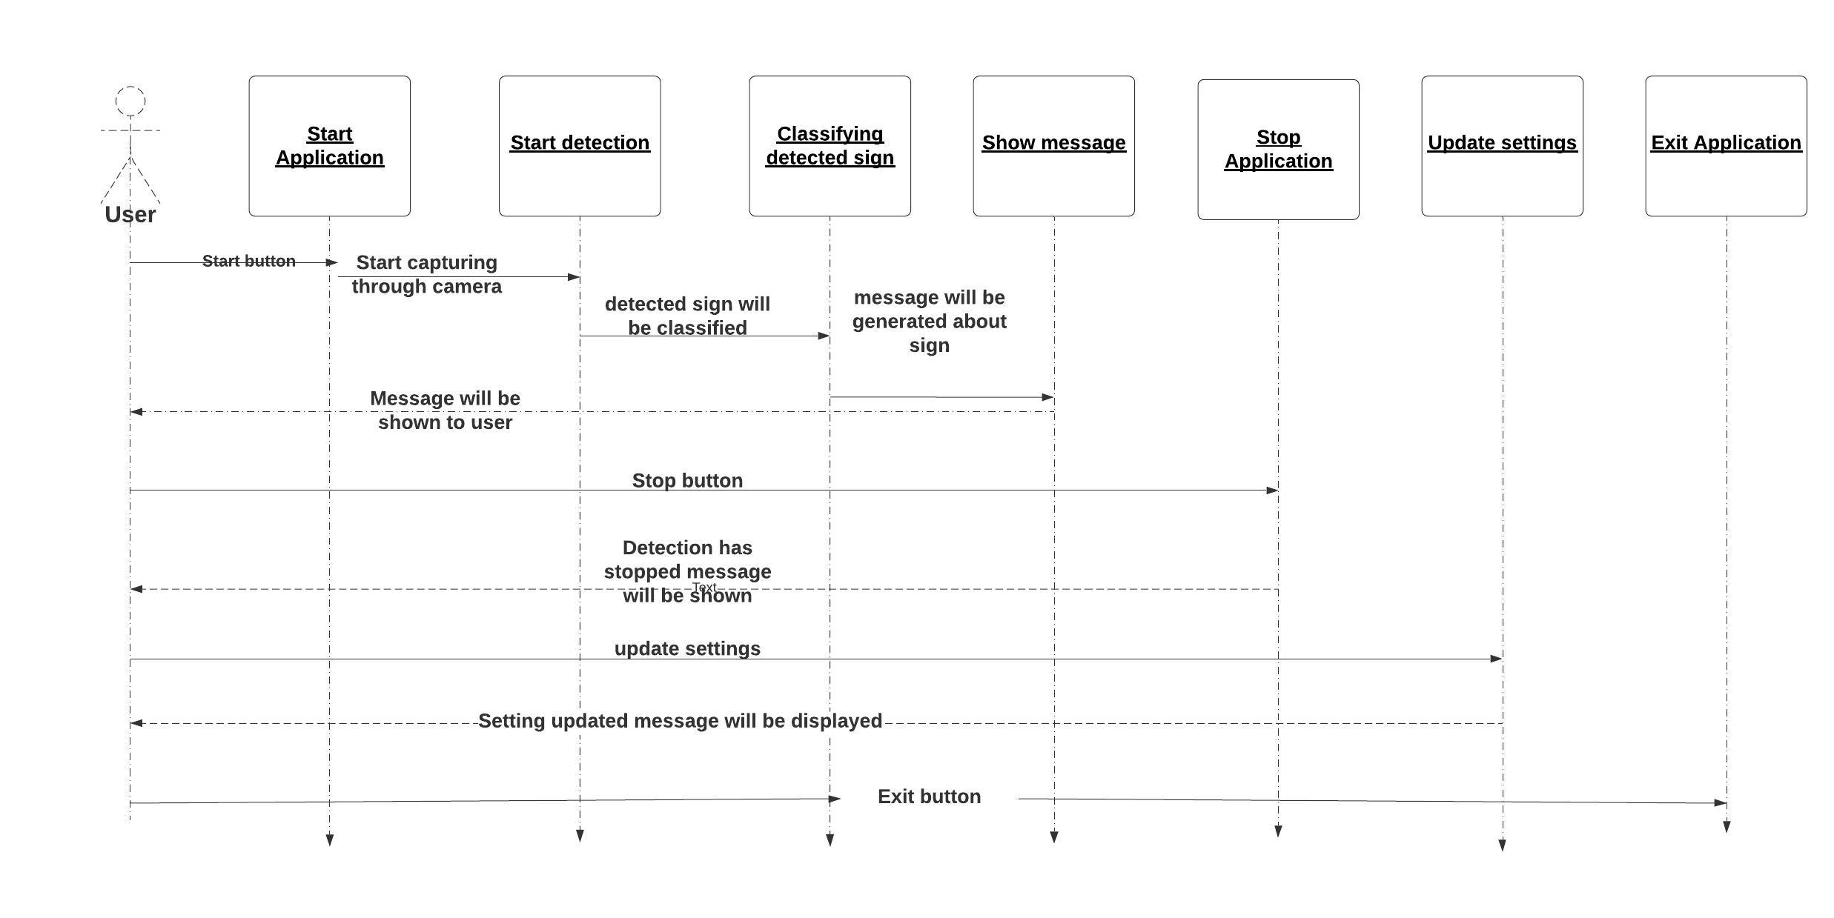
Figure 3.3 : TSR Sequence Diagram

Collaboration Diagram

Start detection by start button

User will start the application and then will press start button to start detection process. Detection will be start through camera. Camera will be capturing the environment to detect traffic signs.

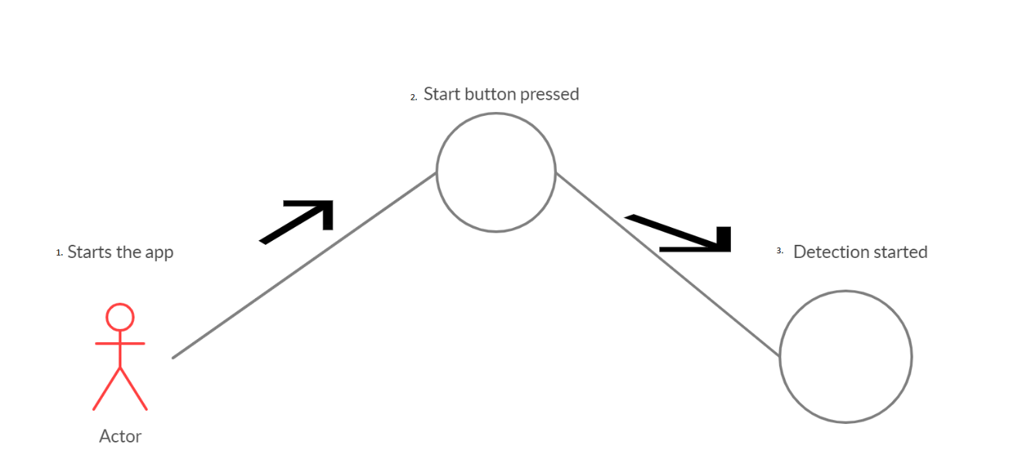
Figure 3.4: Collaboration diagram for start detection

Classification and message to user

During detection process if the system detects any traffic sign, it will forward it for classifying process in which system will know about class of the detected traffic sign. After classifying the sign, the message about the sign’s info will be generated and then will be shown to user.

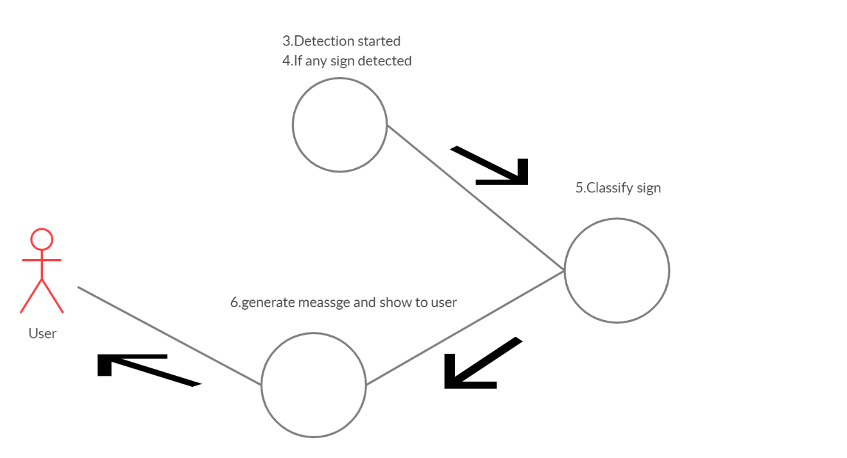
Figure 3.5: Collaboration diagram for classification and alert

Stop detection

To stop the detection process, user will press the stop button then the detection process will be stopped detecting the path through camera. A message will be generated “Detecting has stopped” and will be shown to the user.

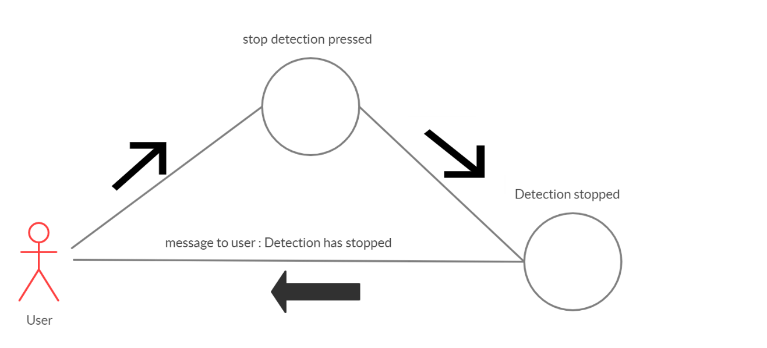
Figure 3.6: Collaboration diagram for stop detection

Update settings

To update the settings, user will go to update setting opting. After selecting the desired setting user will press update button to apply the settings. A message will be generated “Settings updated” and will be shown to the user.
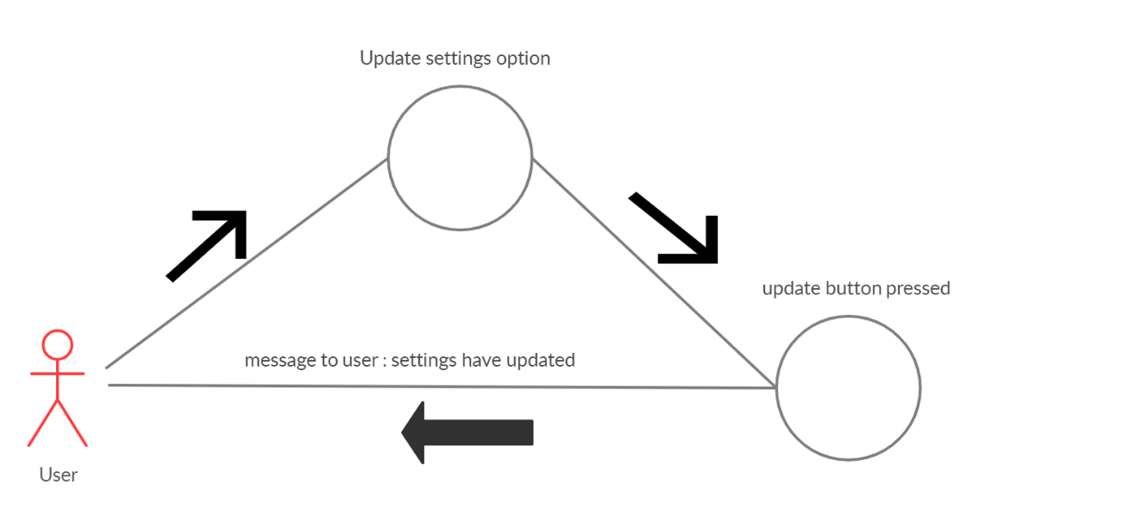
Figure 3.7: Collaboration diagram for update settings

Exit application
To exit the application, user will press exit button and then will be diverted to home screen.

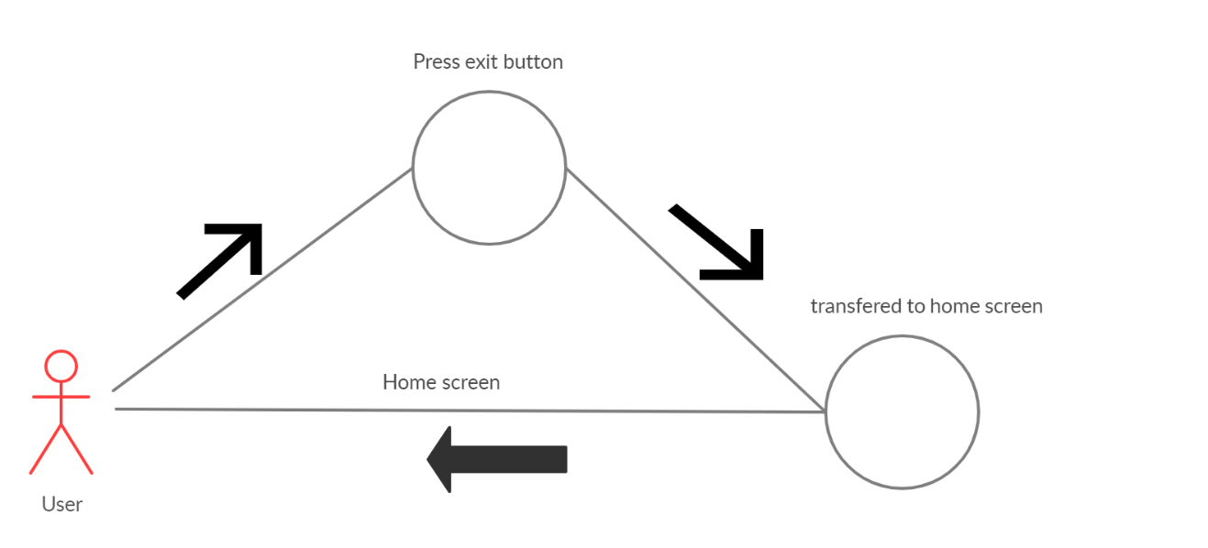
Figure 3.8: Collaboration diagram for exit application

Design Class Diagram

Classes are the workhorses of the design effort. They perform the real work of the system. There will be four main classes in traffic signs recognition system (TSR). The characteristics of the will be like following.

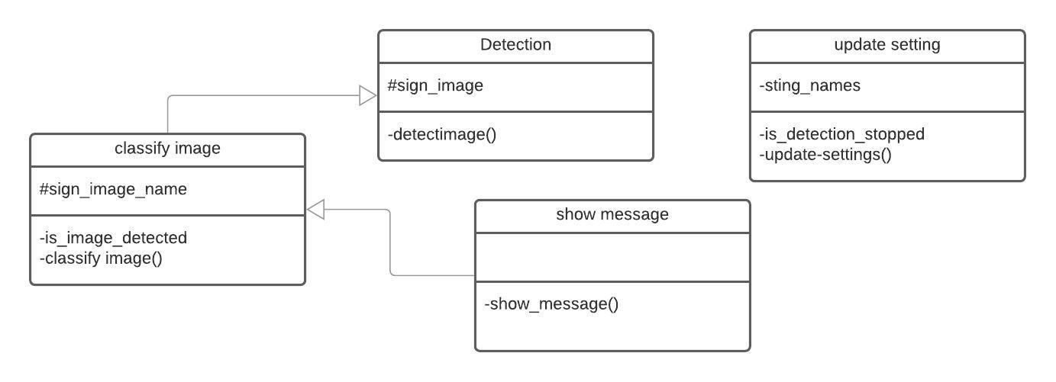
Figure 3.9: TSR Class diagram

DATA AND IMPLMENTATION

Dataset

Dataset was needed which should contain images of different traffic signs to train the model which could classify traffic signs into different classes (like; speed limits, stop signs, etc). So, we took a dataset from Kaggle which contains approximately 55000 images of traffic signs of different classes [5].

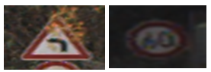
Figure 4.1: Dataset sample

Implementation

In this project we had to train a model first which can classify traffic signs into different classes. As the inputs and outputs of the project are image based, so we used Convolutional Neural Networks (CNN’s) a class of deep neural networks to train the model. Then we build a mobile application using Java as a programming using Android studio as an IDE. The purpose of mobile application is to classify if any traffic sign is present in the frame of its camera [7].

Model

The model is trained using the class of deep learning which is Convolutional Neural Networks (CNN’s). Some samples of the output from model is given below [8].

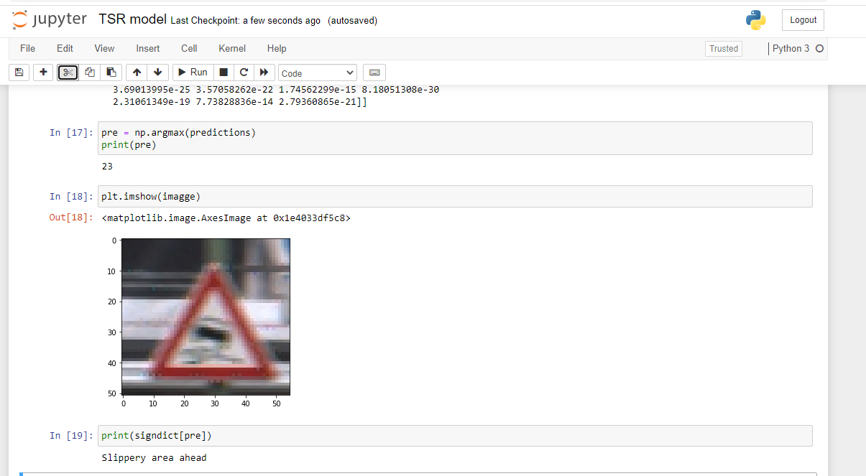
Figure 4.2: Slippery area prediction

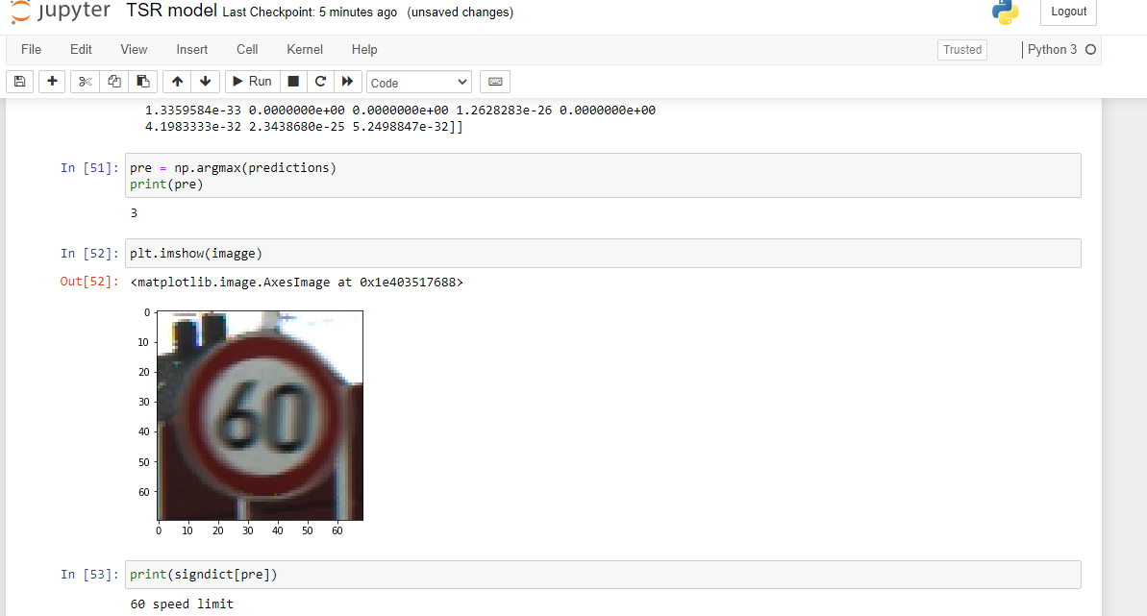
Figure 4.3: 60 speed limit prediction

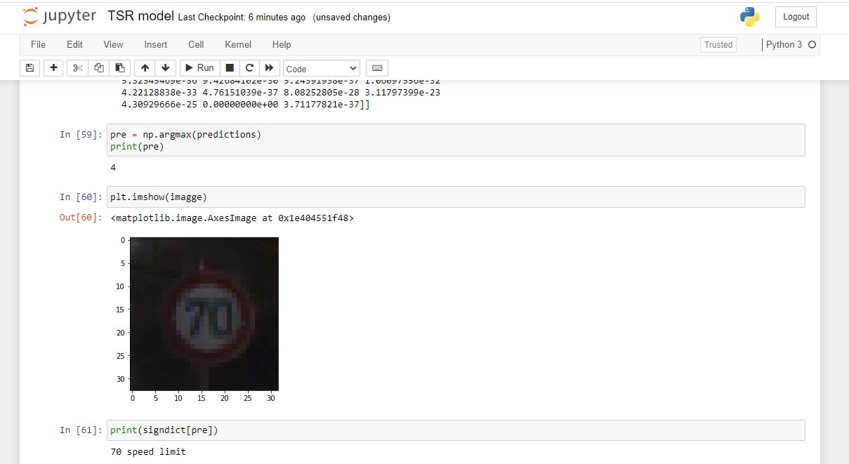
Figure 4.4: 70 speed limit prediction

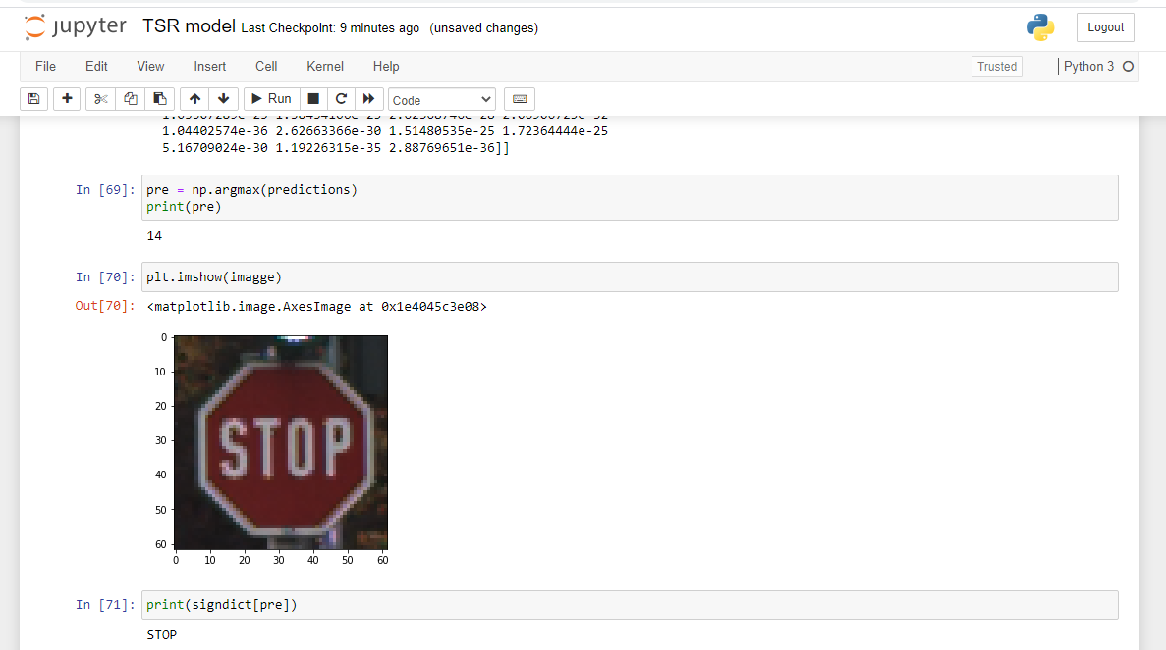
Figure 4.5: Stop sign prediction

Mobile Application

Mobile application is developed to take image of traffic signs if any present as an input using mobile camera, then that input will be classify using the trained model. The interface of mobile application is present in Figure 4.6.

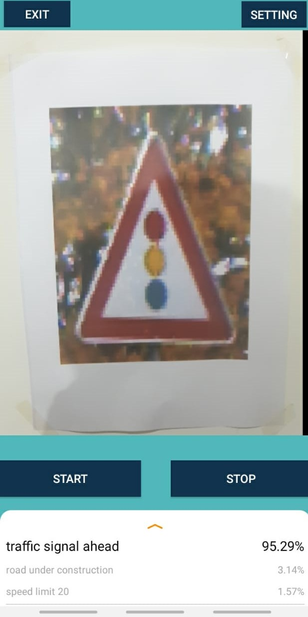
Figure 4.6: GUI

RESULTS AND USER MANUAL

RESULTS

Accuracy

The accuracy of our model is 0.9208 which is approximately 92% shown in Figure 5.1. We calculated this accuracy score using our test dataset. We also plotted the model’s training accuracy which is the accuracy of model during its training and the validation accuracy which is generated by validation data during training shown in Figure 5.2. We also plotted the model’s training loss which is the loss of model during its training and the validation loss which is generated by validation data during training shown in Figure 5.3.
.
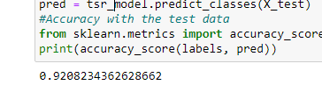
Figure 5.1: Accuracy Score

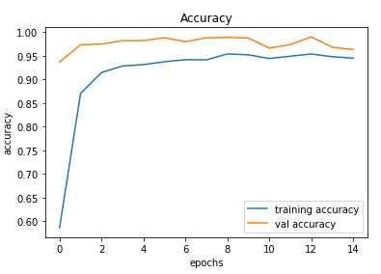
Figure 5.2: Training and Validation Accuracy

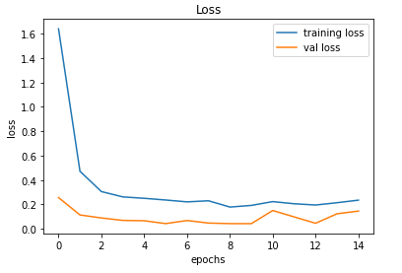
Figure 5.3: Training and Validation Loss

MANUAL

- User can launch the application by pressing application icon.
- To start detection and classification user should press start button given on the screen
- To stop detection and classification user should press stop button given on the screen
- To switch to setting user should press settings button given on the screen
- To exit the application user should press exit button given on the screen
- Visual guidelines for user are shown in Figure 5.4

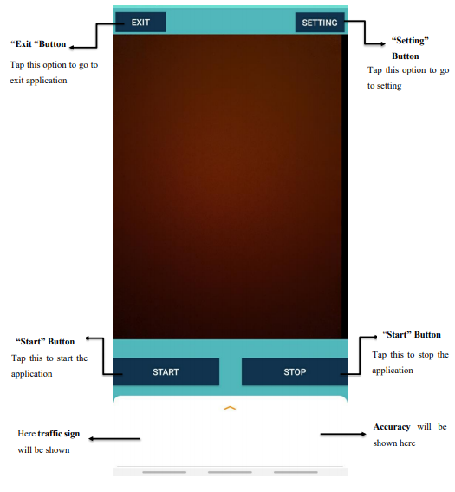

Figure 5.4: User Manual

CONCLUSION AND RECOMMENDATIONS

Conclusion

The conclusion of this project is to assist driver in driving vehicles safely and lawfully. There is a problem of getting distracted from focusing on traffic signs present on the way which could be proved dangerous for peoples and cars. We came with the solution to this problem by creating a mobile application which could detect and classify traffic signs using trained model. It will help drivers to remain known from every traffic sign present on the road, which is a great source for safe and secure driving.

Future Recommendations
If we further work on it, we can enhance this work by adding more classes of signs which are present in Pakistan (i.e. 1122 help line sign, motorway police help line sign, Edhi help line sign, etc ) and can directly embed this technology in the vehicles. Then the vehicles will directly detect and classify the signs present on the road and will notify drivers instantly. It would also help in auto driving vehicles to make decisions according to the instruction given on the roads through signs. We can also add more classes of signs in this project by training it with more different signs of different areas.
.

REFERENCES

[1] K. Bayoudh, F. Hamdaoui, and A. Mtibaa, “Transfer learning based hybrid 2D-3D CNN for traffic sign recognition and semantic road detection applied in advanced driver assistance systems,” Appl. Intell., 2020.
[2] Á. Arcos-García, J. A. Álvarez-García, and L. M. Soria-Morillo, “Deep neural network for traffic sign recognition systems: An analysis of spatial transformers and stochastic optimisation methods,” Neural Networks, vol. 99, pp. 158–165, 2018.
[3] A. Shustanov and P. Yakimov, “CNN Design for Real-Time Traffic Sign Recognition,” Procedia Eng., vol. 201, pp. 718–725, 2017.
[4] A. Broggi, P. Cerri, P. Medici, P. P. Porta, and G. Ghisio, “Real time road signs recognition,” IEEE Intell. Veh. Symp. Proc., no. section III, pp. 981–986, 2007.
[5] “GTSRB - German Traffic Sign Recognition Benchmark | Kaggle.” [Online]. Available: https://www.kaggle.com/meowmeowmeowmeowmeow/gtsrb-german-traffic-sign. [Accessed: 13-Mar-2020].
[6] J. Lilja, “Traffic Sign Recognition Using Machine Learning,” 2020.
[7] Y. Lai, N. Wang, Y. Yang, and L. Lin, “Traffic signs recognition and classification based on deep feature learning,” ICPRAM 2018 - Proc. 7th Int. Conf. Pattern Recognit. Appl. Methods, vol. 2018-Janua, no. January, pp. 622–629, 2018.
[8] J. Li and Z. Wang, “Real-Time Traffic Sign Recognition Based on Efficient CNNs in the Wild,” IEEE Trans. Intell. Transp. Syst., vol. 20, no. 3, pp. 975–984, 2019.

