
BSCS- F19-008
03-134162-081 | EHTASHAM NAEEM QADRI
03-134162-068 | AWAIS BASHIR

COMPATO

In partial fulfilment of the requirements for the degree of
Bachelor of Science in Computer Science
Supervisor: Dr. Ghulam Mustafa
Department of Computer Sciences
Bahria University, Lahore Campus

July 2020

© Bahria University, 2020

C e r t i f i c a t e

We accept the work contained in the report titled
“COMPATO”,
written by
EHTASHAM NAEEM QADRI
AWAIS BASHIR
as a confirmation to the required standard for the partial fulfilment of the degree of
Bachelor of Science in Computer Science.

Approved by:
Supervisor: Dr. Ghulam Mustafa
(Signature)
July 20, 2020

DECLARATION

We hereby declare that this project report is based on our original work except for citations and quotations which have been duly acknowledged. We also declare that it has not been previously and concurrently submitted for any other degree or award at Bahria University or other institutions.

Enrolment | Name | Signature
03-134162-081 | EHTASHAM NAEEM QADRI
03-134162-068 | AWAIS BASHIR

Date: July 20, 2020

Specially dedicated to
my beloved grandparents, mother and father
(EHTASHAM NAEEM QADRI)
my beloved grandparents, mother and father
(AWAIS BASHIR)

ACKNOWLEDGEMENTS

We would like to thank everyone who had contributed to the successful completion of this project. We would like to express our gratitude to our research supervisor, Dr Ghulam Mustafa for his invaluable advice, guidance and his enormous patience throughout the development of the research.

In addition, we would also like to express our gratitude to our loving parent and friends who had helped and encouraged us.

EHTASHAM NAEEM QADRI
AWAIS BASHIR

COMPATO

ABSTRACT

COMPATO is a Recommender Systems based on software tools and techniques providing suggestions for trips according to the requirements of the user. In this project, we will recommend our users about the best trip deals according to their preferences. COMPATO will provide a proper platform to both trip organizers and tourists. Local trip organizers will be able to organize trips and tourists can find trip deals according to their preferences. This platform promotes the tourism industry of Pakistan. Recommender systems filter data according to user preferences and suggest the best deals to them. These suggestions play an important role to help the user to select the right option from the big data available on the internet. Users can avoid complications by using such type of recommendation platform. Many big platforms are using recommender systems like Amazon, Netflix, eBay, YouTube, etc. The recommender system also increases sales and make money by recommending the best deals to a user. Recommendations based on different decision-making processes. First of all, a recommender system pre-processes the user's preferences and train system according to the pre-processed data. After choosing optimal hyperparameter and post-processing we evaluate our recommender system and improve requirements.

TABLE OF CONTENTS

DECLARATION ii
ACKNOWLEDGEMENTS iv
ABSTRACT v
TABLE OF CONTENTS vi
LIST OF TABLES xi
LIST OF FIGURES xiii

CHAPTERS

1 INTRODUCTION 1
1.1 Background 1
1.2 Problem Statements 1
1.3 Aims and Objectives 2
1.4 Scope of Project 2
SOFTWARE REQUIREMENT SPECIFICATION (SRS) 4
2.1 User Classes and Characteristics 4
2.2 Operating Environment 5
2.3 Design and Implementation Constraints 5
2.4 Assumptions and Dependencies 6
2.5 Other Non-functional Requirements 6
2.5.1 Performance Requirements 6
2.5.2 Security Requirements 6
2.5.3 Software Quality Attributes 6
2.5.4 Other Requirements 7
DESIGN AND METHODOLOGY 8
3.1 Use-Case Diagrams 9
3.1.1 System Use-Case diagram 9
3.1.2 Signup Use-Case diagram 10
3.1.3 Admin Login Use-Case diagram 10
3.1.4 Login Use-Case diagram 11
3.1.5 Search Deals Use-Case diagram 11
3.1.6 Make Own Trip Use-Case diagram 12
3.1.7 Preferences Use-Case diagram 13
3.1.8 User Dashboard Use-Case diagram 13
3.1.9 Recommendations Use-Case diagram 13
3.1.10 Help Desk Use-Case diagram 14
3.1.11 Company Dashboard Use-Case diagram 14
3.1.12 Organize Trip Use-Case diagram 15
3.1.13 Admin Panel Use-Case diagram 16
3.2 Use Case Descriptions 17
3.2.1 Signup use-case description 17
3.2.2 Admin Login Use Case description 18
3.2.3 Login Use-Case description 18
3.2.4 Authentication Use-Case descriptions 19
3.2.5 Search Deals Use-Case description 20
3.2.6 Make own Trip Use-Case description 21
3.2.7 User Dashboard Use-Case description 21
3.2.8 Preferences Use-Case description 22
3.2.9 Recommendations Use-Case description 23
3.2.10 Helpdesk Use-Case description 23
3.2.11 Company Dashboard Use-Case description 24
3.2.12 Organize Trips Use-Case description 25
3.2.13 Admin Panel Use-Case description 26
3.2.14 Logout Use-Case description 26
3.2.15 Admin Logout Use-Case description 27
3.3 Sequence Diagrams 28
3.3.1 Sequence diagram of Sign up 28
3.3.2 Sequence Diagram for Admin Login 29
3.3.3 Sequence diagram for Login 30
3.3.4 Sequence Diagram for Search 31
3.3.5 Sequence Diagram for Make Own Trip 32
3.3.6 Sequence Diagram for User Dashboard 33
3.3.7 Sequence Diagram for Preferences 34
3.3.8 Sequence Diagram for Recommendations 35
3.3.9 Sequence Diagram for Help Desk 36
3.3.10 Sequence Diagram for Company Dashboard 37
3.3.11 Sequence Diagram for Organize Trip 38
3.3.12 Sequence Diagram for Logout 39
3.3.13 Sequence Diagram for Admin logout 40
3.4 Domain Model 41
3.5 Class Diagram 42
3.6 Operation Contracts 43
3.6.1 Registration 43
3.6.2 Login 43
3.6.3 Admin Login 44
3.6.4 Search Deals 44
3.6.5 Make Own Trip 44
3.6.6 User Dashboard 45
3.6.7 Preferences 45
3.6.8 Recommendations 46
3.6.9 Help Desk 46
3.6.10 Company Dashboard 46
3.6.11 Organize Trip 47
3.6.12 Admin Panel 47
3.6.13 Admin Logout 48
3.6.14 Logout 48
3.7. Methodology 49
3.7.1. Build a Features list 50
3.7.2. Build by feature 50
3.7.3. Recommendation Technique 50
DATA AND EXPERIMENTS 51
4.1 Languages used for implementation 51
4.1.1 Html 51
4.1.2 CSS 51
4.1.3 JavaScript 51
4.1.4 SQL 52
4.1.5 PHP 52
4.2 Tools used for Implementation 52
4.2.1 XAMPP 52
4.3 Framework 52
4.3.1 Bootstrap 52
5 RESULTS AND DISCUSSIONS 53
5.1 Search Deals at COMPATO 53
5.2 Sign up in COMPATO 54
5.3 Login in COMPATO 54
5.4 Select Preferences 55
5.5 Recommendations according to Preferences 56
5.6 Latest Trip Deals 56
5.7 Best Deals 57
5.8 User Dashboard 57
5.8.1 Change Preferences 57
5.8.2 Change Password 58
5.8.3 Recent Viewed Trips 58
5.8.4 Trip Requests 59
5.9 Make own Trip 59
5.10 Company Dashboard 60
5.10.1 Trip Requests 60
5.10.2 Added Trips 60
5.10.3 Organize Trip 61
5.11 Admin Panel 62
5.11.1 User Data 62
5.11.2 Trips Data 63
5.11.3 Add User 63
5.11.4 Add Trip 64
5.11.5 Pending Trips 64
5.12 Contact us 65
5.13 Help Desk 65
6 CONCLUSION AND RECOMMENDATIONS 66
6.1 Conclusion and Recommendations 66
REFERENCES 67

LIST OF TABLES

TABLE TITLE PAGE
Table 2-1: Operating Environment 5
Table 3-1: Signup use-case description 17
Table 3-2: Admin Use Case description 18
Table 3-3: Login Use Case description 18
Table 3-4: Authentication Use-Case description 19
Table 3-5: Search Deals Use-Case description 20
Table 3-6: Make own Trip Use-Case description 21
Table 3-7: User Dashboard Use-Case description 21
Table 3-8: Preferences Use-Case description 22
Table 3-9: Recommendations Use-Case description 23
Table 3-10: Helpdesk Use-Case description 23
Table 3-11: Company Dashboard Use-Case description 24
Table 3-12: Organize Trips Use-Case description 25
Table 3-13: Admin Panel Logout Use-Case description 26
Table 3-14: Logout Use-Case description 26
Table 3-15: Admin Logout Use-Case description 27
Table 3-16: Registration 43
Table 3-17: Login 43
Table 3-18: Admin Login 44
Table 3-19: Search Deals 44
Table 3-20: Make Own Trip 44
Table 3-21: User Dashboard 45
Table 3-22: Preferences 45
Table 3-23: Recommendations 46
Table 3-24: Help Desk 46
Table 3-25: Company Dashboard 46
Table 3-26: Organize Trip 47
Table 3-27: Admin Panel 47
Table 3-28: Admin Logout 48
Table 3-29: Logout 48

LIST OF FIGURES

FIGURE TITLE PAGE
Figure 3-1: System Use-Case diagram 9
Figure 3-2: Signup Use-Case diagram 10
Figure 3-3: Admin Login Use-Case diagram 10
Figure 3-4: Login Use-Case diagram 11
Figure 3-5: Search Deals Use-Case diagram 11
Figure 3-6: Make Own Trip Use-Case diagram 12
Figure 3-7: Preferences Use-Case diagram 13
Figure 3-8: User Dashboard Use-Case diagram 13
Figure 3-9: Recommendations Use-Case diagram 13
Figure 3-10: Help Desk Use-Case diagram 14
Figure 3-11: Company Dashboard Use-Case diagram 14
Figure 3-12: Organize Trip Use-Case diagram 15
Figure 3-13: Admin Panel Use-Case diagram 16
Figure 3-14: Sequence diagram of sign up 28
Figure 3-15: Sequence Diagram for Admin Login 29
Figure 3-16: Sequence Diagram for Login 30
Figure 3-17: Sequence Diagram for Search 31
Figure 3-18: Sequence Diagram for Make Own Trip 32
Figure 3-19: Sequence Diagram for the User Dashboard 33
Figure 3-20: Sequence Diagram for Preferences 34
Figure 3-21: Sequence Diagram for Recommendations 35
Figure 3-22: Sequence Diagram for Help Desk 36
Figure 3-23: Sequence Diagram for Company Dashboard 37
Figure 3-24: Sequence Diagram for Organize Trips 38
Figure 3-25: Sequence Diagram for Logout 39
Figure 3-26: Sequence Diagram for Admin Logout 40
Figure 3-27: Domain Model 41
Figure 3-28: Class Diagram 42
Figure 3-29 Methodology 49
Figure 5-1: Search Deals at COMPATO 53
Figure 5-2: Register in COMPATO 54
Figure 5-3: Login in COMPATO 54
Figure 5-4: Select Preferences 55
Figure 5-5: Recommendations According to Preferences 56
Figure 5-6: Latest Trip Deals 56
Figure 5-7: Best Deals 57
Figure 5-8: Change Preferences 57
Figure 5-9: Change Password 58
Figure 5-10: Recent Viewed Trips 58
Figure 5-11 Trip Requests 59
Figure 5-12 Make own Trip 59
Figure 5-13: Trip Requests 60
Figure 5-14: Added Trips 60
Figure 5-15: Organize Trip 61
Figure 5-16: Admin Panel 62
Figure 5-17: User Data 62
Figure 5-18: Trips Data 63
Figure 5-19: Add User 63
Figure 5-20: Add Trip 64
Figure 5-21: Pending Trips 64
Figure 5-22: Contact us 65
Figure 5-23: Help Desk 65

INTRODUCTION

Background

The background of COMPATO is to promote the tourism industry of Pakistan and provide a proper channel to both trip organizers and tourists to organize trips and find trips according to preferences. Tourism has a great impact on the economy of any country. It increases the opportunities for local development, businesses, trade etc. Many world economies are based on tourism like Turkey, Thailand, and UAE. Pakistan is blessed with a variety of trip destinations including the beautiful islands, beaches, deserts, mountain ranges and historical places. Tourism in Pakistan can stable the struggling economy and financial crises of Pakistan [1][2].

Problem Statements

Finding the best deal for a perfect trip is very time consuming, costly and complex process. Travellers are very concerned about the facilities and security constraints of trip plans. Unfortunately, Pakistan tourist industry is new and underdevelopment because Pakistan was facing terrorism from the last few decades that's why a few places were open for tourism. Only a few platforms are organizing trips on a lower level. Due to the lack of competition, knowledge and online facilities Pakistan travel industry suffering a lot. Travellers are Incognizant about the unseen beautiful areas of Pakistan and don't know how to explore these areas which are not less than any world-class trip destination. That’s why Pakistan travel industry is in a huge loss. Due to the lack of competition trip destinations in Pakistan are too costly and travellers need too much time to plan trips because there is no infrastructure, transport facilities and guidance. Due to the communication and facilities gap travellers consider exploring Pakistan is not value for the money. In most of the cases, we see even local visit other countries for trips like UAE, Thailand, Turkey and western countries [1].

Aims and Objectives

The objectives for developing this platform are:
- To provide a Trip recommendation platform to the travellers across Pakistan which will suggest the best trip deals according to their requirements.
- To provide a platform to the trip organizers to post their trip plans.
- Travellers can request a customize trip deal according to their requirements.
- To provide a platform on which the user can find the best deals across different platforms.
- Through this platform, clients can view trip plans across Pakistan from anywhere at any time. This platform will provide the facility to our clients to post their requirements and budget and COMPATO will show the best trip deals according to their requirements and budget.

Scope of Project

COMPATO is a trip plans recommendation platform which will provide the facility to our users to search trip deals according to their preferences. COMPATO will show the best trip deals according to their requirements. The users need to register themselves on this platform if they want to save their recent searches and request customize trip plans. User can also select their preferences to get recommendations. Recommendations will be visible to all subscribers of the same category of this platform till the closing date after that Trip will be expired. Through this platform, clients can view trip plans across Pakistan from anywhere at any time. COMPATO also provide the facility to trip organizers to organize trip plans and check to customize trip plan requests. The client may ask queries from the Help Desk available on COMPATO [3][4].

SOFTWARE REQUIREMENT SPECIFICATION (SRS)

User Classes and Characteristics

There will be three types of user classes which are given below

Admin

Admin login into the admin panel then he/she can perform the basic operations to control the system. He/she can add, update or delete a user, company or a trip deal. Admin can also check the messages from contact us section.

User

User can search trip deals according to their requirements. User can also customize a trip if they didn’t find any trip deal according to their requirements. User needs to signup if they want to save their recent searches, request a customized trip, get notifications, and become a verified user.

Company

A company initially needs to sign up then they can post their trip plans on COMPATO and can check the customize trip requests from users. The company also can search for the trip deals to remain up to date and in a competitive environment.

Operating Environment

Operating environment details for COMPATO are:

Table 2-1: Operating Environment
Name | Description
Operating system | Windows
Browser | Google chrome, Internet explorer, UC Browser, Mozilla FireFox
Languages | HTML5, CSS, Bootstrap, JQuery, Core PHP
Tools | Visual Code
Database | MySQL

Design and Implementation Constraints

We developed our front end on CSS, HTML, and Bootstrap and for event handling we used jQuery. For the backend development, we used Core PHP. We will use Xampp server and MySQL database to store the data in cloud database which is more reliable and efficient as compare to any other traditional database and hardware server.

Assumptions and Dependencies

The performance of (COMPATO) depends upon the user's internet because fast internet helps to retrieve data efficiently.

Other Non-functional Requirements

Performance Requirements

- The system should perform all the actions frequently and correctly.
- The system should give a response within a reasonable time.
- The system should display a confirmation message to the user in a sensible time after the submission of information to the system.
- Internet is very essential to run the system because the websites usually rely on the internet. So the faster internet will give better performance for the system.

Security Requirements

- Only an authorized person can register or login.
- Only admin can make changes.

Software Quality Attributes

- This is a web-based application and gives its users high portability so it can be used with internet access and browser.

Other Requirements

Availability:

The system should be available 24/7.

Maintainability:

The system should be maintained and configured easily

DESIGN AND METHODOLOGY

This chapter gives an overview of the design of COMPATO. The system architecture design gives the complete view of the system. This will allow developers and users to see and check the design in detail.
Following artefacts included in this Chapter
- Use case diagrams.
- Use case descriptions.
- Sequence Diagrams.
- Domain Model.
- Class Diagram.
- Operation Contract
- Methodology

Use-Case Diagrams

System Use-Case diagram

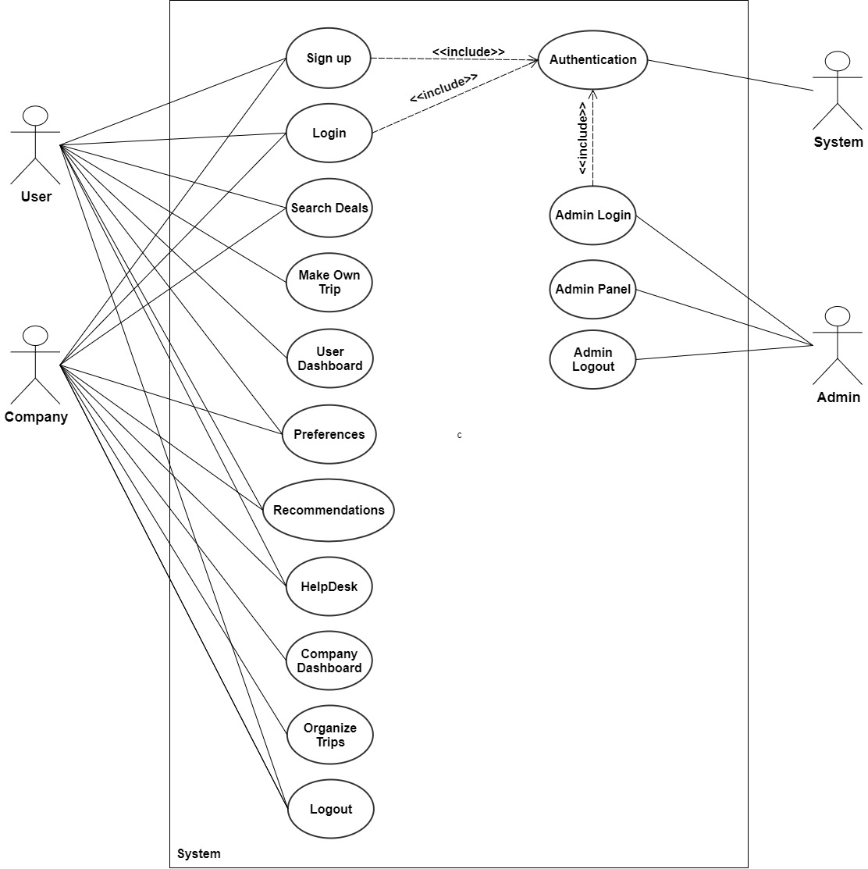
Figure 3-1: System Use-Case diagram

Signup Use-Case diagram

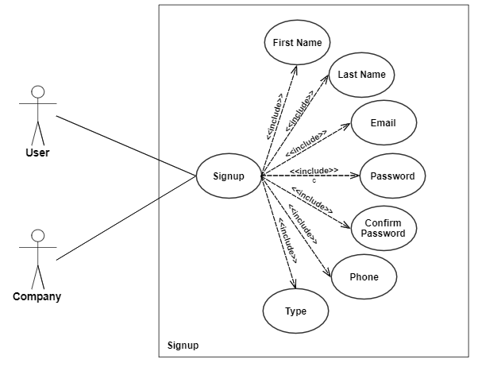

Figure 3-2: Signup Use-Case diagram

Admin Login Use-Case diagram
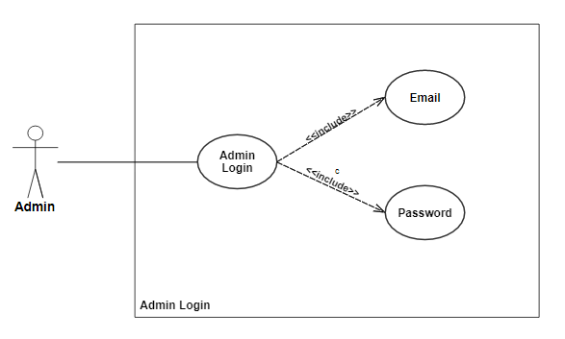
Figure 3-3: Admin Login Use-Case diagram

Login Use-Case diagram
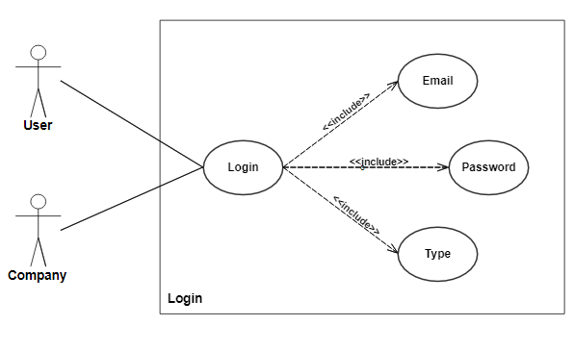
Figure 3-4: Login Use-Case diagram

Search Deals Use-Case diagram
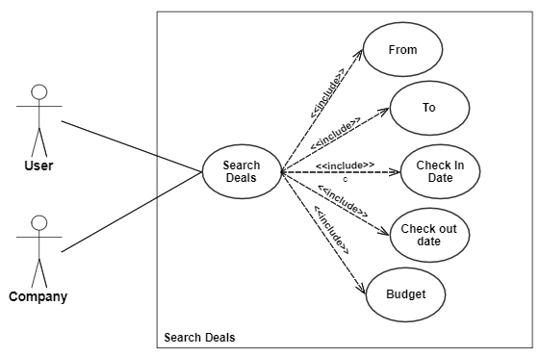
Figure 3-5: Search Deals Use-Case diagram

Make Own Trip Use-Case diagram
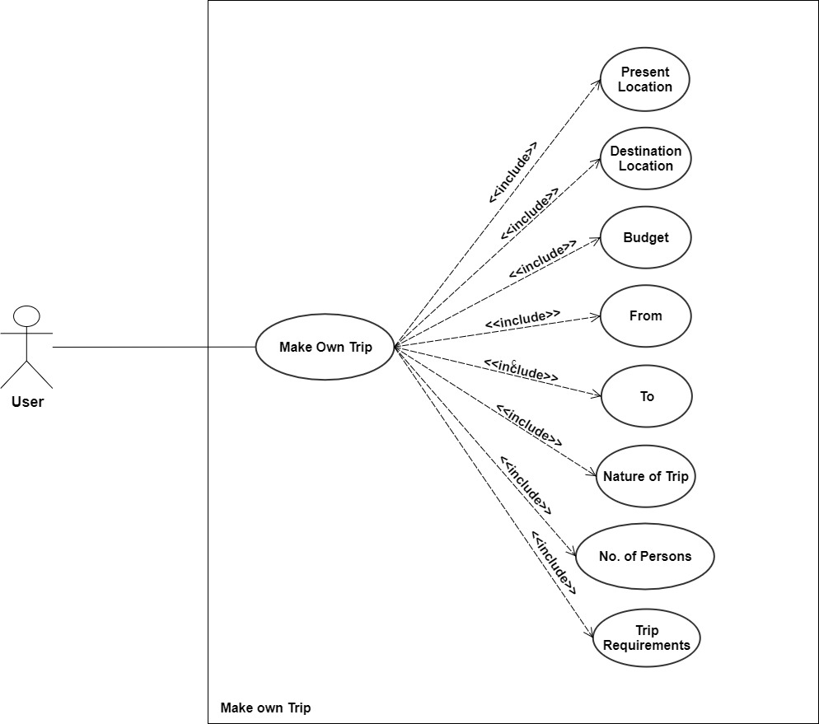
Figure 3-6: Make Own Trip Use-Case diagram

Preferences Use-Case diagram
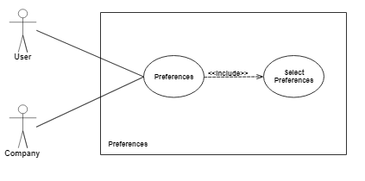
Figure 3-7: Preferences Use-Case diagram

User Dashboard Use-Case diagram
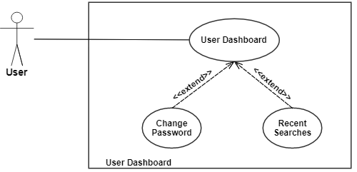

Figure 3-8: User Dashboard Use-Case diagram

Recommendations Use-Case diagram
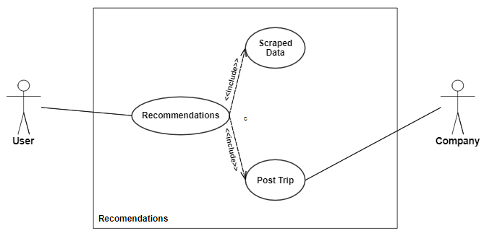

Figure 3-9: Recommendations Use-Case diagram

Help Desk Use-Case diagram
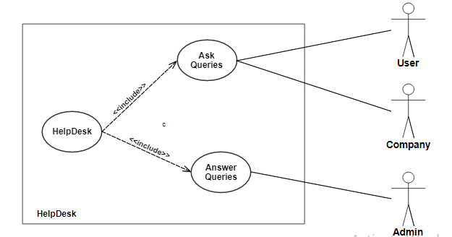
Figure 3-10: Help Desk Use-Case diagram

Company Dashboard Use-Case diagram
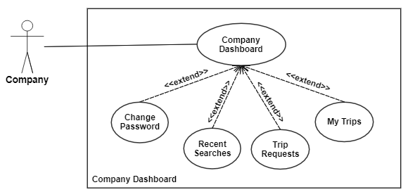
Figure 3-11: Company Dashboard Use-Case diagram

Organize Trip Use-Case diagram
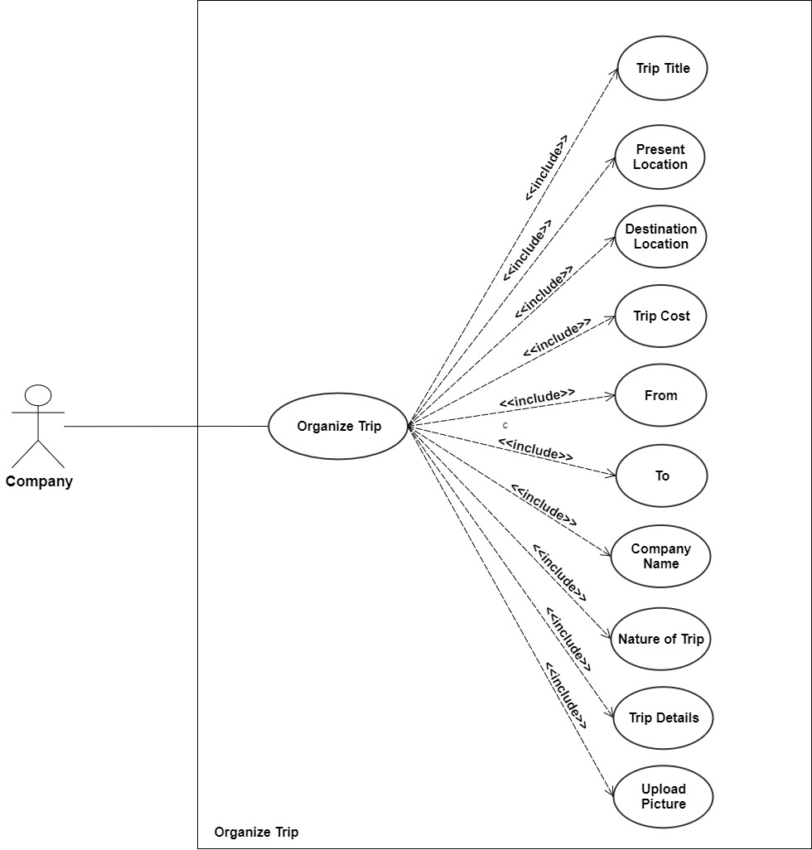
Figure 3-12: Organize Trip Use-Case diagram

Admin Panel Use-Case diagram
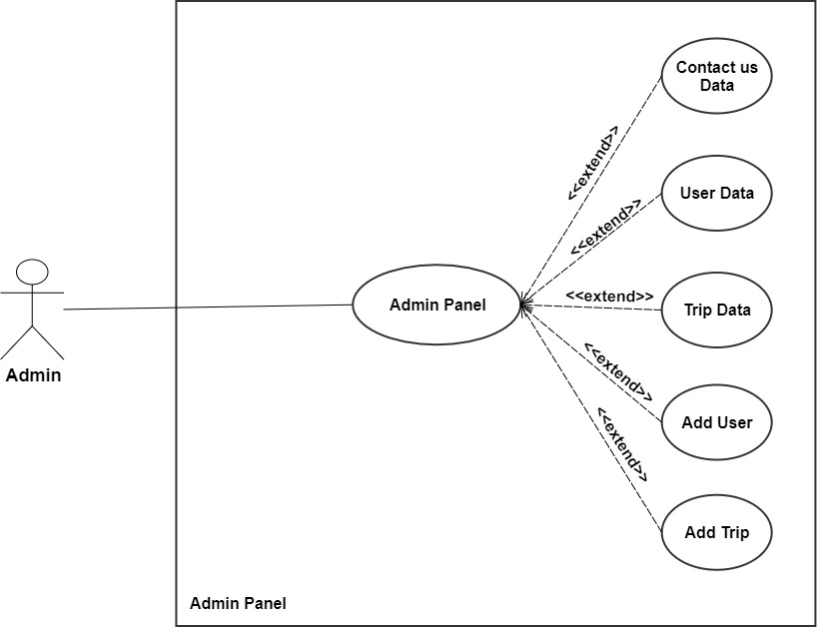
Figure 3-13: Admin Panel Use-Case diagram

Use Case Descriptions

Signup use-case description

Table 3-1: Signup use-case description
Name and ID | Sign up – U1
Brief description | User can Sign up which makes a user a verified user.
Preconditions | The user had a valid email id.
Basic flow or Happy path | - User or company enters the First Name.  - User or company enters the Last Name.  - User or company enters valid Email.  - User or company enters Password.  - The user enters First Confirm Password.  - The user enters Phone Number.  - The user enters the account type.  - The user enters Company name if the account type is company.
Trigger | On clicking Sign up button.
Alternate flows | Alternative Flow 1 – Step (c) user email id is not valid.  The system shows a message to re-enter valid email Id.  Alternative Flow 2 – Step (d) and step (e) password and confirm password are not similar.  The system shows a message password and confirm password are not similar.  Alternative Flow 3 – Email-id is already existing.  The system shows a message account is already registered.
Post-conditions | User is registered.

Admin Login Use Case description

Table 3-2: Admin Use Case description
Name and ID | Admin Login – U2
Brief description | Admin can Log in to the admin panel.
Preconditions | Admin's login data already stored in the database.
Basic flow or Happy path | - Admin enters valid email id and password.  - Admin logs into the admin panel.
Trigger | On clicking the Admin Login button.
Alternate flows | Alternative Flow 1 – Step (a) admin enter invalid email id or password.  The system shows a message to enter a valid email id and password.  Alternative Flow 2 – Admin forgets the password.  Update the admin's password in the database.
Post-conditions | Admin can access admin panel.

Login Use-Case description

Table 3-3: Login Use Case description
Name and ID | Login – U3
Brief description | User can Login to the site.
Preconditions | User must be registered into the site.
Basic flow or Happy path | - The user enters the registered email id.  - The user enters a valid password  - User select account type.  - User press login button.  - User logged in.
Trigger | On clicking Log in button.
Alternate flows | Alternative Flow 1 – Step (a) user enters invalid email id or password.  The system shows a message to enter a valid email id and password.  Alternative Flow 2 – Step (b) user forgets the password.  User can reset the password.
Post-conditions | User Logged in to the site.

Authentication Use-Case descriptions

Table 3-4: Authentication Use-Case description
Name and ID | Authentication – U4
Brief description | The main objective of authentication is to authenticate login information of user, company and admin. And also authenticate user’s email id for registration.
Preconditions | User entered valid email id for registration. Or admin and user login information already stored in the database.
Basic flow or Happy path | - Admin enters valid email id and password and logs in to the admin panel.  - The user enters a valid email id for registration.  - The user enters valid email and password and logs in to the site.
Trigger | During data verification.
Alternate flows | Alternative Flow 1 – Step (a) and Step (c) Admin or user enters invalid email id and password for login.  The system shows a message to enter a valid email id and password.  Alternative Flow 2 – Step (b) User enter invalid email for registration.  The system sends verification mail to the user to check the validity of the email id.
Post-conditions | An authenticated user can register and login into the site and authenticated admin can access admin panel.

Search Deals Use-Case description

Table 3-5: Search Deals Use-Case description
Name and ID | Search Deals– U5
Brief description | User or Company will enter their Present Location, Destination Location, Check-in date, Check-out date and budget to search the trip deals according to their requirements.
Preconditions | User or company must be on the website.
Basic flow or Happy path | - The user enters the Present Location.  - The user enters Destination Location.  - The user enters Check-in Date.  - The user enters Check-out Date.  - The user enters the Budget.  - User click on the search button  - The system shows the Trip data match with the user search data.
Trigger | On clicking the search button.
Alternate flows | Alternative Flow 1- Step (a), Step (b), Step (c), Step (d), Step (e) User didn’t fill any field.  The system show alert  The system show message “search bar is empty”  Alternative Flow 2- Step (c), Step (d), Step (e) Check-in Date is greater than check-out Date  The system show alert  The system show message “Check-out Date must be greater than Check-in Date”  Alternative Flow 3- Step (f) no item match with search job  The system show message “No result found”.  The system redirects to the step (a).
Post-conditions | The system will show the trip recommendation data to the user or company matching with their search requirements.

Make own Trip Use-Case description

Table 3-6: Make own Trip Use-Case description
Name and ID | Make own Trip – U6
Brief description | User can request a trip deal if he didn't find any trip deal according to their requirement. The system will show the trip request to all the companies on COMPATO, Any company can offer a deal to the user according to his/her requirements.
Preconditions | User must be logged in.
Basic flow or Happy path | - User Log in.  - Click the Make own Trip option.  - Fill the Make own Trip form.  - Press Find my trip button.
Trigger | On clicking Find my trip button
Alternate flows | Alternative Flow 1 – Step (b) Check-in Date is greater than the Check-out Date.  The system show alert message “Check-out Date must be greater than Check-in Date”
Post-conditions | The system will show the alert "Request sent successfully we will inform you when we will find any deal according to your requirements"

User Dashboard Use-Case description

Table 3-7: User Dashboard Use-Case description
Name and ID | User Dashboard – U7
Brief description | User can check their recent searches and change their password by using user’s dashboard
Preconditions | User must be logged in.
Basic flow or Happy path | - User login into their account.  - User clicks recent searches to check their recent searches.  - User clicks change the password to change password.  - The user enters the old password, new password and confirm password to change password.
Trigger | On user login.
Alternate flows | Alternative Flow 1 – Step (d) old password is invalid.  System show alert enters the valid old password.  Give a message of data unsuccessfully scraped.  Alternative Flow 2- Step (d) New password and confirm password are not the same.  System show alerts new password and confirm password are not the same.
Post-conditions | User can check their recent searches and can change their password.

Preferences Use-Case description

Table 3-8: Preferences Use-Case description
Name and ID | Preferences – U8
Brief description | User or company select their preferences when they log in the first time they can change their preferences at any time.
Preconditions | User logs in.
Basic flow or Happy path | - User login to the site.  - Select trip destinations as a preference.  - The system will show the trip recommendations according to preferences.
Trigger | On the first login or pressing change preferences button.
Alternate flows | None
Post-conditions | The system will show the recommendations according to the selected preferences.

Recommendations Use-Case description

Table 3-9: Recommendations Use-Case description
Name and ID | Recommendations – U9
Brief description | The system will show the recommendations according to their preferences and searched data.
Preconditions | User needs to search data according to requirements and must be login in case of preferences.
Basic flow or Happy path | - The user enters the present location, destination location, check-in date, check-out date, budget and search to get recommendations.  - User login to select preferences to get recommendations.
Trigger | During data verification.
Alternate flows | Alternative Flow 1- Step (b) User select no preference.  The system will show the latest deals to the user
Postconditions | User can check recommendations.

Helpdesk Use-Case description

Table 3-10: Helpdesk Use-Case description
Name and ID | Helpdesk – U10
Brief description | Users can solve their queries.
Preconditions | None
Basic flow or Happy path | - The user selects the Helpdesk option.  - User can chat will admin or managing agent.
Trigger | On clicking Helpdesk.
Alternate flows | Alternative Flow – Step (b) Admin or managing agent is offline.  User can mail the admin.
Post-conditions | User queries solved or mail sent to the admin in case of offline status.

Company Dashboard Use-Case description

Table 3-11: Company Dashboard Use-Case description
Name and ID | Company Dashboard – U11
Brief description | The company can check their recent searches, change their password, check added trips and trip requests from the users by using Company dashboard
Preconditions | The company must be logged in.
Basic flow or Happy path | - Company login into their account.  - Company click recent searches to check their recent searches.  - Company click change password to change password.  - Company enter the old password, new password and confirm password to change password.  - Company click added trip option to check their added trip deals.  - Company click trip requests to check trip requests from users.
Trigger | On user login.
Alternate flows | Alternative Flow 1 – Step (d) old password is invalid.  System show alert to enter valid old password.  Alternative Flow 2- Step (d) New password and confirm password are not the same.  System show alert new password and confirm password are not same
Post-conditions | The company can check their recent searches, change their password, check their added trip deals and check trip requests.

Organize Trips Use-Case description

Table 3-12: Organize Trips Use-Case description
Name and ID | Organize Trips – U12
Brief description | The company can organize a trip on COMPATO admin will verify the trip and post on the platform.
Preconditions | The company must be logged in.
Basic flow or Happy path | - Company Log in.  - Click on Organize Trip.  - Fill the organize trip form.  - Press Post trip button.
Trigger | On clicking Post trip button.
Alternate flows | Alternative Flow 1 – Step (b) Check-in Date is greater than the Check-out Date.  The system will show the alert message “Check-out Date must be greater than Check-in Date”  Alternative Flow 2 – Step (b) Company enter inappropriate trip details.  The system will show the error alert.
Post-conditions | After admin verification trip will be posted on COMPATO.

Admin Panel Use-Case description

Table 3-13: Admin Panel Logout Use-Case description
Name and ID | Admin Panel – U13
Brief description | Admin can check users, trips and messages from contact us. Admin can also add, update or delete a particular user or a trip plan. Admin verifies the organize trip requests from companies.
Preconditions | Admin must be logged in.
Basic flow or Happy path | - Admin Log in.  - Admin can check users on the platform and can add, update or delete a particular user.  - Admin can check trips on the platform and can add, update or delete a particular trip deal.  - Admin can read messages from users.
Trigger | On login admin panel.
Alternate flows | Alternative Flow 1– Step (b) admin search invalid profile.  The system shows an error message profile does not exist.
Post-conditions | Admin can check users, trips and messages from contact us. Admin can also add, update or delete a particular user or a trip plan. Admin verifies the organize trip requests from companies.

Logout Use-Case description

Table 3-14: Logout Use-Case description
Name and ID | Logout – U14
Brief description | User can logout from the website so no one can access his/her account.
Preconditions | User should be logged in.
Basic flow or Happy path | - User press Logout option.  - User logout from the site.
Trigger | On clicking Log out button.
Alternate flows | None.
Post-conditions | User logged out from the site.

Admin Logout Use-Case description

Table 3-15: Admin Logout Use-Case description
Name and ID | Admin Logout – U15
Brief description | Admin can Logout from admin panel so no one can access his/her account.
Preconditions | Admin logged in.
Basic flow or Happy path | - Admin press logout option.  - Admin logged out from the admin panel.
Trigger | On clicking the Admin Logout button.
Alternate flows | None
Post-conditions | Admin logged out from the site.

Sequence Diagrams

Sequence diagram of Sign up
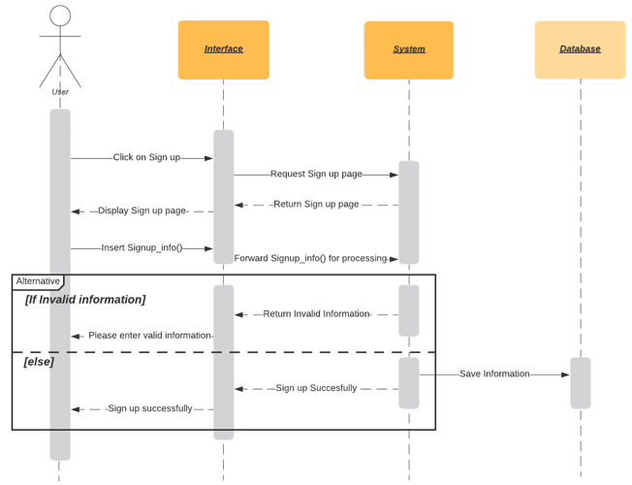
Figure 3-14: Sequence diagram of sign up

Sequence Diagram for Admin Login
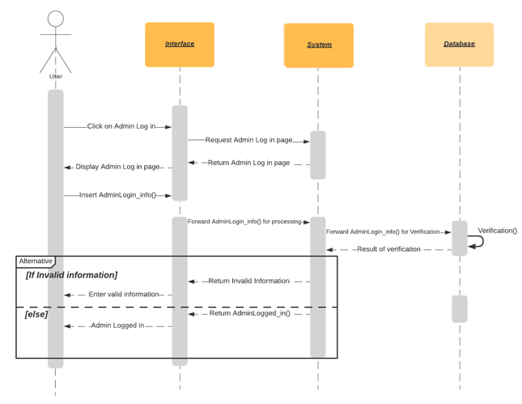
Figure 3-15: Sequence Diagram for Admin Login

Sequence diagram for Login
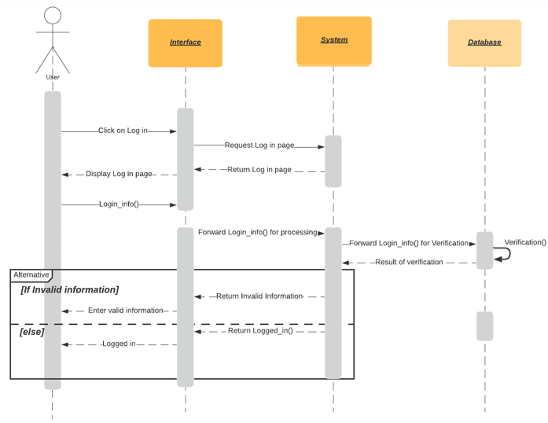
Figure 3-16: Sequence Diagram for Login

Sequence Diagram for Search
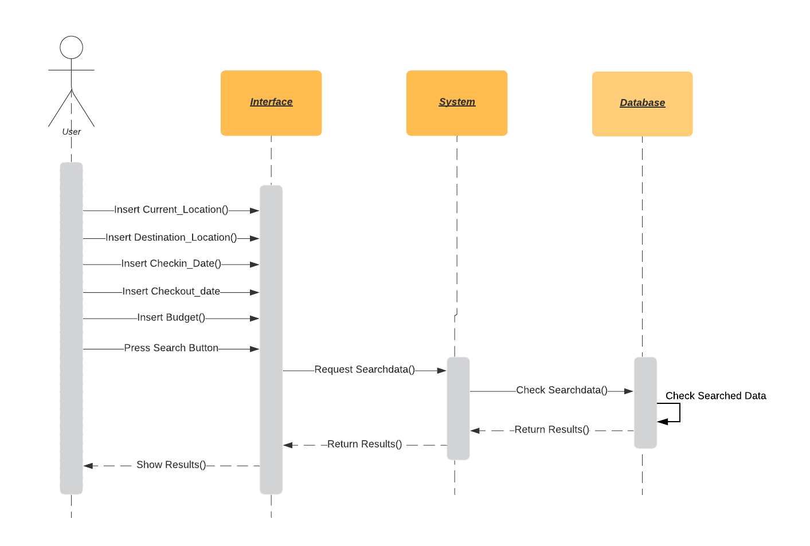
Figure 3-17: Sequence Diagram for Search

Sequence Diagram for Make Own Trip
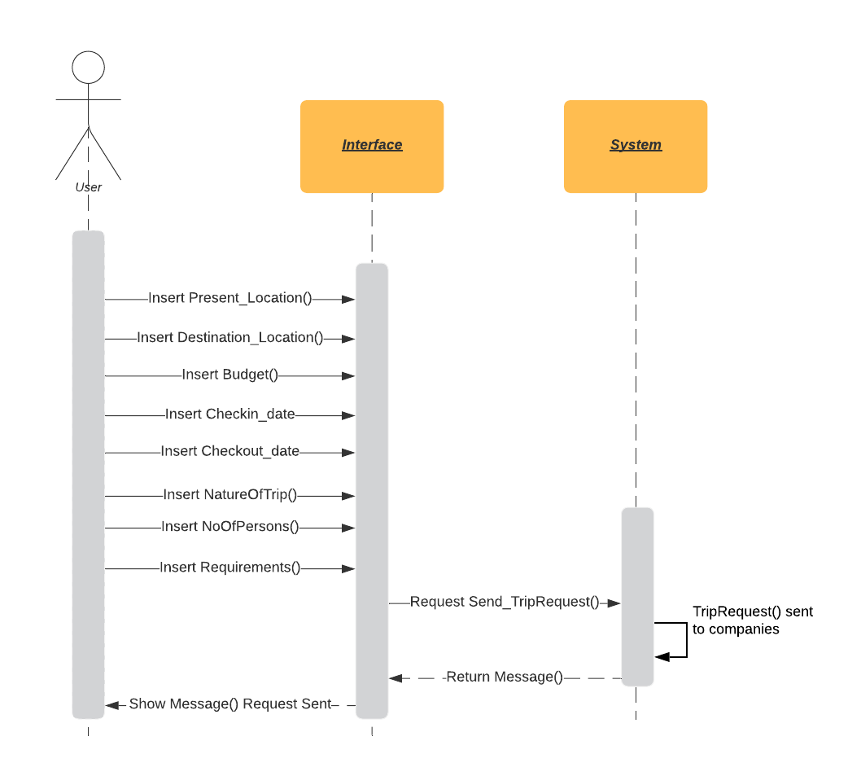
Figure 3-18: Sequence Diagram for Make Own Trip

Sequence Diagram for User Dashboard
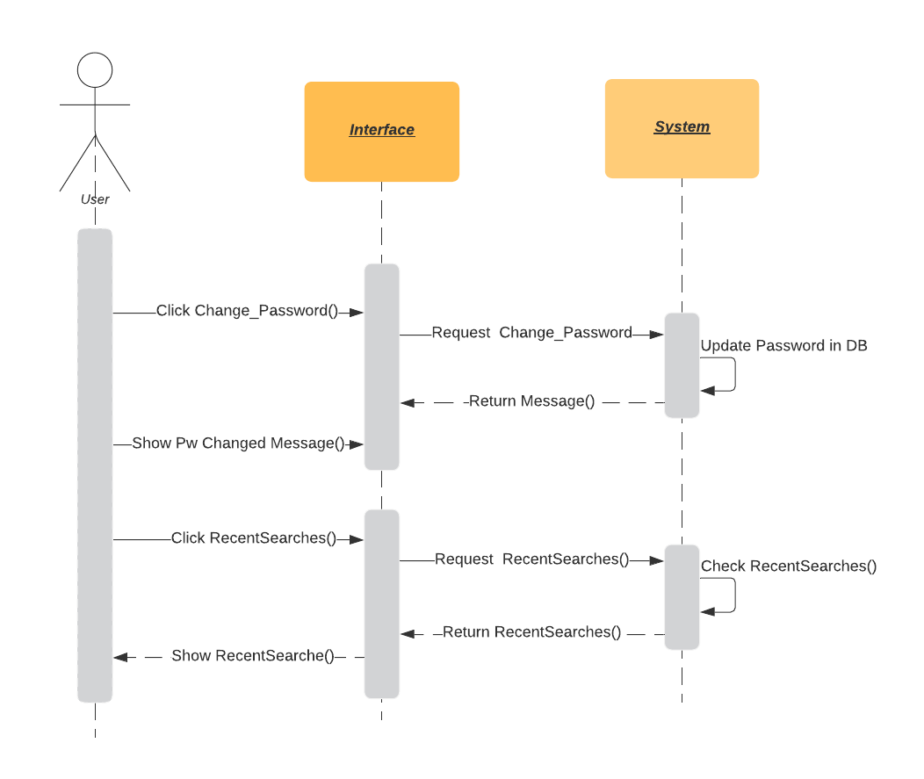
Figure 3-19: Sequence Diagram for the User Dashboard

Sequence Diagram for Preferences
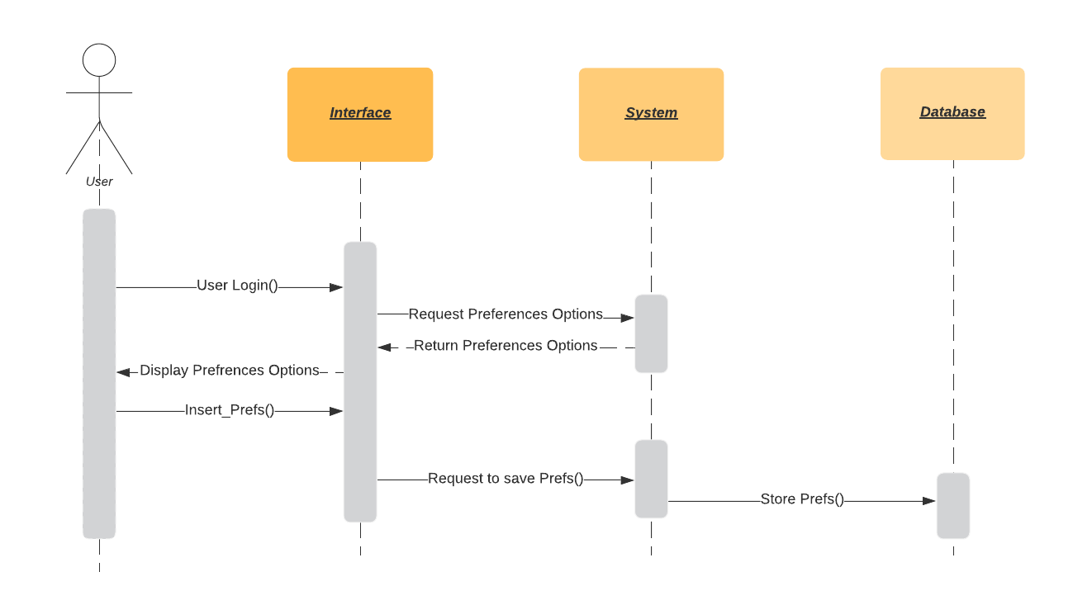
Figure 3-20: Sequence Diagram for Preferences

Sequence Diagram for Recommendations
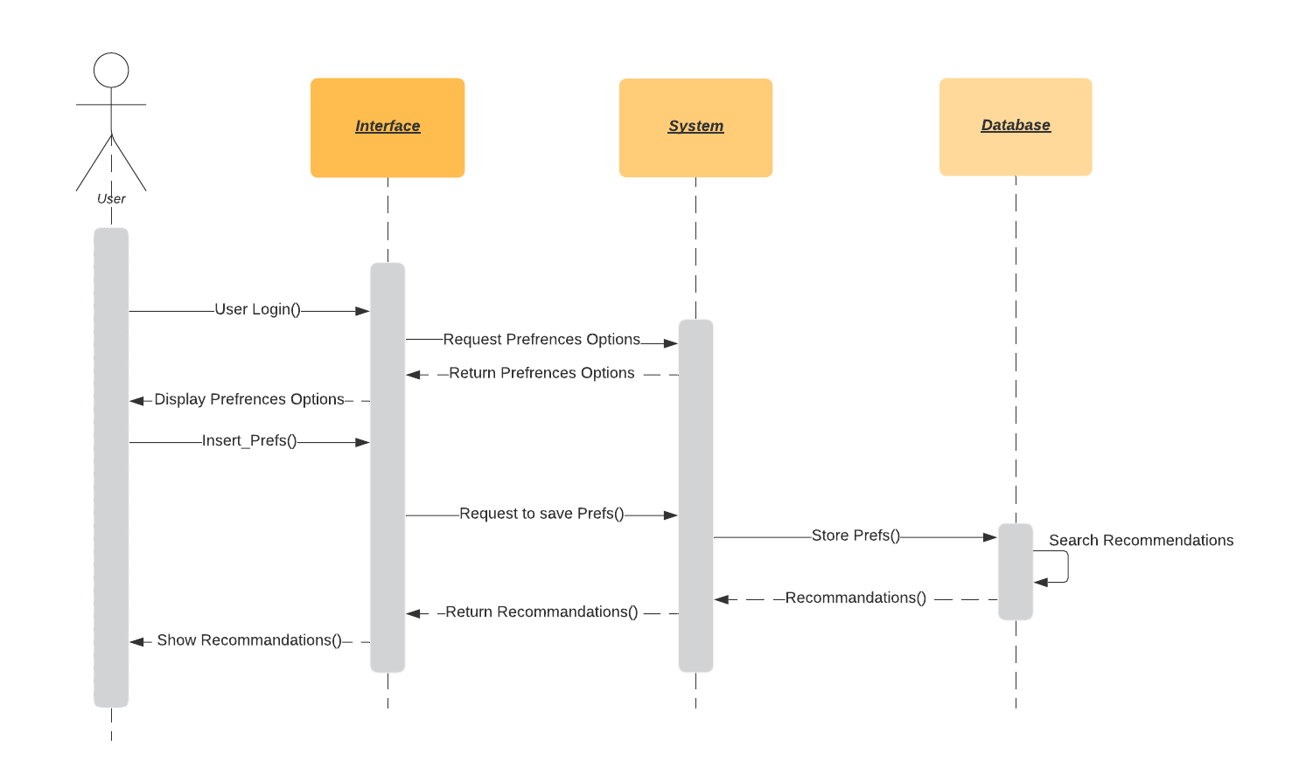
Figure 3-21: Sequence Diagram for Recommendations

Sequence Diagram for Help Desk
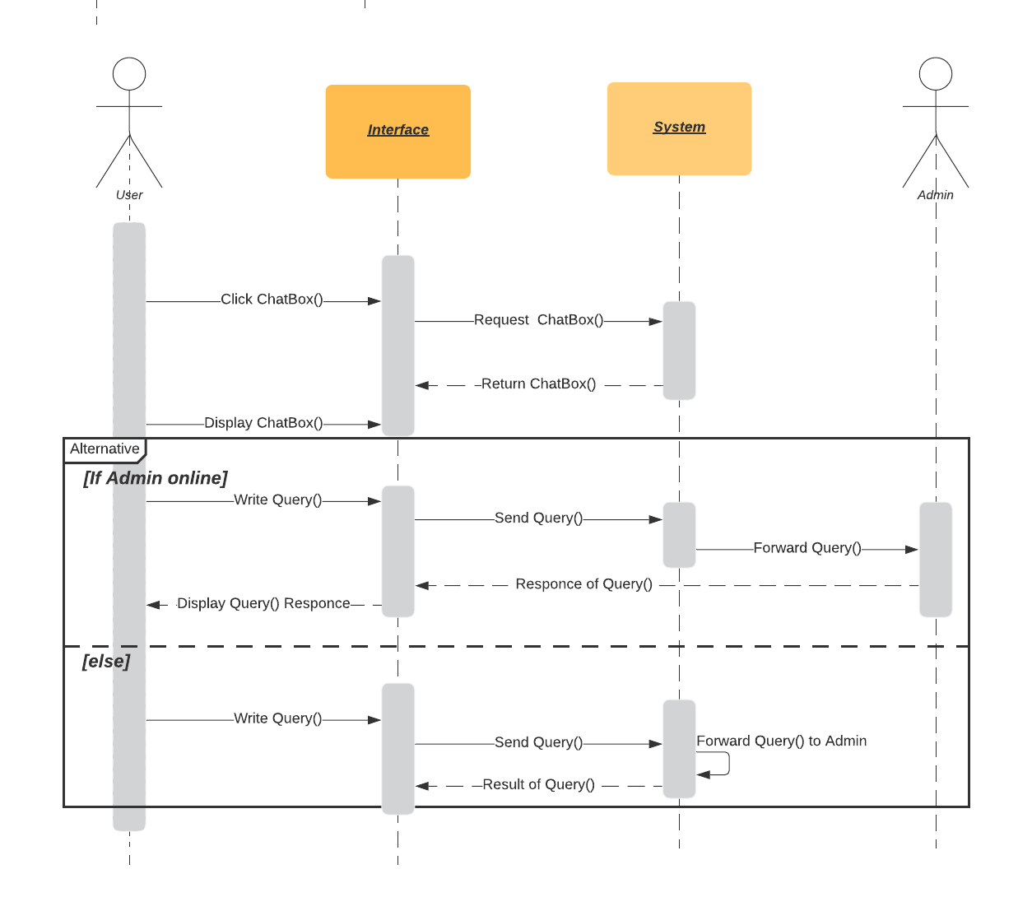
Figure 3-22: Sequence Diagram for Help Desk

Sequence Diagram for Company Dashboard
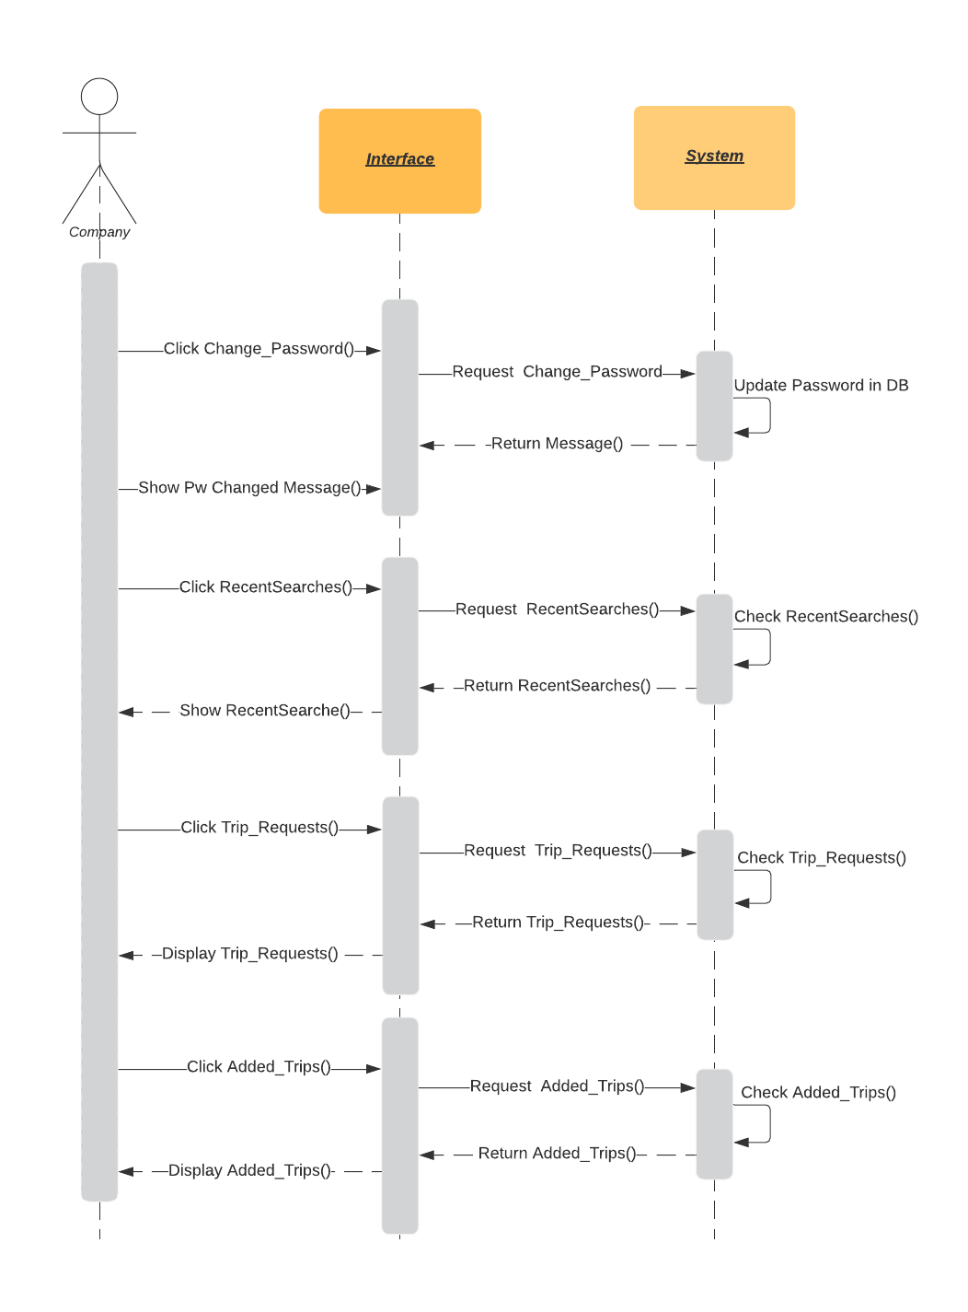
Figure 3-23: Sequence Diagram for Company Dashboard

Sequence Diagram for Organize Trip
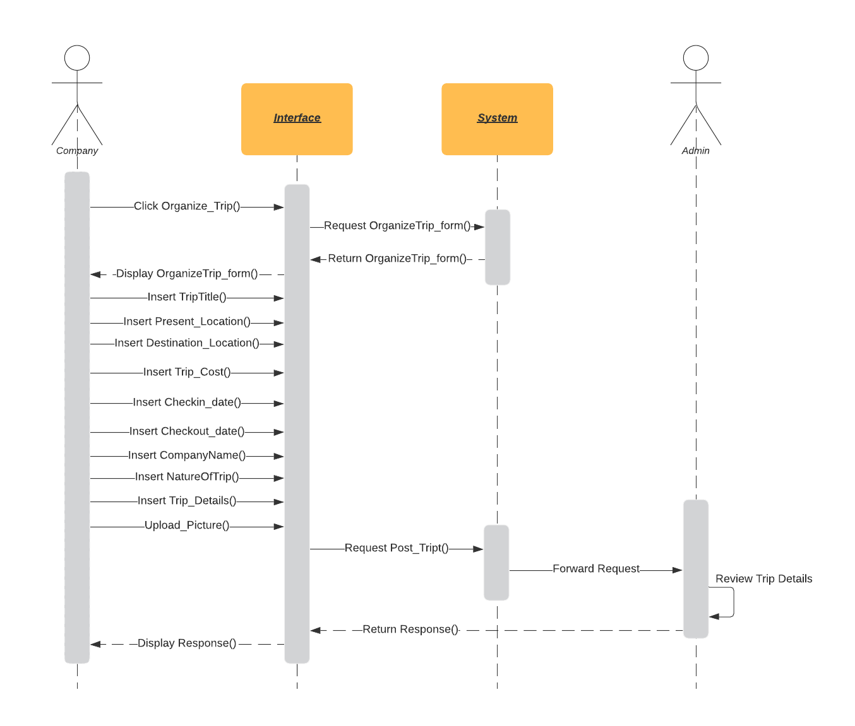
Figure 3-24: Sequence Diagram for Organize Trips

Sequence Diagram for Logout
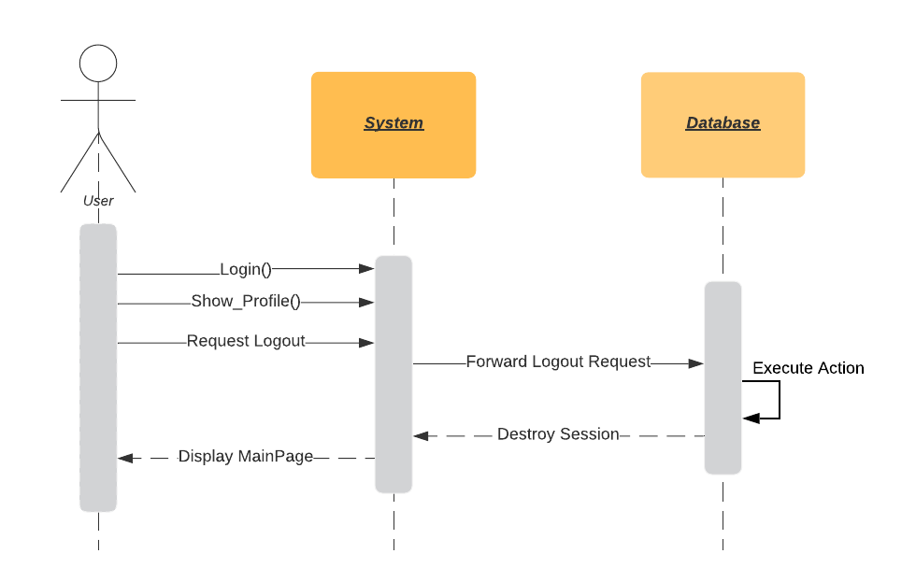
Figure 3-25: Sequence Diagram for Logout

Sequence Diagram for Admin logout
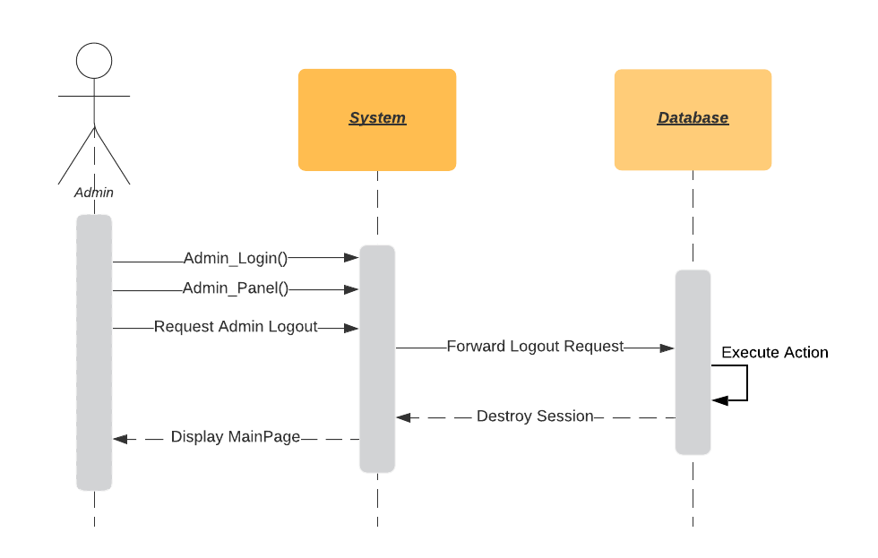
Figure 3-26: Sequence Diagram for Admin Logout

Domain Model
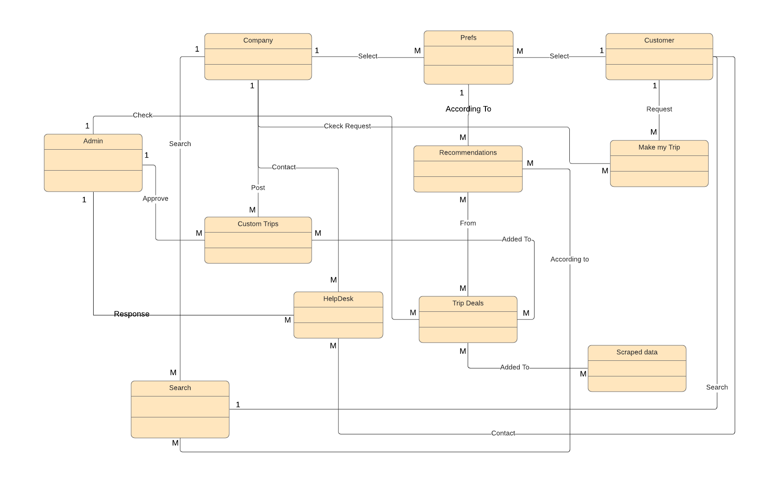
Figure 3-27: Domain Model

Class Diagram
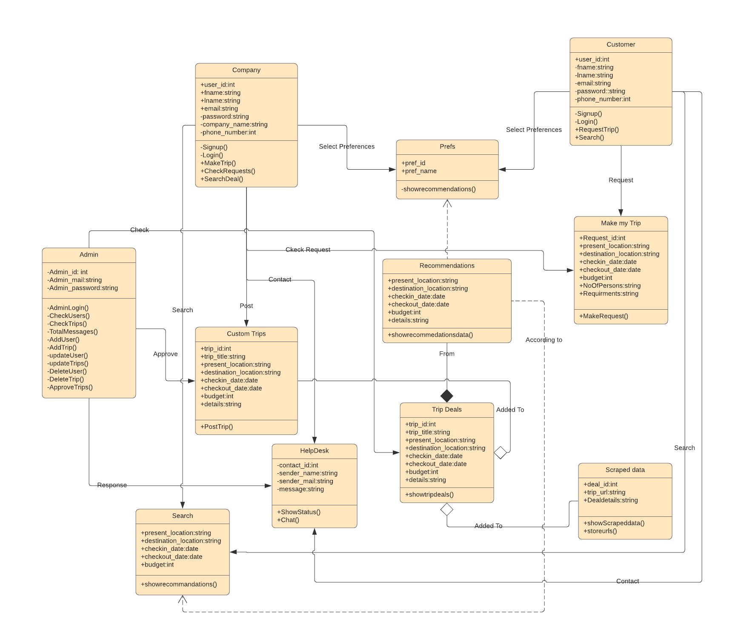
Figure 3-28: Class Diagram

Operation Contracts

Registration

Table 3-16: Registration
Name | Registration
Responsibilities | Register the user
Cross Reference | None
Exception | The system does not respond properly in case of when the server link is down.
Preconditions | - Internet connectivity is available  - User click the registration button  - Give registration credentials.
Post-conditions | Successfully User registration and show the login page.

Login

Table 3-17: Login
Name | Login
Responsibilities | Login of the user to the system
Cross Reference | None
Exception | User entered wrong credentials
Preconditions | First, the user is done with the registration and wants to log in to the system.
Post-conditions | User login is successful then show the profile page to them.

Admin Login

Table 3-18: Admin Login
Name | Admin Login
Responsibilities | Login of Admin to the system
Cross Reference | None
Exception | Admin entered wrong credentials
Preconditions | Admin Login information should be stored in the database.
Post-conditions | Admin login is successful then show the Admin panel

Search Deals

Table 3-19: Search Deals
Name | Search Deals
Responsibilities | Search Trip deals according to user requirements.
Cross Reference | None
Exception | The user enters check-in date greater than check out date.
Preconditions | None
Post-conditions | System show trip deals according to user requirements.

Make Own Trip

Table 3-20: Make Own Trip
Name | Make own Trip
Responsibilities | Request a trip deal for a user if he didn’t find any trip deal according to their requirement.
Cross Reference | None
Exception | User fills invalid credentials.
Preconditions | - The user must be registered to the system  - The user must be logged in to the system.
Post-conditions | - Show Make Own Trip requests to all the companies registered on the platform.

User Dashboard

Table 3-21: User Dashboard
Name | User Dashboard
Responsibilities | Show user recent searches and user can change their password.
Cross Reference | None
Exception | The user enters invalid old Password, new Password or confirm password.
Preconditions | - The user must be logged in to the system.
Post-conditions | User can check their searches and change password.

Preferences

Table 3-22: Preferences
Name | Preferences
Responsibilities | Show recommendations according to user preferences.
Cross Reference | None
Exception | User select no preference.
Preconditions | - User should be registered.  - User should be logged in.
Post-conditions | Show recommendations according to preferences.

Recommendations

Table 3-23: Recommendations
Name | Recommendations.
Responsibilities | Show recommendation according to the selected preferences.
Cross Reference | None
Exception | User select no preference.
Preconditions | - User should be registered.  - User should be logged in.  - User select preferences.
Post-conditions | User can check recommendations.

Help Desk

Table 3-24: Help Desk
Name | Help Desk
Responsibilities | Solve user queries.
Cross Reference | None
Exception | Help Desk is offline.
Preconditions | None
Post-conditions | User queries solved.

Company Dashboard

Table 3-25: Company Dashboard
Name | Company Dashboard
Responsibilities | Show trip requests, posted trips, recent searches and change password.
Cross Reference | None
Exception | Company enter invalid credentials.
Preconditions | - The company should be registered.  - The company should be logged in.  - User request a trip.
Post-conditions | The company can change its password, check trip requests, posted trips and recent searches.

Organize Trip

Table 3-26: Organize Trip
Name | Organize Trip
Responsibilities | Post a trip plan.
Cross Reference | None
Exception | The company put invalid details.
Preconditions | - The company should be registered.  - The company should be logged in.
Post-conditions | Trip posted after admin confirmation.

Admin Panel

Table 3-27: Admin Panel
Name | Admin Panel
Responsibilities | Show contact us data, user data and trip data to admin. Admin also can update or delete users data and trips data.
Cross Reference | None
Exception | None
Preconditions | Admin must be logged in.
Post-conditions | Admin can check to contact us data, user's data, trip data and also can update or change users data or trips data.

Admin Logout

Table 3-28: Admin Logout
Name | Admin Logout
Responsibilities | Logout from the system.
Cross Reference | None
Exception | None
Preconditions | Admin must be logged in.
Post-conditions | Successfully Admin logout.

Logout

Table 3-29: Logout
Name | Logout
Responsibilities | Logout from system
Cross Reference | None
Exception | None
Preconditions | User must be logged in.
Post-conditions | Successfully logout.

Methodology

In this project, we will use the Feature Driven Development Methodology of Agile development framework because it helps the project to adapt changes per requirements. Feature-driven methodology development is model-based iterative process. In which we design the basic model before the process start. In FDD we develop the features in two weeks short iterations based on “Design by features, build by features”.
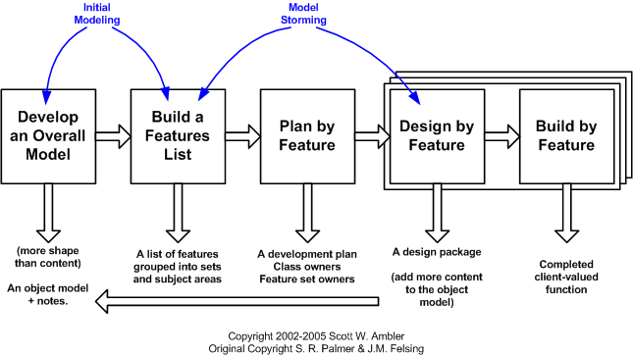
Figure 3-29 Methodology

Build a Features list

- Login and registration
- Take User requirements as preferences
- Company can post trips
- User can search trips
- User can request trip
- Data Searching
- Automatic data selection according to the clients requirement
- Recommend clients about best tour plans
- Help Desk for queries
- Admin Panel to control system

Build by feature

We build our project according to the feature list.

Recommendation Technique

Our trip recommender system is based on regional based recommendation technique in which user select different regions as preferences and COMPATO will select the best trip deals under the limitations of user time, cost and other requirements. This technique also based on knapsack problem to show most visited and latest trip deals to our users. Recommender system select available trip deals based on regions and match these trips with searching parameters of a user. Regional based recommendation technique is provide Best result in travel recommendations. In which we user selects different regions and system show a composite suggestions according to the selected regions [5].

DATA AND EXPERIMENTS

Languages used for implementation

Html

Html stands for hypertext mark-up language (HTML) is a language which is used to create web pages and web applications. This is the front end language used to show content on web pages.

CSS

CSS stands for cascading style sheet. CSS defines how HTML elements are shown on screen and used for the styling of front-end content.

JavaScript

JavaScript is a programming language which describes the behaviour of web pages. JavaScript code is written between the starting and ending tag of the script. It is used for event handling.

SQL

SQL stands for structure quarry language used for storing, manipulating and retrieving data from the database. That is why it is being used in this project because there are certain forms which are used to store and manipulate information.

PHP

PHP stands for hypertext pre-processor. PHP is an open-source scripting language. PHP Code is written between the starting and ending tag of PHP. For the backend of this project, PHP is used.

Tools used for Implementation

XAMPP

In this project, it is used for the local host of data. This host is counting the database of the project in which there are a collection of tables and each table holds data.

Framework

Frameworks which we used to develop our project are:

Bootstrap

Bootstrap is a free and open-source CSS framework directed at responsive, mobile-first front-end web development. It contains CSS- and JavaScript-based design templates for typography, forms, buttons, navigation, and other interface components

RESULTS AND DISCUSSIONS

Search Deals at COMPATO

User can select Present location, destination location, check-in date, check-out date and budget to find best trip deals according to their searching parameters.
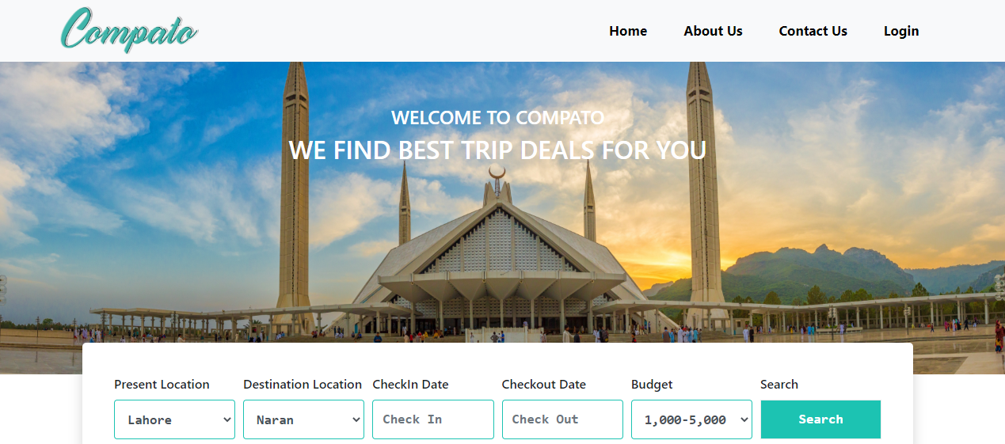
Figure 5-1: Search Deals at COMPATO

Sign up in COMPATO

User needs to signup if they want to check their recent searches, request customize trip plans or post trip deals.
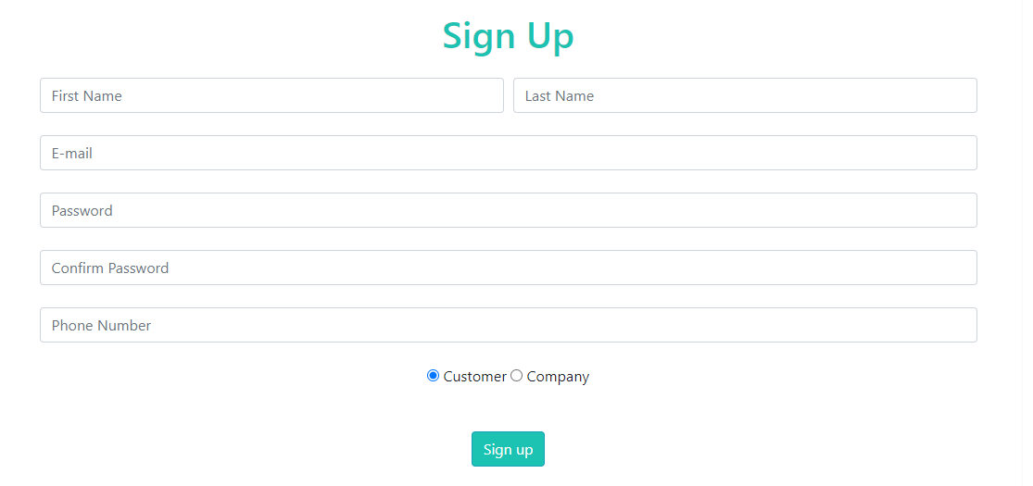
Figure 5-2: Register in COMPATO

Login in COMPATO

User or company needs to login if they want to access their account.
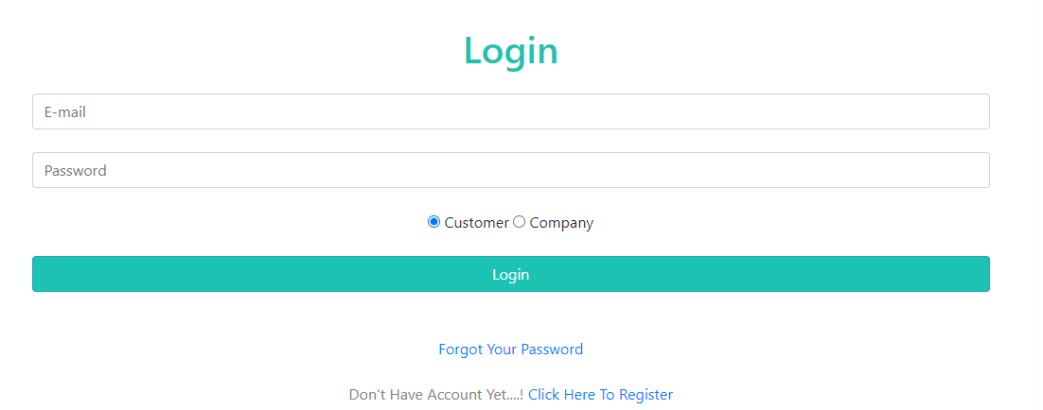
Figure 5-3: Login in COMPATO

Select Preferences

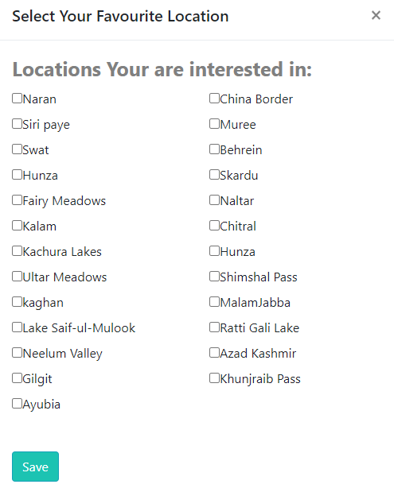
Users will select region based preferences to get recommendations on the basis of preferences when they login in to the system first time. They also can change preferences from their dashboard later.
Figure 5-4: Select Preferences

Recommendations according to Preferences

When user selects preferences then system will show the best trip deals available on database matching with user’s preferences.
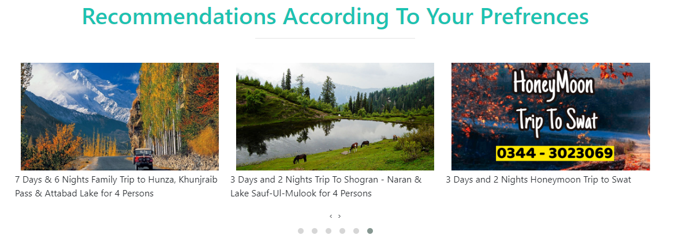
Figure 5-5: Recommendations According to Preferences

Latest Trip Deals

System will also show the latest trip deals to the users.
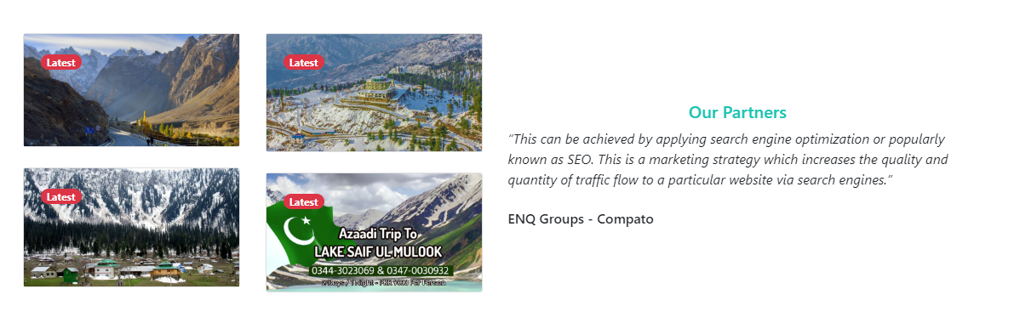
Figure 5-6: Latest Trip Deals

Best Deals

Best deals are most visited trip deals available on platform. Best deals helps the user to find trip deals in less time with less complication.
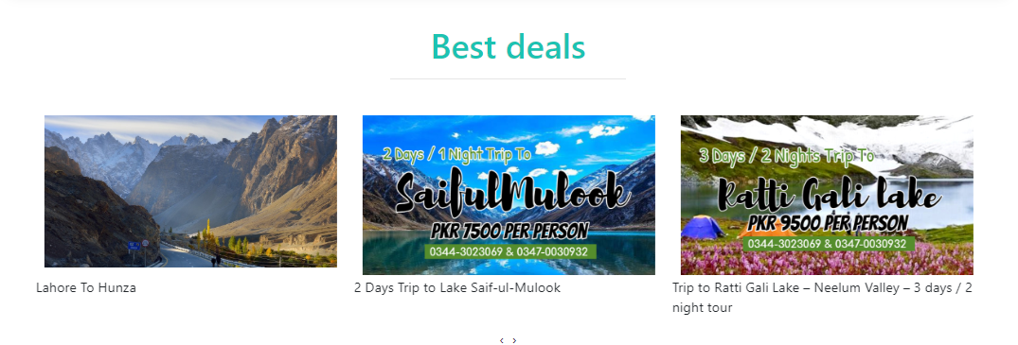
Figure 5-7: Best Deals

User Dashboard

User can change password, check recent searches and request a customize trip plan by using User Dashboard.

Change Preferences
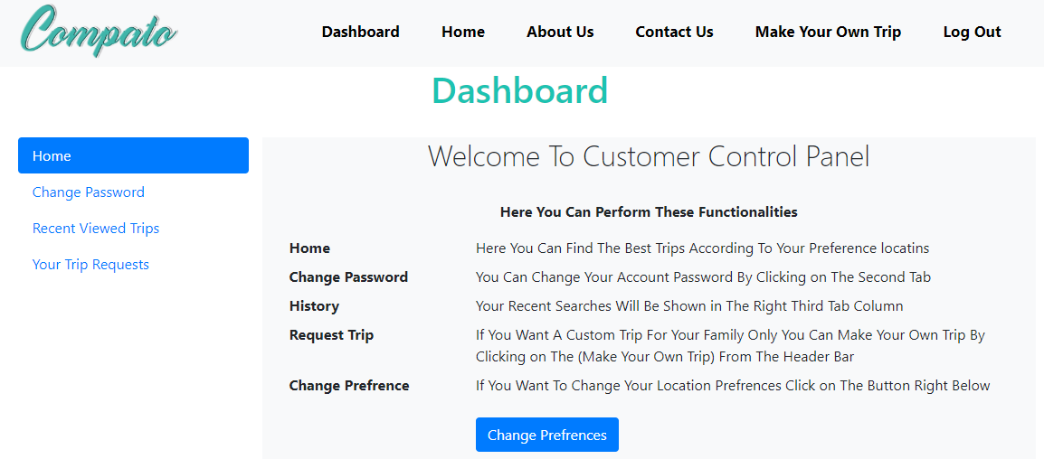
Figure 5-8: Change Preferences

Change Password
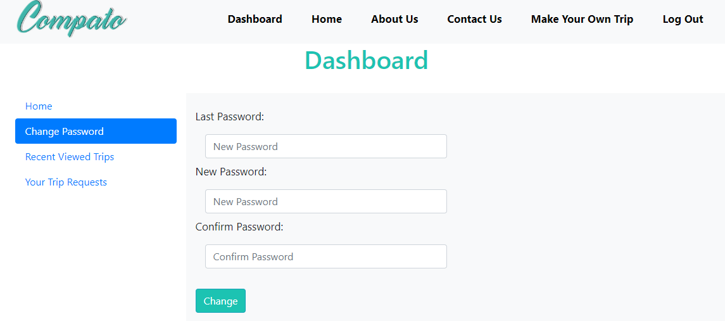
Figure 5-9: Change Password

Recent Viewed Trips
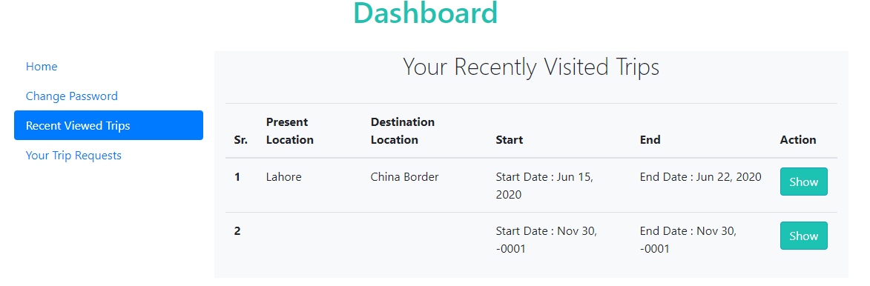
Figure 5-10: Recent Viewed Trips

Trip Requests
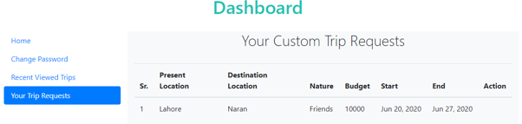
Figure 5-11: Trip Requests

Make own Trip

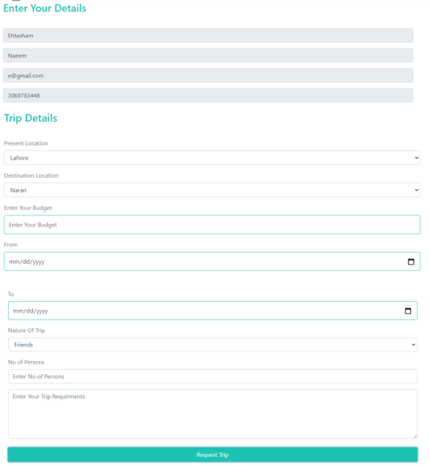
Users can request a customize trip if they did not find any trip deal according to their requirements. Customize trip requests will show on companies dashboard and any company can contact with the user to provide a trip deal according to their requirements.
Figure 5-12: Make own Trip

Company Dashboard
Company can change password, check recent searches, trip request from users and posted trips by using company dashboard.

Trip Requests

Figure 5-13: Trip Requests
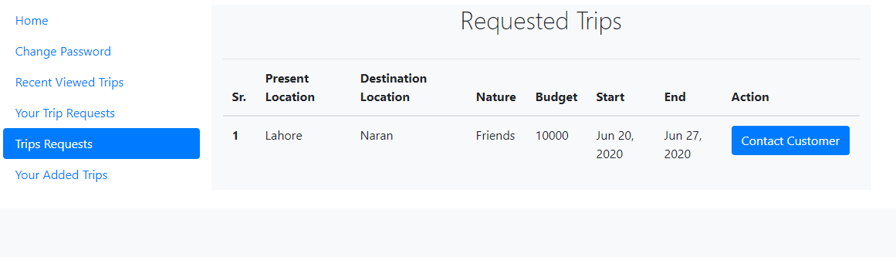

Added Trips
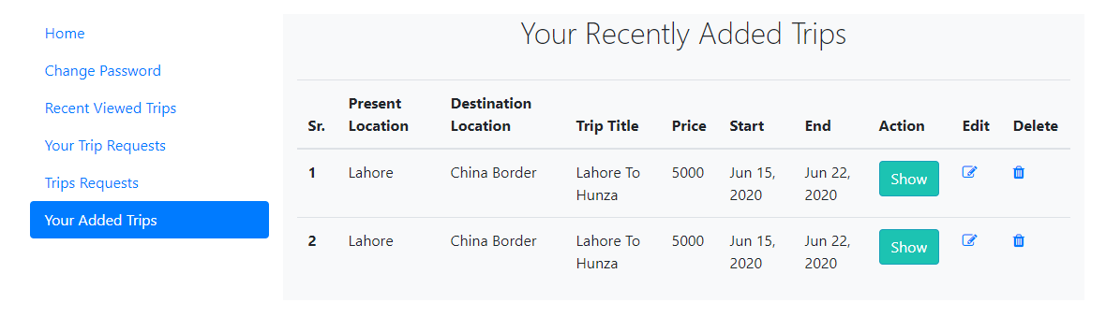
Figure 5-14: Added Trips

Organize Trip

A company can organize a trip plans on COMPATO. Which will be posted on platform after admin verification.
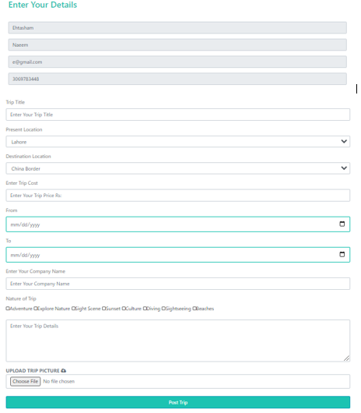
Figure 5-15: Organize Trip

Admin Panel

Admin can perform basic operation to control users and trip deals on COMPATO.
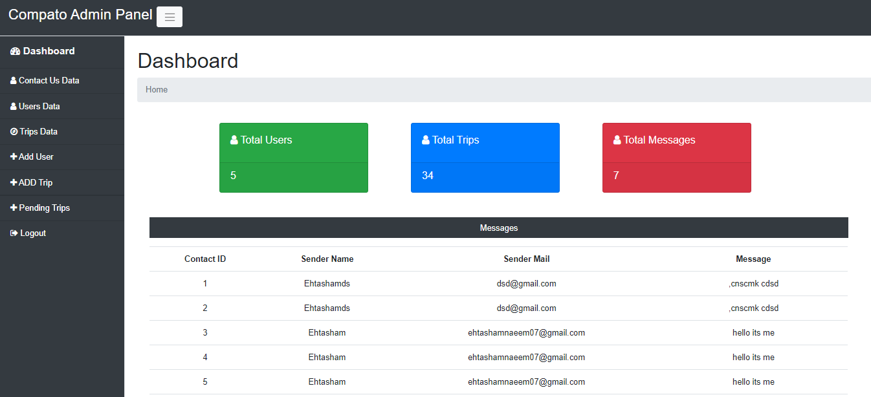
Figure 5-16: Admin Panel

User Data

Admin can check the users available on platform and also can update or delete a particular user’s data.
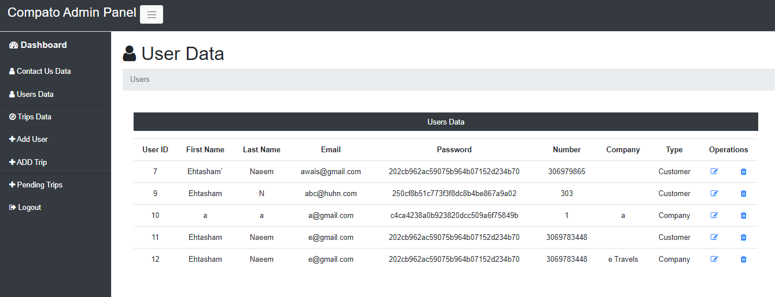
Figure 5-17: User Data

Trips Data

Admin can check the trips data and also can update or delete a particular trip’s data
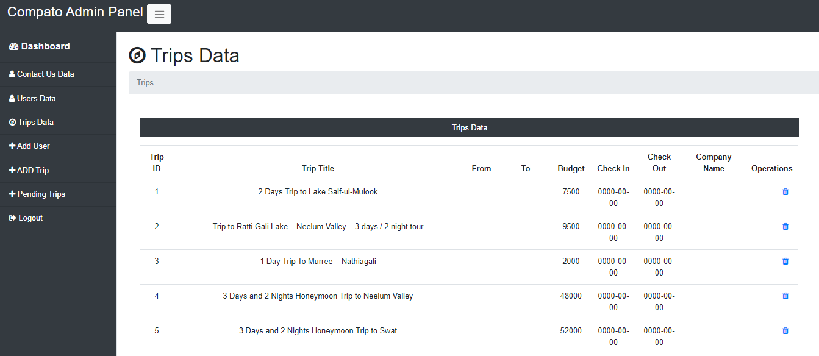
Figure 5-18: Trips Data

Add User

Admin can add a user.
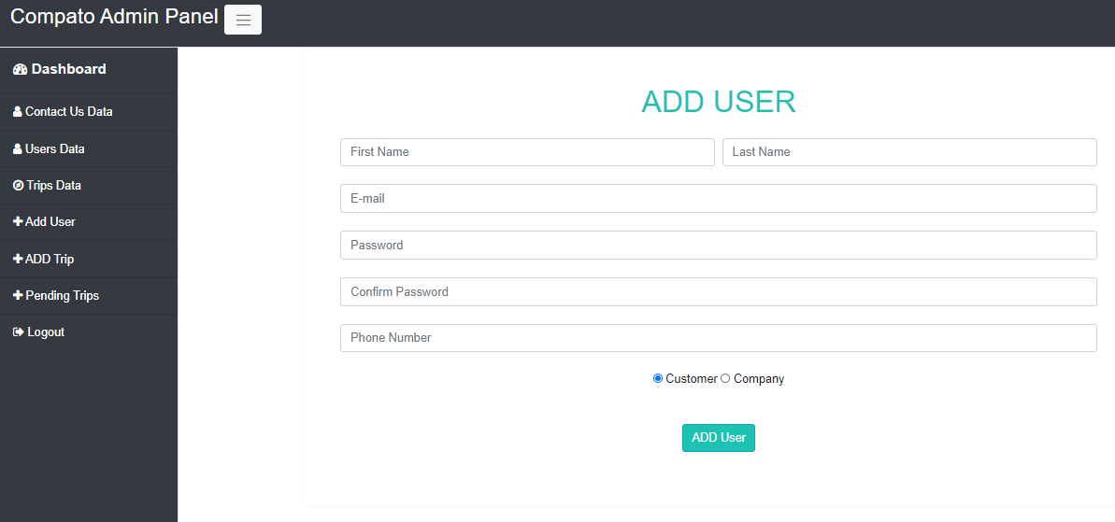
Figure 5-19: Add User

Add Trip

Admin can add a trip deal.
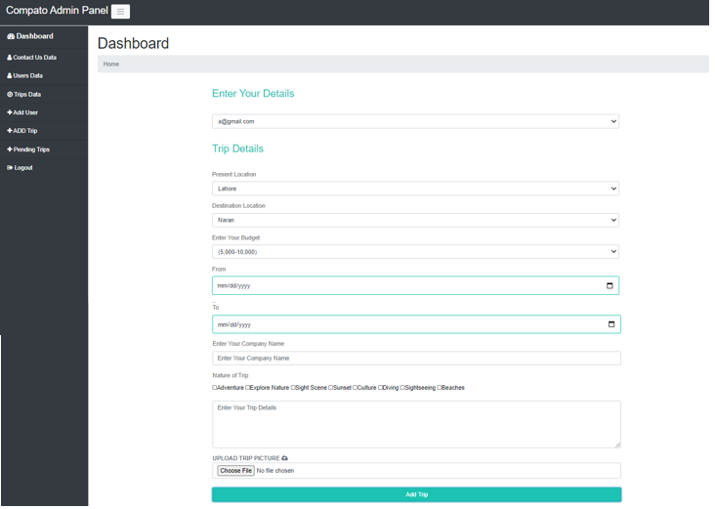
Figure 5-20: Add Trip

Pending Trips

Admin can post the companies trip deals after checking the trip details.
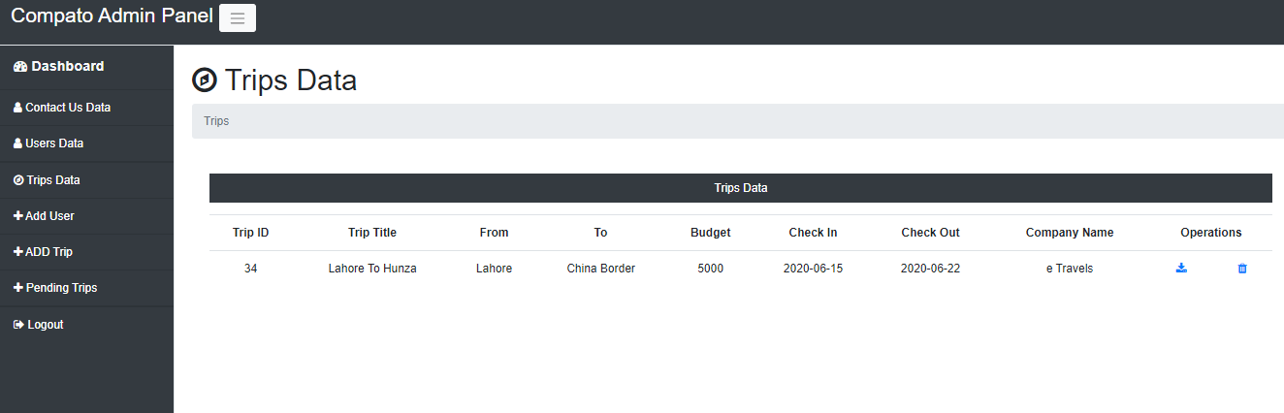
Figure 5-21: Pending Trips

Contact us
User can leave a message or suggestion by using contact us page.
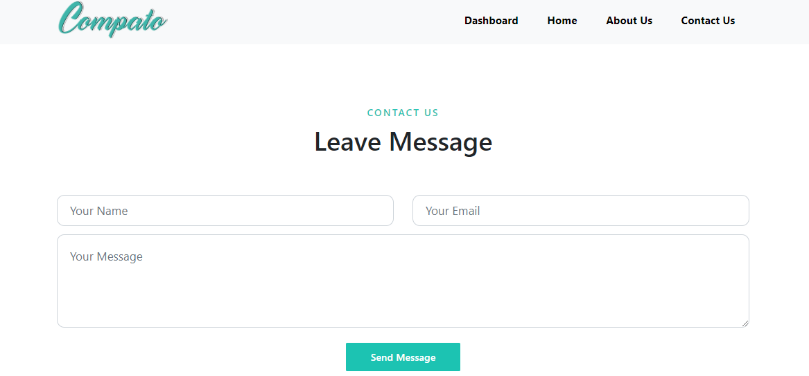
Figure 5-22: Contact us

Help Desk

Users can solve their queries by using Help desk

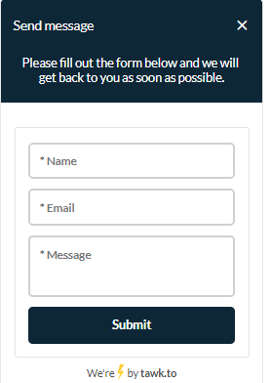

Figure 5-23: Help Desk

CONCLUSION AND RECOMMENDATIONS

Conclusion and Recommendations

COMPATO will provide best trip deals across Pakistan. This platform will be equally beneficial for trip organizers and tourists. Trip Organizers can post trip deals and tourist can find trip deals according to their preferences. This platform provides a proper channel to local trip organizers to organize trip plans and promote tourism in Pakistan. In future will we post blogs and guidelines for trip destination and attract more tourists by modern recommendation techniques and collaboration with other platforms.

REFERENCES

[1] M. I. Arshad, M. A. Iqbal, and M. Shahbaz, “Pakistan tourism industry and challenges: a review,” Asia Pacific J. Tour. Res., vol. 23, no. 2, pp. 121–132, 2018.
[2] Q. M. Adnan Hye and R. E. Ali Khan, “Tourism-Led Growth Hypothesis: A Case Study of Pakistan,” Asia Pacific J. Tour. Res., vol. 18, no. 4, pp. 303–313, 2013.
[3] F. Ricci, L. Rokach, and B. Shapira, Recommender Systems Handbook, no. June 2014. 2011.
[4] I. Cantador, P. Castells, and A. Bellogín, “An enhanced semantic layer for hybrid recommender systems: Application to news recommendation,” Int. J. Semant. Web Inf. Syst., vol. 7, no. 1, pp. 44–78, 2011.
[5] D. Herzog and W. Wörndl, “A travel recommender system for combining multiple travel regions to a composite trip,” CEUR Workshop Proc., vol. 1245, pp. 42–47, 2014.

