
BSIT-F19-005
03-135162-010 | ASADULLAH ATIQ
03-135162-039 | USAMA BIN IJAZ

Team Transport

In partial fulfilment of the requirements for the degree of
Bachelor of Science in Information Technology
Supervisor: Muhammad Hanif
Department of Computer Sciences
Bahria University, Lahore Campus

July 2020

© Bahria University, 2020

Certificate

We accept the work contained in the report titled
“Team Transport”
written by
ASADULLAH ATIQ
USAMA BIN IJAZ

as a confirmation to the required standard for the partial fulfilment of the degree of
Bachelor of Science in Information Technology.

Approved by:
Supervisor: Muhammad Hanif
(Signature)

July 20, 2020

DECLARATION

We hereby declare that this project report is based on our original work except for citations and quotations which have been duly acknowledged. We also declare that it has not been previously and concurrently submitted for any other degree or award at Bahira University or other institutions.

Enrolment | Name | Signature
03-135162-010 | ASADULLAH ATIQ
03-135162-039 | USAMA BIN IJAZ

Date : July 2020

Specially dedicated to
my beloved grandmother, mother and father
(ASADULLAH ATIQ)
my beloved grandmother, mother and father
(USAMA BIN IJAZ)

ACKNOWLEDGEMENTS

We would like to thank everyone who had contributed to the successful completion of this project. We would like to express our gratitude to my research supervisor, Muhammad Hanif for his invaluable advice, guidance and his/her enormous patience throughout the development of the research.

In addition, we would also like to express my gratitude to our loving parent and friends who had helped and given me encouragement.

ASADULLAH ATIQ
USAMA BIN IJAZ

Team Transport

ABSTRACT

The purpose of this project is to mechanize vehicle reservation system so that customer do not need to call and spend unnecessary time in order to reserve a vehicle. This project consists of one part which is the mobile application through which a user can book his ride along with the number of labours.
The objective of this project is to mechanize vehicle reservation so that customer do not need to call and spend unnecessary time in order to reserve a vehicle. Our system allows the customer to book a vehicle from a mobile application. The online vehicle booking system sets up a vehicle menu online and customers can easily book the vehicle as per their wish. After booking vehicle customer can select number of labours, add payment method and edit their booked ride. This system can also provide the feedback system in which user can rate the ride.

TABLE OF CONTENTS

DECLARATION ii
ACKNOWLEDGEMENTS iv
ABSTRACT v
TABLE OF CONTENTS vi
LIST OF TABLES viii
LIST OF FIGURES ix

CHAPTERS
1 INTRODUCTION 1
1.1 Background 2
1.2 Problem Statements 2
1.3 Aims and Objectives 2
1.4 Scope of Project 3
2 Software Requirement Specification 4
2.1 Introduction 4
2.2 Purpose 4
2.3 User classes and characteristics 5
2.3.1 User 5
2.3.2 Driver 5
2.3.3 Admin 5
2.4 Operating Environment 6
2.4.1 Hardware Environment 6
2.4.2 Software Environment 6
2.5 Designing and Implementation Constraints 6
2.6 Assumptions and Dependencies 6
3 DESIGN AND METHODOLOGY 7
3.1 Development Plan 7
3.2 Methodology 8
3.3 System Use Case 8
3.4 Collaboration Diagram 16
3.5 Sequence Diagram 17
3.6 Design Class Diagram 20
3.7 Data Model 20
4 IMPLMENTATION 22
4.1 Implementation 22
4.1.1 Application (Android) 23
5 RESULTS 24
5.1 Mobile Application 24
5.1.1 Login activity for user and driver 24
5.1.2 User Menu 25
5.1.3 Driver Menu 26
5.1.4 History Activity 27
5.1.5 User Booking a ride 28
5.1.6 Driver finding customer 29
5.1.7 Driver vehicle registration 30
6 CONCLUSION 31
6.1 Conclusion 31
REFERENCES 32

LIST OF TABLES

TABLE TITLE PAGE

Table 3.1: User registration and signup 10
Table 3.2: Login Activity for Driver and User 10
Table 3.3: Booking a Ride 11
Table 3.4: Provision to add labour for pickup 11
Table 3.5: Accept or Reject ride 12
Table 3.6: Location Update 13
Table 3.7: Contact Rider/ Customer 13
Table 3.8: Geo location on google maps 13
Table 3.9: Payment delivery method 14
Table 3.10: Reviews about the ride 14
Table 3.11: View ride Information/ History 15
Table 3.12: Admin panel for record upgradation 16

LIST OF FIGURES

FIGURE TITLE PAGE
Figure 3.1: System Use Case 9
Figure 3.2: Collaboration Diagram 17
Figure 3.3: User (a) 18
Figure 3.4: User (b) 18
Figure 3.5: Driver (a) 19
Figure 3.6: Driver (b) 19
Figure 3.7: Design Class Diagram 20
Figure 3.8: Data Model 21
Figure 5.1: Login Page 24
Figure 5.2: User main screen (a) 25
Figure 5.3: User main screen (b) 25
Figure 5.4: Driver main screen(a) 26
Figure 5.5: Driver main screen (b) 26
Figure 5.6: User History 27
Figure 5.7: Driver History 27
Figure 5.8: Selecting the type of vehicle 28
Figure 5.9: Searching driver 28
Figure 5.10: Driver Info 29
Figure 5.11: Driver starts working 29
Figure 5.12: Accept the ride 30
Figure 5.13: Vehicle registration 30

INTRODUCTION
The purpose of this project is to mechanize vehicle reservation system so that customer do not need to call and spend unnecessary time in order to reserve a vehicle. This project consists of one part which is the mobile application through which a user can book his ride along with the number of labours.
The objective of this project is to mechanize vehicle reservation so that customer do not need to call and spend unnecessary time in order to reserve a vehicle. Our system allows the customer to book a vehicle from a mobile application. The online vehicle booking system sets up a vehicle menu online and customers can easily book the vehicle as per their wish. After booking vehicle customer can select number of labors, add payment method and edit their booked ride. This system can also provide the feedback system in which user can rate the ride.
The system includes the procedure of the client booking a vehicle and number of labors by phone. The data will be sent to our computer database system choosing vehicle. The service will run at a time assigned by client. The following are the vehicles and the maximum number of labors,
Types of vehicles Maximum Labor
- Pickup 1-2
- Shahzore 2-3
- Mazda 2-3
Our application is fully optimized. In this application customer can also book vehicle advance. Ride will be automatically sent to nearby drivers. The application is supported with different languages (Urdu, English).

Background

The process of house moving is not a new one, nor it is a simple challenge to tackle. A move can be to a nearby location within the same neighbourhood, a much farther location in a different city, or sometimes a different country. It usually includes packing up all belongings, transferring to the new home, and unpacking, as well as administrative or bureaucratic tasks, such as changing registration data, change of insurance, service, etc.
In a country like Pakistan there are many hurdles that come in our way while moving to a new house like trucks are not available, shortage of labour, demanding heavy money, waste of time finding the vehicle you need, etc. Our project is made by considering these problems in mind.

Problem Statements

The process of moving in a new house is not an easy task in a country like Pakistan. You have to face many problems like, wastage of time: Finding the vehicle of your type, if you found one then there is a challenge of finding the number of labours you need and in the last the negotiating process. This application will provide the cost efficient and time saving solution. The person only needs to download a mobile application from which he selects all the options he wants by staying home.

Aims and Objectives

The objectives of the thesis are shown as following:
- To design an application that helps a person to book vehicle and number of labours without wasting time.
- To design an application that provide full security of user’s luggage.
- To design an application that provide ease for both the user and the driver.
- To design an application that help the user to track their ride.
- To design an application which will also be beneficial to truck drivers as well.

Scope of Project

This project is going to be a full-fledged application with almost all the features a person needs who intends to move to a new house. The main objective of this application is to provide ease to the user so that without wasting any time he/she can book a vehicle of his/her choice with the number of labours they want to full fill their need, by sitting in home. The vehicle arrives at their doorsteps and take their luggage to the destination they marked. This application is beneficial to both the driver and the user.

Software Requirement Specification

Introduction

This Software Requirement Specification (SRS) document provides a complete description of all the functionalities and the specifications of TT (Team Transport). The developers and the testers can use this document as a guideline for developing the design and test plan documents.

Purpose

The purpose of this document is to present a detailed description of the Team Transport that we will design and implement. It will explain the purpose and features of the system, the interfaces of the system, what the system will do, what the system will do or how the system will interact with the external users, the constraints under which it must operate. The Software Requirements Specification document is intended to provide the requirements of the Team Transport project and the expectations of the stakeholders. The document includes the project perspective, data model and constraints of the overall system. Project managers review the document and determine whether the planned system fulfils the requirements. They notify the developers to fill up missing parts. Developers provide consistency by using the documentation. Testers use the documentation for verification and validation. End users make use of this document to learn about the scope of the system and its capabilities.

User classes and characteristics

User

User open the team transport application. First the user create account, they enter the required information. Application will confirm username and password. After the user is registered, menu appears in which he/she can select the option which are book a ride,
Setting, history. If a user clicks a book a ride option a map appears to his screen in which he has to mark a pickup location after the location is marked the user need to select the type of vehicle and the number of labours as per his choice. By clicking on confirm ride the drive came to the location to pick luggage along with the selected number of labours. the user can track the ride by viewing map on his application.

Driver

Driver open the team transport application. First, they create account. Application will save all the information of driver along with the vehicle he registered with. After the driver is registered, menu appears in which by pressing on go online button his vehicle is ready to be booked, whenever a user books a ride the driver gets a notification of incoming ride which he can accept and reject. After the ride is accepted, he has to take the number of labours selected by the user along with him.

Admin

Admins will check the system like update, delete and view profile. Admin update the file by entering new information. Admin delete the profile by clicking delete option. System show the confirmation message for both action delete and update.

Operating Environment

Hardware Environment

Laptop is required for designing and coding of the front end and back end of mobile application as per requirement we need android mobile devices for performing the functionality of the application.

Software Environment

Java platform is used for android application. Can easily run on all devices.

Designing and Implementation Constraints

Tea, Transport is based on one module which is android application. Android application backend developing using java language with firebase database.
An internet connection is required for application to work.

Assumptions and Dependencies

Team Transport has a Database so one assumption about the product is that user must have access to database from Mobile Application. Another assumption is that users must have data connection on their mobile devices so that the database can update on real time. Internet is required for the GPS. Whereas it won’t affect database on mobile application as the data will be cached and the database will be updated whenever the connection is available.

DESIGN AND METHODOLOGY

Development Plan

Team Transport is a mobile application that help user in finding vehicle and the number of labours of their choice. User open the team transport application. First the user create account, they enter the required information. Application will confirm username and password. After the user is registered, menu appears in which he/she can select the option which are book a ride, Setting, history. If a user clicks a book a ride option a map appears to his screen in which he has to mark a pickup location after the location is marked the user need to select the type of vehicle and the number of labours as per his choice. By clicking on confirm ride the drive came to the location to pick luggage along with the selected number of labours. the user can track the ride by viewing map on his application. Driver open the team transport application. First, they create account. Application will save all the information of driver along with the vehicle he registered with. After the driver is registered, menu appears in which by pressing on go online button his vehicle is ready to be booked, whenever a user books a ride the driver gets a notification of incoming ride which he can accept and reject. After the ride is accepted, he has to take the number of labours selected by the user along with him. Admins will check the system like update, delete and view profile. Admin update the file by entering new information. Admin delete the profile by clicking delete option. System show the confirmation message for both action delete and update.

Methodology

We use agile methodology in our project, because with its greater adaptability to frequently changing scope uses iterative or phased planning and continuous integration. The key principle is to keep the project scope soft. The methodology promotes collaboration and results in increased customer satisfaction.

- Scrum Meeting
- Back log
- Sprint

We use agile methodology in our project, because with its greater adaptability to frequently changing scope uses iterative or phased planning and continuous integration. The key principle is to keep the project scope soft. The methodology promotes collaboration and results in increased customer satisfaction.

- Scrum Meeting
- Back log
- Sprint

System Use Case

The whole Use case elaborates the complete Team Transport that how system will work, and all actors will interact with Team Transport system. Team Transport contain 12 Use case having extends and include functionalities. All the actors can perform their specific function which can be shown in this use case Diagram.

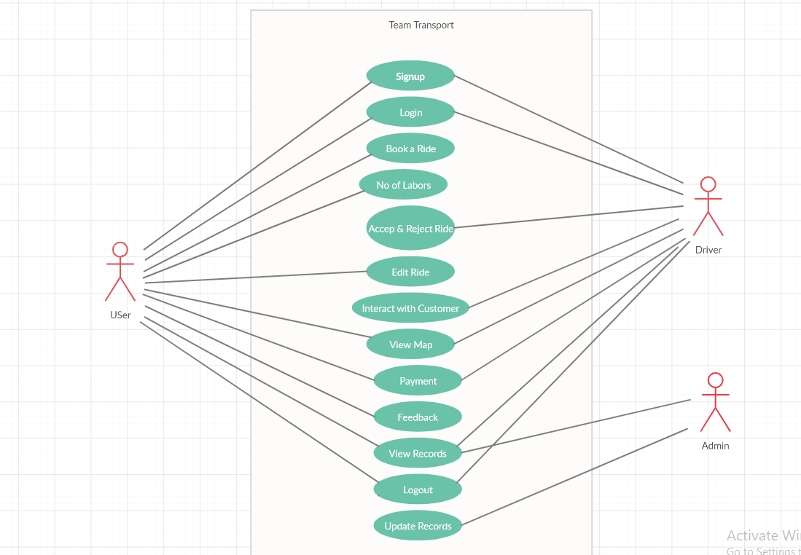
Figure ‎3.1: System Use Case

Table 3.1: User registration and signup
Name | Signup
Unique Identifier | U1
Objective | User & Driver must register in order to use application.
Priority | High
Source | Any user & driver
Actors | User & Driver
Flow of Events | - User & Driver installs the app.  - Make a connection between Wi-Fi and smart device.  - Must register in order to use the application.
Includes | None
Pre-Conditions | Wi-Fi should be enabled.
Post-Conditions | Application will perform tasks as per given commands.
Notes/Issues | None

Table 3.2: Login Activity for Driver and User
Name | Login
Unique Identifier | U2
Objective | User and Driver have to login to their accounts to go further.
Priority | High
Source | Any user and driver
Actors | Users & Driver
Flow of Events | First Login to the application.  The menu will open after the login.
Includes | U1
Pre-Conditions | Application should be connected to Wi-Fi.  Service seeker must be registered.

Table 3.3: Booking a Ride
Name | Booking a Ride
Unique  Identifier | U3
Objective | User will book a ride, three types of vehicle appears after the user have successfully logged in.
Priority | High
Source | Any User
Actors | User
Flow of  Events | After user clicks on booking the user have to select the vehicle, he wants in order to fulfil his requirements. There are three types of vehicle appear after clicking on booking  - Suzuki  - Mazda  - Shahzore
Includes | U2
Pre-Conditions | User must have an account and his device must be connected to the Wi-Fi.
Post-  Conditions | Driver is assigned to the user along with the chosen vehicle and require number of labours.
Notes/Issues | None

Table 3.4: Provision to add labour for pickup
Name | No of Labours
Unique  Identifier | U4
Objective | After selecting the vehicle user can select the no of labours as per his requirement.
Priority | Medium
Source | Any user
Actors | Users
Flow of Events | After booking a ride the user must select the numbers of labours.  Request is sent to the driver
Includes | U2, U3
Pre-Conditions | User must have selected a vehicle.
Post-Conditions | Request will be sent to the nearby drivers
Notes/Issues | None

Table 3.5: Accept or Reject ride
Name | Accept & Reject
Unique  Identifier | U5
Objective | If the driver fulfils the requirement of a ride, then he can accept otherwise he can reject
Priority | High
Source | Driver
Actors | Driver
Flow of Events | Request is sent by the user to driver along with the type of vehicle and labours. Then he will accept the ride
Includes | U3, U4
Pre-Condition | User must have selected the number of labor and type of vehicle.
Post-  Conditions | Driver is assigned to the user.

Table 3.6: Location Update
Name | Edit Ride
Unique  Identifier | U6
Objective | If the user wants to change the location or the number of labors, he can click on edit ride.
Priority | Low
Source | Any User
Actors | Users

Table 3.7: Contact Rider/ Customer
Name | Interact with customer.
Unique Identifier | U7
Objective | It helps the communication between user and the driver
Priority | Medium
Source | User & Driver
Actors | User & Driver
Flow of Events | If anyone want to communicate their contacts are shared with each other.
Includes | U3
Pre-Conditions | Ride must be booked.
Post-Conditions | Both driver and user can track.
Notes/Issues | None

Table 3.8: Geo location on google maps
Name | View Map
Unique Identifier | “U8
Objective | Helps the user and driver to track
Priority | Medium
Source | User & Driver
Actors | User & Driver
Flow of Events | User can track the ride after pickup  Driver can track the location.
Includes | U3
Pre-Conditions | Ride must be booked
Post-Conditions | After completing ride user must pay the calculated amount.
Notes/Issues | None

Table 3.9: Payment delivery method
Name | Payment
Unique Identifier | U9
Objective | Amount is calculated based on vehicle, labour’s and distance.
Priority | High
Source | User & Driver
Actors | User & Driver
Flow of Events | After the ride is completed the calculated amount is appears on the app
Includes | U3
Pre-Conditions | Ride must complete
Post-Conditions | After the payment is done user have to give an optional feedback
Notes/Issues | None

Table 3.10: Reviews about the ride
Name | Feedback
Unique Identifier | U10
Objective | User have to evaluate the service
Priority | Low
Source | User
Actors | User
Flow of Events | After the completing ride and payment user must give an optional feedback.
Includes | U9
Pre-Conditions | Payment should be cleared
Post-Conditions | None
Notes/Issues | None

Table 3.11: View ride Information/ History
Name | View Records
Unique Identifier | U11
Objective | Admin user and driver can see the ride history
Priority | Medium
Source | User, Driver and Admin
Actors | User, Driver and Admin
Flow of Events | By clicking on view records admin, user and driver can see the history of ride
Includes | None
Pre-Conditions | None
Post-Conditions | None
Notes/Issues | None

Table 3.12: Admin panel for record upgradation
Name | Update records
Unique Identifier | U12
Objective | If the driver changes the vehicle, he has to ask admin to update the records
Priority | Low
Source | Admin
Actors | Admin
Flow of Events | Admin can update the record of the driver
Includes | None
Pre-Conditions | None
Post-Conditions | After the payment is done user have to give an optional feedback
Notes/Issues | None

Collaboration Diagram

A collaboration diagram describes a pattern of interaction among objects; it shows the objects participating in the interaction by their links to each other and the messages that they send to each other. Collaboration diagrams are used to show how objects interact to perform the behaviour of a use-case, or a part of a use-case. Along with sequence diagrams, collaborations are used by designers to define and clarify the roles of the objects that perform a flow of events of a use-case. They are the primary source of information used to determining class responsibilities and interfaces.

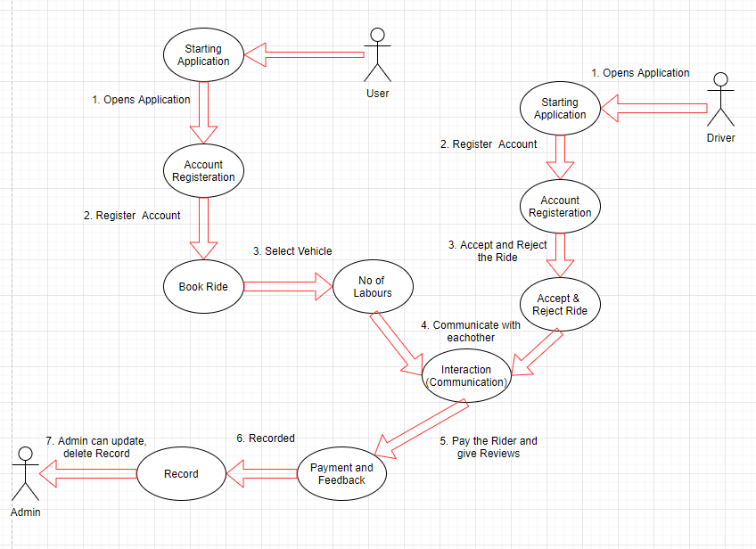
Figure ‎3.2: Collaboration Diagram

Sequence Diagram

A Sequence diagram depicts the sequence of actions that occur in a system. The invocation of methods in each object, and the order in which the invocation occurs is captured in a Sequence diagram. This makes the Sequence diagram a very useful tool to easily represent the dynamic behaviour of a system.

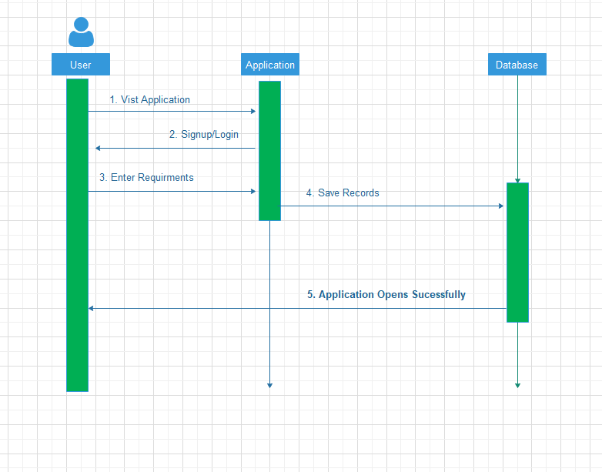
Figure ‎3.3: User (a)
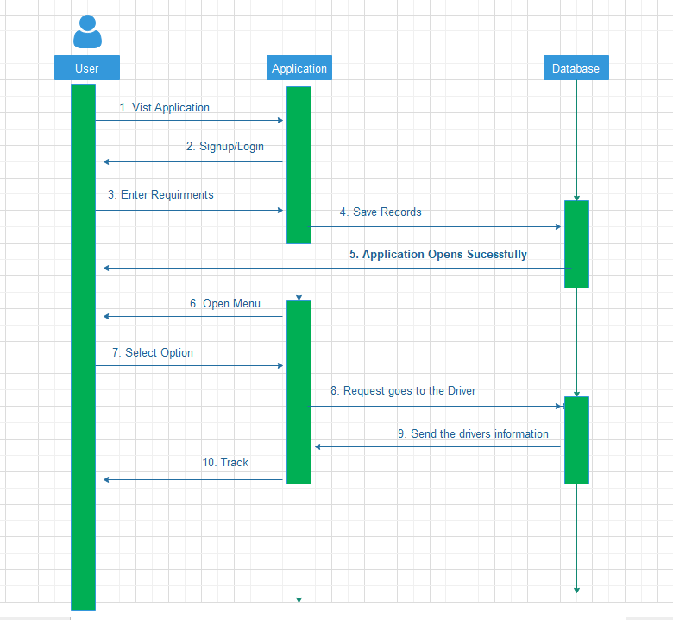

Figure ‎3.4: User (b)
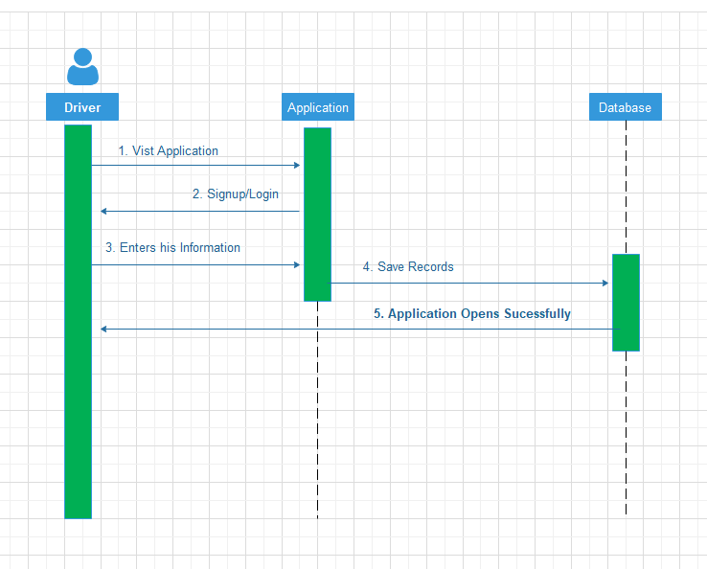

Figure ‎3.5: Driver (a)
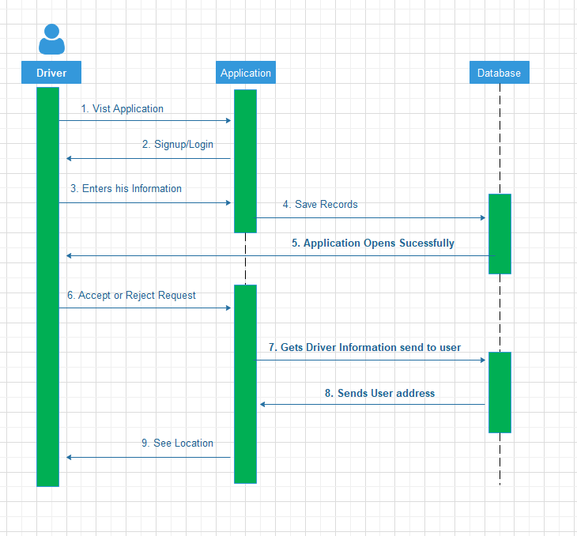
Figure ‎3.6: Driver (b)

Design Class Diagram

Classes are the workhorses of the design effort—they perform the real work of the system. The other design elements—subsystems, packages and collaborations simply describe how classes are grouped or how they interoperate.
Active classes are design classes, which coordinate and drive the behaviour of the passive classes - an active class is a class whose instances are active objects, owning their own thread of control.

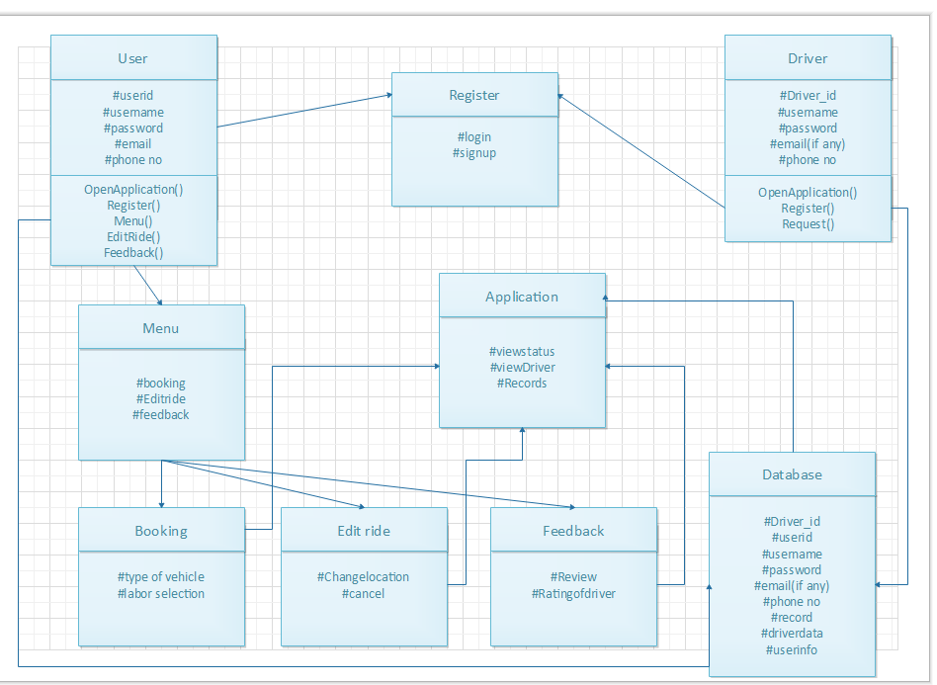
Figure ‎3.7: Design Class Diagram

Data Model

The data model is a subset of the implementation model, which describes the logical and physical representation of persistent data in the system.
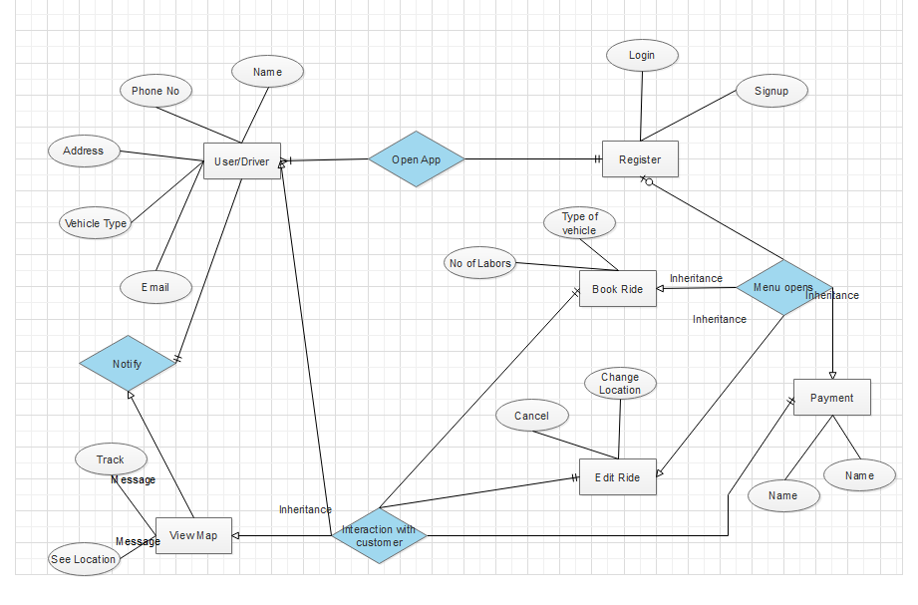
Figure ‎3.8: Data Model

IMPLMENTATION

Implementation

Team Transport is a mobile application that help user in finding vehicle and the number of labours of their choice. User open the team transport application. First the user create account, they enter the required information. Application will confirm username and password. After the user is registered, menu appears in which he/she can select the option which are book a ride, Setting, history. If a user clicks a book a ride option a map appears to his screen in which he has to mark a pickup location after the location is marked the user need to select the type of vehicle and the number of labours as per his choice. By clicking on confirm ride the drive came to the location to pick luggage along with the selected number of labours. the user can track the ride by viewing map on his application. Driver open the team transport application. First, they create account. Application will save all the information of driver along with the vehicle he registered with. After the driver is registered, menu appears in which by pressing on go online button his vehicle is ready to be booked, whenever a user books a ride the driver gets a notification of incoming ride which he can accept and reject. After the ride is accepted, he must take the number of labours selected by the user along with him. Admins will check the system like update, delete and view profile. Admin update the file by entering new information. Admin delete the profile by clicking delete option. System show the confirmation message for both action delete and update.

Application (Android)

User open the team transport application. First the user create account, they enter the required information. Application will confirm username and password. After the user is registered, menu appears in which he/she can select the option which are book a ride, Setting, history. If a user clicks a book a ride option a map appears to his screen in which he has to mark a pickup location after the location is marked the user need to select the type of vehicle and the number of labours as per his choice. By clicking on confirm ride the drive came to the location to pick luggage along with the selected number of labours. the user can track the ride by viewing map on his application. Driver open the team transport application. First, they create account. Application will save all the information of driver along with the vehicle he registered with. After the driver is registered, menu appears in which by pressing on go online button his vehicle is ready to be booked, whenever a user books a ride the driver gets a notification of incoming ride which he can accept and reject. After the ride is accepted, he has to take the number of labours selected by the user along with him. Admins will check the system like update, delete and view profile.

RESULTS

Mobile Application

Login activity for user and driver
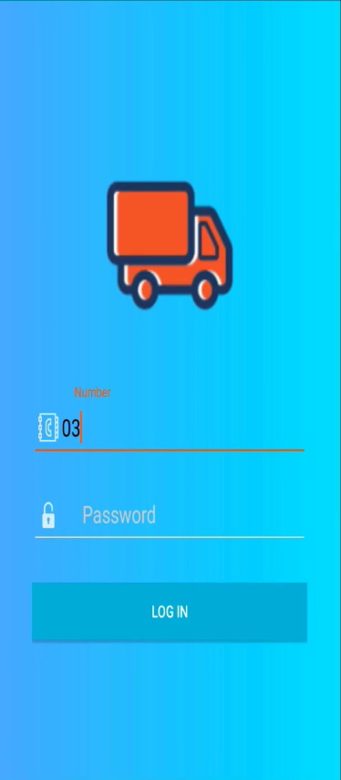

Figure 5.1: Login Page

User Menu

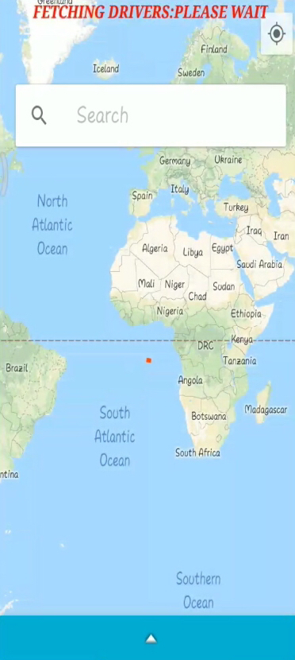

Figure 5.2: User main screen (a)

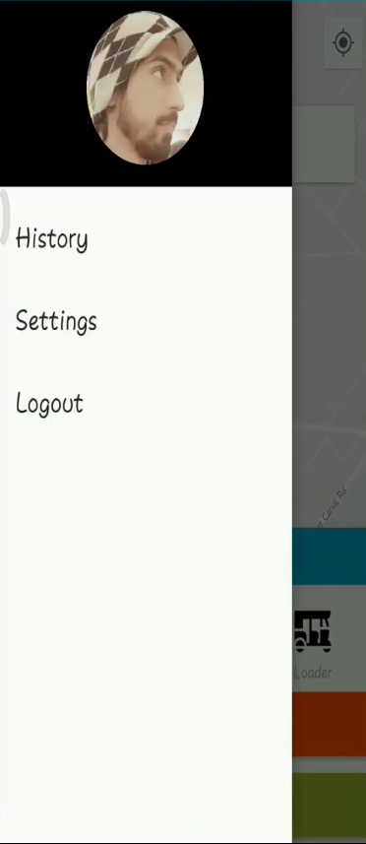

Figure 5.3: User main screen (b)

Driver Menu

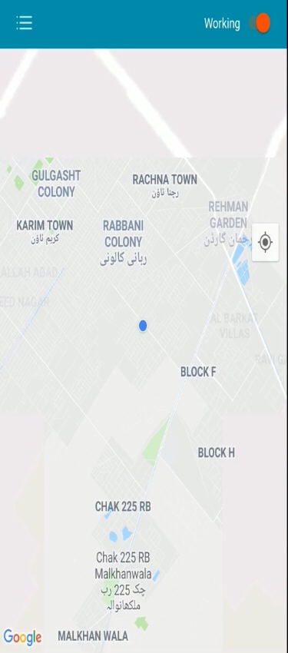

Figure 5.4: Driver main screen(a)

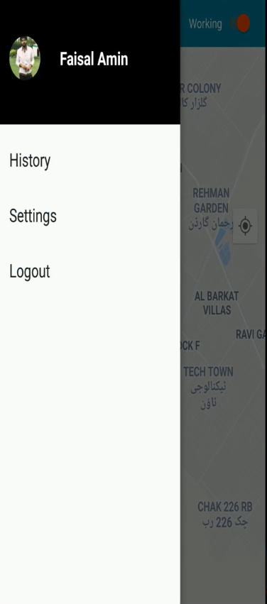

Figure 5.5: Driver main screen (b)

History Activity

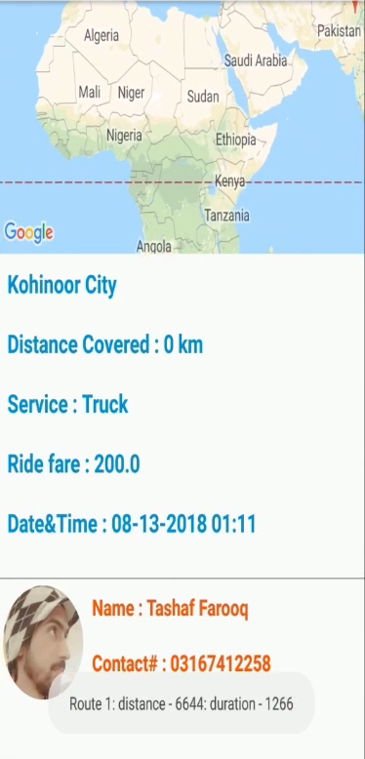

Figure 5.6: User History

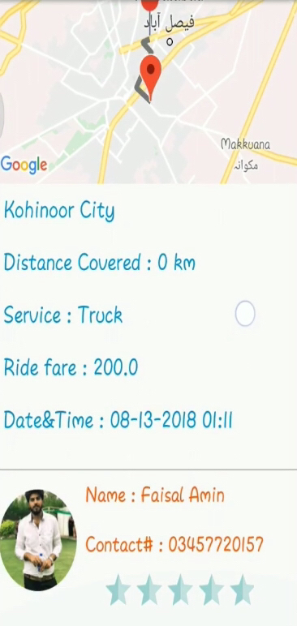

Figure 5.7: Driver History

User Booking a ride
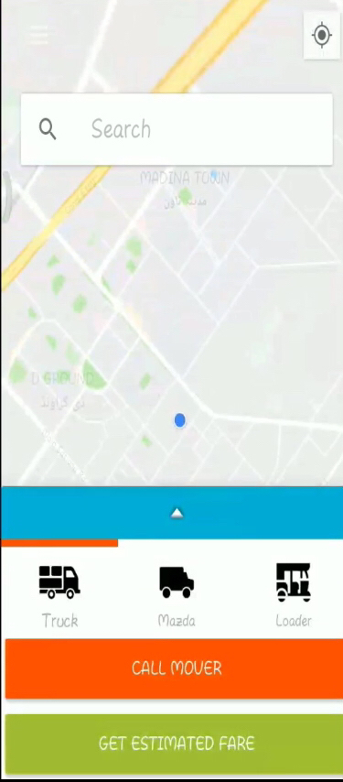

Figure 5.8: Selecting the type of vehicle

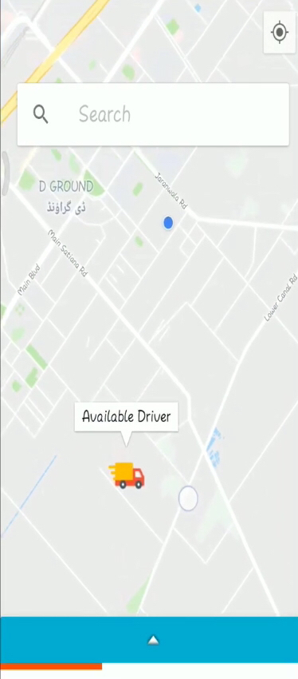
Figure 5.9: Searching driver

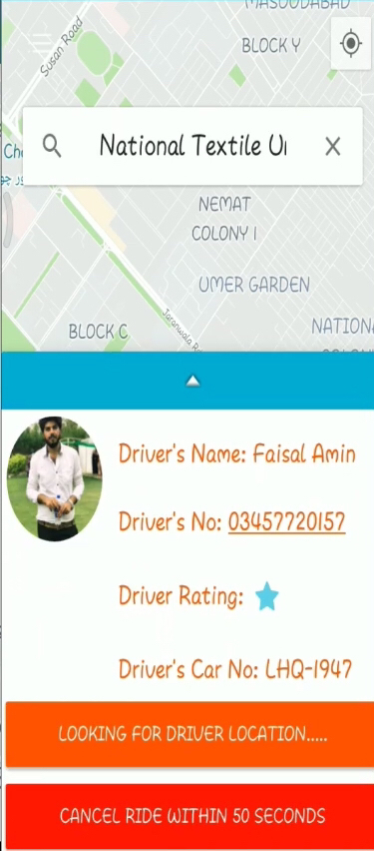

Figure 5.10: Driver Info

Driver finding customer
Figure 5.11: Driver starts working

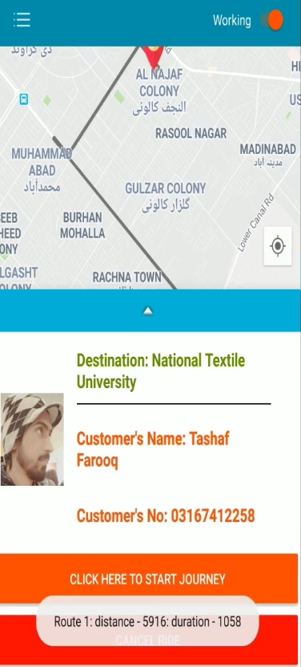

Figure 5.12: Accept the ride

Driver vehicle registration
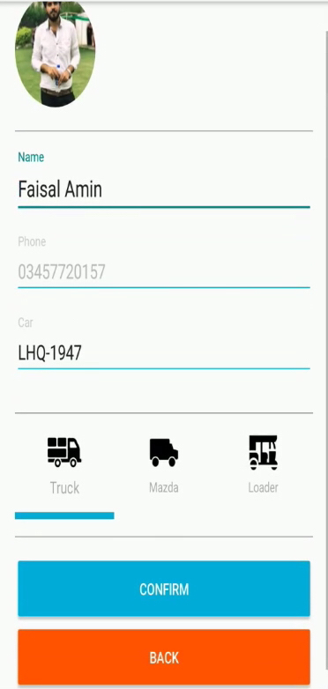

Figure 5.13: Vehicle registration

CONCLUSION

Conclusion

The process of moving in a new house is not an easy task in a country like Pakistan. You have to face many problems like, wastage of time: Finding the vehicle of your type, if you found one then there is a challenge of finding the number of labours you need and in the last the negotiating process. This application will provide the cost efficient and time saving solution. The person only needs to download a mobile application from which he selects all the options he wants by staying home.

REFERENCES

Books:

[1] Cay S. Horstman, Core Java Volume-1 Fundamentals, 11th Edition, Prentice Hall, Boston, MA., 2005
[2] Joshua Baloch, Effective Java, 3rd Edition, Addison wisely, New York, 2001.

Journal Papers:

[3] A. Lance Allison ; Mohammad Muztaba Fuad “Inter-App Communication between Android Apps Developed in App-Inventor and Android Studio” 2016 IEEE/ACM International Conference on Mobile Software Engineering and Systems (MOBILESoft)

[4] Slim Chtourou ; Mohamed Kharat ; Nader Ben Amor ; Mohamed Jallouli ; Mohamed Abid, “Development of an android service to add IOIO Hardware features to an Android App”, 2016 IEEE International Conference on Computer and Information Technology (CIT)

Sources:

[5] Google Maps Api https://cloud.google.com/maps-platform/
[6] Database for mobile to store data
https://console.firebase.google.com/u/0/project/team-transport/overview
[7] https://developer.android.com/studio.

