
BSIT-F19-004
03-135162-012 | HAIDER MAHMOOD
03-135162-004 | AGHA SHEHERYAR KHAN

Student Attendance System by QR Scan

In partial fulfilment of the requirements for the degree of
Bachelor of Science in Information Technology
Supervisor: Muhammad Hanif
Department of Computer Sciences
Bahria University, Lahore Campus

July 20, 2020

© Bahria University, 2020

Certificate

We accept the work contained in the report titled
“Student Attendance System by QR Scan”
written by
HAIDER MAHMOOD
AGHA SHEHERYAR KHAN

as a confirmation to the required standard for the partial fulfilment of the degree of
Bachelor of Science in Information Technology.

Approved by:
Supervisor: Muhammad Hanif
(Signature)

July 20, 2020

DECLARATION

We hereby declare that this project report is based on our original work except for citations and quotations which have been duly acknowledged. We also declare that it has not been previously and concurrently submitted for any other degree or award at Bahria University or other institutions.

Enrolment | Name | Signature
03-135162-012 | HAIDER MAHMOOD
03-135162-004 | AGHA SHEHERYAR KHAN

Date : July 20, 2020

Specially dedicated to
my beloved grandmother, mother and father
(HAIDER MAHMOOD)
my beloved grandmother, mother and father
(AGHA SHEHERYAR KHAN)

ACKNOWLEDGEMENTS

We would like to thank everyone who had contributed to the successful completion of this project. We would like to express our gratitude to my research supervisor, Muhammad Hanif for his invaluable advice, guidance and his/her enormous patience throughout the development of the research.

In addition, we would also like to express my gratitude to our loving parent and friends who had helped and given me encouragement.

HAIDER MAHMOOD
AGHA SHEHERYAR KHAN

Student Attendance System by QR Scan

ABSTRACT

Smartphones are becoming more preferred companions to users than desktops or notebooks. Knowing that smartphones are most popular with users. Using smartphones to speed up the process of taking attendance by university instructors would save lecturing time and hence enhance the educational process. This paper proposes a system that is based on a QR code, which is being displayed for students during or at the beginning of each lecture. The students will need to scan the code in order to confirm their attendance. The project explains the high-level implementation details of the proposed system. It also discusses how the system verifies student identity to eliminate false registrations.

Contents
CHAPTER 1
INTRODUCTION 11
1.1 Background 11
1.2 Aims and Objectives 12
1.3 Scope of Project 12
CHAPTER 2 13
Software Requirement Specifications 13
2.1 Introduction 13
2.3 User Classes and Characteristics 13
2.4 Operating Environment 14
2.5 Design and Implementation Constraints 14
Assumptions and Dependencies 14
CHAPTER 3
DESIGN AND METHODOLOGY 15
3.1 Methodology 15
Table 3.1: Manage Students 17
Table 3.2: Manage Tutor 18
Table 3.3: Manage Courses 19
Table 3.4: Mark Attendance 20
Table 3.5: Manage Result 21
Table 3.6: View Attendance 22
Table 3.: QR Scan 23
Sequence Diagram 24
Figure 3.4 Mark Attendance 26

Figure 3.6 View Profile 27
Figure 3.7 Manage Courses 28
CHAPTER 4 32
IMPLMENTATION 32
4.1 Implementation 32
CHAPTER 5
5.1 Conclusion 36

LIST OF TABLES

TABLE TITLE PAGE

Table 3.1: Manage Students 19
Table 3.2: Manage Tutor 20
Table 3.3: Manage Courses 21
Table 3.4: Mark Attendance 22
Table 3.5: Manage Result 23
Table 3.6: View Attendance 24
Table 3.7: QR Scan 25

LIST OF FIGURES

FIGURE TITLE PAGE
Figure 3.1: System Use Case 18
Figure 3.2: Login into Application 26
Figure 3.3: Change Password 27
Figure 3.4: Mark Attendance 28
Figure 3.5: View Attendance 28
Figure 3.6: View Profile 29
Figure 3.7: Manage Courses 30
Figure 3.8: Manage Result 30
Figure 3.9: Sign-out 31
Figure 3.10: Design Class Diagram 32
Figure 3.11: Data Model 33
Figure 4.1: Mobile App Interface (Login Page) 35
Figure 4.2: Mobile App Interface (Home Page) 35
Figure 4.3: Mobile Interface (Attendance Summary Page) 36
Figure 4.4: Website Interface (Home Page) 37
Figure 4.5: Website Interface (QR code Generator Page) 37

LIST OF SYMBOLS / ABBREVIATIONS

Term | Definitions
CMS | Student Attendance System by QR Scan

CHAPER 1

INTRODUCTION

Taking student’s attendance by university instructors during each class is a time-consuming process especially when classes are big. Some faculty policies require this task to be performed by the instructor in each lecture. In other words, out of the total hours that are assigned to a given course, which is typically forty-eight hours per semester (Bahria University), up to eight hours may be lost to perform this process that usually takes around ten minutes per lecture. Thus, with the widespread of smartphones among university students, this project addresses the problem of such a waste in the lecture time and proposes a system that offers to reduce it by almost 90%. The proposed solution offers a QR code for the students to scan it via a specific smartphone application. The code along with the student identity taken by the application will confirm the students’ attendance. This way, the system will save not only time but also efforts that were supposed to be put by instructors during each lecture. It will speed up the process of taking attendance and leave much time for the lecture to be given properly. The proposed system also takes care of preventing unauthorized attendance registration using multi-factor authentication using phone numbers and email addresses.

Background
Taking student’s attendance by university instructors during each class is a time-consuming process especially when classes are big. Some faculty policies require this task to be performed by the instructor in each lecture. In other words, out of the total hours that are assigned to a given course, which is typically forty-eight hours per semester up to eight hours may be lost to perform this process that usually takes around ten minutes per lecture. Thus, with the widespread of smartphones among university students, this project addresses the problem of such a waste in the lecture time and proposes a system that offers to reduce it by almost 90%. The proposed solution offers a QR code for the students to scan it via a specific smartphone application. The code along with the student identity taken by the application will confirm the students’ attendance. This way, the system will save not only time but also efforts that were supposed to be put by instructors during each lecture. It will speed up the process of taking attendance and leave much time for the lecture to be given properly.

Aims and Objectives
Taking student’s attendance by university instructors during each class is a time-consuming process especially when classes are big. The proposed solution offers a QR code for the students to scan it via a specific smartphone application.

Scope of Project
This project will act as a revolutionary change in attendance and academic portal as it will prove to be an efficient and easy way to handle attendance and maintaining the student history. This will help the teachers by minimizing their struggle of marking attendance through automated system.
- Mark attendance
- Course selection
- Course registration
- Summary

CHAPTER 2

Software Requirement Specifications

2.1 Introduction
This Software Requirement Specification (SRS) document provides a complete description of all the functionalities and the specifications of Student Attendance System by QR Scan. The developers and the testers can use this document as a guideline for developing the design and test plan documents.
  - Purpose
The purpose of this document is to present a detailed description of the Student Attendance System by QR Scan that we will design and implement. It will explain the purpose and features of the system, the interfaces of the system, what the system will do, what the system will do or how the system will interact with the external users, the constraints under which it must operate. The Software Requirements Specification document is intended to provide the requirements of the Hostel Recommender System project and the expectations of the stakeholders. The document includes the project perspective, data model and constraints of the overall system. Project managers review the document and determine whether the planned system fulfils the requirements. They notify the developers to fill up missing parts. Developers provide consistency by using the documentation. Testers use the documentation for verification and validation. End users make use of this document to learn about the scope of the system and its capabilities.

User Classes and Characteristics
Admin
- Register Student.
- Register Teacher.
- Can register courses.

Teacher
- Mark attendance by QR Scan.
- Can also mark attendance manually.
- Manage results.
Student
- Check attendance summary.
- Can mark attendance by scanning QR code.
- Student can see their grades.

Operating Environment
Student attendance system by QR scan mobile apps, this system will be available for android phones and computers.
Mobile and computer must have following specifications:
Hardware Requirements:
- Android device and computer (any version)
- RAM (1GB or more) for Mobile devices
- WIFI 4 or Above
- Data Connection (Cellular or Shared)
- RAM (2 GB or more) for computers
- Processor Intel p4 (1.50 GHz) or above.
- Operating System: Windows 7, 8.1&10.

Design and Implementation Constraints
Student Attendance System by QR Scan is based upon two main module primaries is Web application and secondary is Android application. For implementation of web application front-end HTML, CSS code will be used, and backend developed using PHP database used for data storage and android application backend developing using java language with 000 web host database. Both have different platform for designing purpose, it uses a modular design where every feature is wrapped into a separate module and the modules depend on each other through well-written and libraries. The Internet connection is required for application to work.

Assumptions and Dependencies
- QR Code should be visible on the projector.
- Mobile Phone must have good camera.
- Low lights are preferable.
- Minimum android version should be 5.0 (Lollipop).
- Good internet connection.
- Specified distance from the projector.

CHAPTER 3

DESIGN AND METHODOLOGY

3.1 Methodology
We use agile methodology in our project, because with its greater adaptability to frequently changing scope uses iterative or phased planning and continuous integration. The key principle is to keep the project scope soft. The methodology promotes collaboration and results in increased customer satisfaction.
- Scrum Meeting
- Back log
- Sprint
We use agile methodology in our project, because with its greater adaptability to frequently changing scope uses iterative or phased planning and continuous integration. The key principle is to keep the project scope soft. The methodology promotes collaboration and results in increased customer satisfaction.
- Scrum Meeting
- Back log
- Sprint

3.3 Use Case Diagrams:

System Use Case
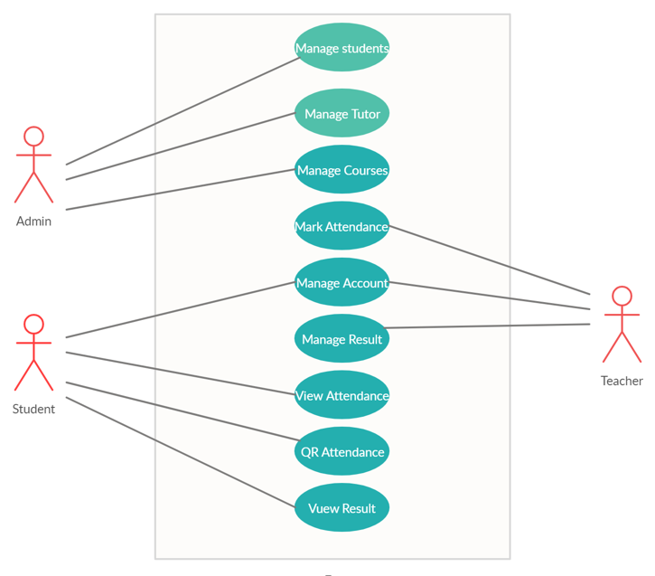
Figure 3.1: UC System

Table 3.1: Manage Students
Name | Manage Student
Unique  Identifier | U1
Objective | - Register Students in portal
Priority | High
Source | Any user
Actors | Admin
Flow of Events | - Take students details.  - Register students in portal.  - Automatically unique ID will be generated for every student.  - Assign a temporary link to set password.
Pre-Conditions | - Must have internet connection.  - Connected to database.  - Students details needs to be complete.
Post-Conditions | Student will set password using temporary link.
Notes/Issues | None

Table 3.2: Manage Tutor
Name | Manage Tutor
Unique  Identifier | U2
Objective | Register teachers on portal
Priority | High
Source | Any user
Actors | Admin
Flow of Events | - Take teacher details.  - Register teachers in portal.  - Automatically unique ID will be generated for every teacher.  - Assign a temporary link to set password.
Pre-Conditions | - Must have internet connection.  - Connected to database.  - Students details needs to be complete.
Post-Conditions | Student will set password using temporary link.
Notes/Issues | None

Table 3.3: Manage Courses
Name | Manage Courses
Unique  Identifier | U3
Objective | - Show list of all courses  - Keep record of subjects enrolled by students.  - Assign courses to teachers.
Priority | High
Source | Any user
Actors | Admin
Flow of  Events | - Student will enrol subjects.  - Classes will be assigned to teachers.
Pre- Conditions | - Show maximum number of credit hours student can be enrolled.  - Available courses.
Post-  Conditions | Show register courses to students.
Notes/Issues | None

Table 3.4: Mark Attendance
Name | Mark Attendance
Unique  Identifier | U4
Objective | Teacher will display QR code.
Priority | High
Source | Any user
Actors | Teacher
Flow of Events | - Teacher will sign into portal.  - Teacher will display QR code.
Pre-Conditions | Teacher will display QR code.
Post-Conditions | Teacher will submit the attendance.
Notes/Issues | None

Table 3.5: Manage Result
Name | Manage Results
Unique  Identifier | U5
Objective | - Teacher will add marks of quiz, assignments, and papers.  - Grade will be generated automatically.
Priority | High
Source | Any user
Actors | Teacher
Flow of Events | - Teacher will login to portal.  - Will open results tab.  - Add students’ marks.  - System will make the grade of students.
Pre-Conditions | - Must add students’ marks.  - Make sure that correct marks are entered of each student.  - Add marks in relevant fields.
Post-Conditions | Grade will be display.
Notes/Issues | None

Table 3.6: View Attendance

Name | View Attendance
Unique Identifier | U6
Objective | Attendance summary will be displayed of each subject.
Priority | High
Source | Any user
Actors | Student
Flow of Events | - Login to portal  - Visit view attendance tab  - View attendance of each subject enrolled.
Includes | None
Pre-Conditions | Must have account on portal.
Post-Conditions | Attendance summary will be displayed.
Notes/Issues | None

Table 3.7: QR Scan
Name | QR Scan
Unique Identifier | U7
Objective | 1- QR code of each subject will be generated 2- Students must scan code using mobile.
Priority | High
Source | Any user
Actors | Student
Flow of Events | - Login to student’s portal using mobile phone.  - Open scanning option  - Scan the QR code using mobile
Pre-Conditions | - QR code will be displayed.  - Must have mobile to scan the code,
Post-Conditions | After scanning the code successful or error message will be displayed.
Notes/Issues | None

Sequence Diagram
A sequence diagram that describes part of the flow of events of the use-case Figure Register into Application
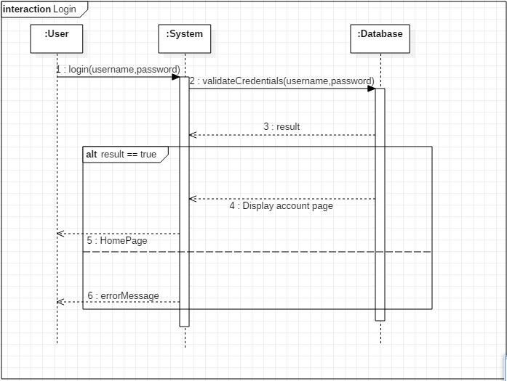 Figure 3.2 Login into Application

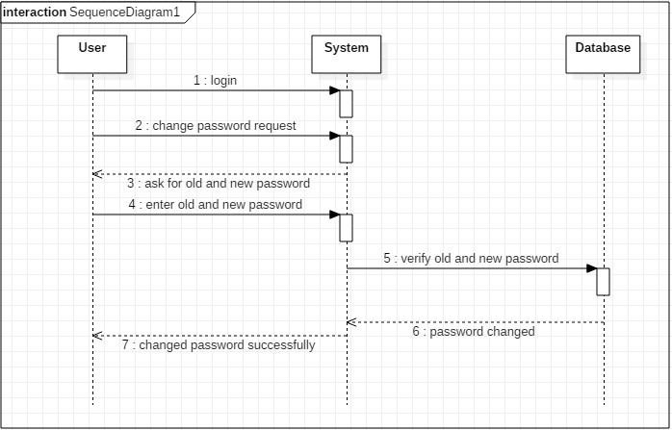 Figure 3.3 Change Password

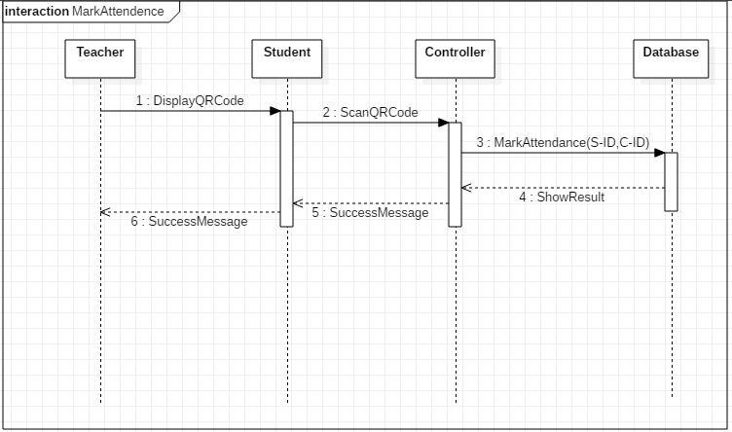

Figure 3.4 Mark Attendance

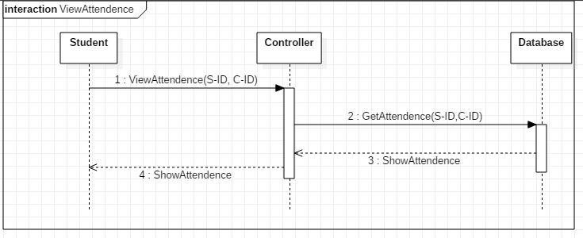Figure 3.5 View Attendance

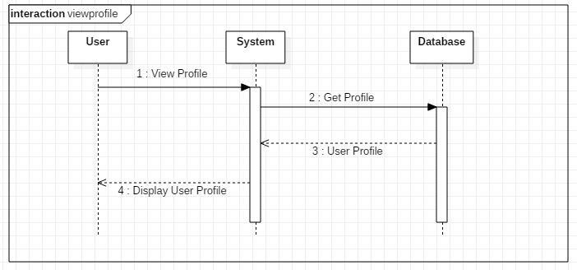

Figure 3.6 View Profile

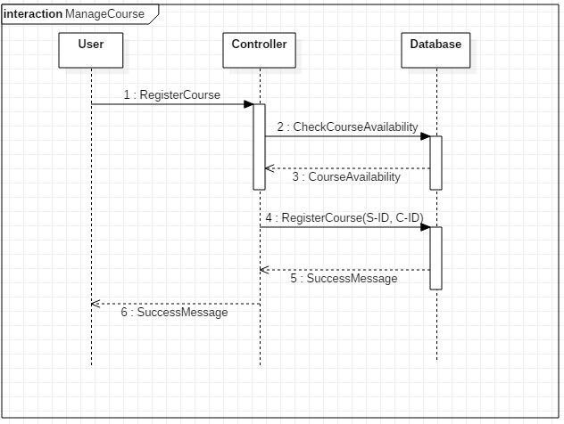

Figure 3.7 Manage Courses

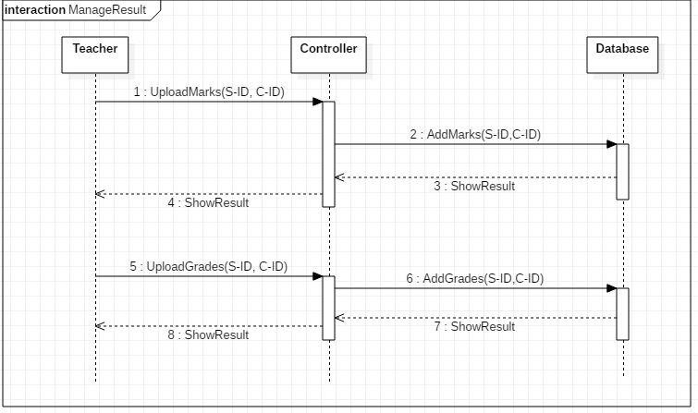
Figure 3.8 Manage Result
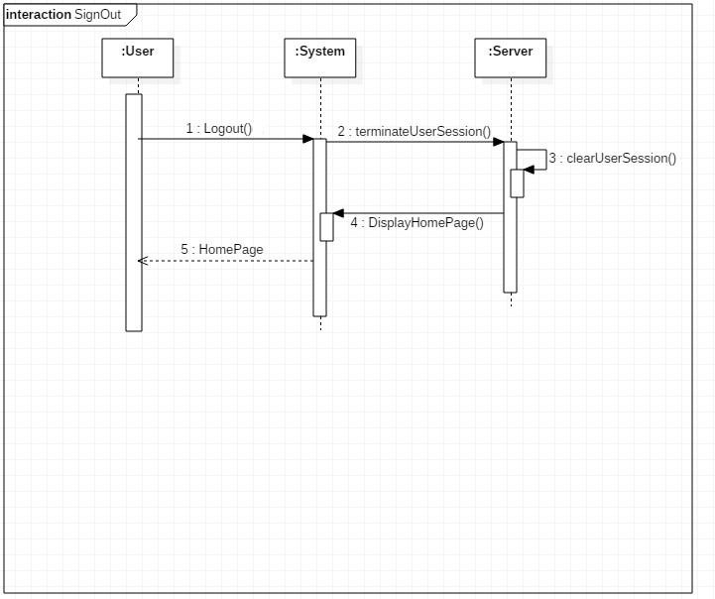
Figure 3.9 Sign-out

  - Design Class Diagram
Classes are the workhorses of the design effort—they actually perform the real work of the system. The other design elements—subsystems, packages and collaborations simply describe how classes are grouped or how they interoperate.
Active classes are design classes, which coordinate and drive the behaviour of the passive classes - an active class is a class whose instances are active objects, owning their own thread of control.
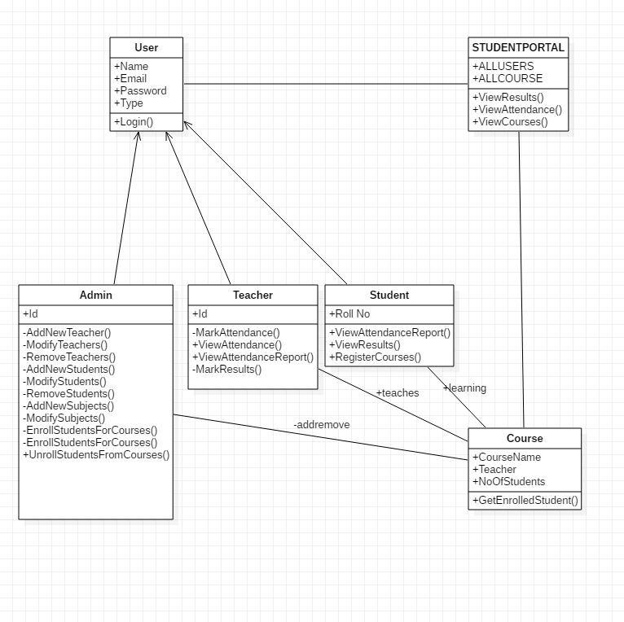
Fig:3.10

  - Data Model
The data model is a subset of the implementation model, which describes the logical and physical representation of persistent data in the system.

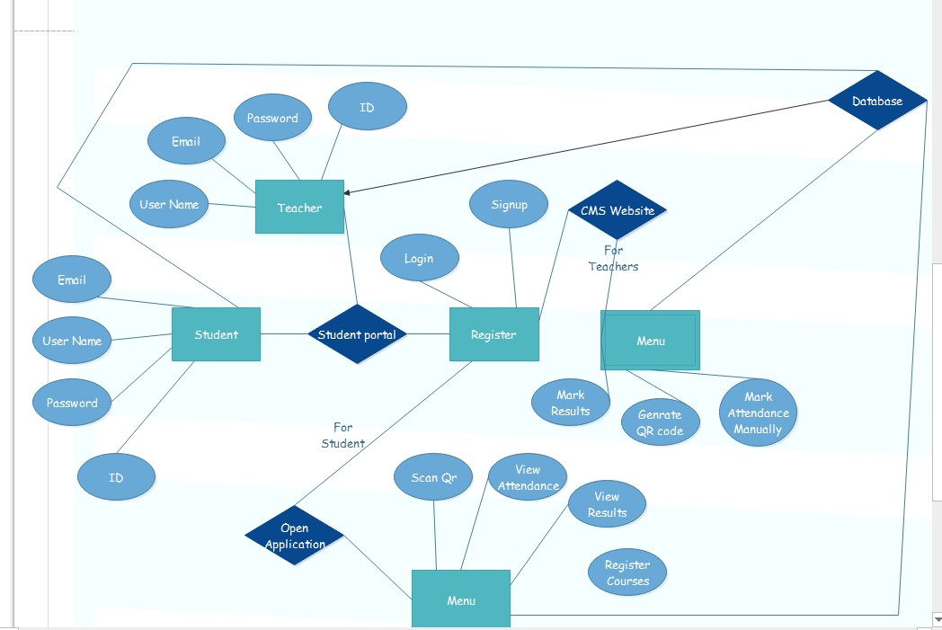
Fig:3.11

CHAPTER 4

IMPLMENTATION

Implementation
Students open the portal application. First, they log into account given by admin. They enter the required information. System will confirm username and password. The student views three options.
- Scan QR code
- View Attendance Summary
- View Result
On Clicking scan QR code System will automatically open the camera and then students just have to scan QR code. On clicking View Attendance System will open the information of each class students is enrolled and show its summary. They can view the attendance of the class they want to confirm. The students can also see their results uploaded by teachers on this application. Admin open the website. He will add students and teachers. Admin will assign students and teachers to their classes and assign courses to both. Teacher can view the profiles of students enrolled in their class. Teacher will generate QR code to mark attendance of students. Teachers can also mark attendance manually. Teachers will also upload results on website.

System Mobile App:
Students open the portal application. First, they log into account given by admin. They enter the required information. System will confirm username and password. The student views three options.
- Scan QR code
- View Attendance Summary
- View Result
On Clicking scan QR code System will automatically open the camera and then students just have to scan QR code. On clicking View Attendance System will open the information of each class students is enrolled and show its summary. They can view the attendance of the class they want to confirm. The students can also see their results uploaded by teachers on this application.

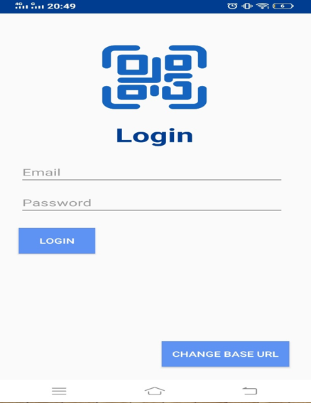
Figure 4.1: Mobile App Interface (Login Page)

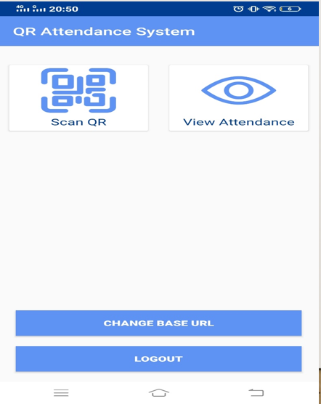
Figure 4.2: Mobile App Interface (Home Page)

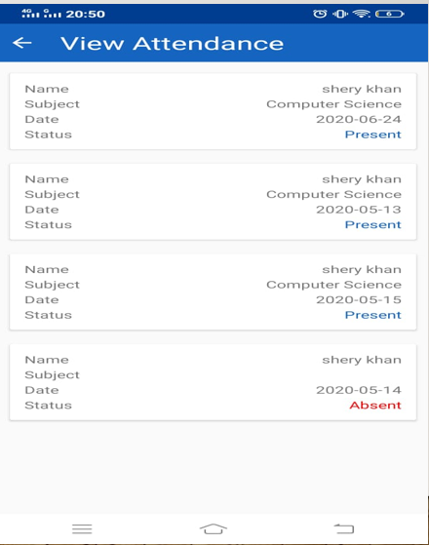
Figure 4.3: Mobile App Interface (Attendance Summary Page)

    - System Website:
The Website is built only for admin and for teachers’ purpose. Admin open the website. He will add students and teachers. Admin will assign students and teachers to their classes and assign courses to both. Teacher can view the profiles of students enrolled in their class. Teacher will generate QR code to mark attendance of students. Teachers can also mark attendance manually. Teachers will also upload results on website.
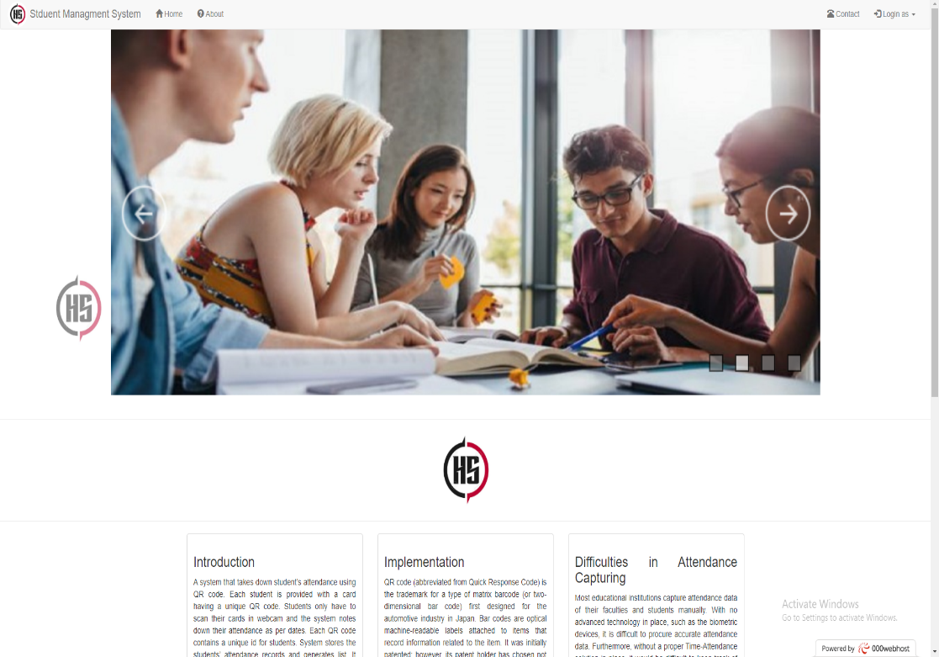

Figure 4.4: Website Interface (Home Page)
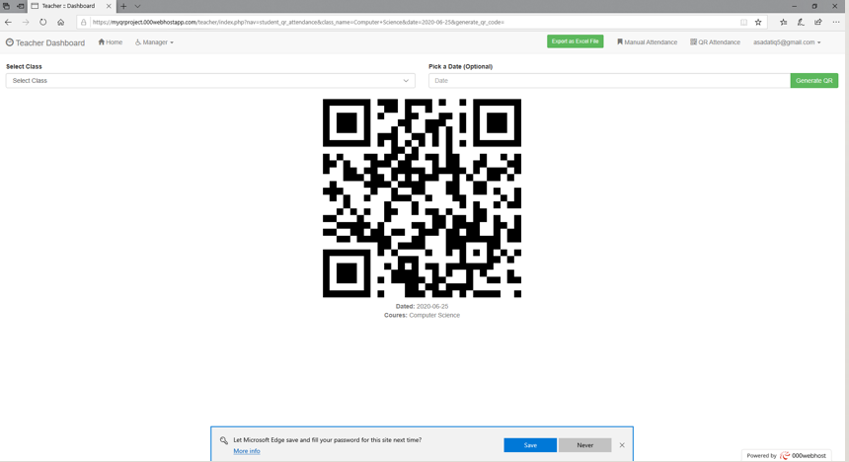
Figure 4.5: Website Interface (QR code generator Page)

CHAPTER 5
CONCLUSION

Conclusion
The proposed solution offers a QR code for the students to scan it via a specific smartphone application. The code along with the student identity taken by the application will confirm the students’ attendance. This way, the system will save not only time but also efforts that were supposed to be put by instructors during each lecture. It will speed up the process of taking attendance and leave much time for the lecture to be given properly. The proposed system also takes care of preventing unauthorized attendance registration using multi-factor authentication using phone numbers and email addresses.

