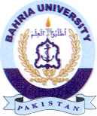
Bahria University Library Islamabad
Source: Pak Observer, Saturday, Oct 12, 2024

