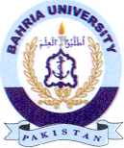
Bahria University Library Islamabad
Source: Pakistan Observer, Thursday, Sep 26, 2024

