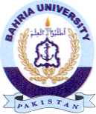
Bahria University Library Islamabad
Source: Daily Jang, Thursday, Sep 19, 2024

