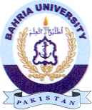
Bahria University Library Islamabad
Source: Pak Observer, Friday, Sep 06, 2024



