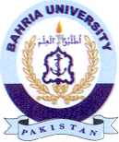Bahria University Library Islamabad
Source: Pakistan Observer, Saturday August 31, 2024

