
Bahria University Library Islamabad
Source: The News, Wednesday August 28, 2024

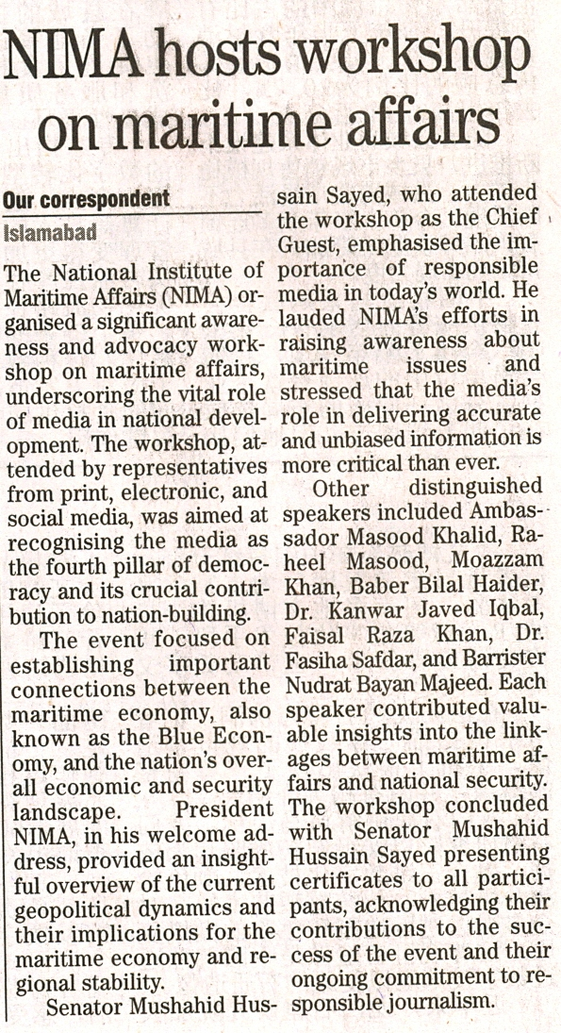

Bahria University Library Islamabad
Source: Pakistan Observer, Wednesday August 28, 2024



Bahria University Library Islamabad
Source: Express Tribune, Wednesday August 28, 2024

