
BSCS-S19-013
03-134161-004 | AMMAR ASIF

Foodie

In partial fulfilment of the requirements for the degree of
Bachelor of Science in Computer Science
Supervisor: Zunnurain Hussain
Department of Computer Sciences
Bahria University, Lahore Campus
January 2020

© Bahria University, 2020

Certificate

We accept the work contained in the report titled
“Foodie”
written by
AMMAR ASIF
as a confirmation to the required standard for the partial fulfilment of the degree of
Bachelor of Science in Computer Science.

Approved by:
Supervisor: Zunnurain Hussain
(Signature)

January 27, 2020

DECLARATION

I hereby declare that this project report is based on my original work except for citations and quotations which have been duly acknowledged. I also declare that it has not been previously and concurrently submitted for any other degree or award at Bahria University or other institutions.

Enrolment | Name | Signature
03-134161-004 | AMMAR ASIF

Date : January 27, 2020

ACKNOWLEDGEMENTS

I would like to thank everyone who had contributed to the successful completion of this project. I would like to express my gratitude to my research supervisor, Mr. Zunnurain Hussain for his invaluable advice, guidance and his/her enormous patience throughout the development of the research.

In addition, I would also like to express my gratitude to my loving parent and friends who had helped and given me encouragement.

AMMAR ASIF

Foodie

ABSTRACT

As it is a client-based project so, when it comes to the food restaurants, the web / mobile apps designed for the users create a sense of a never-ending barrier between the system and the operator. The interface matters the most because for the user interface is everything. User has no concern with the back end, good interface helps the user to use the application more effectively. Secondly every customer wants to get served his food on the table without waiting in the queue to get his order. If we talk about the online food delivery the user will be directed to delivery boy’s whatsapp to send his live location. we will provide a solution of the above mention problems by developing a mobile application. The customer can check the estimated time of food delivery. If customer online orders the food, he can send his live location through whatsapp

TABLE OF CONTENTS

CHAPTERS
INTRODUCTION 1
1.1Background 1
1.2Problem Statements 1
1.3Aims and Objectives 1
1.4Scope of Project 2
LITERATURE REVIEW (and/or SRS) 3
2.1User Classes and Characteristics 3
2.1.1Admin 3
2.1.2Customers 3
2.1.3Delivery Boy 3
2.2Operating Environment: 4
2.2.1Design and implementations constraints 4
DESIGN AND METHODOLOGY 5
3.1Design 5
3.2Use Case Description 5
3.3Use Cases: 5
3.4Use-Case Diagram (refined and updated): 12
3.5Domain Model: 18
3.6Sequence Diagram: 19
3.7Collaboration Diagram: 21
3.8Class Diagram: 25
3.9Data Model: 27
3.9.1 Relational Data Model: 27
3.10Methodology: 28
3.10.1 Choosing a suitable Methodology: 28
DATA AND EXPERIMENTS (and/or IMPLEMENTATION) 29
4.1Implementation 29
4.2Technical Aspects 30
4.2.1Hardware 30
4.2.2Backend 30
4.2.3Frontend 30
4.2.4Database 30
RESULTS AND DISCUSSIONS (or USER MANUAL) 31
5.1User Interfaces 31
5.1.1Dashboard 31
5.1.2Bowl Deals 32
5.1.3Menu 33
5.1.4Bowls Items Selection 34
5.1.5Drawer 35
5.1.6Contact Us 36
5.1.7Reservation 37
5.1.8Cart 38
5.1.9Location 38
CONCLUSION AND RECOMMENDATIONS 40
REFERENCES 40
APPENDICES 42

LIST OF TABLES

Table 1:Sign Up 6
Table 2:Sign In 7
Table 3:Place Order 8
Table 4:Deliver Food 9
Table 5:Online Reservation 10
Table 6:Take Away Order 11

LIST OF FIGURES

Figure 1 Signup/Login 12
Figure 2 Place Order Use Case 13
Figure 3 Deliver Food Use Case 14
Figure 4:Take Away Order Use Case 15
Figure 5:Online Reservation Use Case 16
Figure 6:System Use Case 17
Figure 7: Domain Model 18
Figure 8: SignUp Sequence Diagram 19
Figure 9:Deliver Food Sequence Diagram 19
Figure 10:Place Order Sequence Diagram 20
Figure 11: Reservation Sequence Diagram 20
Figure 12:Take Away Order Sequence Diagram 21
Figure 13:Online Delivery Collaboration Diagram 22
Figure 14:Online Reservation Collaboration Diagram 23
Figure 15: Place Order Collaboration Diagram 23
Figure 16:Take Away Collaboration Diagram 24
Figure 17:Register Collaboration Diagram 24
Figure 18:System Class Diagram 26
Figure 19:System Relational Data Model Diagram 27
Figure 20:FDD Diagram 29
Figure 21:Dashboard 31
Figure 22:Bowl Deals 32
Figure 23:Menu 33
Figure24:Bowls Items Selection 34
Figure 25:Drawer 35
Figure 26:Contact Us 36
Figure 27:Reservation 37
Figure 28: Cart 38
Figure 29:Location 38

LIST OF SYMBOLS / ABBREVIATIONS

c_{p} specific heat capacity, J/(kg⋅K)
h height, m
K_{d} discharge coefficient
M mass flow rate, kg/s
P pressure, kPa
P_{b} back pressure, kPa
R mass flow rate ratio
T temperature, K
v specific volume, m³

α homogeneous void fraction
η pressure ratio
ρ density, kg/m³
ω compressible flow parameter

ID inner diameter, m
MAP maximum allowable pressure, kPa
MAWP maximum allowable working pressure, kPa
OD outer diameter, m
PCB printed circuit board

LIST OF APPENDICES

APPENDIX A: Computer Programme Listing 43

INTRODUCTION

Background

Restaurant order management system in which orders, home delivery, reservations process is made for customer’s ease.

Problem Statements

The rapid order application is android based application that would allow the user to order their food while sitting in the restaurant rather than to wait in a queue to give and take the order also it will save the time of both the user and the employee of that specific restaurant. If a user wants to deliver food from the restaurant user will be connected with delivery boy via whats-app to send his live location. Time is valuable to every person so we will provide a facility in the application in which a user can order the food and collect his order from the restaurant or if a user wants to eat, in the time he will arrive at the restaurant his order will be ready and it saves the time of the user.

Aims and Objectives

To develop an application that provide customer an advance way to order the food and reservations with pre-order service in the restaurants and to let customer aware of all the order details.

Scope of Project

The rapid order application is android based application that would allow the user to order their food while sitting in the restaurant rather than to wait in a queue to give and take the order also it will save the time of both the user and the employee of that specific restaurant. If a user wants to deliver food from the restaurant the live location of the user will be provided so that delivery boy will know the exact location of the user. Time is valuable to every person so we will provide a facility in the application in which a user can order the food and collect his order from the restaurant or if a user wants to eat, in the time he will arrive at the restaurant his order will be ready and it saves the time of the user.

LITERATURE REVIEW (and/or SRS)

User Classes and Characteristics

In this project, our main users are admin, customer, and delivery boy.

Admin
Admin has access of activities. All the orders are reported to admin. Admin will confirm the order. Admin have full access to the system in which he/she can view all registered users, update user’s information, delete users, view the activities and then logout.

Customers
Customers will register themselves using signup form and they will order via application.

Delivery Boy
Delivery boy will get user’s live location via whatsapp to know the exact location of user.

Operating Environment:

The technology we are going to use for this project is Flutter Framework by Google and Laravel Framework for back-end API’s. The technologies include: Dart language in flutter is used on front-end. Php is used in laravel framework which provide us back-end facilities for the project.
Sql which work as a database platform for our project, we integrate all these three emerging technologies to create our application.

Design and implementations constraints
Basically, we are designing a mobile-based application and we are making it optional to make a mobile based application. The constraint in it is time. The minimum RAM required is 4 GB and 500 GB of Hard Disk.

DESIGN AND METHODOLOGY

Design

Following artefacts are included.

Use Case Description

A use-case description is a text that captures the detailed functionality of a use-case. Description of all use-cases are written down in this section.
Use-case description typically contains the following parts:

Use Cases:

Table 1:Sign Up
1 | Unique Identifier | U1
2 | Objective | To have Customer’s/Admin correct information for maintaining record
3 | Priority | High
4 | Source | Customer/Admin/Delivery Boy
5 | Actors | Customer /Admin/Delivery Boy
6 | Flow of events | Basic flow:  - User will fill the required fields  - Validating data  - User is ready to use Application  Alternative flow:  - Registered user cannot register again  - if user already exist then Application will move to login screen
7 | Includes | None
8 | Pre-condition | Customer /Admin is not registered yet
9 | Post condition | Customer /Admin is successfully registered

Table 2:Sign In
1 | Unique Identifier | U2
2 | Objective | To validate that the user login to their account or are they registered yet or not
3 | Priority | High
4 | Source | Customer /Admin/Delivery Boy
5 | Actors | Customer /Admin/Delivery Boy
6 | Flow of events | Basic flow:  - User enter the login credentials  - Validation of data  - user redirected to Dashboard of the application  Alternative flow:  - User cannot use same credentials for another account
7 | Includes | U1
8 | Pre-condition | User must be connected with internet
9 | Post condition | User can easily log in or log out

Table 3:Place Order
1 | Unique Identifier | U3
2 | Objective | To place order using application
3 | Priority | High
4 | Source | Customer /Admin
5 | Actors | Customer /Admin
6 | Flow of events | Basic flow:  - Customer can select food through menu and place order.  - Customer can edit order before checkout.  - Customer will get the confirmation notification of the order  Alternative flow:  - Customer can see their order serving time
7 | Includes | U2
8 | Pre-condition | Customer must be connected with internet
9 | Post condition | Customer can easily log out

Table 4:Deliver Food
1 | Unique Identifier | U4
2 | Objective | To make online food delivery
3 | Priority | High
4 | Source | Customer/Admin/Delivery boy
5 | Actors | Customer/Admin/Delivery boy
6 | Flow of events | Basic Flow:  • Customer will select and order food  • Customer will get order confirmation notification  • Customer will send live location of his/her delivery boy
7 | Includes | U2
8 | Pre-condition | Customer must be connected with internet
9 | Post condition | Customer can order more or can log out from the application

Table 5:Online Reservation
1 | Unique Identifier | U5
2 | Objective | To book table through the application
3 | Priority | High
4 | Source | Customer/Admin
5 | Actors | Customer/Admin
6 | Flow of events | Basic Flow:  • Customer can book reservation  • Customer will get notification whether booking is confirmed or not (due to concerned issues).  • Customer will get confirmation notification  Alternate flow:  - If the customer never arrives after 20 minutes of the reservation time, reservation will be cancelled
7 | Includes | U2
8 | Pre-condition | Customer must be connected with internet  Customer must be logged in
9 | Post condition | Reservation confirmation notification will be sent to the customer’s mobile app

Table 6:Take Away Order
1 | Unique Identifier | U6
2 | Objective | To book take away orders through the application
3 | Priority | High
4 | Source | Customer/Admin
5 | Actors | Customer/Admin
6 | Flow of events | Basic Flow:  • Customer will book take away orders through the application  • Payment will be paid on the spot.  • Customer will get confirmation notification  • Expected order completion time will be shown in the application  Alternate flow:  - Customer will get confirmation message
7 | Includes | U2
8 | Pre-condition | Customer can book food order
9 | Post condition | Customer can see order completion time or can log out from the application

Use-Case Diagram (refined and updated):
Analysis level use-case diagram is a refined High level use-case diagram and is actually the explanation of high level use-case diagram. In this diagram high level use-cases are expanded in a way that exhibit how high level use-cases will reach to their functionality. Figure 1 shows a Sample Use-Case Diagram. Two types of relationships are used in this diagram. Which are:
- extend
- Include

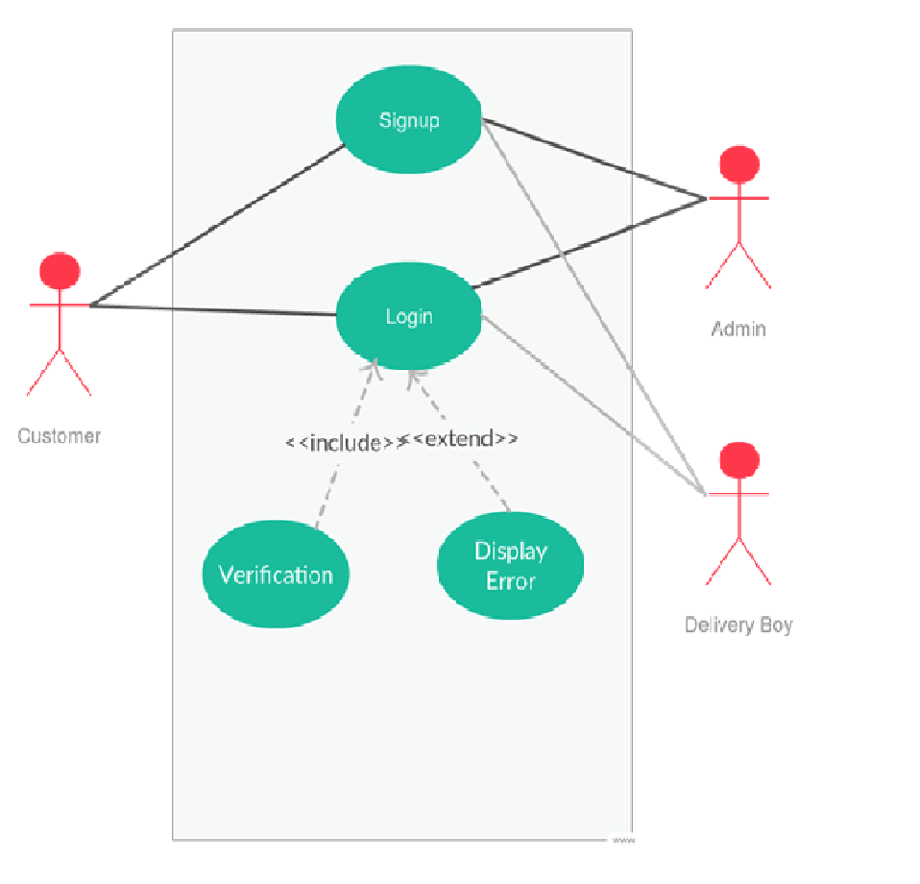
Figure 1 Signup/Login

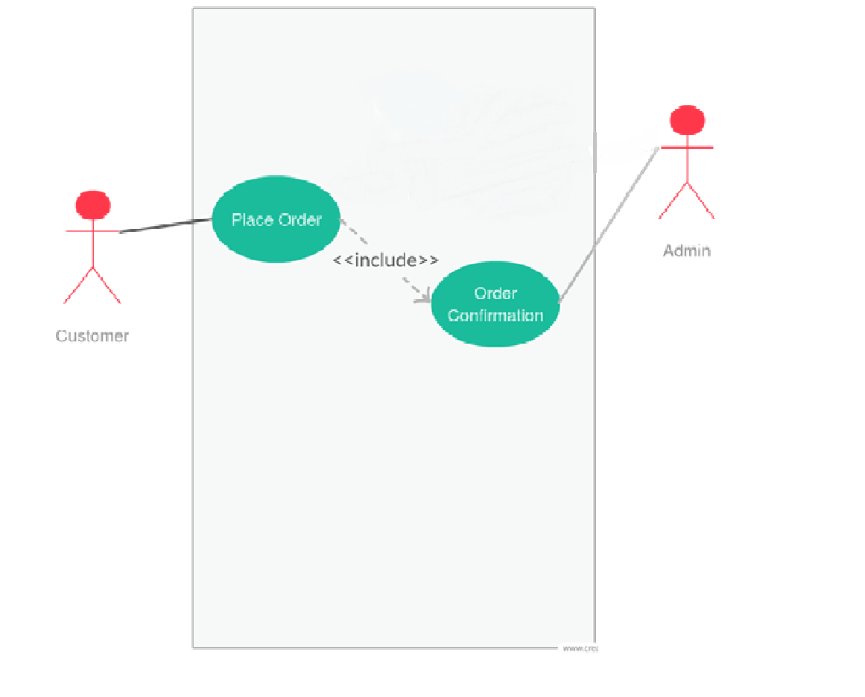
Figure 2 Place Order Use Case

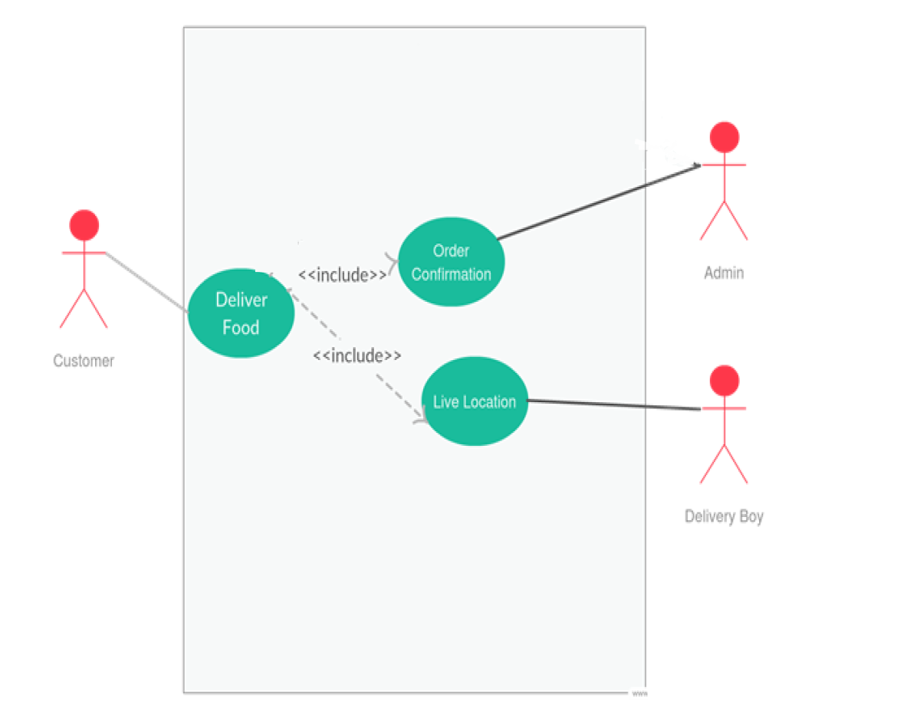
Figure 3 Deliver Food Use Case

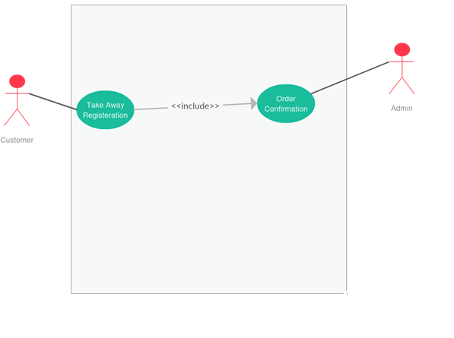
Figure 4:Take Away Order Use Case

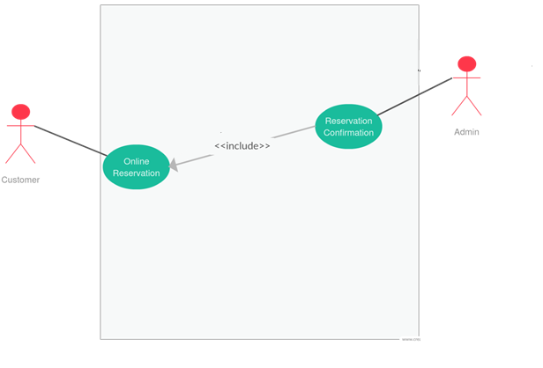
Figure 5:Online Reservation Use Case

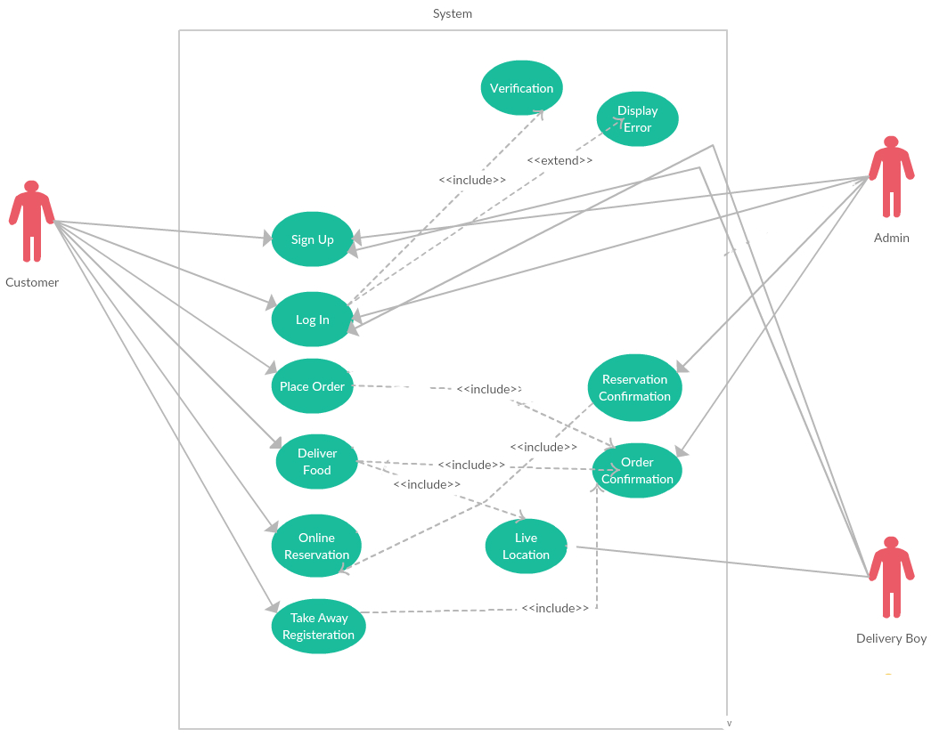
Figure 6:System Use Case

Domain Model:
Domain models represent the set of requirements that are common to systems within a product line. There may be many domains, or areas of expertise, represented in a single product line and a single domain may span multiple product lines. The requirements represented in a domain model include:

- Definition of scope for the domain
- Information or objects
- Features or use-cases, including factors that lead to variation
- Operational/behavioural characteristics
A product line definition will describe the domains necessary to build systems in the product line.

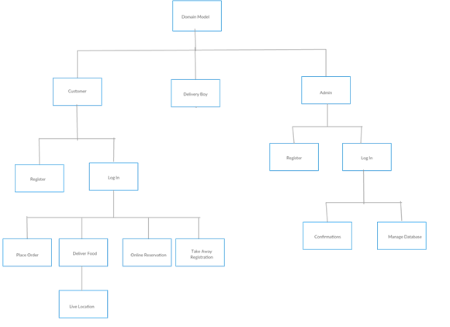
Figure 7: Domain Model

Sequence Diagram:

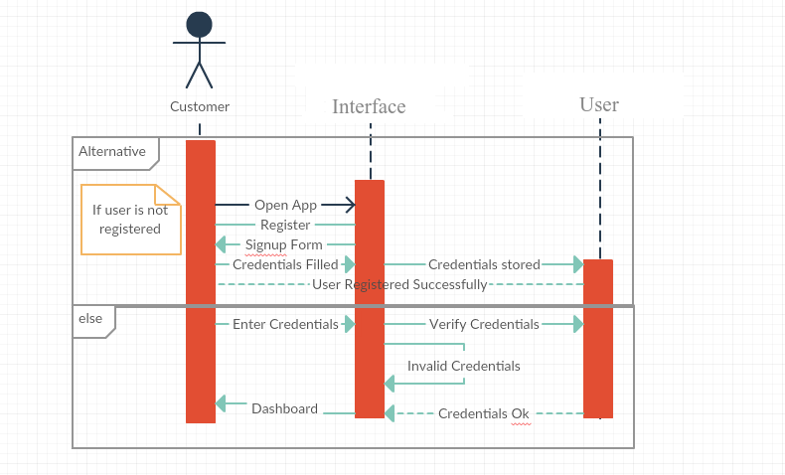
Figure 8: SignUp Sequence Diagram

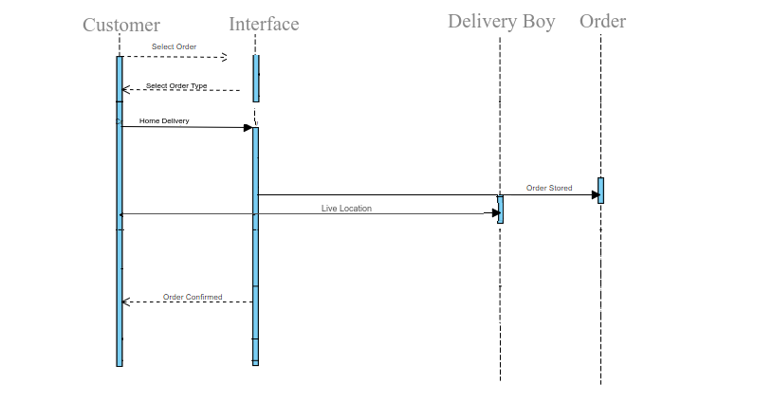
Figure 9:Deliver Food Sequence Diagram

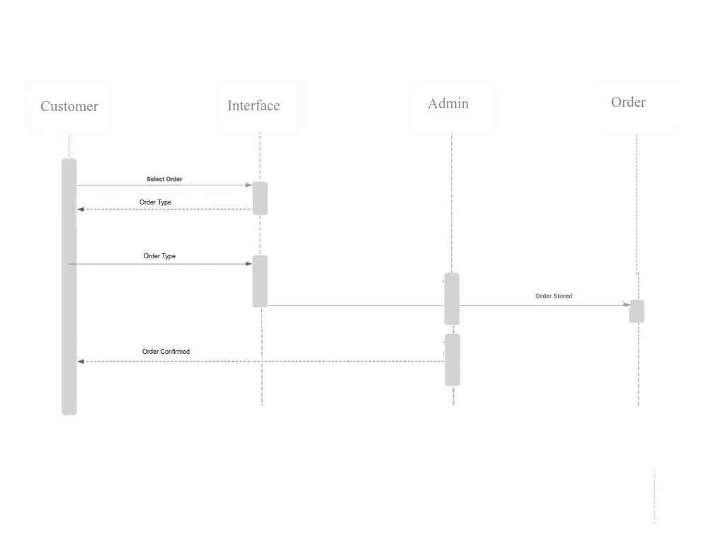
Figure 10:Place Order Sequence Diagram

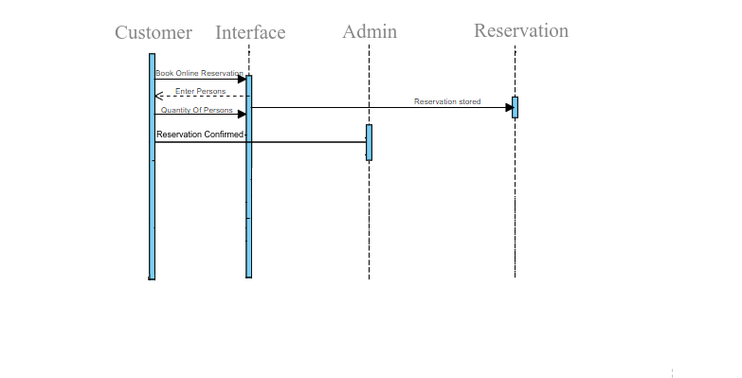
Figure 11: Reservation Sequence Diagram

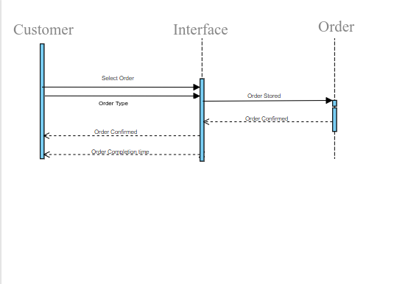
Figure 12:Take Away Order Sequence Diagram

Collaboration Diagram:
A collaboration diagram describes a pattern of interaction among objects; it shows the objects participating in the interaction by their links to each other and the messages that they send to each other.
Collaboration diagrams are used to show how objects interact to perform the behavior of a particular use-case, or a part of a use-case. Along with sequence diagrams, collaborations are used by designers to define and clarify the roles of the objects that perform a particular flow of events of a use-case. They are the primary source of information used to determining class responsibilities and interfaces.
Unlike a sequence diagram, a collaboration diagram shows the relationships among the objects. Sequence diagrams and collaboration diagrams express similar information, but show it in different ways. Collaboration diagrams show the relationships among objects and are better for understanding all the effects on a given object and for procedural design.
Because of the format of the collaboration diagram, they tend to better suited for analysis activities. Specifically, they tend to be better suited to depicting simpler interactions of smaller numbers of objects. As the number of objects and messages grows, the diagram becomes increasingly hard to read. In addition, it is difficult to show additional descriptive information such as timing, decision points, or other unstructured information that can be easily added to the notes in a sequence diagram.

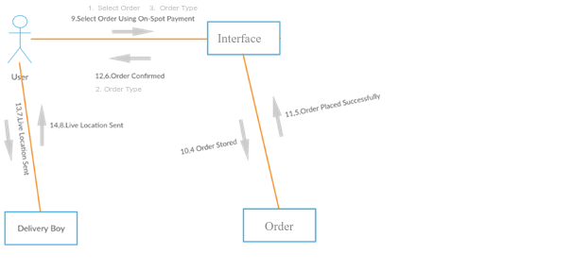
Figure 13:Online Delivery Collaboration Diagram
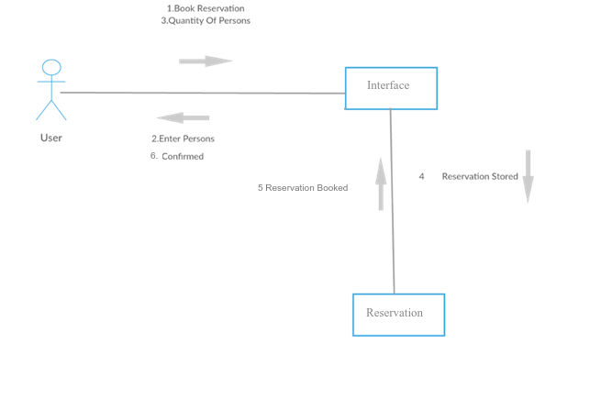
Figure 14:Online Reservation Collaboration Diagram

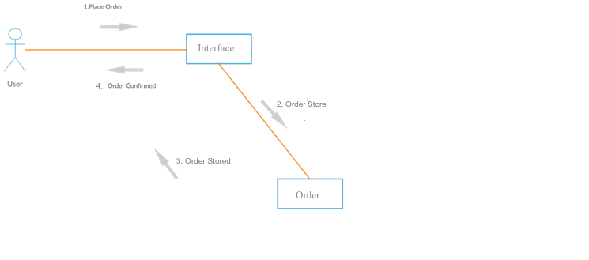
Figure 15: Place Order Collaboration Diagram

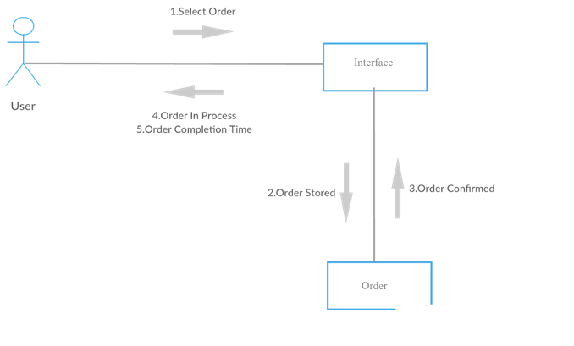
Figure 16:Take Away Collaboration Diagram

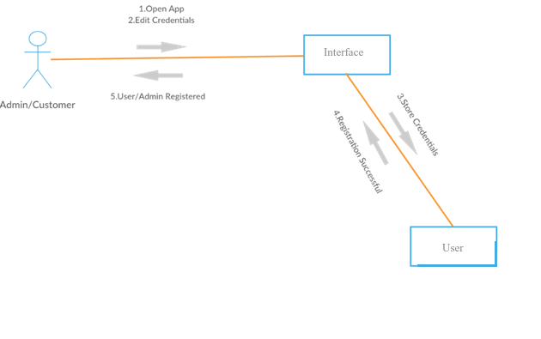
Figure 17:Register Collaboration Diagram

Class Diagram:
Classes are the work-horses of the design effort—they actually perform the real work of the system. The other design elements—subsystems, packages and collaborations simply describe how classes are grouped or how they interoperate.
Capsules are also stereotyped classes, used to represent concurrent threads of execution in real-time systems. In such cases, other design classes are 'passive' classes, used within the execution context provided by the 'active' capsules. When the software architect and designer choose not to use a design approach based on capsules, it is still possible to model concurrent behaviour using 'active' classes.
Active classes are design classes, which coordinate and drive the behaviour of the passive classes - an active class is a class whose instances are active objects, owning their own thread of control.
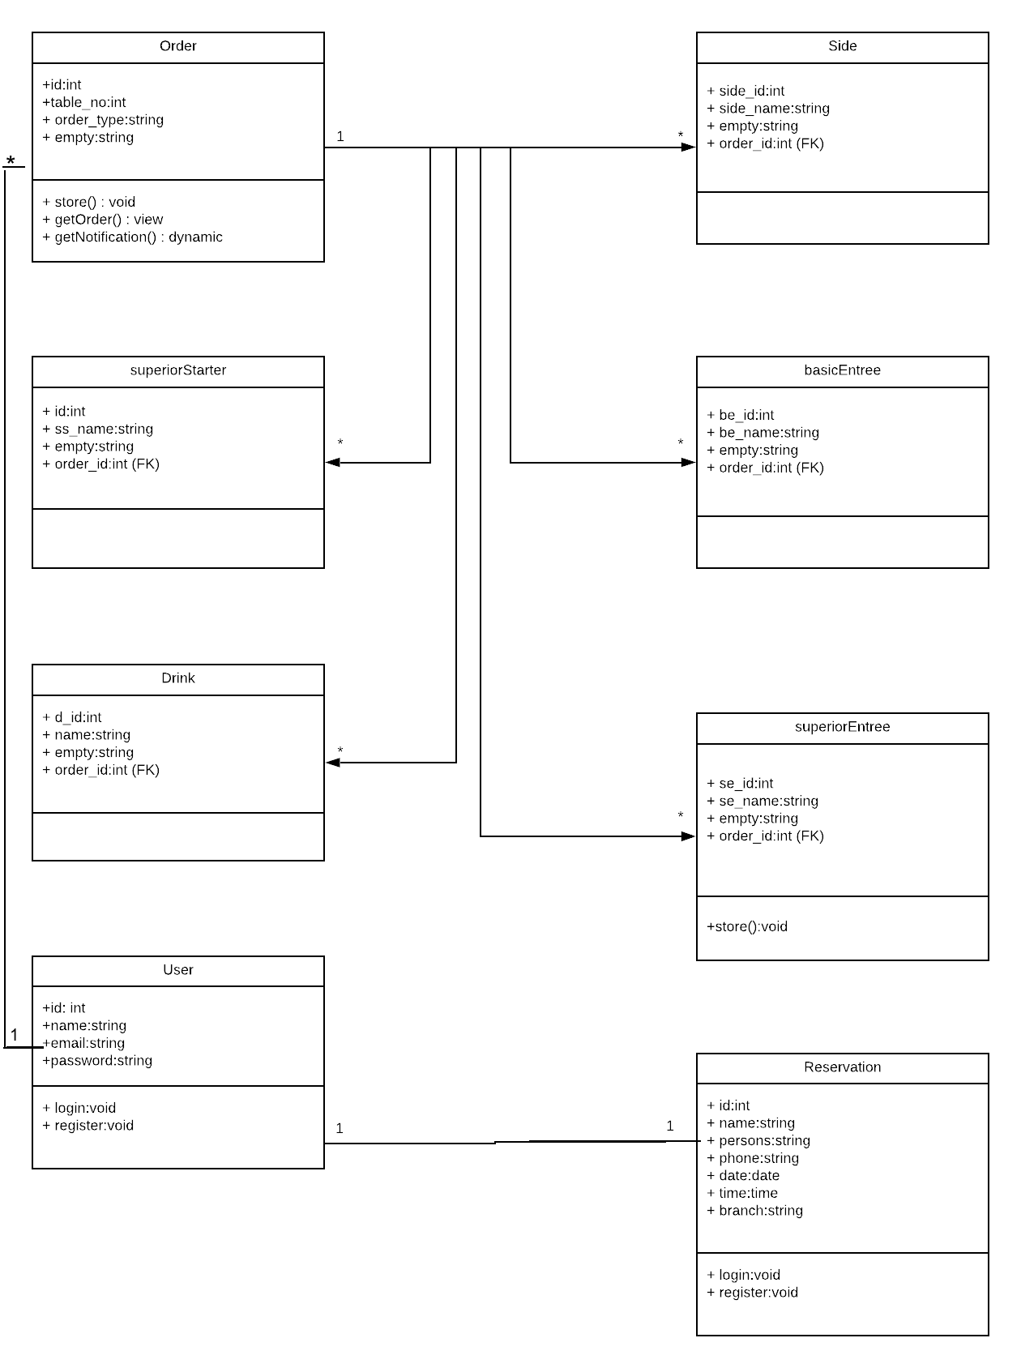
Figure 18:System Class Diagram

Data Model:
The data model is a subset of the implementation model, which describes the logical and physical representation of persistent data in the system.

Relational Data Model:
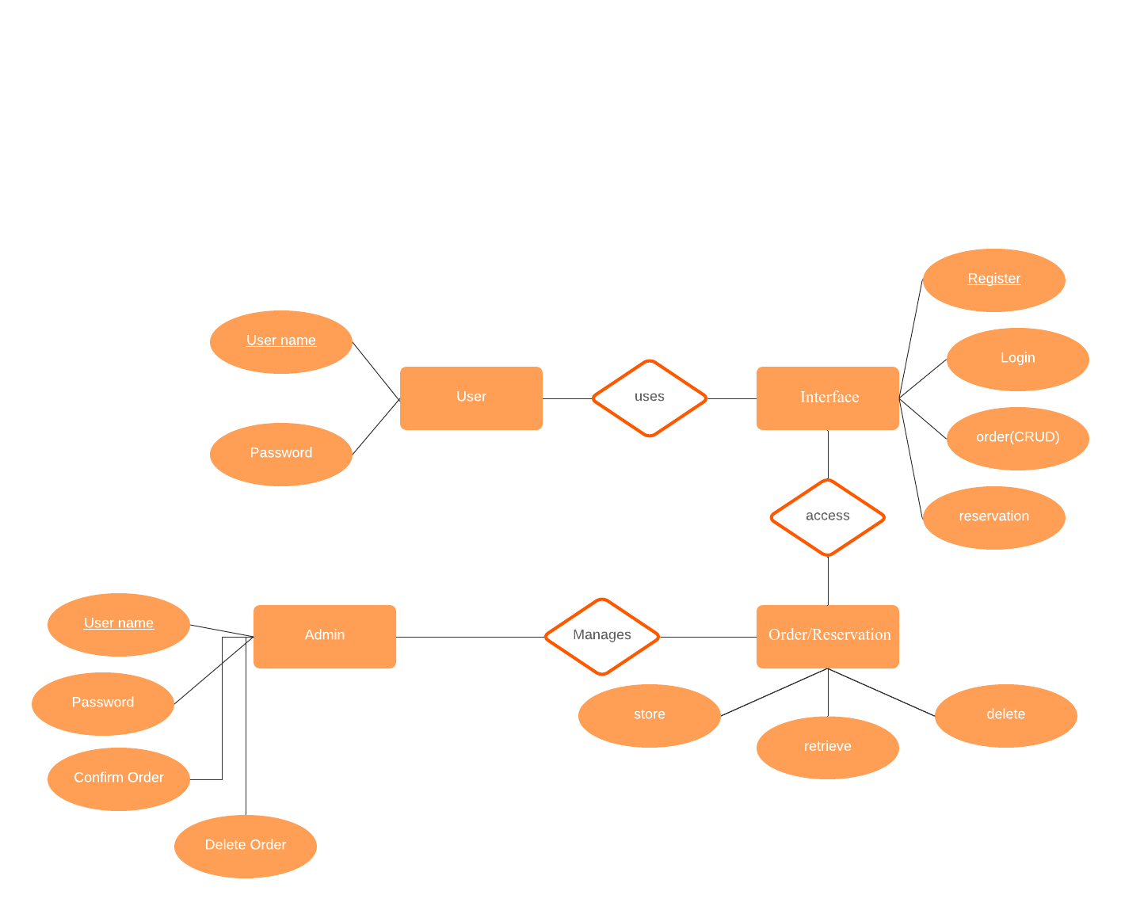
Figure 19:System Relational Data Model Diagram

Methodology:
Methodology can be defined as a system of broad principles or rules from which
specific methods or procedures may be derived to interpret or solve different
problems within the scope of a particular discipline. Unlike an algorithm, a
methodology is not a formula but a set of practices.

Choosing a suitable Methodology:
This project is developed by using FDD (Feature Driven Development) framework of agile method which has five step development process
- Develop an overall model
- Build a features list
- Plan by feature
- Design by feature
- Build by feature

The Agile Method is a particular approach to
project management that is utilized in software development. This method assists teams
in responding to the unpredictability of constructing software. It uses incremental,
iterative work sequences that are commonly known as sprints.

DATA AND EXPERIMENTS (and/or IMPLEMENTATION)

Implementation

The implementation phase of the project is the development of the designs produced during the design phase.

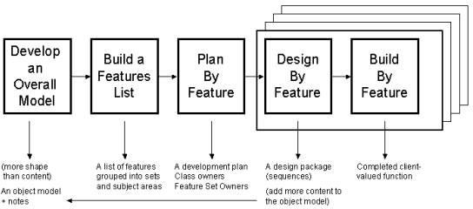
Figure 20:FDD Diagram

Technical Aspects
The system consists of front-end and back-end is categorized into following categories:

Hardware
Hardware contains necessary hardware as PC. The minimum RAM required is 4 GB and 500 GB of Hard Disk.

Backend
Laravel for our website and mobile application backend. Laravel which provide us Backend facilities for this project.

Frontend
Dart language of flutter framework for the frontend of this mobile application.

Database
Sql which work as a database platform for our project.

RESULTS AND DISCUSSIONS (or USER MANUAL)

User Interfaces

Dashboard
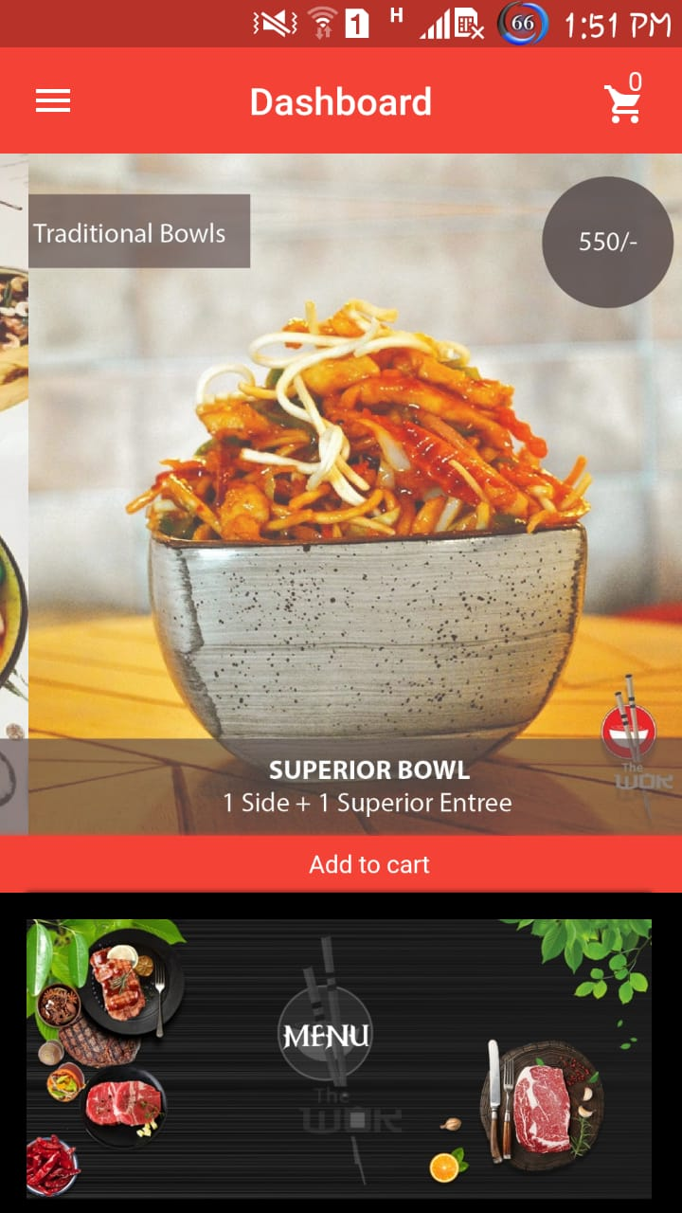
Figure 21:Dashboard

- After login user will be directed to dashboard to select order.

Bowl Deals
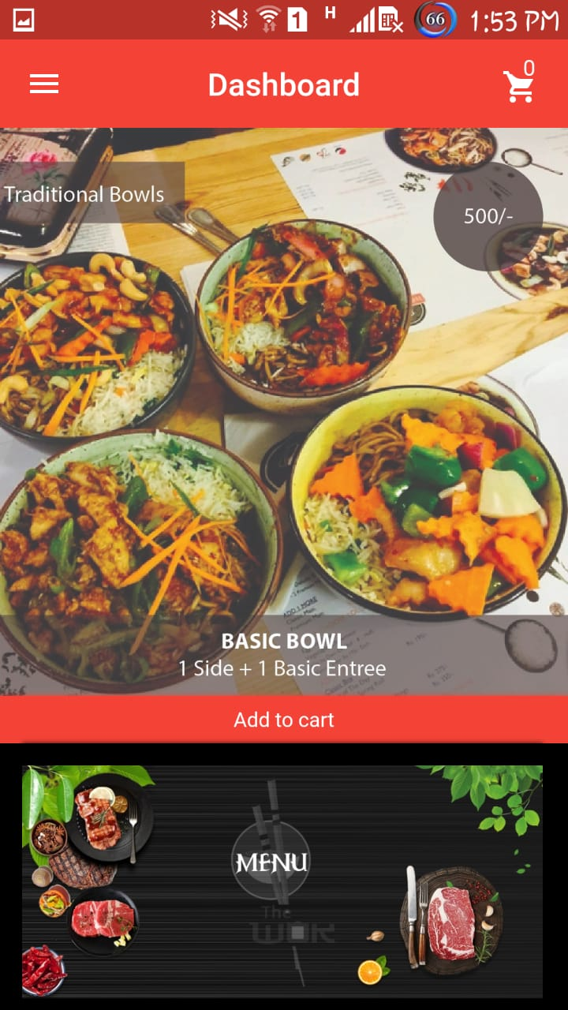
Figure 22:Bowl Deals
- Bowl Deals are available to choose for user.

Menu
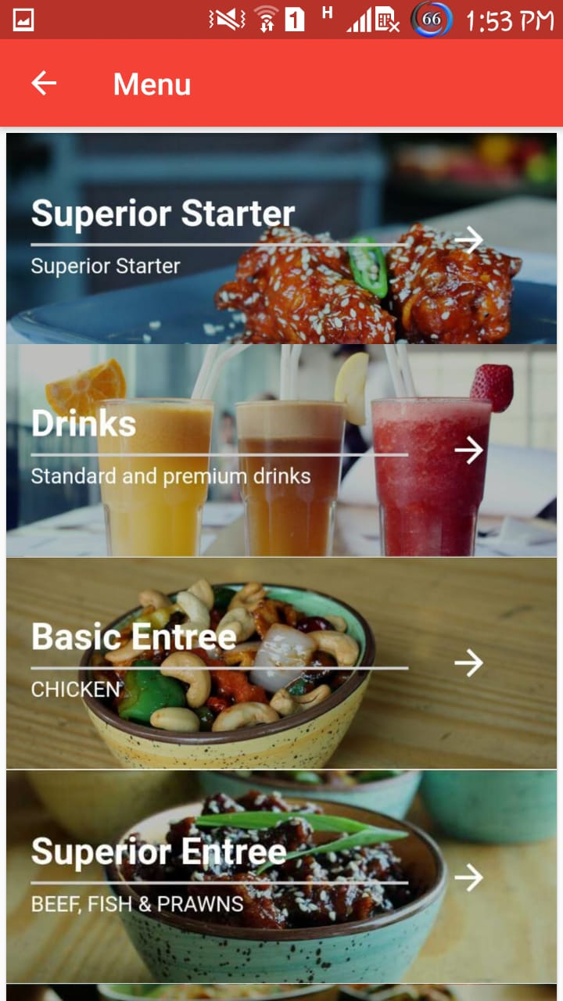
Figure 23:Menu
- User can also select single item from the menu

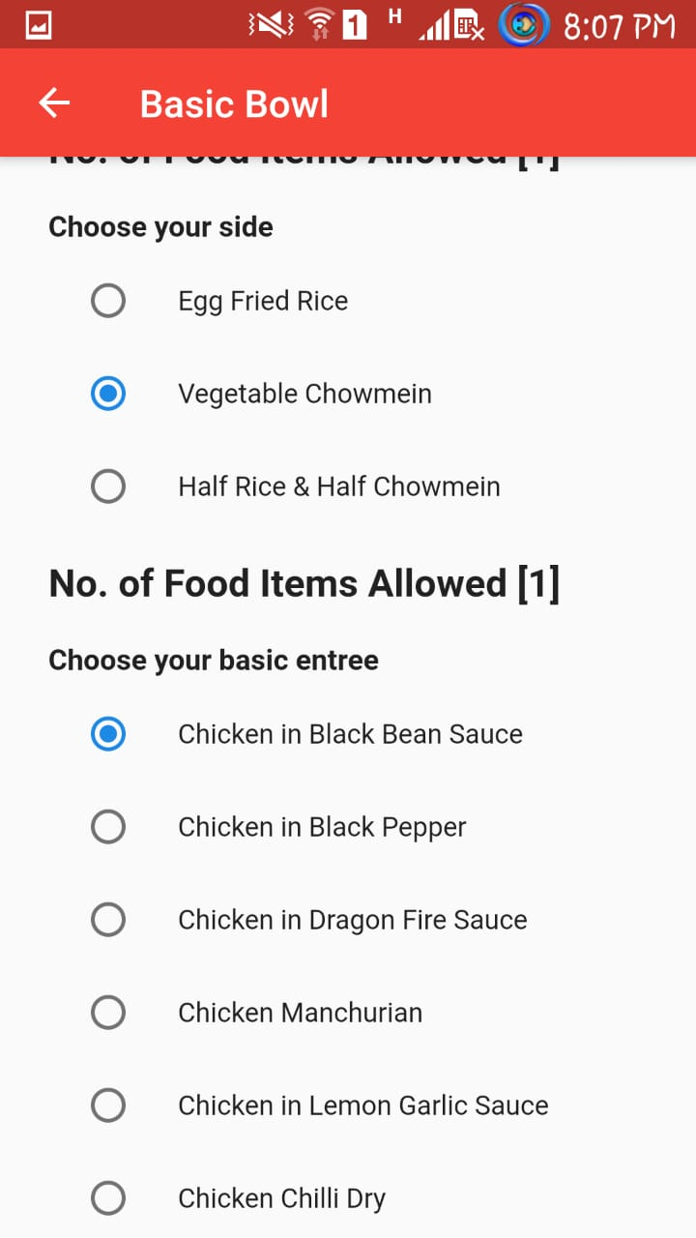
Bowls Items Selection

Figure24:Bowls Items Selection

- For bowl deals user can select item of his own choice.

Drawer
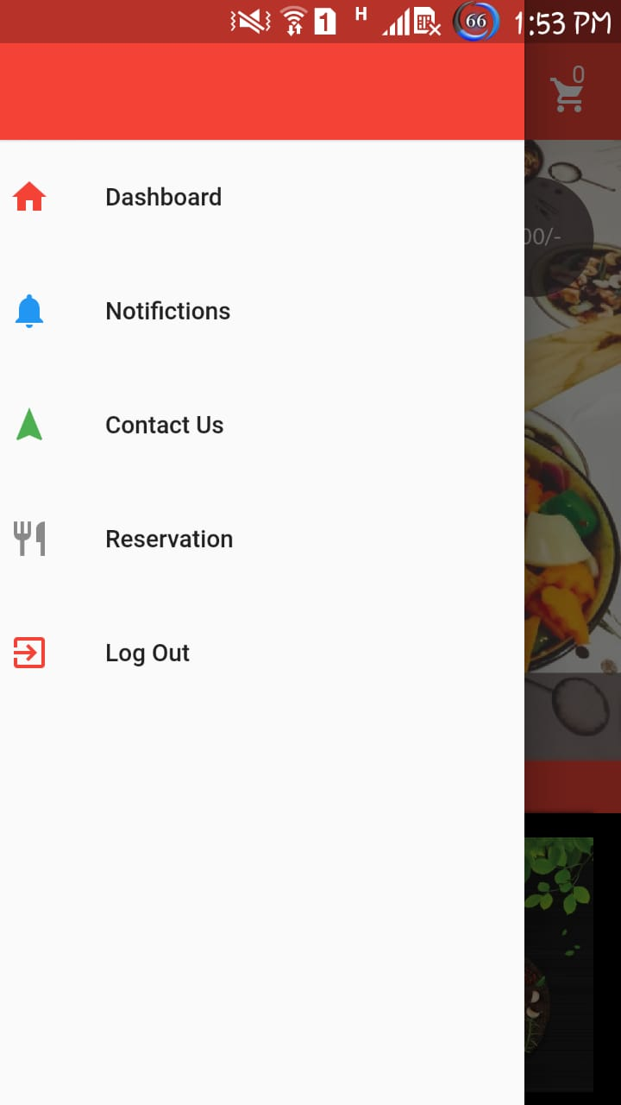
Figure 25:Drawer
- Drawer has different options for user.

Contact Us
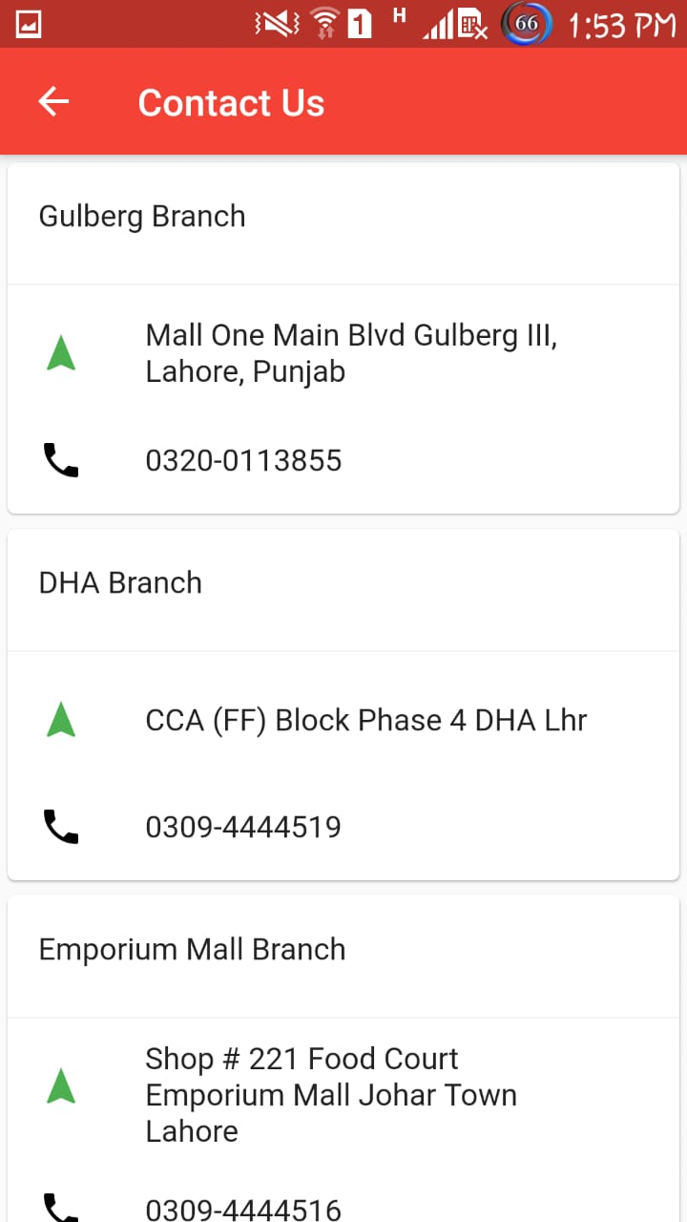
Figure 26:Contact Us
- Restaurants contact information is available in application drawer.

Reservation
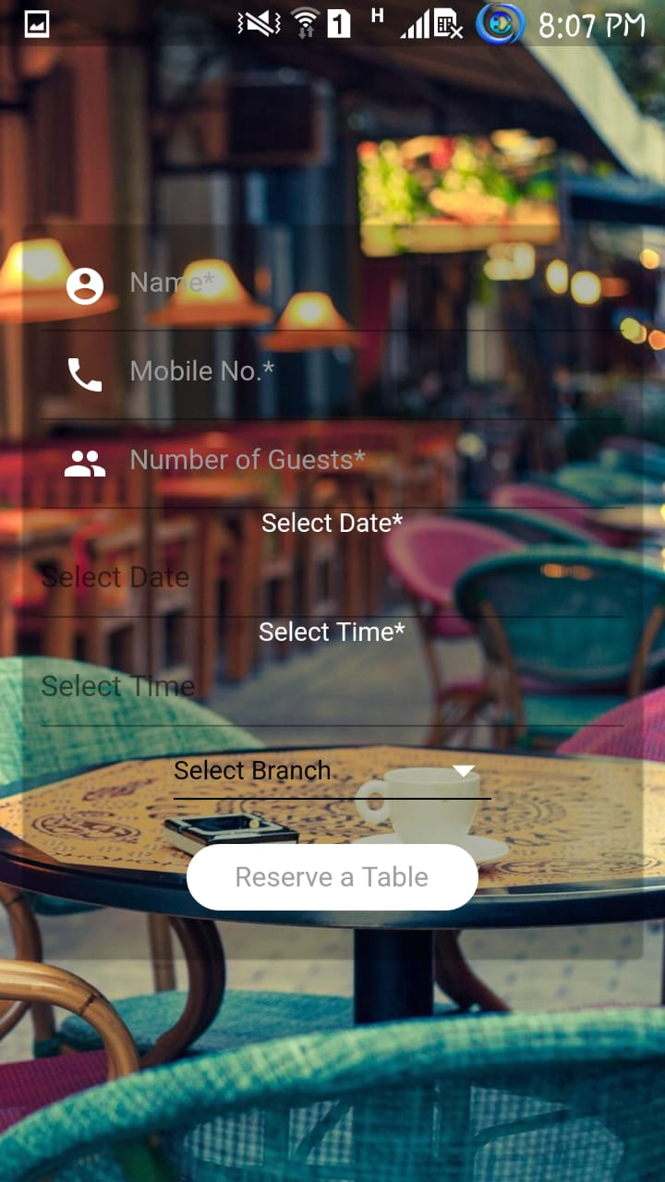

Figure 27:Reservation

- User can reserve his table through the application

Cart
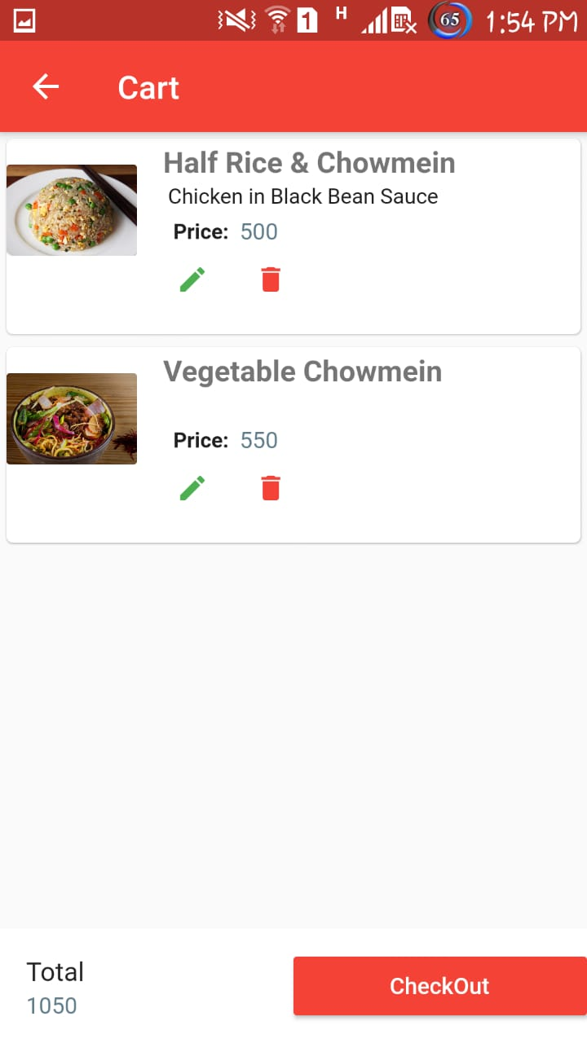
Figure 28: Cart
- Orders will be shown in the cart list of the application.

Location
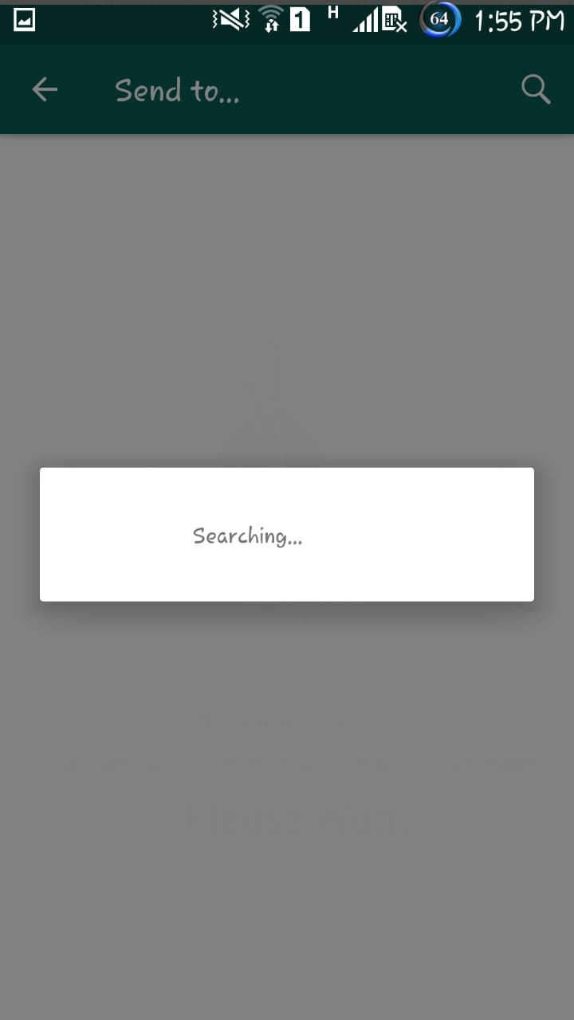
Figure 29:Location
- If user order food to home he will be directed to delivery boy’s whatsapp number to send live location.

CONCLUSION AND RECOMMENDATIONS

To facilitate the restaurants to overcome the manual ordering system keeping in mind the modern era technologies. In this project, User will order his/her food from his/her own mobile through this application. User will send live location to delivery boy, user will reserve his/her table through this application and many more. I have understood the working of the flutter and laravel. I hope it will be helpful for me in the industry and for my client.

REFERENCES

Electronic Sources from Internet:
[1] Martin, G. (2019). My Thoughts About Flutter, The New Cross-Platform Framework. [online] Medium. Available at: https://medium.com/flutter-community/my-thoughts-about-flutter-the-new-cross-platform-framework-bb6c0febf1aa [Accessed 10 Dec. 2019].
[2] Martin, G. (2019). My Thoughts About Flutter, The New Cross-Platform Framework. [online] Medium. Available at: https://medium.com/flutter-community/my-thoughts-about-flutter-the-new-cross-platform-framework-bb6c0febf1aa [Accessed 10 Dec. 2019].
[3] Dart packages. (2019). flutter_launch | Flutter Package. [online] Available at: https://pub.dev/packages/flutter_launch [Accessed 20 May 2019].
[4] karthik, p. (2019). fluttertoast | Flutter Package. [online] Dart packages. Available at: https://pub.dev/packages/fluttertoast [Accessed 5 Sep. 2019].

[5] julien, l. (2019). carousel_pro | Flutter Package. [online] Dart packages. Available at: https://pub.dev/packages/carousel_pro [Accessed 30 Jun. 2019].

APPENDICES

APPENDIX 1: Computer Programme Listing

  - Store Order Function:
public function store(Request $request)
{
\Log::info($request);

$order = new Order();
$order->table_no=$request[0]['bowlType'];
$order->order_type=$request[0]['image'];
$order->save();
$order_table= DB::table('order')->latest('updated_at')->first();
for ($i=0; $i <count(collect($request))-1 ; $i++) {
\Log::info(count(collect($request)));

if($request[$i]['side']!=NULL){
$side = new Side();
$side->order_id = $order_table->id;
$side->side_name = $request[$i]['side'];
$side->save();
}
else
{
$side = new Side();
$side->order_id = $order_table->id;
$side->empty='--';
$side->save();
}

if ($request[$i]['basicEntree']!=NULL) {
$BasicEntree = new BasicEntree();
$BasicEntree->order_id=$order_table->id;
$BasicEntree->be_name=$request[$i]['basicEntree'];
//save data in basic_entree table
$BasicEntree->save();
}
else
{
$BasicEntree = new BasicEntree();
$BasicEntree->order_id=$order_table->id;
$BasicEntree->empty='--';
$BasicEntree->save();
}

if ($request[$i]['superiorEntree']!=NULL) {
$ImperialEntree = new ImperialEntree();
$ImperialEntree->order_id=$order_table->id;
$ImperialEntree->se_name=$request[$i]['superiorEntree'];
//save data in imperial_entree table
$ImperialEntree->save();
}
else
{
$ImperialEntree = new ImperialEntree();
$ImperialEntree->order_id=$order_table->id;
$ImperialEntree->empty='--';
$ImperialEntree->save();
}

if ($request[$i]['drink']!=NULL) {
$Drink = new Drink();
$Drink->order_id=$order_table->id;
$Drink->name=$request[$i]['drink'];
//save data in drink table
$Drink->save();
}
else
{
$Drink = new Drink();
$Drink->order_id=$order_table->id;
$Drink->empty='--';
$Drink->save();
}

if ($request[$i]['superiorStarter']!=NULL) {
$SuperiorStarter = new SuperiorStarter();
$SuperiorStarter->order_id=$order_table->id;
$SuperiorStarter->ss_name=$request[$i]['superiorStarter'];
//add quantity here//
//save data in superior_starter table
$SuperiorStarter->save();
}
else
{
$SuperiorStarter = new SuperiorStarter();
$SuperiorStarter->order_id=$order_table->id;
$SuperiorStarter->empty='--';
$SuperiorStarter->save();
}
}
}

  - Get Notification Function:
public function getNotification()
{
return response()->json([
'message' => 'Your order has been confirmed!'
],422);
}

