
BSCS-S19-010
03-134161-047 | TASKEEN ALTAF SHAH

A Prototype Based on Persuasive System Design of Learning Management System

In partial fulfilment of the requirements for the degree of
Bachelor of Science in Computer Science
Supervisor: Taimoor Aamer
Department of Computer Sciences
Bahria University, Lahore Campus
January 2020

© Bahria University, 2020

Certificate

I accept the work contained in the report titled
“A PROTOTYPE BASED ON PERSUASIVE SYSTEM DESIGN OF LEARNING MANAGEMENT SYSTEM”
Written by
TASKEEN ALTAF SHAH

as a confirmation to the required standard for the partial fulfilment of the degree of
Bachelor of Science in Computer Science.

Approved by:
Supervisor: Taimoor Aamer
(Signature)

January 27, 2020

DECLARATION

I hereby declared that this project report is based on my original work except for citations and quotations which have been duly acknowledged. I also declare that it has not been previously and concurrently submitted for any other degree or award at Bahria University or other institutions.

Enrolment | Name | Signature
03-134161-047 | TASKEEN ALTAF SHAH

Date : January 27, 2020

Specially dedicated to
my beloved grandmother, mother and father
(Taskeen Altaf Shah)

ACKNOWLEDGEMENTS

I would like to thank everyone who had contributed to the successful completion of this project. I would like to express my/our gratitude to my research supervisor, Mr Taimoor Aamer for his invaluable advice, guidance and his enormous patience throughout the development of the research.

In addition, I would also like to express my gratitude to my loving parent and friends who had helped and given me encouragement.

Taskeen Altaf Shah

A PROTOTYPE BASED ON PERSUASIVE SYSTEM DESIGN OF LEARNING MANAGEMENT SYSTEM

ABSTRACT

The objective of this project is to develop a prototype based on persuasive system design in learning management system. This study deals with distance education system which have become more advanced over time. Learning management system is the main component to facilitate the student learning. Persuasive design is all about tempting the learners like how can you make your learning management system more persuasive where people can get attracted towards online learning system. Having a persuasive design in learning management system enable a user to understand and engage with the application in an effective way. Persuasive system design has identified several key features to be embedded in to a system interface in order to enhance the engagement. While taking account the research done by different researchers and their publications the study has been conducted. The study would be measuring the task System support feature from persuasive design model in order to recommend improvement in a learning management system.

TABLE OF CONTENTS

DECLARATION iii
ACKNOWLEDGEMENTS v
ABSTRACT vi
TABLE OF CONTENTS vii

CHAPTERS
INTRODUCTION 1
1.1 Background 1
1.2 Problem Statement 2
1.3 Aims and Objectives 2
1.4 Scope of Project 3
LITERATURE REVIEW (and/or SRS) 4
2.1 Introduction 4
2.2 Learning Management System 6
2.3 Need for Learning Management System 8
2.3.1 Community and Collaboration: 8
2.3.2 Course Authoring Capability 9
2.4 Features of Learning Management System: 9
2.4.1 Overview of Learning Management System and Persuasive System Design 11
2.5 Persuasive System Design 12
2.5.1 Parameters of Persuasive System Design 13
2.5.2 Overview Persuasive System Design and Learning Management System: 16
2.6 Titan Learning Management System 16
2.7 TOP 5 LEARNING MANAGEMENT SYSTEM SOFTWARE: 17
2.7.1 Titan LMS: 18
2.7.2 Benefits of Titan LMS: 18
2.8 USER INTERFACES 19
2.8.1 Login UI 19
2.8.2 Home UI 19
2.8.3 Contact UI 19
2.8.4 Course UI 19
2.8.5 System Task Support UI 20
2.9 User Classes and Characteristics 20
2.9.1 Entity Classes 20
2.10 Controller Classes 22
Login 22
Register 22
2.11 Design and Implementation Constraints 24
• Good internet connection speed for uninterrupted services. 24
2.12 Assumptions and Dependencies 24
3 DESIGN AND METHODOLOGY 25
3.1 Domain model 25
3.2 Sequence Diagram 26
Login 26
3.3 System Use cases 28
3.1 Use case diagram 28
3.1.1 Register Use Case (U1) 28
3.1.2 Sign In User (U2) 29
3.1.3 Create Group/Class (U6) 30
3.1.4 Approve/Reject Request to Join Class/Group (U15) 31
3.1.5 Upload Assignment/Task (U3) 32
3.1.6 View Assignment/Task/file (U5) 33
3.1.7 Submit Assignment (U13) 34
3.1.8 Practice Work (U16) 34
3.1.9 Upload Progress Report (U10) 35
3.1.10 Add members in class (U07) 36
3.1.11 Grade Task/Assignment (U09) 37
3.1.12 Take Quizzes (U17) 38
3.1.13 View Progress Report (U11) 38
3.1.14 Verify Credentials (U18) 39
3.1.15 Confirm Registration (U19) 40
3.1.16 Reject Registration (U20) 40
3.1.17 Upload media (U04) 41
3.1.18 Contact Faculty (U12) 42
3.2 System Requirements Chart 42
3.3 Design and Prototype of Titan LMS 46
3.3.1 About us page 49
3.3.2 Contact Us 49
3.4 Methodology 50
3.4.1 3.4.1 User-driven Development (UDD) 50
3.4.2 Qualitative research 50
3.4.3 Design Thinking 51
4 DATA AND EXPERIMENTS (and/or IMPLMENTATION) 52
4.1 Overview 52
4.2 Software Development Methodology 52
Software Tools 52
Brackets 52
4.2.1 Visual Paradigm for UML Community Edition 53
4.2.2 Adobe Photoshop CS6 53
5 RESULTS AND DISCUSSIONS 54
5.1 Learning Management System 54
5.2 Organization of the User Manual 54
5.2.1 Home page of Titan LMS 54
5.2.2 About Us Page 56
5.2.3 Contact Us 57
5.2.4 Improved Form of Titan LMS: 58
6 CONCLUSION AND RECOMMENDATIONS 60
6.1 Conclusion 60
6.2 Recommendations 60
6.3 Future work 61
REFERENCES 62
Usability Questionnaire 64
APPENDICES 69
User Registration 69
Activity Options 70
III-TITAN LMS 75

LIST OF FIGURES

FIGURE TITLE PAGE

Figure 1: Learning Management System 1 7

Figure 2: Domain Model of Titan Elms 1 25

Figure 3: Sequence diagram of Login 1 26

Figure 3.2: User Grade of Titan Lms 1 26

Figure 3.3: Sequence Diagram User logout 1 27

INTRODUCTION

Background

Learning management system is where individuals can facilitate their trouble while learning in school, home and anyplace. It empowers us for self-learning and diminishes the expense of preparing like it very well may be access by anyplace at any time. In the consistently developing propelled tech-world, there is in every case a type of need of individuals, which should be managed, utilizing trend setting innovation. They require a type of a stage to facilitate their trouble while learning at school or at home. Such a stage can be a learning management system (LMS) which is based on the requirements of these individuals, people everywhere throughout the world are getting advantage particularly those with extraordinary necessities, Persuasive system design empower a client to draw in with application in an effective manner. So one other explanation for this task is to illuminate individuals here in Pakistan that learning management system is a stage which gives the collaboration and joint effort among understudies and staff. It isn't just comprehend the understudy adapting yet it additionally comprehend the understudy conduct. Persuasive system design enables to the students to make moving, persuasive internet learning for the intended interest group. The main opportunity for students to collaborate is a significant component specifically for the students who may be learning at a distance. Tasks should be addressed to a group rather than an individual, and proper means of communication should be established so that student could be able to learn properly. Collaboration is the main part which should be encouraged through tasks and communication technology.

Problem Statement

The problem statement of this project is to design a prototype which is based on persuasive system design in learning management system. We need to identify the importance of persuasive system design in learning management system. To identify the appropriate design/model of persuasive system design in learning management system. Online learning is basically the distance education by any organization like Open University where students can interact with teachers and leaners indirectly without visiting campus.

Aims and Objectives

The objectives of the thesis are shown as following:
- To gather the basic knowledge associated with persuasive system design.
- To identify the importance of persuasive system design in learning management system.
- To identify the appropriate method/model to measure the persuasive system design model in learning management system.
- To recommend improvement in persuasive system model in learning management system.

Scope of Project

The scope of this project is to improve the student engagement in learning management system. Persuasive system design in learning management system plays vital role like we need to know how it could be effective for the people who wants to study through online learning system. It is an environment in which learners interact with learning material (reading, assignments and exercises) and instructions are mediated through advance information technology. Through enhancement in user interface by adopting persuasive design model. Need to recommend areas of research and improvement in User Interface for learning management system. Having persuasive system design in learning management system empower a client to draw in with the application in a successful manner.

LITERATURE REVIEW (and/or SRS)

Introduction
This project is intended to give a complete overview on “A prototype based on persuasive system design of learning management system”. In start, the evolution of learning management system was quite swift. There are many companies who want to invest in educational institution. It is a new learning technology. Evaluation of learning management is complex and demanding process which requires a lot of knowledge, time and effort. Distance learning systems is not limited to classroom instruction only, teaching through different channels to measure the needs of student. Learning management system is a platform where people can ease their difficulty whilst learning in school, home and anywhere. It enables us for self-learning and reduces the cost of training like it can be access by anywhere, anytime. In the ever evolving advanced tech-world, there is always some sort of need of human beings, which needs to be dealt with, using advanced technology. They require some sort of a platform to ease their difficulty whilst learning at school or at home. Such a platform can be a learning management system (LMS) which is built on the needs of these people, humans all over the world are getting benefit especially those with special needs, persuasive system design enable a user to engage with application in an effective way. So one other reason behind this project is to enlighten people here in Pakistan that learning management system is a platform which provides the interaction and collaboration between students and staff. It is not only understand the student learning but it also understand the student behavior. Persuasive system design gives the ability to the student to create inspiring, motivational online learning for the target audience.

Learning management system is where individuals can facilitate their trouble while learning in school, home and anyplace. It empowers us for self-learning and diminishes the expense of preparing like it very well may be access by anyplace, anytime. In the consistently developing propelled tech-world, there is in every case a type of need of individuals, which should be managed, utilizing trend setting innovation. They require a type of a stage to facilitate their trouble while learning at school or at home. Such a stage can be a learning management system (LMS) which is based on the requirements of these individuals, people everywhere throughout the world are getting advantage particularly those with extraordinary necessities, Persuasive system design empower a client to draw in with application in a compelling manner.[1] So one other explanation for this task is to illuminate individuals here in Pakistan that learning management system is a platform which gives the collaboration and joint effort among students and staff. It isn't just comprehend the understudy adapting yet it additionally comprehend the understudy conduct.
Persuasive system design enables to the student to make moving, persuasive internet learning for the intended interest group. The opportunity for clients to work together is a significant design component, especially for students who might be learning at a distance. Subsequently, tasks should be addressed to a group rather an individual, and suitable methods for communication should be built up. Collaboration should be encouraged through suitable assignments and correspondence innovation.[2]

Learning Management System

Learning management system is about tests, assignments and undertakings and it is a web based learning framework which is utilized to encourage student learning. Through internet learning management system anybody can prepare anything from 5 to 50,000 understudies. Learning management system is a product and online innovation which gives the educator/instructor an approach to convey substance and screen understudy cooperation and gets to the understudy execution.[3] Learning management system is progressively compelling for the general population who needs to proceed with their training while at the same time working in normal job.it can make business fruitful. Online can be more effective than customary homerooms. Having a Persuasive system design in learning management system empower a client to comprehend and connect with the application in a viable manner. per[1]The opportunity for clients to work together is a significant design component, especially for students who might be learning at a distance. Subsequently, tasks should be addressed to a group rather an individual, and suitable methods for communication should be built up. Collaboration should be encouraged through suitable assignments and correspondence innovation.
In begin, the utilization of learning management was very quick. It makes learning progressively sensible for individuals who needs to proceed with their investigation while working in workplaces. Internet learning can be more effective than conventional homerooms. Through online framework anybody can prepare anything from 5 to 50,000 understudies or workers all with minimal effort.[1] Learning management system ought to have concentrate and robotize organization. Like an understudy is joined up with a specific course an1d I may allot that understudy to a specific course and confine that to access to that course. This understudy will almost certainly get to that course for the time of 30 days. Following 30 days he won't almost certainly get to that course since understudy access would be incapacitated and vanished.
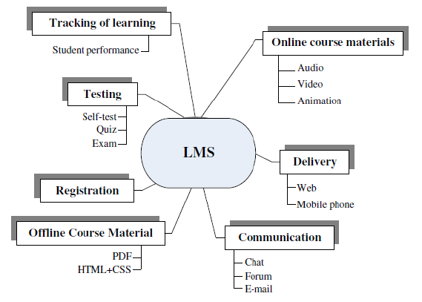
Figure 1: Learning Management System 1

Students cooperate with learning materials like tests, assignments and so forth online courses could be conveyed through sound, video and movements. Much of the time, grade school students are not having the option to comprehend the content or slides. So they like to envision the pic or enlivened thing which could be increasingly reasonable for them. For instance, kid's shows or pics are best case for persuasive structure they can improve data with respect to this. Learning management system is practical it will assist you with saving cash that you would have spent on transportation and printing. It is easy to use where student can get to information or learning material through cell phones, and tablets, workstations. [2] It keeps every one of the information put away in one area so the student won't get confounded over discovering material where it is found. At the point when any understudy get confirmation in any college. He get enrol in various courses and need material with respect to courses. Client needs to get tried out all courses and subsequent to having assessment his everything issues get settled.

Need for Learning Management System
Learning management system is programming and electronic innovation which is utilized to execute, plan and encourage the understudy learning. Learning management system is an online administration system which gives courses as well as a total administration system. A large portion of the LMS are utilized by standard enterprises, budgetary administrations and it divisions. Which help individuals to defeat their separation and can connect with this application successfully. Learning management system is being utilized by virtual colleges which give better training to the general population who can't bear the cost of their costs. For marking in learning management system you have to initially sign and enrol yourself in course to make collaboration and joint effort like human PC connection.[4] There is set number of individuals who realize how to get to and work PCs. So such interfaces are required by utilizing which more individuals can convey and collaborate with PCs utilizing their characteristic dialects.

In this regularly developing present day world, innovation is getting to be huge and individuals are getting specialized with the progression of time and they are working out for better instruction framework and getting communicated towards the persuasive system design to upgrade their commitment with application.[5] At the season of secondary school instruction, individuals must be educated about the new innovation, new patterns, and numerous organizations are having their own LMS. IT framework. A perfect learning management system more likely than not incorporated and robotize organization which should be engaged.

Community and Collaboration:
Learning management system is relational correspondence organize which is being required for the joint effort of system like understudies and teachers can cooperate through framework access of web. For getting register in any course you ought to likely participate in that particular course. People can have register themselves explicitly course. LMS is a phase which is used for chronicles, sounds and presentation.[6] What's more, can download records. It is that stage which has given to the educators to transfer their assignments and tests. It is shared learning for the students.

Course Authoring Capability
Courses will be enrolled or approved by administrator, just those individuals with login will most likely access learning management system. LMS empower instructors to make content for understudies.

Features of Learning Management System:

A learning the administrators system should most likely methodology with control, hard, targets, timetable and execution of advantages the load up endeavours. Essential concern which need to fathom is that what the associations needs to vanquish from a business and an informative point of view and principal object is to recognize the necessities. For the online courses the fundamental exertion required for the learning the authority’s framework is in masterminding and finishing appropriate learning strategies.

Learning management system is connected to empowering the student learning. Distance learning structures isn't obliged to standard homeroom just, yet it furthermore fuses teaching through various channels depending upon the necessities of the understudies. Learning management system deals with the organization of planning and study record of the item for having helpful courses. [4] Various schools and universities apply for learning the officials system to pass on the unmistakable online course. Distance learning isn't confined to ponder corridor direction just, it moreover joins teaching through various channels depending upon the necessities of the understudies.

Online learning is basically the distance education by any organization like Open University where students can interact with tutors and leaners indirectly without visiting campus, learning management system (LMS) is the basic step in the automation of computer and human interactions. Nowadays, in market, the learning management system is the most demanding technology. There is an increasing demand in the market for the applications where learner peruse towards the learning activities through learning management system. It benefits the learners, developers.

For the online courses the essential effort required for the learning the official structure is in arranging and realizing suitable learning procedures.[4]

Learning management system is connected in with encouraging the student learning. Distance learning isn't restricted to customary study hall just, however it additionally incorporates educating through different channels relying upon the requirements of the students. Learning management system manages the administration of preparing and study record of the product for having community oriented courses. Different schools and colleges apply for learning management system to convey the distinctive online course.

Fundamental highlights of learning management system which assumes significant job in doing learning management system.

Authoring Tools:
In learning management system. LMS is an open source which enables you to empower and make a test.[6] Like instructors can empower understudies to access on LMS for pondering assignment, tests and adventures.

Email, Discussion Forums:
Allocate of learning the board framework permits us to talk about through email, and dialog discussions like having great system association will empower us to login into learning management system.

Individual Folders for Work:
In learning management system. It provides platform or place where they can upload their tasks, assignments, projects. Individual folder will be used for work

Access for Students and Teachers:
In learning management system, there will be different access for students, teachers and administration. Same person may give different courses like course 1 is for students, 2nd course will be assigned to the teachers as well as administration.

Distance learning systems is not confined to classroom instruction only, but it also includes teaching through various channels depending on the requirements of the students.

Learning management system is the separation instruction by association like open college where student can cooperate with learning material without visiting the grounds. Understudy and educator can collaborate through email, portable. Moodle is an open source and significant where educators put all task and tests and request that understudies join the class and understudy join the class .at that point get to all assignments and tests as indicated by instructor proposal. Customize learning is the primary technique for understudy commitment with scholastic accomplishments. Not all students are perusable.

Overview of Learning Management System and Persuasive System Design

With the help of learning the board framework, teachers get adequately followed in a progression what an understudy is doing in a course. That is way teacher can without a lot of a stretch recognize zone of course.it keeps all of the data set aside in one region so the understudies won't get perplexed and finding where data is found. Learning the board framework is the partition guidance by affiliation like open school where understudy can help out learning material without visiting the grounds. Understudy and teacher can work together through email, convenient. Moodle is an open source and critical where teachers put all errand and tests and solicitation that understudies join the class and understudy join the class .by then find a workable pace and tests as demonstrated by educator proposition[7]. Customize learning is the primary technique for understudy commitment with scholastic accomplishments. Not all students are perusable.

Persuasive design is all about influencing human behaviour through product or services. It associates with interaction with students, teachers and admin. [6] Making your design more persuasive can influence people through your product. Having persuasive design in learning management system enables a user to engage with application effectively. Through enhancement in user interface we need to embed persuasive system design in learning management system.
Persuasive system design is the component of web based learning and it will improve the student engagement in learning management system. Through enhancement in user interface by adopting persuasive design model in learning management system can be more effective. Persuasive system design is designed to influence the learner to get attracted towards the learning activities in learning management system. It is designed to make sure that learning management system is also meaning as well as traditional classrooms. These technologies like mobile phone, I pads, and laptops provide opportunities to interact and collaborate with the people who are using learning management system.

Persuasive System Design

Persuasion is a word which is defined as “temptation”. When you get pulled in towards something then you will almost certainly comprehend that thing all the more plainly. Influence is about allurement.[5] Assume on the off chance that you get message on your phone, at that point you will most likely become acquainted with and you will get pulled in just to realize what's going on inside.

The idea of powerful innovation centres around PC and data innovation used to change individuals' dispositions or practices. Who's going to messaging or something different? It's called allurement or influence. Where you get pulled in and needed to think about that thing in all respects deliberately. Like you get notice on your Facebook and one minutes from now to you need to see that warning. That is called influence. In electronic learning, there is apparently two significant research bunches where one game plans with the improvement of good plans while various game plans with the assessment of understudy's satisfaction with an online course as it relates to an ordinary course. [8]Persuasive system model in learning management system assumes significant job.
In this regularly advancing innovation, significance of persuasive system design in learning management system is enhancing quickly. Just those individuals with login will almost certainly get to the learning management system. There are three distinct kinds of login Students, instructors, organization. Administrator will almost certainly present the device to client to enable them to include substance and remove the content and permit client access to specific territories of learning management system where can change the setting. Persuasive system design is connected in with impacting human conduct through item or administrations.[9] It partners with communication with understudies, instructors and administrator. Making your plan increasingly convincing can impact individuals through your item. Having persuasive system design in learning management system empowers a client to connect with application successfully. Through upgrade in UI we have to implant persuasive system design in learning management system. [9].Persuasive system design is the part of electronic learning and it will improve the understudy commitment in learning management system. Through improvement in UI by embracing persuasive system design model in learning management system can be increasingly viable. Persuasive system design is intended to impact the student to get pulled in towards the learning exercises in learning management system. It is intended to ensure that learning management system is importance just as conventional homerooms.[5] These advancements like cell phone, I pads, workstations give opportunities to cooperate and team up with the general population who are utilizing learning management system.

Parameters of Persuasive System Design
Main parameters of persuasive system design of learning management system is basically are like
- Primary task support
- System task support
- Credibility support
- Learning support
We will compare the two different features of persuasive system design like primary task support with system task support like which one can be more persuasive so that people could attract towards this design.

Primary Task Support:
Primary task support is an important parameter of persuasive system design. There are some sub factors of primary task support which are as follows:
- Tailoring:
Tailoring is an important sub factor of primary task support.
- Tailors data dependent on clients potential intrigue, use challenge, or different variables significant to a client gathering.

- Tailoring give particular data to center gathering.

- Tailoring gives the opportunity of learning strategy.

- Tailoring customize the information seeing as required by center gathering.
- Reduction:
- It give point as a manual for learning process.

- Learning arrangement ought to be clear and simple to follow.

- It give clarification to certain subject.

- Liking:

- Visual master on any related picture.

- Testimony from the clients.

System Task Support:

System task support is also an important factor of persuasive system design. There are some sub factors of system task support which are as follows:
Suggestions:
System will make suggestion to the user about activities/ actions that can help to improve their task.[11]

Praise:
The system will give praise to the user for each recommended activity/action that he/she has carried out during the day.
Rewards:
The framework will give client a rate increment in everyday vitality (during the present week) if their rest quality is high than the earlier day.

Credibility Support:
Credibility support is also an important feature of persuasive system design of learning management system. There are some sub factors of credibility support.

Information:
Provide users with the variety, useful, relevance, validity, and complete information.

Trustworthiness:
- Provide user with truthful fair and unbiased information.
- Provide recognized information.
- Provide reviewed and analyzed information.
Surface Credibility:
System will not display announcements to the user.

Real world feel:
- Provide instructors information.
- User can select instructor to communicate.
- Provide learning schedule or syllabus.

Learning Support:
Learning support is also an important feature of persuasive system design and their sub features are as follows:

Social Facilitation:
- User can make suggestions.
- Social interaction support.
Self-Monitoring:
- Allow user to keep track of their
- System will present the user sleep quality daily and store the result per week
Real world feel:
- Provide instructors information.
- User can select instructor to communicate.
- Provide learning schedule or syllabus

Recognition:
- Provide the public recognition for the users who perform their target behavior.
- Certification for the rewarded.
- Names of users that complete the courses will be published in news area.

Overview Persuasive System Design and Learning Management System:

Persuasive design is all about influencing human behaviour through product or services. It associates with interaction with students, teachers and admin. Making your design more persuasive can influence people through your product. Having persuasive design in learning management system enables a user to engage with application effectively.[3] Through enhancement in user interface we need to embed persuasive system design in learning management system.
Persuasive system design is the component of web based learning and it will improve the student engagement in learning management system. Through enhancement in user interface by adopting persuasive design model in learning management system can be more effective. Persuasive system design is designed to influence the learner to get attracted towards the learning activities in learning management system. It is designed to make sure that learning management system is also meaning as well as traditional classrooms. These technologies like mobile phone, I pads, and laptops provide opportunities to interact and collaborate with the people who are using learning management system.

Titan Learning Management System
Titan LMS is an online learning management system. It runs on all stages like windows, Ubuntu, Linux and so on. Titan LMS is the mainstream and most utilized learning management system. Titan LMS is an easy to understand e learning stage that play out the learning and preparing needs of individuals from a wide range of association. Titan LMS is about course the board framework. Titan LMS is an open source, allowed to download learning the board framework. It has various modules in which we can make up and coming occasions, ongoing movement, search gathering, most recent news.[12] It is available in Different languages. It is used by teachers and educators. It is the Best e-learning in the net.

For Teachers:
- Teachers can create online courses.
- Teachers can divide students in classes.
- Teachers can upload files and lessons.
- Teachers can create online test and examinations.
- Teachers can provide chat forums.

Teachers and students need login id so they can easily upload test and assignments. And students can login by using their student ID in Titan LMS.[3] Students can also create chat session in outdoor.

STUDENT:
- Students follow the lesson.
- Students follow the subject.
- Students can access assignment and can give online quiz.
- Students can follow the content given by teacher.
- Students and teachers can create chat sessions.

TOP 5 LEARNING MANAGEMENT SYSTEM SOFTWARE:
- Edmodo
- Moodle
- Blackboard
- Skill port
- Canvas
- Google classroom

- Edmodo:
Edmodo is a cloud based elms that takes into consideration community oriented learning through substance sharing. Specialized instruments, and homeroom the board. Instructors can make and send assignments. Tests, tests, and surveys to upgrade and merge their true study hall.

- Moodle:
Moodle is a free web based learning management system giving teachers around the globe. With an open source answer for e discovering that is adaptable, adjustable, and secure with the biggest choice of exercises accessible.
- Blackboard :
Black board is a virtual center point for the understudies administration that give access to online course material, grades, association, records and that's just the beginning. It is allowed to utilize.
- Skill port:
Skill port is a cutting edge, cloud based elms. That gives an unmatched learning experience by interfacing formal, casual shared learning, Skill port is low weight and minimal effort elms.
- Canvas:
Canvas is anything but difficult to utilize and cloud based elms that interfaces every single advanced device and assets. Instructors use into one basic explicit spot.

Titan LMS:
Titan LMS is a popular and most used learning management system. Titan LMS is a flexible, open source, free to download elms. In different public or public sites, the teachers and trainer and employees can create and deliver online courses so that their audience can meet their learning goals. Titan is used by organization is all shapes and sizes. It is used for business, corporation, hospitals and non-profits for online learning, training process.
Titan LMS is used for:
- Online course development.
- Product and service launching
- Communities of expertise
- Communities of practice.
- Workplace safety training.
- The hiring and interview process.

Benefits of Titan LMS:
- Titan LMS is open source and Free:
Client and Organization have opportunity to run, study, and offer adjust the product to address their issues.

- Managed Titan LMS cloud facilitating.

2) Tian LMS execution &setup.

3) Titan LMS counseling.
- Titan LMS is supported by global community

Titan LMS is continually being refreshed by individuals who comprehend what clients requirement for better client experience.

• There are perpetual measure of learning assets.

• Within Titan LMS people group discussion, you can interface with different LMS client and discover answer to your inquiry.

USER INTERFACES
Following are the main user interfaces of the Moodle of LMS

Login UI
The login interface empowers you to incorporate client login with the substance of our site. The System offers security by putting away passwords in encoded structure.

Home UI
The Home interface enables a new user to visit to the Website. And being able to know about the courses which he wants to register. Upcoming homepage events occur.

Contact UI
The report interface displays various reports as progress reports, ongoing course reports, etc.

Course UI
The course interface enables the student to view the course he has registered

System Task Support UI
In system task support, which is modified feature of persuasive system design of learning management systems.
Praise:
In praise, which is the sub parameter of system task support of persuasive system design of learning management system. In which Moodle has not only been praised by individual but also at corporate level.
Reward:
Reward are given by different corporate sector not only by single individual.
Suggestions:
Anyone will be able to get suggestions regarding Moodle freely.

Notification:
Students and teachers will be able to get notification regarding their assignment/project or online quiz.

Overall Description

User Classes and Characteristics

Entity Classes
Visitor
- Visitor can go through the software
- Visitor can register to the software for a free trial of 14 days
Teacher
- User can register
- User can sign in
- User can upload task/assignment
- User can upload media file
- User can make a group/class
- User can invite students using email ID to group/class
- User can accept/reject request of a student to join group/class
- User can schedule an assignment
- User can grade the assignment
- User can upload the deadline of an assignment
- User can Delete an assignment
- User can upload progress report of student
- User can delete a member of the class/group
- User can set the privacy settings for media/file uploaded

Student
- User can register
- User can sign up
- User can send request to join/leave a group/class • User can accept/reject to join class/group.
- User can view the files uploaded in the group
- User can submit the work
- User can view the marks allocated
- User can view the work or assignments uploaded
- User can take practice quizzes/assignments
- User can email the teacher
- User can request for help from teacher
- User can view media/files uploaded by Teacher

Parent
- Can register
- Can sign in
- Can view progress report of student
- Can contact teacher directly

Admin

- Verify credentials
- Confirm registration
- Reject registration
- Check and maintain software
- View/Upload/Delete files:
- View Requests: View requests of all the registered users including Parents, Faculty, and Student.
- Manage Requests: Approve or disapprove requests.

Controller Classes

Login

- Faculty
• Username
• Password
2. Student
• Username
• Password

3. Parent
• Username
• Password

Register

1. Teacher
• First Name
• Last Name
• Username
• Password
• Password Confirmation
• Email
• Institution Name
• Phone Number
• Phone Number verification
2. Student
• First Name
• Last Name
• Username
• Password
• Password Confirmation
• Email
• Institution Name
• Phone Number
• Phone Number verification
3. Parent
• First Name
• Last Name
• Password
• Password Confirmation
• Student name
• Student Institution
• Student Username
• Email
• Student Institution Name
• Student Phone number
• Phone Number
• Phone Number verification

Design and Implementation Constraints

User must have flash player to view videos.

Good internet connection speed for uninterrupted services.

Assumptions and Dependencies

- A user can register only once
- The faculty or student registering should be enrolled or teaching at an institution
- The admin after verifying the credentials will confirm registration.

DESIGN AND METHODOLOGY

Domain model
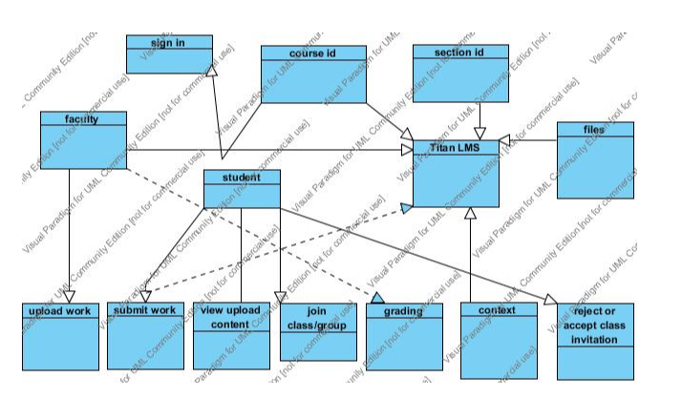
Figure 2: Domain Model of Titan Elms 1

Sequence Diagram

Login
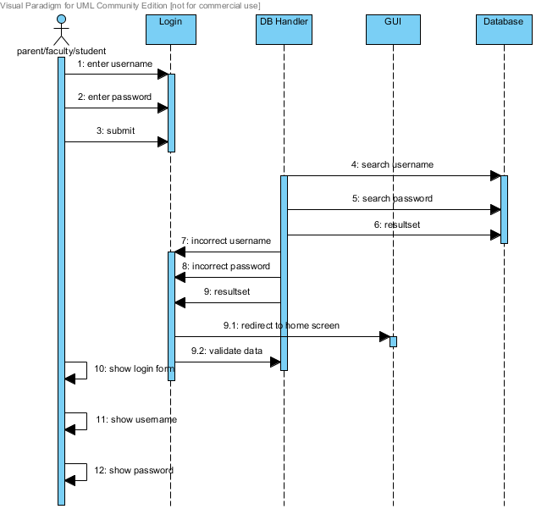
Figure 3: Sequence diagram of Login 1

User grades
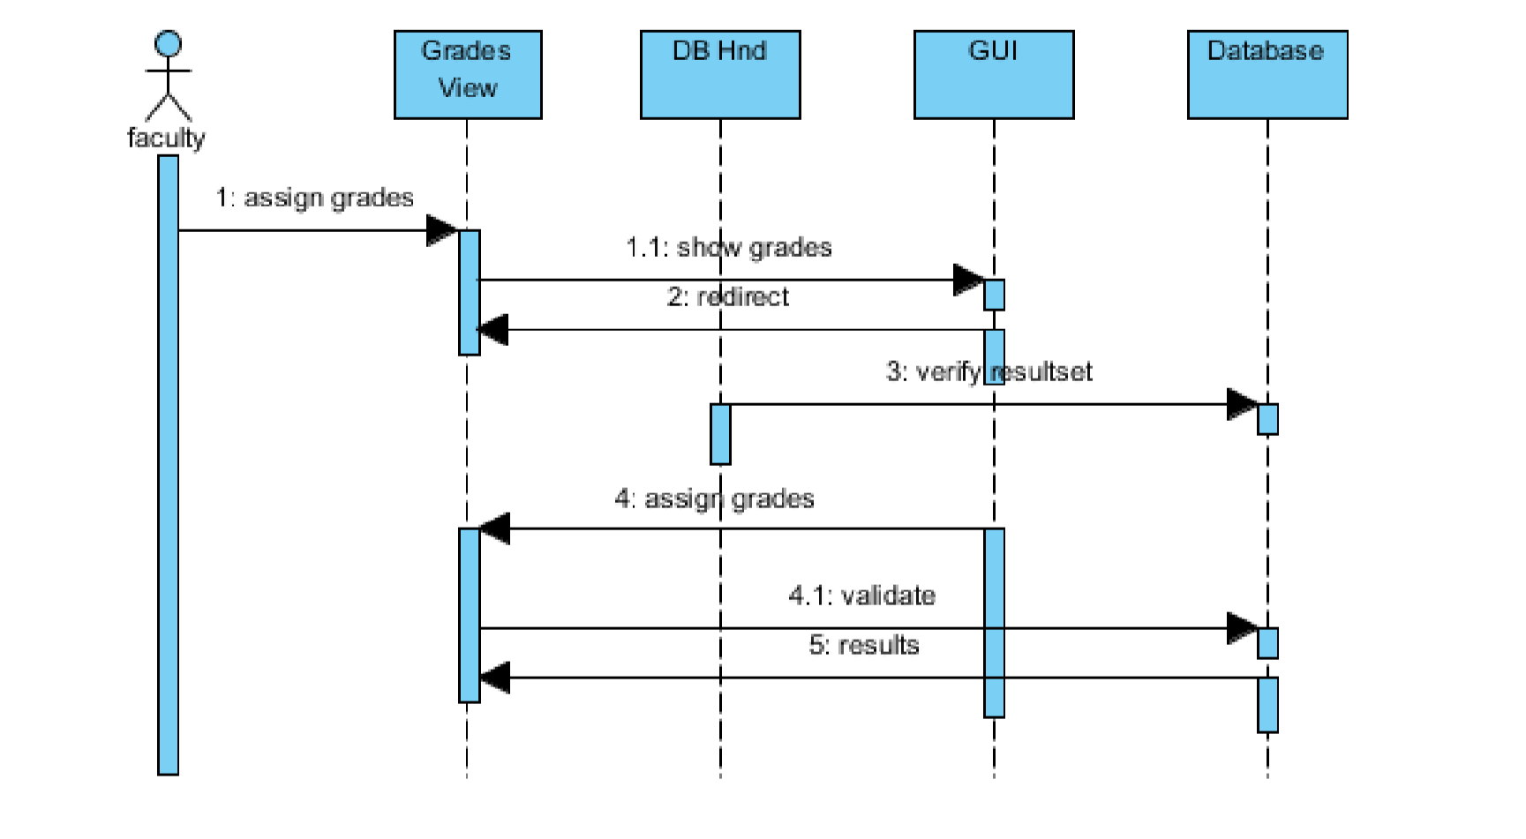
Figure 3.2: User Grade of Titan Lms 1

User Logout
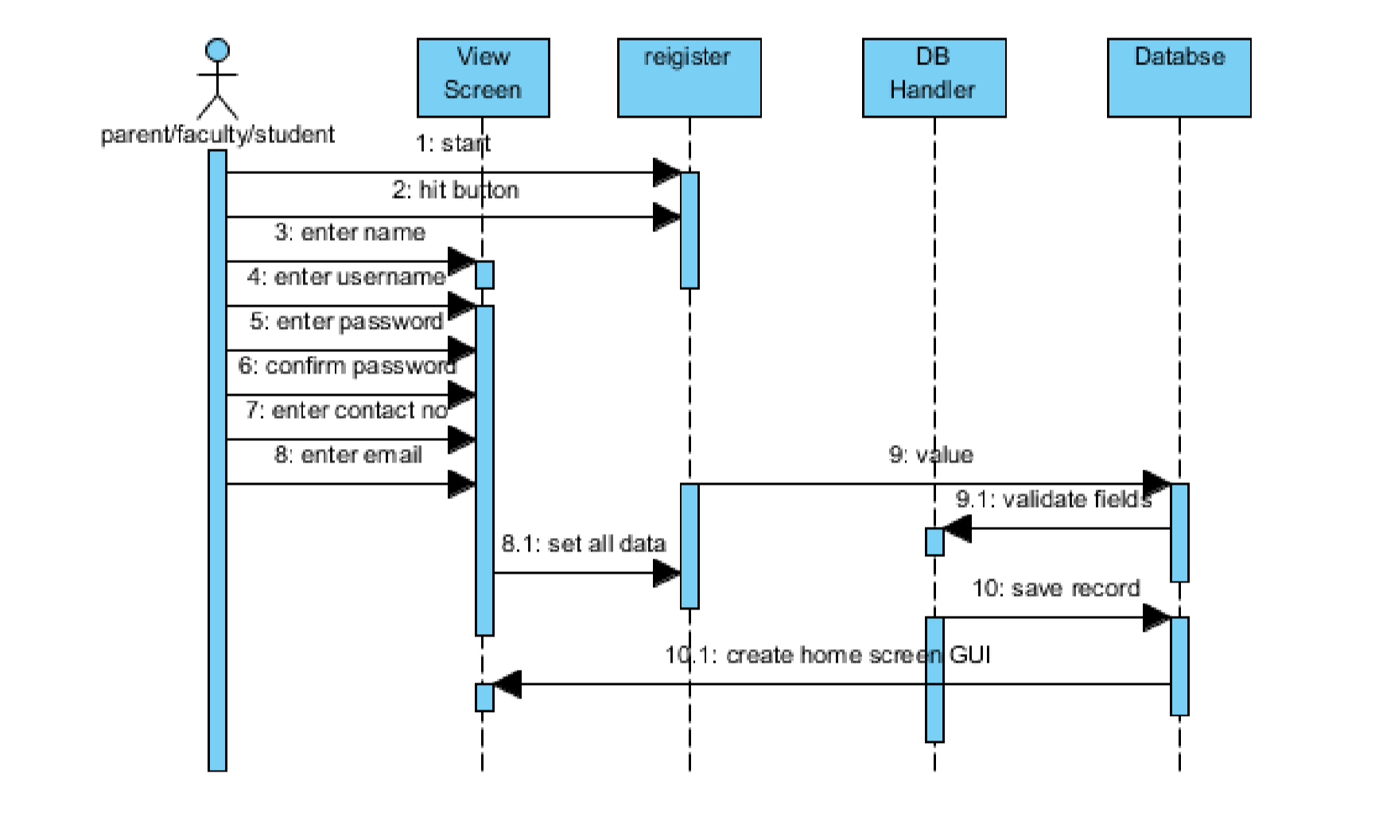
Figure 3.3: Sequence Diagram User logout 1

System Use cases

Use case diagram
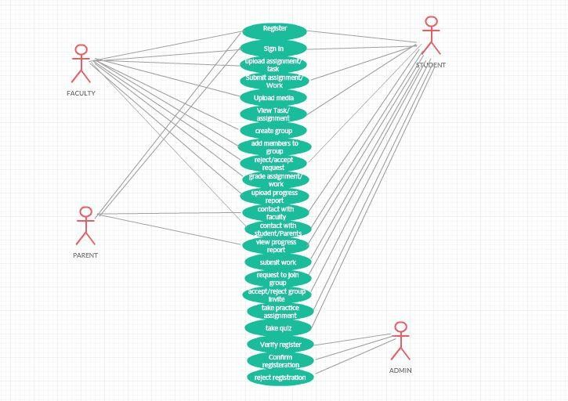
Figure 4: Use case diagram of Titan LMS

Register Use Case (U1)
 | Unique identifier | U-001
3 | Priority | High
4 | Primary Actor | Student Faculty
5 | Other participating Actor(s) | Parent
6 | Description | This use case describes the event of a User registering for the LMS
7 | Pre-condition | User is not registered yet  User is enrolled in an institution
8 | Trigger | This use case initiate when a User is going to register
9 | Typical flow of events | - User will give all the required information to get registered  - User will hit the register button  - User will get a number verification code  - User will verify the number through that specific code
10 | Alternate flow of event | Alt-1- User gives wrong information and a popup message displays  Alt-3- User gives wrong verification code and a popup  message displays
11 | Post condition | User is Successfully registered
12 | Alternate post condition | User is not registered
Table 3.1: Register Use case 1

Sign In User (U2)
1 | Name | Sign In User
2 | Unique Identifier | U-002
3 | Priority | High
4 | Primary Actor | User
5 | Other participating Actor(s) | None
6 | Description | This use case describes the event of a User signing in for the LMS
7 | Pre-condition | User is not signed in yet
8 | Trigger | This use case initiate when a User is going to sign in
9 | Typical flow of events | - User will give username and password to get signed in  - User will hit the sign in button  - System verifies given credentials
10 | Alternate flow of event | Alt-1- User gives wrong information and a popup message displays and takes back the User to sin in menu
11 | Post condition | User is Successfully signed in
12 | Alternate post condition | Sign in failed

Table 3.2: Sign In Use Case 1

Create Group/Class (U6)
1 | Name | Make request
2 | Unique Identifier | U-006
3 | Priority | High
4 | Primary Actor | Faculty
5 | Other participating Actor(s) | Students
6 | Description | This use case describes the event of a User making request to students to join class/group
7 | Pre-condition | Faculty user is signed in and wants to make request to  Students to join group/Class
9 | Typical flow of events | - Faculty User will select the activity from the activity  option menu to make a group/class
- Faculty will send request to students via notification
- Faculty will choose the students via email ID of students
- Faculty will confirm the request
- Students will have option to reject or accept
- Faculty will be notified about the response from student
11 | Post condition | Faculty has selected the activity option Successfully
12 | Alternate post condition | Student rejected or accepted request  Faculty notified about response

Table 3.3: Create Group/class use case 1

Approve/Reject Request to Join Class/Group (U15)

1 | Name | Approve/Reject Request
2 | Unique Identifier | U-004
3 | Priority | High
4 | Primary Actor | Faculty
5 | Other participating Actor(s) | None
6 | Description | This use case describes the event of a faculty user to accept/reject a student request to join a class/group
7 | Pre-condition | Student has requested for a response from Faculty
9 | Typical flow of events | - Faculty will hit the button “Accept/Reject” to cancel  the request
11 | Post condition | Request has been accepted/rejected

Table 3.4: Approve/ Reject class 1

Upload Assignment/Task (U3)

1 | Name | Upload assignment/task
2 | Unique Identifier | U-003
3 | Priority | Medium
4 | Primary Actor | Faculty
5 | Other participating Actor(s) | None
6 | Description | This use case describes the event of a User to upload an assignment/work for students  Can be a “to-do” assignment Can be “for practice”
7 | Pre-condition | Faculty has logged in
9 | Typical flow of events | - Faculty will hit the button Upload an assignment/task  - Faculty will select the file to be uploaded  - Faculty will set timing if it is a “to-do” assignment  - Faculty will select the type of assignment/task  - Faculty will confirm the request  - Students will be notified
11 | Post condition | Assignment/Task has been uploaded, notified to students  and confirmed
12 | Alternate post condition | Assignment/Task is not scheduled due to heavy capacity of  file/file capacity exceeds the maximum capacity of a file

Table 3.5: Upload assignment/ task 1

View Assignment/Task/file (U5)

1 | Name | View Assignment/Task
2 | Unique Identifier | U-006
3 | Priority | High
4 | Primary Actor | Student/Faculty
5 | Other participating Actor(s) | Faculty
6 | Description | This use case describes the event of a faculty/Student o  view the uploaded task/assignment
7 | Pre-condition | Student/Faculty is logged in
9 | Typical flow of events | - Student or faculty will check the account and activity  - Student or faculty will hit the “view this activity” button to view the assignment/task uploaded  - Student and faculty will view what type of assignment it is  - Type 1 OR type 2 (mentioned in annex A)
11 | Post condition | successfully viewed the assignment/task

Table 3.6: View Assignment/task 1

Submit Assignment (U13)

1 | Name | Submit Assignment
2 | Unique Identifier | U-007
3 | Priority | High
4 | Primary Actor | Student
5 | Other participating Actor(s) | Faculty
6 | Description | This use case describes the event of a student to submit a  due assignment/task
7 | Pre-condition | Student is logged in  Assignment due date has not passed
9 | Typical flow of events | - Student will hit the upload button to upload the file  - Student will hit the submit button to submit his/her work

Table 3.7: Submit Assignment 1

Practice Work (U16)

1 | Name | Practice Work
2 | Unique Identifier | U-016
3 | Priority | High
4 | Primary Actor | Student
5 | Other participating Actor(s) | Faculty
6 | Description | This use case describes the event of a student to practice aa  given assignment/Task that does not have a due date
7 | Pre-condition | Student is logged in
9 | Typical flow of events | - Student will search for the assignment/task  - Student will open the assignment/task  - Student will practice the given assignment/work
11 | Post condition | successfully practiced the assignment
Table 3.8 : Practice work 1

Upload Progress Report (U10)

1 | Name | Upload Progress Report
2 | Unique Identifier | U-010
3 | Priority | Medium
4 | Primary Actor | Faculty
5 | Other participating Actor(s) | None
6 | Description | This use case describes the event of a Faculty user uploading progress report of students
7 | Pre-condition | Faculty user has signed in
9 | Typical flow of events | - Faculty will hit the upload progress button  - Students will be notified  - Student can view it  - Parent can view it
11 | Post condition | Faculty user uploaded progress report Successfully
12 | Alternate post condition | Progress report not uploaded

Table 3.9 :Upload progress report 1

Add members in class (U07)

1 | Name | Sign In Worker
2 | Unique Identifier | U-007
3 | Priority | High
4 | Primary Actor | Faculty
5 | Other participating Actor(s) | None
6 | Description | This use case describes the event of a Faculty user adding members to the class by sending invite to group created
7 | Pre-condition | Member not already added in group
9 | Typical flow of events | - Faculty will invite members using email ID
- Faculty will type email ID’s of members to be added
- Faculty will hit send invite button
10 | Alternate flow of event | Alt-1- Faculty gives wrong Email ID and a popup message displays and takes back the Faculty to send invite page
11 | Post condition | Invites sent Successfully
12 | Alternate post condition | Invite not sent due to misspelling/Incorrect email ID of  member to be added

Table 3.10: Add members in class 1

Grade Task/Assignment (U09)

1 | Name | Grade Task/Assignment
2 | Unique Identifier | U-009
3 | Priority | High
4 | Primary Actor | Faculty
5 | Other participating Actor(s) | None
6 | Description | This use case describes the event of faculty to grade an assignment/task submitted by student
7 | Pre-condition | Faculty is signed in and assignment/task is submitted
8 | Trigger | This use case initiate when a Customer /Client is going to  make a request for any service
9 | Typical flow of events | - Faculty will open submitted assignment  - Faculty will grade the assignment  - Student will be notified after faculty submits it
11 | Post condition | Graded and student notified

Table 3.11: Grade/task assignment 1

Take Quizzes (U17)

1 | Name | Take quizzes
2 | Unique Identifier | U-017
3 | Priority | High
4 | Primary Actor | Student
5 | Other participating Actor(s) | None
6 | Description | This use case describes the event of a Student to take a practice quiz
7 | Pre-condition | Quiz uploaded by faculty
9 | Typical flow of events | - Student will look for quiz uploaded in group  - Student will take the quiz as practice  - Quiz correct answers displayed
11 | Post condition | Quiz taken Successfully
Table 3.12: Take quizzes 1

View Progress Report (U11)

1 | Name | View Progress Report
2 | Unique Identifier | U-011
3 | Priority | High
4 | Primary Actor | Student parents Faculty
5 | Other participating Actor(s) | None
6 | Description | This use case describes the event of users to view the progress report uploaded by faculty  Faculty can view it aswell

7 | Pre-condition | Progress report has been uploaded
9 | Typical flow of events | - User will hit view progress report button  - Progress report will be viewed
11 | Post condition | Progress report has been viewed
Table 3.13: View progress report 1

Verify Credentials (U18)

1 | Name | Verify Credentials
2 | Unique Identifier | U-018
3 | Priority | High
4 | Primary Actor | Admin
5 | Other participating Actor(s) | None
6 | Description | This use case describes the event of an admin to verify users credentials
7 | Pre-condition | User should be registered
9 | Typical flow of events | - User will add in credentials i.e. username, password etc  - Admin will verify credentials
10 | Alternate flow of event | Alt-1- Admin can reject the registration  Alt-2- Admin can reject the sign in
11 | Post condition | Admin has verified the Credentials and registered or  allowed the user to sign in
12 | Alternate post condition | Admin has rejected the user.
Table 3.14: Verify credentials 1

Confirm Registration (U19)

1 | Name | Confirm Registration
2 | Unique Identifier | U-019
3 | Priority | High
4 | Primary Actor | Admin
5 | Other participating Actor(s) | None
6 | Description | This use case describes the event of the admin to confirm registration of a user
7 | Pre-condition | credentials verified
9 | Typical flow of events | - admin will register the user  - admin will notify user the confirmation
10 | Alternate flow of event | Alt-1- Admin can reject the registration
11 | Post condition | admin has confirmed registration
12 | Alternate post condition | Admin has rejected the registration.

Table 3.15: Confirm registration 1

Reject Registration (U20)

1 | Name | Reject Registration
2 | Unique Identifier | U-020
3 | Priority | High
4 | Primary Actor | Admin
5 | Other participating Actor(s) | None
6 | Description | This use case describes the event of the admin to reject  registration of a user

7 | Pre-condition | Malicious Things found in credentials
8 | Trigger | This use case initiate when the admin need to reject users  registration
9 | Typical flow of events | - admin will reject the user  - admin will notify the user
10 | Alternate flow of event | Alt-1- ADMIN can accept the registration
11 | Post condition | Admin has rejected the user registration
12 | Alternate post condition | Admin has accepted the user’s registration.
Table 3.16: Reject registration 1

Upload media (U04)

1 | Name | Upload Media
2 | Unique Identifier | U-004
3 | Priority | High
4 | Primary Actor | Faculty
5 | Other participating Actor(s) | None
6 | Description | This use case describes the event of a Faculty user adding media to the group for students to view
7 | Pre-condition | Internet connection
9 | Typical flow of events | - Faculty will choose file to be uploaded  - Faculty will set its privacy settings  - Faculty will hit upload button
10 | Post condition | Media File uploaded Successfully
table 3.17: Upload media 1

Contact Faculty (U12)

1 | Name | Contact Faculty
2 | Unique Identifier | U-012
3 | Priority | High
4 | Primary Actor | Student Parent
5 | Other participating Actor(s) | Faculty
6 | Description | This use case describes the event of a student/Parent user being able to communicate with faulty user
7 | Pre-condition | Student parent added in group
9 | Typical flow of events | - Student/Parent will press contact button  - Student/Faculty will write message in box  - Student/faculty will hit press button  - Message will be sent to faculty email
10 | Post condition | Message sent successfully

Table 3.18: Contact faculty 1

System Requirements Chart

REQ NO | ID | Priority | Type | Contained  In Use-Case | Description
1 |  |  | Functional | N/A | Open LMS
2 | Use-case  R1 | HIGH | Functional | U1 | Register in as a  Faculty/student/parent
3 | Use-case  R2 | HIGH | Functional | U2 | Sign in as a Faculty/Student/parent
4 | Use-case  R3 | HIGH | Functional | U3 | Upload task/assignment

5 | Use-case  R4 | HIGH | Functional | U4 | Upload media
6 | Use-case  R5 | HIGH | Functional | U5 | View assignment/task
7 | Use-case  R6 | HIGH | Functional | U6 | Create group/class
8 | Use-case  R7 | HIGH | Functional | U7 | Add members is  group/class
9 | Use-case  R8 | HIGH | Functional | U9 | Grade assignment/task
10 | Use-case  R9 | HIGH | Functional | U10 | Upload progress report
11 | Use-case  R10 | HIGH | Functional | U11 | View progress report
12 | Use-case  R11 | Medium | Functional | U12 | Contact with faculty
13 | Use-case  R12 | HIGH | Functional | U13 | Submit task/assignment
14 | Use-case  R33 | HIGH | Functional | U14 | Request to join group
15 | Use-case  R14 | HIGH | Functional | U15 | Approve/reject request  from student
16 | Use-case  R15 | HIGH | Functional | U16 | Take “practice  assignment”
17 | Use-case  R16 | HIGH | Functional | U17 | Take practice quizzes
18 | Use-case  R17 | HIGH | Functional | U18 | Verify credentials
19 | Use-case  R18 | HIGH | Functional | U19 | Confirm registration

20 | Use-case  R19 | HIGH | Functional | U20 | Reject registration
21 | Use-case  R20 | HIGH | Non- Functional | N/A | Design best Architecture for better data retrieval from  server
22 | Use-case  R21 | HIGH | Non- Functional | N/A | All the passwords  should be in encrypted form
23 | Use-case  R22 | HIGH | Non-  Functional | N/A | Verification code should  be unique
24 | Use-case FYPDYS- R23 | HIGH | Non- Functional | N/A | One mobile number  contain only one LMS account
25 | Use-case  - R24 | HIGH | Non-  Functional | N/A | User name should be  unique
26 | Use-case  R25 | HIGH | Non-  Functional | N/A | Server response should  be fast
27 | Use-case  R26 | HIGH | Non-  Functional | N/A | Institution name should  be verifiable
28 | Use-case R27 | HIGH | Non- Functional | N/A | User can make another request for registeration after the approval of  previous request
29 | Use-case  - R28 | HIGH | Non-  Functional | N/A | Should be available  24/7
30 | Use-case - R29 | HIGH | Non- Functional | N/A | Components of the project code will be tested alongside the  implementation phase to

ensure that they are
functional.
31 | Use-case FYPDYS- R30 | HIGH | Non- Functional | N/A | Final, integrated project code will test to ensure that complete project is integrated well and  functioning properly
32 | Use-case  FYPDYS- R31 | HIGH | Non-  Functional | N/A | Power loss and system  failure safety

Table 4 : System Requirement Chart 1

Design and Prototype of Titan LMS

This is the prototype of Titan LMS in which we have compared the four parameters of persuasive system design in learning management system. Those were
Primary task support, system task support credibility support and learning system support. So we have done comparison between primary task support and system task support and after conducting survey we have concluded that System task support plays important role for the improvement of student engagement in learning management system.
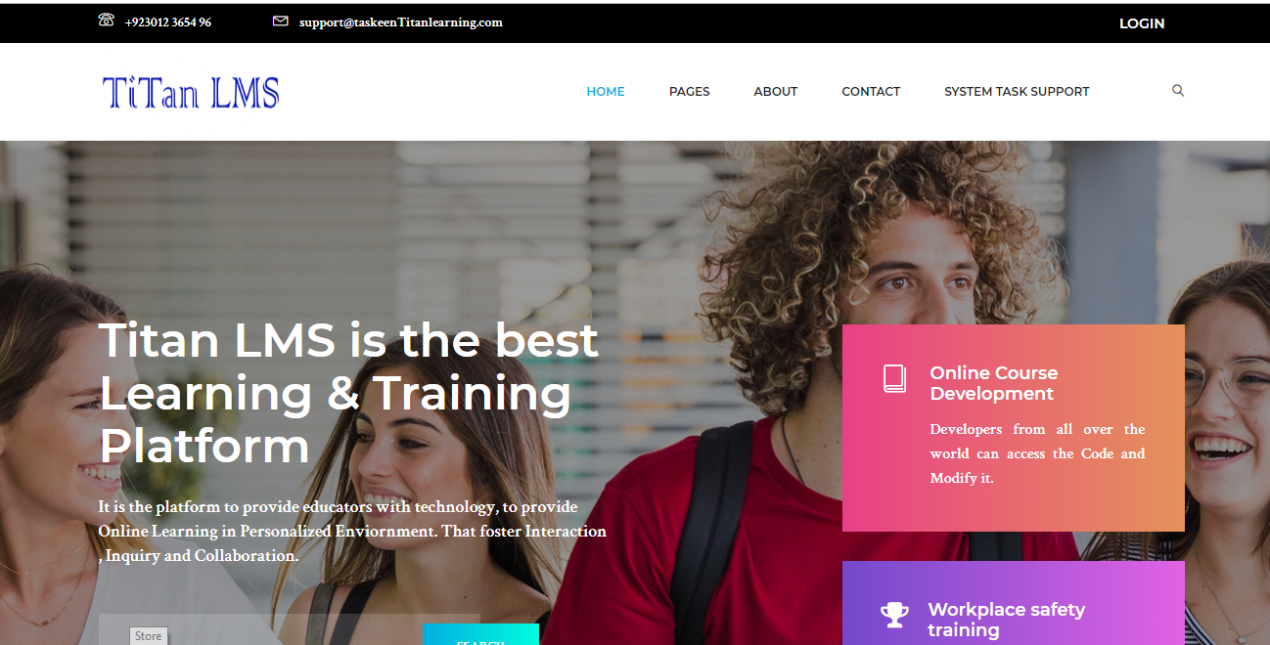

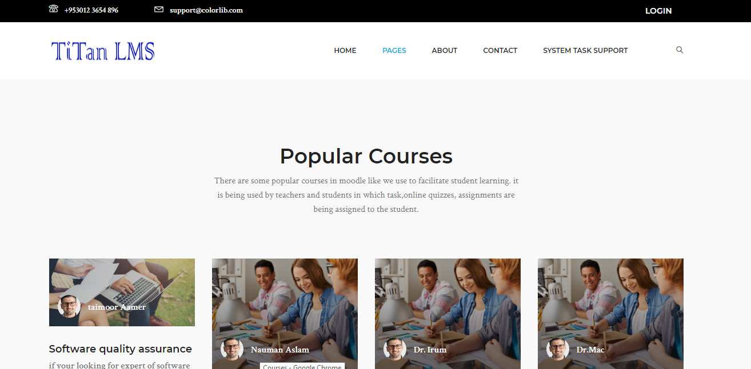

COURSES:
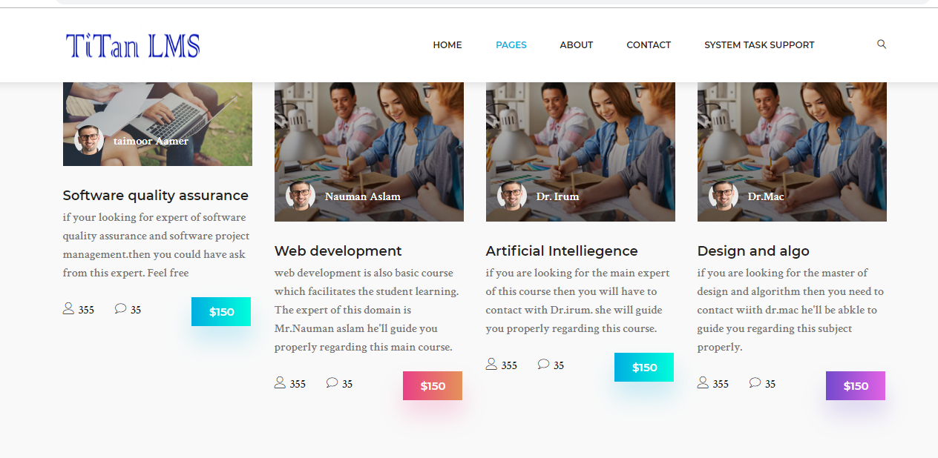

COURSE DETAIL:
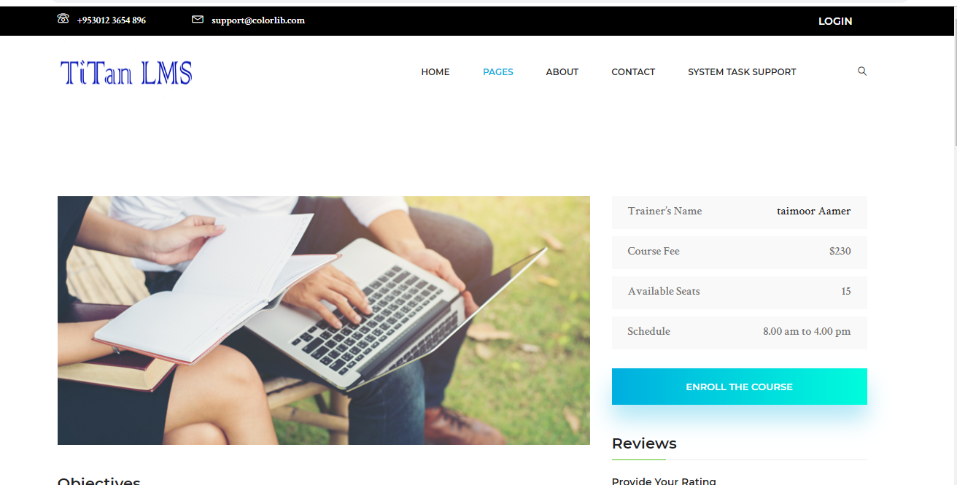
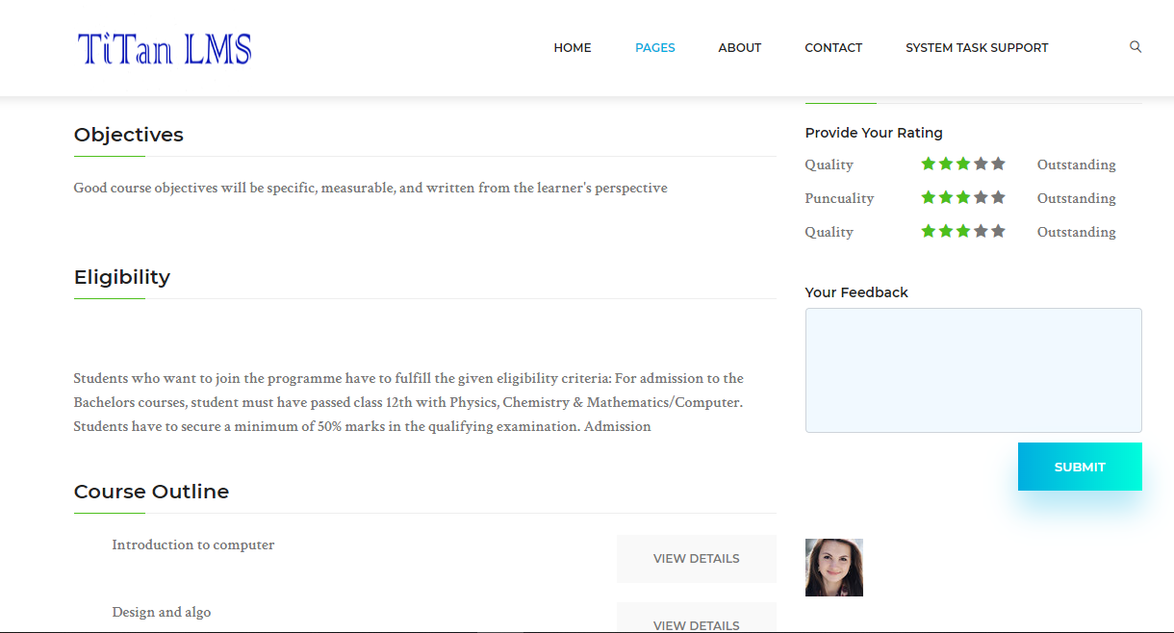

About us page
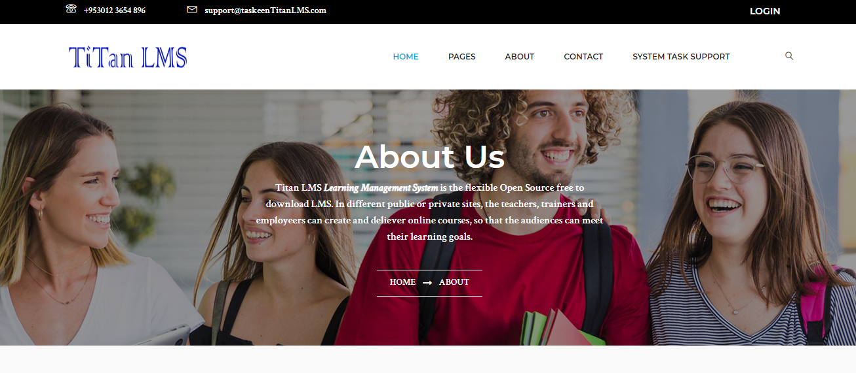

In about us page, we have mentioned regarding instructor of Titan LMS (learning management system)

Contact Us
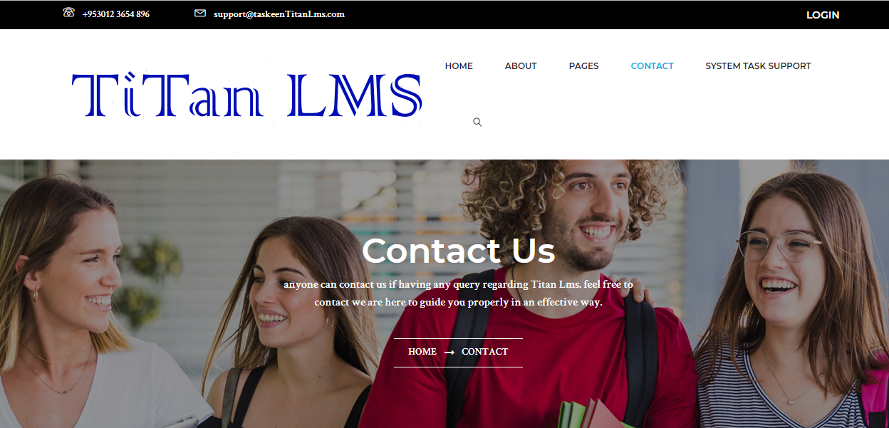
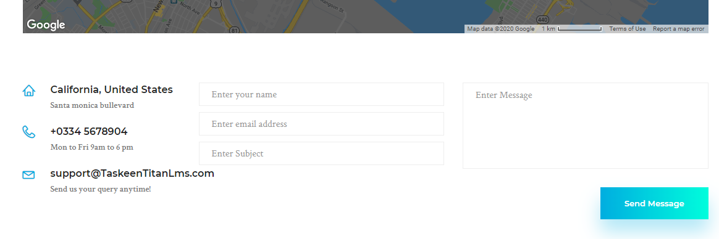

Anyone can contact us anywhere for the further query regarding Titan LMS (online learning management system). We will be able to facilitate the student learning.

Login Page:
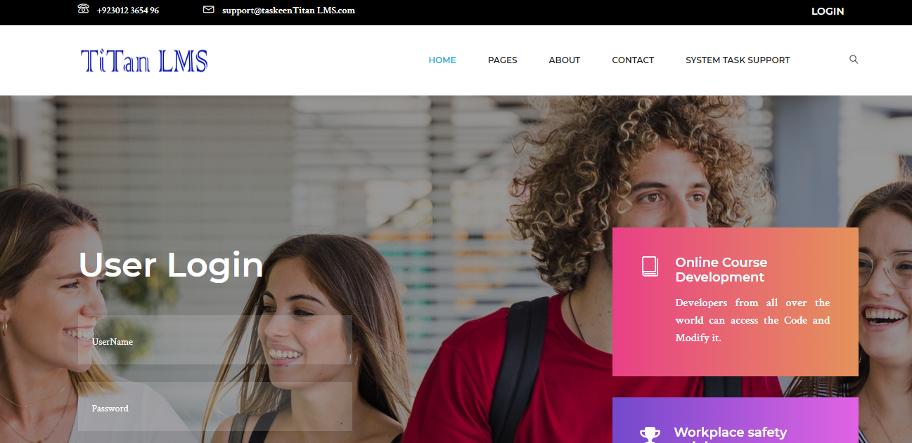

Methodology

3.4.1 User-driven Development (UDD)

UDD is a multi-step process which helps us to design the product based on what the customer or the target audience requires. Every customer/client has different specifications and needs and so this helps to achieve a solution or a product that is solely based on the users design specifications.is a framework of processes (not restricted to interfaces or technologies) in which usability goals, user characteristics, environment, tasks and workflow of a product, service or process are given extensive attention at each stage of the design process.

Qualitative research
We have collected data from primary (Data collected from users) and secondary (data collected from research papers) resources. Like we have made the questionnaire regarding parameters of persuasive system design of LMS and conducted the survey. And our main expertise are teachers and researchers. After analysis of research we have concluded that System task support is the important parameter of the persuasive system design in learning management system which helps us in improvement of student engagement in Titan LMS. We have proposed Titan LMS and embedded System task support in it which is that parameter of persuasive system design in which usability could be improved and we proposed a prototype and user interface of Titan LMS

Design Thinking
Design thinking’s main objective is to find a desired solution for the users. The final product i.e. LMS is based on what the end user requires and needs.

DATA AND EXPERIMENTS (and/or IMPLMENTATION)

Overview

Learning management system is learner friendly anyone can access learning material online. This project is intended to give a complete overview on “A prototype based on persuasive system design of learning management system”. Learning management system is a platform where people can ease their difficulty whilst learning in school, home and anywhere. It empowers us for self-learning .Persuasive system design gives the ability to the student to create inspiring, motivational online learning for the target audience. Learning management system is about tests, assignments and tasks and it is a web based learning framework which is utilized to encourage understudy learning. Through internet learning the board framework anybody can prepare anything from 5 to 50,000 understudies. Learning management system is a product and electronic innovation which gives the educator/instructor an approach to convey substance and screen understudy investment and gets to the understudy execution.

Software Development Methodology

Software Tools

Brackets

It is used to develop the front end of the LMS. It is an easy open source tool that lets us easily code.
ADVANTAGES:
- Combination of HTML,CSS and JavaScript
- Quick Edit
- Live preview
- Color selector
- Font Selector.

Visual Paradigm for UML Community Edition

Visual Paradigm for UML Community Edition is used in this project for designing purpose. Visual Paradigm is a famous platform for deigning UML diagrams.

Adobe Photoshop CS6

Adobe Photoshop CS6 is used in this project for designing prototype interfaces and mock-ups.

RESULTS AND DISCUSSIONS

Learning Management System
Learning management system is learner friendly anyone can access learning material online. Learning management system is a platform where people can ease their difficulty whilst learning in school, home and anywhere. It empowers us for self-learning and diminishes the expense of preparing like it tends to be access by anyplace, This LMS is specially designed for students to help them bring ease in their learning process.

Organization of the User Manual

Home page of Titan LMS

It’s the home page of Titan LMS. It’s the best learning and training platform which provides online learning in personalised environment.in home page, you can visit our website properly and can get information completely.

Pages:

COURSES:

COURSE DETAIL:

About Us Page

In about us page, we have mentioned regarding instructor of Titan LMS (learning management system)

Contact Us
Anyone can contact us anywhere for the further query regarding Titan LMS (online learning management system). We will be able to facilitate the student learning.
Login Page:

Improved Form of Titan LMS:
System task support task support is an important feature of persuasive system design. In which parameters of persuasive system design.

PRAISE:
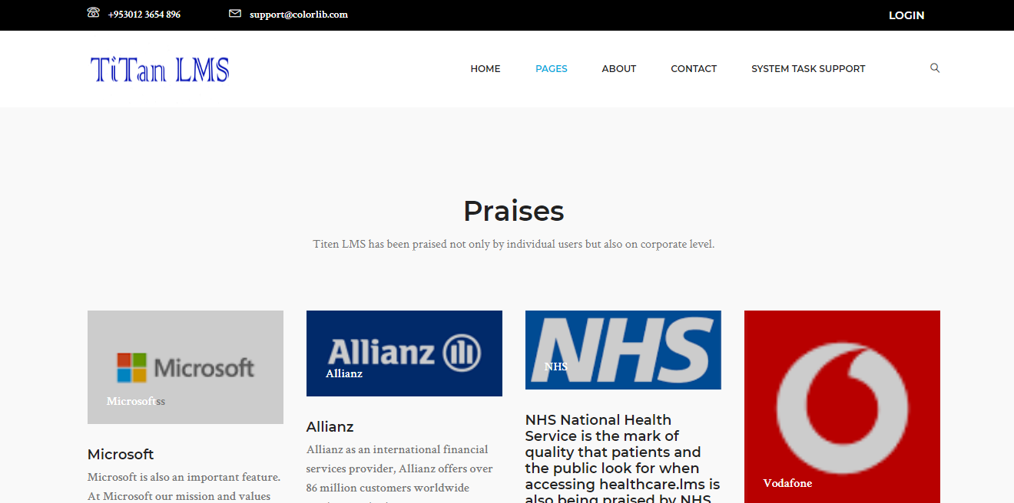

SUGGESTIONS:
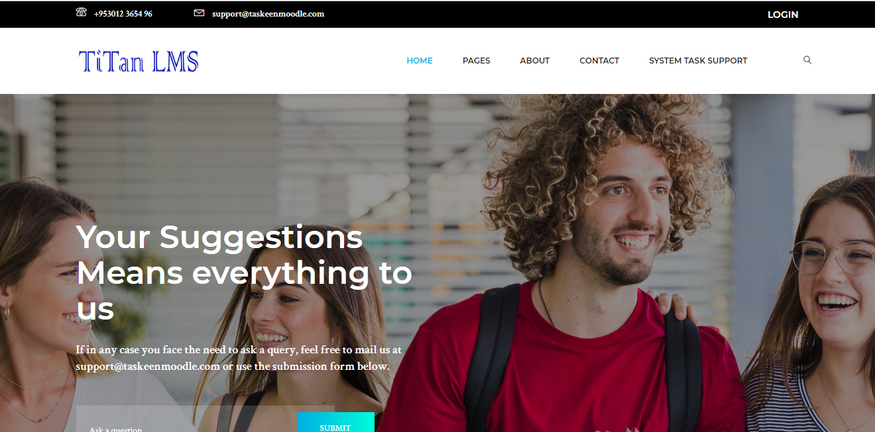
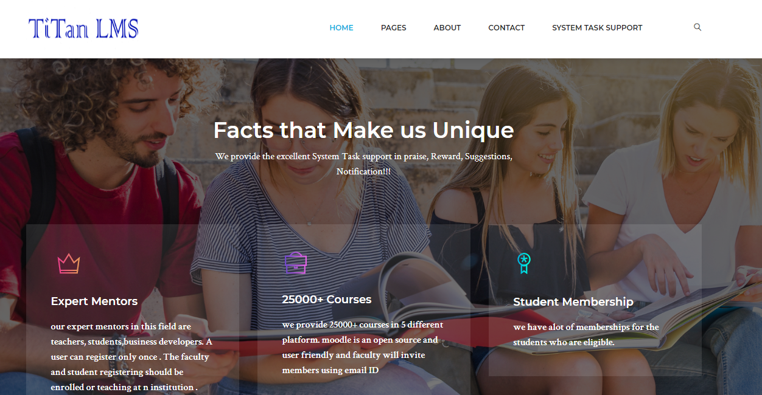

Notification:
In Titan LMS, Notifications will occur by different organizations. It’s the main sub factor of persuasive system design.
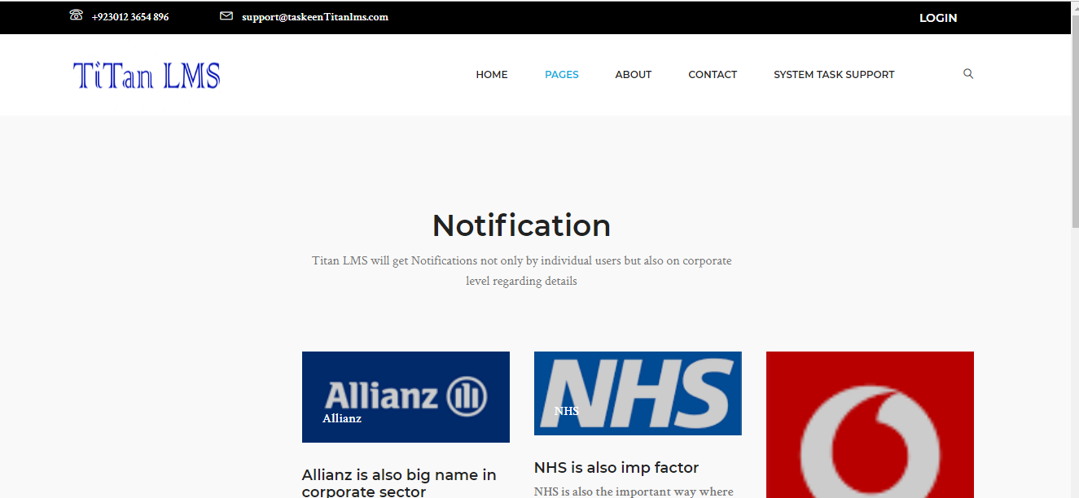

CONCLUSION AND RECOMMENDATIONS

Conclusion
The conclusion of this project is that learning management system is a web based learning system which help us to facilitate the student learning. The run time settings for selection of font, font colour, and background Colour has shown to improve their learning performance. We have worked on persuasive system design like how can people get attracted towards the learning management system and it improves the engagement of student with application in an effective manner. After conducting survey, we have concluded that System task support has proved to be the important parameter of persuasive system design in learning management system. In which notification, suggestion, praise which are the sub factors of persuasive system design has helped a lot to improve the existing design into better one. We have proposed a Titan LMS and embedded system task support in it. Teachers and students can access it on single platform.

Recommendations
In ever evolving tech world we can make more improvements in learning management system like we can make good designs for persuasive system design. In the near future it aims to provide the e-learning services to IOS and android users as a mobile application system. It will also be catered internationally as for now it is only available in Pakistan.

Future work
In future work, we will further see the remaining parameters of persuasive system design, which parameter could be more effective and could help to improve the existing design into modified design. We have three more parameters like primary task support, Credibility task support, learning task support. And can make comparison among them and could be able to see which parameter could be more important list down according to their importance. Persuasive system design plays vital role in learning management system where people would get attract towards the online learning system.

REFERENCES
Books:
[1] J. Herrington, “Authentic e-learning in higher education : Design principles for authentic learning environments and tasks,” World Conf. E-Learning Corp. Gov. Heal. High. Educ., no. October, pp. 13–17, 2006.
[2] D. Howell, “Elements of effective E-Learning,” Coll. Teach., vol. 49, no. 3, p. p87, 4p, 2001.
[3] A. Sheshasaayee and M. N. Bee, “Evaluating user experience in moodle learning management systems,” IEEE Int. Conf. Innov. Mech. Ind. Appl. ICIMIA 2017 - Proc., no. Icimia, pp. 735–738, 2017.
[4] J. Keller and K. Suzuki, “Learner motivation and E-learning design: A multinationally validated process,” J. Educ. Media, vol. 29, no. 3, pp. 229–239, 2004.
[5] T. Daradoumis, R. Bassi, F. Xhafa, and S. Caballé, “A review on massive e-learning (MOOC) design, delivery and assessment,” Proc. - 2013 8th Int. Conf. P2P, Parallel, Grid, Cloud Internet Comput. 3PGCIC 2013, pp. 208–213, 2013.
[6] H. T. Lin, C. H. Wang, C. F. Lin, and S. M. Yuan, “Annotating learning materials on moodle LMS,” ICCTD 2009 - 2009 Int. Conf. Comput. Technol. Dev., vol. 2, pp. 455–459, 2009.
[7] S. M. Kelders, R. N. Kok, H. C. Ossebaard, and J. E. Van Gemert-Pijnen, “Persuasive system design does matter: a systematic review of adherence to web-based interventions,” J. Med. Internet Res., vol. 14, no. 6, p. e152, 2012.
[8] T. Yonglei, “Work in progress - Introducing usability concepts in early phases of software,” Proc. - Front. Educ. Conf. FIE, vol. 2005, p. T4C–7, 2005.
[9] J. Ismail, “The design of an e-learning system beyond the hype,” Internet High. Educ., vol. 4, no. 3–4, pp. 329–336, 2001.
[10] M. Twidale, “Silver Bullet or Fool’s Gold: Supporting usability in Open Source Software development,” Proc. - 27th Int. Conf. Softw. Eng. ICSE05, p. 35, 2005.
[11] A. Lodhi, “Usability heuristics as an assessment parameter: For performing usability testing,” ICSTE 2010 - 2010 2nd Int. Conf. Softw. Technol. Eng. Proc., vol. 2, pp. 256–259, 2010.
[12] D. Susanto, S. Irdoni, and M. U. H. Al Rasyid, “Attendance report plugin for E-learning applications in PENS: (Based on moodle),” Proc. - Int. Electron. Symp. Knowl. Creat. Intell. Comput. IES-KCIC 2017, vol. 2017–Janua, pp. 153–160, 2017.
[13] S. Jin, “Design of an online learning platform with Moodle,” ICCSE 2012 - Proc. 2012 7th Int. Conf. Comput. Sci. Educ., no. Iccse, pp. 1710–1714, 2012.
[14] A. Y. Elmaghrabi and S. M. Eljack, “Enhancement of Moodle learning Management System Regarding Quizzes Security and Stability Problems,” 2019 2nd Int. Conf. Comput. Appl. Inf. Secur., pp. 1–7, 2019.

Usability Questionnaire

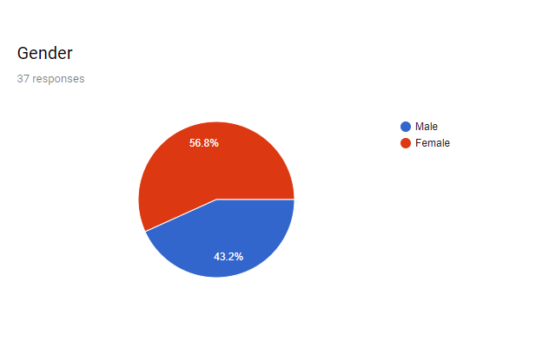
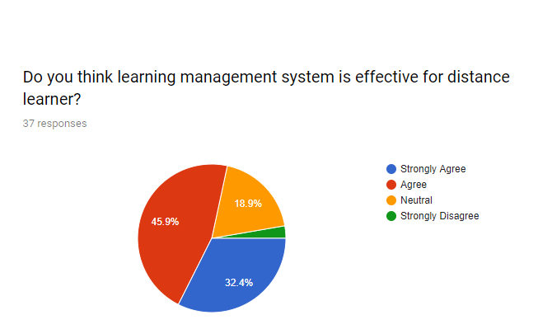
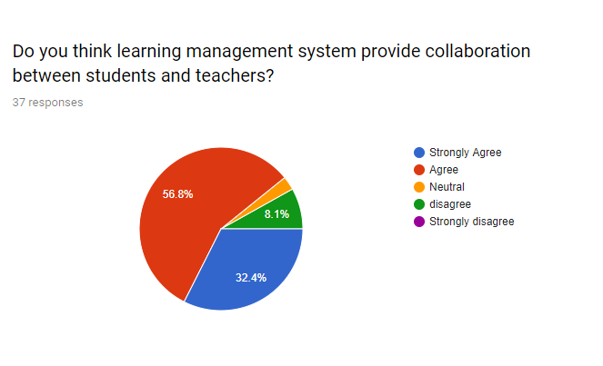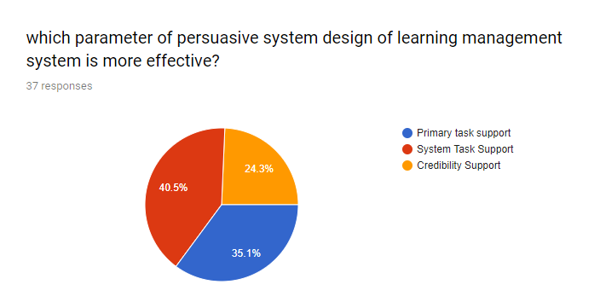
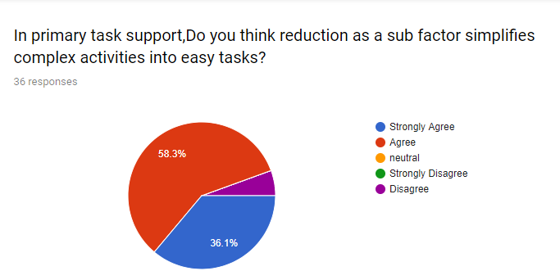
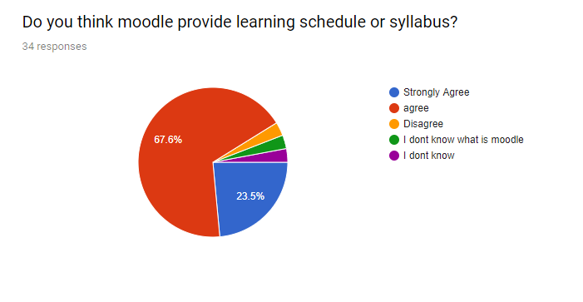
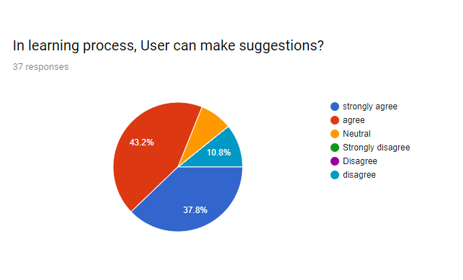
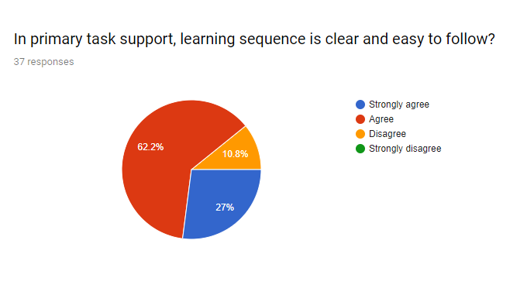
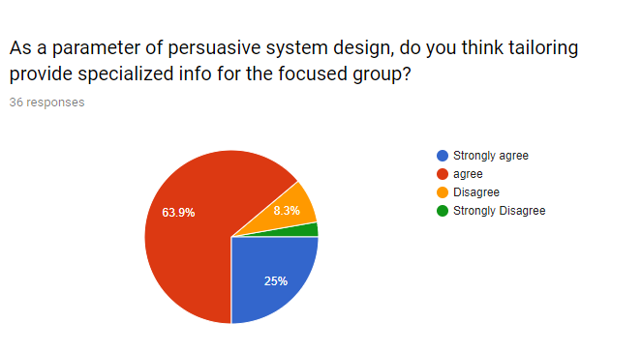
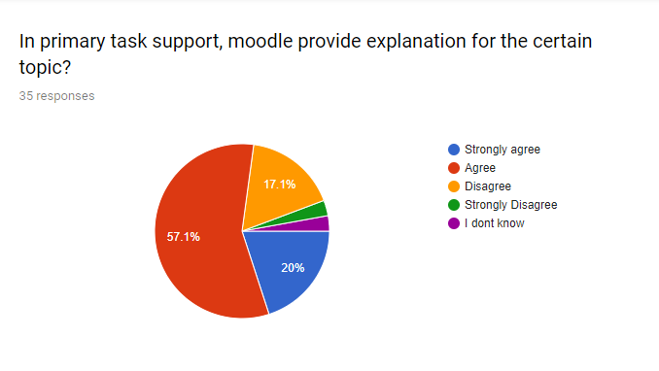
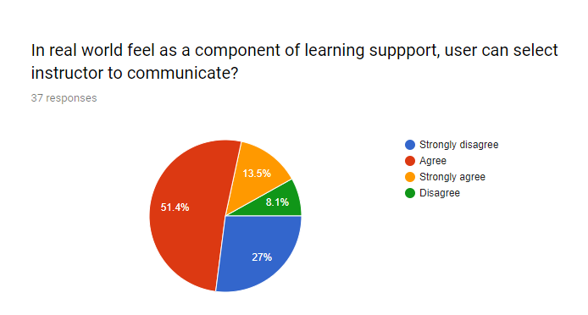
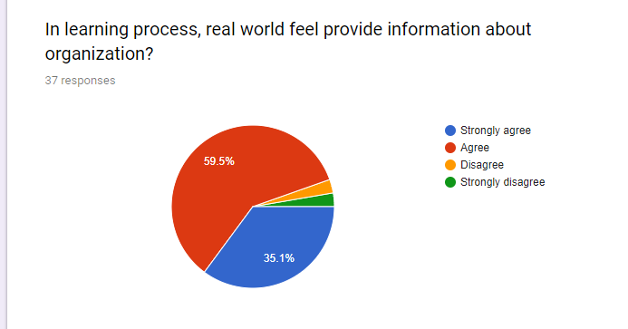

APPENDICES
APPENDIX A

Annex A: Statement of Work

User Registration
- User will register by giving the following information:
- First Name
- Last Name
- Contact No
- Email
- Username
- Confirmed Password
- Institution Name (if any)

Category of User

Student
- First Name
- Last Name
- Contact No
- Email
- Username
- Verification code
- Confirmed Password
- Institution Name (if any)

Faculty
- First Name
- Last Name
- Contact No
- Email
- Username
- Verification code
- Confirmed Password
- Institution Name (if any)

iii) Parent
- First Name
- Last Name
- Contact No
- Email
- Username
- Student name
- Student email ID
- Student institution name
- Verification code
- Confirmed Password

Activity Options
- Add members
- Delete Members
- Make Class/ Group
- Add assignment/work
- Add media
- Delete assignment/work
- Submit work
- Unsubmit Work
- Add Media
- Delete Media
- Automated Email
- Progress Report

Research Paper
“A Prototype Based on Persuasive System Design of Learning Management System”

Abstract

The objective of this project is to develop a prototype based on persuasive system design in learning management system. This study deals with distance education system which have become more advanced over time. Learning management system is the main component to facilitate the student learning. Persuasive design is all about tempting the learners like how can you make your learning management system more persuasive where people can get attracted towards online learning system. Having a persuasive design in learning management system enable a user to understand and engage with the application in an effective way. Persuasive system design has identified several key features to be embedded in to a system interface in order to enhance the engagement. While taking account the research done by different researchers and their publications the study has been conducted. The study would be measuring the System task support feature from persuasive design model in order to recommend improvement in a learning management system.

Keywords- Learning management system, Persuasive system design, Titan LMS

1-INTRODUCTION
This project is intended to give a complete overview regarding” A Prototype Based on Persuasive system design of learning management system. Learning management system is an online learning which is used to facilitate the students learning. Learning management system is software application or web based technology used to plan, implement. [1] A learning management system provides an instructor with a way to create, deliver content, monitor student participation, and access student performance. It is all about assignments, quizzes and projects. In online learning system, 50 to 50,000 learners can learn at a specific place at same time. Learning management system can make business successful and can be effective for the people who are continuing their education while working in regular jobs.[4] Many people tries to take regular courses on professional level to increase their qualification and enhance their career opportunities in their jobs. The best thing about online learning is that an individual can take online courses from the comfort of their office or home.[1] Persuasive system design enables a user to engage with the application in an effective way. The opportunity for users to collaborate is an important design element, particularly for students who may be learning at a distance.[4] Consequently, tasks need to be addressed to a group rather than an individual, and appropriate means of communication need to be established. Collaboration can be encouraged through appropriate tasks and communication technology.

II-LEARNING MANAGEMENT SYSTEM
Learning management system is where individuals can facilitate their trouble while learning in school, home and anyplace. It empowers us for self-learning and diminishes the expense of preparing like it very well may be access by anyplace, anytime. In the consistently developing propelled tech-world, there is in every case a type of need of individuals, which should be managed, utilizing trend setting innovation. They require a type of a stage to facilitate their trouble while learning at school or at home. Such a stage can be a learning management system (LMS) which is based on the requirements of these individuals, people everywhere throughout the world are getting advantage particularly those with extraordinary necessities. [4] Persuasive system design empower a client to draw in with application in a compelling manner.[1] So one other explanation for this task is to illuminate individuals here in Pakistan that learning management system is a platform which gives the collaboration and joint effort among students and staff. It isn't just comprehend the understudy adapting yet it additionally comprehend the understudy conduct.

II- PERSUASIVE SYSTEM DESIGN:
Persuasive design is all about influencing human behaviour through product or services. It associates with interaction with students, teachers and admin. Making your design more persuasive can influence people through your product.[7] Having persuasive design in learning management system enables a user to engage with application effectively. Through enhancement in user interface we need to embed persuasive system design in learning management system. Persuasion is a word which is defined as “temptation”. When you get pulled in towards something then you will almost certainly comprehend that thing all the more plainly. [4]Influence is about allurement. Assume on the off chance that you get message on your phone, at that point you will most likely become acquainted with and you will get pulled in just to realize what's going on inside.

Persuasive system design is the component of web based learning and it will improve the student engagement in learning management system. Through enhancement in user interface by adopting persuasive design model in learning management system can be more effective. Persuasive system design is designed to influence the learner to get attracted towards the learning activities in learning management system.[5] It is designed to make sure that learning management system is also meaning as well as traditional classrooms. These technologies like mobile phone, I pads, and laptops provide opportunities to interact and collaborate with the people who are using learning management system. In persuasive system design we have configured the four important parameters of persuasive system design. They are as follows
- Primary task support
- System task support
- Credibility task support
- Learning task support

These four parameters of persuasive system design has been compared by conducting surveys and System task support has approved to be the important parameter of persuasive system design of learning management system. We have embedded it in Moodle for the improvement of their features. And it facilitate the students learning in a proper way. System task support has further sub factors which are Notification, Rewards, Praise and Suggestions.[7] We have a chance to improve the missing feature of persuasive system design of learning management system. After comparing those four parameters of persuasive system design of learning management system we have concluded that system task support is important feature of persuasive system design of learning management system.in which notification occur when we get to know about courses details and assignments and quizzes uploaded by teachers. [1]Students can access easily by using their student id and password and they can get enrol in it. Students can easily give online quizzes and upload their projects and assignments.
Not all learners are getting attracted towards the online management system. Influence or persuasion is a word which is characterized as “persuasion”. When you get pulled in towards something then you will most likely comprehend that thing all the more unmistakeably. Influence is all about allurement. Assume on the off chance that you get message on your, at that point you will almost certainly become acquainted with and you will get pulled in just to recognize what's going on inside.[4] Who’s going to messaging or something different? It's called allurement or influence. Where you get pulled in and needed to think about that thing in all respects deliberately. Like you get warning on your Facebook and one minutes from now to you need to see that notice. That is called persuasion. Where you get destroyed in and expected to consider that thing in all regards purposely. Like you get cautioning on your Facebook and a little ways from now to you have to see that take note. That is called impact.[7] Amazing arrangement model in learning the administrators structure expect huge employment in this routinely propelling development, essentialness of luring system setup in learning the officials structure is extending rapidly.

III-TITAN LMS
Titan LMS is basically an online learning environment. It is an online learning management system. It can run on all platforms like windows, Ubuntu, Linux etc. Titan LMS will be the most used learning management system.[13] Titan LMS is a user friendly e learning platform that perform the learning and training needs of people from all types of organization. Titan LMS is all about course management system. Titan LMS is an open source, free to download learning management system.[14] It has different modules in which we can upload course and course details, recent activity, search forum, latest news. It is available in 78 languages.[7] It is used in all over the world by teachers and educators. It is the Best e-learning in the net.

For teachers:
- Teachers can create online courses.
- Teachers can divide students in classes.
- Teachers can upload files and lessons.
- Teachers can create online test and examinations.
- Teachers can provide chat forums.
- Teachers can create activities in Titan LMS.
- Teachers can add questions and get feedback from students.
- Teachers provide chapter wise complete course.

Teachers and students need login id so they can easily upload test and assignments.[12] And students can login by using their student ID in Titan LMS. Students can also create chat session in outdoor.

STUDENT:
- Students follow the lesson.
- Students follow the subject.
- Students can access assignment and can give online quiz.
- Students can follow the content given by teacher.
- Students and teachers can create chat sessions.
- Students and teachers can chat on topic.
- Student and teachers can add questions and get feedback.

With 100 million clients (and developing) and more than 100,000 Titan LMS locales can sent around the world, this easy to use eLearning stage serves the learning and preparing needs of a wide range of associations in excess of 225 nations around the world. [6] Learning management system like Titan LMS and Learn produce heaps of information however ordinarily have constrained.

IV- CONCLUSION:

The conclusion of this project is that learning management system is a web based learning system which help us to facilitate the student learning. The run time settings for selection of font, font colour, and background Colour has shown to improve their learning performance. We have worked on persuasive system design like how can people get attracted towards the learning management system and it improves the engagement of student with application in an effective manner. After conducting survey, we have concluded that System task support has proved to be the important parameter of persuasive system design in learning management system. In which notification, suggestion, praise which are the sub factors of persuasive system design has helped a lot to improve the existing design into better one. . We have proposed a Titan LMS and embedded system task support in it. Teachers and students can access it on single platform.

V-FUTURE WORK:
In future work, we will further see the remaining parameters of persuasive system design, which parameter could be more effective and could help to improve the existing design into modified design. We have three more parameters like primary task support, Credibility task support, learning task support. And can make comparison among them and could be able to see which parameter could be more important list down according to their importance.

IV-REFERENCES
[1] J. Herrington, “Authentic e-learning in higher education : Design principles for authentic learning environments and tasks,” World Conf. E-Learning Corp. Gov. Heal. High. Educ., no. October, pp. 13–17, 2006.
[2] D. Howell, “Elements of effective E-Learning,” Coll. Teach., vol. 49, no. 3, p. p87, 4p, 2001.
[3] A. Sheshasaayee and M. N. Bee, “Evaluating user experience in moodle learning management systems,” IEEE Int. Conf. Innov. Mech. Ind. Appl. ICIMIA 2017 - Proc., no. Icimia, pp. 735–738, 2017.
[4] J. Keller and K. Suzuki, “Learner motivation and E-learning design: A multinationally validated process,” J. Educ. Media, vol. 29, no. 3, pp. 229–239, 2004.
[5] T. Daradoumis, R. Bassi, F. Xhafa, and S. Caballé, “A review on massive e-learning (MOOC) design, delivery and assessment,” Proc. - 2013 8th Int. Conf. P2P, Parallel, Grid, Cloud Internet Comput. 3PGCIC 2013, pp. 208–213, 2013.
[6] H. T. Lin, C. H. Wang, C. F. Lin, and S. M. Yuan, “Annotating learning materials on moodle LMS,” ICCTD 2009 - 2009 Int. Conf. Comput. Technol. Dev., vol. 2, pp. 455–459, 2009.
[7] S. M. Kelders, R. N. Kok, H. C. Ossebaard, and J. E. Van Gemert-Pijnen, “Persuasive system design does matter: a systematic review of adherence to web-based interventions,” J. Med. Internet Res., vol. 14, no. 6, p. e152, 2012.
[8] T. Yonglei, “Work in progress - Introducing usability concepts in early phases of software,” Proc. - Front. Educ. Conf. FIE, vol. 2005, p. T4C–7, 2005.
[9] J. Ismail, “The design of an e-learning system beyond the hype,” Internet High. Educ., vol. 4, no. 3–4, pp. 329–336, 2001.
[10] M. Twidale, “Silver Bullet or Fool’s Gold: Supporting usability in Open Source Software development,” Proc. - 27th Int. Conf. Softw. Eng. ICSE05, p. 35, 2005.
[11] A. Lodhi, “Usability heuristics as an assessment parameter: For performing usability testing,” ICSTE 2010 - 2010 2nd Int. Conf. Softw. Technol. Eng. Proc., vol. 2, pp. 256–259, 2010.
[12] D. Susanto, S. Irdoni, and M. U. H. Al Rasyid, “Attendance report plugin for E-learning applications in PENS: (Based on moodle),” Proc. - Int. Electron. Symp. Knowl. Creat. Intell. Comput. IES-KCIC 2017, vol. 2017–Janua, pp. 153–160, 2017.
[13] S. Jin, “Design of an online learning platform with Moodle,” ICCSE 2012 - Proc. 2012 7th Int. Conf. Comput. Sci. Educ., no. Iccse, pp. 1710–1714, 2012.
[14] A. Y. Elmaghrabi and S. M. Eljack, “Enhancement of Moodle learning Management System Regarding Quizzes Security and Stability Problems,” 2019 2nd Int. Conf. Comput. Appl. Inf. Secur., pp. 1–7, 2019.

