
BSCS-S19-011
03-134152-008 | ARSLAN ALI ASHRAF
03-134152-026 | HASSAN ISHTIAQ AHMED
03-134152-050 | MUHAMMAD RAFFAY RAHEEL

Secure E-Voting System Using Blockchain

In partial fulfilment of the requirements for the degree of
Bachelor of Science in Computer Science
Supervisor: Dr. Ghulam Mustafa
Department of Computer Sciences
Bahria University, Lahore Campus
January 2020

© Bahria University, 2020

Certificate

We accept the work contained in the report titled
“Secure E-Voting System using Blockchain”
Written by
ARSLAN ALI ASHRAF
HASSAN ISHTIAQ AHMED
MUHAMMAD RAFFAY RAHEEL
As a confirmation to the required standard for the partial fulfilment of the degree of
Bachelor of Science in Computer Science.

Approved by:
Supervisor: Dr. Ghulam Mustafa
(Signature)

January 28, 2020

DECLARATION

We hereby declare that this project report is based on our original work except for citations and quotations which have been duly acknowledged. We also declare that it has not been previously and concurrently submitted for any other degree or award at Bahria University or other institutions.

Enrolment | Name | Signature
03-134152-008 | ARSLAN ALI ASHRAF
03-134152-026 | HASSAN ISHTIAQ AHMED
03-134152-050 | MUHAMMAD RAFFAY RAHEEL

Date: January 28, 2020

Specially dedicated to
My beloved grandmother, mother and father
(Arslan Ali Ashraf)
My beloved grandmother, mother and father
(Hassan Ishtiaq Ahmed)
My beloved grandmother, mother and father
(Muhammad Raffay Raheel)

ACKNOWLEDGEMENTS

We would like to thank everyone who had contributed to the successful completion of this project. We would like to express our gratitude to my research supervisor, Dr. Ghulam Mustafa for his invaluable advice, guidance and his enormous patience throughout the development of the research.

In addition, we would also like to express my gratitude to our loving parent and friends who had helped and given me encouragement.

Arslan Ali Ashraf
Hassan Ishtiaq Ahmed
Muhammad Raffay Raheel

SECURE E-VOTING SYSTEM USING BLOCKCHAIN

ABSTRACT

Elections have always been plagued with controversies of being unfair and rigged. In the past, Candidates have blamed governments of not conducting free and fair elections. To make the electoral process more transparent we have come up with a solution. Our team plans to develop a Decentralized Web Application using Blockchain technology. This will not only save time and efficiency but will also make the voting system more secure. Our application will use a distributed ledger system, where each user of the application would have access to the election data. Since every user of the network would have a copy of the whole election data, no single individual would not be able to manipulate results or change data on the network without alarming the other users on the network. We will develop a web application that would be optimized for both mobile and desktop platforms.

TABLE OF CONTENTS

DECLARATION ii
ACKNOWLEDGEMENTS iv
ABSTRACT v
TABLE OF CONTENTS vi
LIST OF TABLES ix
LIST OF FIGURES 1

CHAPTERS
1 INTRODUCTION 2
1.1 Background 2
1.2 Problem Statements 2
1.3 Aims and Objectives 3
1.4 Scope of Project 3
2 LITERATURE REVIEW (and/or SRS) 4
2.1 User Classes and Characteristics 4
2.2 Operating Environment 4
2.3 Design and Implementation Constraints 5
2.4 Assumptions and Dependencies 5
3 DESIGN AND METHODOLOGY 6
3.1 Design 6
3.1.1 Use Case Description 6
3.1.2 Use-case diagrams refined 12
3.1.3 Domain Model 19
3.1.4 Sequence Diagram 20
3.1.5 Collaboration Diagram 21
3.1.6 Design Class Diagram 23
3.1.7 Data Model 24
3.1.8 Operation Contracts 25
3.2 Methodology 28
4 DATA IMPLMENTATION 29
4.1 Implementation 29
4.2 Technical Aspects 29
4.2.1 Hardware 29
4.2.2 Back-end 29
4.2.3 Front-end 29
5 USER MANUAL 30
5.1 SEVSB Home Page 30
5.2 Administrators 30
5.2.1 Admin Login 31
5.2.2 Admin Dashboard of SEVSB 31
5.2.3 Create Polls 32
5.2.3.1 Creating New Poll 32
5.2.3.2 Adding Candidates 33
5.2.3.3 Adding Voters 34
5.3 Voting 35
5.3.1 Vote Page 35
5.3.2 Casting Votes 36
5.4 Results 37
6 CONCLUSION AND RECOMMENDATIONS 38
6.1 Suggestions made by External Evaluators 38
6.2 Conclusion 38

REFERENCES 39

LIST OF TABLES

TABLE TITLE PAGE
Table 1: System Requirement Chart of Use Case 1 6
Table 2: System Requirement Chart of Use Case 2 7
Table 3: System Requirement Chart of Use Case 3 8
Table 4: System Requirement Chart of Use Case 4 9
Table ‎5: System Requirement Chart of Use Case 5 10
Table ‎6: System Requirement Chart of Use Case 6 11

LIST OF FIGURES

FIGURE TITLE PAGE
Figure 1: Use Case Diagram 12
Figure 2: Domain Model 19
Figure 3: Sequence Diagram 20
Figure 4: Collaboration Diagram(User) 21
Figure 5: Collaboration Diagram(Administrator) 22
Figure 6: Design Class Diagram 23
Figure 7: Entity Relationship Diagram 24
Figure 9: SEVSB Home Page 30
Figure 10: Admin Login Page 31
Figure 11: Admin Dashboard 31
Figure 12: Creating New Poll 32
Figure 13: Adding Candidates to the Poll 33
Figure 14: Adding Voters to the Poll 34
Figure 15: Voter Verification Page 35
Figure 16: Casting Votes 36
Figure 17: Selecting Chart and Poll Type to View Results 37
Figure 18: Results for Poll Displayed as a Chart 37

INTRODUCTION

Background

Many world governments are always under fire for not conducting free and fair elections. Even in countries with a strong democratic system, where the electoral process is considered quite secure there have always been allegations of rigging by opponents or by the media. Even though online electronic voting systems have been used by some countries to conduct elections, these systems have been proved by experts to be easily hack able. To correct this problem we’ve come up with a solution. We plan to incorporate the use of block chain technology in our application. This will make it almost impossible to hack or manipulate election results.
A block chain is like a linked list that has individual blocks of data connected with each other in such a way that together they form a chain. Each block in the chain links to the previous block by a unique address or value. And as a whole the data blocks form a chain. This data chain is not stored on a central database. Every user has a copy of this chain on their device. So if someone manipulate results or changes data on a device in the network, the rest of the devices on the network will also be alerted as they also have their own copy of the data. So this makes it almost impossible to compromise the network.

Problem Statements
Our team plans to develop a Decentralized Web Application using Blockchain. It would be secure and enable citizens to vote for their favourite candidate in the elections, and solve election related problems.

Aims and Objectives
The objectives of the project are shown as following:
- To provide a voting System
- To provide secure electronic means to vote
- To facilitate voters
- To facilitate organizations

Scope of Project
Our goal is to develop a decentralized web application for conducting elections between two or more candidates. Our system would be completely digital and this would increase efficiency and save time. The application would primarily be used on desktop browsers but we will also optimize it in such a way, so that it can be accessed efficiently by mobile browsers as well. And to do this we will incorporate Blockchain methods in our application.

LITERATURE REVIEW (and/or SRS)

User Classes and Characteristics

Secure E-voting System Using Blockchain (SEVSB), would have two categories of users, namely the Administrators (e.g. polling agent in a polling station) and the end user (voter). Administrators (e.g. polling agents) will be required to deploy the system at polling stations. Once the SEVSB is deployed and active, no administrator is required for further action.
The second category which is the end user (voter) will use the already deployed application to vote for their favourite candidate during polling.

Operating Environment
Since SEVSB is a web based application, it would require an internet browser to work. SEVSB is primarily optimized to work on the following version of browsers:

- Google Chrome
- Mozilla Firefox
- Safari
- Opera
- Microsoft Edge
- Internet Explorer

Design and Implementation Constraints
There are certain testing constraints involved in the development because of the use of Blockchain technology. Blockchain testing is usually done on a large network which maybe a problem, as it is not possible to simulate such an environment without incurring huge developmental costs. There are tools to test Blockchain applications on virtual networks but they also incur some financial cost, which could add up to the total cost of development. SEVSB will have an ever-growing database with no central server, hence limiting storage consumption without altering or effecting or modifying the application’s functional requirements will also be a challenge.

Assumptions and Dependencies
Since the web application requires a device, it is assumed that the voter (user) would know how to use a mouse or in some cases a smartphone or tablet, depending where the web application is accessed from. Users may also be required to know how to use a keyboard. Administrators may require additional skills on how to operate a computer or necessary steps to start and deploy the SEVSB. Users may or may not be required to know how to open an internet browser depending in what context the application is used.
SEVSB is web based so it needs an internet connection to function. This is a core requirement and dependency. It can’t function properly unless and until it has internet connectivity.
Spacing between title of subsection and first line of text is 1.5 lines. The first paragraph in a subsection should align with left margin.

DESIGN AND METHODOLOGY

Design
Following artefacts are included.

Use Case Description
A use-case description is a text that captures the detailed functionality of a use-case. Description of all use-cases are written down in this section. Use-case description typically contains the following parts:

Table 1 System Requirement Chart of Use Case 1:
Name and ID | Administrator Login or U1
Brief description | To log in to the voting system
Preconditions | Administrator Must open the SEVSB website
Basic flow or Happy path | Administrator opens application and logs in
Trigger | Use case initiates when Admin Logs in
Alternate flows | If administrator has a login error it will display an error then the administrator will be prompted for the username and password again
Post conditions | Starting of polling session

Name and ID | Deployment of Voting System or U2
Brief description | To deploy or start the Voting System
Preconditions | Administrator must be logged in to the system
Basic flow or Happy path | Administrator will login then start the polling session
Trigger | Use case initiates after admin logs in to the SEVSB
Alternate flows | None
Post conditions | System is deployed and polling can initiate
Table 2 System Requirement Chart of Use Case 2:

Table 3 System Requirement Chart of Use Case 3:
Name and ID | Close the Voting System or U3
Brief description | To close the Voting System
Preconditions | Administrator must be logged in to the system
Basic flow or Happy path | Administrator ends the voting session
Trigger | Use case initiates when Administrator closes the voting portal
Alternate flows | None
Post conditions | The polling session ends and final results are displayed

Table 4 System Requirement Chart of Use Case 4:
Name and ID | Enter Voter ID or U4
Brief description | In our system, to verify the identity of the voter
Preconditions | Polling must be started before Voter can use the voting system.
Basic flow or Happy path | Voters enter their voter ID
Trigger | Use case initiates when SEVSB has opened and voter enters Voter ID
Alternate flows | If voter enters the wrong Voter ID then it will ask again
Post conditions | Voter ID is verified and voter can vote.

Table 5 System Requirement Chart of Use Case 5:
Name and ID | Cast Vote or U5
Brief description | In our system, to enable the user to vote in our system.
Preconditions | Polling session must be active, Voter ID entered and verified
Basic flow or Happy path | Voter will select the desired candidate and vote for the candidate
Trigger | Use case initiates after Voter ID is verified and voter selects a candidate.
Alternate flows | None
Post conditions | Submission of Voter’s vote to the decentralized database

Table 6 System Requirement Chart of Use Case 6:
Name and ID | View Results or U6
Brief description | To view the current voting results and statistics
Preconditions | Website must be opened
Basic flow or Happy path | Start voting session to see the results
Trigger | Use case initiates when user asks system for results
Alternate flows | None
Post conditions | Results or statistics have been viewed by the user

Use-case diagrams refined
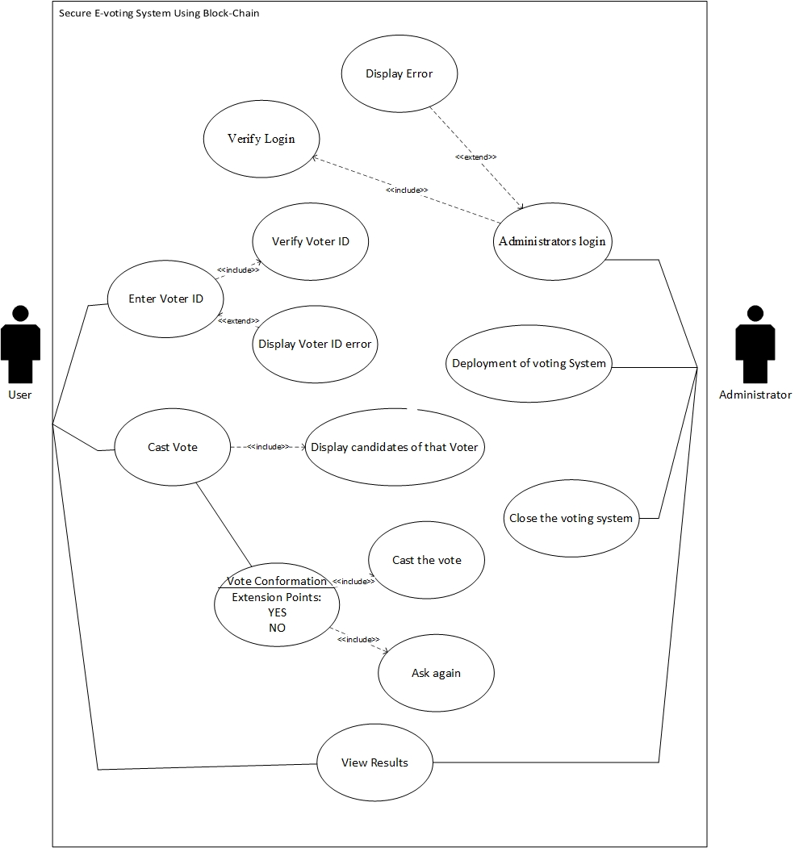
Figure 1: Use Case Diagram (Complete)

Administrator Login
Use Case Name: U1
Objective – To log in to the voting system
Priority High
Source – It describes the event of starting the application by the Administrator and is important to start the voting system
Actors – Administrator
Flow of Events
Basic Flow - Administrator opens application and logs in
Alternative Flow(s) – If administrator has a login error it will display an error then the administrator will be prompted for the username and password again.
Includes – Verify Login, Display Error
Preconditions –Administrator must open the SEVSB website
Post conditions – Starting of polling session
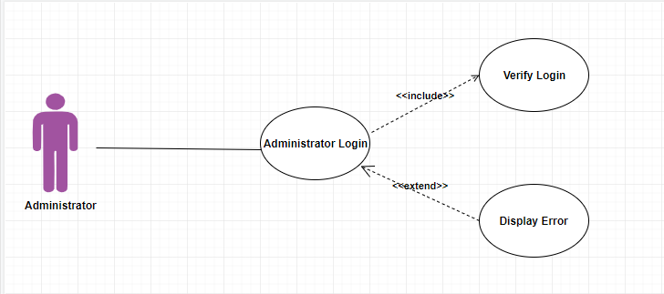
Notes/Issues – Administrator login credentials are sensitive, so must not be shared with anyone else.

Deployment of Voting System
Use Case Name: U2
Objective – To deploy or start the Voting System
Priority High
Source – Another essential use case ensuring the voting system is deployed and voters can use it.
Actors – Administrator.
Flow of Events
Basic Flow - Administrator will login then start the polling session
Preconditions – Administrator must be logged in to the system
Post conditions – System is deployed and polling can initiate
Notes/Issues – None
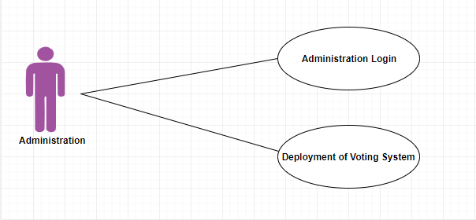

Close the Voting System
- Use Case Name: U3
- Objective – To close the Voting System.
- Priority High
- Source – The events pertaining to ending the voting session and displaying the voting results
- Actors – Administrator
- Flow of Events
  - Basic Flow – Administrator ends the voting session
- Preconditions – Administrator must be logged in to the system
- Post conditions –The polling session ends and final results are displayed.
- Notes/Issues – When the Administrator selects to end the polling session, he is required to login again.
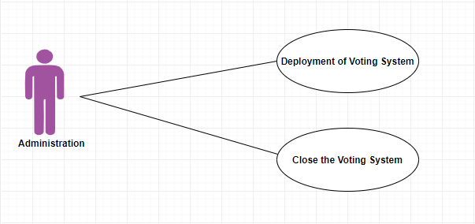

Enter Voter ID
Use Case Name: U4
Objective – In our system, to verify the identity of the voter
Priority – High
Source – This event describes the voter verification process
Actors – Voter
Flow of Events
Basic Flow - Voters enter their voter ID.
Alternative Flow(s) – If voter enters the wrong Voter ID then it will ask again.
Includes –Verify Voter ID, Display Voter ID error
Preconditions – Polling must be started before Voter can use the voting system.
Post conditions – Voter ID is verified and voter can vote.

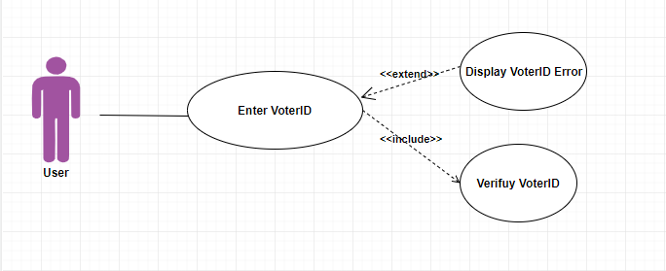

Cast Vote
Use Case Name: U5
Objective – In our system, to enable the user to vote in our system.
Priority – High
Source – the events of voter selecting his vote and submitting it
Actors – Voter
Flow of Events
Basic Flow – Voter will select the desired candidate and vote for the candidate
Includes – Display Candidates, Vote Confirmation, Case the Vote (YES)
Preconditions – Polling session must be active, Voter ID entered and verified.
Post conditions – Submission of Voter’s vote to the decentralized database.
Notes/Issues – If the Voter ID is already checked then it will display an error it won’t form a new block with the same number or it also won’t overwrite it.
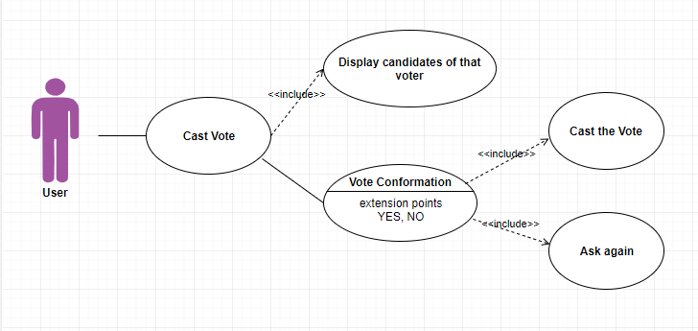

View Results
Use Case Name: U6
Objective – To view the current voting results and statistics.
Priority – Medium
Source – General Users may want to see vote results and this case allows that
Actors – User, administrator.
Flow of Events
Basic Flow – Start voting session to see the results.
Preconditions –Website must be opened
Post conditions – Results or statistics have been viewed by the user.
Notes/Issues – None
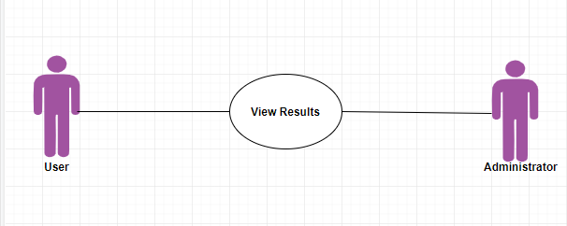

Domain Model
Domain models represent the set of requirements that are common to systems within a product line. There may be many domains, or areas of expertise, represented in a single product line and a single domain may span multiple product lines. The requirements represented in a domain model include:
- Definition of scope for the domain
- Information or objects
- Features or use-cases, including factors that lead to variation
- Operational/behavioural characteristics
A product line definition will describe the domains necessary to build systems in the product line.

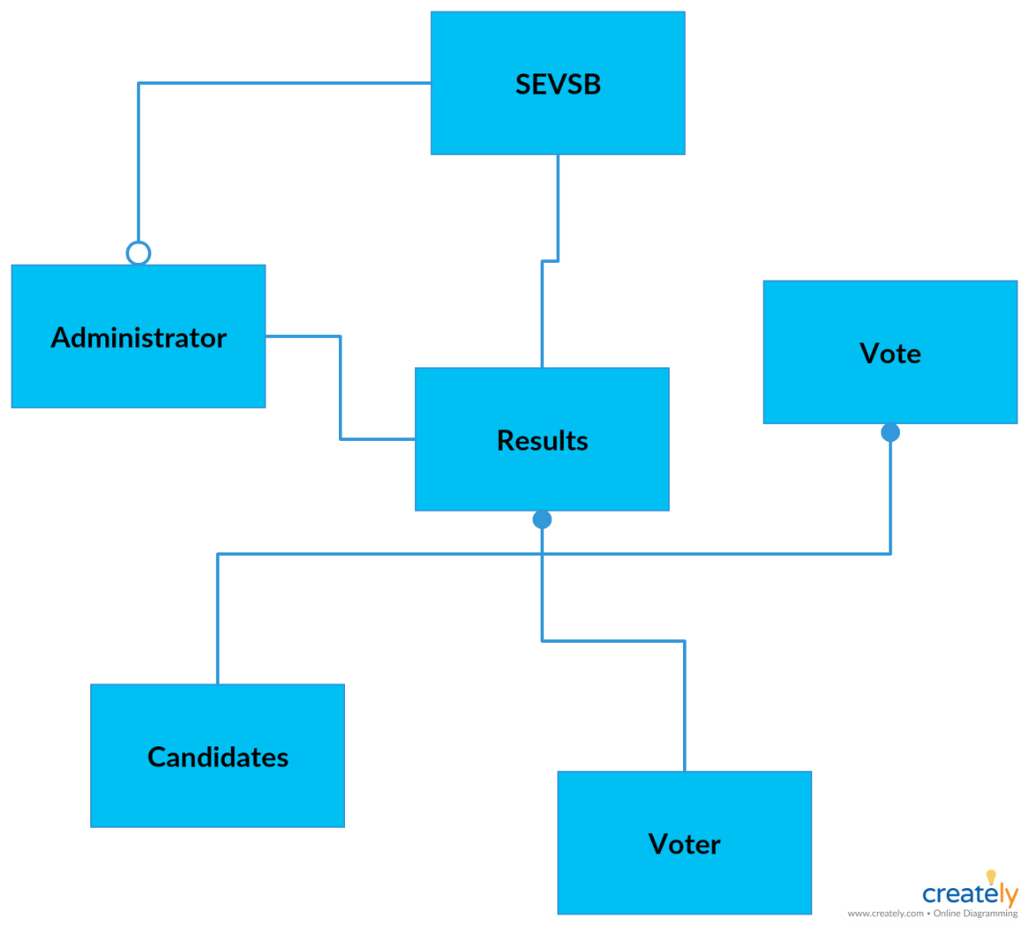
Figure 2: Domain Model

Sequence Diagram
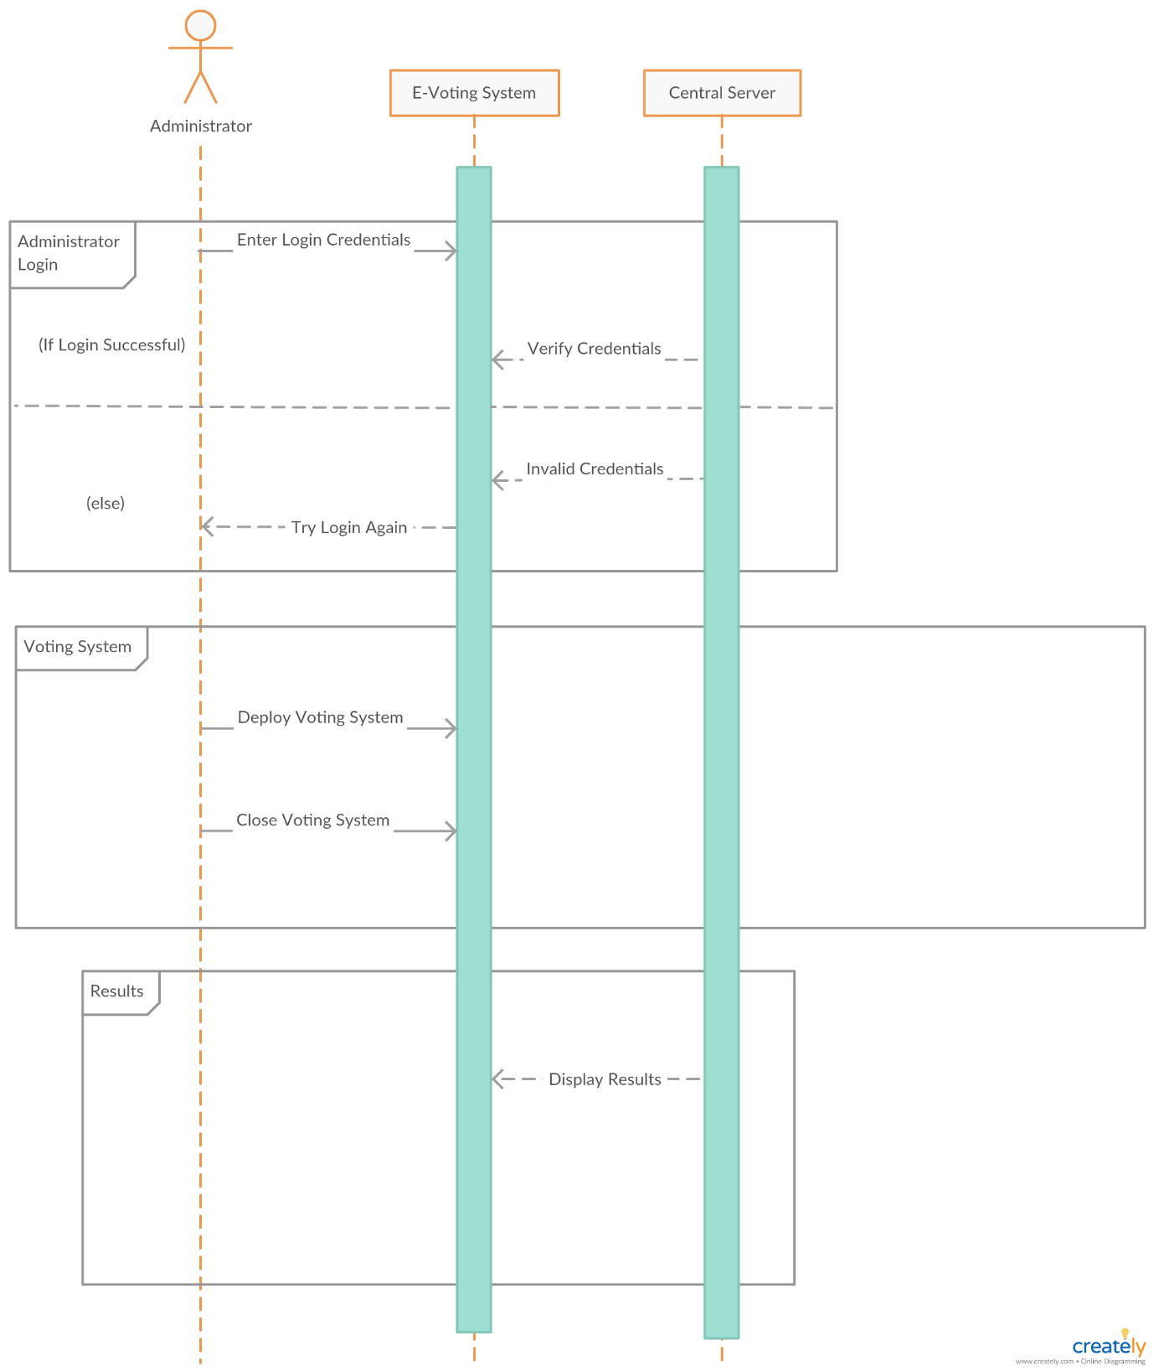
A Sequence diagram depicts the sequence of actions that occur in a system. The invocation of methods in each object, and the order in which the invocation occurs is captured in a Sequence diagram. This makes the Sequence diagram a very useful tool to easily represent the dynamic behaviour of a system.

Figure 3: Sequence Diagram (Administrator)

Collaboration Diagram
A collaboration diagram describes a pattern of interaction among objects; it shows the objects participating in the interaction by their links to each other and the messages that they send to each other.
Collaboration diagrams are used to show how objects interact to perform the behaviour of a particular use-case, or a part of a use-case. Along with sequence diagrams, collaborations are used by designers to define and clarify the roles of the objects that perform a particular flow of events of a use-case. They are the primary source of information used to determining class responsibilities and interfaces.
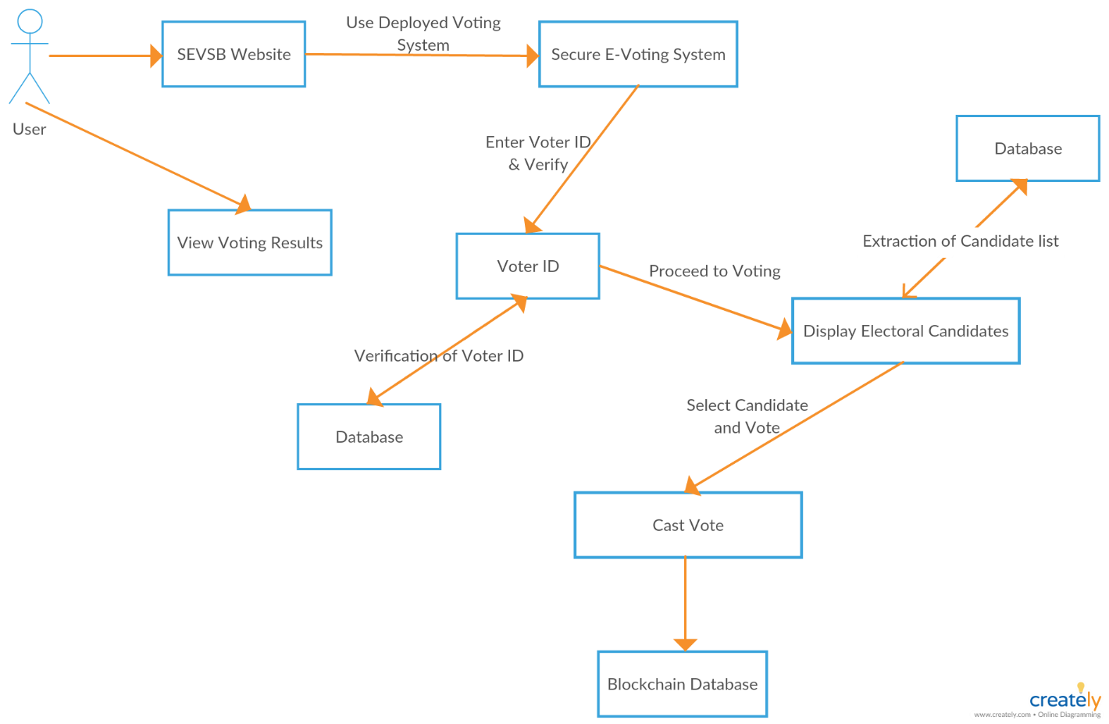

Figure 4: Collaboration Diagram (User)

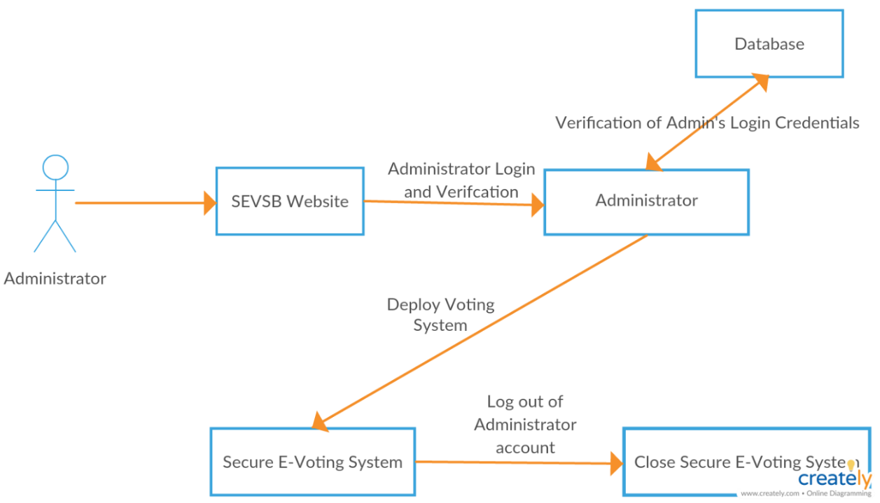

Figure 5: Collaboration Diagram (Administrator)

Design Class Diagram
Classes are the work-horses of the design effort—they actually perform the real work of the system. The other design elements—subsystems, packages and collaborations simply describe how classes are grouped or how they interoperate.
Capsules are also stereotyped classes, used to represent concurrent threads of execution in real-time systems. In such cases, other design classes are 'passive' classes, used within the execution context provided by the 'active' capsules. When the software architect and designer choose not to use a design approach based on capsules, it is still possible to model concurrent behaviour using 'active' classes.
Active classes are design classes, which coordinate and drive the behaviour of the passive classes - an active class is a class whose instances are active objects, owning their own thread of control.

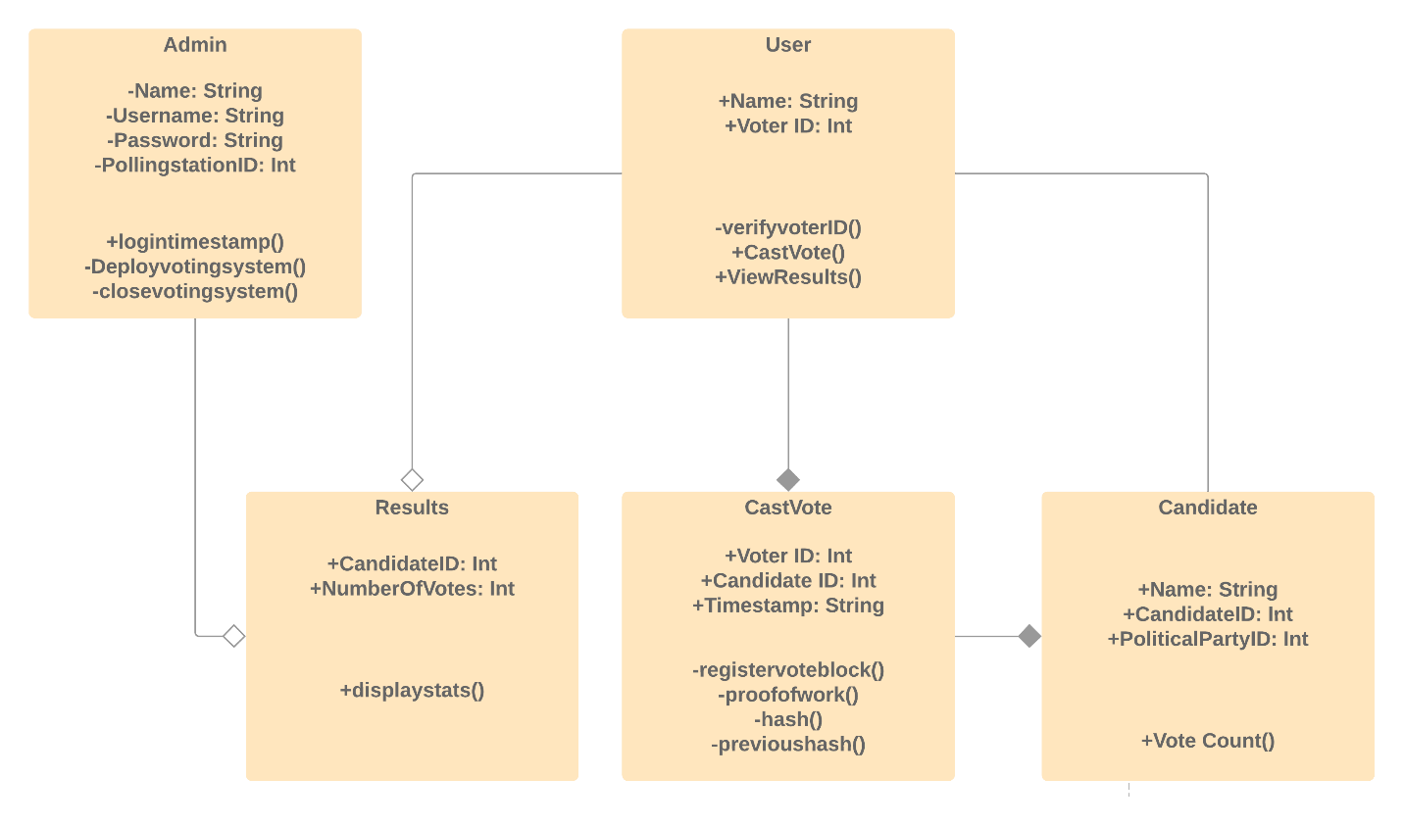
Figure 6: Class Diagram

Data Model
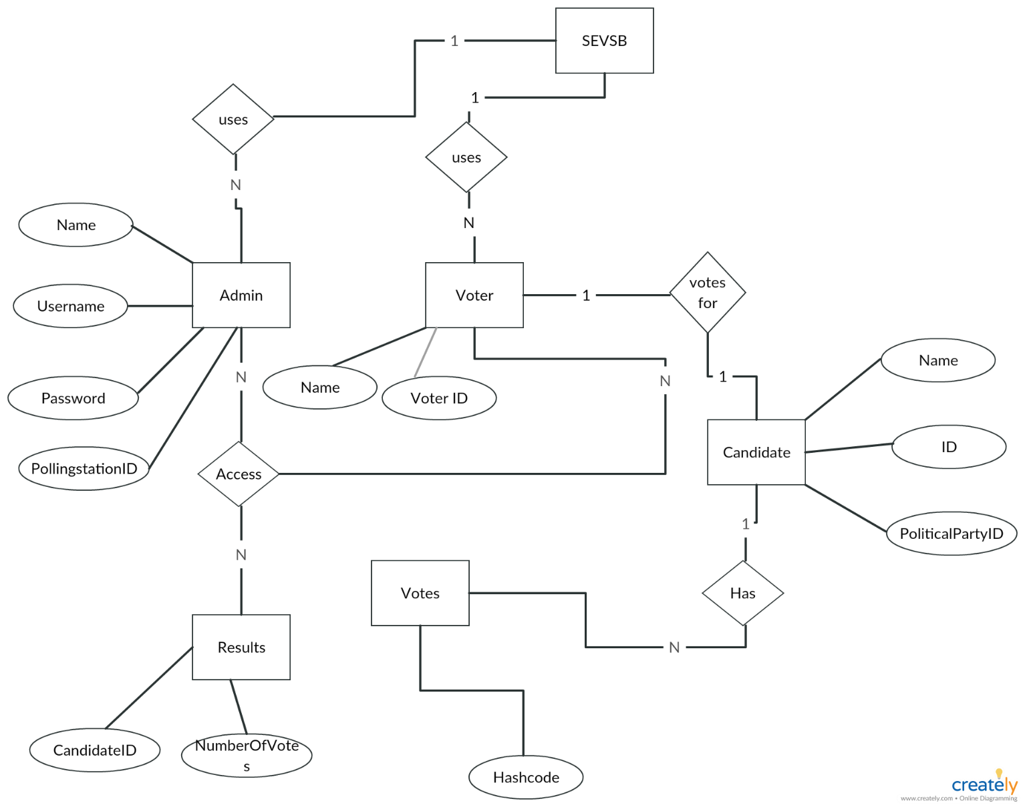
The data model is a subset of the implementation model, which describes the logical and physical representation of persistent data in the system.

Figure 7: Entity Relationship Diagram

Operation Contracts

A UML Operation contract identifies system state changes when an operation happens. Effectively, it will define what each system operation does. An operation is taken from a system sequence diagram. It is a single event from that diagram. A domain model can be used to help generate an operation contract.

Operation Contract Administrator Login
Name: Administrator Login
Responsibilities: To log in to the voting system.
Cross References: U1
Exceptions: Administrator entered wrong credentials.
Preconditions: Administrator must open the SEVSB website.
Post conditions: Starting of polling session.

Operation Contract Deploy Voting System
Name: Deploy Voting System
Responsibilities: To deploy or start the Voting System.
Cross References: U2
Exceptions: none
Preconditions: Administrator must be logged in to the system.
Post conditions: System is deployed and polling can initiate.

Operation Contract Close Voting System
Name: Close Voting System
Responsibilities: To close the voting system.
Cross References: U3
Exceptions: none
Preconditions: Administrator must be logged in to the system.
Post conditions: The polling session ends and final results are displayed.

Operation Contract Voter ID
Name: Voter ID
Responsibilities: To verify the identity of the voter.
Cross References: U4
Exceptions: Voter enters wrong Voter ID.
Preconditions: Polling must be started before voter can use the voting system.
Post conditions: Voter ID is verified and voter can vote.

Operation Contract Cast Vote
Name: Cast Vote
Responsibilities: to enable the user to vote in our system.
Cross References: U5
Exceptions: none
Preconditions: Polling session must be active, voter ID entered and verified.
Post conditions: Submission of vote to the decentralized database.

Operation Contract View Results
Name: View Results
Responsibilities: To view the current voting results and statistics.
Cross References: U6
Exceptions: none
Preconditions: Website must be opened.
Post conditions: Results or statistics have been viewed by the user.

Methodology
We are going to be using agile Method. The Agile Method is a particular approach to project management that is utilized in software development. This method assists teams in responding to the unpredictability of constructing software. It uses incremental, iterative work sequences that are commonly known as sprints.

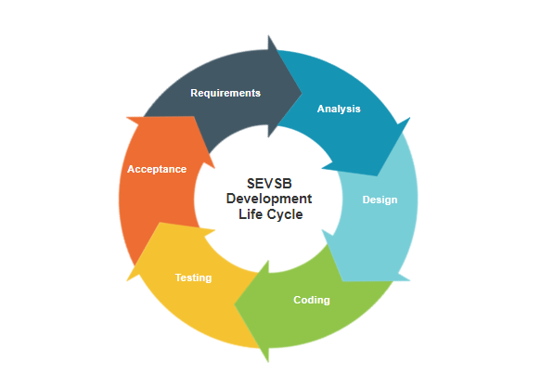
Figure 8: Development Life Cycle

DATA IMPLMENTATION

Implementation

The implementation phase of the project is the development of the designs produced during the design phase.

Technical Aspects
Since the System is an embedded system, both web server and database management system and web application are necessary. The system consists of the following technical aspects:

Hardware
Hardware contains necessary hardware as PC. The minimum RAM required is 4 GB and 80 GB of Hard Disk.

Back-end
NODEJS which provides us with Back-end facilities for this project. Ethereum transactions (Voting) is done through Testrpc on a Blockchain node. A MongoDB database stores all records.

Front-end
Front-end also developed in NODEJS using EJS template engine. Voting is done through testrpc and stored on the Blockchain node.

USER MANUAL

This manual describes the SEVSB interface and all its features. This document is to assist users in navigating the app.

SEVSB Home Page
This is the main home page of SEVSB and is the first page that will open when the web app is opened. This is the landing page of the voting system.

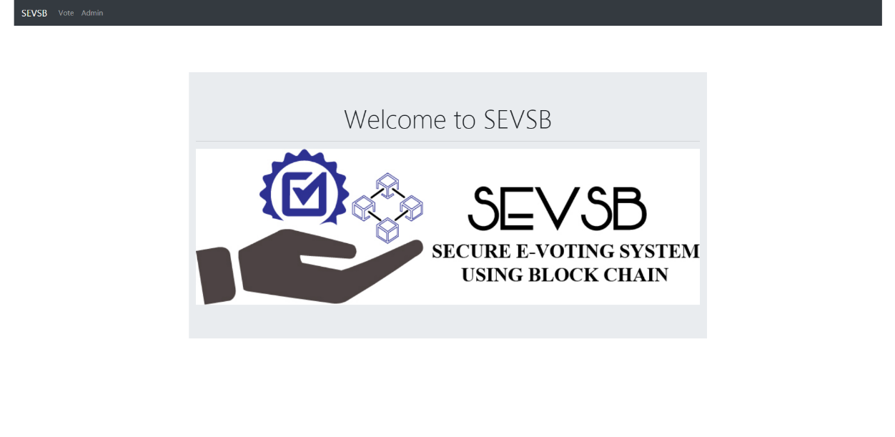
Figure 9: SEVSB Home Page

Administrators
Administrators in SEVSB will be users who create polls and add voters and candidates to these polls.

Admin Login
The Admin login page is specifically for poll administrators, and administrators of the can login using their credentials to the Admin Dashboard to create and deploy polls.
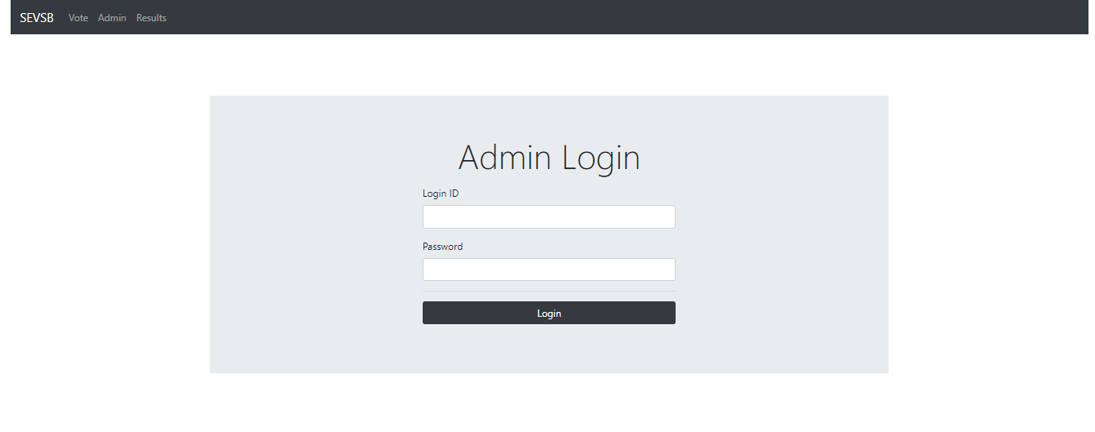
Figure 10: Admin Login Page

Admin Dashboard of SEVSB
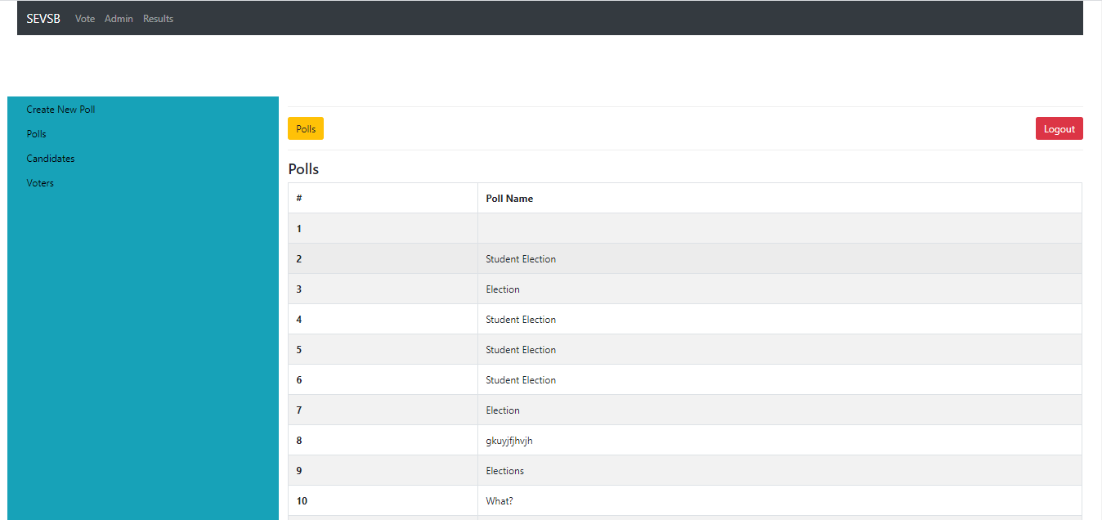
The Admin Dashboard displays all polls, candidates and voters added by the Administrator to the voting system. Administrators can choose between any of the options from the sidebar. For example clicking the “List Polls” option from the side menu will display all polls created and deployed in the system.

Figure 11: Admin Dashboard

Create Polls
SEVSB allows poll administrators to create multiple polls. To do this Admins need to be logged in to the Administrator account.

Creating New Poll
Administrators can create new polls from the Admin dashboard. Simply clicking on the “Create New Poll” button will open up a new page where the Admin can start creating a poll. Entering a new name for the poll and pressing on the button will create the poll.

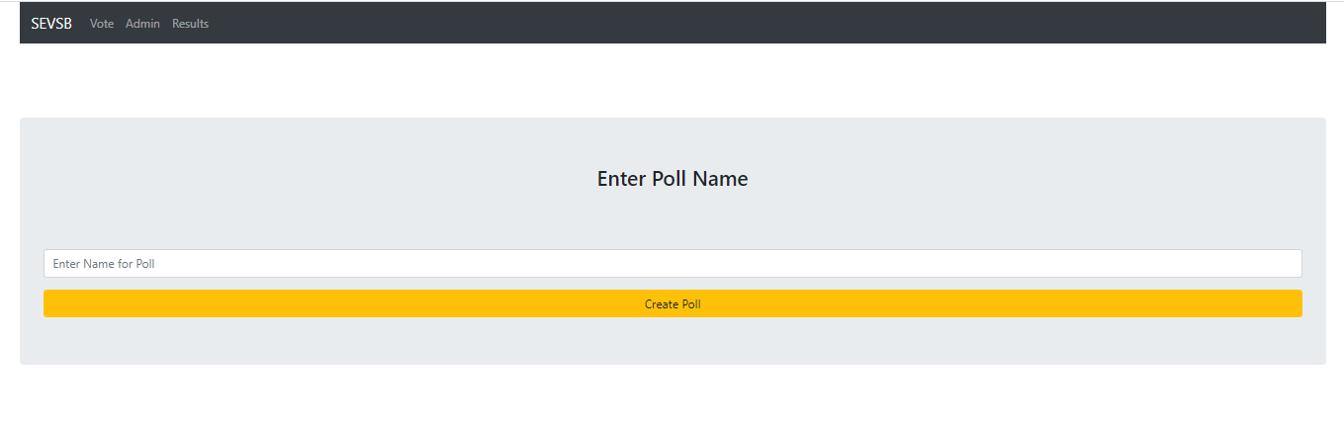
Figure 12: Creating New Poll

Adding Candidates
After a poll is created, the website will open up a new page where the Admin is required to add candidates to the newly created poll. After entering names and adding them to the candidate list, admins are required to add voters by pressing the “Proceed to adding voters” button at the bottom.
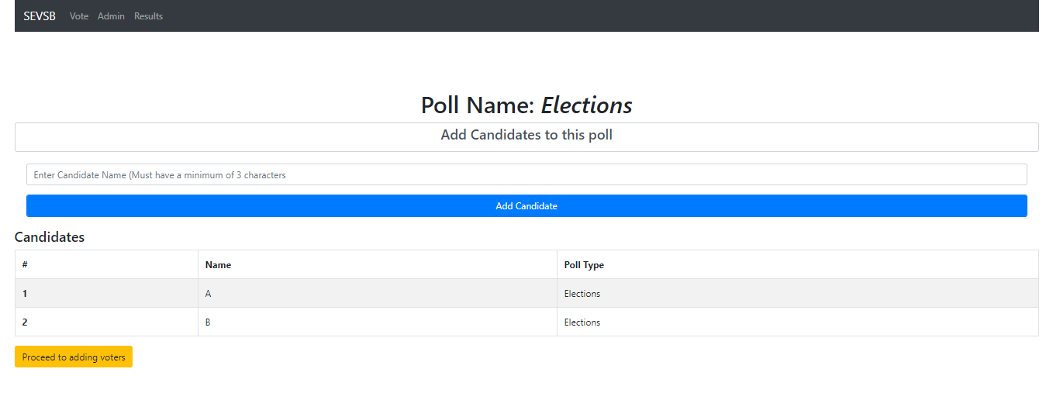
Figure 13: Adding Candidates to the Poll

Adding Voters
After candidates are added, the website will open up a new page where the Admin is required to add candidates to the newly created poll. After entering names and adding them to the voter list, admins can go back to the admin dashboard by pressing the “Return to Dashboard” button at the bottom.

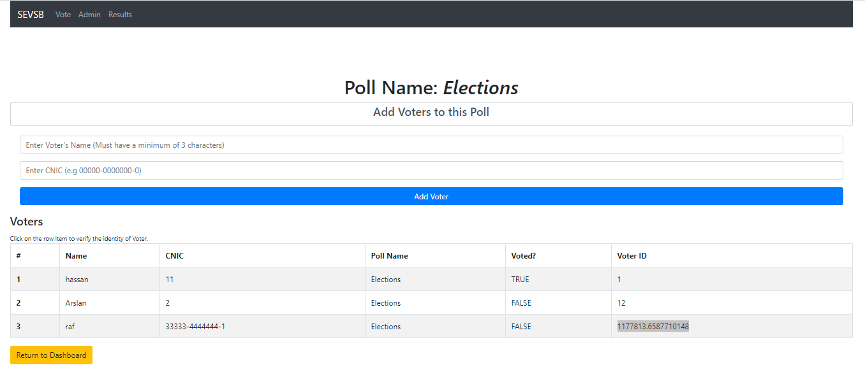
Figure 14: Adding Voters to the Poll

Voting
Voters can vote in their desired poll once they’ve been verified. After they cast the vote the vote is saved and the results for the poll are updated.

Vote Page
Voting in SEVSB can be done by navigating to the vote page. Voters are required to enter their credentials over here for verification. After entering their details voters must select a poll they’re authorized to vote for and then hit verify.

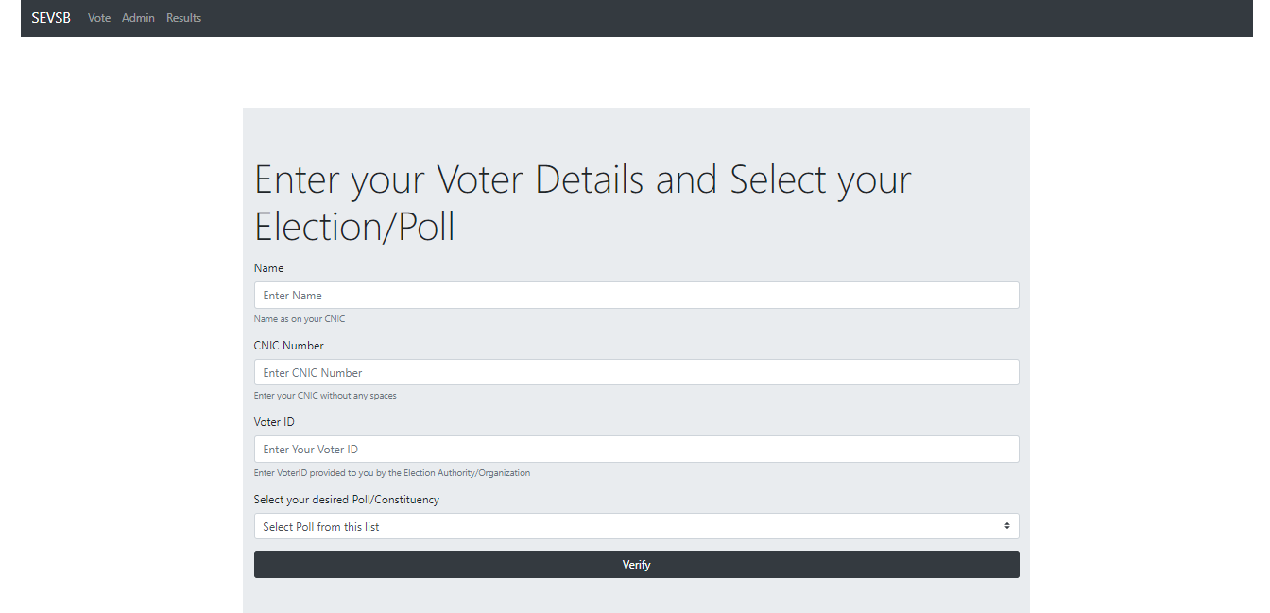
Figure 15: Voter Verification Page

Casting Votes
Once a user is found eligible, they are navigated to the voting page, where the poll they selected is displayed along with its candidates. The voter is required to choose the candidate they want to vote for and hit the “Submit” button. Once this is done, the vote is saved and the website redirects to the SEVSB homepage.

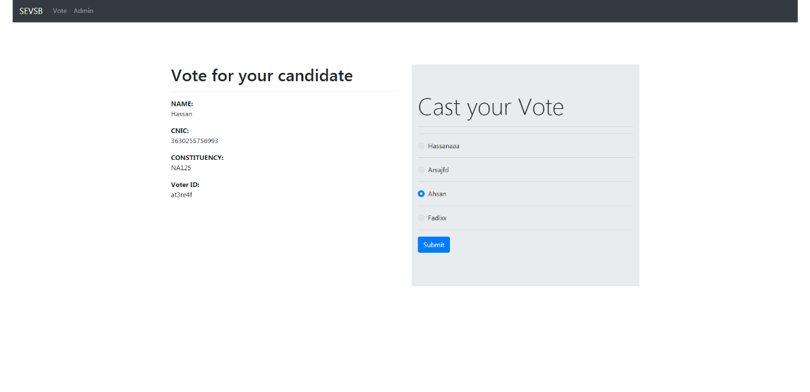
Figure 16: Casting Votes

Results
Users of SEVSB can also view poll results anytime they want by simply navigating to the result page and selecting a poll. On the results page a user is required to select a poll and also the type of chart they want to see the results in. For example if the user selects “pie” for a poll, the voting results for that poll will be displayed in the form of a pie chart.

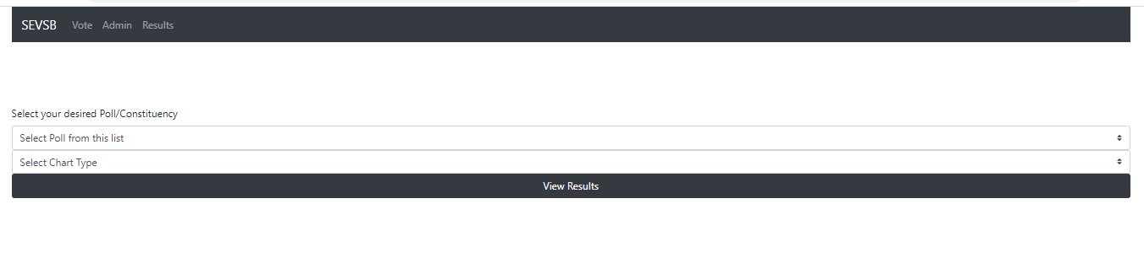
Figure 17: Selecting Chart and Poll Type to View Results

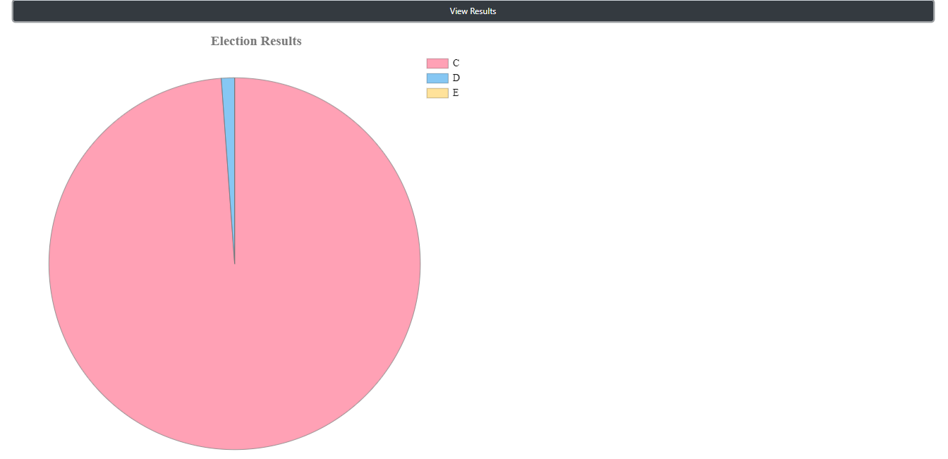

Figure 18: Results for Poll Displayed as a Chart

CHAPTER 6

CONCLUSION AND RECOMMENDATIONS

6.1 Conclusion
The purpose of making this project is to understand the working of Blockchain Development. So that it would be helpful for us in the industry. Also, we want to facilitate organizations who conduct elections to make polling and voting easy and safe. All these things will happen once web app is deployed. We have understood the working of Ethereum Network and developing applications using Ethereum smart contracts. We hope it will be helpful for us and this website will be helpful for the stakeholders of this website.

6.2 Recommendations
Although we developed the voting system and deployed it on a Blockchain node and it has been completely tested on the Ethereum Virtual Machine, there were a few limitations. As this is a voting app, it requires a list of voters and candidates. These datasets were not readily available so in the future when the app is deployed in real-time, organizations like NADRA can use their own dataset with the voting app.

REFERENCES

- Freya Sheer Hardwick, Apostolos Gioulis, Raja Naeem Akram, and Konstantinos Markantonakis, “E-Voting with Blockchain: An E-Voting Protocol with Decentralisation and Voter Privacy”, 2018, Available at: https://arxiv.org/pdf/1805.10258.pdf.
- Philip Boucher, “What if block chain technology revolutionised voting?”European Parliament,2016, Available at: https://www.europarl.europa.eu/RegData/etudes/ATAG/2016/581918/EPRS_ATA(2016)581918_EN.pdf
- Nafeesa Syeed, “Is Blockchain Technology the Future of Voting?”, 2018, Available at: https://www.bloomberg.com/news/articles/2018-08-10/is-blockchain-technology-the-future-of-vot

