
BSCS-S19-012
03-134161-036 | MUHAMMAD FARRUKH NADEEM
03-134161-007 | HAFIZ GHULAM ABBAS
03-134161-058 | MUHAMMAD ALI

Blood Share: A System To Manage Voluntarily Donations Of Blood

In partial fulfilment of the requirements for the degree of
Bachelor of Science in Computer Science
Supervisor: Ghulam Mustafa
Department of Computer Sciences
Bahria University, Lahore Campus
January 2020

© Bahria University, 2020

Certificate

We accept the work contained in the report titled
“BLOOD SHARE: A SYSTEM TO MANAGE VOLUNTARILY DONATIONS OF BLOOD”
Written by
MUHAMMAD FARRUKH NADEEM
HAFIZ GHULAM ABBAS
MUHAMMAD ALI
As a confirmation to the required standard for the partial fulfilment of the degree of
Bachelor of Science in Computer Science.

Approved by:
Supervisor: Ghulam Mustafa
(Signature)

January 27, 2020

DECLARATION

We hereby declare that this project report is based on our original work except for citations and quotations which have been duly acknowledged. We also declare that it has not been previously and concurrently submitted for any other degree or award at Bahria University or other institutions.

Enrolment | Name | Signature
03-134161-036 | MUHAMMAD FARRUKH NADEEM
03-134161-007 | HAFIZ GHULAM ABBAS
03-134161-058 | MUHAMMAD ALI

Date : January 27, 2020

Specially dedicated to
My beloved grandmother, mother and father
(Muhammad Farrukh Nadeem)
My beloved grandmother, mother and father
(Hafiz Ghulam Abbas)
My beloved grandmother, mother and father
(Muhammad Ali)

ACKNOWLEDGEMENTS

We would like to thank everyone who had contributed to the successful completion of this project. We would like to express our gratitude to our research supervisor, Dr Ghulam Mustafa for his invaluable advice, guidance and his enormous patience throughout the development of the research.

In addition, we would also like to express my gratitude to our loving parent and friends who had helped and given me encouragement.

Muhammad Farrukh Nadeem
Hafiz Ghulam Abbas
Muhammad Ali

BLOOD SHARE: A SYSTEM TO MANAGE VOLUNTARILY DONATIONS OF BLOOD

ABSTRACT

Blood is one of the most important necessities of our life. Blood Share is to create a networking system where patient can communicate with the donor. User can hire the services in the form of blood donation. Admin is the main authority who can do addition, deletion, and modification if required. When a person needs blood, he/she must contact a blood bank or a compatible blood group of a donor in their circle, family, friends and blood bank.
Using this application at the emergency time of blood needed we can check for blood donor nearby by using GPS. Once the app user enters the blood group which he/she needed it will automatically show the donor nearby and send an alert message/notification to the donor. In case if the donor is not available in current area it will expand the area/distance and search the next donor. It is a mobile-based project developed in android platform. This android project provides an easy and fast way to search for blood. This app also provides the reward-based system for the donor. Here users can easily find the details of donors and receivers through their mobiles. Users need to register with the application to view all the information which is available on the app. The user can search the details and find the details of the blood donors. Users can get brief details about the donor’s contact details including their location which help the user to connect donor.

TABLE OF CONTENTS
DECLARATION ii
ACKNOWLEDGEMENTS iv
ABSTRACT v
LIST OF TABLES ix
LIST OF FIGURES x
LIST OF SYMBOLS / ABBREVIATIONS xi

CHAPTERS
INTRODUCTION 1
1.1 Background 1
1.2 Problem Statements 2
1.3 Aims and Objectives 2
1.4 Scope of Project 2

SOFTWARE REQUIREMENT SPECIFICATION 3
2.1 User Classes and Characteristics 3
2.1.1 Donor 3
CHAPTER 2 2.1.1.1 Signup 3
CHAPTER 5 2.1.1.2 Login 3
CHAPTER 6 2.1.1.3 Requests 3
CHAPTER 7 2.1.1.4 Chat Rooms 3
CHAPTER 8 2.1.1.5 Reward 3
2.1.2 Receiver 3
CHAPTER 9 2.1.2.1 Signup 3
CHAPTER 1 2.1.2.2 Login 3
CHAPTER 1 2.1.2.3 Requests 4
CHAPTER 1 2.1.2.4 Chat Room 4
2.1.3 Admin 4
CHAPTER 1 2.1.3.1 Login 4
2.2 Operating Environment 4
2.2.1 Android-Based Requirements: 4
2.2.2 Database Management System: 4
2.2.3 Android Development System: 4
2.2.4 Web-based requirements 4
2.2.5 Web development framework 4
2.3 Design and Implementation Constraint 5
2.3.1 Assumption and Dependencies 5
2.4 System Requirements Chart 5
DESIGN AND METHODOLOGY 9
3.1 Design 9
3.2 Use Case Diagram 9
3.3 Use Case Description 10
3.3.1 Signup 10
3.3.2 Login 10
3.3.3 Search for Blood 11
3.3.4 Request 12
3.3.5 Reward Base System 13
3.3.6 View Reward Status 13
3.3.7 Chat Room 14
3.3.8 View Profile 15
3.3.9 Accept/Reject Request 15
3.3.10 Logout 16
3.4 Sequence Diagram 17
3.4.1 Signup Sequence Diagram 17
3.4.2 Login Sequence Diagram 18
3.4.3 Search Donor Sequence Diagram 18
3.4.4 Request Sequence Diagram (Recipient) 19
3.4.5 Request Sequence Diagram (Donor) 19
3.4.6 Reward Sequence Diagram 20
3.4.7 Reward Status Diagram 20
3.4.8 Admin Sequence Diagram 21
3.4.9 Logout Sequence Diagram 21
3.5 Domain Model 22
3.6 Entity Relationship Diagram 23
3.7 Class Diagram 24
3.8 Operation Contracts 24
DATA AND EXPERIMENTS (and/or IMPLMENTATION) 27
4.1 Language Used for Implementation 27
4.1.1 XML 27
4.1.2 JAVA 27
4.2 Tool Used for Implementation 27
4.2.1 Android Studio 27
4.2.2 SQL 27
RESULTS AND DISCUSSIONS (or USER MANUAL) 28
5.1 Splash Screen 28
5.2 Login 28
5.3 Signup 29
5.4 Homepage 29
5.5 After Selecting Blood Group 30
5.6 Forget Password 30
CONCLUSION AND RECOMMENDATIONS 31
6.1 Conclusion 31
6.2 Recommendation 31
REFERENCES 32

LIST OF TABLES

TABLE TITLE PAGE
Table 2-1 System Requirement Chart 8
Table 3-1 Signup U1 10
Table 3-2 Login U2 11
Table 3-3 Search for Blood U3 12
Table 3-4 Request U4 12
Table 3-5 Reward Based System U5 13
Table 3-6 View Reward Status U6 14
Table 3-7 Chat Room U7 15
Table 3-8 View Profile U8 15
Table 3-9 Accept/Reject Request U9 16
Table 3-10 Logout U10 17

LIST OF FIGURES

FIGURE TITLE PAGE
Figure 3-1 System use-case diagram 9
Figure 3-2 Signup Sequence Diagram 17
Figure 3-3 Login Sequence Diagram 18
Figure 3-4 Search Donor Sequence Diagram 18
Figure 3-5 Request Sequence Diagram (Recipient) 19
Figure 3-6 Request Sequence Diagram (Donor) 19
Figure 3-7 Reward Sequence Diagram 20
Figure 3-8 Reward Status Sequence Diagram (Donor) 20
Figure 3-9 Admin Sequence diagram 21
Figure 3-10 Logout Sequence diagram 21
Figure 3-11 Domain Model 22
Figure 3-12 Entity Relationship Diagram 23
Figure 3-13 Class Diagram 24
Figure 5-14 Splash Screen 28
Figure 5-15 Login Screen 28
Figure 5-16 Signup 29
Figure 5-17 Home Screen 29
Figure 5-18 Donors Show 30
Figure 5-19 Forgot Password 30

LIST OF SYMBOLS / ABBREVIATIONS

XML extensible Mark-up Language
SQL Structure Query Language
GPS Global Positioning System
WHO World Health Organization
HIV Human Immunodeficiency Virus
FDD Feature Driven Development
MVC Model View Control
DBAs Database Administrators
IDE Integrated Development Environment
OS Operating System

CHAPTER 1

INTRODUCTION

Background

Pakistan is among those low-income bracket countries that appallingly suffer from a lack of blood donors. Over 90 percent of total blood transfused in Pakistan is donated by the friends and relatives of patients. Around 10-20 percent of blood supply is still donated by professional donors. Pakistan’s annual blood transfusion requirement is approximately 1.5 million bags, with 40 percent of the demand being met by the public sector. Blood transfusion services in Pakistan are mostly hospital-based [4]. There are nearly 150 public and 450 private blood banks in the country and most of these are unregistered and unregulated due to which business of substandard and unscreened blood has assumed an alarming proportion.

Blood is an essentially significant fluid in our body. Blood Share is to develop a networking platform where the receiver can interconnect with the donor. Receiver can request the donor for blood donation. Admin have all the rights If any changes required in application. At the point when people need blood, he/she should contact a blood donation centre or find the required blood group in their social circle, relatives and blood donation centre. In emergency people need blood donor, so by using this application they can search blood donors who are close to your location by utilizing GPS. Once the receiver enters the blood group that he/she need it will search the required blood group donor who is nearby to your location and receiver request to the donor for donating blood [1]. By chance the blood donor is not being accessible in the existing range it will expand the range and search the subsequent blood donor. The receiver can see the short details of the blood donor’s cell number as well as their area which helps the receiver to send a blood request to the donor. Both donor and receiver have to register with this application to perform all these actions. By using android platform, we are going to develop this mobile based application. This application gives a simple and quick way to find the donor nearby. This application also gives the reward-based system for the blood donor. After donating blood, the receiver can rate the donor and on the bases of rating, the donor gets the points. By using these points, they can avail discount on a different lab test that provides by laboratories.

Problem Statements

The main purpose of our Blood Share is to design an application for arranging blood in a short interval of time. It also provides a facility of reward to donors to get discount on laboratory test.

Aims and Objectives

- To design an android-based platform for blood donors and the recipients.
- To provide an easy way to recipients to arrange blood.
- To develop a Blood Donation Application that will provide the facility to arrange nearest blood donor and help him reach the destination.
- To provide a useful application to find compatible blood donors.

Scope of Project

The primary scope of blood share application provides a platform to search donor and provide a connection between blood donor and user who request the donor. User can register himself on application through basic information and blood group. In case of emergency if anyone required blood then he/she go to blood bank or call the relative to find relevant blood donor. If relevant donor not available at right time, then it will create problem so to overcome the above problem we will develop an application. The application that is not only for business purpose. This can take for social services, because if we are using this application, it will be making easy to register the donors and contact the donors in an emergency. It provides an elegant management of blood for donors online. The main purpose of this project is to interconnect all donors into a single network and store various data and information of blood donors. This application is used to store data over a centralized server which consist of database where the individuals’ information cannot be accessed by a third party.

CHAPTER 2

SOFTWARE REQUIREMENT SPECIFICATION

User Classes and Characteristics

Donor

2.1.1.1 Signup

- Name
- Email
- CNIC
- Mobile No
- Blood Group
- Area
- Password
- Age

2.1.1.2 Login
- Username
- Password

2.1.1.3 Requests
- Accept requests / Reject requests
- Request processed history

2.1.1.4 Chat Rooms
- Chat with Receiver

2.1.1.5 Reward
- Donor get reward

Receiver

2.1.2.1 Signup
- Name
- Email
- CNIC
- Mobile No
- Password
- Age
- Area

2.1.2.2 Login
- Username
- Password
- User selects the required blood group.

2.1.2.3 Requests
- Can request donors on Map
- Profiles of donors will pop-up in the defined radius

2.1.2.4 Chat Room
- Chat with donor

Admin

2.1.3.1 Login
- Username
- Password
- Update and delete the records

Operating Environment

2.2.1 Android-Based Requirements:

Android version (minimum 4.0)
Google Play Services

2.2.2 Database Management System:

SQL

2.2.3 Android Development System:

Android Studio.

2.2.4 Web-based requirements

Google chrome

2.2.5 Web development framework

MVC

Design and Implementation Constraint
Blood share is an Android-Based system therefore front-end of application will be developed using XML and back-end will be developed using JAVA and SQL for developing database. It will be developed using Feature Driven Development which divide complex structures into sub parts. This model recurrence last two phases i.e. Design by feature and Develop by Feature until all features will complete.

Assumption and Dependencies
- Google play services is required to run Google applications. So, user need to have this feature to interact with our application. Without Google play services, features like Google maps cannot be used.
- The app requires location of both end users so GPS is also required.
- Both end users need to have an active internet connection.

System Requirements Chart

ID | Priority | Type | Source | Used in Use case | Description
1 | High | Functional | Laboratories | N/A | Open the App
2 | High | Functional | Laboratories | U1 | Registration is done by both receiver and donors interact.
3 | Medium | Functional | Laboratories | U2 | User Login
4 | Medium | Functional | Laboratories | U2 | Reset Password
5 | High | Functional | Laboratories | U1 | Register Users
6 | Medium | Functional | Laboratories | U1 | View Search Users
7 | Medium | Functional | Laboratories | U10 | Logout
8 | Medium | Functional | Laboratories | U3 | Registered receiver search for required blood
9 | Medium | Functional | Laboratories | U3 | Drop down list shows up of all  possible blood groups
10 | Medium | Functional | Laboratories | U3 | Selects Required blood from drop down list

11 | High | Functional | Laboratories | U4 | Radius is defined around the Area and then expanded
12 | High | Functional | Laboratories | U4 | Donor pops up in the shortest radius first
13 | High | Functional | Laboratories | U4 | User requests the blood
14 | Medium | Functional | Laboratories | U5 | Request accepted
15 | Medium | Functional | Laboratories | U5 | Receiver rate the Donor
16 | Low | Functional | Laboratories | U6 | Opens status interface for reward
17 | Low | Functional | Laboratories | U6 | Both Donor, Admin can see the status
18 | Low | Non Functional | Laboratories | U7 | Create a Chat
19 | Low | Functional | Laboratories | U7 | Add both users

20 | Low | Non Functional | Laboratories | U7 | Open Chat
21 | Low | Non Functional | Laboratories | U7 | Delete Chat Box
22 | Low | Functional | Laboratories | U8 | Profile Created
23 | Low | Functional | Laboratories | U8 | Opens Profile
24 | High | Functional | Laboratories | U4 | Blood Request Accepted
25 | High | Functional | Laboratories | U4 | Blood Request rejected. Find a new Donor.
26 | High | Non  Functional | Laboratories | N/A | Display all content after registering the application
27 | High | Non  Functional | Laboratories | N/A | Server Response
28 | High | Non  Functional | Laboratories | N/A | Make a check if  Receiver is in the  Hospital
29 | High | Non  Functional | Laboratories | N/A | All the passwords should be in encrypted form
30 | High | Non  Functional | Laboratories | N/A | Only Related People can access
31 | High | Non  Functional | Laboratories | N/A | Components of the project code will be tested alongside the implementation  Phase to ensure that they are functional.
32 | High | Non  Functional | Laboratories | N/A | Final, integrated  project code will test to ensure that complete project is integrated well and functioning Properly

Table 2-1 System Requirement Chart
CHAPTER 3

DESIGN AND METHODOLOGY

Design
This chapter overviews the design of Blood Share. The system architecture design gives the total perspective of the system. This will enable developers and clients to see and check the design plan in detail. Following artefacts incorporated in this Chapter
- Use-case description
- Use-case diagram refined
- Domain Model
- Sequence Diagram
- Collaboration Diagram
- Operation Contracts
- Design Class Diagram
- Data Model

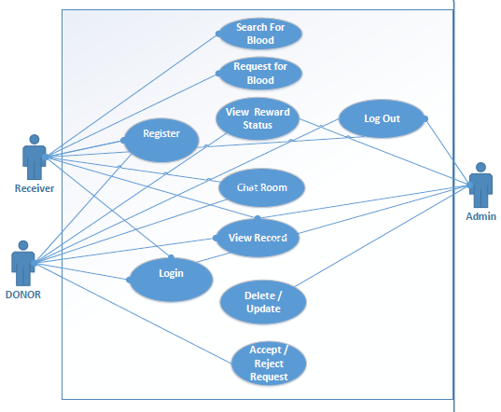
Use Case Diagram
Figure 3-1 System use-case diagram

3.3 Use Case Description
A use-case description is a text that captures the detailed functionality of a use-case. Description of all use-cases are written down in this section.

Signup
Use-case description typically contains the following parts:

Name and ID | Signup U1
Brief description | Users need to Sign up to save their record and to interact with this application.
Preconditions | User must be not already register.
Basic flow or Happy path | - User opens the application.  - Clicks on Signup Button.  - Enters Required Data.  - Press Register Button
Trigger | This use case is initiated when a donor or receiver is going to register himself
Alternate flows | - At 4 if CNIC already exists in the database  - User will be asked to login if his record already exists.  - At 4 if all required fields are not filled properly  - Error message is displayed to fill all the fields.  - Return to step 3
Post conditions | User gets registered.

Table 3-1 Signup U1

3.3.2 Login
Use-case description typically contains the following parts:

Name and ID | Login U2
Brief description | Registered users can login.
Preconditions | User should be Signup
Basic flow or Happy path | 1. User opens the application.  2. Clicks on Donor/Receiver Button.  3. Enters username and password.  4. Press Login Button.
Trigger | This use case is initiated when donors and receivers are going to login.
Alternate flows | - At 4 if the user record does not exist  - User will be asked to register on the application first.  - At 4 if the user enters wrong username or password  - User will be asked to enter correct username or password.  - At 4 user enters wrong password press forgot password  - Send PIN to phone. No or email  - User will reset the password using PIN
Post conditions | Successful login.

Table 3-2 Login U2

3.3.3 Search for Blood
Use-case description typically contains the following parts:

Name and ID | Search for Blood U3
Brief description | Receivers will search required blood donor through blood group.
Preconditions | User should be logged in
Basic flow or Happy path | - User opens the application.  - Receiver registers/login.  - From the drop-down menu receiver select the required blood group
Trigger | This use case is initiated when receiver is going to search the blood.
Alternate flows | - At 2 If the user record does not exist in database  - User will be asked to sign up on the application first  - At 2 if user enters wrong username or password  - User will be requested to correct username or password.  - At 2 if user enters wrong password press forgot password  - Send PIN to phone. No or email  - User will reset the password using PIN
Post conditions | Blood group gets selected.

Table 3-3 Search for Blood U3

3.3.4 Request
Use-case description typically contains the following parts:

Name and ID | Request U4
Brief description | Receiver can request donor.
Preconditions | User should be logged in.  Blood group needs to be selected.
Basic flow or Happy path | - User opens the application.  - Registers/login.  - Selects Blood Group.  - Donors matched in the defined radius.
Trigger | This use case is initiated when receiver is going to request for a donation of blood to donor.
Alternate flows | - At 2 if user record does not exist  - User will be asked to register on the application first.  - At 2 if user enters wrong username or password  - User will be asked to enter correct username or password.  - At 2 if user enters wrong password press forgot password  - Send PIN to phone. No or email  - User will reset the password using PIN  - At 4 if receiver is not in the predefined locations  - Request will not be processed unless he is in some govt. hospital.  - At 4 if no donor gets popped up in the defined radius  - Radius will be expanded to make sure the availability of donor.
Post conditions | Donor is arranged.

Table 3-4 Request U4

3.3.5 Reward Base System
Use-case description typically contains the following parts:

Name and ID | Reward Base System U5
Brief description | After the donor’s donation receiver will be required to rate him for reward.
Preconditions | - User should be logged in.  - User should donate blood.  - User should be rated.
Basic flow or Happy path | - User opens the application.  - Registers/login.  - Selects Laboratory.  - Donors are then matched in the defined Test points.  - Select Test option will allow the donor to get discount rate in Test from selected.
Trigger | This use case is initiated when donors donates blood and receivers rate him for the reward.
Alternate flows | - At 2 if the user record does not exist  - User will be asked to register on the application first.  - At 2 if user enters the wrong username or password  - User will be asked to correct the username or password.  - At 4 if the receiver is not in the predefined criteria  - Request will not be processed unless he/she has significant points.
Post conditions | Donor get reward.

Table 3-5 Reward Based System U5

3.3.6 View Reward Status
Use-case description typically contains the following parts:

Name and ID | View reward status U6
Brief description | After get rewarded, donor can view reward status.
Preconditions | User should be logged in
Basic flow or Happy path | - User opens the application.  - Registers/login.  - Donor view reward status
Trigger | This use case is initiated when donor is going to view reward status.
Alternate flows | - At 2 if user enters wrong username or password  - User will be asked to correct username or password
Post conditions | N/A

Table 3-6 View Reward Status U6

3.3.7 Chat Room
Use-case description typically contains the following parts:

Name and ID | Chat Room U7
Brief description | Receiver and donors can chat with each other.
Preconditions | Users should be logged in.  Request needs to be processed.
Basic flow or Happy path | - User opens the application.  - Registers/login.  - Receiver requests the blood.  - Donor accepts the request.  - When request is accepted, a connection will be established between donor and receivers.  - Both users can then chat with each other.
Trigger | This use case is initiated when a donor and a receiver chat with each other
Alternate flows | - At 2 if user record does not exist  - User will be asked to register on the application first.  - At 2 if user enters wrong username or password  - User will be asked to enter correct username or password.  - At 3 if receiver is not in the predefined location  - Request will not be processed unless he is in some govt. hospital.  - At 4 if donor rejects  - Return to 3.  - At 5 if no donor gets popped up in the defined radius  - Radius will be expanded to make sure the availability of donor.
Post conditions | Availability of donor and receiver.

Table 3-7 Chat Room U7

3.3.8 View Profile
Use-case description typically contains the following parts:

Name and ID | View Profile U8
Brief description | Receiver and donors can view their own profiles.
Preconditions | Users should be logged in.
Basic flow or Happy path | - User opens the application.  - Register/Login.  - Clicks the profile button from the swipe tray
Trigger | This use case is initiated when receiver and donors view their profile.
Alternate flows | - At 2 if user record does not exist  - User will be asked to register on the application first.  - At 2 if user enters wrong username or password  - User will be asked to correct username or password.
Post conditions | None

Table 3-8 View Profile U8

3.3.9 Accept/Reject Request
Use-case description typically contains the following parts:

Name and ID | Accept/Reject Requests U9
Brief description | Donors can accept or reject requests.
Preconditions | Users should be logged in.
Basic flow or Happy path | - User opens the application.  - Registers/login.  - Gets blood request  - Accepts/rejects the request
Trigger | This use case is initiated when a donor receive request and they can accept or reject the request
Alternate flows | - At 2 if user record does not exist  - User will be asked to register on the application first.  - At 2 if user enters wrong username or password  - User will be asked to enter correct username or password.
Post conditions | N/A

Table 3-9 Accept/Reject Request U9

3.3.10 Logout
Use-case description typically contains the following parts:

Name and ID | Logout U10
Brief description | Receiver and donors can logout.
Preconditions | User must be logged in
Basic flow or Happy path | - User opens the application.  - Receiver registers/login.  - From the drop-down menu receiver select the required blood group
Trigger | This use case is initiated when user is going to logout from the application
Alternate flows | - At 2 if user record does not exist in database  - User will be requested to register on the application first  - At 2 if user enters wrong username or password  - User will be requested to correct username or password.
Post conditions | N/A

Table 3-10 Logout U10

3.4 Sequence Diagram
Following are the sequence diagrams

Signup Sequence Diagram
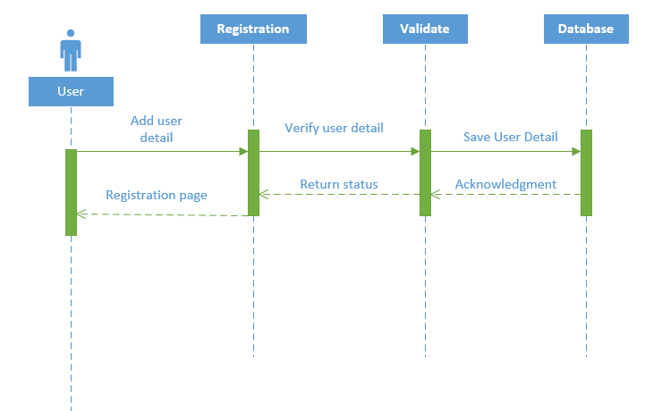
Figure 3-2 Signup Sequence Diagram

Login Sequence Diagram
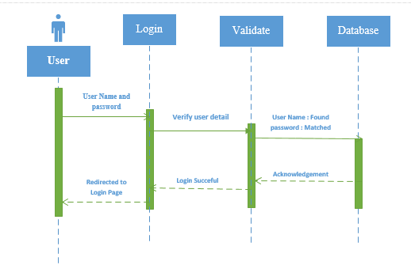
Figure 3-3 Login Sequence Diagram

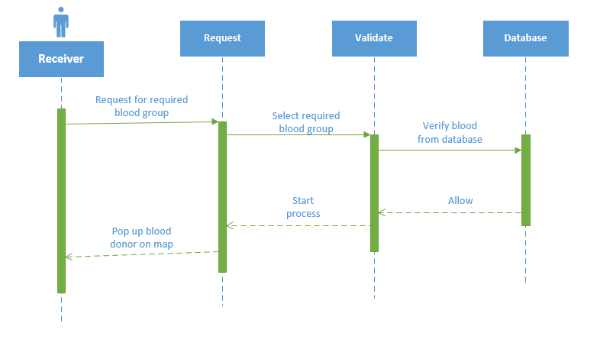
Search Donor Sequence Diagram

Figure 3-4 Search Donor Sequence Diagram

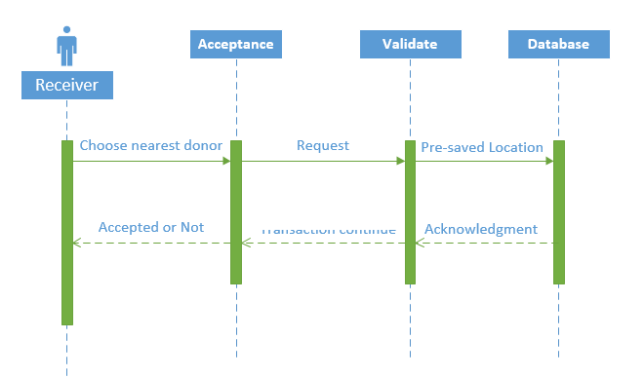
Request Sequence Diagram (Recipient)

Figure 3-5 Request Sequence Diagram (Recipient)

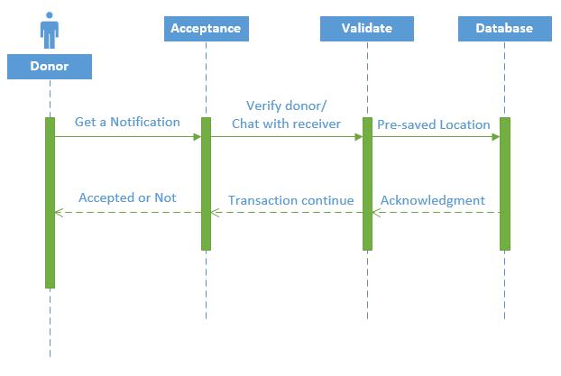
Request Sequence Diagram (Donor)
Figure 3-6 Request Sequence Diagram (Donor)

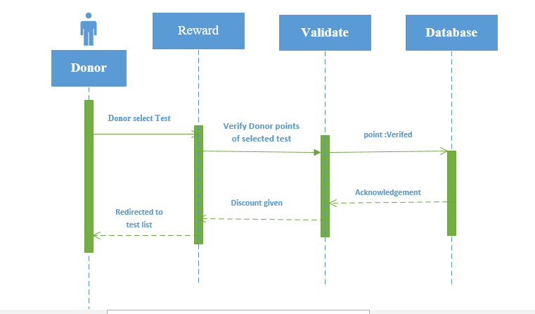
Reward Sequence Diagram
Figure 3-7 Reward Sequence Diagram

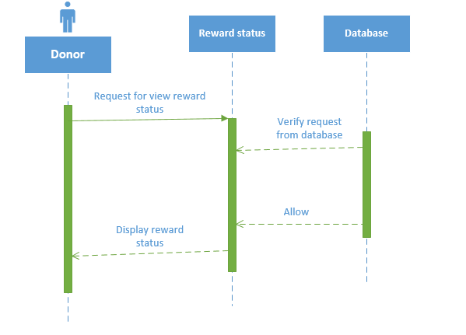
Reward Status Diagram
Figure 3-8 Reward Status Sequence Diagram (Donor)

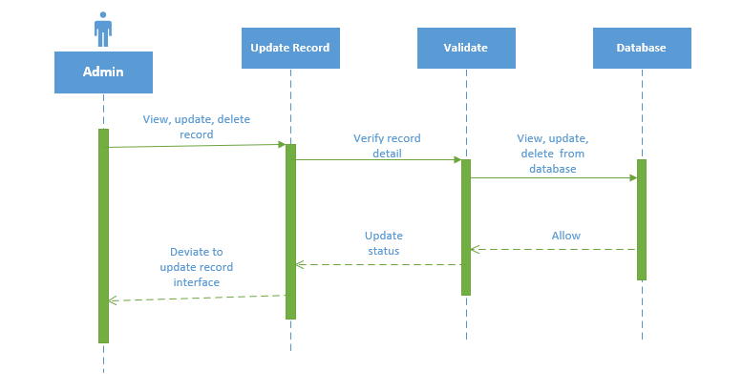
Admin Sequence Diagram
Figure 3-9 Admin Sequence diagram

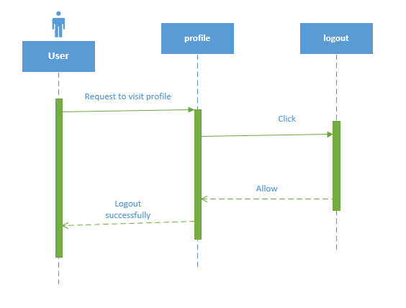
Logout Sequence Diagram
Figure 3-10 Logout Sequence diagram

3.5 Domain Model

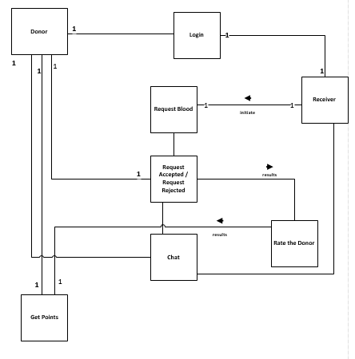

Figure 3-11 Domain Model

Entity Relationship Diagram
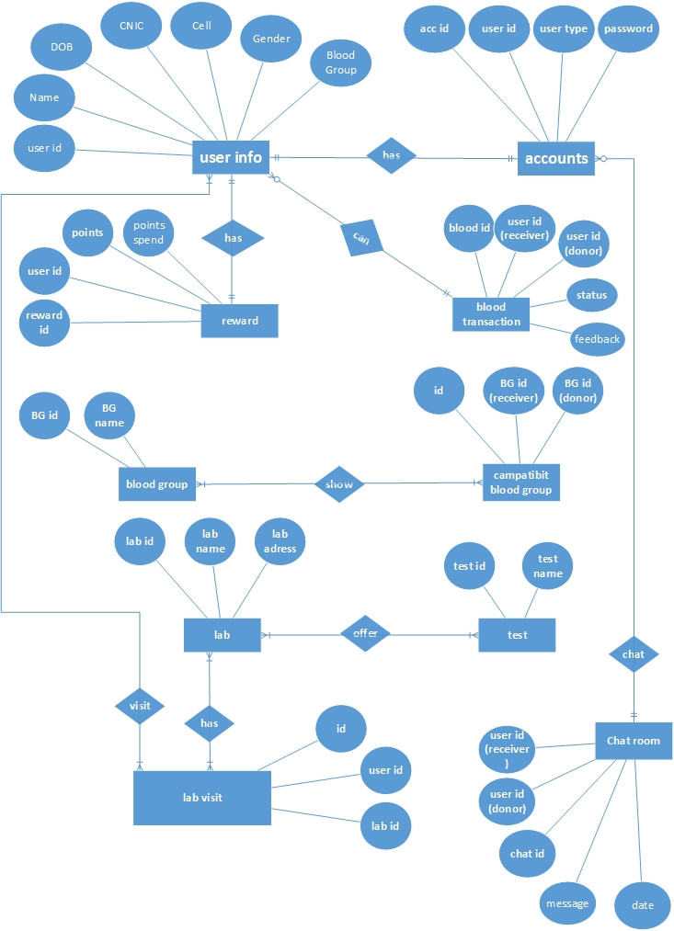

Figure 3-12 Entity Relationship Diagram

3.7 Class Diagram
Figure 3-13 Class Diagram

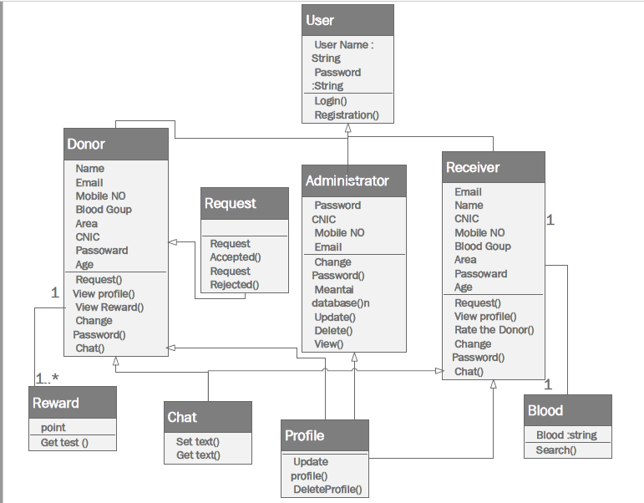

3.8 Operation Contracts
Operation Contract Signup
Name: Signup
Responsibilities: Users need to Signup to have their record saved and to interact with this app
Cross References: U1
Exceptions: None
Preconditions: User in not already registered.
Post conditions: User was registered.
Operation Contract Login
Name: Login
Responsibilities: Registered users can login
Cross References: U2
Exceptions: User entered wrong credentials
Preconditions: User should be registered.
Post conditions: User was logged in.
Operation Contract Request
Name: Request
Responsibilities: Receiver can request donor.
Cross References: U4
Exceptions: None
Preconditions: User needs to be in one of the pre-selected hospitals.
Post conditions: Donor was arranged.
Operation Contract Search for blood
Name: Search blood
Responsibilities: To search required blood group.
Cross References: U3
Exceptions: none
Preconditions: User should be logged in.
Post conditions: Blood group gets selected.
Operation Contract Reward Base System:
Name: Reward
Responsibilities: After the donor’s donation receiver will be required to rate him for reward.
Cross References: U5
Exceptions: User entered wrong credentials
Preconditions:
  - User should be logged in.
  - User should donate blood.
Operation Contract View Reward Status
Name: Reward Status
Responsibilities: After get rewarded, donor can view reward status
Cross References: U6
Exceptions: none
Preconditions: User should be logged in.
Operation Contract Chat Room
Name: Chat Room
Responsibilities: donors and receiver can chat with each other.
Cross References: U7
Exceptions: None
Preconditions: Donor was arranged previously.
Post conditions: Availability.
Operation Contract View Profile:
Name: Profile
Responsibilities: Receiver and donors can view their own profiles.
Cross References: U8
Exceptions: User entered wrong credentials
Preconditions: User was logged in.
Operation Contract View Profile:
Name: Accept/Reject Requests
Responsibilities: Donors can accept or reject requests.
Cross References: U9
Exceptions: User entered wrong credentials.
Preconditions: User was logged in.
Operation Contract Logout:
Name: Logout
Responsibilities: Receiver and donors can logout
Cross References: U10
Exceptions: none
Preconditions: User should be logged in.

CHAPTER 4

DATA AND EXPERIMENTS (and/or IMPLMENTATION)

Language Used for Implementation

XML
XML stands for extensible Mark-up Language. XML is a mark-up language much like HTML. XML was designed to store and transport data. XML was designed to be self- descriptive. XML is a W3C Recommendation.

JAVA
Java is a general-purpose computer-programming language that is concurrent, class- based, object-oriented, and specifically designed to have as few implementation dependencies as possible.

Tool Used for Implementation

Android Studio
Android Studio is the official integrated development environment for Google's Android operating system, built on Jet Brains' IntelliJ IDEA software and designed specifically for Android development. It is available for download on Windows, mac OS and Linux based operating systems.

SQL
Structured Query Language (SQL) is a standard computer language for relational database management and data manipulation. SQL is used to query, insert, update and modify data. Most relational databases support SQL, which is an added benefit for database administrators (DBAs), as they are often required to support databases across several different platforms.

RESULTS AND DISCUSSIONS (or USER MANUAL)

Splash Screen

This is the splash screen. When you download the application and run it on your phone. First it will appear on your screen.
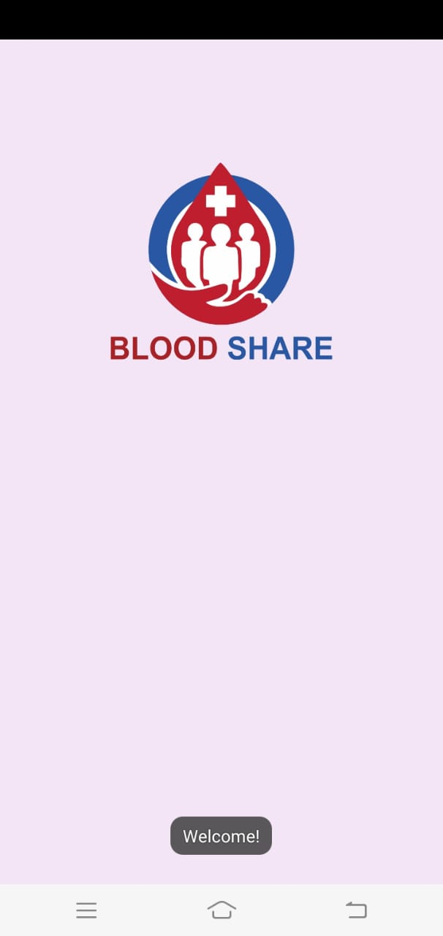

Figure 5-14 Splash Screen

Login
This is the first interface comes up to your screen when you interact with the application. You can easily Login and use it.
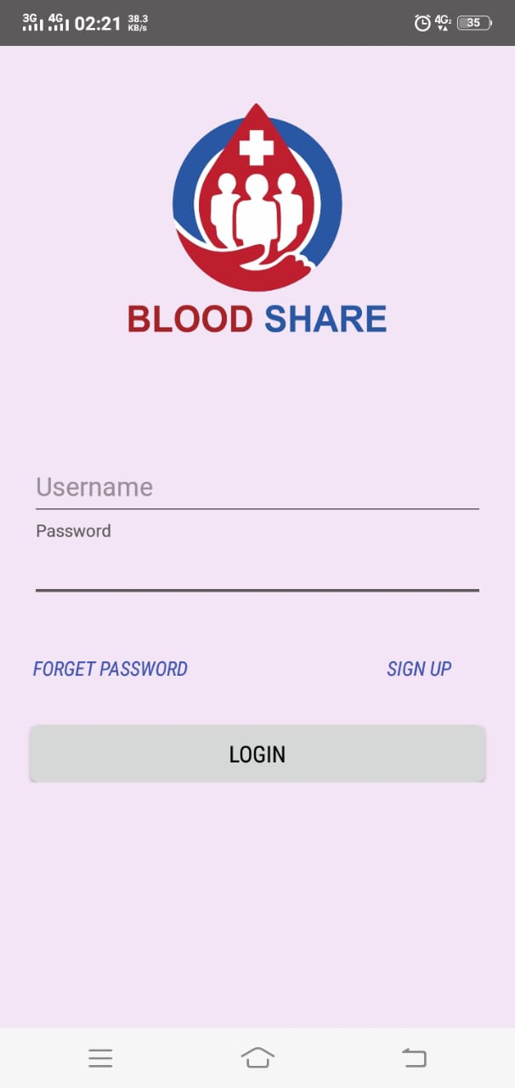

Figure 5-15 Login Screen

Signup
You can easily register as User by providing specific information on the registration page and click on Signup button. User registration contains Username, Blood Group, Phone No., Email, Password and Location by enabling your GPS.
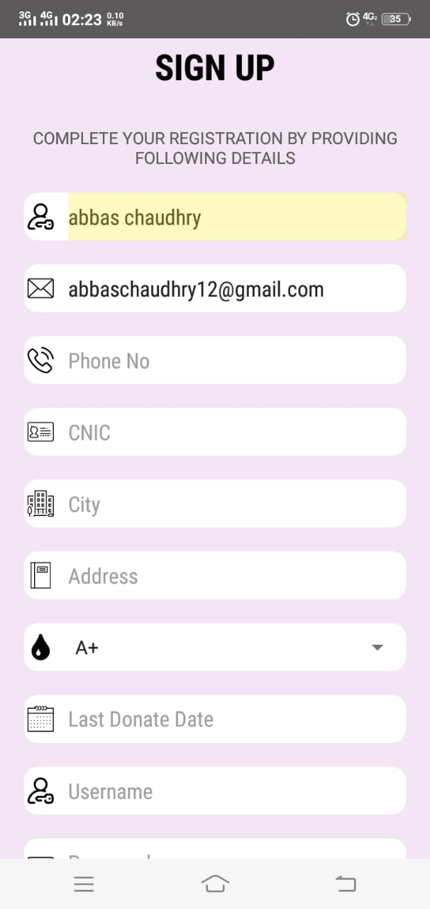

Figure 5-16 Signup

Homepage
This is the Donor Home page. Here you can get the notification of Blood Donation requests by Recipient. Here you can easily request the donor by selecting blood group and then click on search button. You can also accept/reject the requests.
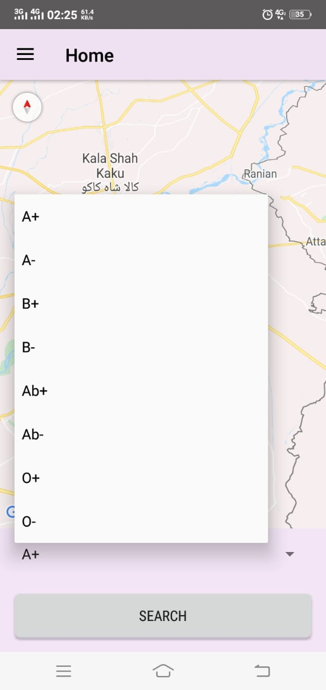

Figure 5-17 Home Screen

After Selecting Blood Group
After selecting the blood group, you can see the different donors on maps that are within 5 km radius.
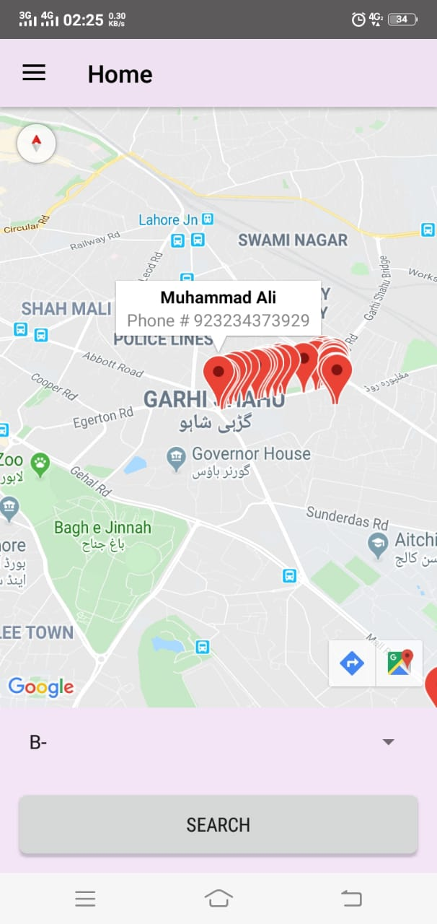

Figure 5-18 Donors Show

Forget Password
In Forgot password screen if you forget your then you can easily create new password after verifying Email.
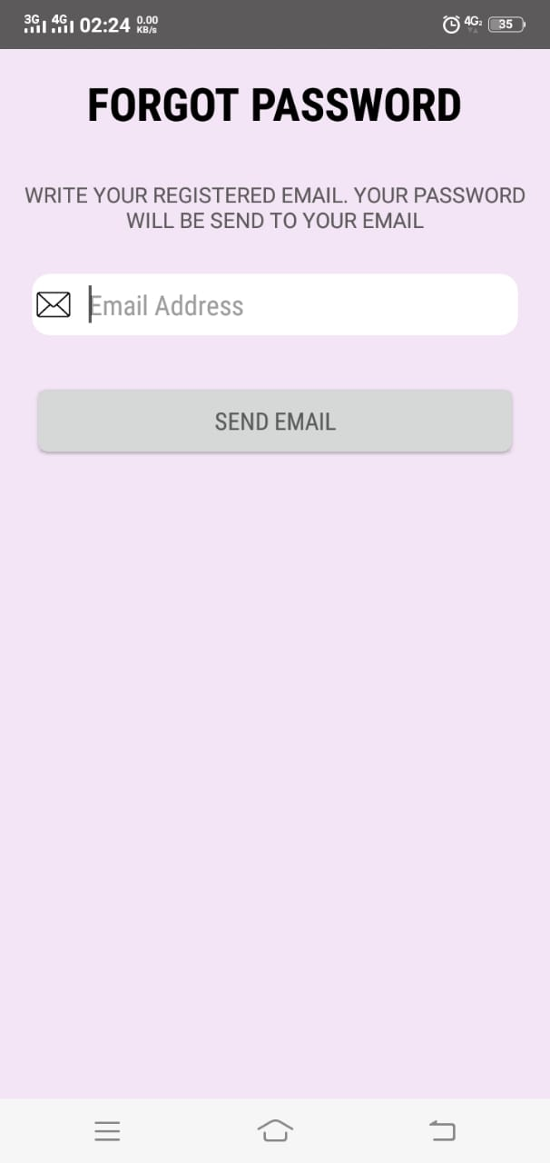

Figure 5-19 Forgot Password

CHAPTER 6

CONCLUSION AND RECOMMENDATIONS

Conclusion

Blood Share focusing on usability goals, requirements and privacy for user. Recipients can easily get the required Blood on a single platform. Donors can easily get discount on test from different laboratories. Donor and Recipient can communicate with each other and Recipients can request Donors to donate blood. We are making this System best for Donors and Recipients.

Recommendation

Due to difficulty in finding Blood we easily meet the Recipient requirements. It will help the Recipient to find Blood ASAP and also helps the Donor to get discount from different laboratories. In the future, we shall expand this to more major cities. We can add some extra features to use further techniques that can be helpful for the use.

REFERENCES

Books:

[1] Screening donated blood for transfusion-transmissible infections. Geneva: World Health Organization; 2010. 17 August 2012.
[2] World Health Organization Guidelines on Assessing Donor Suitability for Blood Donation, 4th Ed., WHO, New York, 2012.

Journal Papers:

[3] Snigdha et al., "Android Blood Bank", International Journal of Advanced Research in Computer and Communication Engineering, vol. 4, no. 11, pp. 86-88, November 2015, ISSN 2278-1021.
[4] Sultan Turhan, "An Android Application Volunteer Blood Donors", ICBB-2015, pp. 23-30.
Conference Papers:

[5] M R Annish Brislin ; J Albert Mayan ; R Aroul Canessane ; M R Anish Hamlin “Blood donation and life saver app” 2nd International Conference on Communication and Electronics Systems (ICCES) 2017, Coimbatore, India

