
BSCS-S19-018
03-134161-034 | HARIS REHMAN
03-134161-018 | HAMZA MAHMOOD
03-134161-009 | HAMZA JAVAID

Tourmet

In partial fulfilment of the requirements for the degree of
Bachelor of Science in Computer Science
Supervisor: Numan Aslam
Department of Computer Sciences
Bahria University, Lahore Campus
January 2020

© Bahria University, 2020

Certificate

We accept the work contained in the report titled
“TOURMET”
Written by
HARIS REHMAN
HAMZA MAHMOOD
HAMZA JAVAID
as a confirmation to the required standard for the partial fulfilment of the degree of
Bachelor of Science in Computer Science.

Approved by:
Supervisor: Numan Aslam
(Signature)

January 27, 2020

DECLARATION

We hereby declare that this project report is based on our original work except for citations and quotations which have been duly acknowledged. We also declare that it has not been previously and concurrently submitted for any other degree or award at Bahria University or other institutions.

Enrolment | Name | Signature
03-134161-034 | HARIS REHMAN
03-134161-018 | HAMZA MAHMOOD
03-134161-009 | HAMZA JAVAID

Date : January 27, 2020

We dedicate this work to our parents and all our lecturers of the Department of Computer Sciences at Bahria University Lahore Campus, for their tireless and selfless efforts they have spread us in making us who we are today.

Specially dedicated to
Haris Rehman
My beloved Father, Mother and Brothers
Hamza Mahmood
My beloved grandmother, mother and father
Hamza Javaid
My beloved grandmother, mother and father

ACKNOWLEDGEMENTS

We would like to thank everyone who had contributed to the successful completion of this project. We would like to express our gratitude to our research supervisor, Mr Numan Aslam for his invaluable advice, guidance and his enormous patience throughout the development of the project.

In addition, we would also like to express our gratitude to our loving parents and friends who has helped and given us encouragement.

Haris Rehman
Hamza Mahmood
Hamza Javaid

TOURMET

ABSTRACT

Our application will be developed to provide easier and convenient accommodation online for tourists by empowering local people rather than traditional tour planners. The local will offer accommodation consisting of staying, tour guide, transportation and food. The web application will be developed to address the online tourist’s accommodation. Members can use the service to arrange or post to search for locals based on location and ratings with or without rooms for primarily homestays and tourism experiences. There would be an online payment gateway to process the successful trip booking with Stripe to enable payment to the local.

TABLE OF CONTENTS

DECLARATION ii
ACKNOWLEDGEMENTS iv
ABSTRACT v
TABLE OF CONTENTS vi
LIST OF TABLES ix
LIST OF FIGURES x

CHAPTERS
1 INTRODUCTION 1
1.1 Background 1
1.2 Problem Statement 1
1.3 Aims and Objectives 2
1.4 Scope of Project 2
2 LITERATURE REVIEW (and/or SRS) 3
2.1 User Classes and Characteristics 3
2.1.1 Admin 3
2.1.2 Tourist 3
2.1.3 Locals 3
2.2 Operating Environment 4
3 DESIGN AND METHODOLOGY 5
3.1 Design 5
3.1.1 Use-case description 5
3.1.2 Use-case diagram refined 5
3.1.3 Sequence Diagram 19
3.1.4 Design Class Diagram 23
3.1.5 Collaboration Diagram 24
3.2 Methodology 27
3.2.1 Choosing Suitable Methodology 27
3.2.2 Model the Complete System 28
3.2.3 Build Feature List 28
3.2.4 Plan Each Feature 28
3.2.5 Design by Feature 28
3.2.6 Develop by Feature 28
4 DATA IMPLMENTATION 29
4.1 Implementation 29
4.2 Technical Aspect: 30
4.2.1 Hardware 30
4.2.2 Backend 30
4.2.3 Frontend 30
4.2.4 Database 30
5 USER MANUAL 31
5.1 User Access, Roles and Privileges 31
5.1.1 Sign Up 31
5.1.2 Login 31
5.1.3 Booking 32
5.1.4 Payment 32
5.1.5 Ratings 32
5.2 User Interfaces 33
5.2.1 Home Page 33
5.2.2 Listings 33
5.2.3 Login 34
5.2.4 Register 34
5.2.5 Manage Booking 35
5.2.6 Create Listing 35
5.2.7 Description 36
5.2.8 Accommodation 36
5.2.9 Location 37
5.2.10 Booking 38
5.2.11 Payment 39
5.2.12 Give Reviews and Ratings 40
5.2.13 Reviews and Ratings 40
5.2.14 Profile 41
5.2.15 Admin Booking Dashboard 42
5.2.16 Admin Booking 43
5.2.17 Admin Login 44
5.2.18 Admin Payment Options 44
5.2.19 Admin Rental Dashboard 45
5.2.20 Admin Rental Edits 45
5.2.21 Admin Rental Search Options 46
5.2.22 Admin Rental Update 47
5.2.23 Admin Review Privileges 47
5.2.24 Admin Review Management 48
5.2.25 Admin User Management 48
6 CONCLUSION 49
REFERENCES 50

LIST OF TABLES

TABLE TITLE PAGE
Table 3-1 Signup 6
Table 3-2 Login 7
Table 3-3 Make Search 8
Table 3-4 User Profile 10
Table 3-5 Tour Details 11
Table 3-6 Tour Booking 12
Table 3-7 Manage Payment 13
Table 3-8 Manage Events 15
Table 3-9 Ratings and Reviews 16
Table 10 Modify Booking 17

LIST OF FIGURES

FIGURE TITLE PAGE
Figure 2-1 Environment of MEAN Stack 4
Figure 3-1 Use Case Sign Up 6
Figure 3-2 Login 7
Figure 3-3 Make Search 8
Figure 3-4 User Profile 9
Figure 3-5 Tour Details 11
Figure 3-6 Tour Booking 12
Figure 3-7 Manage Payment 13
Figure 3-8 Manage Events 14
Figure 3-9 Reviews and Ratings 15
Figure 3-10 Modify Booking 17
Figure 3-11 Tourmet System Use Case Diagram 18
Figure 3-12 User Signup Sequence Diagram 20
Figure 3-13 User Login Diagram 21
Figure 3-14 User Booking Sequence Diagram 21
Figure 3-15 Modify Booking Sequence Diagram 22
Figure 3-16 Payment Sequence Diagram 22
Figure 3-17 Ratings Sequence Diagram 23
Figure 3-18 Search Sequence Diagram 24
Figure 3-19 Design Class Diagram 25
Figure 3-20 Collaboration Diagram Login/Registration 26
Figure 3-21 Collaboration Diagram Search 26
Figure 3-22 Collaboration Diagram Booking 27
Figure 3-23 Collaboration Diagram Payment 27
Figure 3-24 Collaboration Diagram Ratings and Reviews 28
Figure 4-1 FDD Diagram 30
Figure 5-1 Home Page 34
Figure 5-2 Listings 34
Figure 5-3 Login 35
Figure 5-4 Register 35
Figure 5-18 Manage Booking 36
Figure 5-19 Create Listing 36
Figure 5-20 Description 37
Figure 5-5 Accommodation 37
Figure 5-21 Location 38
Figure 5-17 Booking 39
Figure 5-22 Payment 40
Figure 5-23 Give Reviews and Ratings 41
Figure 5-24 Reviews and Ratings 41
Figure 5-25 Profile 42
Figure 5-6 Admin Booking Dashboard 43
Figure 5-7 Admin Booking 44
Figure 5-8 Admin Login 45
Figure 5-9 Admin Payment Options 45
Figure 5-10 Admin Rental Dashboard 46
Figure 5-11 Admin Rental Edits 46
Figure 5-12 Admin Rental Search Options 47
Figure 5-13 Admin Rental Update 48
Figure 5-14 Admin Review Privileges 48
Figure 5-15 Admin Review Management 49
Figure 5-16 Admin User Management 49

INTRODUCTION

Background

WTTC (World Travel and Tourism Council) evaluates Pakistan’s tourism industry to $36.1 billion [1]. It is a huge untapped online market. If someone wants to travel and explore beautiful historical and tourist locations, traditional foods, cultural and religious events of Pakistan, there is no specific private or government online web-based application through which tourists can book their trip with stay accommodation, food and proper tour guidance. Tourist can be a Pakistani or a foreigner who can travel and stay with the local who will be his host for the tour.

Problem Statement

We want to facilitate tourists and as well as locals by developing WEB APP to overcome the manual working tour planning. In this project, tourist can search different locations on the basis of their interest. In this way tourists can get proper tour guidance via local citizens. Tourists can also avail food and meals package if they want. Tourists can get accommodation where he can use regular use items. Tourists can get all these facilities on one platform.

The technology we are going to use for this project is MEAN Stack (MongoDB, Express, Angular, NodeJS) [2]. In this system, there are four major technologies, we will use them while developing. These four technologies include: MONGODB [3] which act as a database platform for our project, EXPRESSJS [4] for our website backend, ANGULARJS [5] for the frontend of this WEB APP, and then we have NODEJS [6] which provide us Backend facilities for this project. We integrate all these four emerging technologies to create our WEB APP.

Aims and Objectives

Following are the objectives:
- Facilitate tourists to find stay in places with local hosts.
- Tourists can get tour guidance.
- To provide local people a way to earn extra money by renting their apartments or an entire home with personalized experience.

Scope of Project

There is no such service through which tourists can book their trip with stay, accommodation, food and personalized tour guidance. Along with providing rental services the travellers can also find tour guides for every city given the newness, they will find a plethora of key information pertaining to the local tour guides in their chosen city, including photos, reviews, ratings and pricing.

With growing opportunity for tourism in Pakistan, Tourmet will help tourists find personalized experiences rather than formal tourists along with ratings and their previous reviews. The feedback and opinion will determine the accuracy and ranking of a profile or place to stay. Traveling has never been more convenient, with internet being available to everyone anybody could reserve a booking away from just a few clicks through a web application.

LITERATURE REVIEW (and/or SRS)

User Classes and Characteristics

In this project, our main users are admin, tourists and locals

Admin

Admin has access of activities. All the activities are reported to admin. Admin can update the events according to the situation. View all registered users, update user’s information, delete users, and manage transactions and view the activities of system could done by admin.

Tourist

Tourist can view different location and book his tour. Tourist can get accommodation plans and food or meals packages. Tourist can also give ratings and reviews about trip with locals.

Locals

Locals can earn money by providing tourist accommodation and meals packages. They can also give tour guidance to tourists.

Operating Environment

The technology we are going to use for this project is MEAN Stack. In which there are four major technologies on which we are going to work on. These four technologies include: MONGODB which work as a database platform for our project, EXPRESSJS for our website backend, ANGULARJS/REACTJS for the frontend of this WEB APP, and then we have NODEJS which provide us Backend facilities for this project. We integrate all these four emerging technologies to create our WEB APP.

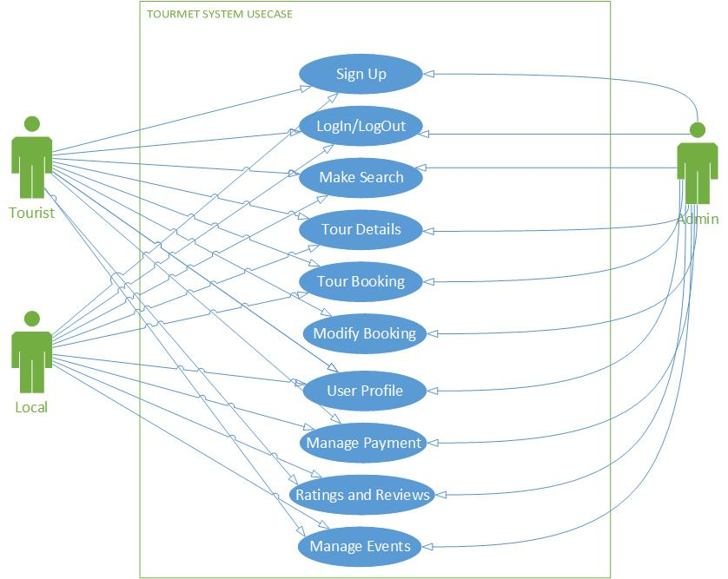
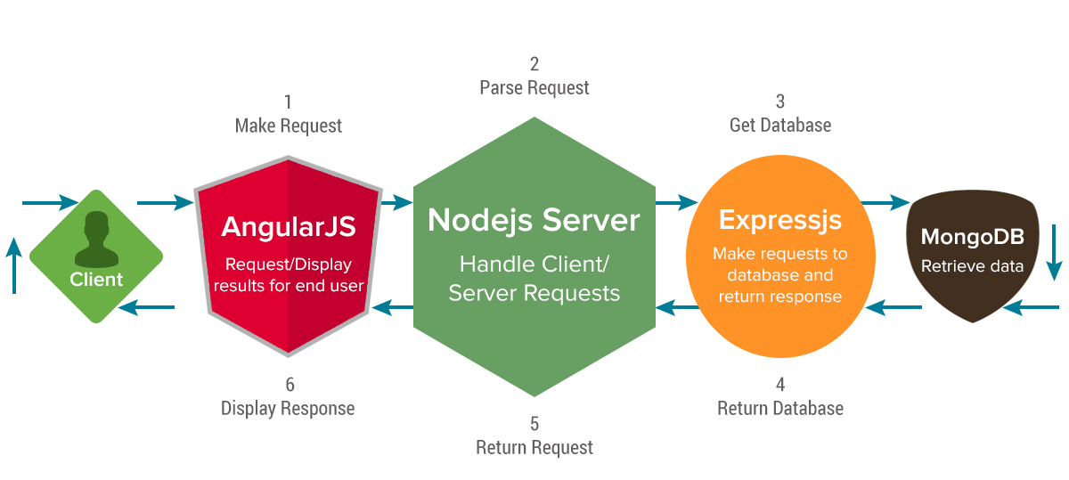
Figure 2-1 Environment of MEAN Stack

DESIGN AND METHODOLOGY

Design

Design includes following artefacts:

Use-case description

A text that captures the detailed functionality of a use case is written in in use-case description. All use-cases description is written down in this section.
It comprises the following parts.

Use-case diagram refined
High level use-case diagram is explained in refined high-level use-case diagram. The expansion of high level use-cases in such a way that explains the flow of functionality of the high level use-case is explained by this diagram. Two types of relationships are used in this diagram. Which are:
  - Extend
  - Intend

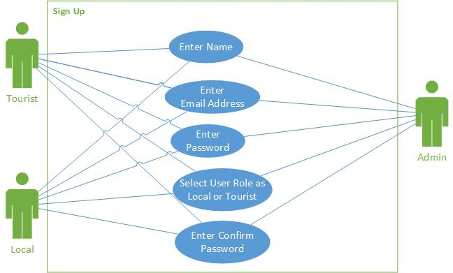
Use case Signup
Figure 2 Sign Up
Figure 3-1 Use Case Sign Up

Table 3-1 Signup
Use Case ID: | UC1 | Priority: | High
Use Case Name | Sign Up
Actors | Admin, Tourist, Local
Description: | User must have a login to the application to use this application. For login on the application, the user must register itself by providing information such as name, email ID, user role (local or tourist) and password.
Preconditions: | User must have a good condition laptop to handle the flow of website.
Post conditions: | User assigned by unique ID and password.
Triggers: | User account is created
Flow: | - Registration button is being clicked by user and fill requirements of registration form.  - User enters the user name, email-id, and password and re-enter password.  - The user specifies to surf the application as a user role of a local or whether as a tourist service.  - By click on the signup button the unique-id and password will be allotted to the user.
Alternative Flow: | NONE
Exceptions: | Invalid user name or password.

Use Case Login
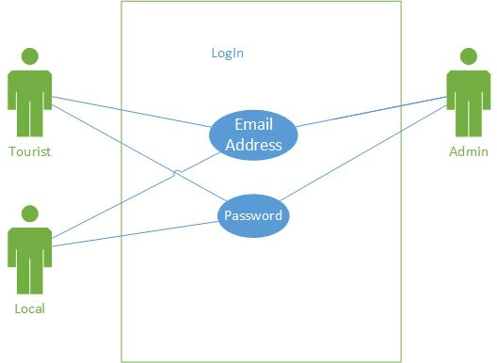
Figure 3 Login/ Logout
Figure 3-2 Login

Table 3-2 Login
Use Case ID: | UC2 | Priority: | High
Use Case Name | Login/Logout
Actors | Admin, Tourist, Local
Description: | By entering the valid user name and password, user can use the application.
Preconditions: | - User must be connected with internet connection for an application.  - User must remember their valid username and password.
Post conditions: | Main screen will appear
Triggers: | Logged in with a unique user profile
Flow: | - User enters the username and password.  - System will check the validating of username and password.  - User forwarded to main screen of his account.
Alternative Flow: | None
Exceptions: | Invalid user name or password.

Use case Make Search
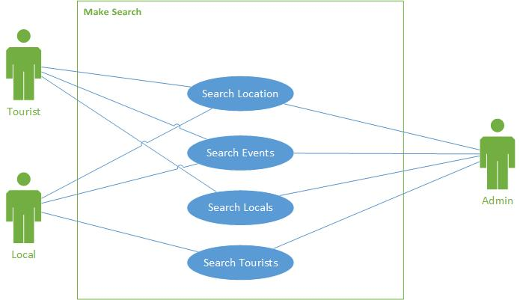
Figure 4 Make Search
Figure 3-3 Make Search

Table 3-3 Make Search
Use Case ID: | UC3 | Priority: | High
Use Case Name | Make Search
Actors | Admin, Tourist, Local
Description: | The user can search various locations of Pakistan.
Preconditions: | The user tries to search some location.
Post conditions: | Users get their desired results on the basis of their search.
Triggers: | Search results are displayed
Flow: | - User click on search bar.  - User can search different locations of Pakistan.  - User can search different events of Pakistan.  - User will get a page of desired results.
Alternative Flow: | None
Exceptions: | Application failure

Use Case User Profile
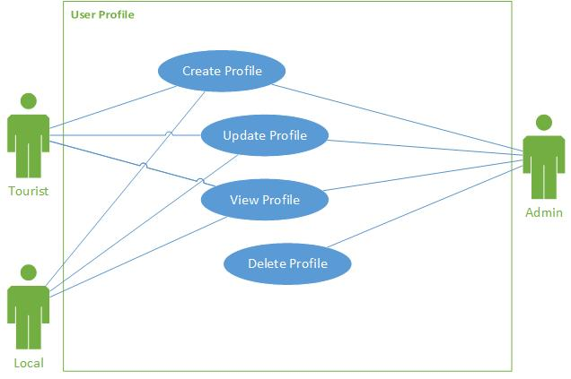

Figure 3-4 User Profile

Table 3-4 User Profile
Use Case ID: | UC4 | Priority: | High
Use Case Name | User Profile
Actors | Admin, Tourist, Local
Description: | Tourist and locals both can create, update and view their profiles. Admin can delete their profile. Tourist can view local’s profile also.
Preconditions: | Locals or tourists wants to see a profile of each other
Post conditions: | Move to the tourists or locals’ profile.
Triggers: | View or change user profile details
Flow: | - Tourist could see the profile of local at end of rental post.  - Locals/tourist can contact each other via phone numbers once booking is confirmed.  - Local can view tourists profile picture and tourist can view locals profile picture.  - Tourist can view accommodation.  - Tourist can view ratings of local.  - Admin can delete profile.
Alternative Flow: | None
Exceptions: | Application failure

Use Case Tour Details
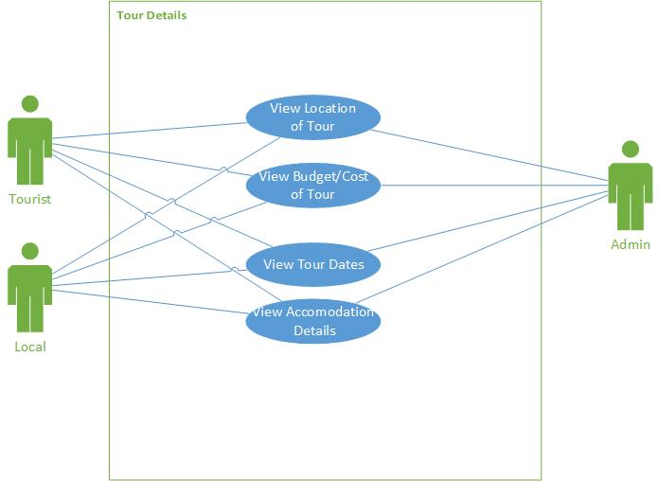
Figure 6 Tour Details
Figure 3-5 Tour Details

Table 3-5 Tour Details
Use Case ID: | UC5 | Priority: | High
Use Case Name | Tour Details
Actors | Admin, Tourist, Local
Description: | The actors can see the tour details which consist of tour location, tour budget, tour dates and tour accommodation details.
Preconditions: | Locals have to book a trip.
Post conditions: | Locals, tourists and admin can view tour detail.
Triggers: | Details of the tour are decided
Flow: | - Tour location will display.  - Tour cost will display.  - Tour dates will display.  - Accommodation details will display.
Alternative Flow: | None
Exceptions: | Application failure.

Use Case Tour Booking
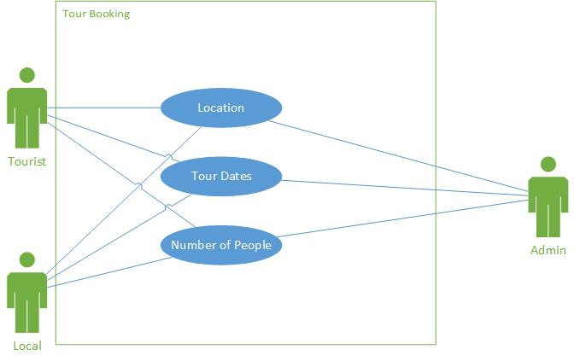
Figure 3-6 Tour Booking
Figure 7 Tour Booking

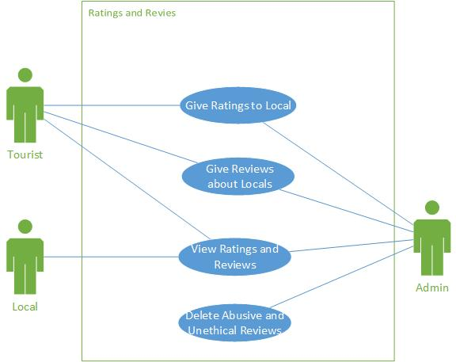
Table 3-6 Tour Booking
Use Case ID: | UC6 | Priority: | High
Use Case Name | Tour Booking
Actors | Admin, Tourist, Local
Description: | Tourist set the tour details and local can view these details.
Preconditions: | Locals have booked a tour.
Post conditions: | Booking will change after modification.
Triggers: | A tour is booked.
Flow: | - Tourist will select location first.  - Tourist will select tour dates.  - Tourist will select the number of people travel with him.  - Local will have the contact details on successful booking.
Alternative Flow: | None
Exceptions: | Application failure.

Use Case Manage Payment
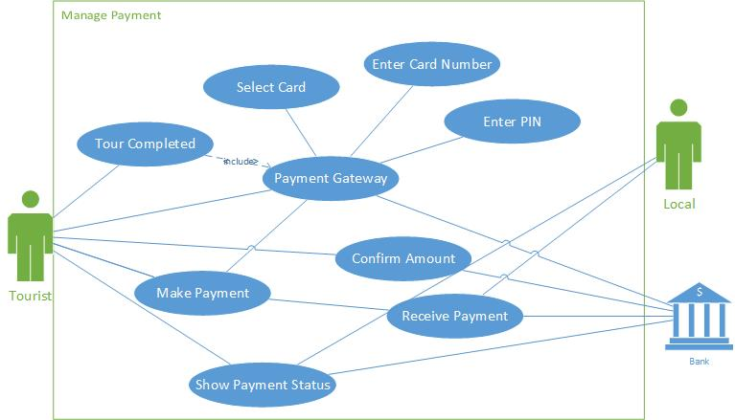
Figure 3-7 Manage Payment

Table 3-7 Manage Payment
Use Case ID: | UC7 | Priority: | High
Use Case Name | Manage Payment
Actors | Admin, Tourist
Description: | Tourist can pay charges through their credit cards. A payment gateway (3rd party) will be used to process payments. First select card type then enter card number and after PIN verification on the payment gateway, amount will be confirmed. Once confirmed, the payment will be received by the local.
Preconditions: | Tourist(s) have to pay charges
Post conditions: | Tourist(s) have paid charges.
Triggers: | Payment is Processed
Flow: | - Payment Gateway is opened.  - Tourist can pay payment by selecting his card type (VISA, MASTERCARD etc.)  - Enter Card number.  - Then after verification payment will be received by the local.
Alternative Flow: | None
Exceptions: | Application failure.

Use case Of Manage Events
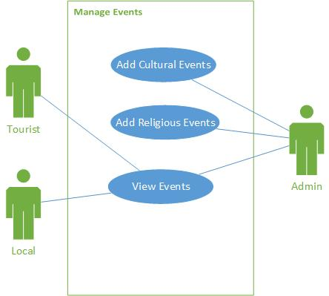

Figure 3-8 Manage Events

Table 3-8 Manage Events
Use Case ID: | UC8 | Priority: | High
Use Case Name | Manage Events
Actors | Admin, Tourist, Local
Description: | Admin will provide events information on application. Locals and tourists will get this information.
Preconditions: | Admin wants to add events on application
Post conditions: | Events information will display on the interface of application.
Triggers: | Events related tours displayed
Flow: | - Admin check the site.  - Provide events information on the site.  - Locals and tourists both will see the events information.
Alternative Flow: | None
Exceptions: | Application failure.

Use Case Reviews and Ratings
Figure 10 Reviews and Ratings
Figure 3-9 Reviews and Ratings

Table 3-9 Ratings and Reviews
Use Case ID: | UC9 | Priority: | High
Use Case Name | Ratings and Reviews
Actors | Admin, Tourist, Local
Description: | Tourists can give locals ratings and reviews on the basis of their experience.  Local can only view his ratings and reviews. Admin can delete abusive and unethical vies.
Preconditions: | Tourists have completed their tour. They want to give ratings and reviews about their experience with locals.
Post conditions: | Ratings has marked and reviews has commented.
Triggers: | User ratings are committed
Flow: | - Tourist has completed his tour.  - After completing a tour, tourist will mark local‘s ratings on the basis of his experience.  - After completing a tour, tourist will give reviews and comments about local on the basis of his experience.  - If any abusive comment will occur on the profile then admin can delete this type of comment.
Alternative Flow: | None
Exceptions: | Application failure.

Use Case Modify Booking
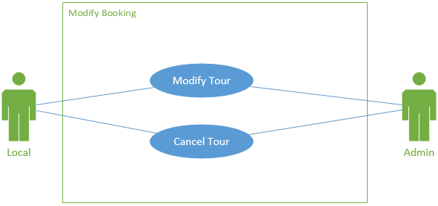
Figure 3-10 Modify Booking

Table 10 Modify Booking
Use Case ID: | UC10 | Priority: | High
Use Case Name | Modify Booking
Actors | Admin and Tourist
Description: | Tourist and admin can modify tour details and tour.
Preconditions: | Tourist has booked a tour.
Post conditions: | Tour details have modified.
Triggers: | Booking details are changed.
Flow: | - Local could accept or decline a tour.  - Tourist and admin both can cancel the tour
Alternative Flow: | None
Exceptions: | Application failure.

Figure 3-11 Tourmet System Use Case Diagram

Sequence Diagram
The sequence of actions that occur in a system represent in sequence diagram. It represents the dynamic behaviour of a system.
Following are the sequence diagrams of our project:

Sign Up
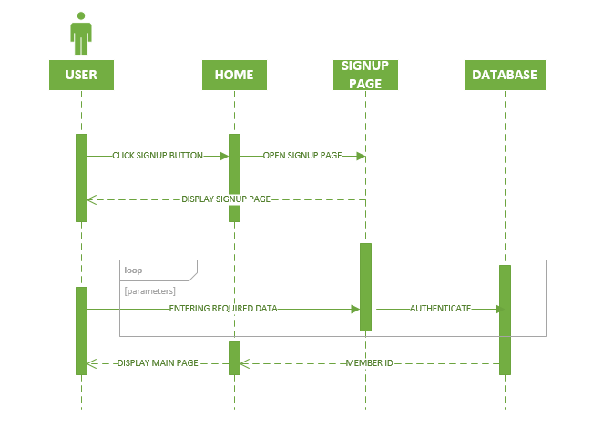
Figure 3-12 User Signup Sequence Diagram

Login
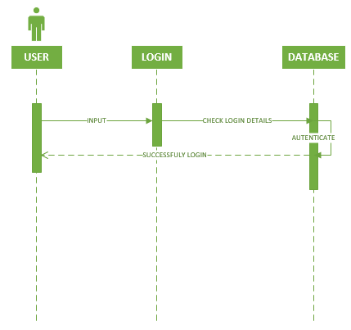
Figure 3-13 User Login Diagram

User Booking Sequence Diagram

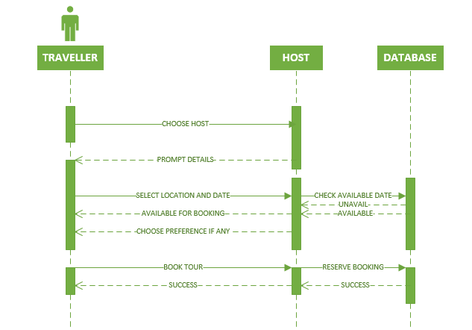
Figure 3-14 User Booking Sequence Diagram

Modify Booking Sequence Diagram
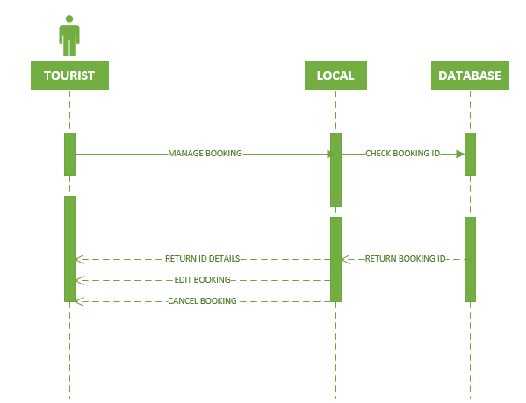
Figure 3-15 Modify Booking Sequence Diagram

Payment Sequence Diagram
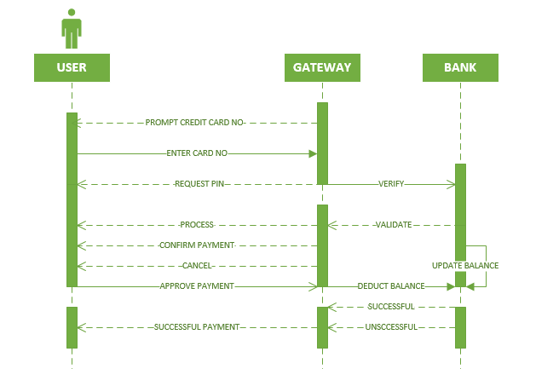
Figure 3-16 Payment Sequence Diagram

Ratings Sequence Diagram
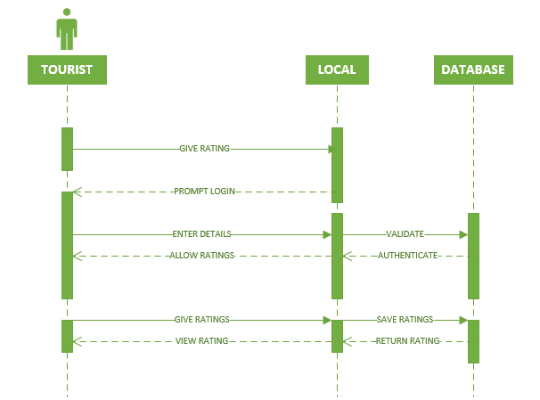
Figure 3-17 Ratings Sequence Diagram

Search Sequence Diagram
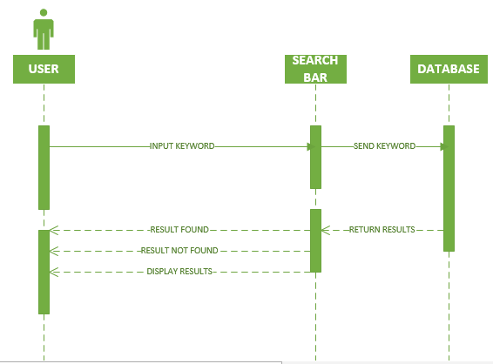
Figure 3-18 Search Sequence Diagram

Design Class Diagram
The real work of the system is being displayed by classes. Capsules are also stereotyped classes, used to represent concurrent threads of execution in real-time systems. Concurrent threads of execution in real time systems are represented by classes. Objects occur in their own thread of actions is Active Objects. Objects do not have capacity to start the flow of execution is Passive object.
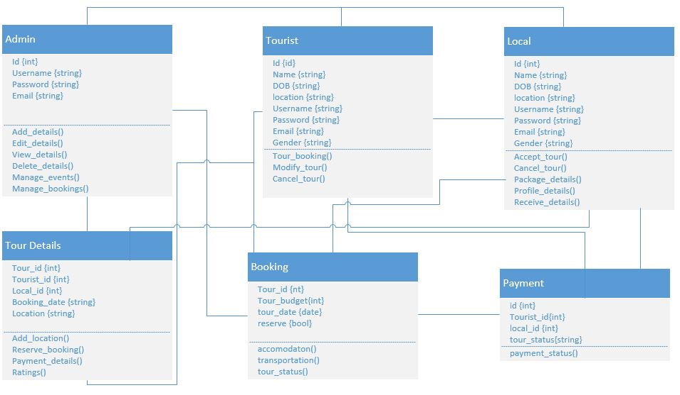
Figure 3-19 Design Class Diagram

Collaboration Diagram

A pattern of interaction between objects is described by collaboration diagram. It suits for analysis activities. Simple interactions of smaller number of objects is better described by collaboration diagram. Diagram turns difficult and hard to read when messages and number of object increase.
Following diagrams are created with the help of online tool creately [7]

Collaboration Diagram Login/Registration

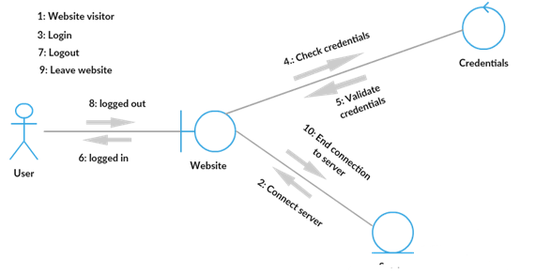
Figure 3-20 Collaboration Diagram Login/Registration

Collaboration Diagram Search

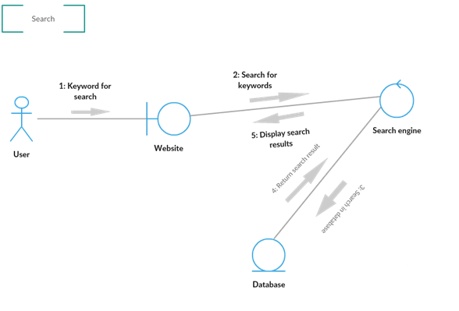
Figure 3-21 Collaboration Diagram Search

Collaboration Diagram Booking
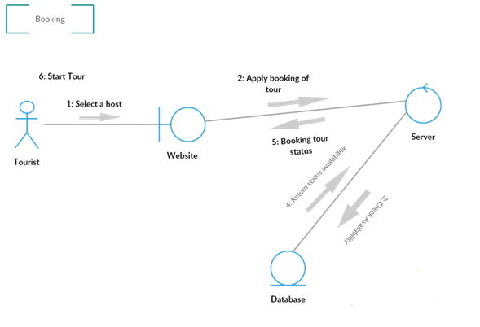
Figure 3-22 Collaboration Diagram Booking

Collaboration Diagram Payment
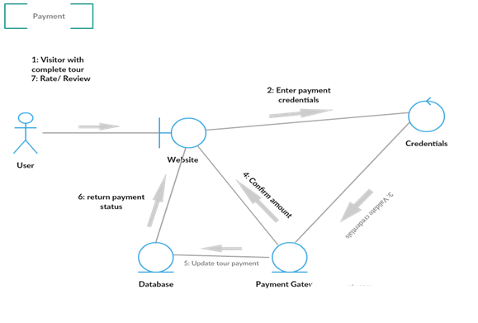
Figure 3-23 Collaboration Diagram Payment

Collaboration Diagram Ratings and Reviews

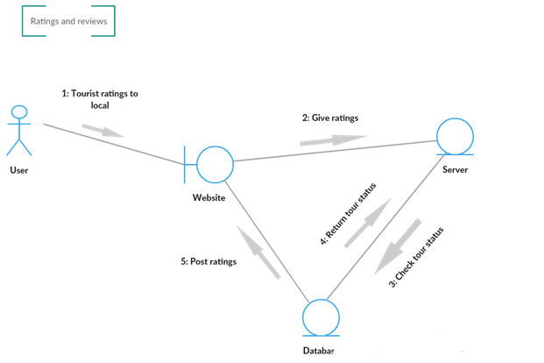
Figure 3-24 Collaboration Diagram Ratings and Reviews

Methodology

Methodology can be defined as set of rules or principles from which criteria and procedures to solve or crack different problems of particular field obtain. Methodology is generally a set of practices.

Choosing Suitable Methodology
This project will be developed by using agile methodology because agile models handle change in requirements easily, divides complex projects into parts which simplify the project and deliver working software after every iteration.
In agile there are many models but here Feature Driven Development (FDD) will be used as it is one of the simplest and easy to follow agile methodology. FDD model repeats last two phases i.e. Design by Feature and Develop by Feature until all features will complete.

Model the Complete System
The first phase defines the scope for this project and develops a big picture of the system by analysing different learning platforms that how these platforms are working, managing users and data. Entity Relationship Model build in this phase to help us in understanding the system.

Build Feature List
After defining the scope now in this step all essential features of this project will be listed down by functionally decomposing the domain into subject areas.

Plan Each Feature
After the feature list is completed, the next step is to produce the development plan that divides features into sub-feature and make groups of related features. Planning involve how each feature interact with other one and what are the users of features or group of features.

Design by Feature
A design package is produced for each feature. Chief programmer selects a small group of features that are to be settled within two weeks. Together with the corresponding class owners, for each feature, chief programmer works on detailed sequence diagram and refines the overall model.

Develop by Feature
The class owners start coding for their classes after effective design inspection for each activity. In the end, unit testing evaluates successful code inspection for each feature to be promoted for main build.

DATA IMPLMENTATION

Implementation

Development of the designs produced during the design phase is the implementation phase of the project.

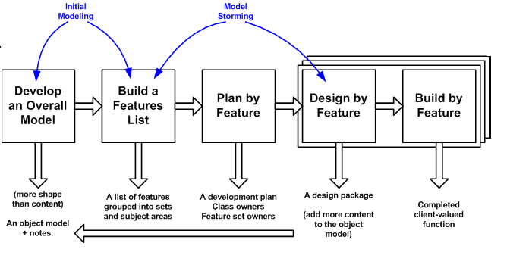
Figure 4-1 FDD Diagram

Technical Aspect:
Since the project is a web application, so a web server and database management
System both are required. System would have a front-end and back-end.

Hardware
Hardware contains necessary hardware as PC. The minimum RAM required is 4GB and 80 GB of Hard Disk.

Backend
EXPRESSJS for our website backend. NODEJS which provide us Backend facilities for this project.

Frontend
ANGULARJS/REACTJS for the frontend of this WEB APP.

Database
MONGODB work as a database platform for our project.

USER MANUAL

User Access, Roles and Privileges

The users of the application are the admin and application user, each user has some privileges. Some of them are as following:

Sign Up

Description: | Input: | Output: | Workflow:
If the user of the  Website doesn’t have an account he/she can make an account. | Username, Email, Password, Confirm Password and Select Role of User. | Creation of new user account. | User enters the details and record get added to master record.

Login

Description: | Input: | Output: | Workflow:
User has an account and user can login using his account. | Email and Password | User can see the features that can only be accessed by account holders. | Enter user details and user gets logged in

Booking

Description: | Input: | Output: | Workflow:
User can book their trip on their available dates and on desirable location | Select a location, enter number of guests, and confirm the dates of tour. | Ask for payment criteria to confirm the booking. | User gets logged in clicks on Location and then fulfills the requirements.

Payment

Description: | Input: | Output: | Workflow:
When User Booked their trip, he can make payment. | Enter Card number, expiry date and cvc. | User booked his tour and made his payment of trip. | Select tour and enter booking details. After this enter all details to make payment/

Ratings

Description: | Input: | Output: | Workflow:
User can give ratings and reviews after completing a tour. | Select number of stars to give ratings and write reviews about tour. | Ratings and reviews have posted. | User can give ratings and reviews about trip after completing a tour.

User Interfaces

Home Page

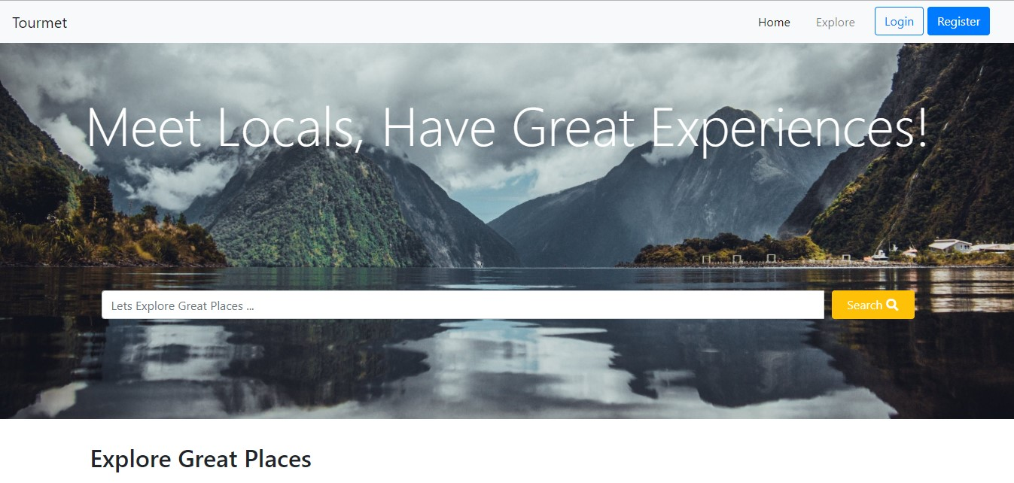
Figure 5-1 Home Page

Listings
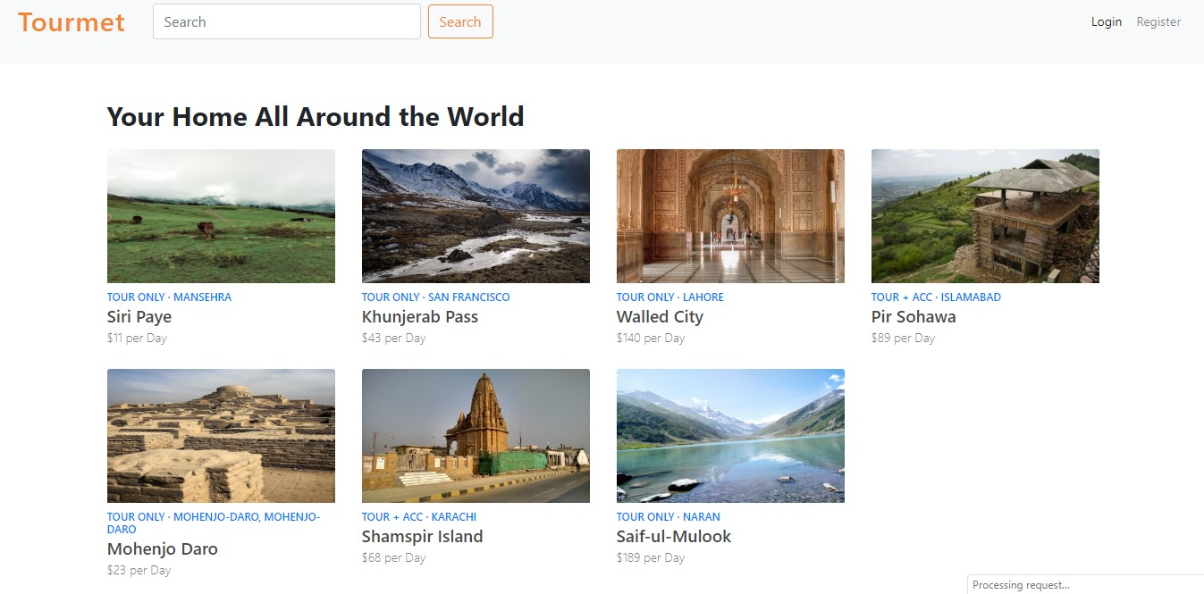
Figure 5-2 Listings

Login
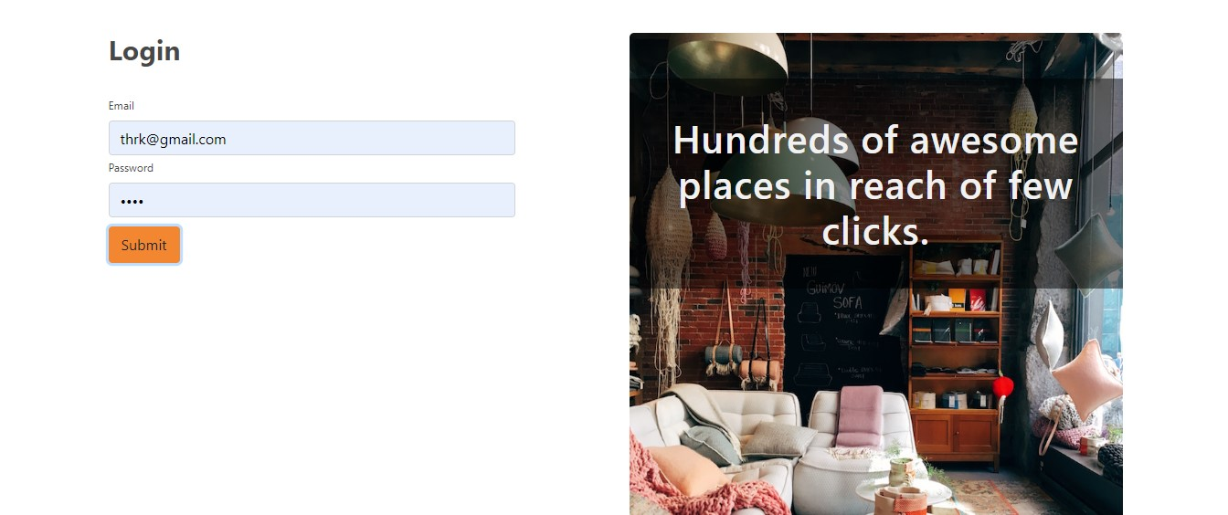
Figure 5-3 Login

Register

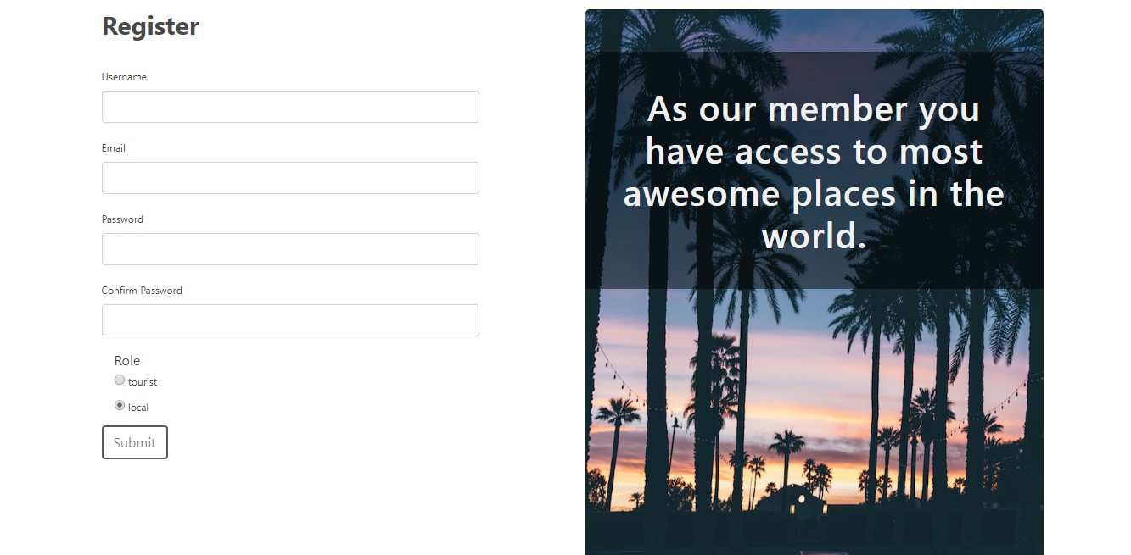
Figure 5-4 Register

Manage Booking

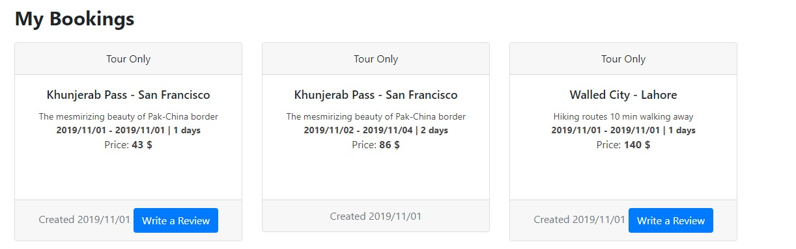
Figure 5-5 Manage Booking

Create Listing

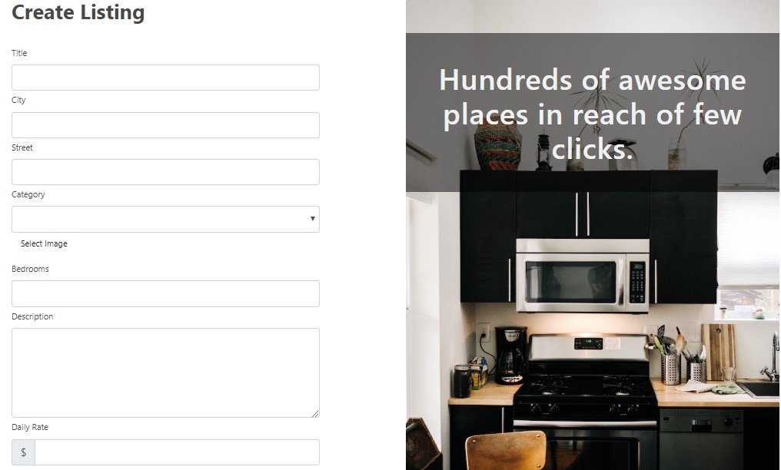
Figure 5-6 Create Listing

Description

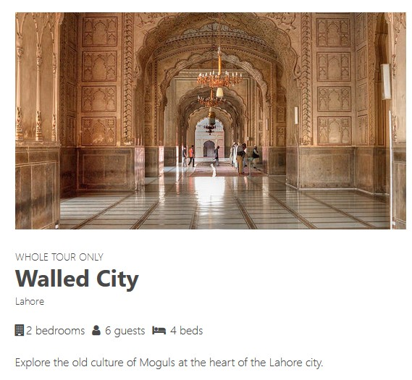
Figure 5-7 Description

Accommodation
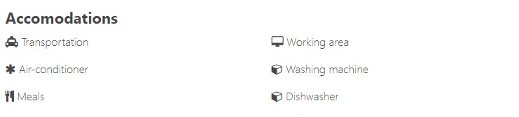
Figure 5-8 Accommodation

Location

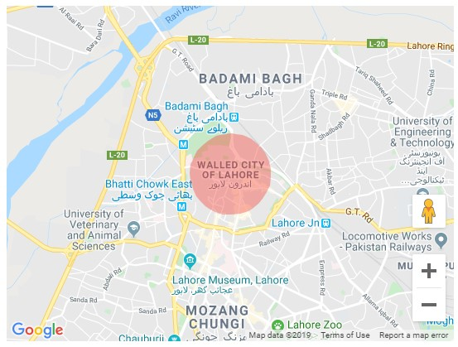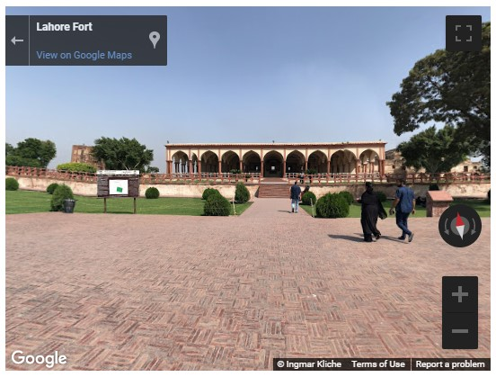
Figure 5-9 Location

Booking

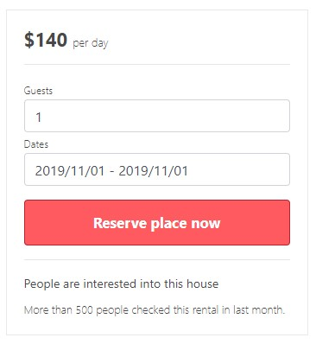
Figure 5-10 Booking

Payment

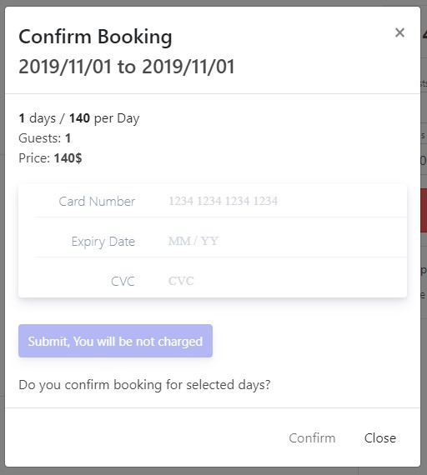
Figure 5-11 Payment

Give Reviews and Ratings

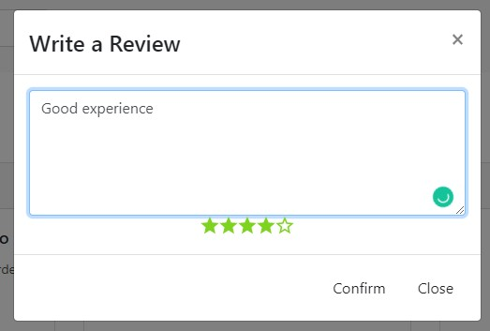
Figure 5-12 Give Reviews and Ratings

Reviews and Ratings

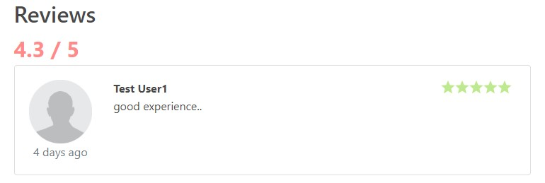
Figure 5-13 Reviews and Ratings

Profile

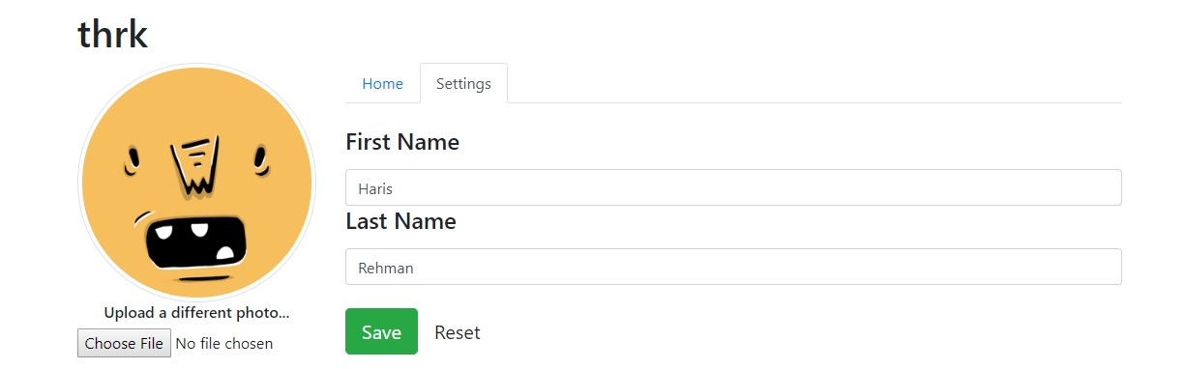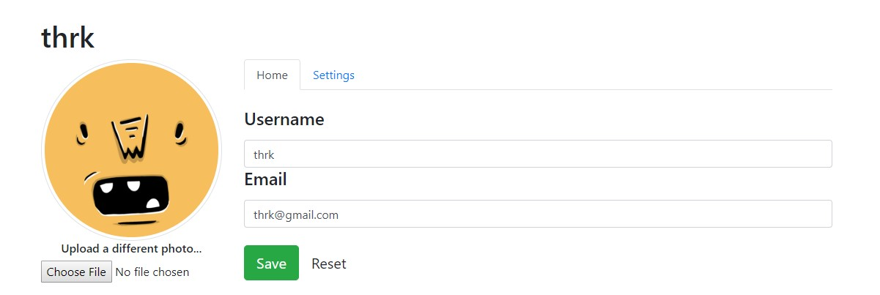
Figure 5-14 Profile

Admin Booking Dashboard
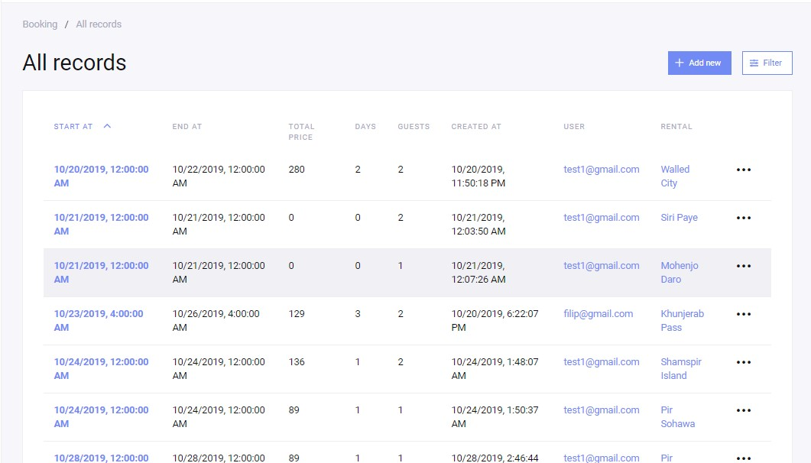
Figure 5-15 Admin Booking Dashboard

Admin Booking

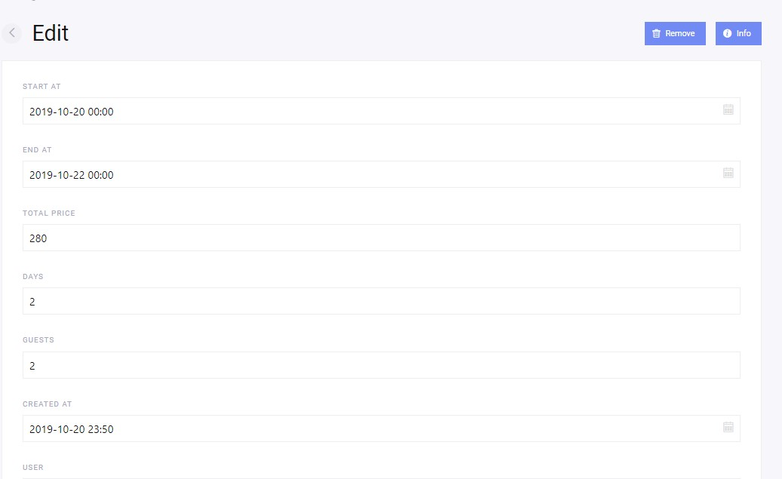
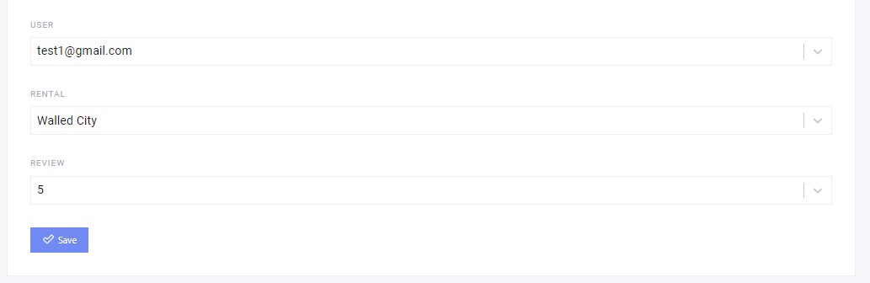
Figure 5-16 Admin Booking

Admin Login

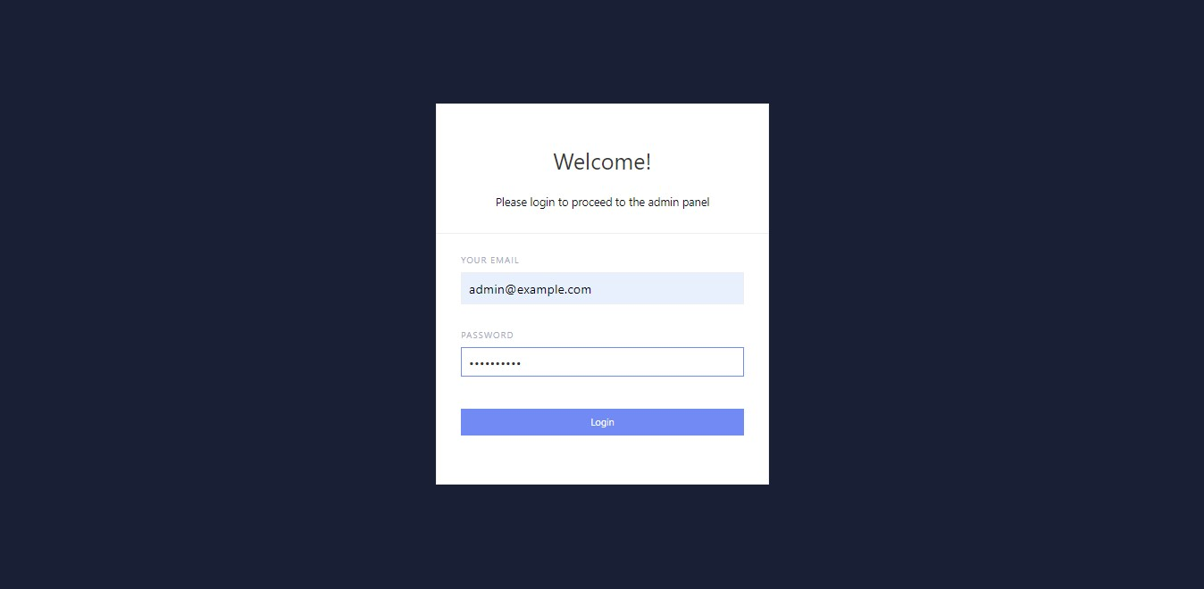
Figure 5-17 Admin Login

Admin Payment Options

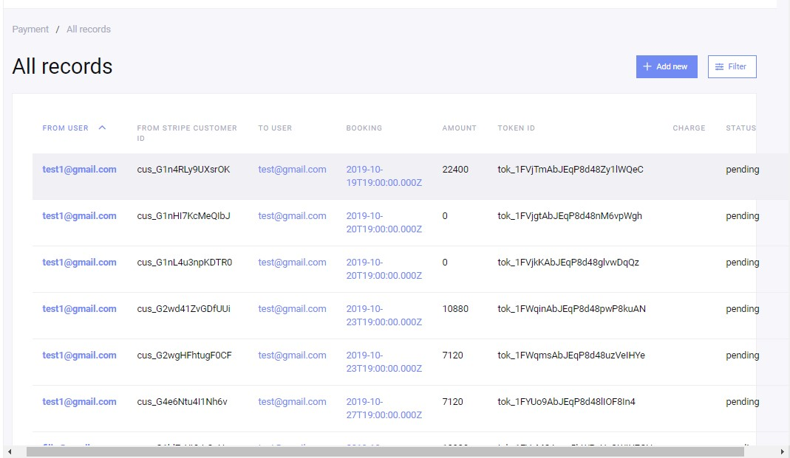
Figure 5-18 Admin Payment Options

Admin Rental Dashboard

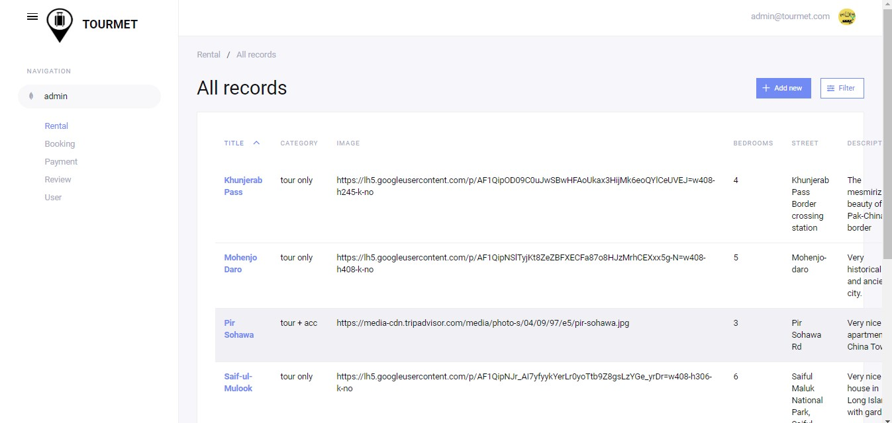
Figure 5-19 Admin Rental Dashboard

Admin Rental Edits

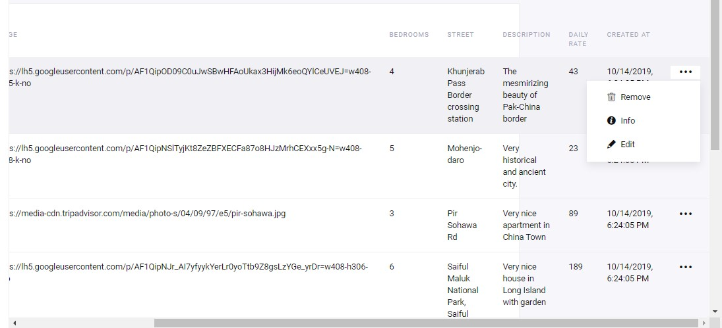
Figure 5-20 Admin Rental Edits

Admin Rental Search Options

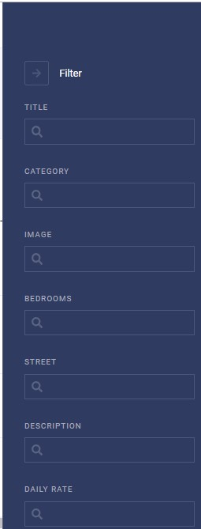
Figure 5-21 Admin Rental Search Options

Admin Rental Update

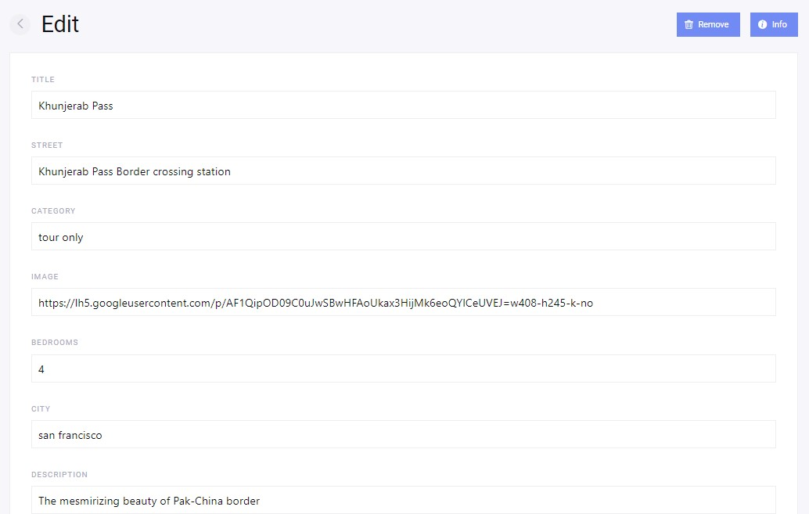
Figure 5-22 Admin Rental Update

Admin Review Privileges

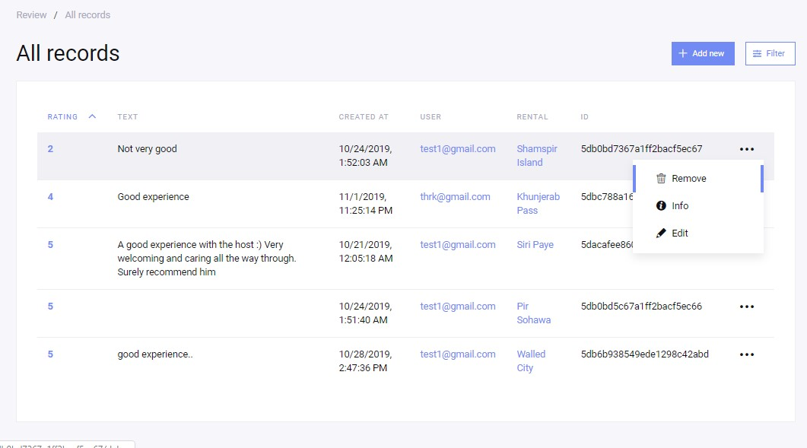
Figure 5-23 Admin Review Privileges

Admin Review Management

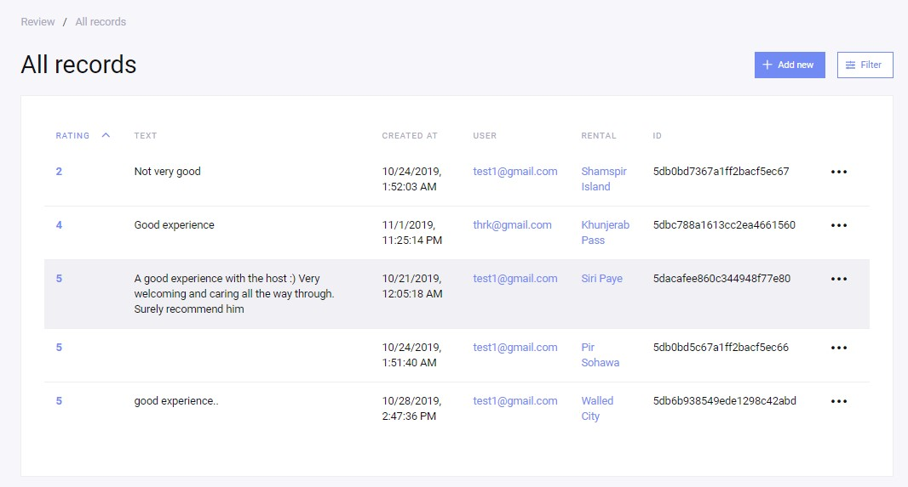
Figure 5-24 Admin Review Management

Admin User Management

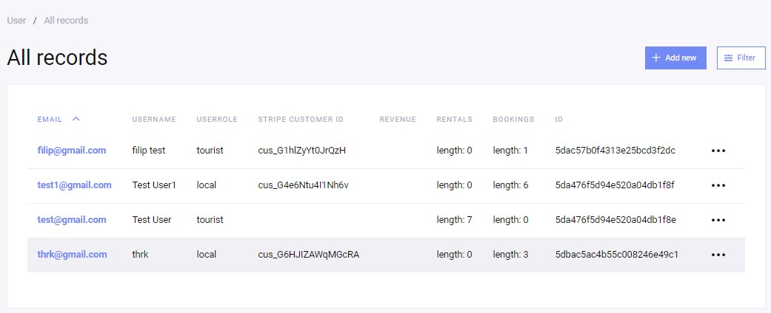
Figure 5-25 Admin User Management

CONCLUSION

The purpose of making this project is to understand the working of MEAN Stack Development. So that it would be helpful for us in the industry. Also, we want to facilitate also we want to facilitate tourists and locals with one web application where tourists can search location, select location, book their tour with accommodation and food packages if they want. Locals can earn money by giving tour guidance, accommodation to tourist and meals packages to tourists. We also want to promote the tourism of Pakistan and attract the tourists towards the interactive and beautiful nature of Pakistan. In this way people get their jobs and tourist can make their tour remarkable. We have understood the working of the MEAN STACK. We hope it will be helpful for us and this website will be helpful for the stakeholders of this website.

REFERENCES

[1] | “Times of Islamabad (Pakistan Tourism Potential),” [Online]. Available: https://timesofislamabad.com/26-Apr-2018/pakistan-tourism-potential-stands-at-36-billion-report.
[2] | “MEAN (software bundle),” [Online]. Available: https://en.wikipedia.org/wiki/MEAN_(software_bundle).
[3] | “MongoDB,” [Online]. Available: https://www.mongodb.com/.
[4] | “Expressjs.com,” [Online]. Available: http://expressjs.com/.
[5] | “Angularjs.org,” [Online]. Available: https://angularjs.org/.
[6] | “Node.js Foundation,” [Online]. Available: https://nodejs.org/.
[7] | “Diagram Maker | Online Diagram Software,” [Online]. Available: https://creately.com/.

