
BSCS-S19-006
03-134161-044 | MUHAMMAD ADEEL AKBAR
03-134161-031 | UZAIR SIDDIQUI
03-134161-029 | TOOBA JAVED

Ai Enable Elderly Care Robot

In partial fulfilment of the requirements for the degree of
Bachelor of Science in Computer Science
Supervisor: Dr. Irum Noreen
Department of Computer Sciences
Bahria University, Lahore Campus
January 2020

© Bahria University, 2020

Certificate

We accept the work contained in the report titled
“AI ENABLE ELDERLY CARE ROBOT”
written by
MUHAMMAD ADEEL AKBAR
UZAIR SIDDIQUI
TOOBA JAVED
as a confirmation to the required standard for the partial fulfilment of the degree of
Bachelor of Science in Computer Science.

Approved by:
Supervisor: Dr. Iram Noreen
(Signature)

January 30, 2020

DECLARATION

We hereby declare that this project report is based on our original work except for citations and quotations, which have been duly acknowledged. We also declare that it has not been previously and concurrently submitted for any other degree or award at Bahria University or other institutions.

Enrolment | Name | Signature
03-134161-044 | MUHAMMAD ADEEL AKAR
03-134161-031 | UZAIR SIDDIQUI
03-134161-029 | TOOBA JAVED

Date : January 30, 2020

Specially dedicated to
my beloved grandmother, mother and father
(Muhammad Adeel Akbar)
my beloved grandmother, mother and father
(Uzair Siddiqui)
my beloved grandmother, mother and father
(Tooba Javed)

ACKNOWLEDGEMENTS

We would like to thank everyone who had contributed to the successful completion of this project. We would like to express my/our gratitude to my research supervisor, Dr. Iram Noreen for her invaluable advice, guidance and her enormous patience throughout the development of the research.

In addition, we would also like to express my gratitude to our loving parent and friends who had helped and given me encouragement.

Muhammad Adeel Akbar
Uzair Siddiqui
Tooba Javed

AI ENABLE ELDERLY CARE ROBOT

ABSTRACT

Our project title is “AI-Enabled Elderly Care Robot”. We worked on JD Humanoid robot, which supports complex programming using platforms like MATLAB, C++ and Android Studio. We aimed to customize the functionality of robot, which involves the use of “Artificial Intelligence algorithms” for object tracking. We embed our code in robot, to make different types of interactions with human. We also developed an android application to control the robot’s functionality. This project also provides the notifications of daily routine for an elder person like prayer reminders, exercise reminders, and medication reminders.

TABLE OF CONTENTS

DECLARATION ii
ACKNOWLEDGEMENTS iv
ABSTRACT v
TABLE OF CONTENTS vi
LIST OF TABLES ix
LIST OF FIGURES x

CHAPTERS
1 INTRODUCTION 1
1.1 Background 1
1.2 Problem Statements 1
1.3 Aims and Objectives 2
1.4 Scope of Project 2
1.4.1 Primary Scope 2
1.4.2 Optional Scope 3
2 LITERATURE REVIEW (and/or SRS) 4
2.1 Literature Review 4
3 DESIGN AND METHODOLOGY 7
3.1 Use Case Diagram 7
3.2 Use Case Descriptions 8
3.2.1 Sign Up Use Case 8
3.2.2 Download Content Use Case 9
3.2.3 Object Recognition Use Case 10
3.2.4 Object Tracking Use Case 11
3.3 Top Level Architecture 12
3.4 DFD 0 12
3.5 DFD 1 13
3.6 Deployment Model 14
3.7 Sequence Diagram 15
3.8 Methodology 16
3.9 Convolution Neural Network 16
4 DATA AND EXPERIMENTS (and/or IMPLMENTATION) 18
4.1 Dataset 18
4.2 Tools/Algorithms 18
4.3 Research Design (Qualitative/Quantitative) 18
4.4 Software Interfaces 19
4.5 Robot Assembly and Configuration 19
4.6 Training Session 22
4.7 Experimental Setup 23
4.8 Assumption/Pre-Conditions 24
4.9 Experiment Cases Details 24
4.9.1 Identify Object from Front Angle 24
4.9.2 Identify Object from Side Angle 25
4.10 Future Challenges 25
5 RESULTS AND DISCUSSIONS (or USER MANUAL) 26
5.1 Robot Walk 26
5.2 Discussion 27
5.3 Confusion Matrix 28
6 CONCLUSION AND RECOMMENDATIONS 31
6.1 Conclusion 31
6.2 Recommendations 32
REFERENCES 33

LIST OF TABLES

TABLE TITLE PAGE
Table 3-1: Sign-up use case 8
Table 3-2: Download content use case 9
Table 3-3: Object Recognition use case 10
Table 3-4: Object tracking use case 11
Table 5-1: Processing Time for Different Machines 27
Table 5-2: Result Outcomes 29

LIST OF FIGURES

FIGURE TITLE PAGE
Figure 3-1: Overall System Use Case 7
Figure 3-2: Top Level Architecture of Proposed System 12
Figure 3-3: Data Flow Diagram 0 12
Figure 3-4: Data Flow Diagram 1 13
Figure 3-5: Deployment Model 14
Figure 3-6: Sequence Diagram 15
Figure 4-1: Robot Servos 19
Figure 4-2: Sample Code 20
Figure 4-3: Sample Code for Camera 20
Figure 4-4: Assembled Robot 21
Figure 4-5: Training Process 22
Figure 4-6: Complete Block Diagram 23
Figure 4-7: De-shape images 24
Figure 5-1: Robot Movement 26
Figure 5-2: Detection Process 27
Figure 5-3: Confusion Matrix 28

INTRODUCTION

Background

Robots are machines that usually controlled the computer program or electronic circuitry. Humans may directly control them. Humanoid is a category of robots that are designed to look like humans, and their interactions/behaviour may demonstrate intelligence. Now a day every physical work is shifting on the machine, similarly, robots are being used in medical care especially in Japan. Elderly persons especially with dementia ailment, suffer from memory loss and cognitive impairment. They face difficulties to identify and narrate different objects of routine life. In this project, we are introducing the “JD Humanoid Robot” for elderly care support. Our robot is based on artificial intelligence algorithms to support elderly persons in their routine life. It works as a daily routine assistant, it helps to identify different kinds of objects by using object detection and tracking features. We also built an android based application to facilitate an elder person in controlling the robot.

Problem Statements

Our target was to find ease for elderly people. As with the growing age, people lose the capability of listening properly. It is also difficult for them to recognize their faces. Therefore, our mission was to help them to track the objects and recognize the faces through our robot.
Robotics makes use of existing ICT infrastructure and also implies a continued technological evolution of these networks. We see an age-old dream come true, a device that resembles the human and animals can interact with us. Due to further aging, it is accepted that people will be living longer than before, care robots will take the workload away from the caregivers. As our robot is very expensive so we have a cost factor risk in our project. Involves new concepts that we have not covered as courseware in our BS program. So the project requires a lot of self-learning. Hardware issues and software bugs may cause irregularities to the robot and the robot may damage its hardware.

Aims and Objectives

We seek to obtain the following objectives:
- Beneficiaries enjoy a supportive family environment and enhanced social experience.
- Beneficiaries are able to identify the objects.
- Beneficiaries are able to enjoy the feature of physiotherapy trainer in the form of the robot (optional)
- To study the material degradation on the plasma actuator surfaces.

Scope of Project

Primary Scope
The primary scope of the project is as follows:

- To recognize the object by using object tracking algorithms.

Optional Scope
Optional scope of the project is as follows:
  - Provide notifications about exercise, medicine schedule, prayers, and doctor’s visit
  - Physiotherapy-guide

LITERATURE REVIEW (and/or SRS)

Literature Review

Object can be tracked by the numerous way, researchers track the object by the different aspects, and different angles and dimensions basic three techniques by which the object tracked through the multi-structured techniques feature in which the one is special model, this is related to the geometric shape of the learning the problem and it is related to the geometric verification of an object. Second is the temporal model, this is related to the multi-tasked structure, it is related to the adjustment of the frames and the third is discriminative feature is related to the intra-class compactness and inter-class reparability. The above all is to achieve our desired goal to tract the object. Many dimensions of the object can be analysed and investigated which discussed the basic work is feature representation in this feature it separates the object to the background to its foreground. The other is object model learning is can be done by classifying the object.
For detecting the object sensors should be of the quick response of gesture. If the sensors not work properly or it works to slow the results may be varied from the actual results for this the researchers design an efficient algorithm which works in divisions of seconds, in the past work was done on this by the central clearing and settlement system, they work on the HMM chains on the cockpit control of the system .The focus of CCASS was on the Inertial Navigation Systems and Motion modelling [2].
The vision is associated with how far or how near is our object. It is connected to the motion of the object. Some event-driven oscillation may be heavy or short term, some of them are short term tracker, updating and discriminative learning. Target re-detection this mentioned is associated with the robot or captured device navigation and movement and object oscillation and captured object by a detector. The tracking techniques may be adopted by the different ways like trackers with drift alleviation/re-detection, correlation filter based tracking, deep learning-based tracking, technical comparisons among similar trackers this is to track the object and recognized what basically the major object is it, keeping in mind the oscillation of the object [3].
For better communication the robot and the human must have interaction through some medium we determined several tasks like finding an accurate position of the robot and the area of robot traveling and the area where the object is placed. The robot used the image of object as an input and does an analysis of the image. It applies image processing different techniques and filters, also perfume image segmentation, transformation. The robot is used for different purposes like security, tracking, and acquisition. The object may be tracked in the 2D or 3D, the sum of squared difference (SSD) calculates the vector displacement of each time interval [5].
Visual programming faces the big challenge of object tracking. It focuses on the training of the data during tracking. It basically calculates the computational cost to track the object. This can be done by the humanoid robot. Tracking of object may have done by the live stemming of the RGB images the frames applied individual first red then blue and then green on image frame and get final coloured images with enhances pixels and coloured information this also separates the object image to its background to the foreground by applying the different image processing techniques on image and get the resultant RGB image. First it labels the object and then tracks the object [7].Object tracking techniques focused on the visual positioning and frame sequence to get better results [8].Navigation is also related to the movement of robot and the object to detect it easily. Through navigation, robot can easily reach their destination [9][10][11].
Artificial intelligence reduces the human effort it serves us in many fields like detection treatment and for diagnosis, purpose AI tools used in major’s areas as discussed. They all tools are futuristic based. Poly vision-based is highly recommended, it involved the vision and motor processing it gives us an overview of robot and properties of environment for robot. It tells how to build system and in future what parameter will be kept in mind to build the system. Elderly care robots are dehumanized, in this elderly people can look after by the mechanical machines. Different approaches and technologies used for this some use ICT skills, some use ICT skills in healthcare, and some suggest the humanoid robot different approaches used and the remaining used information technologies.

DESIGN AND METHODOLOGY

Use Case Diagram

Following are the Overall System Use Case Diagram
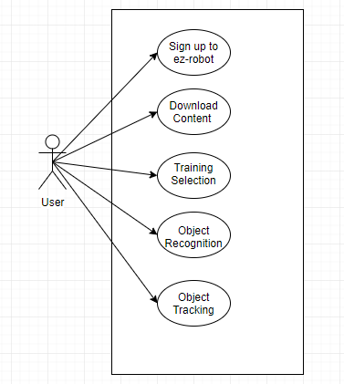
Figure 3-1: Overall System Use Case

Use Case Descriptions

Sign Up Use Case
Use Case ID: |  | Priority: High
Use Case Name | sign-up (Ez-robot website)
Actors | User
Description: | User registers/sign up its device on the website (ez-robot)^{[1]}.Registers its device and account details.
Preconditions: | - User must own a device  - The device should be functional and properly working.  - Users should have working internet.
Post conditions: | - Move to use Case id 2
Triggers: | EZ-robot will send a confirmation message verifying the account details, and registration confirmation on the provided email account.
Flow: | - Opens up Ez-robot official website.  - Click on the sign-up option  - Follow the steps to create the account.
Alternative Flow: | None
Exceptions: | - Unstable internet connection  - Password not meeting the required criteria  - User name already is taken  - Invalid email account

Table 3-1: Sign-up use case

Download Content Use Case
Use Case ID: | 2 | Priority: High
Use Case Name | Download Content
Actors | User
Description: | The user downloads the required assets and files that include IDE, Documentation, etc.
Preconditions: | - The system must have required volume  - Stable internet connection
Post conditions: | - All content successfully download  - Installation starts
Triggers: | None
Flow: | - Login in Ez-robot  - Open download content field  - Select items for downloading
Alternative Flow: | None
Exceptions: | - Unstable internet connection  - System specifications do not meet the requirement  - User name already is taken  - Invalid email account

Table 3-2: Download content use case

Object Recognition Use Case
Use Case ID: | 3 | Priority: High
Use Case Name | Object Recognition
Actors | User
Description: | We will train the Robot with different views and aspects of the object so that the robot can identify that particular object.
Preconditions: | - The software must be installed in the robot  - The battery must be fully charged.  - Laptop with IDE installed in it or connected with android
Post conditions: | - Further functions can be performed after object reorganization.
Triggers: | None
Flow: | - The robot will scan the initial angle of the object.  - The Robot will request a different angle of the object.  - The Robot will scan different angles of the object.  - The Robot will confirm after the completion of the scan.  - The robot is able to identify that a particular object is scanned.
Alternative Flow: | None
Exceptions: | - Low battery levels  - All angles of the object were not read properly

Table 3-3: Object Recognition use case

Object Tracking Use Case
Use Case ID: | 5 | Priority: High
Use Case Name | Object Tracking
Actors | User
Description: | The Robot vision will follow the object movement and act accordingly.
Preconditions: | - The software must be installed in the Robot.  - The robot must be connected with the internet/Laptop or Android Cell Phone.
Post conditions: | - Object Tracking Module successful.
Triggers: | None
Flow: | - Is an object identifiable?  - If yes, then follow its movements.
Alternative Flow: | None
Exceptions: | - The object is out of vision.  - The object is not identifiable.  - Hardware error.

Table 3-4: Object tracking use case

Top Level Architecture
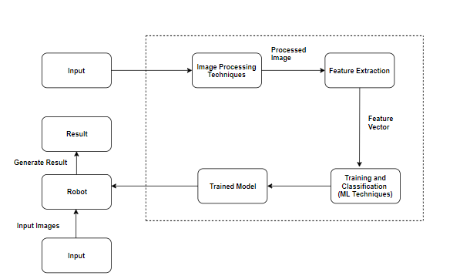

Figure 3-2: Top Level Architecture of Proposed System

DFD 0
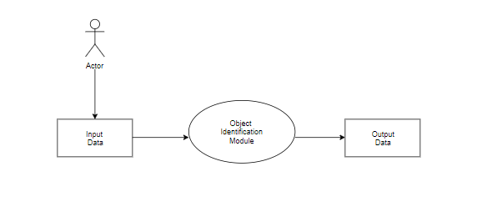

Figure 3-3: Data Flow Diagram 0

DFD 1
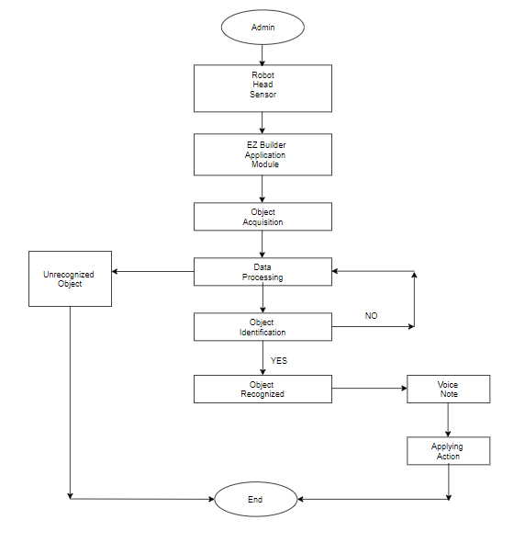
Figure 3-4: Data Flow Diagram 1

Deployment Model
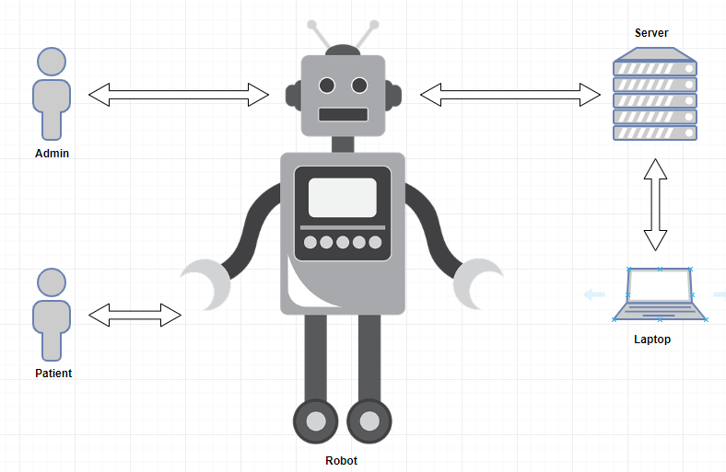

Figure 3-5: Deployment Model

Sequence Diagram

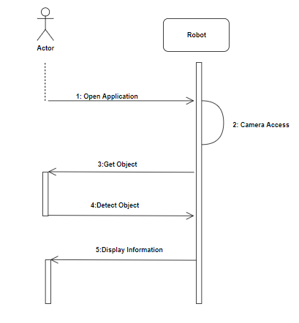
Figure 3-6: Sequence Diagram

Methodology

The development methodology used is scrum as it suits the project requirements that are based on a tight schedule, any adjustments should be made without messing up previous progress. Scrum development model helped us to test the product on each level of development and provided us room for rapid changes on the go. Since the deliverables should be delivered on time, rapid testing helped us quickly identify bugs or problems in the product. Furthermore, this model helped us in sustaining transparency in process management.

Convolution Neural Network

Different types of Neural Networks are used for different purposes, for example for predicting the sequence of words we use Recurrent Neural Networks more precisely an LSTM, similarly for image classification we use Convolution Neural Network. In a regular Neural Network there are three types of layers:
- Input Layers: It’s the layer in which we give input to our model. The number of neurons in this layer is equal to total number of features in our data (number of pixels in case of an image).
- Hidden Layer: The input from Input layer is then feed into the hidden layer. There can be many hidden layers depending upon our model and data size. Each hidden layers can have different numbers of neurons which are generally greater than the number of features. The output from each layer is computed by matrix multiplication of output of the previous layer with learnable weights of that layer and then by addition of learnable biases followed by activation function which makes the network nonlinear.
- Output Layer: The output from the hidden layer is then fed into a logistic function like sigmoid or softmax which converts the output of each class into probability score of each class.

A covnets is a sequence of layers, and every layer transforms one volume to another through differentiable function.
Types of layers:
Let’s take an example by running a covnets on of image of dimension 32 x 32 x 3.
- Input Layer: This layer holds the raw input of image with width 32, height 32 and depth 3.
- Convolution Layer: This layer computes the output volume by computing dot product between all filters and image patch. Suppose we use total 12 filters for this layer we’ll get output volume of dimension 32 x 32 x 12.
- Activation Function Layer: This layer will apply element wise activation function to the output of convolution layer. Some common activation functions are RELU: max (0, x), Sigmoid: 1/(1+e^-x), Tanh, Leaky RELU, etc. The volume remains unchanged hence output volume will have dimension 32 x 32 x 12.
- Pool Layer: This layer is periodically inserted in the covnets and its main function is to reduce the size of volume which makes the computation fast reduces memory and also prevents from overfitting. Two common types of pooling layers are max pooling and average pooling. If we use a max pool with 2 x 2 filters and stride 2, the resultant volume will be of dimension 16x16x12.
- Fully-Connected Layer: This layer is regular neural network layer which takes input from the previous layer and computes the class scores and outputs the 1-D array of size equal to the number of classes.

DATA AND EXPERIMENTS (and/or IMPLMENTATION)

Dataset

A data set is a collection of related, discrete items of related data that may be accessed individually or in combination or managed as a whole entity. In our project, we captured the image form Robot’s head and then the image is stored into to database. After that, we applied the algorithm named CNN to train our object.

Tools/Algorithms

The following are the tools.
- CNN Framework
- E-Z builder library
- JD HUMANOID robot for hardware

Research Design (Qualitative/Quantitative)

In our project, 20 percent of qualitative and 80 percent of quantitative methods are used. 20 percent for the descriptive form or collection of data which are based on reading research papers, interviews, and surveys.

80 percent of data get through quantitative methods like:
- Mean
- Standard Deviation
- Smoothness

Software Interfaces
Operating system: Windows
IDE: EZ builder IDE
Scripting language: EZ script (based on C++)

Robot Assembly and Configuration

Following are the robot assembly
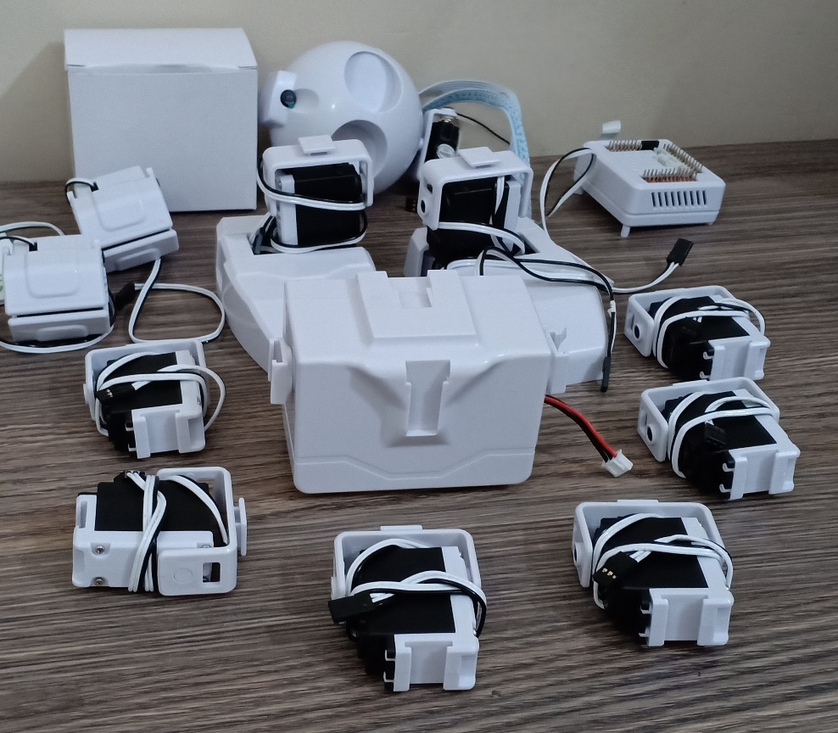

Figure 4-1: Robot Servos

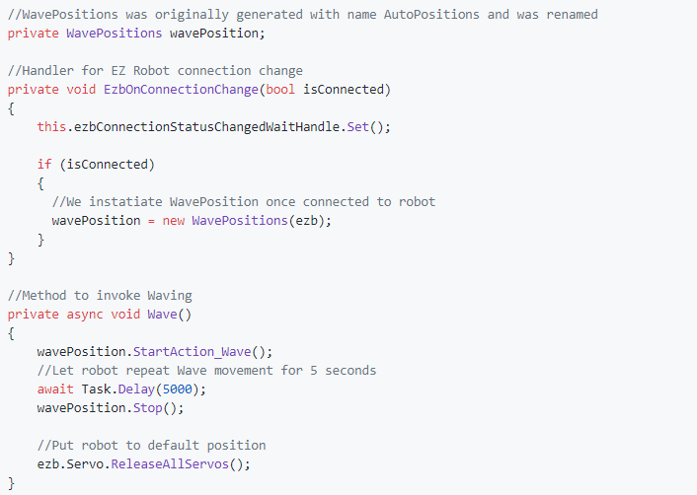

Figure 4-2: Sample Code

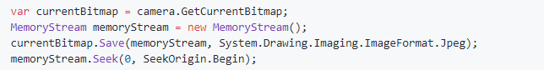

Figure 4-3: Sample Code for Camera

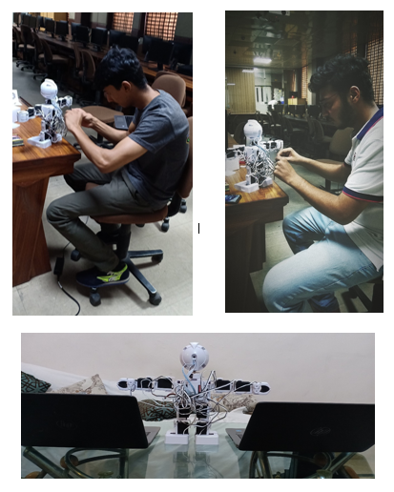
Figure 4-4: Assembled Robot

Training Session

For the detection we must train our data so the robot easily performs their detection for all detection we must train and save our object every object has their different training frames and parameter for training we click on the object option on EZ builder IDE and then checkbox tick the face and object then we train object.

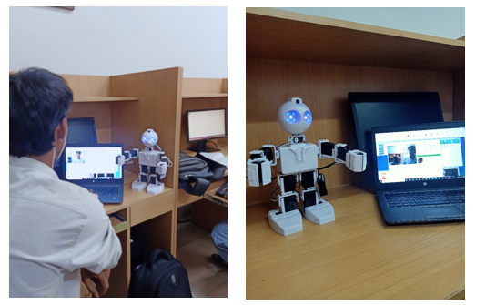

Figure 4-5: Training Process

Experimental Setup

The computer/laptop containing the EZ builder IDE and the JD Humanoid robot will be on the same network and communicate through the network. Both the laptop and the JD Humanoid robot must be on the same network at all times to work properly.
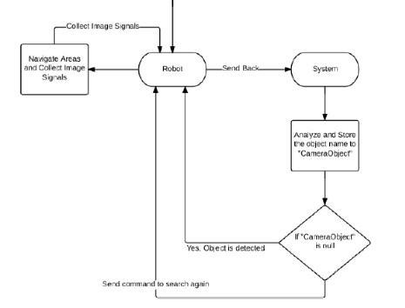

Figure 4-6: Complete Block Diagram

Assumption/Pre-Conditions

Don’t sudden off the robot while performing any functionality on the robot before the turnoff you must null all values of every part of the robot then disconnect then off if direct we close the IDE the robot may de-shape.

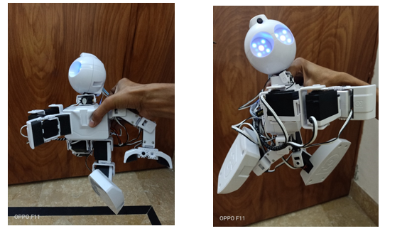

Figure 4-7: De-shape images

Experiment Cases Details

Identify Object from Front Angle

From the front angle, the detection takes place from multiple ways its angle of freedom basically of 16 degrees. The detection takes place when the objects bring in front of the robot sensor. The robot has 18 sensors in it, during the detection all sensors become active, during training it picks up the different points of an image. It takes up the different frames of the image and uses that frames during the detection. When it detects an object it gives a response from an audio channel and speaks the specific objects name which we have trained.
During the detection period, it picks an object which we have trained from multiple objects and matches it with its memory and speaks the name of that object Sometimes It gets confused due to illusion factor, motion blur then its sensor lights fade or blinks. It can detect an object from the front angle by moving its Servo at 180 shifts. The detection can take place at up, down, right, left, forward, roll, pitch, and yaw position getting view from its front side.

Identify Object from Side Angle

The side angle detection takes place when we allow the tracking if an object; due to the angle of freedom at their 16 degrees, it can be track or detect an object from its side. All the working has been done on the bases of CNN algorithm.

Future Challenges

Sometimes robot gets confused about what the object is. The robot sensor light becomes fades and starts diming or blink. The confusion takes place when the buffer of the previous object while cleaning and the other object loaded on the buffer so as the result the robot becomes confused. This is because conditional statement executes so fast that the previous buffer was removed while the next buffer starts loaded so the robot becomes confused.

RESULTS AND DISCUSSIONS (or USER MANUAL)

Robot Walk

When we give, the command to our robot to move forward it executes and moves forward until we do not give the command to stop it. During its movement it is all servos involves in motion. Following are the images of its motion
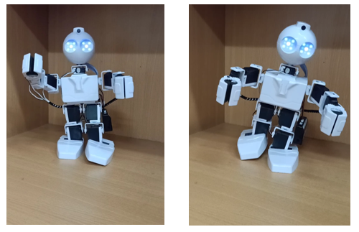
Figure 5-1: Robot Movement

When it detects an object, it gives its audio response that the object it sees. During the detection the green colour frames occur on the face or object dimension around, it means that the object can be found then the detection phenomena take place.

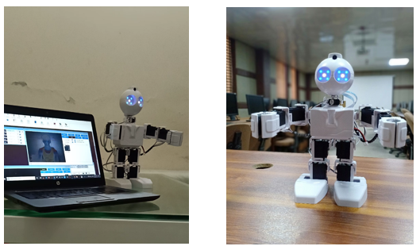

Figure 5-2: Detection Process

Discussion

A sample of data used during training for detection is shown in table 5.

Board | Robot
Board | 1 | 2 | 3 | 4 | 5
CameraObjectName | Uzair | Tooba | Adeel | Pen | Keys
CameraObjectTracking | 1 | 1 | 1 | 1 | 1
Frame Volume | 100 | 90 | 110 | 98 | 95

Table 5-1: Processing Time for Different Machines

Confusion Matrix

A Confusion Matrix is a popular representation of the performance of classification models. The matrix (table) shows us the number of correctly and incorrectly classified examples, compared to the actual outcomes (target value) in the test data. One of the advantages of using confusion matrix as evaluation tool is that it allows more detailed analysis (such as if the model is confusing two classes) than simple proportion of correctly classified examples (accuracy) which can give misleading results if the dataset is unbalanced (i.e. when there are huge differences in number of between difference classes).

The matrix is n by n, where n is the number of classes. The simplest classifiers, called binary classifiers, has only two classes: positive/negative, yes/no, male/female… Performance of a binary classifier is summarized in a confusion matrix that cross-tabulates predicted and observed examples into four options:

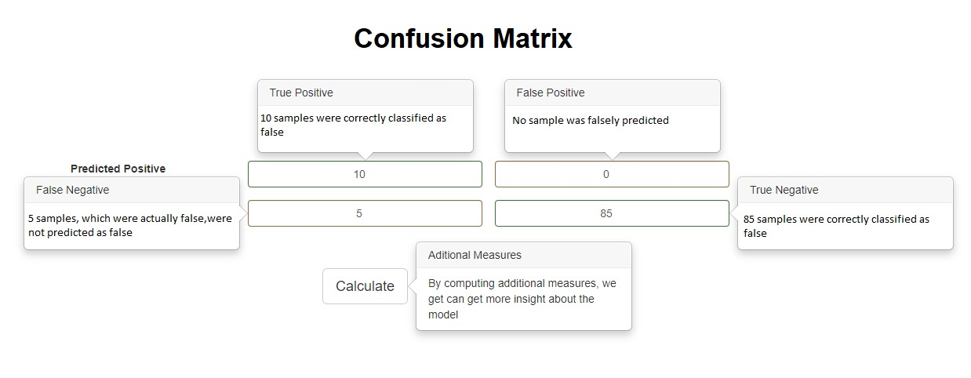

Figure 5-3: Confusion Matrix

Measure | Value
Sensitivity | 0.6667
Specificity | 1.0000
Precision | 1.0000
Negative predictive value | 0.9444
False-positive rate | 0.0000
False discovery rate | 0.0000
False-negative rate | 0.3333
Accuracy | 0.9500
F1 score | 0.8000
Matthews correlation coefficient | 0.7935

Table 5-2: Result Outcomes

a) True Positive (TP)
Correctly predicting a label (we predicted “yes”, and it’s “yes”)
b) True Negative (TN)
Correctly predicting the other label (we predicted “no”, and it’s “no”)
c) False Positive (FP)
Falsely Predicting a label (we predicted “yes”, but it's “no”)
d) False Negative (FN)
Missing and incoming label (we predicted “no”, but it’s “yes”)
e) Sensitivity
Sensitivity or True Positive Rate (TPR)
TPR = TP / (TP + FN)
f) Specificity
Specificity (SPC) or True Negative Rate (TNR)
SPC = TN/ (FP + TN)
g) Precision
Precision or Positive Predictive Value (PPV)
PPV = TP / (TP + FP)
h) Negative Predictive Value
Negative Predictive Value (NPV)
NPV = TN / (TN + FN)
i) False Positive Rate
Fall-out or False Positive Rate (FPR)
FPT = FP / (FP + TN)
j) False Discovery Rate
False Discovery Rate (FDR)
FDR = FP / (FP + TP)
k) False Negative Rate
Miss Rate or False Negative Rate (FNR)
FNR = FN / (FN + TP)
l) Accuracy
Accuracy (ACC)
ACC = (TP + TN) / (P + N)
m) F1 Score
F1 Score (F1)
F1 = 2TP / (2TP + FP + FN)
n) Matthews Correlation Coefficient
Matthews Correlation Coefficient (MCC)
TP*TN – FP*FN / sqrt ((TP + FP) *(TP + FN)*(TN + FP)*(TN + FN))

CONCLUSION AND RECOMMENDATIONS

Conclusion

Our project title is “AI-Enabled Elderly Care Robot”. We worked on JD Humanoid robot, which supports complex programming using platforms like MATLAB, C++ and Android Studio. We aimed to customize the functionality of the robot, which involves the use of “Artificial Intelligence algorithms” for object tracking. We embed our code in robot, to make different types of interactions with human. We also developed an android application to control the robot’s functionality. The project also provides the notifications of daily routine for elder person like prayer reminders, exercise reminders, and medication reminders.
As we begin to develop a solution, we mapped out our proposed program on paper or by talking through the logic with another person. This helped us to develop computational thinking skills.
With the help of the robot’s head having a camera, the attributes of any 2D or 3D object are captured. We allowed the robot to examine the object and retrieve attributes from it with the help of object tracking algorithms. These attributes are used as a signature to recognize the object and store in the active memory of the robot, meaning that at any time if the object is identified according to its signature, without any hassle the robot immediately recognizes the object.

Recommendations

As we know, Robots are usually machines controlled by a computer program and/or electronic circuitry. Humans may directly control them. Humanoid is a category of robots that are designed to look like humans, and their interactions/behavior may demonstrate intelligence. Now a day every physical work is shifting on the machine, similarly, robots are being used in medical care especially in Japan. In this project, we introduced the “JD Humanoid Robot” for elderly care support. Our robot used artificial intelligence algorithms to support elderly persons in their routine life. It works as a daily routine assistant, it helps to identify different kinds of objects by using object detection and tracking features. Following are the recommendations that can be enabled on our “JD Humanoid Robot”
- Gestures and voice control function
- AR function
- Cognitive Face function
- Speech recognition function

REFERENCES

[1] X. Li et al., “Multi-Task Structure-Aware Context Modeling for Robust Keypoint-Based Object Tracking,” IEEE Trans. Pattern Anal. Mach. Intell., vol. 41, no. 4, pp. 915–927, 2019.
[2] M. Haid, B. Baker, M. Geiger, D. Husfeldt, M. Hartmann, and N. Berezowski, “Inertial-Based Gesture Recognition for Artificial Intelligent Cockpit Control using Hidden Markov Models,” 2019 IEEE Int. Conf. Consum. Electron. ICCE 2019, pp. 1–4, 2019.
[3] M. Guan, C. Wen, M. Shan, C. L. Ng, and Y. Zou, “Real-time event-triggered object tracking in the presence of model drift and occlusion,” IEEE Trans. Ind. Electron., vol. 66, no. 3, pp. 2054–2065, 2019.
[4] A. Khan, J. Li, A. Malik, and M. Y. Khan, Soft Computing and Signal Processing, vol. 898. Springer Singapore, 2019.
[5] N. P. Papanikolopoulos and K. Pradeep, “Combination of Control and Vision,” IEEE Trans. Robot., vol. V9, no. I, pp. 14–35, 1993.
[6] S. Heinrich, P. Springstübe, T. Knöppler, M. Kerzel, and S. Wermter, “Continuous convolutional object tracking in developmental robot scenarios,” Neurocomputing, vol. 342, no. XXXX, pp. 137–144, 2019.
[7] R. Martin and L. Agapito, “Co-Fusion: Real-time Segmentation, Tracking, and Fusion of Multiple Objects | UCL Visual Computing,” Icra, pp. 4471–4478, 2017.
[8] W. Luo, P. Sun, F. Zhong, W. Liu, T. Zhang, and Y. Wang, “End-to-end Active Object Tracking and Its Real-world Deployment via Reinforcement Learning,” vol. 14, no. 8, pp. 1–16, 2018.
[9] A. K. Mutasim, R. S. Tipu, M. R. Bashar, M. K. Islam, and M. A. Amin, Computational intelligence for pattern recognition in EEG signals, vol. 777. Springer International Publishing, 2018.
[10] A. Talele, A. Patil, and B. Barse, “Detection of Real-Time Objects Using TensorFlow and OpenCV,” vol. V, no. I, pp. 1–4.
[11] Y. Zhang, H. Wang, and F. Xu, “Object detection and recognition of intelligent service robot based on deep learning,” 2017 IEEE Int. Conf. Cybern. Intell. Syst. CIS 2017 IEEE Conf. Robot. Autom. Mechatronics, RAM 2017 - Proc., vol. 2018-January, pp. 171–176, 2018.
[12] F. Jiang et al., “Artificial intelligence in healthcare: Past, present, and future,” Stroke Vasc. Neurol., vol. 2, no. 4, pp. 230–243, 2017.
[13] I. Horswill, “Polly : A Vision-based Artificial Agent,” 1993.
[14] M. Coeckelbergh, “Care robots and the future of ICT-mediated elderly care: a response to doom scenarios,” AI Soc., vol. 31, no. 4, pp. 455–462, 2016.

