
BSCS-S19-007
03-134161-055 | Sehrish Ghaffar
03-134161-053 | Muhammad Umar Farooq

Smart Gardening

In partial fulfillment of the requirements for the degree of
Bachelor of Science in Computer Science
Supervisor: Dr. Iram Noreen
Department of Computer Sciences
Bahria University, Lahore Campus
November 2019

© Bahria University, 2020

Certificate

We accept the work contained in the report titled
“Smart Gardening”
written by
Sehrish Ghaffar
Muhammad Umar Farooq
as a confirmation to the required standard for the partial fulfillment of the degree of
Bachelor of Science in Computer Science.

Approved by:
Supervisor: Dr. Iram Noreen
(Signature)

November 30, 2019

DECLARATION

We hereby declare that this project report is based on our original work except for citations and quotations which have been duly acknowledged. We also declare that it has not been previously and concurrently submitted for any other degree or award at Bahria University or other institutions.

Enrolment | Name | Signature
03-134161-055 | Sehrish Ghaffar
03-134161-053 | Muhammad Umar Farooq

Date: November 30, 2019

Specially dedicated to
my beloved grandmother, mother, and father
(Muhammad Umar Farooq)
my beloved grandmother, mother, and father
(Sehrish Ghaffar)

ACKNOWLEDGMENTS

We would like to thank everyone who had contributed to the successful completion of this project. We would like to express our gratitude to my supervisor, Dr. Iram Noreen for her invaluable advice, guidance and her enormous patience throughout the development of the research.

In addition, We would also like to express my gratitude to our loving parents and friends who had helped and given me encouragement.

Sehrish Ghaffar
Muhammad Umar Farooq

SMART GARDENING

ABSTRACT

The smart gardening project is based on image processing techniques to identify and classify fungal disease symptoms on different plants in gardens that are reduced a large work on daily monitoring. The plant disease diagnosis is limited by human eye capacity because the first symptoms (like lesion or spots) are microscopic. The color, area, and the number of these spots will be determined.
Plant disease is caused by bacteria, fungi, viruses, and nematodes. A fungus is the main disease-causing distortion of a leaf. We have been detecting healthy or unhealthy plants on their first symptoms of disease with accuracy through the image processing technique. Disease detection steps like image acquisition, image pre-processing, image segmentation, feature extraction, and classification involves in used trained model. A smart gardening project system is based on an android mobile application. It used the picture of the affected leaf of plants. An algorithm is used for identification of disease involve steps like loading the image, contrast enhancement, segmentation, extracting of features. At the final step, the classification result along with the necessary control measures are presented through the mobile application on phone.

TABLE OF CONTENTS

DECLARATION ii
ACKNOWLEDGMENTS iv
ABSTRACT v
TABLE OF CONTENTS vi
LIST OF TABLES viii
LIST OF FIGURES ix
LIST OF APPENDICES xi

CHAPTERS
1 INTRODUCTION 1
1.1 Background 1
1.2 Problem statement 1
1.3 Aims and objectives 1
1.4 Scope of project 1
2 LITERATURE REVIEW (and/or SRS) 3
2.1 Literature review 3
2.1.1 State of art comparative analysis 5
2.1.2 Research and Development Gap 8
2.2 Use-case description 9
2.2.1 Register 9
2.2.2 Login 9
2.2.3 View history 10
2.2.4 View results 10
2.2.5 View plants information 11
2.2.6 Logout 12
2.2.7 Make complaint 12
3.1 Use-case Diagram (refined and updated) 14
4 DESIGN AND METHODOLOGY 18
4.1 Methodology 18
4.2 Research Design (Quantitative/Qualitative Model) 18
4.3 Top Level Architecture 19
4.4 DFD-0 20
4.5 DFD-1 21
4.6 System Sequence Diagram 22
4.7 Design 23
5 DATA AND EXPERIMENTS (and/or IMPLEMENTATION) 28
5.1 Dataset 28
5.2 Tools used for implementation 28
5.2.1 Android studio 28
5.2.2 Google firebase 28
5.3 Experimental setup 28
5.3.1 Transfer learning 28
5.3.2 Google colab 29
5.3.3 VGG-16 29
6 RESULTS AND DISCUSSIONS 31
6.1 Classes 32
6.2 Training information 32
6.2.1 Training accuracy 32
6.2.2 Validation accuracy 32
6.2.3 Training loss 33
6.2.4 Validation loss 33
6.3 Confusion matrix 34
6.4 Classification report 35
7 CONCLUSION AND RECOMMENDATIONS 37
REFERENCES 38
APPENDICES 40

LIST OF TABLES

TABLE TITLE PAGE
Table 1: Register use-case 9
Table 2: Login use-case 10
Table 4: View history use-case 10
Table 5: View results use-case 11
Table 6: View plants information use-case 12
Table 7: Logout use-case 12
Table 8: Make complaint use-case 13

LIST OF FIGURES

FIGURE TITLE PAGE
Figure 1:System use-case 14
Figure 2: Register use-case 15
Figure 3: Login 15
Figure 4: Manage Plants 15
Figure 5: View History 16
Figure 6: View Results 16
Figure 7: View Plants Information 16
Figure 8: Logout 17
Figure 9: Make Complaints 17
Figure 10: Top level architecture of the proposed system 19
Figure 11 : DFD-0 20
Figure 12 : DFD-1 21
Figure 13 : System Sequence Diagram(SSD) 22
Figure 14: Home & Register user 23
Figure 15: Login & Recover password 24
Figure 16: Post login & Check disease 25
Figure 17: User profile & Notification 26
Figure 18: Feedback & History 27
Figure 19: Architecture of VGG-16 [26] 30
Figure 20: Model detail 31
Figure 21: Training information 32
Figure 22: Training accuracy 33
Figure 23: Training loss 34
Figure 24: Classification report 35

INTRODUCTION

Background

The purpose of this project is to identify the disease in plants and to provide a solution using an android application. The basic idea of this project is to used image processing and classification techniques for the detection of disease (fungi) in plants. The proposed system also providing the care description of plants against disease. The method of detection is providing results in a healthy or unhealthy detailed description and solution. It also provides a history of maintenance of plant-based on the initial discovery of disease and recovery guidelines for further checking the schedule of a plant. The proposed system has been deployed as a smart application on an android phone for the end-user.

Problem statement

This project is based on an android application which helps to detect the fungus from the leaves of the plants. We have been providing the treatment for identifying disease of leaf/plant which is affected by fungus.

Aims and objectives

The objective of this project is to implement image analysis & classification techniques for the detection of leaf diseases and classification.
- To detect an unhealthy region of plant leaves.
- To guide home gardeners about plant maintenance.

Scope of project

In this contemporary era of technology, research institutions around the world are making scientific efforts for state of the art techniques in home gardening for disease detection. The method for detection and classification of leaf diseases is based on masking and removing green pixels, applying a specific threshold to extract the infected region and computing the texture statistics to evaluate the diseases [1]. Most of the researchers used the k-means and support vector machine algorithm on the dataset of leaves for detecting the fungi disease in plants [2]. A home garden is a term used for any, combining multiple farming components such as crops, trees, shrubs, herbs, livestock and occasionally fisheries, practiced on the land adjoining the household.
“Home gardens” total area in South Asia is about 200 million hectors and over 80 percent of home gardens in the region (South Asia) are extremely small with an average size of fewer than 0.6 hectares (the size of a small football field), says the Asia-Pacific Network (APN) document [3].
APN funded-project titled Vulnerability of Home Garden Systems to climate change and its impacts on Food Security in South Asia has provided a deep understanding of fresh veggies to the people with opportunities of household income [4].
This project has been focused on detecting a leaf with the name of a plant, name of the disease and its further guideline description. If gardening plants are unhealthy or weak then the nutrition problem process (guardian tips) will be implemented. This has been achieved by using mobile applications with image processing techniques, and further classification techniques as per requirement.

LITERATURE REVIEW (and/or SRS)

Literature review
Gavhale et al. (2014) [5] introduce an android application design using image processing techniques to detect the leaf disease. The leaf database holds unhealthy and healthy leaves, which are captured from a digital camera and send through the internet. Image processing toolbox is used to detect the leaf disease. Firstly unhealthy and healthy leaves are processed in image acquisition. Noise is introduced during the image acquisition process. Noisy image changes the pixel values of the original that affected the real image intensities. These unhealthy and healthy leaves dataset is called the training dataset. The train images of leaves saved in proper format and size with proper light intensities to ease the reflection. The median filter for image enhancement and segmentation for extraction of the diseased portion are used to identify the disease level. Image enhancement process used for further image analysis for a more suitable output display. Noisy image changes the pixel values of the original that affected the real image intensities. These images are divided into small multiple segments using an image segmentation process. It depends on the image problem and segmentation has to stop if a desirable image unique.
Valliammai et al. (2012) [6] introduce the extract enhanced features from the segmented image to reduce the image data by using the feature extraction process. The classification technique has introduced by Singh and Mishra et al. (2016) [7] for leaf disease detection. The different classification techniques such as k-nearest neighbor classifier (KNN), probabilistic neural network (PNN), genetic algorithm, support vector machine (SVM) and principal component analysis, artificial neural network. These extracted features are input to a classifier for classifies leaves images with support vector machine (SVM) gives maximum accuracy of 94.45%. The farmer’s wrong diagnosis of crop disease, reason insecticides spray unfitted.
Traditional methods such as neural network, backpropagation and other pattern recognition concepts described by Kaur et al. (2016) [8]. The Android software development kit (Android SDK) consists of the tools and application programmable interface (API) to start developing applications on the Android platform using the Java programming language. This application used the GPRS [general packet radio service] feature of a mobile phone as a resolution for an irrigation control system and GSM (global system of mobile communication) for communication.
In 2015, Xi and Li et al. [9] have proposed the android design of wheat diseases to diagnose the system. In this process, users collect images of wheat diseases using android phones and send the images across the network to the server for disease diagnosis. Many works involving plant leaf disease detection have been introduced, but in general, they do not discuss the effectiveness of their work. S.Selvarajah et al. (2011) [10] introduced the texture feature-based image recovery algorithms. Image recovery is the process of recovering the most closely matched images automatically by extracting the features such as edge, shape, color, and textures from an image. Grey –level co-occurrence matrix (GLCM) and color co-occurrence matrix (CCM) are recommended for texture features. The GLCM and CCM individually combined with a color feature with the use of quantization of HSV color space. The image color conversion is RGB to HCI conversion. The RGB color model is not enough to recognize the natural colors accurately. So the HCI color model is used to identify the leaf image color precisely. The multi-feature extraction is obtained through the Euclidean distance classifier.
Deng Sheng Zhang et al. (2001) [11] have introduced a comparative study on shape recovery using Fourier descriptors with different shape signatures. The shape is one of the most important features in content-based image retrieval (CBIR). Then the disease detection process identified the disease name and gives the suggestion to the disease. The proposed integrated concept is used to detect plant leaf diseases. They have considered the expert dataset having a leaf of four different types of diseases (alter aria alternate, bacterial blight, fungal leaf spot, and fungus anthracnose). They considered the dataset images of mainly fungal and bacterial. Common methods for the diagnosis and detection of plant diseases include visual plant disease estimation by human raters, microscopic evaluation of morphology features to identify pathogens, as well as molecular, serological, and microbiological diagnostic techniques Dan-based and serological methods, have revolutionized the identification and quantification of pathogens and diseases.

State of art comparative analysis
Sr. | Researcher’s Detail | Year | Approach | Main Contribution | Accuracy
 | Prakash H. Mainkar et al [12]. | 2015 | - RGB image accuisition.  - K mean apply for image segmentation.  - Masking of the green pixel.  - Convert the infected clustered from RGB to HIS. | - Graphics user interface built for the system.  - Introduced the shape of over abstract idea. | 90.96%
 | Iqbal Deep Kaur et al [13]. | 2016 | - Histogram equalization for contrast image.  - K-mean for segmentation.  - GLCM(grey level occurrence matrices) for feature extraction. | - In the proposed concept, SVM is implemented with ACO to improve disease detection results.  - The GUI system to evaluate results and accuracy. | 96.77% -98.42%
 | Sumit Nema et al [14]. | 2017 | - Gaussian and speckle for noise removal.  - A hybrid filter method is developed to improve the quality of the image.  - Artificial Neural Network, Bayes classifier, Fuzzy Logic for classification. | - Comparison of different leaf disease detection methods.  - Compare the 38 research papers for different methods to find disease in plants. | 94.45%
 | Joko Prasetyo et al [15]. | 2017 | - Functional testing in this study uses the Black Box Equivalence Partitioning (EP) method.  - A questionnaire is filling out to provide an assessment of the application. | - To make an expert system that is able to diagnose disease in chili plants based on  the knowledge that provided directly from the experts.  - Use the classical probability calculation method for calculating the percentage of diagnoses and implemented on the Android mobile device. | 85% - 865
 | Ballal Sayali et al [16]. | 2017 | - The blurring technique is used to remove noise in the image.  - Windowing technique (3*3) used for blurring.  - The image is divided into a block of 8 pixels for segmentation.  - RGB TO HSV conversion.  - Histogram generation.  - Euclidean distance measure. | - Provide automatic detection of the disease on  unhealthy plants.  - To design, implement and evaluate a web-based image processing solution for detection and classification  of plant leaf disease.
 | Ehsan Kiania et al [17]. | 2017 | - Color processing detection algorithm (CPDA).  - Fuzzy logic classification algorithm (FLCA). | - The efforts were put in this paper for proposing a method to identify the strawberry leaves disease and deployed on single-chip computers. | 97%
 | Faiza Anjum et al [18]. | 2018 | - MATLAB local database.  - Use GLCM for extracting the features from the query image.  - K-means segmentation.  - SVM classification. | - By using this proposed system detects Viral disease symptoms and Bacterial disease symptoms. | 96%
 | S.A. Khandekar et al [19]. | 2019 | - RGB to Grayscale.  - Morphological techniques.  - Millimeter graph method.  - SVM and K means clustering. | - Identify the custard apple leaf diseases. | 92.4%
 | D.M.Motiur Rahman et al [20]. | 2019 | - Correlation.  - Energy.  - Entropy.  - Mean.  - Kurtosis.  - Root mean square.  - SVM for classification. | - Detect and classify the grapevine disease accurately. | 98.99%
 | C. Deisy et al [21]. | 2019 | - Capture image in RGB.  - Resized image.  - SIFT filter.  - Gabor filter.  - CNN  - URL | - Detection and classify the tomato and apple healthy and disease leaf images. | 87%
 | Nikhil Shah et al [22]. | 2019 | - RGB to HSV.  - Converted into a binary image.  - Artificial Neural Network | - Detecting the disease in cotton plants and quality of plants
 | V Suma et al [23]. | 2019 | - Python tool.  - Neural Network.  - K means clustering. | - Detect the healthy and unhealthy leaf.  - Detect the sectorial leaf blight, down mildew diseases. | 99.32%
 | S.M. Jaisakthi et al [24]. | 2019 | - Global thresholding.  - Semi-supervised techniques.  - SVM | - Classify the healthy, esca, leaf blight and rot. | 93%

Research and Development Gap
The main development objective of this application reduces the effort, time and money. This application will be very useful for users and agriculture departments in Pakistan because this will detect, identify and accuracy of the healthy or unhealthy plant on their first symptoms of the disease through image processing. In Pakistan, the implementation of this application will introduce very first time which consists of local plants data set that plants mostly used by users. User can adopt this system for automatic detection of plant leaf disease. This application provides a quick result with accuracy. The system will work usually by calculating the type of plant, the kind of disease.

Use-case description

Register
Use Case ID: | UC1 | Priority: | High
Use Case Name | Register
Created by: |  | Date Created:
Actors | Admin, User
Description: | To use this application user must have a login to the application. For login on the application, the user must register itself by providing information such as name, email_id, and password.
Preconditions: | Users must have an android mobile/tablet and must install the application.
Postcondition: | Unique user_id and password will be assigned to the user.
Triggers:
Flow: | - The user clicks on the registration button and fills the registration form.  - The user enters the user name, email_id, and password and re-enters the password.  - By click on the signup button, the unique-id and password will be assigned to the user.
Alternative Flow: | None.
Exceptions: | Invalid user name or password.
Table 1: Register use-case

Login
Use Case ID: | UC2 | Priority: | High
Use Case Name | Login
Created by: |  | Date Created:
Actors | Admin, User
Description: | The user uses the application by entering their valid user name and password by using login.
Preconditions: | - Users must be connected with an internet connection for an application.  - Users must remember their valid username and password.
Postcondition: | Move to the main screen.
Triggers:
Flow: | - User and Admin enter the username and password.  - User will click on the login button.  - The system will check the validating of username and password.  - The user redirected to the main screen of their account.
Alternative Flow: | None
Exceptions: | Users will enter an invalid user name or password.
Table 2: Login use-case

View history
Use Case ID: | UC4 | Priority: | High
Use Case Name | View history
Created by: |  | Date Created:
Actors | User
Description: | Users can view history includes a list of images, disease names, and disease treatment.
Preconditions: | Users must be login into application by providing authorized information.  Users must take images of plants previously to check the disease of plants.
Postcondition:
Triggers:
Flow: | - User clicks on history button.  - The system shows a history of plants to users.
Alternative Flow: | None.
Exceptions: | Application failure
Table 4: View history use-case

View results
Use Case ID: | UC5 | Priority: | High
Use Case Name | View Results
Created by: |  | Date Created:
Actors | User
Description: | A user can see the plant disease include disease name, treatment and other plant information which based on the image.
Preconditions: | Users must be login into application by providing authorized information.  The system should be functional.
Postcondition: | The user will save the record of the result.
Triggers:
Flow: | - User will click on the capture image button.  - The user will capture the images of the plant through a mobile camera.  - The system will apply the algorithm of pre-processing, segmentation and classification for detecting healthy and unhealthy plants.  - The user will click on the show result button.  - The system will show the disease name and disease treatment tips.
Alternative Flow: | None
Exceptions: | Application failure.  The quality of the captured image will not be good.
Table 5: View results use-case

View plants information
Use Case ID: | UC6 | Priority: | High
Use Case Name | View Plants Information
Created by: |  | Date Created:
Actors | User
Description: | A user can view the plant's details include plant name and plant description.
Preconditions: | Users must be login into application by providing authorized information.  The system should be functional.
Postcondition: | The user will save the record of the result.
Triggers:
Flow: | - User will click on the capture image button.  - The user will capture the images of the plant through a mobile camera.  - The system will apply the algorithm of pre-processing, segmentation and classification for detecting healthy and unhealthy plants.  - The user will click on the show result button.  - The system will show the plant name and plant description.
Alternative Flow: | None
Exceptions: | Application failure.  The quality of the captured image will not be good.
Table 6: View plants information use-case

Logout
Use Case ID: | UC7 | Priority: | Low
Use Case Name | Logout
Created by: |  | Date Created:
Actors | Admin, User
Description: | Users can log out of their accounts.
Preconditions: | Users must be login in their accounts.
Postcondition: | Move to the home screen.
Triggers:
Flow: | - The user will click the logout button.  - Users move on to the home page again.
Alternative Flow: | None.
Exceptions: | None.
Table 7: Logout use-case

Make complaint
Use Case ID: | UC8 | Priority: | Low
Use Case Name | Make Complaints
Created by: |  | Date Created:
Actors | Admin, User
Description: | The user will put complaints and give suggestions related to the application.  Admin will receive complaints and suggestions.
Preconditions: | Admin and User must be login.
Postcondition: | Admin will resolve the complaints and update the application.
Triggers:
Flow: | - The user will put complaints and give suggestions in complaint textbox.  - User will click on the complaints button.  - Admin will receive a notification of any suggestions and complaints.
Alternative Flow: | No
Exceptions: | Application failure.
Table 8: Make complaint use-case

Use-case Diagram (refined and updated)
The overall use case diagram should be here.

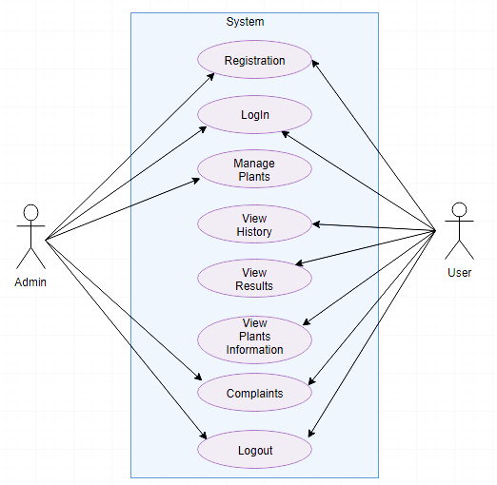

Figure 1:System use-case

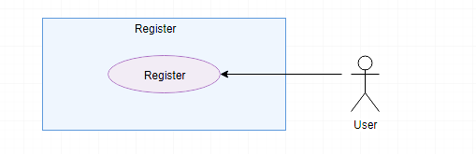

Figure 2: Register use-case

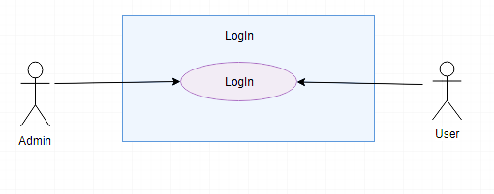
Figure 3: Login

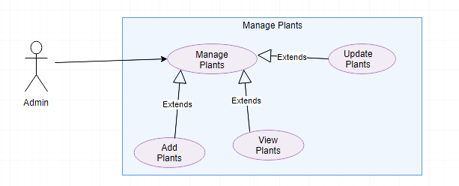
Figure 4: Manage Plants

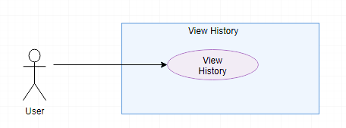

Figure 5: View History

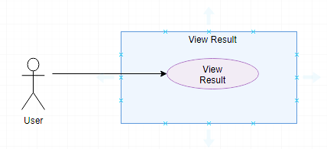

Figure 6: View Results

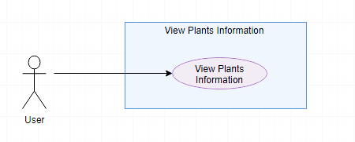

Figure 7: View Plants Information

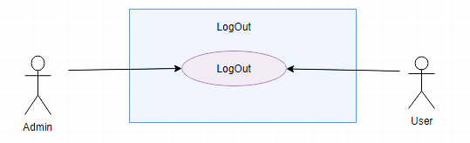

Figure 8: Logout

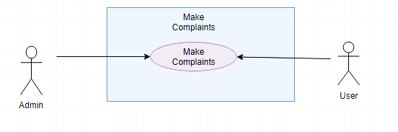
Figure 9: Make Complaints

DESIGN AND METHODOLOGY

Methodology
The development methodology which is used in this project is a scrum methodology. Scrum is a simple framework that facilitates team collaboration on the project and it is easy to understand. This model helps us to test the application on each level of development and helps us to identify the errors or bugs at each level and we have been removed the errors or apply changes at each level.
The product is based on digital image processing and android studio. Digital image processing used a computer algorithm to perform image processing on digital images. Initially, we have been trained dataset using python then we applied it to the android studio. The application detects an image of leaf, recognize their pattern and display the detail of the plant.

Research Design (Quantitative/Qualitative Model)

In our model, 20 percent qualitative and 80 percent quantitative method will be used. 20 percent for the descriptive form or collection of data which are based on reading research papers, interviews and through surveys.
80 percent data get through quantitative methods like:
- Contrast
- Correlation
- Energy
- Homogeneity
- Mean
- Standard Deviation
- Entropy
- Variance
- Smoothness
- Kurtosis
- Skewness

Top Level Architecture
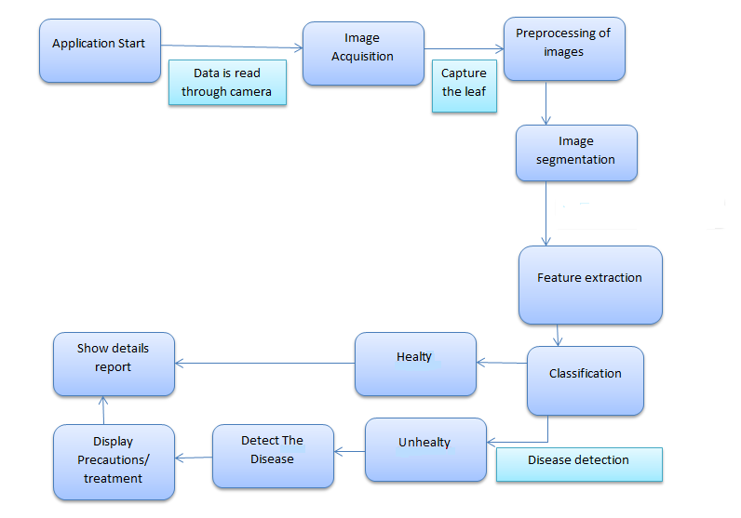

Figure 10: Top level architecture of the proposed system

DFD-0
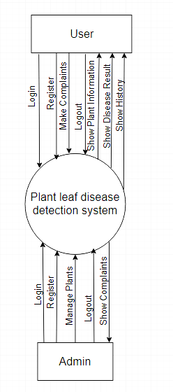
Figure 11 : DFD-0

DFD-1
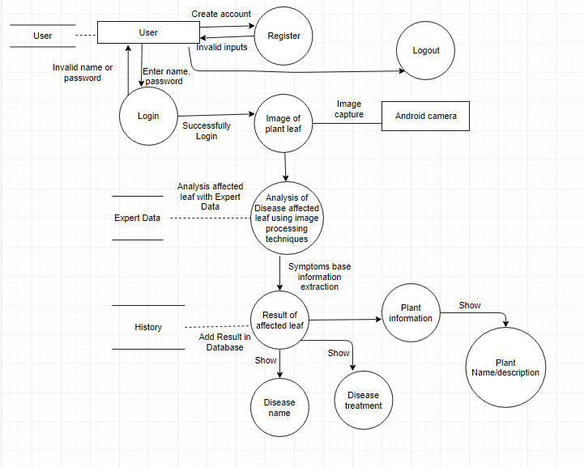
Figure 12 : DFD-1

System Sequence Diagram
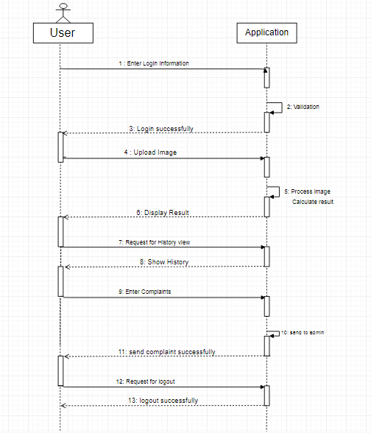
Figure 13 : System Sequence Diagram(SSD)

Design

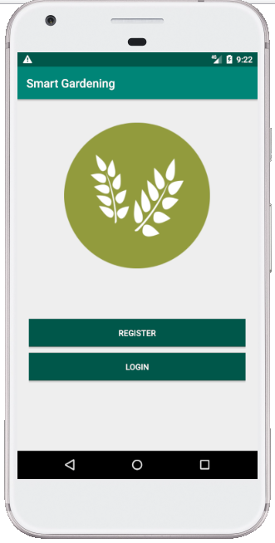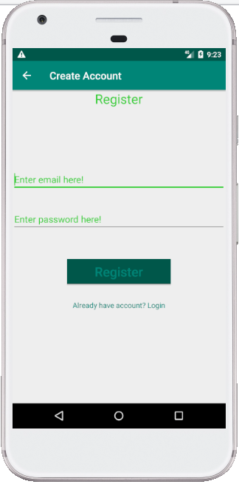
Figure 14: Home & Register user
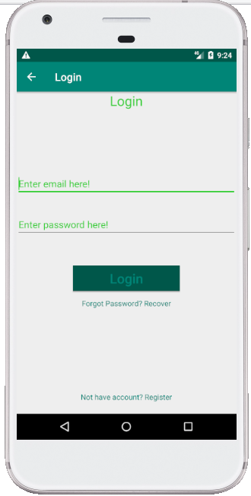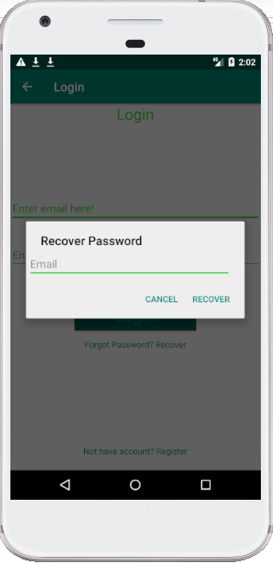
Figure 15: Login & Recover password
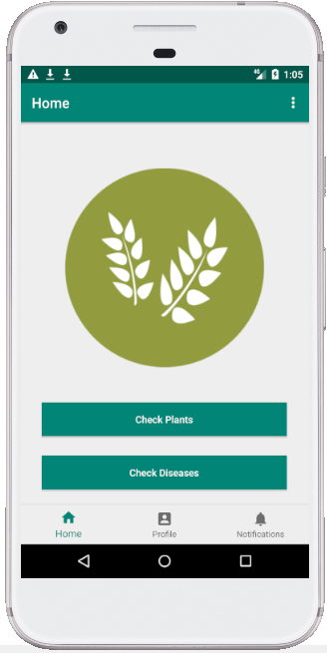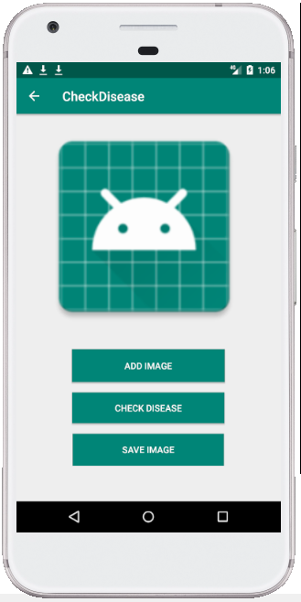
Figure 16: Post login & Check disease
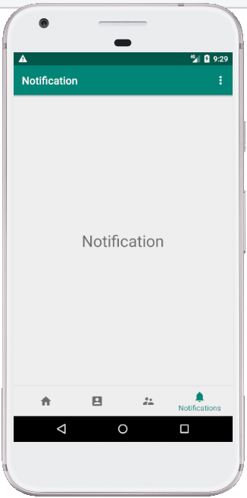
Figure 17: User profile & Notification

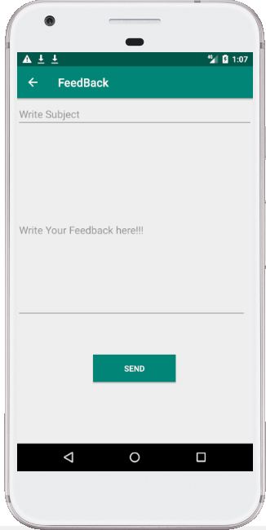
Figure 18: Feedback & History

DATA AND EXPERIMENTS (and/or IMPLEMENTATION)

Dataset
Dataset [25] consists of more than 7000 images of grape and strawberry. The images are in the form of RGB. The Disease which is available in this plant is Black Rot which is a type of fungi and the other is leaf_scorch.

Tools used for implementation

Android studio

Android studio(3.4.1) is an official integrated development environment for Google’s Android operating system, built on Jet Brains’ IntelliJ IDEA software and designed specifically for Android development. It is available for download on Windows mac OS and Linux based operating systems.

Google firebase

Firebase is a mobile and web application development platform developed by firebase.

Experimental setup
Dataset consists of two types of disease one is Balck rot and the other is Leaf_Scorch. VGG-16 Neural Network is used to classify the dataset. In VGG-16 we freeze all layers except input and output layers and customize the output layer according to the given classes.

Transfer learning
Transfer learning is a machine learning approach that is used for the improvement of learning in a new task from the already related learned task through the transfer of knowledge.
There are two common approaches which is used for transfer learning:
- Develop a model
- Pre-trained model
In the developing model, there are the following steps that are used for transfer learning.
- Source task selection
- Developing of source model
- Reuse source model
- Tune source model
In the pre-trained model following steps are used for transfer learning.
- Source model selection
A pre-trained model is selected from the available models which are released from many research institutions on large datasets.
- Reuse source model
The pre-trained model can be used for the model of interest on the second task. On the basis of using model techniques all or part of the model will be used.
- Tune source model
The model can be refined on the basis of available input and output data for an interesting task.

Google colab
Google collab is a cloud service that is used in free and it supported GPU and TPU. By using the Keras, OpenCV, Tensorflow and PyTorch libraries deep learning applications can be developed.

VGG-16
VGG-16 is a convolutional neural network architecture and it has 16 layers. These layers include convolutional layers, Max pooling layers, Activation layers, Fully connected layers.

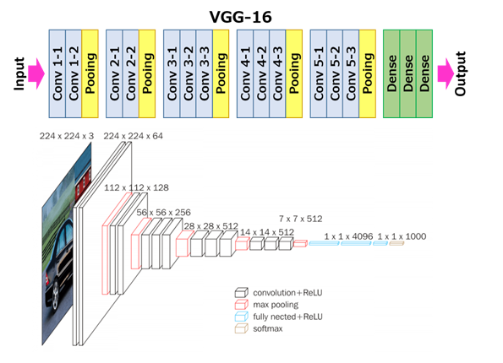
Figure 19: Architecture of VGG-16 [26]
All hidden layers of the VGG-16 model are frozen so that we don’t have to retrain the model and readjust it weights again, Also the output layer isn’t used because it contains 1000 outputs because it was trained on the ImageNet dataset and was created to classify 1000 different classes.

RESULTS AND DISCUSSIONS
A transfer learning approached is used for the training of the dataset.VGG-16 Model is used for transfer learning. we add our custom output layer of 4 classes with Softmax as the activation function shown in figure 9.
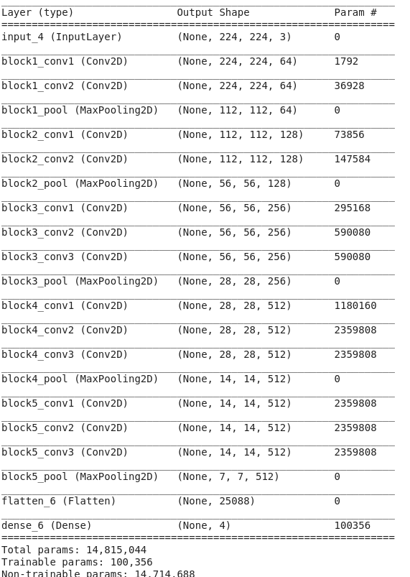
Figure 20: Model detail

Classes
There are Four Classes which are given below:
- Grape Black_Rot
- Grape Healthy
- Strawberry Leaf_Scorch
- Strawberry Healthy
Total Number of training images: 7178
Total Number of validation images: 1795

Training information
The number of epochs is a parameter which defines the number of completed passes(time) through which the learning algorithm will work throughout the given dataset. The epoch information of the training dataset is shown in figure 10.
Total number of epochs = 5
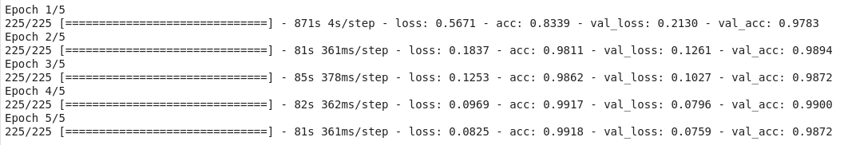
Steps per epoch = 225
Figure 21: Training information

Training accuracy
Training accuracy tells how well the data set is trained on training algorithms. When the number of epochs increase the training accuracy is also increased and after 4 epoch the training accuracy change with constant rate that is shown in figure 11.

Validation accuracy
Validation accuracy tells how well a model is performed. When the number of epochs increase the validation accuracy is also increased and after 4 epoch the validation accuracy decrease that is shown in figure 11.

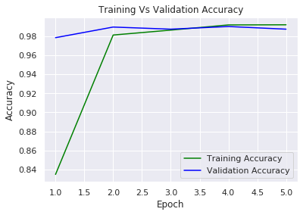

Figure 22: Training accuracy

Training Accuracy: 0.9918 or 99.18%
Validation Accuracy: 0.9872 or 98.72%

Training loss
Training loss is the error during training on the given data set. The number of epoch increase training loss starts decreasing which is shown in figure 12.

Validation loss
Validation loss is the error that occurs through the trained network after validation of the data set. As the number of epoch increase validation loss starts decreasing which is shown in figure 12.
Training Loss: 0.0825 or 8.25%
Validation Loss: 0.0759 or 7.59%

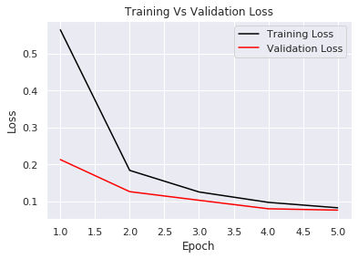

Figure 23: Training loss

Confusion matrix
The performance of the classifier can be described on a given test data set for which the true values are known. There are following basic terms which are used in confusion matrix:
- True positive (TP)
In this case, we predict that there is a disease(yes) and there is no disease.
- True negative (TN)
In this case, we predict that there is no disease(no) and there is no disease.
- False-positive (FP)
In this case, we predict there is a disease (yes) but actually, there is no disease is present.
- False-negative (FN)
In this case, we predict there is no disease (no) but actually, there is a disease is present.

'Grape___Black_rot' 'Grape___healthy' 'Strawberry___Leaf_scorch' 'Strawberry___healthy'
[ 470 2 0 0 ]

[ 4 414 0 5 ]

[ 0 0 432 12 ]

[ 0 0 0 456 ]

Classification report
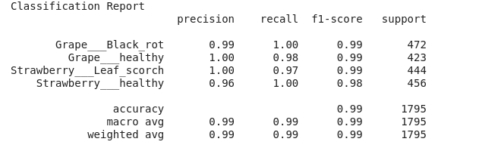
By applying the different algorithms of classification, the quality of predictions can be measured by using a classification report shown in fig 13.

Figure 24: Classification report
- Precision
Precision is the ratio of positive observation which is correctly predicted to the total predicted positive observation. When the precision value is high relates to the low rate of false positive.
Precision = TP/TP+FP
- Recall
Recall is the ratio of positive observation which is predicted to the all observation present in actual class.
Recall = TP/TP+FN

- F1-score
F1-score is the weighted average of precision and recall.
F1 Score = 2*(Recall * Precision) / (Recall + Precision)
- Support
Support is the number of occurrences of the class in the specified dataset.

CONCLUSION AND RECOMMENDATIONS
Recognizing the disease is mainly the purpose of the transfer learning approach. The model is used for transfer learning is “VGG-16”.It has 16 layers and the VGG-16 network is trained on the ImageNet dataset with 92.7% accuracy. By using smart gardening application users detecting the grape and strawberry disease easily. The diseases which are detecting by using application are Black_Rot and Leaf_Scorch. The results show that the VGG-16 has achieved Training Accuracy 99.18% and Validation Accuracy 98.72% which is very promising.
Future Scope
- More plants
More plants will be added in the training dataset and it will helpful for the user to know about more plants and they're how to protect them from diseases.
- More diseases
More disease will be detected by using this application. Users easily detect more diseases and know about the treatment of that disease that will be helpful for the user to save the plants on the timely detection of diseases.
- Home services
Home services like medicine of detected diseases will be provided on the user call and the user can easily consult with the specialist or experienced person for the proper guideline on plants affected by the diseases.
- Create a website
A proper website will be created which can be used by anyone related to information of plants and proper farming and disease attacks on each plant. Specialist guidelines and nearly available medicines details will also be provided to the user by this website.

REFERENCES

[1] | Ms. Monika Gupta, "Plant Disease Detection using Digital Image Processing," International Journal of Innovations & Advancement in Computer Science , vol. 7, no. 5, p. 6, May 2018.
[2] | Sujatha R , Y Sravan Kumar , and Garine Uma Akhil , "Leaf disease detection using image processing," Journal of Chemical and Pharmaceutical Sciences , vol. 10, no. 1, p. 3, January - March 2017.
[3] | (2017, 27-january) home-gardening-a-sound-approach-to-food-security. nation.com.pk.
[4] | (2017, 14-january) home-gardens-a-sound-approach-to-food-security. www.pakistantoday.com.pk.
[5] | Gavhale, Gawande , and K. R. , "An Overview of the research on plant leaves disease detection using image processing techniques," IOSR J. of Computation Engineering (IOSR-JCE), vol. 16, pp. 10-16, 2014.
[6] | Valliammai , Geethaiakshmi , and S.N. , "Multiple noise reduction using hybrid method for leaf recognition," 2012 International Conference on Devices, Circuits and Systems (ICDCS), vol. 7, pp. 15-16, March 2012.
[7] | Singh , V. and Mishra , and A. K. , "“Detection of plant leaf diseases using image segmentation and soft computing techniques," in InformationProceedings in Agricultur, 2016.
[8] | Kaur , P. and Singla , and S. , "A review on plant leaf disease detection techniques," International Journal of Innovative in Engineering and Technology, vol. 7, pp. 539-543, 2016.
[9] | Xia , Y. Q. , Li , and Y.and Li , "Intelligent diagnose system of wheat diseases based on android phone," Journal of Information& Computation Science, vol. 12, pp. 6845-6852, 2015.
[10] | S.Selvarajah and S.R. Kodituwakku , "Analysis & comparison of texture features for CBIR," International Journal of Latest Trends in Computing, vol. 2, pp. 2045-536, March 2011.
[11] | Dengsheng Zhang and Guojun Lu , "A comparative study on shape retrieval using Fourier descriptor with different shape signatures," in Gippsland School of Computing and Information Technology. In Proc. of IEEE Conference on Multimedia and Expo, 2001.
[12] | Shreekant Ghorpade , Prakash M. Mainkar , and Mayur Adawadkar , "Plant Leaf Disease Detection and Classification Using Image," International Journal of Innovative and Emerging, vol. 2, no. 4, pp. 2394 – 5494, 2015.
[13] | Iqbaldeep Kaur , Gifty Aggarwal , and Amit Verma , "Detection and Classification of Disease Affected Region of Plant Leaves using Image Processing," Indian Journal of Science and Technology, vol. 9, December 2016.
[14] | Sumit Nema , Bharat Mishra , and Mamta Lambert , "Advance App Design Methods of Leaf Disease Detection using Image Processing Approach – A Review," International Journal of Innovative Research in Science,Engineering and Technology, vol. 6, no. 7, pp. 13277-13283, July 2017.
[15] | Joko Prasetyo , Kurnia Muludi , and Mita Fuljana , "Expert System of Chili Plant Disease Diagnosis using Forward Chaining Method on Android," International Journal of Advanced Computer Science and Applications, vol. 8, no. 11, pp. 164-168, 2017.
[16] | Desale Minakshi , Patil Mayuri , Ballal Sayali , and G.M.Poddar , "Android Application for Leaf Disease Recognition," International Journal of Engineering Science and Computing, vol. 7, no. 10, pp. 15293-15295, October 2017.
[17] | Ehsan Kiania and Tofik Mamedov , "Identification of plant disease infection using soft-computing: Application to modern botany," in 9th International Conference on Theory and Application of Soft Computing, Computing with Words and Perception, Budapest, Hungary, 4-25 August 2017, pp. 893-900.
[18] | Chaitra K M, , Faiza Anjum , Harshitha I P , and Rachitha M V , "Plant Leaf Disease Identification System for Android," International Journal of Engineering Research in Computer Science and Engineering, vol. 5, no. 6, pp. 48-53, June 2018.
[19] | Appasaheb and Khandekar, Mr SA Gargade, "A Review: Custard Apple Leaf Parameter Analysis and Leaf Disease Detection using Digital Image Processing," in 3rd International Conference on Computing Methodologies and Communication (ICCMC), 2019, pp. 267--271.
[20] | DM Motiur and Baby, Tintu and Oczkowski, Alex and Paul, Manoranjan and Zheng, Lihong and Schmidtke, Leigh M and Holzapfel, Bruno P and Walker, Rob R and Rogiers, Suzy Y Rahaman, "Grapevine nutritional disorder detection using image processing," in Pacific-Rim Symposium on Image and Video Technology, Springer, 2019, pp. 184--196.
[21] | Mercelin and Deisy, C Francis, "Disease Detection and Classification in Agricultural Plants Using Convolutional Neural Networks—A Visual Understanding," in 2019 6th International Conference on Signal Processing and Integrated Networks (SPIN), 2019, pp. 1063--1068.
[22] | Nikhil and Jain, Sarika Shah, "Detection of Disease in Cotton Leaf using Artificial Neural Network," in 2019 Amity International Conference on Artificial Intelligence (AICAI), 2019, pp. 473--476.
[23] | V and Shetty, R Amog and Tated, Rishab F and Rohan, Sunku and Pujar, Triveni S Suma, "CNN based Leaf Disease Identification and Remedy Recommendation System," in 2019 3rd International conference on Electronics, Communication and Aerospace Technology (ICECA), 2019, pp. 395--399.
[24] | SM and Mirunalini, P and Thenmozhi, D and others Jaisakthi, "Grape Leaf Disease Identification using Machine Learning Techniques," in 2019 International Conference on Computational Intelligence in Data Science (ICCIDS), 2019, pp. 1--6.
[25] | (2016) GitHub. [Online]. www.github.com/spMohanty/PlantVillage-Dataset
[26] | (2018, November) VGG16 - Convolutional Network for Classification and Detection. [Online]. https://neurohive.io/en/popular-networks/vgg16/

.

APPENDICES
Python Code use for training
“”
Package: Cnn.py
Author: Umar Farooq & Sehrish Ghaffar
Last Modified: 04/12/2019
"""

# Importing Plotting & Matrix Libraries
import seaborn as sns
import matplotlib.pyplot as plt
import numpy as np

# Importing Keras Libraries And Packages
from keras.callbacks import ModelCheckpoint
from keras.layers import Dense, Flatten
from keras.models import Model
from keras.applications.vgg16 import VGG16
from keras.preprocessing import image
from keras.preprocessing.image import ImageDataGenerator
from keras import optimizers

# Importing Metrics Functions From Scikit-Learn
from sklearn.metrics import classification_report, confusion_matrix

# Train And Validation Datasets
train_path = "Dataset/train"
valid_path = "Dataset/valid"

# Image Should Be Resized To 224 X 224
IMAGE_SIZE = [224, 224]

class ConvolutionalNeuralNetwork:
"""
Custom Implementation Of CNN Using VGG-16 as Base
"""

def __init__(self):
# Initializing The CNN

self.num_of_classes = 4

self.base_model = VGG16(input_shape=IMAGE_SIZE + [3], weights='imagenet', include_top=False)

# Freezing Hidden Layers Of VGG-16 So That We Don't Train Existing Weights
for layer in self.base_model.layers:
layer.trainable = False

def define_model(self):
# Adding Layers To The Model

layer = Flatten()(self.base_model.output)

# Adding Custom Ouput Layer To The Model With 4 Classes
output_layer = Dense(self.num_of_classes, activation='softmax')(layer)

# Create A New Customised Model From Base Model And New Output Layer
self.model = Model(inputs=self.base_model.input, outputs=output_layer)

# View The New Structure Of The Model
self.model.summary()

# Setting The Optimazation And Cost/Loss Functions For Model
self.model.compile(
loss='categorical_crossentropy',
optimizer=optimizers.SGD(lr=0.001, nesterov=True),
metrics=['accuracy']
)

def preprocess_images(self):
# Using Image Augmentation To Increase Features/Images

self.train_datagen = ImageDataGenerator(rescale=1. / 255,
shear_range=0.2,
zoom_range=0.2,
horizontal_flip=True)

self.valid_datagen = ImageDataGenerator(rescale=1. / 255)

self.training_set = self.train_datagen.flow_from_directory(train_path,
target_size=(224, 224),
batch_size=32,
class_mode='categorical')

self.valid_set = self.valid_datagen.flow_from_directory(valid_path,
target_size=(224, 224),
batch_size=32,
class_mode='categorical')

self.train_num = self.training_set.samples
self.valid_num = self.valid_set.samples

def create_checkpoints(self):
# Saving Best Weights On Every Epoch

weightpath = "Best_Weights.hdf5"
checkpoints = ModelCheckpoint(weightpath, monitor='val_acc', verbose=1, save_best_only=True,
save_weights_only=True, mode='max')
self.callback_list = [checkpoints]

def train_model(self):
# Training The Model

training_history = self.model.fit_generator(
self.training_set,
validation_data=self.valid_set,
epochs=5,
steps_per_epoch=len(self.training_set),
validation_steps=len(self.valid_set),
callbacks=self.callback_list)

self.history = training_history.history

def save_model(self):
# Saving The Trained Model

file_path = "Model.hdf5"
self.model.save(file_path)

def visualize_results(self):
# Plot Training And Validation Learning Curves

sns.set()

acc = self.history['acc']
val_acc = self.history['val_acc']
loss = self.history['loss']
val_loss = self.history['val_loss']
epochs = range(1, len(loss) + 1)

# Accuracy Plot
plt.plot(epochs, acc, color='green', label='Training Accuracy')
plt.plot(epochs, val_acc, color='blue', label='Validation Accuracy')
plt.title('Training Vs Validation Accuracy')
plt.ylabel('Accuracy')
plt.xlabel('Epoch')
plt.legend()

plt.figure()
# Loss Plot
plt.plot(epochs, loss, color='black', label='Training Loss')
plt.plot(epochs, val_loss, color='red', label='Validation Loss')
plt.title('Training Vs Validation Loss')
plt.xlabel('Epoch')
plt.ylabel('Loss')
plt.legend()

plt.show()

def generate_classification_metrics(self):
# Generating Confusion Matrix And Classification Report

test_datagen = image.ImageDataGenerator(rescale=1. / 255)
img_batch = test_datagen.flow_from_directory(valid_path, target_size=(224, 224), shuffle=False)

predictions = self.model.predict_generator(img_batch, steps=1795 // 32 + 1)

y_pred = np.argmax(predictions, axis=1)
y_true = img_batch.classes

print('\nConfusion Matrix')
print(confusion_matrix(y_true, y_pred))

print('\n\n')

print('Classification Report')
class_names = ['Grape___Black_rot', 'Grape___healthy', 'Strawberry___Leaf_scorch', 'Strawberry___healthy']
print(classification_report(y_true, y_pred, target_names=class_names))

if __name__ == '__main__':
cnn = ConvolutionalNeuralNetwork()
cnn.define_model()
cnn.preprocess_images()
cnn.create_checkpoints()
cnn.train_model()
cnn.save_model()
cnn.visualize_results()
cnn.generate_classification_metrics()

