
BSCS-S19-019
03-134161-052 | HAMZA ZIA
03-134161-022 | MUHAMMAD USMAN
03-134161-026 | SALMAN AHMED BUTT

Move Together

In partial fulfillment of the requirements for the degree of
Bachelor of Science in Computer Science
Supervisor: Nadeem Sarwar
Department of Computer Sciences
Bahria University, Lahore Campus
January 2020

© Bahria University, 2020

Certificate

We accept the work contained in the report titled
“Move Together”
written by
HAMZA ZIA
MUHAMMAD USMAN
SALMAN AHMED BUTT
as a confirmation to the required standard for the partial fulfillment of the degree of
Bachelor of Science in Computer Science.

Approved by:
Supervisor: Nadeem Sarwar
(Signature)

January 27, 2020

DECLARATION

We hereby declare that this project report is based on our original work except for citations and quotations which have been duly acknowledged. We also declare that it has not been previously and concurrently submitted for any other degree or award at Bahria University or other institutions.

Enrolment | Name | Signature
03-134161-052 | HAMZA ZIA
03-134161-022 | MUHAMMAD USMAN
03-134161-026 | SALMAN AHMED BUTT

Date : January 27, 2020

Specially dedicated to
my beloved family
(Hamza Zia)
my beloved grandmother, mother, and father
(Muhammad Usman)
my beloved grandmother, mother, and father
(Salman Ahmed Butt)

ACKNOWLEDGEMENTS

We would like to thank everyone who had contributed to the successful completion of this project. We would like to express our gratitude to our research supervisor, Mr. NADEEM SARWAR for his invaluable advice, guidance and his enormous patience throughout the development of the research.

In addition, We would also like to express our gratitude to our loving parents and friends who had helped and given me encouragement.

Hamza Zia
Muhammad Usman
Salman Ahmed Butt

MOVE TOGETHER

ABSTRACT

Groups that work well together can achieve much more than individuals working on their own. While traveling alone, every responsibility depends upon you for finding accommodation, all other stuff and making sure you get the best from your destination. A good way to organize group traveling. In group traveling, we face many difficulties to reach the exact location and find where are our trip mates. Google map provides location service but not provide the facility of making groups and to chat with members while traveling. In this application, we can make groups in which every group member’s phone number is used as his/her ID to track and communicate with other group members on the same map interface and share their location. In case of internet un-availability, using this application they will broadcast their message through Short Message Service (SMS) instead of Mobile-Internet along with GPS. The chat module will help in broadcasting messages to all group members.

TABLE OF CONTENTS

DECLARATION ii
ACKNOWLEDGEMENTS iv
ABSTRACT v
TABLE OF CONTENTS vi
LIST OF TABLES ix
LIST OF FIGURES x
LIST OF APPENDICES xiii

CHAPTERS
1 INTRODUCTION 1
1.1 Background 1
1.2 Problem Statements 2
1.3 Aims and Objectives 2
1.4 Scope of Project 3
1.4.1 Primary Scope 3
1.4.2 Optional Scope 3
2 SRS 4
2.1 Primary User 4
2.2 Operating Environment 4
2.3 Design and Implementation Constraints 5
2.4 Assumptions and Dependencies 5
3 DESIGN AND METHODOLOGY 6
3.1 Design 6
3.2 Use Case Diagrams 7
3.2.1 System Use Case Diagram 7
3.2.2 Register Use Case Diagram 8
3.2.3 Create a Group Use Case Diagram 8
3.2.4 View Member Use Case Diagram 9
3.2.5 Show Location Use Case Diagram 9
3.2.6 Update Location Use Case Diagram 10
3.2.7 Communication Use Case Diagram 10
3.3 Use a Case a Descriptions 11
3.3.1 Register UC1 11
3.3.2 Create Group UC2 12
3.3.3 View Group Members UC3 13
3.3.4 Show Location UC4 14
3.3.5 Communication UC5 15
3.4 Sequence Diagrams 16
3.4.1 Sequence Diagrams of Registration 16
3.4.2 View Group Members 16
3.4.3 Show Location 17
3.4.4 Sequence Diagrams of View Group Members Location 17
3.4.5 Sequence Diagrams of Broadcast Message 18
3.5 Domain Model 19
3.6 Collaborative Diagram 20
3.6.1 Register User 20
3.6.2 Create Group 20
3.6.3 View Group Members 21
3.6.4 Show Location 21
3.6.5 Hide Location 22
3.6.6 Show Group Members Location 22
3.6.7 Broadcast Message 23
3.6.8 Set Communication Mode 23
3.6.9 Set Location Update Time 24
3.7 Class Diagram 24
3.8 Data Model 25
3.9 Use Case Description 26
3.9.1 Register User 26
3.9.2 Create Group 26
3.9.3 View Group Members 27
3.9.4 Show Location 27
3.9.5 Communication 28
3.10 Methodology 29
4 DATA AND IMPLMENTATION 30
4.1 Languages used for Implementation 30
4.1.1 JAVA 30
4.2 Tools for Implementation 30
4.2.1 Android Studio. 30
4.2.2 XML 30
4.2.3 SQLite 30
4.3 Key Features 31
5 USER MANUAL 32
5.1 User Manual 32
6 CONCLUSION AND RECOMMENDATIONS 47
6.1 Conclusion 47
6.2 Recommendations 47
6 REFERENCES 49
6 APPENDICES 50

LIST OF TABLES

TABLE TITLE PAGE
Table 3-1: Registration use-case 11
Table 3-2: Create Group use-case 12
Table 3-3: View Group Members use-case 13
Table 3-4: Show Location use-case 14
Table 3-5: Communication use-case 15
Table 3-6: Register User 26
Table 3-7: Create Group 26
Table 3-8: View Group Members 27
Table 3-9: Show Location 27
Table 3-10: Communication 28

LIST OF FIGURES

FIGURE TITLE PAGE
Figure 3-1: System Use-Case Diagram 7
Figure 3-2: Register Use-Case Diagram 8
Figure 3-3: Create Group Use-Case Diagram 8
Figure 3-4: View Members Use-Case Diagram 9
Figure 3-5: Show Location Use-Case Diagram 9
Figure 3-6: Update Location Use-Case Diagram 10
Figure 3-7: Communication Use-Case Diagram 10
Figure 3-8: Register Sequence Diagram 16
Figure 3-9: View Group Members Sequence Diagram 16
Figure 3-10: Show Location Sequence Diagram 17
Figure 3-11: View Group Members Location Sequence Diagram 17
Figure 3-12: Broadcast Message Sequence Diagram 18
Figure 3-13: Domain Model 19
Figure 3-14: Register User Collaboration diagram 20
Figure 3-15: Create Group Collaboration diagram 20
Figure 3-16: View Group Members Collaboration diagram 21
Figure 3-17: Show Location Collaboration diagram 21
Figure 3-18: Hide Location Collaboration diagram 22
Figure 3-19: Show Group Members Location Collaboration diagram 22
Figure 3-20: Broadcast Message Collaboration diagram 23
Figure 3-21: Set Communication Mode Collaboration diagram 23
Figure 3-22: Set Location Update Time Collaboration diagram 24
Figure 3-23: Data Model 24
Figure 3-24: ERD 25
Figure 3-25: Waterfall Model 29
Figure 5-1: Registration 32
Figure 5-2: Show Contacts 33
Figure 5-3: Groups 34
Figure 5-4: Select Contact 35
Figure 5-5: Create Group selected contacts 36
Figure 5-6: Join Group 37
Figure 5-7: Profile 38
Figure 5-8: Select image from camera or gallery 39
Figure 5-9: Save Profile 40
Figure 5-10: App Permissions 41
Figure 5-11: Invite Contacts to use app 42
Figure 5-12: Group member’s location 43
Figure 5-13: Navigation 44
Figure 5-14: Speed Notifier 45
Figure 5-15: Chat 46
Figure 5-16: More Options 47

ABBREVIATIONS

SMS Short Message Service
XML Extensible Markup Language
SQL Structured Query Language.
UML Unified Modeling Language
ERD Entity–Relationship Diagram
UC Use Case
GPS Global Positioning System
GB Gigabyte

LIST OF APPENDICES

APPENDIX TITLE PAGE
APPENDIX A: Graphs 19
APPENDIX B: Computer Programme Listing 20

INTRODUCTION

Background

People face a lot of problems while traveling in groups. Sometimes they lost their location between them and face difficulty to find each other. This is also possible that someone forgot the path and remain behind other member of their group. This leads to the wastage of time and even divert people from their purpose of traveling.
At present, Google Maps is good in location-based services but even Google Maps is not providing the facility to make a group and share user’s location based on their real-time current location offline without access to the internet.
Our application (MOVE TOGETHER) will facilitate the people traveling in groups in such a way that people will don’t lose their way. They can see each other’s location on the map. They can chat with each other while traveling. And also in the case of internet unavailability, our application will communicate through standard text messages. They can also decide a meeting point where people can meet, a complete route to that location will be provided so that they can travel with ease.
The project is basically a group traveling purpose application which will solve the problem of locating people or fellows without any internet dependency. In this application, one can make groups in which every group member’s phone number is used as his/her ID to track and communicate with other group members on the same map interface.
The application will communicate through Short Message Service (SMS) instead of Mobile-Internet along with GPS. The chat module will help in broadcasting messages to all group members.

Problem Statements

People often travel in the form of groups for refreshing their minds, so we have observed it many times that when we travel in groups like in two or more vehicles, for example going for a trip, often we are left behind by others and lose our way. Directions given by others on the phone calls or SMS are vague and one can’t comprehend them easily. As a result, we face many difficulties to reach the exact location where our trip mates currently are. We need to find them as soon as possible. so that we can continue our journey with them. It's the need of the hour to have such a platform through which one can locate his trip mates so that one can reach to their location to continue one’s journey with them.

Aims and Objectives

Following are the Objectives:
- Providing an easy map interface to visualize all the team/group members and provides a route map for all the members to reach the desired destination.
- To provide assistance to the users in the area where there is no internet and will provide the application’s communication through standard text messages (SMS).
- Provide the Facility to invite friends for downloading the Application.
- To provide a chat module by which users will be able to chat with each other in their journey.
- Interactive Interface
- Emojis
- Auto Vocabulary

Scope of Project

Primary Scope
This application facilitates students, tourists and trip organizers to easily move together without any worry. Users can locate every member on the map and share information.
Many traveling apps provide the facility, but they provide online. This Application facilitates users even if they don’t have internet availability

Optional Scope
- This application may also provide Online working Module
- Live Location
- Share Pictures
- Send Audio
- Users can feedback about the route.
- There may be some adds.

SRS

Primary User

- Android smartphone users

They can create an account via Android application and can perform all the operations provided by our application, for example, create an account, make groups, add members in the group, broadcast messages to group members, show or hide location and locate members of the group on the map interface.

Operating Environment

The project is basically an Android-based application and the minimum requirement is an android phone with at least Jelly Bean version 4.1. The hardware components we are going to use for this project are Android mobile phones and tablets. Software components of our system include Android Studio and Adobe Illustrator to build an application.

Design and Implementation Constraints

Basically, we are designing an android mobile application. Time is a major constraint. The app is totally depending on Short Message Service (SMS) through which communication and location and location will be shared. To communicate with an SMSC, an SMSC protocol is required. The most commonly used SMSC protocol is SMPP (Short Message Peer to Peer) that most of the mobile operator companies used. For the development side, A minimum 4th generation system with i3 Processor is required to build this application. The minimum RAM required is 8 GB and 128 GB of Hard Disk to work without any interruptions.

Assumptions and Dependencies

There is an assumption that the application runs in an accurate manner. We have assessed the feasibility of information. It is complete, reliable, and meaningful. We will use GPS to get the current location of every user. All requirements and goals of our project are clearly defined. Our system is legally and ethically correct and secure. No such feature has been used that would because of any infringements or liabilities. We will give our privacy policy to the user to make our intentions clear.
The major dependencies of our app are mobile network and an SMS package through which our app will be working. The signal must be strong enough to send and receive a message on time and the user must be subscribed to an SMS package to avoid any credit loss.

DESIGN AND METHODOLOGY

Design

Following Diagrams Represent the Design Methodology of the project.
1. Use case diagrams
2. Use case descriptions
3. Sequence diagrams
4. Collaborative Diagram
5. Domain Model
6. Entity Relationship Diagrams
7. Design Class Diagram
8. Operation Contract

Use Case Diagrams

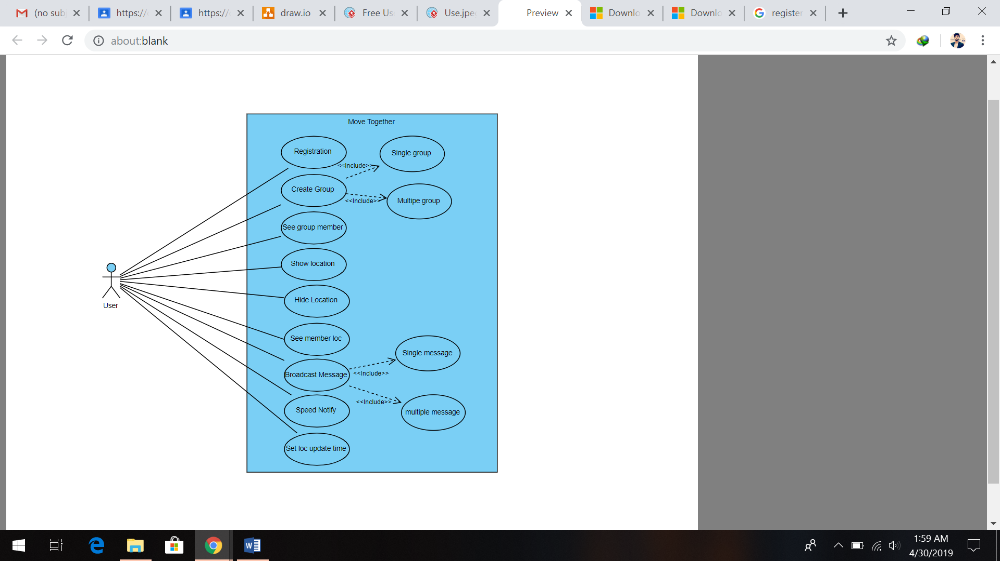
System Use Case Diagram

Figure 3-1: System Use-Case Diagram

Register Use Case Diagram
The following Figure.2 shows the Register Use-case.diagram.
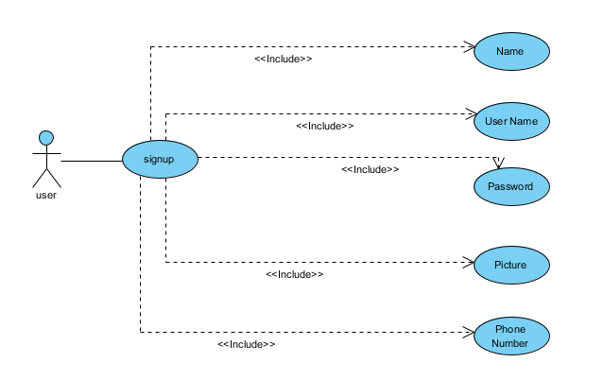
Figure 3-2: Register Use-Case Diagram

Create a Group Use Case Diagram
The.following.Figure.3 shows.the.Group.Creation.Use-case diagram.
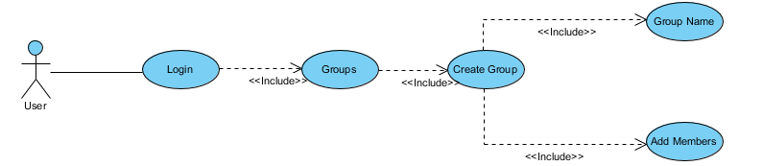

Figure 3-3: Create Group Use-Case Diagram

View Member Use Case Diagram
The.following.Figure.4.shows.the.View.Members.Use-case diagram.

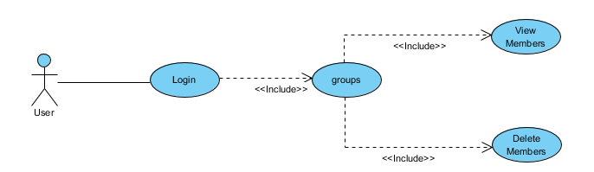
Figure 3-4: View Members Use-Case Diagram

Show Location Use Case Diagram
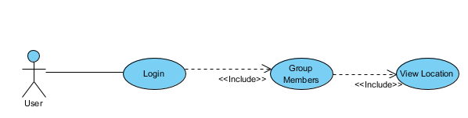
The.following.Figure.5.shows.the.Show.Location.Use-case diagram.

Figure 3-5: Show Location Use-Case Diagram

Update Location Use Case Diagram
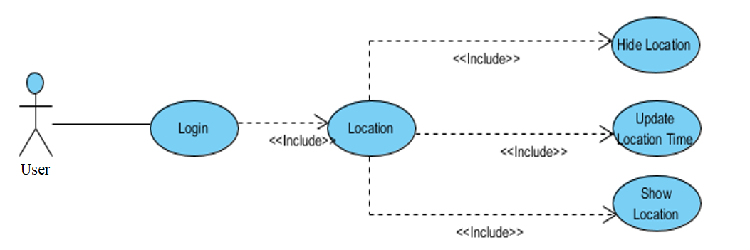
The.following.Figure.6.shows.the.Update.Location.Use-case diagram.

Figure 3-6: Update Location Use-Case Diagram

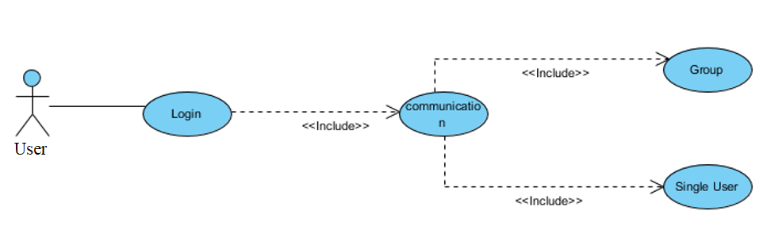
Communication Use Case Diagram

Figure 3-7: Communication Use-Case Diagram

Use a Case a Descriptions
Below are the detailed description of Use Cases.

Register UC1
Use a Casean ID | UC1
Use a Case a Name: | Signup
Primary Actors: | User
Brief a description: | A.user.can.register.himself.to.the.system.by.entering.his.phone number.
Preconditions | - User is connected to the internet
Postconditions | User is registered to the system
Basic flow
Actor a Action |  | System a Response
1. A user enters his phone no in the phone number field on the UI screen and clicks.on the.register.button. |  | 1.The.system.verifies.that.the.phone number.is.valid.and belongs to the user. The user is registered and logged in.
Alternate flows
Actor a Action |  | System a Response
A user enters the wrong phone number or some random phone number in the phone number field on the UI screen and clicks on the register button. |  | The.ystem.shows.an.error.message to.the.user.that the phone number is not valid and asks.the.user.to.enter a.valid.phone.number. The.user is not registered.

Table 3-1: Registration use-case

Create Group UC2
Use a Case a ID | UC2
Use a Case a Name: | Create a Group
Actors a: | User
Brief a description: | A user can create groups and add members in it
Preconditions | User is registered
Postconditions | The group is successfully created
Basic a flow
Actor a Action |  | System a Response
A user selects the group members from his contacts and enters the group name and clicks.on.the.create.group.button. |  | The.system verifies that the.members are not exceeded from the limit and the group is created.
Alternate flows
Actor Action |  | System Response
A user selects group members more than the limit and clicks a a on a a the a create group button. |  | The a system shows an a error a message a to a the user a that a the members’ count has exceeded the limit and asks the user to enter members according to the members’ limit. The group is not created.

Table 3-2: Create Group use-case

View Group Members UC3
Use a Case a ID | UC3
Use a Case a Name: | View Group Members
Actors: | User
Brief a description: | A user can view group members of the group of which it is a member
Preconditions | - User is registered  - User a is a a a member a of a the a group
Postconditions | User successfully views group members
Basic.flow
Actor.Action |  | System.Response
User can click on the see group members button. |  | The system fetches data from the database and displays a list a of members successfully.
Alternate flows
Actor Action |  | System Response
A user can click on the seeing group members button and there are no members in a group. |  | The system fetches data from the database and shows an error message of “No group Members”
Table 3-3: View Group Members use-case

Show Location UC4
Use a Case a ID | UC4
Use a Case a Name: | Show Location
Actors: | User
Brief a description: | A user can show his location to other members of the group
Preconditions | - User is registered  - User is a member of the group
Postconditions | User location is shown to other members of the group
Basic.flow
Actor.Action |  | System.Response
A user can click on the show location button. |  | The.system.updates.the.user.location.  status to available.
Table 3-4: Show Location use-case

Communication UC5
Use a Case a ID | UC5
Use a Case a Name: | Communication
Actors: | User
Brief a description: | A user can broadcast messages to other members of the group
Preconditions | - User is registered  - User is a member of the group
Postconditions | The message is successfully broadcasted to other group members of the group
Basic.flow
Actor.Action |  | System.Response
A user can click on the group, enters the message and click on the broadcast message button. |  | The.system broadcasts the.message to all the group members.
Alternate flows
Actor Action |  | System Response
A user can click on the group, enters the message and clicks on the broadcast message button and there are no members in a group. |  | The system fetches data from the database and shows an error message of “no group members”.

Table 3-5: Communication use-case

Sequence Diagrams
Following are the Sequence diagrams

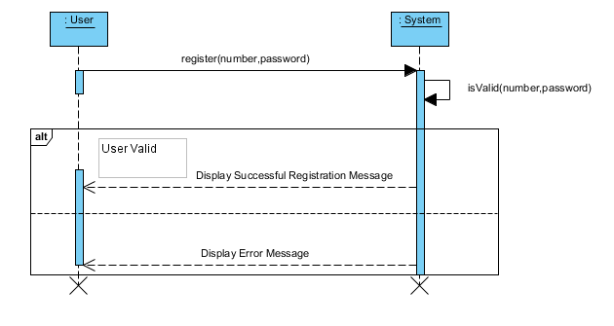
Sequence Diagrams of Registration
Figure 3-8: Register Sequence Diagram

View Group Members
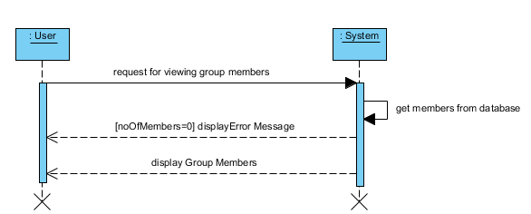
Figure 3-9: View Group Members Sequence Diagram

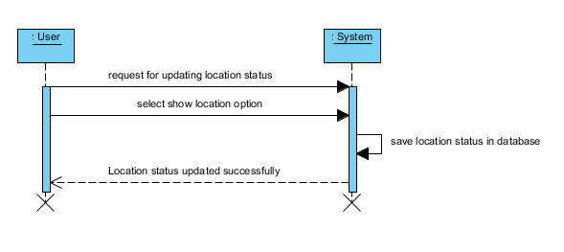
Show Location

Figure 3-10: Show Location Sequence Diagram

Sequence Diagrams of View Group Members Location
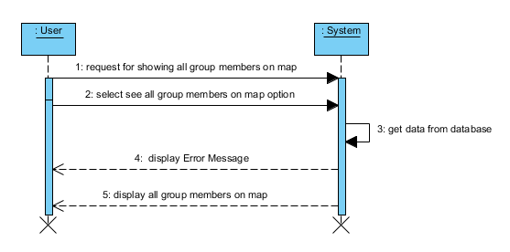
Figure 3-11: View Group Members Location Sequence Diagram

Sequence Diagrams of Broadcast Message
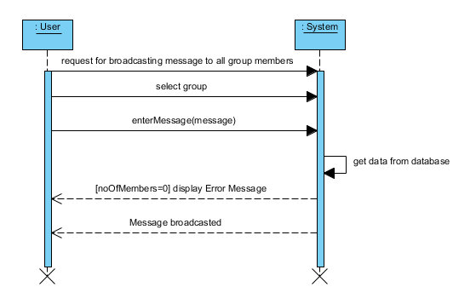
Figure 3-12: Broadcast Message Sequence Diagram

Domain Model
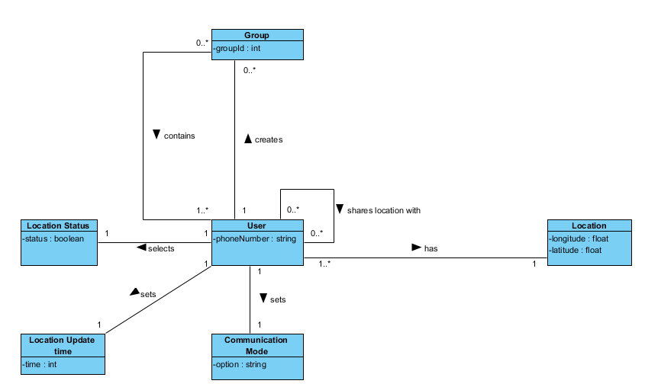
Following.is.the.Domain.Model.of.the.project.

Figure 3-13: Domain Model

Collaborative Diagram

Register User
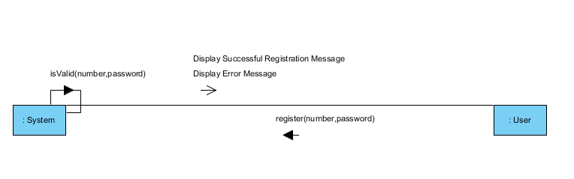
Figure 3-14: Register User Collaboration diagram

Create Group
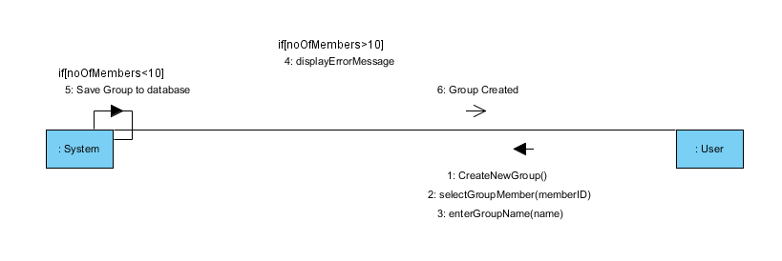

Figure 3-15: Create Group Collaboration diagram

View Group Members
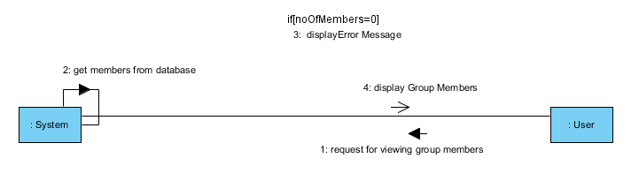

Figure 3-16: View Group Members Collaboration diagram

Show Location

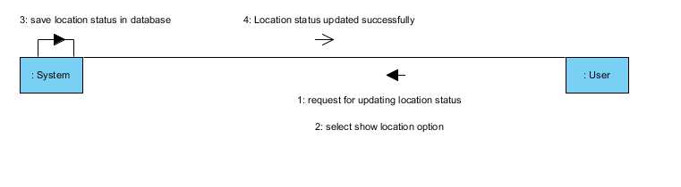

Figure 3-17: Show Location Collaboration diagram

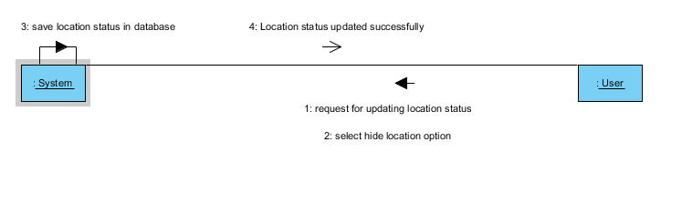
Hide Location

Figure 3-18: Hide Location Collaboration diagram

Show Group Members Location
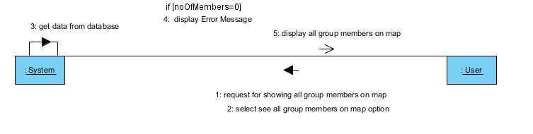

Figure 3-19: Show Group Members Location Collaboration diagram

Broadcast Message
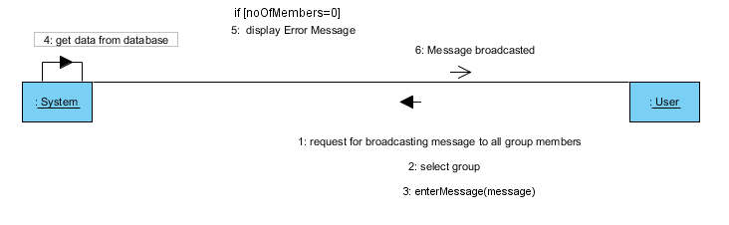

Figure 3-20: Broadcast Message Collaboration diagram

Set Communication Mode
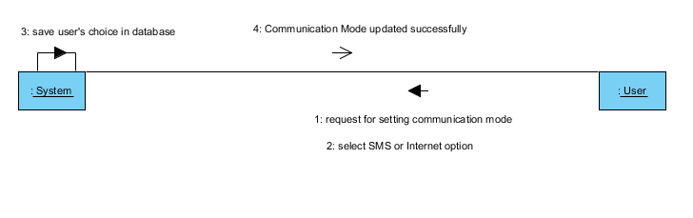

Figure 3-21: Set Communication Mode Collaboration diagram

Set Location Update Time
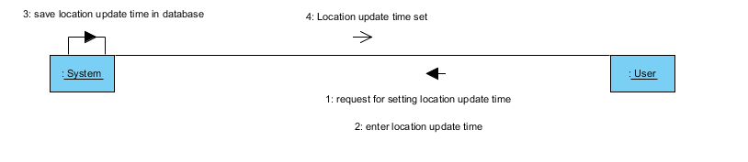

Figure 3-22: Set Location Update Time Collaboration diagram

Class Diagram
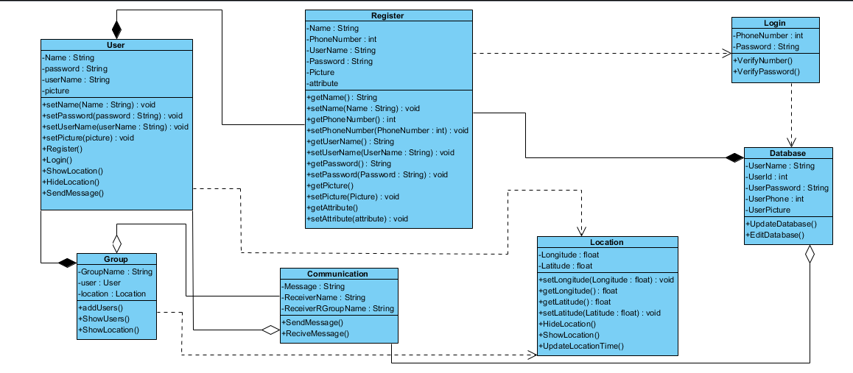

Figure 3-23: Data Model
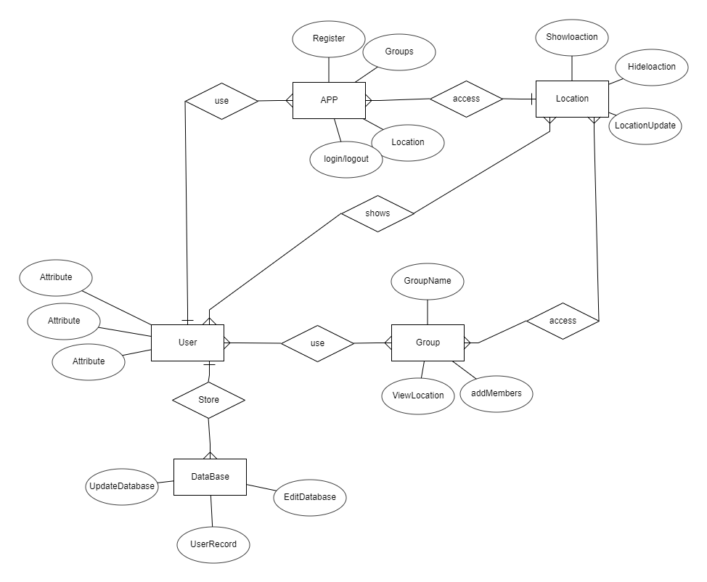

Figure 3-24: ERD

Use Case Description

Register User

Name: | Register User
Responsibilities: | Register.the.user.to.the.system
Cross Reference: | UC_Register_User
Exceptions: | None
Preconditions | - User is connected to the internet
Post conditions | User registered to the system
Table 3-6: Register User

Create Group

Name: | Create Group
Responsibilities: | Create groups and add members in it
Cross References: | UC_Create_Group
Exceptions: | None
Preconditions | - User is connected to the internet  - User is registered
Post conditions | Group created
Table 3-7: Create Group

View Group Members

Name: | View.Group.Members
Responsibilities: | View group.members of the group to the user of which the user is a member
Cross References: | UC_ View_Group_Members
Exceptions: | None
Preconditions | - User is connected to the internet  - User is registered  - User is a member of the group
Post conditions | User viewed group members
Table 3-8: View Group Members

Show Location

Name: | Show Location
Responsibilities: | Show the location of the user to other members of the group
Cross References: | UC_ Show_Location
Exceptions: | None
Preconditions | - User is connected to the internet  - User is registered  - User is a member.of.the group
Post.conditions | User.location is shown to other members of the.group
Table 3-9: Show Location

Communication

Name: | Chat
Responsibilitie: | The user can chat with other group members.
Cross References: | UC_Chat
Exceptions: | None
Preconditions | User must add in groups
Post.conditions | User receives message
Table 3-10: Communication

Methodology
We have used Waterfall Methodology in our project which is best and useful for our project. The phases of the Model are as follow
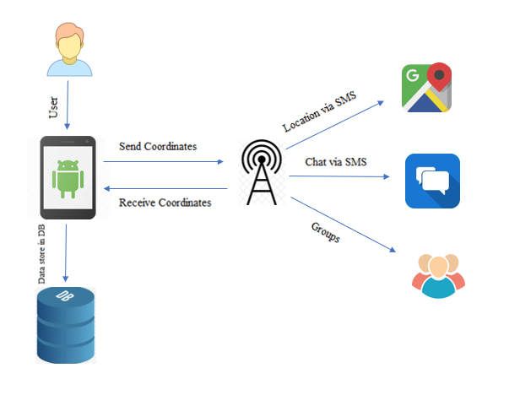
Figure 3-25: Waterfall Model

DATA AND IMPLMENTATION

Languages used for Implementation

JAVA
Java is a wide-ranging, multi-paradigm programming language including strong typing, lexically scoped, authoritative, declarative, functional, component-oriented language. The language we used in our backend.

Tools for Implementation

Android...Studio.
Android .studio .is .powerful .cross-platform .and .an .easy .to .use .improvement .condition. Simple .enough .for .the .learner .and .amazing .enough .for .the .master. Android .studio should .premium .anyone .who .needs .to .effortlessly .make .android .applications.
..

XML
XML .allows .you .to .create .and .maintain .screens .in .android .studio. Also, XML .will automatically .integrate .into .the .android .studio .open .when .you .double .click .on .the XML .file .it .will .create .an .environment .to .edit .or .create .screens .of .the .android .app.

SQLite
SQLite .is .a .library .that .performs .an .independent, without server, .zero-setup, and assessment-based .SQL .database .engine.

Key Features
The main features of our app are

- Map Interface:
We .will provide an easy map interface to visualize all the team/group members. And also provide a route map for all the members to reach the desired destination.
- Groups:
Users can create a Group and add members before starting the journey. Users can make more than one group at a time.
- Chat Module:
We will also include the chat module by which users will be able to chat with each other in their journey to make our users happy. The broadcast messages will be displayed to all the members.
- Invite Friends
Users can invite their contacts via an SMS link to download the application if they haven’t downloaded yet.
- Profile
Users can manage the profile of their Application.
- Speed Notifier
Users can check the speed of Vehicle while Traveling.

USER MANUAL

User Manual
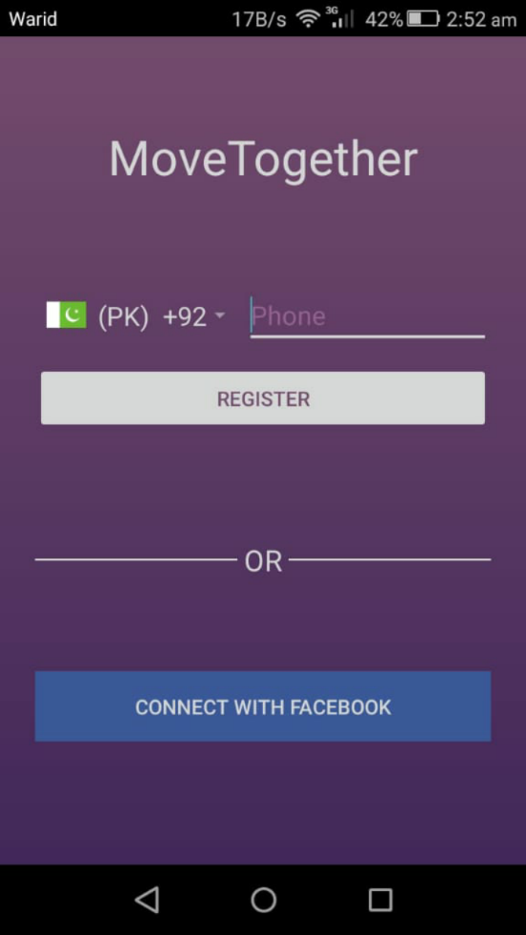
- Register User

Figure 5-1: Registration

2. Registered Contacts cCCC
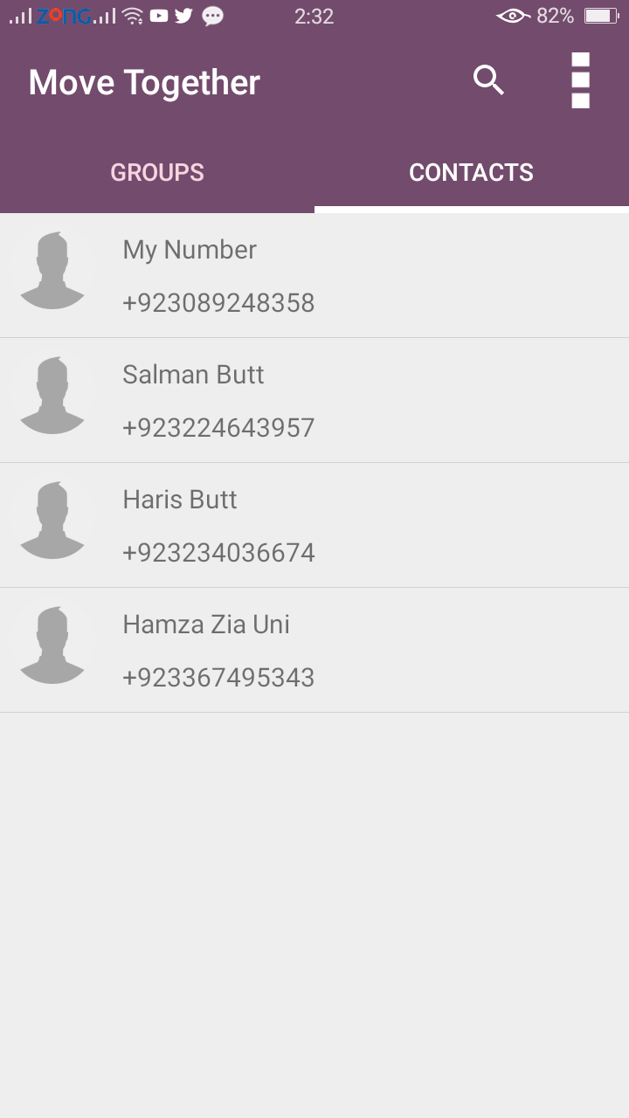
Figure 5-2: Show Contacts

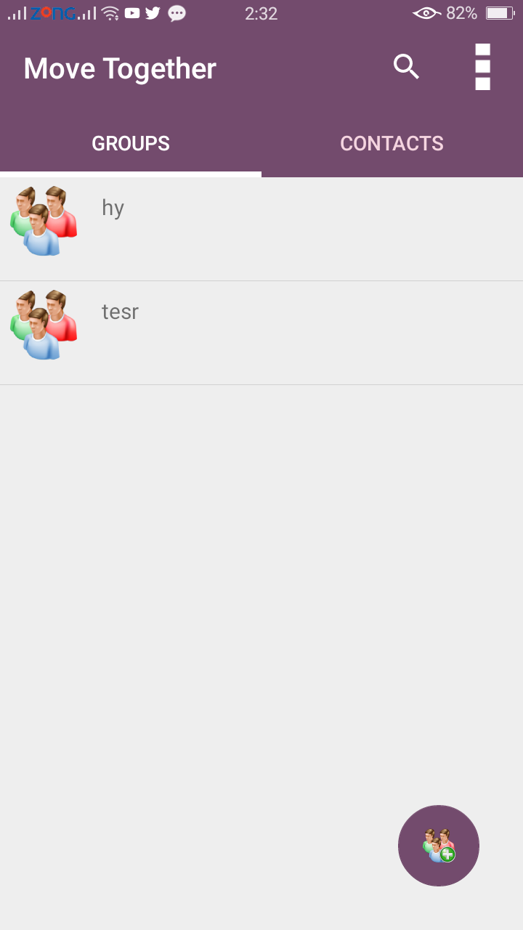
3. Group Formation

Figure 5-3: Groups

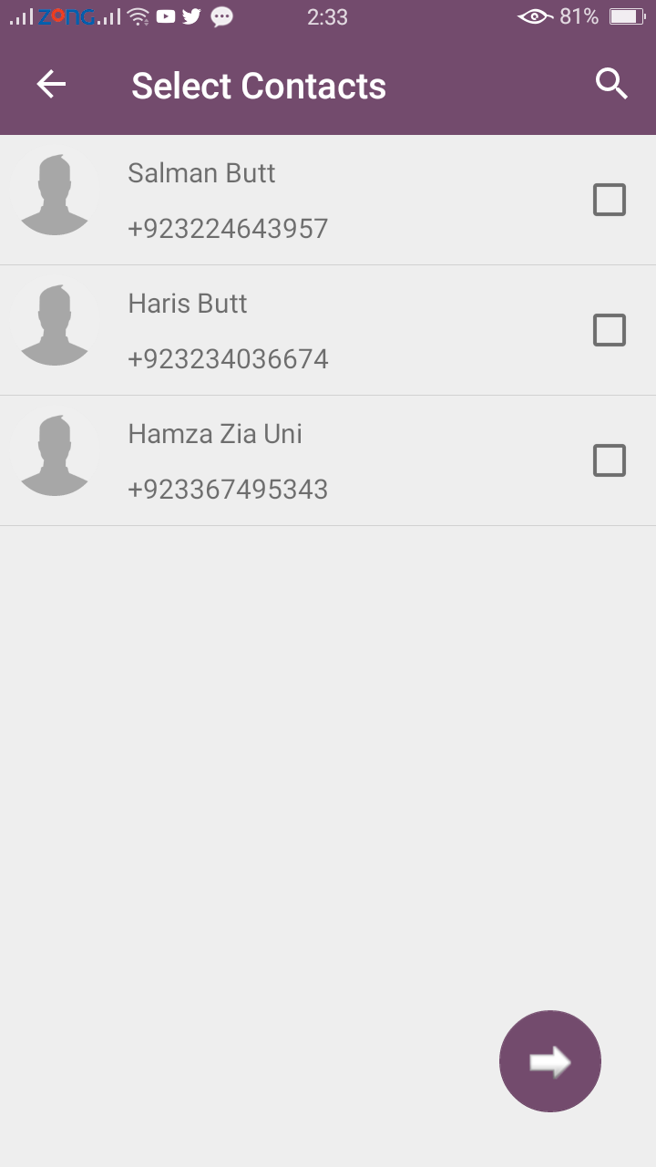
4. Select Contacts which you want to add in group

Figure 5-4: Select Contact

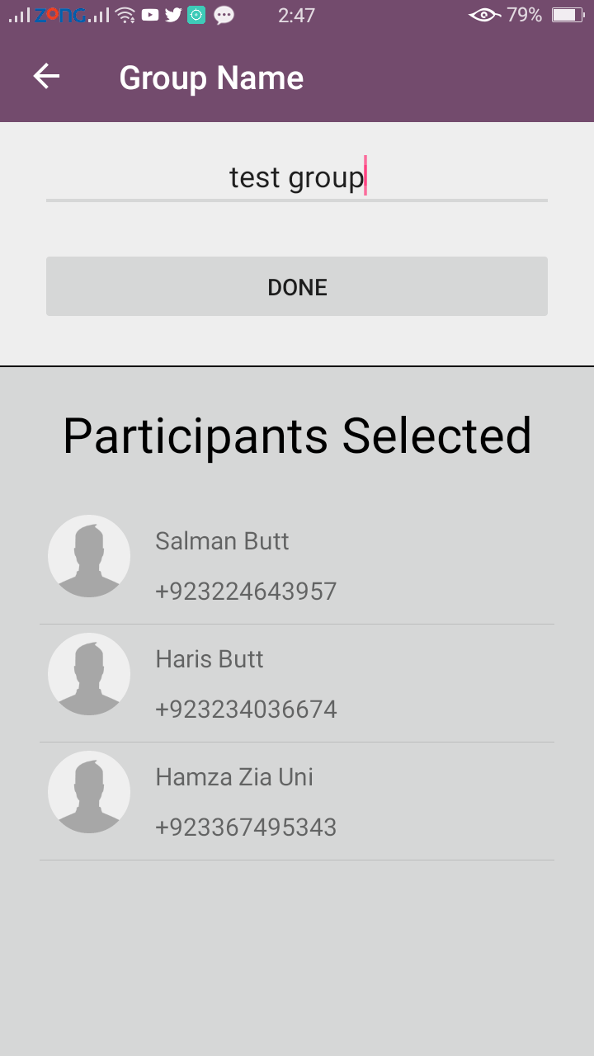
5. Set Group Name

Figure 5-5: Create Group selected contacts

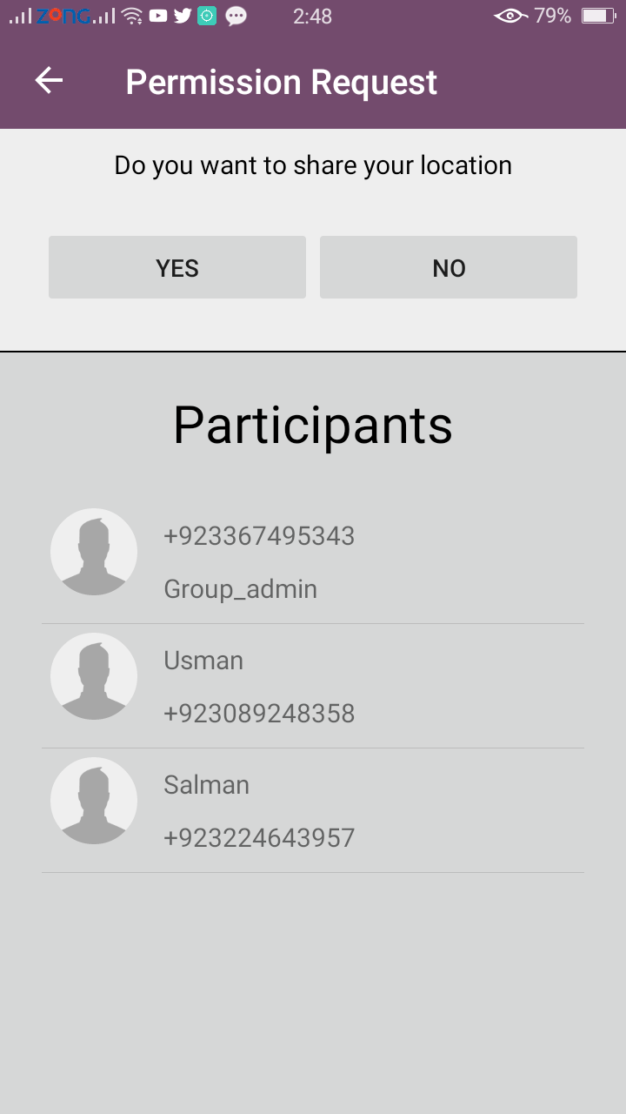
6. Permission Request to share their location with others

Figure 5-6: Join Group

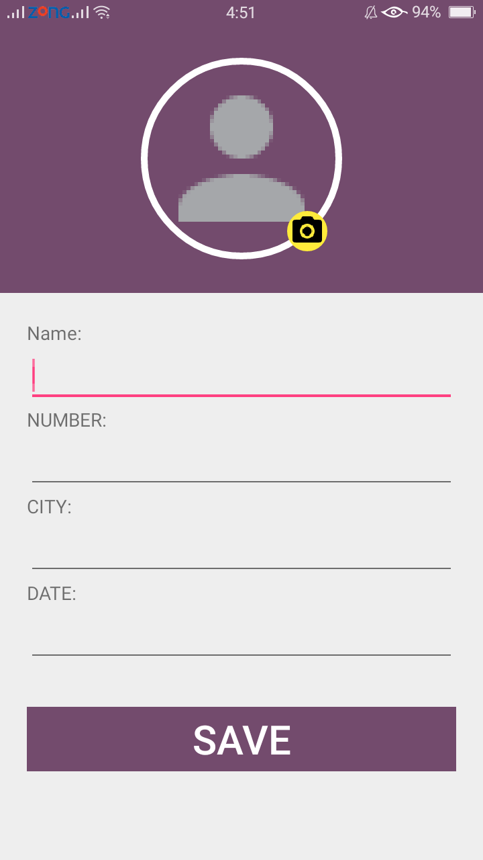
7. Manage profile

Figure 5-7: Profile

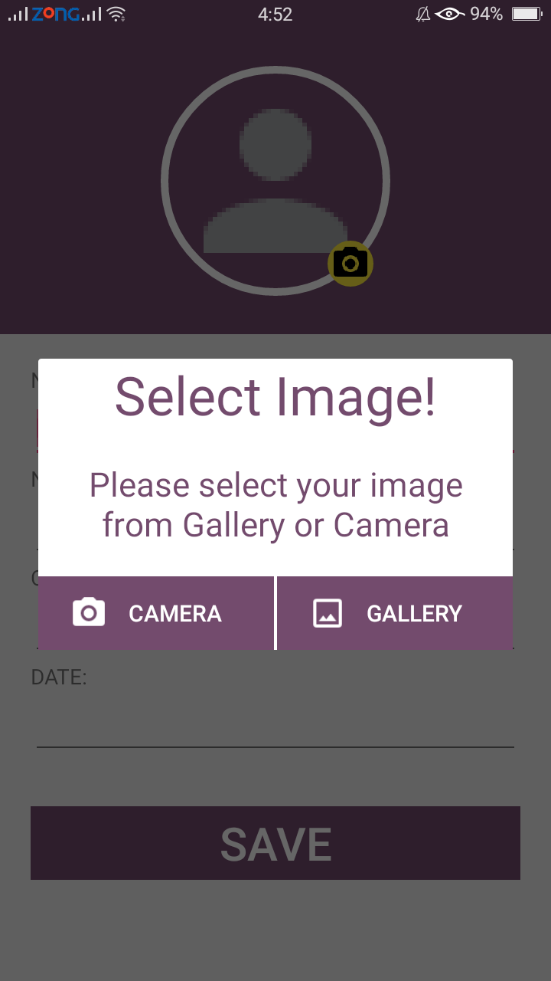
8. Set Your Profile picture

Figure 5-8: Select image from camera or gallery

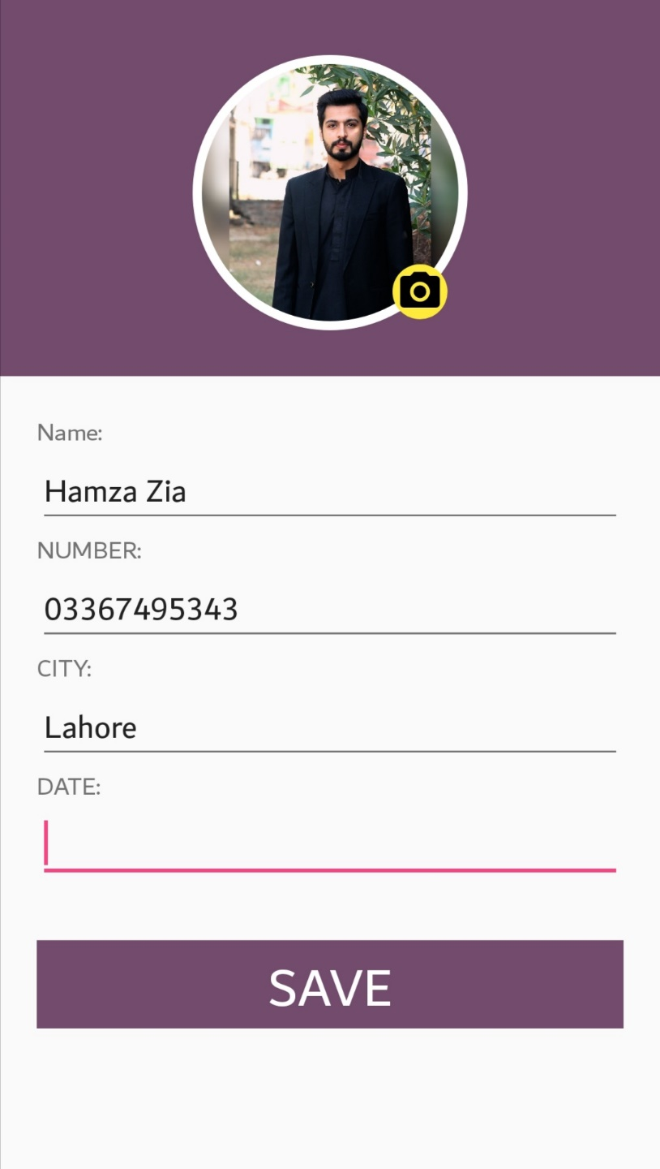
9. Save your profile

Figure 5-9: Save Profile

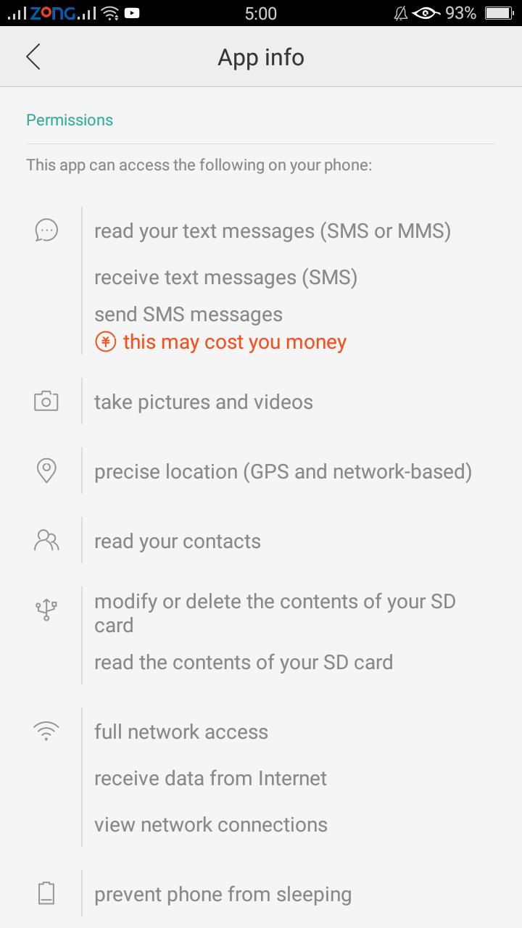

10. Application information and permissions
Figure 5-10: App Permissions

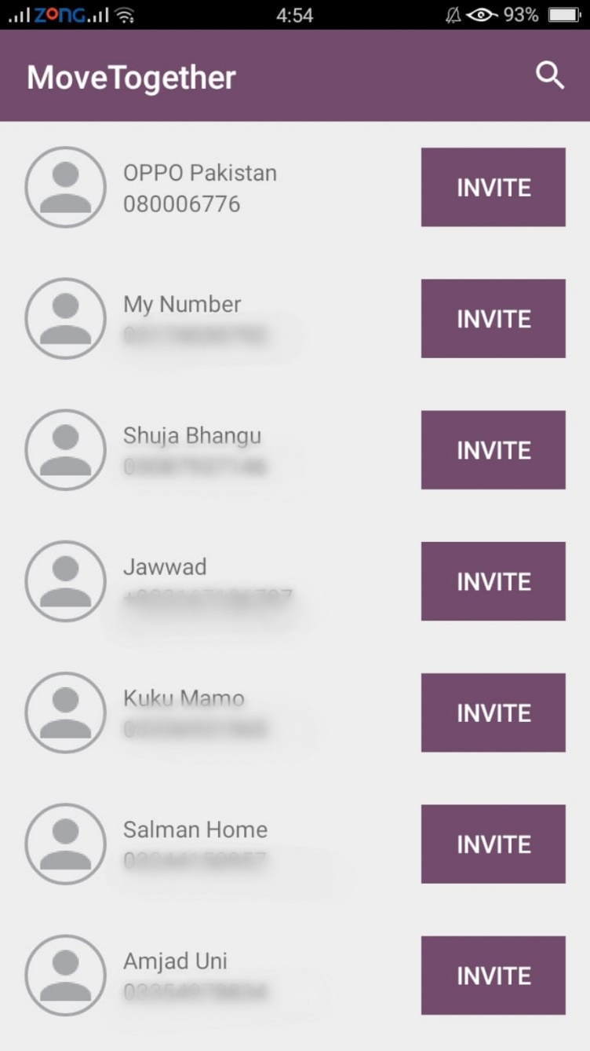
11. Invite friends via SMS link to install your application

Figure 5-11: Invite Contacts to use app

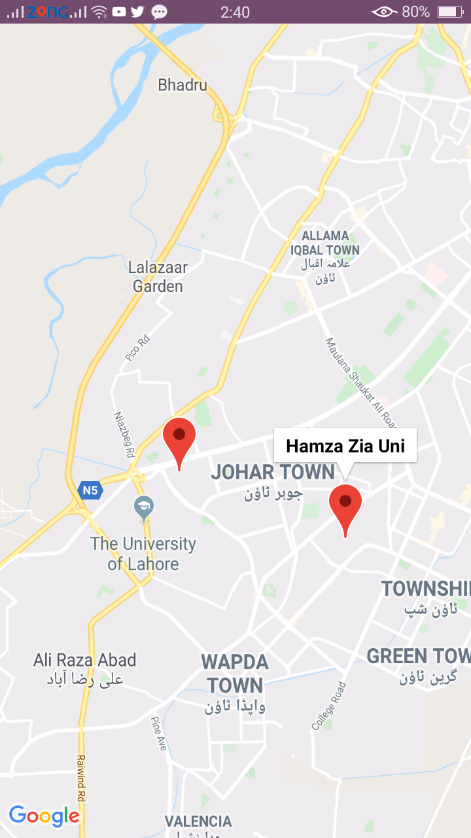
12. Current location of group members on google map

Figure 5-12: Group member’s location

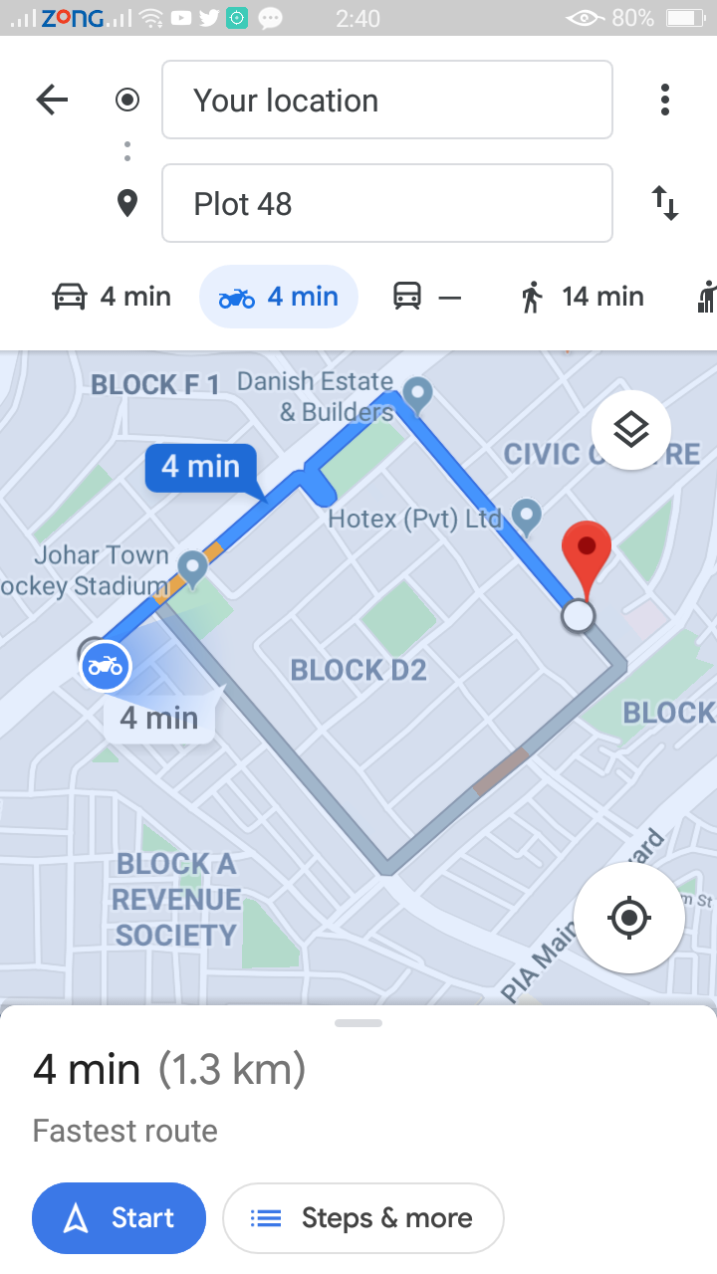
13. Track your group members location.

Figure 5-13: Navigation

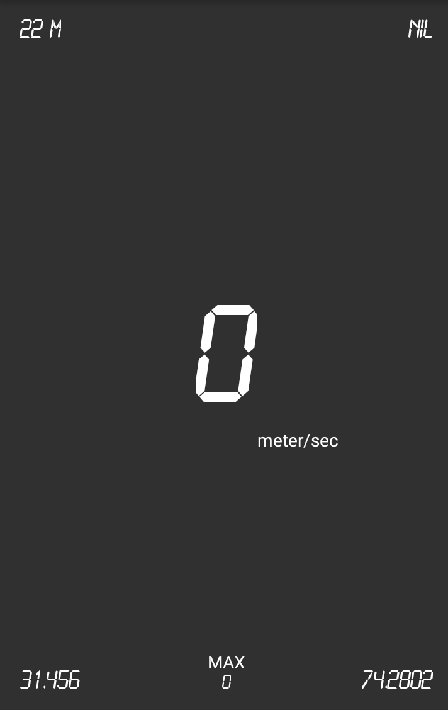
14. Indicate Vehicle Speed

Figure 5-14: Speed Notifier

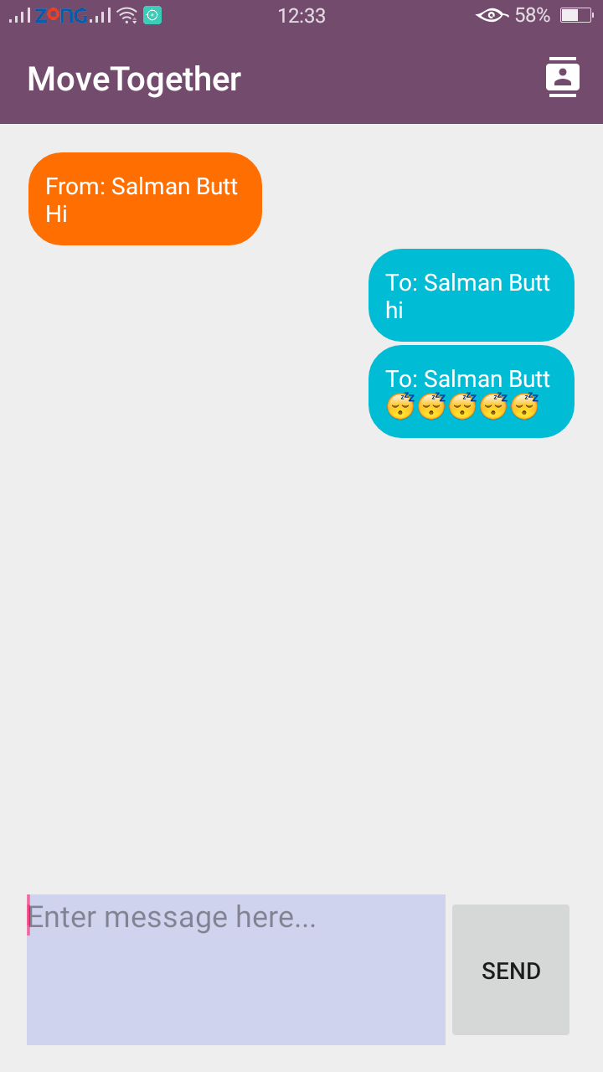

15. Chat

Figure 5-15: Chat
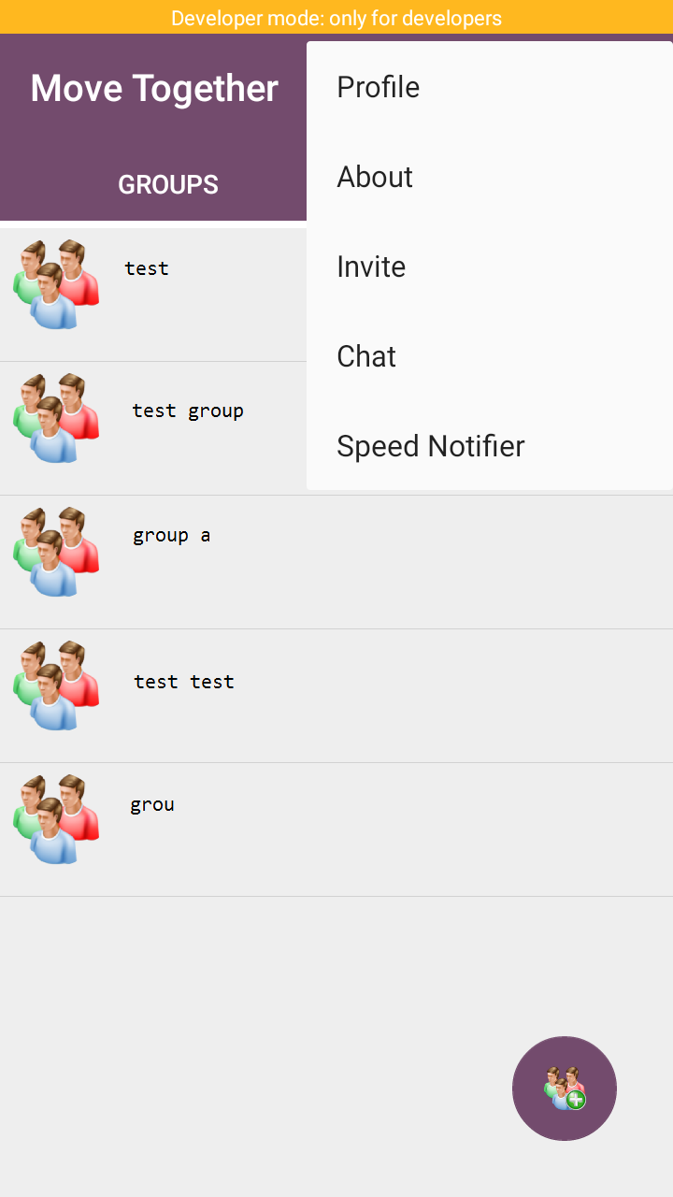
15.More Options

Figure 5-16: More Options

CONCLUSION AND RECOMMENDATIONS

Conclusion

The.aim.of.this.Project.was.to improve group traveling. Specifically, for those users who travel.in northern areas where there are a lot of signal problems, it will facilitate them to track each other location and allow them to chat with group members using this application which will operate totally.in offline mode. This project successfully met the usability and functional requirements of the user. The user testing and evaluation of the application did, however, highlight the room for improvements and expansion. Although all the user requirements were fulfilled. The application could, therefore.be developed further to include additional functionality and allow the user greater control. It is observed that this application was very useful during the testing phase and was addressing the issue accurately. Also, this application will facilitate any type of traveling without any constraints. It is expected that this application will truly serve the purpose and will function properly. Moreover, we conducted surveys about the application and gained positive feedback from the user which indicates that application is according to the user's need.

Recommendations

- It's mandatory for users to have an android version of at least 4.0 (Jelly Bean).
- Also, it is necessary for the user to have an SMS package.
- An offline map of a relevant city or area should be downloaded on your phone before starting the journey.

REFERENCES

[1] Ian Sommerville, Software engineering, 9th edition, Jersey: Wiley & Sons, October 2009.

Electronic source of the internet:

[2]KatieAiton, “TripPlanning”, Nov12,2013 ,Online Available At https://matadornetwork.com/trips/12-reasons-its-better-to-travel-in-a-group.

[3] ArthurShelton,”SDLC-waterfallmethod”,Oct12,2010, Online Available At https://www.tutorialspoint.com/sdlc/sdlc_waterfall_model.htm

[4] Chris Hoffman,,”Navigation direction without Gps”, JULY 12, 2017, Online Available At https://www.howtogeek.com/182965/how-to-get-navigation-directions-even-offline-without-buying-a-gps/

[5] Lerry Christ,”Offline Maps for android”, Jun 23,2014, Online Available At https://www.offline-maps.net/

[6] Thomas John,”Gps Cordinates”, May 23,2019, Online Available At https://www.gps-coordinates.net/

[7] Tom Ogg,”Developing a Group Travel Concept”, April 23,2016, Online Available At https://www.travelprofessionalnews.com/developing-a-group-travel-concept-june-2017/

[8]Chris Morris “Android Chat Tutorial”, January 23,2006, Online Available At https://www.scaledrone.com/blog/android-chat-tutorial/

[9John Ketting“UdacityTutorial”, January 13,2015, Online Available At https://www.udacity.com/google-maps-apis--ud864

[10] Henry Obama”All Business” March 13,1995, Online Available At https://www.forbes.com/sites/allbusiness

APPENDICES

Requirement List

Map Module
R1 Pre downloaded Map
R2 GPS status must be on
R3 Signal Strength must be Good

Chat Module
R1 Must Be Subscribed to an SMS package
R2 There must be some Text to Send chat
R3 Signal Strength must be Good

Groups
R1 Add at least one member
R2 Group Name is mandatory
R3 One member can make multiple groups

