
BSCS-S19-015
03-134161-033 | ZEERAK AHMAD KHAN
03-134161-012 | MAHRUKH JAVED
03-134161-023 | MUHAMMAD USMAN

Drive It

In partial fulfilment of the requirements for the degree of
Bachelor of Science in Computer Science
Supervisor: Dawood Akram
Department of Computer Sciences
Bahria University, Lahore Campus
January 2020

© Bahria University, 2020

Certificate

We accept the work contained in the report titled
“DRIVE IT”
written by
ZEERAK AHMAD KHAN
MAHRUKH JAVED
MUHAMMAD USMAN
as a confirmation to the required standard for the partial fulfilment of the degree of
Bachelor of Science in Computer Science.

Approved by:
Supervisor: Dawood Akram
(Signature)

January 27, 2020

DECLARATION

We hereby declare that this project report is based on our original work except for citations and quotations which have been duly acknowledged. We also declare that it has not been previously and concurrently submitted for any other degree or award at Bahria University or other institutions.

Enrolment | Name | Signature
03-134161-033 | ZEERAK AHMAD KHAN
03-134161-012 | MAHRUKH JAVED
03-134161-023 | MUHAMMAD USMAN

Date : January 27, 2020

Specially dedicated to
my beloved grandmother, mother and father
(Zeerak Ahmad Khan)
my beloved grandmother, mother and father
(Mahrukh Javed)
my beloved grandmother, mother and father
(Muhammad Usman)

ACKNOWLEDGEMENTS

We would like to thank everyone who had contributed to the successful completion of this project. We would like to express our gratitude to our project supervisor, Mr Dawood Akram for his invaluable advice, guidance and his enormous patience throughout the development of the research.

In addition, we would also like to express our gratitude to our loving parents and friends who have helped and given us encouragement.

Zeerak Ahmad Khan
Mahrukh Javed
Muhammad Usman

DRIVE IT

ABSTRACT

This Project is a Game Simulator which will help people learn the Traffic Rules. This project will help the maximum number of people to get a piece of maximum knowledge about traffic rules being deployed in Pakistan. A major number of accidents are being occurred due to unawareness of traffic rules. To eradicate these lives taking problems, we are designing a game that will hold all the traffic rules abiding in Pakistan.

Different stages are planned in the game. By every stage, the difficulty level will be increased and by the last stage of the game, it will be made sure that a user has a maximum knowledge of all the traffic rules.

This interactive game is designed not only to help the people to learn the traffic rules but it will also help City Traffic Police in many ways.

TABLE OF CONTENTS

DECLARATION ii
ACKNOWLEDGEMENTS iv
ABSTRACT v
TABLE OF CONTENTS vi
LIST OF TABLES ix
LIST OF FIGURES x
LIST OF SYMBOLS / ABBREVIATIONS xii
LIST OF APPENDICES xiii

CHAPTERS
1 INTRODUCTION 1
1.1 Background 1
1.2 Problem Statements 2
1.3 Aims and Objectives 2
1.4 Scope of Project 3
1.4.1 Primary Scope 3
1.4.2 Optional Scope 3
2 LITERATURE REVIEW 4
2.1 Common Violations 4
2.2 Traffic Rules 4
2.2.1 The Main Pakistan’s road traffic rules 4
3 DESIGN AND METHODOLOGY 7
3.1 Design 7
3.2 Use Case Diagram 8
3.2.1 System Use Case Diagram 8
3.2.2 Register Use Case Diagram 9
3.2.3 Login Use Case Diagram 9
3.2.4 Play Game Use Case Diagram 10
3.2.5 Update Use Case Diagram 10
3.2.6 View achievements Use Case Diagram 11
3.2.7 Solve Quiz Use Case Diagram 11
3.3 Use Case Descriptions 12
3.3.1 Register UC2 12
3.3.2 Login UC3 13
3.3.3 Play Game UC4 14
3.3.4 Update Settings UC5 15
3.3.5 View achievements UC6 16
3.3.6 Solve Quiz UC7 17
3.4 Sequence Diagrams 18
3.4.1 Sequence Diagrams of Registration 18
3.4.2 Sequence Diagrams of Login 19
3.4.3 Sequence Diagrams of Play Game 20
3.4.4 Sequence Diagrams of Update Settings 21
3.4.5 Sequence Diagrams of View Achievements 22
3.4.6 Sequence Diagrams of Solve Quiz 23
3.5 Domain Model 24
3.6 Collaboration Diagram 25
3.7 Class Diagram 26
3.8 Data Model 27
3.9 Operation Contracts 28
3.10 Methodology 29
3.10.1 Feature Driven Development History 29
4 DATA AND EXPERIMENTS (and/or IMPLMENTATION) 31
4.1 Languages and Implementations 31
4.1.1 C Sharp (C#) 31
4.2 Tools for Implementation 31
4.2.1 Unity 3D 31
4.2.2 Visual Studio 32
4.2.3 Adobe Photoshop 32
4.3 Key Features 32
4.3.1 Settings: 32
4.3.2 Help 33
4.3.3 Achievement Board 33
4.3.4 Vehicles 33
4.3.5 Modes 34
4.3.6 Training Mode 34
4.3.7 Arcade Mode 34
4.3.8 Google AdMob 34
4.3.9 Road Signs 35
5 RESULTS AND DISCUSSIONS (or USER MANUAL) 36
5.1 User Manual 36
6 CONCLUSION AND RECOMMENDATIONS 52
6.1 Conclusion 52
6.2 Recommendations 53
REFERENCES 54
APPENDICES 55

LIST OF TABLES

TABLE TITLE PAGE
Table 3.1: Registration use-case 12
Table 3.2: Login use-case 13
Table 3.3: Play Game use-case 14
Table 3.4: Update Settings use-case 15
Table 3.5: View Achievement use-case 16
Table 3.6: Solve Quiz use-case 17

LIST OF FIGURES

FIGURE TITLE PAGE
Figure 3.1: System Use-Case Diagram 8
Figure 3.2: Login Use-Case Diagram 9
Figure 3.3: Play Game Use-Case Diagram 10
Figure 3.4: Update Setting Use-Case Diagram 10
Figure 3.5: View Achievement Use-Case Diagram 11
Figure 3.6: Solve Quiz Use-Case Diagram 11
Figure 3.7: Register Sequence Diagram 18
Figure 3.8: Login Sequence Diagram 19
Figure 3.9: Play Game Sequence Diagram 20
Figure 3.10: Update Settings Sequence Diagram 21
Figure 3.11: View Achievements Sequence Diagram 22
Figure 3.12: Solve Quiz 23
Figure 3.13: Domain Model 24
Figure 3.14: Collaboration Diagram 25
Figure 3.15: Class Diagram 26
Figure 3.16: ERD 27
Figure 4.1: Traffic Signs 36
Figure 5.1: Signup Panel 39
Figure 5.2: Login Panel 40
Figure 5.3: Main Menu 41
Figure 5.4: Controls Setting 41
Figure 5.5: Graphics Settings 42
Figure 5.6: Sound Settings 42
Figure 5.7: Vehicle Selection 43
Figure 5.8: Mode Selection 43
Figure 5.9: Spin Board 44
Figure 5.10: Level Selection in Arcade Mode 45
Figure 5.11: Start-Up Message 45
Figure 5.12: Training Mode 46
Figure 5.13: Steering Mode 46
Figure 5.14: Age Checking Pop up 47
Figure 5.15: Underage Violation 47
Figure 5.16: Speed Limit 48
Figure 5.17: Signal Violation Pop-Up 48
Figure 5.18: Speed limit Violation Pop-Up 49
Figure 5.19: Stay on Footpath Warning 49
Figure 5.20: Footpath Violation Pop-Up 50
Figure 5.21: Level Completion Pop-Up 50
Figure 5.22: Drug Addiction Form 51
Figure 5.23: Quiz after every level 51
Figure 5.24: Quit Game Option 52
Figure Appendix 1: Game Manager 57
Figure Appendix 2: Ad Manager 57
Figure Appendix 3: Level Manager 58
Figure Appendix 4: Traffic Sign Controller 58
Figure Appendix 5: Constants 59

LIST OF SYMBOLS / ABBREVIATIONS

WHO World Health Organization.
Km/h Kilometre per hour
LTV Light Transport Vehicle
HTV Heavy Transport Vehicle

LIST OF APPENDICES

APPENDIX TITLE PAGE
APPENDIX A: Code 57

INTRODUCTION

Background

This Project is a Game Simulator which will help people learn the Traffic Rules. This project will help the maximum number of people to get maximum knowledge about traffic rules being deployed in Pakistan. A major number of accidents are being occurred due to unawareness of traffic rules. To eradicate these lives taking problems, we are designing a game that will hold all the traffic rules abiding in Pakistan.

As the simulator is interactive, people get training in an interactive way by just having that simulator on their phones instead of going somewhere for practice or learning things. And in Pakistan, there aren’t that many training institutes that will teach people about road signs, violations and all.

There different applications available for driving rules but aren’t following the rules. They don’t show any violations in the form. The primary motivation behind the development of this project was the significant occurrence of traffic incidents in our surroundings.

Hundreds of accidents occur per day in front of our eyes, and no one took a step to eradicate this lack of traffic sense in the people. There are thousands of journals available on the internet regarding traffic rules, but no one in his life has so much time to read those papers to understand the traffic rules.

That's why we got an idea to make people aware of traffic rules in an interactive way, and we ended up on this simulator

Problem Statements

1.2 million People died annually in road accidents according to the latest research of WHO. The death ratio in Pakistan due to road accidents is 15000 to 16000 annually. The death ratio in road accidents is much higher than the death ratio in terrorism [1].

The primary cause of the high death rate is the unawareness of traffic rules in the people. There should be proper training and practice related to traffic rules. Different training sessions were organized by national highway and motorway police with the collaboration of the Islamabad Chamber of Commerce and Industry, just to let people aware of different driving techniques [2].

Now to overcome such scenarios, we are developing an android simulator game that will include maximum traffic rules abiding in Pakistan. It will help people to learn all the traffic rules level by level in an interactive way. If any of these rules are not followed on any level or portion of the game, a warning popup will be displayed and the level will be restarted. Different stages will be given and by every stage, the difficulty level will be increased to make the people fully aware of the traffic rules.

Aims and Objectives

The objectives of the thesis are shown as following:

- To help People in learning traffic rules in an interactive way.
- To address the general problem of understanding of traffic rules.

Scope of Project

Primary Scope

As we mentioned earlier that a huge number of accidents are due to a lack of traffic sense. Now for making people aware of the traffic rules we have initiated this idea to make a simulator that will help people to have maximum knowledge of traffic rules being deployed in our country. According to recent research, 35% of Pakistan’s population uses smartphones [3] and almost all of them love to play different games on their phones that’s why we have chosen this platform so that a large number of people can take benefit from this initiative.

Optional Scope

- Association with Traffic Police.
- Virtual Reality

LITERATURE REVIEW

Common Violations

The most common issue on roads is Exceeding the speed limit. Different traffic wardens are there to fine such people but they somehow pay the fine or they either contact higher authority for the favour. These things should be eradicated.

Some other common violations are like too close to the other vehicle, driving harshly. Some neglect emergency vehicles like an ambulance. Some didn’t use a helmet. Some failed to maintain their lane. Motorcycle riders didn’t wear headgear. Few used a suspended driving license, which leads to liability insurance. While driving, people continuously used cell phones, which is the first violation — crossing on the red lead to an accident with other side vehicles. Most people didn’t use a seat belt while driving on the roads [4].

Some other common violations are like too close to the other vehicle due to which when brakes are applied that short distance may cause accidents.

Traffic Rules

The Main Pakistan’s road traffic rules

- Left side driving on the road.
- 18 age limit minimum for driving any vehicle
- Alcohol or drugs are forbidden under driving influence.
- The proper indicator uses during driving to change the lane.
- Don’t stop on a zebra crossing.
- There should be a red flag in the day time and use of red light at night to any load carrier
- Use of helmet for scooter and motorcycle.
There should be L- plates on the vehicles of the learner.
- The right way to a pedestrian should be adopted.
- The use of seat belts should be there for the driver and all the passengers [5].
- Use of mobile phones prohibited during driving.
- Throw lighted cigarettes on the road is prohibited.
- Speed limited should be maintained (120 km/h on rural highways, 100 km/h on the secondary road, 80 km/h for tertiary roads, 50 km for residential streets and 40 km/h for mosques, hospitals, and school areas)
- 65 km/h should be minimum on rural highways and 50 km/h on urban motorways.
- The pedestrian crossing should be clear in case of a traffic queue.
- Shouldn’t park on a pedestrian crossing and zigzag lined area.
- A way should be provided to school children when there is a signboard of stop for children.
- When someone is on the pedestrian crossing, the driver should give way to him.
- Cycle lane should be prohibited.
- When there’s a red signal, it is not allowed to cross.
- The use of horns is restricted in particular areas.
- It is not allowed to use radio, tape recorder, etc. in public transports.
- On the corner, bending of hills overtaking should be prohibited.
- Turning from the left to right lane or right to the left lane is not allowed.
- Fog lights are not allowed in daily routine but may use where there is a fog, and the driver can see more than 100 meters.
- Bus/ car lane, carriageway on a motorway, pedestrian crossing, curved lines, footpath, near the bus stop. In these areas, you can’t park your vehicle [6].

DESIGN AND METHODOLOGY

Design

This chapter overviews the design of Drive It. The system architecture design gives the total perspective of the system. This will enable developers and clients to see and check the design plan in detail. Following artefacts incorporated in this Chapter.

- Use case diagrams
- Use case descriptions
- Sequence diagrams
- Collaborative Diagram
- Domain Model
- Entity Relationship Diagrams
- Design Class Diagram
- Operation Contract

Use Case Diagram

System Use Case Diagram

The following diagram shows the system Use-case diagram.

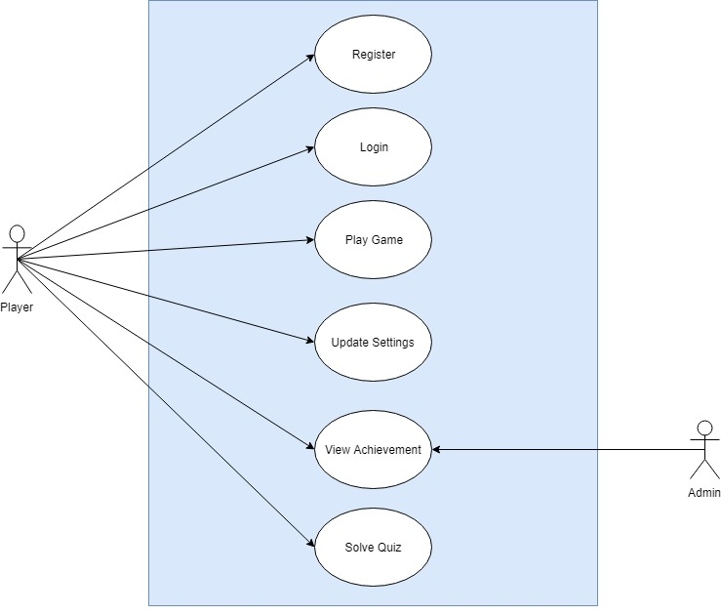
Figure 3.1: System Use-Case Diagram

Register Use Case Diagram

The following diagram shows the Register Use-case diagram.
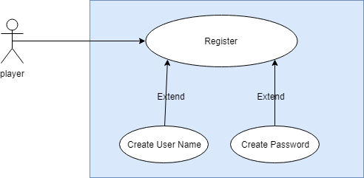

Figure 3.2: Register Use-Case Diagram

Login Use Case Diagram

The following Figure 3.3 shows the Login Use-case diagram.
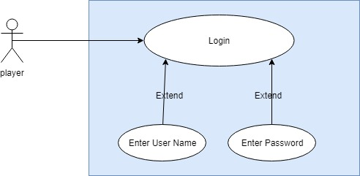
Figure 3.2: Login Use-Case Diagram

Play Game Use Case Diagram

The following diagram shows the Play Game Use-case diagram.

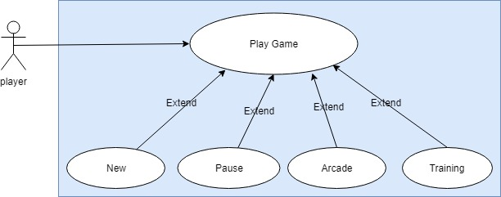
Figure 3.3: Play Game Use-Case Diagram

Update Use Case Diagram

The following diagram shows the Update Use-case diagram.

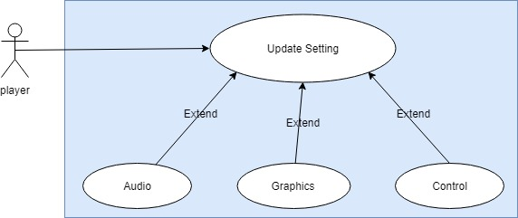
Figure 3.4: Update Setting Use-Case Diagram

View achievements Use Case Diagram

The following diagram shows the View Achievements Use-case diagram.
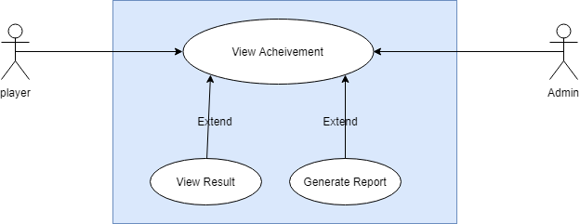

Figure 3.5: View Achievement Use-Case Diagram

Solve Quiz Use Case Diagram

The following diagram shows the Solve Quiz Use-case diagram.

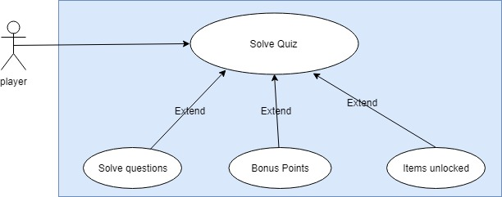
Figure 3.6: Solve Quiz Use-Case Diagram

Use Case Descriptions

A use-case description is a text that captures the detailed functionalities of a use-case.
The description of all use-cases is written down in this section.

Register UC2

Table 3.1: Registration use-case
Use Case ID: | UC2 | Priority: | High
Name | Register
Created by: |  | Date Created:
Actors | Admin, Player
Description: | To use this application user must have a login to the application. For login on the application, the user must register itself by providing information such as name, email id, and password.
Preconditions: | Users must have an android mobile/tablet and must installed applications.
Postconditions: | A unique user id and password will be assigned to the user.
Flow: | - The user clicks on the registration button and fills the registration form.  - A user enters the user name, email id, and password and re-enters the password.  - By click on the signup button, the unique-id and password will be assigned to the user.
Alternative Flow: | NONE
Exceptions: | Invalid user name or password.

Login UC3

Table 3.2: Login use-case
Use Case ID: | UC3 | Priority: | High
Name | Login
Created by: |  | Date Created:
Actors | Admin, Player
Description: | The user uses the application by entering their valid user name and password by using login.
Preconditions: | - Users must be connected with an internet connection for an application.  - Users must remember their valid username and password.
Postconditions: | Move to the main screen.
Flow: | - User Admin enters the username and password.  - The system will check the validating of username and password.  - Users redirected to the main screen of their accounts.
Alternative Flow: | None
Exceptions: | Users will be entered an invalid user name or password.

Play Game UC4

Table 3.3: Play Game use-case
Use Case ID: | UC4 | Priority: | High
Name | Play Game
Created by: |  | Date Created:
Actors | Player, Admin
Description: | - A player can start a new game or pause it  - Moreover, the player can also choose out of two modes given
Preconditions: | - A player must have opened the application  - The system should be functional.
Postconditions: | The player can play a game then.
Flow: | - A player can choose Training mode to have a brief knowledge of the complete game  - A player can choose the arcade mode for a complete scenario game  - The player can start a new game  - A player can pause the running game  - Admin can also be the player of a game.
Alternative Flow: | None
Exceptions: | Application failure.

Update Settings UC5

Table 3.4: Update Settings use-case
Use Case ID: | UC5 | Priority: | High
Name | Update Settings
Created by: |  | Date Created:
Actors | Player, Admin
Description: | The player can change the audio settings.  A player can change the graphical settings.  A player can update the control settings.
Preconditions: | A player should have started the app
Postconditions: | The player can play the game with modified settings
Flow: | - The player should click on the settings button.  - The player can update background music, sound effects, etc. from audio settings  - The player can increase or decrease the graphical aspect of the game  - The player can select from the gyroscope or steering wheel.  - Admin can also update the settings while playing
Alternative Flow: | None
Exceptions: | Application failure

View achievements UC6

Table 3.5: View Achievement use-case
Use Case ID: | UC6 | Priority: | High
Name | View Achievement
Created by: |  | Date Created:
Actors | Player, Admin
Description: | - A player can see the result containing a score of each level  - The player can also view the complete report generated containing all the violations he/she did in each level
Preconditions: | - The player must have played at least 1 time  - The system should be functional.
Postconditions: | The player can save the report by taking a screenshot
Flow: | - Player will play at least one time  - After the game being played, the player can view the result of that level.  - A report of rules violation is generated so that the player should know what violations he/she did.  - The achievement list or a report can be viewed by Admin too.
Alternative Flow: | None
Exceptions: | Application failure.

Solve Quiz UC7

Table 3.6: Solve Quiz use-case
Use Case ID: | UC7 | Priority: | High
Name | Solve Quiz
Created by: |  | Date Created:
Actors | Player, Admin
Description: | After every 2-3 stages that a player clears, there is a quiz for the player to get to know that how far they came in learning traffic rules
Preconditions: | - The player must have played and cleared at least 2-3 stages  - The system should be functional.
Postconditions: | The player can earn bonus points and unlock certain items by answering them right
Flow: | - Player will play at least 2-3 stages  - A quiz is generated which should be answered by the player.  - Bonus coins are offered alongside the unlocking of new items.  - Admin can also play the quiz.
Alternative Flow: | None
Exceptions: | Application failure.

Sequence Diagrams

Following are the Sequence diagrams

Sequence Diagrams of Registration

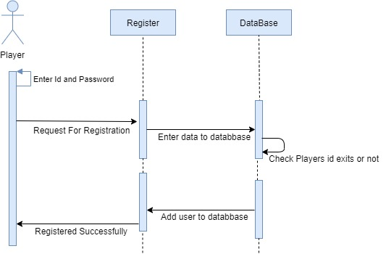
Figure 3.7: Register Sequence Diagram

Sequence Diagrams of Login

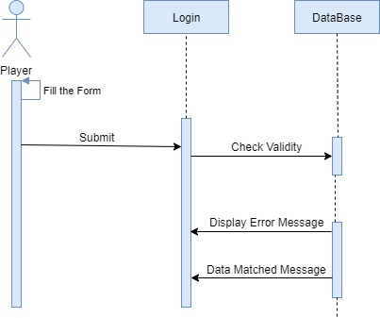
Figure 3.8: Login Sequence Diagram

Sequence Diagrams of Play Game

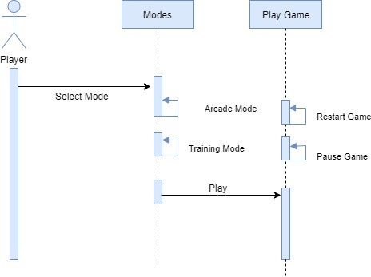
Figure 3.9: Play Game Sequence Diagram

Sequence Diagrams of Update Settings

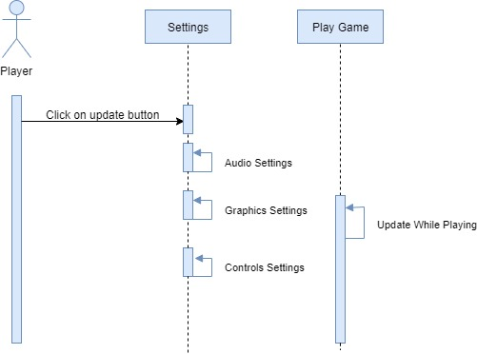
Figure 3.10: Update Settings Sequence Diagram

Sequence Diagrams of View Achievements

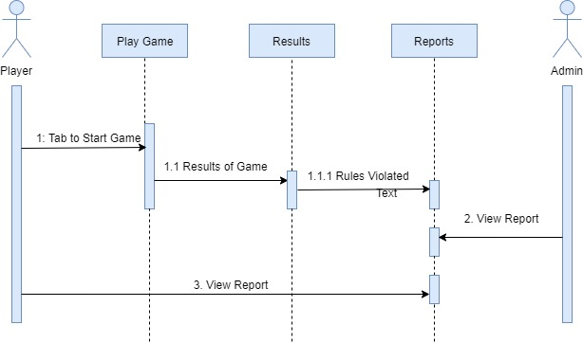
Figure 3.11: View Achievements Sequence Diagram

Sequence Diagrams of Solve Quiz

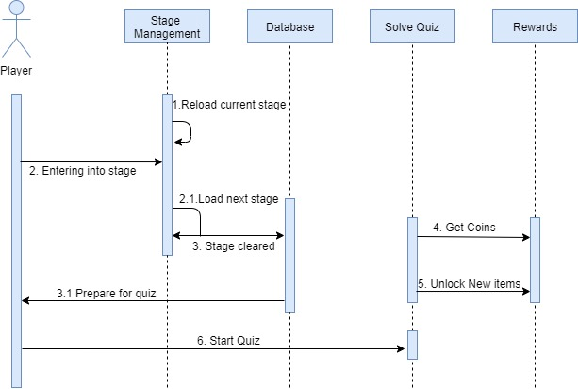
Figure 3.12: Solve Quiz

Domain Model

Following is the Domain Model of the project.

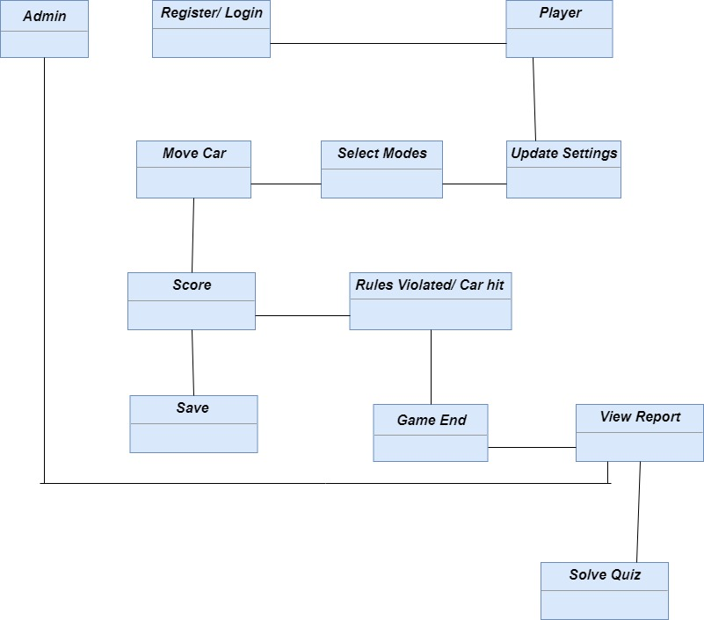
Figure 3.13: Domain Model

Collaboration Diagram

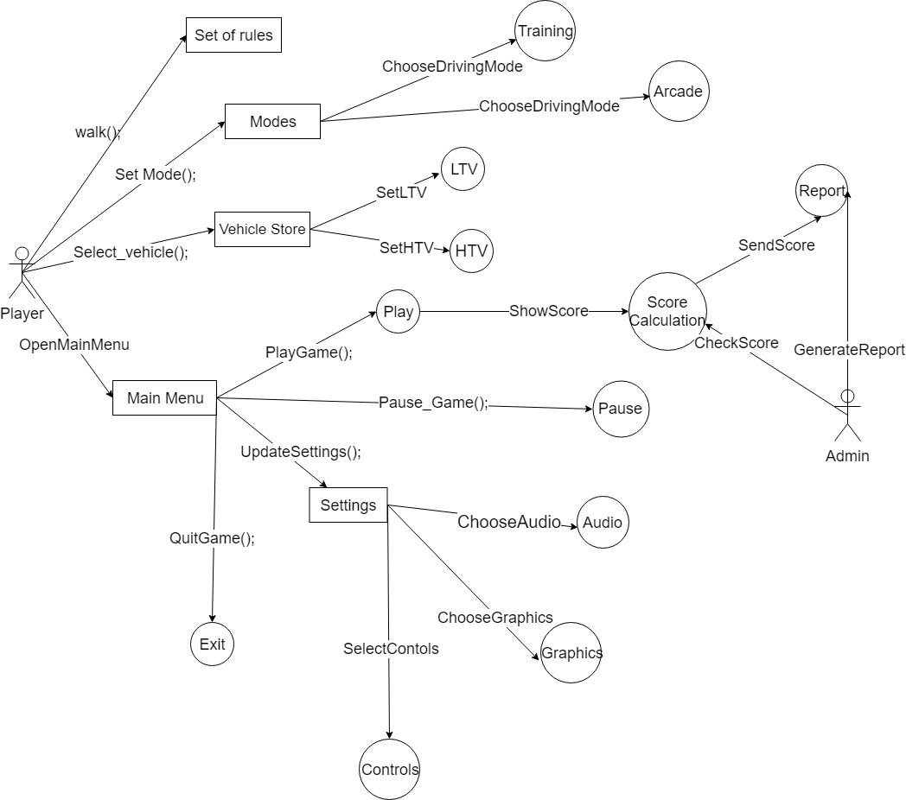
Figure 3.14: Collaboration Diagram

Class Diagram

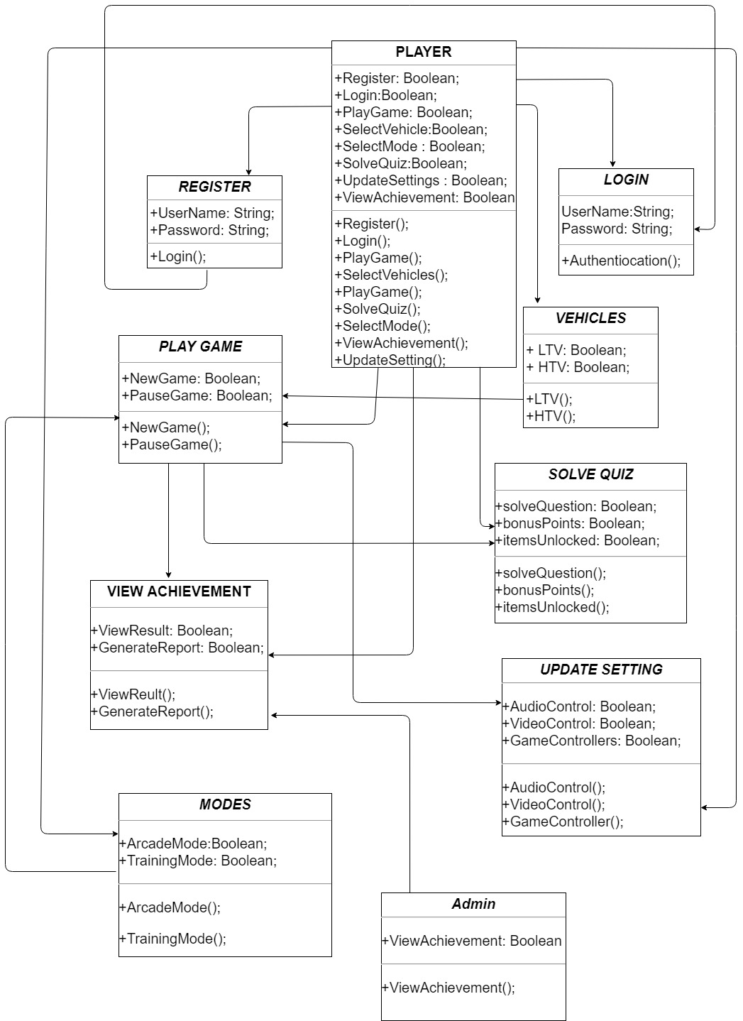
Figure 3.15: Class Diagram

Data Model

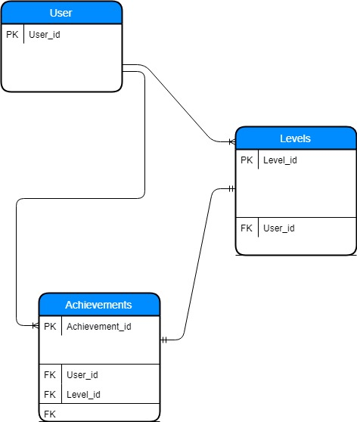
Figure 3.16: ERD

Operation Contracts

Name: Register
Cross References: UC2
Exceptions: Invalid user name or password
Pre-conditions: User must have an android mobile/tablet and must installed application.
Post-conditions: Unique user id and password will be assigned to the user.

Name: Login
Cross References: UC3
Exceptions: Users will enter an invalid user name or password.
Pre-conditions: Users must be connected with an internet connection for an application.
Post-conditions: Move to the main screen.

Name: Play Game
Cross References: UC4
Exceptions: Application failure
Pre-conditions: Player must have opened the application and the system should be functional.
Post-conditions: Players can play a game then.

Name: Update Setting
Cross References: UC5
Exceptions: Application failure
Pre-conditions: Player should have started the app
Post-conditions: Player can play the game with modified settings

Name: View Achievement
Cross References: UC6
Exceptions: Application failure
Pre-conditions: Player must have played at least 1 time
Post-conditions: Player can save the report by taking a screenshot

Name: Solve Quiz
Cross References: UC7
Exceptions: Application failure
Pre-conditions: Player must have played and cleared at least 2-3 stages. The system should be functional.
Pre-conditions: The player can earn bonus points and unlock certain items by answering the right.

Methodology

The methodology which we have opted for this project is Feature Driven Development which is basically a part of the Agile Framework. The project will be done feature by feature. As this project is based upon traffic police requirements so agile framework is the best method to be adopted. Risk can be analysed at an early stage and it can be prevented. We can ensure the quality by confirming testing all the features. We can effectively use all resources time.

Feature Driven Development History

The first real-world application of the Feature Driven Development methodology was on a 50-person software-development project for a Singapore-based financial institution, and the first public discussion of the methodology was in the 1999 book Java Modeling in Color with UML.

FDD was designed to follow a five-step development process, built largely around discrete “feature” projects. That project lifecycle looks like this:
- Develop an overall model
- Build a features list
- Plan by feature
- Design by feature
- Build by feature [7].

DATA AND EXPERIMENTS (and/or IMPLMENTATION)

Languages and Implementations

C Sharp (C#)

C# (pronounced see sharp, but written with the number sign) is a general-purpose, multi-paradigm programming language encompassing strong typing, lexically scoped, imperative, declarative, functional, generic, object-oriented (class-based), and component-oriented programming disciplines. It was developed around 2000 by Microsoft [8].
The language we used in our script is C sharp.

Tools for Implementation

Unity 3D

A powerful and user-friendly development environment or platform for users. This platform is not only good for expert-level but also easy to use for beginners. With an interactive interface, everybody takes an interest in it for game development [9].
All level designing of the game is being done in unity 3D.

Visual Studio

The integrated development environment is provided in Microsoft Visual Studio. Different websites, mobile applications, computer programs, and web services are developed through Visual Studio [10].

In the case of Unity 3d, scripting of the whole project is being done in the visual studio. The tool that is used for scripting is a visual studio that comes built-in with the unity 3D.

Adobe Photoshop

Adobe Photoshop is used for graphic designing, editing images, digital art, etc. In 1989, John sold the program to Adobe Systems, which marketed it as “Photoshop.” Since then, the program has become the de facto industry standard for raster graphics editing [11].

The background of the main menu for Games is being done on Adobe Photoshop.

Key Features

The main features of our simulator are:

Settings:

  - We are providing background music to the game which will basically be the theme song of this game. Users can switch the music on or off according to their needs.
  - Different sound effects will be added according to the scenes. Users can turn it on or off.
  - Two steering modes are provided
        - Gyroscope
        - Steering Wheel
  - User can select his desired language out of different languages.
  - Users can select the resolution of according to his/her mobile specifications. We are providing the following resolutions.
        - High (1080p)
        - Medium (720p)
        - Low (480p)

Help

  - There will be a proper Instruction Manual, which includes complete instructions related to our simulator.

Achievement Board

  - Results
- Score Board comprises of total scores attained at respective levels.
  - Report
      - The report has a complete list of traffic rules which were violated during each level in the form of notification.

Vehicles

We have planned two modes:
  - LTV
- The user will be provided with a single classic car. He/she can change the cars according to coins in their wallet.
  - HTV
- Users can pick up trucks. Same features for the trucks too as for cars.

Modes

We have two modes. One is a training mode and the other one is arcade mode. Training mode will have simple mode, on the other side arcade mode comprises of different levels, and difficulty level increased step by step.

Training Mode
          - Single Car
          - No Traffic
          - Free Drive
          - No Rules
          - Driving test environment

Arcade Mode

          - City Roads
          - Highways
          - Different stages
          - Traffic
          - Different percentage of traffic rules in every stage
          - Traffic rules/signs quiz after every stage.
          - Gifts and Coins for every cleared stage
          - Spin Board
          - 1000 initial coins
          - If rules are violated, the level will restart and shows the pop up of the violated rule.

Google AdMob

There’s a feature of google AdMob in our game, that will appear after every level completion.

Road Signs

There will be almost all road signs according to the environment [12].
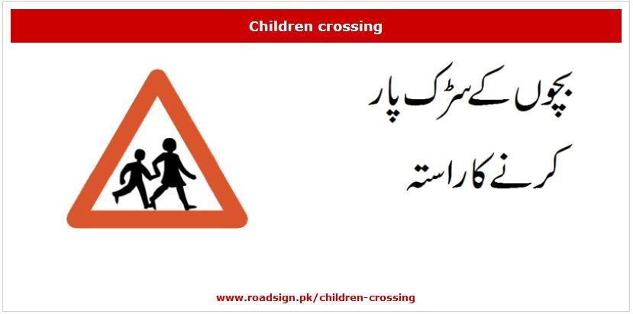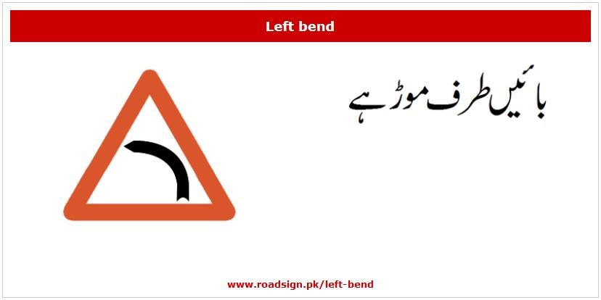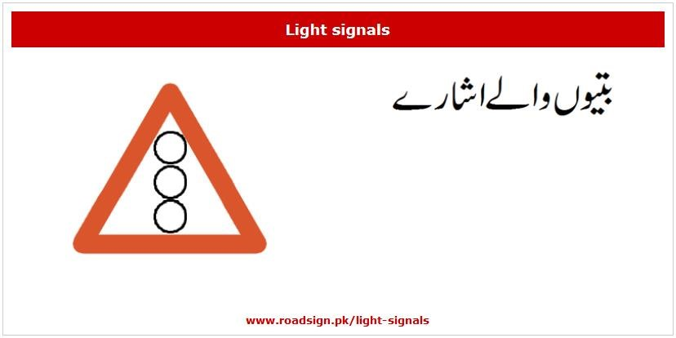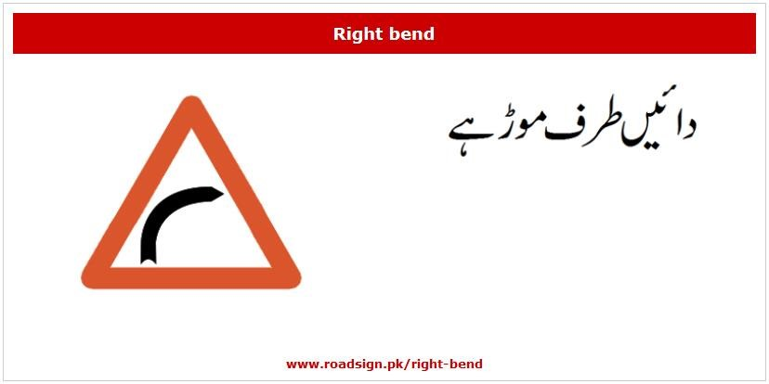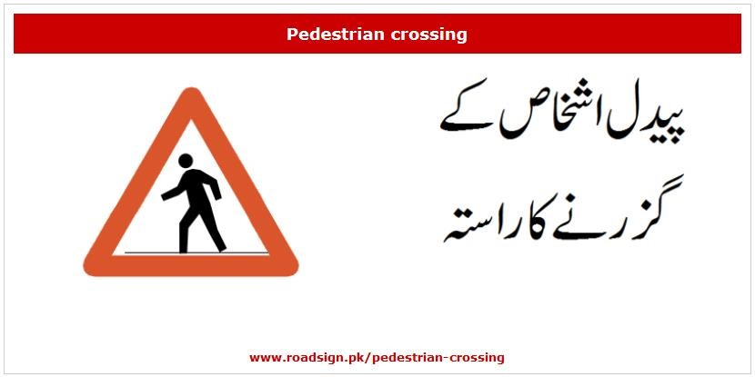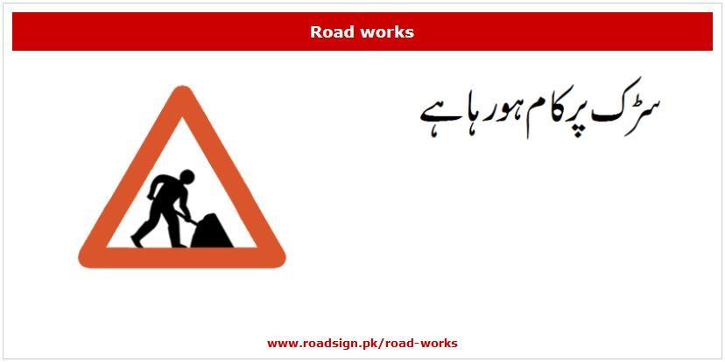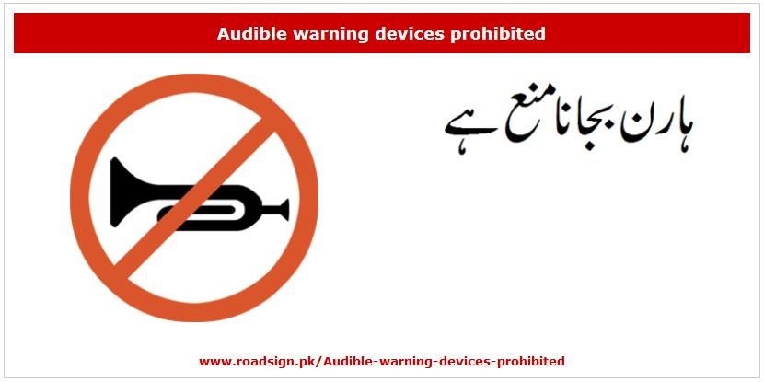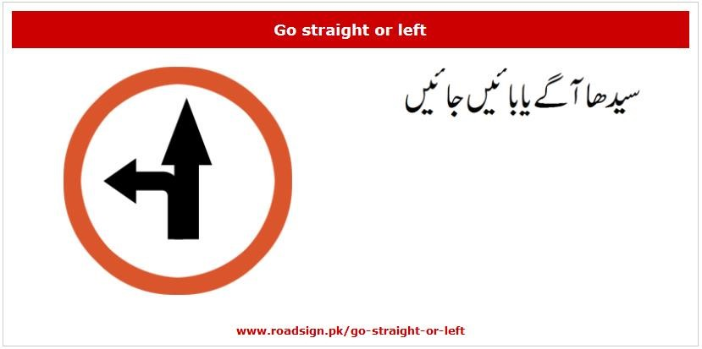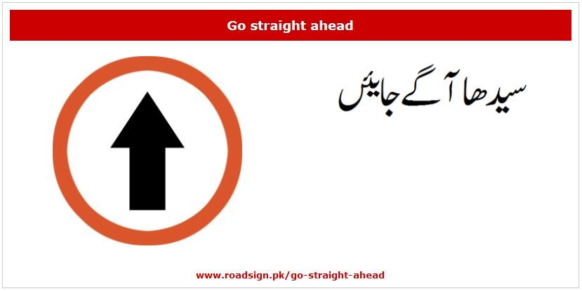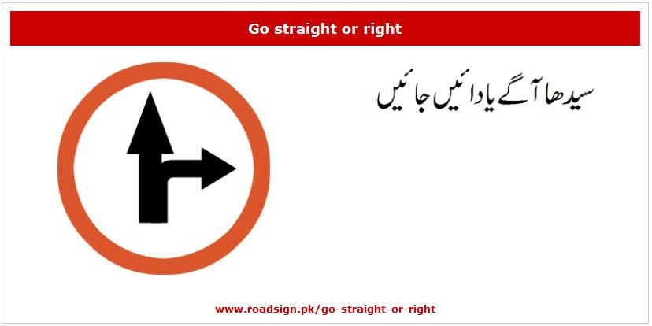
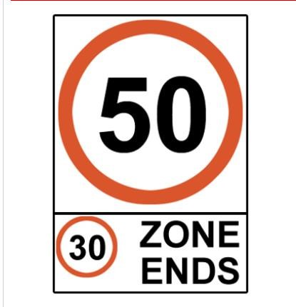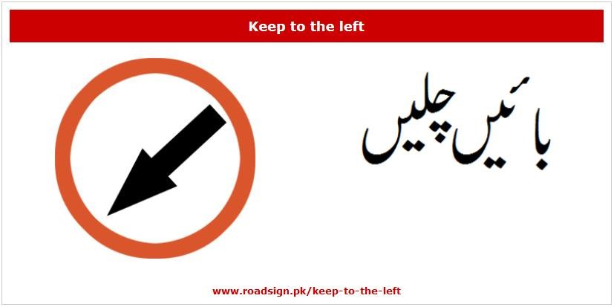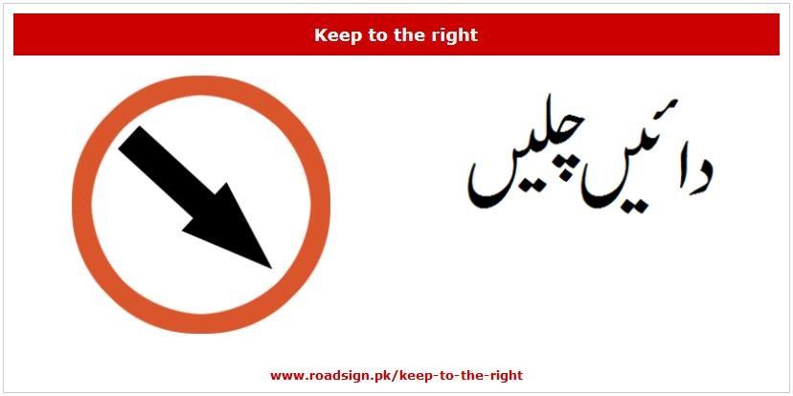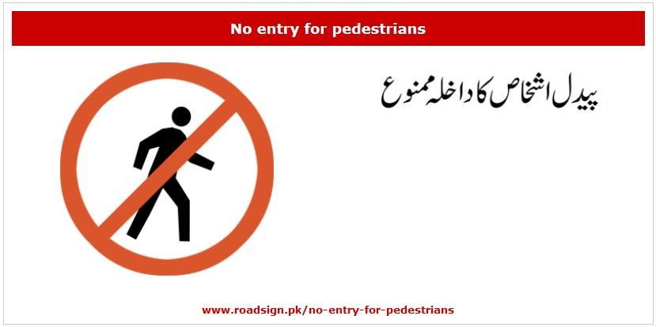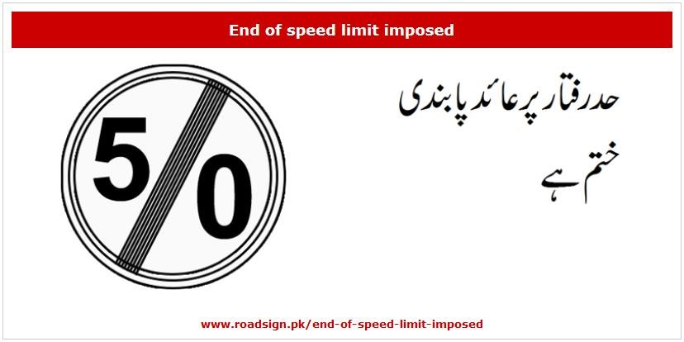
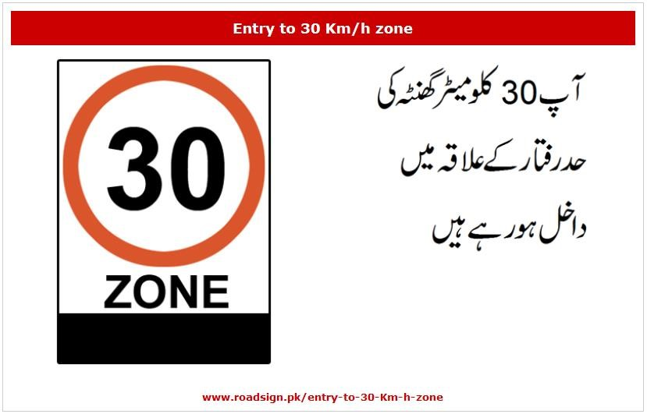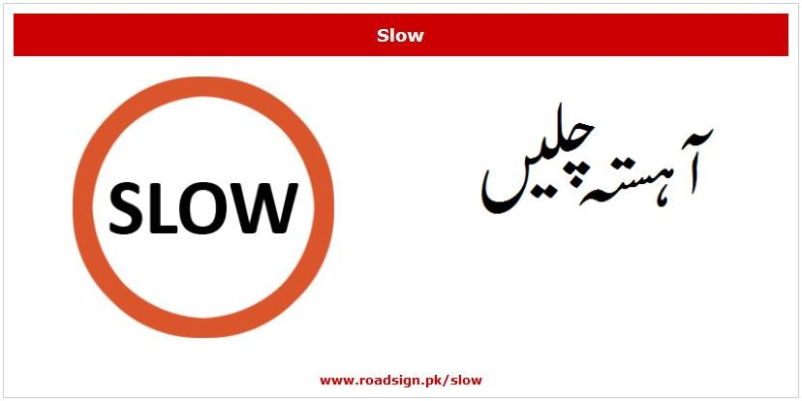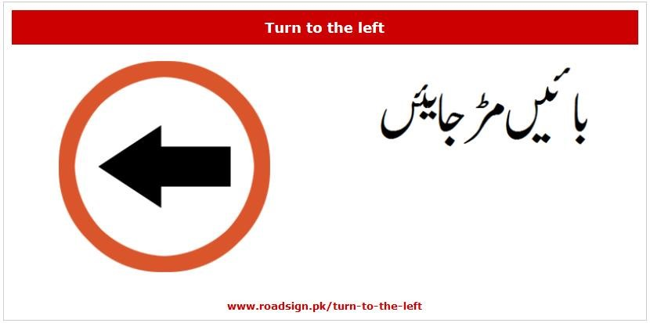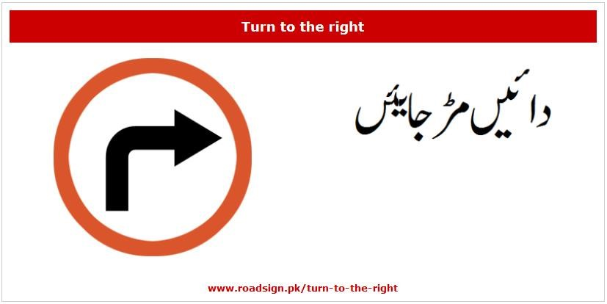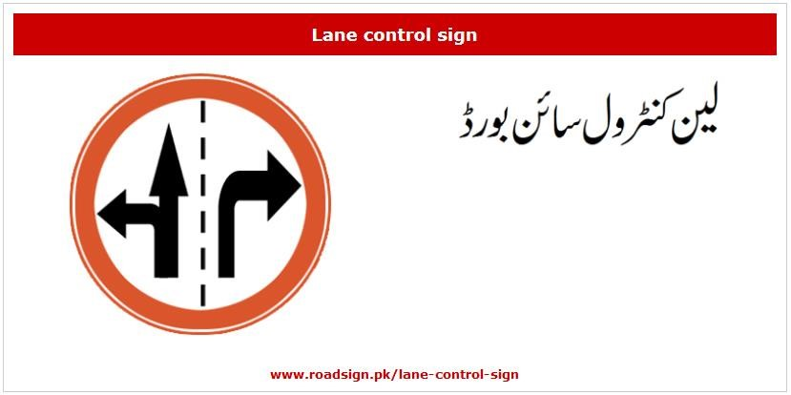
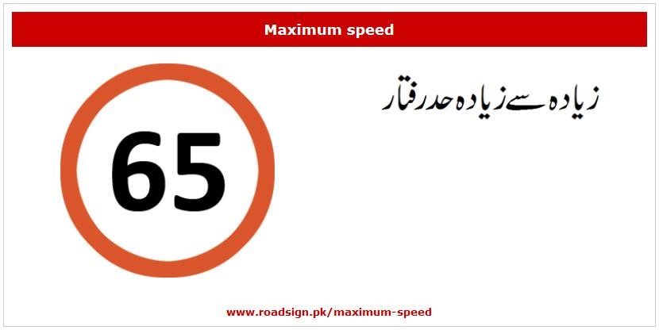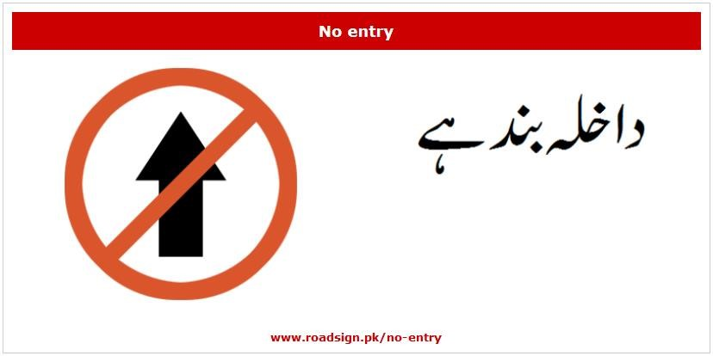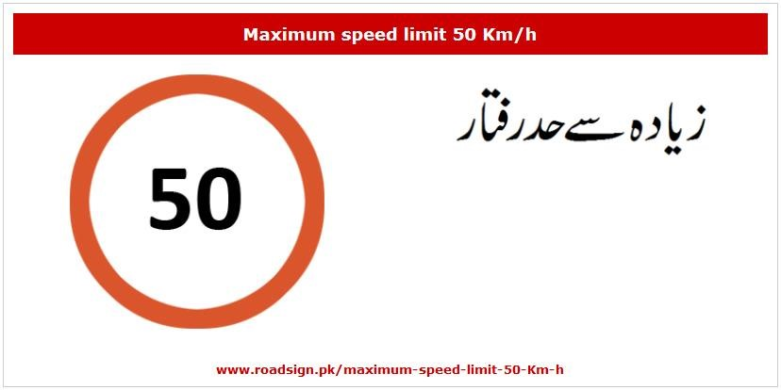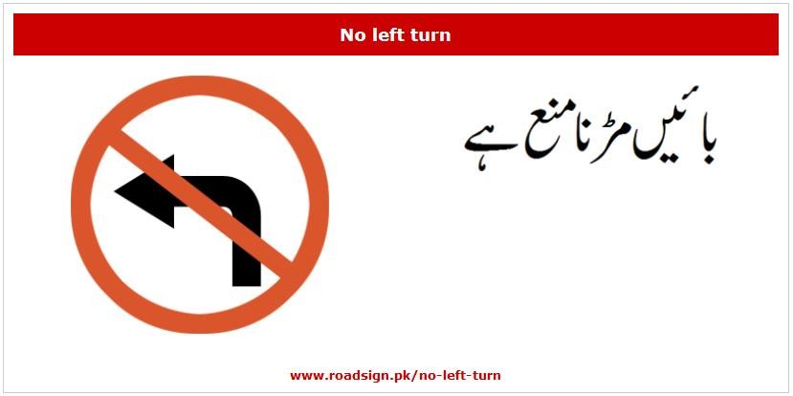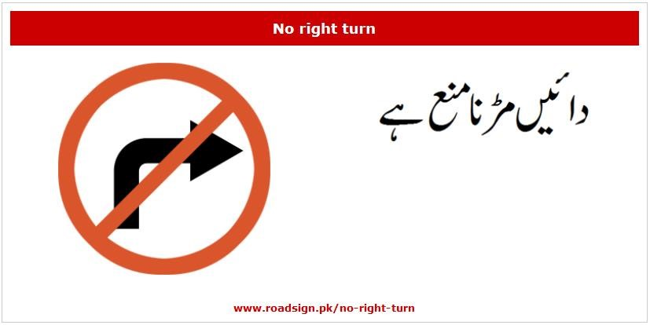
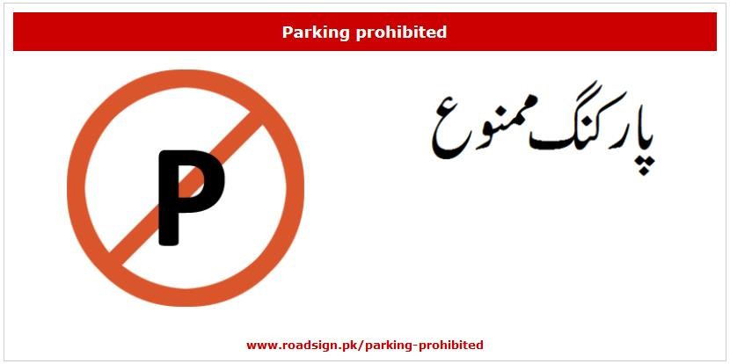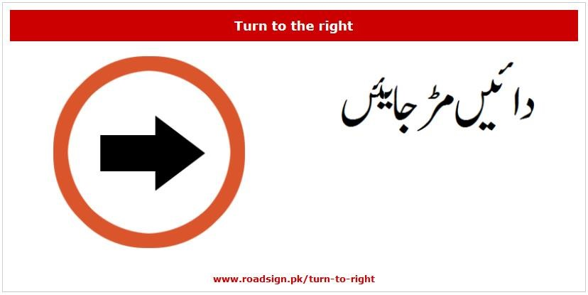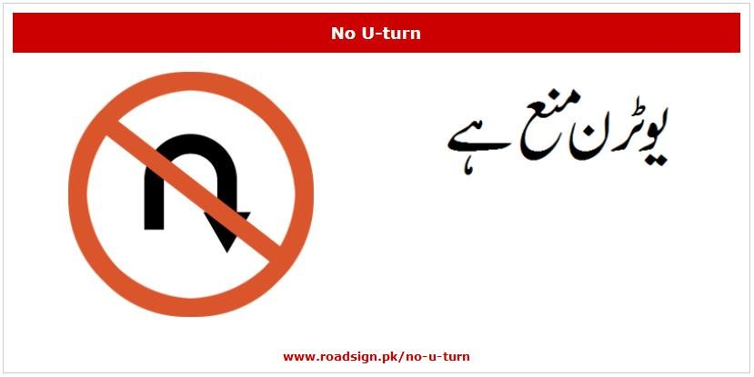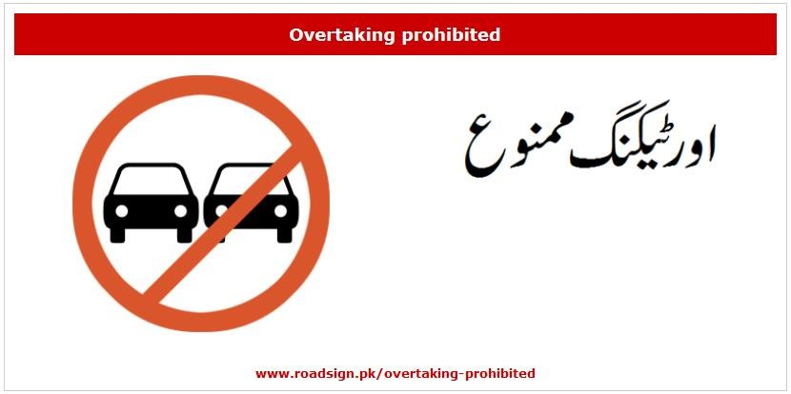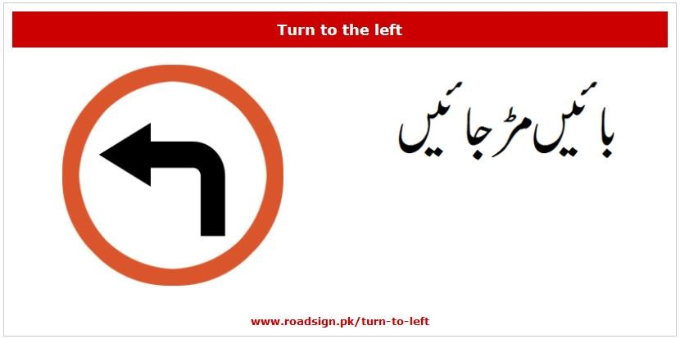
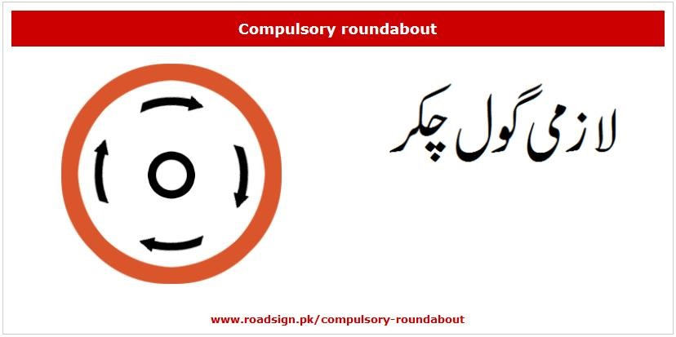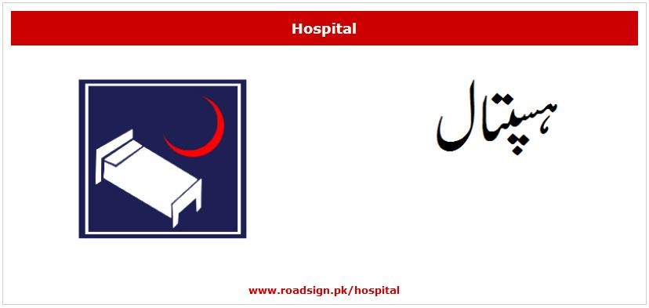
Figure 4.1: Traffic Signs

RESULTS AND DISCUSSIONS (or USER MANUAL)

User Manual

- The user firstly has to register the account.
- Login the account to start the game.
- The main menu will appear after the login screen.
- The main menu consists of Play, Settings, Help, Exit, Spin Board and Initial Coins.
- In Help, there will be proper guidance for the player.
- In the Settings panel, there will be three further options (controls, sound, and graphics).
- In Controls panel, 3 settings will be available (Gyroscope, Buttons and Steering wheels).
- Sound includes the music option.
- Graphics Panel comprised of 3 types of graphics (high, medium, low).
- After updating the settings according to the user’s choice, he can use the spin board to add coins.
- In-Play Panel, modes panel will appear comprises of training and arcade mode.
- Training mode includes the driving test environment with no traffic.
- Arcade mode further includes 7 different levels. Except for level 1, initially, all levels are locked.
- Levels will open when you clear the previous level.
- Different rules are being deployed at different levels.
- After selecting mode and level, there will be a selection of Car.
- Selecting a car according to the user’s choice and coins.
- Users will jump into the game.
- If a user is in training mode, there will be no limitations for him. But if its arcade mode, age will be confirmed.
- After age confirmation, drug addictions form will pop up to confirm whether a player is drunk or not.
- Going through all those questions, pop up will appear and the user can play the game.
- Different rules are there in the game, and if the user violates any rule being deployed in-game, level will restart and the violated rule pop up will appear.
- If the level will be cleared, the user has to solve the quiz at the end of each level.
- Users can exit the game by the Exit button.

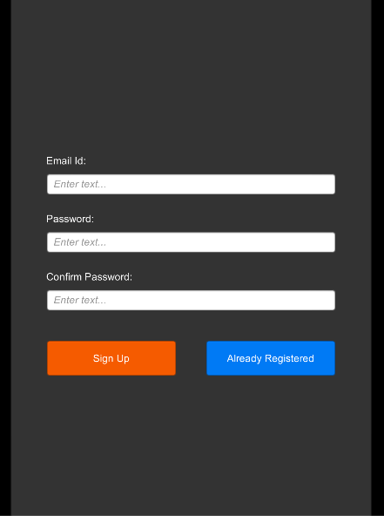
Figure 5.1: Signup Panel

In sign up panel, the user has to enter the email and set the desired passwords against his or his login.
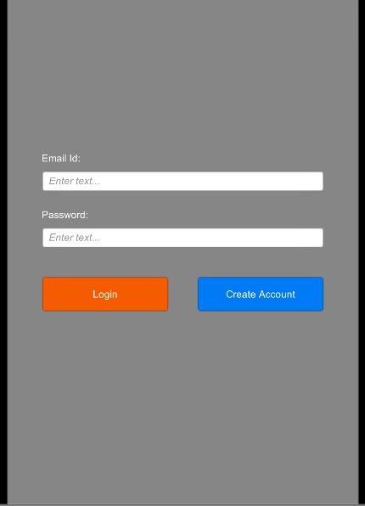
Figure 5.2: Login Panel

The login panel includes the email and password of already registered users.

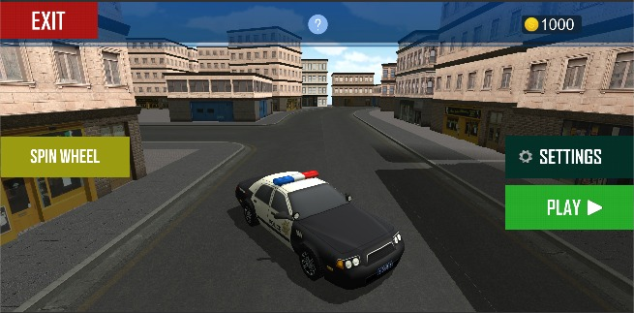
Figure5.3: Main Menu

The main menu includes different buttons being displayed above in the screenshot. In main menu Exit, Spin Wheel, Play, Initial Coins and Help options in it.

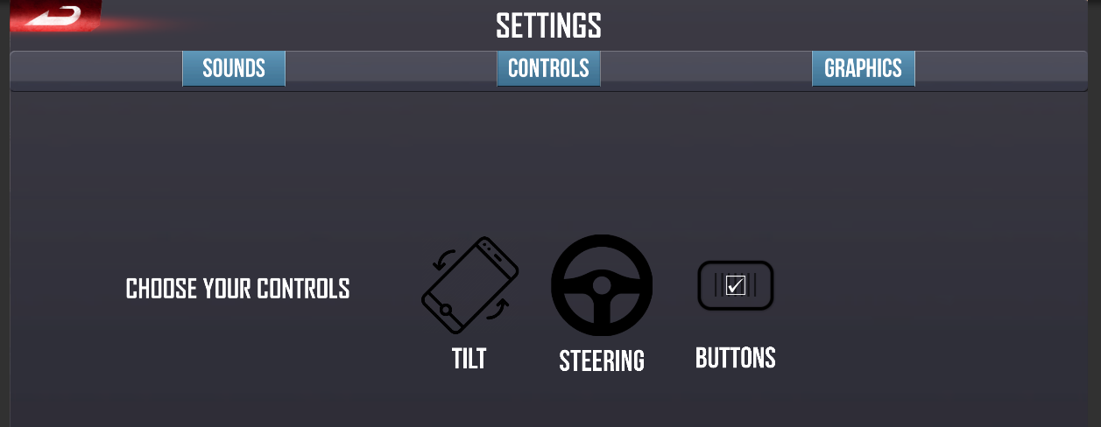
Figure 5.4: Controls Setting

Control settings have three different options of buttons, tilt and steering wheel. Users can select according to their ease.

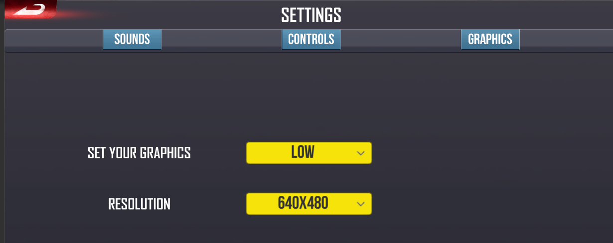
Figure 5.5: Graphics Settings

Graphic settings can be changed by the user to high medium and low.

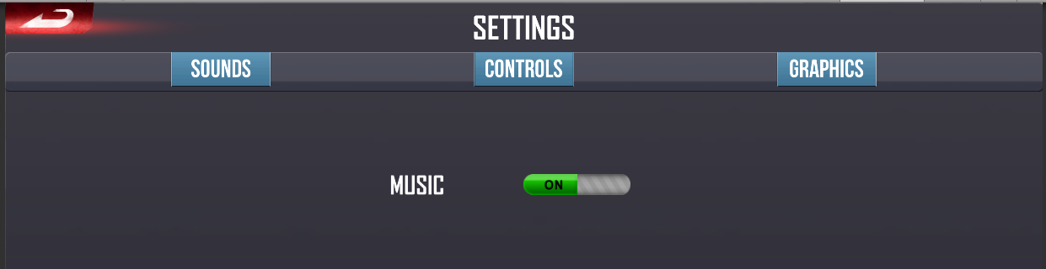
Figure 5.6: Sound Settings

Music on and off option is available to the user.

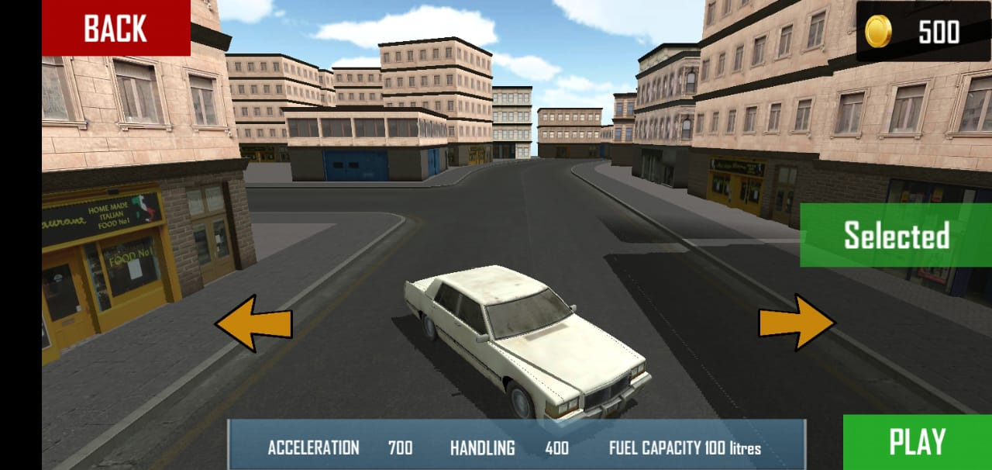
Figure 5.7: Vehicle Selection

Different LTV’s and HTV’s will be available and the user can buy a car in correspondence with the coins.

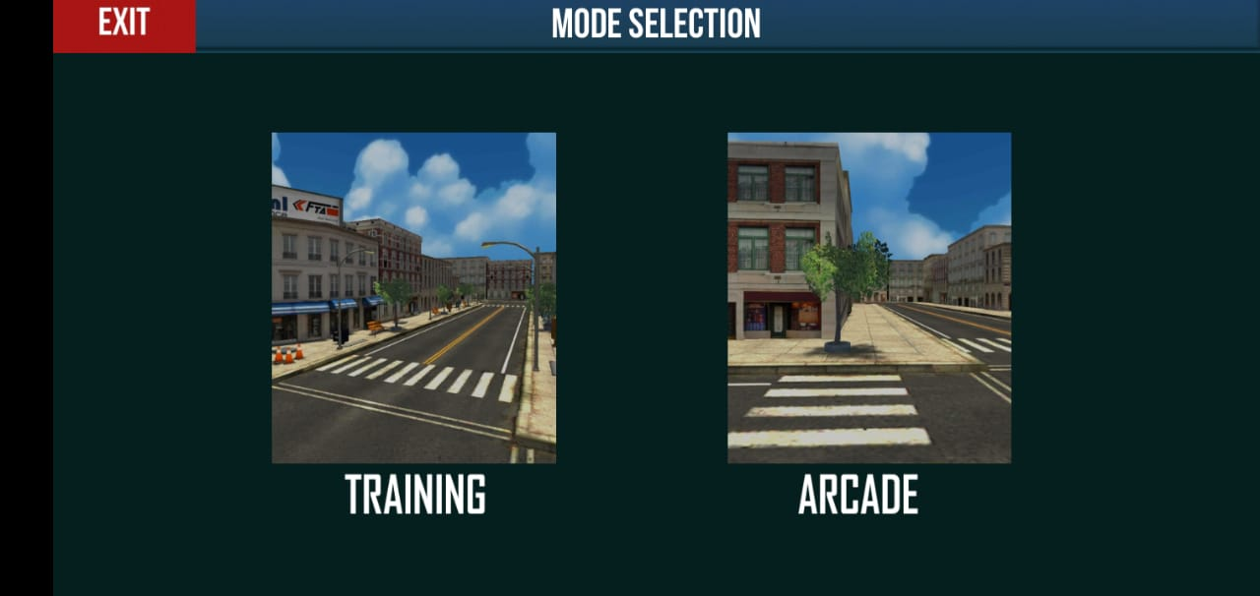
Figure 5.8: Mode Selection

As per the requirement of our proposal, there will be two modes which are training mode and arcade mode.

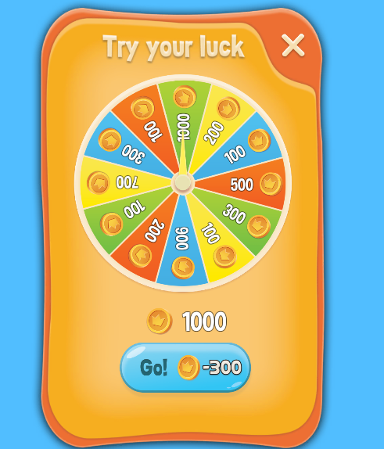
Figure 5.9: Spin Board

Users can spin this board and get the reward according to his/ her spin.

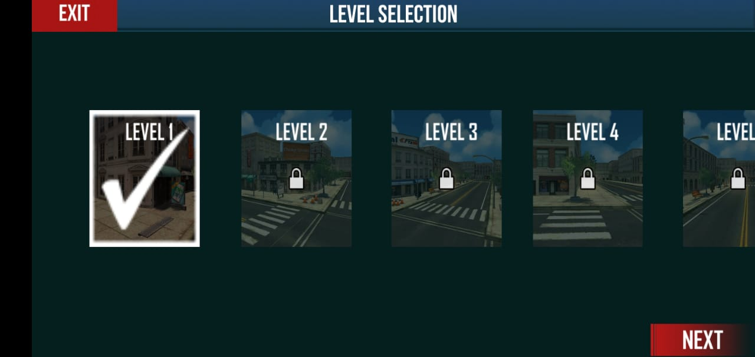
Figure 5.10: Level Selection in Arcade Mode

There are total 7 levels in the game in which levels 6 and 7 are highway levels. And the level selection is based upon the previous level clarification.

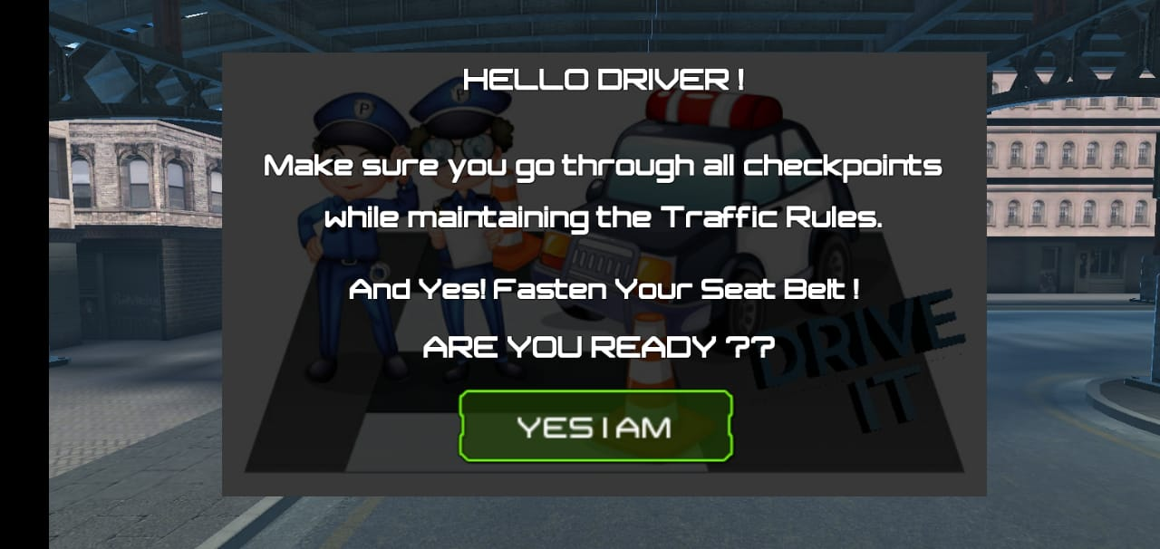
Figure 5.11: Start-Up Message

Before starting the level, a pop up will appear that ensures about the seat belt to start the level.

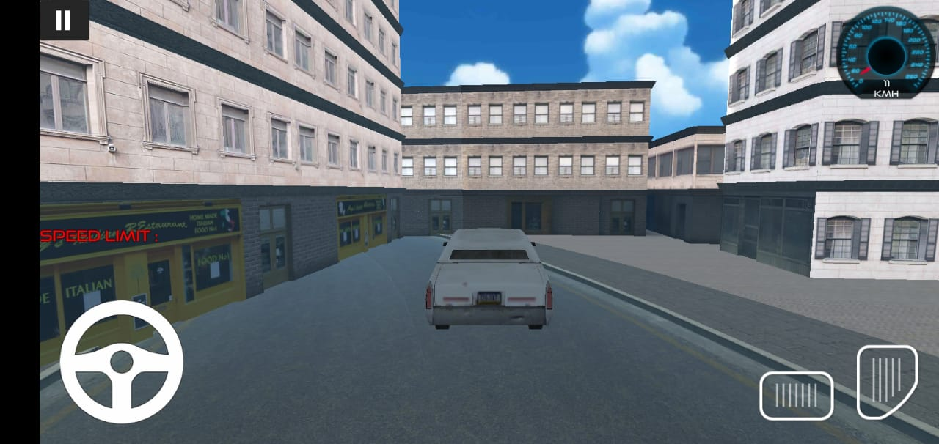
Figure 5.12: Training Mode

Training mode is just a free ride where there are no limitations of rules and no traffic included in the level.

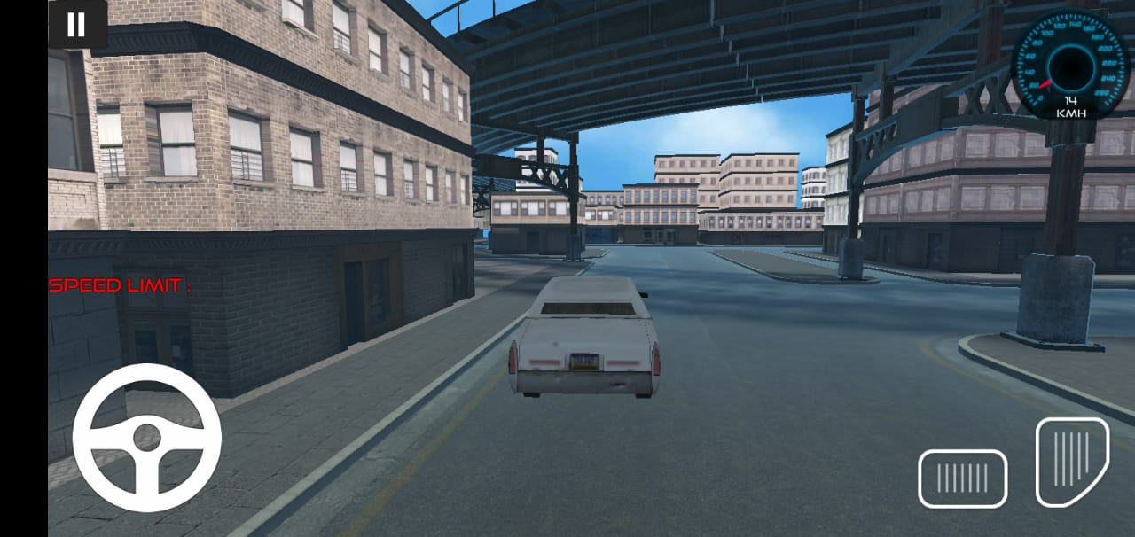
Figure 5.13: Steering Mode

The above screenshot is showing that we have enabled the steering wheel to play the game.

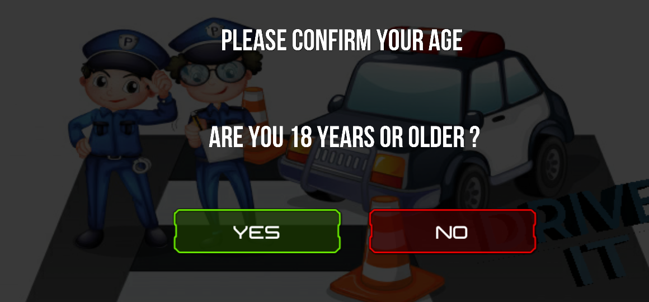
Figure 5.14: Age Checking Pop up

Pop up for the age limit will appear on the screen before starting the game to make sure that the user is above 18.

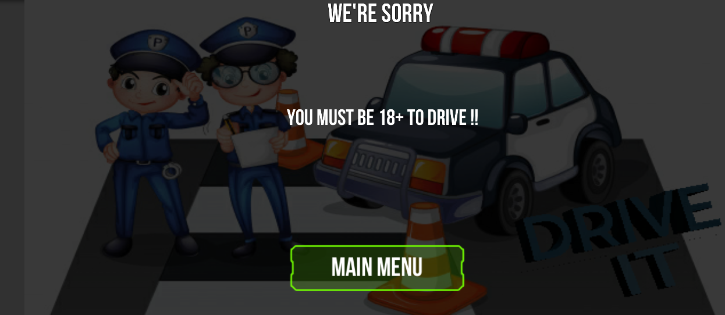
Figure 5.15: Underage Violation

If the user is underage, the underage pop up will appear to show the user that he can’t drive before 18.

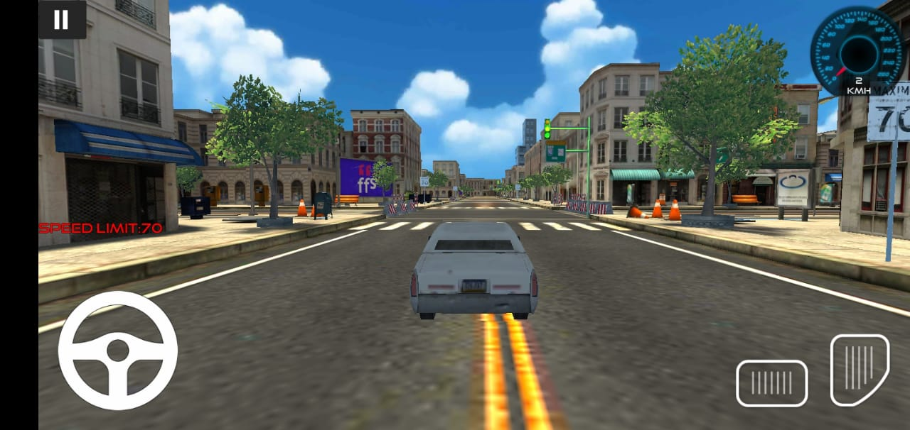
Figure 5.16: Speed Limit

In the arcade mode level, the speed limit is showing on the left side of the screen and also signboards of the speed limit will be available.

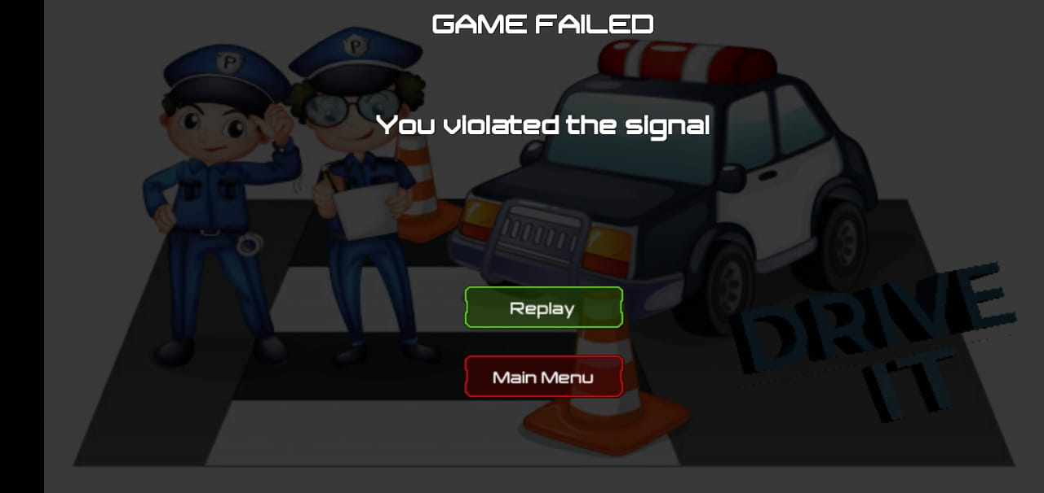
Figure 5.17: Signal Violation Pop-Up

User crossed the road on a red signal, so a pop up will appear of failed and showing the rule violated in the game

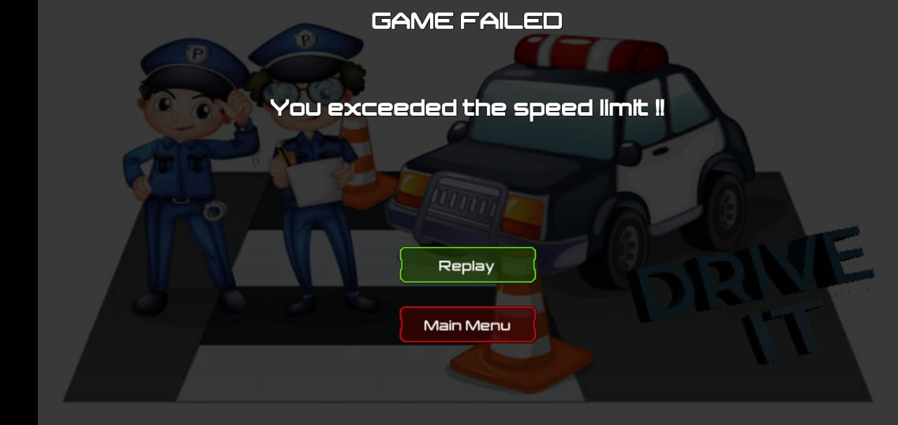
Figure 5.18: Speed limit Violation Pop-Up

Exceeding the speed limit is the major cause of the accident in Pakistan, so speed limit violation popup screenshot is attached.

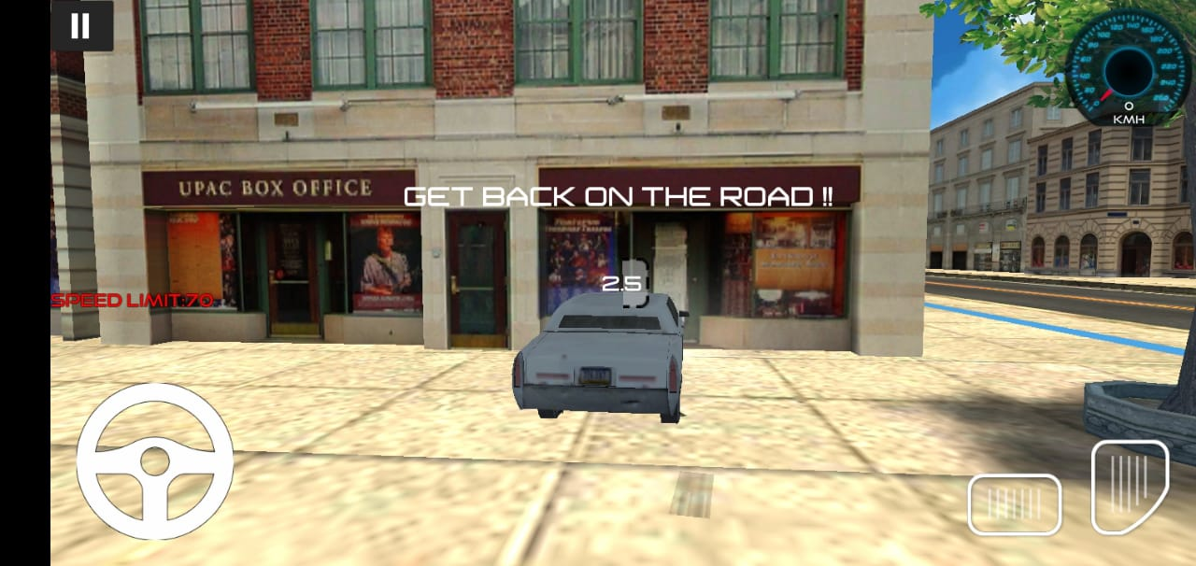
Figure 5.19: Stay on Footpath Warning

The user gets on the footpath, and the game was showing him the timer. If the user will get back on the road within the decided time then the game will continue otherwise level will fail.

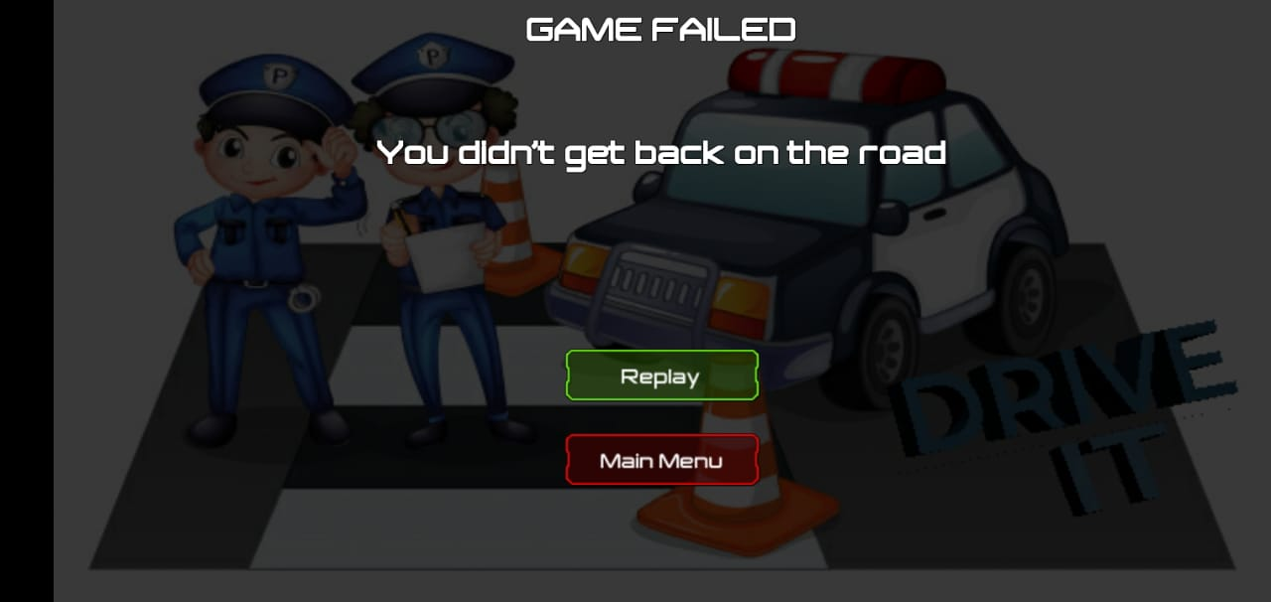
Figure 5.20: Footpath Violation Pop-Up

This mentioned Screenshot is showing that the user didn’t get back on the road at the desired time.

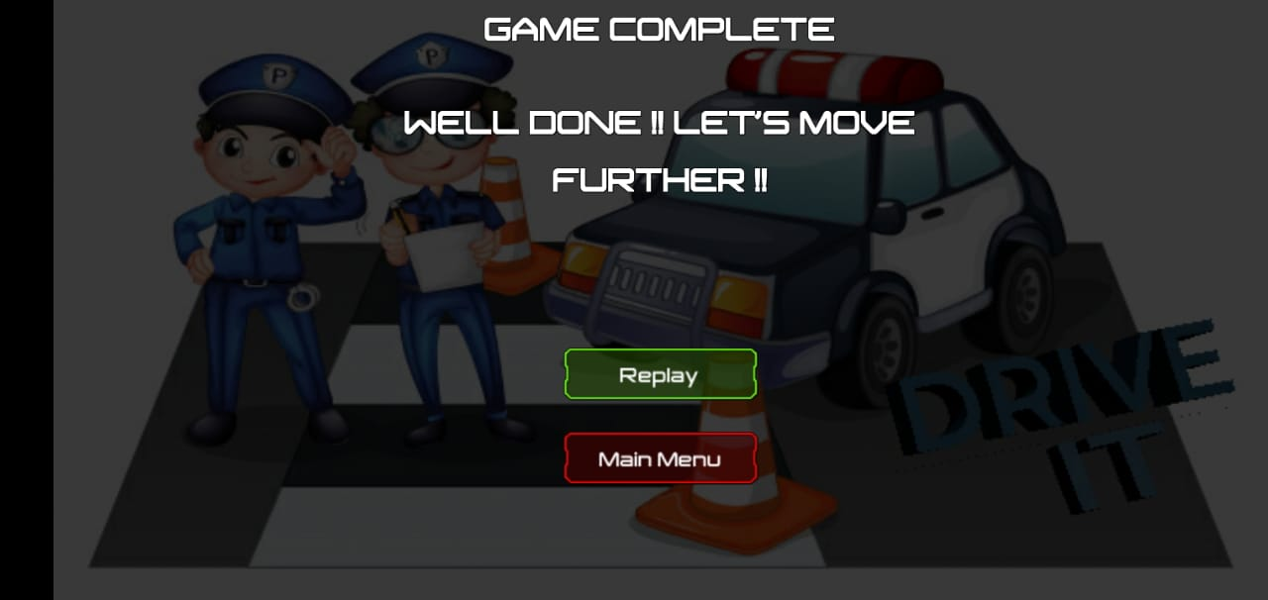
Figure 5.21: Level Completion Pop-Up

This is the level completion popup that users go through all the rules deployed at a specific level.

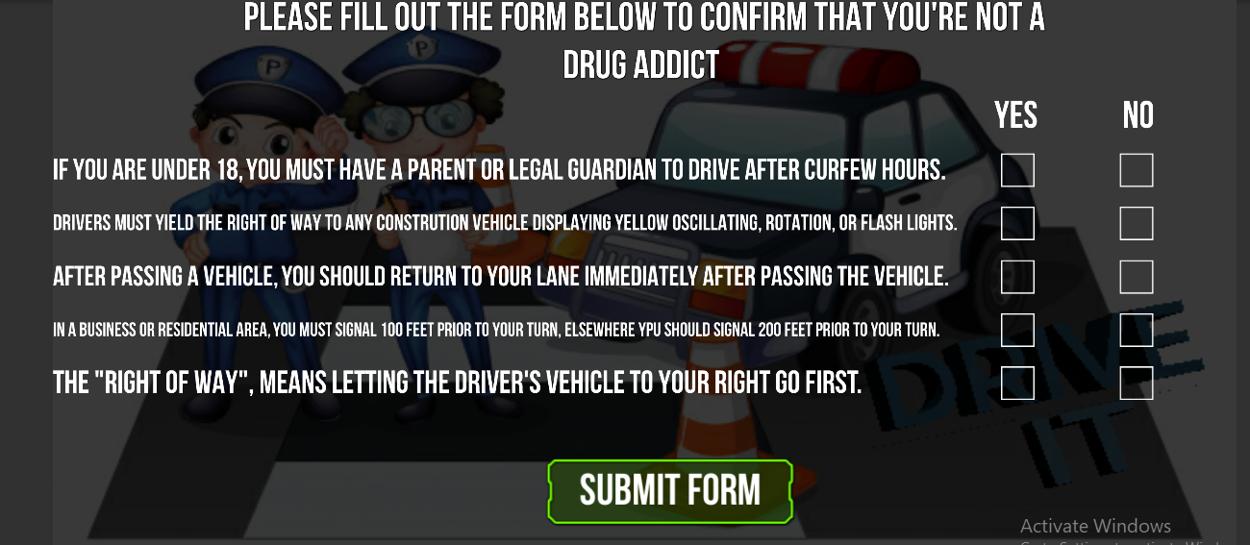
Figure 5.22: Drug Addiction Form

To make sure that the user isn’t drunk, we created a form for checking him. When the user filled this form correctly, he will be able to play the game. Otherwise, he needs to be active mentally.

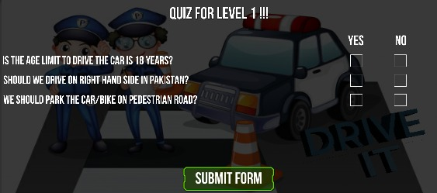
Figure 5.23: Quiz after every level

After successful completion of each level, a quiz will appear which user has to fill at the end of the level.

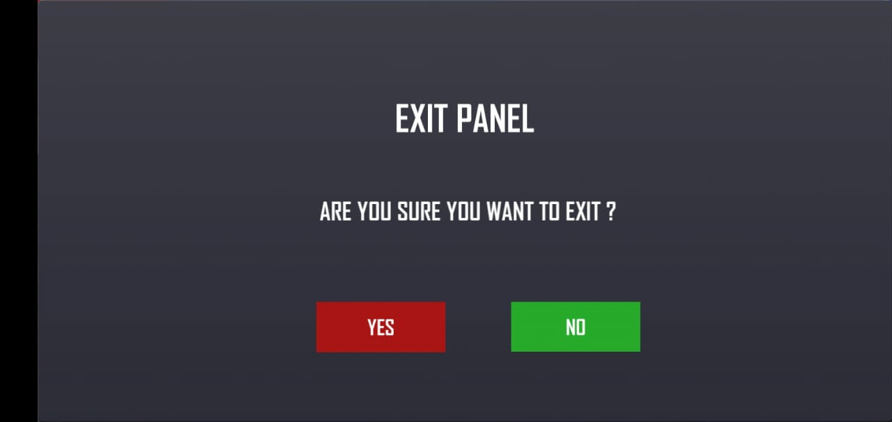
Figure 5.24: Quit Game Option

If the user doesn’t want to play the game, he can exit from the game by confirming to quit.

CONCLUSION AND RECOMMENDATIONS

Conclusion

This whole project comprised of different driving rules deployed in Pakistan. People will get enough knowledge about this rule. And will able to have hands-on practice on this simulator. This simulator will be available on the play store, and people will start practicing on them. After all these the death rate will decrease.

Different stages are planned in the game. By every stage, the difficulty level will be increased and by the last stage of the game, it will be made sure that a user has a maximum knowledge of all the traffic rules.

This interactive game is designed not only to help the people to learn the traffic rules but it will also help City Traffic Police in many ways.

This game is beneficial for all the people who intend to lean traffic rules. This game will make them able to have complete knowledge of all the traffic rules being followed in Pakistan. We are so keen to help the community through this. We have not designed this game only to help people but this will also help our City traffic police department in many useful ways.

Recommendations

- The rule should be implemented that one person can only own one car because having more than one car increases the traffic on the road and heavy traffic causes accidents.
- In the future can also associate this driving simulator with city traffic, so that people will become aware of our project. And also have hands-on practice in an interactive way for a better understanding of the traffic rules.
- Identify training objectives;
- Vehicle game should be the best preoccupation of people, specifically children along with youngsters
- Develop means to interpret the results of the simulation.
- It should lead people to stimulate creative thinking.
- Interactive games are an effective purpose of giving awareness, enhancing participant analysis, and familiarizing participants with the roles, aims, and perspectives.

REFERENCES

Electronic Sources from Internet:

[1] | World Life Expectancy. (2019). Road Traffic Accidents in Pakistan. [online] Available at: https://www.worldlifeexpectancy.com/pakistan-road-traffic-accidents [Accessed 8 Dec. 2019].
[2] | The Nation. (2019). Over 15000 people die in Pakistan annually due to traffic accidents. [online] Available at: https://nation.com.pk/10-Jul-2018/over-15000-people-die-in-pakistan-annually-due-to-traffic-accidents [Accessed 27 Nov. 2019].
[3] | Grappetite.com. (2019). Smartphone usage in Pakistan. [online] Available at: https://grappetite.com/blog/smartphone-usage-in-pakistan/ [Accessed 8 Dec. 2019].
[4] Hg.org. (2019). [online] Available at: https://www.hg.org/traffic-law.html [Accessed 27 Nov. 2019].
[5] Nhmp.gov.pk. (2019). [online] Available at: http://nhmp.gov.pk/wp-content/uploads/2017/12/Newsletter-January-2019.pdf [Accessed 4 Dec. 2019].
[6] Nhmp.gov.pk. (2019). Penalty Table | NH&MP | National Highways & Motorway Police. [online] Available at: http://nhmp.gov.pk/?page_id=413 [Accessed 27 Nov. 2019].
[7] Productplan.com. (2019). What is Feature Driven Development (FDD)? | Definition. [online] Available at: https://www.productplan.com/glossary/feature-driven-development/ [Accessed 8 Dec. 2019].
[8] En.wikipedia.org. (2019). C Sharp (programming language). [online] Available at: https://en.wikipedia.org/wiki/C_Sharp_(programming_language) [Accessed 8 Dec. 2019].
[9] Zamojc, I. (2019). Introduction to Unity3D. [online] Code Envato Tuts+. Available at: https://code.tutsplus.com/tutorials/introduction-to-unity3d--mobile-10752 [Accessed 8 Dec. 2019].
[10] En.wikipedia.org. (2019). Microsoft Visual Studio. [online] Available at: https://en.wikipedia.org/wiki/Microsoft_Visual_Studio [Accessed 8 Dec. 2019].
[11] Techopedia.com. (2019). What is Adobe Photoshop? - Definition from Techopedia. [online] Available at: https://www.techopedia.com/definition/32364/adobe-photoshop [Accessed 8 Dec. 2019].
[12] Roadsign.pk. (2019). Account Suspended. [online] Available at: http://www.roadsign.pk/must-follow-road-sign [Accessed 18 Mar. 2019].

APPENDICES

APPENDIX A: Code

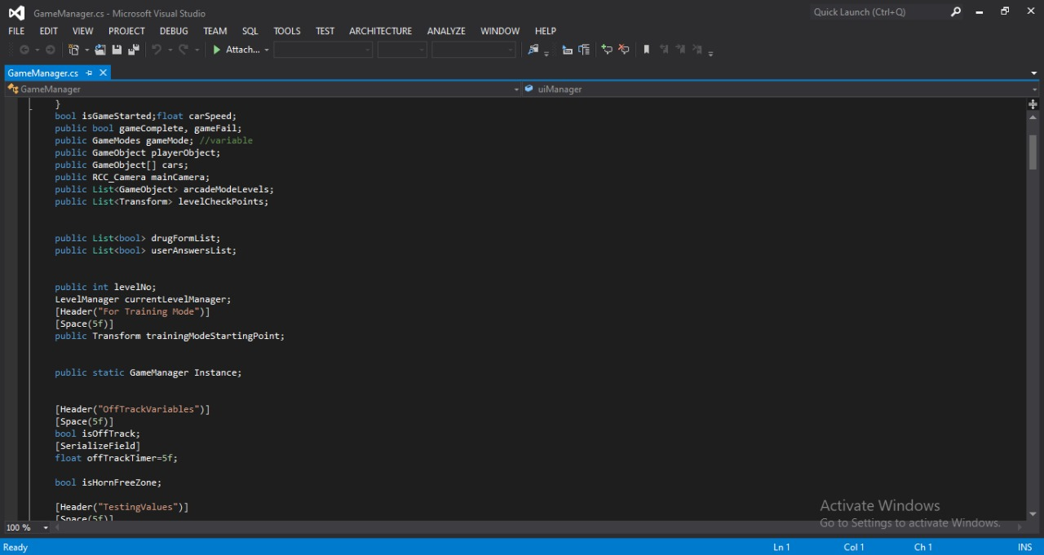
Figure Appendix 1: Game Manager

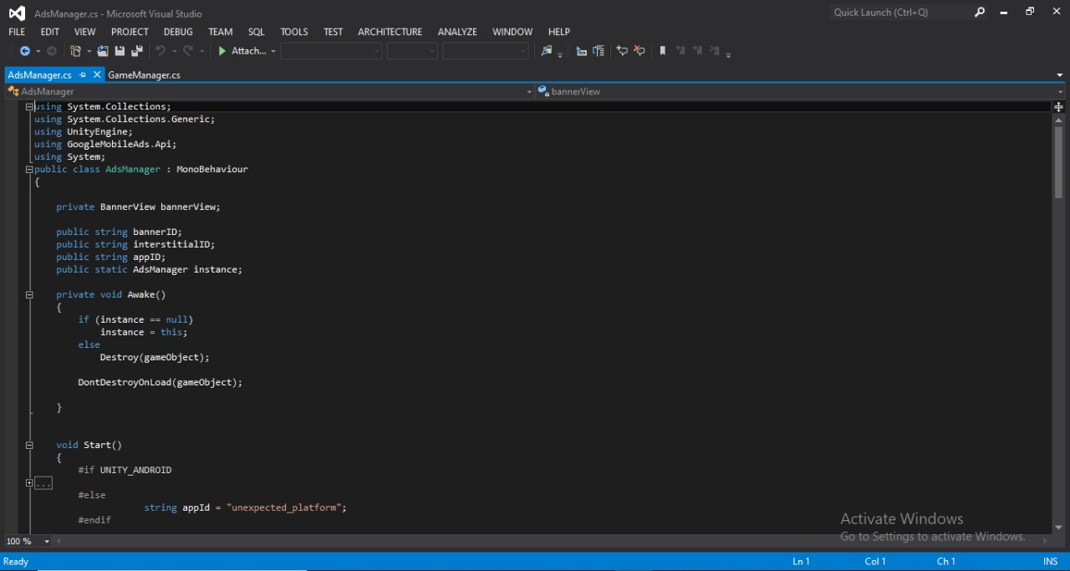
Figure Appendix 2: Ad Manager

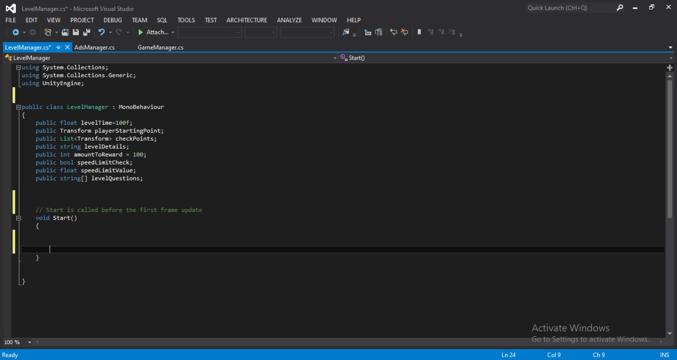
Figure Appendix 3: Level Manager

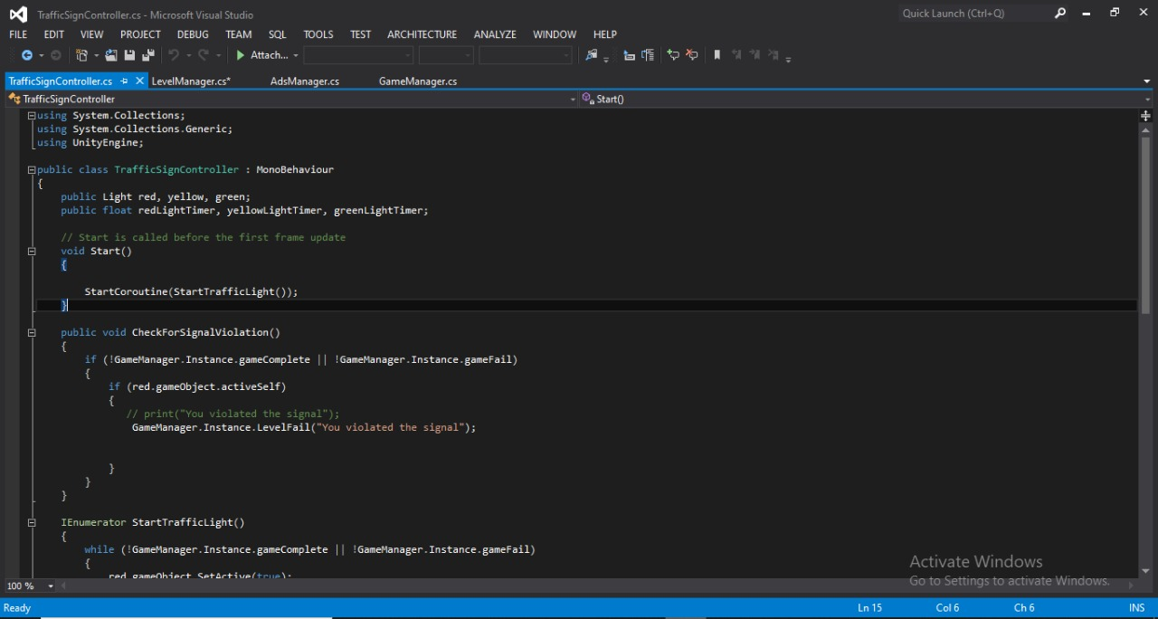
Figure Appendix 4: Traffic Sign Controller

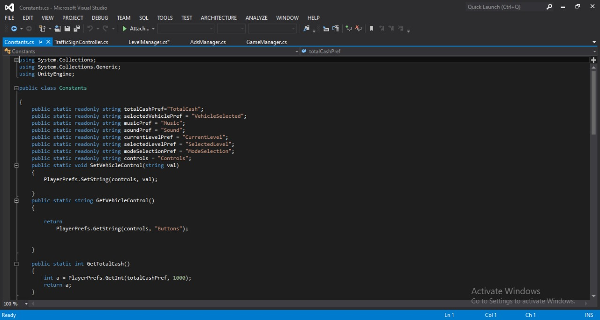
Figure Appendix 5: Constants

