
BSCS-S19-01616
03-134161-011 | Mahboob Sardar
03-134161-013 | Mirza M. Rashid Tufail
03-134161-048 | Muhammad Haseeb Aslam

Detecting Lung Cancer using Image Processing
(PulmoOnco Spot)
In partial fulfilment of the requirements for the degree of
Bachelor of Science in Computer Science
Supervisor: Dawood Akram

Department of Computer Sciences
Bahria University, Lahore Campus
January 2020

© Bahria University, 2020

Certificate

We accept the work contained in the report titled
“Detecting Lung Cancer using Image Processing”
(PulmoOnco Spot)
Written by

Mahboob Sardar
Mirza M. Rashid Tufail
Muhammad Haseeb Aslam

as a confirmation to the required standard for the partial fulfillment of the degree of
Bachelor of Science in Computer Science.

Approved by:
Supervisor: Dawood Akram
(Signature)

January 30, 2020

DECLARATION

We hereby declare that this project report is based on our original work except for citations and quotations which have been duly acknowledged. We also declare that it has not been previously and concurrently submitted for any other degree or award at Bahria University or other institutions.

Enrolment | Name | Signature
03-134161-011 | MAHBOOB SARDAR
03-134161-013 | MIRZA M. RASHID TUFAIL
03-134161-048 | MUHAMMAD HASEEB ASLAM

Date: January 30, 2020

Specially dedicated to
My beloved parents and siblings
(Mahboob Sardar)
My beloved parents and siblings
(Mirza M. Rashid Tufail)
My beloved parents and siblings
(Muhammad Haseeb Aslam)

ACKNOWLEDGEMENTS

We would like to acknowledge our gratitude to our supervisor, Dawood Akram for his guidance, constant attention and personal concern towards the completion of this project. Furthermore, our appreciation also goes to our co-supervisor Mr. Shujaat and lab engineers from the department of computer science for their time, attention and guidance. We are also thankful to the evaluating team who evaluated our project with full dedication pinpointed our mistakes and guided as in the right way during the whole project.

In addition, we would also like to say thanks to our loving parents and friends who had helped and given encouragement.

Mahboob Sardar
Mirza M. Rashid Tufail
Muhammad Haseeb Aslam

Detecting Lung Cancer using Image Processing
(PulmoOnco Spot)

ABSTRACT

Lung cancer growth is one of the significant reasons for death in the world. Different diagnosis and detection of lung cancer have been done using many data analysis and classification techniques. Since the cause of lung cancer growth remains unsure, prevention becomes impossible, therefore early detection of tumors in the lungs is the only way to cure lung cancer. Thus, lung cancer detection system using image processing and machine learning is used to classify the presences of lung cancer in a CT-images. This research focuses on the detection of lung cancer by using the Alexnet classifier. The two different types of lung data used originates from the Cancer imaging archive Database, the data used consisted of a total of 301 CT-images. The first CT-image data consists of 154 images and the second CT-image data consists of 133 images. The classifier trained on both dataset and combination (hybrid data set) of both datasets. The results from both the data set show system can detect CT-image of normal lung and lung cancer with an accuracy of respectively 87% and 92%. The hybrid dataset shows an accuracy of 95%. Hopefully, use to help medical personnel and research to detect lung cancer status.

TABLE OF CONTENTS

DECLARATION iii
ACKNOWLEDGEMENTS v
ABSTRACT vi
TABLE OF CONTENTS vii
LIST OF TABLES ix
LIST OF FIGURES x
LIST OF SYMBOLS / ABBREVIATIONS xii

CHAPTER 1 1
INTRODUCTION 1
1.1 Background 1
1.2 Problem Statements 1
1.3 Aims and Objectives 2
1.4 Scope of Project 2
CHAPTER 2 3
2 Software Requirement Specification 3
2.1 Overall Description 3
2.2 Operating Environment 3
2.3 Design and Implementation Constraints 3
2.4 Assumptions and Dependencies 4
2.5 Other Non-functional Requirements 4
2.6 Software Quality Attributes 5
2.7 System Requirements Chart 6
CHAPTER 3 7
3 DESIGN AND METHODOLOGY 7
3.1 Use Case Diagram 7
3.2 Use case Description 15
3.3 Domain Model 26
3.4 Sequence Diagram 27
3.5 Design Class Diagram 33
3.6 Entity Relationship Diagram 33
CHAPTER 4 34
4 DATA AND EXPERIMENTS (and/or IMPLEMENTATION) 34
4.1 Methodology 34
4.2 Technology 35
CHAPTER 5 36
5 RESULTS AND DISCUSSIONS (USER MANUAL) 36
5.1 User access, roles, and privileges 36
5.2 User interface 37
CHAPTER 6 49
6 CONCLUSION AND RECOMMENDATIONS 49
6.1 Conclusion 49
6 REFERENCES 50

LIST OF TABLES

TABLE TITLE PAGE
Table 2.7-1: System Requirements Chart 6
Table 3.2-1: Register 16
Table 3.2-2: Login 17
Table 3.2-3: Change Password 18
Table 3.2-4: Security Question 19
Table 3.2-5: Forgot Password 20
Table 3.2-6: Patient Info 21
Table 3.2-7: Input Image 22
Table 3.2-8: Reset 23
Table 3.2-9: Diagnose 24
Table 3.2-10: Save Report 25
Table 3.2-11: Logout 26

LIST OF FIGURES

Figure 3.1-1: Main Use Case 7
Figure 3.1-2: Register 8
Figure 3.1-3: Login 9
Figure 3.1-4: Change Password 9
Figure 3.1-5: Security Question 10
Figure 3.1-6: Forgot Password 11
Figure 3.1-7: Patient Info 12
Figure 3.1-8: Input Image 12
Figure 3.1-9: Diagnose 13
Figure 3.1-10: Reset 13
Figure 3.1-11: Save Report 14
Figure 3.1-12: Logout 14
Figure 3.3-1: Domain Model 26
Figure 3.4-1: Login 27
Figure 3.4-2: Select Security Question 28
Figure 3.4-3: Change Password 29
Figure 3.4-4: Forgot Password 30
Figure 3.4-5: Patient Info 30
Figure 3.4-6: Diagnose 31
Figure 3.4-7: Reset 32
Figure 3.4-8: Logout 32
Figure 3.5-1: Class Diagram 33
Figure 3.6-1: ERD 33
Figure 4.1-0-1: Development Method 34
Figure 5.2-1: Login Screen 37
Figure 5.2-2: Enter Password 38
Figure 5.2-3: Set Security Question 39
Figure 5.2-4: Forgot Password 40
Figure 5.2-5: Enter New Password 41
Figure 5.2-6: Menu Screen 42
Figure 5.2-7: Change Password Screen 43
Figure 5.2-8: Select Open (From Menu) 44
Figure 5.2-9: Patient Info Screen 45
Figure 5.2-10: After Patient Info 46
Figure 5.2-11: Image Upload Screen 46
Figure 5.2-12: Diagnose Screen 47
Figure 5.2-13: Reset 47
Figure 5.2-14: Logout 48

LIST OF SYMBOLS / ABBREVIATIONS

WHO World Health Organization
POS PulmoOnco Spot
CT Computed Tomography
MRI Magnetic Resonance Image

INTRODUCTION

Background

Lung cancer is the abnormal growth of a cell in one or both lungs. With the passage of time, these abnormal cells start affecting other organs around the lungs. According to the World Health Organization (WHO) statistics, it was observed that lung cancer was the foremost cause of death worldwide as compared to other types of cancers. The number of deaths recorded caused by lung cancer was approximately 1.59 million in 2012. The main cause of lung cancer is the addiction to smoking cigarettes, carcinogenic environments such as radioactive gas and air pollution [3]. We are going to propose a computer-aided system based on image processing of lungs CT scan or MRI images that will provide aid to doctors or radiologists to diagnose lung cancer at an early stage.

Problem Statements

Detection of lung cancer nodules at an early stage that doctors cannot diagnose at the right time, i.e. at the beginning. Lung cancer is one of the top causes of death as compared to other types of cancers [3]. PulmoOnco Spot is a desktop application that will be processing and extracting features from CT scan or MRI images to detect Lung cancer at an early stage. In this way, we can help patients and provide aid to doctors to serve their patients effectively.

Aims and Objectives

The objective of PulmoOnco Spot (POS) is to detect lung cancer by using Digital Image Processing techniques.

Scope of Project

We are going to develop a system that can detect lung cancer by using CT scan images of lungs, by implementing Digital Image Processing techniques on them. PulmoOnco Spot (POS) detects cancerA. In most cases lung cancer can detect at an early stage, detection of lung cancer could be the best strategy to save lives. By using POS doctors can diagnose whether a patient has lung cancer or not at an early stage.

Software Requirement Specification

Overall Description

User Classes and Characteristics
In this project, our main users are doctors and radiologists.
Doctor/radiologist:
User has access to everything. Users can log in, input the image, diagnosis the lung cancer, and Save the report and then logout.

Operating Environment
  - Operating system: Windows
  - Platform: MATLAB

Design and Implementation Constraints
We are going to design a desktop application. The design of our desktop application will be user-friendly for Doctors / Radiologist. The desktop application will be responsive and compatible with all types of computers and laptops with the Windows operating system. We also required the dataset of the lungs. Application detecting disease from CT scan images of the lung.

Assumptions and Dependencies

The user should have a computer or laptop to use this application. The user should have sufficient knowledge about the application. We want to detect lung cancer and then show the report of a patient is healthy or not.

Other Non-functional Requirements

Performance Requirements

The desktop application should perform all actions correctly and reliably. The application should give a response within time. The application upload images and perform all the necessary requirements then shows the result on a frame within a reasonable time. For the best performance of this desktop application, the computer or laptop has a good processor and memory. By using these specifications the desktop application will become fast and responsive.

Security Requirements

The users must provide their user name and password for login. Dataset of the CT scan images must be secure because the trained dataset which is required for the application and disease detection.
The desktop application coding part is private for external users. Because if anyone who has sufficient knowledge can access the coding part of the application, then they can change the environment related to application components, functionalities and features also. Therefore, the application code must be private to the developer.

Software Quality Attributes

Availability:
The application will be available to the user 24/7.
Flexibility:
The application would be flexible.
Usability:
The application should be user-friendly for the Doctor / Radiologist. Doctor / Radiologist easily understand how to use the application.
Testability:
The application should be easy to test at each level and find the bugs/defect at each level of development and remove the defects easily.
Reusability:
The application is divided into different modules of coding. These modules can be used across the application.
Maintainability:
The application will be easy to maintain by removing bugs/errors from time to time if arises.

System Requirements Chart

Table 2.7-1: System Requirements Chart
ID | Priority | Type | Used use cases | Description
1 | High | Functional | U1 | Register Login Credentials for Doctors/radiologists.
2 | High | Functional | U2 | Only registered users can login in order to use the tool.
3 | High | Functional | U3 | Can change the current password
4 | High | Functional | U4 | Select and answer the security questions.
5 | High | Functional | U5 | Answer the already selected security questions to reset the password
6 | High | Functional | U6 | Input image, select the CT Scan of the patient
7 | High | Functional | U7 | Run the algorithm to Diagnose the cancer
8 | High | Functional | U8 | Save the report after Diagnosing
9 | High | Functional | U9 | Logout

DESIGN AND METHODOLOGY

Use Case Diagram

Main Use Case
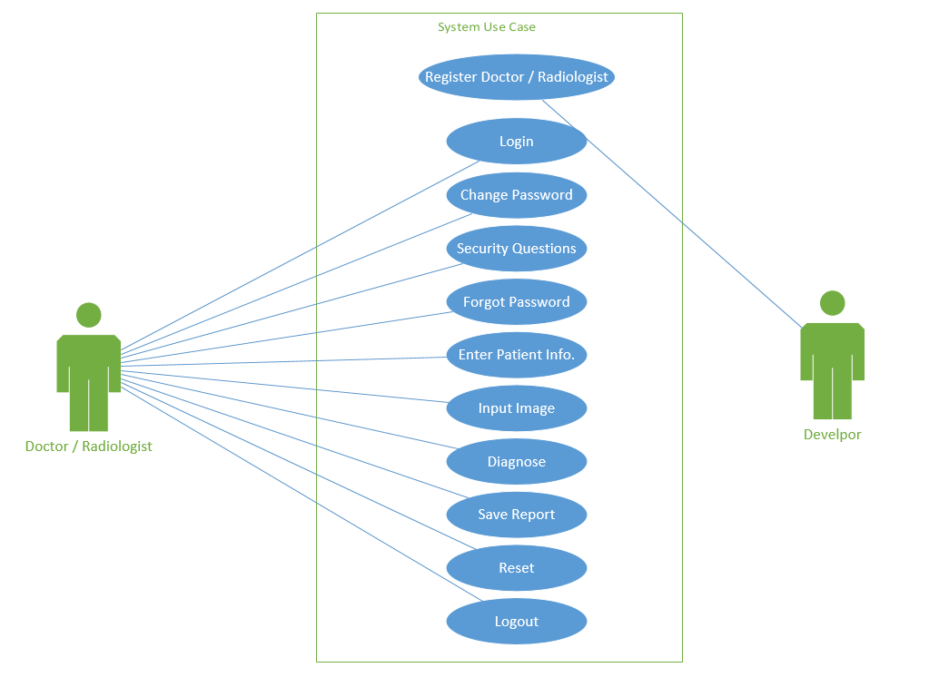
Figure 3.1-1: Main Use Case

Register Doctor / Radiologist (U1)

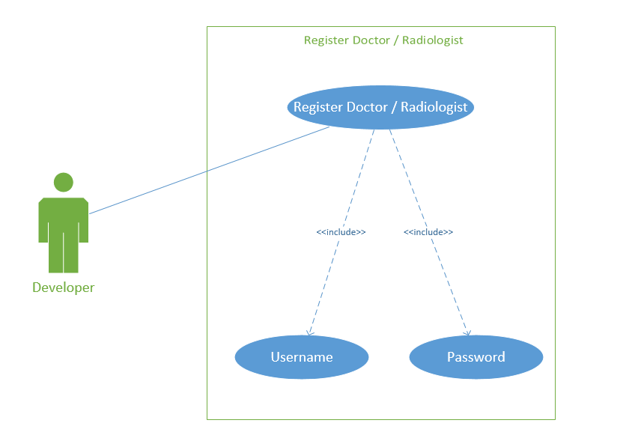
Figure 3.1-2: Register

Login (U2)
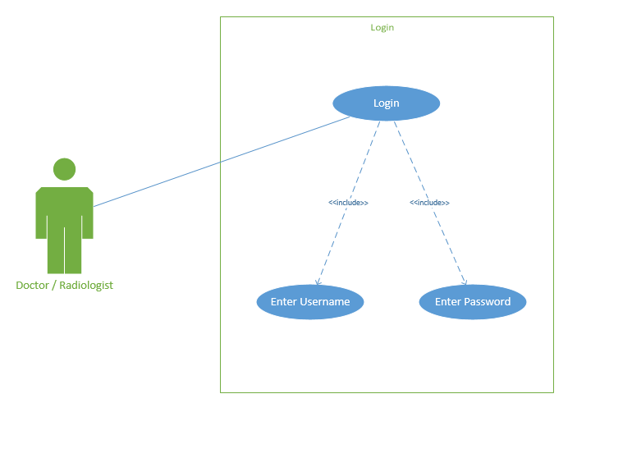
Figure 3.1-3: Login

Change Password (U3)

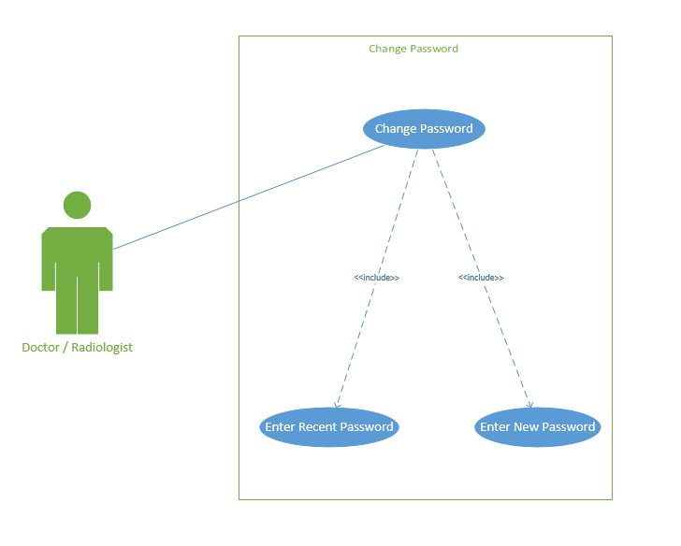
Figure 3.1-4: Change Password

Security Questions (U4)

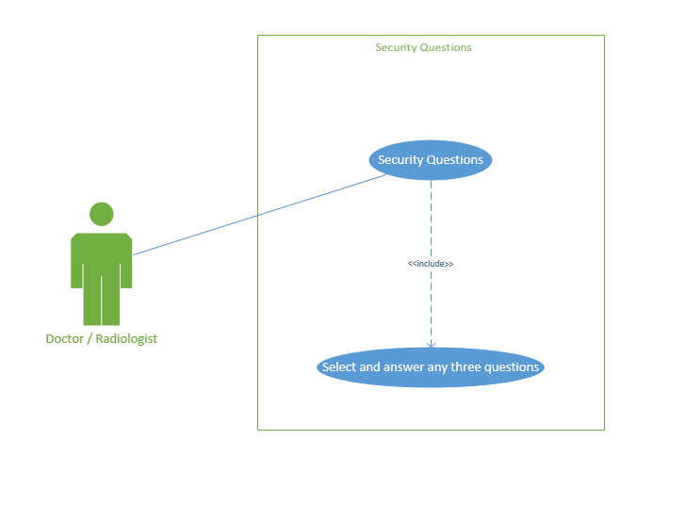
Figure 3.1-5: Security Question

Forgot Password (U5)
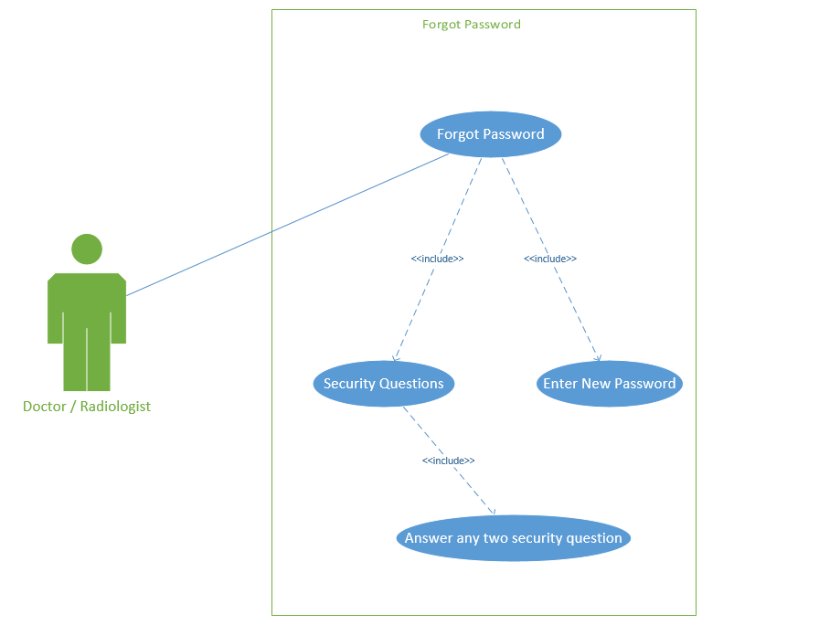
Figure 3.1-6: Forgot Password

Patient Info (U6)
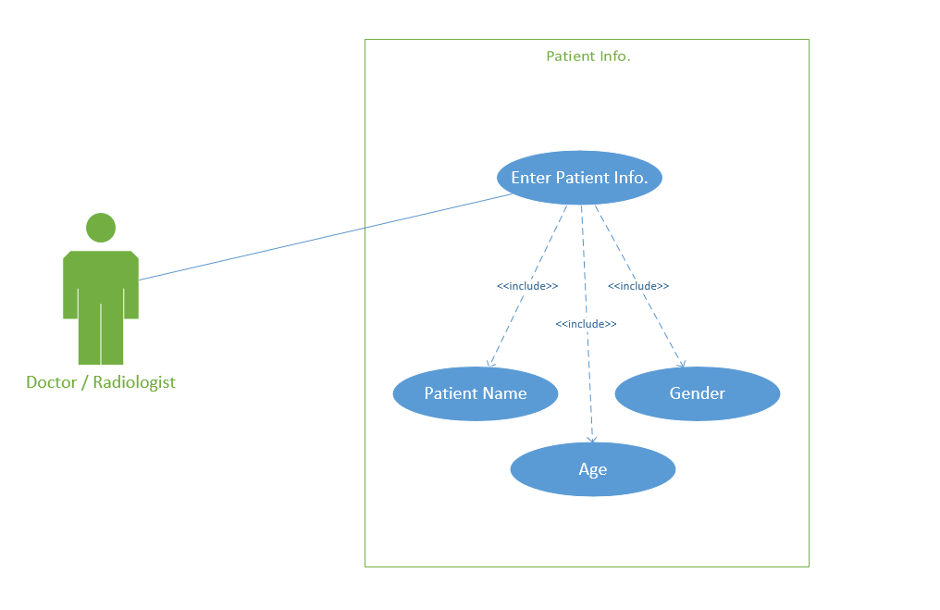
Figure 3.1-7: Patient Info

Input Image (U7)
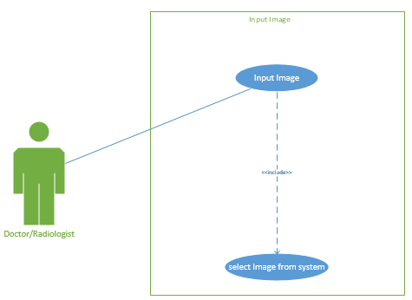
Figure 3.1-8: Input Image

Diagnose (U8)
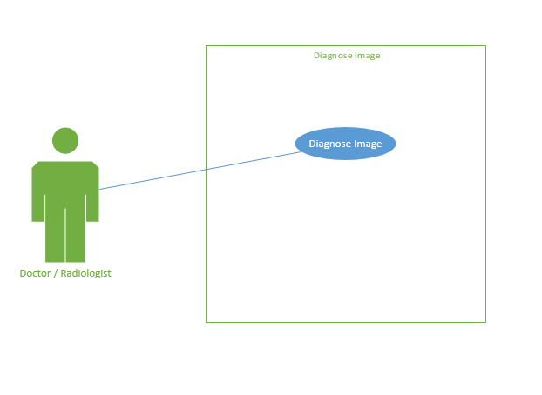
Figure 3.1-9: Diagnose

Reset (U9)
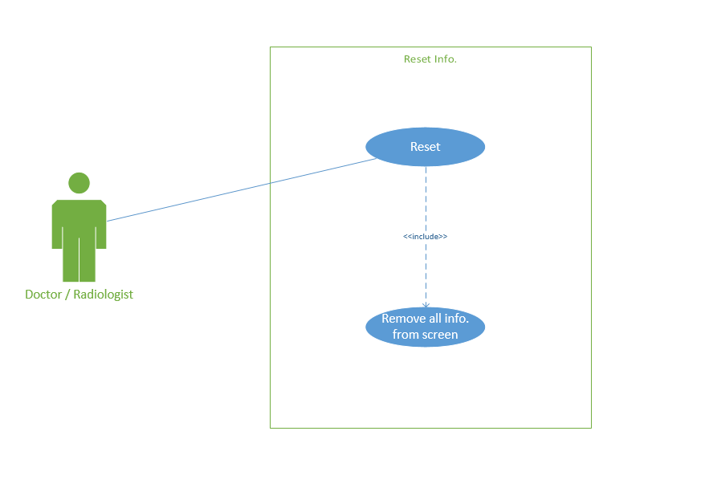
Figure 3.1-10: Reset

Save Report (U10)
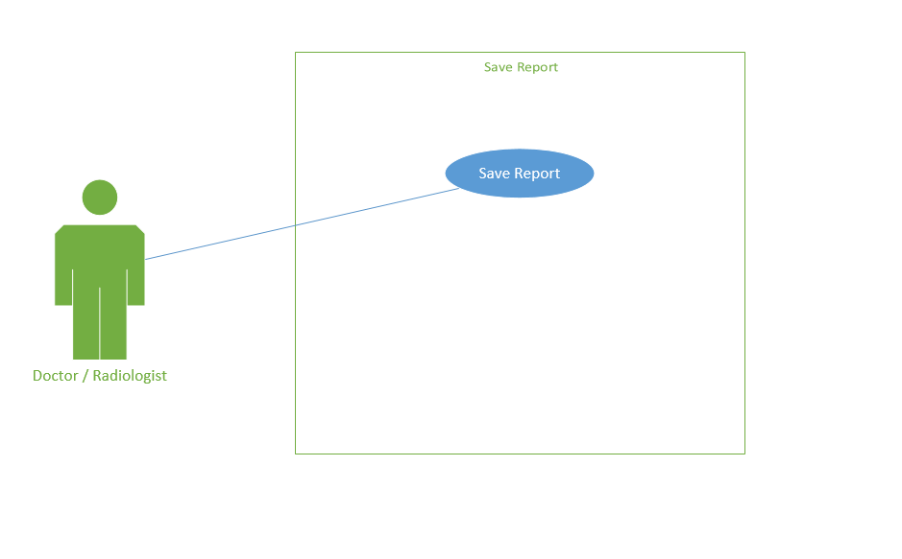
Figure 3.1-11: Save Report

Logout (U11)
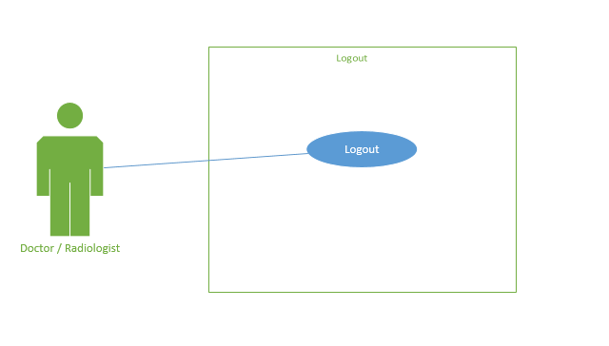
Figure 3.1-12: Logout

Use case Description

Register <U1>

Table 3.2-1: Register
Unique Identifier | U1
Objective | Doctor /Radiologists use this software.
Priority | High
Source | Developer
Actors | Developer
Flow of Event | 1. | BASIC FLOW  The developer enters the username and password for registration of the doctor/radiologist.
 | 2. | Confirmation of username and password.
 | 3. | Username and password save in the software.
Includes | U1
Pre-Conditions | The developer must be connected with System.
Post-Conditions | Doctor / Radiologist can login.

Login <U2>

Table 3.2-2: Login
Unique Identifier | U2
Objective | To secure the Doctor / Radiologist account.
Priority | High
Source | Doctor / Radiologist
Actors | Doctor / Radiologist
Flow of Event | 1. | BASIC FLOW  The doctor/ Radiologist enters the username and password.
 | 2. | Validation of username and password.
 | 3. | Doctor / Radiologist redirected to dashboard.  ALTERNATIVE FLOW
 | 1. | Doctor / Radiologist cannot use the same credentials for another account
Includes | U2
Pre-Conditions | The doctor/ Radiologist must be connected with the System and must remember the username and password.

Change Password <U3>

Table 3.2-3: Change Password
Unique Identifier | U3
Objective | Doctor / Radiologist personal password
Priority | High
Source | Doctor / Radiologist
Actors | Doctor / Radiologist
Flow of Event | 1. | BASIC FLOW  The doctor/ Radiologist enters the recent password and adds a new password.
 | 2. | Validation of a recent password.
 | 3. | The doctor/Radiologist's password successfully changed.
Includes | U3
Pre-Conditions | The doctor/ Radiologist must be login with System and recent password.
Post-Conditions | Move to the dashboard or log out.

Security Question <U4>

Table 3.2-4: Security Question
Unique Identifier | U4
Objective | For security.
Priority | High
Source | Doctor / Radiologist
Actors | Doctor / Radiologist
Flow of Event | 1. | BASIC FLOW  The doctor/ Radiologist selects any three questions.
 | 2. | Give answers to these selected questions.
Includes | U4
Pre-Conditions | Doctor / Radiologist must be login with System.
Post-Conditions | Move to the dashboard or log out.

Forget Password <U5>

Table 3.2-5: Forgot Password
Unique Identifier | U5
Objective | If doctor / radiologist forget their password.
Priority | High
Source | Doctor / Radiologist
Actors | Doctor / Radiologist
Flow of Event | 1. | BASIC FLOW  The doctor/ Radiologist gave the answer to any two questions which are saved in the system.
 | 2. | Validation of answers.
 | 3. | Doctor / radiologist create new password.
Includes | U5
Pre-Conditions | The doctor/ Radiologist must be connected with System and must remember the answer to two questions enter a new password.
Post-Conditions | Move to the login or dashboard or log out.

Patient Info<U6>

Table 3.2-6: Patient Info
Unique Identifier | U6
Objective | For entering the patient info.
Priority | High
Source | Doctor / Radiologist
Actors | Doctor / Radiologist
Flow of Event | 1. | BASIC FLOW  The doctor/ Radiologist enters the patient's name, age, and gender.
 | 2. | Validation of name, age, and gender.
 | 3. | The doctor/ Radiologist redirected to the main screen.  ALTERNATIVE FLOW
 | 1. | The doctor/ Radiologist must log in to the system to enter the patient info.
Includes | U6
Pre-Conditions | The doctor/ Radiologist must be connected with the System and must enter the patient info.

Input Image <U7>

Table 3.2-7: Input Image
Unique Identifier | U7
Objective | To apply techniques on the image.
Priority | High
Source | Doctor / Radiologist
Actors | Doctor / Radiologist
Flow of Event | 1. | BASIC FLOW  Doctor / Radiologist click on input image tab.
 | 2. | Doctor / Radiologist select DICOM file (.dcm) image from system.
Includes | U7
Pre-Conditions | The doctor/ Radiologist must be login with System and select the input image option.
Post-Conditions | Move to the dashboard or diagnose or log out.

Reset <U8>

Table 3.2-8: Reset
Unique Identifier | U8
Objective | To change the patient info and the rest screen.
Priority | High
Source | Doctor / Radiologist
Actors | Doctor / Radiologist
Flow of Event | 1. | BASIC FLOW  The doctor/ Radiologist reset the patient info and input image.
 | 2. | Validation of patient info and the input image.
 | 3. | The doctor/ Radiologist redirected to the main screen.  ALTERNATIVE FLOW
 | 1. | The doctor/ Radiologist can change the patient info and input image.
Includes | U8
Pre-Conditions | The doctor/ Radiologist must be connected with System.

Diagnose<8>

Table 3.2-9: Diagnose
Unique Identifier | U9
Objective | Doctor / Radiologist can diagnose the cancer.
Priority | High
Source | Doctor / Radiologist
Actors | Doctor / Radiologist
Flow of Event | 1. | BASIC FLOW  Doctor / Radiologist click on diagnose tab.
Includes | U9
Pre-Conditions | The doctor/ Radiologist must be login with System and input image from the system.
Post-Conditions | Move to the dashboard or Save report or log out.

Save Report <U10>

Table 3.2-10: Save Report
Unique Identifier | U10
Objective | Doctor / Radiologist see a result.
Priority | High
Source | Doctor / Radiologist
Actors | Doctor / Radiologist
Flow of Event | 1. | BASIC FLOW  Doctor / Radiologist click on Save report tab.
Includes | U10
Pre-Conditions | Doctor / Radiologist must be login with System and the diagnoses process is already completed.
Post-Conditions | Move to the dashboard or log out.

Log out <U11>

Table 3.2-11: Logout
Unique Identifier | U11
Objective | To secure the Doctor / Radiologist account.
Priority | High
Source | Doctor / Radiologist
Actors | Doctor / Radiologist
Flow of Event | 1. | BASIC FLOW  Doctor / Radiologist click on logout tab.
Includes | U11
Pre-Conditions | Doctor / Radiologist must be login with System then logout the application.

Domain Model

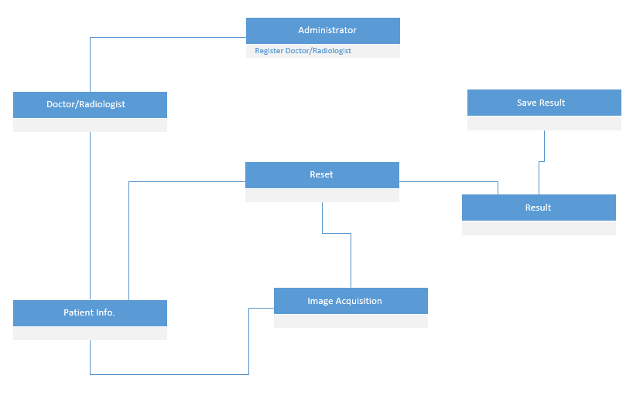
Figure 3.3-1: Domain Model

Sequence Diagram

Login
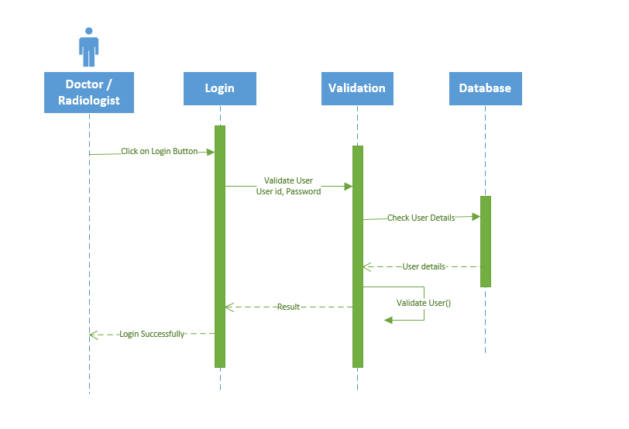
Figure 3.4-1: Login

Select Security Question (for New User)
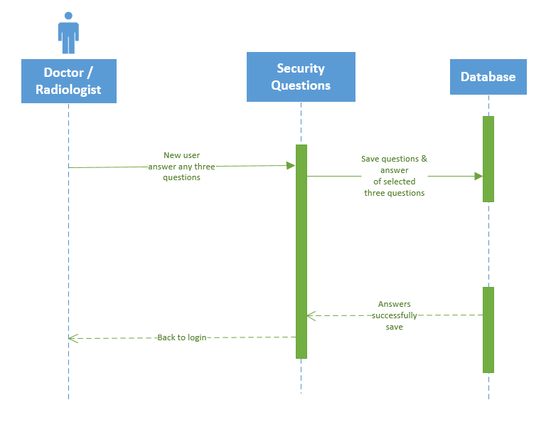
Figure 3.4-2: Select Security Question

Change Password
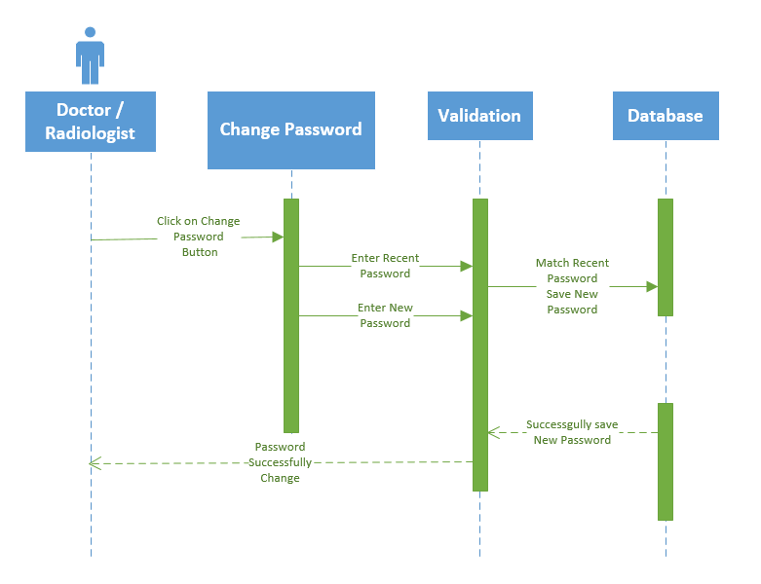
Figure 3.4-3: Change Password

Forgot Password
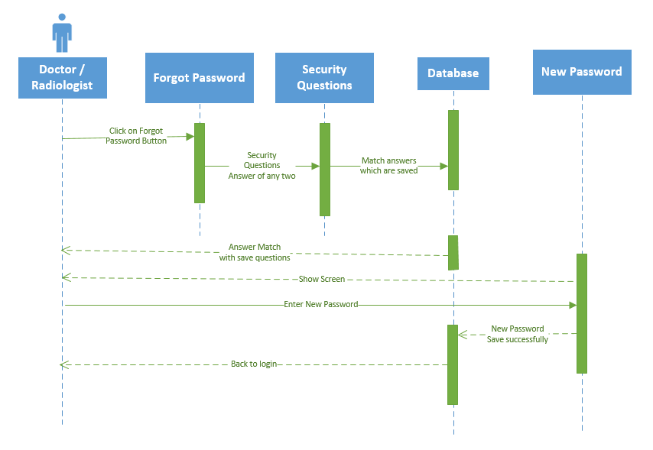
Figure 3.4-4: Forgot Password

Enter Patient Info
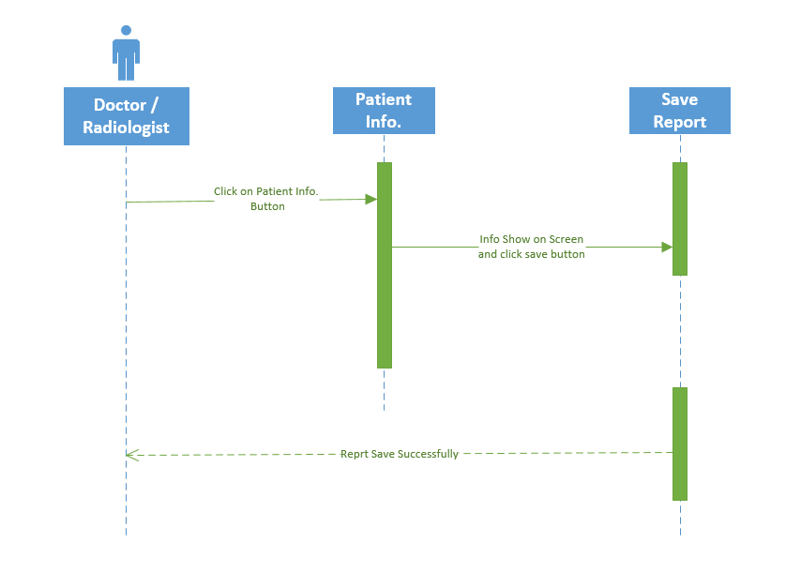
Figure 3.4-5: Patient Info

Diagnose
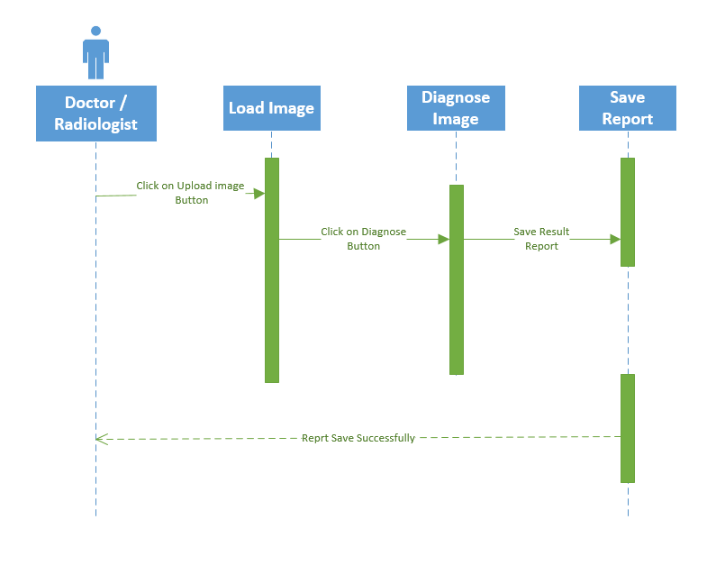
Figure 3.4-6: Diagnose

Reset
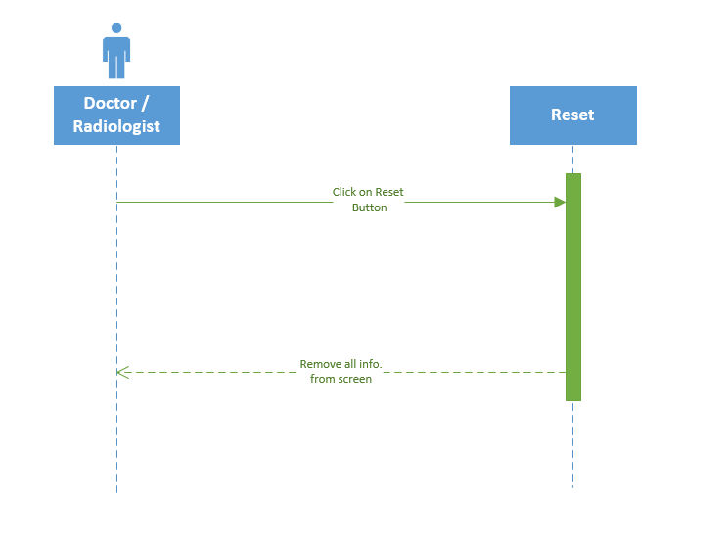
Figure 3.4-7: Reset

Logout
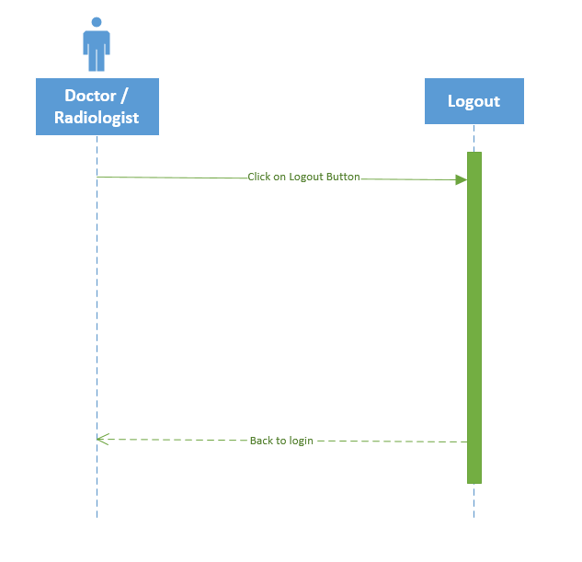
Figure 3.4-8: Logout

Design Class Diagram
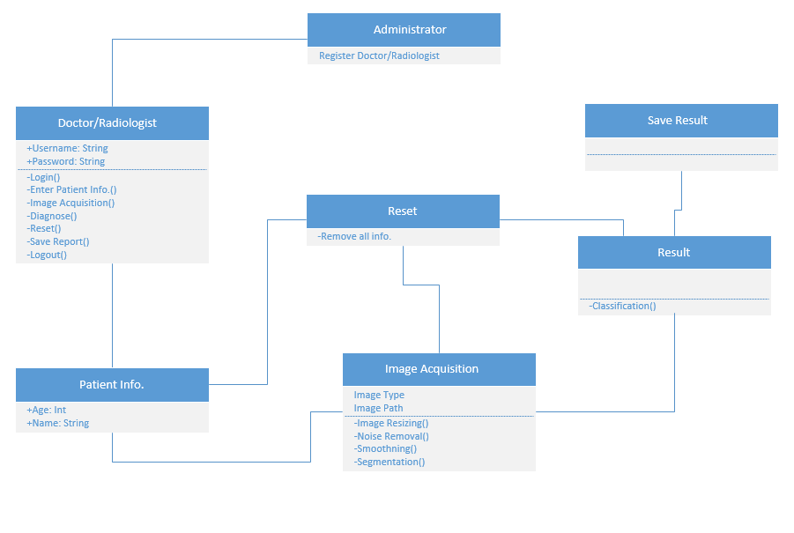
Figure 3.5-1: Class Diagram

Entity Relationship Diagram
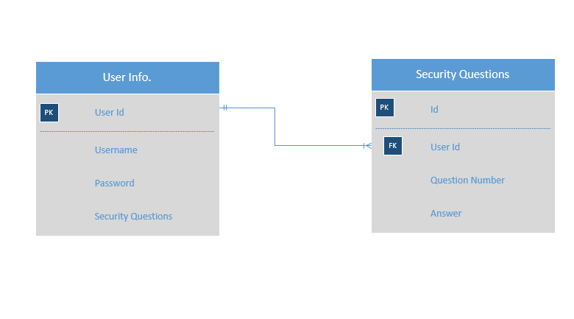
Figure 3.6-1: ERD

DATA AND EXPERIMENTS (and/or IMPLEMENTATION)

Methodology

Feature Driven Development (FDD) will be used as a development methodology as it matches the project needs that are based on a fixed plan. FDD model will help us to test the product on each phase of development and before the process starts the overall model shape is established. Since the deliverables should be delivered on time, rapid testing will help us for debugging in the product. To develop this application, we’ll use the following tool.
MATLAB
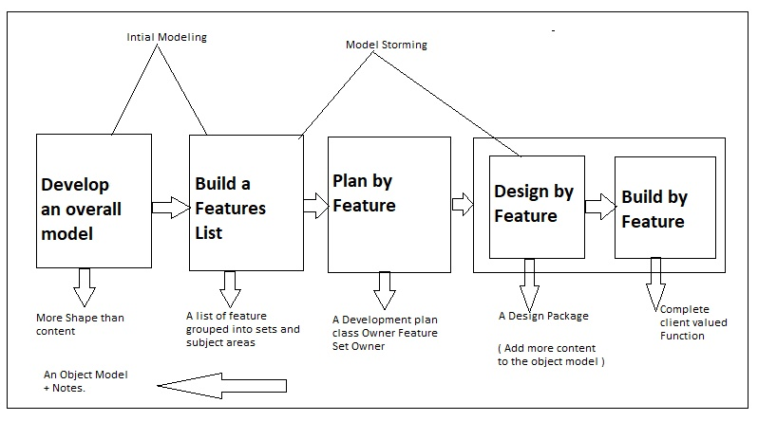
Figure 4.1-0-1: Development Method

Technology

- MATLAB
- MS Access
Any system with these specifications
- Minimum 8 GB RAM
- Minimum 100 GB Storage
- Core i7

RESULTS AND DISCUSSIONS (USER MANUAL)

User access, roles, and privileges
The user of the application is a doctor/radiologist, the user has some privileges.
Some of them are following

Name: Login
Description: | Input: | Output: | Workflow:
User has an account and user can login using his/her account. | Username, password | Users can see the feature that can only be accessed by the account holder. | Enter user details and user get logged in.

Name: Forgot Password
Description: | Input: | Output: | Workflow:
If user has forgot his/her login password. | Username | System show random question which should answer by user | Answer the random questions then system show change password screen

User interface

Login Screen
Doctor will enter registered username.
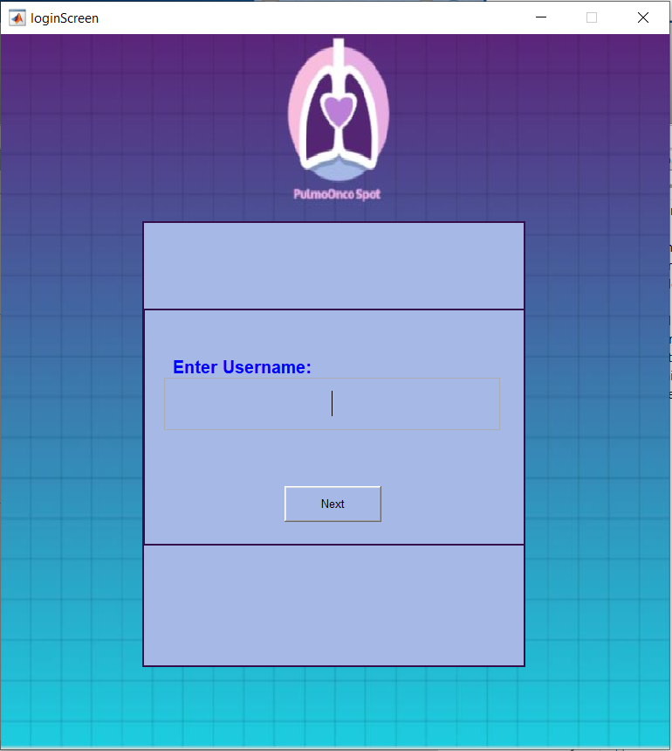
Figure 5.2-1: Login Screen

Enter Password
Doctor has to input password.
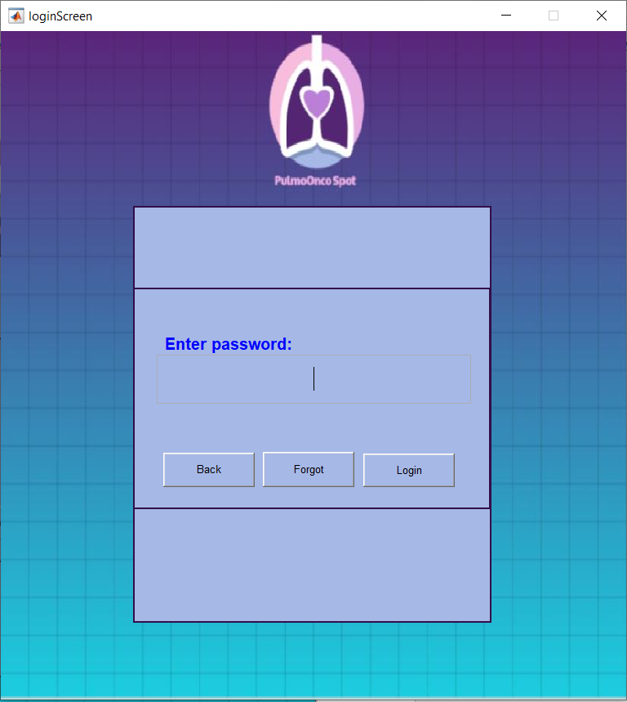
Figure 5.2-2: Enter Password

Set Security Question
If the doctor is new it is mandatory to set security questions.
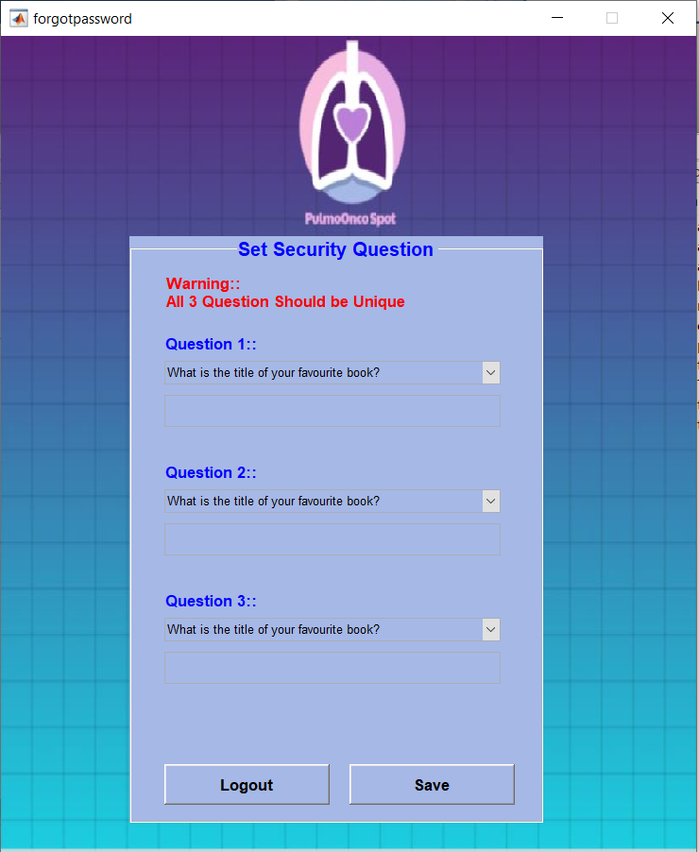
Figure 5.2-3: Set Security Question

After the selection of security questions. Then user enters his/her user name and password.

Forgot Password (Answer the question)
Doctor has to input correct answer of the security questions.
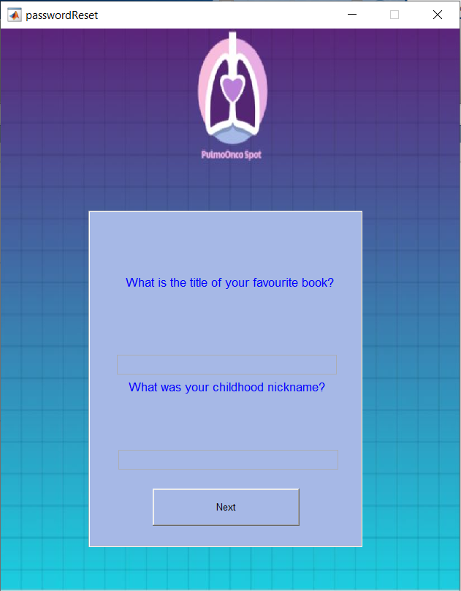
Figure 5.2-4: Forgot Password

Enter New Password
Here, doctor has to input the desire password.
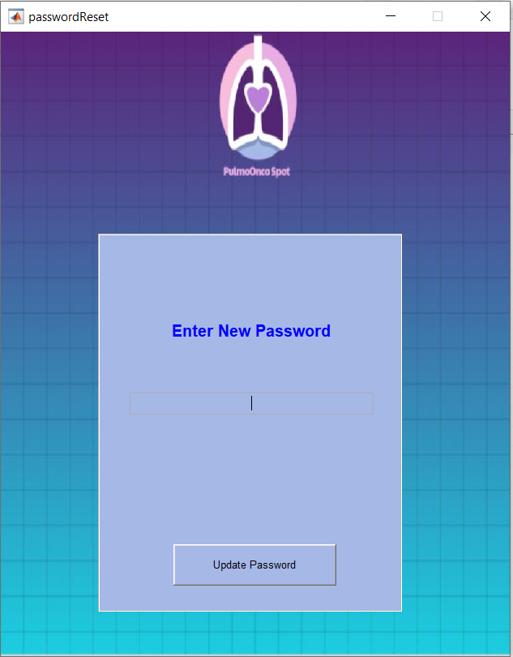
Figure 5.2-5: Enter New Password

Menu Screen
Main menu.
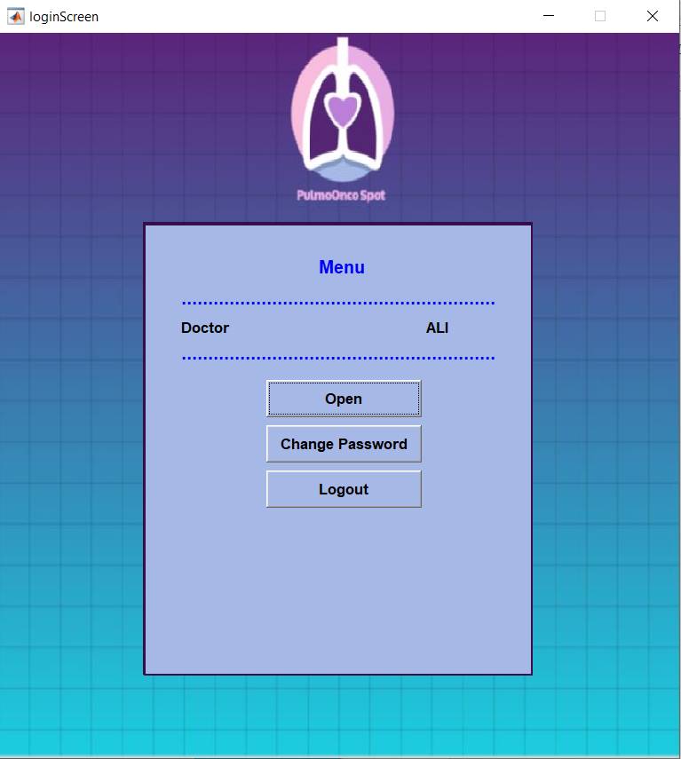
Figure 5.2-6: Menu Screen

Change Password Screen
Doctor has to input current password with the new password.
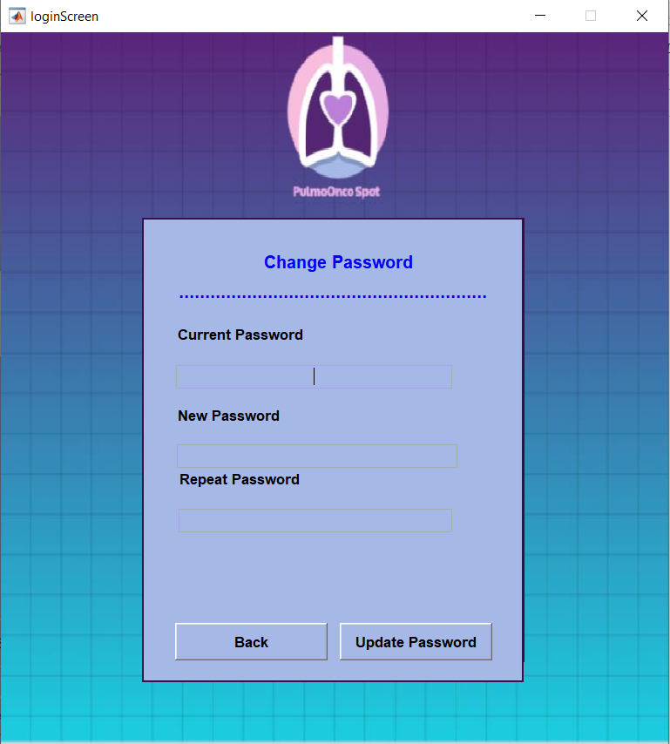
Figure 5.2-7: Change Password Screen

Select Open (From Menu Screen)
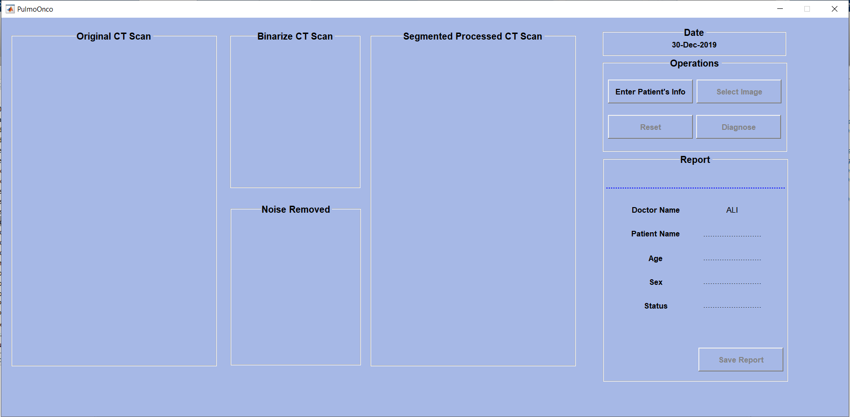
Figure 5.2-8: Select Open (From Menu)

Patient info screen
Here, doctor will enter patient’s information.
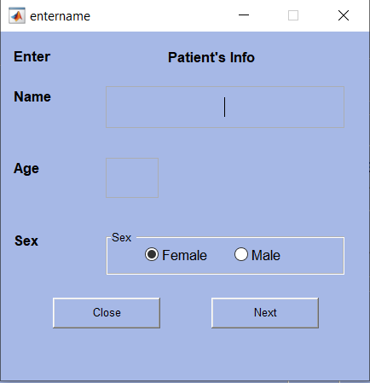
Figure 5.2-9: Patient Info Screen

After Enter patient information
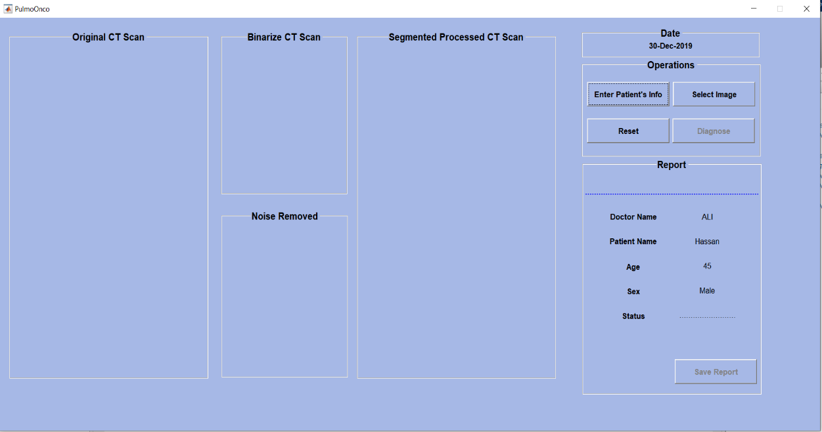
Figure 5.2-10: After Patient Info

Select Image
Here, doctor will input the CT Scan image of the patient.
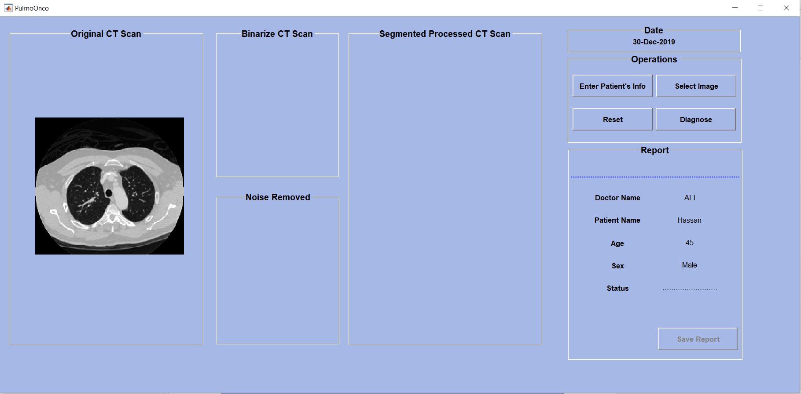
Figure 5.2-11: Image Upload Screen

Diagnose
By clicking the diagnose button, following output will be shown.
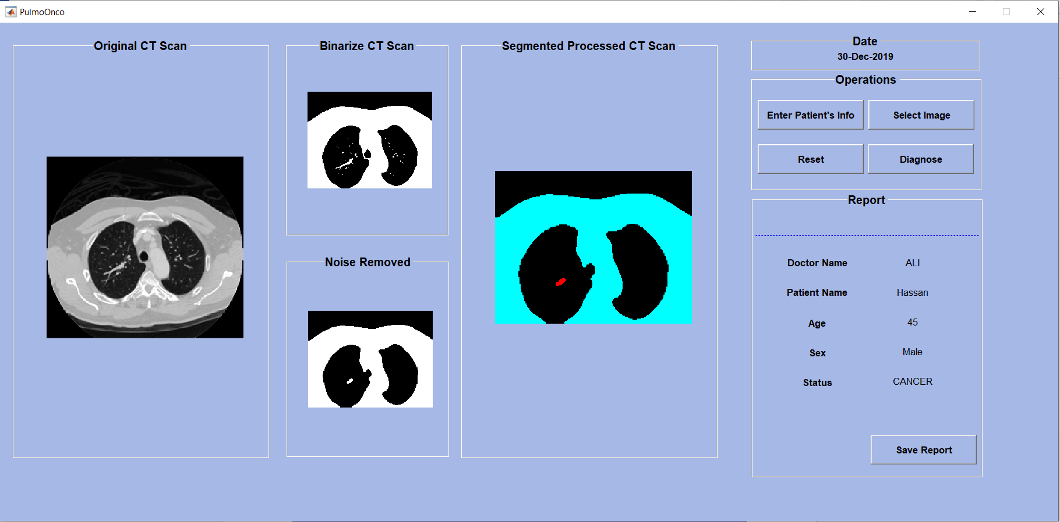
Figure 5.2-12: Diagnose Screen

Reset
Reset button will clear all the input and system will be ready for new patient input.
Figure 5.2-13: Reset

Logout

Figure 5.2-14: Logout

CONCLUSION AND RECOMMENDATIONS

Conclusion

Lung cancer is the most dangerous and widespread in the world. According to world health organization (WHO), the discovery of the cancer cells in the lungs increases day by day, this gives us the sign that the process of recognition of this infection plays an important and essential role to maintain serious stages and to decrease its ratio in the world. Lung nodule detection in CT scan is an active area of research that is consistently developing and there are many improvements that can be included to make gradually efficient.
The motivation behind making this work area application to aid the Doctor/radiologist. This application detects a lung nodule. Sometime Doctor/radiologist can't detect nodule with the naked eye so we recommend this computer aided system for the detection of a nodule and assure that image is cancerous or non-cancerous?
The proposed system efficiently detects lung cancer from CT scan images. At the end of the system can say that the system achieves its desire expectation. The proposed system trained on more than 300 lung CT images and by using confusion matrix obtained the desired result.

REFERENCES

Books:

[1] Book by Rafael C. Gonzalez, Richard E. Wood, Steven L. Eddins, Pearson, “Digital Image Processing using MATLAB, 2nd Ed.”.
[2] Guide by MATLAB, “MATLAB Getting Started”, 2018 Edition.

Journal Papers:
[3] Yosefina Finsensia Riti, Hanung Adi Nugroho, Sunu Wibirama, Budi Windarta, and Lina Choridah, “Feature Extraction for Lesion Margin Characteristic Classification from CT Scan Lungs Image”, 1st International Conference on Information Technology, Information Systems and Electrical Engineering (ICITISEE), pp. 54, 2016.

Electronic Sources from the Internet:
[4] www.cancerimagingarchive.ne

