

BSCS-S19-003
03-134161-051 | ASAD KHAN
03-134161-021 | USAMA HASSAN
03-134161-030 | USAMA MUKHTAR

Intellic@re

In partial fulfilment of the requirements for the degree of
Bachelor of Science in Computer Science
Supervisor: TAHIR IQBAL
Department of Computer Sciences
Bahria University, Lahore Campus
January 2020

© Bahria University, 2020

Certificate

We accept the work contained in the report titled
INTELLICARE
written by
ASAD KHAN
USAMA HASSAN
USAMA MUKHTAR
as a confirmation to the required standard for the partial fulfilment of the degree of
Bachelor of Science in Computer Science.

Approved by:
Supervisor: TAHIR IQBAL
(Signature)

January 27, 2020

DECLARATION

We hereby declare that this project report is based on our original work except for citations and quotations which have been duly acknowledged. We also declare that it has not been previously and concurrently submitted for any other degree or award at Bahria University or other institutions.

Enrolment | Name | Signature
03-134161-051 | ASAD KHAN
03-134161-021 | USAMA HASSAN
03-134161-030 | USAMA MUKHTAR

Date : January 27, 2020

Specially dedicated to
My beloved grandmother, mother and father
Asad Khan
My beloved grandmother, mother and father
Usama Hassan
My beloved grandmother, mother and father
Usama Mukhtar

ACKNOWLEDGEMENTS

We would like to thank everyone who had contributed to the successful completion of this project. We would like to express our gratitude to my supervisor, Mr TAHIR IQBAL for his invaluable advice, guidance and his enormous patience throughout the development of the research.

In addition, we would also like to express my gratitude to our loving parent and friends who had helped and given me encouragement.

Asad Khan
Usama Hassan
Usama Mukhtar

INTELLIC@RE

ABSTRACT

The current standard operating procedure in healthcare environment for patient registration and appointment scheduling and maintaining current and new appointment records are time consuming and somehow troublesome. IntelliCare is a web based service introduced for managing appointment-booking process and patients profiling system, regardless of the type of service they schedule in Lahore. The practitioners will have to sign up on the online appointments portal and can view the appointment made by user, the patients.
It will help user, to schedule their appointment using the Medical Appointment application. Furthermore it will provide a market to its users to purchase medicine as for the techniques used to develop this system is NOSQL Database and for development we will be using REACT.js. By developing this system, it will reduce the number of calls for an appointment and avoid the morning rush for an urgent appointment and huge amount of paper work to be carried. Also, it will potentially reduce the need for extra reception staff, a significant reduction in labour.
Furthermore, it helps user in time saving and avoiding the need to negotiate with the receptionist for a convenient appointment time. This technology can transform the current daunting appointment process and enable them to run more efficiently, effectively and profitably.

TABLE OF CONTENTS

DECLARATION ii
ACKNOWLEDGEMENTS iv
ABSTRACT v
TABLE OF CONTENTS vi
LIST OF TABLES ix
LIST OF FIGURES x
LIST OF APPENDICES xiii

CHAPTERS
1 INTRODUCTION 1
1.1 Background 1
1.2 Problem Statements 2
1.3 Aims and Objectives 3
1.4 Scope of Project 3
2 SOFTWARE REQUIREMENT SPECIFICATION 5
2.1 Overall Description 5
2.1.1 User Classes and Characteristics 5
2.1.2 Operating Environment 5
2.1.3 Design and Implementation Constraints 6
2.1.4 Database Design 6
2.1.5 Assumptions and Dependencies 9
2.2 External Interface Requirements 10
2.2.1 User Interfaces 10
2.2.2 Hardware Interfaces 15
2.2.3 Software Interfaces 15
2.3 Use Cases Diagram 16
2.3.1 System Use Case 16
2.3.2 Use Cases 17
2.4 Requirement 22
2.4.1 Performance Requirements 22
2.4.2 Safety Requirements 22
2.4.3 Security Requirements 22
2.4.4 Software Quality Attributes 22
2.4.5 Other Requirements 22
2.5 Sequence diagram 23
2.5.1 Login 23
2.5.2 Registration 24
2.5.3 Appointment 25
2.5.4 Purchase medicine 26
2.5.5 View profile 27
2.5.6 Logout 28
2.6 Collaboration diagram 29
2.6.1 Login 29
2.6.2 Registration 29
2.6.3 Appointment 30
2.6.4 Purchase Medicine 30
2.6.5 Logout 31
2.7 Class Diagram 32
2.8 Domain Diagram 33
3 DESIGN AND METHODOLOGY 34
4 IMPLEMENTATION 36
4.1 Languages and Implementation 36
4.1.1 MERN Development 36
4.2 Tools for Implementation: 36
4.2.1 React js 36
4.2.2 Express js 37
4.2.3 Node js 37
4.2.4 Mongo DB 37
5 User Manual 38
5.1 User Manual: 38
6 CONCLUSION 40
6.1 Remarks and Conclusion 40
REFERENCES 41
APPENDICES 42

LIST OF TABLES

TABLE TITLE PAGE
Table 2.1 : Use_Case_U1 Registration 17
Table 2.2 : Use_Case_U2 Login 18
Table 2.3 : Use_Case_U3 Logout 19
Table 2.4 : Use_Case_U4 Schedule Appointment 20
Table 2.5 : Use_Case_U5 Purchase Medicine 21
Table 2.6 : Use_Case_U5 Purchase Medicine 21

LIST OF FIGURES

FIGURE TITLE PAGE
Figure 2.1 : Generalized FLOW of System 6
Figure 2.2 : Appointment schema 7
Figure 2.3 : Cash On Delivery form schema 7
Figure 2.4 : Doctor Schema 8
Figure 2.5 : Patient Schema 9
Figure 2.6 : Homepage 10
Figure 2.7 : Search page 10
Figure 2.8 : My Appointments 11
Figure 2.9 : About page 11
Figure 2.10 : Login 12
Figure 2.11 : Signup page 12
Figure 2.12 : Signup form 13
Figure 2.13 : Patient profile 13
Figure 2.14 : Doctor profile 14
Figure 2.15 : E-pharmacy 14
Figure 2.16 : Cart 15
Figure 2.17 : System Use case Diagram 16
Figure 2.18 : Login sequence 23
Figure 2.19 : Registration sequence 24
Figure 2.20 : Appointment sequence 25
Figure 2.21 : Purchase medicine sequence 26
Figure 2.22 : View profile sequence 27
Figure 2.23 : Logout sequence 28
Figure 2.24 : Login collaboration 29
Figure 2.25 : Registration collaboration 29
Figure 2.26 : Appointment collaboration 30
Figure 2.27 : Purchase medicine collaboration 30
Figure 2.28 : Logout collaboration 31
Figure 2.29 : Class Diagram 32
Figure 2.30 : Domain model 33
Figure 3.1 : FDD methodology 34
Figure A.1 : Controller mapping 43
Figure A.2 : Authentication services 44
Figure A.3 : Authentication services 44
Figure A.4 : Appointment services 45
Figure B.1 : Question 1 of SUS 46
Figure B.2 : Question 2 of SUS 47
Figure B.3 : Question 3 of SUS 47
Figure B.4 : Question 4 of SUS 48
Figure B.5 : Question 5 of SUS 48
Figure B.6 : Question 6 of SUS 49
Figure B.7 : Question 7 of SUS 49
Figure B.8 : Question 8 of SUS 50
Figure B.9 : Question 9 of SUS 50
Figure B.10 : Question 10 of SUS 51
Figure B.11 : Question 11 of SUS 51

LIST OF APPENDICES

APPENDIX TITLE PAGE
APPENDIX A: APIs 43
APPENDIX B: SUS Survey result of Intellicare 46

INTRODUCTION

Background

Globally, health care sector is the pivot and integral part of human lives. Thus, any error committed in the clinical services might leads to defect or termination of life. Recently, information and Communication has been used extensively to improve the various operations and services in the field of the health care service. Patient appointment with the Doctor is one of the clinical services that have been automated. Healthcare providers are motivated to reduce operation cost while improving the quality of service. This has given rise to preventive medicine in order to avoid disease, lessening the demand for emergency department and hospital stays for sick people. The importance of Patient Scheduling cannot be underestimated in the health care delivery landscape. Patient scheduling is a complex process that performs a crucial role in health care. Patient scheduling performs several functions, from allocating resources to patients in need of exams and allocation of surgery rooms to on-demand appointment scheduling with Family Doctors working at Primary Care clinics. A good appointment scheduling system encourages patient and physician satisfaction, and as such, is an important component of healthcare. The efficiency of health care delivery hinged solely on the effectiveness of the Patient scheduling system. It reduces medical error among practitioner and also reduces the number of unsatisfied patient. Appointment systems have been extensively used to reduce patient waiting times and waiting-room congestion. Such systems have the potential to increase access to medical resources while reducing cost, as well as staff and patient dissatisfaction derived from unmet schedule constraints.
The main aim of optimal patient scheduling is to determine an appointment technique for which a particular measure of performance is optimized under uncertain conditions. Appointment scheduling system is a system for planning of appointments between resources such as patients, facilities and providers. It is used in order to minimize waiting times, prioritize appointments and optimize the utilization of resources

Intellicare is a web based service introduced for managing appointment-scheduling process and patients profiling system, regardless of the type of service they schedule in Lahore. The practitioners will have to sign up on the online appointments portal themselves and can view the appointment made by user, the patients. It will help user, to schedule their appointment using the Medical Appointment application. Furthermore it will provide a market for to its users to purchase medicine online.

Problem Statements

The scheduling of appointments is an important task in the operations of all sized organizations, from companies and enterprise corporations, right down to service-based small businesses. While the manner of appointment-scheduling has evolved through the years, from taking appointments over the phone and recording them in a paper appointment book to utilizing an electronic calendar such as those offered by REACT-DATE-TIME-PICKER, the task itself remains tedious and time- consuming for organizations that continue to rely on these outdated and inefficient methods. Medical appointment is a meeting between a patient with a physician or doctor to get health advice or treatment for a symptom or condition.

Appointments are strongly encouraged so that Medical Services staff may be sensitive to any time constraints. Every person wants to purchase Medicines online, patients want to deliver product at home at the certain time. 24/7 service can boost up the business and can attract more customers. INTELLICARE providing solution to the users on couple of clicks.

Aims and Objectives

The objectives of the project are shown as following:
- Design a Medical Appointment application that will act as a medical practitioner market place in Lahore that wants to participate in one place. A market place for Doctors to register themselves with their profile.
- To provide a medical patients profiling services.
- To introduce a platform with high impact public interests which will empowers its users with features of purchasing medicine online from the online market.

Scope of Project

The current standard operating procedure in the healthcare environment for patient registration and appointment scheduling and profile maintaining are time consuming and somehow troublesome. It is prone to duplications, unnecessary visits and skipped follow ups. It is practically impossible to make a faultless appointment schedule, if done by hand. Most people have been frustrated by the queuing and waiting to see a doctor. Furthermore, carrying all the paper work and medical records is also arduous. The users can participate only if they have created an account through the registration form. Once they get registered themselves further they can schedule desired appoint and maintain their data accordingly.

Increased rate of missed appointments and patient dissatisfaction pushed to recognize the need for better-quality care services. In Pakistan, there is a huge trend of private medical clinics and hospitals. This system will also provide platform to buy medicine from pharmacies, which will have an additional home delivery and home pricking feature. Doctors run their own private clinics and consult patients during the evening or any time of the day depending on their availability. Some are popular and known to all while some are known by few people. This situation proves to be a challenge for new practitioners as they are known to very few people even if they have a good academic background. On the other side, patients also face difficulty in finding and choosing a nearby doctor. Unscheduled appointments, long waiting lines and keeping medical files in physical form are also the common problems faced by the people/ patients of Pakistan.

SOFTWARE REQUIREMENT SPECIFICATION

Overall Description

User Classes and Characteristics

Patient:
- Register
- Login
- Schedule Doctors Appointment
- Purchase Medicine
- View Profile

Doctor:
- Register
- Login
- Purchase Medicine
- View Profile

Operating Environment

We are going to provide a web and android interface as our final product in which user will be privileged to schedule his appointment with a doctor of his choice from a whole doctors market, manage his profile, purchase medicines online and schedule laboratory test and get its result anywhere. It will require any web browser in any device having internet, so it is not dependent on the operating system.

Design and Implementation Constraints

The system Intellicare is a web based service. The front end of the web will be developed using REACT.JS and other HTML, CSS and BOOTSTRAP techniques. The back end will be developed using MERN and the database will be created using NO SQL and MONGODB.
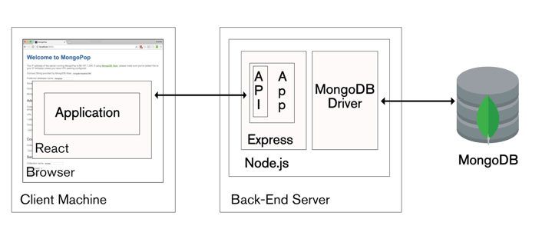
Figure 2.1 : Generalized FLOW of System

Database Design

In mongo dB, data is stored in BSON documents which are binary representation of JSON file / other file type you are using in your project to which database is embedded.

As its non-relational database, there are no tables, row and column and other relation between records. It stores data in fields, those fields are stored in records which are then compressed in collections. Non-relational database is effective for data which is large in numbers.

In this project, DOCTORS, CHECKOUT and PATIENTS information is stored in mongo DB; the following below are schema for each collection implemented in this project
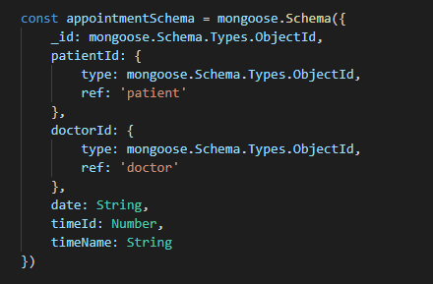
Figure 2.2 : Appointment schema

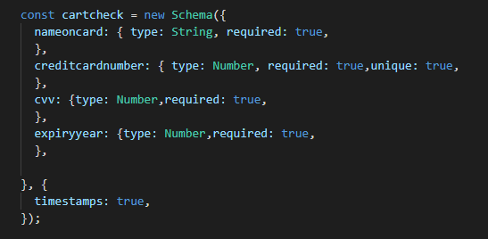
Figure 2.3 : Cash On Delivery form schema

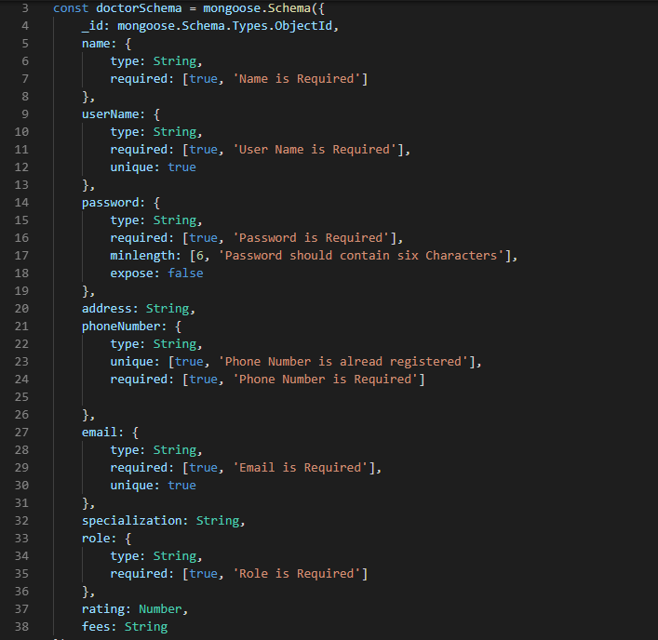
Figure 2.4 : Doctor Schema

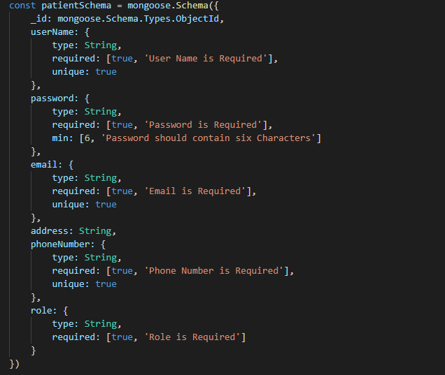
Figure 2.5 : Patient Schema

Assumptions and Dependencies

- The code should be free with compilation errors/syntax errors.
- The product have an interface which is simple enough to understand.
- API calls are dependent on internet access for loading some

External Interface Requirements

User Interfaces

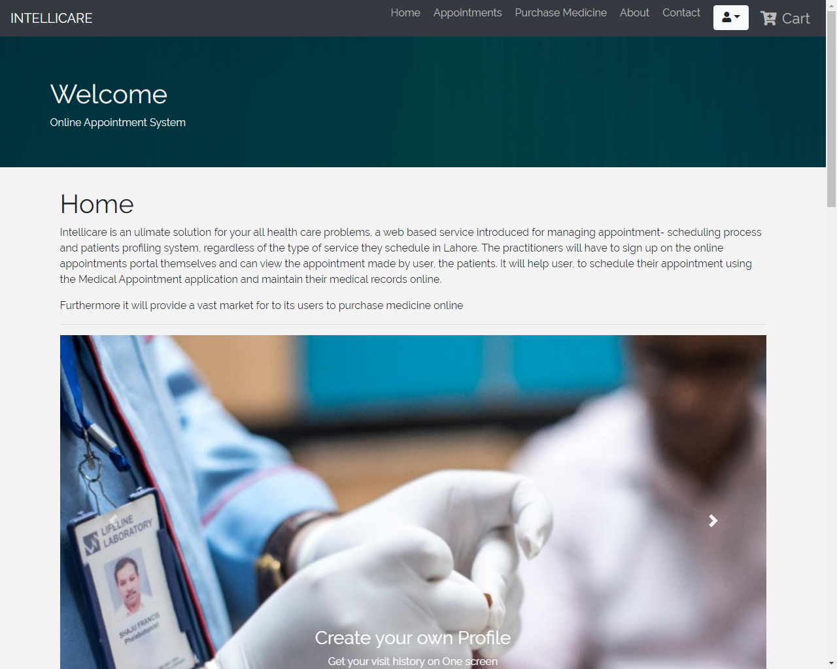
Figure 2.6 : Homepage

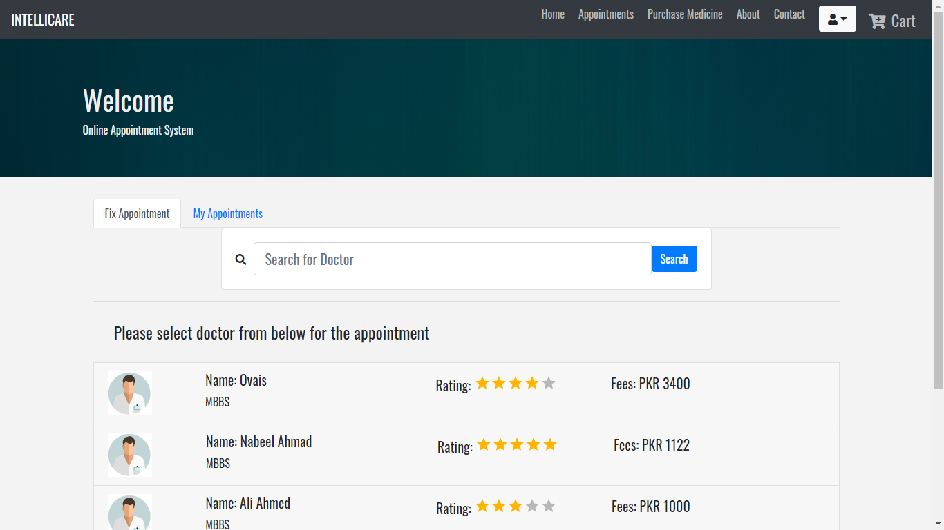

Figure 2.7 : Search page
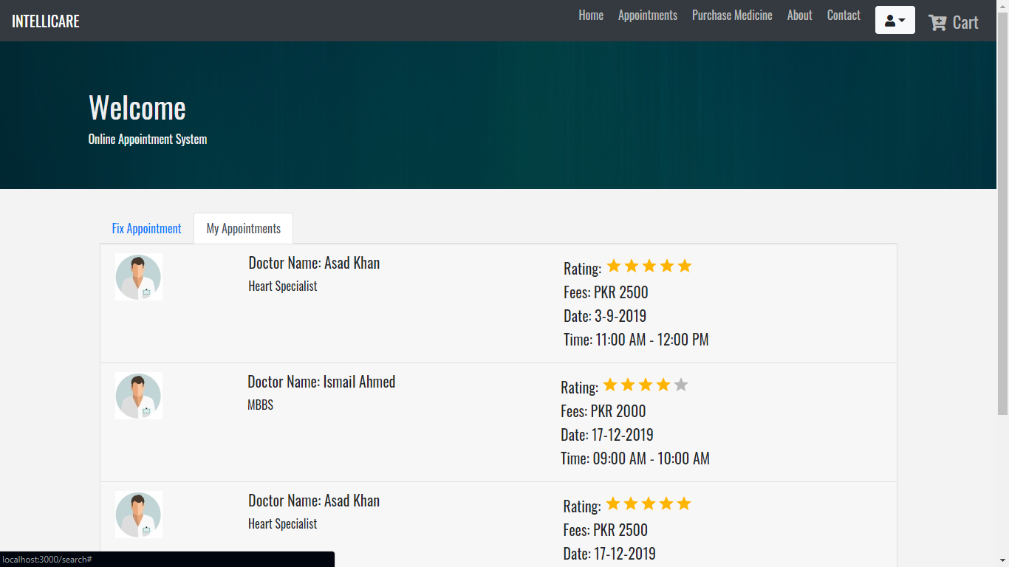
Figure 2.8 : My Appointments

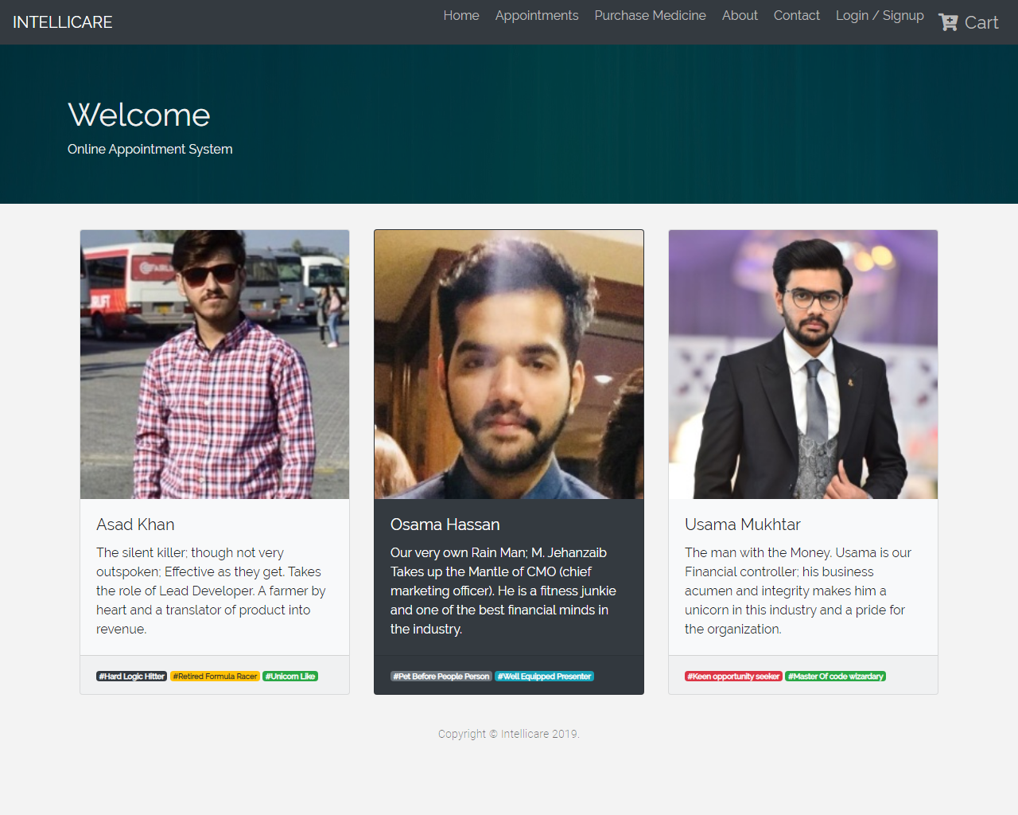
Figure 2.9 : About page

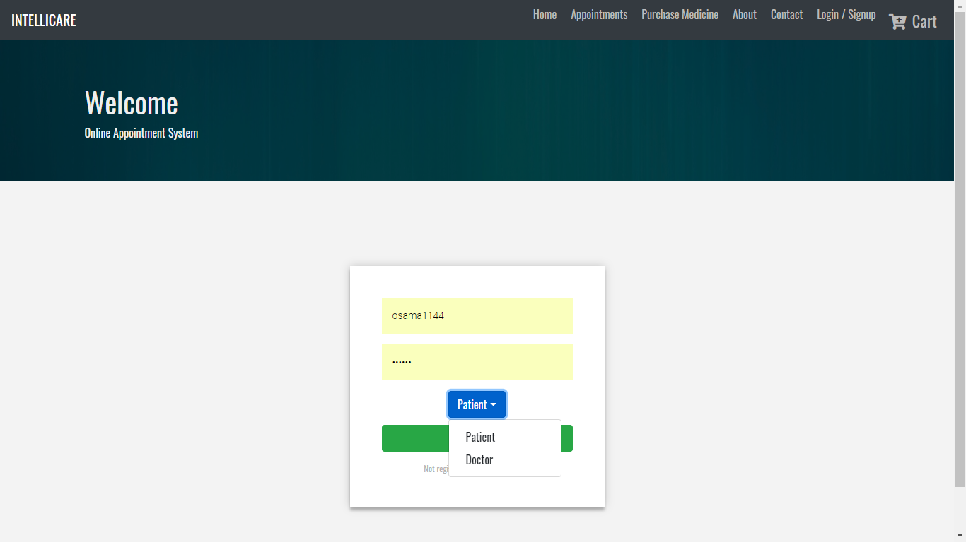
Figure 2.10 : Login
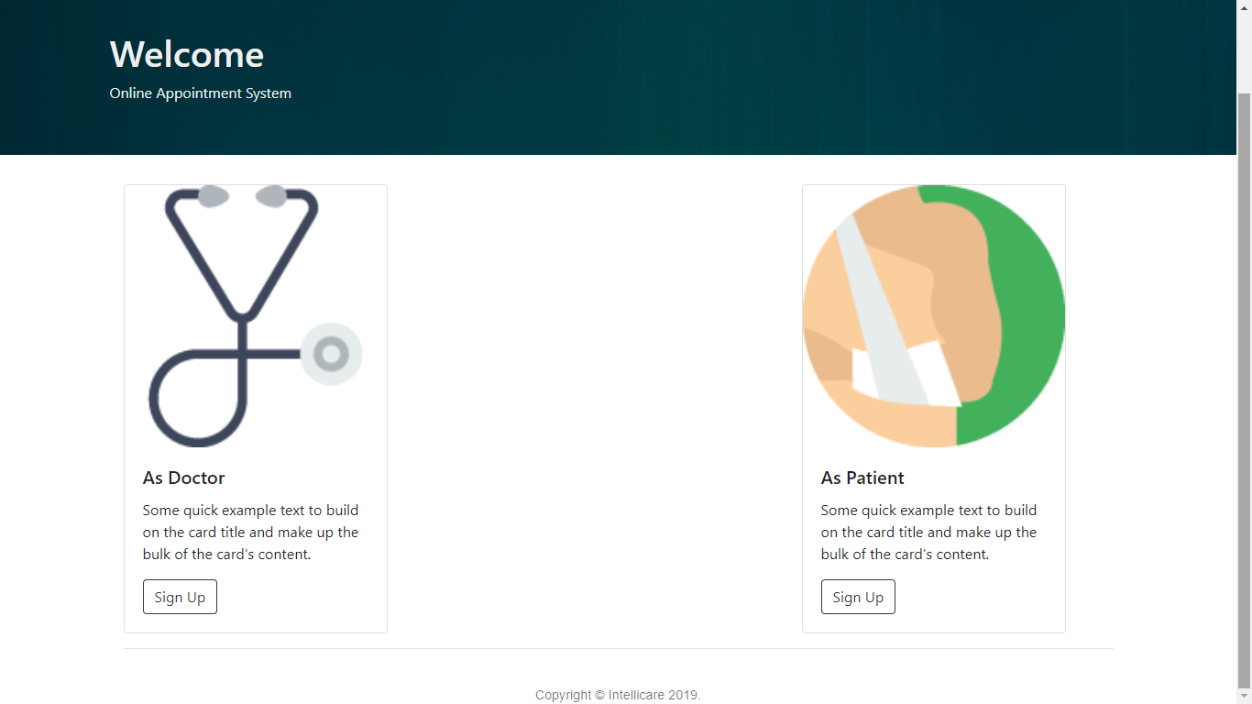
Figure 2.11 : Signup page
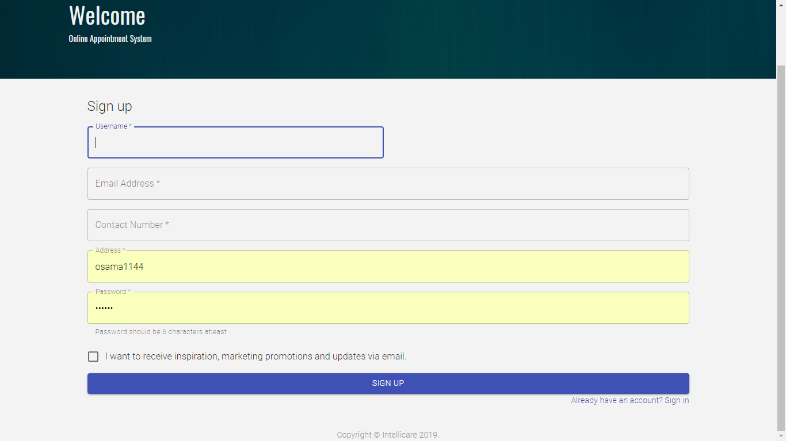
Figure 2.12 : Signup form

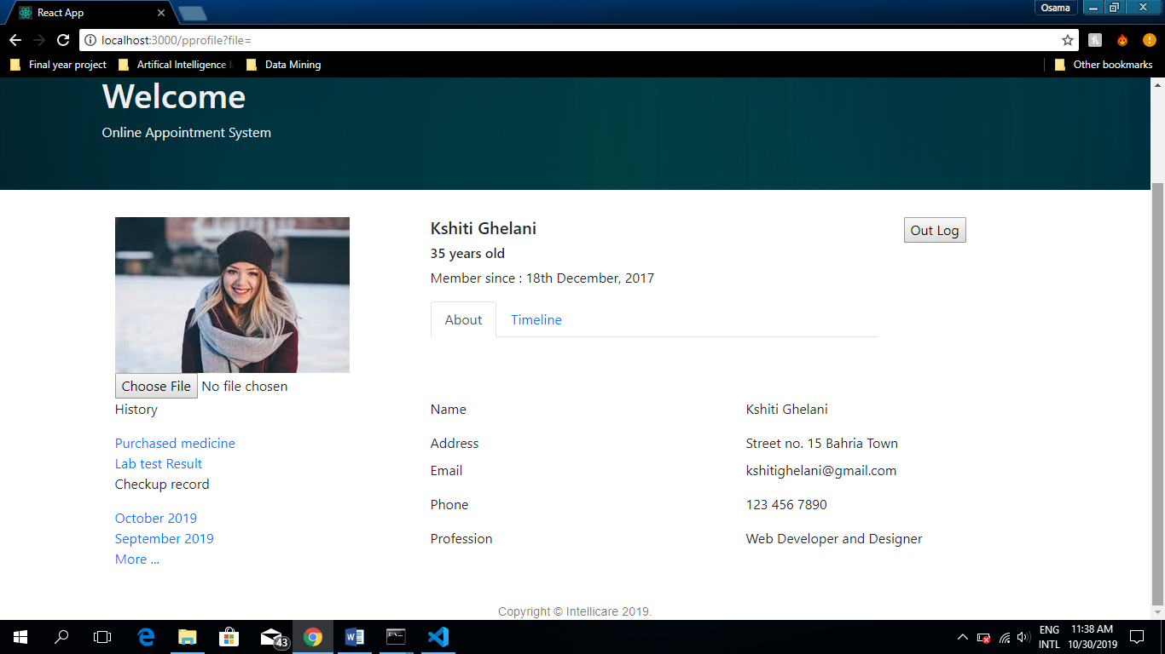
Figure 2.13 : Patient profile
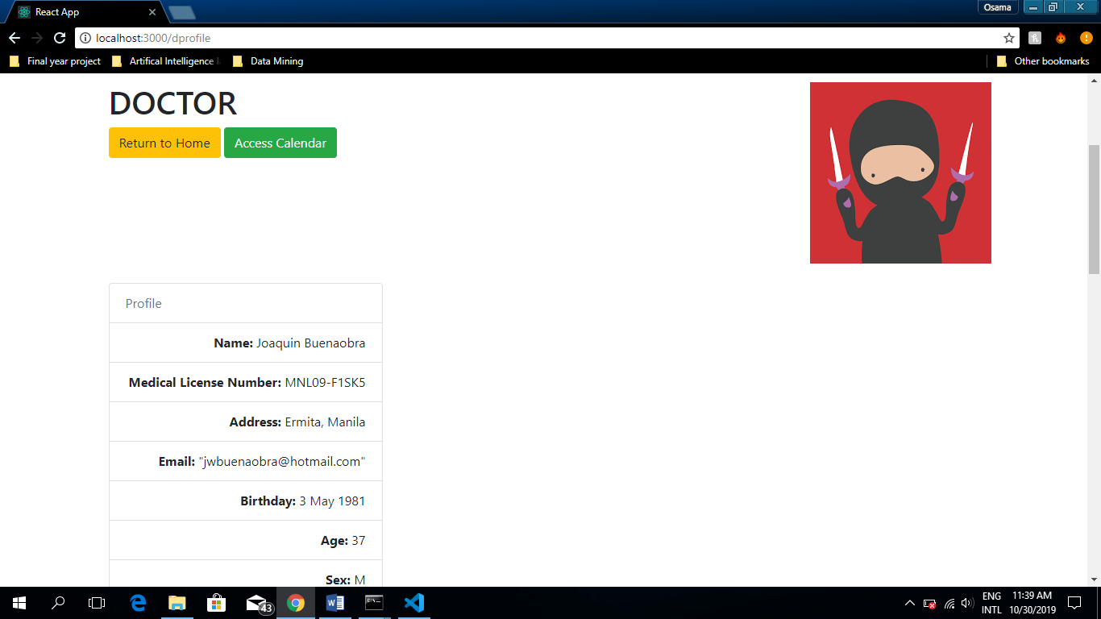
Figure 2.14 : Doctor profile

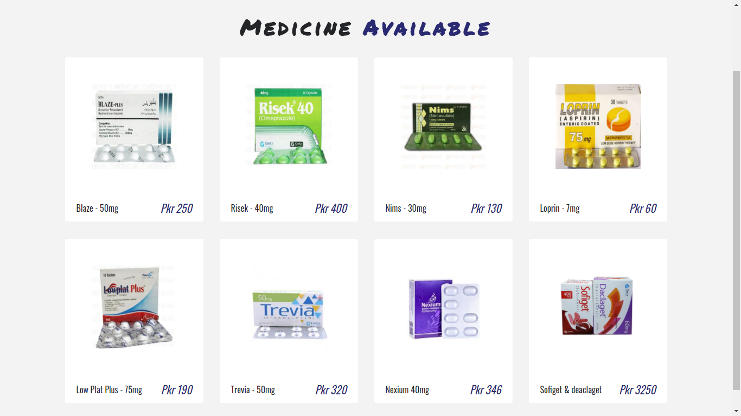
Figure 2.15 : E-pharmacy
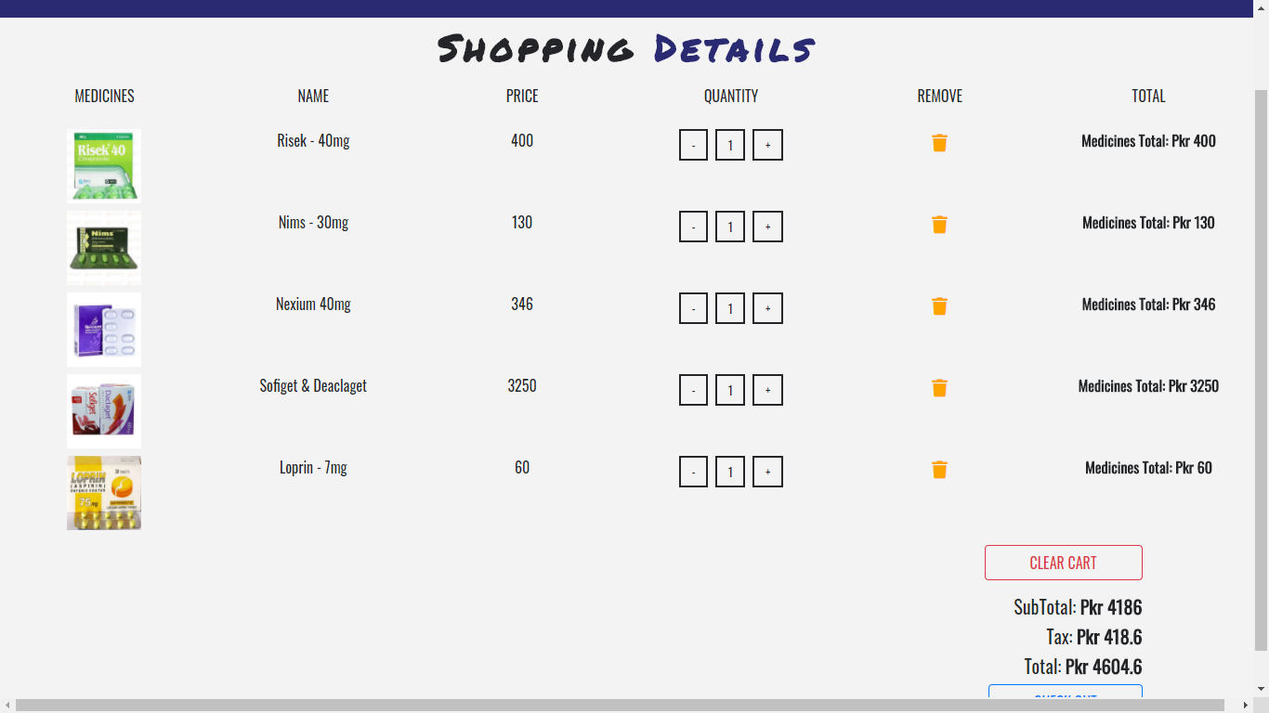
Figure 2.16 : Cart

Hardware Interfaces

This system doesn’t require any hardware interface. The one used here is monitor, keyboard and mouse.

Software Interfaces

Operating system – Windows
Tool – REACT.JS
BOOTSTRAP
MONGOOSE
EXPRESS
NODE.JS
Database – Mongo dB

Use Cases Diagram

System Use Case
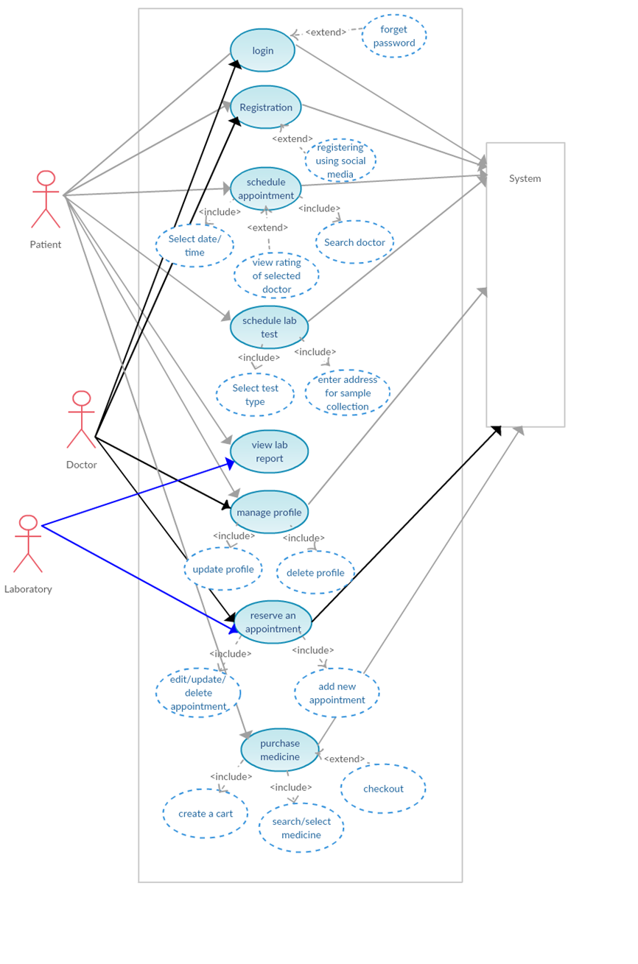
Figure 2.17 : System Use case Diagram

Use Cases

<Use-case #1>

Table 2.1 : Use_Case_U1 Registration
Name and ID | Registration
Brief description | This use case describes the event of registration of patient or doctor. Once user has opened the website then he has to register himself first on the website.
Preconditions | User must open the website.
Basic flow or Happy path | - User open the website  - Press Register  - Registration Form Displays  - Enter all required data  - Press confirm
Trigger | This use case initiate when a user press register.
Alternate flows | Alt-1. Hasn’t entered the correct data  Alt-2. Username already exist
Post conditions | User is registered.

<Use-case #2>

Table 2.2 : Use_Case_U2 Login
Name and ID | Login
Brief description | This use case describes the event of login of patient or doctor once user has open website then he has to login himself first in order to use the services provided by the platform
Preconditions | User must open the website.  User must already registered
Basic flow or Happy path | - User open the website  - Login Page Appears  - Enter Username password  - Press Login button.  - Logins User After Checking In Database
Trigger | This use case initiate when a user attempts to login.
Alternate flows | 1. Forget Password  2. Wrong username or password
Post conditions | User logged in.

<Use-case #3>

Table 2.3 : Use_Case_U3 Logout
Name and ID | Login Out
Brief description | This use case describes the event of logout of patient or doctor once user has logged into the website then he has to logout himself. When the user logs out all his records are saved for him
Preconditions | User must have an account and logged in to the website.
Basic flow or Happy path | - Press Logout Button  - Sessions are destroyed  - User is logged out.  - Main Page Appears
Trigger | This use case initiate when the logout button is pressed.
Alternate flows | -
Post conditions | User logged out successfully

<Use-case #4>

Table 2.4 : Use_Case_U4 Schedule Appointment
Name and ID | Schedule An Appointment (U4)
Brief description | This use case describes the event of scheduling an appointment of doctor/ Laboratory and determining venue and time.
Preconditions | User must open the website.  User must already registered
Basic flow or Happy path | - User login  - Main page appears after login  - Search relevant doctor  - Selects the doctor  - Select “make an appointment” option  - Select the available slot of desire
Trigger | This use case initiate when a user attempts schedule an appointment with the desired doctor
Alternate flows | Alt-1. Doctor not available  Alt-2. No free slot available
Post conditions | Appointment scheduled.

<Use-case #5>

Table 2.5 : Use_Case_U5 Purchase Medicine
Name and ID | Purchase Medicine (U5)
Brief description | This use case describes the event of purchasing medicine from the “e pharmacy” facility.
Preconditions | Patient must be logged in.
Basic flow or Happy path | - User press Online pharmacy  - E-shopping page appears  - Search and create a catalog of item he/she want to purchase.  - Press purchase  - Final invoice will generate and option payment will be selected  - Press check out Select the available slot of desire  - Purchase successful page displays
Trigger | This use case initiate when patient selects online pharmacy option from main menu.
Alternate flows | Alt-1. Hasn’t purchase anything
Post conditions | Order will be sent to our partner pharmacy and will be delivered to patient and history will be stored in patient purchase history

<Use-case #6>

Table 2.6 : Use_Case_U5 Purchase Medicine
Name and ID | Profiling (U6)
Brief description | This use case describes the event of making profile and maintaining records of patients
Preconditions | Patient must be logged in.
Basic flow or Happy path | - User press Profile  - Profile page appears  - View records.
Trigger | This use case initiate when patient clicks on his profile
Alternate flows | Alt-1. Hasn’t clicked profile
Post conditions | User will be able to load his profile and load his records

Requirement

Performance Requirements
- Accurate result
- Less time
- Efficient data management

Safety Requirements
- In case the user forgets or loses Password, the repair functionality helps by choosing “forgot password” option in the main login window.
- To avoid this kind of situations, backups can be done regularly.
- While typing the password, if the caps lock is on it must be notified.
- If the system is kept idle for 10 min the session will expire.

Security Requirements
This system is provided with authentication without which no user can pass. So only the legitimate users are allowed to use the application. If the legitimate user’s share the authentication information then the system is open to outsider.

Software Quality Attributes
- Reliability: Good validations of user inputs will be done to avoid incorrect storage of records.
- Maintainability: During the maintenance stage, SRS document can be referred for any validations.
- Portability: This system can be installed in any personal computers supporting windows operating system platform.
- Flexibility: The system keeps on updating the data according to the transactions that takes place.
- Timeless: The system carries out all the operations with consumption of very less time.
- Security: Security of the system is maintained d by giving access to only authenticated user id and password.

Other Requirements
- Database: The records of all operations are stored in database.

Sequence diagram

Login

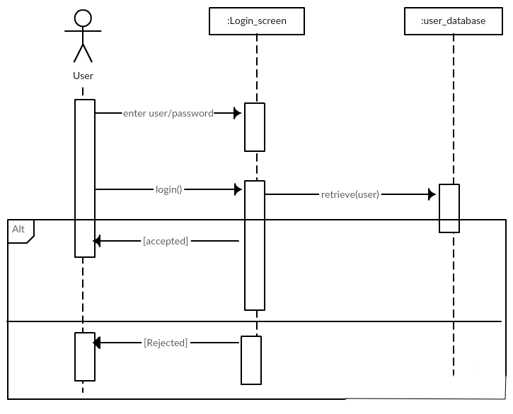
Figure 2.18 : Login sequence

Registration

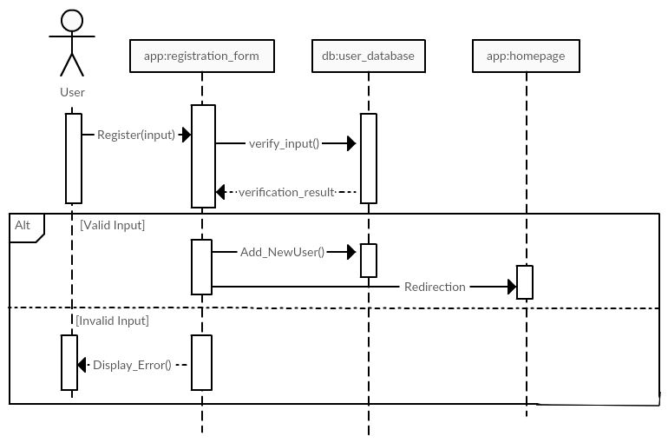
Figure 2.19 : Registration sequence

Appointment

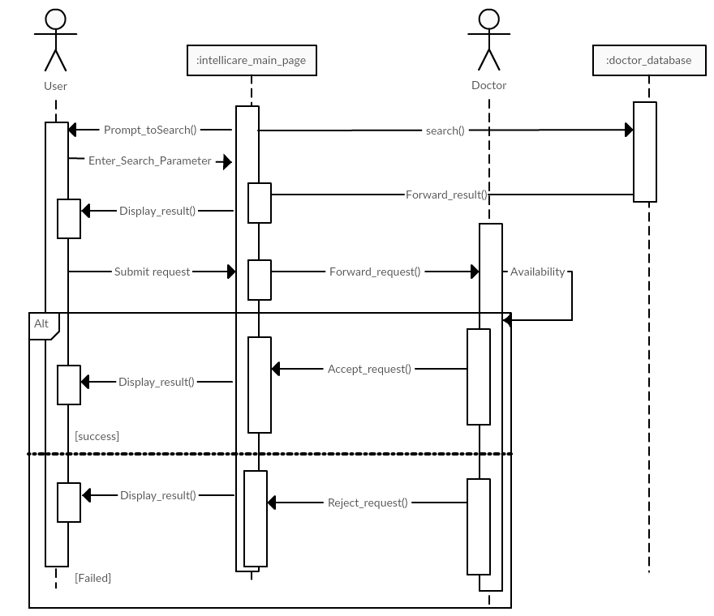
Figure 2.20 : Appointment sequence

Purchase medicine

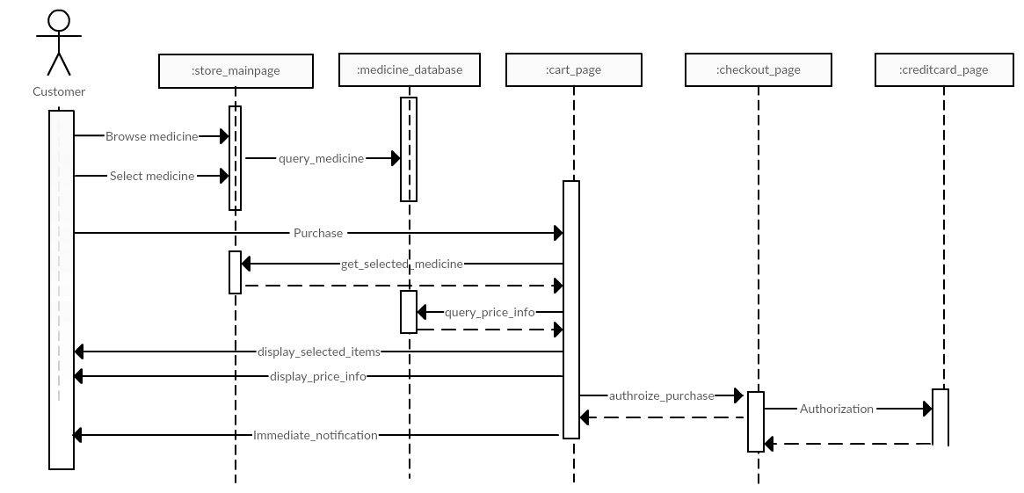
Figure 2.21 : Purchase medicine sequence

View profile

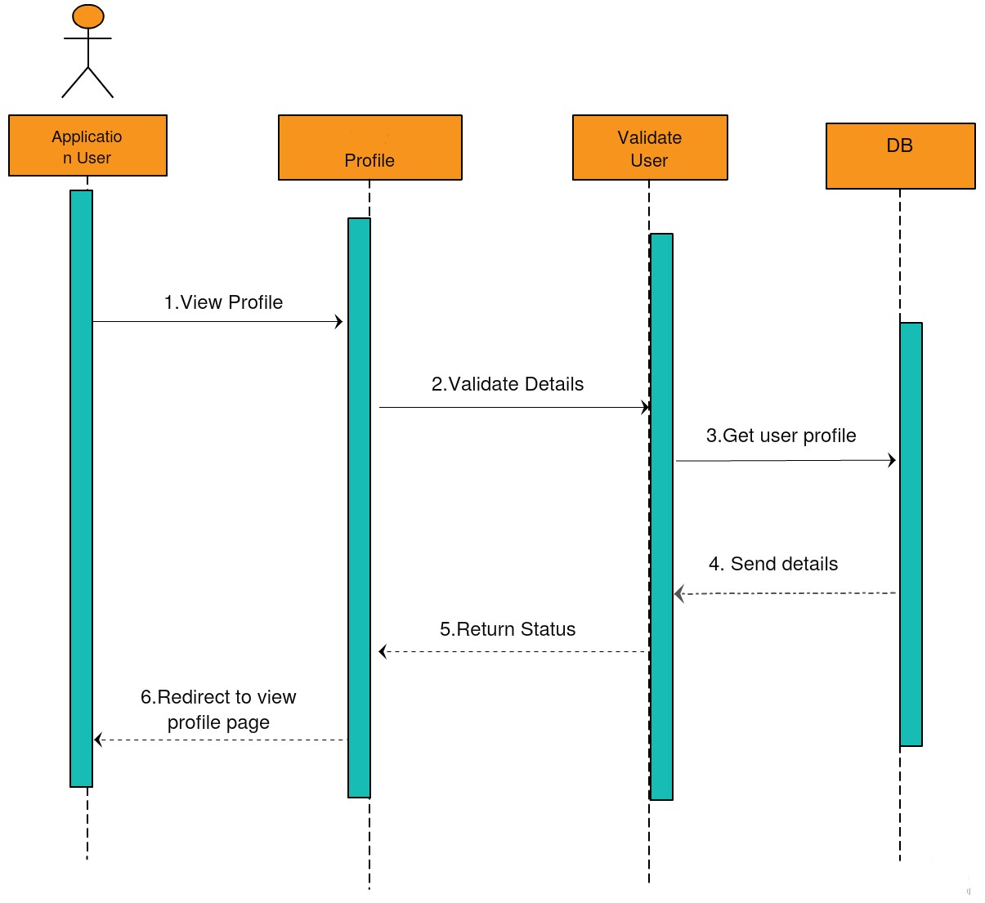
Figure 2.22 : View profile sequence

Logout

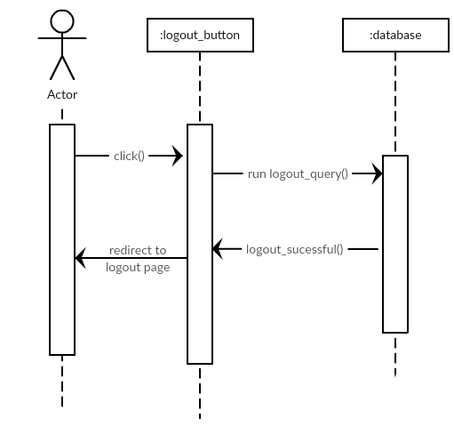
Figure 2.23 : Logout sequence

Collaboration diagram

Login

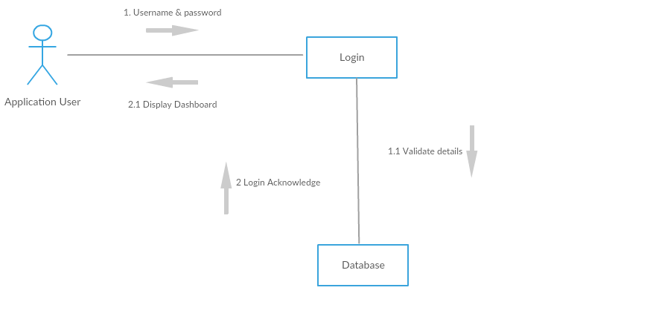
Figure 2.24 : Login collaboration

Registration

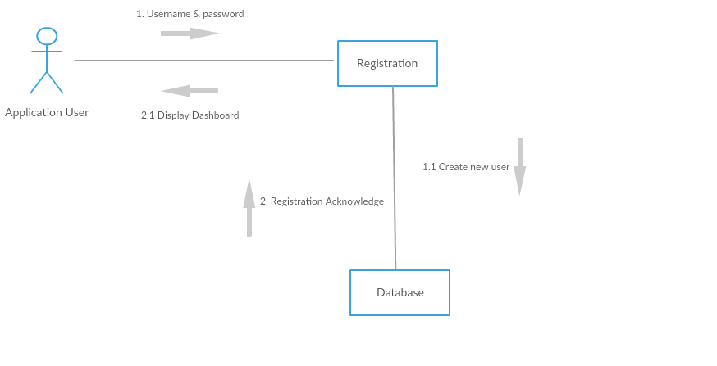
Figure 2.25 : Registration collaboration

Appointment

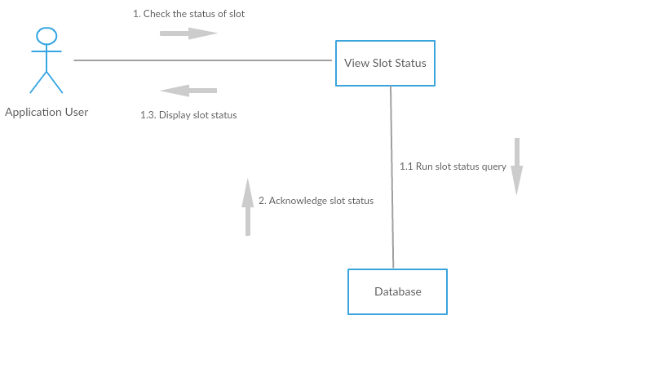
Figure 2.26 : Appointment collaboration

Purchase Medicine

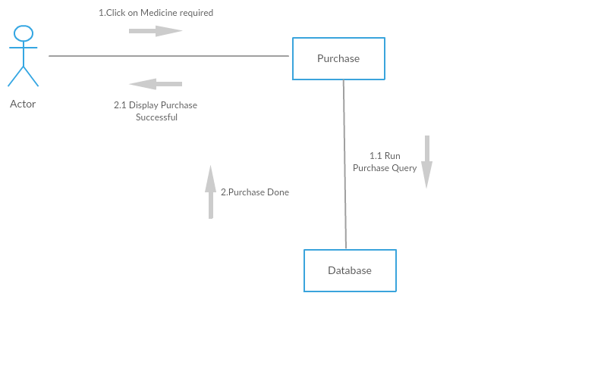
Figure 2.27 : Purchase medicine collaboration

Logout

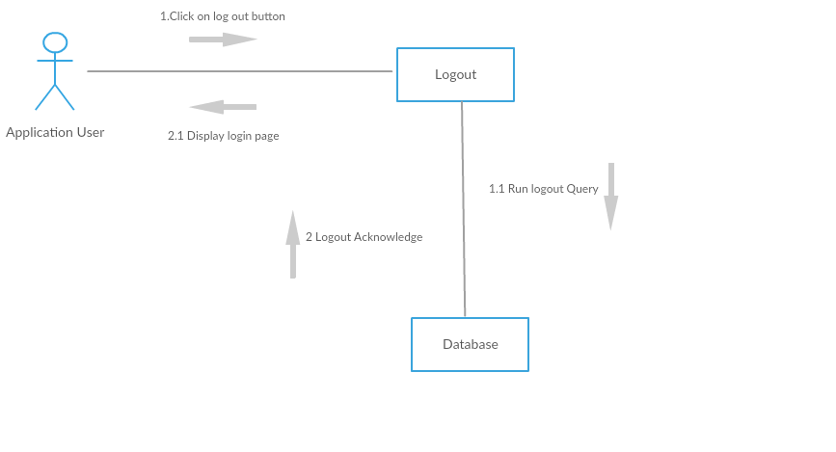
Figure 2.28 : Logout collaboration

Class Diagram

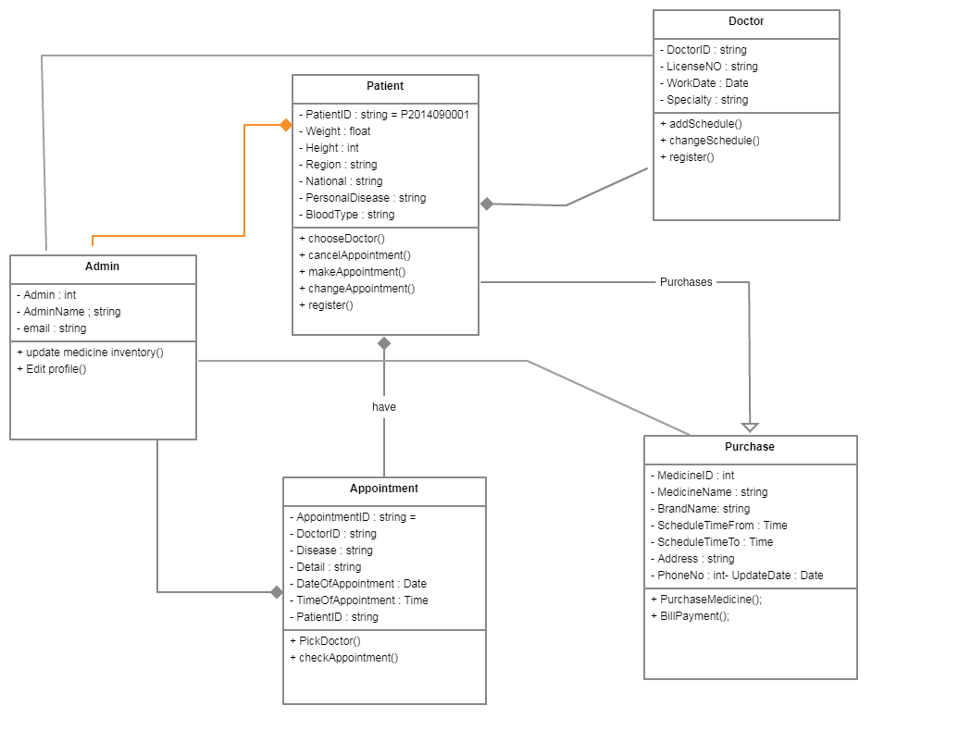
Figure 2.29 : Class Diagram

Domain Diagram

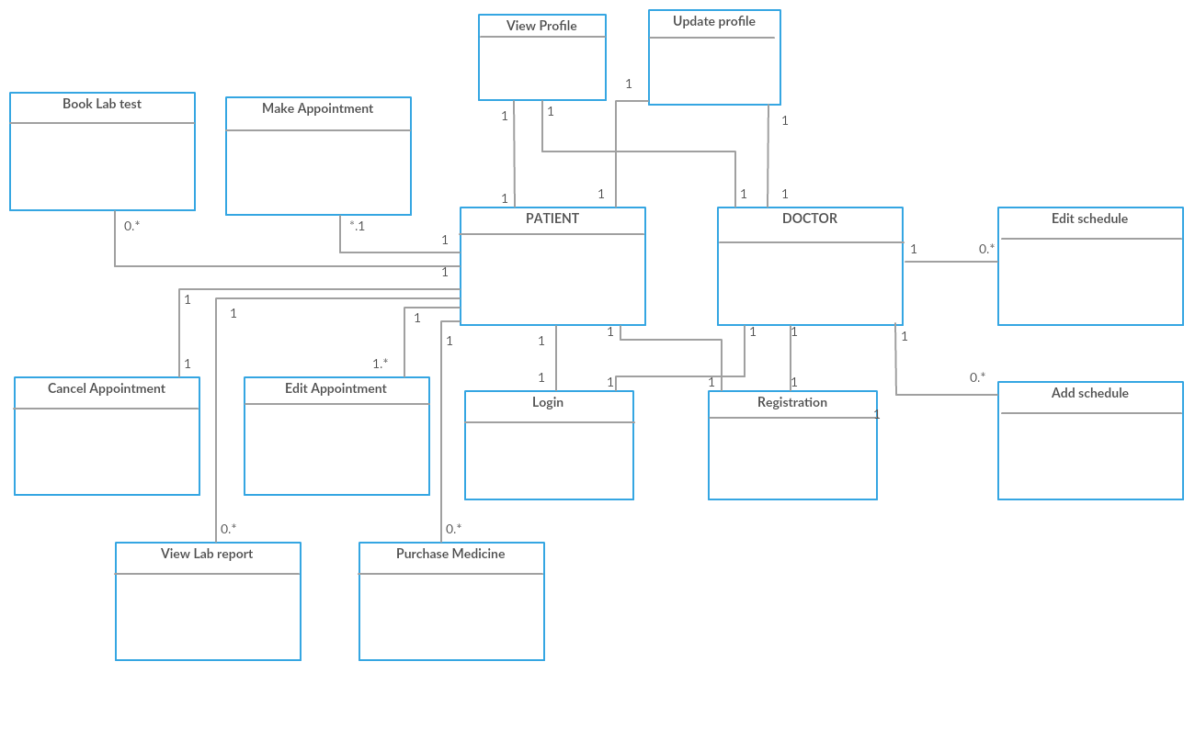
Figure 2.30 : Domain model

DESIGN AND METHODOLOGY

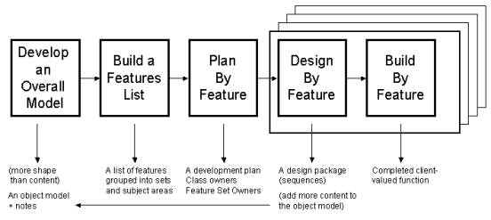
Figure 3.31 : FDD methodology

There are several methodologies that could be implemented during the Online Patient Scheduling System. Agile Methods are focused on different aspects of the software development life cycle. Though few of the agile methods are practice centric such as Extreme Programming, Pair Programming, others focus on software projects such as the Feature-driven development Approach

Among several methods available in Agile Methodology, we have chosen the Feature-driven development (FDD) approach to develop the proposed system. FDD is one of the most widely used Agile Methods. Feature-driven development process is designed to follow a five-step development process, built largely around discrete “feature” projects [2] .

Develop an overall model (Phase 1): In this phase an overall model of the system will be designed which will help us to get a strong understanding of the project as well as a solid communication.
Building the feature list (Phase 2): Here we will have to identify the features which are valuable to the client and which will basically guide the project to proceed.
Planning by feature (Phase 3): In the third phase we will plan and organize that in which order the features will be implemented.
Designing by feature (Phase 4): Here we will be designing all the listed features through working out on detailed sequence diagrams for each feature and refining of the overall model.
Building by feature (Phase 5): It is the fifth and last phase of our development in which we will develop system according to the designs created. Implement the code in the form of system and test it.

IMPLEMENTATION

Languages and Implementation

MERN Development

MERN is the name given to a set of JavaScript based technologies used in developing web applications. MERN is the acronym name given to the set of technologies including Mongo DB, Express JS, React JS/ Redux and Node JS [1].

Tools for Implementation:

React js

ReactJS is an open-source JavaScript library which is used for building user interfaces specifically for single page applications. It's used for handling view layer for web and mobile apps. React also allows us to create reusable UI components. It is maintained by Facebook and a community of individual developers and companies.
React can be used as a base in the development of single-page or mobile applications. However React is only concerned with rendering data to the DOM and so creating React applications usually requires the use of additional libraries for state management, routing, and interaction with an API. Redux, React Router and axios are respective examples of such libraries [3] .

Express js

Express.js, or simply Express, is a web application framework for Node.js, released as free and open-source software under the MIT License. It is designed for building web applications and APIs. It has been called the de facto standard server framework for Node.js. Express.js basically helps you manage everything, from routes, to handling requests and views. Redis is a key/value store -- commonly used for sessions and caching in Node.js applications [6].

Node js

Express.js, or simply Express, is a web application framework for Node.js, released as free and open-source software under the MIT License. It is designed for building web applications and APIs. It has been called Node.js is an open-source, cross-platform, JavaScript runtime environment that executes JavaScript code outside of a browser. Node.js lets developers use JavaScript to write command line tools and for server-side scripting—running scripts server-side to produce dynamic web page content before the page is sent to the user's web browser. Consequently, Node.js represents a "JavaScript everywhere" paradigm, unifying web-application development around a single programming language, rather than different languages for server- and client-side scripts. The de facto standard server framework for Node.js [7].

Mongo DB

MongoDB is a cross-platform document-oriented database program. Classified as a NoSQL database program, MongoDB uses JSON-like documents with schema.
MongoDB was among several database products, apart from MySQL, Hadoop and HBase, originally procured for running the database search. Here, MySQL is used for storing demographic data and MongoDB is used to store images [5].

User Manual

User Manual:

- User is directed to the homepage which consist of Navigation bar holding About, Appointment, contact and Purchase Medicine
- User need to register and create an account.
- Creating account holds two sections one for patient registration and other for doctor registration.
- After the registration user will be directed to the login page.
- User needs to select the either he is patient or doctor.
- Login Page requires username and password.
- Once successfully logged in user will again be redirected to the homepage screen.
- To book appointment user needs to click on the appointment button in navigation bar.
- User will be redirected to Appointment page.
- Appointment page will be holding the list of doctors available.
- Each doctors will be having his/her name, specialization, ratting, fees, date and time displayed.
- User need to click on doctor to open appointment module.
- Appointment module will be holding date calendar with time slots available.
- User needs to select date and time available to schedule an appointment with the doctor.
- Once an appointment is scheduled the user will be notified with a toast notification.
- User can see his appointment in the my appointment tab which will be holding the records of his appointment.
- A doctor can see his scheduled slots in his my appointment section.
- User click of about which will direct him to page holding the information of the author and their picture.
- User click on purchase medicine will direct him to online medicine shopping market.
- Purchase medicine holds the medicine products available in the e shopping.
- Clicking the medicine will direct the user to medicine details page.
- Medicine detail page will hold the medicine's details, medicine image as well as two buttons one to back to shopping and other to check out.
- User clicks on continue shopping will redirect to medicine market page.
- User clicks on check out will direct him to cart check out page.
- Cart page will be holding all the selected medicines.
- Cart page will be displaying the medicine's name, image, price and number of quantity which can be incremented and decremented with the addition and subtraction operator.
- User will be given two methods to pay alongside two buttons.
- Cash on delivery button will direct user to delivery form.
- Delivery form will be having fields like name, address and call number.
- A online payment method PayPal is also available if user click on it, it will redirect him to pay pays payment page where he can pay online with his smart cards.

CONCLUSION

Remarks and Conclusion

React allows developers to create large web applications which can change data, without reloading the page. The main purpose of using React was to make the service be fast, scalable, and simple.
The main idea of this work was to achieve and provide platform for ease and comfort and to make an interaction system for doctors and patient without any hesitation. The service also resolves the problems that the patients has to face while making an appointment. The web based application Intellicare acts as a client whereas the database containing the doctor’s details, patient’s details and appointment details is maintained by a website as a server. Furthermore Intellicare allows its users to purchase medicines online from the medical Ecommerce shopping market.

REFERENCES

Books:

[1] A. Banks and E. Porcello, Learning react.
[2] J. Dickey, Write modern web apps with the MEAN stack. San Francisco, CA: Peachpit Press, 2015.

Electronic Sources from Internet:

[3] En.wikipedia.org. (2020). React (web framework). [online] Available at: https://en.wikipedia.org/wiki/React_(web_framework) [Accessed 15 Sep. 2019].
[4] En.wikipedia.org. (2020). MongoDB. [online] Available at: https://en.wikipedia.org/wiki/MongoDB [Accessed 24 Nov. 2019].
[5] Alligator.io. (2020). Basic Express Server in Node.js. [online] Available at: https://alligator.io/nodejs/express-basics/ [Accessed 15 Sep. 2019].
[6] Code, V. (2020). Documentation for Visual Studio Code. [online] Code.visualstudio.com. Available at: https://code.visualstudio.com/docs [Accessed 10 Oct. 2019].
[7] Node.js. (2020). Getting Started Guide | Node.js. [online] Available at: https://nodejs.org/en/docs/guides/getting-started-guide/ [Accessed 12 Sep. 2019].
[8] Affairs, A. (2020). System Usability Scale (SUS) | Usability.gov. [online] Usability.gov. Available at: https://www.usability.gov/how-to-and-tools/methods/system-usability-scale.html [Accessed 26 Dec. 2020].

APPENDICES

APPENDIX A: APIs

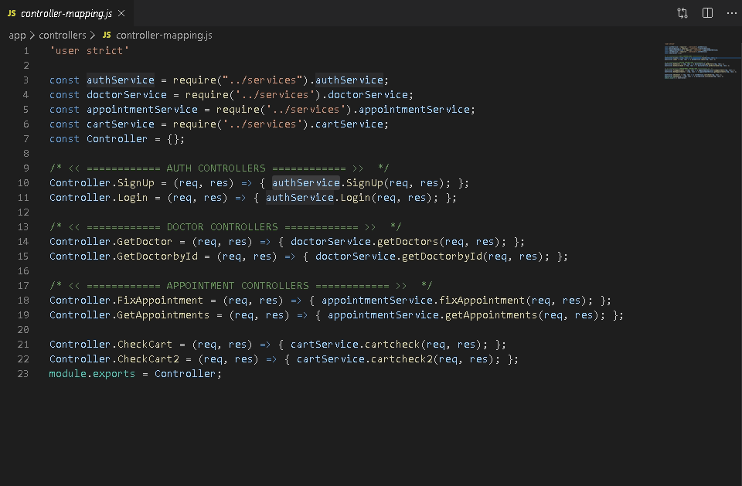
Figure A.1 : Controller mapping

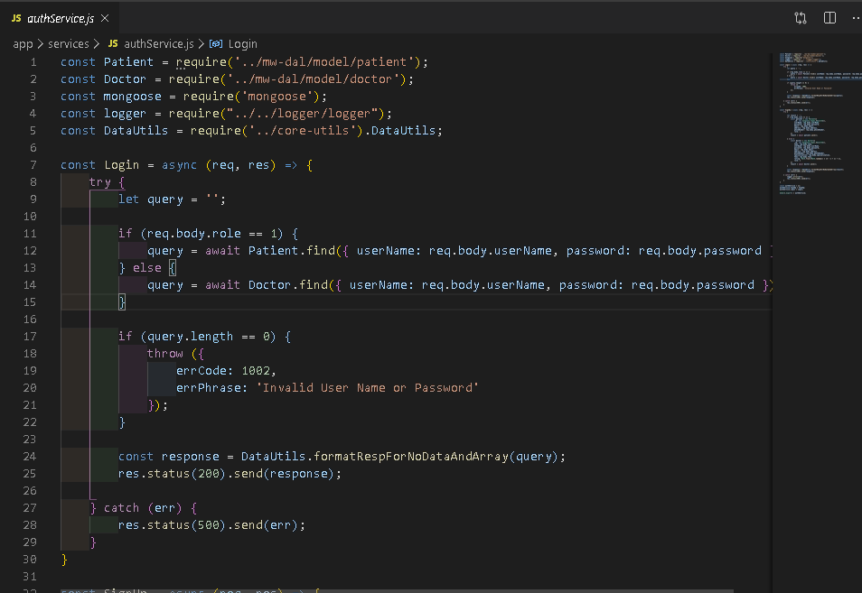
Figure A.2 : Authentication services

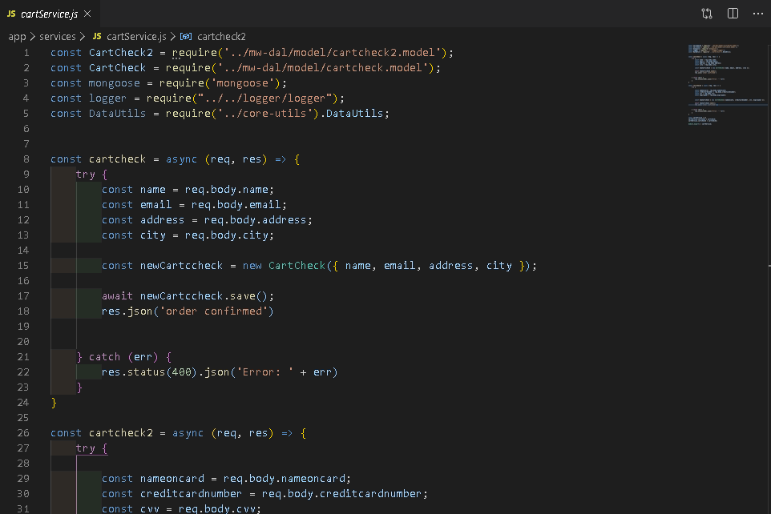
Figure A.3 : Authentication services

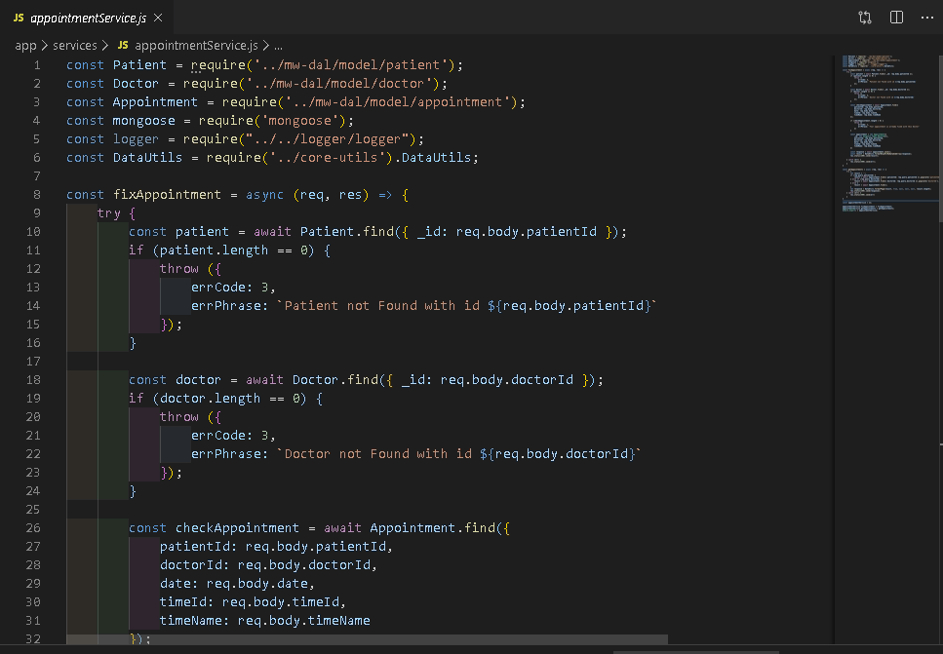

Figure A.4 : Appointment services

APPENDIX B: SUS Survey result of Intellicare

The System Usability Scale (SUS) provides a “quick and dirty”, reliable tool for measuring the usability. It consists of a 10 item questionnaire with five response options for respondents; from Strongly agree to Strongly disagree. Originally created by John Brooke in 1986, it allows you to evaluate a wide variety of products and services, including hardware, software, mobile devices, websites and applications [8].
A SUS survey was conducted via Google form and following result was generated on basis of eleven responses. Where
1 represents strongly disagree
2 represents disagree.
3 represents uncertain.
4 represents agree.
5 represents strongly agree.

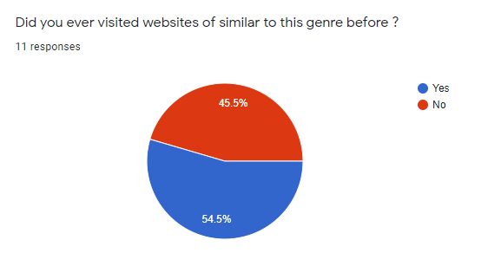

Figure B.1 : Question 1 of SUS

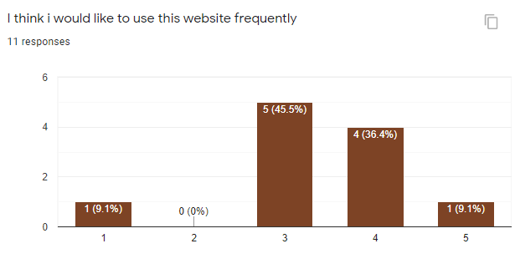
Figure B.2 : Question 2 of SUS

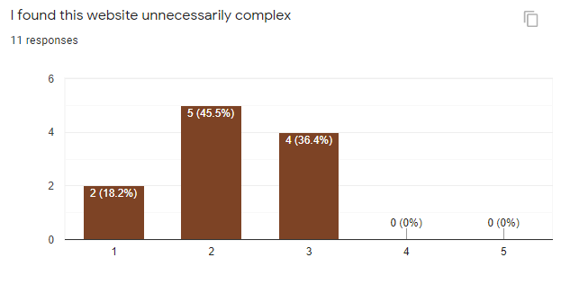
Figure B.3 : Question 3 of SUS

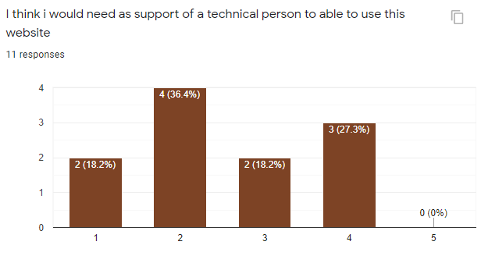
Figure B.4 : Question 4 of SUS

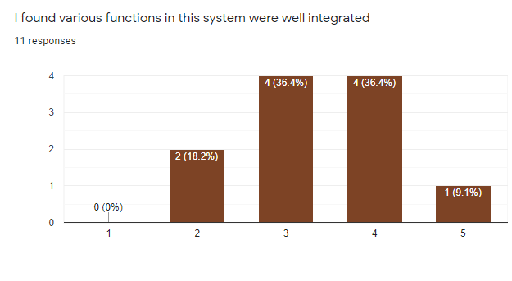
Figure B.5 : Question 5 of SUS

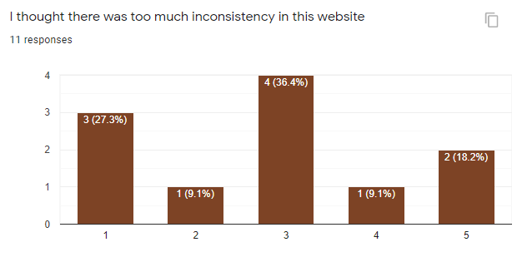
Figure B.6 : Question 6 of SUS

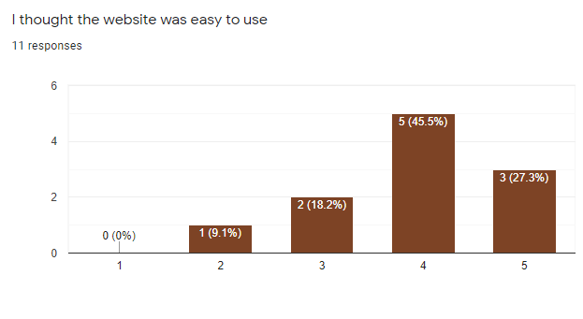
Figure B.7 : Question 7 of SUS

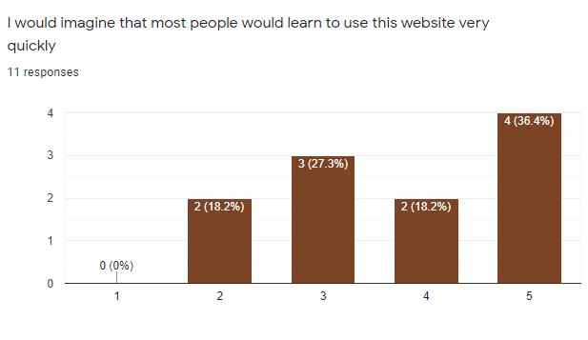
Figure B.8 : Question 8 of SUS

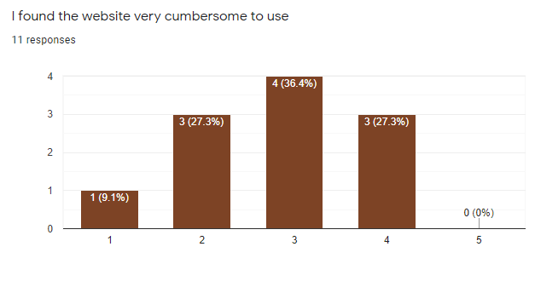
Figure B.9 : Question 9 of SUS

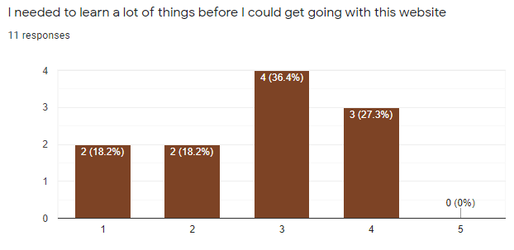
Figure B.10 : Question 10 of SUS

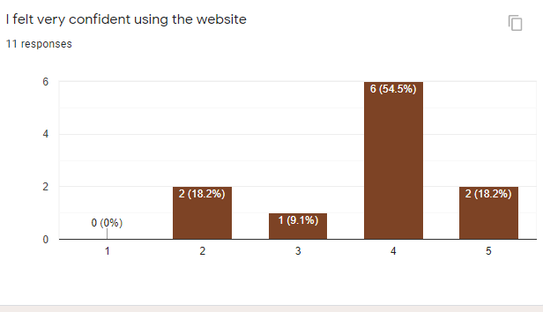
Figure B.11 : Question 11 of SUS

