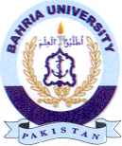
Bahria University Library Islamabad
Source: The News & Daily Jang Sunday August 18, 2024

