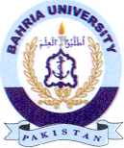
Bahria University Library Islamabad
Source: Pakistan Observer Saturday August 17, 2024

