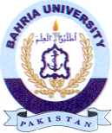
Bahria University Library Islamabad
Source: Dawn Sunday August 11, 2024

