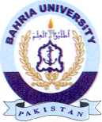
Bahria University Library Islamabad
Source: Pakistan Observer Saturday August 10, 2024

