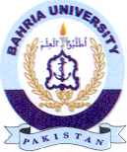
Bahria University Library Islamabad
Source: Dawn, Sunday Aug 04, 2024

