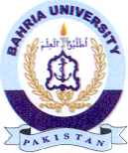
Bahria University Library Islamabad
Source: Dawn & Jang, Thursday August 01, 2024

