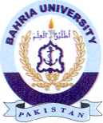
Bahria University Library Islamabad
Source: Express Tribune, Wednesday Jun 12, 2024

