
BSCS-S19-004
03-134161-020 | MUHAMMAD TAHIR ALI

Augmented Adverts

In partial fulfilment of the requirements for the degree of
Bachelor of Science in Computer Science
Supervisor: Dr. Iram Noreen
Department of Computer Sciences
Bahria University, Lahore Campus
January 2020

© Bahria University, 2020

Certificate

We accept the work contained in the report titled
“AUGMENTED ADVERTS”
Written by
MUHAMMAD TAHIR ALI
as a confirmation to the required standard for the partial fulfilment of the degree of
Bachelor of Science in Computer Science.

Approved by:
Supervisor: Dr. Iram Noreen
(Signature)

January 27, 2020

DECLARATION

I hereby declare that this project report is based on my original work except for citations and quotations which have been duly acknowledged. I also declare that it has not been previously and concurrently submitted for any other degree or award at Bahria University or other institutions.

Enrolment | Name | Signature
03-134161-020 | MUHAMMAD TAHIR ALI

Date : January, 2020

Specially dedicated to
Maa

ACKNOWLEDGEMENTS

I would like to thank everyone who had contributed to the successful completion of this project. I would like to express my gratitude to my supervisor, Dr. Iram Noreen for her invaluable advice, guidance and her enormous patience throughout the development of the project.

In addition, I would also like to express my gratitude to my loving parent who had helped me and given me encouragement.

Muhammad Tahir Ali

AUGMENTED ADVERTS

ABSTRACT

This project aims to introduce Augmented Reality as a medium for advertisement. The project is developed mainly for the hyper malls. Project is expected to bring cost effectiveness, creativity, innovation and eco-friendly solutions to the current advertisement market. From static brochure advertisement to replacing a high definition jumbo-tron playing brands’ advertisement 24/7, this project will help in minimizing paper and flex wastage contributing to cost effectiveness and eco-friendly environment at the same time.

TABLE OF CONTENTS

DECLARATION iv
ACKNOWLEDGEMENTS vi
ABSTRACT vii
TABLE OF CONTENTS viii
LIST OF TABLES x
LIST OF FIGURES xi
LIST OF SYMBOLS / ABBREVIATIONS xii

CHAPTERS
1 INTRODUCTION 1
1.1 Background 1
1.2 Problem Statements 1
1.3 Aims and Objectives 2
1.4 Scope of Project 2
2.1 LITERATURE REVIEW (SRS) 3
2.2 Functional Requirements 5
2.3 Product Requirements 5
3 DESIGN AND METHODOLOGY 7
3.1 Tools and Skills 7
3.2 Design 7
3.3 Methodology 8
4 IMPLMENTATION 9
4.1 Base 9
4.2 Account management 10
4.3 Relation between Phase 1 and Phase 2 11
4.4 Admin Portal 13
5 RESULTS AND DISCUSSIONS 14
5.1 Completion 14
5.2 Improvements 14
6 CONCLUSION AND RECOMMENDATIONS 15
6.1 Conclusion 15
6.2 Recommendations 15
6.3 Future enhancements 15
REFERENCES 16

LIST OF TABLES

TABLE TITLE PAGE
Table 1 Functional Requirements 5
Table 2 Product Requirements 5

LIST OF FIGURES

FIGURE TITLE PAGE
Figure 2.1 AR example with virtual chairs and a virtual lamp 3
Figure 2.2: Process of marker based AR 5
Figure 3.1: Main Use Case Diagram 8
Figure 3.2 User's use case diagram 9
Figure 3.3 Manager's Use case diagram 10
Figure 3.4 Admin's use case diagram 11
Figure 3.5 Class Diagram 18
Figure 3.6 User's Activity Diagram 19
Figure 3.7 Manager/Admin Activity Diagram 20
Figure 3.8 Scrum Framework [3] 21
Figure 4.1 Main Screen 22
Figure 4.2 Management Portal 23
Figure 4.3 Plain camera perspective 24
Figure 4.4 Application Screen, user perspective 25
Figure 4.5 Admin Portal Webpage 26

LIST OF SYMBOLS / ABBREVIATIONS

AR Augmented Reality
SQL Search Query Language
PVC Poly-Vinyl Chlorine
CRUD Create, Read, Update, Delete
SLAM Simultaneous Localization and Mapping
RB Recognition Based
LB Location Based
NFT Natural Feature Tracking
GPS Global Positioning System

INTRODUCTION

Background
Augmented Reality has opened new doors towards user’s interaction with machines. Despite being still perfected in terms of hardware, this technology still has the potential to bring so much change in current lifestyle.

Advertisement on the other hand has been nearly same for last decade, the methodologies may have been evolved but the sources and physical costs are not that much changed
In the era where a small bump may cause the methodology or process to become obsolete, current advertisement methods should be changed, not because there are alternatives available but because they are doing more harm than good.

Problem Statements

- Current advertising methods are health hazards
- Clean, efficient alternate of PVC flex is necessary
- More solutions can be derived using AR technology
- We can achieve so much more from this method comparative to current advertisement method

Aims and Objectives

Augmented Adverts is an advertisement based application that will provide the user a platform to interact with brands. This application is developed keeping in mind a hyper mall environment. Brand owners will be able to advertise their brand without investing in flex and paper based mediums, on the other hand customers and viewers can reap benefits from it without any wastage of flex and paper medium involved.

Scope of Project
The primary goal of the proposed system is to make an application that can:
- Introduce AR as an advertising medium
- Introduce cost effectiveness in advertisement
- Reduction in wastage of paper and PVC flex
- Introduce eco-friendly solutions to advertisement
In other words, this project will help reducing cost and health hazards as well as introducing an innovative technology in advertisement market.

LITERATURE REVIEW (SRS)

Augmented Reality (AR) is a new technology that involves the overlay of computer graphics on the real world (Figure 1) [1].
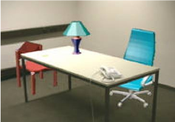
Figure 2.1 AR example with virtual chairs and a virtual lamp

As mentioned in the reference, this research paper was published in late 90’s. But surprisingly enough, the potential of this technology was even then, never underestimated. The only difference now is that we have potential technological assets to actually implement it into society and reap benefits from it, though research work is currently being done on AR regarding hardware i.e. headgears like Google Hololens, which indicates that the chances of AR taking over current user interface mediums are high.
A more recent book, dedicated towards teaching Augmented Reality states that “Augmented reality holds the promise of creating direct, automatic, and actionable links between the physical world and electronic information. It provides a simple and immediate user interface to an electronically enhanced physical world. The immense potential of augmented reality as a paradigm-shifting user interface metaphor becomes apparent when we review the most recent few milestones in human–computer interaction: the emergence of the World Wide Web, the social web, and the mobile device revolution [2].”

Talking about its working mechanism, AR deploys virtual image over real-world objects. The overlay is executed simultaneously with the input received from a camera or another input device like smart glasses. This superimposition of virtual images over real-world objects creates an illusion that can effectively engage users in a virtual world [3]. There are 3 different ways to implement AR, SLAM (Simultaneous Localization and Mapping), RB (Recognition Based) and LB (Location Based).
SLAM based AR or (Simultaneous Localization and Mapping) technique is an effective way to render virtual images over real-world objects. SLAM simultaneously localizes sensors with respect to their surroundings, while at the same time mapping the structure of the environment. SLAM is an approach to solve complex AR simulation problems and is not any specific algorithm or software. The SLAM system is, in fact, a set of algorithms aimed at solving simultaneous localization and mapping problem [write separate lists of SLAM algorithms and understand them].
RB or (Recognition Based) augmented reality uses a camera to identify visual markers or objects, such as a QR/2D code or Natural Feature Tracking (NFT) markers, to showcase an overlay only when the marker is sensed by the device. Marker-based AR technology depends upon device camera to distinguish a marker from other real-world objects.
LB or (Location Based) augmented reality relies on a GPS, digital compass, velocity meter, or accelerometer to provide data about the location and the augmented reality visualizations are activated based on these inputs. It is also known as marker less augmented reality. The location detection features in smartphones make it easy to leverage this type of augmented reality technology, making it quite popular. Some common uses of location-based AR include mapping directions, finding nearby services, and other location-centric mobile apps.

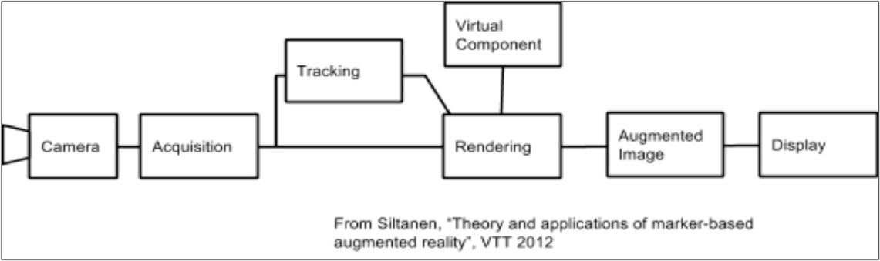
Figure 2.2: Process of marker based AR

Functional Requirements

Functional Requirement No. | Functional Requirement Description | Requirement mentioned in original proposal
FR1 | User/Business Owner Login/Sign Up module | No
FR2 | Web Based Admin portal for CRUD and reports | No
FR3 | AR based advertisement system that is PVC flex free | Yes
FR4 | Record user/managerial statistics | No
FR4 | News Feed | Yes

Table 1 Functional Requirements

Product Requirements

Product Requirement No. | Product Requirement Description
PR1 | Product should not rely on excessive need of PVC flex
PR2 | Product should not be complex to use
PR3 | Product should be designed to support Business Intelligence future
PR4 | Product should highlight the use of AR to promote new ideas
Table 2 Product Requirements

DESIGN AND METHODOLOGY

Tools and Skills

Tools were selected which were easy to implement and has a large community available to minimize dead ends, this resulted in Unity, Vuforia, Visual Studio, MySQL and Firebase being shortlisted for the final tools as a start. But after some time, Firebase was discarded as Web Domain was more profitable in terms of developing freedom and community count available on internet.

Other secondary tools were learned based on targeted learning basis whenever a requirement came up. These secondary tools included bootstrap, C#, PHP, Visual Studio.

Design

Since Augmented Reality require a camera to access user’s perspective view, an android application was a good choice since AR based headgears are pretty expensive, on the other hand android devices with camera are a common novelty nearly everyone possesses. GUI was decided to be as simple as possible since AR has not been introduced in market, too much dynamic and complication may drive user away from this concept and technology.

Use Cases
Main Use Case
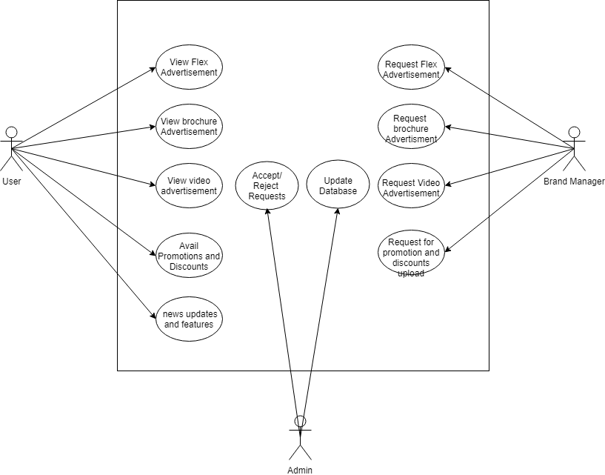
Figure 3.1: Main Use Case Diagram

User’s Use case
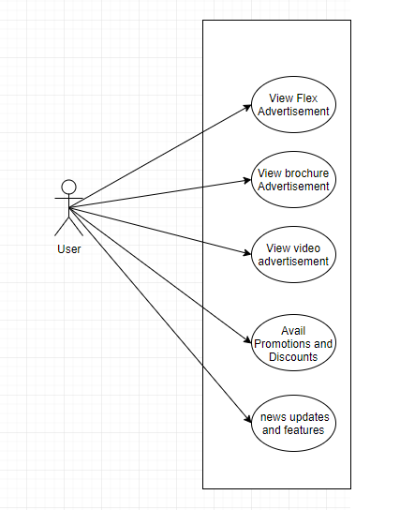
Figure 3.2 User's use case diagram

Manager’s Use case
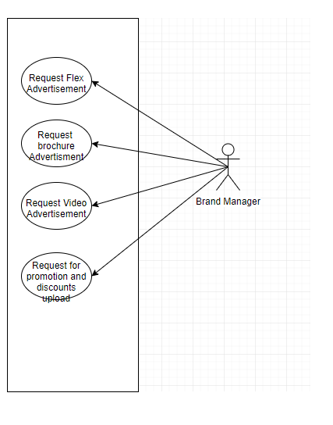
Figure 3.3 Manager's Use case diagram

Admin’s Use Case
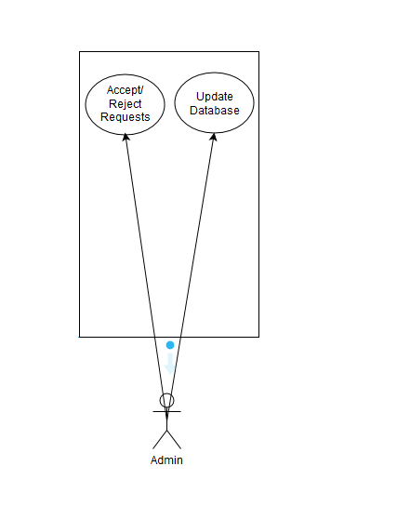
Figure 3.4 Admin's use case diagram

Use Case Description

View flex advertisement
Use Case ID: | 1 | Priority: High
Use Case Name | View flex advertisement
Actors | User
Description: | User views marker through mobile and ultimately views flex advertisement imposed at marker.
Preconditions: | - User must own a device fulfilling minimum requirements.  - User must be logged in to his/her account or get signed in.  - User should have a working internet.
Post conditions: | - Keep viewing advertisement as long as marker is in sight
Triggers: | AR markers will be triggering this use case
Flow: | - User launches the application using android device.  - Search marker in real world environment with the help of camera  - Experience AR flex advertisement
Alternative Flow: | None
Exceptions: | - Advertisement not available  - Unstable internet connection

View Brochure advertisement
Use Case ID: | 2 | Priority: High
Use Case Name | View brochure advertisement
Actors | User
Description: | User views marker through mobile and ultimately views brochure advertisement imposed at marker.
Preconditions: | - User must own a device fulfilling minimum requirements.  - User must be logged in to his/her account or get signed in.  - User should have a working internet.
Post conditions: | - Keep viewing advertisement as long as marker is in sight
Triggers: | AR markers will be triggering this use case
Flow: | - User launches the application using android device.  - Search marker in real world environment with the help of camera  - Experience AR flex advertisement
Alternative Flow: | None
Exceptions: | - Advertisement not available  - Unstable internet connection

View video advertisement
Use Case ID: | 3 | Priority: High
Use Case Name | View video advertisement
Actors | User
Description: | User views marker through mobile and ultimately views video advertisement imposed at marker.
Preconditions: | - User must own a device fulfilling minimum requirements.  - User must be logged in to his/her account or get signed in.  - User should have a working internet.
Post conditions: | - Keep viewing advertisement as long as marker is in sight
Triggers: | AR markers will be triggering this use case
Flow: | - User launches the application using android device.  - Search marker in real world environment with the help of camera  - Experience AR flex advertisement
Alternative Flow: | None
Exceptions: | - Advertisement not available  - Unstable internet connection

Avail promotions and Discounts
Use Case ID: | 4 | Priority: High
Use Case Name | Avail promotions and discounts
Actors | User
Description: | User avails promotions and discounts provided by brands by using provided interface
Preconditions: | - User must own a device fulfilling minimum requirements.  - User must be logged in to his/her account or get signed in.  - User should have a working internet
Post conditions: | - User will get discounts or perks as per availed offer
Triggers: | AR markers will be triggering this use case
Flow: | - Opens up application  - Search marker in real world environment  - Discounts and promotions will pop up
Alternative Flow: | None
Exceptions: | - No offers available  - Unstable internet connection

News Updates
Use Case ID: | 5 | Priority: medium
Use Case Name | News updates and features
Actors | User
Description: | User can opt to view news updates and other features provided by the application while experiencing other AR activities
Preconditions: | - User must own a device fulfilling minimum requirements.  - User must be logged in to his/her account or get signed in.  - User should have a working internet.
Post conditions: | - User can view news updates and features and AR features simultaneous
Triggers: | No triggers are involved this feature will always run when user enables it.
Flow: | - User launches the application using android device.  - Search marker in real world environment with the help of camera  - Experience AR flex advertisement
Alternative Flow: | None
Exceptions: | - News disabled  - Unstable internet connection

Request flex advertisement
Use Case ID: | 6 | Priority: High
Use Case Name | Request flex advertisement
Actors | Brand Manager
Description: | Brand manager requests admin to place the uploaded material to storage for viewers to see
Preconditions: | - Brand manager must own a device  - He/she must be logged in  - He/she should have a working internet.
Post conditions: | - Request accepted by admin  - Request denied by admin
Triggers: | Brand manager will be triggering this use case
Flow: | - Brand manager opens up application using android device  - Manager will Access the request portal  - Upload material to be displayed  - Confirm request
Alternative Flow: | None
Exceptions: | - Failed uploading  - Unstable internet connection

Request brochure advertisement
Use Case ID: | 7 | Priority: High
Use Case Name | Request brochure advertisement
Actors | Brand Manager
Description: | Brand manager requests admin to place the uploaded material to storage for viewers to see
Preconditions: | - Brand manager must own a device  - He/she must be logged in  - He/she should have a working internet.
Post conditions: | - Request accepted by admin  - Request denied by admin
Triggers: | Brand manager will be triggering this use case
Flow: | - Opens up application  - Go to request portal  - Upload material to be displayed  - Confirm request
Alternative Flow: | None
Exceptions: | - Failed uploading  - Unstable internet connection

Request video advertisement
Use Case ID: | 8 | Priority: High
Use Case Name | Request video advertisement
Actors | Brand Manager
Description: | Brand manager requests admin to place the uploaded material to storage for viewers to see
Preconditions: | - Brand manager must own a device  - He/she must be logged in  - He/she should have a working internet.
Post conditions: | - Request accepted by admin  - Request denied by admin
Triggers: | Brand manager will be triggering this use case
Flow: | - Opens up application  - Go to request portal  - Upload material to be displayed  - Confirm request
Alternative Flow: | None
Exceptions: | - Failed uploading  - Unstable internet connection

Request for discounts and promotions
Use Case ID: | 9 | Priority: High
Use Case Name | Request for uploading discounts and promotions details
Actors | Brand Manager
Description: | Brand manager requests admin to place the uploaded material to storage for viewers to see
Preconditions: | - Brand manager must own a device  - He/she must be logged in  - He/she should have a working internet.
Post conditions: | - Request accepted by admin  - Request denied by admin
Triggers: | Brand manager will be triggering this use case
Flow: | - Opens up application  - Go to request portal  - Upload material to be displayed  - Confirm request
Alternative Flow: | None
Exceptions: | - Failed uploading  - Unstable internet connection

Accept/Reject requests
Use Case ID: | 10 | Priority: High
Use Case Name | Accepts/rejects requests of brand managers
Actors | Admin
Description: | Admin will look whether it’s feasible or valid to upload material for users to see and other. Other factors may be involved.
Preconditions: | - Admin must be logged in  - He/she should have a stable internet
Post conditions: | - Request accepted by admin  - Request denied by admin  - In case of denial, send information regarding denial so that any mistakes from manager’s end are corrected
Triggers: | Admin will be triggering this use case
Flow: | - Opens up application  - Go to request portal  - Accepts/rejects requests  - Send info to manager
Exceptions: | - Unstable internet connection

Update Database
Use Case ID: | 11 | Priority: High
Use Case Name | Updates database
Actors | Admin
Description: | Admin uploads the provided data onto the server so that users can experience the facilities
Preconditions: | - Requests accepted  - Provided data is verified
Post conditions: | - Changes are made in server  - Data uploaded
Triggers: | Admin will be triggering this use case
Flow: | - Opens up application  - Go to request portal  - Accepts request  - Open server  - Upload details and materials  - Save changes
Exceptions: | - Unstable internet connection

Class Diagram
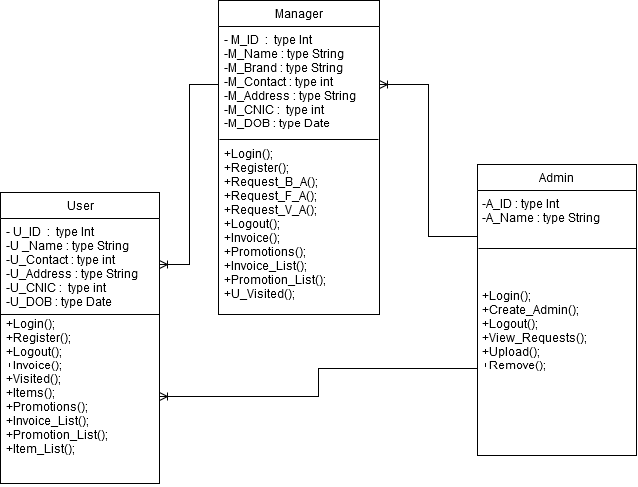
Figure 3.5 Class Diagram

Activity Diagram
User
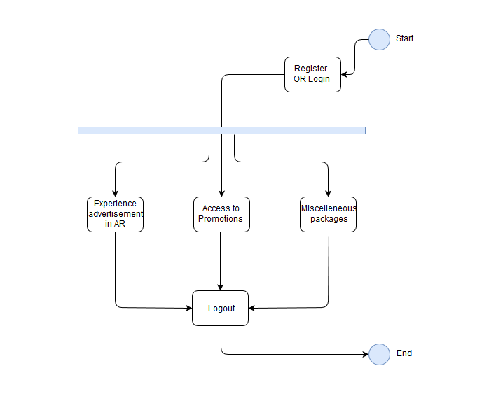
Figure 3.6 User's Activity Diagram

Brand Manager/Admin
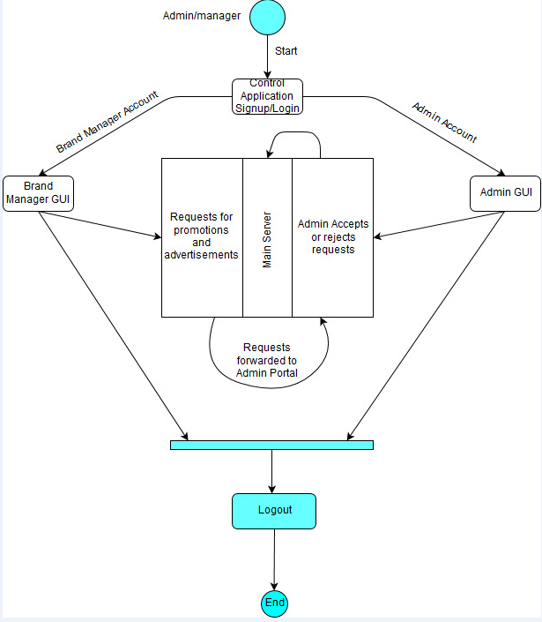
Figure 3.7 Manager/Admin Activity Diagram

Methodology
The development methodology used was scrum as it suited the project requirements that were based on tight schedule, any adjustments should have been made without messing up previous progress. Scrum development model helped me in testing the product on each level of development while providing me room for rapid changes on the go. Since the deliverables were supposed to be delivered on time, rapid testing helped me quickly identifying bugs or problems in the product. Furthermore this model helped sustaining transparency in process management.
Scrum sprints were made and being the sole member of my team, I was scrum master and scrum, In collaboration with project supervisor, sprints were designed and reviewed while managing backlogs.

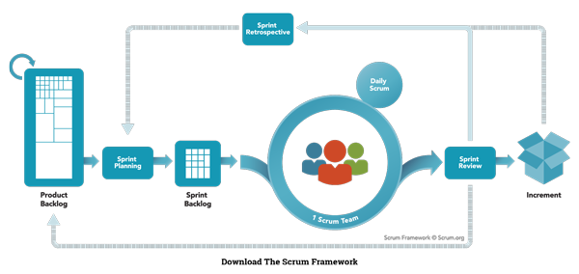
Figure 3.8 Scrum Framework [3]

IMPLMENTATION

Base

The most important factor of the product was the Augmented Reality module on which all the working of application was dependant on, this module was designed and developed first-hand so that all other dependencies can be built around it, this module included integrating vuforia engine with unity and adding coded co-routines to view advertisement.

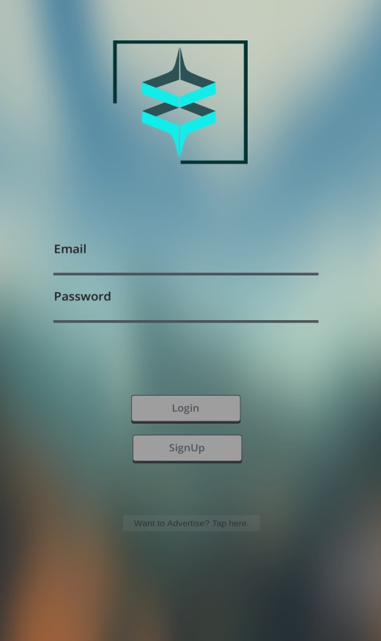
Figure 4.1 Main Screen

Account management

Second phase included creating user and manager account systems, integrating those accounts with unity application was the core requirement of this phase. This phase was mainly focused on preserving data that is user perspective which in future may provide us opportunities to apply data mining concepts upon.

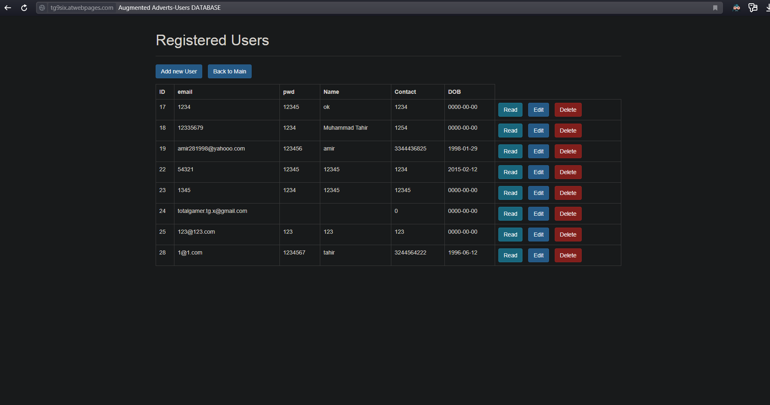
Figure 4.2 Management Portal

Relation between Phase 1 and Phase 2

The final stage was to connect database with main AR screen to generate co-routines for certain functions to perform which included the data that would enable us to find out the user who viewed ad by a certain company or which ads were most viewed etc.


Figure 4.3 Plain camera perspective

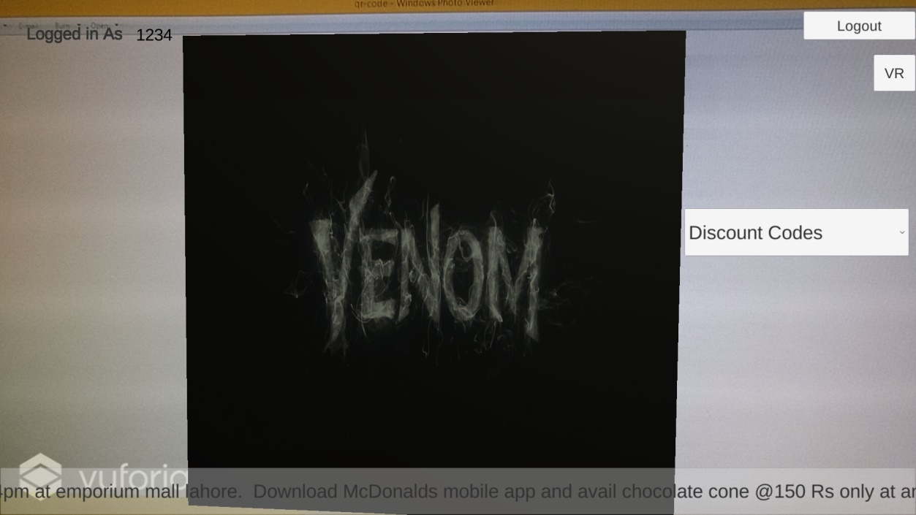
Figure 4.4 Application Screen, user perspective

Admin Portal

The last feature was to add an admin portal web page for admin to perform CRUD operations to all available data as well as generate reports that can highlight the top performers.


Figure 4.5 Admin Portal Webpage

RESULTS AND DISCUSSIONS

Completion

On completion all the modules were tested and results were quite convincing, the dynamic flow of advertisement posting and retrieving from database was smooth and provided an insight about how in future this project has so many extendable features.

Improvements

This project can be further modified to work with all major AR devices which will soon become a common feature, huge data mining and warehousing techniques can be applied to derive data critical for business owners which was not possible using current advertisement method, being a bachelor level project, this project has clearly positive results and can be fully modified to add more core features which would not be a problem in near future.

CONCLUSION AND RECOMMENDATIONS

Conclusion

The finished project has the full potential to start giving current advertisement methods a good competition, since there are several areas where room for improvement will always exist, this project can alone start to set trends in current advertisement market.

Recommendations

Since AR is still being perfected in so many ways, this project must be updated whenever a new technology or method is introduced. These small patches or updates will ensure the product’s flexibility and competitiveness in market. Moreover, the project must be perfected over time while gathering data regarding its performance in real-time environment.

Future enhancements

Since advertising digitally provides more data than current trends, there are a lot of researches and data mining techniques that can be applied to extract valuable data and trends.
Introduction of AR in other daily tasks will further excel these researches and in a near future this could become the next best thing.

REFERENCES

- R. Silva, J. Oliveira C., and G. Giraldi A., “Introduction to Augmented Reality”, Last accessed: 2019.
- Schmalstieg, D. and Hollererv, T. (2016). Augmented Reality: Principles and Practice. 1st ed. Addison-Wesley Professional., p. 32.
[3]. https://www.scrum.org/resources/whunityat-is-scrum

