
BSCS-S19-005
03-134161-032 | ZARNAB IMRAN
03-134161-025 | MUHAMMAD ZUBAIR

Cancer Diagnosis Using Image Processing And AI Based Techniques

In partial fulfilment of the requirements for the degree of
Bachelor of Science in Computer Science
Supervisor: Dr. Iram Noreen

Department of Computer Sciences
Bahria University, Lahore Campus
January 2020

© Bahria University, 2020

Certificate

We accept the work contained in the report titled
“CANCER DIAGNOSIS USING IMAGE PROCESSING AND AI BASED TECHNIQUES”
written by
ZARNAB IMRAN
MUHAMMAD ZUBAIR
as a confirmation to the required standard for the partial fulfilment of the degree of
Bachelor of Science in Computer Science.

Approved by:
Supervisor: Dr. Iram Noreen
(Signature)

January 27, 2020

DECLARATION

We hereby declare that this project report is based on our original work except for citations and quotations which have been duly acknowledged. We also declare that it has not been previously and concurrently submitted for any other degree or award at Bahria University or other institutions.

Enrolment | Name | Signature
03-134161-032 | ZARNAB IMRAN
03-134161-025 | MUHAMMAD ZUBAIR

Date : January 27, 2020

Specially dedicated to
My beloved mother and father
(Zarnab Imran)
My beloved mother and father
(Muhammad Zubair)

ACKNOWLEDGEMENTS

We would like to thank everyone who contributed in the successful completion of this project. We would like to express our gratitude to our supervisor, Dr. Iram Noreen for her invaluable advice, guidance and patience throughout the development of the project.

In addition, we would also like to express our gratitude to our loving parents and friends who for their support and encouragement.

ZARNAB IMRAN
MUHAMMAD ZUBAIR

CANCER DIAGNOSIS USING IMAGE PROCESSING AND AI BASED TECHNIQUES

ABSTRACT

A brain tumor is a growth of abnormal cells in the tissues of the brain. It affects large number of people of different age worldwide. Early detection of the brain tumor is possible with the advancement of machine learning (ML) and image processing. Magnetic Resonance Imaging (MRI) is the most effective and extensively used technique for brain tumor detection as it provides greater contrast images of the brain. However, complexity level of the problem, manual classification process, requirement of skilled medical practitioners and huge amount of MRI scan data are major factors thwarting timely classification of tumor vs. non-tumor. Hence automatic classification schemes such as Neural Networks (NN) are highly effective for the process of classification. The purpose of this project is the development of software to detect brain tumor using machine learning and image processing based techniques.

TABLE OF CONTENTS

DECLARATION ii
ACKNOWLEDGEMENTS iv
ABSTRACT v
TABLE OF CONTENTS vi
LIST OF TABLES viii
LIST OF FIGURES ix
LIST OF SYMBOLS / ABBREVIATIONS x
LIST OF APPENDICES xi

CHAPTERS
1 INTRODUCTION 1
1.1 Background 1
1.2 Problem Statements 2
1.3 Aims and Objectives 2
1.4 Scope of Project 3
2 LITERATURE REVIEW 4
2.1 Related Work 4
2.2 Research and Development Gap 8
3 DESIGN AND METHODOLOGY 9
3.1 Methodology 9
3.2 Research Design (Quantitative/Qualitative Model) 11
3.3 Top Level Architecture 12
4 DATA AND EXPERIMENTS (and/or IMPLMENTATION) 13
5 RESULTS AND DISCUSSIONS 14
5.1 Training Results 14
5.1.1 5 Fold Training Results 14
5.1.2 Confusion Matrix 15
5.1.3 ROC Curve 17
5.2 Application Results 18
6 CONCLUSION AND RECOMMENDATIONS 20
REFERENCES 21
APPENDICES 25

LIST OF TABLES

TABLE TITLE PAGE
Table 2.1: Summary of related work 7
Table 3.1: Qualitative Vs Quantitative model [22] 11
Table 5.1: Evaluation Measurements of Confusion Matrix 16

LIST OF FIGURES

FIGURE TITLE PAGE
Figure 1.1 : MRI of Brain[2] 2
Figure 3.1: Feature Driven Development (FDD)[20] 9
Figure 3.2: Top Level Architecture of Proposed System 12
Figure 5.1: 5 Fold Training Results 14
Figure 5.2: Confusion Matrix of Trained Model 15
Figure 5.3: ROC Curve[29] 17
Figure 5.4: Login Screen 18
Figure 5.5: Initial Home Screen 19
Figure 5.6: Home Screen After Diagnosis 19

LIST OF SYMBOLS / ABBREVIATIONS

MRI | Magnetic Resonance Imaging
FIS | Fuzzy Inference System
FCM | Fuzzy C-Means
KNN | K Nearest Neighbour
CNN | Convolution Neural Network
MRF | Margo Random Field
LIPC | Local Independent Projection-based Classification
FFT | Fast Fourier transform
MRMR | Minimal-Redundancy-Maximal-Relevance
RBF | Radial Basis Function
SVM | Support Vector Machine
GMM | Gaussian Mixture Model
PCA | Principal Component Analysis
NN | Neural Networks

LIST OF APPENDICES

APPENDIX TITLE PAGE
APPENDIX A: Fold Training details 26

INTRODUCTION

Background

A brain tumor is a collection or mass of abnormal cells in the brain. The skull, which encloses the brain, is very rigid. Any growth inside such a restricted space can cause problems. Brain tumor can be cancerous (malignant) or non-cancerous (benign). When benign or malignant tumors grow, it increases pressure inside the skull. This leads to brain damage and it can be life threatening.

Nowadays the prevalence of brain tumor is increasing rapidly. Pakistan is the 7th populous country with estimated over 148,000 cases being diagnosed with cancerous tumor annually. Over 100,000 cancer-related deaths and a prevalence of 350,000 living cancer patients have been reported during the past 5 years [1]. First major challenge is the diagnosis of brain tumor due to diverse shape, size, location and appearance of tumor in brain. Second major challenge is the accurate measurement of tumor. But once the brain tumor is identified at the very beginning, the proper treatments can be done and it may be curable. At present, visual representation of the interior of the body is processed using medical imaging technique for clinical analysis and medical researches [2]. Magnetic Resonance Imaging (MRI) is most effective and extensively used technique for brain tumor detection as it provides greater contrast images of the brain and cancerous tissues compared with the other medical imaging techniques [2].

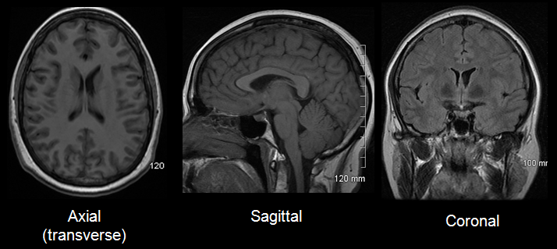
Figure 1.1: MRI of Brain[2]

Problem Statements

Current Cancer diagnosis techniques are performed using the conventional methods based on human experience and this increases the possibility of false detection when identifying brain tumors. Present tools and methods to analyse tumors and their behaviour have become more prevalent. Image processing and machine learning based techniques can be used to name brain tumors. Image processing is a method to convert an image into digital form & perform some operation on it, in order to get an enhanced image or to extract some useful information from it [2].

Aims and Objectives

The objectives of the project are shown as following:
- To facilitate doctors to diagnose cancer using image processing and machine learning based software.
- To save doctor’s time for identification of the brain tumor in contrast to manual process.
- To eliminate any possibility of false detection when identifying brain tumors.

Scope of Project
Cancer diagnostic model is a desktop application that will use following image processing and machine learning based techniques to detect brain tumor and further characterize what type of tumor it is either cancerous or non-cancerous.
- Pre-processing(if necessary)
- Feature Extraction and Selection using CNN
- Classification

LITERATURE REVIEW

Related Work
Many methods and algorithms have been proposed by multiple researchers for detecting the brain tumor and other abnormalities in human brain using MRI images. In [3], they proposed the approach of using segmentation, histogram and thresholding for the detection of tumor in brain.
In [4], which is titled as “Brain Tumor Extraction from MRI Images Using MATLAB”, the Meyer’s flooding Watershed algorithm was used for segmentation and also presents the morphological operation.
In [5], the algorithm which incorporates segmentation through Nero Fuzzy Classifier was presented. Neural network is used to train the system but that could be a problem because the system requires many input images to train the network. The proposed system can only be used to detect tumor not for any other abnormalities.
In [6], which is titled as “Segmented morphological approach to detect tumor in brain images”, an algorithm is presented for segmented morphological approach which is a novel technique for detecting brain tumor.
In [7], brain tumor segmentation and classification method is performed by using fuzzy logic based control theory. The Fuzzy Inference System (FIS) which is a fuzzy based technique was proposed in this paper for brain segmentation. Membership function of fuzzy controller were created using supervised classification. The performance of the proposed system is high but the accuracy is low.
In [8], contrast of the image was improved by using the adaptive histogram equalization. Then tumor was separated from the whole brain image using the Fuzzy C-Means (FCM) based segmentation. After that the abnormal cells of brain were filtered by extracting the Gabor feature. Lastly, Abnormalities in the brain MRI image were found by applying the fuzzy logic with K Nearest Neighbor (KNN) classification. The complexity of this system is high but the accuracy is low. In this paper, they proposed a new novel technique which is automatic classification of brain tumor using Convolution Neural Network (CNN).
In [9], a new technique for brain tumor segmentation called “multimodal brain tumor segmentation scheme” was introduced in this paper. They also proposed a way of achieve high performance than the existing method by combining different segmentation algorithms. But the complexity of this system is high.
In [10], a brain tumor segmentation survey was presented. Various segmentation methods were briefly discussed such as Fuzzy C Means segmentation, geometric deformable model, Margo Random Field (MRF), threshold based segmentation, deformable model, Region based segmentation and Atlas based segmentation. The robustness, accuracy and validity of these methods were also analyzed.
In [11], voxel of the brain was classified using the local independent projection-based classification (LIPC) method. Path feature was also extracted in this method. So, there’s no need to use explicit regularization in LIPC. The accuracy of the proposed method is low.
In [12], a novel modeling technique is presented for analyzing the step by step growth of tumor in patients. This technique is a bio-physiomechanical tumor growth modeling which will be applied to seizure the significant tumor mass effect of gliomas and solid tumor with individual margins. Tumor growth modeling was created by combining the discrete and continuous methods. The proposed approach provides the method of using the atlas-based registration to tacitly segment tumor-bearing images. Brain tissue segmentation mostly uses this technique but the computation time of this technique is high.
In [13], Damodharan and Raghavan proposed a neural network based technique for detecting and classifying brain tumor. In the proposed approach, the quality rate of segmentation of GM, WM, CSF and tumor regions is produced separately and an accuracy of 83% is claimed using the neural network based classifier.
In [14], Alfonse and Salem proposed an approach of using SVM-based classifier for automatic classification of brain tumor from MRI images. Features were extracted using Fast Fourier transform (FFT) and features were then reduced using the Minimal-Redundancy-Maximal-Relevance (MRMR) technique to improve the accuracy of the classifier. An accuracy of 98.9% was obtained using this technique.
In [15], Kumar and Vijayakumar proposed an approach of using radial basis function (RBF) kernel based SVM and component analysis (PCA) for brain tumor segmentation and classification. Using this method, they claimed similarity index of 96.20%, overlap function of 95% and an extra fraction of 0.025%.
In [16], Chaddad has proposed a method of using Gaussian mixture model (GMM) using MRI images for automatic feature extraction for brain tumor detection. In this method, the performance of the GMM feature extraction is enhanced using the principal component analysis (PCA) and wavelet based features. The accuracy obtained using this method is 97.05% for the T1-weighted and T2-weighted and 94.11% for FLAIR-weighted MRI images.
In [17], Deepa and Arunadevi proposed a new method for classification of brain tumor from 3D MRI images using extreme learning machine. Using this method, An accuracy of 93.2%, sensitivity of 91.6% and specificity of 97.8% was obtained.
In [18], a new technique of ANN and then PCA-ANN is proposed for a multiclass brain tumor classification, segmentation, and feature extraction performed using a dataset of 428 MR images. Using this method, increment in classification accuracy from 77% to 91% was observed.
In [19], they proposed a new method based on Neural Network (NN) and k- Nearest Neighbor (k-NN) algorithms for brain tumor classification of MRI images. An accuracy of 100% was achieved using k-NN and 98.92% accuracy was achieved using NN.
Summary of related work
S.no | Author | Technique | Purpose | Limitations
1 | Manoj et al. 2012,[3] | Segmentation, histogram and thresholding | Detection of tumor in brain | Lack the sensitivity and specificity
2 | Rajesh C. et al. [4] | Meyer’s flooding Watershed algorithm | Segmentation and also presents the morphological operation. | Highly sensitive to local minima
3 | M.Karuna et al. 2013,[5] | Nero Fuzzy Classifier | Detection of tumor in brain | Non-effective with complex data
4 | Vinay et al. 2014,[6] | Segmented morphological approach | Detection of tumor in brain | Generally computationally complex.
5 | R. Karuppathal et al. 2014,[7] | Fuzzy Inference System | Brain tumor segmentation and classification | The curse of dimensionality
6 | Janani et al. 2013,[8] | K Nearest Neighbor (KNN) | Detection of tumor in brain | Lazy learner
7 | Bjoern H. Menze et al. 2014, [9] | Multimodal brain tumor segmentation scheme | Brain tumor segmentation | Restricted to image format used for the training data
8 | Jin Liu et al. 2011, [10] | Fuzzy C means, MRF threshold based segmentation, deformable model, Region and Atlas based segmentation | Robustness, accuracy and validity | Complex , slow and a very long process
9 | Meiyan Huang et al. 2013, [11] | Local independent projection-based classification (LIPC) method | Classification of voxel of the brain, path feature extraction | Local independent projection based classification
10 | Stefan Bauer et al. 2012, [12] | Bio-physiomechanical tumor growth modeling | Tacitly segment tumor-bearing images | Long and complex model raises chances of error
11 | Damodharan et al.2015,[13] | Segmentation of GM, WM, CSF and tumor regions | Detecting and classifying brain tumor | Restricted to image format used for the training data
12 | Alfonse M. et al. 2016, [14] | SVM-based classifier | Automatic classification of brain tumor | Not suitable for large data sets
13 | Kumar P. et al. 2015, [15] | Radial basis function (RBF) kernel based SVM and component analysis (PCA) | Brain tumor segmentation and classification | Not suitable when data set has more noise and large data sets
14 | Chaddad A. 2015, [16] | Gaussian mixture model (GMM) | Automatic feature extraction for brain tumor detection | Uncertainty measure or probability in data point association
15 | Deepa S. N. et al. 2013, [17] | Extreme learning machine | Classification of brain tumor from 3D MRI images | Randomness of ELM causes an additional uncertainty problem
16 | Sachdeva J. et al. 2013, [18] | ANN and then PCA-ANN | Multiclass brain tumor classification, segmentation, and feature extraction | Hardware dependence, Unexplained behavior of the network
17 | Amer et al. 2012,[19] | Neural Network (NN) and k- Nearest Neighbor (k-NN) | Brain tumor classification | Difficulty of showing the problem to the network
Table 2.1: Summary of related work

Research and Development Gap
Research:
Many researches have proposed many algorithms and segmentation techniques to find abnormalities in the brain using MRI images. Most of them proposed various algorithms to find the abnormality in the brain like brain tumor. Some focused on the pre-processing and segmentation of the brain tumor while others proposed many algorithms for classification of the brain tumor. Although, some of these techniques proved to be highly accurate while most of them had low accuracy. Techniques that obtained the most accuracy are SVM-based classifier, Neural Network (NN) and k- Nearest Neighbor (k-NN) algorithms, a new technique of ANN and then PCA-ANN, Convolution Neural Network (CNN).

Development:
CaPTk is a software platform for analysis of radiographic cancer images, currently focusing on brain, breast, and lung cancer. CaPTk integrates advanced, validated tools performing various aspects of medical image analysis, that have been developed in the context of active clinical research studies and collaborations toward addressing real clinical needs.

CaPTK is a very large scale platform which requires heavy processing power and a team of professionals to produce accurate results. It mainly focuses on image enhancement and segmentation. Classification process doesn’t exist. It only gives enhanced image of brain tumor.

DESIGN AND METHODOLOGY

Methodology
This project will be developed by using agile methodology because agile models handle change in requirements easily, divide complex projects into parts (iterations) which simplifies the project and deliver working software after every iteration. In agile, there are many models but here Feature Driven Development (FDD) will be used as it is one of the simplest and easy to follow agile methodology. FDD develop project in features and divide complex features into sub parts. This model repeats last two phases i.e. Design by feature and develop by feature until all features will complete.
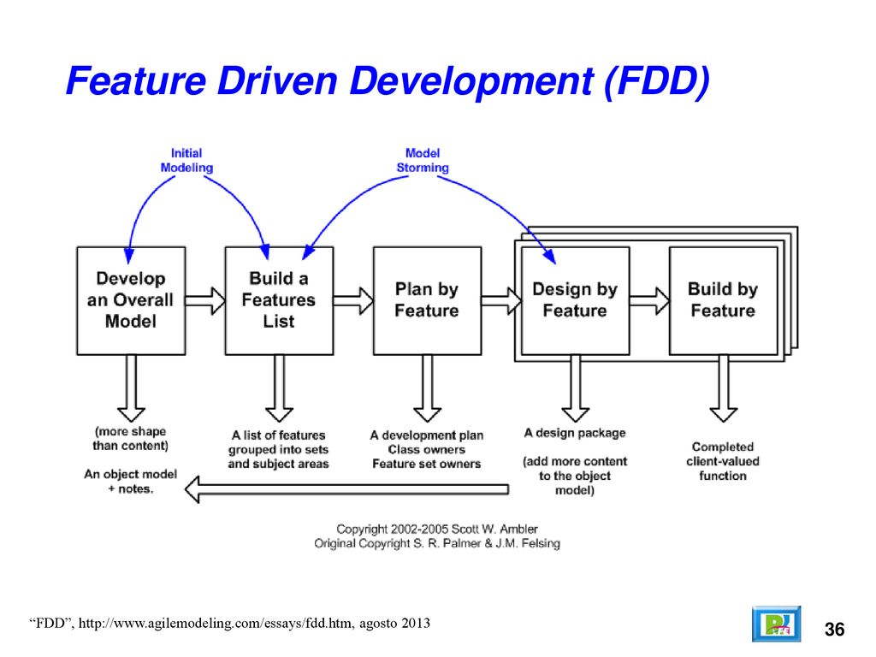
Figure 3.1: Feature Driven Development (FDD)[20]

Following are the FDD phases that will be followed in this project.
Model overall system
In this first step, define scope of project and develop top level architecture of the system by analyzing different research papers.
Build Feature List
After defining the scope, list down the all essential features of the system by functionally decomposing the domain into subject areas.
Plan by Feature
After the feature list is completed, the next step is to produce the development plan that divide features into sub-features and make groups of related features. Planning involves how each feature interacts with other one and what are the users of features or group of features (Distinguish the rights of different users).
Design by Feature
In this phase, follow the following steps.
- Create use case/UML diagrams for each feature
- Activity diagrams for each feature
- Design the user interface(s) for each feature
Develop by Feature
Following steps use for each feature development
- Apply Image Processing algorithms
- Feature Extraction and Feature Selection using CNN
- Training & Classification using CNN
- Testing
- Develop the MATLAB GUI

Research Design (Quantitative/Qualitative Model)

Research is the most widely used tool to increase and brush-up the stock of knowledge about something and someone. In the Medical researches especially cancer diagnostic models there are two standard ways of conducting research, i.e., qualitative research or quantitative research [21]. While the qualitative research relies on verbal narrative like spoken or written data, the quantitative research uses logical or statistical observations to draw conclusions.
In our model, 20 percent qualitative and 80 percent quantitative method will be used. 20 percent for the descriptive form or collection of data and 80 percent for the result mean median mode etc.

Qualitative Model | Quantitative Model
Methods include focus groups, in-depth interviews, and reviews of documents for types of themes
  Surveys, structured interviews & observations, and reviews of records or documents for numeric information
Primarily inductive process used to formulate theory or hypotheses | Primarily deductive process used to test pre-specified concepts, constructs, and hypotheses that make up a theory
More subjective: describes a problem or condition from the point of view of those experiencing it | More objective: provides observed effects (interpreted by researchers) of a program on a problem or condition
Text-based | Number-based
No statistical tests | Statistical tests are used for analysis
Time expenditure lighter on the planning end and heavier during the analysis phase | Time expenditure heavier on the planning phase and lighter on the analysis phase
Less generalizable | More generalizable
Table 3.1: Qualitative Vs Quantitative model [22]
Research in psycho-oncology investigates the psycho-social and emotional aspects of cancer and how this is related to health, well-being and overall patient care. Coping with cancer is a prime focus for researchers owing to its impact on patients' psychological processing and life in general. Research so far has focused mainly on quantitative study designs such as questionnaires to examine the coping strategies used by cancer patients. However, in order to gain a rich and deep understanding of the reasons, processes and types of strategies that patients use to deal with cancer, qualitative study designs are necessary. Few studies have used qualitative designs such as semi-structured interviews to explore coping with cancer. The current paper aims to review the suitability and benefits of using qualitative research designs to understand coping with cancer with the help of some key literature in psycho-oncology research [23].

Top Level Architecture
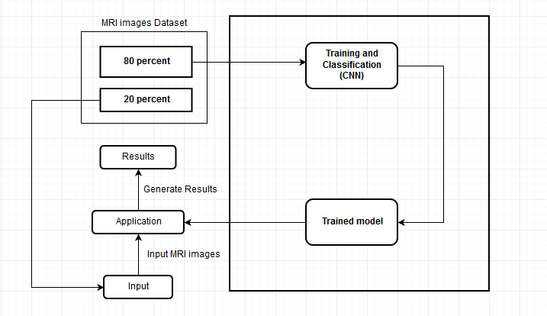
K-fold cross validation
Figure 3.2: Top Level Architecture of Proposed System

DATA AND EXPERIMENTS (and/or IMPLMENTATION)
Following datasets is used for the project.
- Calgary Campinas: An open, multi-vendor, multi-field-strength brain MR dataset [24]
- Figshare: This brain tumor dataset contains 3064 T1-weighted contrast-enhanced images with three kinds of brain tumor [25]
- Shaukat Khanum Research Centre: We had meetings with the officials of this Research Centre. They have agreed to provide support for datasets[26]
- Keras Dataset for vgg-19 Pre-trained model[27]

The final model was trained on “Keras Dataset for vgg-19 Pre-trained model”, which was obtained from kaggle. The dataset contained 3064 brain mri images of 3 different type of tumors, which are: glioma, meningioma, pituitary. The dataset was divided into 5 sets, each set having same amount of images. Four sets were used for training the model and one set was used for testing purposes. 80 percent of the dataset was used for training and the remaining 20% was used for testing the trained model.

RESULTS AND DISCUSSIONS

Training Results
Following are the results of VGG19 [28] neural network using k-fold technique.

5 Fold Training Results
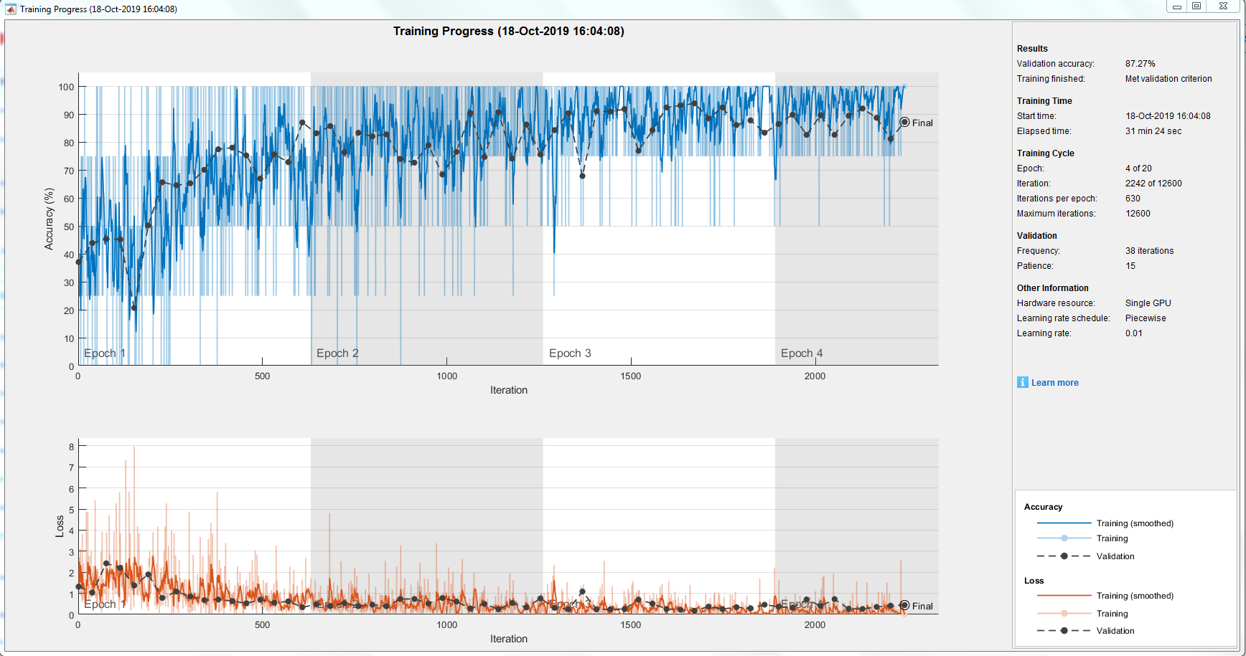
Figure 5.1: 5 Fold Training Results
Several performance measures are deﬁned for the standard evaluation of a classiﬁer. Classiﬁcation accuracy is the most extensively used quality index. Accuracy, in classiﬁcation, is deﬁned as the ratio of the number of correctly classiﬁed samples to the total number of data samples. The classiﬁcation accuracies obtained in our training folds are the following.
- The classification accuracy of 1st Fold is 45.20 %.
- The classification accuracy of 2nd Fold is 88.56 %.
- The classification accuracy of 3rd Fold is 87.08 %.
- The classification accuracy of 4th Fold is 45.20 %.
- The classification accuracy of 5th Fold is 87.27 %.

Confusion Matrix
Confusion matrix describes the performance of a classification model on a set of test data for which the true values are known. It allows the visualization of the performance of an algorithm. The confusion matrix is a three by three table that contains nine outcomes produced by a multiclass classifier.

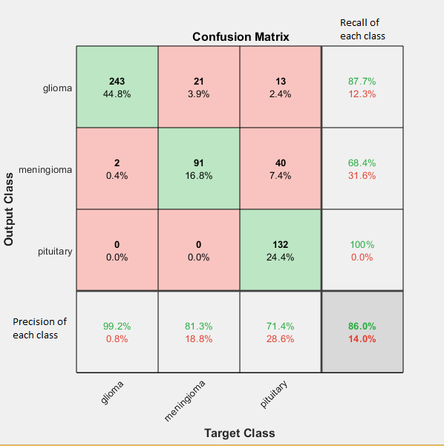
Figure 5.2: Confusion Matrix of Trained Model
True Positive:
A true positive test result is one that detects the condition when the condition is present.
False Positive:
A test result which wrongly indicates that a particular condition or attribute is present.
True Negative:
A true negative is an outcome where the model correctly predicts the negative class.
False Negative:
A false negative is a test result that indicates a person does not have a disease or condition when the person actually does have it.
Accuracy:
Classification accuracy is defined as the number of correctly classified patterns to the total number of patterns.
(TP+TN)/(P+N)
Precision:
Precision is the fraction of relevant instances among the retrieved instances.
TP/ (TP+FP)
Recall:
Recall is the fraction of the total amount of relevant instances that were actually retrieved.
TP/P
F-Score:
It is the harmonic mean(average) of the precision and recall.
2*(Recall * Precision) / (Recall + Precision)
Evaluation Measurements of Confusion Matrix
Accuracy | 0.876
Precision | 0.887
Recall | 0.8757
F-Score | 0.881
Table 5.1: Evaluation Measurements of Confusion Matrix

Confusion matrix describes the performance of a classification model on a set of test data for which the true values are known .Various measures such as accuracy, recall and precision are derived from the confusion matrix. These values help evaluate the model.

ROC Curve
A useful tool when predicting the probability of a binary outcome is the Receiver Operating Characteristic curve, or ROC curve.
It is a plot of the false positive rate (x-axis) versus the true positive rate (y-axis) for a number of different candidate threshold values between 0.0 and 1.0. Put another way, it plots the false alarm rate versus the hit rate.
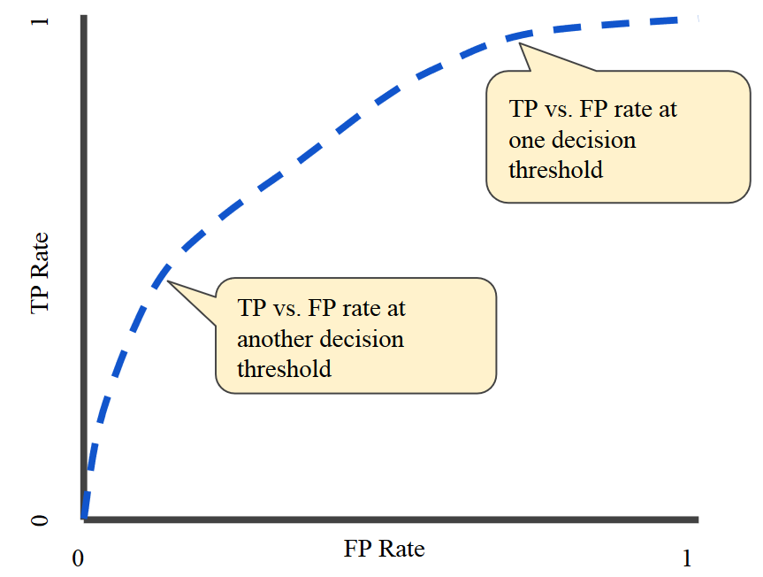
Figure 5.3: ROC Curve[29]

Matlab provides a function “perfcurve” which takes parameters and generates an ROC curve but since ROC is only applicable on binary classifier it doesn’t apply on our model [29].

Application Results
A GUI interface was built using Matlab version R2018a. Matlab provides a feature of Matlab App Designer which was used create a GUI interface. Trained model was integrated with GUI interface. This application provides users an easy and effective way to upload and classify MRI images using the trained model.

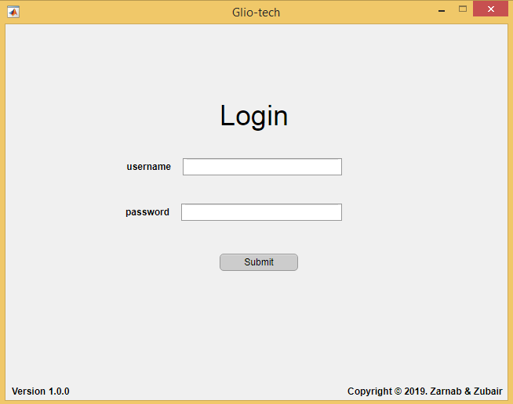
Figure 5.4: Login Screen

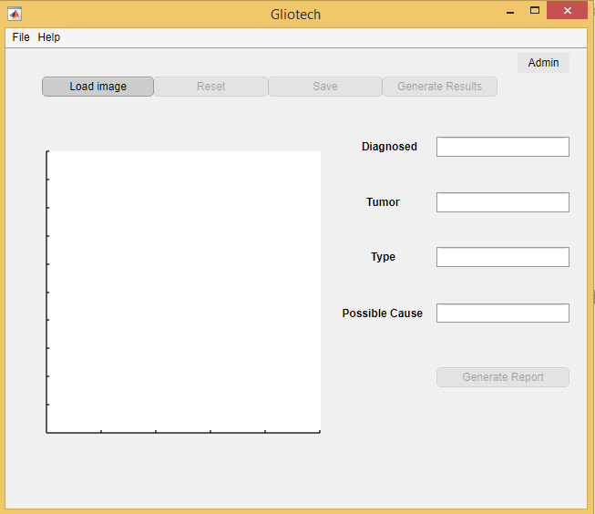
Figure 5.5: Initial Home Screen

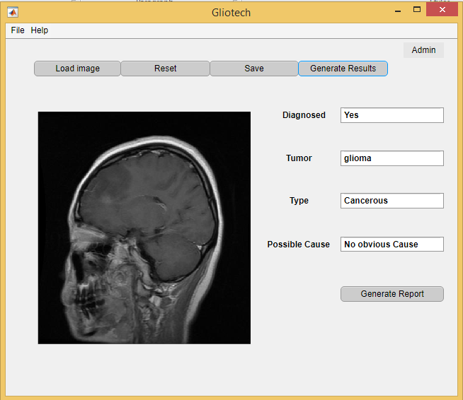
Figure 5.6: Home Screen After Diagnosis

CONCLUSION AND RECOMMENDATIONS

This project have demonstrated 88.5% accuracy that is appropriate as per project’s objectives. Model was trained using the k-fold technique, training contained total 5 folds and with each fold accuracy of the model increased up to 5th fold. After the 5th fold, accuracy started decreasing because our dataset was not sufficient enough for more than 5 fold. So the model trained till 5th fold with 88.5% accuracy was selected for final results.
Trained model was integrated in application to be used by medical practitioner. Matlab App Designer was used to create a GUI interface and model was integrated with it.
Accuracy and effectiveness could be improved by enhancing data set and after Training vgg19 pre-trained neural network with a bigger data set using the fold techniques than the accuracy of the model would be even higher.
Another feature could be added that tumor part of the image can be highlighted after the image has been diagnosed with tumor.
Trained model only classify three types of tumor, model can be further trained to classify other types of brain tumors.

REFERENCES

Electronic Sources from Internet:
[1] The Nation, “Over 148,000 Pakistanis diagnosed with cancer annually”, 2018. Retrieved from: https://nation.com.pk

Technical Reports and Thesis:
[2] Gamage P.T, “Identification of Brain Tumor using Image Processing”, Faculty of Information Technology, University of Moratuwa, 2017.

Journal Papers:
[3] Manoj K Kowear and Sourabh Yadev, “Brain tumor detection and segmentation using histogram thresholding”, International Journal of engineering and Advanced Technology, April 2012.
[4] Rajesh C. patil, A.S. Bhalchandra, “Brain tumor extraction from MRI images Using MAT Lab”, IJECSCSE, ISSN: 2277-9477, Volume 2, issue1
[5] M.Karuna, Ankita Joshi, “Automatic detection and severity analysis of brain tumors using gui in matlab” IJRET: International Journal of Research in Engineering and Technology, ISSN: 2319-1163, Volume: 02 Issue: 10, Oct-2013.
[6] Vinay Parmeshwarappa, Nandish S, “A segmented morphological approach to detect tumor in brain images”, IJARCSSE, ISSN: 2277 128X , volume 4, issue 1, January 2014
[7] R. Karuppathal and V. Palanisamy, “Fuzzy based automatic detection and classification approach for MRI-brain tumor”, ARPN Journal of Engineering and Applied Sciences, 9(12): (2014).
[8] Janani and P. Meena, “image segmentation for tumor detection using fuzzy inference system”, International Journal of Computer Science and Mobile Computing, 2(5): 244 – 248 (2013)
[9] Bjoern H. Menze et al, “The Multimodal Brain Tumor Image Segmentation Benchmark (BRATS)”, IEEE Transactions on Medical Imaging, (2014).
[10] Jin Liu et al, “A Survey of MRI-Based Brain Tumor Segmentation Methods”, TSINGHUA Science and Technology, 19(6) (2011).
[11] Meiyan Huang et al, “Brain Tumor Segmentation Based on Local Independent Projectionbased Classification”, IEEE Transactions on Biomedical Engineering, IEEE, (2013).
[12] Stefan Bauer et al, “Multiscale Modeling for Image Analysis of Brain Tumor Studies”, IEEE Transactions on Biomedical Engineering, 59(1): (2012).
[13] Damodharan S., Raghavan D. Combining tissue segmentation and neural network for brain tumor detection. International Arab Journal of Information Technology. 2015;12(1):42–52.
[14] Alfonse M., Salem A.-B. M. An automatic classification of brain tumors through MRI using support vector machine. Egyptian Computer Science Journal. 2016;40:11–21.

[15] Kumar P., Vijayakumar B. Brain tumour Mr image segmentation and classification using by PCA and RBF kernel based support vector machine. Middle-East Journal of Scientific Research. 2015;23(9):2106–2116.
[16] Chaddad A. Automated feature extraction in brain tumor by magnetic resonance imaging using gaussian mixture models. International Journal of Biomedical Imaging. 2015;2015:11. doi: 10.1155/2015/868031.868031
[17] Deepa S. N., Arunadevi B. Extreme learning machine for classification of brain tumor in 3D MR images. Informatologia. 2013;46(2):111–121.
[18] Sachdeva J., Kumar V., Gupta I., Khandelwal N., Ahuja C. K. Segmentation, feature extraction, and multiclass brain tumor classification. Journal of Digital Imaging. 2013;26(6):1141–1150. doi: 10.1007/s10278-013-9600-0.
[19] Amer Al-Badarnech, Hassan Najadat, Ali M. Alraziqi, “A Classifier to Detect Tumor Disease in MRI Brain Images”, IEEE Computer Society, ASONAM. 2012,142
[20] Mekni, Mehdi & Buddhavarapu, Gayathri & Chinthapatla, Sandeep & Gangula, Mounika. (2018). Software Architectural Design in Agile Environments. Journal of Computer and Communications. 06. 171-189. 10.4236/jcc.2018.61018.
[21] Angela Tinkler, Julie Hotchkiss, E Andrea Nelson, Liz Edwards, “Identifying the best research design to fit the question”, Evidence-Based Nursing, January 1999, Vol 2 No 1
[22] Surbhi S., “Difference Between Qualitative and Quantitative Research”, April 2016, Retrived from: https://keydifferences.com/difference-between-qualitative-and-quantitative-research.html
[23] Chittem M. ,”Understanding coping with cancer: How can qualitative research help?”,J Can Res Ther 2014;10:6-10
[24] Calgary Campinas Public Dataset, “Calgary Campinas: An open, multi-vendor, multi-field-strength brain MR dataset”, 2019. Retrieved from: https://sites.google.com/view/calgary-campinas-dataset/home
[25] Brain Tumor Dataset, “Figshare: T1-weighted contrast-enhanced images dataset”, 2017. Retrieved from: https://figshare.com/articles/brain_tumor_dataset/1512427/5
[26] Dr. Imran Khalid Niazi, Head of Radiology Department, Shaukat Khanum Memorial Cancer Hospital and Research Centre, 2019.
[27] Kaggle, “Keras Dataset for vgg-19 Pre-trained model”, 2018. Retrieved from: https://www.kaggle.com/keras/vgg19
[28] Matlab documentation, “vgg19”, 2019. Retrieved from: https://www.mathworks.com/
[29] Wikipedia, “Receiver operating characteristic”, 2019. Retrieved from: https://en.wikipedia.org/wiki/Receiver_operating_characteristic

APPENDICES

APPENDIX A: Fold Training details

Training details:
Plots:
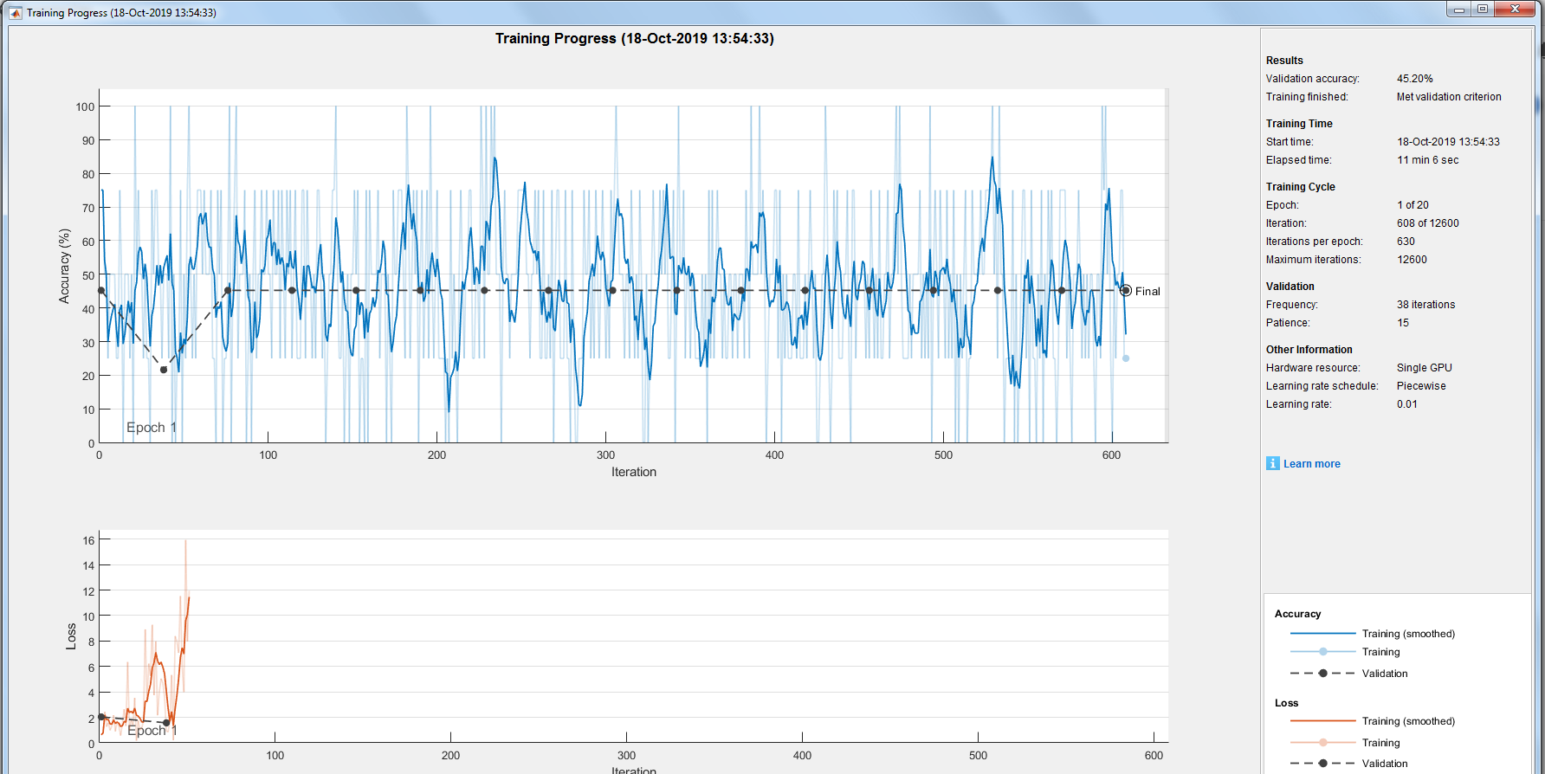

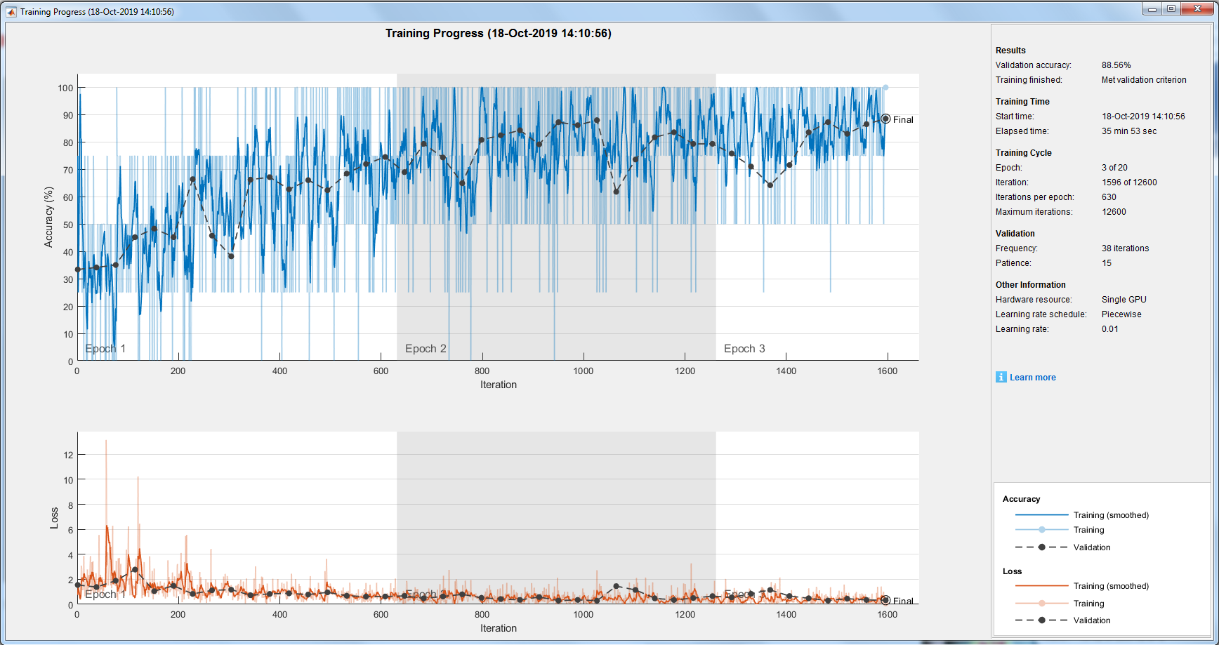

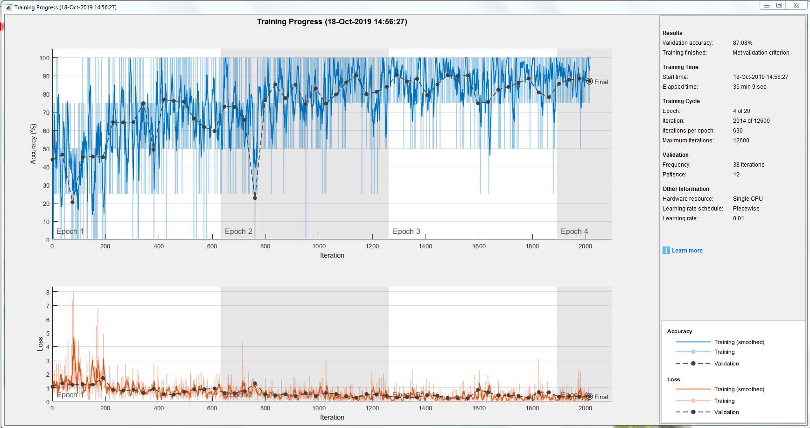

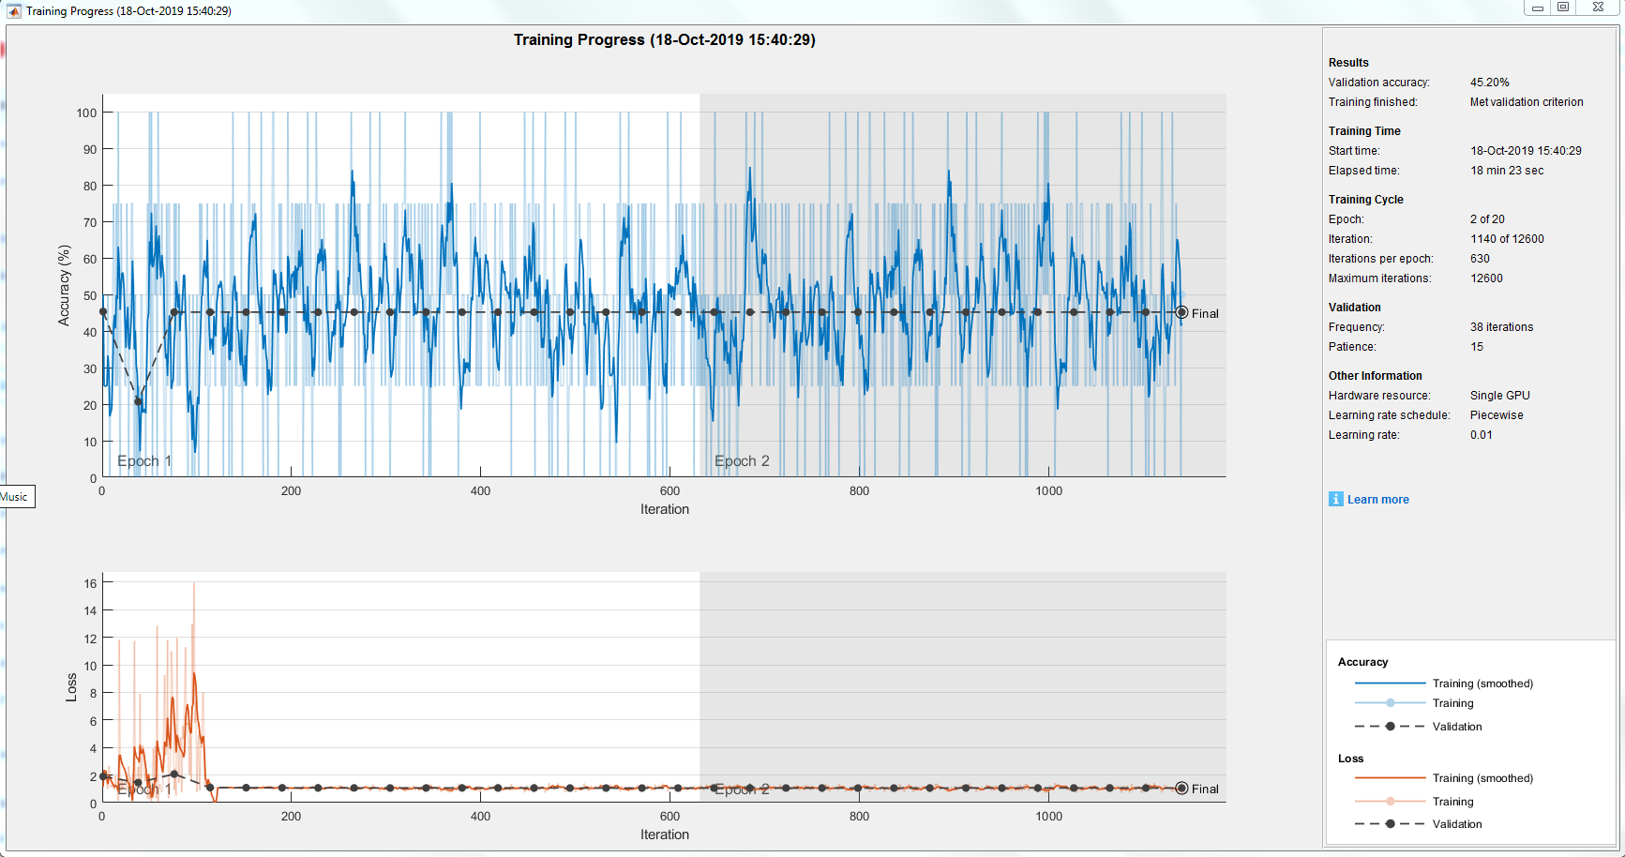

Details:
Epoch | Iteration | Time Elapsed | Mini-batch | Validation | Mini-batch | Validation | Base Learning
 |  | (hh:mm:ss) | Accuracy | Accuracy | Loss | Loss | Rate
1 | 1 | 00:00:01 | 75.00 | 45.20 | 0.6277 | 2.0352 | 0.0100
1 | 38 | 00:00:41 | 50.00 | 21.59 | 0.9297 | 1.5700 | 0.0100
1 | 76 | 00:01:32 | 50.00 | 45.20 | NaN | NaN | 0.0100
1 | 114 | 00:02:26 | 25.00 | 45.20 | NaN | NaN | 0.0100
1 | 152 | 00:03:17 | 50.00 | 45.20 | NaN | NaN | 0.0100
1 | 190 | 00:04:05 | 50.00 | 45.20 | NaN | NaN | 0.0100
1 | 228 | 00:04:47 | 25.00 | 45.20 | NaN | NaN | 0.0100
1 | 266 | 00:05:26 | 50.00 | 45.20 | NaN | NaN | 0.0100
1 | 304 | 00:06:06 | 60.00 | 45.20 | NaN | NaN | 0.0100
1 | 342 | 00:06:44 | 50.00 | 45.20 | NaN | NaN | 0.0100
1 | 380 | 00:07:22 | 50.00 | 45.20 | NaN | NaN | 0.0100
1 | 418 | 00:08:02 | 60.00 | 45.20 | NaN | NaN | 0.0100
1 | 456 | 00:08:37 | 25.00 | 45.20 | NaN | NaN | 0.0100
1 | 494 | 00:09:13 | 50.00 | 45.20 | NaN | NaN | 0.0100
1 | 532 | 00:09:54 | 250.00 | 45.20 | NaN | NaN | 0.0100
1 | 570 | 00:10:31 | 75.00 | 45.20 | NaN | NaN | 0.0100
1 | 608 | 00:11:03 | 25.00 | 45.20 | NaN | NaN | 0.0100

Epoch | Iteration | Time Elapsed | Mini-batch | Validation | Mini-batch | Validation | Base Learning
 |  | (hh:mm:ss) | Accuracy | Accuracy | Loss | Loss | Rate
1 | 1 | 00:00:01 | 75.00 | 33.39 | 0.7518 | 1.5437 | 0.0100
1 | 38 | 00:01:29 | 25.00 | 34.13 | 2.1014 | 1.3804 | 0.0100
1 | 76 | 00:02:17 | 25.00 | 35.06 | 1.4762 | 1.8867 | 0.0100
1 | 114 | 00:03:04 | 75.00 | 45.20 | 1.2251 | 2.7768 | 0.0100
1 | 152 | 00:03:51 | 0.00 | 48.34 | 2.8649 | 1.0511 | 0.0100
1 | 190 | 00:04:30 | 75.00 | 45.20 | 0.8698 | 0.4810 | 0.0100
1 | 228 | 00:06:59 | 25.00 | 66.42 | 1.6483 | 0.8330 | 0.0100
1 | 266 | 00:04:44 | 75.00 | 45.76 | 0.6391 | 1.1172 | 0.0100
1 | 304 | 00:08:33 | 25.00 | 38.19 | 1.5472 | 1.1690 | 0.0100
1 | 342 | 00:09:19 | 75.00 | 66.24 | 0.5250 | 0.7275 | 0.0100
1 | 380 | 00:10:01 | 75.00 | 67.16 | 0.4665 | 0.8315 | 0.0100
1 | 418 | 00:10:46 | 75.00 | 62.73 | 0.9732 | 0.8761 | 0.0100
1 | 456 | 00:11:38 | 75.00 | 66.05 | 0.5068 | 0.7777 | 0.0100
1 | 494 | 00:12:21 | 10.00 | 62.36 | 0.0978 | 0.9558 | 0.0100
1 | 532 | 00:13:03 | 50.00 | 68.45 | 1.0295 | 0.6833 | 0.0100
1 | 570 | 00:14:21 | 50.00 | 71.96 | 1.7051 | 0.6142 | 0.0100
1 | 608 | 00:15:33 | 75.00 | 74.54 | 0.2919 | 0.6254 | 0.0100
2 | 646 | 00:18:23 | 100.00 | 69.00 | 0.9739 | 0.6718 | 0.0100
2 | 684 | 00:19:09 | 100.00 | 79.34 | 0.8583 | 0.4752 | 0.0100
2 | 722 | 00:19:44 | 100.00 | 74.35 | 0.8388 | 0.6254 | 0.0100
2 | 760 | 00:20:25 | 100.00 | 64.94 | 0.2697 | 0.7961 | 0.0100
2 | 798 | 00:21:10 | 50.00 | 80.81 | 0.1686 | 0.5219 | 0.0100
2 | 836 | 00:21:10 | 75.00 | 82.47 | 0.2054 | 0.4184 | 0.0100
2 | 874 | 00:21:47 | 25.00 | 84.32 | 0.1317 | 0.3535 | 0.0100
2 | 912 | 00:22:21 | 100.00 | 79.15 | 0.4708 | 0.5795 | 0.0100
2 | 950 | 00:23:03 | 100.00 | 87.27 | 1.1116 | 0.3009 | 0.0100
2 | 988 | 00:23:47 | 100.00 | 86.16 | 0.4867 | 0.3505 | 0.0100
2 | 1026 | 00:24:29 | 100.00 | 88.01 | 2.7239 | 0.2922 | 0.0100
2 | 1064 | 00:25:13 | 50.00 | 61.81 | 0.0270 | 1.4512 | 0.0100
2 | 1102 | 00:25:54 | 100.00 | 73.62 | 0.0522 | 1.1500 | 0.0100
2 | 1140 | 00:26:37 | 75.00 | 81.73 | 0.2379 | 0.4840 | 0.0100
2 | 1178 | 00:27:59 | 100.00 | 83.58 | 0.2674 | 0.3422 | 0.0100
2 | 1216 | 00:28:43 | 100.00 | 79.34 | 1.0842 | 0.4991 | 0.0100
2 | 1254 | 00:29:45 | 75.00 | 79.34 | 0.0653 | 0.6538 | 0.0100
3 | 1292 | 00:31:11 | 100.00 | 75.83 | 0.6627 | 0.5520 | 0.0100
3 | 1330 | 00:31:51 | 100.00 | 71.03 | 0.0503 | 0.8401 | 0.0100
3 | 1368 | 00:32:33 | 100.00 | 64.21 | 0.0770 | 1.1497 | 0.0100
3 | 1406 | 00:33:17 | 100.00 | 71.59 | 0.3690 | 0.6578 | 0.0100
3 | 1444 | 00:33:59 | 75.00 | 64.2 | 1.2753 | 0.4807 | 0.0100
3 | 1482 | 00:34:35 | 100.00 | 71.59 | 0.1507 | 0.2996 | 0.0100
3 | 1520 | 00:35:14 | 100.00 | 83.58 | 0.0067 | 0.4497 | 0.0100
3 | 1552 | 00:35:14 | 100.00 | 86.53 | 0.0132 | 0.3469 | 0.0100
3 | 1596 | 00:35:53 | 100.00 | 88.56 | 0.0528 | 0.3253 | 0.0100

Epoch | Iteration | Time Elapsed | Mini-batch | Validation | Mini-batch | Validation | Base Learning
 |  | (hh:mm:ss) | Accuracy | Accuracy | Loss | Loss | Rate
1 | 1 | 0:00:05 | 50.00% | 43.91% | 1.1764 | 1.0692 | 0.01
1 | 38 | 0:00:40 | 75.00% | 46.68% | 0.6787 | 1.3232 | 0.01
1 | 76 | 0:01:21 | 0.00% | 20.48% | 7.3719 | 1.206 | 0.01
1 | 114 | 0:02:05 | 100.00% | 45.20% | 0.1913 | 1.2486 | 0.01
1 | 152 | 0:02:43 | 75.00% | 45.57% | 0.5489 | 1.2293 | 0.01
1 | 190 | 0:03:20 | 50.00% | 45.20% | 1.5684 | 1.7059 | 0.01
1 | 228 | 0:04:02 | 100.00% | 64.58% | 0.2773 | 0.8489 | 0.01
1 | 266 | 0:04:44 | 100.00% | 64.39% | 0.2382 | 0.7891 | 0.01
1 | 304 | 0:05:22 | 25.00% | 64.58% | 1.1747 | 0.8436 | 0.01
1 | 342 | 0:06:02 | 50.00% | 74.91% | 1.3929 | 0.616 | 0.01
1 | 380 | 0:06:46 | 50.00% | 49.45% | 0.7508 | 0.915 | 0.01
1 | 418 | 0:07:22 | 75.00% | 76.94% | 0.3392 | 0.5189 | 0.01
1 | 456 | 0:08:09 | 75.00% | 76.20% | 0.4817 | 0.4951 | 0.01
1 | 494 | 0:08:48 | 50.00% | 75.83% | 0.9121 | 0.6919 | 0.01
1 | 532 | 0:09:29 | 75.00% | 66.42% | 0.5867 | 0.8763 | 0.01
1 | 570 | 0:10:07 | 75.00% | 61.81% | 0.5653 | 0.8873 | 0.01
1 | 608 | 0:10:44 | 75.00% | 59.59% | 0.3964 | 0.9428 | 0.01
2 | 646 | 0:11:50 | 50.00% | 73.06% | 0.6547 | 0.6028 | 0.01
2 | 684 | 0:12:56 | 100.00% | 72.88% | 0.2726 | 0.5949 | 0.01
2 | 722 | 0:13:41 | 75.00% | 65.68% | 0.4863 | 0.7479 | 0.01
2 | 760 | 0:14:29 | 0.00% | 22.69% | 1.4936 | 1.3169 | 0.01
2 | 798 | 0:15:13 | 100.00% | 76.57% | 0.0713 | 0.5202 | 0.01
2 | 836 | 0:15:48 | 50.00% | 85.24% | 0.6499 | 0.437 | 0.01

Epoch | Iteration | Time Elapsed | Mini-batch | Validation | Mini-batch | Validation | Base Learning
 |  | (hh:mm:ss) | Accuracy | Accuracy | Loss | Loss | Rate
1 | 1 | 00:00:04 | 50.00 | 45.39 | 1.1539 | 1.8975 | 0.0100
1 | 38 | 00:00:38 | 0.00 | 20.66 | 2.6156 | 1.4497 | 0.0100
1 | 76 | 00:01:14 | 75.00 | 45.20 | 0.9100 | 2.0730 | 0.0100
1 | 114 | 00:01:50 | 25.00 | 45.20 | 1.1057 | 1.0899 | 0.0100
1 | 152 | 00:02:28 | 25.00 | 45.20 | 1.1188 | 1.8060 | 0.0100
1 | 190 | 00:03:05 | 50.00 | 45.20 | 1.0651 | 1.0724 | 0.0100
1 | 228 | 00:03:40 | 75.00 | 45.20 | 0.9616 | 1.0660 | 0.0100
1 | 266 | 00:04:52 | 75.00 | 45.20 | 0.9361 | 1.0654 | 0.0100
1 | 304 | 00:05:28 | 0.00 | 45.20 | 1.2888 | 1.0611 | 0.0100
1 | 342 | 00:06:01 | 50.00 | 45.20 | 1.0423 | 1.0630 | 0.0100
1 | 380 | 00:06:36 | 25.00 | 45.20 | 1.0411 | 1.0649 | 0.0100
1 | 418 | 00:07:10 | 50.00 | 45.20 | 1.1844 | 1.0602 | 0.0100
1 | 456 | 00:07:44 | 250.00 | 45.20 | 1.0424 | 1.0520 | 0.0100
1 | 494 | 00:08:18 | 50.00 | 45.20 | 1.1652 | 1.0560 | 0.0100
1 | 532 | 00:08:54 | 75.00 | 45.20 | 1.1090 | 1.0552 | 0.0100
1 | 570 | 00:09:28 | 50.00 | 45.20 | 0.8852 | 1.0556 | 0.0100
1 | 608 | 00:10:16 | 50.00 | 45.20 | 1.0484 | 1.0571 | 0.0100
2 | 646 | 00:10:58 | 75.00 | 45.20 | 1.0996 | 1.0565 | 0.0100
2 | 722 | 00:11:40 | 75.00 | 45.20 | 0.9078 | 1.5450 | 0.0100
2 | 760 | 00:12:09 | 25.00 | 45.20 | .9335 | 1.0559 | 0.0100
2 | 798 | 00:12:50 | 100.00 | 45.20 | 1.2600 | 1.0577 | 0.0100
2 | 836 | 00:13:29 | 75.00 | 45.20 | 0.7918 | 1.0586 | 0.0100
2 | 874 | 00:14:05 | 50.00 | 45.20 | 0.8914 | 1.0599 | 0.0100
2 | 912 | 00:14:45 | 50.00 | 45.20 | 0.9999 | 1.0584 | 0.0100
2 | 950 | 00:15:21 | 100.00 | 45.20 | 0.7387 | 1.0605 | 0.0100
2 | 988 | 00:15:59 | 50.00 | 45.20 | 0.7254 | 1.0634 | 0.0100
2 | 1026 | 00:16:35 | 50.00 | 45.20 | 1.0411 | 1.0512 | 0.0100
2 | 1064 | 00:17:12 | 0.00 | 45.20 | 1.0419 | 1.0585 | 0.0100
2 | 1102 | 00:17:47 | 50.00 | 45.20 | 1.4395 | 1.0580 | 0.0100
2 | 1140 | 00:18:23 | 100.00 | 45.20 | 0.9806 | 1.0500 | 0.0100

Epoch | Iteration | Time Elapsed | Mini-batch | Validation | Mini-batch | Validation | Base Learning
 |  | (hh:mm:ss) | Accuracy | Accuracy | Loss | Loss | Rate
1 | 1 | 0:00:01 | 25.00% | 37.08% | 1.1837 | 1.3185 | 0.01
1 | 38 | 0:00:47 | 0.00% | 43.91% | 1.3458 | 1.0334 | 0.01
1 | 76 | 0:01:23 | 75.00% | 45.39% | 0.6446 | 2.4243 | 0.01
1 | 114 | 0:01:56 | 25.00% | 45.20% | 3.8354 | 2.2074 | 0.01
1 | 152 | 0:02:41 | 50.00% | 20.66% | 7.9712 | 1.3717 | 0.01
1 | 190 | 0:03:13 | 100.00% | 50.18% | 0.1706 | 1.8977 | 0.01
1 | 228 | 0:03:50 | 50.00% | 65.68% | 1.0711 | 0.781 | 0.01
1 | 266 | 0:04:23 | 25.00% | 64.58% | 1.0725 | 1.0824 | 0.01
1 | 304 | 0:04:53 | 75.00% | 65.31% | 0.7989 | 0.8585 | 0.01
1 | 342 | 0:05:19 | 25.00% | 70.11% | 1.359 | 0.6759 | 0.01
1 | 380 | 0:05:44 | 50.00% | 77.49% | 0.9249 | 0.7089 | 0.01
1 | 418 | 0:06:08 | 25.00% | 78.04% | 1.0277 | 0.6359 | 0.01
1 | 456 | 0:06:32 | 50.00% | 75.28% | 1.6543 | 0.528 | 0.01
1 | 494 | 0:06:56 | 50.00% | 66.97% | 0.9083 | 0.6998 | 0.01
1 | 532 | 0:07:20 | 100.00% | 75.65% | 0.3348 | 0.5555 | 0.01
1 | 570 | 0:07:44 | 100.00% | 72.88% | 0.1525 | 0.6212 | 0.01
1 | 608 | 0:08:13 | 50.00% | 87.08% | 1.6557 | 0.3404 | 0.01
2 | 646 | 0:08:51 | 75.00% | 83.21% | 0.5096 | 0.4791 | 0.01
2 | 684 | 0:09:15 | 75.00% | 85.79% | 0.194 | 0.3962 | 0.01
2 | 722 | 0:09:42 | 75.00% | 76.38% | 0.7089 | 0.5365 | 0.01
2 | 760 | 0:10:05 | 25.00% | 83.39% | 0.9899 | 0.3964 | 0.01
2 | 798 | 0:10:28 | 100.00% | 82.10% | 0.14 | 0.4614 | 0.01
2 | 836 | 0:10:52 | 100.00% | 82.84% | 0.095 | 0.3859 | 0.01
2 | 874 | 0:11:15 | 100.00% | 73.99% | 0.1218 | 0.7305 | 0.01
2 | 912 | 0:11:38 | 100.00% | 72.69% | 0.4628 | 0.7326 | 0.01
2 | 950 | 0:12:02 | 75.00% | 78.97% | 0.2946 | 0.5152 | 0.01
2 | 988 | 0:12:25 | 100.00% | 68.45% | 0.0405 | 0.7785 | 0.01
2 | 1026 | 0:12:48 | 100.00% | 76.57% | 0.0187 | 0.6117 | 0.01
2 | 1064 | 0:13:23 | 100.00% | 90.41% | 0.2197 | 0.2841 | 0.01

