
BSIT-S19-008
03-135161-002 | ARSALAN NASEEM
03-135161-010 | SYED FURQAN UD DIN

Text Reader For Blinds

In partial fulfilment of the requirements for the degree of
Bachelor of Science in Information Technology
Supervisor: Summaira Nosheen

Department of Computer Sciences
Bahria University, Lahore Campus
January 2020

© Bahria University, 2020

Certificate

We accept the work contained in the report titled
“TEXT READER FOR BLINDS”
Written by
ARSALAN NASEEM
SYED FURQAN UD DIN
As a confirmation to the required standard for the partial fulfilment of the degree of
Bachelor of Science in Computer Science.

Approved by:
Supervisor: Summaira Nosheen
(Signature)

January 31, 2020

DECLARATION

We hereby declare that this project report is based on our original work except for citations and quotations which have been duly acknowledged. We also declare that it has not been previously and concurrently submitted for any other degree or award at Bahria University or other institutions.

Enrolment | Name | Signature
03-135161-002 | ARSALAN NASEEM
03-135161-010 | SYED FURQAN UD DIN

Date : January 31, 2020

Specially dedicated to
my beloved grandmother, mother and father
(Arsalan Naseem)
my beloved grandmother, mother and father
(Syed Furqan ud din)

ACKNOWLEDGEMENTS

We would like to thank everyone who had contributed to the successful completion of this project. We would like to express our gratitude to research supervisor, Ms Summaira Nosheen for her invaluable advice, guidance and her enormous patience throughout the development of the research.

In addition, we would also like to express gratitude to our loving parent and friends who had helped and given me encouragement. We are also very thanked full
To BULC that enhance our skill, personality knowledge and for everything that we
Got from BULC

Arsalan Naseem
Syed Furqan ud Din

TEXT READER FOR BLINDS

ABSTRACT

We developed a “Text Reader For Blinds” mobile application. It can be used to read text written in English language. It is a composite of software and hardware developed on raspberry pi using Optical character recognition technology (OCR) and Text-To-Speech synthesis. It is controlling the surrounding like Mobile Camera, speaker and LCD which is an interface between the structure and the user. Optical Character Recognition or OCR is implemented to find characters which are then read out by the structure through a speaker[1], [2]. As seem in the task, the mobile is setup on a remain in such a position, that if a paper is placed under the area set apart by precise support, it catches a full point of view on the paper into the framework. The text on the paper must to be written in English and be of good text aspect. Picture will be taken using mobile camera and stored in the device storage. Optical Character Recognition is used to convert images into text and then Text to speech conversion API is used finally the output would be broadcasted using speaker. In OCR technology we are using TESSERACT library and Python to convert the text into speech[3]. The text files are processed by OpenCV library & python language and audio output is achieved. The system operates on an android phone, connected over Bluetooth to a raspberry pi. The app recognizes speech commands and transmits it to the node. Based on the devices connected to it, the node searches for keywords in the command and takes a control action [5].
.

TABLE OF CONTENTS

DECLARATION ii
ACKNOWLEDGEMENTS iv
ABSTRACT v
TABLE OF CONTENTS vi
LIST OF TABLES viii
LIST OF FIGURES ix
LIST OF SYMBOLS / ABBREVIATIONS x

CHAPTERS
1 INTRODUCTION 11
1.1 Background 12
1.2 Problem Statements 13
1.3 Aims and Objectives 13
1.4 Scope of Project 13
CHAPTER 2 15
LITERATURE REVIEW 15
2.1. Background 15
2.2.1. Mobile OCR 16
2.2.2. Mobile face and object recognition 16
2.2.3. Brief Overview 17
2.2.4. List of Voice Recognition Systems 19
2.2.5. Challenges to Text Reader for Blinds 19
2.2.6. Comparison of Various Text to Speech Conversion Applications 21
DESIGN AND METHODOLOGY 23
3.1. Development Plan 23
3.2. Methodology 23
3.3.1. System Design 25
3.3.1.1. System Use Case 25
3.3.1.2. Speech of Speed Use Case 26
3.3.1.3. Playing Functionalities Use Case 27
3.3.2. Block Diagram 28
3.3.3. Sequence Diagram 29
3.3.3.1. Sequence Diagram for Control Speech of Speed 29
3.3.3.2. Sequence Diagram for Playing functionalities 30
3.3.4. Activity Diagram 31
IMPLMENTATION 32
4.1. Image Capturing 32
4.2. Pre-Processing 32
4.3. Text Extraction 33
RESULTS AND DISCUSSIONS 34
5.1. Mobile Application 34
5.2. Raspberry Pi 35
CONCLUSION AND RECOMMENDATIONS 37
6.1. Conclusion 37
REFERENCES 38

LIST OF TABLES

TABLE TITLE PAGE
Table 3-1: Main Use Case 26
Table 3-2: Speech Speed 27
Table 3-3: Playing Functionalities 28
Table 3.3-4: OC Speed of Speech 29
Table 3.3-5: OC Playing Functionalities 30

LIST OF FIGURES

FIGURE TITLE PAGE
Figure 3-1:UC System 25
Figure 3-2: Speech Speed 26
Figure 3-3: Playing Functionalities 27
Figure 3-4: Block Diagram 28
Figure 3-5: Speech Speed 29
Figure 3-6: Playing Functionalities 30
Figure 3-7: Activity Diagram 31
Figure 4-1: Pre-Processing. 33
Figure 4-2: Text Extraction 34
Figure 5-1: Image Captured by App 35
Figure 5-2: Raspberry Pi Interface 36

LIST OF SYMBOLS / ABBREVIATIONS

Term | Definitions
OCR | Optical Character Recognition Technique
NLP | Natural Language Processing
TTS | Text-To-Speech Synthesis
HAS | Home Automation System

INTRODUCTION

In market many applications are available which reads text and play important role in blind people life. Daze Reader is a multiskilled, facility, study devices made for the blind individuals. The Braille devices are expensive and are not available to many. Dazzle Reader beats the limitation of regular Braille machine by making it reasonable for the normal masses[4]. The structure use OCR innovation to change over pictures into content and read out the content by use Text-to-Speech conversion. The structure support sound yields by Speakers just as earphone. The blind person also can stop the sound yield at any point he wants. It also has the office to store the pictures in their separate book envelope, in this way making electronic increase throughout. With this structure, the blind people don’t require the unsure of Braille machine to read a book. Everything required is a catch to control the whole framework. Speech recognition has become a common feature in smartphones. Some of the popular applications include the Apple's SIRI, Google Voice Search and Microsoft's Cortana. Primary objective is to provide comfort and convenience to the user. It can be especially helpful for the blind people by giving a remote access as well as simpler voice command facility[5]. The user can operate different tasks like play next and previous audio, speed of speech. from a single device wirelessly by just speaking out what they want it to do.

Background

In our planet of 7.4 billion people, 285 million are outwardly impeded out of whom 39 million individuals are totally visually impaired, for example have no vision by any stretch of the imagination, and 246 million have mellow or extreme visual disability (WHO, 2011). It has been anticipated that continuously 2020, these numbers will ascend to 75 million visually impaired and 200 million individuals with visual hindrance[6]. As perusing is of prime significance in the day by day schedule of humanity, outwardly debilitated individuals face a great deal of challenges. Our gadget helps the outwardly impeded by perusing out the content to them.
Used for the detection and reading of documented text in images to help the blind and visually impaired people. The overall algorithm has a success rate of 90% on the test set as the unread text is significantly small and distant from the camera. We have proposed a technique to extract text from typed documents, convert them into machine encoded text, create the text files and then process them using Tesseract and OpenCV Library to convert the text into audio output. Our focus is on enhancing the capabilities of blind people by providing them a solution so that the information can be fed to them in the form of a speech signal. This project can also be implemented for the automatic detection of road signs, warning signs, in other terms to improve the blind navigation on larger scale[3].
With the increase in processing power of handheld devices, speech recognition has become a common feature in smartphones. Some of the popular applications include the Apple’s SIRI, Google Voice Search and Microsoft’s Cortana. Over time this technology has been used for Home Automation Systems. Primary objective of HAS is to provide comfort and convenience to the user. It can be especially helpful for the elderly and handicapped patients by giving a remote access as well as simpler voice command facility. The user can operate different home appliances like fans, lights, air conditioners, televisions etc. from a single device wirelessly by just speaking out what they want it to do. At present, there are many types of commercially available home automation systems. But they have some crucial challenges which are high ownership cost, need to replace all legacy home appliances with new compatible ones and complicated user interface making it unsuitable for elderly people. To address these problems a low-cost Bluetooth app based HAS has been proposed[6]. Modern smartphones, being fairly advanced and cheap, serve as a perfect platform for the high computationally demanding speech recognition. This is further improved because of openly available APIs for speech recognition. The app is designed to send the recognized speech.

Problem Statements

Nowadays, text reader is becoming useful. Many applications are already available in market but some these applications are very expensive for the blind persons. Some applications have restrictions like how the blind person operate the application or how blind person will come to know that where is the application. Applications have physical restrictions that how touchscreen mobile application work.

1.3. Aims and Objectives

Our aim and objective of the system is to make blind peoples in our community to work and interact in a normal environment. The system will help the blind people to read the documents because blind people are unable to perform visual tasks.

Scope of Project

There is different number of application related to text reader for blinds but these applications are too much costly. By seeing the increasing demand of text reader for blinds, we propose a text reader application to convert the text from the document into audio format.
    - Our project is basically for those people who are blind persons and want to allow them to read document without any physical interpreter. Our proposed system benefits people with disabilities. For those that are blind can use Text Reader for Blinds Application in many ways to get ease in their daily life. Optical Character Recognition OCR is proposed to overcome all these problems and lowering the rate of error as well[6].
    - Our focus is on enhancing the capabilities of blind people by providing them a solution so that the information can be represented in the form of a speech
    - Develop android application
    - Converts an image’s text file to speech
    - Image undergoes a series of pre-processing steps
    - Text-to-speech library the data will be used for conversion.
    - The audio output is heard through the raspberry pi’s using speakers
    - Use voice command to Stop, play, forward and reverse the audio
    - Alteration in speed of speech

CHAPTER 2

LITERATURE REVIEW

Background

A content per user is a type of assistive innovation (AT) which is fundamental to individuals who are visually impaired, just as helpful to individuals who are outwardly weakened, ignorant, or have a learning handicap. Content per users are programming and equipment applications that endeavor to pass on what individuals with ordinary vision see on a presentation to their clients by means of non-visual methods, similar to content to-discourse, sound symbols, or a Braille gadget. They do this by applying a wide assortment of strategies that incorporate for instance associating with devoted availability APIs, utilizing different working framework includes and utilizing snaring procedures. Microsoft Windows working frameworks have incorporated the Microsoft Narrator content per user since Windows 2000[1]. Apple Inc's. macOS, iOS, and tvOS incorporate Voice Over as an inherent screen per user, while Google's Android gives Talkback content per user since 2009. Also, Android-based gadgets from Amazon give the VoiceView content per user. BlackBerry 10 gadgets, for example, the BlackBerry Z30also incorporate an inherent content per user. There is additionally a free content per user application for more established BlackBerry gadgets. There are additionally famous free and open source content per users, for example, Speak up and Orca for Linux and Unix-like frameworks and Nonvisual for Windows.

Classification of Recognition:

Mobile OCR
In walking around while wearing The voice with a head-mounted camera and stereo headphones preferably all integrated in video sunglasses - it would be convenient if the blind user could occasionally have any text in the camera view automatically recognized and spoken by The voice, using speech recognition and speech synthesis for the user interface[4]. The voice now supports all of this functionality by invoking an external OCR engine for optical character recognition (OCR) of any text in the camera view. This could in principle help with reading large print (headlines), street signs (names), name tags and labels on or beside office doors, LCD and LED displays of digital clocks, calculators, VCRs, microwave ovens, elevators, etcetera.

Mobile face and object recognition
Third-party developers can simply modify the contents of the batch file recognize.bat, because The voice will not overwrite it once it exists. This open interface makes it very easy to replace the invoked OCR engine and to include other types of visual object and visual pattern recognition engines for use in a cognitive vision system (to implement an auto-tagging "virtual commentator", "virtual reporter" or "virtual sighted guide"). Artificial cognitive systems in general need to be fed with real-life data for training purposes[3].
One can think of integration with other more or less specialized applications for image analysis, such as face recognition, object recognition and object categorization, and automatic interpretation of codes, currency, signs, or logo's[4]. For instance, one may consider using the Favela command line tools for shape recognition, as developed by Patrick Andrews of Break-Step Productions Ltd, forming the basis of the Scene Reader sign reader for extracting text from images, or face recognition and sign reading technology from Riya, the Microsoft Photo2Search photograph-based search project, approaches that make adaptive (trainable) vision systems through the use of many visual training examples. Startups such as Numenta, founded by Jeff Hawkins, Dileep George and Donna Dubinsky, can test and demonstrate their artificial intelligence capabilities on practical real-world recognition tasks that would supplement The voice’s direct visual mapping approach[1]. One may also consider building a database of feature signatures for everyday visual object views based on David Lowe's SIFT approach (Scale-Invariant Feature Transform), which formed the basis of the VI PR (visual pattern recognition) technology Evolution Robotics. Another method is SURF (Speeded Up Robust Features, by Herbert Bay and others). A starting point for testing can be the use of public image databases such as COIL-20 or ETH-80. COIL-20 sample[1]. Even with perfect object recognition, giving a verbal description can never match the visions provided by the voice, but it can offer useful complementary information to help the blind user in interpreting the visual scene.

Brief Overview

Visual impedance, otherwise called vision hindrance or vision misfortune, is a diminished capacity to see to a degree that causes issues not fixable by normal methods, for example, glasses Some additionally incorporate the individuals who have a diminished capacity to see since they don't approach glasses or contact focal points. Visual weakness is regularly characterized as a best adjusted visual keenness of more awful than either 20/40 or 20/60. The most widely recognized reasons for visual hindrance all around are uncorrected refractive mistakes (43%), waterfalls (33%), and glaucoma (2%). Refractive mistakes incorporate partially blind, far located, presbyopia, and astigmatism. The World Health Organization (WHO) gauges that 80% of visual debilitation is either preventable or reparable with treatment. Starting at 2015 there were 940 million individuals with some level of vision misfortune. 246 million had low vision and 39 million were visually impaired. Most of individuals with poor vision are in the creating scene and are beyond 50 years old years. Rates of visual weakness have diminished since the 1990s. About 90% of individuals who are outwardly debilitated live in the creating scene. Daze individuals may utilize talking gear, for example, thermometers, watches, timekeepers, scales, mini-computers, and compasses. They may likewise amplify or check dials on gadgets, for example, broilers and indoor regulators to make them usable.
Correspondence with the outwardly weakened can be more troublesome than speaking with somebody who doesn't have vision misfortune[6]. In any case, numerous individuals are awkward with speaking with the visually impaired, and this can cause correspondence boundaries. One of the greatest obstructions in speaking with outwardly impeded people originates from eye to eye communications. There are numerous components that can cause the located to end up awkward while conveying eye to eye. There are numerous non-verbal components that impede correspondence between the outwardly debilitated and the located, more frequently than verbal elements do. These components, which Rivka Bialistock makes reference to in her article, incorporate[1]. The visually impaired individual sends these signs or kinds of non-verbal correspondence without staying alert that they are doing as such. These elements would all be able to influence the manner in which an individual would feel about speaking with the outwardly disabled. This leaves the outwardly impeded inclination rejected and forlorn. The WHO gauges that in 2012 there were 285 million outwardly debilitated individuals on the planet, of which 246 million had low vision and 39 million were visually impaired. Of the individuals who are visually impaired 90% live in the creating scene.
Worldwide for each visually impaired individual, a normal of 3.4 individuals has low vision, with nation and territorial variety going from 2.4 to 5.5. Since the appraisals of the 1990s, new information dependent on the 2002 worldwide populace demonstrate a decrease in the quantity of individuals who are visually impaired or outwardly disabled, and the individuals who are visually impaired from the impacts of irresistible maladies, however an expansion in the quantity of individuals who are visually impaired from conditions identified with longer life expectancies. In 1987, it was assessed that 598,000 individuals in the United States met the lawful meaning of visual deficiency. Of this number, 58% were beyond 65 years old. In 1994– 1995, 1.3 million Americans detailed lawful visual deficiency. A recent report tried the impact of utilizing quality treatment to help re-establish seeing patients with an uncommon type of acquired visual impairment, known as Liber’s intrinsic amaurosis or LCA. Liber’s Congenital Amaurosis harms the light receptors in the retina and for the most part starts influencing sight in early adolescence, with compounding vision until complete visual deficiency around the age of 30[5][6].
The investigation utilized a typical cold infection to convey an ordinary variant of the quality called RPE65 straightforwardly into the eyes of influenced patients. Surprisingly, every one of the 3 patients, matured 19, 22 and 25, reacted well to the treatment and detailed improved vision following the system. Because of the age of the patients and the degenerative idea of LCA, the improvement of vision in quality treatment patients is empowering for scientists. It is trusted that quality treatment might be much increasingly viable in more youthful LCA patients who have encountered constrained vision misfortune, just as in other visually impaired or mostly dazzle people. Two test medications for retinal issues incorporate a computerized substitution and transplant of fatal retinal cells.

List of Voice Recognition Systems
Portrayal and utilization of human voices are a remarkable formula to make online students progressively intrigued and candidly associated with the eLearning course. Luckily, there is extraordinary wealth in portrayal and voice-over experts out there. Be that as it may, the cost continues rising in the event that you choose to contract an expert[3]. There likewise emerges the issue of what happens when you choose to refresh or add substance to your web based instructional class. Content to discourse programming apparatuses take out the need to pay an expert while handling instances of outwardly hindered online students or online students with different other learning handicaps.
Following are the Text-To-Speech conversion system
- Seeing AI
- Apple's SIRI
- Google Voice Search
- Microsoft's Cortina
- Ivana
- Natural Reader
- Zabaware Text To Speech Reader
- I Speech
- Acapela Group Virtual Speaker
- Text Speech Pro
- Audio Book Maker
- Text Aloud 3
- Read The Words
- Voice Reader 15

Challenges to Text Reader for Blinds

Developing a “Text Reader for Blinds” mobile application is a challenging task. That includes following challenges:

- Different formats of text.
- Some newly and self-learned usage of tools and technologies
- Working on hardware (throughout self-learning)
- Bluetooth connection failure Do we have limited Environmental conditions?
- Hardware limitation could be problem
- Does any algorithm have 100% accuracy?

Comparison of Various Text to Speech Conversion Applications

[1] Raspberry Pi Based Reader for Blind People

Author: A. Goel (June, 2018)
Recognition technique: Optical Character Recognition, Text-to-speech synthesis
Language: Python, C++, C
Accuracy: 90%

[2] Image Text to Speech Conversion using Raspberry Pi & OCR Techniques

Author: Mishra (Aug, 2017)
Recognition technique: Optical Character Recognition, Text-to-speech synthesis
Language: Python, C++.
Accuracy: 70%

[3] Implementatiom of OCR Using Raspberry PI for Visually Impaired Person

Author: V. Mahalakshm (Aug,2019)
Recognition technique: Optical Character Recognition, Document image analysis, Technology-To-Speech synthesis
Language: Python, Cuneiform and Tesseract
Accuracy: 76%

[4] Image to Speech Conversion for Visually Impaired

Author: A. G. Hagargund
Recognition technique: Embedded system, OCR, pre-processing, Raspberry Pi, TTS,
Language: C++, Python, Java etc.
Accuracy: 87%

[5] Low-Cost Android App Based Voice Operated Room Automation System

Author: Prasanmit Nath, Umesh Chandra Pati
Recognition technique: Voice control, home automation, Bluetooth control, command recognition, IR transmitter.
Language: C++
Accuracy: 96%

[6] A voice-controlled multi-functional Smart Home Automation System:

Author: Yash Mittal, Paridhi Toshniwal
Recognition technique: Machine Learning, Natural User Interaction
Language: Natural Language Processor, Text-To-Speech
Accuracy: 70%

[7] Smart Shopping assistant label reading system with voice output for blind using raspberry pi

Author: Ms.Athira Panicker, Ms.Anupama Pandey
Recognition technique: OCR, Image Text to Speech Image Pre-Processes
Language: C/C++, Python, Java
Accuracy: 80%

[8] Wearable Obstacle Avoidance Electronic Travel Aids for Blind

Author: Dimitrios Dakopoulos , Nikolaos G. Bourbakis
Recognition technique: 1-D data, Extended Kalman filter
Language: Natural Language Processor, Text-To-Speech
Accuracy: 72%

[9] A system for converting English text into speech

Author: William A. Ainsworth
Recognition technique: Computer Vision, Digital Image Processing And Audio
Language: Natural Language Processor, Text-To-Speech
Accuracy: 96%

[10] Finger Reader Is audio reading gadget for Index Finger

Author: Larry Hardesty
Recognition technique: Computer Vision, Digital Image Processing And Audio Processing
Language: Natural Language Processor, Text-To-Speech
Accuracy: 99%
CHAPTER 3

DESIGN AND METHODOLOGY

3.1. Development Plan

Text Reader for Blinds is based on text reader as well as mobile application for interacting with blind persons because blind people are unable to perform visual tasks. It can be used to read text written in English language. It is a composite of software and hardware developed on raspberry pi using Optical character recognition technology (OCR) and Text-To-Speech synthesis[4].

It is controlling the surrounding like Mobile Camera, speaker and LCD which is an interface between the structure and the user. Optical Character Recognition or OCR is implemented to find characters which are then read out by the structure through a speaker. As seem in the task, the mobile is setup on a remain in such a position, that if a paper is placed under the area set apart by precise support, it catches a full point of view on the paper into the framework.

The text on the paper must to be written in English and be of good text aspect. At the point when every one of these conditions are met the framework click the picture. It converts an image’s text to audio output which is then broadcasted using speaker.

In OCR technology we are using TESSERACT library and Python to convert the text into speech. The text files are processed by OpenCV library & python language and audio output is achieved.

3.2. Methodology

We have use “Feature-driven development Methodology” in this project because it provides an iterative and process-oriented method that puts more emphasis on software quality. FDD is a design-oriented agile process

  - Research

A comprehensive understanding of the project scope and status of the project area monitored and analysed. The overall model is formulated so that the project reaches its final product form.

- Planning:
We have created the feature list and plan for features of the project. Dependencies of features on others are tracked and prioritized for smooth and efficient development.

- Design:
Each possible UML diagram is formulated to better illustrate the characteristics and phases of the project.

- Feature Build- Development, Testing, Setup
Functions are developed based on the feature list. Each feature is tested and configured for the final product to be delivered. From asset design to hardware assembly, each iteration leads to a new role in the project.

- Feedback
Comments on the final product will be obtained to determine the measure of project performance and percentage of success.

- Maintenance
Any errors or changes required will be made to increase the level of satisfaction and experience of the user.

System Design

System Use Case

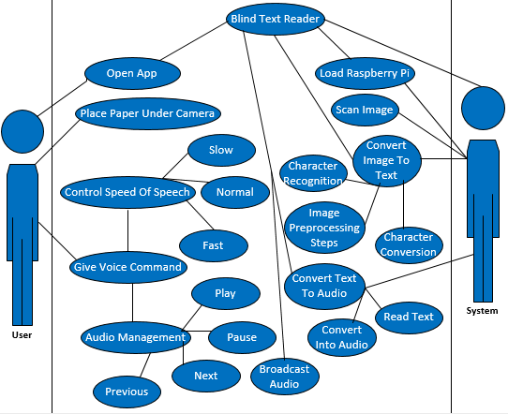
Figure 0-1:UC System

System Use case Description
Name: Text Reader | Id: 1
Actor: User | Priority: High
Description: User can select gander like male/female, perform audio playing functionalities and can alternate the speed of speech.
Trigger: User open the app.
Preconditions
Must have Power Supply
Normal flow of user  User open the application  Use will speak command to start the  Process  User can select the speed of audio file  User can play the audio  User can pause the audio  User can forward the audio  User can previous the audio |  | Normal flow of system  System will capture the image and processing will begin after preprocessing system will save image in mobile directory  System will convert image into text  System will convert text into audio and store it in mobile directory  System will play the audio  System will pause the audio  System will load next audio  System will load previous audio  If page ends system will stop
Alternative flow
- If user cannot perform above functionalities then system display “system error try again”.
- If user face problem continuously then he can take offline help through app.
- If page ends system will stop broadcasting.
Post conditions
User successfully perform the task.
Table 0-1: Main Use Case

Speech of Speed Use Case
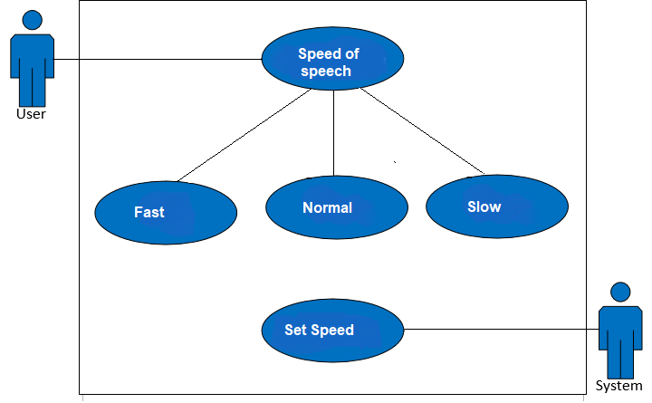
Figure 0-2: Speech Speed

Speech of Speed use Case Description
Name: Speed of speech | Id: 3
Actor: User | Priority: Medium
Description: User can alternate the speed of speech.
Trigger: User can select and control the speed of speech.
Preconditions
- Must have Power Supply

Normal flow
- User open the application
- User can select speed of speech
- User give voice command to adjust the speed of speech

Alternative flow
- If User do not select the speed of speech it will use by default speed.

Post conditions
- User successfully perform the task.
Table 0-2: Speech Speed

Playing Functionalities Use Case
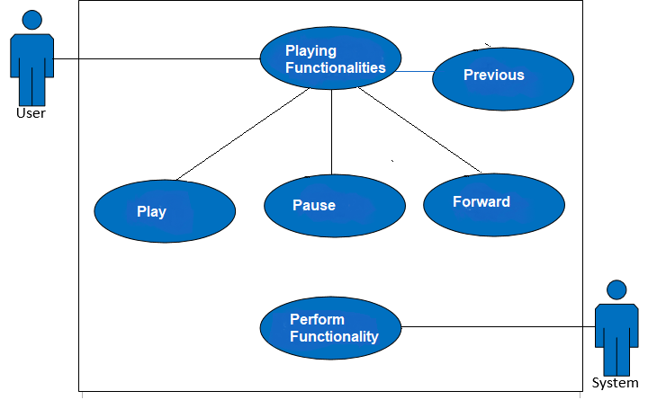
Figure 0-3: Playing Functionalities

Playing Functionalities Use Case Description
Name: Playing Functionalities | Id: 4
Actor: User | Priority: High
Description: User can perform audio playing functionalities.
Trigger: User will perform functionalities like play, pause, forward and previous.
Preconditions Must have Power Supply
Normal flow
User open the application
User can perform different functionalities like play, pause, forward and previous
Alternative flow
If user cannot perform above functionalities system will not perform any thing.
Post conditions
1. User successfully perform the task.
Table 0-3: Playing Functionalities

Block Diagram
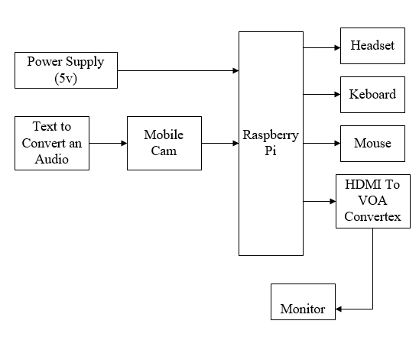
Figure 0-4: Block Diagram

Sequence Diagram

Sequence Diagram for Control Speech of Speed
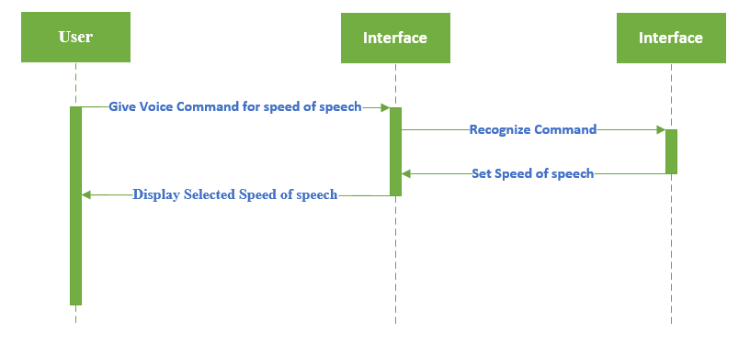
Figure 0-5: Speech Speed

Operation Contract for Control speed of speech
Name | Speed of Speech
Responsibilities | User can alternate the speed of speech.
Exception | If user do not select the speed of speech it will use by default speed.
Preconditions | Must have Power Supply
Post conditions | User successfully perform the task.
Table 3.0-4: OC Speed of Speech

Sequence Diagram for Playing functionalities
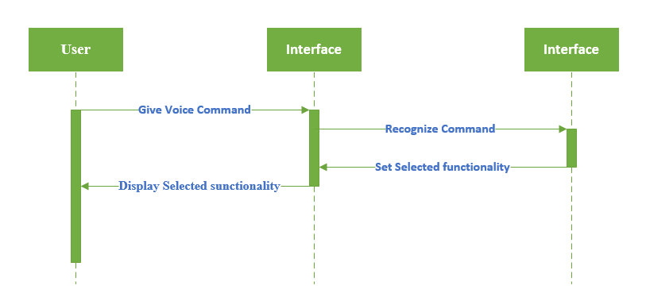
Figure 0-6: Playing Functionalities

Operation Contract for Playing Functionalities
Name | Playing Functionalities
Responsibilities | User can perform audio playing functionalities.
Exception | If user cannot perform above functionalities system will not perform any thing.
Preconditions | Must have Power Supply
Post conditions | User successfully perform the task.
Table 3.0-5: OC Playing Functionalities

Activity Diagram
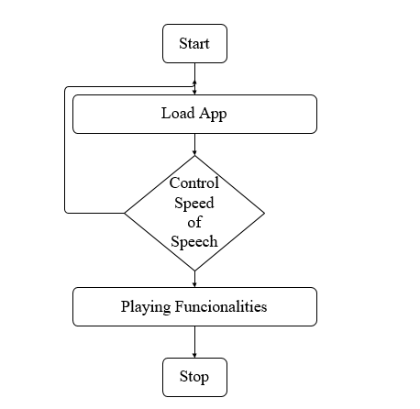
Figure 0-7: Activity Diagram

CHAPTER 4

IMPLMENTATION

The Text Reader for Blinds system is to enhance the capabilities of blind people by providing them a solution so that the information can be represented in the form of a speech. To develop android application that converts an image’s text file to speech. Image undergoes a series of pre-processing steps. Then Text-to-speech library is used that will convert the data and is converted into the audio. The audio output is heard through the raspberry pi’s using mobile speaker or speakers. Use of voice command to Stop, play, forward and reverse the audio. Alteration in speed of speech can also be done.

Image Capturing

The initial phase in which a device is moved over the page were an inbuilt camera captures the pictures of the content. The nature of the picture captured will be high in order to have quick and clear recognition because of the high definition camera

Pre-Processing

In pre-processing Skew Correction, Linearization and Noise removal was carried out in which the captured picture is checked for skewing. There are conceivable outcomes of picture getting skewed with either left or right orientation. The skew identification checks for a point of orientation between ±15 degrees and if recognized then a small image rotation turn is done till the lines coordinate with the genuine horizontal axis, which delivers a skew corrected picture[1].
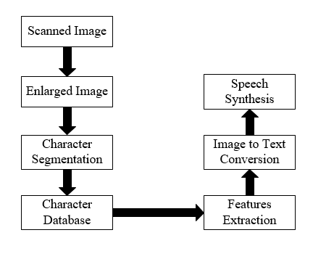
Figure 0-1: Pre-Processing.

Text Extraction

In this stage the perceived content present in the scanned image are separated utilizing OCR engines. Here we utilize tesseract OCR engine which separates the recognized characters

  - Text to speech conversion

This module is initiated with the conclusion of the receding module of Character Recognition. The module performs the task of conversion of the transformed text to audible form[3]. The Raspberry Pi has an on-board audio jack, the on-board audio is generated by a PWM output and is minimally filtered. A USB audio card can greatly improve the sound quality and volume.
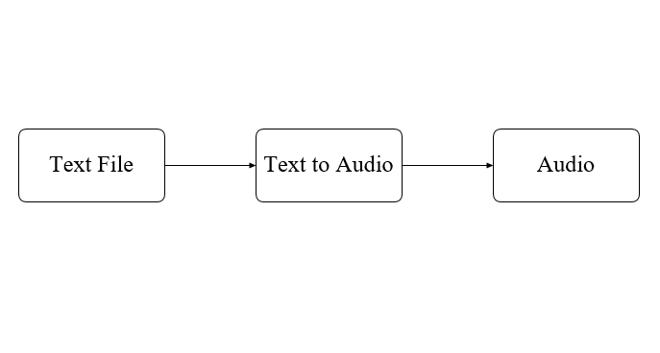
Figure 0-2: Text Extraction

CHAPTER 5

RESULTS AND DISCUSSIONS

Mobile Application

In the mobile there is app which works on the voice command. With the help of voice command, the blind person can operate the app. Through the app the blind person can change the speed of speech it can also play, pause, next and previous audio.

When the person gives “Click” command to the app it will capture the picture of page placed under the mobile camera. Same as that all the functionality in the app is performed through the voice command
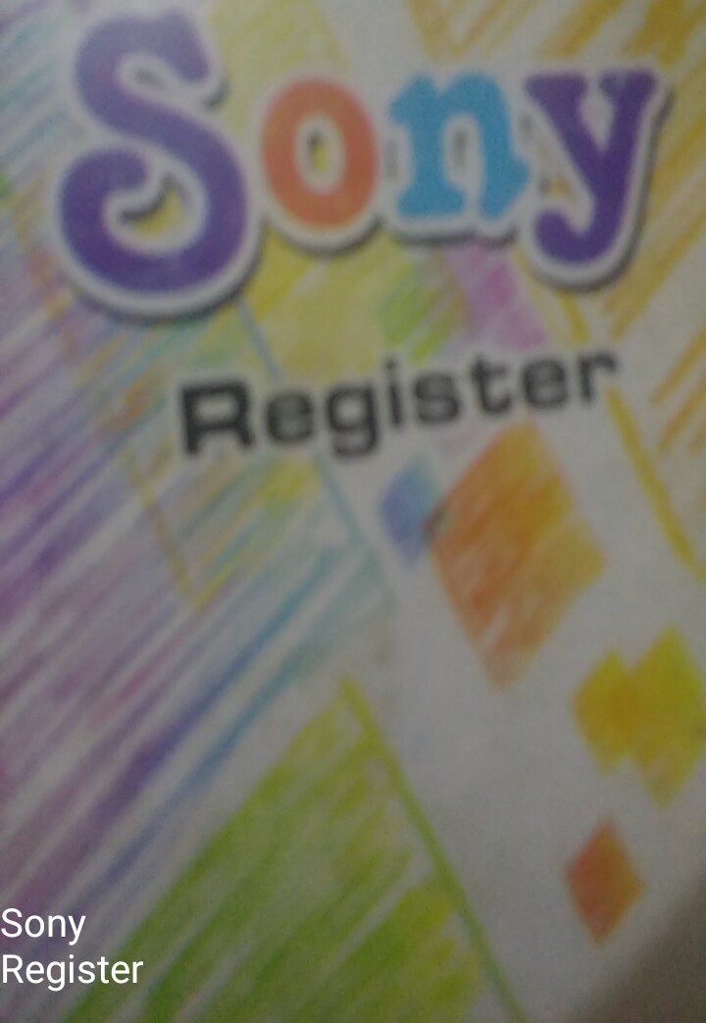
Figure 0-1: Image Captured by App

Raspberry Pi

The image is taken through the mobile camera by giving voice command to the mobile app then the image is converted into the digital image after some pre-processing steps with the help of raspberry pi. After this the image is again stored into the mobile device.

When the image is stored in the mobile the blind person can give command to the mobile app to play these text in the audio format through the mobile speaker.

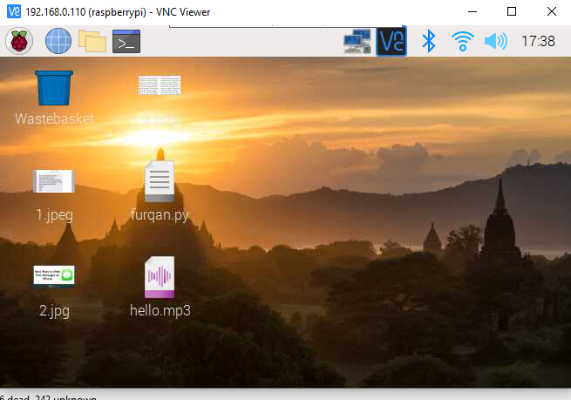
Figure 0-2: Raspberry Pi Interface

CHAPTER 6

CONCLUSION AND RECOMMENDATIONS

Conclusion

The aim of this project is to develop a text reader through Mobile Application and Raspberry Pi. So many applications are introduced but no one has yet focused over Voice Command.
Nearby character gathering is performed to compute hopefuls of content patches prepared for content arrangement. Partner degree Ad boost learning model is used to restrict message in camera-based pictures. OCR is utilized to perform word acknowledgment on the confined content areas and improve into sound yield for visually impaired clients. Amid this investigation, the camera goes about as contribution for the paper. Since the Raspberry Pi board is powerful the camera begins unrestrained. The unrestrained information will be shown on the screen exploitation GUI application. When the thing for content perusing is set in front of the camera then the catch is clicked to deliver picture to the board. Utilizing Tesseract library, the picture will be conceived again into information and furthermore the learning distinguished from the picture will be appeared on the standing bar. The acquired learning will be articulated through the ear telephones utilizing Text-to-speech synthesis.

REFERENCES

[1] | A. Goel, "Raspberry Pi Based Reader for Blind People," International Research Journal of Engineering and Technology (IRJET), vol. 05, no. 06, pp. 1639-42, June, 2018.
[2] | N. Mishra, "Image Text to Speech Conversion Using Raspberry Pi & OCR Techniques," IJSRD-International Journal for Scientific Research & Development, vol. 05, no. 08, pp. 523-25, 2017.
[3] | V. Mahalakshmi, "Implementation of OCR Using Raspberry Pi for Visually Impaired Person," International Journal of Pure and Applied Mathematics, vol. 119, no. 15, pp. 111-17, 2018.
[4] | A. G. Hagargund, "Image to Speech Conversion for Visually Impaired," International Journal of Latest Research in Engineering and Technology (IJLRET), vol. 03, no. 06, pp. 09-15, June 2017.
[5] | P. Nath, "Low-Cost Android App Based Voice Operated Room Automation System," 3rd International Conference for Convergence in Technology (I2CT), pp. 1-4, 2018.
[6] | Y. Mittal, "A voice-controlled multi-functional Smart Home Automation System," Proc. Of Annual IEEE India Conference (INDICON), pp. 1-6, 2015.
[7] | M. A. Panicker, "Smart Shopping assistant label reading system with voice output for blind using raspberry pi," International Journal of Advanced Research in Computer Engineering & Technology (IJARCET), vol. 05, no. 10, 2016.
[8] | D. Dakopoulos, "Wearable Obstacle Avoidance Electronic Travel Aids for Blind," IEEE Transactions on systems, man and cybernetics, vol. 40, no. 01, Jan 2010.
[9] | W. A. Ainsworth, "A system for converting English text into speech," IEEE Transactions on Audio and Electroacoustics, vol. 21, no. 03, Jun 1973.
[10] | M. McEnancy, "Finger Reader Is audio reading gadget for Index Finger," IJECCE, vol. 05, no. 04, July 2014.

