
BSIT-S19-004
03-135161-031 ZAFAR ULLAH
03-135161-022 FARAZ KAREEM
03-135161-028 SYED TAYYAB SAGHEER

A Context Aware Recommender System: A Decision Support System
In partial fulfilment of the requirements for the degree of
Bachelor of Science in Information Technology
Supervisor: DR. GHULAM MUSTAFA

Department of Computer Sciences
Bahria University, Lahore Campus
January 2020

© Bahria University, 2020

Certificate

We accept the work contained in the report titled
“A Context Aware Recommender System: A Decision Support System”
Written by
ZAFAR ULLAH
FARAZ KAREEM
SYED TAYYAB SAGHEER
As a confirmation to the required standard for the partial fulfilment of the degree of
Bachelor of Science in Information Technology.

Approved by:
Supervisor: DR. GHULAM MUSTAFA
(Signature)

January 27, 2020

DECLARATION

We hereby declare that this project report is based on our original work except for citations and quotations which have been duly acknowledged. We also declare that it has not been previously and concurrently submitted for any other degree or award at Bahria University or other institutions.

Enrolment | Name | Signature
03-135161-031 | ZAFAR ULLAH
03-135161-022 | FARAZ KAREEM
03-135161-028 | SYED TAYYAB SAGHEER

Date : January 27, 2020

Specially dedicated to
My beloved Mother and Father
ZAFAR ULLAH
My beloved Father, Mother, Sisters and elder Brothers
FARAZ KAREEM
My beloved Mother and Father
SYED TAYYAB SAGHEER

ACKNOWLEDGEMENTS

In the name of ALLAH Almighty, the Most Gracious and the Most Merciful. Alhamdulillah, all praises to ALLAH for the strengths and His blessing in completing this project.

We would like to express our deepest gratitude to our Supervisor Dr. Ghulam Mustafa for his deep patience, providing information regarding project, helping for getting necessary data, scholar inspiration guidance during the project.

We would like to express many special thanks to our parents and family, who were always there to give all sorts of understanding and support.

ZAFAR ULLAH
FARAZ KAREEM
SYED TAYYAB SAGHEER

A CONTEXT AWARE RECOMMENDER SYSTEM:A DECISION SUPPORT SYSTEM

ABSTRACT

Job Recommender System basically a web based application which help to recommend a job for job seekers through the internet according to user preferences. The proposed system is the web based application. Basically we are going to develop a context aware recommender system and the specific domain in which we will work is job recommender system. Job recommender system will perform functionality on the basis of profile preferences, behaviour of the job search and on the basis of content based matching. Job recommender system will suggest latest and timely jobs and provide good percentage of accuracy while making predictions which are most relevant and according to the interest of the candidates on the basis of profile. Reason why we need job recommender system as it is very difficult or time consuming to search your interested job from the number of thousands of posted jobs on different local platforms. Another reason why we need recommender system is exponential growth of data which arise the problem called information overload. Due to information overloading it is very difficult to search a specific job of their interest at the right time. To tackle this problem, we are going to providing a web personalized platform which has all the posted jobs that are posted on different local platforms by continues scrapping form these local platforms. Another important point that this project is not only based on scrapping the data from local platforms like rozee.pk etc. We also providing registration facility to companies to register and post their jobs on our platform as we going to deploy website on server domain (if possible). To achieve our purpose to provide a platform which help to find specific job according to skills and interest.

TABLE OF CONTENTS

DECLARATION ii
ACKNOWLEDGEMENTS iv
A CONTEXT AWARE RECOMMENDER SYSTEM:A DECISION SUPPORT SYSTEM v
ABSTRACT v
TABLE OF CONTENTS vi
LIST OF TABLES xi
LIST OF FIGURES xii
LIST OF SYMBOLS / ABBREVIATIONS /DEFINITIONS 15

CHAPTERS

1 INTRODUCTION 16
1.1 Background 16
1.2 Problem Statements 16
1.3 Aims and Objectives 17
1.4 Scope of Project 18
1.5 Final Deliverable of the Project and Beneficiaries 18
2 LITERATURE REVIEW (SRS) 20
2.1 Introduction 20
2.2 Background 20
2.3 JRS Functions 21
2.3.1 Maintain customer profile 21
2.3.2 Provide personalized profile 21
2.3.3 Provide Search facility 21
2.3.4 Detailed product Categorizations 22
2.3.5 Provide comprehensive product details 22
2.3.6 Provide Customer Support 22
2.3.7 Email Conformations 22
2.3.8 Detailed job for customer 22
2.3.9 Allow online job search facility reviews 23
2.3.10 Apply for job 23
2.3.11 Fetch data 23
2.3.12 Others 23
2.4 Operating Environment 23
2.4.1 Hardware Environment: 23
2.4.2 Software Environment 24
3 DESIGN AND METHODOLOGY 25
3.1 Methodology 25
3.2 High level Functional requirement 25
3.2.1 Other Non-functional Requirements 26
3.3 Feasibility Plan 26
3.3.1 Resource Requirement 26
3.4 Design and Implementation Constraints 26
3.5 Assumptions and Dependencies 27
3.6 Interface 27
3.6.1 User Interfaces 27
3.6.2 Hardware Interfaces 27
3.6.3 Software Interfaces 28
3.6.4 Communications Interfaces 28
3.6.5 Applicable Standards 29
3.7 Use case 29
3.7.1 User account 29
3.7.2 User Login 30
3.7.3 Apply for job 31
3.7.4 Data Scrapping 32
3.7.5 Posted job 33
3.7.6 Logout 34
3.7.7 Forget Password 34
3.7.8 Company registration 35
3.7.9 Admin Profile 36
3.7.10 Filtering Job 37
3.7.11 Change Password 38
3.7.12 Show Profile 39
3.7.13 Job Detail 40
3.7.14 Behaviour of search job 41
3.7.15 Register Complain 42
3.7.16 Search for job 43
3.7.17 Download personal information 44
3.7.18 Download job information 44
3.7.19 Update 45
3.8 System Requirements Chart 46
3.1 Analysis Models 53
3.1.1 System Use Case Diagram 53
3.2 Sequence Diagram 55
3.2.1 Create account 55
3.2.2 Login 56
3.2.3 Apply For Job 56
3.2.4 Logout 57
3.2.5 Forget Password 58
3.2.6 Company Registration 58
3.2.7 Admin profile 59
3.2.8 Filtering Jobs 60
3.2.9 Change Password 60
3.2.10 Show Profile 61
3.2.11 Job Detail 61
3.2.12 Behaviour of Search Job 62
3.2.13 Report Complain 62
3.2.14 Search for Job 63
3.2.15 Download job information 63
3.2.16 Update profile 64
3.3 CLASS DIAGRAM 64
3.4 Data Model 65
4 DATA AND EXPERIMENTS (and/or IMPLMENTATION) 67
4.1 Languages used 67
4.1.1 HTML 67
4.1.2 Cascading Style Sheets 67
4.1.3 SQL 67
4.1.4 C# 68
4.1.5 Python 68
4.1.6 JQuery 68
4.1.7 JavaScript 68
4.1.8 Ajax 68
4.1.9 LINQ 69
4.2 Framework 69
4.2.1 Bootstrap 69
4.2.2 MVC 69
4.2.3 Asp.net 69
4.2.4 Tools 69
5 RESULTS AND DISCUSSIONS (or USER MANUAL) 70
5.1 Opening Website of JRS (job recommendation system) 70
5.2 Contact us (job recommendation system) 71
5.3 JRS team (job recommendation system) 73
5.4 JRS (job recommendation system) Testimonials 73
5.5 JRS (job recommendation system) Login Panel 74
5.6 JRS (job recommendation system) Candidate Panel 75
5.7 View Profile of Candidate 77
5.8 Edit information of Candidate Profile 78
5.9 Search Job using filter 79
5.10 Apply for job 80
5.10.1 Apply for Scrapped job 80
5.11 View Detail of Job & Company 81
5.11.1 View Detail of Job 81
5.11.2 View Detail of Company 82
5.12 View List of Companies 83
5.13 Logout 84
5.14 Sign up 84
5.15 Forget Password 85
5.16 JRS (job recommendation system) Company Panel 85
5.17 JRS (job recommendation system) Company Panel 86
5.18 JRS Company Panel Change Password 86
5.19 JRS (job recommendation system) Admin Panel 88
5.20 JRS (job recommendation system) Admin Authority 88
5.21 JRS (job recommendation system) Manage User or Candidate Profile 89
5.22 JRS (job recommendation system) Manage Menus 90
5.23 JRS (job recommendation system) Company Profile 92
5.24 JRS (job recommendation system) Company Dashboard 92
5.25 JRS (job recommendation system) Company Profile 93
5.26 JRS (job recommendation system) Edit Company Profile 93
6 ALGORTHIM AND IT’s IMPLEMENTATION 94
6.1 TF-IDF 94
6.1.1 Term –Frequency 94
6.1.2 Inverse Term Frequency 94
6.1.3 Formula TF-IDF 95
1.1.4 Pre-processing 95
6.2 Algorithm (Code) 95
6.2.1 Batch File 96
6.2.2 Python Script 96
7 7.1 Conclusion 101
References 102

LIST OF TABLES

TABLE PAGE

Table 1 - Abdreviation Error! Bookmark not defined.
Table 2 - Requirement traceability 52

LIST OF FIGURES

FIGURE TITLE PAGE
Figure 3-1: System Diagram 28
Figure 3-2: System diagram 53
Figure 3-3 : Job searcher 54
Figure 3-4 : Company Use case 54
Figure 3-5 : Admin Use case 55
Figure 3-6 : Create account sequences 55
Figure 3-7 : Login sequence diagram 56
Figure 3-8 : Job apply sequence diagram 57
Figure 3-9 : LOGOUT sequence diagram 57
Figure 3-10 : Forget Password Sequence Diagram 58
Figure 3-11 : Company Registration Sequence Diagram 59
Figure 3-12 : Admin profile Sequence Diagram 59
Figure 3-13 : Filtering job Sequence Diagram 60
Figure 3-14 : Change Password Sequence Diagram 60
Figure 3-15 : Show Profile Sequence Diagram 61
Figure 3-16 : Job Detail Sequence Diagram 61
Figure 3-17 : Job Search Behaviour Sequence Diagram 62
Figure 3-18 : Report Complain Sequence Diagram 62
Figure 3-19 : Search for Job Sequence Diagram 63
Figure 3-20 : Download job Information Sequence Diagram 63
Figure 3-21 : Update Profile Sequence Diagram 64
Figure 3-22 : Class Diagram 65
Figure 3-23 : Data Model 66
Figure 5-1 : Website of JRS 70
Figure 5-2 : Contact us page 71
Figure 5-3 : Admin received email panel 72
Figure 5-4 : JRS team 73
Figure 5-5 : JRS testimonials 73
Figure 5-6 : Login Panel 74
Figure 5-7 : JRS candidate panel 75
Figure 5-8 : Recommended jobs 76
Figure 5-9 : ALL JOBS 77
Figure 5-10 : Candidate profile 78
Figure 5-11 : Jobs filtering 79
Figure 5-12 : recommended Jobs after filtering 80
Figure 5-13 : Apply for jobs 80
Figure 5-14 : Job & Company detail 81
Figure 5-15: Job Detail 81
Figure 5-16: Company Detail 82
Figure 5-17 : Google Map 82
Figure 5-18: List of Company 83
Figure 5-19 : Search of companies 83
Figure 5-20 : Sign up 84
Figure 5-21: Forget Password changing method 85
Figure 5-22 : Company Panel 86
Figure 5-23: Company Panel (Job Posting) 86
Figure 5-24: Change Password 87
Figure 5-25: Dataset Visualization 88
Figure 5-26: Admin Management Panel 88
Figure 5-27: Update User Profile 89
Figure 5-28: User Profile Information 89
Figure 5-29: Creating Company Profile 92
Figure 5-30: Company Dashboard 92
Figure 5-31: Company Profile 93
Figure 5-32: Update Company Profile 93
Figure 6-1: Dataset before Pre-processing 95
Figure 6-2 : Standardized pre-process dataset 97
Figure 6-3 : Algorithm accuracy 100

LIST OF SYMBOLS / ABBREVIATIONS /DEFINITIONS
JRS | Job Recommender System
User | Someone who interacts with the web based application
Admin/Administrator | System administrator who is given specific permission for managing and controlling the system
IIS | Internet Information System (IIS) used to deploy asp.net applications
Syndicated Data | Dynamically receiving data through different sources
Standardized format | In data management, record standardization is a process in which files are first parsed (assigned to appropriate fields in a database record) and then translated to a common format
Transformed | Converting data or information from one format to another, usually from the format of a source system into the required format of a new destination system.
Stakeholder | Any person who interacts with the system who is not a developer.
Scrapping Scripts | Which take the crawl data from the internet which is present on different website and save it in database after pre-processing
Visual Studio | It is development IDE to develop asp.net application and the version we are going to use 2017
Jupyter notebook | It is used to develop the Scrapping scripts
Software | The programs and other operating information used by a computer.
U | Use Case

INTRODUCTION

Background

In this modern era the volume of data over internet grown exponentially, problem occur in extraction of data due to a huge volume of data related to different internet based platforms. The aim of this project to develop a recommender system for a particular domain to search job. This system provide an opportunity for both job researcher and publisher to hire a right talent for job that has become a big challenge for recruiters now days. We are going to developed a web based and optionally mobile based application that recommend jobs to candidates depending on their profile preferences, behaviour of the job search(if possible) and as well as content base matching [1]. The recommender system will provide a web personalized platform for the customer to search job easily because thousands of jobs posted on website time to time on different local platforms like Rozee.pk, Mustaqil.com etc. As the traditional website has only one dashboard or home page for each user but in web personalization every user has their own separate and unique landing page depending upon on the user interest and its profile.

Problem Statements

In modern era mostly people are seeking the jobs for this purposes they use internet and visit hundreds of jobs website to search the proper job which are according to their interest and skills .by spending several mints they can’t find any proper job while some time they miss the precious information about the job or vacancy due to a huge amount of large and un-structured data present on the internet e.g. like career okay, cvsakar and other jobs related website their basic aim to give information about the latest jobs and vacancies to the searcher in valid time and date but due to unstructured [2], huge data and lack of searching skills the searcher or job seeker miss the job opportunity and these website are fail to provide accurate and concise information about the jobs and cannot meet the job seekers expectations and unable to provide the classic and effected job platform.
In our society mostly organization Hire their employees through the internet instead of spending thousands of money on Advertisement and other resources like agents they basically hire directs employee from the internet which is fastest way to hiring. Need a website which fully help the jobseekers and organization to find a job and find a right person in less time for the right job.

Aims and Objectives

The basic aim of our project to reduce gap between organization and job seekers by providing such a platform which is easily useable for both organization and job seekers like organization can hire a perfect employee in less time while on the others hand a job seeker can find accurate job according to their expertise, skills and relevant fields. Our aim to provide useful platform for both companies and job seeker or employees through the website Job recommender system (JSR).

- To address long tail phenomena. Long tail phenomena is use to address those candidate having unique choice and they are enable to figure out their relevant jobs on local platforms

- To recommend the most relevant job to candidate. Everyone have different expertise but having interest in one of them, We provide jobs to candidate on the basis of content based matching as well as profile preference and additionally we are using loops to find most relevant jobs by matching behaviour of the job search

- To automate the job search process making it easy for atmosphere. We provide a platform that will be having all current jobs that are posted on different local platform like Careerokay, Mustaqbil.com etc. through scraping the posted jobs data continuously.

Note: we scrape data from the different website every data on set time using task scheduler of servers. In this project we use task scheduler of windows

Scope of Project

Basically, we want to overcome the communication gap between job seekers and organization through our project our website remove the barrier of un-structured (big data) and provide accurate platform where they can find their most relevant and fields related latest jobs while on others hand it provide the platform for organization to hire more relevant person in no time from the market through internet without any agents or by using third party services and saving a lot of money from hiring process.
Whenever a single job offer for any post it recommends to thousands of candidates while job posting is typically meant to hire one or few candidates only related to that field. For the local platform it is very difficult and big challenge to offer that job to most relevant candidate. To handle this problem we make a recommender system that recommend the job to the most relevant candidate on the basis of their profile preference, content based matching as well as behaviour of the job search.
Due to exponential growth of data on the internet that arise a problem of huge data (Big Data) and this is an open challenge for world. Data available on internet are uncategorized which arise the problem of searching anything on the internet. So we focus on to categorize data properly to make it as strategic information that are able for decision making. It help us to recommend a right jobs for the right person at right time.

Final Deliverable of the Project and Beneficiaries

- Job recommender system web based application
- Direct/Indirect beneficiaries of the project are:
- Company’s Human resource department
- Job Seekers
- Job Publisher
- Admin

Note: Web site owner achieved benefit from Google advertisement for this purpose we show some kind demo in the project

LITERATURE REVIEW (SRS)

Introduction

This Software Requirement Specification (SRS) provides a complete description of all the functionalities and the specifications of JRS (Job Recommender System) project. The developers and the testers can use this document as a guideline for developing the design and test plan documents. For this substance, we are going to work on JRS (Job Recommender System). However, it will explain different functional as well as non-functional requirements of the system, the interfaces of the system, what the system will do or how the system will interact with the external users, what are the constraints under which it will operate [3]. This Software Requirement Specification document will provide a clear understanding of what is expected by the user in the proposed system. This will give a clear idea and guideline to development team that how to develop software for end users. This SRS will provide a basic flow and solid base for project as well as help us to design low level design document and also helpful to create test plans for testing purpose.

Background

Job Recommender System (JRS) was developed for all those user that are interested in finding job or wants to keep themselves update with the trends of jobs available in the market. It can handle the syndicated data coming from different platform like Careerokay, Mustaqil.com etc. and stored in standardized format. JRS has also capability to register companies in it. So the system are able to recommend job easily and also provide additional option of filtering to users [4]. System give the option of feedback to rate the jobs and improve the profile of the user on the behaviour of job search.

JRS Functions

Maintain customer profile

- The system shall allow user to create profile and set his credential.
- The system shall authenticate user credentials to view the profile.
- The system shall allow user to update the profile information.
- User and companies are able to send complain us using contact us page

Provide personalized profile

- The system shall display the detailed information about the selected job through filtering job.
- The system shall display the most frequently searched items by the user in the profile.

Provide Search facility

- The system shall enable user to enter the require job on the search bar.
- The system shall display matching result on the current screen.
- The system shall notify the user when no matching product is found on the search

Detailed product Categorizations

- The system shall display detailed job categorization to the user so that user can easily differentiated between the items.

Provide comprehensive product details

- The system shall display detailed information of the
Selected job.
- The system shall provide browsing options to see job details.

Provide Customer Support

- The system shall allow user to enter the contact number for support personnel to call.
- The system shall display the customer support contact numbers on the screen
- The system shall provide online help, FAQ’s customer support
- The system shall allow user to select the support type he wants.

Email Conformations

- The system shall maintain customer email information as a required part of customer profile and company profile.
- The system shall inform customer and company about profile creation through email
- The system shall also send email when the company and user forget password

Detailed job for customer

- The system shall allow to save the details of job in the form of pdf
- The system shall also allow the users to save their information in the form of pdf

Allow online job search facility reviews

- The system shall enable the user to enter their reviews and ratings
- The system shall record the search history of the user

Apply for job

- The system shall allow the user to apply for the job on JRS

Fetch data

- The system shall allow to scrape data from different platform like Careerokay, Mustaqil.com continuously
- System will arrange the posted job on main page after scrapping data

Others

    - Company will register in JRS to post Jobs
    - Admin have authority to manage profile of user, company

Operating Environment

Hardware Environment:

- If possible we are going to deploy website jrs on web server domain so that we can launch it publicly
- We schedule the Scripts on the task scheduler of the Server

Software Environment

Python & asp.net platform is used for design our web application and scrapping scripts and both are compatible with window 10. The supported web browser are commonly Chrome, Firefox, Internet explorer and Microsoft edge.

DESIGN AND METHODOLOGY

Methodology

We use agile development methodology to develop a job recommender system (JRS). The benefits of agile software development is as it easily accept changes through a process of continuous planning and feedback.

High level Functional requirement

- Creating a profile of the user that describes the types of items on the basis of the user likes.
- The recommender system technology help users in finding the items that match their personnel interests.
- The profile is often created and updated automatically in response to feedback on the desirability of items that have been presented to the user.
- Data will be scraping from different job searching platform dynamically.
- Job posted by different company will be show on this website.
- Job will be recommend to the customer on the basis of their interest based and on their profile preference, ratings, content based matching and search behaviour of job.
- There will be option for filtering.

Other Non-functional Requirements

Performance

- The product shall be based on web and has to be run from a web server if possible otherwise on localhost.
- The product shall take initial load time depending on internet connection strength which also depends on the media from which the product is run.
- The performance shall depend upon hardware components of the client/customer.

Security

- The system’s back-end servers shall only be accessible to authenticated administrators.
- The system’s back-end databases shall be encrypted.

Feasibility Plan

Resource Requirement

Following resources are required to complete this project
- Access to Internet
- Machines (Computer or Laptops)
- Server domain
- Integrate Development Requirement Software’s

Design and Implementation Constraints

JRS is based upon two main module primary is Web application and secondary is Web scrapping scripts. For implementation of web front-end HTML, CSS, Bootstrap, jQuery, JavaScript, Razor syntax, jQuery UI, Sweet alert, particle JS is used and backend developed using SQL Server and C#. Scrapping script is develop using python programming language. Both have different platform for designing purpose, it uses a modular design where every feature is wrapped into a separate module and the modules depend on each other through well python scripts and libraries. The Internet connection is required for application to work.

Assumptions and Dependencies

JRS system have web module so one assumption about the product is that web browser which is compatible with our application. Another assumption is that our user has internet connection in their home and places where they want to use our application. Server down effect on communication. If Scrapping Scripts communication got damage or down than it does effect on other parts of the system but the other part of the system perform the functionality independently. Another technical dependency on our project that will affect the project is to scraping the data from other websites if the other websites block the scraping content then our project will be effected and will not be work as accepted. If no companies register on our platform

Interface

User Interfaces

- The user interface for the software is compatible to any browser such as UC browser, Google Chromo, Mozilla or Netscape Navigator by which user can access to the system.

Hardware Interfaces

- Since the application must run over the internet, all the hardware shall require to connect internet will be hardware interface for the system. As for e.g. Modem, WAN – LAN, Ethernet Cross-Cable.

Software Interfaces

This system is divided into two parts scrapping scripts and application interface. Through Web scrapping scripts we continue to scrape the data from the different platforms and maintain the database by Appling prepressing technique on it and store it in clean form [5]. Python scripts after set interval refresh the database with new data with the help of crawling

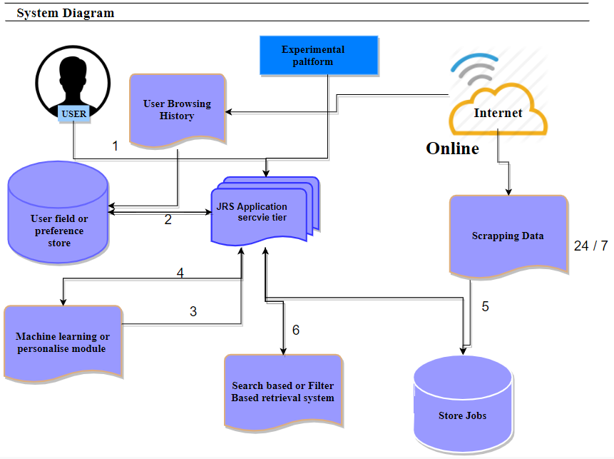

Figure 3-1: System Diagram

Communications Interfaces

The JRS system shall use the HTTP protocol for communication over the internet or may use HTTPS protocol for communication.

Applicable Standards

- It shall be as per the industry standard

Use case

3.7.1 User account
- U1
- Objective – To create account on JRS to access information.
- Priority – High
- Source – Client
- Actors – Job searcher
- Flow of Events
  - Basic Flow –
6.1.1. User open the JRS website.
6.1.2. User click on Create Account.
6.1.3. User enter the required information.
6.1.4. System will confirm user name and password to user again.
6.1.5. On Clicking Submit button system will show confirmation message.
6.1.6. System also send them message to their Gmail of account creation.

  - Alternative Flow 1- The step 6.1.2 user enter wrong information or missing field.
6.2.1. Show Red line on border of each missing field.
6.2.2. Show message, please fill the required field.

6.3. Alternative Flow 2- The step 6.1.4 enter User name and password not match with first attempt.
6.3.1. Sorry, your user name and password not matched with first attempt that enter user name and password.
6.3.2. Please re-enter the password.
6.3.3. On third time enter incorrect password return to step 6.1.3.
6.4. Alternative Flow 3- The step 6.1.5 failed submission.
6.4.1. Please check the connection.
6.4.2. Please go to help.
6.4.3. Please re-enter the information.

6.5. Exception Flow(s) –
6.5.1 Server down.
- Includes - None
- Preconditions – User must be linked with JRS website.
- Post conditions – User account are created.
- Notes/Issues - None

3.7.2 User Login
- U2
- Objective – To authorize the user to access the JRS.
- Priority – High
- Source – Client
- Actors – User
- Flow of Events
  - Basic Flow –
6.1.1. User open the JRS website.
6.1.2. Please enter username and password.
6.1.3. Press Login Button.

  - Alternative Flow 1- The step 6.1.2 user enter wrong username or password.
6.2.1. Show warning for wrong information either username or password on Login Button.
6.2.2. Show message, please re-enter the password or username.

  - Alternative Flow 2- The step 6.1.2 user forget password.
6.3.1. Click on change password option.
6.2.2. Go to email enter new password and save them

6.4. Exception Flow(s) –
6.5.1 Server down.
- Includes – U1
- Preconditions – User must have account on JRS already.
- Post conditions – User will be login and access information from JRS.
- Notes/Issues – None

3.7.3 Apply for job
- U4
- Objective – To apply for the posted job.
- Priority – High
- Source – Client
- Actors – Job searcher
- Flow of Events
  - Basic Flow –
6.1.1. User Login to JRS.
6.1.2. User check the posted jobs.
6.1.3. User click on the Apply option present with posted job.
6.1.4. System open the apply form of the company through link.
6.1.5. User fill the form and submit them.

  - Alternative Flow 1- The step 6.1.2 on expired date of posted job.
6.2.1. Apply Button disabled.
6.2.2. Show message on posted job Mouse Hover, this job is expired.
6.2.3. System show expiry date to user on mouse Hover.

6.3. Alternative Flow 2- The step 6.1.3 link of posted job not opened.
6.3.1. Please check your net connection.
6.3.2. Please re-press the apply option.
6.3.3. Please contact with admin.
6.4. Alternative Flow 3- . The step 6.1.5 failed submission.
6.3.1. Please check the connection.
6.3.2. Please check the missing field and the requirement.
6.3.3. Please re-enter the information.

6.5. Exception Flow(s) –
6.5.1 Server down.
- Includes – U2, U5, U6
- Preconditions – User must be Login in JRS.
- Post conditions – Apply form will be submitted successfully.
- Notes/Issues - None

3.7.4 Data Scrapping
- U5
- Objective – To scrape data from different platform like Rozee.pk, Mustaqil.com etc.
- Priority – High
- Source – Client
- Actors – Admin, System
- Flow of Events
  - Basic Flow –
6.1.1. Syndicated Data are scraped from different sources store in Data Lake.
6.1.2. Database deployed on first server to save the unstructured data.
6.1.3. Data are transformed to standardized format and send to another server.
6.1.4. Second server store the conformed and standardized data.
6.1.5. Give notification to admin of approval of standardized data.
  - Alternative Flow 1- The step 6.1.2 on server down problem.
6.2.1. System give message to admin of server problem.
6.2.2. Give message of data unsuccessfully scraped.
6.3. Alternative Flow 2- Data transformation problem.
6.3.1. Database show error.
6.3.2. System give notification to admin of database error.
6.3.3. Data will be stay on first server to wait for solving transformation problem
6.4. Exception Flow(s) –
6.5.1 Server down.
- Includes - None
- Preconditions – Server must be workable and linked with internet.
- Post conditions – Data will be continuously scrapped, transformed and successfully saved.
- Notes/Issues – None

3.7.5 Posted job
- U6
- Objective – To arrange the posted job on main page after scrapping data.
- Priority – Low
- Source – Client
- Actors – Admin
- Flow of Events
  - Basic Flow –
6.1.1. First of all data will be scrapped, transform and save in database.
6.1.2. Data are extracted from database and show on main page.
6.1.3. Arrange the posted jobs in a sequence with respect to issue date.
6.1.4. System show message to admin about new job.
  - Alternative Flow 1- The step 6.1.2 Extraction data failed.
6.2.1. Show message to admin about data extraction failure.
6.2.2. Check the server connection.
6.2.1. Check the data load.
6.2.2. Check data scrapping and transformation
6.3. Exception Flow(s) –
6.5.1 Server down.
- Includes – U5
- Preconditions – Data must be scrapped and transform save in database.
- Post conditions – Job will be posted.
- Notes/Issues – None

3.7.6 Logout
1. U7
2. Objective – Able user to logout from the system.
3. Priority – Medium
4. Source – Client
5. Actors – User
6. Flow of Events
6.1 Basic Flow –
6.1.1. Logout option are fixed in menu bar.
6.1.2. User can click on logout to leave the JRS.
6.1.3. System will destroy their session.
6.1.4. System redirect user to main page.

6.2 Alternative Flow 1- N/A

6.3. Exception Flow(s) –
6.5.1 Server down.
7. Includes – U2
8. Preconditions – User must be LOGIN in JRS.
9. Post conditions – User will be logout from JRS.
10. Notes/Issues – None

3.7.7 Forget Password
- U8
- Objective – To allow user to send email for changing password.
- Priority – Low
- Source – Client
- Actors – Admin, User
- Flow of Events
  - Basic Flow –
6.1.1. First website are loaded.
6.1.2. System will provide the Button of forget password.
6.1.3. User click the Button and the system will display form.
6.1.4. User enter email and press the send button.
6.1.5. The system check the email in the database.
6.1.6. The system send them password if email available in database.
  - Alternative Flow 1- The step 6.1.5 If email are not available in database.
6.2.1. System show error.
6.2.2. Show message, sorry you are not registered.
6.2.3. Display message, please register or create your account first.
6.3. Exception Flow(s) –
6.5.1 Server down.
- Includes - None
- Preconditions – User must have account or registered in JRS.
- Post conditions – System will send password on the user Gmail.
- Notes/Issues - None

3.7.8 Company registration
- U9
- Objective – To register company in JRS
- Priority – High
- Source – Client
- Actors – Company, Admin
- Flow of Events
  - Basic Flow –
6.1.1. Company user open the JRS website.
6.1.2. Click the option create company account.
6.1.3. Company fill the requirement provided by system.
6.1.4. System will provide the link for uploading profile.
6.1.5. By uploading file system show the confirmation message.
6.1.6. At last company user press the submit button.

  - Alternative Flow 1- The step 6.1.3 Missing the field.
6.2.1. Show message, please fill the requirement.
6.2.2. Show red line on missing field.

6.3. Alternative Flow 2- The step 6.1.4 File not uploaded.
6.3.1. Please check the network connection.
6.3.2. Please re-upload the file.
6.3.3. Return to step 6.1.2.

6.5. Exception Flow(s) –
6.5.1 Server down.
- Includes - None
- Preconditions – Company User must be linked with JRS website.
- Post conditions – Company will be registered and created their account.
- Notes/Issues - None

3.7.9 Admin Profile
- U10
- Objective – To check, delete and update profile
- Priority – Medium
- Source – Client
- Actors – Admin
- Flow of Events
  - Basic Flow –
6.1.1. Admin open the website.
6.1.2. Click on the profile option.
6.1.3. System will show option update, delete and view profile.
6.1.4. Admin update the file by entering new information.
6.1.5. Admin delete the profile by clicking delete option.
6.1.6 System show the confirmation message for both action delete and update.

  - Alternative Flow 1- The step 6.1.4 admin entering wrong information.
6.2.1. System display error message.
6.2.2. Return to step 6.1.3.

6.3. Alternative Flow 2- The step 6.1.2 select wrong option.
6.3.1. System provided back option.

6.4. Exception Flow(s) –
6.5.1 Server down.
- Includes – U2
- Preconditions – Admin must be Login to JRS website.
- Post conditions – System will be show, update and delete profile.
- Notes/Issues – None

3.7.10 Filtering Job
- U11
- Objective – Able user to find the specific job through filtering.
- Priority – Medium
- Source – Client
- Actors – Job searcher
- Flow of Events
  - Basic Flow –
6.1.1. User open the JRS website.
6.1.2. User login to JRS.
6.1.3. The system will provide a separate option of filtering.
6.1.4. User click the Filter option present on main page.
6.1.5. A form will be open.
6.1.4. User enter the information that are required in the form.
6.1.5. Click all the field press search button to find the posted job.

  - Alternative Flow 1- The step 6.1.4. User enter wrong information or missing field.
6.2.1. Show Red line on border of each missing field.
6.2.2. Show message, please fill the required field.

6.3. Alternative Flow 2- The step 6.1.5. No new job are posted yet.
6.3.1. System display Sorry, No result found.
6.3.2. Please check for other jobs.

6.4. Exception Flow(s) –
6.5.1 Server down.
- Includes – U6
- Preconditions – User must be login in the JRS website.
- Post conditions – New posted Job will be found and show on screen.
- Notes/Issues - None

3.7.11 Change Password
- U12
- Objective – To allow user to change the password and give new password.
- Priority – Medium
- Source – Client
- Actors – User
- Flow of Events
  - Basic Flow –
6.1.1. User open the JRS website.
6.1.2. User login to JRS.
6.1.3. User click on Change Password option.
6.1.4. A form will open and enter the new password.
6.1.5. Once again enter the password to confirm password correctness.

  - Alternative Flow 1- The step 6.1.5. Enter wrong password not match with first attempt.
6.2.1. You enter wrong password second time displayed by system.
6.2.2. Please re-enter the password or return to step 6.1.5.

6.3. Exception Flow(s) –
6.5.1 Server down.
- Includes – U1
- Preconditions – User must be login in JRS.
- Post conditions – Password will be changed.
- Notes/Issues - None

3.7.12 Show Profile
- U13
- Objective – The system show the personal information on if user want to see them.
- Priority – Medium
- Source – Client
- Actors – User, Admin, Company user
- Flow of Events
  - Basic Flow –
6.1.1. User open the JRS website.
6.1.2. User login to JRS.
6.1.3. Show profile Option are fixed in menu bar.
6.1.4. System will extract information from database through query
6.1.5. Show the information on new page.

  - Alternative Flow 1- The step 6.1.4 system failed to extract information.
6.2.1. System show error.
6.2.2. System show message please re-try.
6.2.3. Show error of server problem.
6.2.4. Please return to step 6.1.3.

6.3. Exception Flow(s) –
6.5.1 Server down.
- Includes – U2
- Preconditions – User must be login in JRS.
- Post conditions – System will show their personal information or their profile.
- Notes/Issues - None

3.7.13 Job Detail
- U14
- Objective – To display the available description of job to user.
- Priority – Medium
- Source – Client
- Actors – Job searcher
- Flow of Events
  - Basic Flow –
6.1.1. User open the JRS website.
6.1.2. User login to JRS.
6.1.3. User check the job first.
6.1.4. With posted job a link will be provided.
6.1.5. User will click on the detail link.
6.1.6. System will provide a full available description of job.

  - Alternative Flow 1- The step 6.1.5 link not working.
6.2.1. Please check internet connection.
6.2.2. Please check expiry date of job.

6.5. Exception Flow(s) –
6.5.1 Server down.
- Includes – U6
- Preconditions – User will already login in JRS.
- Post conditions – Job detailed will be displayed on screen.
- Notes/Issues - None

3.7.14 Behaviour of search job

- U15
- Objective – System will save the user searching record in database that the user search on the JRS.
- Priority – High
- Source – Client
- Actors – User
- Flow of Events
  - Basic Flow –
6.1.1. User open the JRS website.
6.1.2. User login in JRS.
6.1.3. User search any job on JRS website.
6.1.4. System will save the search behaviour in the database.
6.1.5. In database a specific table store the search history of user.
6.1.6. System use the user history for matching job and user interest to recommend job for user.
6.1.7. System use algorithm to match user interest and job requirement.

  - Alternative Flow 1- The step 6.1.5 database missing to store data.
6.2.1. Data will stay on waiting for database recovery.
6.2.2. Send notification to admin for not proper functioning of database.

6.3. Exception Flow(s) –
6.5.1 Server down.
- Includes – U17
- Preconditions – User must be search anything in JRS website.
- Post conditions – System will store the user history of their searching for recommendation purpose in database.
- Notes/Issues - None

3.7.15 Register Complain
1. U16
2. Objective – Describes how a customer can give feedback to the company
3. Priority – Medium
4. Source – Client
5. Actors – User, Admin, Company
6. Flow of Events
6.1 Basic Flow –
6.1.1. User click on the customer care service
6.1.2. The system show message box on screen display
6.1.3. The user enter the text in text area of message box
6.1.4. The user click on the submit response
6.1.5. The system send the message in the email to the admin also text you have a complaint in your inbox

6.2 Alternative Flow 1- The step 6.1.4. The user forget to enter the text in text area
6.2.1. The system show error
6.2.2. The system show message “Kindly fill the complaint area”
6.3 Alternative Flow 2- The step 6.1.4. Submission fail
6.3.1. The system show message “Something go wrong”
6.3.2. The system redirect to the step 6.1.1

6.4. Exception Flow(s) –
6.5.1 Server down.
7. Includes – None
8. Preconditions – The user must go to website
9. Post conditions – Complain will be send to admin
10. Notes/Issues – None

3.7.16 Search for job
1. U17
2. Objective – The process for finding a job in the system
3. Priority – Low
4. Source – Client
5. Actors – User, Admin, Company
6. Flow of Events
6.1 Basic Flow –
6.1.1. The user login to the website (JRS)
6.1.2. The user go to search bar on the top of the navigation bar
6.1.3. The user enter the text in search box
6.1.4. The user click on the search button
6.1.5. The system show the jobs match with the user search job

6.2 Alternative Flow 1- The step 6.1.4. The user forget to enter the text in search bar
6.2.1. The system show alert
6.2.2. The system show message “search bar is empty”
6.3 Alternative Flow 2- The step 6.1.4. Search fail
6.3.1. The system show message “Something go wrong”
6.3.2. The system redirect to the step 6.1.2.
6.4 Alternative Flow 3- The step 6.1.4. No item match with search job
6.4.1. The system show message “No result found”
6.4.2. The system redirect to the step 6.1.2

6.5. Exception Flow(s) –
6.5.1 Server down.
7. Includes – U2, U6
8. Preconditions – The user must login to website
9. Post conditions – posted job will be show matching with their search requirement
10. Notes/Issues – None

3.7.17 Download personal information
1. U18
2. Objective – The process for downloading personal information
3. Priority – Medium
4. Source – Client
5. Actors – User, Company
6. Flow of Events
6.1 Basic Flow –
6.1.1. The user login to the website (JRS)
6.1.2. The user go to personal information page
6.1.3. The user click on the download button
6.1.4. The system download the file in pdf

6.2 Alternative Flow 1- The step 6.1.3. Information failed to download
6.2.1. The system show alert
6.2.2. The system show message “Something went wrong”

6.5. Exception Flow(s) –
6.5.1 Server down.
7. Includes – U13
8. Preconditions – The user must login to website
9. Post conditions – The file will be download
10. Notes/Issues – None

3.7.18 Download job information
1. U19
2. Objective – The process for downloading job information
3. Priority – Medium
4. Source – Client
5. Actors – User
6. Flow of Events
6.1 Basic Flow –
6.1.1. The user login to the website (JRS)
6.1.2. The user go to job detail option
6.1.3. The user click on the download button
6.1.4. The system download the file in pdf

6.2 Alternative Flow 1- The step 6.1.3. Information failed to download
6.2.1. The system show alert
6.2.2. The system show message “Something went wrong”

6.5. Exception Flow(s) –
6.5.1 Server down.
7. Includes – U14
8. Preconditions – The user must login to website
9. Post conditions – The file will be download
10. Notes/Issues – None

3.7.19 Update

- U3
- Objective – To update the user account.
- Priority – High
- Source – Client
- Actors – User, Admin
- Flow of Events
  - Basic Flow –
6.1.1. User open the JRS website.
6.1.2. User click on update profile option.
6.1.3. System show the information of user profile in form.
6.1.4. User enter the information to field that want to update.
6.1.5. User Click on the update Button.
6.1.5. System show the confirmation message.

  - Alternative Flow 1- The step 6.1.2 user enter incorrect information or missing field.
6.2.1. Show Red line on border of each missing field.
6.2.2. Show error message, please fill the required field.

6.3. Exception Flow(s) –
6.5.1 Server down.
- Includes – U1, U2
- Preconditions – User must have already account on JRS.
- Post conditions – System will be updated user account.
- Notes/Issues - None

System Requirements Chart

ID | Priority | Type  NF=Non Functional  F=Functional | Source | Used in Use case | Description
1 | High | F | Client | U1 | The system shall allow user to create profile and set his credential
2 | Medium | F | Client | U12 | The system shall authenticate user credentials to view the profile
3 | High | F | Client | U3 | The system shall allow user to update the profile information
4 | Medium | F | Client | U11 | The system shall display the detailed information about the selected job through filtering job
5 | High | F | Client | N/A | The system shall display the most frequently searched items by the user in the profile
6 | High | F | Client | U17 | The system shall enable user to enter the require job on the search
7 | Medium | F | Client | N/A | The system shall display only 10 matching result on the current screen
8 | Medium | F | Client | N/A | The system shall notify the user when no matching product is found on the search
9 | Medium | F | Client | N/A | The system shall display detailed job categorization to the user so that user can easily differentiated between the item
10 | Medium | F | Client | U14 | The system shall display detailed information of the selected job
11 | High | F | Client | N/A | The system shall allow user to enter the contact number for support personnel to call
12 | High | F | Client | U2 | Login in to Job Recommendation system
13 | Low | F | Client | N/A | The system shall display the customer support contact numbers on the screen
14 | Medium | F | Client | N/A | The system shall allow user to select the support type he wants
15 | Medium | F | Client | U13 | The system shall maintain customer email information as a required part of customer profile and company profile
16 | High | F | Client | U1 | The system shall inform customer and company about profile creation through email
17 | Low | F | Client | U7 | The system shall also send email when the company and user forget Password
18 | Medium | F | Client | U18 | The system shall allow to save the details of job in the form of pdf
19 | Low | F | Client | U17 | The system shall also allow the users to save their information in the form of pdf
20 | High | F | Client | N/A | The system shall enable the user to enter their reviews and ratings
21 | High | F | Client | U15 | The he system shall record the search history of the user
22 | Low | F | Client | N/A | The system shall allow the user to view the location of the company if they want
23 | High | NF | Client | N/A | The product shall take initial load time depending on internet connection strength which also depends on the media from which the product is run
24 | Low | NF | Client | N/A | The performance shall depend upon hardware components of the client/customer
25 | High | NF | Client | N/A | The system’s back-end servers shall only be accessible to authenticated administrators
26 | High | NF | Client | N/A | The system’s back-end databases shall be encrypted
27 | Medium | NF | Client | N/A | The system provide use of icons according to the conditions and their usage
28 | Low | NF | Client | N/A | The system provide smooth look and flow between the different pages
29 | Medium | NF | Client | N/A | Change / check the status of slot at every five second
30 | Medium | NF | Client | N/A | The system shall use secure sockets in all transactions that include any confidential customer information
31 | Medium | NF | Client | N/A | The system shall not leave any cookies on the customer’s computer containing the user’s password
32 | Medium | NF | Client | N/A | The system shall not leave any cookies on the customer’s computer containing any of the user’s confidential information
33 | High | F | Client | U4 | The user apply for the job on JRS
34 | High | F | Client | U5 | System will scrape data from different platform like Rozee.pk, Mustaqil.com
35 | Low | F | Client | U6 | System will arrange the posted job on main page after scrapping data
36 | Low | F | Client | U8 | Allow user to send email for changing password id if user forget password
37 | High | F | Client | U9 | Company will register in JRS to post Jobs
38 | Medium | F | Client | U10 | Admin have authority to check, update and delete profile
39 | Medium | F | Client | U16 | User and companies are able to send complain us

Table 1 - Requirement traceability

Analysis Models

System Use Case Diagram

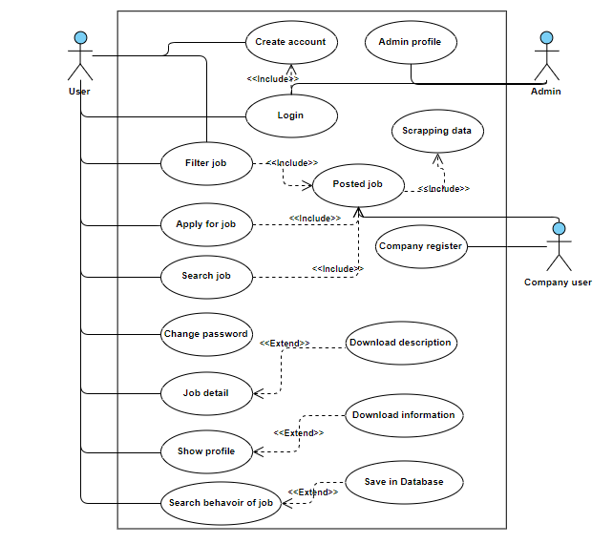
Figure 3-2: System diagram

User (Job searcher) Use Case Diagram
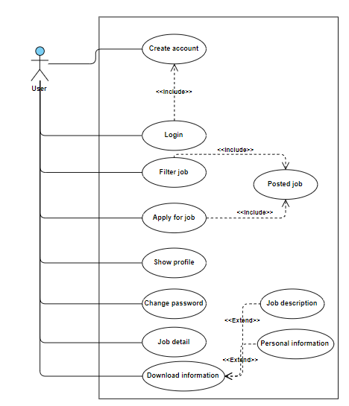
Figure 3-3 : Job searcher

: Company Use Case Diagram
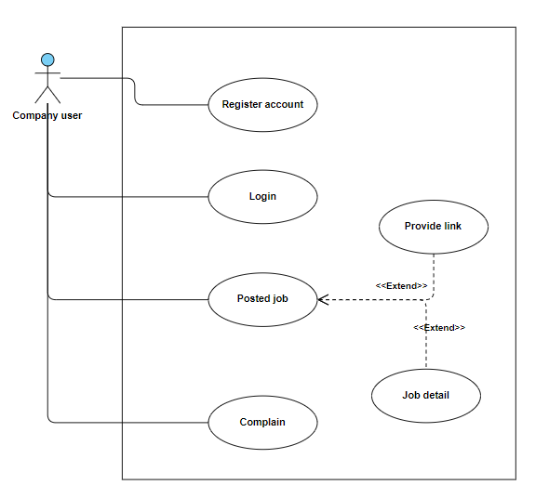
Figure 3-4 : Company Use case

Admin Use Case Diagram
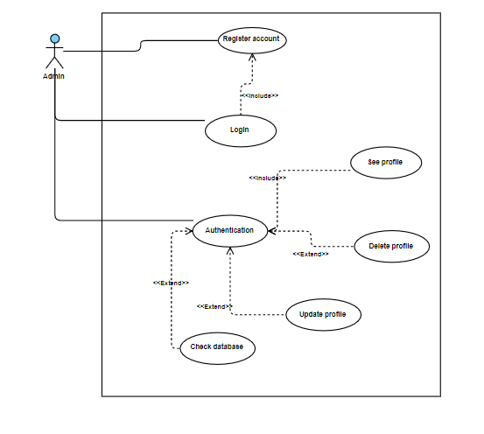
Figure 3-5 : Admin Use case

Sequence Diagram

Create account

User can create account on JRS by enter his/her information. User will register to JRS when the information successfully saved in database.
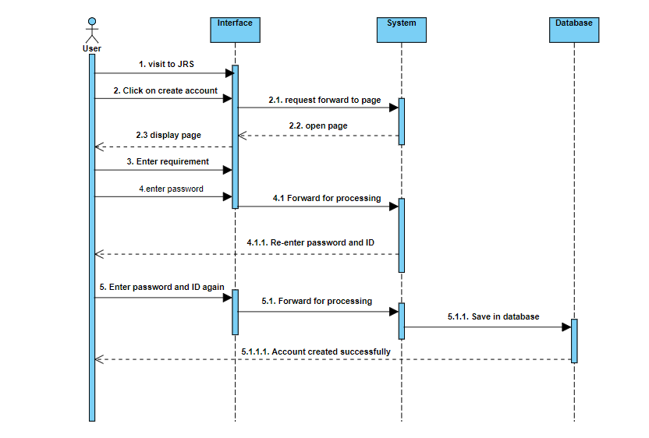

Figure 3-6 : Create account sequences

Login

User will login in JRS by providing their credential. The credential is verified from database that condition are valid or invalid.

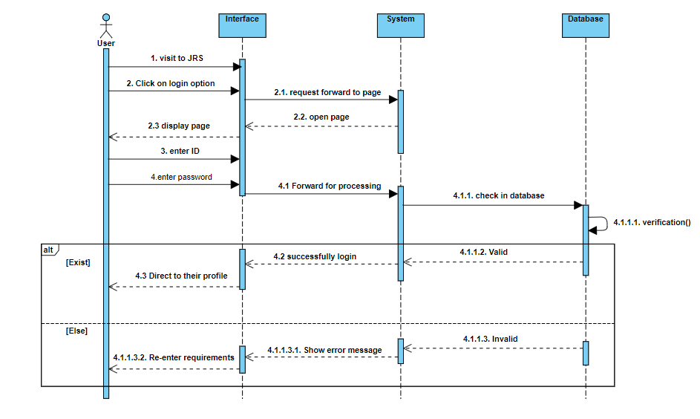
Figure 3-7 : Login sequence diagram

Apply For Job

User (i.e. Job searcher) apply for the job that have already created account. User apply for the job that are posted and verified from database that are valid or expired.
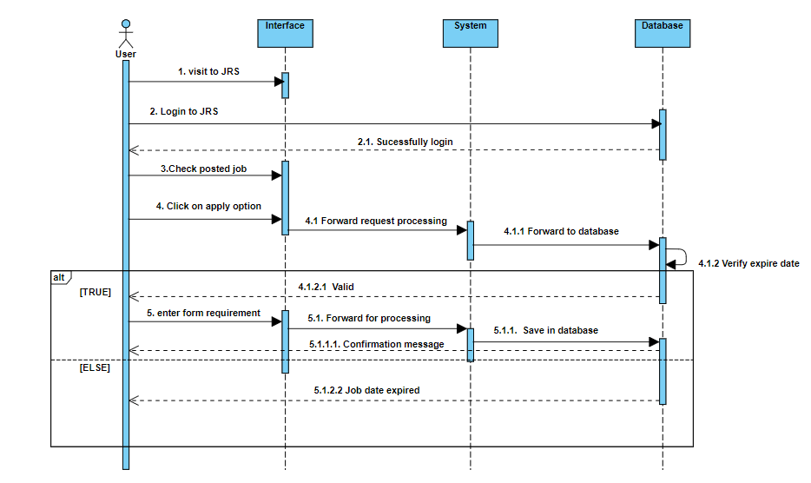
Figure 3-8 : Job apply sequence diagram

Logout

User logout by clicking the Logout Button fixed in navigation bar, the session will be destroyed and redirect user to main page.

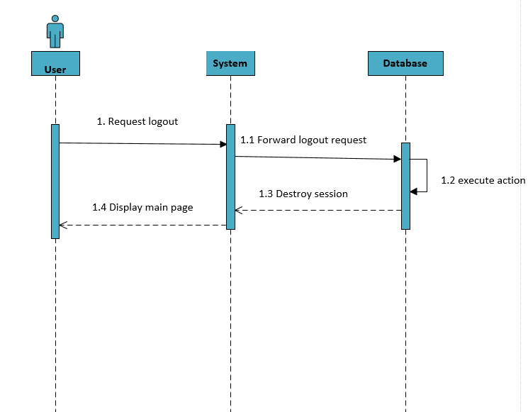

Figure 3-9 : LOGOUT sequence diagram

Forget Password

User click on forget password to set new password through Gmail by enter correct email address in new form.
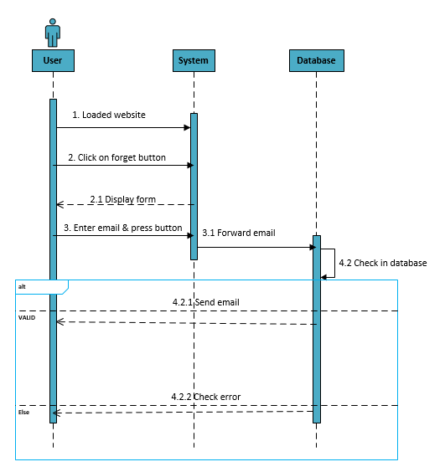

Figure 3-10 : Forget Password Sequence Diagram

Company Registration

Company create account by enter the required information available in form. On saving in database message will show the confirmation message.
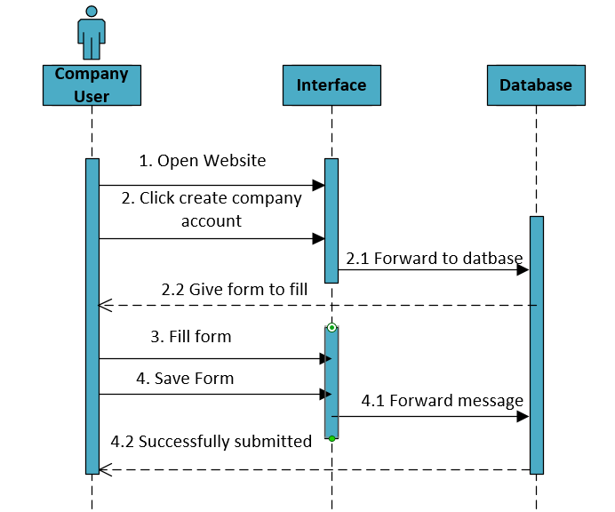
Figure 3-11 : Company Registration Sequence Diagram

Admin profile

Admin login to system by enter his/her credential and have the authority to update, delete and add information to JRS.
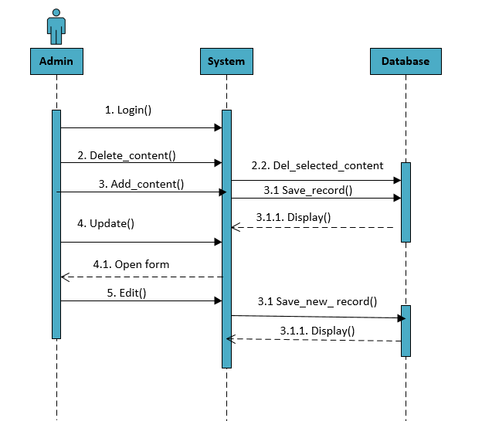
Figure 3-12 : Admin profile Sequence Diagram

Filtering Jobs

The JRS also provide the filtering option to search job through filtering. User (i.e. Job Searcher) insert requirements and click search button then system will verify from database.
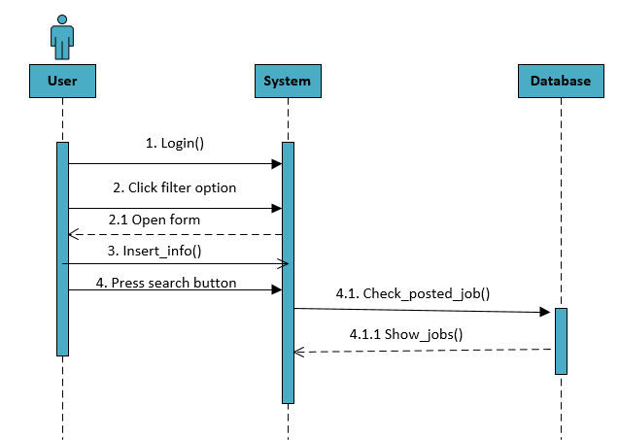
Figure 3-13 : Filtering job Sequence Diagram

Change Password

User (i.e. Job searcher or company user or admin) change their password by clicking change password option. Enter new password and submitted them.

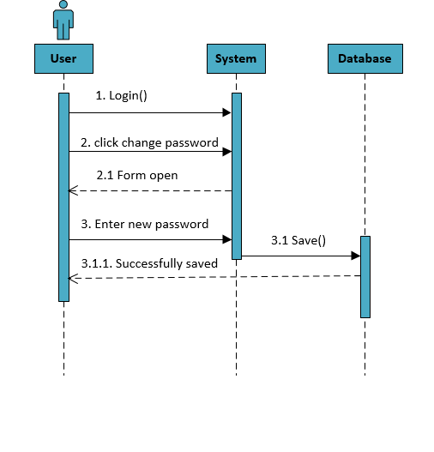
Figure 3-14 : Change Password Sequence Diagram

Show Profile

User login to JRS website and see their personal information by clicking show profile option.
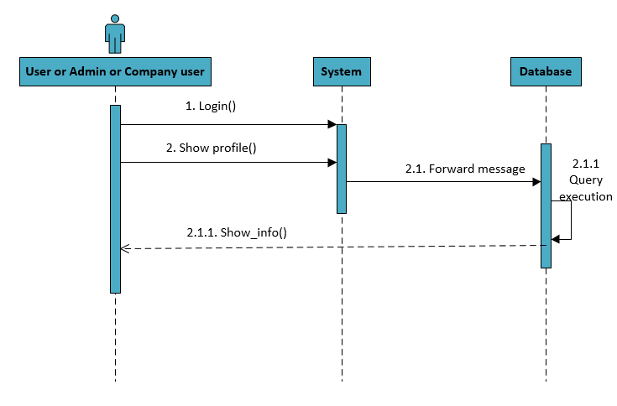
Figure 3-15 : Show Profile Sequence Diagram

Job Detail
User can check the job description of posted job by clicking the detail option present with posted job. Database will provide the detail information of posted job.
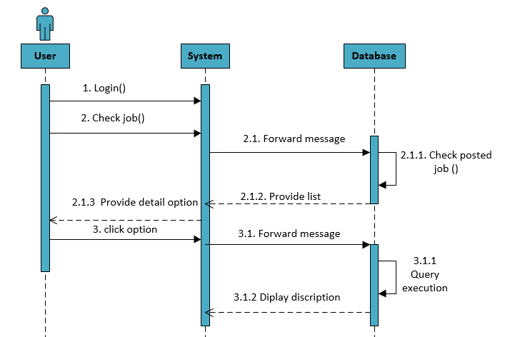
Figure 3-16 : Job Detail Sequence Diagram

Behaviour of Search Job

In this case system save the searching record of user (i.e. Job Searcher) in database. This user history is also used to access user interest and match with jobs requirements to recommend.
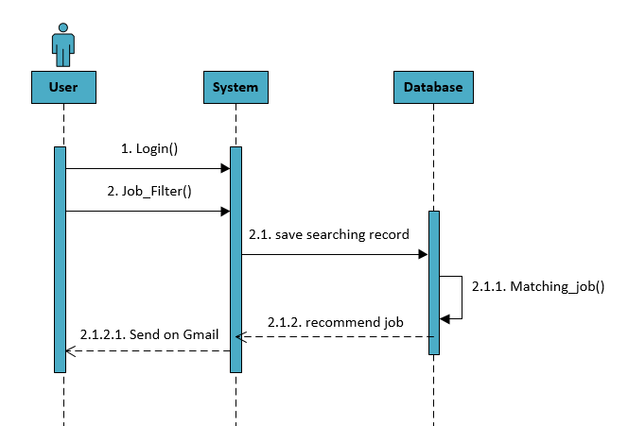
Figure 3-17 : Job Search Behaviour Sequence Diagram

Report Complain
User (i.e. Job searcher or Company user) insert complain in the text area and submitted them. Admin give response to user after receiving from database.
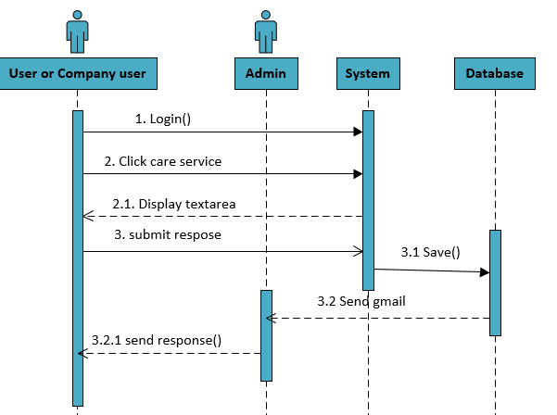
Figure 3-18 : Report Complain Sequence Diagram

Search for Job

The JRS website also give the search facility, user easily check job by using search bar. System check searched job in database.
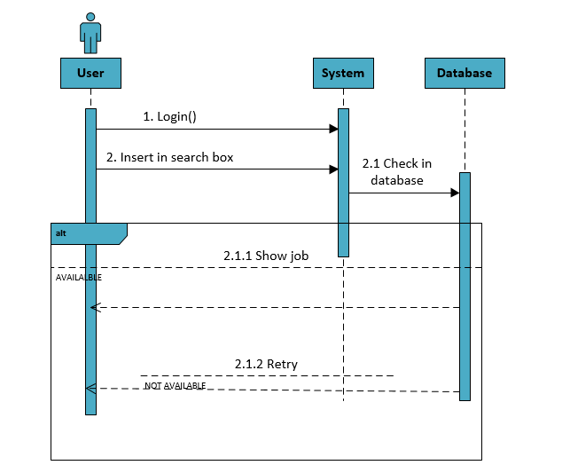
Figure 3-19 : Search for Job Sequence Diagram

Download job information

User can download the job description by the detail option where download button will be show and press the download button.
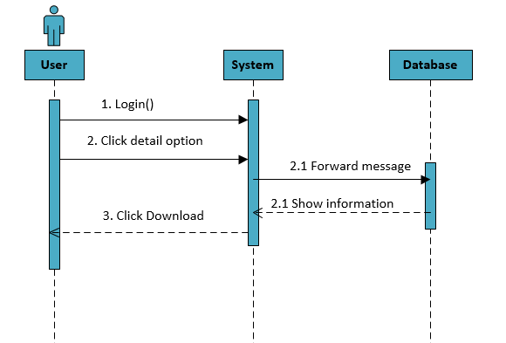
Figure 3-20 : Download job Information Sequence Diagram

Update profile

User also updated their profile by clicking update profile option and submitted a new opened form after enter required information. Updated information will be save in database.

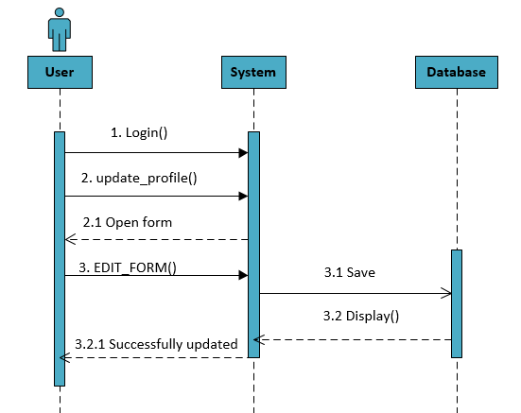
Figure 3-21 : Update Profile Sequence Diagram

CLASS DIAGRAM

Classes are the work-horses of the design effort—they actually perform the real work of the system. The other design elements—subsystems, packages and collaborations simply describe how classes are grouped or how they interoperate.
Active classes are design classes, which coordinate and drive the behaviour of the passive classes - an active class is a class whose instances are active objects, owning their own thread of control.

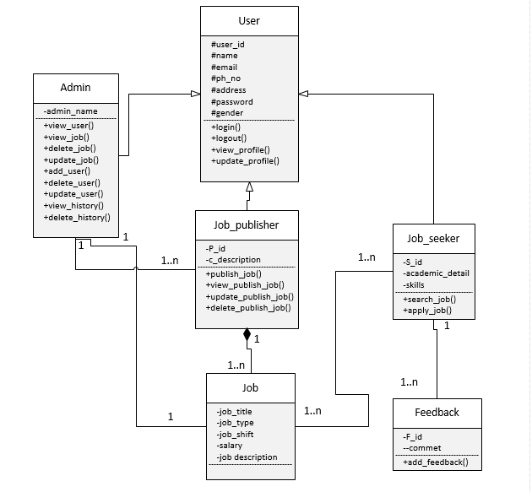
Figure 3-22 : Class Diagram

Data Model

The data model is a subset of the implementation model, which describes the logical and physical representation of persistent data in the system.

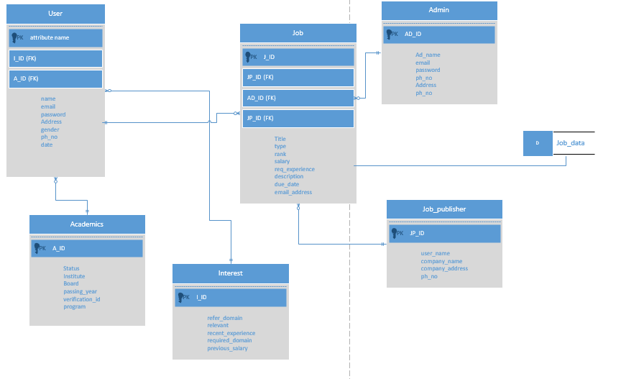

Figure 3-23 : Data Model

DATA AND EXPERIMENTS (and/or IMPLMENTATION)

Languages used

Following are the tools and technologies which will be used in his project

HTML

HTML stands for Hypertext Mark-up Language .It is the standard mark-up Language for documents designed to be displayed in a web browser. It can be assisted by technologies such as Cascading Style Sheets (CSS) and scripting Language such as JavaScript, JQuery, and JQuery UI
Version: HTML5

Cascading Style Sheets

It is used for the describing the presentation of a document which is written in Hypertext Mark-up Language. CSS is a foundation technology of the World Wide Web.

SQL
It is a standard language to communicate with the database. It is database management system
Version: SQL Server 2017

C#

C# is used as programming language in our project to develop the back end functionalities of the project

Python

We use python for 2 reason in our project which is listed below
- Python is used in our project to scrape the data from the different website like careerokay, mustakbil.com etc. Library used by the python to scrape the database is numpy, beautifulsoup, pandas, pyodbc
- It is also used to implement algorithm in our project for recommendation of the jobs to the candidate. Library used by the python to implement the algorithm part numpy, pandas, sys, stringIO , sklearn
Version: Python 3.7.4

JQuery

It is used for the DOM traversal and manipulation as well as event handling of the project. It also help to do CSS animation and Ajax manipulation in the project. It is develop on the top of the JQuery
Version: 3.4.1

JavaScript

It is used to control the website behaviour programmatically. We used it to scroll up and down of the website page.

Ajax

We use Ajax to send and receive the data from the server asynchronously without interfering with the display and behaviour of the existing page.

LINQ

It stands for Language Integrated Query is a Microsoft .NET Framework component. It is used to do data manipulation in the project e.g. update, delete, insert etc.

Framework

Bootstrap
It is an open source framework which is used to develop responsive website in our project
Version: 3

MVC

MVC stand for model view controller. It is design pattern which is used to develop the project.

Asp.net

It is open source server side language used to develop the back end of the project .Website is performing all the functionalities using this framework. It is developed by Microsoft
Version: 4.6.1

Tools
- SQL Management Studio 2017
- Visual Studio 2017
- Jupyter notebook
- Batch File
- Sublime Editor

RESULTS AND DISCUSSIONS (or USER MANUAL)

Opening Website of JRS (job recommendation system)
To open website type URL http://localhost:54840/Home/login in the browser. Website automatically load in the browser and show the dashboard
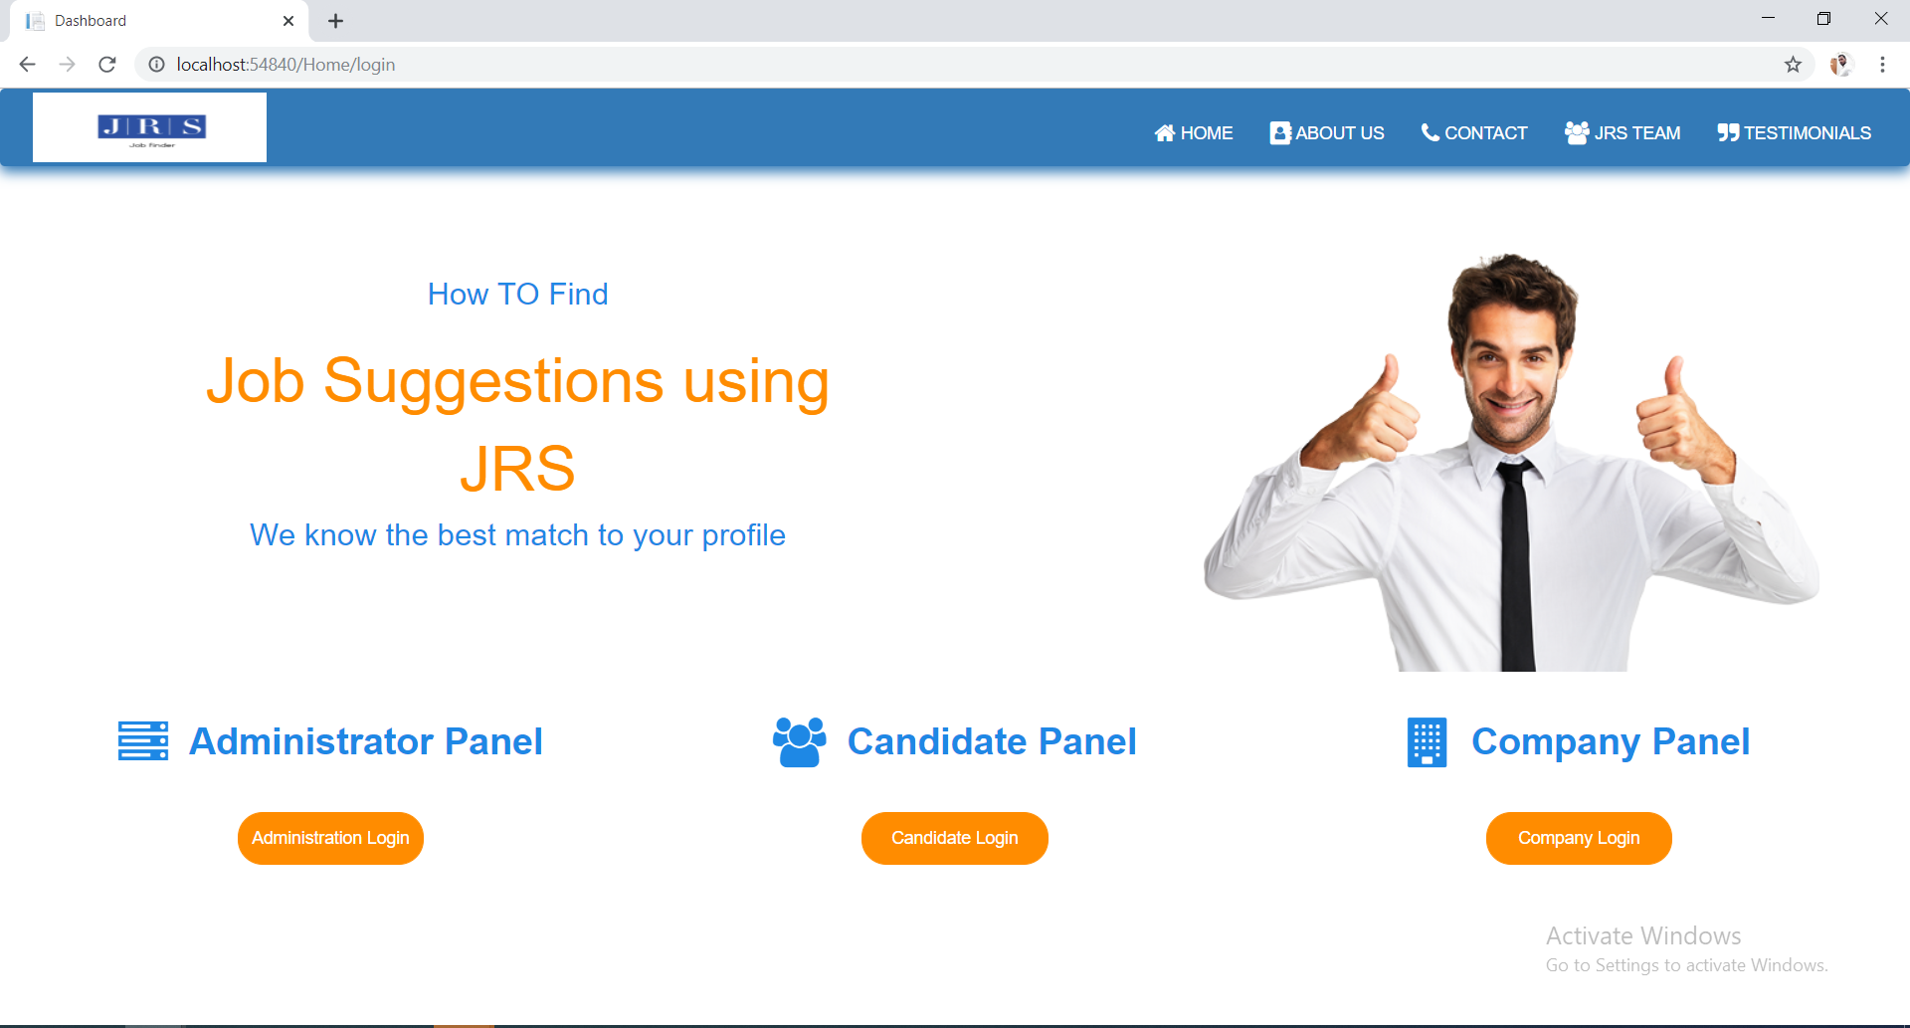

Figure 5-1 : Website of JRS

Contact us (job recommendation system)
When the click on contact tab at the navigation bar of the website or type URL http://localhost:54840/Home/Contact_US the website redirect to the contact us where user’s send us query or problems she/he faces during the experiencing of the website service or give this feedback
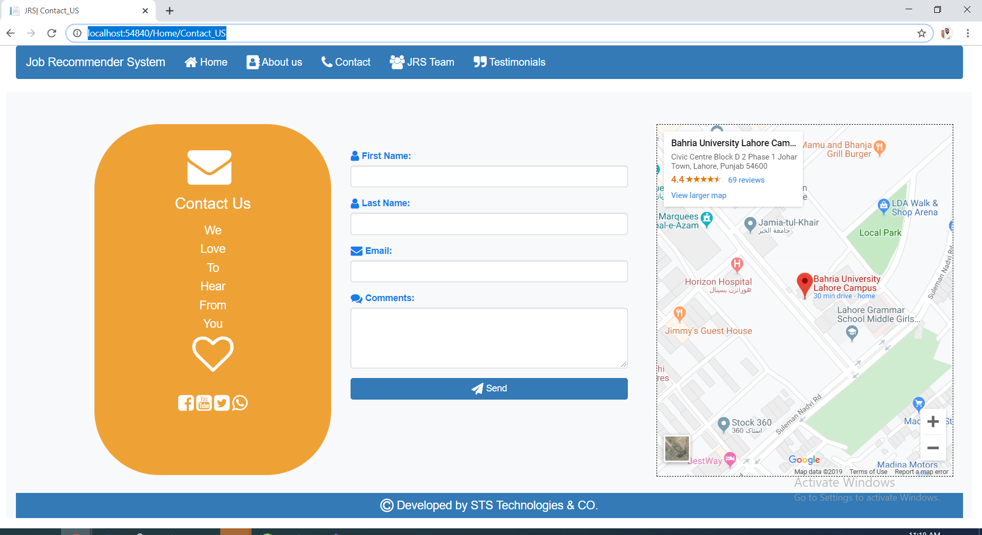

Figure 5-2 : Contact us page

Submitting a Coment to the website

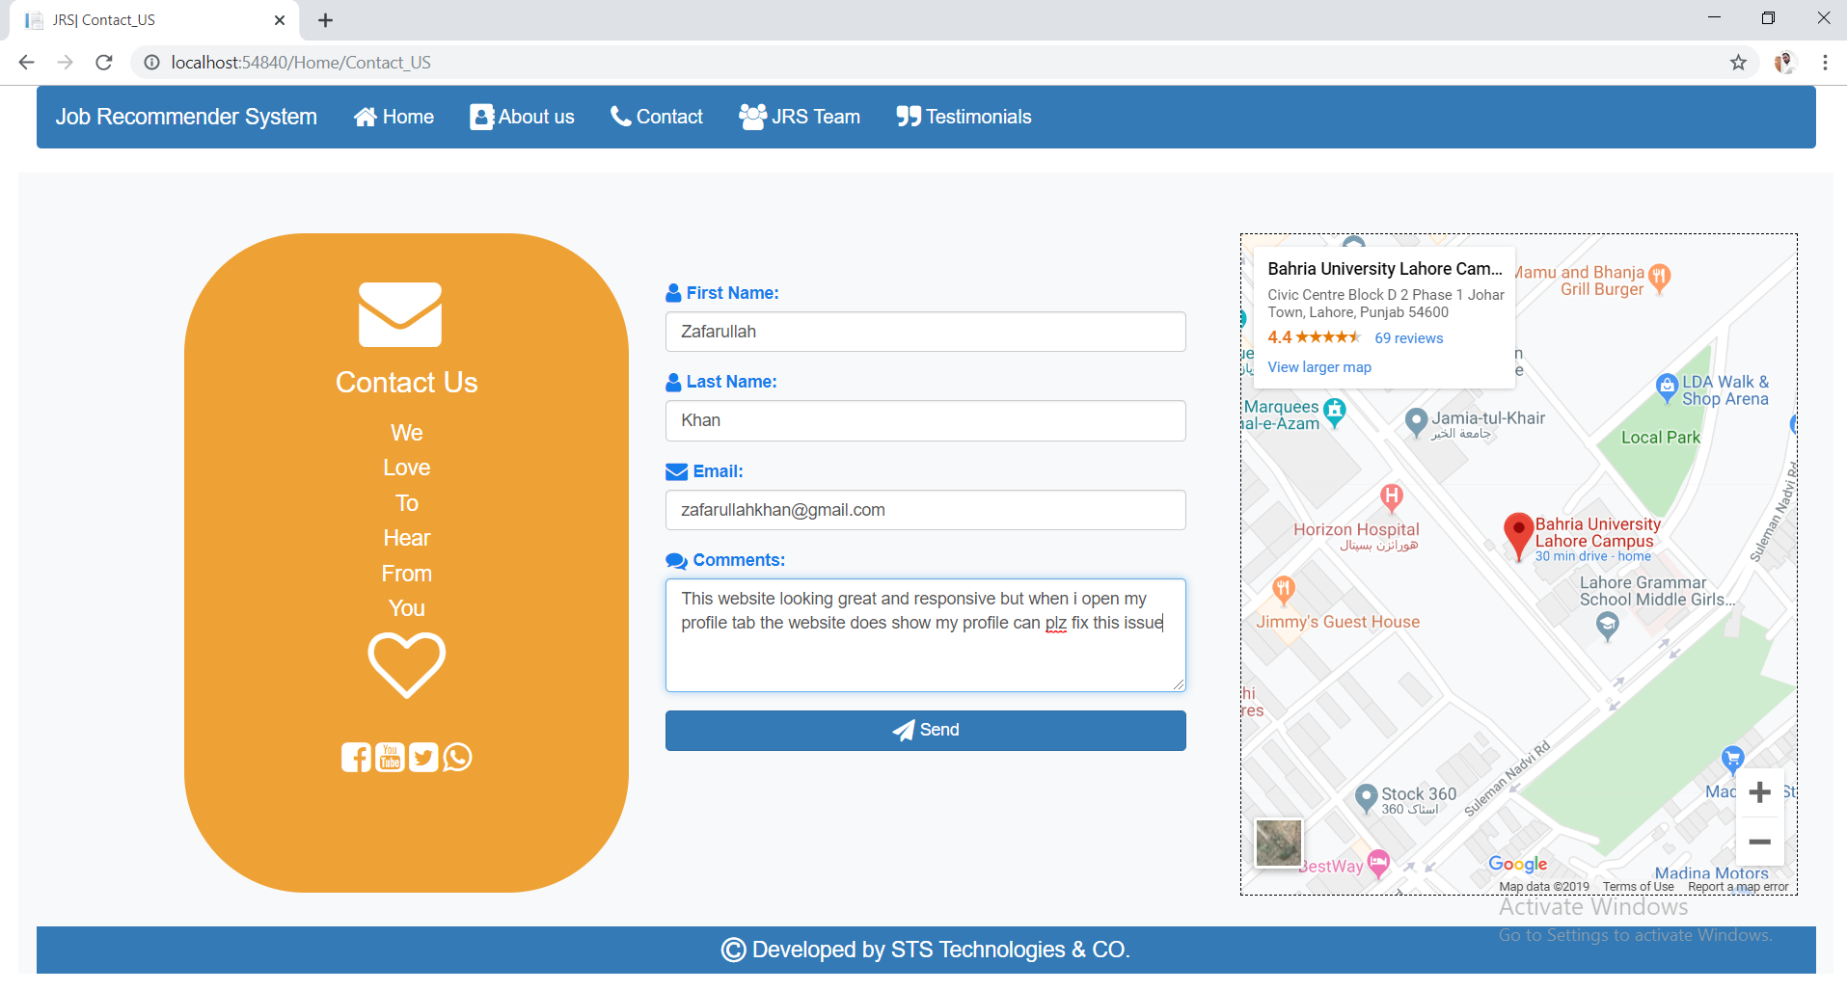

After submitting the comment website show a pop up to notify user the comment has been submitted
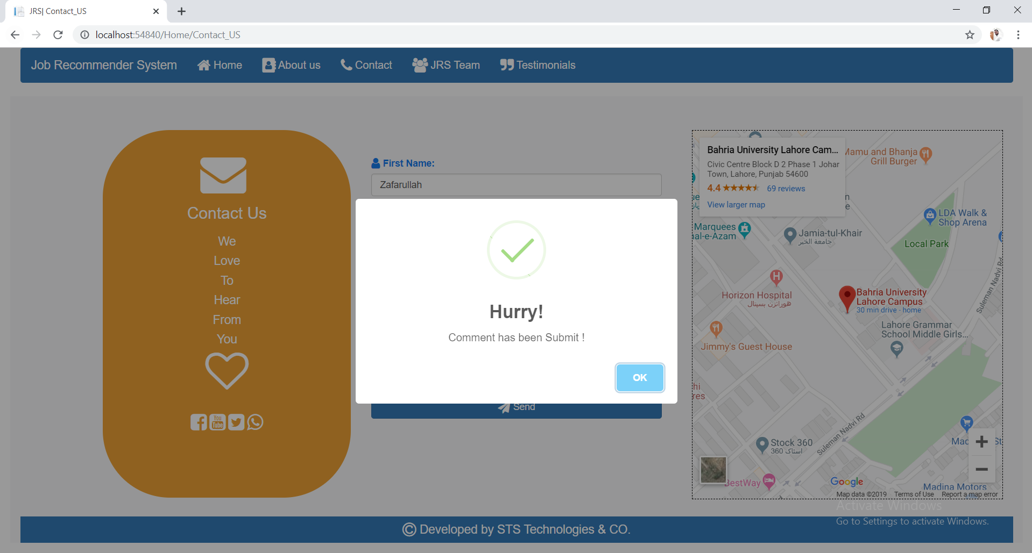

Admin received this comment on his email through which he/she reply the query of the user

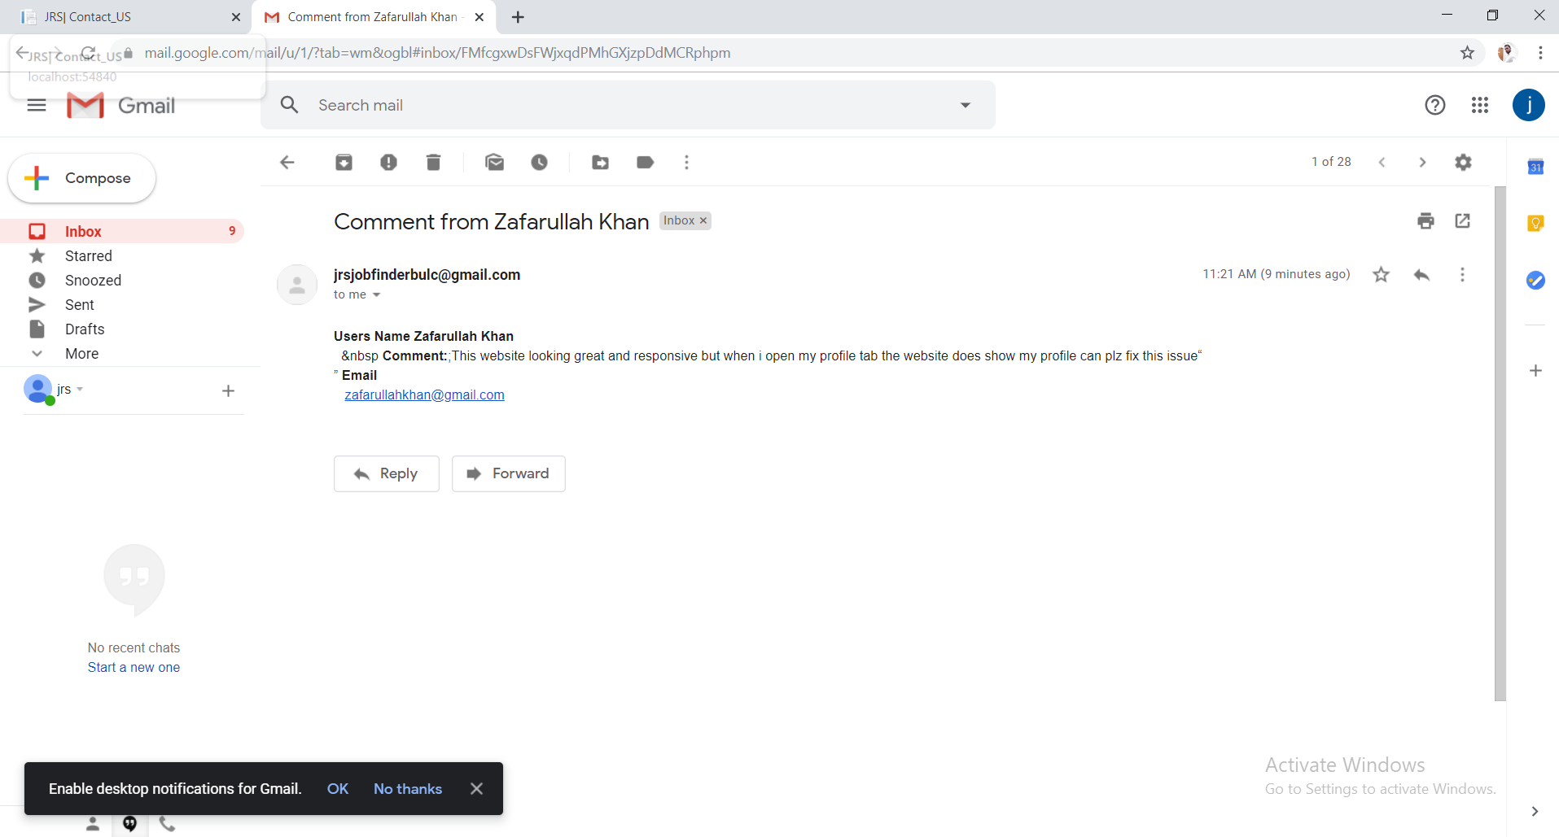

Figure 5-3 : Admin received email panel

JRS team (job recommendation system)
When the user click on jrs team tab at the navigation bar of the website or user type URL http://localhost:54840/home/Jrs_Team the website redirect to jrs team page where the user’s find the information of the team who are involve in this project throughout SDLC

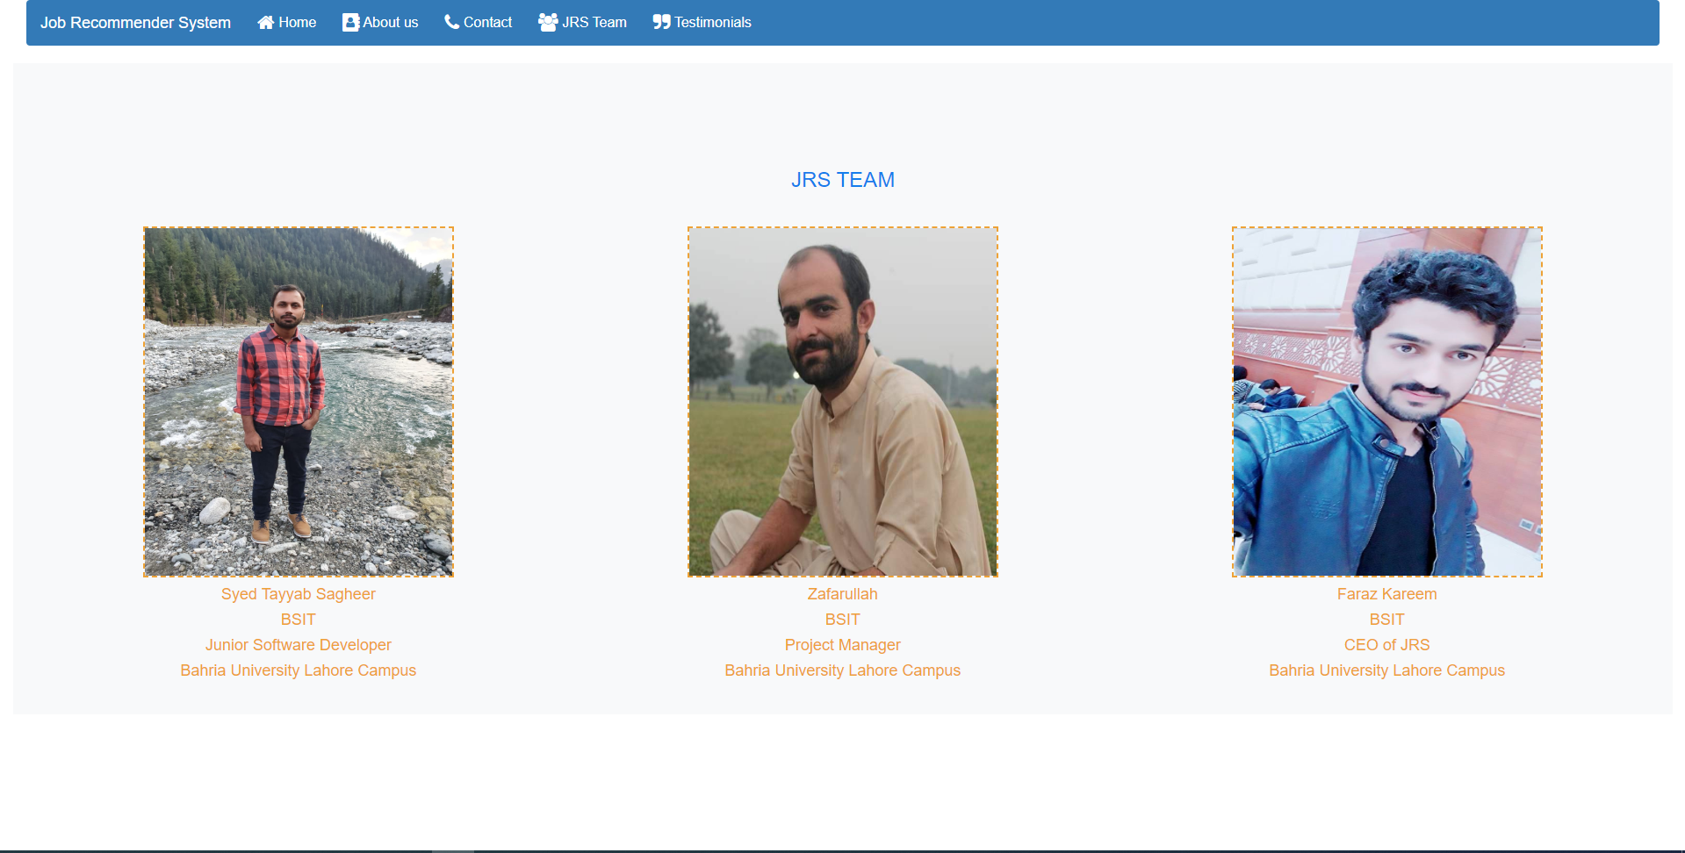

Figure 5-4 : JRS team

JRS (job recommendation system) Testimonials
When the user click on the testimonials tab at the navigation bar of the website or type URL http://localhost:54840/home/Testimonials the website redirects to testimonials page where the he/she find reviews about the website from the people using the website and feel good

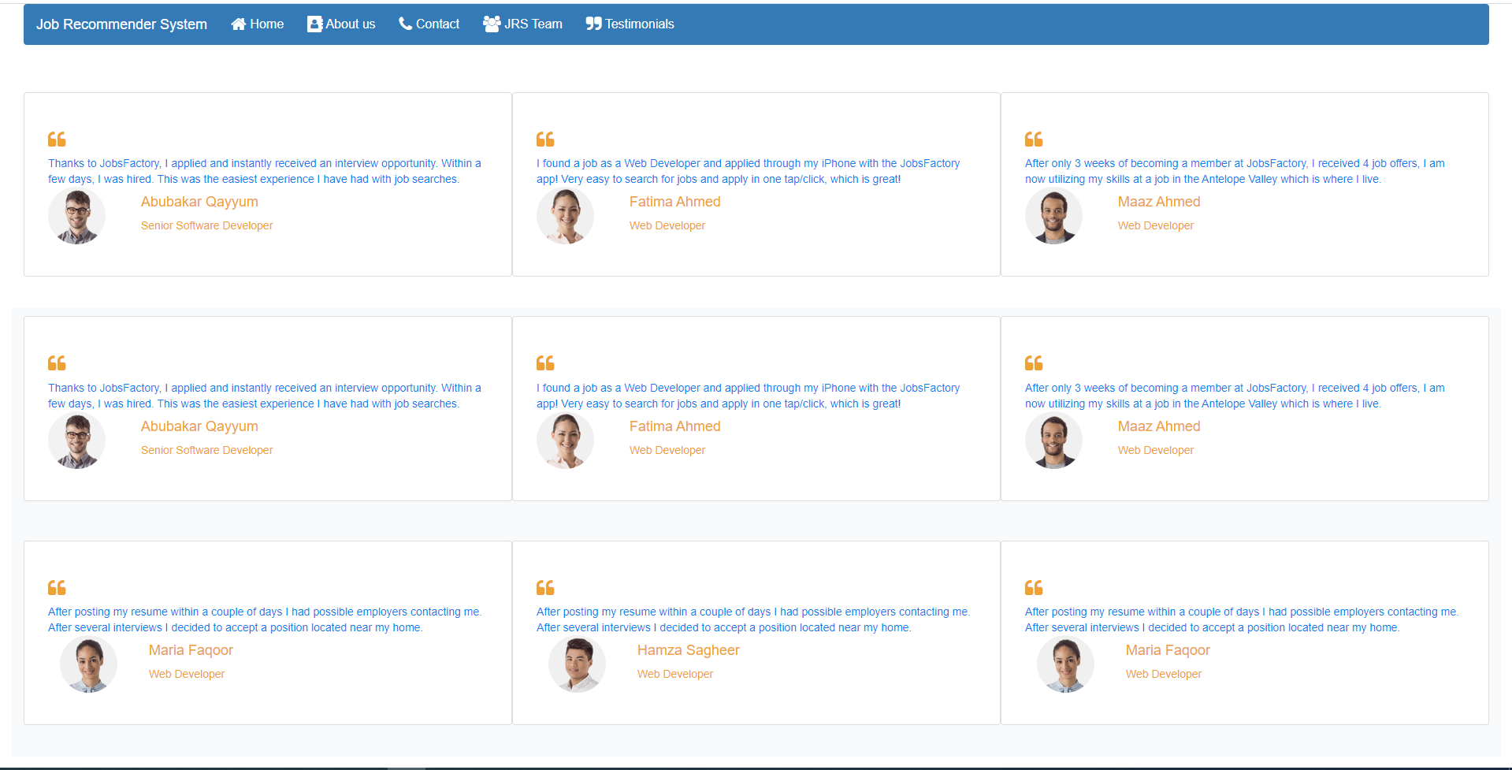
Figure 5-5 : JRS testimonials

JRS (job recommendation system) Login Panel
The website contains 3 panel of the login as it divide into three role
- Candidate
- Company
- Admin
When the user click on the button (Candidate Login) and type URL http://localhost:54840/Candidate/Candidate_Login_Page the website redirect to the candidate login panel where the candidate login into the website

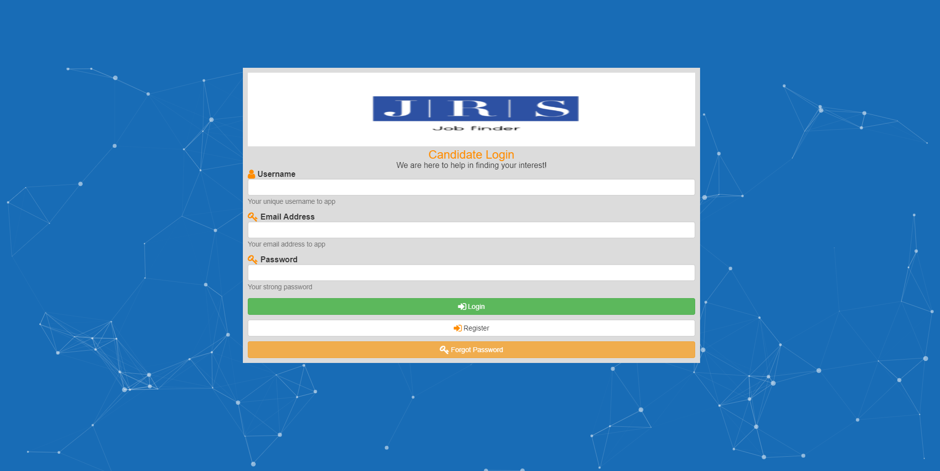

Figure 5-6 : Login Panel

When the user click on the button (Company Login) and type url http://localhost:54840/Company/Company_Login_Page the website redirect to the candidate login panel where the candidate login into the website
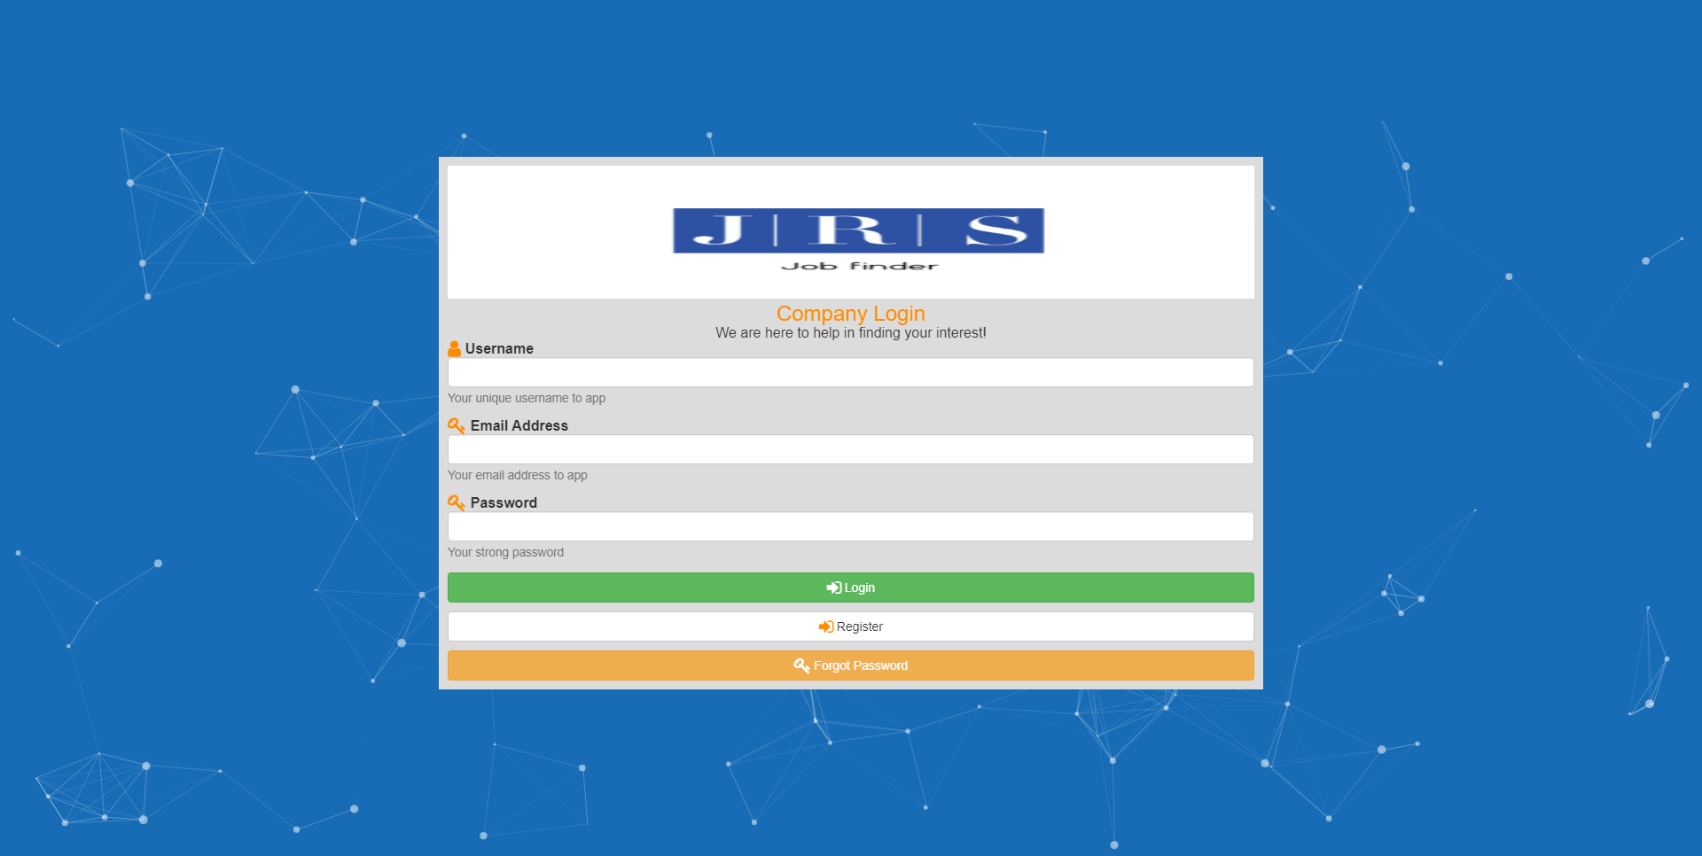
When the user click on the button (Admin Login) and type URL http://localhost:54840/Admin/Admin_Login_Page the website redirect to the admin login panel where the admin login into the website
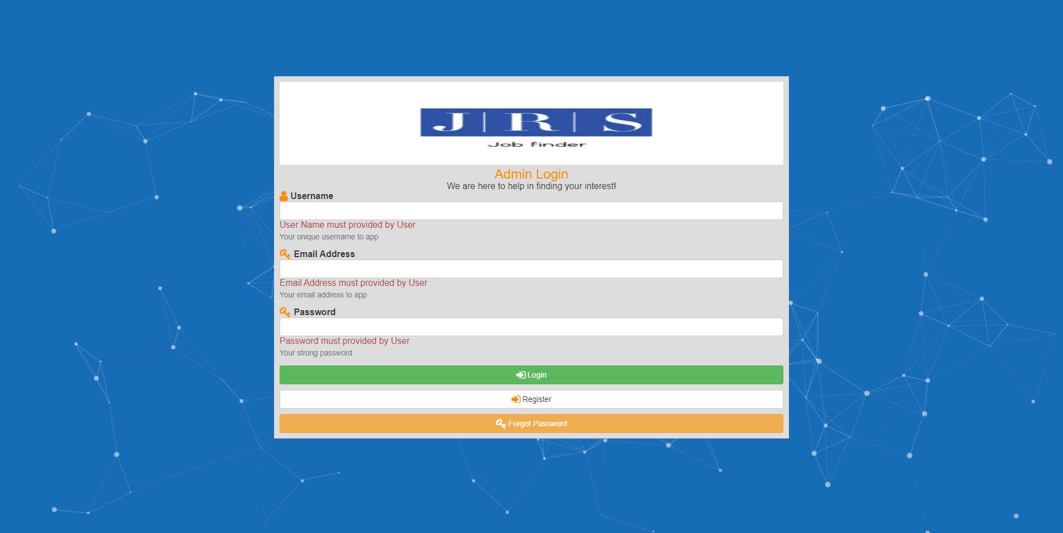

JRS (job recommendation system) Candidate Panel

When user enter the right credentials the website redirects to the candidate dashboard if the validation fails the website redirect to the login page where the user find the validation error

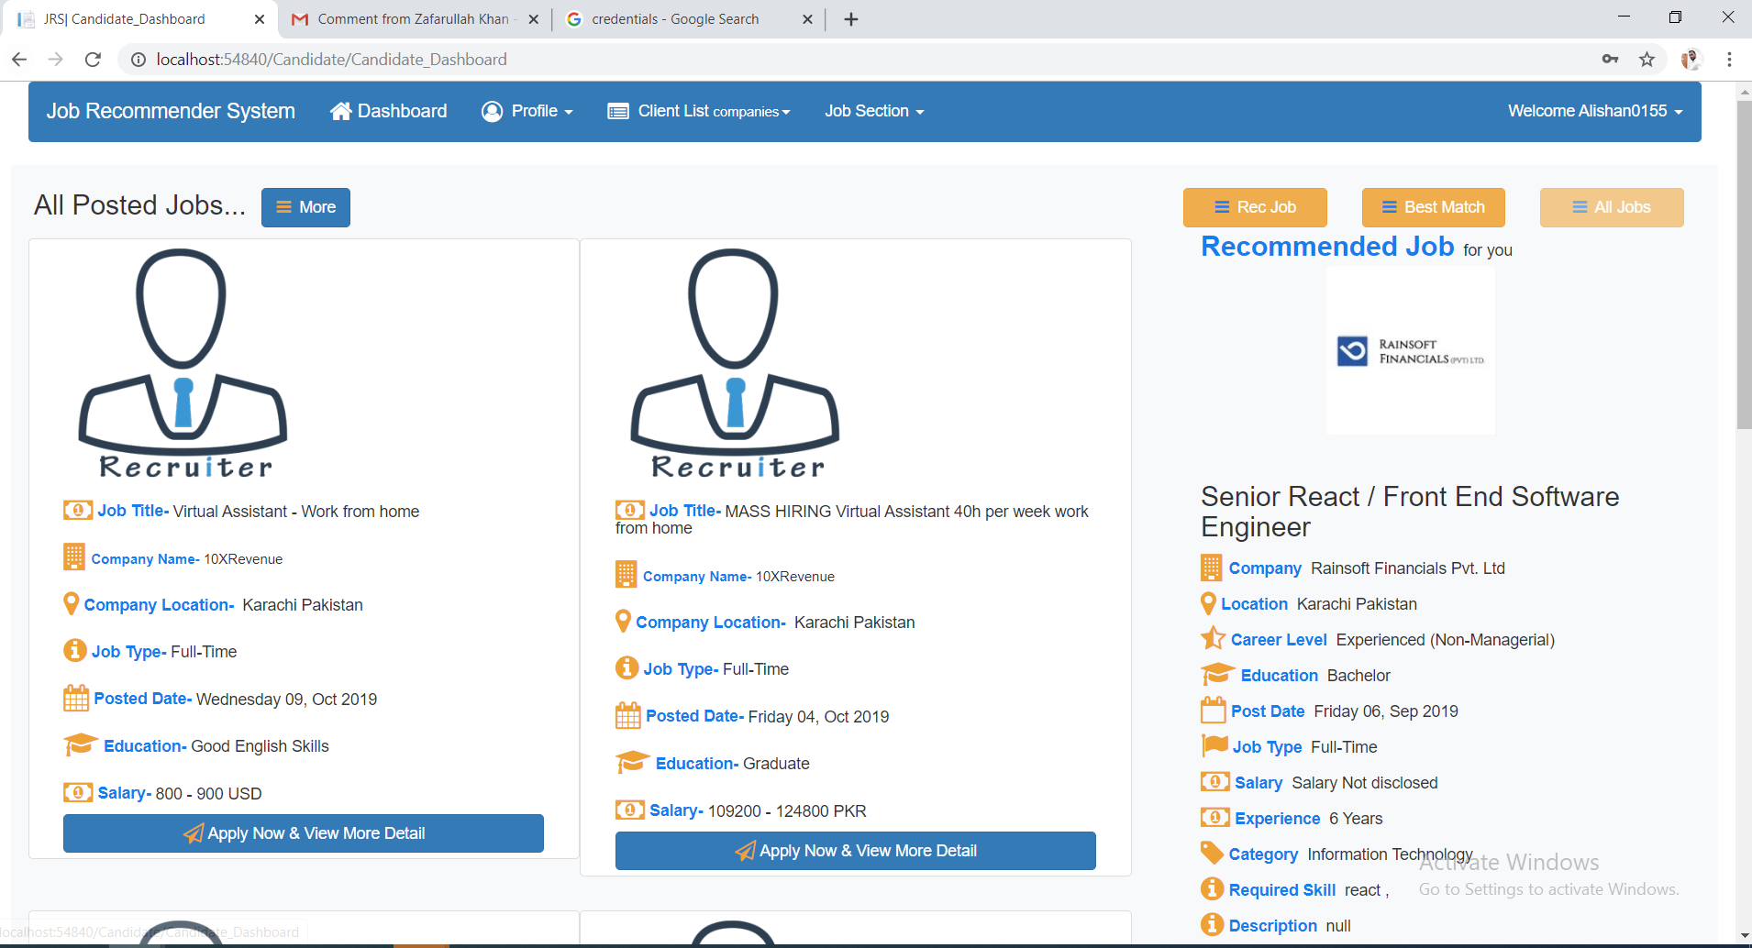
Figure 5-7 : JRS candidate panel

Dashboard is personalize to the user desire which he/she give while making the profile of the candidate
Dashboard contains 3 options
- Recommended Jobs
The website send the skill set of the user to the algorithms after that algorithm predicate the category in which user lies after that website matches the category to the categories match to the user.
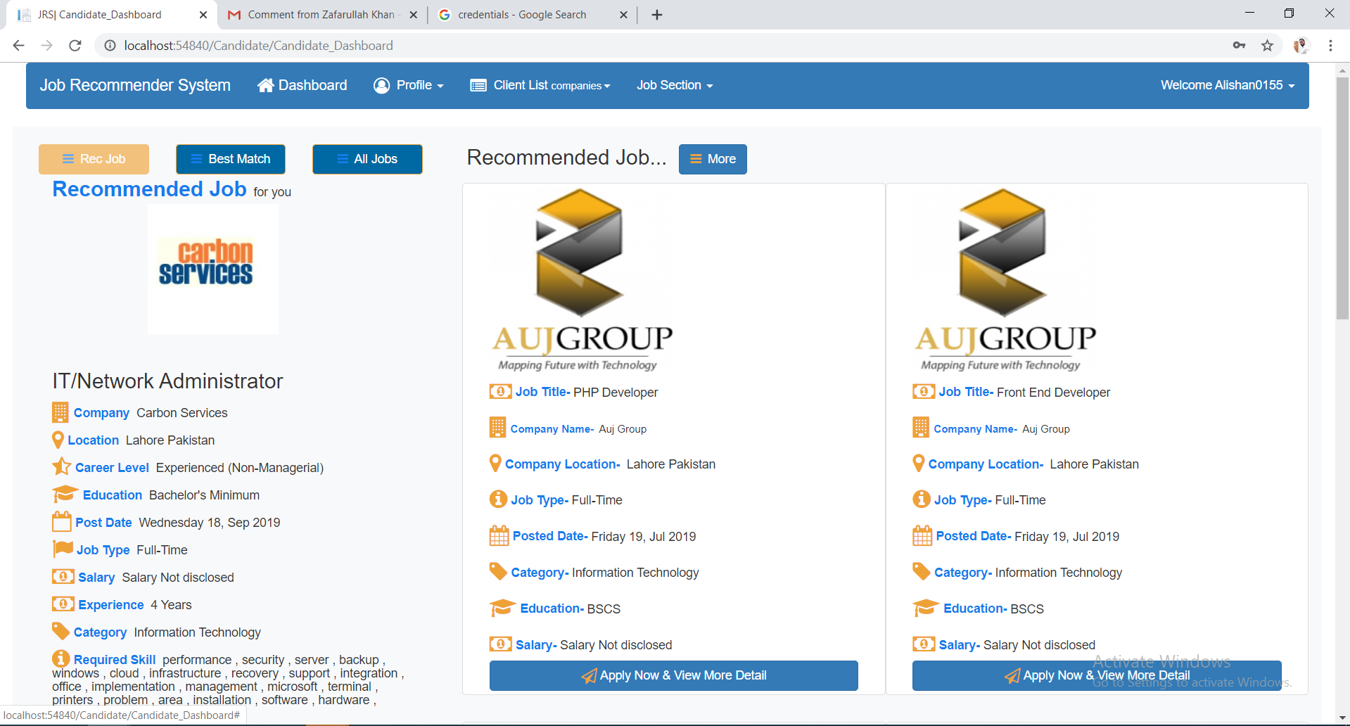
Figure 5-8 : Recommended jobs

- Best match Jobs
The website match the location and category as well as experience of the user to the jobs available to website and show the jobs which are best match to the user profile

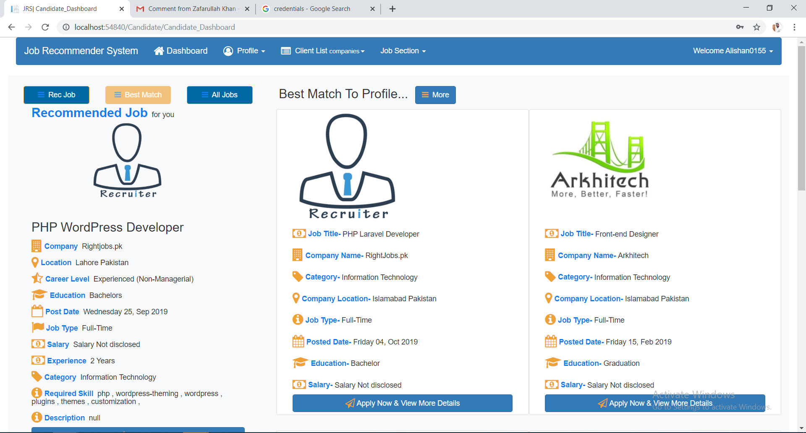
- All post
It show all jobs the website database contains on the main page

Figure 5-9 : ALL JOBS

View Profile of Candidate

When the user click on the profile a drop down
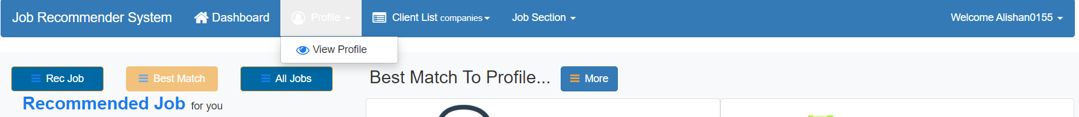

User click on the view profile or type URL the website the user to his profile page of the user where he/she view his information
URL: http://localhost:54840/Candidate/View_Profile_of_User

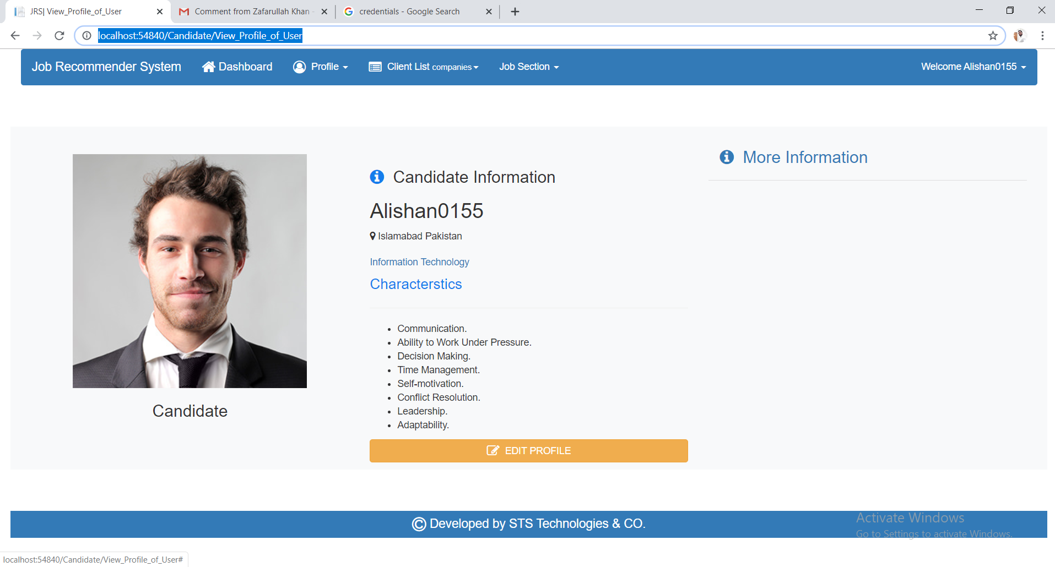

When the user click on more information the website show drop and user will see all his information which he /she give while making profile
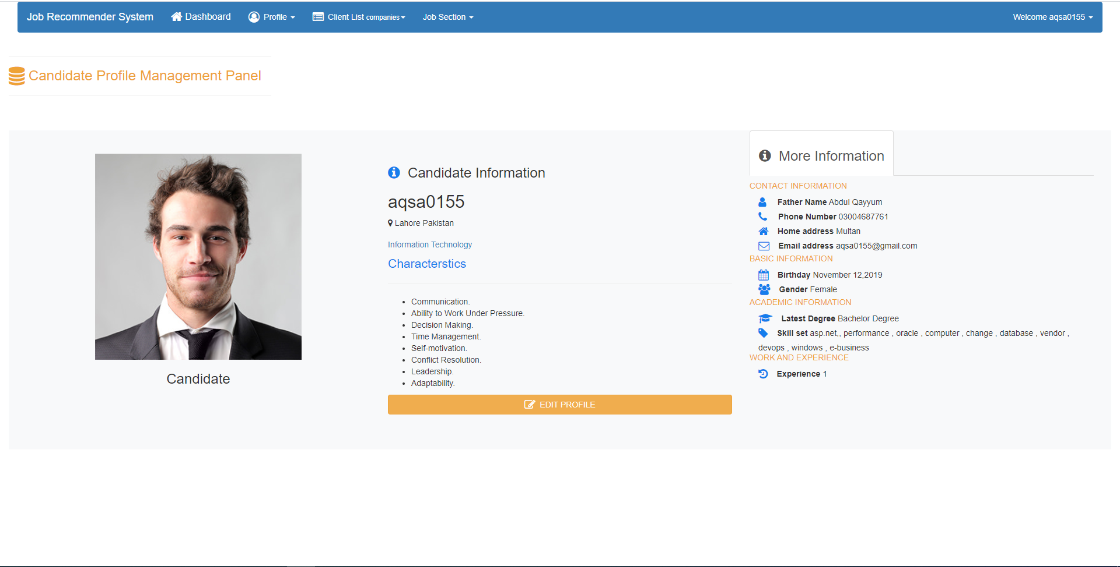

Figure 5-10 : Candidate profile

Edit information of Candidate Profile

User can edit his information while clicking on the edit button and type URL http://localhost:54840/Candidate/Edit_Profile_of_User website redirect to edit information page where user can edit his information

When the website update the information of the candidate it show all that information is update and redirect to the dashboard to that algorithms runs again

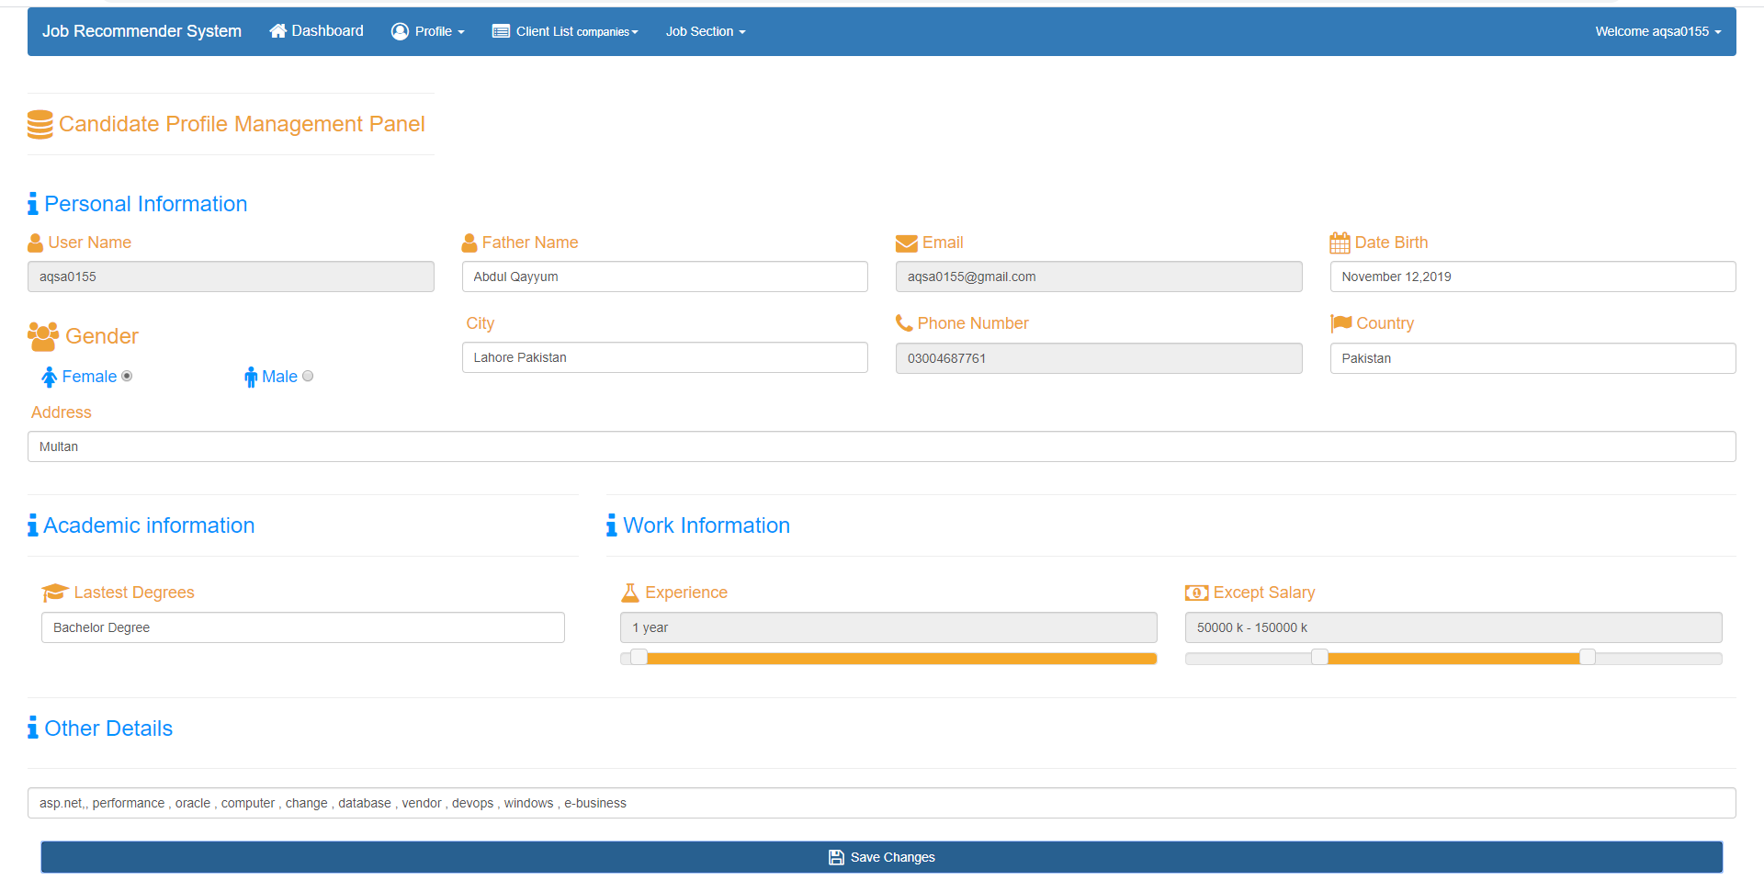

Search Job using filter
User can search the job using filters in the website also by click Job section a dropdown show where the user select the view all jobs or user directly go to the page using url http://localhost:54840/Company/View_Posted_Job

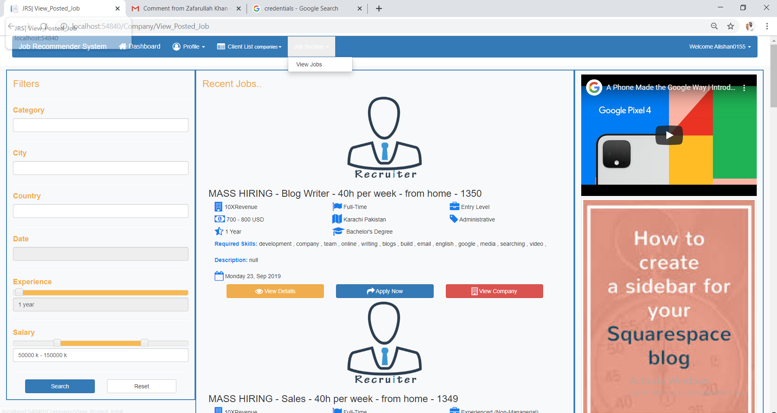
Figure 5-11 : Jobs filtering

when the user click search using filter and did not fill the category field website show pop up showing kindly fill the fields

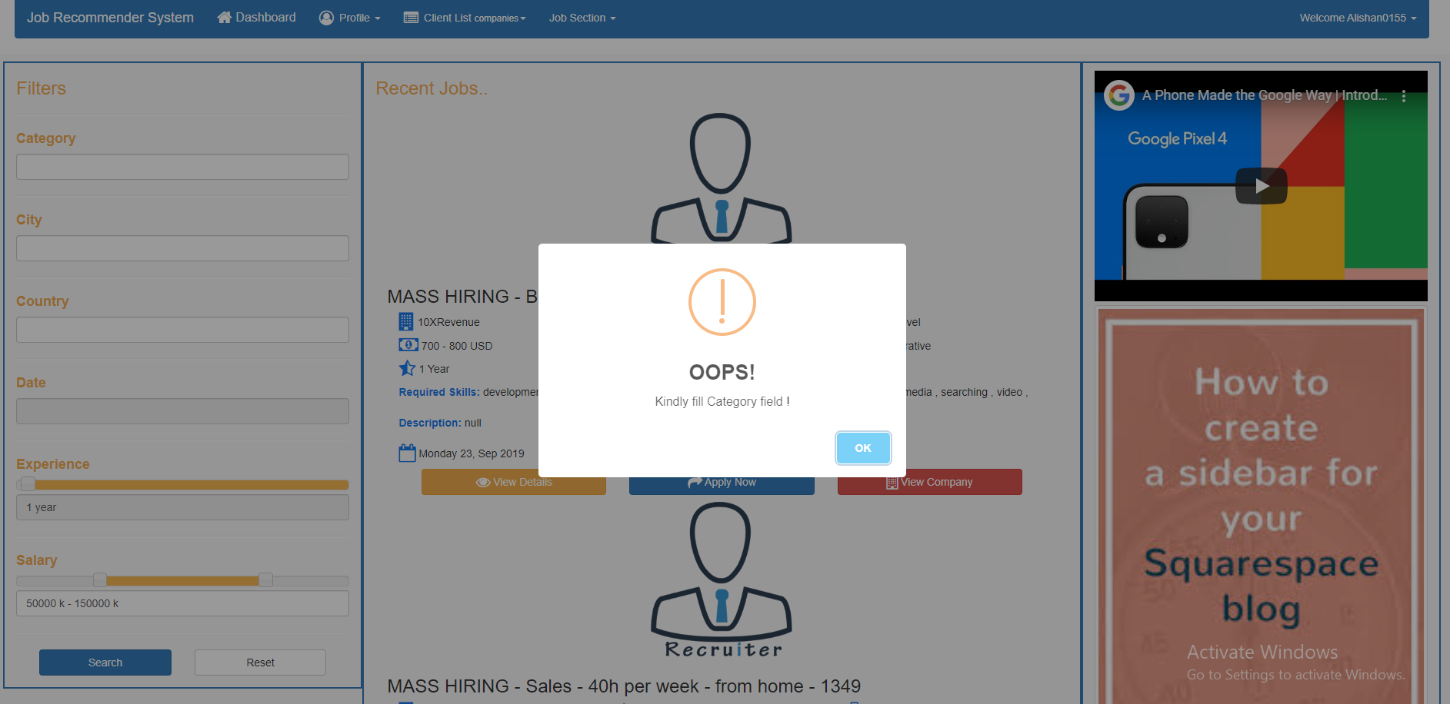

When the fill the category field and then search all the job that match the filter will show in the right of the website
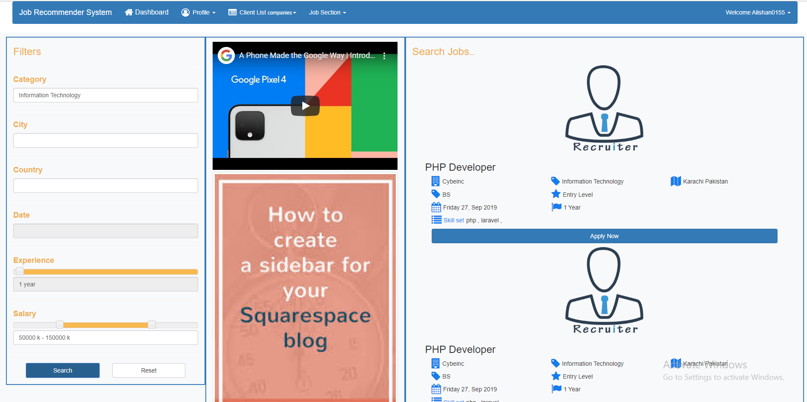

Figure 5-12 : recommended Jobs after filtering

Apply for job
When the user click on the apply job button the website redirects to the link from where the job is scrape so that user can apply their and if the company is register with us then we take CV from the user and email that CV to the company email

Apply for Scrapped job
When the user click on apply button it automatically redirect to that website contain that job

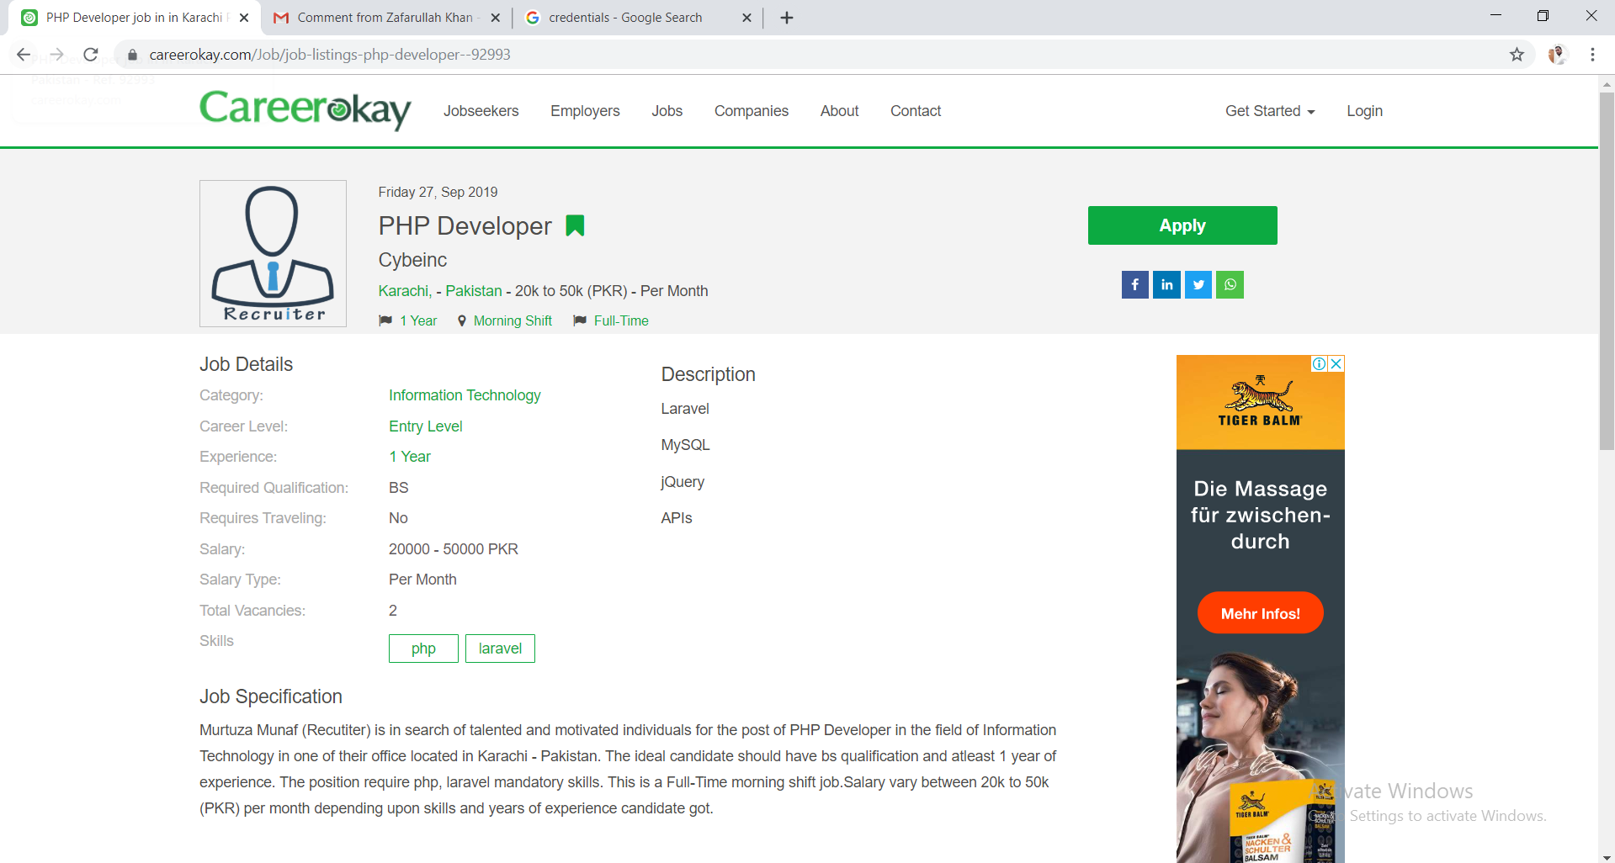

Figure 5-13 : Apply for jobs

View Detail of Job & Company
When user want to view more detail about the job and company he/she just click on the buttons at the end of the each post


Figure 5-14 : Job & Company detail

View Detail of Job
If the user click on the view details of the Job. The detail of that job show in the right side bar of the page view post

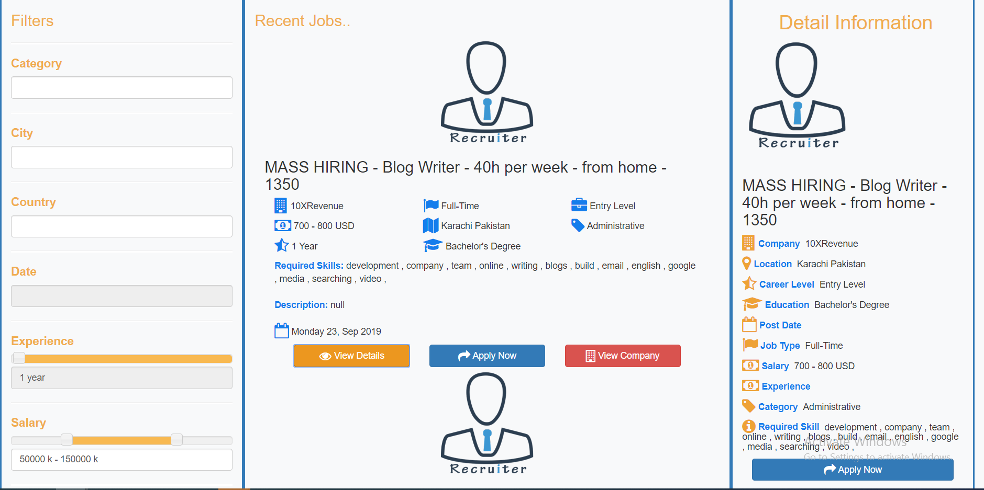

Figure 5-15: Job Detail

View Detail of Company

If user click on the view detail of the company the detail of the company show in the side bar of the view posted page like detail of the job

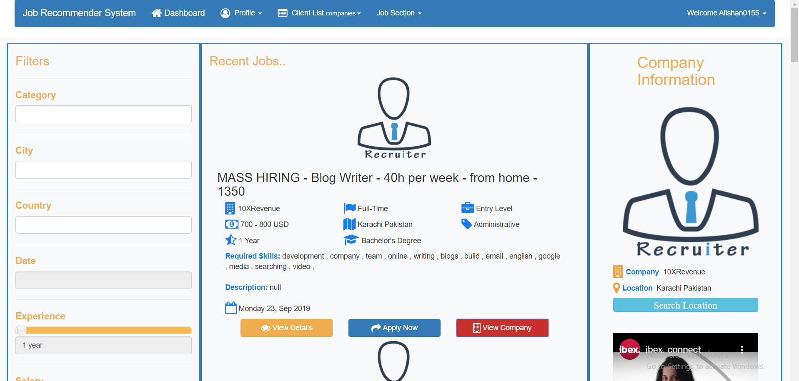
Figure 5-16: Company Detail

If user want to view location of the company he/she click on view location website use Google map he direct to the location where the company is situated

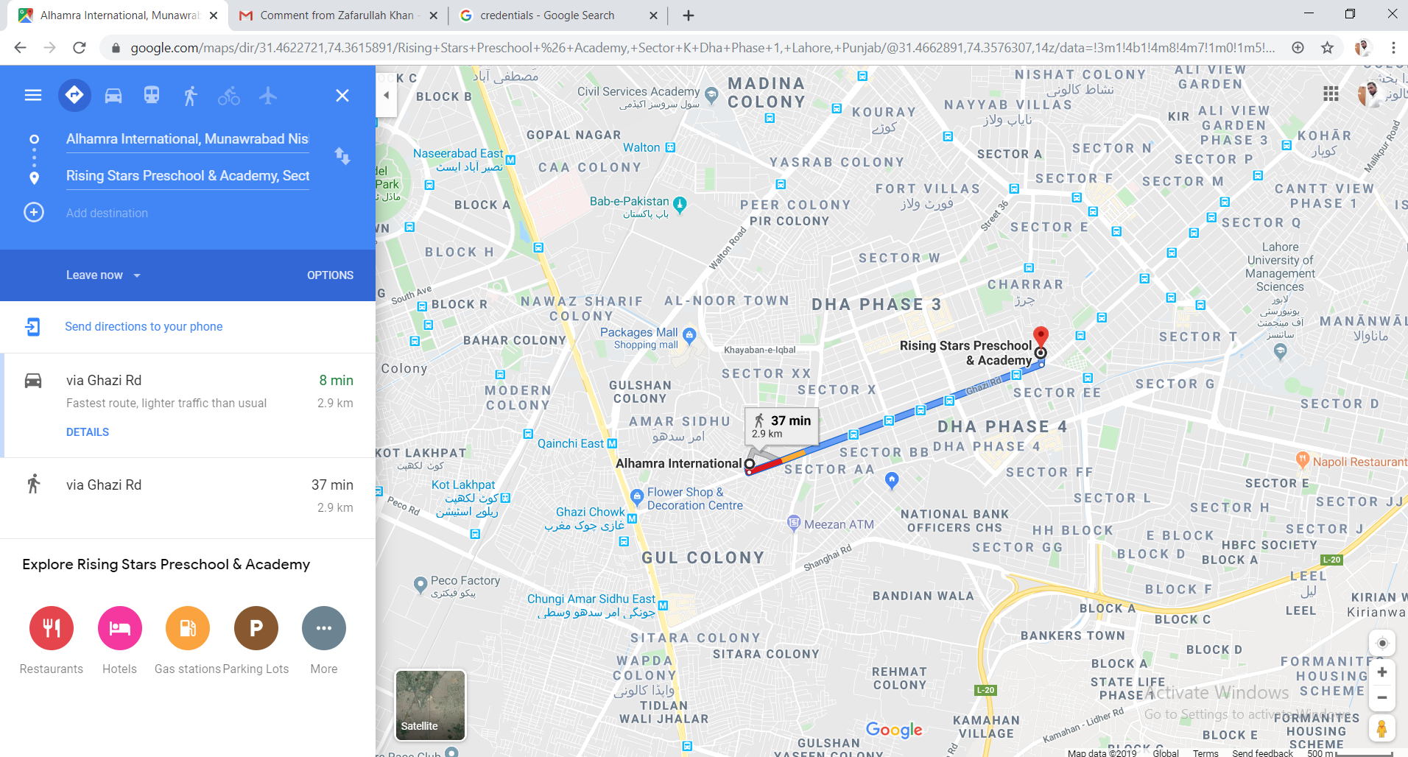

Figure 5-17 : Google Map

View List of Companies
User can also see the companies at our panel or the companies jobs we are showing at our website by just clicking on the client list option a drop down shows where the user select companies or type URL http://localhost:54840/ListCompanies/ListCompanies
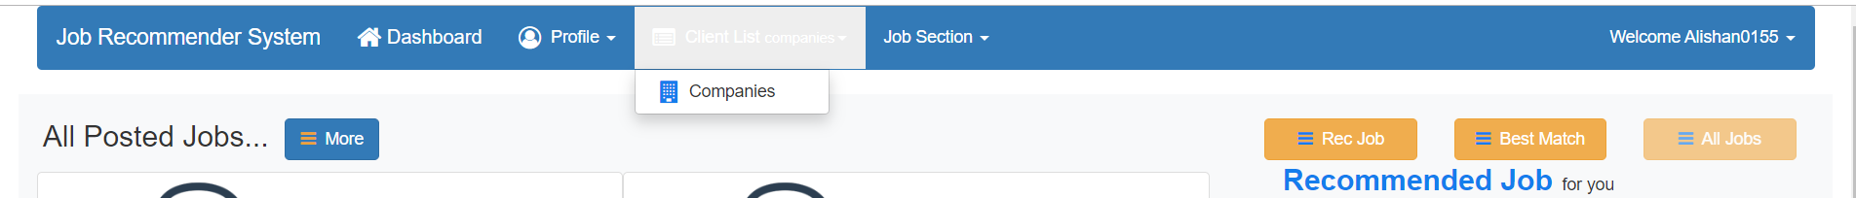

List of the all the companies at our panel if the user want to see more he/just click on the more button and if he want to search about the companies he/she click on the companies picture

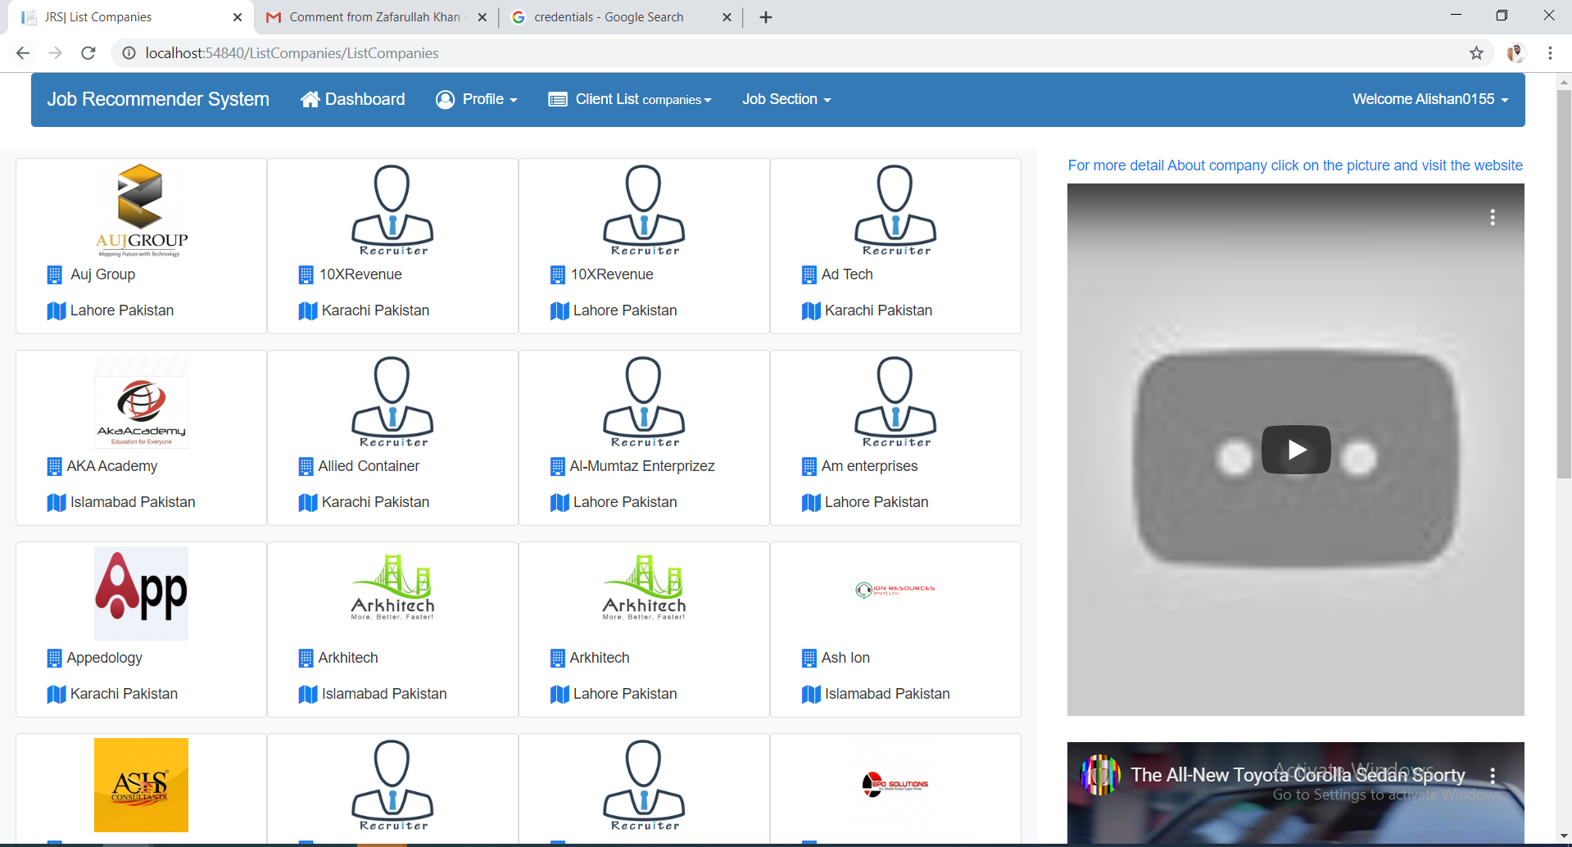

Figure 5-18: List of Company

Search about company click on the picture of the company
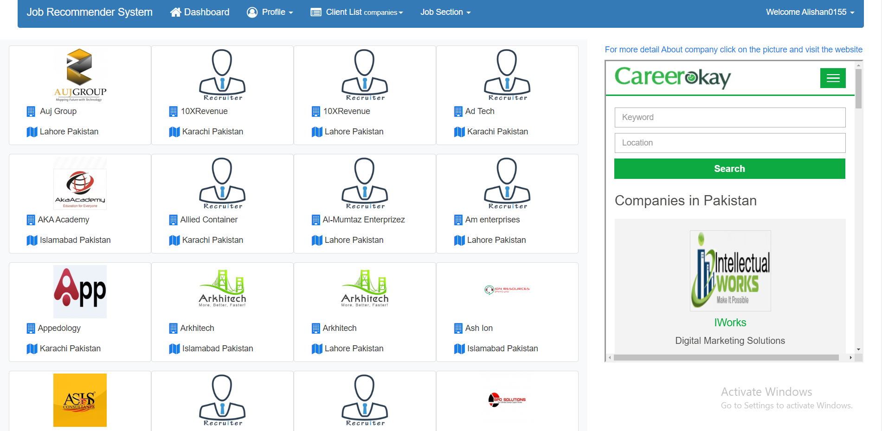

Figure 5-19 : Search of companies
It show the website from where we just fetch these jobs so you can go there find out what’s going on

Logout
User can logout from the website by just click on the drop showing name and click on logout and the user redirect to the Login Panel
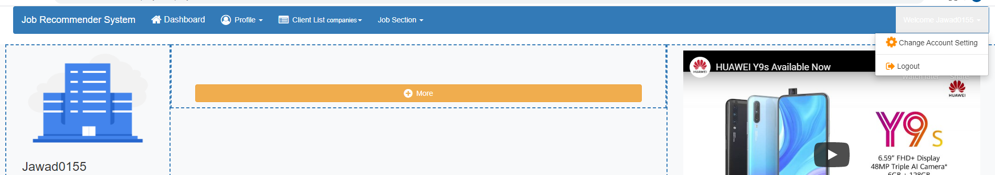

Sign up
User can register to the website by click in the register button of their desire panel e.g. if user want to register himself/herself to website he go to his desire panel e.g. Candidate Login and then click on register Button

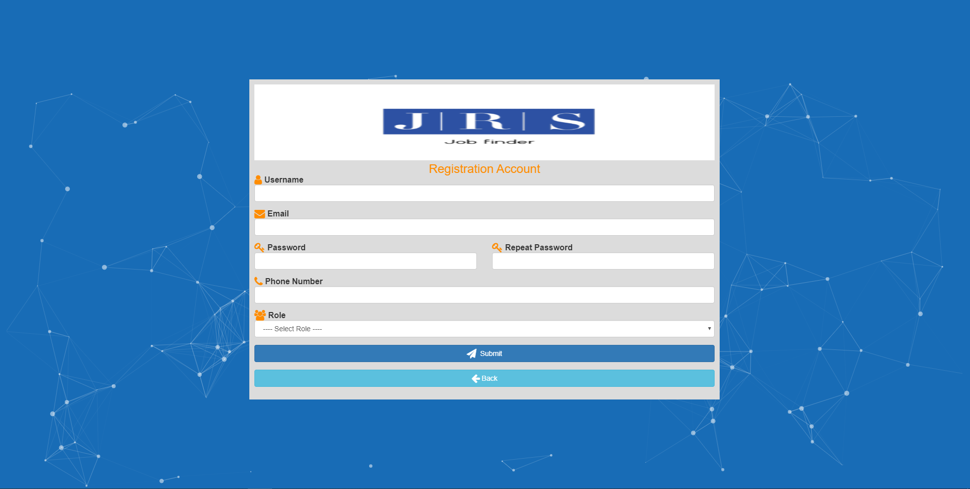

Figure 5-20 : Sign up

Note: While filling the form carefully select the your role

After filling the credentials submit it and the website redirect the user to the home page
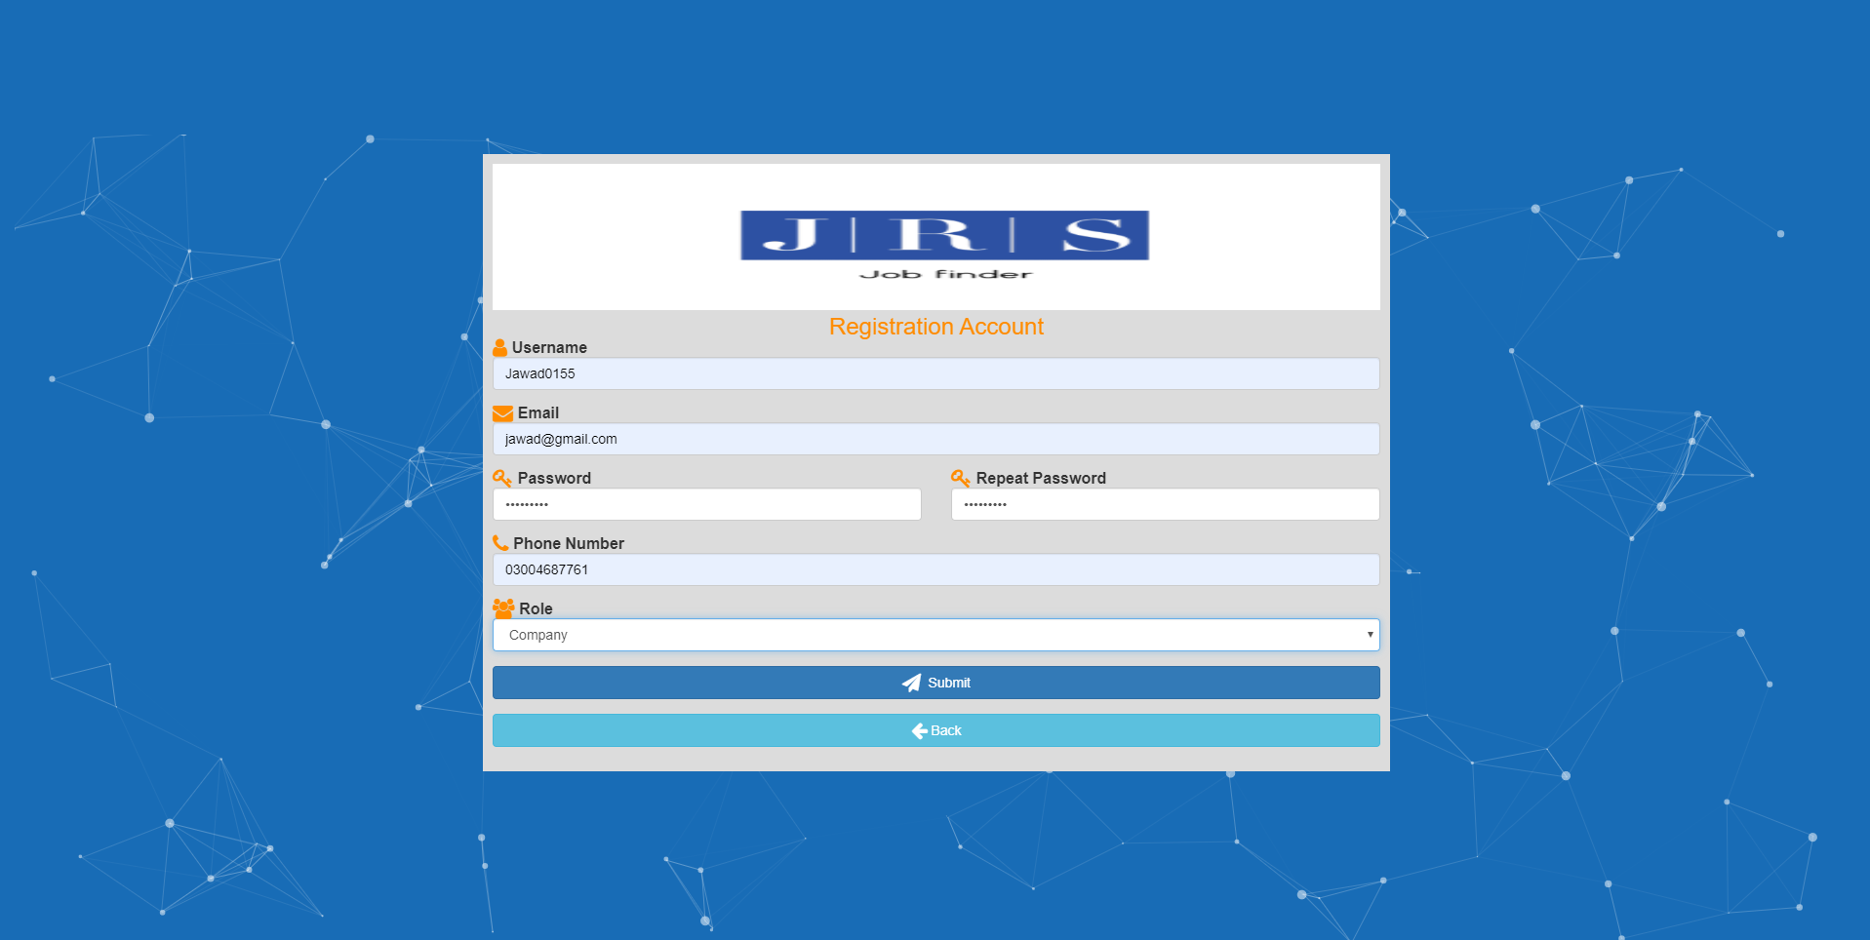

Forget Password
If user forget password he can get it through email by just click the forget password button and fill the credentials of the forget password form fields

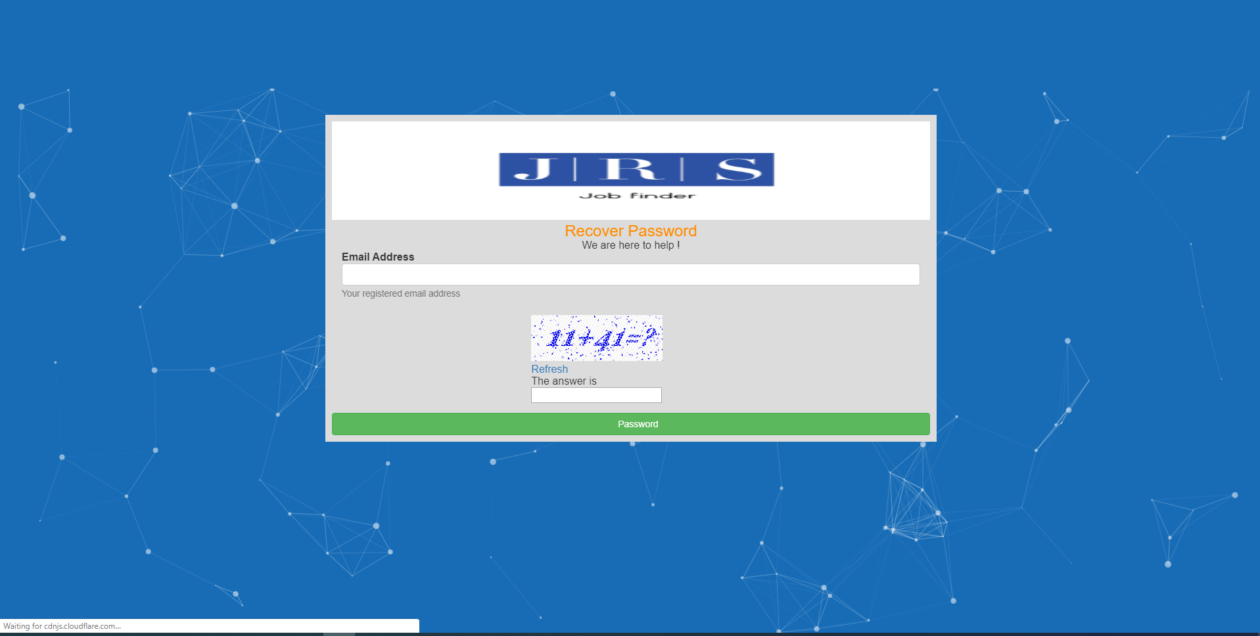

Figure 5-21: Forget Password changing method

User can get it password on his email through which he/she register to the website

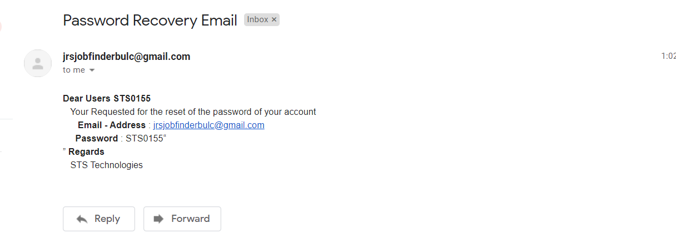

JRS (job recommendation system) Company Panel
Company can login into website by filling the correct information
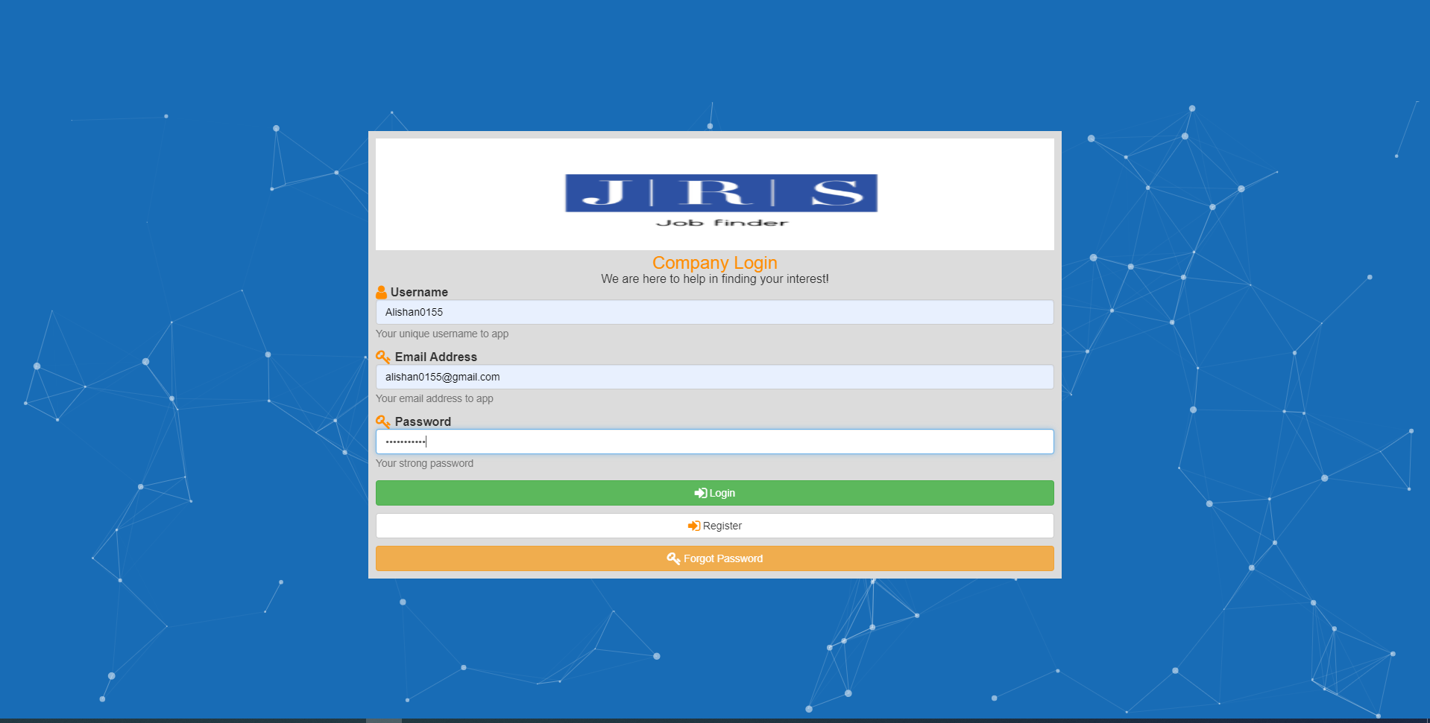

Figure 5-22 : Company Panel

JRS (job recommendation system) Company Panel
Company can post job by just click on the Job Section, select post job option or directly go to URL http://localhost:54840/Company/Post_Job
And fill the information for the job

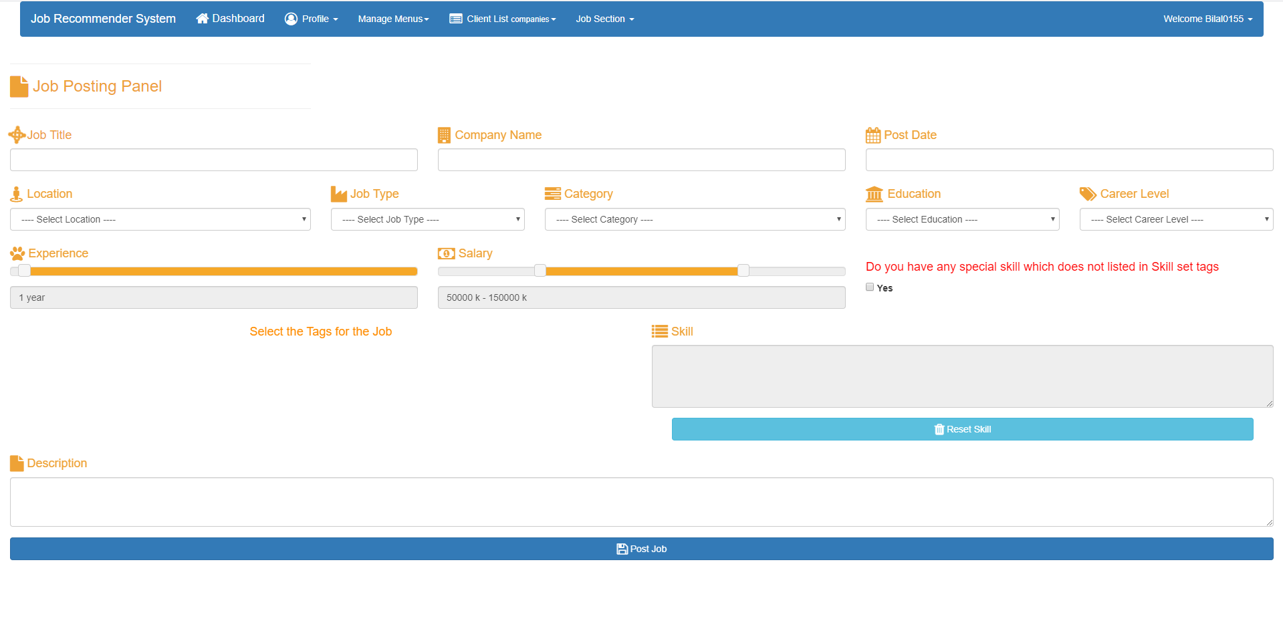
Figure 5-23: Company Panel (Job Posting)

Company can edit, delete, and add information of the job

JRS Company Panel Change Password
Company can change password for their account by just click on the option change password

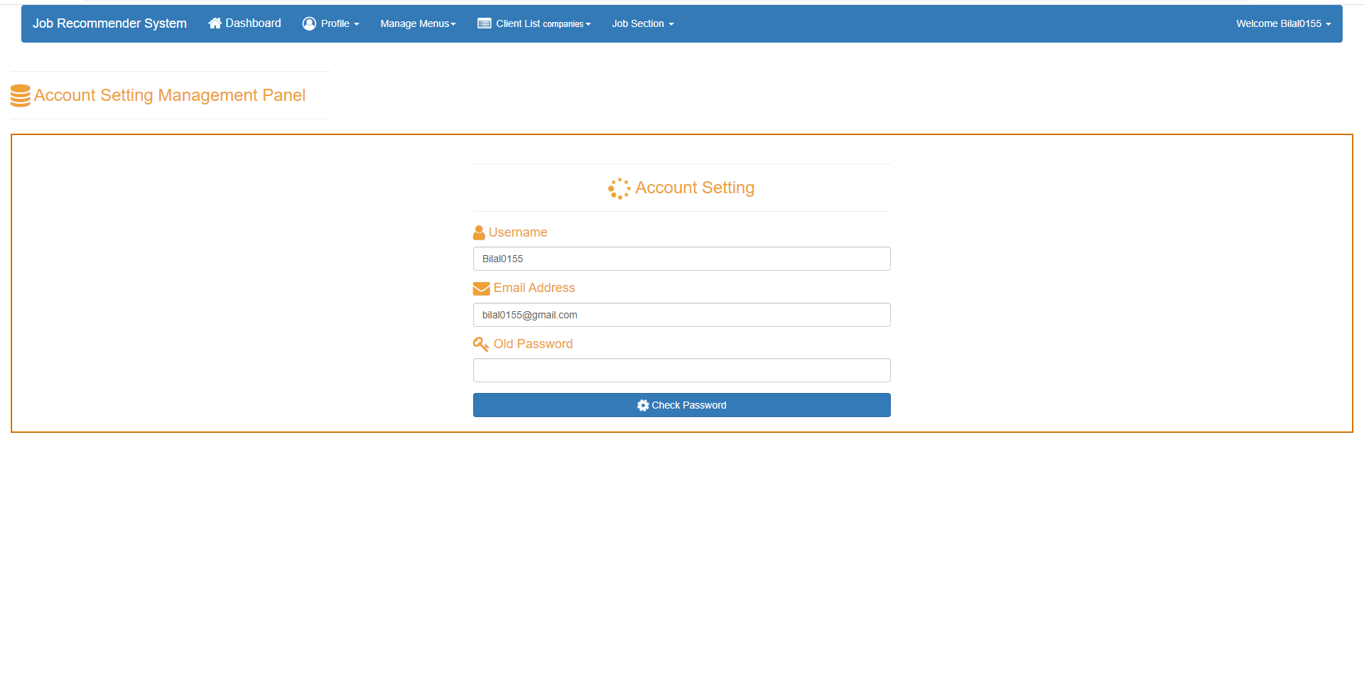

When the user click on the check password the website enable user to enter the new password

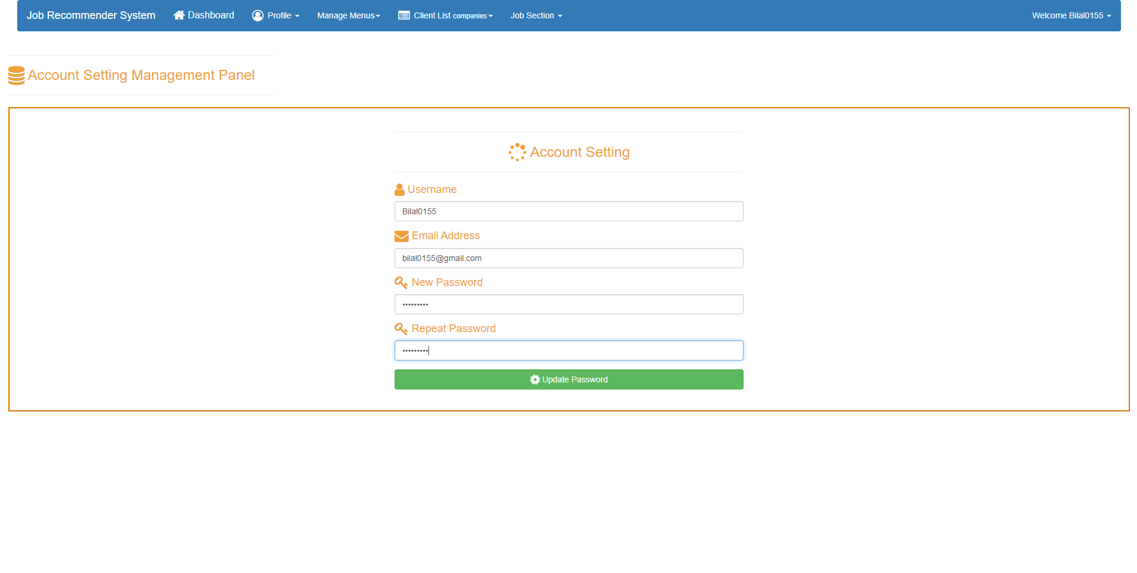
Figure 5-24: Change Password

When the user enter the new password click on the update password the website change the password of the user and redirect him to login page with success message

JRS (job recommendation system) Admin Panel

When the admin enter the right credentials the website redirects to the admin dashboard if the validation fails the website redirect to the login page where the user find the validation error

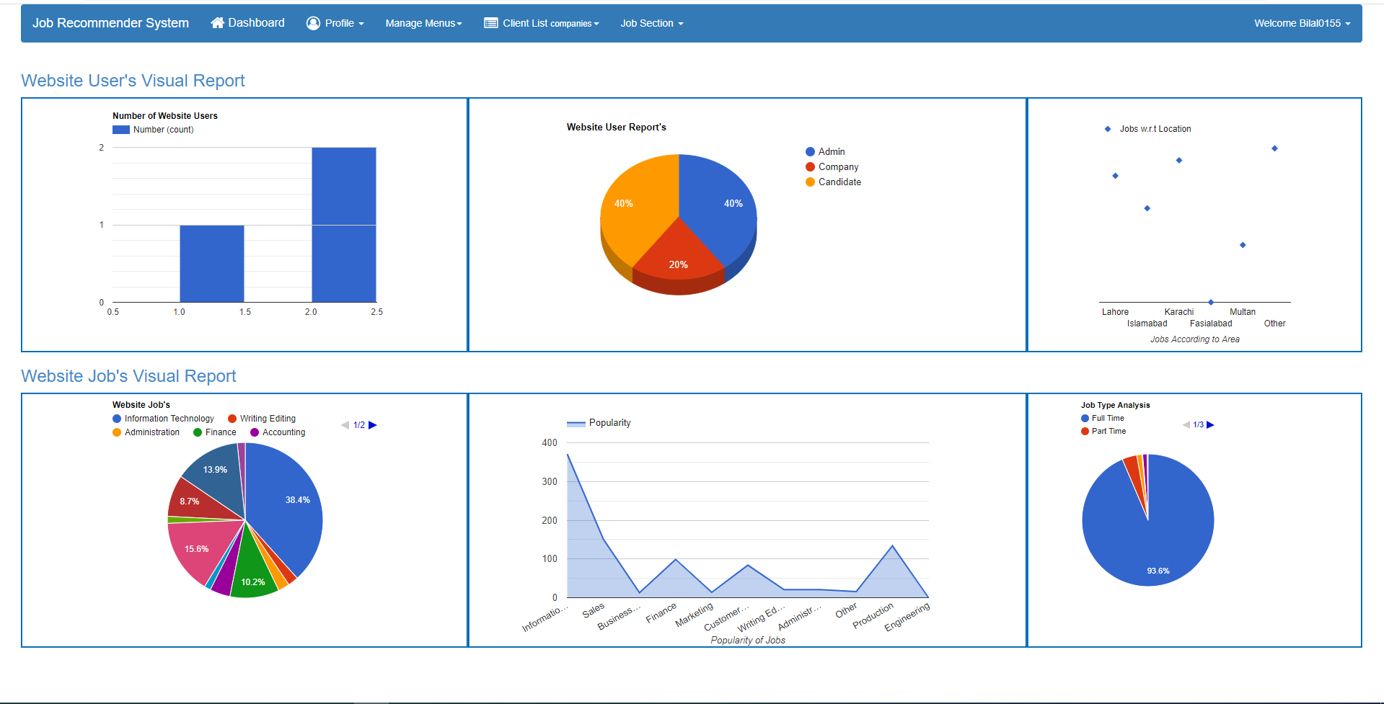

Figure 5-25: Dataset Visualization

It contains set of graph which shows different information about the dataset and the user of the website

JRS (job recommendation system) Admin Authority
Admin has right to make more admin if he or she want to give someone right as well as admin has right to delete other admin
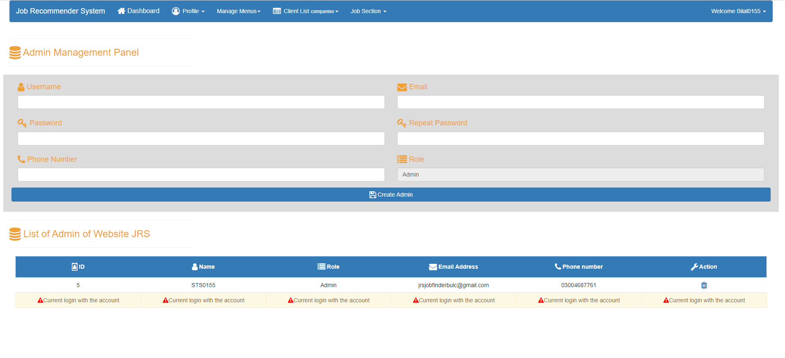
Figure 5-26: Admin Management Panel

JRS (job recommendation system) Manage User or Candidate Profile
Admin can manage user as well as candidate profile he has right to delete, update delete the profiles

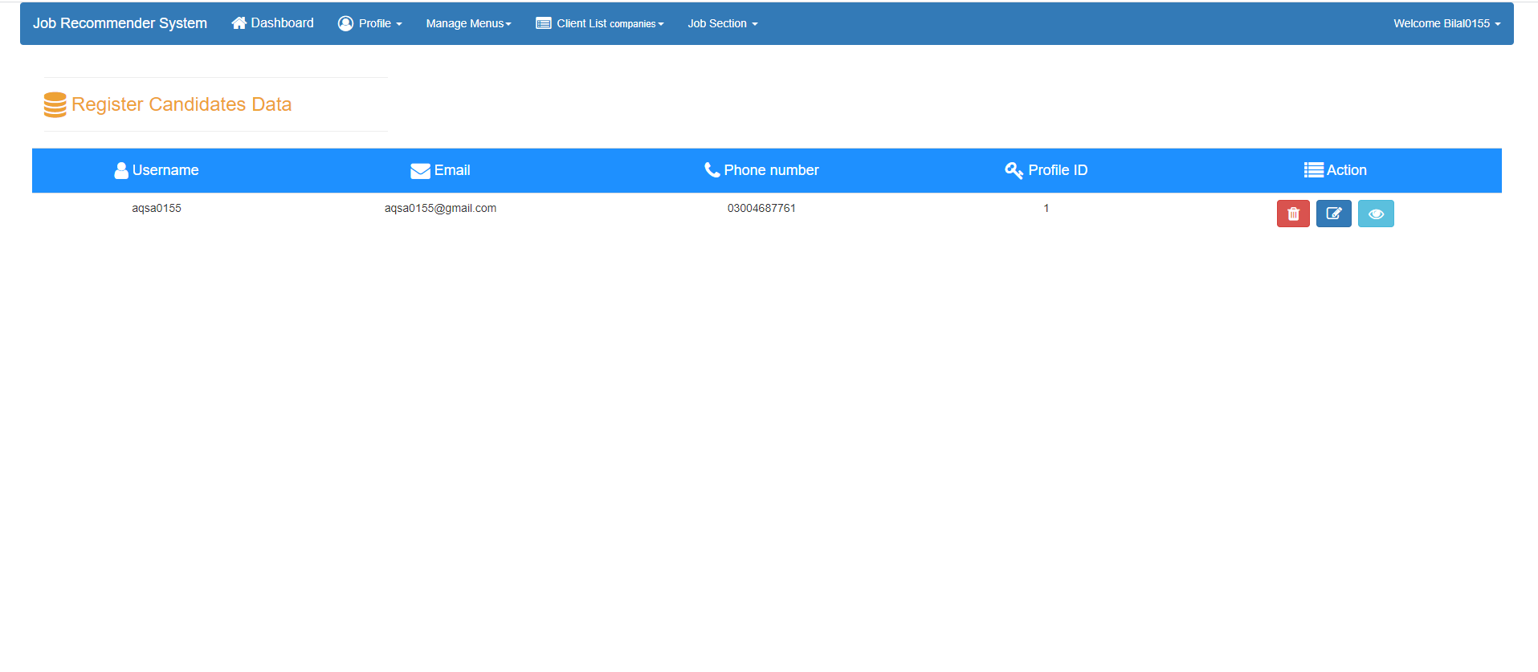
Candidate
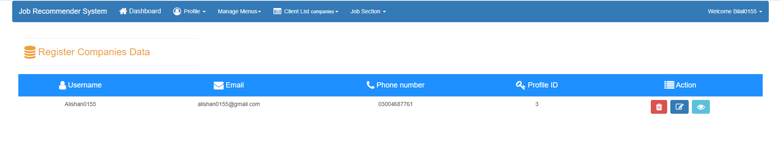
Company
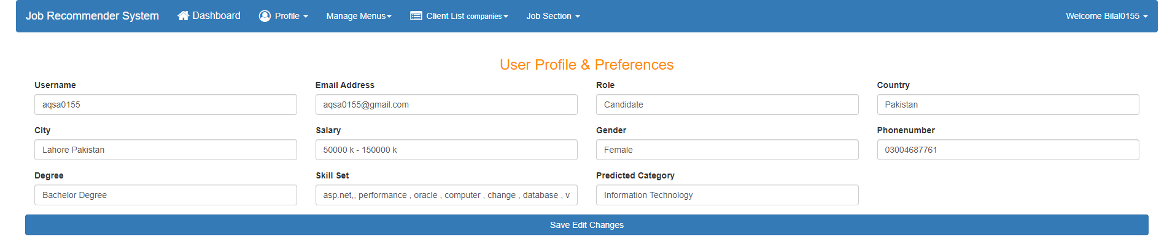
Figure 5-27: Update User Profile

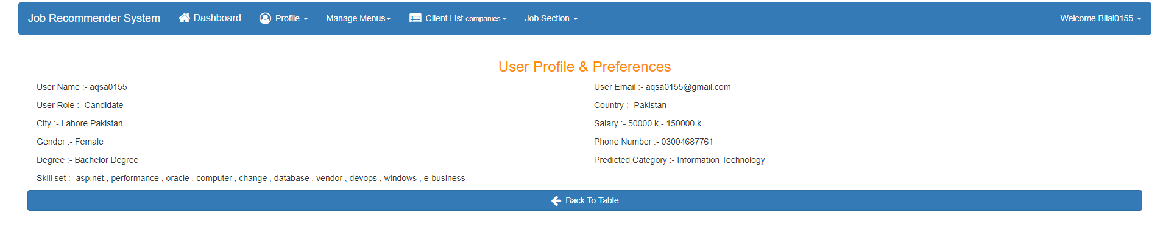
Figure 5-28: User Profile Information

JRS (job recommendation system) Manage Menus
Admin has right he/she able to manage city, countries, career level, job type, user role, block company and candidate profile of the user and company
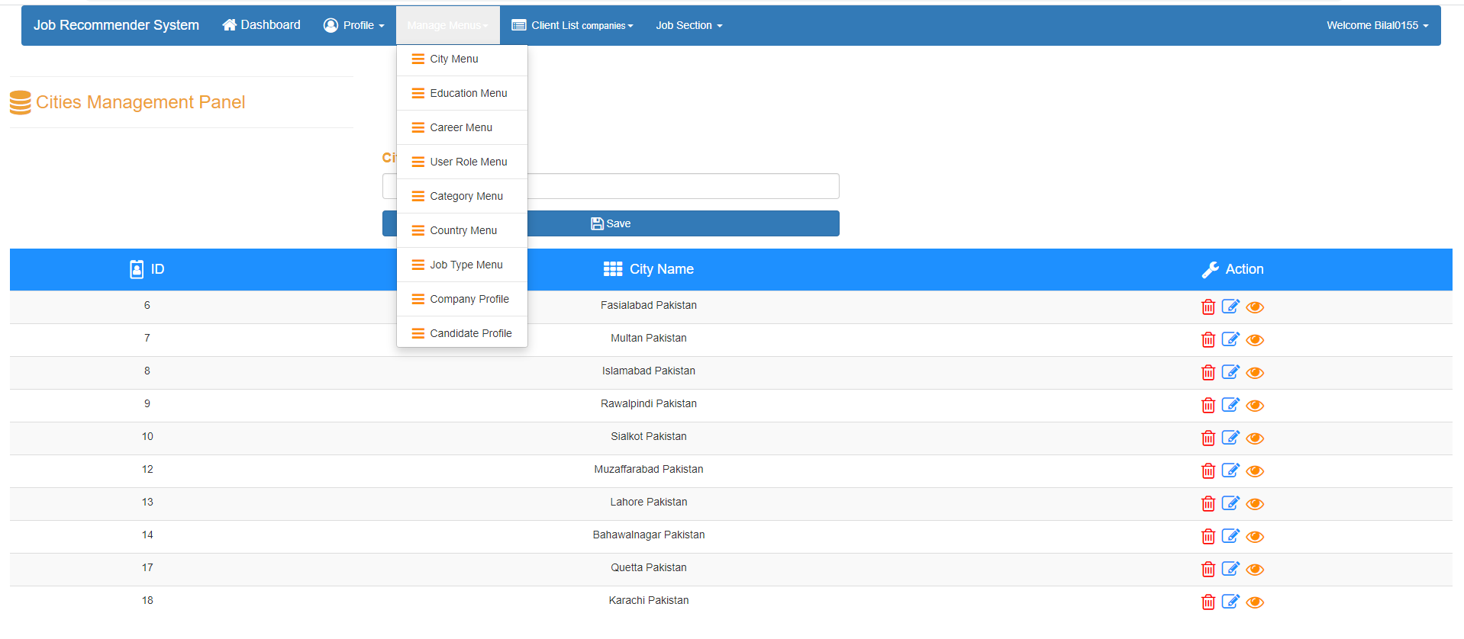
City
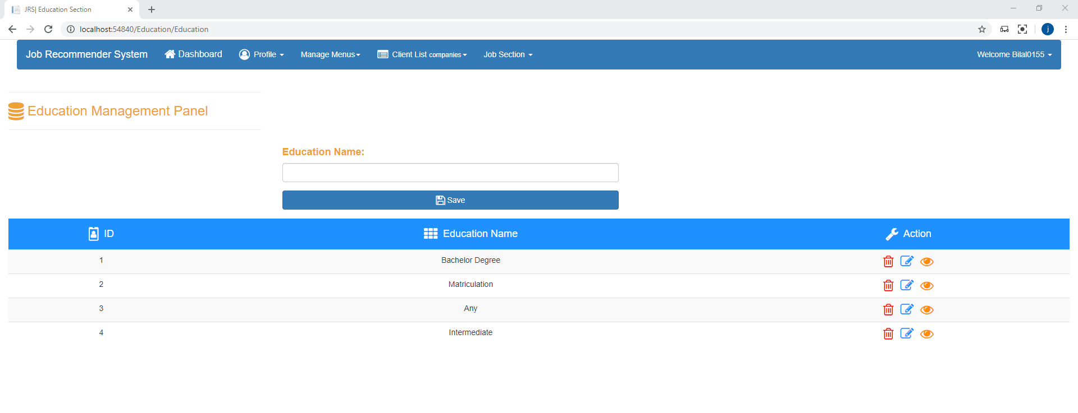
Education
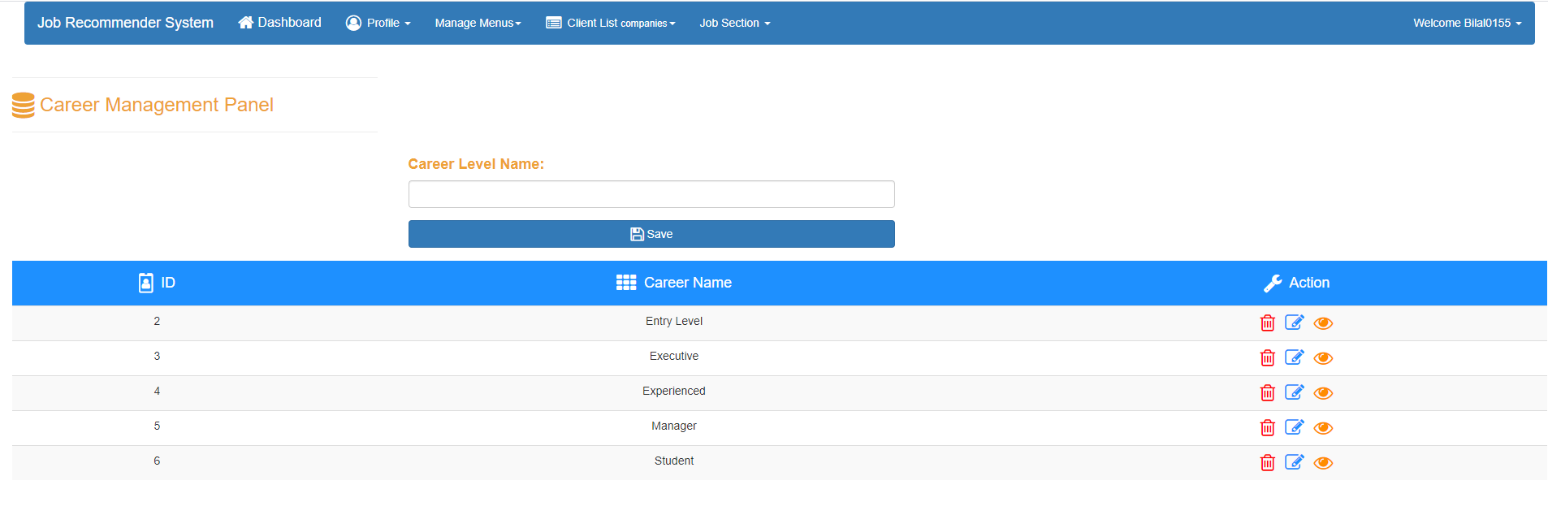
Career level
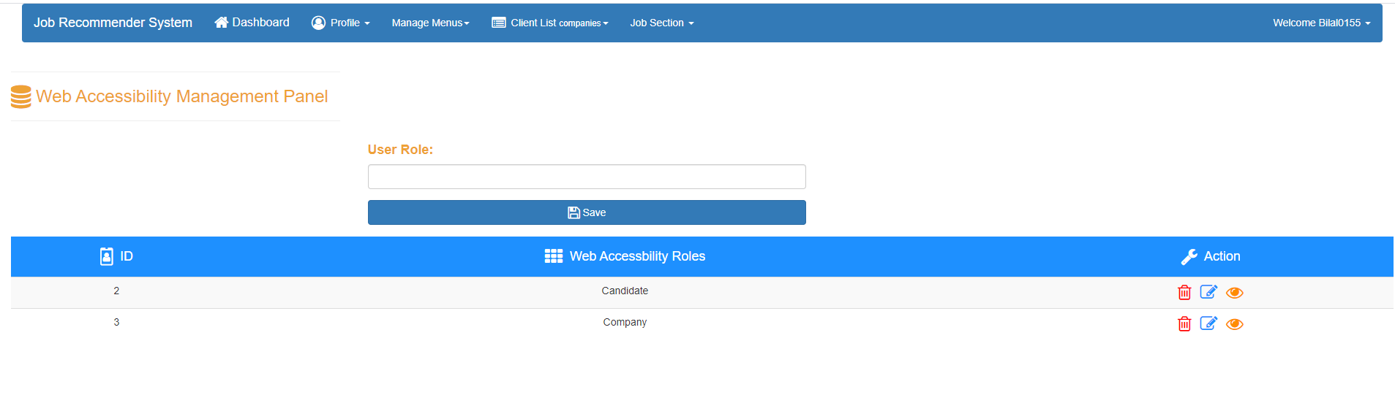
User role
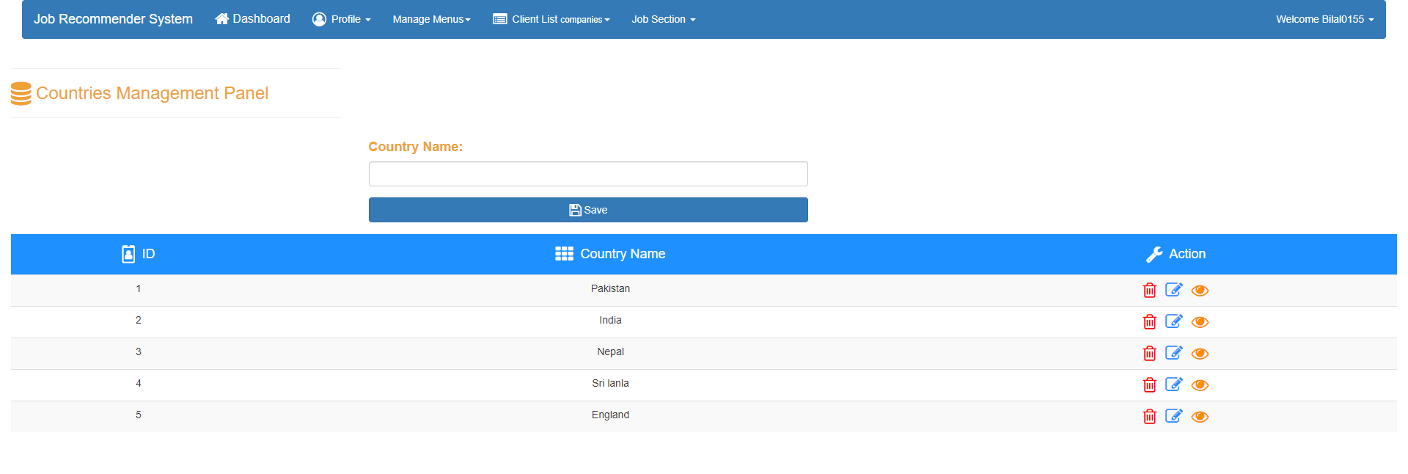
Country
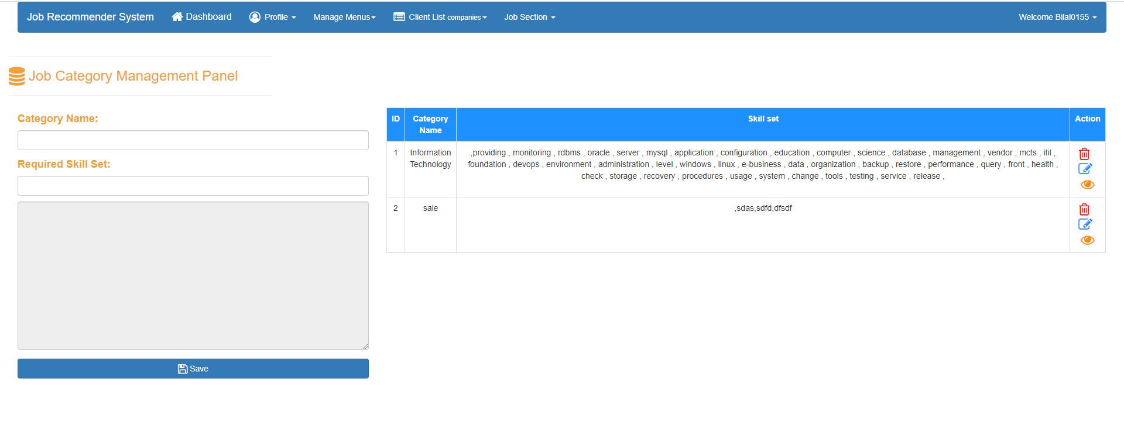
Category
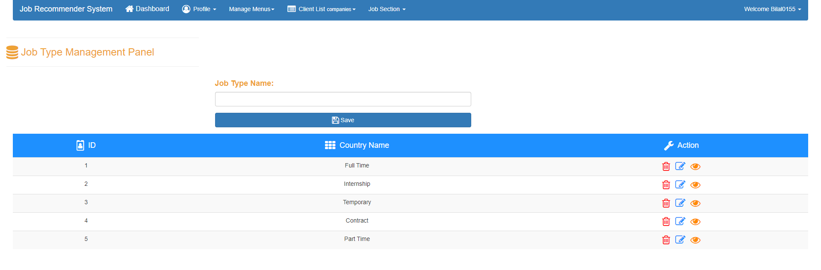
Job type
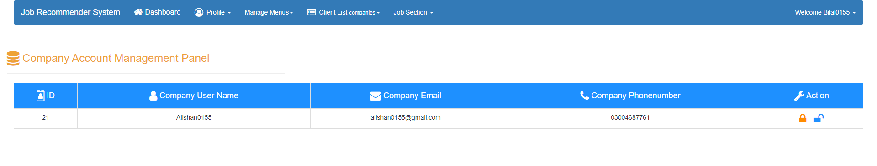
Block company profile

JRS (job recommendation system) Company Profile
In this panel company fill its information and complete its profile creation
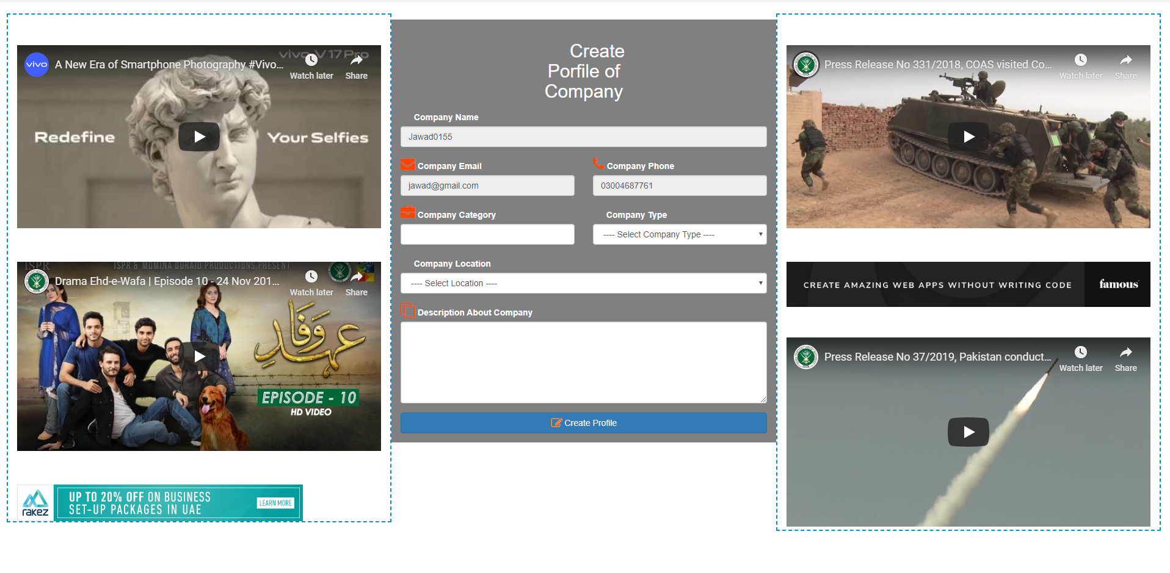
Figure 5-29: Creating Company Profile

JRS (job recommendation system) Company Dashboard
When the company fill the correct information in the login panel it lands on the company dashboard page.

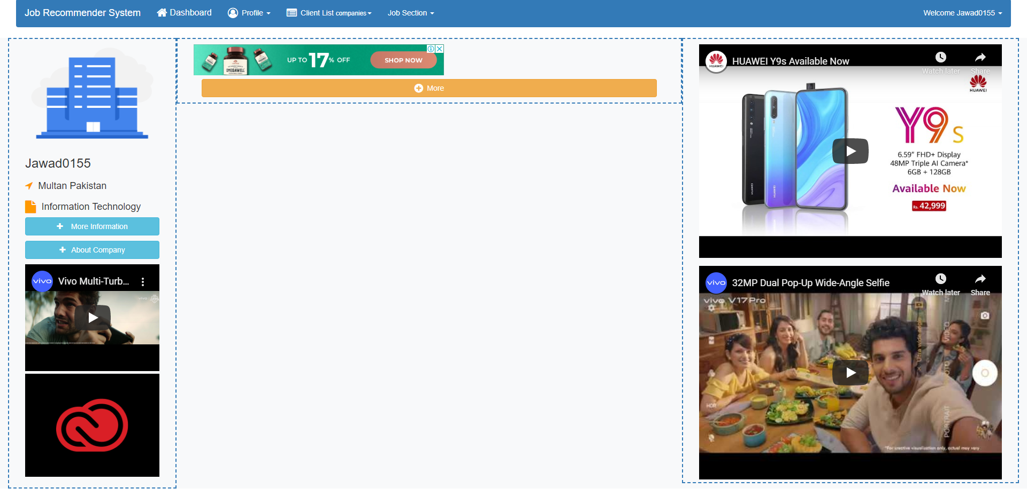

Figure 5-30: Company Dashboard

JRS (job recommendation system) Company Profile
When the user click on the profile button the navigation it redirect to profile page and show company information which they fill while making the account
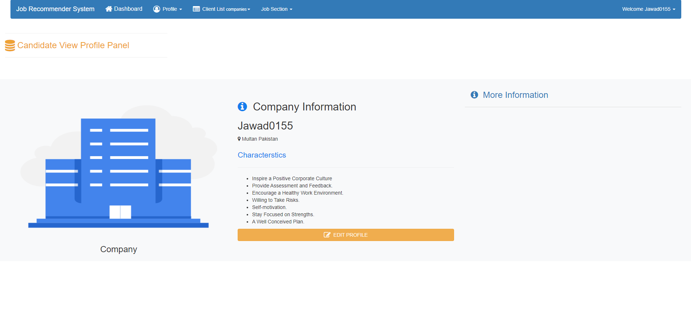
Figure 5-31: Company Profile

JRS (job recommendation system) Edit Company Profile
Company can change its information according to the it’s requirement whenever they want by just click edit profile button on the profile page

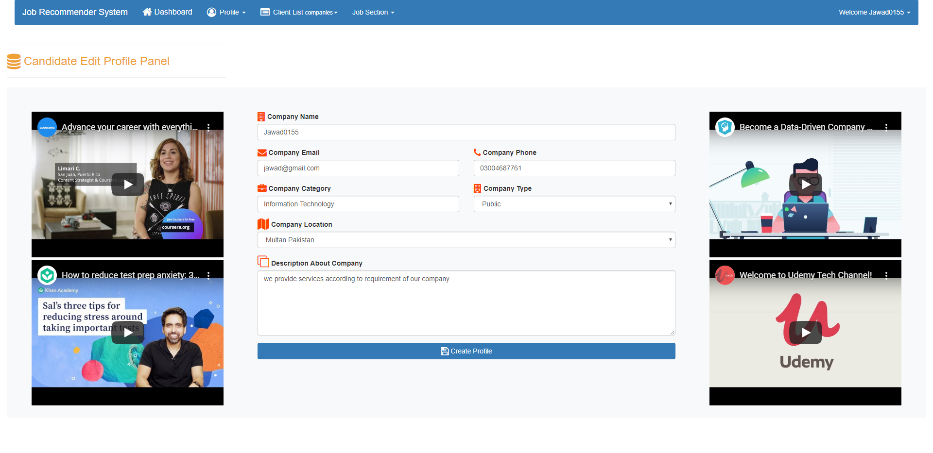
Figure 5-32: Update Company Profile

ALGORTHIM AND IT’s IMPLEMENTATION

In this Project we are going to use TF-IDF as Data is in text form

TF-IDF

TF-IDF stands for term frequency-inverse document frequency is a metric that represents how important a word is to document in the document set.
It is mainly used NLP (Natural Language Processing). Basically TF-IDF is invented for document search and information retrieval. It works by increasing proportionally to the number of times a word appears in a document, but is offset by the number of documents that contain the word. So, words that are common in every document.

Term –Frequency

Frequency of word is calculating the raw count of instances of word appears in a document
$$tf\left(t,d\right)=log⁡(1+freq\left(t,d\right))$$

Inverse Term Frequency

Inverse term frequency is how common or rare a word is in the entire document
$idf\left(t,D\right)=log⁡(\frac{N}{count(d ∈D:t∈d})$
This metric can be calculated by taking the total number of documents, dividing it by the number of documents that contain a word, and calculating the logarithm. So, if the word is very common and appears in many documents, this number will approach 0. Otherwise, it will approach 1.

Formula TF-IDF

$$tfidf\left(t,d,D\right)=tf\left(t,d\right).idf(t,D)$$

Pre-processing

Dataset before pre-processing
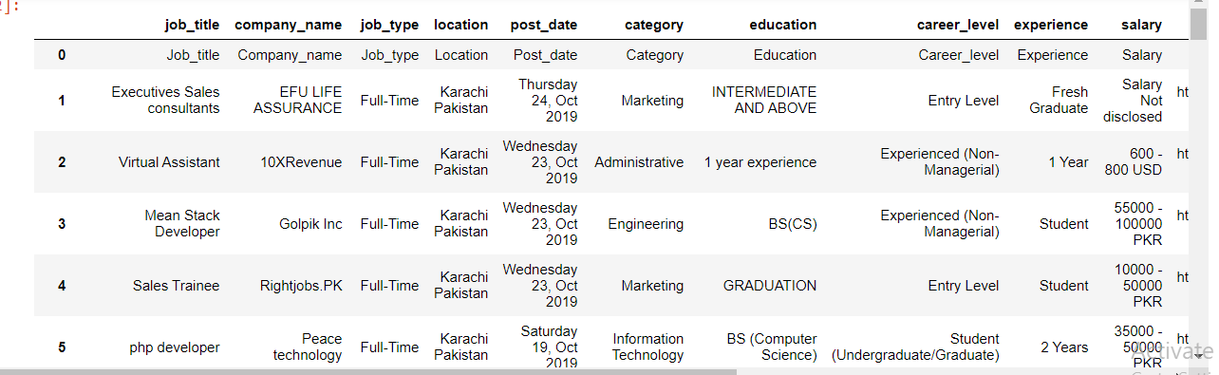

Figure 6-1: Dataset before Pre-processing

- Drop rows which is not needed
- Removing special characters from the columns
- Removing null values from the dataset
- Trim the values according to the need
- Strip the blank spaces from the dataset

Algorithm (Code)

This algorithm is implement with the help of the batch file. Augment from asp.net application is send to batch file then batch execute path code and send that argument to python script which batch file received from the algorithm.

Batch File

"C:\ProgramFiles(x86)\Python3732\python.exe"C:/Users/Zero/Desktop/AlgorithmofJRS.py %1
Pause

Batch file work as “executable “address of the python script

Executable
It is the address of the where python is install in the system. It is essential to run python script in the windows 1% it is used to catch the argument which is send from asp.net application to batch and it pass that argument to the python script

Steps for Vectorization (used in algorithm)
- Import
- Instantiate
- Fit
- Transform

Python Script

Import sys
#import sys is used to receive the argument from the terminal in this case we
#it as catch the argument which is pause from the batch file
Import pyodbc as pyodbc
#import pyodbc is used to connect with sql server from the python script
conn = pyodbc.connect('Driver={SQL Server};'
'Server=DESKTOP-8QBJ34G;'
'Database=jrs_database;'
'Trusted_Connection=yes;')
# it is the connect the database with which i am working on
username =sys.argv[1]
#argument which come from path file assign to username variable
cursor = conn.cursor()
sql_select_query = """select Skills from User_Profile_Table where Username = (?)"""
#sql statement it is used to get skill of the candidate from the table where # username is send from the asp.net application
cursor.execute(sql_select_query, (username,))
record = cursor.fetchall()
#it is used to fetch the record from the database
conn.commit()
import pandas as pd
#pandas is used dataframe in the script
from io import StringIO
columns = ["job_title","company_name","job_type","location","post_date","category","education","career_level","experience","salary","link","skill","imageurl"]
df = pd.read_csv(r'C:\Users\Zero\Desktop\jobsdata.csv',names=columns)
df.drop(df.index[:1], inplace=True)
# it is used to drop the first row in the dataset which is import from csv file
df = df.replace('\n','', regex=True)
df = df.replace('\r','', regex=True)
df = df.replace(',','',regex=True)
df=df.replace('/',' ',regex=True)
df=df.replace('<','',regex=True)
df=df.replace('&','',regex=True)
#removing special characters from the dataframe
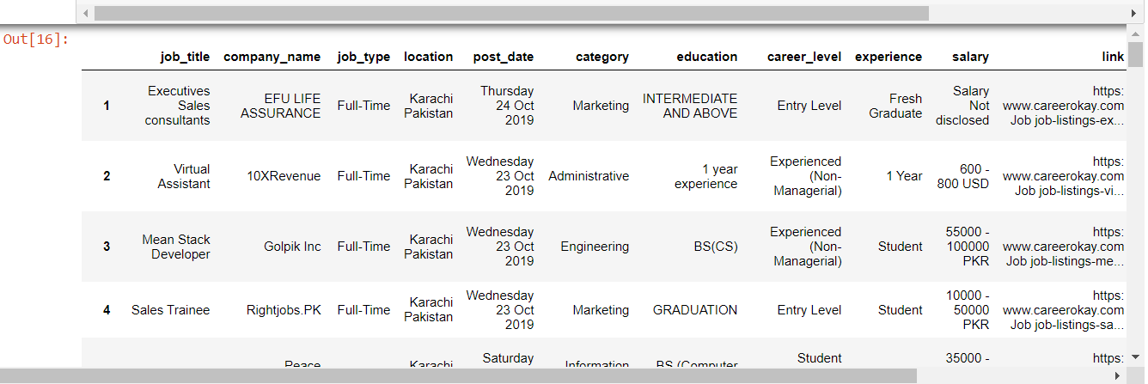

Figure 6-2 : Standardized pre-process dataset
from io import StringIO
col = ['category', 'skill']
# select the column from the dataframe on which we run algorthim
df = df[col]
df = df[pd.notnull(df['skill'])]
df=df[pd.notnull (df['category'])]
#checking category or skill don’t have null value
df.columns = ['category', 'skill']
df['category_id'] = df['category'].factorize()[0]
category_id_df = df[['category', 'category_id']].drop_duplicates().sort_values('category_id')
category_to_id = dict(category_id_df.values)
id_to_category = dict(category_id_df[['category_id', 'category']].values)

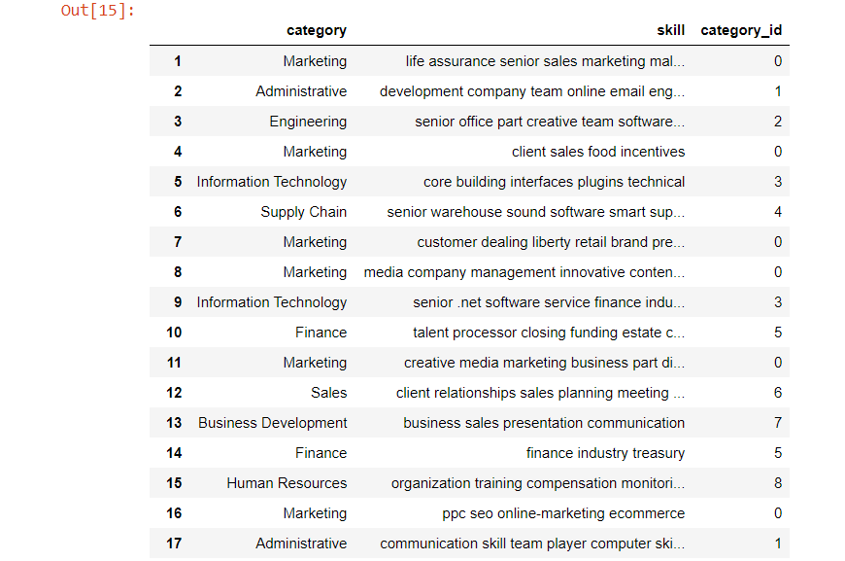

from sklearn.feature_extraction.text import TfidfVectorizer
tfidf = TfidfVectorizer(sublinear_tf=True, min_df=5, norm='l2', encoding='latin-1', ngram_range=(1, 2), stop_words='english')
features = tfidf.fit_transform(df.skill).toarray()
labels = df.category_id
from sklearn.feature_selection import chi2
import numpy as np
N = 2
for category, category_id in sorted(category_to_id.items()):
features_chi2 = chi2(features, labels == category_id)
indices = np.argsort(features_chi2[0])
feature_names = np.array(tfidf.get_feature_names())[indices]
unigrams = [v for v in feature_names if len(v.split(' ')) == 1]
bigrams = [v for v in feature_names if len(v.split(' ')) == 2]

from sklearn.model_selection import train_test_split
from sklearn.feature_extraction.text import CountVectorizer
from sklearn.feature_extraction.text import TfidfTransformer
from sklearn.naive_bayes import MultinomialNB
X_train, X_test, y_train, y_test = train_test_split(df['skill'], df['category'], random_state = 0)

# split the datase into 2 train and test dataset
count_vect = CountVectorizer()
X_train_counts = count_vect.fit_transform(X_train)
tfidf_transformer = TfidfTransformer()
X_train_tfidf = tfidf_transformer.fit_transform(X_train_counts)

#We call vectorization the general process of turning a collection of text #documents into numerical feature vectors. This specific strategy #(tokenization, counting and normalization) is called the Bag of Words
clf = MultinomialNB().fit(X_train_tfidf, y_train)

values = ','.join(str(v) for v in record)
#converting list into string
dataset_array = []
dataset_array.append(values)
#Converting string into array

go =clf.predict(count_vect.transform(dataset_array))
# assign predicated category to the go value which come from alogrthim
str1 = ' '.join(go)
print(str1)
# return ouput to asp.net from the python script

Output

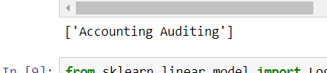

Accuracy of Algorithm

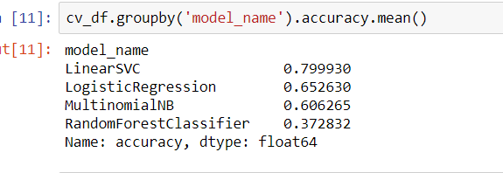
:
Figure 6-3 : Algorithm accuracy

Note:

Accuracy of the algorithm depend on the number of dataset .Till now size of my
Dataset is 1120 rows as I am increasing my dataset accuracy is increasing

7.1 Conclusion

In this document we summarize the Job recommender system that basically provide a personalized platform for job seeker to find the relevant job that are matched their interest and also help the company to find out the high talented candidate. Also discuss different methods to create a project easily like making use case diagram to identify different objects and sequence diagram to find out object flow. We also used Web API to scrape data and TF-IDF algorithm to perform the JRS functionality well and improve their accuracy.

References

Journals Papers:

[1] | R. G. Belsare and V. M. Deshmukh, “Employment Recommendation System using Matching, Collaborative Filtering and Content Based Recommendation,” International Journal of Computer Applications Technology and Research, 2018.
[2] | K. Haruna, M. Ismail and S. Suhendroyono, “Context-Aware Recommender System: A Review of Recent Developmental Process and Future Research Direction,” 2017.
[3] | S. T. Al-Otaib and M. Ykhlef, “A survey of job recommender systems,” International Journal of the Physical Science, 2012.
[4] | K. Kenthapadi, “Personalized Job Recommendation System at LinkedIn: Practical Challenges and Lessons Learned,” ACM, 2017.
[5] | A. Gupta and D. Garg, “Applying Data Mining Techniques in Job Recommender System for Considering Candidate Job Preferences,” in InternationalConference on Advances in Computing,Communicationsand Informatics (ICACCI, 2014.

