
BSIT-S19-002
03-135161-033 | MUHAMMAD WAQAS IQBAL

Implementation of SNA Techniques Using Medium Sized OSN Database : A comparison of Python and NodeXL.

In partial fulfilment of the requirements for the degree of
Bachelor of Science in Information Technology
Supervisor: Taimoor Aamer
Department of Computer Sciences
Bahria University, Lahore Campus
January 2020

© Bahria University, 2020
Certificate

We accept the work contained in the report titled
“IMPLEMENTATION OF SNA TECHNIQUES USING MEDIUM SIZED OSN DATABASE”
written by
MUHAMMAD WAQAS IQBAL
as a confirmation to the required standard for the partial fulfilment of the degree of
Bachelor of Science in Information Technology.

Approved by:
Supervisor: Taimoor Aamer
________________________________________________________________(Signature)

January, 27, 2020

DECLARATION

I hereby declare that this project report is based on my original work except for citations and quotations which have been duly acknowledged. I also declare that it has not been previously and concurrently submitted for any other degree or award at Bahria University or other institutions.

Enrolment | Name | Signature
03-135161-033 | MUHAMMAD WAQAS IQBAL

Date : January, 27, 2020

Specially dedicated to
my beloved grandmother, mother and father
(Muhammad Waqas Iqbal)

ACKNOWLEDGEMENTS

I would like to thank everyone who had contributed to the successful completion of this project. I would like to express my gratitude to my research supervisor, Mr Taimoor Aamer for his invaluable advice, guidance and his enormous patience throughout the development of the research.

In addition, I would also like to express my gratitude to my/our loving parent and friends who had helped and given me encouragement.

Muhammad Waqas Iqbal

IMPLEMENTATION OF SNA TECHNIQUES USING MEDIUM SIZED OSN DATASET

ABSTRACT

The proposed project would be under taking medium size social network dataset and will employee different social networking techniques based on literature review with the specific focus on density, clique, flow and centrality. This project will contribute in a way that provides an implementation of SNA techniques using online social network of four specific network parameters by implying social network techniques. Performing in a way that simulation will be able to upload data, performing analysis, generating graph reports, and view reports. These are the major and functional requirements to generate proposed project and analysis work. Information control in term of exposer. Working on why because this study would be contributing in the field of systematic literature review of social networking and analysis techniques. And will find present processing time, techniques analysis of any network. Project is held to compare different tool relating to techniques as well. Study concludes with the analysis of the result and recommends future gaps to be studied as wall

TABLE OF CONTETS
DECLARATION iii
ACKNOWLEDGEMENTS v
ABSTRACT vi
TABLE OF CONTETS vii
LIST OF SYMBOLS / ABBREVIATIONS ix
LIST OF APPENDICES x

CHAPTERS 1
1 INTRODUCTION 1
1.1 Background 1
1.2 Fig 1.1. Cyclic and Acyclic 2
1.3 Problem Statements 2
1.4 Aims and Objectives 2
1.5 Scope of Project 3
2 LITERATURE REVIEW 4
2.1 Social network Analysis 4
2.2 Semantic Network Approach 5
2.3 Database Implementation. 5
2.4 Comparison. 5
2.5 Figure 2.1: Clique Environnent 6
3 DESIGN AND METHODOLOGY 7
3.1 Proposed Approach 7
3.2 Flow 7
3.3 Centrality 7
3.4 Clique 8
3.5 Density 8
3.6 Methodology 9
4 COMPUTER PROGRAMME LISTING 10
4.1 Main Files 10
4.2 Osndriver: 10
4.3 LoginWindow(): 10
4.4 RegisterWindow(): 11
4.5 HomeWindow(): 11
4.6 GraphWindow(): 11
4.7 UploadDatasetThread(): 11
4.8 DeleteDatasetThread(): 12
4.9 Generategraph: 12
4.10 Databasehandler: 12
4.11 Code for requirements: 12
5 RESULTS AND GRAPHS 17
Resultant Working Environment. 17
5.1 Fig 5.1. Signup 17
5.2 Fig 5.2. Login 18
5.3 Fig 5.3. Upload, View, Delete. Generate Dataset 19
5.4 Fig 5.4. Techniques Availability 20
5.5 Fig 5.5. General Graph. 21
5.6 Fig 5.6. Centrality Graph 21
5.7 Fig 5.7. Clique Graph 22
5.8 Fig 5.8. Density 24
5.9 Fig 5.9. NodeXL Table 24
5.10 NodeXL Findings 25
5.11 PyCharm GUI Findings 25
REFERENCES 25
APPENDICES 29

LIST OF SYMBOLS / ABBREVIATIONS

SNA Social Network Analysis
OSN Online Social Network
OS Operating System

LIST OF APPENDICES

APPENDIX | TITLE | PAGE
APPENDIX A:Graphs |  | 30
APPENDIX B: Computer Programme Language |  | 31

INTRODUCTION

Background

Social network means relating to society or to the way society is organized. It can be defining in various event like social has influence on crime, long term social change. The worst effect of unemployment, low pay and other social problems. A group of people or mora than one person gathered on an instance is known as social gathering. A group of people interconnected with each other through a particular source is known as network. A network is defined as a group of two or more computer systems linked together.
Where as a social network which will be presented in graph because this is the way to figure out and understand the connection among nodes and vertices visually. Social media is a best example for social network where a single node presents a person or an organization and the relationship between them is considered to be vertex or edge. A node in a network is always depend on the other node according to the nature of relationship like mutual friend, common likes, dislikes, knowledge etc. An overall geographical structure can be very complex when it gets to manage millions of interconnection of nodes and edges[1]. For solving this issue of understanding many researchers have revealed their strategy of gathering data, keeping that data stable and read able. It helps in addressing many things like understanding the way how an organization run, it helps and solve many critical problems[2].
According to Trinda Dutta Xavier college, geographical presentation will be mainly stand on two strategies the 1st one is Directed Graph and 2nd one is Undirected Graph. Both will generate and work accordingly to the nature of a data like producing Cyclic graph and Acyclic graph[3]. Examples are given below
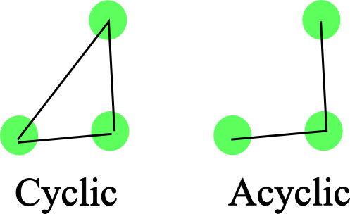

Fig 1.1. Cyclic and Acyclic
.

Problem Statements

My research will be based on the conversion of literature view. A review that tackles with four domains of a network called density, clique, flow and centrality and will provide graphical presentation of it. Research will measure the deficiency of a network and will figure out the challenges during techniques testing.
It is consisting of three principle steps. First, it uses the theoretical foundations laid out above as a framework in classifying the existing research on the challenges of SNA.
In a second step It examined the literature in more details to identify similarities and differences between the individual’s articles. Therefor determined how the Medium size dataset challenges become apparent in the SNA steps, and which solutions researchers have proposed. This step serves to inductively synthesize prior research and group related articles into logical concepts. Finally, in the third step, it considered the larger implications of our analysis for future research and derived an extension of the SNA framework. literature review follows the systematic sequential process.

Aims and Objectives

The objectives of the research are shown as following:
- To define use and test Density, Clique, Centrality, Flow on different tools.
- To build prototype based on the working environment of Density, Clique, Centrality and Flow
- To study and find differences in SNA.

Scope of Project
Research will overcome the gap of SNA to figure out the relational behaviour of Density, Clique, Flow and centrality. Performing in a way that simulation will be able to upload data, normalizing dataset, performing analysis, generating graph reports, store reports and view reports. These are the major and functional requirements to generate proposed project and analysis work.

LITERATURE REVIEW

Social network Analysis

Since an ever-increasing part of the population makes use of social media in their day-to-day lives, social media data is being analyzed in many diﬀerent disciplines[4]. The social media analytics process involves four distinct steps, data discovery, collection, preparation, and analysis.
Revealing every single aspect of life is known to be done by social network which not just involve the nature of network analysis but also focuses on the sentiments analysis, trend analysis and collaborative recommendation[5]. A basic network analysis is based on the term network has different meaning and understandings but for this paper a network is a combination of different nodes and how they act to present their identity to another node. whereas node is usually defining as vertices and points on the other hand relationship is defined as edges, links and ties. It can be directed or undirected depending on network bridge and user indications[4]. End to End user methodology is always required here which makes sure the network is stable and firm with each other. The second Methodology is homogeneous graph relationship because it’s the only way to identify the rigorously know relationship in a network. More over a social network has a very large amount of data to analysis and figure out what one data has in it. It typically contains a very huge linkages and datasets to make repository or content. This type of data is further divided into two categories the one is structure and the second one in unstructured.
On further clearing out the concept of structure and unstructured data I can say that a data depended on timely manner is structure and the one which is like doing “tweets”, “Likes”, “comments” etc. is unstructured data[6][7].

Semantic Network Approach
It’s also a study between the individual, groups and organization but what makes itself different from other is network behavior it is constantly limited to its identical region like an example of an institute where students work under their mentors for research work they have to go through the particular source to gather and gain access and produce productive output so their network output would be like wise attached bellow. There is no undirected graph allocation for this because it’s always directed concerns[8].
A role relationship hierarchy may have inverse relationship and each role relationship in the hierarchy can have role label. The role relationship class induced from the corresponding role relationship generates the context based on them. Also, as context-dependent attributes and relationships are used to describe properties of instances of induced role relationship class, they are also under the corresponding role relationship class[9]. The deﬁnition induces the role relationship classes which have the context relationships with nested role labels and context-dependent properties.

Database Implementation.
Dataset size at this point to identify and test our different techniques on it. Dataset is always important to be chosen properly. For the comparison of above four techniques called Density, Clique, Flow, Centrality. It will be using medium sized dataset that.

Comparison.
Four techniques (density, clique, flow, centrality) to compare these techniques with each other’s. it will use medium sized dataset that will help in more a way to identify current situation. It’s a data that is divided into chunks. The specific datasets derived after digging into the huge chunks of data that can also be referred to SNA Data. There are a lot of issues within an organization that demand quick and instant analysis. In cases like these[7]. These is no doubt that technology is growing so fast so talking about dataset for my research it should have a proper one to implement my four techniques. Choosing medium size dataset because it is handy and easy to take decisions and it is also an easy way to identify what is going on in that particularly field of work. It takes less time to test data because large data or huge data, that requires billions of datasets in Exabyte and will get and required more professional team to handle it. For this type of dataset (large dataset) it requires expert team, numbers of computer and a huge network. For our four required techniques it’s enough to go for medium sized dataset. Above four techniques will allow us to test the medium or small size of social network set and will compare those techniques on different platform like NodeXL Pajek, Gephi, network kit etc. End product will simulate the result of all provided techniques will make a stand according to the comparison. It will generate and give direction to the resultant points[10].

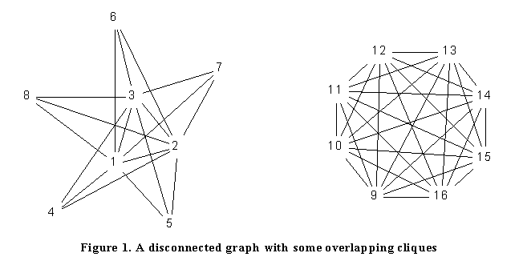

Figure 2.1: Clique Environnent
By Martin G. Everett
University of Greenwich
Stephen P. Borgatti
Boston College

DESIGN AND METHODOLOGY

Proposed Approach
It will maintain a small python based tool having following use cases.
- Upload dataset
- Generate Graph
- Interpretation of the graphs
  - Flow.
  - Centrality.
  - Clique.
  - Density.

Flow
Especially large companies struggle in dealing with unclear and incorrect information flows. These information flows can be improved by means of information flow analysis and flow patterns. One technique to analyse information flows is the FLOW method. It supports visualization and analysis of information flows to detect lacks and anomalies and thereby improves information flows. An analyst gathers information transported in the company. Afterwards, information flows are visualized and analysed based on patterns and personal experience. Nevertheless, analysis based on individual knowledge is error-prone. Hence, it improved the FLOW method with the help of social network analysis applying centrality that measures and give direction to the FLOW method and to support the FLOW analyst[11][12].

Centrality
Hot node and actual Highgate of that network will be measured using this technique. Why hoax become a reality and why reality turns to lie[13]. Every single dimension of the network stands on centrality. This is how I compared to overcome this issue and give direction in a way to improve a network communication. It can say calculate where tightly connected nodes and a degree of centrality is assigned.

Clique
It is graphical representation of network; it is a subset of vertices of undirected graph use to make a connection stable like mutual relation on social media. Who all know each other and imposes some practicality of algorithms. a clique is the maximum number of actors who have all possible ties present among themselves. A "Maximal complete sub-graph" is such a grouping[14].

Density
Density in a network describe the potential connection those are actual connection and make connectivity over the path a potential connection is a connection that could potential exist to nodes or more in a particular pattern. A person potentially has a direct connection with other to have centrality point to overcome the connection flow difficulty. To cover the actual depth of a network in the mean while manner of systematic literature review. It gives me ability to know the communication pattern by checking out actual potential connection between two nodes. Another reason for using this technique to have firm relation with all the nodes so that a network can be driven properly. To assume the strength and weakness of that particular node.
Attached the mathematical formalization for finding the flow of density[15][11].
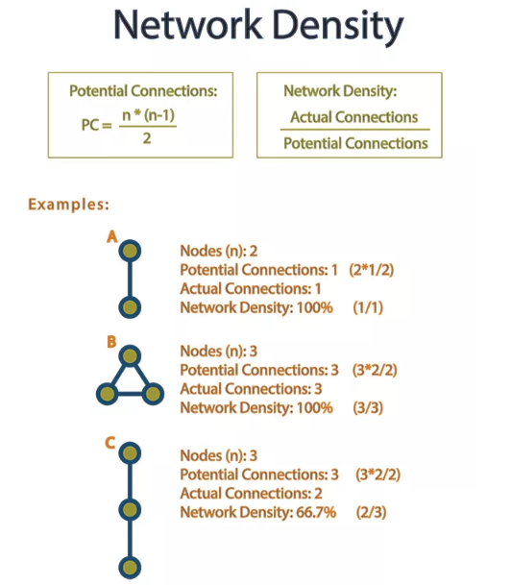

Figure 3.1: Density Diagram

Methodology
- Normalizing dataset.
- Performing analysis.
- Generating reports.
- Store reports.
- View Reports.

COMPUTER PROGRAMME LISTING

Main Files
In OSN project we have three main files.
- Osndriver.py
- Generategraph.py
- Databasehandler.py

Osndriver:
This file has class to handle the GUI component of the application.
It contains the following classes. The GUI component are made in QT designer.
- class LoginWindow()
- class RegisterWindow(QMainWindow)
- class HomeWindow(QMainWindow)
- class GraphWindow(QMainWindow)
- class UploadDatasetThread(QThread)
- class DeleteDatasetThread(QThread)

LoginWindow():
This class is responsible for the first window open to the user which is login window. It loads the login.ui from UI folder in the project.
It has the following function:
- constructor (): Responsible for load login.ui
- login (): check username and password from db.
- signup (): load class RegisterWindow().
- validate (): check if username and password is not empty
- set_message(): show validation message to the user.
- clear_error(): clear error messages

RegisterWindow():
This class show user the signup window.it loads signup.ui from UI folder of the project.
It contains the following function:
- constructor(): Load the registration window
- show_message(): Show message to the user
- signup(): send data to database to add user
- login(): load login window
- validate(): check the input of the user
- set_message(): set message the GUI

HomeWindow():
This class show the user the option of handle the dataset. This function contains the main functionality of the application. t loads home.ui from UI folder of the project.
It contains the following function:
- constructor (): Load the GUI if HomeWindow
- upload (): this method contains the functionality to upload database.
- dataset_uploaded (): Check the state of the upload button. if dataset is upload then the button will be disable.
- view (): this method shows the dataset in csv file format to the user
- delete (): it will delete the dataset
- dataset_deleted (): Check the state of the delete button. If dataset is upload then the button will be usable.
- generate_graphs(): this method will load the Generategraph GUI.
- log_out(): logout the user.

GraphWindow():
This class will be only accusable if dataset is upload. In this GUI user can perform the analysis of the dataset. t loads graph.ui from UI folder of the project.
It contains the following function:
- constructor (): Load the GraphWindow GUI
- home(): Return to the HowmWindow
- log_out(): Logout user
- general(): call genrategraph class to create general graph
- centrality(): call genrategraph class to create centrality graph
- clique(): call genrategraph class to create clique graph
- density(): call genrategraph class to calculate density

UploadDatasetThread():
Create the thread to upload the dataset

DeleteDatasetThread():
Create the thread to delete the uploaded dataset

Generategraph:
In this file we have only one class which is Genrategraph itself. This is the main class of the project in which every graph is generated.
It contains the following method:
- constructor (): set the starting and ending values for the graph to be generated
- general_graph(): method will generate general graph
- centrality_graph(): method will generate the centrality graph
- clique_graph(): method will generate clique graph
- calculate_density(): method will calculate the density

Databasehandler:
In This file we handle the DB of the application.
It contains the following functions.
- constructor(): load the database and establish connection
- close(): close connection
- create_db_tables(): create the database table. Method will run on initiation of the application
- execute_query(): a query will be pass as argument if the query will be empty then it will return null else perform the query
- create_user(email, username, password): email , username and password will be passed as a argument then a string will be created and passed to execute_query() method.
- get_all_users(): this method will return all users
- get_user_by_id(user_id): a user id will be passed into the function user record will be return
- update_user(user): get user info as an array and generate query and pass it to execute_query()
- authenticate(username, password): method will check if username and password is correct. If it is correct return true .

Code for requirements:

GenerateGraph.py
-------------------------------------------
Package Name: GenerateGraph
Version: 1.0.0
Last Modified: 04/11/2019
-------------------------------------------
"""

import pandas as pd
import networkx as nx
import matplotlib.pyplot as plt
import time

class GenerateGraph:
"""
Class For Generating Various Graphs And
Measures For OSN Dataset Analysis
"""
data_set = None
start_value = None
end_value = None

def __init__(self, start, end):
self.data_set = pd.read_csv("Dataset/data.csv")
self.start_value = start
self.end_value = end
self.data_set = self.data_set[self.start_value:self.end_value]

def general_graph(self):
start_time = time.time()

G = nx.from_pandas_edgelist(self.data_set, source='from_node', target='to_node')

pos = nx.spring_layout(G)

node_color = [20000.0 * G.degree(v) for v in G]

plt.figure(figsize=(20, 20))

nx.draw_networkx(G, pos=pos, with_labels=False,
node_color=node_color)

plt.axis('off')

plot_title = "General Graph -- Sample Range < "+ str(self.start_value) + " : " + str(self.end_value) +" >"

plt.title(plot_title, fontsize=30)

description = "Total Edges: " + str(G.number_of_edges()) + " | Total Nodes: " + str(G.number_of_nodes()) + " | Execution Time: " + str(time.time() - start_time) + " Seconds"

plt.figtext(.02, .02, description)

plt.show()

def centrality_graph(self):
start_time = time.time()

G = nx.from_pandas_edgelist(self.data_set, source='from_node', target='to_node')

pos = nx.spring_layout(G)

betCent = nx.betweenness_centrality(G, normalized=True, endpoints=True)

node_color = [20000.0 * G.degree(v) for v in G]

node_size = [v * 10000 for v in betCent.values()]

fig = plt.figure(figsize=(15, 15))

nx.draw_networkx(G, pos=pos, with_labels=True,
node_color=node_color,
node_size=node_size)
plt.axis('off')

ax = fig.add_subplot(1, 1, 1)

top_five = sorted(betCent, key=betCent.get, reverse=True)[:5]

table_data = []

sr = 1
for node in top_five:
table_data.append([sr, node, betCent[node]])
sr = sr + 1

table = ax.table(cellText=table_data, loc='bottom left', colWidths=[.05, .05, .1], colLabels= ['Top Five','Node', 'Centrality'])

table.set_fontsize(12)

table.scale(1, 3)

fig.subplots_adjust(left=0.17, bottom=0.23)

ax.axis('off')

plot_title = "Centrality Graph -- Sample Range < "+ str(self.start_value) + " : " + str(self.end_value) +" >"

plt.title(plot_title, fontsize=30)

description = "Total Edges: " + str(G.number_of_edges()) + " | Total Nodes: " + str(G.number_of_nodes()) + " | Execution Time: " + str(time.time() - start_time) + " Seconds"

plt.figtext(.02, .02, description)

plt.show()

def get_cliques(self):
G = nx.from_pandas_edgelist(self.data_set, source='from_node', target='to_node')
cliques = nx.find_cliques(G)
return list(cliques)

def calculate_density(self):
G = nx.from_pandas_edgelist(self.data_set, source='from_node', target='to_node')
density = nx.density(G)
return density

def calculate_flow(self):
G = nx.from_pandas_edgelist(self.data_set, source='from_node', target='to_node')

capacity = self.data_set['capacity']

nodes = list(G.nodes)

edges = list(G.edges)

c_index = 0

for edge in edges:
G.edges[edge[0], edge[1]]['capacity'] = capacity[c_index]
c_index += 1

start_node = min(nodes)
end_node = max(nodes)

maxflow = nx.maximum_flow(G, start_node, end_node)[0]

return maxflow

# if __name__ == '__main__':
#
# start = 0
# end = 1000
#
# gg = GenerateGraph(start, end)
# gg.centrality_graph()

RESULTS AND GRAPHS

Resultant Working Environment.

Fig 5.1. Signup
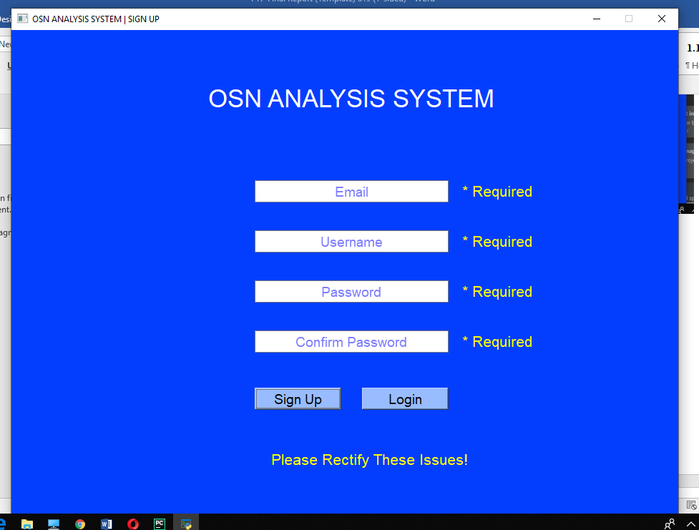
System will be able to check all the validation including email, Username, Password, confirm password and will notify if it is not fill according to the given requirements during signup process.

Fig 5.2. Login
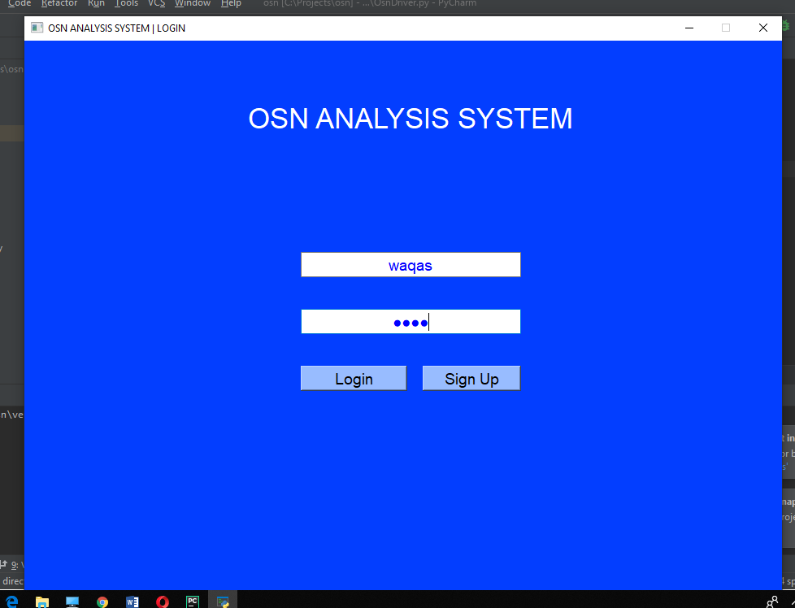
User name and password will be required to sign in as it is mandatory to access network analysis.

Fig 5.3. Upload, View, Delete. Generate Dataset
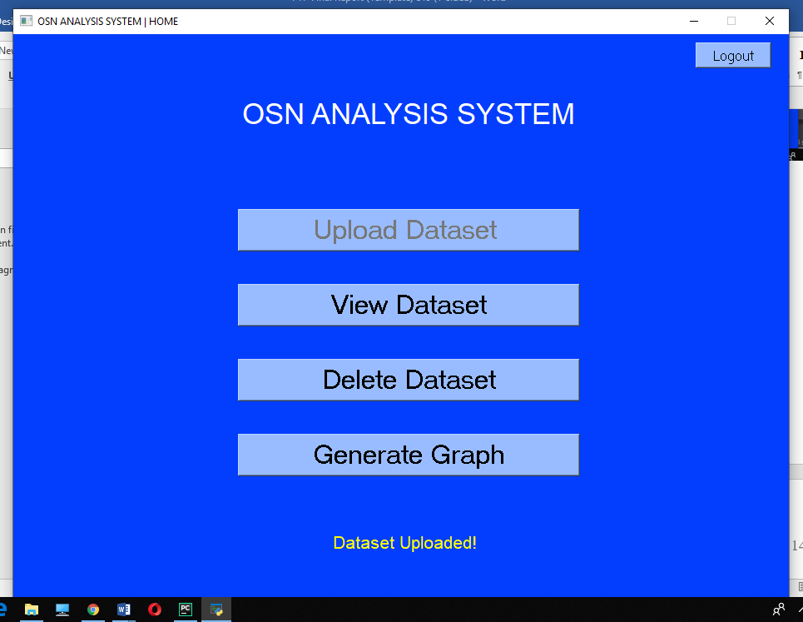
Home page will look alike this by providing FOUR main option 1st Upload dataset, 2nd view Dataset, 3rd Delete Dataset, Generate graph. Upload Dataset option will upload CSV or excel file to make sure and provide dataset into GUI environment, preform analysis later, View dataset will open dataset inn excel format so it can be edit able at any point. Delete button will delete the uploaded dataset. Generate graph button will take to next page to perform different network analysis.

Fig 5.4. Techniques Availability
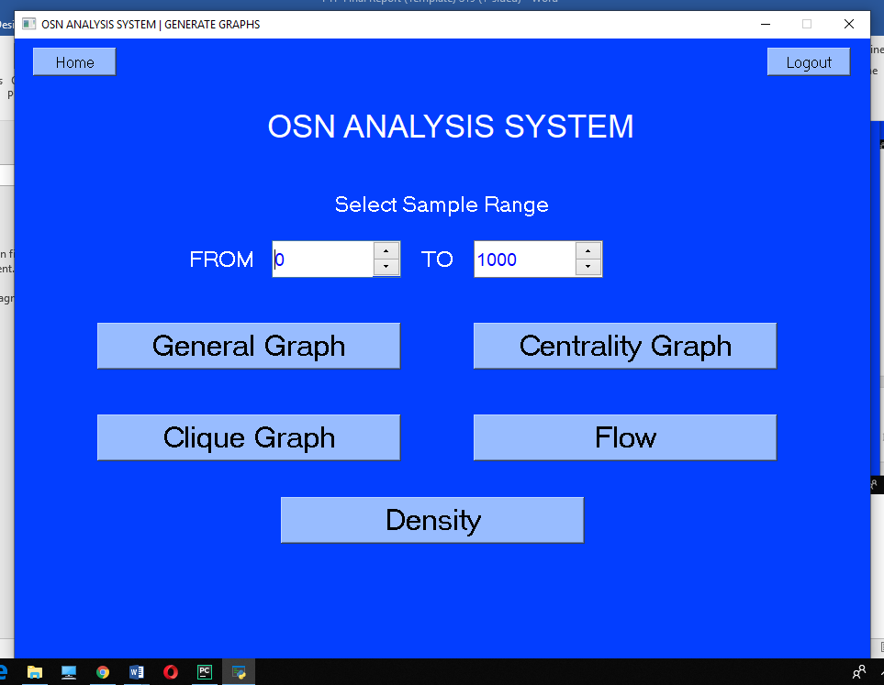

Select range of nodes and edges at select sample range here bar. General graph will provide the overall graph of a network. Centrality graph will generate centrality point of that particular range, Clique graph will make sure and provide all the given cliques in that particular range. Flow will measure flow of the network. Density will calculate the overall density.

Fig 5.5. General Graph.
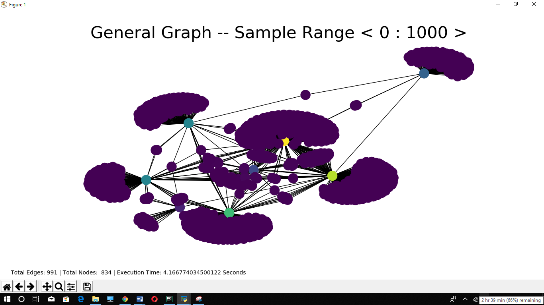

Fig 5.6. Centrality Graph
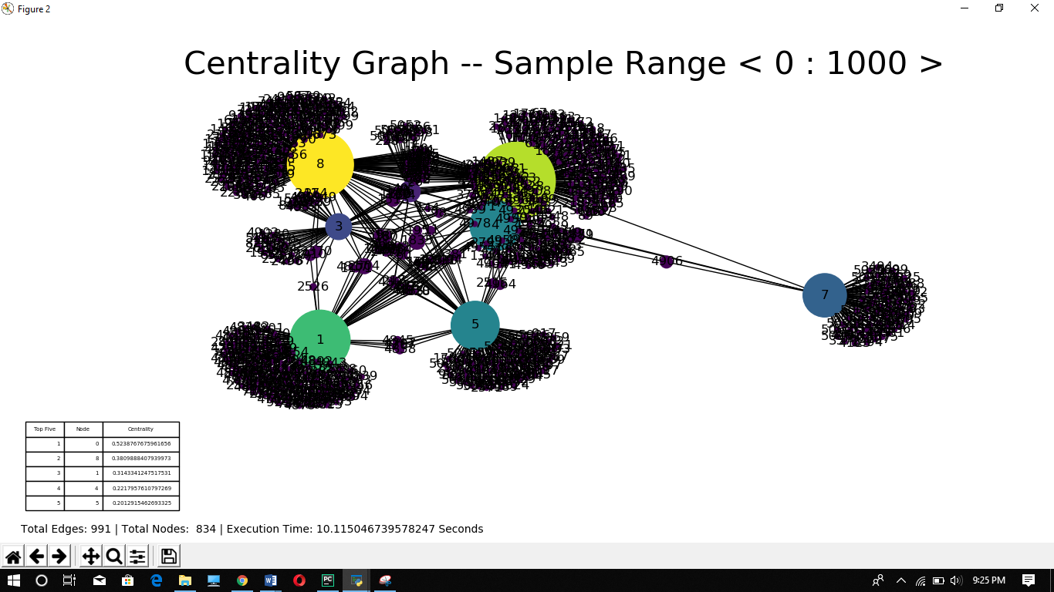
Colour nodes will present centrality points of the network so it’s easy to identify if give them any random colours. Top five nodes will be presented in the form of table as well. Total number of edges and total nodes presented in given graph will be shown as well. Execution time will also measure and get compared with NodeXl

Fig 5.7. Clique Graph
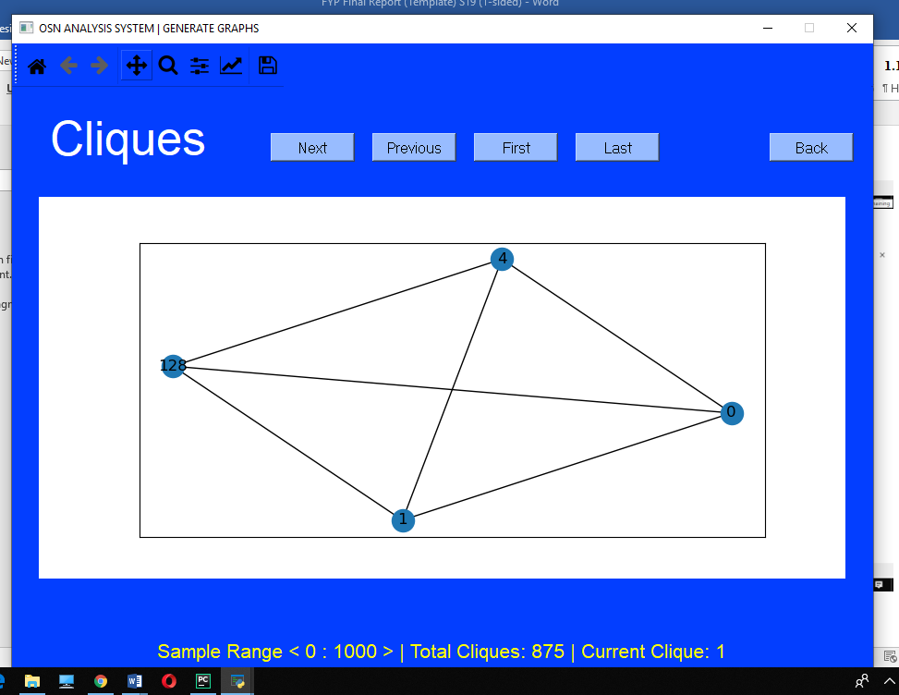
Clique examples are attached as per sample range and current clique will guide the current clique that a person is testing.
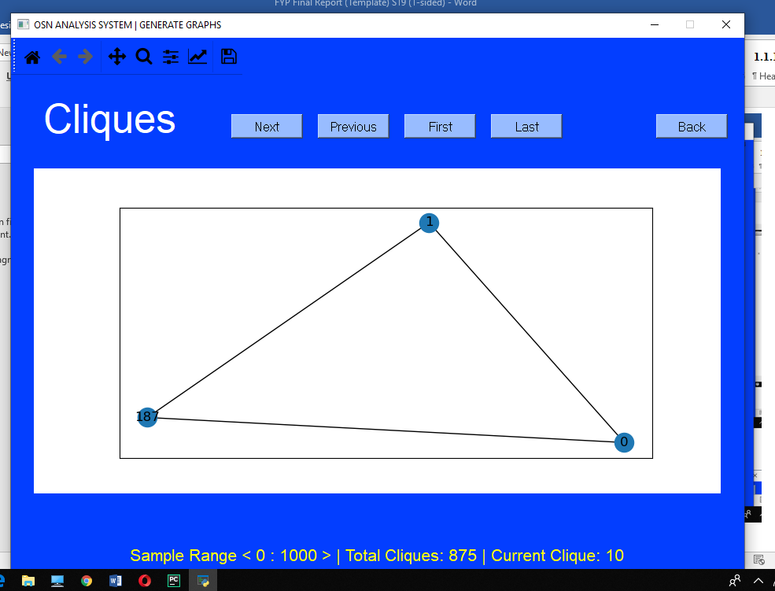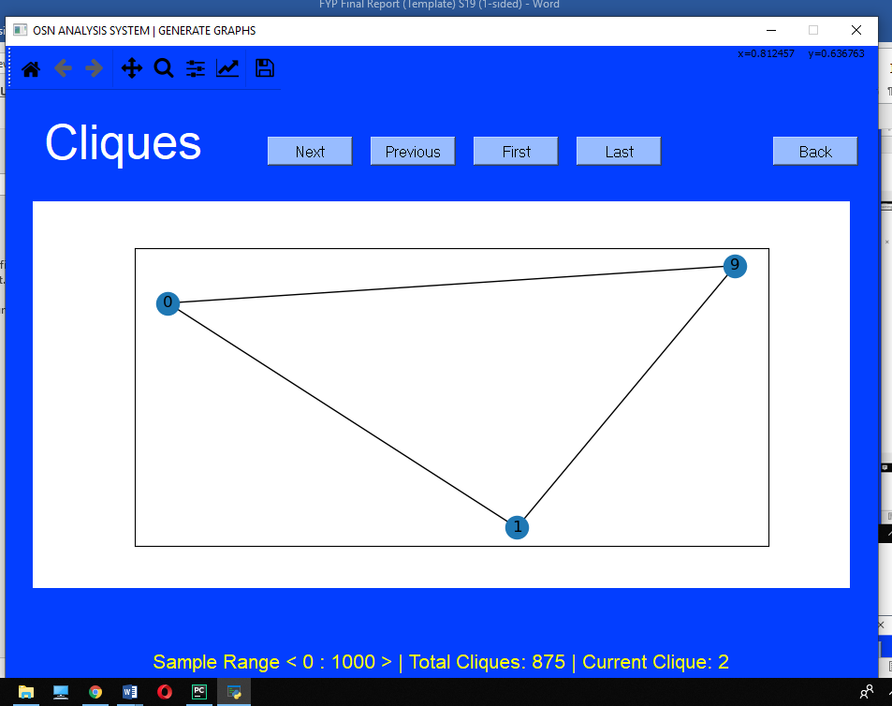

Fig 5.8. Density
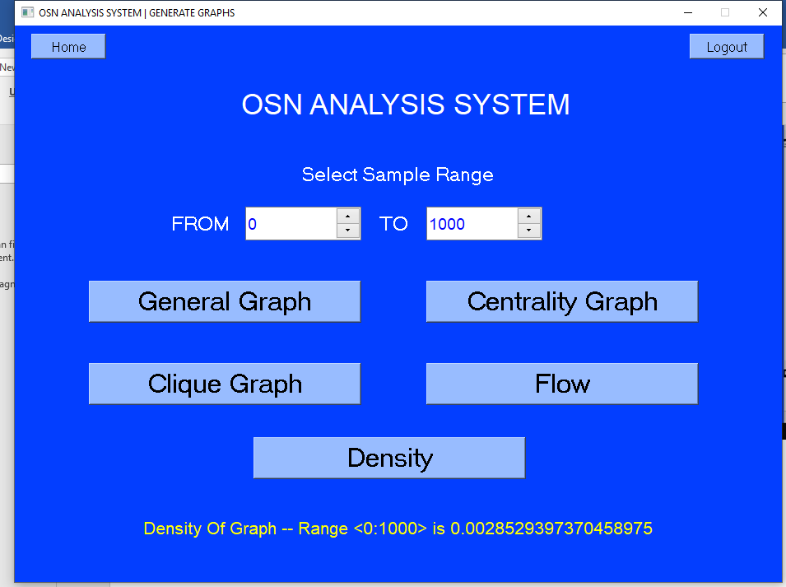

Fig 5.9. NodeXL Table

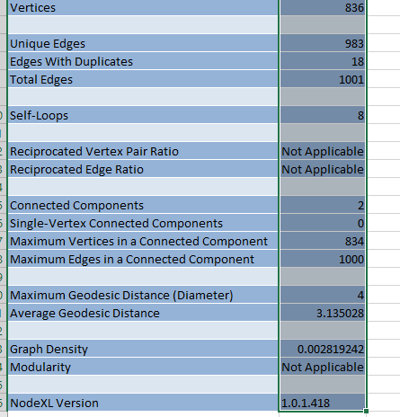
NodeXL provides the same results but execution time matters at some point.

NodeXL Findings

PyCharm GUI Findings

REFERENCES

[1] P. Hawe, C. Webster, and A. Shiell, “A glossary of terms for navigating the field of social network analysis,” J. Epidemiol. Community Health, vol. 58, no. 12, pp. 971–975, 2004.
[2] M. H. Raza, L. Hughes, and I. Raza, “Density : A Context Parameter of Ad Hoc Networks,” pp. 525–526, 2008.
[3] D. Du, “Social Network Analysis : Centrality Measures.”
[4] A. Sapountzi and K. E. Psannis, “Social networking data analysis tools & challenges,” Futur. Gener. Comput. Syst., vol. 86, pp. 893–913, 2018.
[5] S. Stieglitz, M. Mirbabaie, B. Ross, and C. Neuberger, “Social media analytics – Challenges in topic discovery, data collection, and data preparation,” Int. J. Inf. Manage., vol. 39, no. October 2017, pp. 156–168, 2018.
[6] C. Haythornthwaite, “Social network analysis: An approach and technique for the study of information exchange,” Libr. Inf. Sci. Res., vol. 18, no. 4, pp. 323–342, 1996.
[7] I. Ha, H. Park, and C. Kim, “Analysis of Twitter research trends based on SLR,” Int. Conf. Adv. Commun. Technol. ICACT, pp. 774–778, 2014.
[8] P. Hawe, C. Webster, and A. Shiell, “A glossary of terms for navigating the field of social network analysis,” J. Epidemiol. Community Health, vol. 58, no. 12, pp. 971–975, 2004.
[9] Home Office, “Social Network Analysis: ‘How to guide,’” no. January, p. 13, 2016.
[10] A. Tapiador, D. Carrera, and J. Salvachúa, “Social stream, a social network framework,” 1st Int. Conf. Futur. Gener. Commun. Technol. FGCT 2012, pp. 52–57, 2012.
[11] C. Thovex and F. Trichet, “A multidisciplinary model of dynamic and semantic social networks analysis for institutions,” Proc. - 2010 Int. Conf. Adv. Soc. Netw. Anal. Mining, ASONAM 2010, pp. 397–399, 2010.
[12] C. S. Castro and C. A. Madariaga, “Social networks analysis and perception of social support of young mothers in the process of reconstruction: The social fabric of winter victims in the Colombian Caribbean (South America),” ASONAM 2014 - Proc. 2014 IEEE/ACM Int. Conf. Adv. Soc. Networks Anal. Min., pp. 306–309, 2014.
[13] L. Izquierdo and R. Hanneman, “Introduction to the formal analysis of social networks using mathematica,” Introd. to Form. Anal. Soc. networks using Math., pp. 1–31, 2006.
[14] D. Gómez, J. Rui, and A. Eusébio, “Modeling centrality measures in social network analysis using bi-criteria network flow optimization problems,” vol. 226, pp. 354–365, 2013.
[15] J. Hu, M. Liu, and J. Zhang, “A semantic model for academic social network analysis,” ASONAM 2014 - Proc. 2014 IEEE/ACM Int. Conf. Adv. Soc. Networks Anal. Min., no. Asonam, pp. 310–313, 2014.

APPENDICES

APPENDIX A: Graphs
It’s to notify that PyCharm resultants are better in terms of providing processing time with hands on experience of dealing with processing speed. Density resultants are comparatively accurate on PyCharm GUI and proving actual figures.
Relatable graphs will provide accurate moment and flow according to required results. Density will be measured in actual figure on python based GUI which is (0.0028529397370458975) whereas relatively on NodeXL is (0.002819242) hence it proves the equality.

APPENDIX B: Computer Programme Listing

Python is base line codec environment. Pycharm is a platform that help in assembling Anaconda and PyQT nature of index to full fill the GUI required tasks.

