

03-134151-041 | USAMA NISAR
03-134142-112 | UMAIR PERVAIZ BUTT

COUNSEL A WEB-BASED PLATFORM

In partial fulfilment of the requirements for the degree of
Bachelor of Science in Computer Science
Supervisor: Mr. Taimoor Aamer
Department of Computer Sciences
Bahria University, Lahore Campus
13th, December 2018

© Bahria University, 2018

C e r t i f i c a t e

We accept the work contained in the report titled
“COUNSEL A WEB-BASED PLATFORM”,
written by
USAMA NISAR
UMAIR PARVAIZ BUTT
as a confirmation to the required standard for the partial fulfilment of the degree of
Bachelor of Science in Computer Science.

Approved by:
Supervisor: Mr. Taimoor Aamer
(Signature)
13th,December 2018

DECLARATION

We hereby declare that this project report is based on our original work except for citations and quotations which have been duly acknowledged. We also declare that it has not been previously and concurrently submitted for any other degree or award at Bahria University or other institutions

Enrolment | Name | Signature
03-134151-041 | USAMA NISAR
03-134142-112 | UMAIR PERVAIZ BUTT

Date : _________________________

Specially dedicated to
my beloved grandmother, mother and father
(Usama Nisar)
my beloved grandmother, mother and father
(Umair Pervaiz Butt)

ACKNOWLEDGEMENTS

We would like to thank everyone who had contributed to the successful completion of this project. We would like to express our gratitude to our project supervisor, Mr. Taimoor Aamer for his valuable advice, guidance and his enormous patience throughout the development of the project.

In addition, we would also like to express my gratitude to our loving parent and friends who had helped and given me encouragement.

Usama Nisar
Umair Pervaiz Butt

COUNSEL A WEB-BASED PLATFORM

ABSTRACT

It is a web-based platform in which Final Year Project (FYP) office of university will be accommodated. In this platform FYP office will only provide ID to groups and to supervisors. FYP Office will announce all updates related to final year projects (FYP) which consist of project phases submission, marks of projects phases, meeting with supervisor (weekly logbook). Notifications about deadline tracking and projects submission dates. Supervisor will give marks of SRS and Design Document and it will be sent to FYP Office. Supervisor will send all updated materials related to FYP to FYP Office. Groups will upload all material related to supervisor.

TABLE OF CONTENTS

DECLARATION iii
ACKNOWLEDGEMENTS vii
ABSTRACT ix
TABLE OF CONTENTS xi
LIST OF TABLES xv
LIST OF FIGURES xvii
LIST OF SYMBOLS / ABBREVIATIONS xxi
LIST OF APPENDICES xxii

CHAPTERS
1 INTRODUCTION 1
1.1 Background 1
1.2 Problem Statements 1
1.3 Aims and Objectives 2
1.4 Scope of Project 2
2 Software Requirement Specification 3
2.1 Product Perspective 3
2.2 User Classes and Characteristics 3
2.2.1 FYP Office 3
2.2.2 Supervisor 3
2.2.3 Group 4
2.3 Operating Environment 4
2.4 Design and Implementation Constraints 4
2.5 Assumptions and Dependencies 4
2.6 System Requirement Chart 5
3 DESIGN AND METHODOLOGY 7
3.1 Methodology 7
3.1.1 Build feature list 7
3.1.2 Sprint Planning 7
3.1.3 Daily sprint meeting 7
3.1.4 Testing and sprint demonstration 7
3.1.5 Retrospective and Next Sprint Planning: 7
3.2 Design 8
3.2.1 Use case diagram 9
3.2.2 Use Case Description 10
3.2.3 Sequence Diagram 18
3.2.4 Collaboration Diagram 28
3.2.5 Domain Model 34
3.2.6 Class Diagram 35
3.2.7 ERD 37
4 IMPLEMENTATION AND METHODOLOGY 39
4.1 Methodology 39
4.1.1 Build feature list 40
4.1.2 Sprint Planning 40
4.1.3 Daily sprint meeting 40
4.1.4 Testing and sprint demonstration 40
4.1.5 Retrospective and Next Sprint Planning 40
4.2 Implementation 41
4.2.1 Tools Used 41
4.2.2 Hardware Used 41
4.2.3 Technical Aspect of Counsel 42
4.2.4 Basic Structure of User Interface Structure 43
5 USER MANUAL 45
5.1 Getting started 45
5.1.1 User Access, Roles and Privileges 45
5.1.2 How to access COUNCEL 46
5.1.3 Login & Registration at COUNSEL 46
5.1.4 Role based authorized home screens: 47
5.1.5 Introduction to Navigation Bar 47
5.1.6 FYP Office 48
5.1.7 Supervisor 53
5.1.8 Groups 55
6 CONCLUSION 59
REFERENCES 61
APPENDICES 63

LIST OF TABLES

TABLE TITLE PAGE
Table 1:System Requirement Chart 5
Table 2: Use-Case Login 10
Table 3: Use-Case Add Batch 10
Table 4: Use-Case Upload FYP Documents 11
Table 5: Use-Case Create Notification 11
Table 6: Use-Case Add Supervisor 12
Table 7: Use-Case Maintain Track Record 12
Table 8: Use-Case View FYP Groups 13
Table 9: Use-Case Search FYP Material 14
Table 10: Use-Case View Notification 14
Table 11: Use-Case View Weekly Log Book 15
Table 12: Use-Case Write Weekly Log Book 15
Table 13: Use-Case Documentation Marks 16
Table 14: Use-Case View Documentation Marks 16
Table 15: Use-Case Manage Accounts 17
Table 16: Front End Technologies 42

LIST OF FIGURES

FIGURE TITLE PAGE
Figure 1: Use Case Diagram 9
Figure 2: FYP Login 18
Figure 3: Add Batch Details 19
Figure 4: View All Batch 19
Figure 5: Add Supervisor 20
Figure 6: View Supervisor Details 20
Figure 7: Add Groups 21
Figure 8: View All groups 21
Figure 9: Add Announcement 22
Figure 10: View All Announcement 22
Figure 11: View Announcement submission 23
Figure 12: View Weekly Log-Book 23
Figure 13: Supervisor Login 23
Figure 14: View Supervisor Announcement 24
Figure 15: Supervisor View Their Groups 24
Figure 16: Supervisor View All Submission 24
Figure 17: Group Login 25
Figure 18: Group View Announcement 25
Figure 19: Group View Log-Book 25
Figure 20: View Result 26
Figure 21: Complete Sequence Diagram 27
Figure 22: Collaboration Diagram of FYP Office Login 28
Figure 23: Collaboration Diagram of Supervisor Login 29
Figure 24: Collaboration diagram of Group Login 29
Figure 25: Collaboration Diagram of Add Account 29
Figure 26: Collaboration Diagram of Add Announcement 30
Figure 27: Collaboration Diagram of View All Batches 30
Figure 28: Collaboration Diagram of Add Supervisor 30
Figure 29: Collaboration Diagram of View All Supervisor 31
Figure 30: Collaboration Diagram of Add Group 31
Figure 31: Collaboration Diagram of View All Group 31
Figure 32: Collaboration Diagram of View All Announcement 32
Figure 33:Collaboration Diagram of View all Announcement Submission 32
Figure 34: Collaboration Diagram of Add Announcement Submission 32
Figure 35: Collaboration Diagram of View Group Announcement 33
Figure 36: Collaboration Diagram of Write Weekly log-Book 33
Figure 37: Collaboration Diagram of Add Batch 33
Figure 38: Collaboration Diagram of View Weekly Log-Book 34
Figure 39: Domain Model of Counsel 34
Figure 40: Class Diagram of Counsel 36
Figure 41: ERD 37
Figure 42: Scrum Model 40
Figure 43: Structure of Back End Technologies 42
Figure 44: Base URL 46
Figure 45: Login Page 46
Figure 46: Group Account type 47
Figure 47: Supervisor Account type 47
Figure 48: FYP Office account type 47
Figure 49: Navigation bar 47
Figure 50: FYP Office Dashboard 48
Figure 51: Main FYP Dashboard 48
Figure 52: Batch options 48
Figure 53: Add batch 49
Figure 54: All batch 50
Figure 55: Group option 50
Figure 56: Add group 51
Figure 57: All group 52
Figure 58: Announcement option 52
Figure 59: Group announcement submission 52
Figure 60: Log book 53
Figure 61: Supervisor dashboard 53
Figure 62: Supervisor menu 54
Figure 63: All announcements for supervisor 54
Figure 64: All groups under supervisor 55
Figure 65: View all submission for supervisor 55
Figure 66: Group main page 55
Figure 67: Group dashboard 56
Figure 68: Group menu 56
Figure 69: Group announcements 57
Figure 70: Log book of group 57
Figure 71: Result of group 57

LIST OF SYMBOLS / ABBREVIATIONS

ID Identity
FYP Final Year Project
CSS Cascading Style Sheet
PHP Hypertext Pre-processor
HTML Hyper Text Mark-up Language
SRS Software Requirement Specification
E-Learning Electronic Learning
UML Unified Modelling Language
ERD Entity Relationship Diagram

LIST OF APPENDICES

APPENDIX TITLE PAGE
No table of figures entries found.

INTRODUCTION

Background

Universities with multiple departments/campuses that are in different locations even in this age of email, cell phones and web conferencing, have communication gaps. Most of the universities in Pakistan now shifting towards e-learning that minimizes the communication gap between Students and teachers. Moreover, organizations use traditional ways of communication (i.e. circulation of piece of papers called memos) between or inside departments.
Bahria University uses different learning platforms like Piazza, Turnitin, Google Classroom for e-learning purposes but not all faculty members strictly follow these platforms. Some faculty also uses social media platform like Facebook, Google Groups. Due to these multiple learning methodologies makes confusion or difficulties for Students.

Problem Statements

FYP Offices of different universities were having difficulties maintaining records of students related to FYP. The process through which all activities of FYP were being handled was becoming difficult to execute. All activities were being conducted through hard form which was strenuous. Maintain track record of FYP of students was becoming laborious.

Aims and Objectives

The objectives of the project are shown as following:
- FYP Office will announce all updates related to final year projects (FYP)
- FYP office will upload abstract of completed FYP of the graduate Groups
- Notification, deadline tracking meeting tracking with supervisor and weekly log related to FYP of Groups will be provided by this platform
- Groups can upload all material related to their FYP
- Supervisor will give marks of Doc 1 and Doc 2
- Supervisor will send all updated materials related to FYP to FYP Office

Scope of Project

In this platform FYP office will announce all updates related to FYP of Groups. Notification, deadline tracking, meeting tracking with supervisor and weekly log related to FYP of groups will be provided by this platform. Groups will upload their assignments and all material related to FYP. Supervisor will give marks of SRS and Design Document and it will be sent to FYP office. Supervisor will send all updated materials related to FYP office.

Software Requirement Specification

Product Perspective
It is a web-based platform in which Final Year Project (FYP) office of university will be accommodated. In this platform FYP office will provide ID to groups and to supervisors. FYP office will announce all updates related to final year projects (FYP), which consist of project submission phase, marks of projects phase, meeting with supervisor (weekly logbook). There will be Notifications about deadline tracking and projects submission dates to the students and supervisors. Supervisor will give marks of SRS and Design Document; these marks will show to FYP office. Supervisor will send all updated materials related to FYP to FYP office. Groups will upload all material related to supervisor.

User Classes and Characteristics

“Counsel A Web Based Platform” is divided into three users i.e. FYP Office, Group and Supervisor.

FYP Office
- FYP office will generate account for supervisor and groups
- FYP office will generate announcement
- FYP office will add groups for supervisor
- FYP office will maintain record of supervisor and groups
- FYP office will see weekly log-book

Supervisor
- Supervisor will see their groups
- Supervisor will give marks of SRS and Design Documentation
- Supervisor will see all announcement

Group
- Group will see announcement of FYP
- Group will write their weekly log-book
- Group will see their result
- Group will upload documentation

Operating Environment

This is a web-based platform and run accurately on following web browsers
- Google Chrome
- Opera

Design and Implementation Constraints

“COUNSEL” is a web-based platform therefore front-end of “COUNSEL” is developed using “HTML” and “CSS” and back-end developed using php and “MySQL” database. It uses “PHP” framework “code-igniter” includes its Ion-Auth library for user registration and authentication. “Xampp” server used as host server. “COUNSEL” is developed using Scrum Agile methodology, where projects progress via a series of sprints. Sprints are time boxed to no more than a month long, most commonly two weeks. One sprint at a time is completed after which next sprint comes in consideration.

Assumptions and Dependencies

“COUNSEL” is a web-based platform so it requires Google Chrome or Opera browser installed on user’s system. COUNSEL requires 35.1 version or higher for Google Chrome, and 52 or higher version of Opera to run efficiently.

System Requirement Chart

Table 1:System Requirement Chart
ID | Priority | Type | Contained in  Use-Case | Description
Use-Case  COUNSEL-R1 | High | Functional | Use-Case -1 | Registration
Use-Case  COUNSEL -R2 | High | Functional | Use-Case -2 | Login
Use-Case  COUNSEL -R3 | High | Functional | Use-Case -4 | Search Project
Use-Case  COUNSEL -R4 | High | Functional | Use-Case -5 | View Project
Use-Case  COUNSEL -R5 | High | Functional | Use-Case -6 | Request Project
Use-Case  COUNSEL -R6 | High | Functional | N/A | List of SH
Use-Case  COUNSEL -R7 | High | Functional | Use-Case -9 | Discussion  Forum (Chat with  Users)
Use-Case  COUNSEL -R8 | High | Functional | Use-Case -3 | Upload Project
Use-Case  COUNSEL -R9 | Medium | Functional | Use-Case -6 | Accept/Decline Request

Use-Case  COUNSEL -R10 | Medium | Functional | Use-Case -8 | Add new Teacher Account
Use-Case  COUNSEL -R11 | Medium | Functional | Use-Case -8 | Delete Teacher Account
Use-Case  COUNSEL -R12 | High | Functional | Use-Case -8 | Add FYP office Account
Use-Case COUNSEL -R13 | Medium | Non-  Functional | Use-Case -8 | Responsive  Website Design
Use-Case COUNSEL - R14 | Medium | Non-  Functional | N/A | Testing Website will be done module by module
Use-Case COUNSEL - R15 | Medium | Non-  Functional | N/A | Design best Architecture for better data retrieval from server
Use-Case COUNSEL -R16 | High | Non-  Functional | N/A | Final, integrated project code will test to ensure that complete project is integrated well and functioning properly

DESIGN AND METHODOLOGY

Methodology

Methodology used for this project is scrum which is a sub-group of agile methodology; the purpose of using scrum is because of its simplicity and iterative development. The Scrum methodology includes further definitions and specifications, but purses the values and principles of agile. Class diagram and sequence diagram will be used in the system analysis, and feedback on the initial design will be acquired from real users of the system.

Build feature list
In this step all important features will be listed down.

Sprint Planning
The next step after building feature list is to produce the development plan which is called a sprint planning. This phase also determines sprint duration.

Daily sprint meeting
In this phase daily, stand-up meeting will be conducted with supervisor to discuss the problems and progress of current working sprint.

Testing and sprint demonstration
The team demonstrates the results of their current sprint by creating a review.
Supervisor takes a decision about further project changes after examining the demonstration.

Retrospective and Next Sprint Planning:
In this phase sprint’s result will be discussed by supervisor and determine the ways how to improve development process. After this next sprint planning will be started.

Design

Following artefacts included in this Chapter
- Use case diagram
- Use case description
- Sequence Diagram
- Collaboration Diagram
- Domain Model
- Design Class Diagram
- ERD

Use case diagram
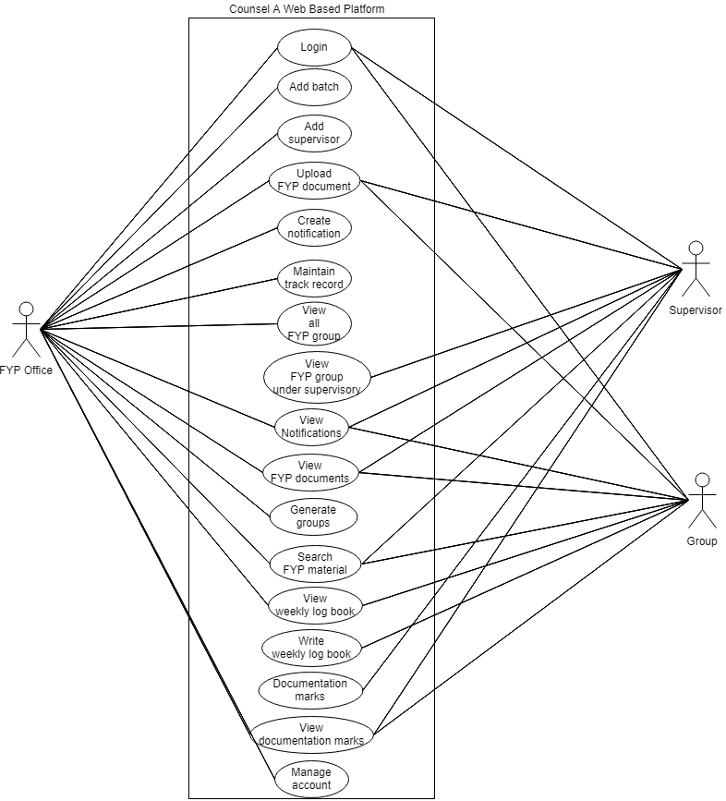
Figure 1: Use Case Diagram

Use Case Description

Following are the narrative parts of every bubble in above use case diagrams

Table 2: Use-Case Login
Name | Login
Use-Case ID | COUNSEL-R1
Priority | High
Primary Actor | FYP Office
Other participating Actor(s) | Supervisor/Group
Description | This use case will login all stake holders of COUNSEL
Pre-condition | FYP Office/Supervisor/Group must be logged in
Trigger | This use case initiate when FYP Office will add account of the Groups and Supervisor
Typical flow of Event | - Open COUNSEL  - Log in as FYP Office /Supervisor/Group
Alternate flow of Event | FYP Office will not add Groups, Supervisor
Post condition | Successfully FYP Office will add Groups, Supervisor account
Alternate post condition | Have not add Groups, Supervisor account

Table 3: Use-Case Add Batch
Name | Add batch
Use-Case ID | COUNSEL-R2
Priority | High
Primary Actor | FYP Office
Other participating Actor(s) | N/A
Description | This use case describes when FYP Office will login at  COUNSEL
Pre-condition | FYP Office must have account at COUNSEL
Trigger | This use case initiate when a FYP Office add’s batch
Post condition | Batch successfully created
Alternate post condition | Batch not created

Table 4: Use-Case Upload FYP Documents
Name | Upload FYP documents
Use-Case ID | COUNSEL-R3
Priority | High
Primary Actor | FYP Office, Supervisor, Group
Other participating Actor(s) | ---
Description | This use case describes when FYP Office, Supervisor,  Group upload FYP documents
Pre-condition | User must open COUNSEL in browser and must be logged in
Trigger | This use case initiate when FYP Office will upload FYP documents in COUNSEL
Typical flow of Event | - Open COUNSEL  - Logged in as FYP Office/Supervisor/Group  - Upload FYP documents
Alternate flow of Event | User will not upload FYP documents
Post condition | Successfully user will upload FYP documents
Alternate post condition | Have not Upload FYP documents

Table 5: Use-Case Create Notification
Name | Create Notification
Use-Case ID | COUNSEL-R4
Priority | Medium
Primary Actor | FYP office
Other participating Actor(s) | ---
Description | This use case describes when FYP Office will notify regarding FYP
Pre-condition | The FYP groups should have account in COUNSEL
Trigger | This use case initiate when the FYP Office will notify regarding FYP
Typical flow of Event | - Open COUNSEL  - Log in as FYP Office  - Click on Add Notification
Alternate flow of Event | The FYP groups are not added in COUNSEL
Post condition | Successfully notified regarding FYP
Alternate post condition | No notification made

Table 6: Use-Case Add Supervisor
Name | Add supervisor
Use-Case ID | COUNSEL-R5
Priority | High
Primary Actor | FYP Office
Other participating Actor(s) | ---
Description | This use case describes when FYP Office will add supervisor for FYP in COUNSEL
Pre-condition | The FYP Office should be register in COUNSEL
Trigger | This use case initiate when FYP Office will add supervisor in  COUNSEL
Typical flow of Event | - Open COUNSEL  - Log in as FYP Office  - Select supervisor  - Click on Add supervisor
Alternate flow of Event | Supervisor will not be added in COUNSEL
Post condition | Successfully added supervisor
Alternate post condition | No supervisor added

Table 7: Use-Case Maintain Track Record
Name | Maintain Track Record
Use-Case ID | COUNSEL-R6
Priority | Medium
Primary Actor | FYP Office
Other participating Actor(s) | ---
Description | This use case describes when FYP Office will maintain the records of FYP in COUNSEL
Pre-condition | 1.FYP Office must open COUNSEL in browser and must be logged in  2.Group must be added in FYP
Trigger | This use case initiate when a FYP Office will maintain the record of registered FYP groups
Typical flow of Event | - Open COUNSEL  - Log in as FYP Office  - Search FYP Group ID
Alternate flow of Event | FYP Office have not search FYP Group ID
Post condition | Successfully maintain the record of the added FYP groups
Alternate post condition | Have not maintain the record of added FYP groups

Table 8: Use-Case View FYP Groups
Name | View FYP groups
Use-Case ID | COUNSEL-R7
Priority | High
Primary Actor | FYP Office
Other participating Actor(s) | ---
Description | This use case describes when FYP Office will view FYP groups in COUNSEL
Pre-condition | FYP Office must open COUNSEL in browser and must be logged in
Trigger | This use case initiate when FYP Office will view FYP groups in  COUNSEL
Typical flow of Event | 1. Open COUNSEL  2. Log in as FYP Office  3. View FYP groups
Alternate flow of Event | FYP office will not view FYP groups
Post condition | Successfully FYP Office will view FYP groups
Alternate post condition | Have not viewed FYP groups

Table 9: Use-Case Search FYP Material
Name | Search FYP material
Use-Case ID | COUNSEL-R8
Priority | Medium
Primary Actor | FYP Office/Supervisor/Group
Other participating Actor(s) | ---
Description | This use case describes when FYP Office will search FYP material
Pre-condition | 1. FYP Office must open COUNSEL in browser and must be logged in  2. Supervisor must open COUNSEL in browser and must be logged in  3. Group must open COUNSEL in browser and must be logged in
Trigger | This use case initiate when FYP Office/Supervisor/Group will search FYP material in  COUNSEL
Typical flow of Event | 1. Open COUNSEL  2. Log in as FYP Office/Supervisor/Group  3. Search FYP material
Alternate flow of Event | FYP Office login and will not search FYP material
Post condition | Successfully FYP Office will search FYP material
Alternate post condition | Have not search FYP material

Table 10: Use-Case View Notification
Name | View Notification
Use-Case ID | COUNSEL-R10
Priority | Medium
Primary Actor | FYP office, Group, supervisor
Other participating Actor(s) | ---
Description | This use case describes when FYP Office, Group and supervisor will view notification regarding FYP
Pre-condition | The FYP Office, FYP groups and supervisor should be register in  COUNSEL
Trigger | This use case initiate when the FYP Office, Group and supervisor will view notification regarding FYP
Typical flow of Event | - Open COUNSEL  - Log in as FYP Office/Supervisor/Group  - Click on View Notification
Alternate flow of Event | The FYP Office, FYP groups and supervisor are not add in  COUNSEL
Post condition | Successfully view notification regarding FYP
Alternate post condition | FYP Office, supervisor and Group will not view notification

Table 11: Use-Case View Weekly Log Book
Name | View weekly log book
Use-Case ID | COUNSEL-R11
Priority | Medium
Primary Actor | Group, FYP office
Other participating Actor(s) | ---
Description | This use case describes when Group and FYP office will view weekly log book
Pre-condition | The FYP office and Groups should be register in COUNSEL
Trigger | This use case initiate when the Group and FYP office will view weekly log book
Typical flow of Event | 1. Open COUNSEL  2. Log in as FYP Office/Group  3.Click on view weekly log book
Alternate flow of Event | The FYP office and Groups are not added in COUNSEL
Post condition | Successfully view weekly log book
Alternate post condition | FYP office and Group will not view weekly log book

Table 12: Use-Case Write Weekly Log Book
Name | Write weekly log book
Use-Case ID | COUNSEL-R12
Priority | High
Primary Actor | Groups
Other participating Actor(s) | ---
Description | This use case describes when Groups will write weekly log book
Pre-condition | The Group should be added in COUNSEL
Trigger | This use case will initiate after generating weekly log book by FYP  Office
Typical flow of Event | 1. Open COUNSEL  2.Click on Weekly log book
Alternate flow of Event | Group not added in COUNSEL
Post condition | Successfully weekly log book written
Alternate post condition | Groups will not write weekly log book

Table 13: Use-Case Documentation Marks
Name | Documentation marks
Use-Case ID | COUNSEL-R13
Priority | Medium
Primary Actor | Supervisor
Other participating Actor(s) | ---
Description | This use case describes when supervisor will grade documents
Pre-condition | The supervisor should be added in COUNSEL
Trigger | This use case initiate when supervisor will grade documents
Typical flow of Event | 1. Open COUNSEL  2. Click on announcement submissions
Alternate flow of Event | The supervisors are not added in COUNSEL
Post condition | Successfully graded documents
Alternate post condition | Supervisor will not grade document

Table 14: Use-Case View Documentation Marks
Name | View documentation marks
Use-Case ID | COUNSEL-R14
Priority | Medium
Primary Actor | FYP Office, Group and supervisor
Other participating Actor(s) | ---
Description | This use case describes when supervisor will grade FYP document
Pre-condition | The FYP Office, Group and supervisor should be register in  COUNSEL
Trigger | This use case initiate when FYP Office, Group and supervisor will view documentation marks
Typical flow of view Event | 1. Open COUNSEL  2.Click on View Announcements
Alternate flow of Event | - FYP Office, Group and supervisor will not be logged in  COUNSEL  - The document is not graded
Post condition | Successfully View documentation marks
Alternate post condition | FYP Office, Group and supervisor will not view documentation marks

Table 15: Use-Case Manage Accounts
Name | Manage accounts
Use-Case ID | COUNSEL-R15
Priority | Medium
Primary Actor | FYP Office
Other participating Actor(s) | ---
Description | This use case describes when FYP Office will accounts
Pre-condition | The FYP Office should be register in COUNSEL
Trigger | This use case initiate when FYP Office will manage account
Typical flow of Event | 1. Open COUNSEL  2.Click on All Groups/All Supervisors
Alternate flow Event | - FYP Office will not be logged in COUNSEL  - The accounts not edited
Post condition | Successfully managed account
Alternate post condition | FYP Office will not manage account

Sequence Diagram
A Sequence diagram illustrates the sequence of actions that appear in a system. The appeal of methods in each object, and the order in which appeal occurs is displayed in a Sequence diagram. This makes Sequence diagram a very appropriate tool to easily represent the dynamic behaviour of a system.
A Sequence diagram is two-dimensional in nature. On the horizontal axis, it shows the life of the object that it represents, while on the vertical axis, it shows the sequence of the creation of these objects.
Sequence diagram is very effective in elaborating the dynamic design and the sequence of appeal of objects. Following are the sequence diagrams of “Counsel A Web-Based Platform”

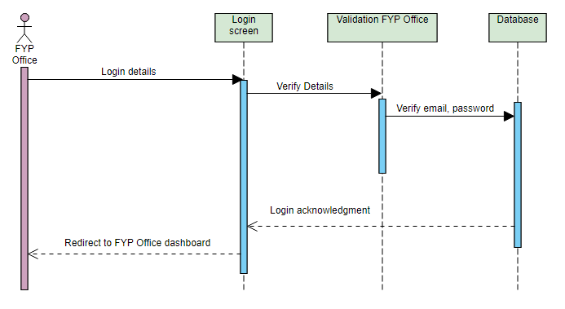
Figure 2: FYP Login

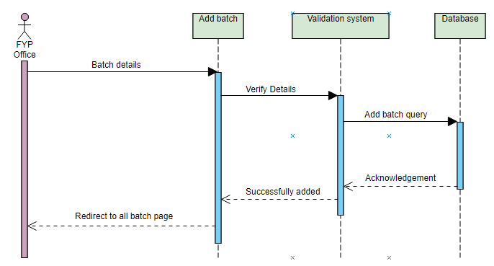
Figure 3: Add Batch Details

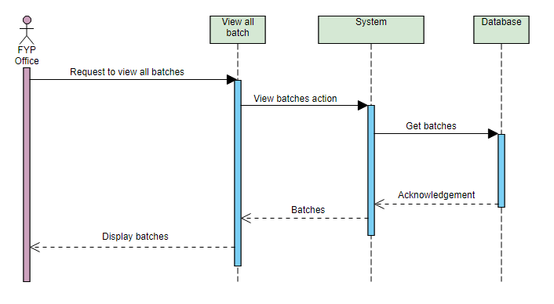
Figure 4: View All Batch

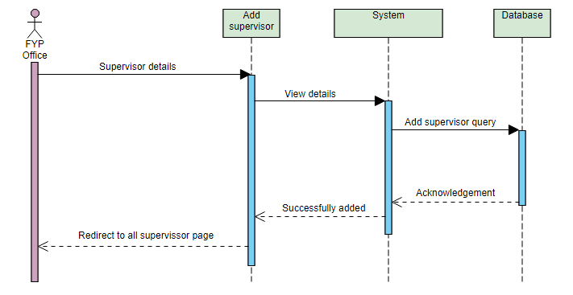
Figure 5: Add Supervisor

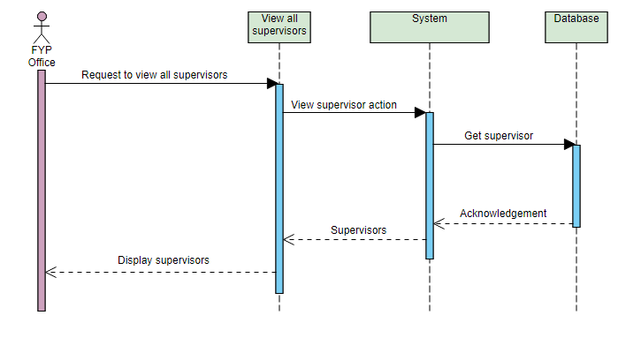
Figure 6: View Supervisor Details

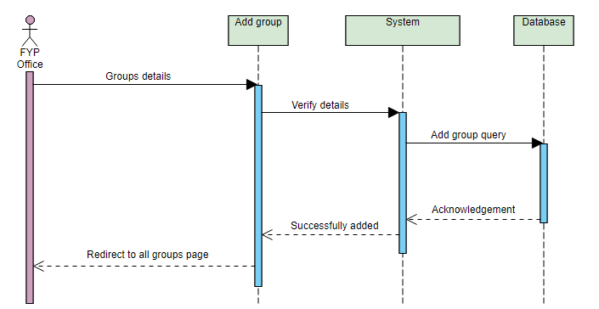
Figure 7: Add Groups

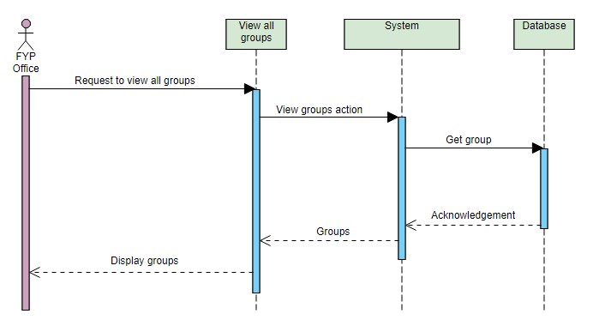
Figure 8: View All groups

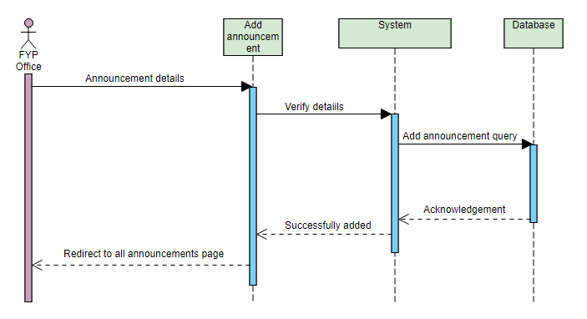
Figure 9: Add Announcement

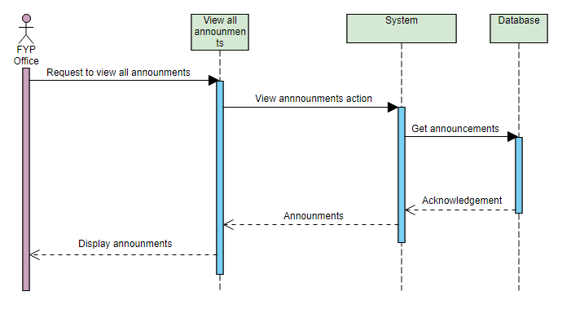
Figure 10: View All Announcement
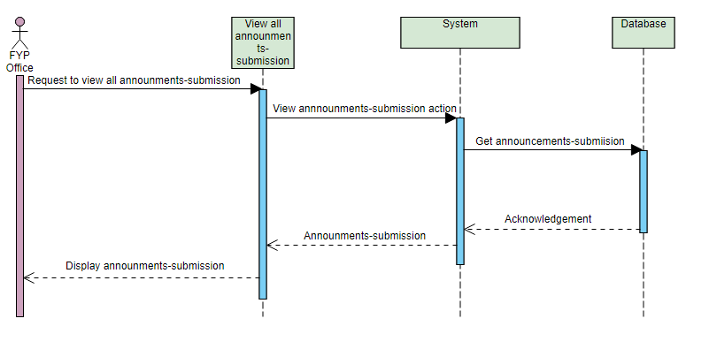
Figure 11: View Announcement submission

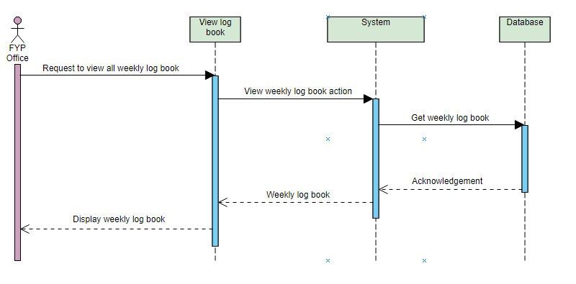
Figure 12: View Weekly Log-Book

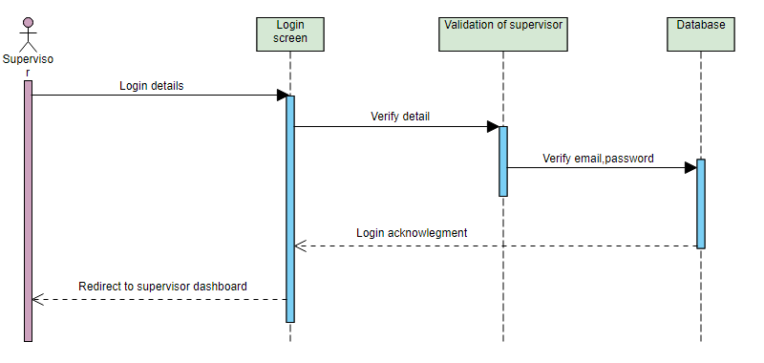
Figure 13: Supervisor Login
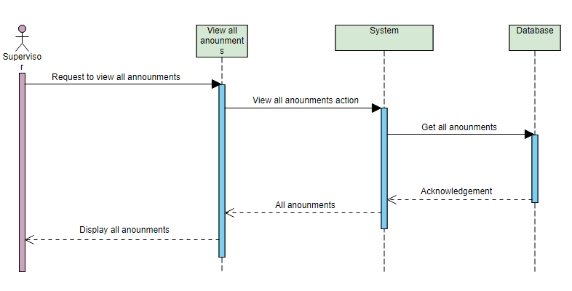
Figure 14: View Supervisor Announcement

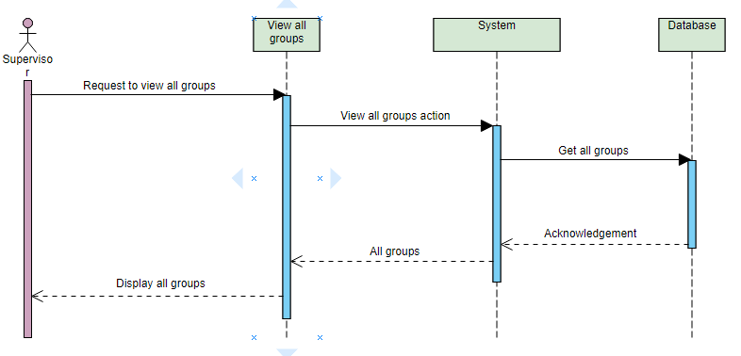
Figure 15: Supervisor View Their Groups

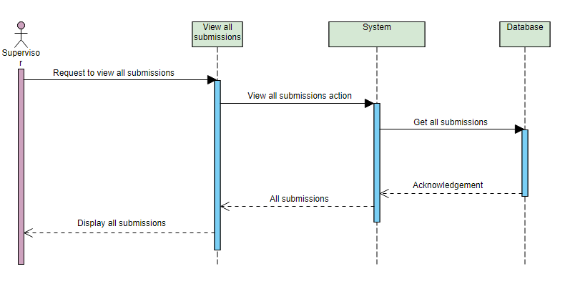
Figure 16: Supervisor View All Submission
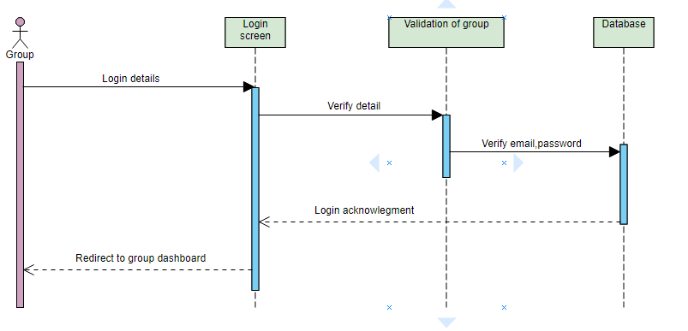
Figure 17: Group Login

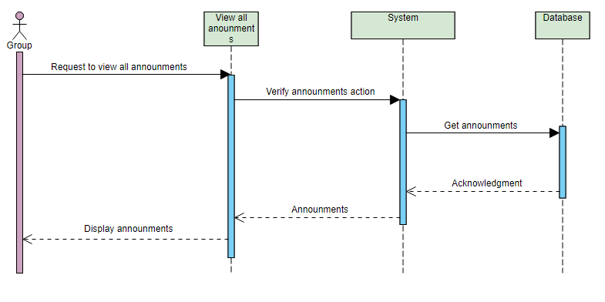
Figure 18: Group View Announcement

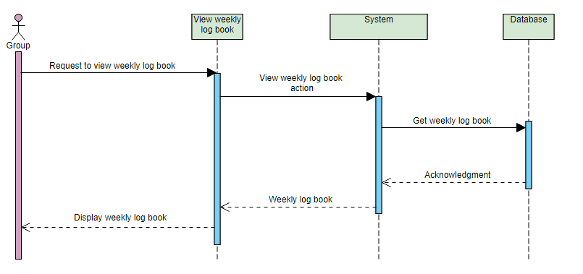
Figure 19: Group View Log-Book
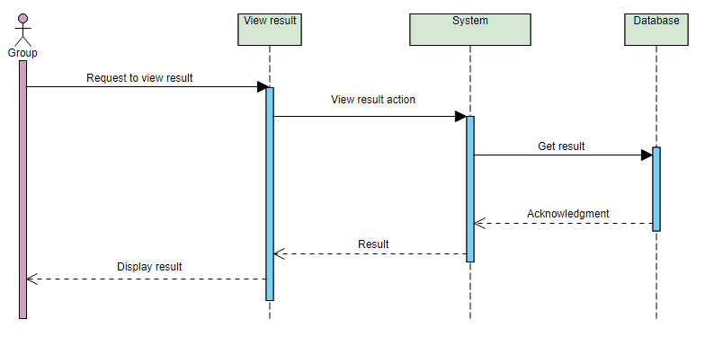
Figure 20: View Result

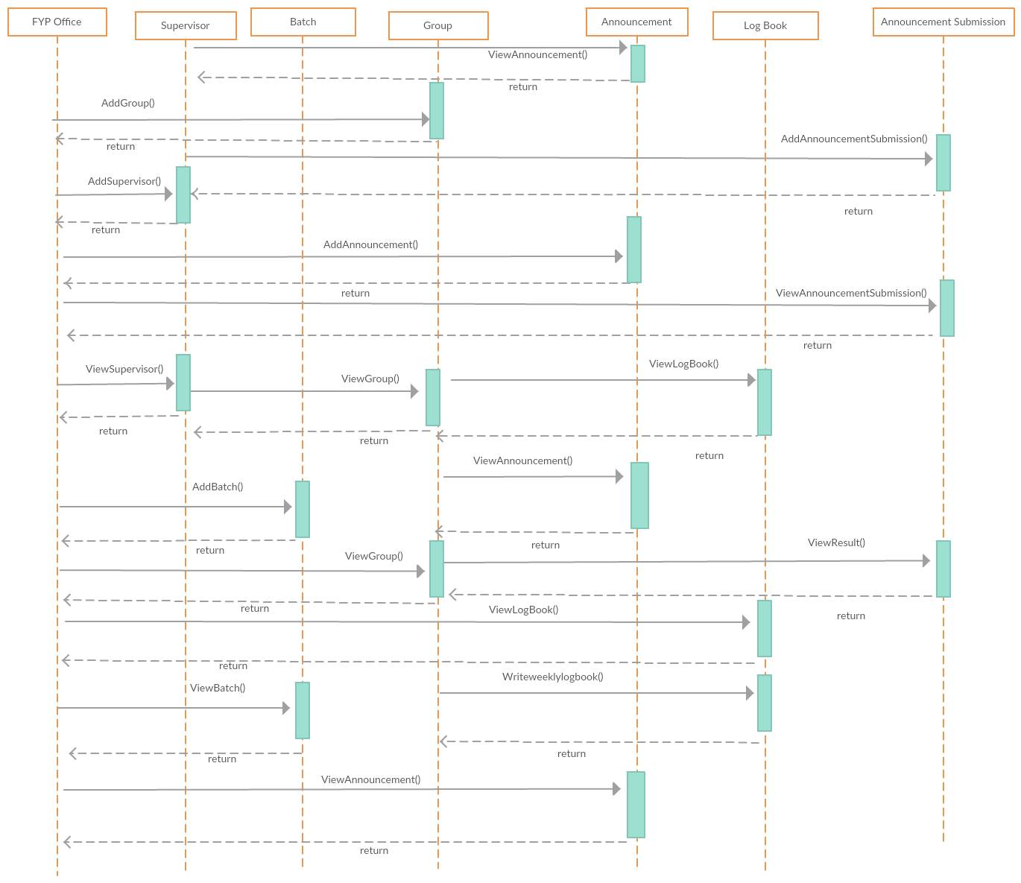
Figure 21: Complete Sequence Diagram

Collaboration Diagram

A collaboration diagram defines a pattern of interaction among objects; it shows the objects engaging by their links to each other.
Collaboration diagrams are used to display how objects interact to achieve the behaviour of an appropriate use-case, or a part of a use-case. Collaborations are used by designers to describe and clarify the aspects of the objects that perform a particular flow of collection of a use-case.
Unlike a sequence diagram, a collaboration diagram depicts the relationships among the objects. Collaboration diagrams and sequence diagrams express similar information, but in different ways.
Collaboration diagram are better for analysis because of its format. Specifically, they tend to be better suited to depicting simpler collaborations of smaller numbers of objects with each other.
Following are the Collaboration Diagrams of “Counsel A Web-Based Platform”.

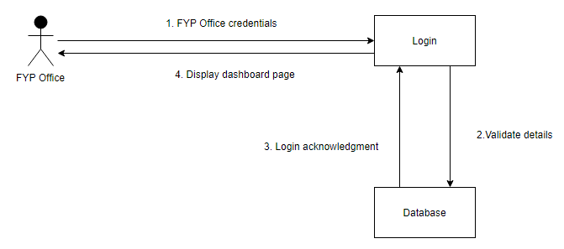
Figure 22: Collaboration Diagram of FYP Office Login

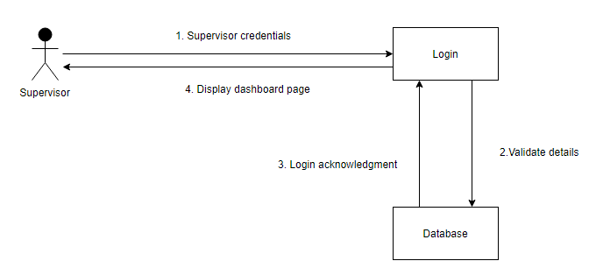
Figure 23: Collaboration Diagram of Supervisor Login

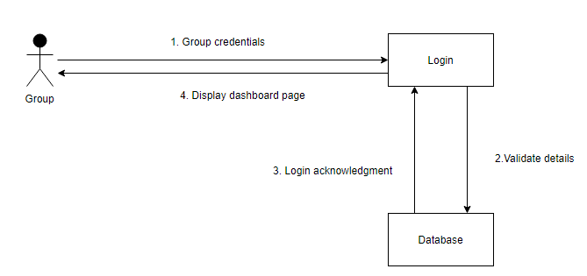
Figure 24: Collaboration diagram of Group Login

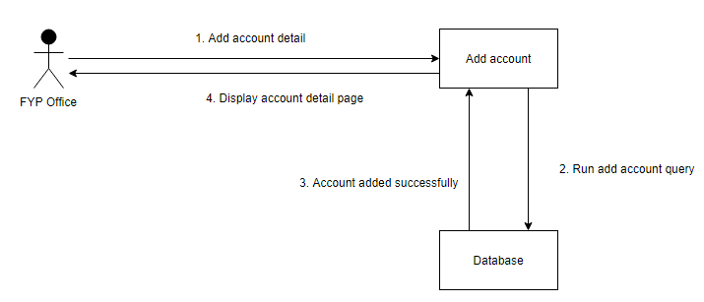
Figure 25: Collaboration Diagram of Add Account

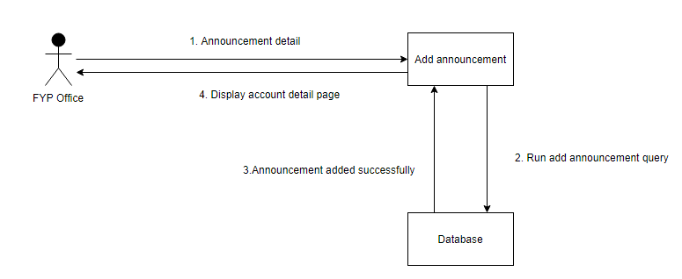
Figure 26: Collaboration Diagram of Add Announcement

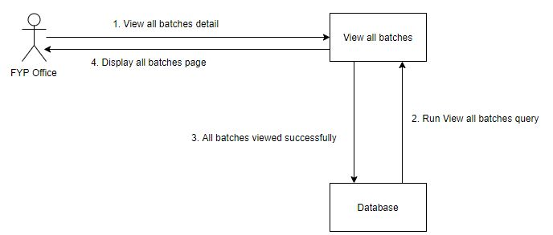
Figure 27: Collaboration Diagram of View All Batches

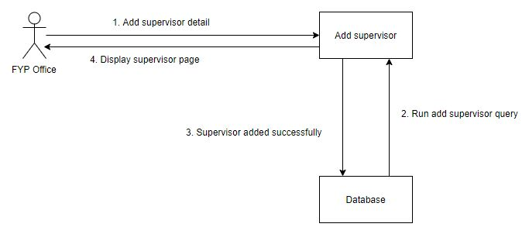
Figure 28: Collaboration Diagram of Add Supervisor
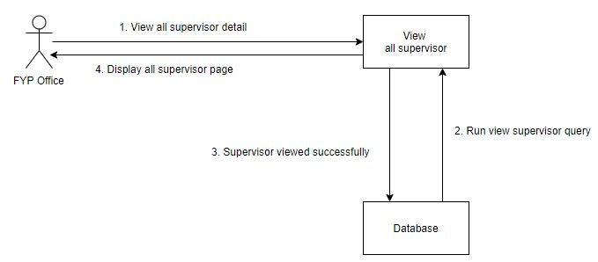
Figure 29: Collaboration Diagram of View All Supervisor

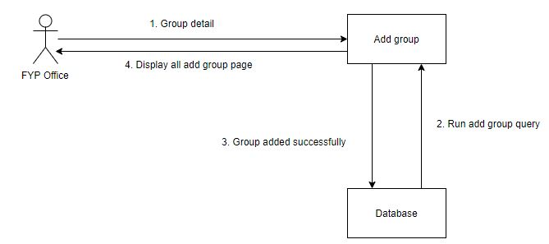
Figure 30: Collaboration Diagram of Add Group

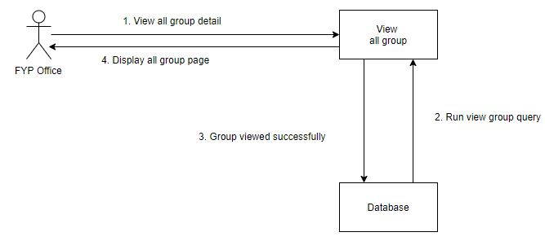
Figure 31: Collaboration Diagram of View All Group

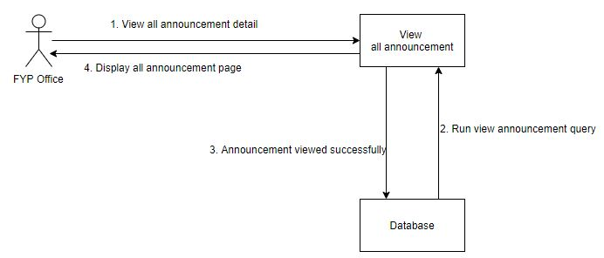
Figure 32: Collaboration Diagram of View All Announcement

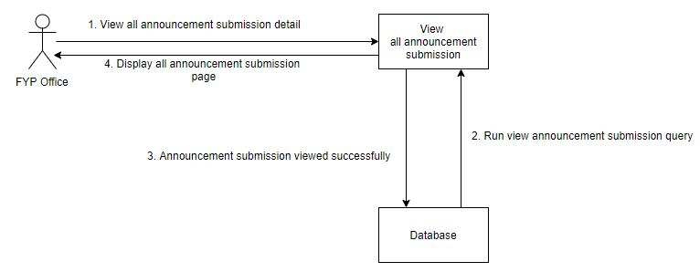
Figure 33:Collaboration Diagram of View all Announcement Submission

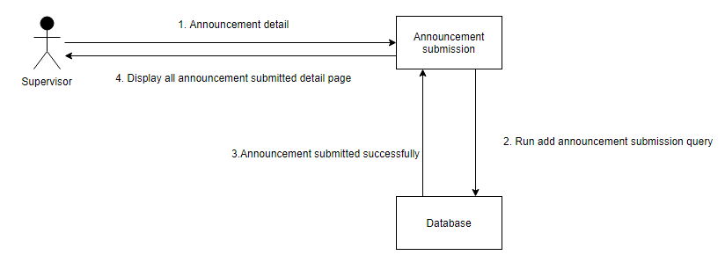
Figure 34: Collaboration Diagram of Add Announcement Submission

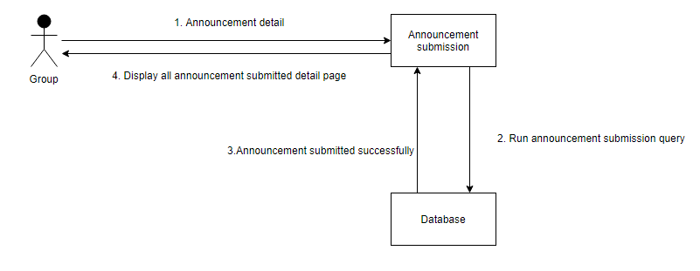
Figure 35: Collaboration Diagram of View Group Announcement

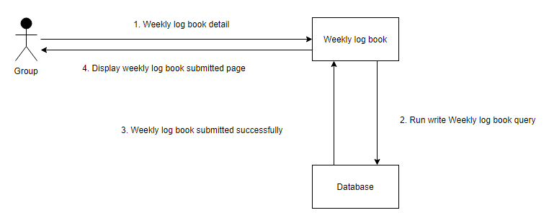
Figure 36: Collaboration Diagram of Write Weekly log-Book

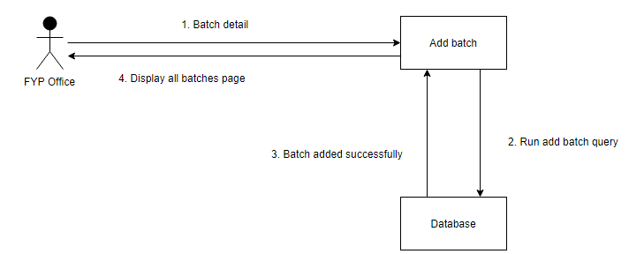
Figure 37: Collaboration Diagram of Add Batch

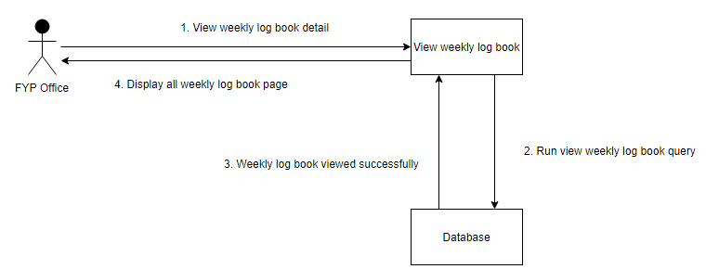
Figure 38: Collaboration Diagram of View Weekly Log-Book

Domain Model

Domain models, within a product line represent the set of requirements that are common to systems. Domain Model for “Counsel A Web-Based Platform” is given below.
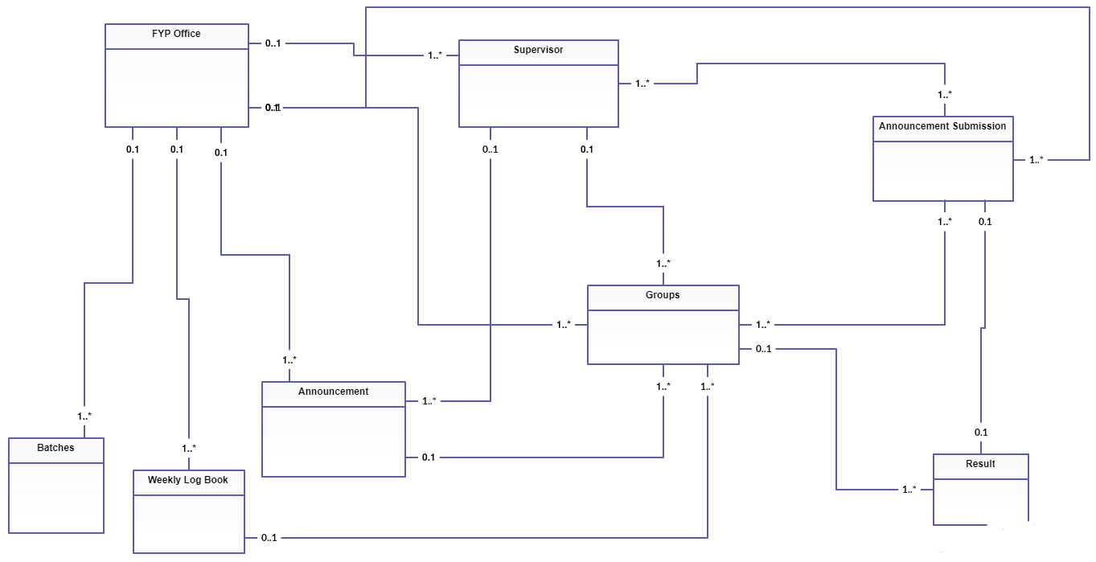
Figure 39: Domain Model of Counsel

Class Diagram

Classes actually perform the actual work of the system. The other design elements simply depict how classes are grouped or how they interoperate.
Class diagram is static structure diagram that represents the structure of a system by displaying the relationships among objects. Class diagram of “Counsel A Web-Based Platform” is given below:
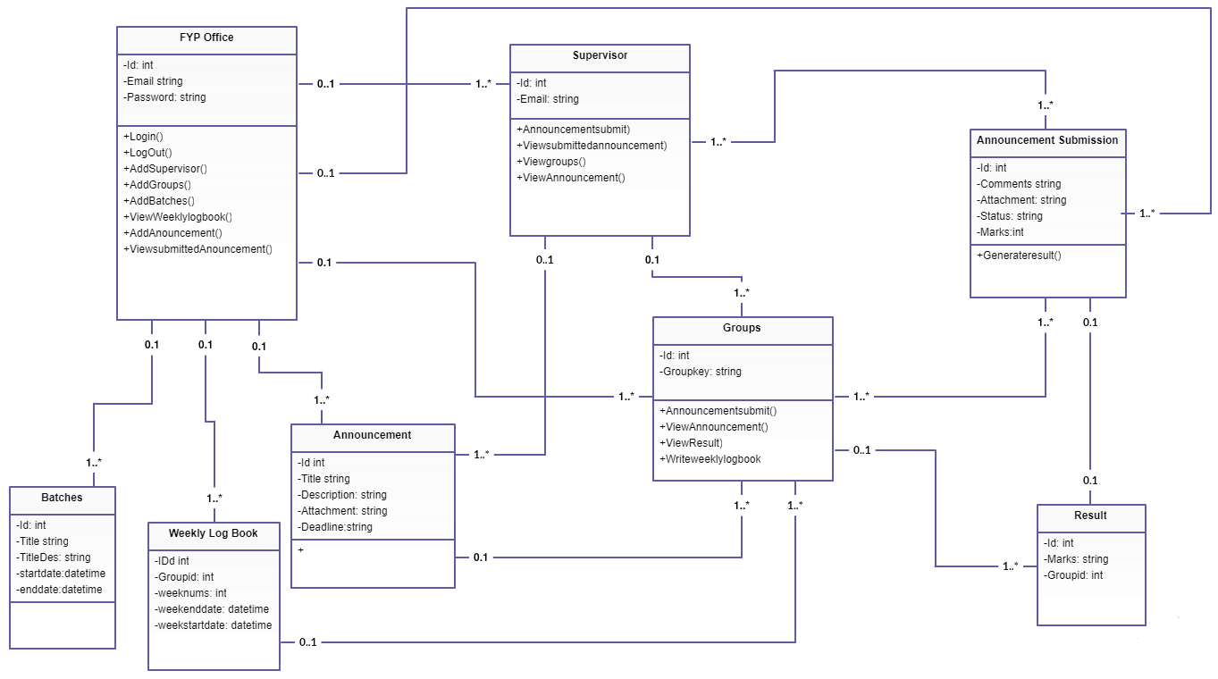
Figure 40: Class Diagram of Counsel

ERD

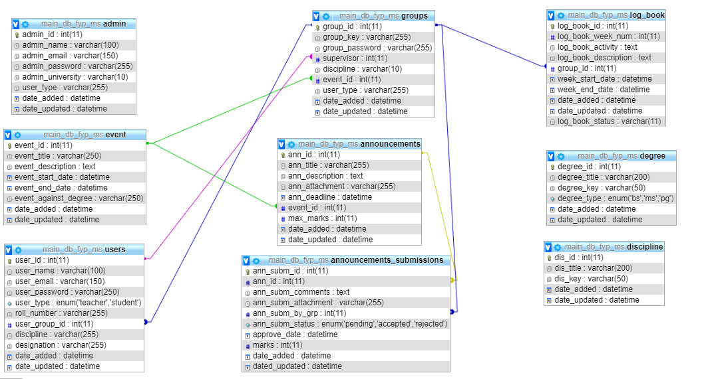
Figure 41: ERD

IMPLEMENTATION AND METHODOLOGY

Methodology

Methodology used for this project is scrum which is a sub-group of agile methodology; the purpose of using scrum is because of its simplicity and iterative development. The Scrum methodology includes further definitions and specifications, but purses the values and principles of agile. Class diagram and sequence diagram will be used in the system analysis, and feedback on the initial design will be acquired from real users of the system.

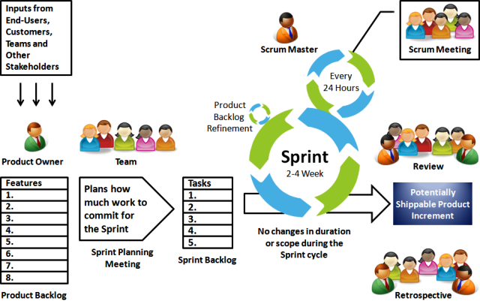
Figure 42: Scrum Model

Following are the Scrum phases that will be followed in this project.

Build feature list
In this step all important features will be listed down.

Sprint Planning
The next step after building feature list is to produce the development plan which is called a sprint planning. This phase also determines sprint duration.

Daily sprint meeting
In this phase daily, stand-up meeting will be conducted with supervisor to discuss the problems and progress of current working sprint.

Testing and sprint demonstration
The team demonstrates the results of their current sprint by creating a review.
Supervisor takes a decision about further project changes after examining the demonstration.

Retrospective and Next Sprint Planning
In this phase sprint’s result will be discussed by supervisor and determine the ways how to improve development process. After this next sprint planning will be started.

Implementation

Implementation phase illustrates design development .

Tools Used
The following tools are used in Counsel to extend its functionality:

XAMPP Server
XAMPP is a local host that helps in checking and testing websites offline. To make this easy to use, by default some important security features are disabled.

Sublime Text Editor
Sublime Text is a text editor tool for writing code in different programming languages. It is a powerful text editor containing plug-ins, clever auto-completion and many other features.

Visual Paradigm
Visual Paradigm for is used for designing purpose. Visual Paradigm is a famous platform for deigning UML diagrams.

Adobe photoshop
Adobe Photoshop is used in this project for designing interfaces

Hardware Used
“Counsel” is a web-based platform is developed by using DELL Latitude E6220 containing operating system Microsoft Windows 10 Enterprise. Specifications of the laptop are mentioned below:
- (RAM) 8GB
- 500GB ROM
- Processor Intel Core i5

Technical Aspect of Counsel
Since the “Counsel” is a web-based platform, both web server and database management system are necessary. A high-level system architecture diagram is illustrated below.
The system consists of front-end and back-end and is categorized into five layers.

Front End Technologies

Table 16: Front End Technologies
Technology | Major functions on a web page
HTML | Outline the structure of a web, it serves as the building blocks
CSS | Set the visual style to provide a better user interface
JavaScript/jQuery | Provide interactive elements

Back End Technologies

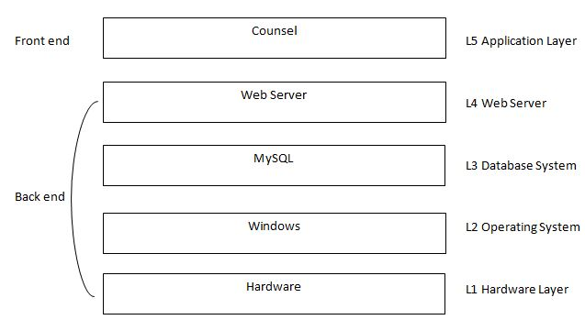
Figure 43: Structure of Back End Technologies

The details of each layer in the architecture above figure discussed below.
L0: Hardware layer contains necessary hardware (Personal Computer) for the COUNSEL to deploy.
L1: COUNSEL will deploy under the Windows operating system, which operated above the hardware layer
L2: MySQL is chosen as the database system. It is relational database system that is renowned for its reliability and data integrity.
L3: The COUNSEL uses the code-Ignitor web framework as its back-end system

Basic Structure of User Interface Structure
Following picture is the basic structure of user interface.

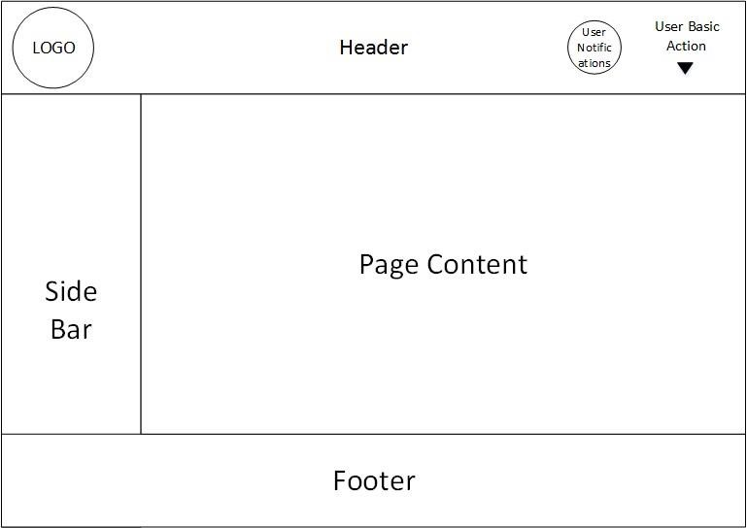

USER MANUAL

Getting started
Counsel is a web-based platform which provides communication between supervisor, groups and FYP office.

User Access, Roles and Privileges
The users of the application are the Supervisors, Groups and FYP office of university. “Counsel” require authorization. All supervisors and groups will get their credentials from FYP office.

FYP Office Roles
- FYP office will register Supervisor and Groups
- FYP office will register Batch of FYP
- Keep track records of weekly log book
- FYP office will send announcement to Groups and supervisors regarding their projects
- FYP office will attach template format of projects

Supervisor Roles
- Supervisor will give marks of documentation on portal.
- Supervisor will only see announcement from FYP office
- Supervisor will see their groups

Group Role
- Group will see their result of documentation. Group will upload their FYP documentation on portal
- Group will fill their weekly log book
- Group will get announcement from FYP office

How to access COUNCEL
Open browser such as Google Chrome or Mozilla Firefox and type URL localhost/fyp_ms/ on the address bar of the browser and hit ‘Enter key’. As shown in below figure.
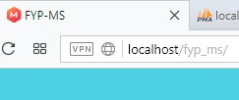
Figure 44: Base URL

Login & Registration at COUNSEL
After accessing COUNSEL, Login screen (as shown below) will display.
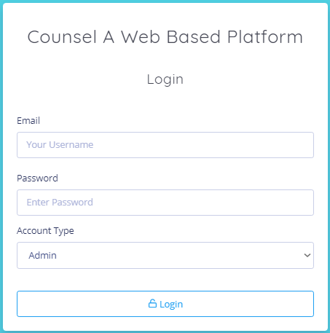
Figure 45: Login Page

Role based authorized home screens:
  - Students will select group section from Account type
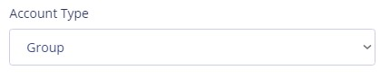
Figure 46: Group Account type

  - Supervisor select their Account type as teacher
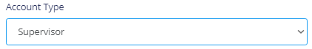
Figure 47: Supervisor Account type

  - FYP office will select their account type as admin
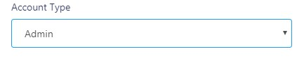
Figure 48: FYP Office account type

Introduction to Navigation Bar
Navigation bar contains the user notification list and user basic functionalities that include ‘Logout’ as shown in below figure.
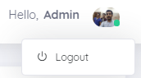
Figure 49: Navigation bar

FYP Office
After successful login of FYP office page will look like this
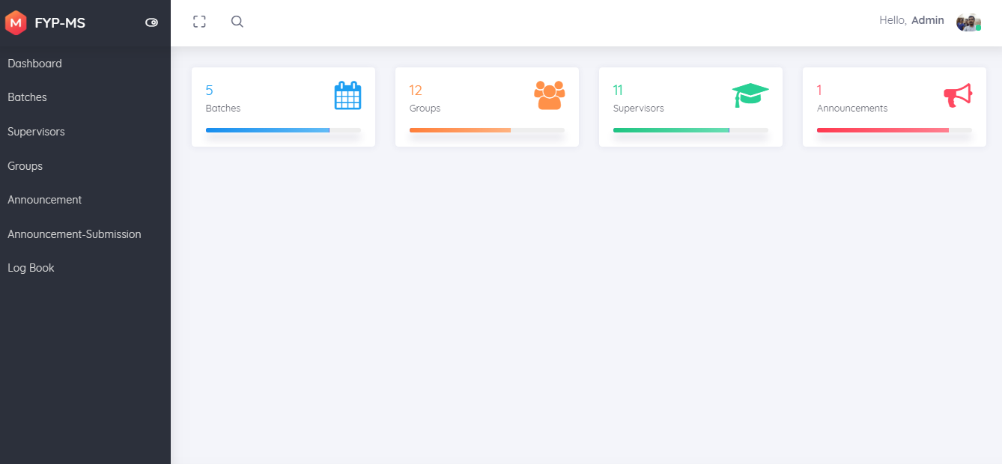
Figure 50: FYP Office Dashboard

Introduction to Dashboard
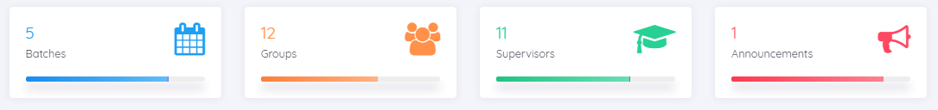
Figure 51: Main FYP Dashboard

- Batch shows semester intakes
- Groups show registered FYP groups
- Supervisor shows registered supervisors
- Announcement shows all FYP related material

Batch
Batch will show semester.


Figure 52: Batch options

Add Batch
After clicking add batch it will open like a form after filing this form it will generate a semester project.

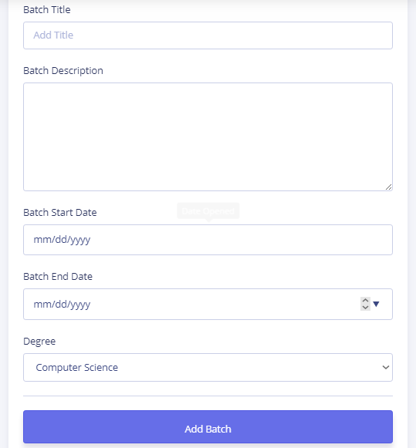
Figure 53: Add batch

All Batch
All batches show the total registered semester of FYP projects

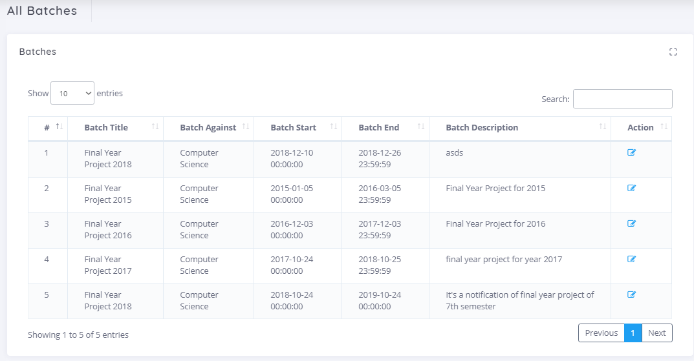

Figure 54: All batch

Groups

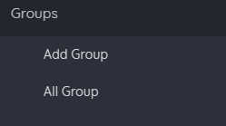
Figure 55: Group option

Add Group
Add group will register the group of FYP project.

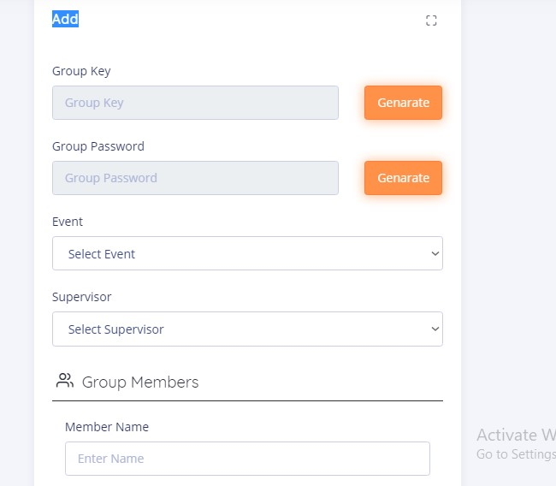
Figure 56: Add group

All group
All groups will show the total register groups in FYP.
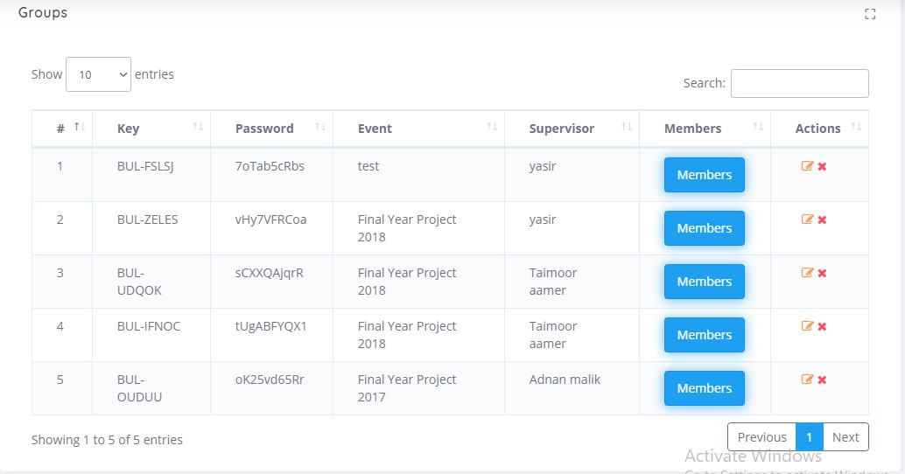
Figure 57: All group

Announcement

Figure 58: Announcement option

Announcement Submission
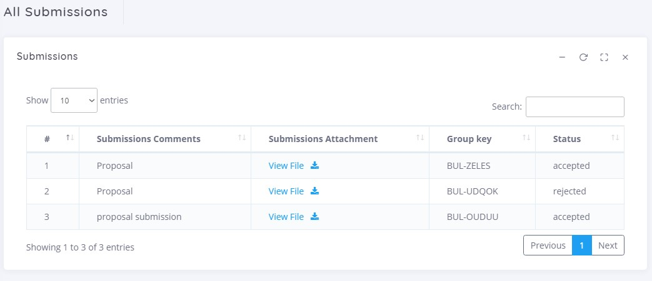
Figure 59: Group announcement submission

Logbook
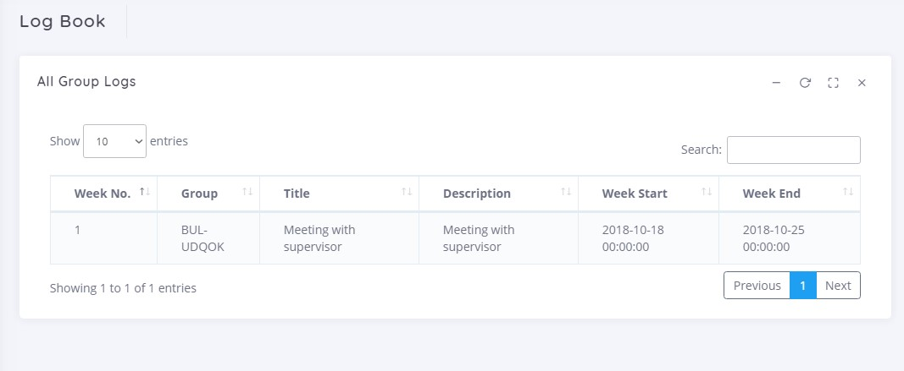
Figure 60: Log book

Supervisor
After successful login of Supervisor account page will look like this
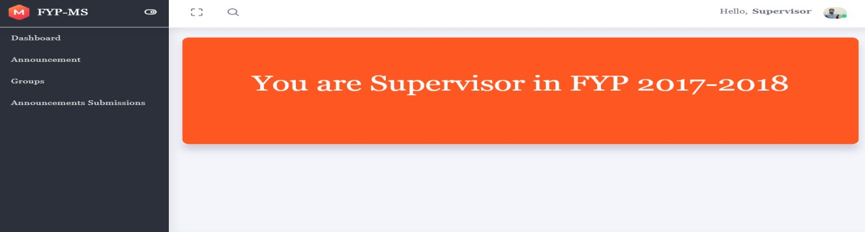
Figure 61: Supervisor dashboard

Menu
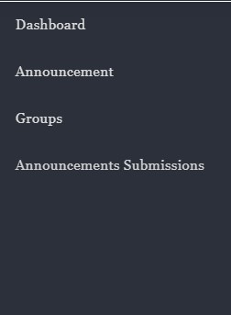
Figure 62: Supervisor menu

Announcement
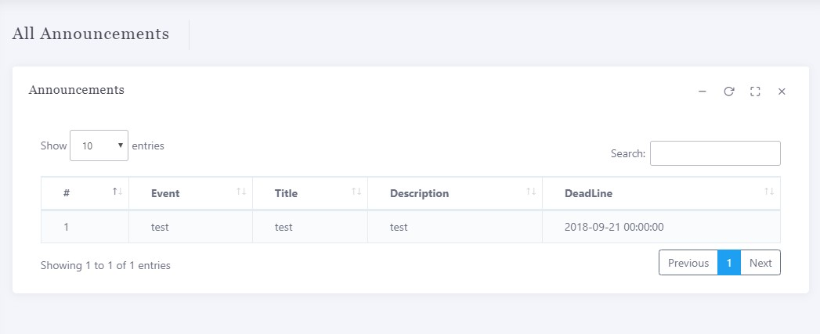
Figure 63: All announcements for supervisor

Groups
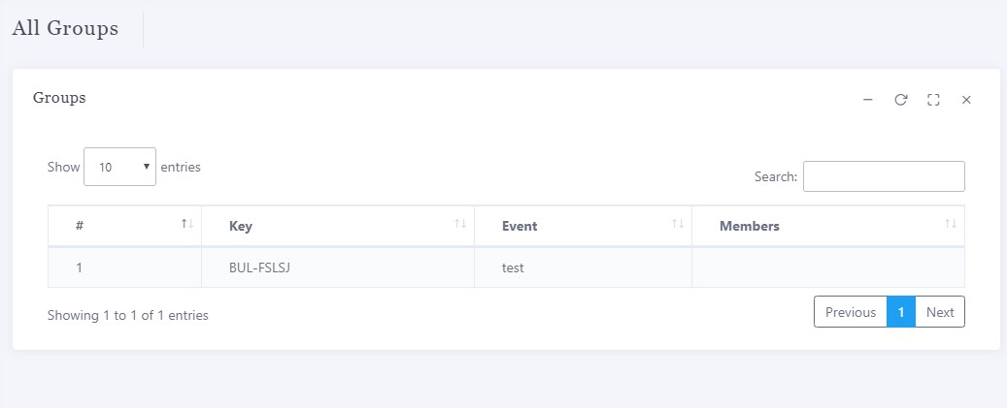
Figure 64: All groups under supervisor

Announcement Submission
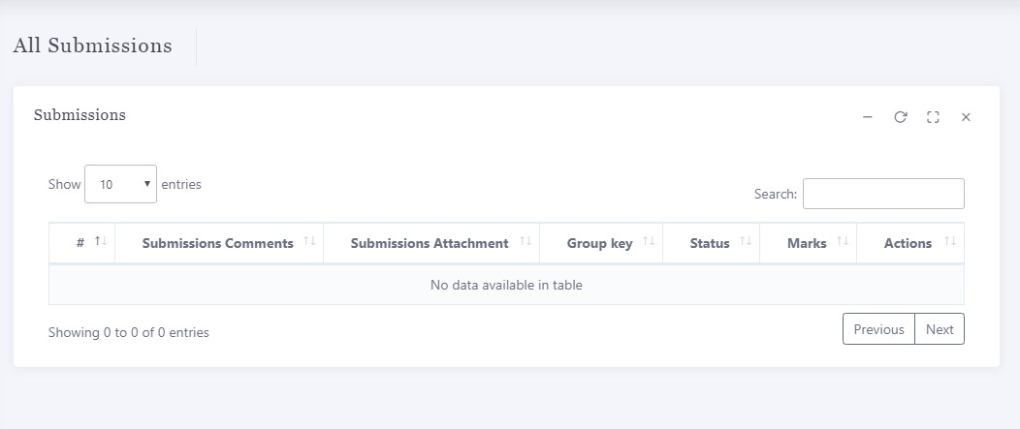
Figure 65: View all submission for supervisor

Groups
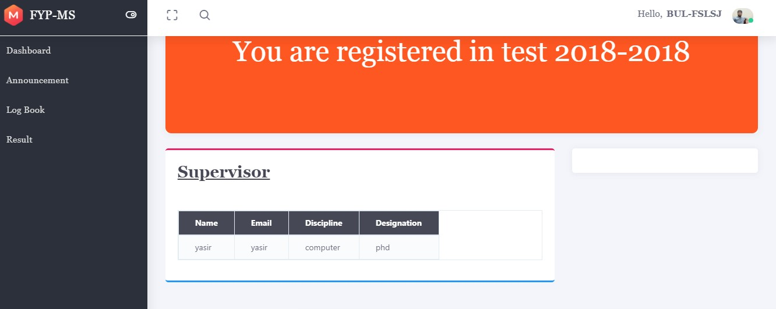
Figure 66: Group main page

Dashboard
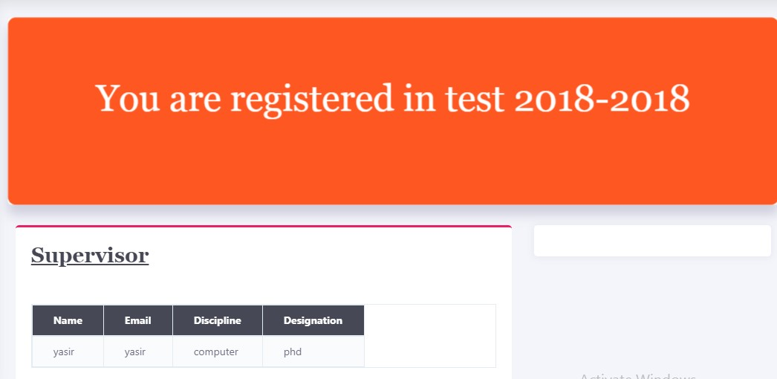
Figure 67: Group dashboard

Menu
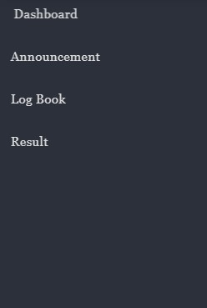
Figure 68: Group menu

Announcement
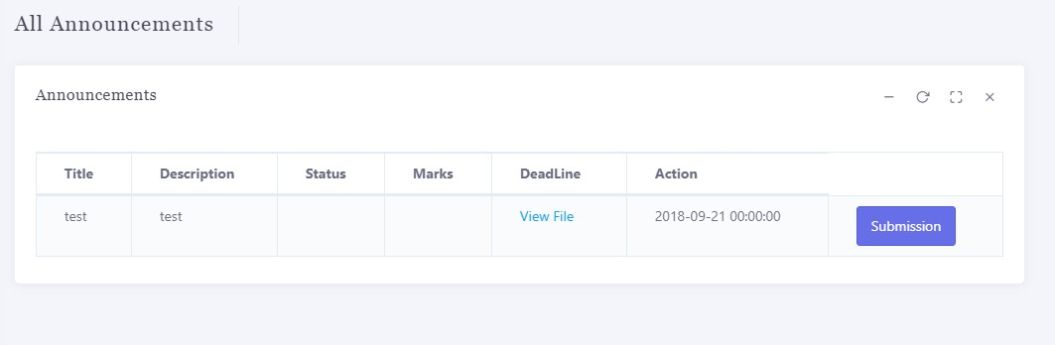
Figure 69: Group announcements

Log Book
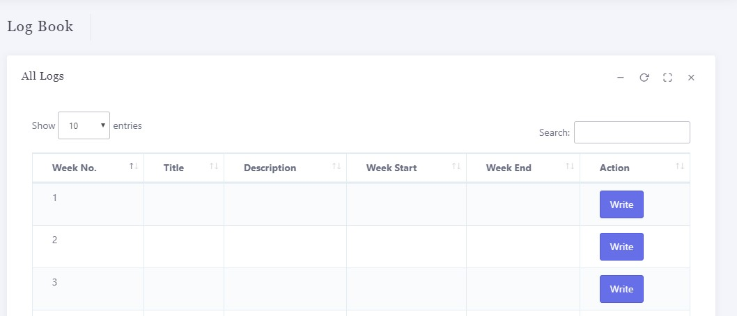
Figure 70: Log book of group

Result
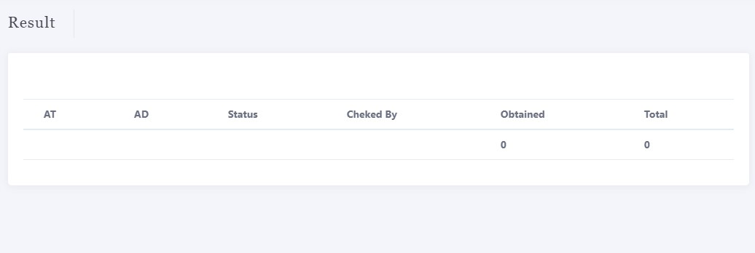
Figure 71: Result of group

CONCLUSION

The aim of this project was to provide a System to Bahia University that improve learning processes and improve other communication processes. The development
focused primarily on the usability of such an application, under strict usability guidelines, and the functionality needs of the user. It was recognized early in the project that a usable solution must utilize a database to drive the content of the application.
The system produced successfully met the usability and functional requirements of the user and gained their acceptance. The roll out of this application on local server shows the project was successful. The user testing and evaluation of the application did however highlight room for improvements and expansion. Although all the user requirements were fulfilled. The application could therefore be developed further to include additional functionality and allow the user greater control.

REFERENCES

Books:

- Jeffrey L. Whitten, System Analysis and Design Methods, 7th Edition, McGrawHill, New York, 2007

Technical Report and Theses:
- Paul Chapman, Software Engineering with Web Development Frameworks, BSc Computer Science Final Report, University of Leeds, Minerva, 2007.
- Gary Ingham, A Content Management System to support small sports clubs, BSc Computing (Industry) Final Report, University of Leeds, Minerva, 2006
Internet:
“System Development Methodologies for Web Enabled E-Business: A Customization
Paradigm”; Linda Night, Theresa Steinbach, and Vince Kellen; November 2001; (http://www.kellen.net/SysDev.htm)

APPENDICES
Requirement List

R1: GUI should compatible with Chrome and Mozilla both.
R2: Components of the project code will be tested alongside the implementation phase to ensure that they are functional.
R3: Final, integrated project code will test to ensure that complete project is integrated well and functioning properly.
R4: Display all the content after loading of web page.
R5: Server response should be kept in mind while designing data retrieval algorithms.

FYP Office Module Requirement List
R1: FYP office is the admin of the system
R2: To login FYP head have their Access
R3: Generate group key and password
R4: Generate FYP Batch
R5: Provide Login to supervisor
R6: Create notification
R7: Keep Track through Log book
Supervisor Module Requirement List
R1: Supervisor login
R2: Give marks of documentation
R3: Supervisor will see their groups
Group Requirement List
R1: Group login
R2: Upload their documentation
R3: Receive Notification from FYP office
R4: View their marks of documentation
R5: Write their weekly log books

