
03-134142-094 M.Abdullah
03-134142-035 Iftikhar Ahmed
Khadim Online
In partial fulfilment of the requirements for the degree of
Bachelor of Science in Computer Science
Supervisor: Taimoor Aamer
Department of Computer Sciences
Bahria University, Lahore Campus
June 2018 © Bahria University, 2018
Certificate

We accept the work contained in the report titled
“Khadim Online”, written by
M.Abdullah
Iftikhar Ahmed
as a confirmation to the required standard for the partial fulfilment of the degree of Bachelor of Science in Computer Science.
Approved by:
Supervisor: Taimoor Aamer
(Signature)
June4th, 2018

DECLARATION
We hereby declare that this project report is based on our original work except for citations and quotations which have been duly acknowledged. We also declare that it has not been previously and concurrently submitted for any other degree or award at Bahria University or other institutions.
Enrolment | Name | Signature
03-134142-094 | M.ABDULLAH
03-134142-094 | IFTIKHAR AHMED

Date : _________________________

Specially dedicated to
my beloved mother and father
(M.Abdullah)
my beloved mother and father
(Iftikhar Ahmed)
ACKNOWLEDGEMENTS
I/We would like to thank everyone who had contributed to the successful completion of this project. We would like to express my/our gratitude to my research supervisor, Mr TAIMOOR AAMER for his invaluable advice, guidance and his enormous patience throughout the development of the research.
In addition, I/We would also like to express my gratitude to my/our loving parent and friends who had helped and given me encouragement.
M.Abdullah
Iftikhar Ahmed

KHADIM ONLINE
ABSTRACT
The objective of this project is to develop an android based application where user can get the facilitation to place an order online. This project also uses the location manager to get the location of the user. Different stages involving order placing, price estimation and order history. Finally the end product of the algorithms will be written in the software called Android Studio.
This project uses the JAVA and php to develop the software. The main advantage of using this technique is that it provides maximum features with a small effort. The methodology used for developing this project is Agile (Scrum) that has divided the development phase into smaller modules. After trials and errors, an application has developed that facilitates the user to place an order to get the services.
The system first proceeds with a registration that requires Email and password. The already registered members will login the application and after placing the order a notification will be sent to the admin panel and to the rider as well. Rider will pick-up the things and again a notification is generated for the user to get the order from doorstep.

TABLE OF CONTENTS
DECLARATION |  | iii
ACKNOWLEDGEMENTS |  | vii
ABSTRACT |  | ix
TABLE OF CONTENTS  LIST OF TABLES |  | xi
LIST OF FIGURES  LIST OF SYMBOLS / ABBREVIATIONS  LIST OF APPENDICES  CHAPTERS |  | xvii
1 | INTRODUCTION | 1
 | 1.1 Background | 1
 | 1.2 Problem Statements | 1
 | 1.3 Aims and Objectives | 2
 | 1.4 Scope of Project | 2
2 | LITERATURE REVIEW(and/orSRS) | 3
 | 2.1 Purpose: | 3
 | 2.2 Refrences | 3
 | 2.3 Overall Discription | 4
 | 2.3.1 User classes and characteristics | 4
 | 2.4 Operating environment | 4
 | 2.5 Design and complete constraints | 4
 | 2.6 Assumptions and dependencies | 4 xii
 | 2.7 System Use cases | 6
 | 2.8 Manage Registration (U1) | 8
 | 2.9 Manage Login (U2) | 10
2.10 Order confirmation (U3) 11
2.11 Delivery (U4) 12
2.12 Other Non functional requirements 13
2.12.1 Performance requirements 13
2.12.2 Safety Requirements 13
2.12.3 Security Requirements 13
2.13 Software Quality Attributes 13
2.14 System Requirement chart 14

3 DESIGN AND METHODOLOGY 15
3.1 Design Specification 15
3.2 Use case Description 15
3.3 Domain Model 17
3.3.1 Domain model description 17
3.4 Sequence Diagram 18
3.4.1 Sequence Diagram (Login) 19
3.4.2 Sequence Diagram (Order confirmation) 20
3.5 Sequence Diagram (Delivery) 21
3.6 Collaboration Diagram 22
3.7 Operation Contracts 23
3.8 Data Model 24

4 DATA AND EXPERIMENTS (and/or IMPLMENTATION) 25
4.1 Data Base 25
4.1.1 Khadim 25
4.1.2 Customer 25
4.1.3 Admin 26
4.1.4 Order Complete 26
4.2 Advantages of using Firebase 26
4.2.1 Real-Time 26
4.2.2 Offline 26
4.2.3 Accessible from Client’s devices 26
4.2.4 Scale Across multiple databases xlviii

6 CONCLUSION AND RECOMMENDATIONS 43
6.1 Conclusion 43
6.2 Recommendations 43
6.2.1 Strong internet connection 43
6.2.2 Free mobile storage 43
6.2.3 Work satisfaction level 43

REFERENCES 45
4.3 Software used for Application Development 27
4.3.1 Android studio 27
4.3.2 Advantages 27
4.3.3 Json 27
4.4 Errors during development 27
4.4.1 Firebase connectivity error 27
4.4.2 Firebase retrieval error 28

4.4.3 Module integration Error 28 5 RESULTS AND DISCUSSIONS(or USER MANUAL) 29
LIST OF FIGURES
FIGURE TITLE | PAGE
Figure 1 System usecase | 6
Figure 2 Manage Registration | 8
Figure 3 Manage Login | 10
Figure 4 Order confirmation | 11
Figure 5 Delivery | 13
Figure 6 Domain Model | 17
Figure 7 Sequence Diagram Registration | 18
Figure 8 Sequence Diagram of Login | 19
Figure 9Sequence diagram (Order confirmation) | 20
Figure 10 Sequence Diagram (Delivery) | 21
Figure 11 Collaboration Diagram | 22
Figure 12Data model | 24

CHAPTER 1
1 INTRODUCTION

1.1 Background
It seems very boring to go out and to bring goods for your home. It is very awkward especially when you are having guests at your home and you have to go outside home while leaving your guest alone. To provide the comfort to people in such conditions, an application has been developed where people can place an order and they will get the desired things in a very short time.
Moreover the user will also be able to see the price of anything that he wants to order.

1.2 Problem Statements
People feel it difficult to go outside their homes especially in the extreme weather conditions. People want comfort and luxury life style. If someone is having his desired things at his doorstep in very short time then why will he prefer to go out? Due to the security issues mothers do not want their kids to bring anything from the market. Students at the hostels are not allowed to go out at late night. If someone is ill and he doesn’t want to go out he will definitely need such service.
To solve such kind of issues we thought to launch such service which can benefit people and people will love to use this service. To provide this service we will launch an application where people will place their orders and then we will deliver order through the riders.
The problem we can face is to receive multiple orders at the same time. This will happen only when we will be the need of almost everyone. To solve this issue we can increase the number of riders or we can have our own warehouse so that single rider can pick up multiple orders at the same time.

1.3 Aims and Objectives
Aim is to provide the people with comfort through the delivery services The objectives of the thesis are shown as following:
- To provide an application to users will be provided with the delivery services.
- Generate bill on the application so that user may know about the price of
everything.

1.4 Scope of Project
The primary scope of the project is to develop an android based application where user can place the order to get delivery services. Moreover if user wants to check the price of any product he will just open the application and he can check the price of any product. If user places an order he will be able to see the receipt on the application and a notification will be generated for the user after the arrival of rider at the door step. Besides this rider will get the location of customer and admin will get details of order whether it is delivered or not?

CHAPTER 2

2 LITERATURE REVIEW (and/or SRS)

2.1 Purpose:
Khadim online will be a Mobile application. The establishment and improvement of Khadim online is a very important requirement especially now a days when the mobile communication technology is developing rapidly. The advantages of mobile app can be reduce human effort and also reduce distance gap between customers and stores. Khadim online service is more specialized delivery service in which people can order anything they need in daily life at home /office, the product will be delivered at your doorstep. Both the rider and customer are able to obtain required data or information to achieve a better interaction .The platform, mobile application and database technology are all gradually maturing, so that we can develop a khadim online and customer interaction system on Android and web platform to meet the needs of the customers and provide them more efficient and convenient means of communication with customer.

2.2 Refrences
- A generalization of dijkstra’s shortest path algorithm with applications to VLSI routing:
By: Sven peyer, Dieter Rautenbach, Jens Vygen.
- Dijkstra’s Algorithm:
Source: S. Skiena. The Algorithm Design Manual. S. Sedgewick. Algorithms in C++.

2.3 Overall Discription

2.3.1 User classes and characteristics

User Classes
There will be three user classes which are following below.
- Admin Class: Admin class will contain the information of the database administrator which will be able to have the access of all privileges of the system.
- Rider’s Class: Rider’s class will contain the data of riders such as rider’s name, current location, bike number they are putting on the system.
- Customer’s Class: Customer class will contain the login information, basic information of the customer such as customer name, customer current location, customer contact number which is only visible for admin. 2.4 Operating environment
Name | Description
Operating system | Android platform
Languages | java
Tools | Android studio
Database | Firebase
Server | Firebase

2.5 Design and complete constraints
The IDE (Android Studio) used for android development is a heavy software it requires best machines for development otherwise it becomes leggy and take too much time. The main constraint for our project implementation is integration.
- For the Android based databases the system will not use any built in tools like Dreamweaver.
- Khadim online will use APP based databases to store the data instead of purchasing and deploying a hardware server because, trend is moving toward cloud databases.

2.6 Assumptions and dependencies
- System will rely on the internet because it is the online ordering system.
.
- Rider and Customer must have the mobile with android operating system.
- The system will not be violating any ethical or cultural rules and won’t be blocked by the Telecom companies.
- The performance of the Application will be based on the internet of the user.
- Fast internet allows the user to retrieve the more quickly and efficiently.

2.7 System Use cases
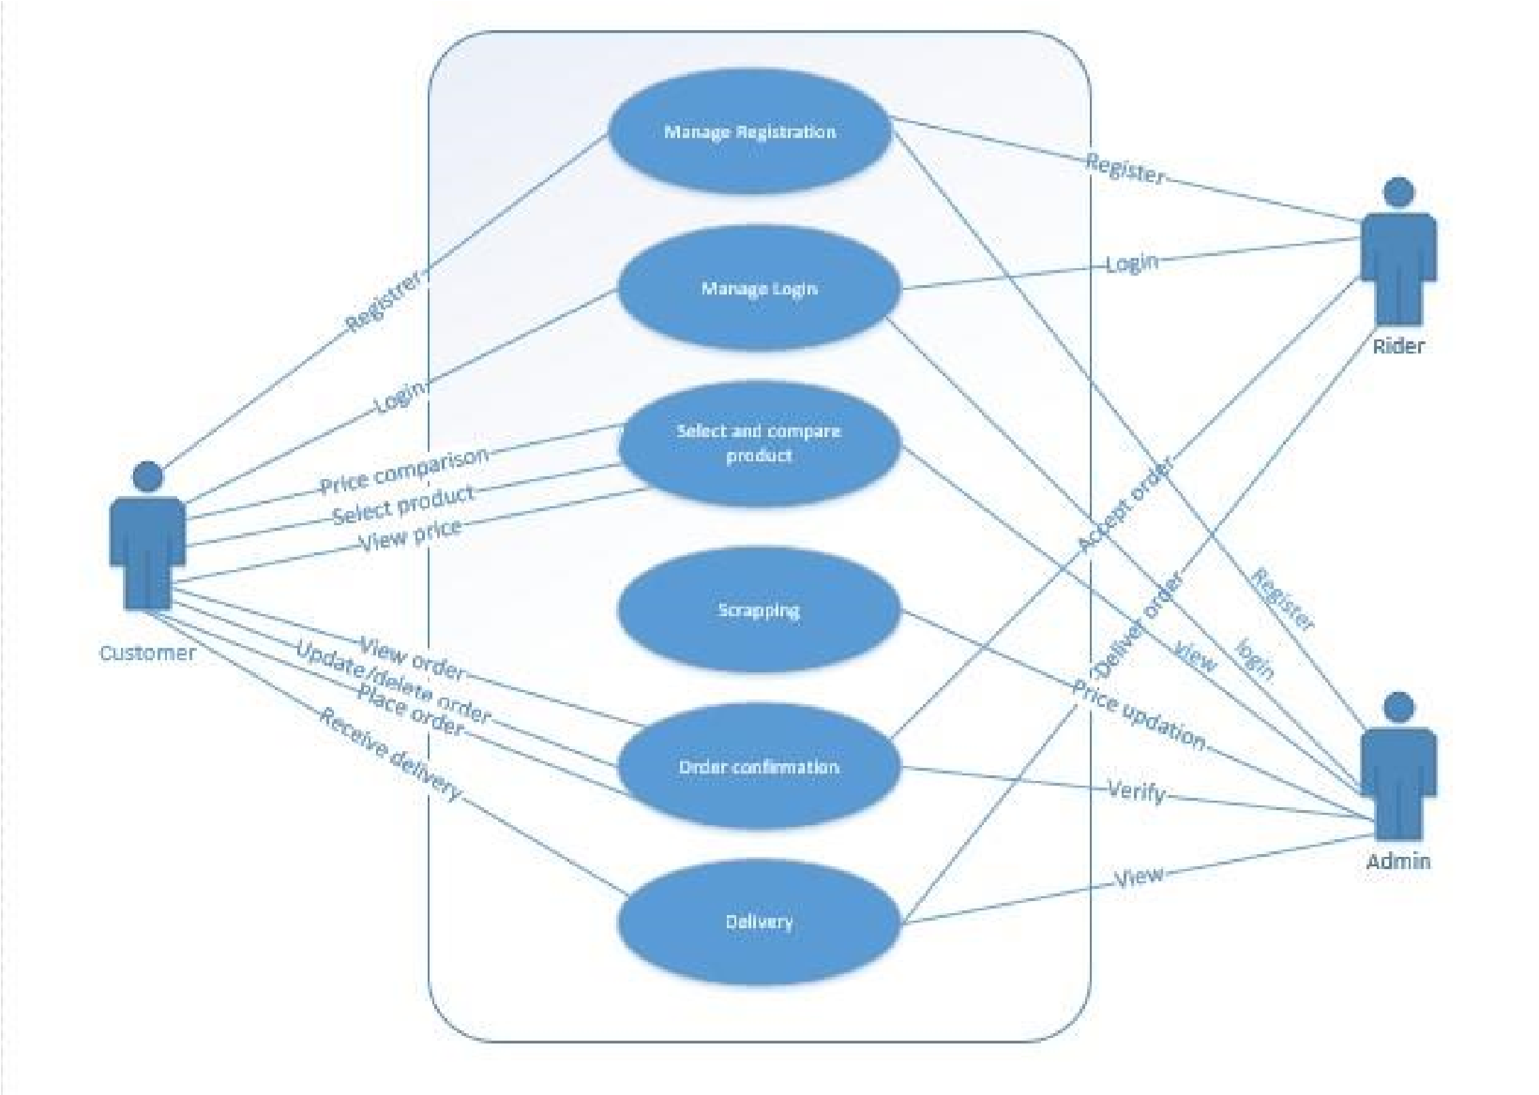
Figure 1 System use case
Figure 1 describes the use case of the whole system. There is an admin, customer and a rider. Each actor will use email to verify his/her authentication. Customer will place the order and rider and admin will receive the order. Rider will accept the order and then he will deliver the order at the doorstep of customer.

2.8 Manage Registration (U1)
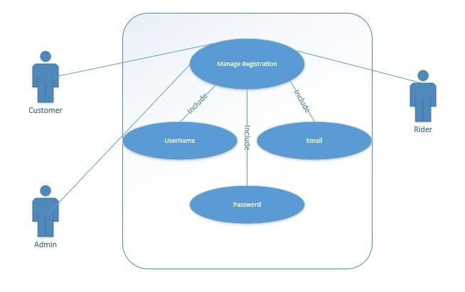
Figure 2 Manage Registration
In figure 2 each admin, customer and rider will use there username email and the password to register themselves.

Use Case Name: Khadim Online |  |  |  | Id: A-1 |  | Priority: High
Actors: Customer, Rider, Admin
Description: This system provides the delivery services.
Trigger: User requires an internet connection. Type:
External
Preconditions:
- User required an internet connection on mobile.
- User must register first.
Normal Course: Information of Steps  - User will sign-up the application  - App will get the location of the customer through GPRS.  - Customer can view price of a product.  - Customer can compare product price.  - Customer can place order.  - Customer can update or delete an order.  - Rider will register first.  - System will approve the request.  Confirmation 3.2. Rider will receive order information.  - Rider will get the location of customer.  - Rider will deliver order. 4. Admin will register first. password  - Check in database.  Confirmation  - Admin will get the live location of rider and customer.  - Admin can see the total profit or loss of a trip.  - Admin can view all activities. |  |  |  |  | Name and password  Name and password
Alternative Course:
- No rider is available in the area.
- Internet is not available.
Post Conditions:
- Database is accessible.
- App is responding properly.
Summary Inputs  Customer Name  Password and | Source  Customer |  | Outputs  Conformation Notification |  | Destination  Customer
Unique Identifier |  | U1
Objective |  | It is use for the registration of customer, rider and admin, to check the authenticity. System Admin view all the activities.
priority |  | High
Source |  | Customer, rider, admin
Actors |  | Customer, rider and admin
Flow of Event |  | Basic Flow  - All users fill the required fields.  - Move to the main screen  Alternative Flow  1. If already registered move to the login screen.
Includes |  | None
Pre-Conditions |  | User must be connected with internet.
Post-Conditions |  | Move to the login screen

1. Unique Identifier
- Objective - What is the ultimate objective of the use-case. What is it trying to achieve? What was the source of the use-case requirement?
- Priority – The overall priority of this use-case (Low, Medium, High)
- Source – Who is the main source of this use case. Who cares most about this functionality? This should be the one person you would ask if there is a question about this use-case. (Make up a name and cite their: John Smith (End-user) here.)
- Actors - Who is involved in the use-case? Which actors/stakeholders?

6. Flow of Events
6.1. Basic Flow - flow of events normally executed in the use-case
6.2. Alternative Flow(s) - a secondary flow of events due to infrequent conditions
6.3. Exception Flow(s) - Exceptions that may happen during the execution of the use case
- Includes - other use case IDs that are referenced in steps in the flow of events.
- Preconditions - Any condition that must be satisfied before the use case begins. If the condition is “User is logged in”, then the first step of the use case is NOT “User logs in”. They are already logged in if that is a precondition!
- Post conditions - The conditions that will be satisfied after the use case successfully completes
- Notes/Issues - Any relevant notes or issues that need to be resolved 2.9 Manage Login (U2)
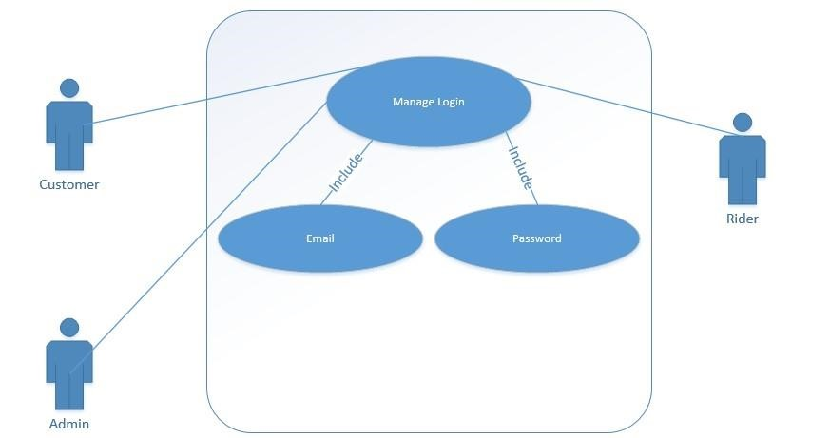
Figure 3 Manage Login
In figure 3 Admin, rider and the customer will use their emails and password to authenticate.
Unique Identifier | U2
Objective | To secure the accounts of all users.
Priority | High
Source | Customer, Admin, Rider
Actors | Customer, Admin and Rider
Flow of Event | BASIC FLOW 1. Users  enter the username and password.  - Validating of username and password.  - User redirected to main screen, of their account.  ALTERNATIVE FLOW  1. User cannot use same credentials for another account
Includes | U1
Pre-Conditions | User must be connected with internet and must remember the username and password.
Post-Conditions | Move to the main screen or log in or log out.

2.10 Order confirmation (U3)
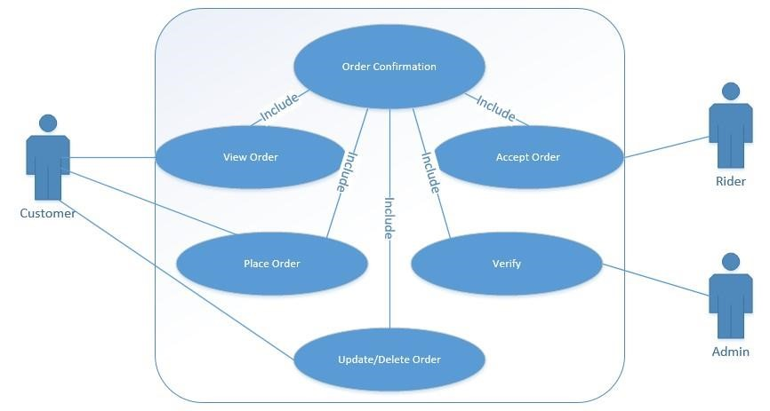
Unique Identifier | U3
Objective | Customer can place order. Customer can view or update an order. Rider can accept order and admin can verify order.
Priority | High
Source | Customer, rider, admin
Actors | User, Bus Admin and System Admin.
Flow of Event | BASIC FLOW  1. User will place and view order, rider will accept order and admin will verify.  ALTERNATIVE FLOW  1. Customer can just view the price and do place order.
Includes | U3
Pre-Conditions | 1. The user must have login the application.
Post-Conditions | User will get delivery.

2.11 Delivery (U4)
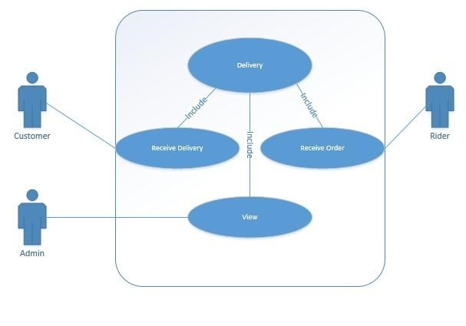
Figure 5 Delivery
Unique Identifier | U4
Objective | Customer will receive delivery through rider and admin will get the confirmation of product delivery.
Priority | High
Source | Customer, rider, admin
Actors | User, Bus Admin and System Admin.
Flow of Event | BASIC FLOW  - Customer receives delivery, rider delivers order and admin gets the confirmation notification.  ALTERNATIVE FLOW  - Customer can just view the price and do place order.
Includes | U3
Pre-Conditions | 1. The user must have placed order.
Post-Conditions | User will get delivery.

2.12 Other Non functional requirements

2.12.1 Performance requirements
Khadim Online application requires a GPS enabled android phone to work with at least version 5.0. Phone should have at least 2GB of ram and expected 100MB of free space.

2.12.2 Safety Requirements
Personal information of the customers like mobile numbers will be kept safe. As no rider will be able to see the contact number of the customers so data will be safe. 2.12.3 Security Requirements
Khadim Online Application does not have any security requirements and thus any type of user can use it without any additional privileges. Only the authorized person can add, delete and update the information.

2.13 Software Quality Attributes
Khadim Online provides the users with some unique features like time based. Due to its well designed and easy to use interface it can be used both by experts and typical users however users (workers) must have basic knowledge of English Language.

2.14 System Requirement chart
Requirement  No | Priority | Type | Source | Contained in Use  Case | Description
SR1 | High | Functional | Customer, rider,  admin | U1 | It is used for the registration of all users to check the authenticity.  System Admin view all the activities.
SR2 | High | Functional | Customer, rider, admin | U2 | To secure the accounts of all users.
SR3 | High | Functional | Customer, rider, admin | U2 | Customer will place order, rider and admin will get its notification.
SR4 | High | Functional | Customer, rider, admin | U3 | After placing order, the rider will deliver order and admin will be watching the live location of cutomer and rider.

CHAPTER 3

3 DESIGN AND METHODOLOGY

3.1 Design Specification
This document specifies the steps required to develop the Khadim Online Mobile Application, describes all data, functional and behavioural requirements of the software under development. The resulting system should be secure. As a user; system will be easy to use. Document includes:
Use case description
Use case diagram refined
Domain Model
Sequence Diagram
Collaboration Diagram
Operation Contracts
Design Class Diagram These are as follows:

3.2 Use case Description
There would be three types of user which will interact with the application, Customer, Rider and System Administrator. So, all of them would have different type of requirements. Products available in the market are visible on the Application. This platform provides the best delivery services from the market to your desired destination which saves your time and also gives the comparison of prices among different products to save your money. Customer can use the application to get the information of a product like the price. He can also place the order to get it on his location or any other desired location. He will also track the order. Rider will receive the information of that order and he will get the location of order. System Admin panel will be on the web portal to monitor all the activities.
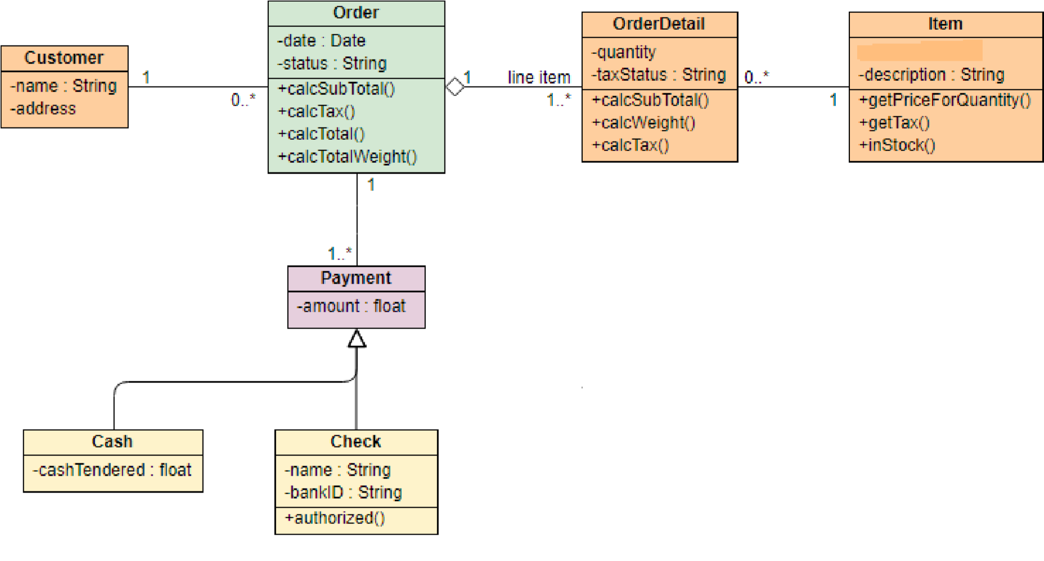
Figure 6 use case diagram

Preconditions
User required an internet connection on mobile.
Bus Admin Must be registered first.

Basic flow
Apps will automatically get the location of the user through GPRS.
- Customer can also enter the location manually.
- Customer can view the prices of products.
- Customer can compare prices of products at different stores.
- Customer can track order.
- Customer will receive order. Customer will register first.
- System will approve the request.
Rider will receive order information.
- Get customer’s location.
- Deliver Order
System Admin can view all the activities.

Alternate flows
No Rider available in the area Internet is not available.

Post conditions
Database is accessible.
App is responding properly.

3.3 Domain Model
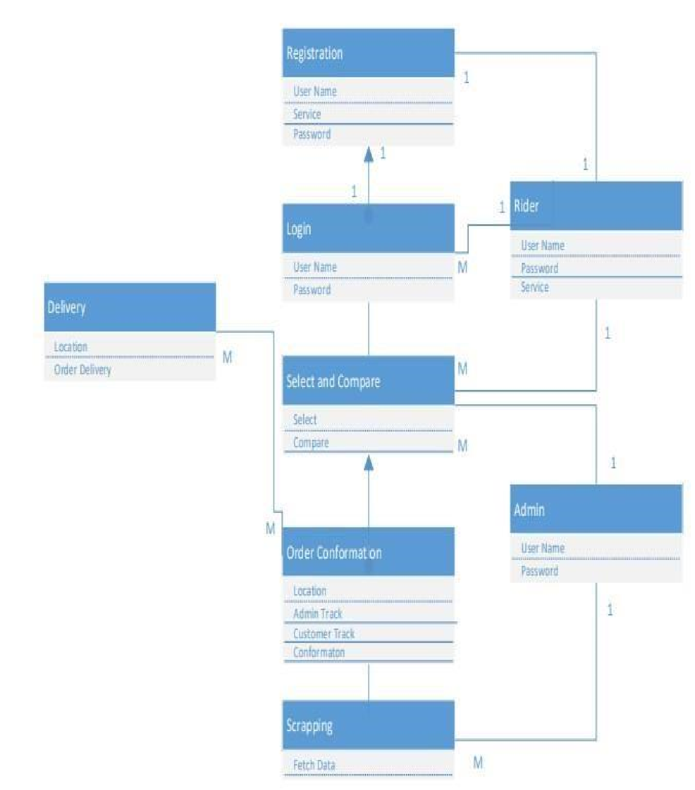
Figure 6 Domain Model

3.3.1 Domain model description
Users will get registered first, users will apply for login. Customer is able to enter order information, edit order, update and delete the order till a specific time.
Customer is able to view the rider’s location. Similarly, the rider will get the location of customer. And admin can track the both.

3.4 Sequence Diagram
Sequence Diagram (Registration)
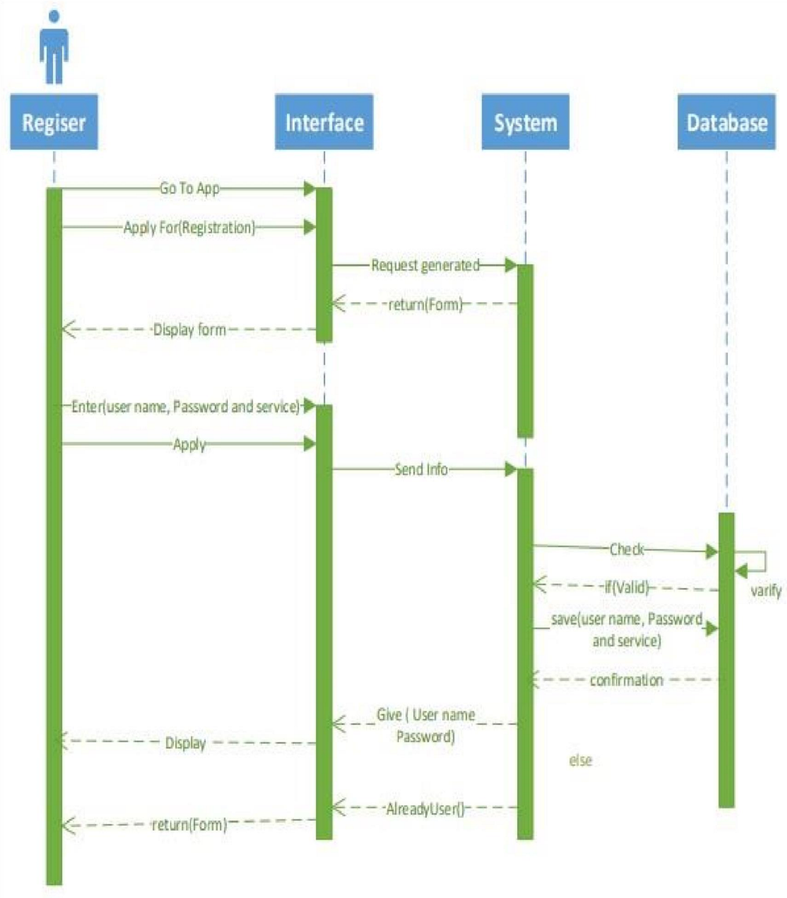
Figure 7 Sequence Diagram Registration Description
In figure 7 Admin will apply for registration by filling up the registration form on interface, after that interface will send that particular information to the system. System will a request to database to store the data.

3.4.1 Sequence Diagram (Login)
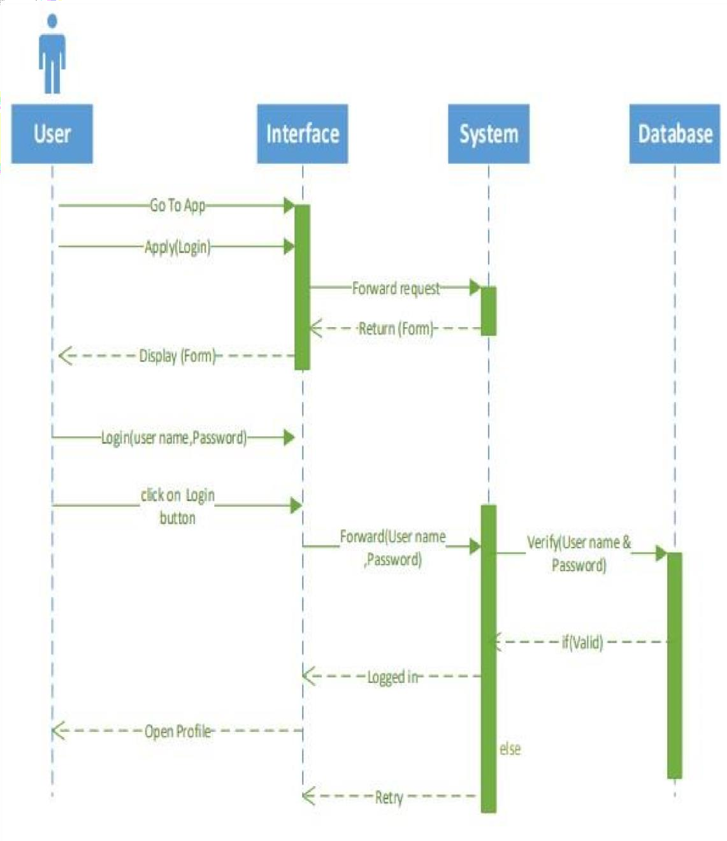
Figure 8 Sequence Diagram of Login

Description
In figure 8 Admin, rider and the customer have to fill up all the credential which are on login page to get logged in. After that interface will send a request to verify the credential to the system, system will verify from the database. If credentials are true the Bus Admin move to the next screen, otherwise it will show an error.

3.4.2 Sequence Diagram (Order confirmation)
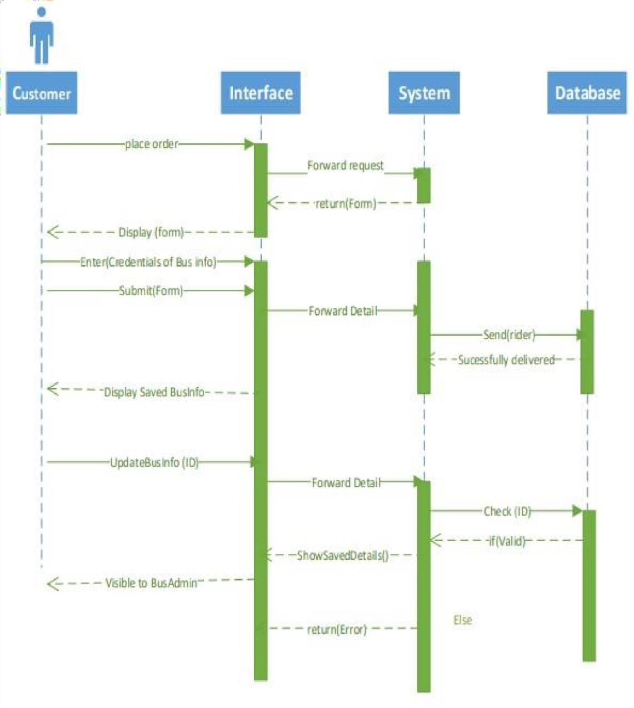
Figure 9 Sequence diagram (Order confirmation)
In figure 9 the customer places the order and rider and admin will get the information of the order.

3.5 Sequence Diagram (Delivery)
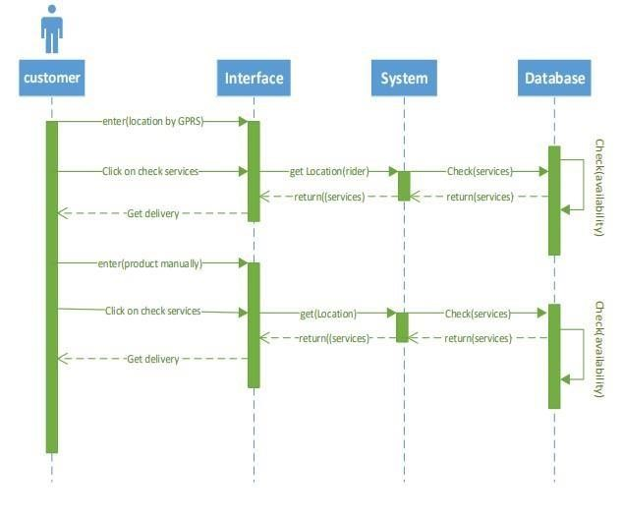
Figure 10 Sequence Diagram (Delivery)
In figure 10 the rider will receive the location of the customer and he will deliver the products at the location of customer.

3.6 Collaboration Diagram
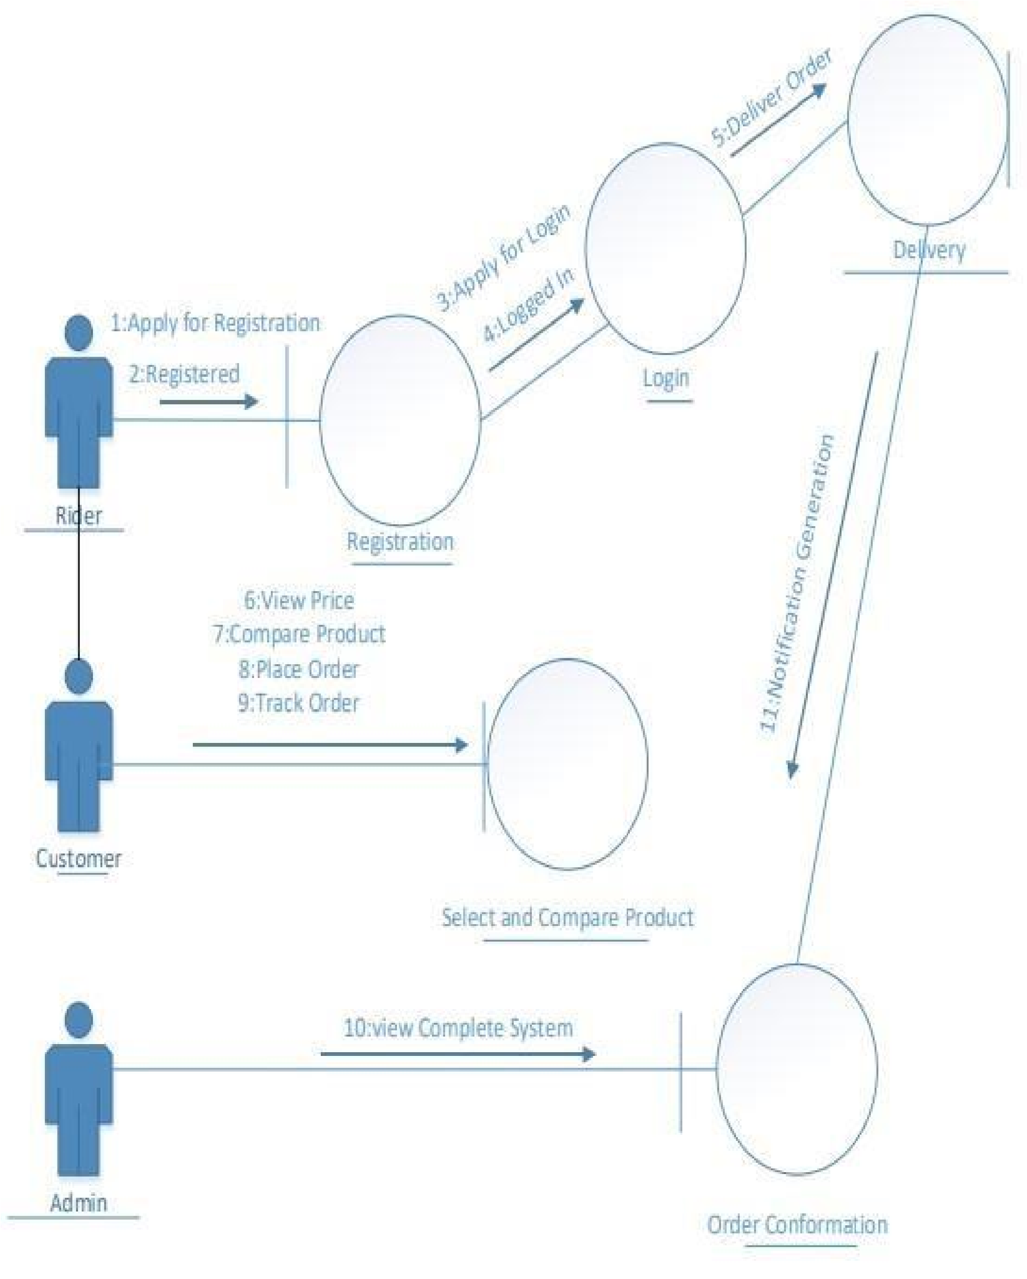
Figure 11 Collaboration Diagram

3.7 Operation Contracts

Responsibilities: Registration (Username, Password)
Cross References: Use Cases: Manage Registration
Exceptions: none
Preconditions: Internet connection must be there.
Post conditions: Move to the main screen.

Responsibilities: Login (Username, Password)
Cross References: Use Cases: Login
Exceptions: none
Preconditions: User must be connected with internet and must remembered the username and password.
Post conditions: Move to the main screen.
Responsibilities: Order Confirmation (View Order, Update Order, Place Order).
Cross References: Use Cases: Order Confirmation
Exceptions: none
Preconditions: Must have internet connection, User must be registered, User must be logged in.
Post conditions: Location of rider will be shown.

Responsibilities: Order delivery (Location).
Cross References: Use Cases: Delivery
Exceptions: none
Preconditions: Must have internet connection, User must be registered, User must be logged in, Order must be placed. Post conditions: Order is delivered.






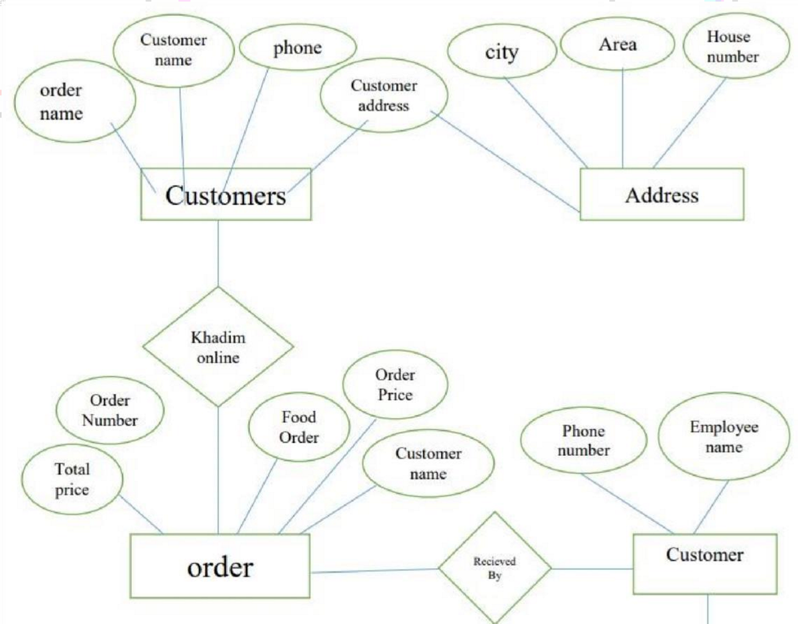
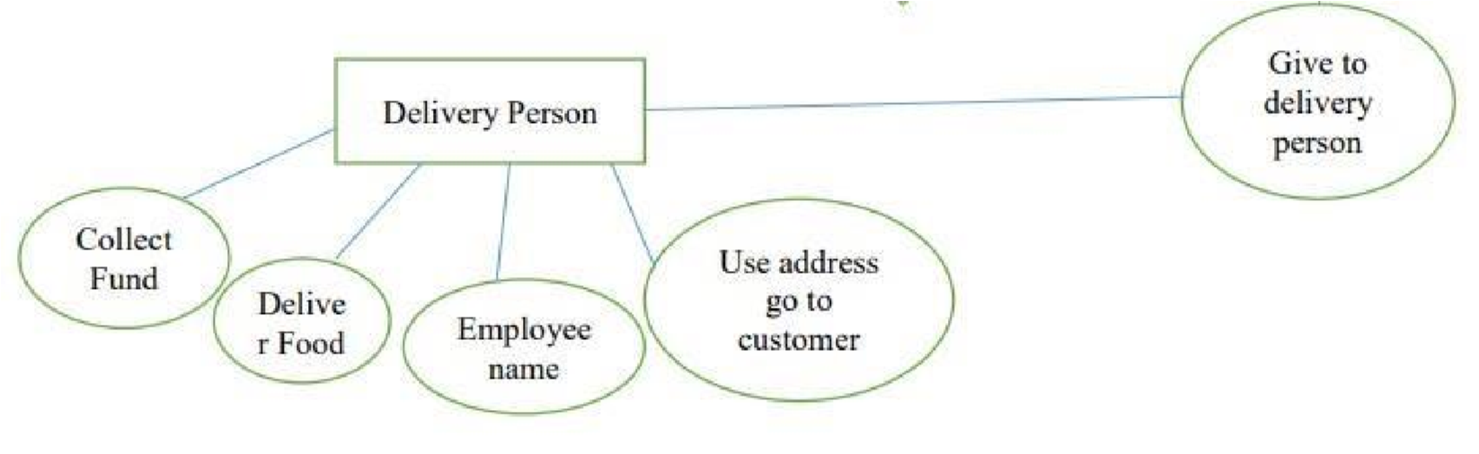
3.8

Data Model

Figure

12

Data

model

ERD Diagram
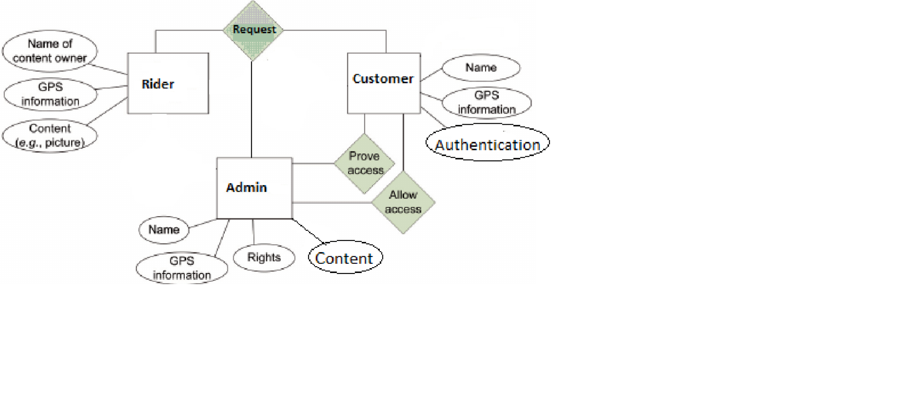
Figure 11 ERD diagram
Figure 11 is describing the whole system where customer will request for the products and rider and admin will receive the request will the order detail and location of the customer.

CHAPTER 4

4 DATA AND EXPERIMENTS (and/or IMPLMENTATION)

4.1 Data Base
We have used firebase that provides us various features like Authentication, Messaging and Real-time Database. Database in firebase is a cloud-based database and does not need SQL-based queries to store and retrieve data. Firebase database is highly reliable and superfast means that data is updated and synchronized in no time. We also use the firebase authentication feature that provides us to authenticate email validation ^{[5]}.
There are six main roots
- Khadim
- Customer
- Admin
- Order complete

4.1.1 Khadim
In Khadim root we have multiple childs that represent different workers and each child contains data about single Rider which contains the workers Email used as a unique identifier. Unique identifiers contain further subchilds which contains the information of worker like its first name, last name address, phone number and password.

4.1.2 Customer
In User root we have multiple childs that represent different users and each child contains data about single user which contains the user Email used as a unique identifier. Unique identifiers further contain sub childs which has the information of user like its first name, last name, email address, phone no, password.

4.1.3 Admin
In Admin root we have multiple childs that represent different users and each child contains data about single user which contains the user Email used as a unique identifier. Unique identifiers further contain sub childs which has the information of user like its first name, last name, email address, phone no, password.

4.1.4 Order Complete
Order complete has childs which are unique identifiers of complete order done and identifier child further contains request id, user and worker id, work duration and work payment.

4.2 Advantages of using Firebase

4.2.1 Real-Time
Instead of using the HTTP requests, Firebase real-time Database uses synchronization of data every time data changes, any device which are connected with the real-time database receives that update just within milliseconds. Firebase provides collaborative and immersive experiences without having to think about networking coding.

4.2.2 Offline
A major benefit of using firebase database is that Firebase apps remain responsive even when it is used offline because the Firebase Real-time Database SDK persists your data to the disk. Once online connectivity with database is re-established, the client device receives changes it missed whether in any way and synchronizes it with current state of the server.

4.2.3 Accessible from Client’s devices
The Firebase Real-time Database can directly be accessed from a mobile device or web browser and there’s no need to use an application server. Security of data and data validation are available through the Firebase realtime. Database Security Rules, expression-based rules that are executed when data is accessed for reading or writing data.

4.2.4 Scale Across multiple databases
With the use of Firebase Real-time Database, you can support your applications data needs by splitting your data across multiple database instances in the same Firebase project. Control access to entire data in each database with custom firebase real-time database rules for each database instance.

4.3 Software used for Application Development

4.3.1 Android studio
Android studio is an integrated development environment used for the development of android applications.

4.3.2 Advantages
- Android studio has a flexible Gradle-based build system
- A fast and feature-rich emulator with versatile functionalities  A vast environment where you can develop for all the Android devices.
- Instantrun your project so that you don’t have to build APK every time.
- Importing sample codes from GitHub and other platforms becomes easy.
- Extensive testing tools and large variety frameworks.
- Built-in support for Google Cloud Platform, making it easy to integrate Google.
- Cloud Messaging and App Engine.

4.3.3 Json
JavaScript Object Notation is a lightweight data-interchange format. It is easy for humans to read and write. It is easy for machines to parse and generate.

4.4 Errors during development

4.4.1 Firebase connectivity error
This error occurred because the old version of the firebase dependencies added were not being supported and synced by the latest version of the android studio that was android 3.0.1 at that moment.

4.4.2 Firebase retrieval error
Inability to read the content of our Firebase real time data base. This error occurred because we did not set the rules of data base read to true in the Firebase Real time database rules.

4.4.3 Module integration Error
During the creation of a map activity the java file was not being linked with other xml files which resulted in the crash of the application.

CHAPTER 5

5 RESULTS AND DISCUSSIONS(or USER MANUAL)

STEP 1
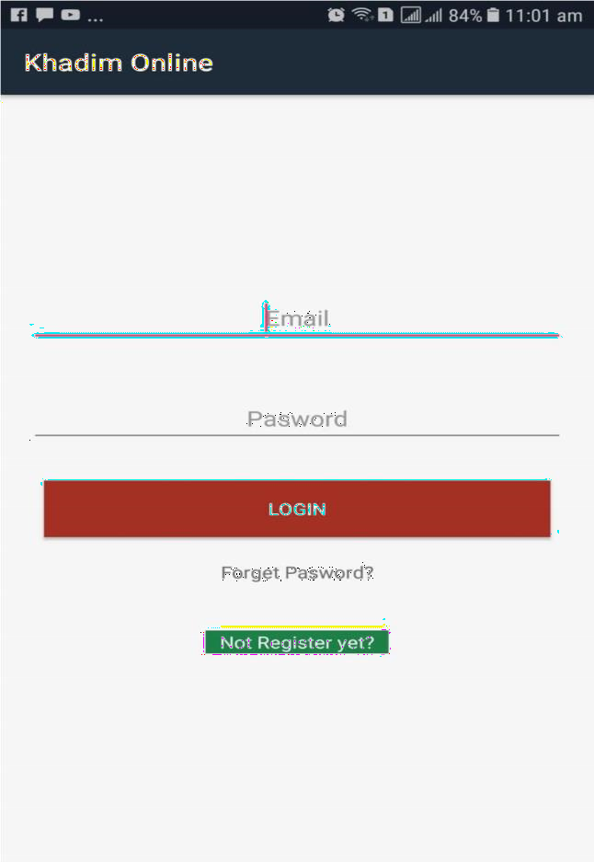
1: Use your verified email to login enter in the field area to proceed.
2: Enter that password which was provided by you at the time of registration.
3: Press login to use Khadim online services.
4: If you are not register TAP on the “REGISTER AS A NEW MEMBER” to register in the application.
5: If you are registered and forgot your password then TAP on “FORGOT PASSWORD” it will take you to another page where you can recover your password using your email.

Step 2
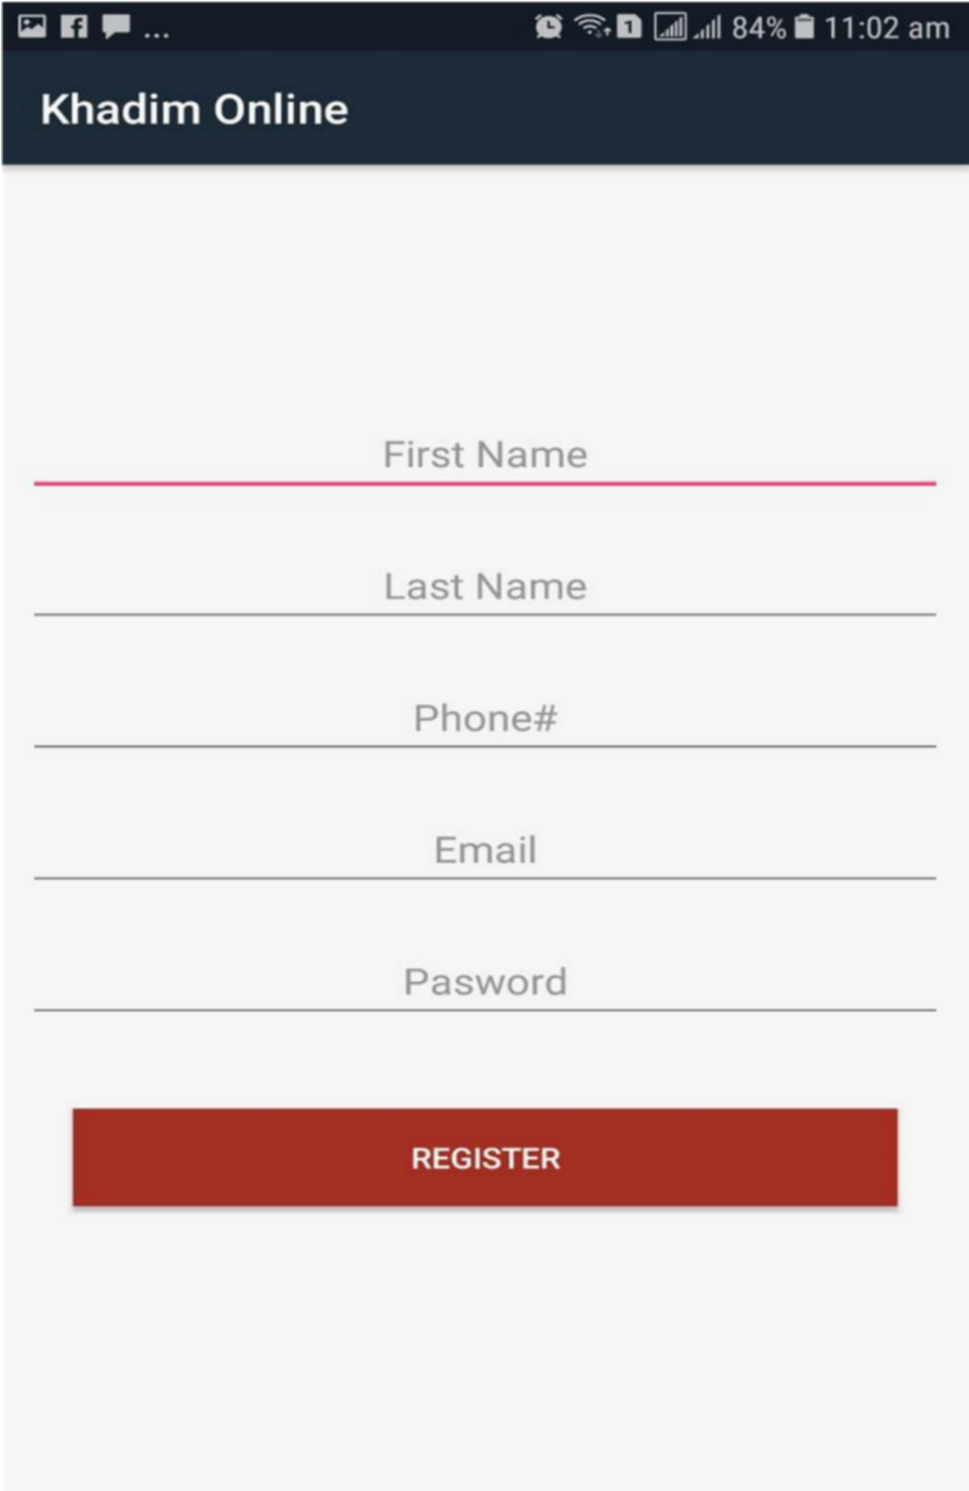
1: Enter your first name properly. 2: Enter your last name properly.
3: Enter your valid email address
4: Type your password with minimum 6 letters 5: Enter your valid phone number.
6: Press Register

Step 3
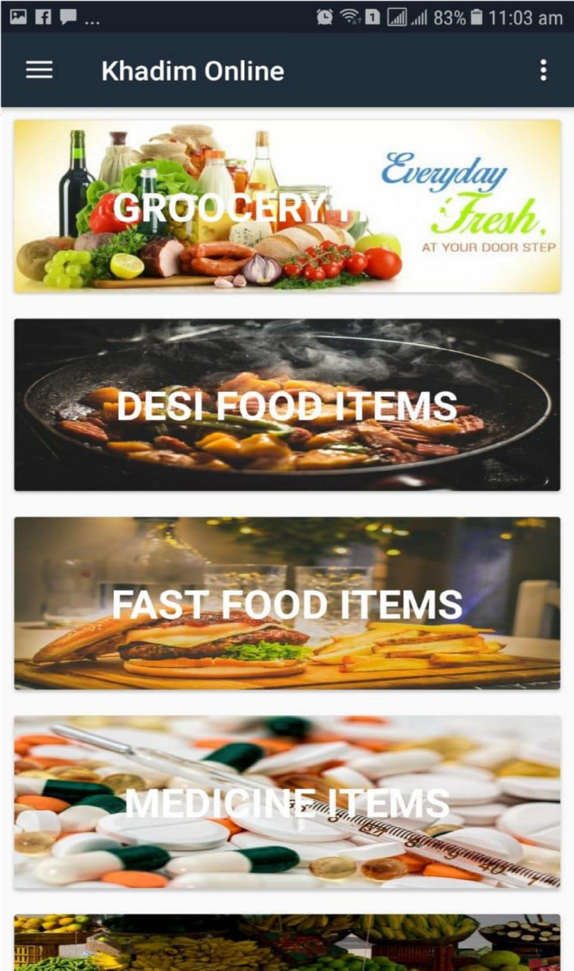
1. Select a category of item that you want to order.

p 4
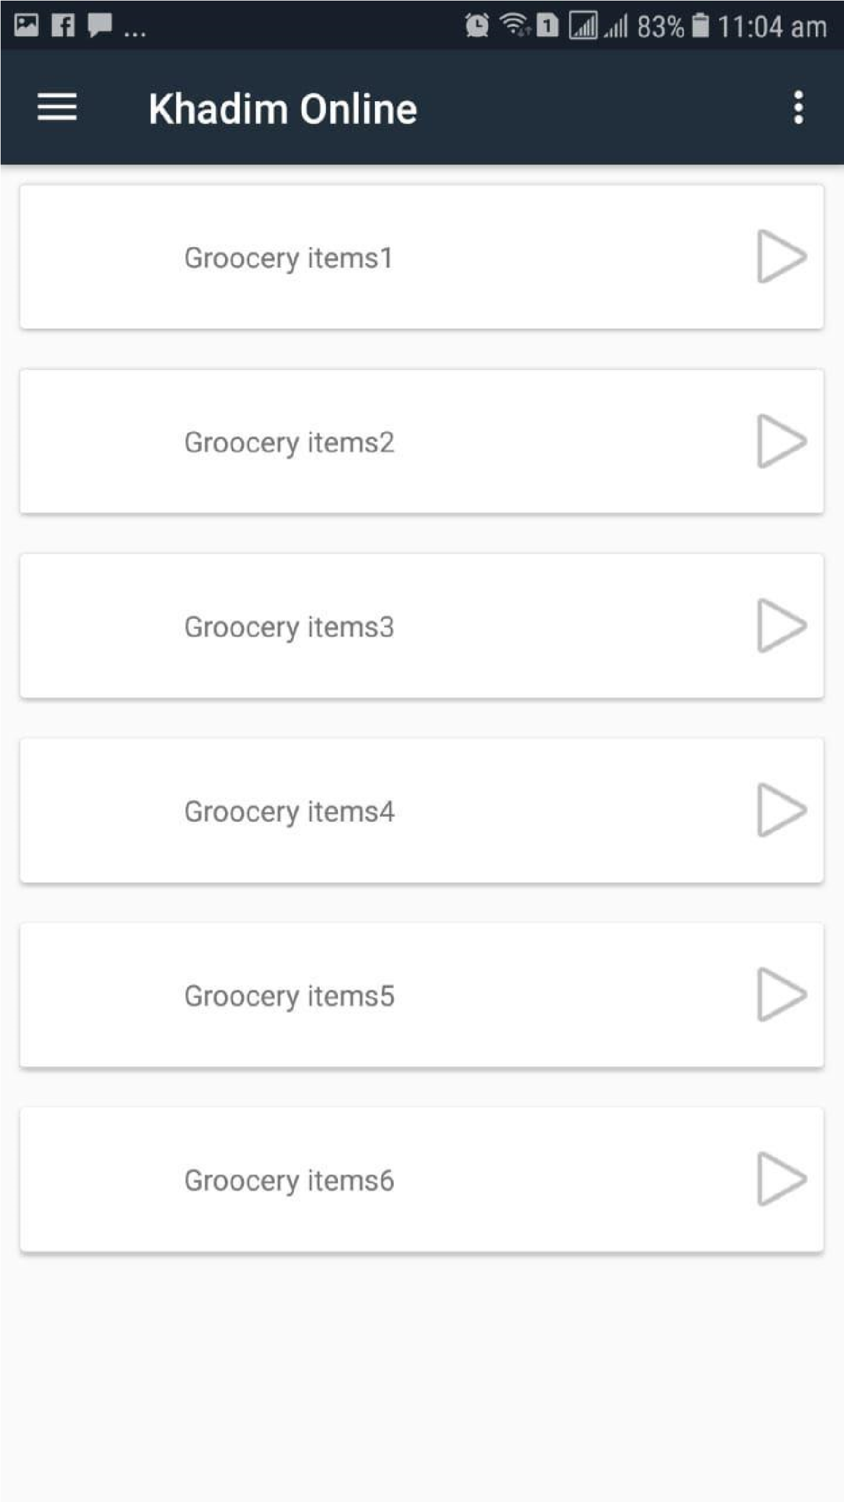
1. Select a product from a category. p 5
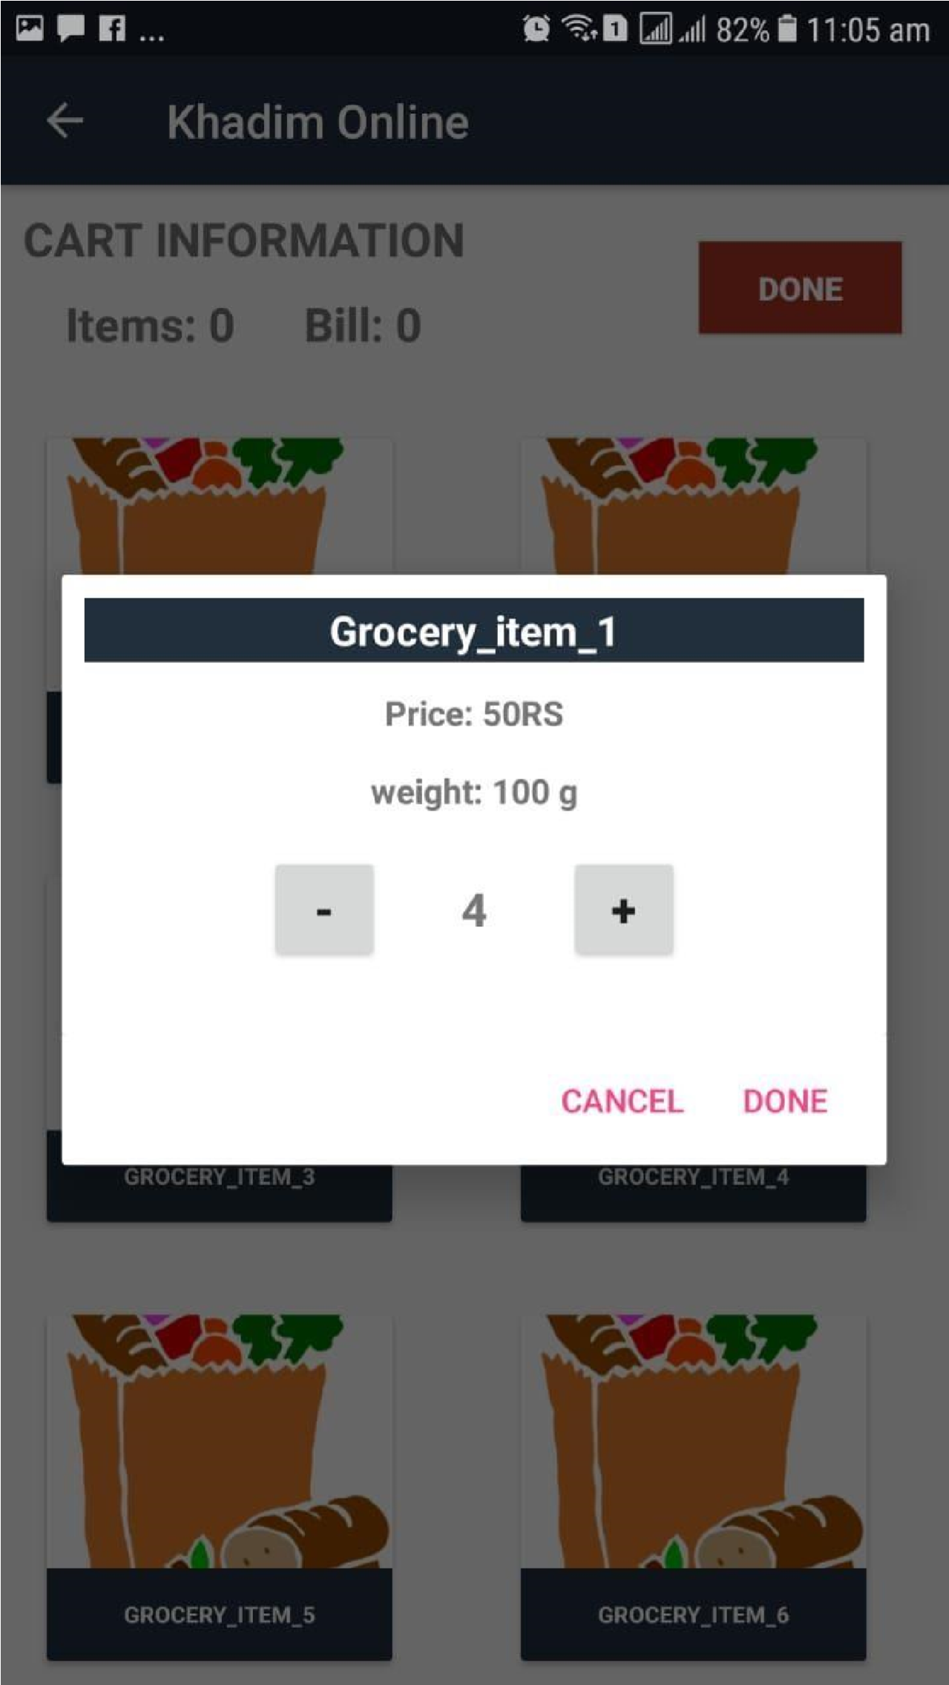
- Increase or decrease the quantity of your ordered product.
- “+” will increase the quantity.
- “- “ will decrease the quantity.

p 6
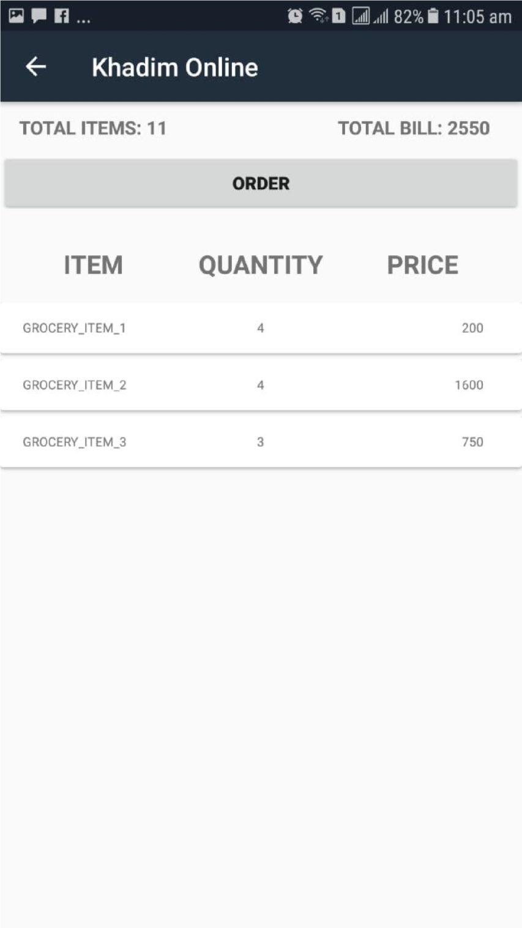
Get your receipt.

Step 7
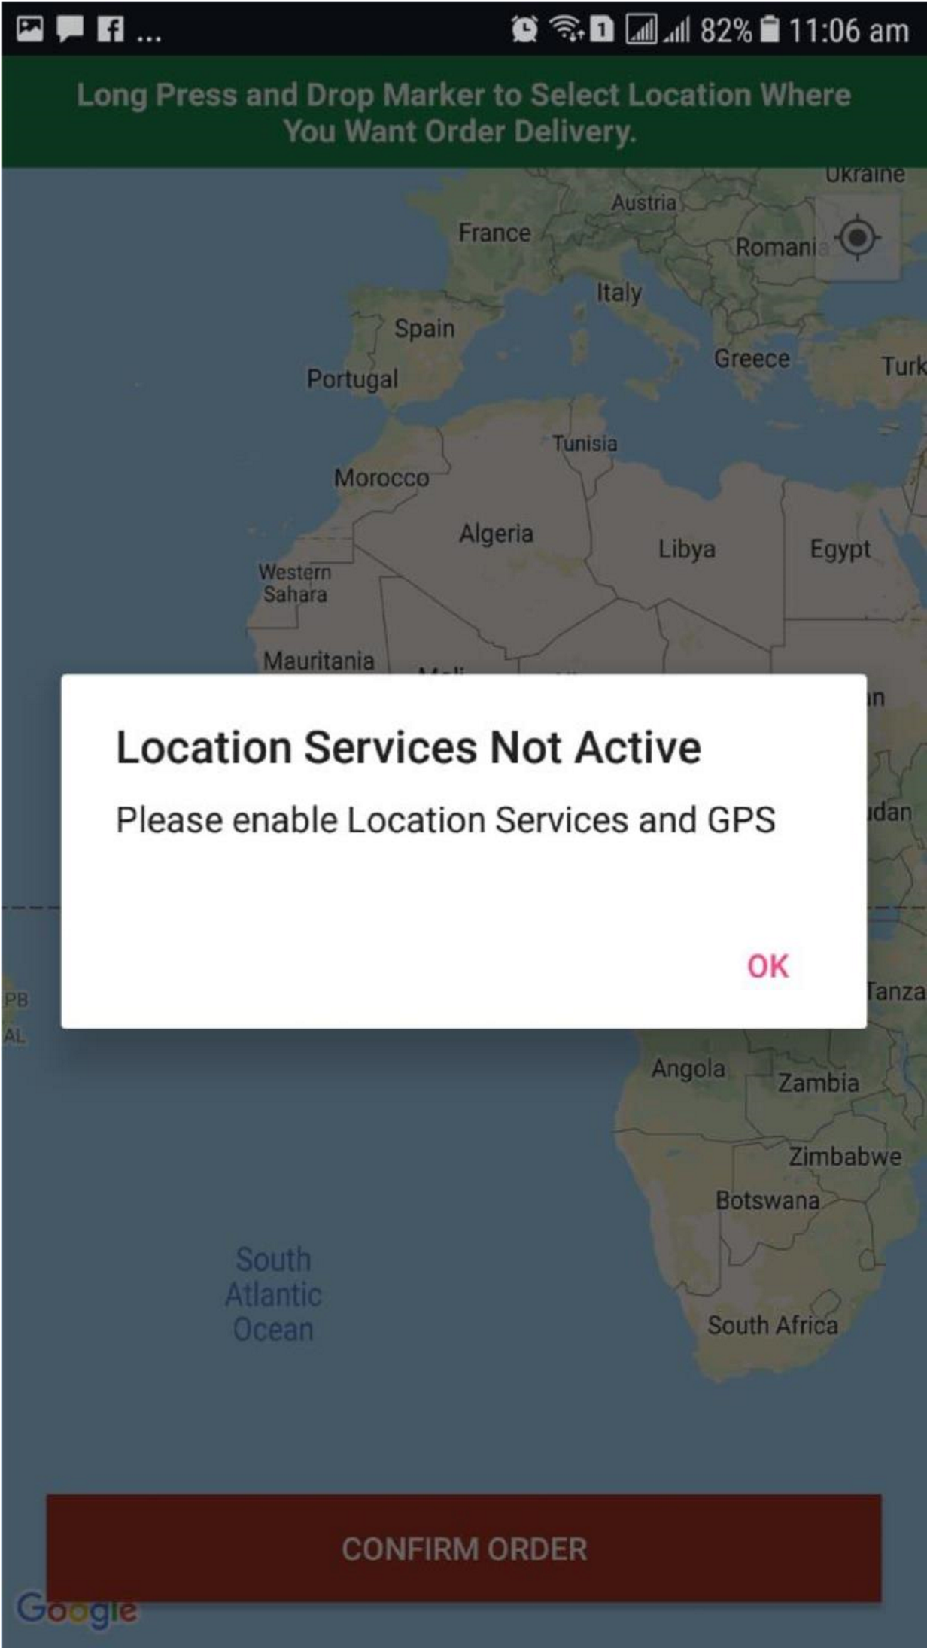
Enable your GPS location Step 8
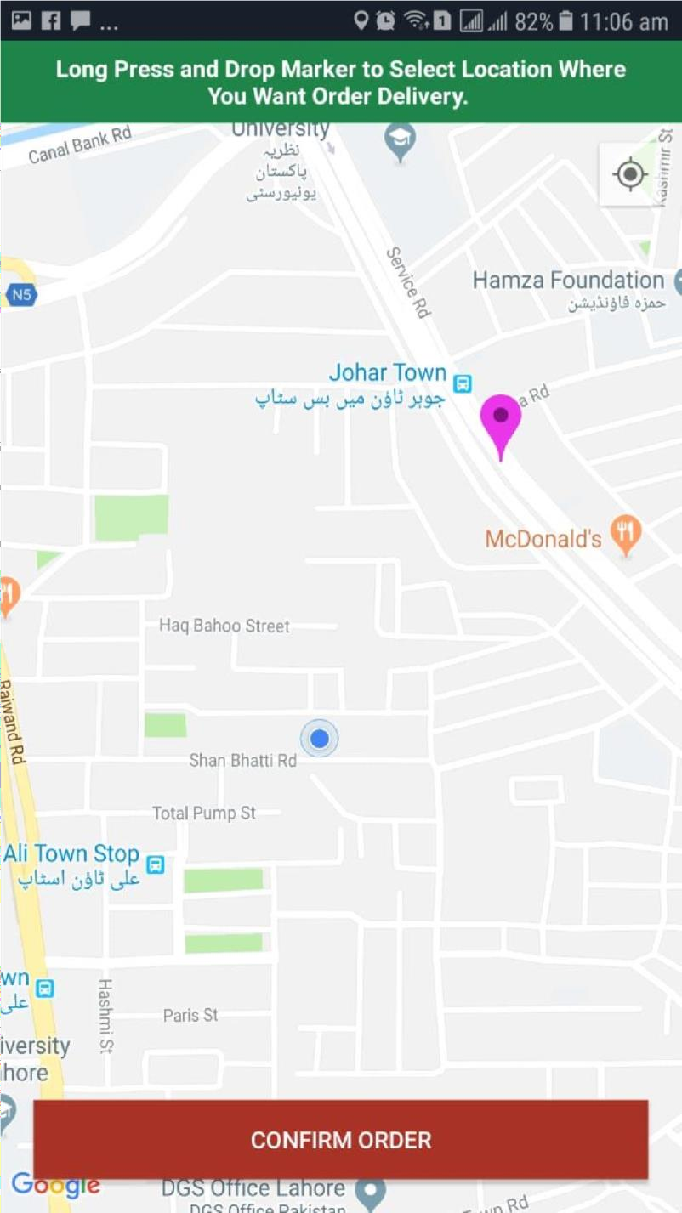
Get your current location Step 9
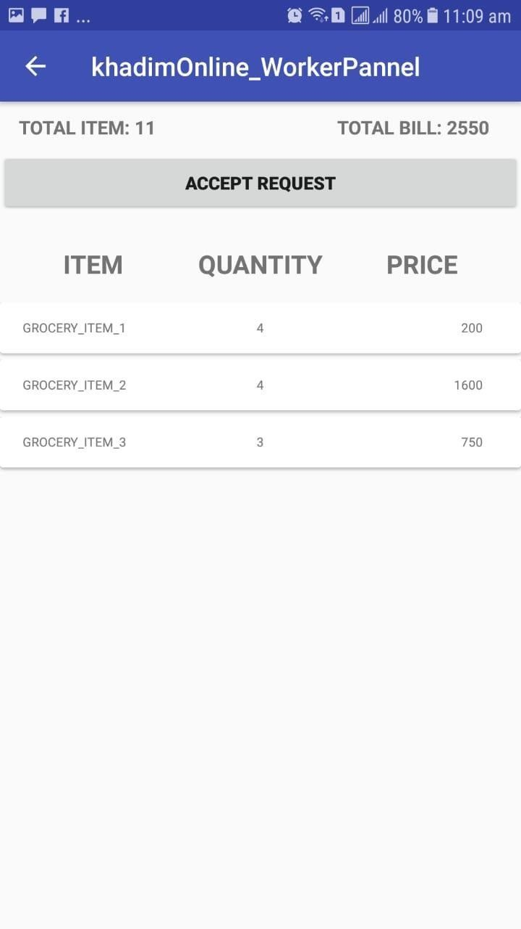
- Rider will accept the request.
- Rider will get the detail of order.

Step 10
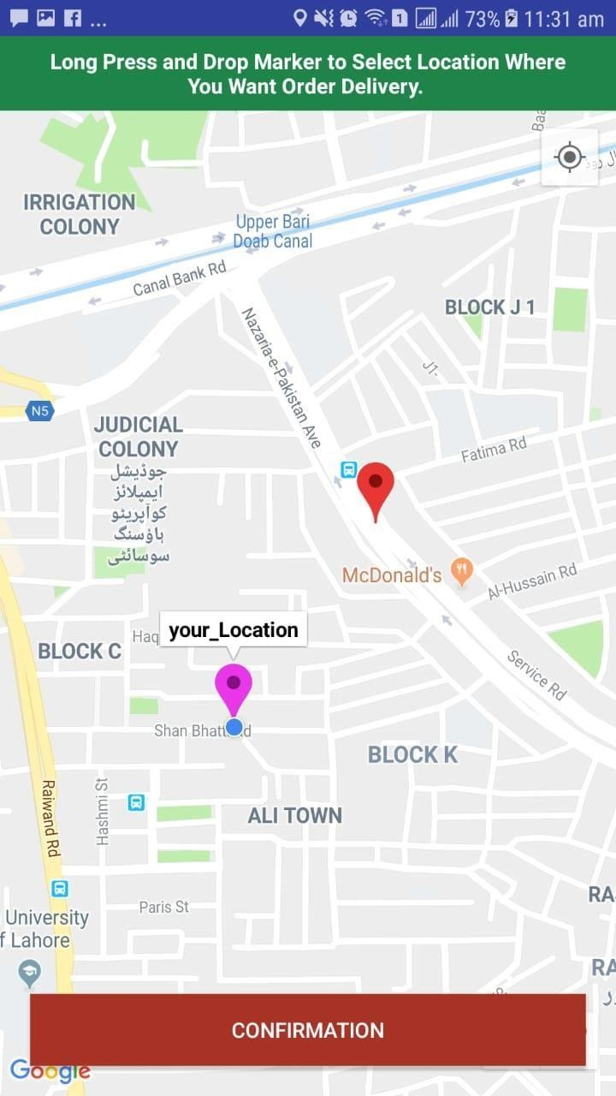
1. Rider will get the location of the customer.

Step 11
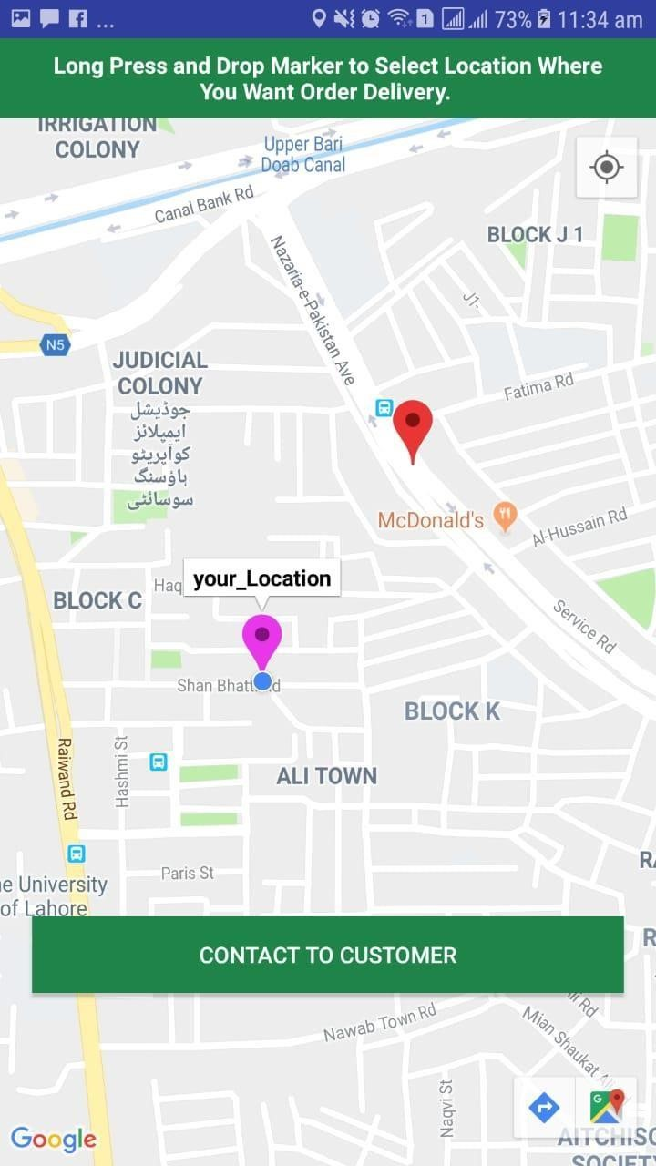
1. Rider can get the contact number of customer by clicking the button on map.

Step 12
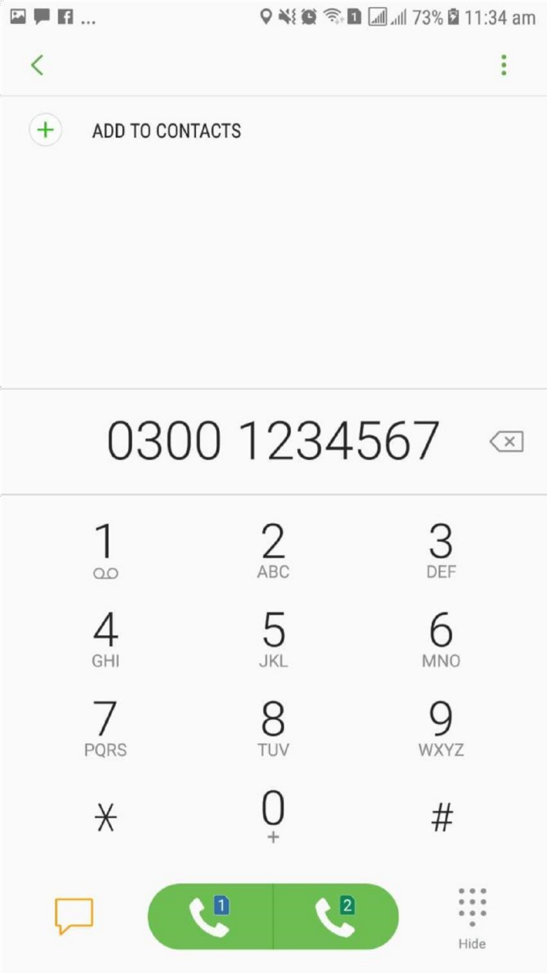
1. Customer’s contact is visible on rider’s dial pad.
CHAPTER 6
6 CONCLUSION AND RECOMMENDATIONS

6.1 Conclusion
Khadim online is committed to provide excellence in its customer service. Customer service is an important aspect in the provision of our services using our application. Perfection in customer benefit can only be fully accomplish by having a value system known as feedback which places the customer at the heart of all in all. Khadim online has fixed this fashion of customer benefit by giving high arrangement to a customer.

6.2 Recommendations

6.2.1 Strong internet connection
The workers should use a 3G or 4G facility on their mobiles otherwise the application might lag while getting the location of the customer.

6.2.2 Free mobile storage
The worker and customer should at least have 1GB of free space on their phone so that the application can run on the mobile phone without affecting the phones speed.

6.2.3 Work satisfaction level
Customer should ensure that he has received the ordered products or not before paying the bill.

REFERENCES

Journal Papers:
[1]. “A New Approach for Location based Tracking” Shaveta Bhatia1, Saba Hilal, ,Manav Rachna International University 2013.
- “GOOGLE MAPS AND RSS INTEGRATION IN ANDROID”, Sabyasachi
Patra1, Karishma Velisetty2 and Prathamesh Patel3 2013.
- Study of Google Firebase API for Android “Navdeep Singh” Bachelor of Technology Student, Department of Computer Science Engineering, Seth Jai Parkash Mukand Lal Institute of Engineering and Technology, Radaur, Yamunanagar, India 2016.
- Real Time Databases for Applications “Sonam Khedkar1, Swapnil Thube2, MCA (IMCOST), Mumbai University C-4 , Wagle Industrial Estate, Near Mulund (W)” 2017.
- Go Mumbai “NehaSaxena , Suhasini Maurya, Ankit Rai , Santosh Yadav, Jinesh Malavia” 2017.
- Rapid Applications Development Techniques: A Critical Review “Riffat Naz and M. N. A. Khan, Shaheed Zulfikar Ali Bhutto Institute of Science and Technology
(SZABIST) Islamabad, Pakistan” 2015.

