
BSCS-S18-012
03-134151-026 | M EHSAN SIDDIQUI
03-134151-021 | M FAHAD ISHAQ
03-134151-001 | ABDUL HASEEB

FYP AUGMENTATION PLATFORM

In partial fulfilment of the requirements for the degree of
Bachelor of Science in Computer Science
Supervisor: DR. Abdul Hafeez
Department of Computer Sciences
Bahria University, Lahore Campus
January 2019

© Bahria University, 2019

Certificate

We accept the work contained in the report titled
“FYP AUGMENTATION PLATFORM”,
written by
M EHSAN SIDDIQUI
M FAHAD ISHAQ
ABDUL HASEEB
as a confirmation to the required standard for the partial fulfilment of the degree of
Bachelor of Science in Computer Science.

Approved by:
Supervisor: DR. Abdul Hafeez

January 11th, 2019

DECLARATION

We hereby declare that this project report is based on our original work except for citations and quotations which have been duly acknowledged. We also declare that it has not been previously and concurrently submitted for any other degree or award at Bahria University or other institutions.

Enrolment | Name | Signature
03-134151-026 | M EHSAN SIDDIQUI
03-134151-021 | M FAHAD ISHAQ
03-134151-001 | ABDUL HASEEB

Date : _________________________

Specially dedicated to
my beloved grandmother, mother and father
(M Ehsan Siddiqui)
my beloved grandmother, mother and father
(M Fahad Ishaq)
my beloved grandmother, mother and father
(Abdul Haseeb)

ACKNOWLEDGEMENTS

Starting with the name of Allah (S.W.T), first we would like to thank Allah (S.W.T) very much for giving us strength to complete this project. We would like to thank everyone who had contributed to the successful completion of this project. We would like to express my gratitude from the depth of our heart to my research supervisor, Mr. Abdul Hafeez for his invaluable advice, guidance and his enormous patience throughout the development of the research.

In addition, we would also like to express my gratitude to our loving parents who stood beside us in the every hour of need, our friends who had helped us in completing this project and given me encouragement.

Our teachers who taught us all from the start and helping us with all our queries and ambiguities so that we could bring this idea into real shape.

M Ehsan Siddiqui
M Fahad Ishaq
Abdul Haseeb

FYP AUGMENTATION PLATFORM

ABSTRACT

Students of FYP (Final year project) of many universities especially of BULC are facing problem about its future. Also most of the students face challenge to come in the market based on their FYP project. This project is about the development of web-based interactive application for BULC in which main stakeholders of FYP (Students, FYP office, Software houses and teachers) can get benefit to augment FYP. FYP office can provide opportunity by providing many online services to students. Students of completed and on-going projects can get the opportunity to adjust in the market though this platform where software companies can pick them directly. Software houses can search the competitive students as they required and can upload their projects on which student can request and gain knowledge. Students who want to do the FYP in the future can get benefit by getting assistance from seniors and experts. FYP office can upload the necessary documents for students. Teachers can also upload their ideas and can assist online through this platform. The main focus will be on searching the required information from the uploaded projects. Moreover, an interactive chat session will be created among students, teachers and experts where they can direct chat and interact with each other. BULC, Students and software companies can get benefit through this platform. Agile methods with the help of traditional SDLC (system development life cycle) will be used to develop and implement the website.[2]

TABLE OF CONTENTS

DECLARATION ii
ACKNOWLEDGEMENTS iv
ABSTRACT v
TABLE OF CONTENTS vi
LIST OF TABLES ix
LIST OF FIGURES x
LIST OF SYMBOLS / ABBREVIATIONS xii

CHAPTERS
1 INTRODUCTION 1
1.1 Background 1
1.2 Problem Statements 2
1.3 Aims and Objectives 2
1.4 Scope of Project 3
Primary Scope 3
Benefits: 3
Modules 4
2 SOFTWARE REQUIREMENT SPECIFICATION 5
2.1 Product Perspective 5
2.2 User Classes and Characteristics 5
2.3 Operating Environment 7
2.4 Design and Implementation Constraints 7
2.5 Assumptions and Dependencies 7
2.6 System Requirement Chart 7
3 DESIGN AND METHODOLOGY 9
3.1 Methodology 9
3.1.1 Planning 9
3.1.2 System Analysis and Requirements 9
3.1.3 System Design 9
3.1.4 Development 9
3.1.5 Integrating and Testing 10
3.1.6 Implementing 10
3.1.7 Operation & Maintenance 10
3.2 Design 10
3.2.1 Use Case Diagram 11
3.2.2 Use Case Description 12
3.3 Sequence Diagram 21
3.4 Collaboration Diagram 27
3.5 Domain Model 29
3.6 Design Class Diagram 30
3.7 Data Model 32
3.7.1 ERD 32
3.7.2 Fully Attributed ERD 33
4 IMPLMENTATION 34
4.1 Implementation 34
4.1.1 Design Algorithm 34
4.1.2 Technical Aspect of the FYPAP 36
4.1.3 Back-end Technologies 36
4.1.4 Front-end Technologies 36
5 USER MANUAL 38
5.1 Getting Started 38
5.1.1 User Access, Roles and Privileges. 38
5.1.2 How to access FYP Augmentation: 39
5.1.3 Login & Registration at FYPAP 39
5.1.4 Navigation Bar of FYPAP 41
5.1.5 Dashboard of FYPAP 42
5.1.6 User List Registered By Admin 42
5.1.7 List of the software houses 43
5.1.8 User View Project 43
5.1.9 Project List in FYPAP 44
5.1.10 Upload Project 44
5.1.11 Project Request Proposal 45
5.1.12 Create User Account 45
5.1.13 Discussion Forum in FYPAP 46
6 CONCLUSION AND RECOMMENDATIONS 47
REFERENCES 48
APPENDICES 49

LIST OF TABLES

TABLE TITLE PAGE
Table 1: System Requirement Chart 7
Table 2 (Use-Case FYP Augmentation Platform-1) 12
Table 3 (Use-Case FYP Augmentation Platform -2) 13
Table 4 (Use-Case FYP Augmentation Platform -3) 14
Table 5 (Use-Case FYP Augmentation Platform -4) 15
Table 6 (Use-Case FYP Augmentation Platform -5) 16
Table 7 (Use-Case FYP Augmentation Platform -6) 17
Table 8 (Use-Case FYP Augmentation Platform -7) 18
Table 9 (Use-Case FYP Augmentation Platform -8) 19
Table 10 (Use-Case FYP Augmentation Platform-9) 20
Table 11 Front End Technologies 20

LIST OF FIGURES

FIGURE TITLE PAGE

Figure 1: Flow of FYAP 4
Figure 2: Features of FYAP 6
Figure 3:Use-Case Diagram of FYAP 11
Figure-4 Sequence Diagram User Login 21
Figure-5 Sequence Diagram Teacher View Project 22
Figure-6 Sequence Diagram Teacher View Request List 22
Figure-7 Sequence Diagram Student Search Project 23
Figure-8 Sequence Diagram Student Request Project 24
Figure-9 Sequence Diagram FYP Office View Request Page 24
Figure-10 Sequence Diagram Software House View Project 25
Figure-11 Sequence Diagram Software House Send Project Request 26
Figure-12 Sequence Diagram Complete Sequence Diagram 26
Figure-13 Collaborative Diagram FYP Office 27
Figure-14 Collaborative Diagram User View Project 28
Figure-15 Collaborative Diagram FYP Office Remove Project 28
Figure-16 Collaborative Diagram User Login 29
Figure 17: Domain Model of FYAP 30
Figure 18: Class Diagram of FYAP 31
Figure 19: ERD of FYAP 32
Figure 20: Fully Attributed Data Model of FYAP 33
Figure 21: Project Request Algorithm of FYAP 34
Figure 22: Show Result Algorithm pf FYAP 35
Figure 23: Download Project Algorithm of FYAP 35
Figure 24: Website Framework 36
Figure 25: Access Url for FYAP 39
Figure 26: Login Page 39
Figure 27: Registration Form 40
Figure 28:Navigation Bar of website 41
Figure 29: Dashboard Page 42
Figure 30: User Lists Page 42
Figure 31: List of Software House Page 43
Figure 32: User View Project Page 43
Figure 33: Project List Page 44
Figure 34: Upload Project Page 44
Figure 35: Project Request Page 45
Figure 36: Create User Account Page 45
Figure 37: Discussion Forum Page 46

LIST OF SYMBOLS / ABBREVIATIONS

FYP Final Year Project
PHP Hypertext Preprocessor
CSS Cascading Style Sheets
HTML Hyper Text Markup Language
SDLC Software Development Lifecycle
ERD Entity Relationship Diagram
FYPAP FYP Augmentation Platform

INTRODUCTION

Background

Students of FYP (Final year project) of many universities are facing problem about their future. Also most of the students face challenge to come in the market based on their FYP project. They have very less opportunities to polish their skills and get experience about the market. Moreover students do not know about the expertise of the software houses so they drop their job application without knowing the expertise of the software house. It will also help the junior students in their FYP.

FYP Augmentation Platform is a web base application in which we will provide an interactive platform for those graduate students who have completed their final year project. And by using this they will boost their ideas in market. FYP office will upload the completed final year project of the graduate students. This platform will provide services to many software houses to select student according to their requirements and expertise fields. Teams of software houses will observe and visit graduate students project. They can see student’s final year project rating that will be given by universities. Software Houses will upload their project and student can request on them. The account for software houses will be necessary in which they will upload their work history and expertise so the students can see the work history and expertise of a particular software house. Such that students can see software houses expertise and they can prepared themselves to compete market demands.

At our platform teachers can upload their upcoming projects and research work. And interested students can search and see their projects and contact with teachers to work on specific project. This platform will give a good opportunity for students by which they can work on teacher’s projects and do research to gain knowledge. Chat session will be medium among students, teachers and software house.

Student can search teacher’s upcoming project, graduated student’s final year project and list of the software house. This will provide an opportunity for the students to start their career in a positive way.

Problem Statements

Nowadays, students have very less opportunities to adjust and start their career at a proper place. They have a very less exposure of the market. The student does not know about technologies that are using in the market. So for this purpose we are developing a portal for students to start their career in a successful way. Moreover student does not know about the expertise of the software house and they drop their job application without knowing the expertise of the software house.

Teacher can also upload their project in FYP Augmentation Platform so the student can increase their learning and experience by working on teachers project and research work.

Software Houses can also upload their project so the student will know about the technologies that are now in common in market and can also increase their experience

Aims and Objectives

The main objective of our project is to provide an interactive web based platform for FYP stakeholders where
- FYP office can upload FYP of the graduate students to provide opportunity in their career.
- Teachers can upload upcoming teacher project or research work for students that will enhance their skills.
- Students of completed project FYP can adjust in the market
- Students of running and upcoming get opportunity to FYP can get search the required documents
- Software houses will upload their project and can search best candidate
- Stakeholders can communicate through chat and interact with each other.

Scope of Project

Primary Scope
Our web based platform can be used in different universities. FYP office will upload student final year project which can be seen by different software houses. That will provide opportunity to graduated students. Teachers can upload their research work and projects. It will also provide opportunity to the existing students to work with teachers in their projects and research work. That will enhance the skills of the students. This platform will also increase the interaction between students and teachers as we are using chat session for their interaction on our website.

Benefits:
Following are the benefits of FYP Augmentation Platform.
  - Graduated students will get the opportunity to adjust in the market through this platform.
  - Students will have jobs at the end of their degree.
  - Interaction between students and teacher will be improved.
  - Students can gain knowledge and experience by working with the teacher on his project.
  - Students can get the idea of technology that is currently used in the market.
  - Students can ask for assistance from teacher at any time.
  - Students can get the assistance of FYP of senior’s students.
  - Software house can get the students according to their requirement.
  - FYP of the graduated students will be maintained.
  - Students can search the software house and can prepare themselves according to the expertise of that software house.

Modules
Modules and features of the modules are describe below
FYP Office:
- Upload FYP projects with university ratings.
Software House:
- Upload Software House information during registration.
- Upload Software House Projects.
- Select the competitive students according their expertise.
Teachers:
- Upload their upcoming projects and research work.
- Can assist students online through a chat session.
Students:
- Students can search the FYP of the senior’s student to get the assistance.
- Students can search the upcoming projects of the teacher and request to work with them.
- Students can also search the software house to see the expertise of that software house.
Admin:
- Will be able to add/Remove teachers.
Registration
Upload project
View/ search projects

Request

Chat session

Figure 1: Flow of FYAP

SOFTWARE REQUIREMENT SPECIFICATION

Product Perspective
FYP Augmentation Platform is all about opportunities for the student. Graduated student will get the jobs in the market based on their FYP and can also boost their ideas in the market. They can get the basic understanding of the market and can adjust in the market in the good way. This product can be used in the universities and software houses. Website will be main user interface where stakeholders can operate all the provided functionality. FYP Augmentation Platform is based on the project which can uploaded by the stakeholders and two (Students , Software houses) main stakeholder can request on the project and graduated student can also can hired by the software houses based on their FYP.

User Classes and Characteristics
FYP Augmentation Platform can be used in universities and software houses. FYP Augmentation Platform is divided into four modules i.e. Student, FYP Office, Teacher and Software Houses.

Universities
- Students can get hired by Software house and can get knowledge about the market
- Students can search the FYP of the graduated students and can come up with a better and enhanced ideas
- Students do not know about the expertise of the software houses. They will know the expertise of the software houses and other things about the software house through our product
- Teachers will upload their project or research work and student will request on them this will increase the knowledge of the students and increase the interaction between teacher and students
- FYP office can maintain the record of the FYP online
- The reputation of the university will become better

Software Houses
- Software houses will get the best candidate according to their expertise in a short time without conducting to many online test and interviews for their seat
- Software houses can upload project on FYP Augmentation Platform and students will request on projects and can work on it. The student can increase their knowledge and software house can increase their profits
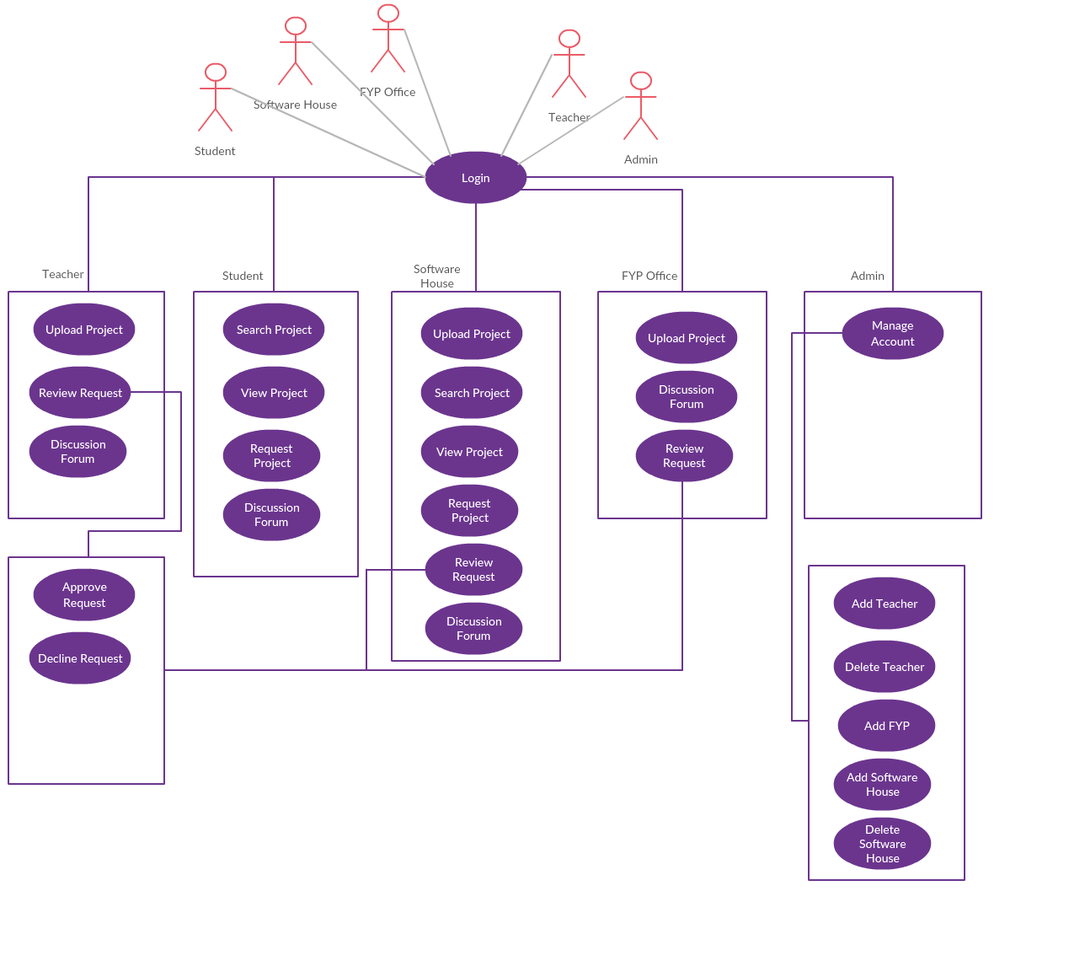

Figure 2: Features of FYAP

Operating Environment
This is a web-based platform and run accurately on following web browsers
- Google Chrome version 35.1 or higher
Mozilla Firefox version 40.0 or higher

Design and Implementation Constraints
FYP Augmentation Platform is a web-based system therefore front-end of FYP Augmentation Platform developed using HTML and CSS and backend developed using php and MySQL database. It uses php framework symphony. Moreover chat library of symphony also used. Xampp server used as host server. FYP Augmentation Platform developed using Agile Software Development Lifecycle, so it uses a modular design where features of every module wrapped separately and can be to back to the development of the module case of error in the development of module

Assumptions and Dependencies
FYP Augmentation Platform is a web-based system so it requires Google Chrome or Mozilla Firefox browser installed on user’s system. FYP Augmentation Platform requires 35.1 or higher for Google Chrome and 40.0 higher for Mozilla Firefox to run efficiently. There is a 24/7 host server of all time access for users of FYP Augmentation Platform.

System Requirement Chart

Table 1: System Requirement Chart
ID | Priority | Type | Contained in Use-Case | Description
Use-Case FYPAF-R1 | High | Functional | Use-Case -1 | Student registration
Use-Case FYPAF -R2 | High | Functional | Use-Case -2 | Student Login
Use-Case FYPAF -R3 | High | Functional | Use-Case -4 | Search Project
Use-Case FYPAF -R4 | High | Functional | Use-Case -5 | View Project
Use-Case FYPAF -R5 | High | Functional | Use-Case -6 | Request Project
Use-Case FYPAF -R6 | High | Functional | N/A | List of SH
Use-Case FYPAF -R7 | High | Functional | Use-Case -9 | Discussion Forum(Chat with Users)
Use-Case FYPAF-R8 | High | Functional | Use-Case -3 | Upload Project
Use-Case FYPAF-R9 | Medium | Functional | Use-Case -6 | Accept/Decline Request
Use-Case FYPAF-R10 | Medium | Functional | Use-Case -8 | Add new Teacher Account
Use-Case FYPAF-R11 | Medium | Functional | Use-Case -8 | Delete Teacher Account
Use-Case FYPAF-R12 | High | Functional | Use-Case -8 | Add FYP office Account
Use-Case FYPAF -R13 | Medium | Non-Functional | Use-Case -8 | Responsive Website Design
Use-Case FYPAF -R14 | Medium | Non-Functional | N/A | Testing Website will be done module by module
Use-Case FYPAF -R15 | Medium | Non-Functional | N/A | Design best Architecture for better data retrieval from server
Use-Case FYPAF -R16 | Medium | Non-Functional | N/A | While input data in dashboard any internet disconnection will save user data so he won’t have to write it again
Use-Case FYPAF -R17 | High | Non-Functional | N/A | Final, integrated project code will test to ensure that complete project is integrated well and functioning properly

DESIGN AND METHODOLOGY

Methodology
We will follow the agile methods to gather requirements and for the development with traditional system development life cycle (SDLC). SDLC is describes all phases of the project development process. And user can easily understand the activities in given step. In this we can repeat step and modified if required to improve the system. There are following seven stages which will be followed to complete project.[3]

Planning
In this phase, we will find scope of problems and its solutions. Then we also discuss about its resources and time.

System Analysis and Requirements
All functional and non-functional requirements are analyzed and find out solutions.to find out the requirements system will be analyzed and discuss thoroughly. And there will be confirmed all expectation of the project.

System Design
After the analysis and requirement gathering phase, we will then design the projects according to the user requirement. For this we will create ERD diagrams and use case Diagram. Activity diagrams will also create for each module. And we will design the user interface of each module.

Development
In this phase we will develop the user interface of each module. And we will integrate all user interfaces with database using php.

Integrating and Testing
We will integrate a complete project and test. It will be tested and make sure that will we have competed the all requirements that mentioned.

Implementing
We will implement our project and allow for live on webserver.

Operation & Maintenance
At last our web-based application will be handled carefully and maintain its performance. [2]

Design

Following artefacts included in this Chapter
1. Use case diagram
2. Use case description
3. Sequence Diagram
4. Collaboration Diagram
5. Domain Model
6. Design Class Diagram
7. Data Model

Use Case Diagram
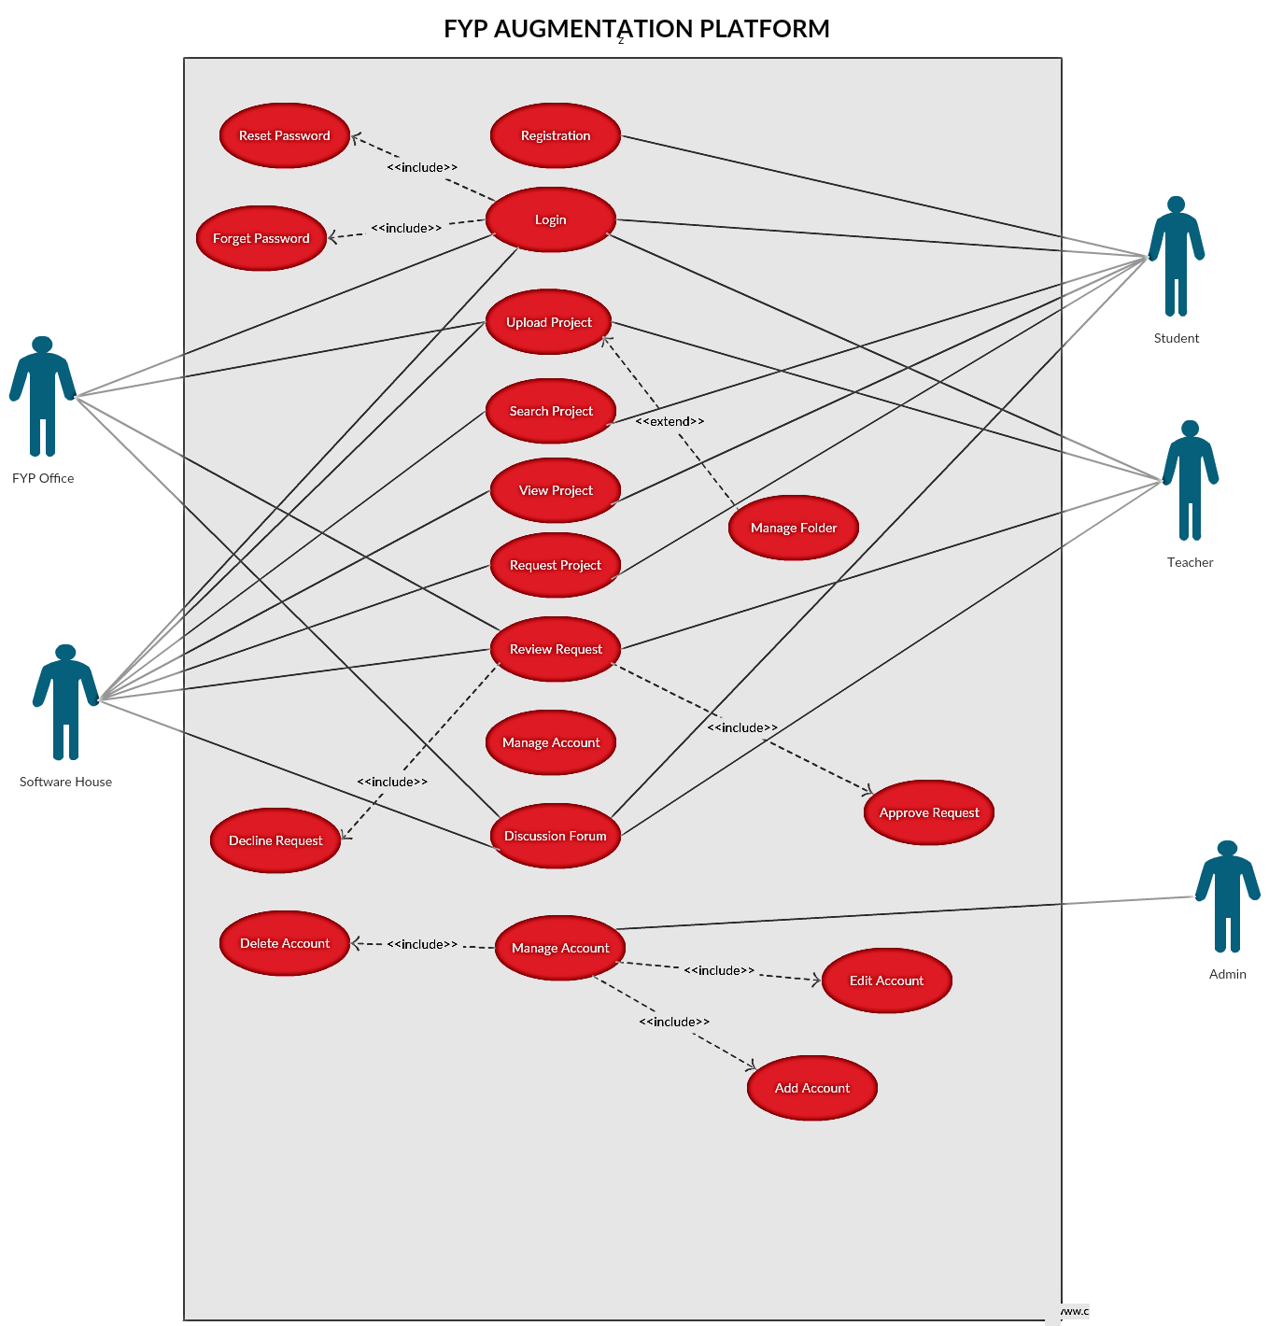

Figure 3:Use-Case Diagram of FYAP

Use Case Description
Following are the narrative parts of every bubble in above use case diagrams

Table 2 (Use-Case FYP Augmentation Platform-1)
Name | Register
Use-Case ID | FYPAF-R1
Priority | High
Primary Actor | Student
Other participating Actor(s) | System
Description | This use case describes the event of a Student registering for FYP AUGMENTATION PLATFORM
Pre-condition | User should not register yet
Trigger | This use case initiate when a Student going to register
Typical flow of events | 1. User gives new username and a new password  2. A confirmation e-mail sent to user with verification code  3. User enter the verification code
Alternate flow of event | Alt-1 user gives wrong username and a popup error displays  Alt-3 user gives wrong verification code and a popup error displays
Post condition | User is successfully registered
Alternate post condition | User isn’t register

Table 3 (Use-Case FYP Augmentation Platform -2)
Name | Login
Use-Case ID | FYPAF -R2
Priority | High
Primary Actor | Student ,Software House ,FYP Office, Teacher
Other participating Actor(s) | System
Description | This use case describes the event when user going to login at FYP AUGMENTATION PLATFORM
Pre-condition | 1.User must be registered at FYP AUGMENTATION PLATFORM  2.User should not login
Trigger | This use case initiate when a user going to Login
Typical flow of events | 1. User gives username and a password  2. System verifies User Credentials
Alternate flow of event | Alt-1 User gives wrong credentials, system generate a popup error and take user  to login page
Post condition | User successfully logged in
Alternate post condition | Login failed

Table 4 (Use-Case FYP Augmentation Platform -3)
Name | Search Project
Use-Case ID | FYPAF -R3
Priority | High
Primary Actor | Student ,Software House
Other participating Actor(s) | ---
Description | This use case describes the event when Student and Software House search project in FYP AUGMENTATION PLATFORM
Pre-condition | Student must open FYP Augmentation Platform in browser and project should be uploaded by FYP office ,Teacher and Software Houses
Trigger | This use case initiate when a Student and Software House search project in FYP Augmentation Platform
Typical flow of events | 1. Open FYP Augmentation Platform.  2. Search different projects by name,tags
Alternate flow of event | Alt-2 Student and Software House have not search project  Alt-3 Student and Software House get no result get landing page
Post condition | Successfully Search Project
Alternate post condition | Have not search project

Table 5 (Use-Case FYP Augmentation Platform -4)
Name | View Project
Use-Case ID | FYPAF -R4
Priority | High
Primary Actor | Student ,Software House
Other participating Actor(s) | ---
Description | This use case describes the event when Student and Software House going to View projects in FYP Augmentation Platform
Pre-condition | Student must open FYP Augmentation Platform in browser
Trigger | This use case initiate when a Student and Software House View projects in FYP Augmentation Platform
Typical flow of events | 1. Open FYP Augmentation Platform.  2.Click on View projects
Alternate flow of event | Alt-1 Students and Software House not open FYP Augmentation Platform in browser
Post condition | Successfully View projects
Alternate post condition | Not View projects

Table 6 (Use-Case FYP Augmentation Platform -5)
Name | Request Project
Use-Case ID | FYPAF –R5
Priority | High
Primary Actor | Student, Software House
Other participating Actor(s) | ---
Description | This use case describes the event when Student and Software House going to Request projects in FYP Augmentation Platform
Pre-condition | Student and Software House must open FYP Augmentation Platform in browser and must view a project
Trigger | This use case initiate when a Student and Software House Request projects in FYP Augmentation Platform
Typical flow of events | 1. Open FYP Augmentation Platform.  2.Click on View projects  3.Click on Request Button
Alternate flow of event | Alt-1 Students and Software House not open FYP Augmentation Platform in browser
Post condition | Successfully Request projects
Alternate post condition | Not Request projects

Table 7 (Use-Case FYP Augmentation Platform -6)
Name | Discussion Forum
Use-Case ID | FYPAF –R6
Priority | Medium
Primary Actor | Students ,Software House ,FYP Office,Teacher
Other participating Actor(s) | Teacher, Software House
Description | This use case describes the event when user discuss about projects to in FYP AUGMENTATION PLATFORM
Pre-condition | 1.User must open FYP AUGMENTATION PLATFORM in browser and must be logged in
Trigger | This use case initiate when a user chat to discuss project FYP AUGMENTATION PLATFORM
Typical flow of events | 1.Open FYP AUGMENTATION PLATFORM  2.Search Projects/View Projects  3. Click on particular Project  4. Click on chat button
Alternate flow of event | Alt-3 User have not click on Project  Alt-4 .User have not click on chat button
Post condition | Successfully chat to discuss about project
Alternate post condition | Have not chat to discuss about project

Table 8 (Use-Case FYP Augmentation Platform -7)
Name | Upload Project
Use-Case ID | FYPAF –R8
Priority | High
Primary Actor | Teacher ,FYP Office ,Software House
Other participating Actor(s) | ---
Description | This use case describes the event when users will upload project in FYP AUGMENTATION PLATFORM
Pre-condition | 1.User must open FYP AUGMENTATION PLATFORM in browser and must be logged in
Trigger | This use case initiate when user will upload project in FYP AUGMENTATION PLATFORM
Typical flow of events | 1.Open FYP AUGMENTATION PLATFORM  2.Logged in  3. Upload Project
Alternate flow of event | Alt-3 user will not upload project
Post condition | Successfully user will upload project
Alternate post condition | Have not Upload Project

Table 9 (Use-Case FYP Augmentation Platform -8)
Name | Review Request
Use-Case ID | FYPAF –R7
Priority | Medium
Primary Actor | Teacher, FYP Office, Software House
Other participating Actor(s) | ---
Description | This use case describes the event when user will response to the request of students on their project in FYP AUGMENTATION PLATFORM
Pre-condition | 1.Users must open FYP AUGMENTATION PLATFORM in browser and must be logged in
Trigger | This use case initiate when users will response to the request of other users on their project in FYP AUGMENTATION PLATFORM
Typical flow of events | 1.Open FYP AUGMENTATION PLATFORM  2.Logged in  3. Response to the request
Alternate flow of event | Alt-3 User will not response to the project
Post condition | Successfully User will response to the project
Alternate post condition | Have not response to the Project

Table 10 (Use-Case FYP Augmentation Platform-9)
Name | Manage Account
Use-Case ID | FYPAF –R9
Priority | High
Primary Actor | Admin
Other participating Actor(s) | ---
Description | This use case describes the event when Admin will add account of the Teacher, FYP Office, Software House in FYP AUGMENTATION PLATFORM
Pre-condition | 1.Admin must open FYP AUGMENTATION PLATFORM in browser and must be logged in
Trigger | This use case initiate when Admin will add account of the Teacher, FYP Office, Software House in FYP AUGMENTATION PLATFORM
Typical flow of events | 1.Open FYP AUGMENTATION PLATFORM  2.Logged in  3. Add Teachers,FYP Office, Software House account
Alternate flow of event | Alt-3 Admin will not add Teachers, FYP Office, Software House account
Post condition | Successfully Admin will add Teachers, FYP Office, Software House account
Alternate post condition | Have not add Teachers, FYP Office, Software House account

Sequence Diagram
Sequence diagrams describe interactions among classes in terms of an exchange of messages over time. They're also called event diagrams. A sequence diagram is a good way to visualize and validate various runtime scenarios. These can help to predict how a system will behave and to discover responsibilities a class may need to have in the process of modelling a new system. There exists sequence diagram against every use case. Following are the sequence diagrams of FYP Augmentation Platform.

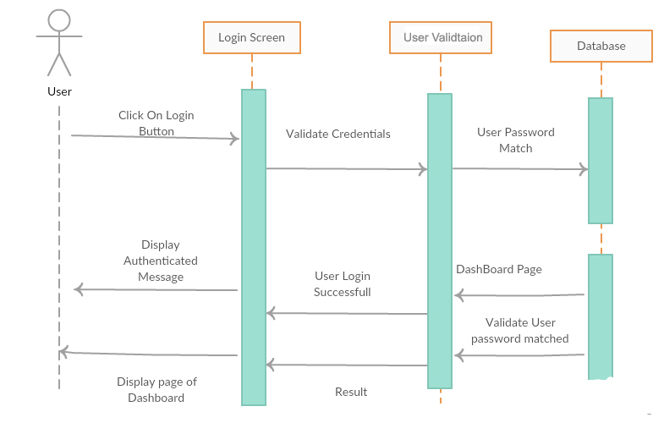
Figure-4 Sequence Diagram User Login
Above diagram describes the sequence of a user login process in which user enters the login credentials on login screen. Those details will validate from the database and an acknowledgement sent from the database. At end, user redirect to the authorized page.

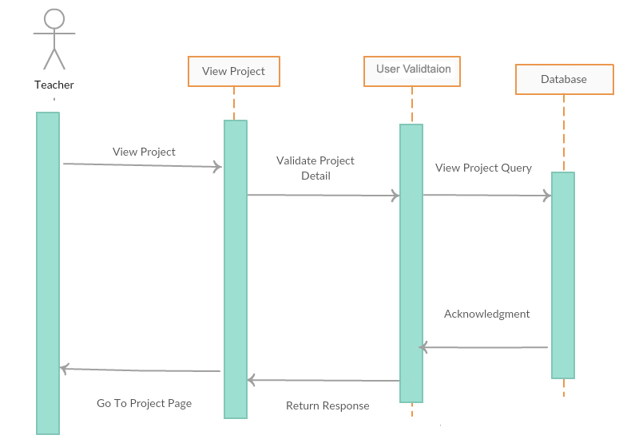
Figure-5 Sequence Diagram Teacher View Project
Above Diagram describe how the teacher will view the projects in the FYP Augmentation Platform
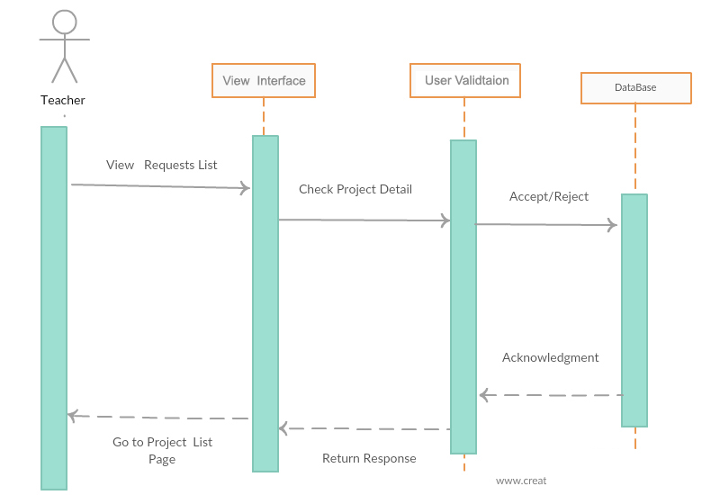

Figure-6 Sequence Diagram Teacher View Request List
Above Diagram describe the sequence of how the teacher will view the request list in FYP Augmentation Platform
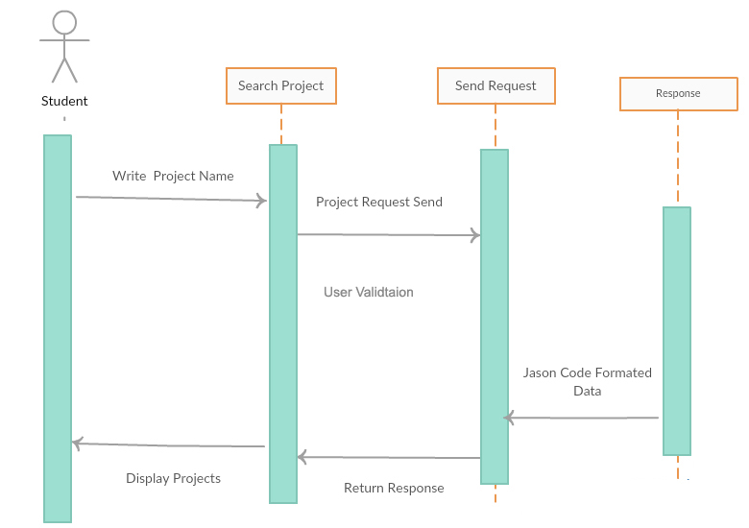
Figure-7 Sequence Diagram Student Search Project
Above Diagram describe how student will search the project in FYP Augmentation Platform
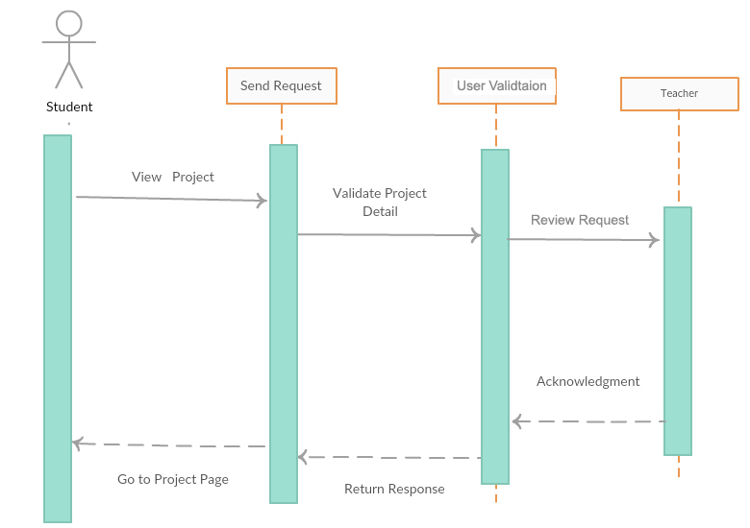Figure-8 Sequence Diagram Student Request Project
Above Diagram describes how the student will request the project of software houses and teachers in FYP Augmentation Platform
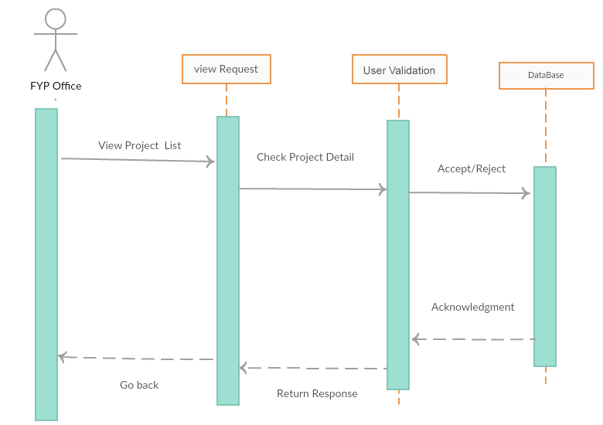
Figure-9 Sequence Diagram FYP Office View Request Page
Above Diagram describes the sequence of FYP Office view request page in FYP Augmentation Platform
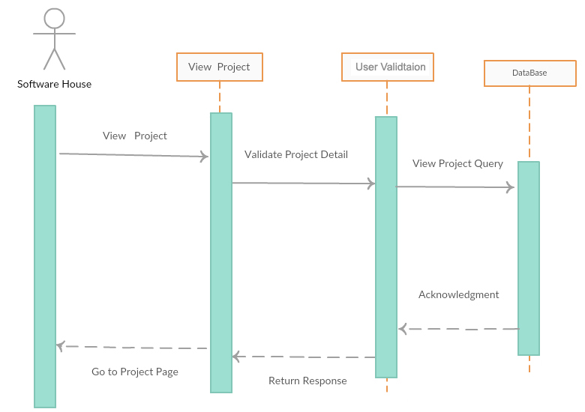
Figure-10 Sequence Diagram Software House View Project
Above diagram describe the sequence of the projects that will be viewed by software house in FYP Augmentation Platform.
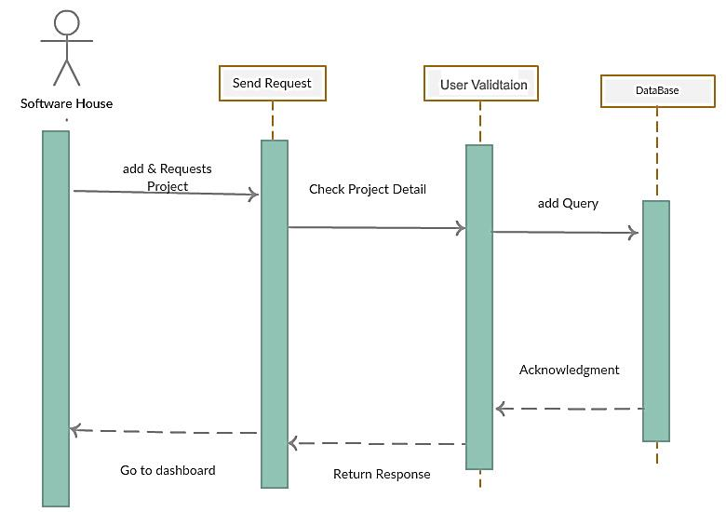
Figure-11 Sequence Diagram Software House Send Project Request
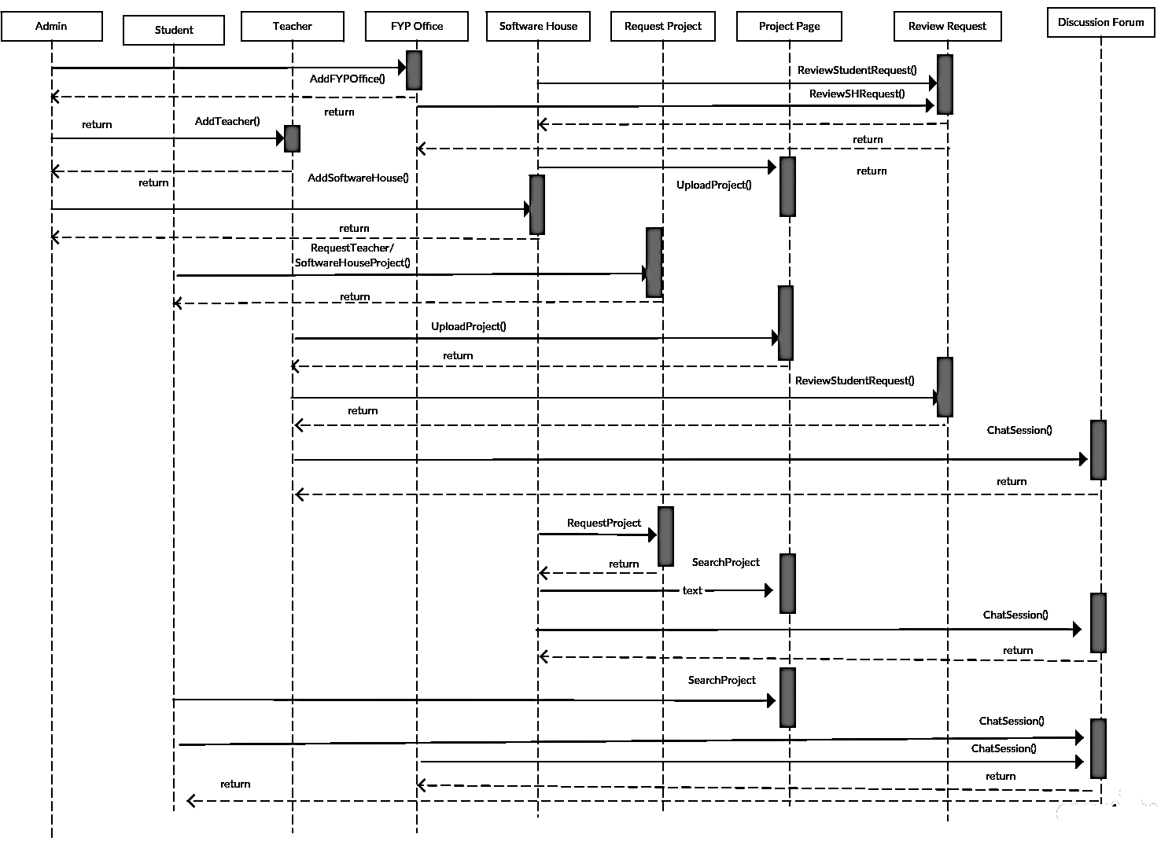
Above diagram describe how the software house will send the request on the project in FYP Augmentation Platform.
Figure-12 Sequence Diagram Complete Sequence Diagram

Above diagram describe the complete system sequence diagram of the FYP Augmentation Platform.

Collaboration Diagram
UML collaboration/communication diagrams like UML sequence diagrams are used to explore the dynamic nature of your software. Collaboration diagrams show the message flow between objects in an OO application, and also imply the basic associations (relationships) between classes. The UML Collaboration diagram is used to model how objects involved in a scenario interact, with each object instantiating a particular class in the system. Objects are connected by links, each link representing an instance of an association between the respective classes involved. There exists collaboration diagram against every sequence diagram.
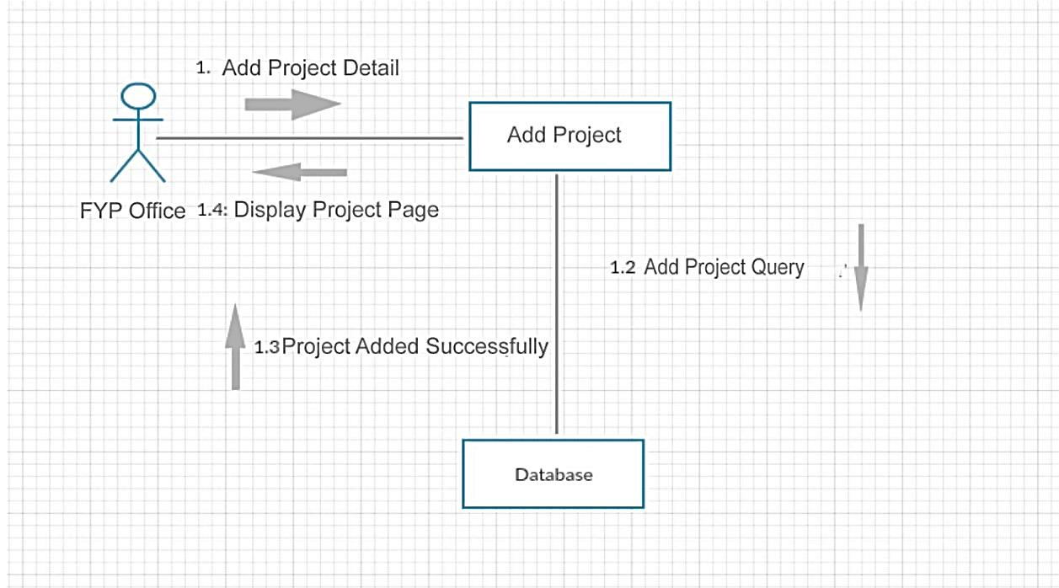
Figure-13 Collaborative Diagram FYP Office

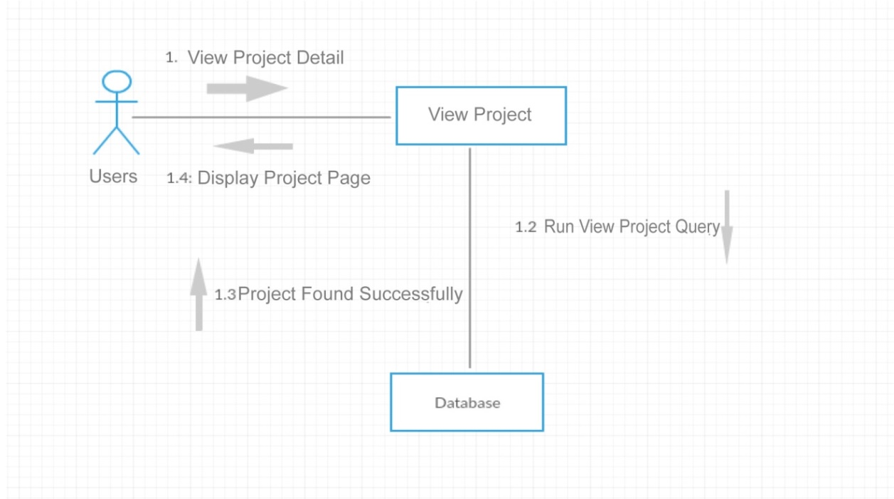
Figure-14 Collaborative Diagram User View Project

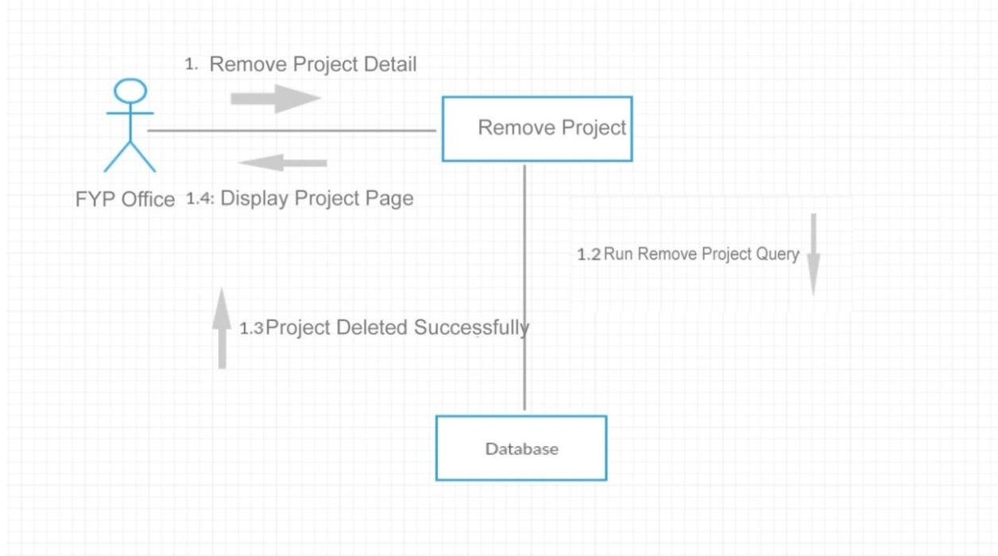
Figure-15 Collaborative Diagram FYP Office Remove Project

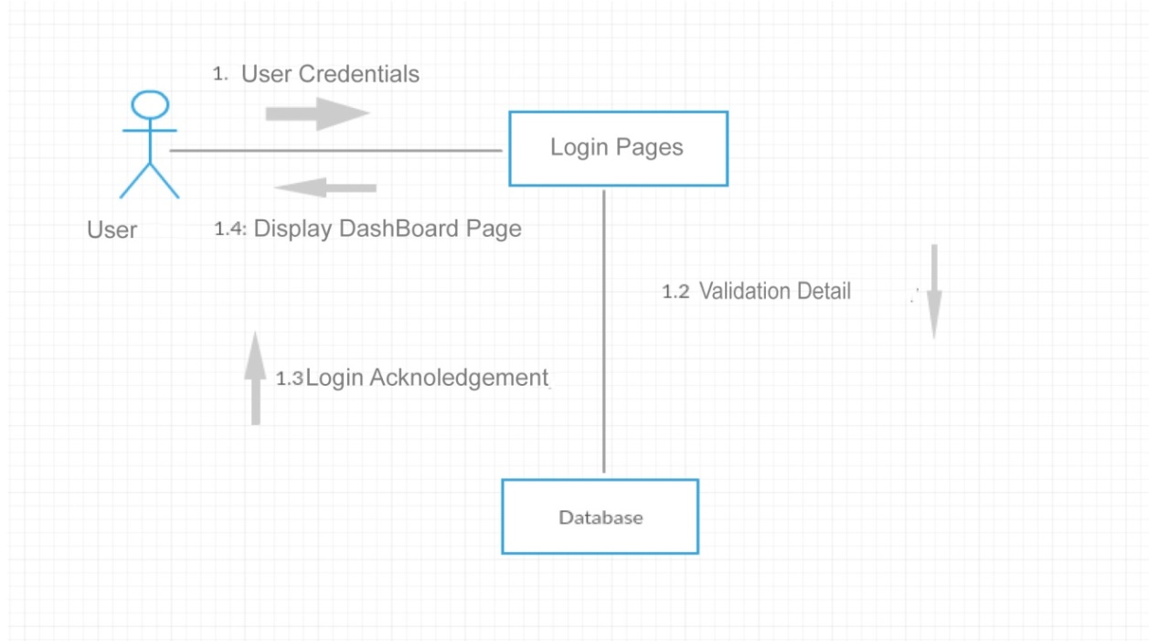
Figure-16 Collaborative Diagram User Login

Domain Model
A domain model is a conceptual model of the domain that incorporates both behaviour and data. Domain Modelling is a way to describe and model real world entities and the relationships between them, which collectively describe the problem domain space. Derived from an understanding of system-level requirements, identifying domain entities and their relationships provides an effective basis for understanding and helps practitioners design systems for maintainability, testability, and incremental development. Following is the Domain Model of FYP Augmentation Platform.
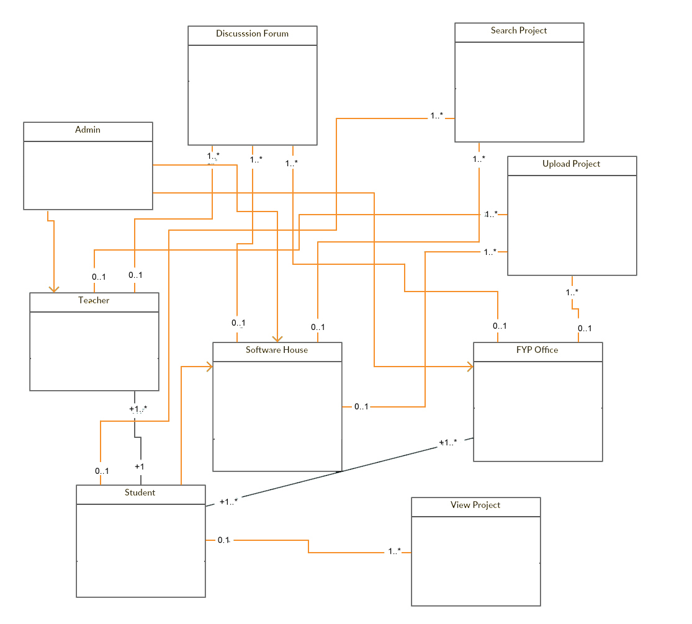
Figure 17: Domain Model of FYAP

Design Class Diagram
Classes are the work-horses of the design effort—they actually perform the real work of the system. The other design elements—subsystems, packages and collaborations simply describe how classes are grouped or how they interoperate.

Capsules are also stereotyped classes, used to represent concurrent threads of execution in real-time systems. In such cases, other design classes are 'passive' classes, used within the execution context provided by the 'active' capsules. When the software architect and designer choose not to use a design approach based on capsules, it is still possible to model concurrent behaviour using 'active' classes.

Active classes are design classes, which coordinate and drive the behaviour of the passive classes - an active class is a class whose instances are active objects, owning their own thread of control. .Following is the class diagram of FYP Augmentation Platform
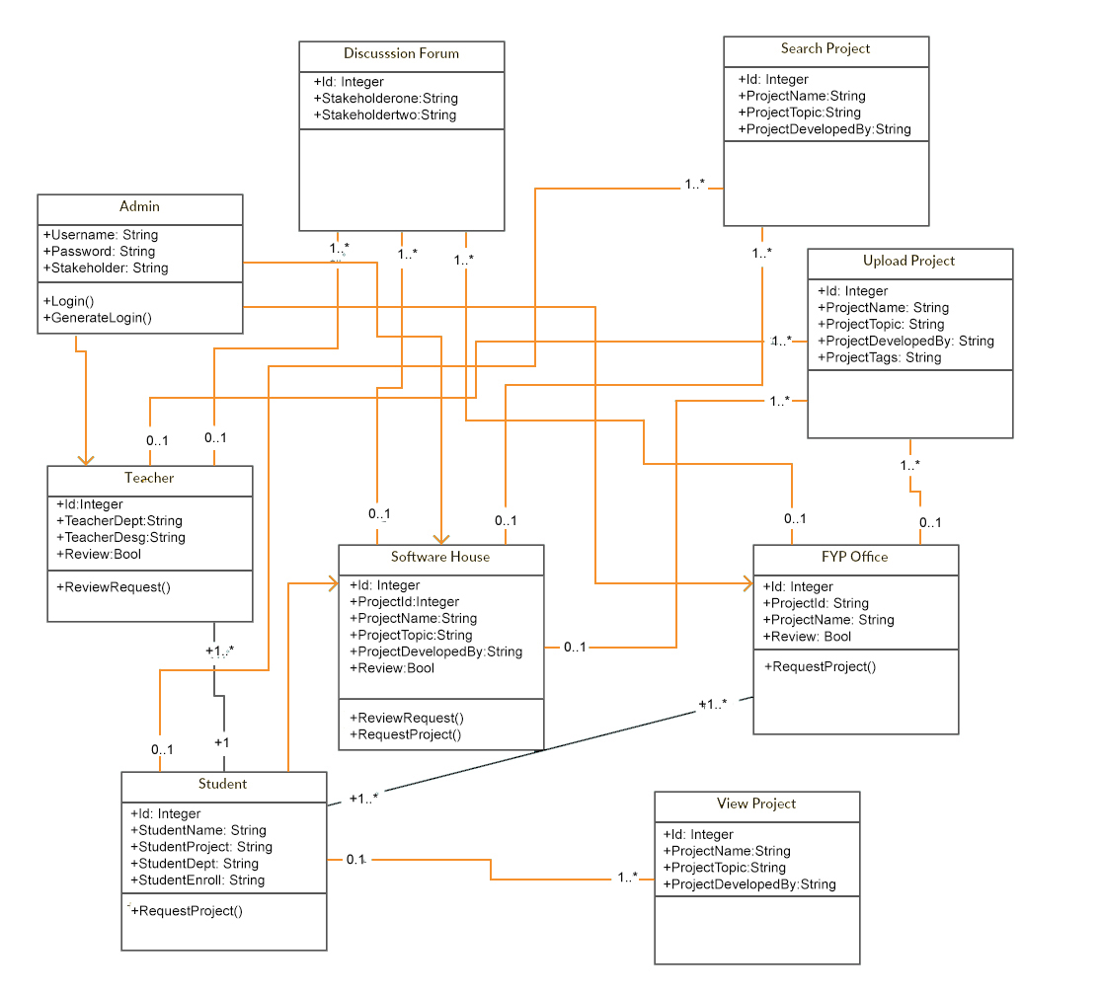
Figure 18: Class Diagram of FYAP

Data Model
The data model is a subset of the implementation model, which describes the logical and physical representation of persistent data in the system.

ERD
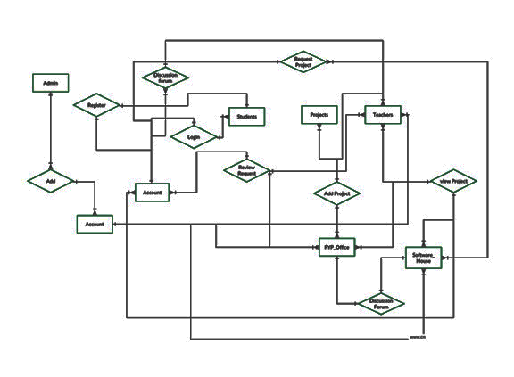
Figure 19: ERD of FYAP

Fully Attributed ERD
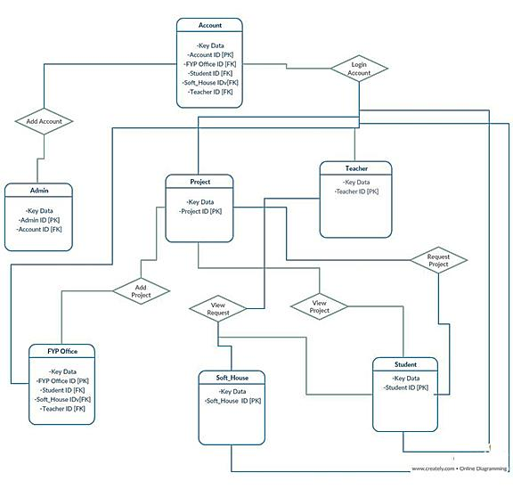
Figure 20: Fully Attributed Data Model of FYAP

IMPLMENTATION

Implementation
The implementation phase of the project is the development of the designs produced during the design phase

Design Algorithm
As this is a web-based application and by following a symfony framework, the best practices are available so there is no really need to design such an algorithm but sometimes to fulfil the application requirements it may require. Here we discuss some main functions’ code that handles application’s some tasks and give best results for users.

This is algorithm query that is given below in diagram. When a student visits the project list and show interest and wants to send proposal to project owner. This code manages this action using this function code. In this algorithm code get logged in use id and get the project id of user and project owner then using id send project request to project owner. Then project owner see request and accept student’s request. [2]
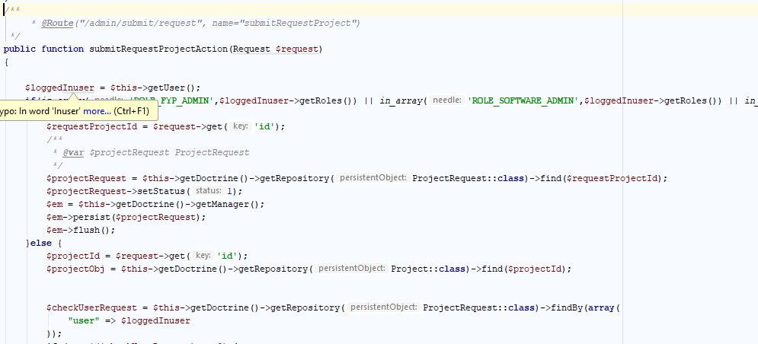.
Figure 21: Project Request Algorithm of FYAP

This algorithm get user id and user’s role then show the result according to user role.

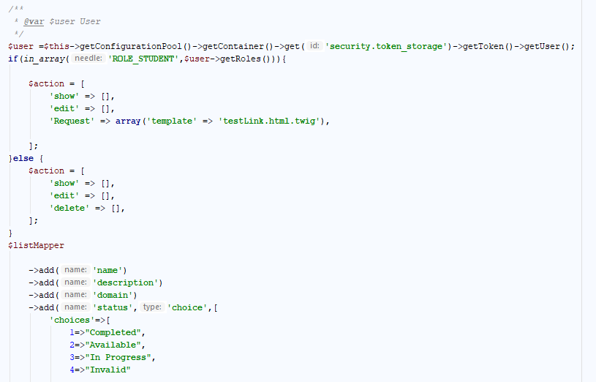
Figure 22: Show Result Algorithm pf FYAP

In this algorithm user can download the document and view the project details

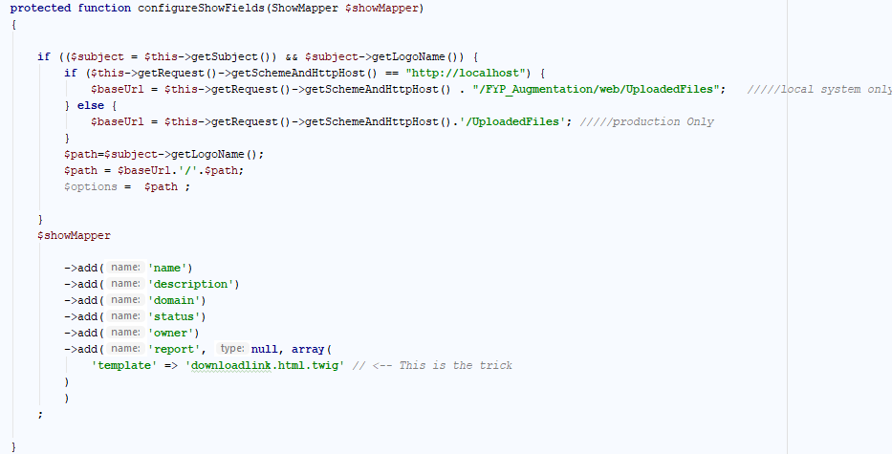

Figure 23: Download Project Algorithm of FYAP

Technical Aspect of the FYPAP
Since the FYP Augmentation Platform is a web application, both web server and database management system are necessary. A high-level system architecture diagram is illustrated below. The system consist of front-end and back-end and is categorised into five layers.

Back-end Technologies
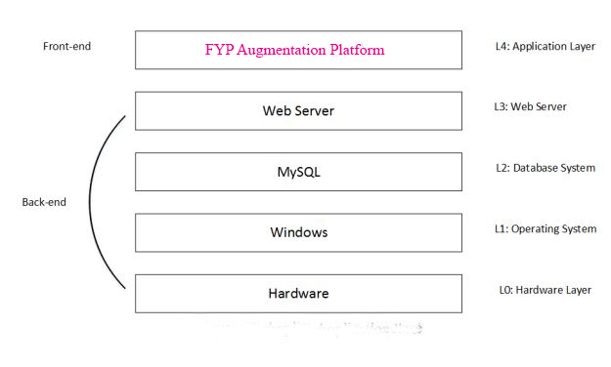
Figure 24: Website Framework
The details of each layer in the architecture above figure discussed below.
L0: Hardware layer contains necessary hardware (Personal Computer) for the FYAP to deploy.
L1: FYPAP will deploy under the Windows operating system, which operated above the hardware layer
L2: MySQL is chosen as the database system. It is relational database system that is
renowned for its reliability and data integrity.
L3: The FYAP uses the symfony web framework as its back-end system.

Front-end Technologies

Table 11: Front End Technologies
Technology | Major functions on a web page
HTML | Outline the structure of a web, it  serves as the building blocks
CSS | Set the visual style to provide a  better user interface
JavaScript/JQuery | Provide interactive elements

USER MANUAL

Getting Started

User Access, Roles and Privileges.

The users of the application are students, teachers and FYP Office faculty of Bahria University. Software houses are also users of web application. Every user has its own roles and specific tasks which are defined by super admin.

Student Roles:
Student can only access to view list of projects and software houses. Student can send request on available projects which are assigned by teachers and software houses.

Teacher Roles :
Teacher can upload projects and view the list of project request which will be sent by students.

FYP Office Roles:
FYP Office can also upload completed project of last graduated students. They can view list of completed projects and list of software houses.

Software House Roles:
Software house can also upload projects and view completed projects of graduate student.

How to access FYP Augmentation:
Open internet browser (i.e. Google Chrome and Mozilla Firefox) and type in the
following URL http://127.0.0.1:8000/ on the browser’s address bar and hit ‘Enter key’
(As shown in below figure)


Figure 25: Access Url for FYAP

Login & Registration at FYPAP
After accessing FYAP, Login screen (as shown below) will display.
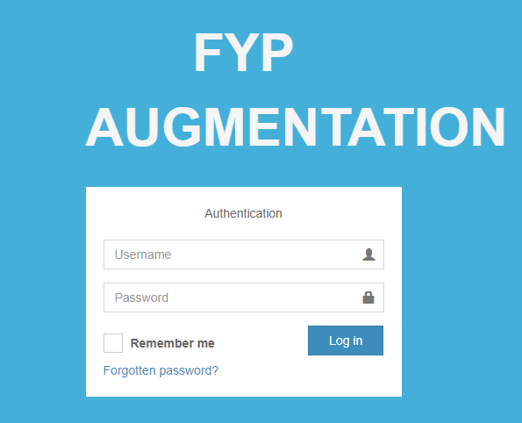
Figure 26: Login Page
- Enter login credentials if you are already registered at FYPAP and click on Login button

- Click on ‘Create an account’ to registered at FYPAP. After click on ‘Create an account’ registration form will show as in below figure

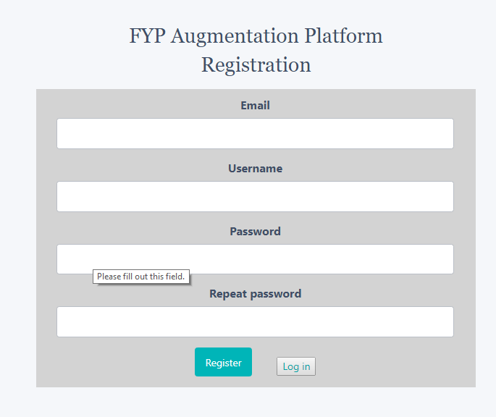
Figure 27: Registration Form
- Fill the registration form by providing university identity number (i.e. Student
Enrolment /Employee ID) and a new password of minimum 8-character length then click on ‘Create User’ button it will redirect you to Login and send an account activation link to your email. By clicking on activation link, your account will activate and you can now login from login screen
2) By click on ‘Log in’ button, you will go back to Login screen

Navigation Bar of FYPAP

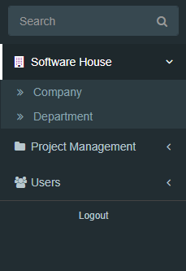
Figure 28:Navigation Bar of website
- Click on software house and software house list will be display and software house account can be created
- Click on project management ,the list of project is displayed and manage of project request
- Click on user to create users.

Dashboard of FYPAP
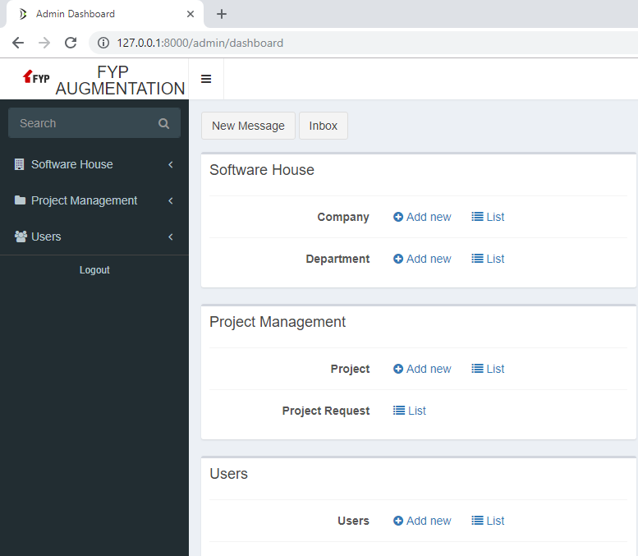
Figure 29: Dashboard Page
- Admin can view the projects and list of software houses and can perform any task and can define the roles to the individual users.

User List Registered By Admin

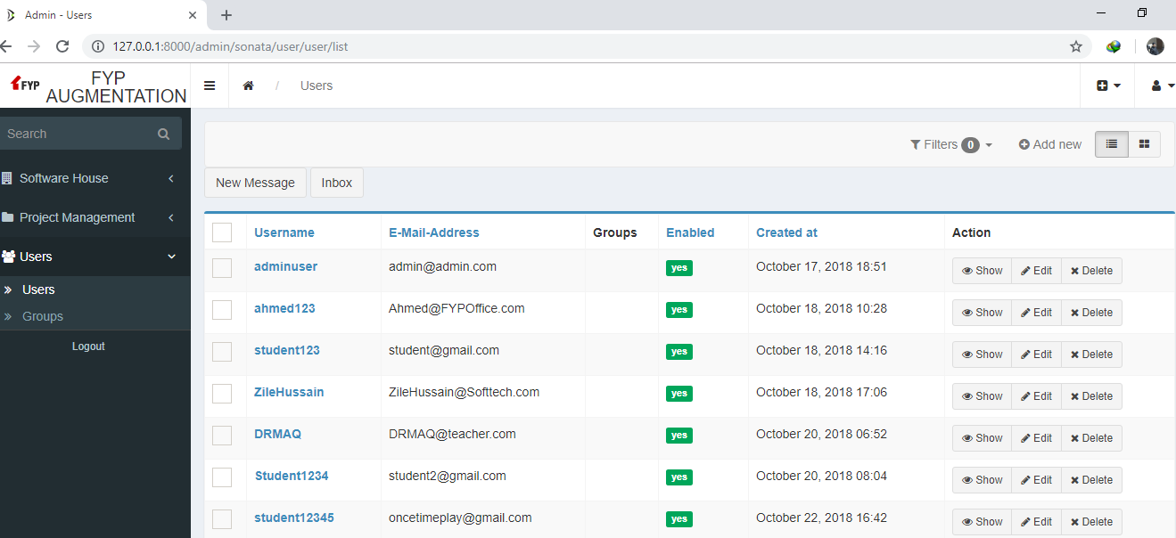
Figure 30: User Lists Page
- Admin can create the user and update the user role by editing user profile and can view all profile information.

List of the software houses

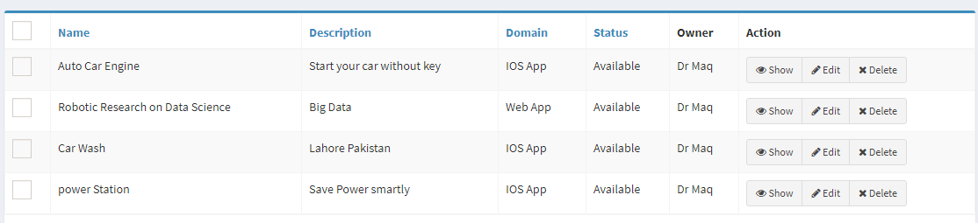
Figure 31: List of Software House Page
- Admin can create the user and update the software house role by editing user profile and can view all profile information.

User View Project

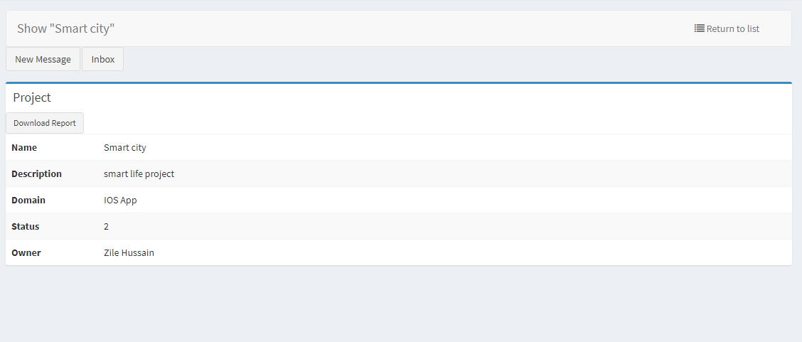
Figure 32: User View Project Page
1) User will view the project details
2) Project will be downloaded by clicking on the download report button

Project List in FYPAP
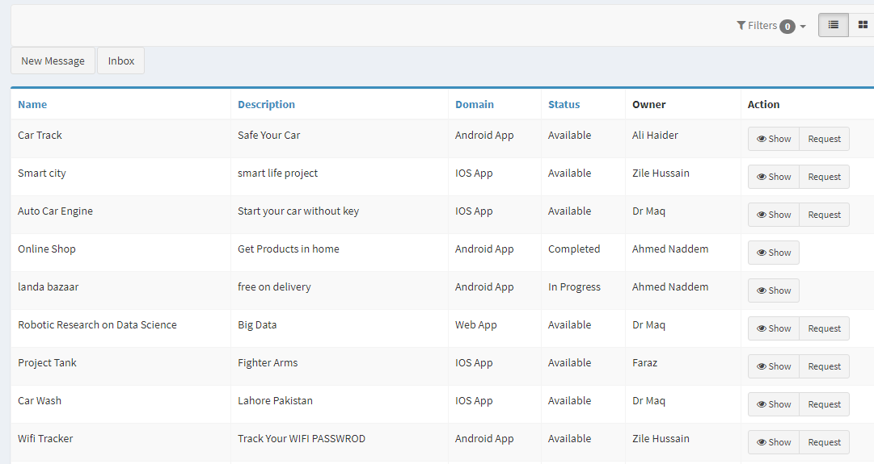
Figure 33: Project List Page
1) User can view the completed and available project.
2) Completed project cannot be requested
3) Available project can be requested and proposal will be submitted to the project owner

Upload Project

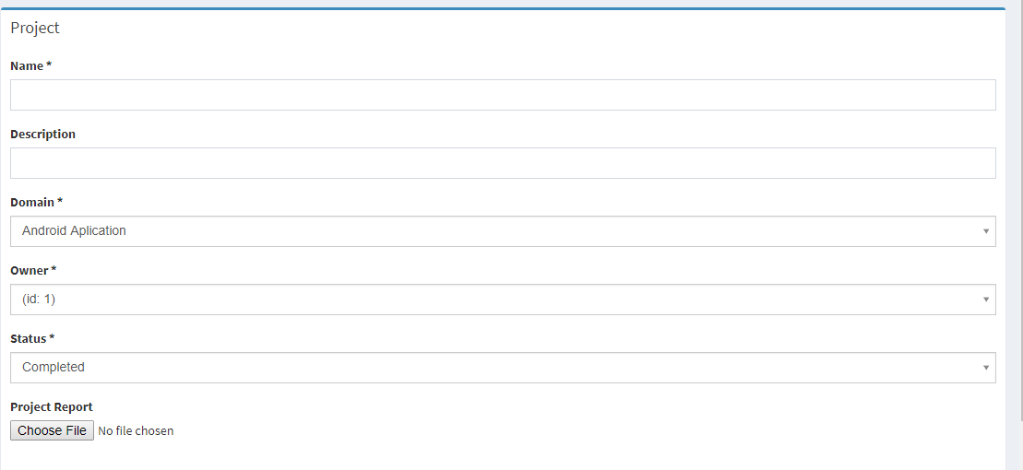
Figure 34: Upload Project Page
1) Project will be uploaded through this form. User will enter all the required information and details about project to upload the project
2) Project status will be available, completed, in progress and invalid.

Project Request Proposal
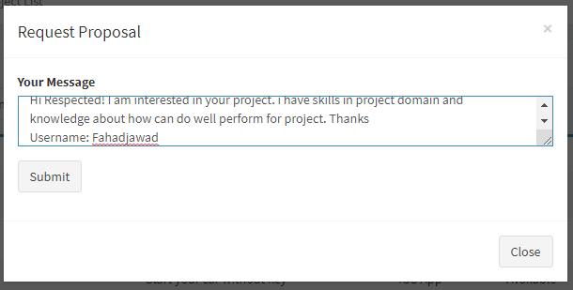
Figure 35: Project Request Page
1) Project proposal about the project will be submitted by the user .
2) User will mention their enrolment and name in project proposal
3) Project Request will submitted by clicking on submit button

Create User Account
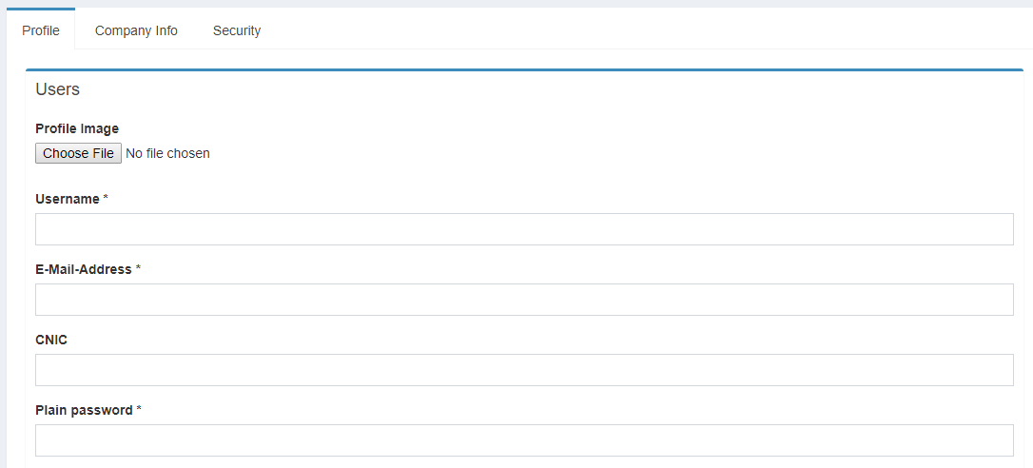
Figure 36: Create User Account Page
- Admin will be required to enter the information about user to create their account

Discussion Forum in FYPAP
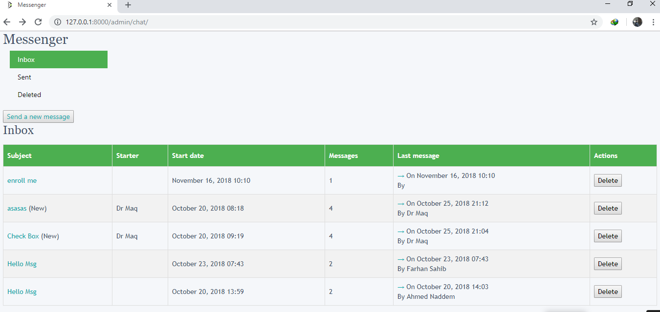
Figure 37: Discussion Forum Page
1) Through discussion forum our users can communicate using usernames
2) Chat session can be between end to end user

CONCLUSION AND RECOMMENDATIONS

The aim of this project was to provide a System for students to start their career in a successful way. This system will provide the experience of the market to the students. Students can work in professional way as describe by the software houses to the students. Student can know the expertise of the software houses which will help them in job hunting. Teacher can communicate with students in a professional way through our platform. Students can gain knowledge from teachers by working on their project. Junior Students can come up with good and enhanced ideas through our project. The development focused primarily on the usability of such an application, under strict usability guidelines, and the functionality needs of the user. It was recognised early in the project that a usable solution must utilise a database to drive the content of the application. Symfony is a complete framework designed to optimize the development of web applications by way of several key features. For starters, it separates a web application's business rules, server logic, and presentation views. It contains numerous tools and classes aimed at shortening the development time of a complex web application.[1]

The system produced successfully met the usability and functional requirements of the user and gained their acceptance. The roll out of this application onto the World Wide Web shows the project was successful. The user testing and evaluation of the application did however highlight room for improvements and expansion. Although all the user requirements were. The application could therefore be developed further to include additional functionality and allow the user greater control.

REFERENCES

Electronic Sources from Internet:
[1]https://symfony.com/legacy/doc/gentle-introduction/1_4/en/01-Introducing-Symfony
[2]https://www.qasymphony.com/blog/agile-methodology-guide-agile-testing/
[3]https://www.cprime.com/resources/what-is-agile-what-is-scrum/
[4]https://www.agile.com/resources/what-is-agile-what-is-scrum/

APPENDICES

Requirement List

R1: GUI should compatible with Chrome and Mozilla both.
R2: Components of the project code will be tested alongside the implementation phase to ensure that they are functional.
R3: Final, integrated project code will test to ensure that complete project is integrated well and functioning properly.
R4: Display all the content after loading of web page.
R5: Server response should be keep in mind while designing data retrieval algorithms.

Student Module Requirement List

R1: Student must be registered to access FYP Augmentation Platform
R2: Student login
R3: Search Project of Teacher and Software House
R4: View Software House Project
R5: View Teacher Project
R6: Request on Project
R7: Student can also search the list of the software House
R8: Student can also view the list of the software House
R9: Chat with the teacher on the given project

Software House Module Requirement List

R1: Software House must be registered to access FYP Augmentation Platform
R2: Software House login
R3: Search the Student projects by tags
R4: View Student Project uploaded by FYP Office
R5: Request on Project
R6: Software House can also upload the project
R7: Accept/Decline Request of Project
R8: Chat with the FYP Office on the requested project

FYP Office Module Requirement List

R1: Login will be provided to FYP Office to access FYP Augmentation Platform
R2: FYP Office login
R3: Upload project of the graduated student to the FYP Augmentation Platform
R4: Accept/Decline Request of Project
R5: Chat with the Software House on the requested project of student

Teacher Module Requirement List

R1: Login will be provided to Teachers to access FYP Augmentation Platform
R2: Teacher login
R3: Upload project or research work to the FYP Augmentation Platform
R4: Accept/Decline Request of Project
R5: Chat with the student on the given project

