

03-134142-012 ANWAR ALI

03-134142-029 HAMZA JAVED

Tour Advisor and Booking System
(TABS)

In partial fulfilment of the requirements for the degree of
Bachelor of Science in Computer Science
Supervisor: Dawood Akram
Department of Computer Sciences
Bahria University, Lahore Campus
June 2018

© Bahria University, 2018

C e r t i f i c a t e

We accept the work contained in the report titled
“TOUR ADVISOR AND BOOKING SYSTEM”,
written by
ANWAR ALI
HAMZA JAVED
as a confirmation to the required standard for the partial fulfilment of the degree of
Bachelor of Science in Computer Science.

Approved by:
Supervisor: Mr. Dawood Akram
(Signature)
June 4th, 2018

DECLARATION

We hereby declare that this project report is based on our original work except for citations and quotations which have been duly acknowledged. We also declare that it has not been previously and concurrently submitted for any other degree or award at Bahria University or other institutions.

Enrolment | Name | Signature
03-134142-012 | ANWAR ALI
03-134142-029 | HAMZA JAVED

Date : _________________________

Specially dedicated to
my beloved grandmother, mother and father
(ANWAR ALI)
my beloved grandmother, mother and father
(HAMZA JAVED)

ACKNOWLEDGEMENTS

We would like to thank everyone who had contributed to the successful completion of this project. We would like to express my gratitude to my research supervisor, Mr Dawood Akram for his invaluable advice, guidance and his enormous patience throughout the development of the research.

In addition, We would also like to express my gratitude to our loving parent and friends who had helped and given me encouragement.

Anwar Ali
Hamza Javed

TOUR ADVISOR AND BOOKING SYSTEM

ABSTRACT

The Purpose of this project is to develop Provide a fully automate system regarding Booking and travel accommodation in which a user can book Tours, Flights, Railways, Bus and Hotel Reservation on a single Web-Portal. To develop this Project, we use the Following Stack PMCH (PHP, MySQL, CSS, and HTML). Core PHP is the base of the project and the Software use to develop this Project is PHP Strom. The system first proceeds with the signup the user provide Credentials after that the system take it to the Home Screen where user Select Tour or the time and date after that he checks for the Bus, flight, Railway so the system shows him the available tickets and timings of the select transport mode there is an additional features of hotel booking as in which the user booking the hotel suits their budget

Now all these manual processes will be handled through using different web languages and frameworks

Recommendations for development in future and conclusions of the project are also included in the report

TABLE OF CONTENTS

DECLARATION iii
ACKNOWLEDGEMENTS vii
ABSTRACT ix
TABLE OF CONTENTS xi
LIST OF TABLES xv
LIST OF FIGURES xvii
LIST OF SYMBOLS / ABBREVIATIONS / DEFINITIONS xix

CHAPTERS
1 INTRODUCTION 1
1.1 Background 1
1.2 Problem Statements 1
1.3 Aims and Objectives 2
1.4 Scope of Project 2
2 SOFTWARE REQUIRMENT AND SPECIFICATION(SRS) 3
2.1 Introduction 3
2.2 User Classes and Booking System 3
2.2.1 User Classes 3
2.2.2 User Characteristics 5
2.2.3 Operating Environment 5
2.2.4 Web Browser 5
2.2.5 Database management system 5
2.2.6 Web Development System 5
2.3 Design and implementation constrains 5
2.4 Assumptions and Dependencies 5
2.5 System Use Cases 6
2.6 Other Non-functional Requirements 6
2.6.1 Performance Requirements. 6
2.6.2 Safety Requirements 7
2.6.3 Security Requirements 7
2.7 Software Quality Attributes 7
2.7.1 Availability 7
2.7.2 Correctness 7
2.7.3 Maintainability 8
2.7.4 Usability 8
2.8 Other Requirements 8
3 DESIGN AND METHODOLOGY 9
3.1 Introduction 9
3.2 Use case Description 10
3.2.1 Use Case Registration 10
3.2.2 Use Case Login 10
3.2.3 Use Case Logout 11
3.2.4 Use Case Railways Reservation 11
3.2.5 Use Case Bus Reservation 12
3.2.6 Use Case Flight Reservation 13
3.2.7 Use Case Hotel Reservation 14
3.3 Use case Diagram (refined and updated) 15
3.4 Sequence Diagram 16
3.4.1 Register 16
3.4.2 Log-In 16
16
3.4.3 Bus Reservation 17
3.4.4 Railway Reservation 18
3.4.5 Hotel Reservation 18
3.4.6 Flight Reservation 19
3.4.7 Log Out 19
3.5 Design Class Diagram 20
4 DATA AND EXPERIMENTS (and/or IMPLMENTATION) 21
4.1 Technologies used 21
4.1.1 HTML,CSS,Java script PHP & My SQL 21
4.1.2 PHP and SQL 21
4.2 Tools used 21
4.2.1 PHP Strom 21
4.2.2 System Requirement 22
4.2.3 Pre-requisite 22
5 RESULTS AND DISCUSSIONS (or USER MANUAL) 23
5.1 Administrator’s Panel (Backend) 23
5.1.1 Login panel 23
5.1.2 Dashboard 23
5.1.3 User 23
5.1.4 List of tour operators 23
5.2 USER ’s Panel (after login) 23
5.2.1 Account settings 23
5.3 User Interface (potential customer) 24
5.4 How to Access 24
5.5 Home Screen 25
5.6 Tour List 25
5.7 Bus Bookings 26
5.8 Hotel Booking 26
5.9 Railway Bookings 27
5.10 Flight Bookings 27
5.11 View Bookings 28
5.12 Print Ticket 28
5.13 Write Us 29
6 CONCLUSION AND RECOMMENDATIONS 30
6.1 Conclusion 30
6.2 Recommendations 30
REFERENCES 31

LIST OF TABLES

TABLE TITLE PAGE

Table 1 Use Case Registration 10
Table 2 Use Case Login 10
Table 3 Use Case Logout 11
Table 4 Use Case Railways Reservation 11
Table 5 Use Case Bus Reservation 12
Table 6 Use Case Flight Reservation 13
Table 7 Use Case Hotel Reservation 14

LIST OF FIGURES

FIGURE TITLE PAGE
Figure 1 System Use Case 6
Figure 2 Use case Refined 15
Figure 3 Sequence Diagram Registration 16
Figure 4Sequence Diagram Log -In 17
Figure 5 Sequence Diagram Bus Reservation 17
Figure 6 Sequence Diagram Railway Reservation 18
Figure 7 Sequence Diagram Hotel Reservation 18
Figure 8Sequence Diagram Flight Reservation 19
Figure 9 Sequence Diagram Log Out 19
Figure 10 Class Diagram 20
Figure 11 Access TABS 24
Figure 112 Home Screen 25
Figure 113 Tour List 25
Figure 114 Bus Bookings 26
Figure 115 Hotel Booking 26
Figure 116 Railway Bookings 27
Figure 117 Flight Bookings 27
Figure 118 View Bookings 28
Figure 119 Print Ticket 28
Figure 20 Write Us 29

LIST OF SYMBOLS / ABBREVIATIONS / DEFINITIONS
User | Someone who interacts with the mobile phone application
TABS | Tour Advisor and Booking System
Application | Software running on laptop to interpret and transmit input
PHP | Hypertext Preprocessor
CRUD | Create , Read , Update , Delete

INTRODUCTION

Background

The online ticketing system is a ticket booking system that has all kinds of bookings on a website. Unless it is like the previous stage, people have to check the time in order to enter the travel agency company to purchase tickets. Introducing an online ticket booking system overcomes this problem. The project will provide customers with the option of booking tickets online and viewing confirmation information online. Customers who use this system can book tickets, bus tickets, train tickets, and they can book or book hotels

Problem Statements

People face many problems while going for a trip in vacations or when they want to go back to their homes. They do not get tickets of their desired date and suitable time as well. A person goes for the tour and faces many problems regarding accommodation and travelling around. Therefore, this system will help such people as the check the availability of tickets and available mode of transport and accommodation.

Aims and Objectives

The main purpose of our online booking system is to provide customers with another convenient way to purchase airline, bus and train tickets. This is an automated system. After the data is entered into the database, employees do not need to perform any operation on the order after receiving the order through the system.

Scope of Project

This project is about booking online Ticketing & Trip system in which user will have the opportunity to book his/her complete trip (Tickets, Travel, Accommodation) using a single forum and get confirmation before leaving to destination.

SOFTWARE REQUIRMENT AND SPECIFICATION(SRS)

Introduction

Tour Advisor and Booking System (TABS) will be a web based project. TABS will be a unique platform which reduces the physical efforts of humans. Now-a-days the most important factors for any person are time and money. While finding the desired Hotel, Bus, Flight, Railway User waste a lot of time. Also, there is no proper Way to track Vacant and Booked Tickets or Room as well that’s why our system is user friendly and meet all user’s Requirements

TABS will be a proper platform for the customers where they can book their desired Tickets online from home.

User Classes and Booking System

User Classes
There will be Two user classes which are following below.
- Admin Class: Admin class will contain the information of the database administrator which will be able to have the access of all privileges of the system.

User Class: User will contain the login information, basic information of the us

User Characteristics
User must have the knowledge about the Online-Booking system so that he/she may
use the website easily.

Operating Environment
“Windows (XP, 7, 8, 8.1, 10), Android Smart Phones”

Web Browser
Google Chrome, Internet Explorer (ver. 8 or later), Mozilla Firefox, Safari (Mac)

Database management system
MySQL, SQL Server, Microsoft Access, Oracle.

Web Development System
Adobe Dreamweaver ,Notepad++, PHP Storm.

Design and implementation constrains
Implementation constraints are following below.
Instead of buying and deploying hardware servers, we will use an online database to store data, because now the trend is toward more secure and encrypted cloud databases than traditional databases.
System will be only implementable in Pakistan initially.

Assumptions and Dependencies
Assumption and dependencies are as fallows.
- System will rely on the internet because it is the online-based system.

- Payments can only be make online when the SSL certificate of the company will be up to date

- The performance of the website will be based on the internet of the user. Fast internet will help to retrieve the fast and reliable data to the user.

System Use Cases

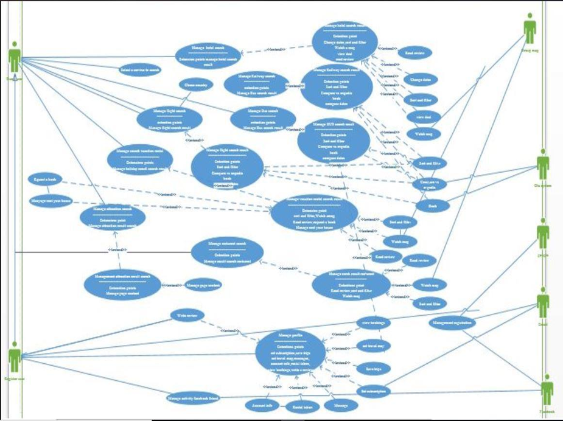
Figure 1 System Use Case

Other Non-functional Requirements

Performance Requirements.
As discussed already, the Internet is compulsory to run the system, for the reason that the website usually depends on the Internet. Therefore, a faster Internet will bring better performance to the system. One more thing is to enhance performance by buying a good host that must be confined by all network layers so that DDOS attacks do not affect the system. The steps involved in performing a subscription database implementation are listed below. The E-R diagram represents a method that graphically represents the logical structure of the database. Then use this analysis to organize the data into relationships, normalize the relationships, and finally get the relational database.

Safety Requirements
If a large portion of a database is widely compromised due to a catastrophic breakdown the recovery method will return a previous replica of the database backups to the archive storage (usually tape) and rebuild the update status by reapplying or redoing The operation of the committed transaction in the log has been backed up until it fails.

For the reason that if the layers are not protected, attacks such as DDOS and MAP will affect the system's downtime for a long time, so IP (Internet Protocol) protection at each network layer will be the primary security requirement.

Security Requirements
Database storage is used as common function for data storage as many others systems does, the care with the database is taken so that it can’t be affected by some virus or accessed by some unethical means. All the transactions occur in the database will based on 2 protocols certificates SSL or TLS, these certificates can be purchased from any 3rd party. To encrypt the data these protocols has been implemented on the network layer so that the most sensitive data can’t be hacked.

Software Quality Attributes

Availability
Transport / Rom must be provided on a stated date and at a specific time, as many customer book in advance.

Correctness
The data saved in the system and database must be correct so that it helps the system to work normally without any interruption.

Maintainability
The administrators should maintain the Record of system.

Usability
The Booking system should please all-out total of customer’s needs.

Other Requirements

  - Reliable

  - Efficient

  - Reduce physical effort

  - Accuracy in terms of security

DESIGN AND METHODOLOGY

Introduction

The deliverables mention in it is use for software modelling and designing, we are using different tools for it. In the last section we have completed the system analysis and resolve the different issues related to the domain. Now the solution has been proposed we are ready to take the object oriented approach by following the different artefacts and UML models.

- Use case description

- Use case diagram refined

- Sequence Diagram

- Design Class Diagram

Use case Description

Use Case Registration
Table 1 Use Case Registration
Name |  |  | Registration.
Use Case ID |  |  | TABS-1
Priority |  |  | High.
Primary actor |  |  | User.
Description |  |  | This use case describe the action when
 |  |  | user want to register him/her on this.
Pre-condition |  |  | User come to the Portal for
 |  |  | Registration.
Trigger |  | “ 1. |  | Internet connectivity is available
 |  |  | 2. User click the registration button
 |  | 3. |  | Give registration credentials.”
System Response |  |  | The System checks the validations for
 |  |  | the registration.
Post Condition |  |  | The user is Register successfully and view
 |  |  | the login page.

Use Case Login

Name |  |  | Login
Use Case ID |  |  | TABS-2
Priority |  |  | High.
Primary actor |  |  | User, Admin.
Description |  |  | when
 |  |  | user want to login.
Pre-condition |  |  | First done with the registration of user
 |  |  | and user visits the application for login.
Trigger |  |  | 1. | User click the login button.
 |  |  | 2. | Give login credentials
System Response |  |  | 1. The System checks the
 |  |  |  | validations
 |  |  | 2. The System verifies the
 |  |  |  | credentials
 |  |  | 3. System show the profile after
 |  |  |  | successful login.
Post Condition |  |  | Successfully User login and show the
 |  |  | profile page to the user
Table 2 Use Case Login

Use Case Logout

Table 3 Use Case Logout
Name | User logout
Use-Case ID | TABS-3
Priority | High
Primary Actor | User
Other participating Actor | Systm
Description | when a user going to logout.
Pre-condition | 1. | User must be registered at TABS
 | 2. | User should be logged in
Trigger | This use case initiate when a user going to logout.
Typical Flow of events | 1. | User clicks on its profile from navigation bar
 | 2. | Click on logout from drop down menu.
Alternate flow of events | N/A
Post condition | User successfully logged out.
Alternate post condition | Still Login

Use Case Railways Reservation
Table 4 Use Case Railways Reservation
Name | Railway Reservation
Use-Case ID | TABS-4
Priority | High
Primary Actor | User
 | when a user Search for Railway
Description | Reservation
Pre-condition | 1. | User must be logged in
Trigger | when a user Search for Railway Reservation
Typical flow of events | 1. | Go to Search
 | 2. | Go to Select Desired time & Date For booking
 | 3. | Select Destination & Train
 | 4. | Select Seats
 | 5. | View Fare
 | 6. | Print Ticket
Alternate flow of events | Back to Search Bar
Post condition | Ticket were successfully Reserved
Alternate post condition | Try again

Use Case Bus Reservation
Table 5 Use Case Bus Reservation
Name | Bus Reservation
Use-Case ID | TABS-5
Priority | High
Primary Actor | User
Description | when a user Search for Bus Reservation
Pre-condition | 1. | User must be logged in
Trigger | when a user Search for Bus Reservation
Typical flow of events | 1. | Go to Search
 | 2. | Go to Select Desired time& Date For booking
 | 3. | Select Destination & Bus
 | 4. | Select Seats
 | 5. | View Fare
 | 6. | Print Ticket
Alternate flow of events | Back to Search Bar
Post condition | Ticket were successfully Reserved
Alternate post condition | Try again

Use Case Flight Reservation
Table 6 Use Case Flight Reservation
Name | Flight Reservation
Use-Case ID | TABS-6
Priority | High
Primary Actor | User
Other participating Actor | ----
Description | This use case describe the event when a user Search for Flight Reservation
Pre-condition | 1. | User must be logged in
Trigger | when a user Search for Flight Reservation
Typical flow of events | 1. | Go to Search
 | 2. | Go to Select Desired time and Date For booking
 | 3. | Select Destination & Airline
 | 4. | Select Seats
 | 5. | View Fare
 | 6. | Print Ticket
Alternate flow of events | Back to Search Bar
Post condition | Ticket were successfully Reserved

Use Case Hotel Reservation
Table 7 Use Case Hotel Reservation
Name | Hotel Reservation
Use-Case ID | TABS-7
Priority | High
Primary Actor | User
Other participating Actor | ----
Description | This use case describe the event when a user Search for Hotel Reservation
Pre-condition | 1. | User must be logged in
Trigger | when a user Search for Hotel Reservation
Typical flow of events | 1. | Go to Search
 | 2. | Select Desired Date For Booking
 | 3. | Select No of People & No of Rooms
 | 4. | Select Room
 | 5. | View Fare
 | 6. | Print Receipt
Alternate flow of events | Back to Home Page
Post condition | Hotel is successfully Reserved
Alternate post condition | Try again

Use case Diagram (refined and updated)

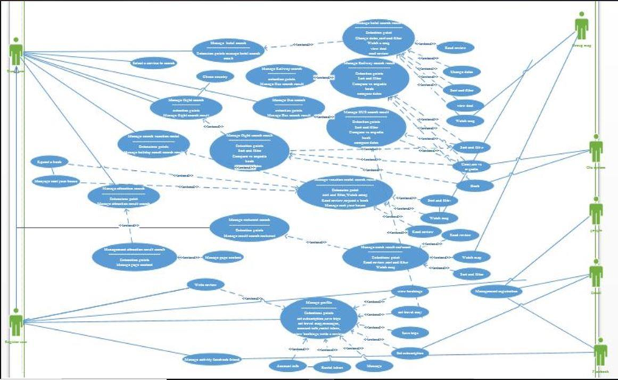
Figure 2 Use case Refined

Sequence Diagram

Register
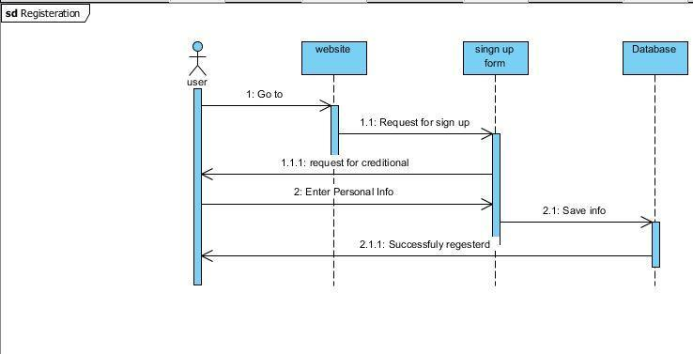
Figure 3 Sequence Diagram Registration

Log-In
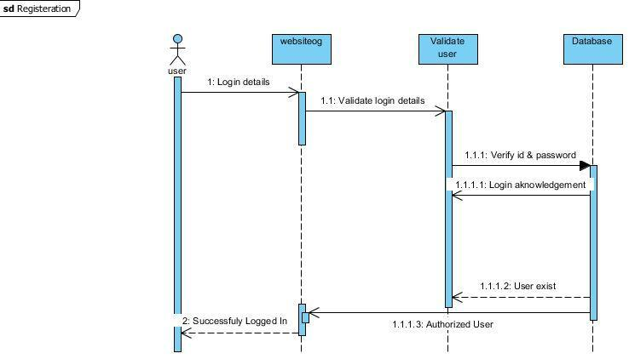

Figure 4Sequence Diagram Log -In

Bus Reservation
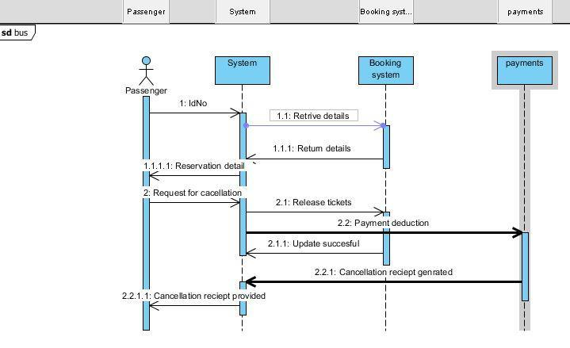
Figure 5 Sequence Diagram Bus Reservation

Railway Reservation
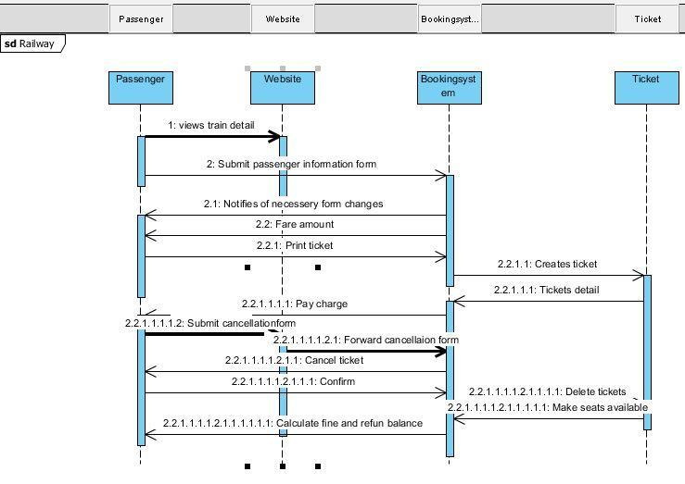
Figure 6 Sequence Diagram Railway Reservation

Hotel Reservation
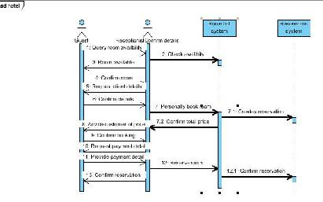
Figure 7 Sequence Diagram Hotel Reservation

Flight Reservation
Figure 8Sequence Diagram Flight Reservation
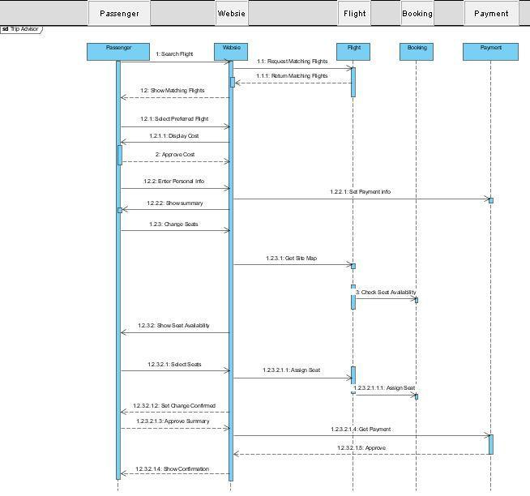

Log Out
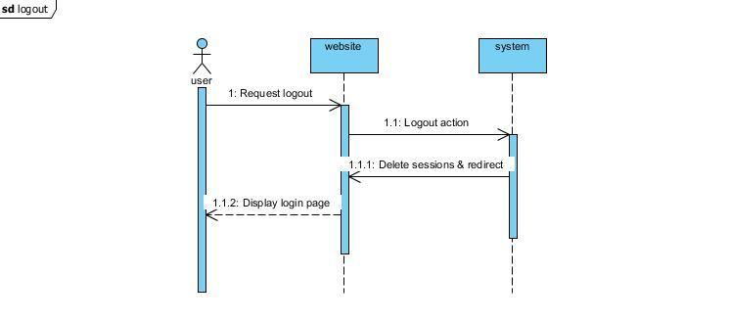
Figure 9 Sequence Diagram Log Out

Design Class Diagram
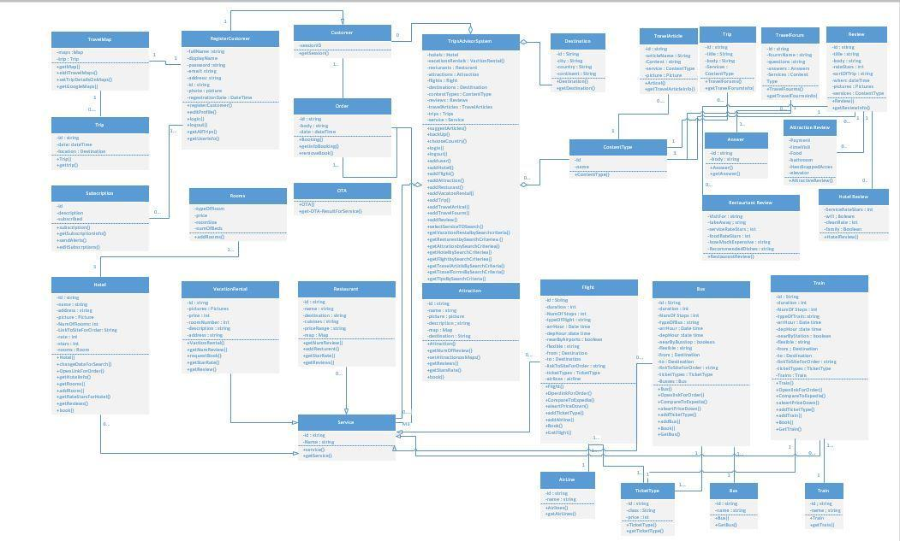
The Class Diagram is produced after a process of OOAD (Object Oriented Analysis & Design), beginning with the need and the core requirements; you should identify the use cases of that domain and your website idea. Then according to the need you can detail it with activity diagrams and see the object interactions in sequence diagrams. While you are doing this, your tool (RSA for instance) will automatically add the "messages" to your classes as behaviour. Therefore, after couple of iteration, your class diagram will be more mature and you would validate it against the requirements and use-cases of your website.

Figure 10 Class Diagram

DATA AND EXPERIMENTS (and/or IMPLMENTATION)

Technologies used

HTML,CSS,Java script PHP & My SQL
As we know that for web languages HTML is the basic language to construct any web page and to make it more beautiful and attractive we use CSS basically these are the two most common web basic languages and java scripting is use to add some sliders mouse hovers and more animated functionalists as well. These are the front end languages

PHP and SQL
SQL stands for Structures Query Language. This language allows you to manipulate and access your databases. It is approved by ANSI. By using this language, you can create, remove tables in database and you can add, delete and update records in that tables. This language is most popular to handle the databases. That is why it is being used in this project.

PHP and SQL are used for back end programming. These are the specified languages used for databases

Tools used

PHP Strom
It is one of the most powerful editor by jet brains, it follows in depth directory structure, and it consists if almost all type of libraries and functions which we will sue in the implementation of this program. It gives the comments and spacing in a proper manner so that the debug will be easy.

System Requirement
The most feasible system requirement is given in the below table:
Device | Operating System (OS) | OS Version | RAM
PC, Laptop , Mobile | Windows | Vista,7,8,8.1,10 | 1GB or above

Pre-requisite
- User must be registered with a valid user name to use TABS.

- User must have a valid password to use TABS

RESULTS AND DISCUSSIONS (or USER MANUAL)

Administrator’s Panel (Backend)

Login panel
  - Login to account
  - Reset password

Dashboard
    - Number of tour operators (total, pending, rejected, approved)
    - Number of tours (total, pending, rejected, approved)
    - Create tour operator.

User
    - Name
    - Phone
    - Email (that will serve as login)
    - Password

List of tour operators
    - Create
    - Update
    - Edit
    - Delete
    - Ability to change status: pending, rejected, approved.

USER ’s Panel (after login)

Account settings
A. Actions:
    - Edit
    - Update/Save
    - Change password
- List of My Tours
B Actions:
    - Create
    - Update
    - Edit
    - Delete
    - Send for review and approval

User Interface (potential customer)
- List of All Approved Tours
  - List of tours
    - Owner (Tour operator)
    - Location (Tour titles)
- Description
- Available Periods
- Amenities
- Price
- Buy
  - Checkout form (will be send via email to administrator)
    - First and Last name
    - Email
    - Phone
    - Tour id

How to Access
Figure 11 Access TABS

  - It we enter above URL then our home screen is load.

Home Screen
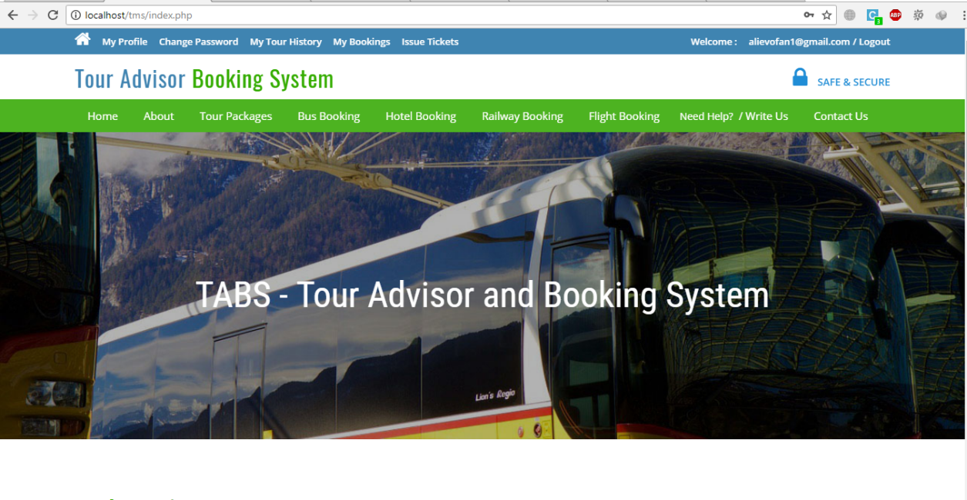
Figure 112 Home Screen

Tour List
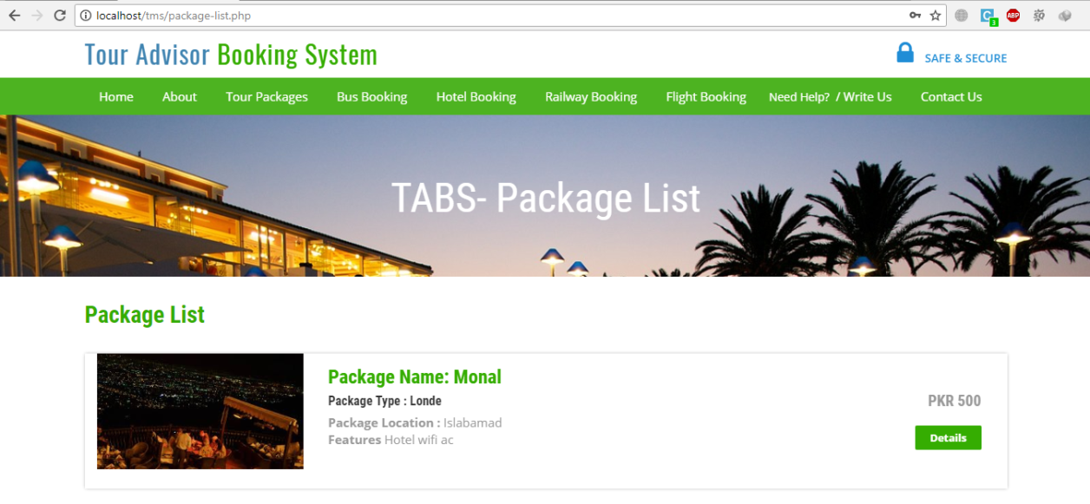
Figure 113 Tour List

Bus Bookings
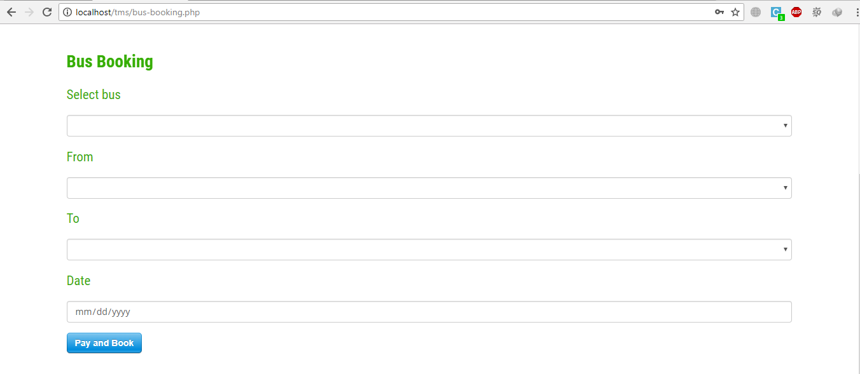
Figure 114 Bus Bookings

Hotel Booking

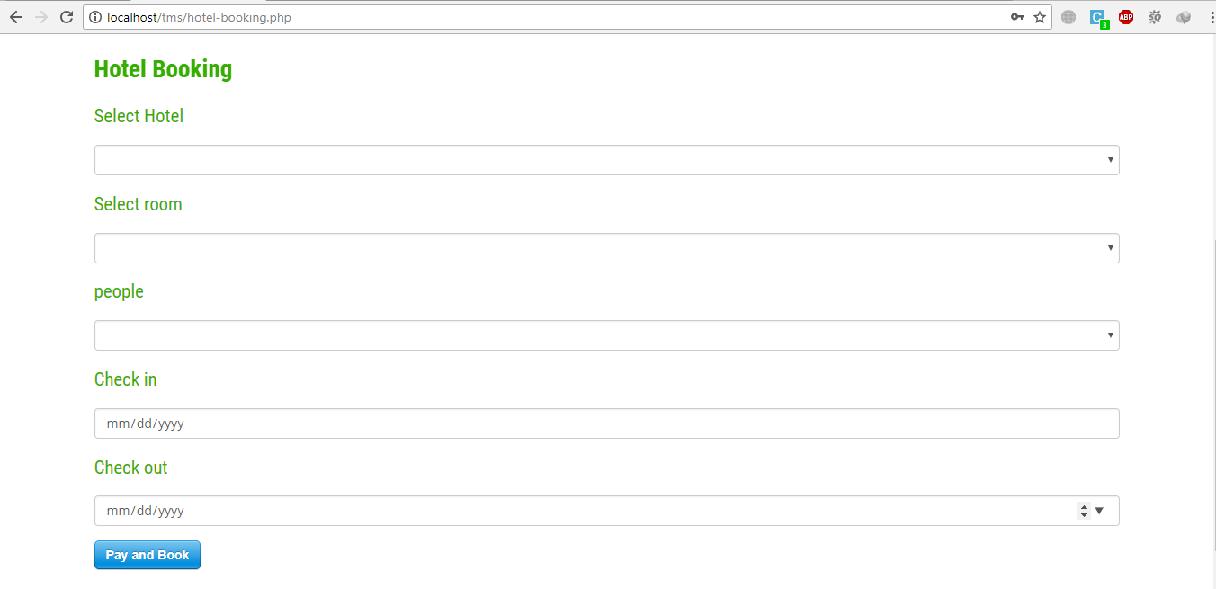
Figure 115 Hotel Booking

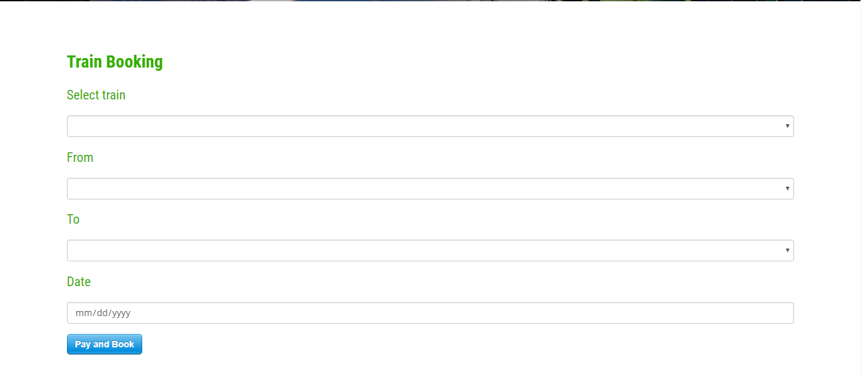
Railway Bookings
Figure 116 Railway Bookings

Flight Bookings
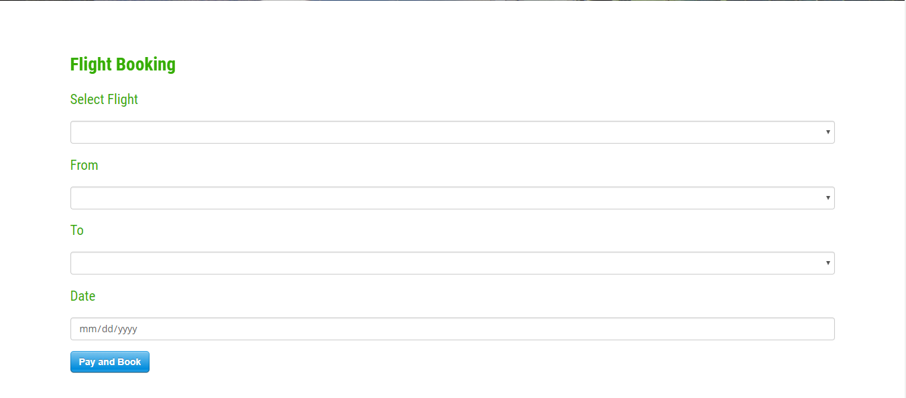
Figure 117 Flight Bookings

View Bookings
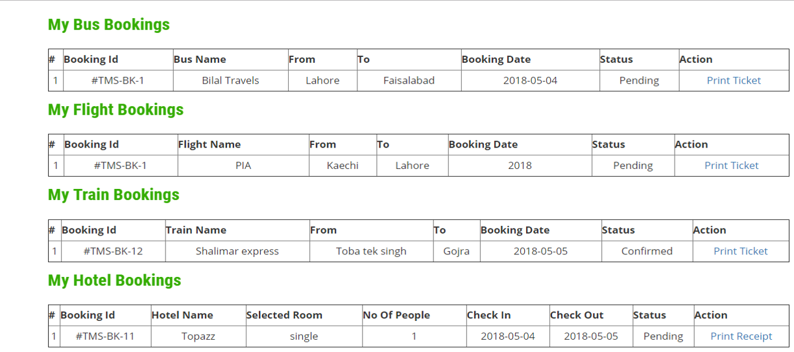
Figure 118 View Bookings

Print Ticket
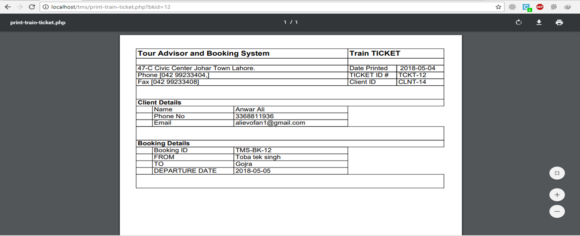
Figure 119 Print Ticket

Write Us
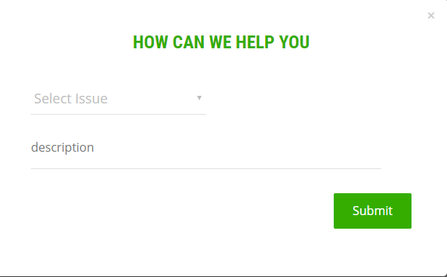
Figure 20 Write Us

CONCLUSION AND RECOMMENDATIONS

Conclusion
The system implementation is focus on different factors such as efficiency, latency, page load and reliability of the system. It means that user get the same data if login once or after 1000 times there will be no difference. The main objective is to provide the efficient system to all the users.

Recommendations
As TABS is a general-purpose Web base app, so in future it can be expanded for different sort of things. In addition, this project is only a Web based initially. Therefore, in future can be developed into multi-platform support like Android and IOS app. Also, many processes still can be added into this web app to make it more useful attractive and efficient

REFERENCES

.

Journal Papers:
Booking system challenges NHS. (2003). BMJ, 327(7424), pp.0-e-0.
Choudhari, M. (2017). Research on “TABS”. International Journal for Research in Applied Science and Engineering Technology, V(III), pp.345-349.
García-Mendoza, B. and Jaimez-Gonzalez, C. (2017). A Customisable and Responsive Design Online Booking System. International Journal of Computer Science and Information Technology, 9(5), pp.67-86.

