

03-134142-043 | MUHAMMAD MOHSIN
03-134142-044 | MUHAMMAD SARMAD SULTAN
03-134142-086 | SYED SULEMAN TAHIR

Kill Asylum

In partial fulfilment of the requirements for the degree of
Bachelor of Science in Computer Science
Supervisor: Asghar Ali Shah
Department of Computer Sciences
Bahria University, Lahore Campus
June 2018

© Bahria University, 2018

C e r t i f i c a t e

We accept the work contained in the report titled
“KILL ASYLUM”,
written by
MUHAMMAD MOHSIN
MUHAMMAD SARMAD SULTAN
SYED SULEMAN TAHIR
as a confirmation to the required standard for the partial fulfilment of the degree of
Bachelor of Science in Computer Science.

Approved by:
Supervisor: Asghar Ali Shah
(Signature)
June 4th, 2018

DECLARATION

We hereby declare that this project report is based on our original work except for citations and quotations which have been duly acknowledged. We also declare that it has not been previously and concurrently submitted for any other degree or award at Bahria University or other institutions.

Enrolment | Name | Signature
03-134142-043 | MUHAMMAD MOHSIN
03-134142-044 | MUHAMMAD SARMAD SULTAN
03-134142-086 | SYED SULEMAN TAHIR

Date : 02- 06- 2018

Specially dedicated to
my beloved mother and father
(Muhammad Mohsin)
my beloved mother and father
(Muhammad Sarmad Sultan)
my beloved mother and father
(Syed Suleman Tahir)

ACKNOWLEDGEMENTS

We would like to thank everyone who had contributed to the successful completion of this project. We would like to express my gratitude to my research supervisor, Mr Asghar Ali Shah for his invaluable advice, guidance and his enormous patience throughout the development of the research.

In addition, we would also like to express my gratitude to our loving parent and friends who had helped and given me encouragement.

Muhammad Mohsin
Muhammad Sarmad Sultan
Syed Suleman Tahir

KILL ASYLUM

ABSTRACT

As First Person Shooter games are really famous in the gaming world these days. They provide realistic experience and are more user friendly than third person shooter games Example includes Far Cry, Tom Clancy’s Rainbow Six Siege. Our Project Kill Asylum is a FPS game which will provide close to the reality environment for a close quarter combat.
Purpose of this game is to engage player in a tactical environment where player’s objective is to survive first and eliminate the enemies later because of the constraints implemented in the gameplay which does not allow re-spawning in the same level.
Kill Asylum is a game in which player’s objective is to eliminate the enemies in TDM for winning the match. There will be a best-of-3 round match. To provide challenge in the game, player will not be able to respawn in or load the same level. No save games will be allowed. Game’s AI bots known as enemies will force player to use different approach each time they encounter as enemies will act dynamically against player’s movement and actions.

TABLE OF CONTENTS

DECLARATION ii
APPROVAL FOR SUBMISSION iii
ACKNOWLEDGEMENTS v
ABSTRACT vi
TABLE OF CONTENTS viii
LIST OF TABLES ix
LIST OF FIGURES x
ABBREVIATIONS xii

CHAPTERS
1 INTRODUCTION 1
1.1 Purpose of the Project 1
1.2 Objectives and Success Criteria of the Project 2
1.3 Scope of Project 3
2 SRS 4
2.1 Project Charter 4
2.2 Functional Requirements 4
2.3 Nonfunctional Requirements 5
3 DESIGN AND METHODOLOGY 7
3.1 System Deisgn Models 7
3.1.1 Use Case Model 7
3.1.2 Sequence Diagram 18
3.1.3 Collaboration Diagram 25
3.1.4 Data Flow Diagram 31
3.1.5 Design Class Diagram 34
3.2 System Design Methodology 43
3.2.1 Sequence Diagrams Methodology 43
3.2.2 Collaboration Diagrams Methodology 45
3.2.3 Data Flow Diagrams Methodology 46
3.2.4 Design Class Diagrams Methodology 48
4 IMPLEMENTATION 50
4.1 Overview 50
4.2 Prototypes 51

REFERENCES 17

LIST OF TABLES

TABLE TITLE PAGE
Table 2.1: Project Charter 3
Table 3.1: Sequence Diagram Methodology 44
Table 3.2: Collaboration Diagram Methodology 45
Table 3.3: Data Flow Diagram Methodology 47
Table ‎3.4: Design Class Diagram Methodology 48

LIST OF FIGURES

FIGURE TITLE PAGE
Figure 3.1.1: Use Case Model 7
Figure 3.1.2: Sequence Diagram 18
Figure 3.1.3: Collaboration Diagram 25
Figure 3.1.4: Data Flow Diagram 31
Figure 4.1: Objective Room Prototype 51
Figure 4.2: Soldier Prototype 52
Figure 4.3: Sample for Wall Texture 53
Figure 4.4: Sample for Windows Texture 53

ABBREVIATIONS & TECHNICAL TERMS

Model A base object or primitive which can be molded into different objects.

Foxals A faction/group in game on defender side. Controlled by Enemy AI.

HedgeHogs A faction/group in game on attacker side. Controlled by Player.

TDM Abbreviation for Team Death Match game mode where objective is to eliminate the enemies.

Game A game is an instance of Kill Asylum.

HUD Abbreviation for Head Up Display that displays several important information on game’s screen during gameplay.

FPS Abbreviation for First Person Shooter type game where camera view displays weapon of the main character.

Minimap A small instance of full map that displays nearby information in the level.

Level A level is considered standalone playable area with objective for main player.

Map Provides Overview of playable area.

Ammo Short for Ammunition, an HUD element that provides information about bullet count.

Player Any user that interacts with the system.

System Any interactions performed by the application are considered to be performed by the system.

Score The number of points earned player by completing objectives in game.

ScoreBoard A leaderboard for displaying current score.

Enemies Application controlled bots that will react against player’s actions and movement.

AI Abbreviation for Artificial Intelligence, referred to Application controlled bots and dynamic environment in the playable area.

Round A period of time where a player is allowed to interact with the game’s current level.

Timer The system process keeping track of the amount of time a player has left in the current round.

Log A record of all of the game’s major interactions.

GUI Graphical User Interface

Loadout Collection of weapons and gadget available.

Kill Log a HUD element that displays current kill status whenever one character kills the other character.

Melee Attacking with knife with hovering movement.

Objective Capture Time period starts when Player’s Character enters the objective area alone.
Initiation Phase

Securing Time period of 10 seconds which Player’s Character spends in the objective area alone.

Contested It stops the round timer and occurs when Enemy’s Character enters the objective area during Objective Capture Initiation Phase.

Capture State of Securing the Objective.

Pause Menu Trigerred by pressing Esc key during game.

INTRODUCTION

Purpose of the Project

If you plan to become involved in the game development industry, it is important
that you learn about its evolution. [1]
As First Person Shooter games are really famous in the gaming world these days. They provide realistic experience and are more user friendly than third person shooter games Example includes Far Cry, Tom Clancy’s Rainbow Six Siege. Our Project Kill Asylum is a FPS game which will provide close to the reality environment for a close quarter combat.
Purpose of this game is to engage player in a tactical environment where player’s objective is to survive first and eliminate the enemies later because of the constraints implemented in the gameplay which does not allow re-spawning in the same level.
An ally is a character who helps the hero progress on the journey and may also assist
the hero with tasks that might be difficult or impossible to accomplish alone. [2]

Objectives and Success Criteria of the Project

The success of the application depends upon meeting the following core set of objectives:

- The design of player’s movement model should response appropriately against keyboard and mouse input.
- Level design should follow a sequential order.
- The design of a GUI to enable the proper playing of a game.
- The use of automatic test cases to validate that 80% of the written code executes according to specification.
- Game should dynamically react with player’s movement.

Scope of Project

Kill Asylum is a game in which player’s objective is to eliminate the enemies in TDM for winning the match. There will be a best-of-3 round match. To provide challenge in the game, player will not be able to respawn in or load the same level. No save games will be allowed. Game’s AI bots known as enemies will force player to use different approach each time they encounter as enemies will act dynamically against player’s movement and actions.
Like most shooter games, first-person shooters involve an avatar, one or more ranged weapons, and a varying number of enemies. [3]

SRS (Software Requirement Specification)

Project Charter

Project Title: Kill Asylum
Project Start Date: October 9, 2017 Projected Finish Date: June 5, 2018
Key Schedule Milestones:
Map Design July 10, 2017
Character Modeling August 21, 2017
Game User Interface August 15, 2017
Artificial Intelligence April 31, 2018
Texture and Lightning April 18, 2018
Testing May 6, 2018
Budget Information: Budgeted Rs. 4,00,000 for hardware and software costs
Project Manager: Muhammad Mohsin, muhammadmohsin284@gmail.com
Project Objectives:
To introduce High Level Game Development in Pakistan
To make competitive multiplayer shooter game
To promote storytelling environment
Project Success Criteria: Kill Asylum should get hit in the market (sales) and provide realistic environment with fun and entertainment (Gameplay).
Approach:
- Design Play Experience.
- Prototyping
- User Interaction and Feedback via beta testing
- Implementation/Testing
Roles And Responsibilities:

Name | Role | Responsibility
Muhammad Mohsin | CEO, Project Manager | - Monitor project  - Plan and execute project  - Assist developing software  - Assist in documentation
Syed Suleman Tahir | CIO, Developer | - Plan and develop Application Interface  - Assist in integration  - Assist in documentation
Muhammad Sarmad Sultan | Designer | - Collaborate with Project Manager  - Meet Project Deadlines.  - Manage Asset Design

Sign-off: (Signatures of all the above stakeholders)

Functional Requirements

The game must be playable by at least 1 player.

Players must be able to enter its name, and choose specific loadout only before starting the round.

Players must be able to start a new game when the program is loaded.

Players must be able to start a new game during the progress of a game with confirmation that they want to cancel the old game.

Enemies remaining must be a part of HUD during round.

Scoreboard should display kills and deaths a player get.

Player must be able to move the character over the obstacles by vault over them.

Player must be able to abandon the match whenever he want.

Player must be able to proceed to next level if he kills all the enemies before time.

Player must be able to choose difficulty level only before starting the match.
- Player must be able to reload the weapon whenever he wants.
- Weapon should take a cooldown time of 5 second when fired continuously for 30 seconds.

Nonfunctional Requirements

- Game must be playable only with keyboard and mouse.
- “Help” information about the game must be able to be retrieved at any point during the game or the run of application.
- Player’s health should decrease depends on where he got hit by enemy fire.
- Game’s AI will try to hide from as much it can.
- Game’s GUI will inform player whether he got victorious or got defeat in the current round.
- Game must play a sound when player has 10 seconds or less during the round. (Single or multiple beeps)
- Game must play a sound when player runs out of time. (Round End Sound)
- Game’s HUD must display kill log when player kills an enemy.
- Game’s GUI must display a replay whenever you get killed by the enemy. The last 5 second recap of enemy’s perspective.
- Game’s GUI must provide player option to select TDM game mode only before starting the match.
- Game’s GUI should show game related wallpaper in main menu.
  - Components of the project code will be tested alongside the implementation phase to ensure that they are functional.
  - Final project version will be tested with stress testing to ensure the highest chance of being quality code.
  - Game should perform well on majority of low end computers.
  - Game should not crash when it requires peak processing power from the computer.
  - The application is Windows platform dependent.
  - Project will be implemented in C-sharp.
  - All project graphical user interfaces will be created using a Unity3D editor.

DESIGN AND METHODOLOGY

System Design Models
In this section, system models including Use Case Models, Sequence Diagrams, Collaboration Diagrams, Data Flow Diagrams, Design Class Diagrams will be previewed.

    - Use case model

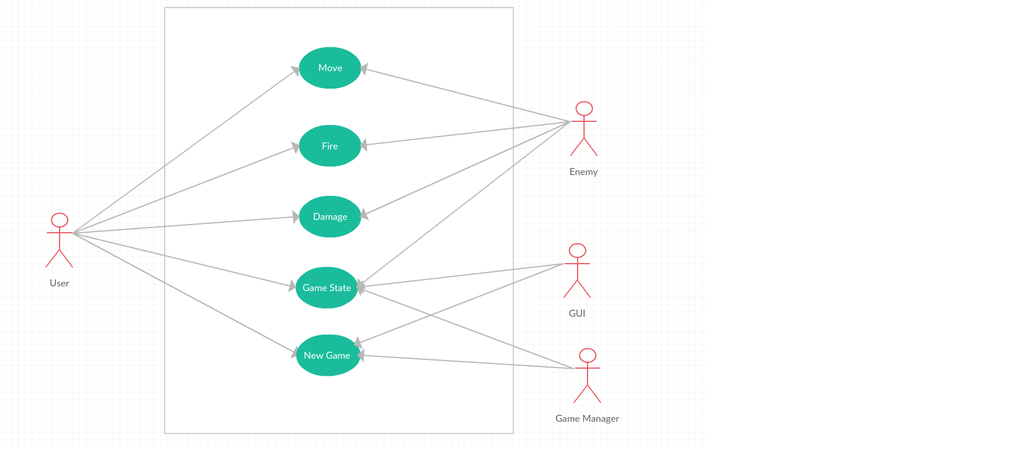
Main Use Case Model
StartNewGame Use Case Model.

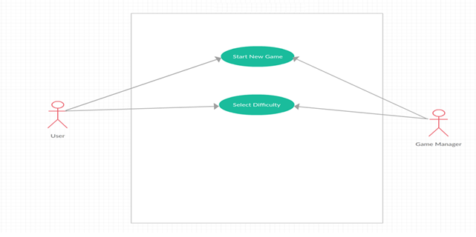

StartNewWhileGameInProgress Use Case Model
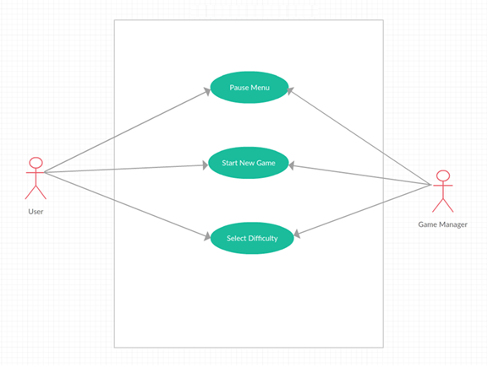

MovePlayer Use Case Model
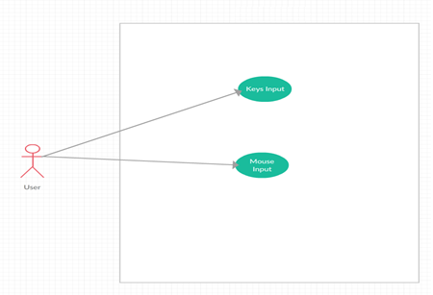

FireFriendlyWeapon Use Case Model
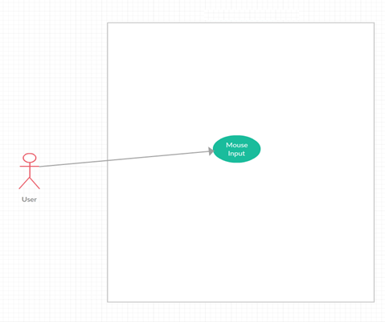

FireEnemyWeapon Use Case Model
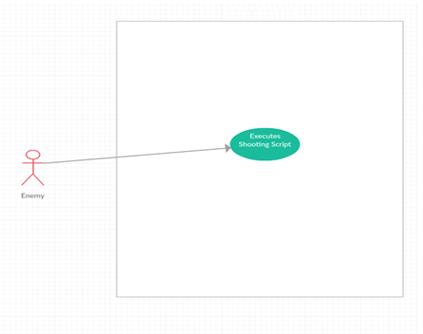

MoveEnemy Use Case Model

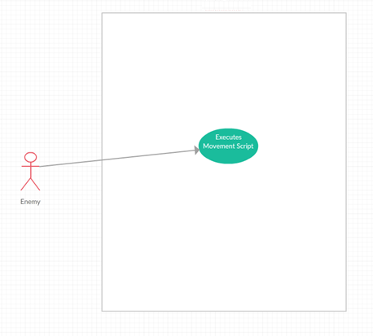

DamageEnemy Use Case Model
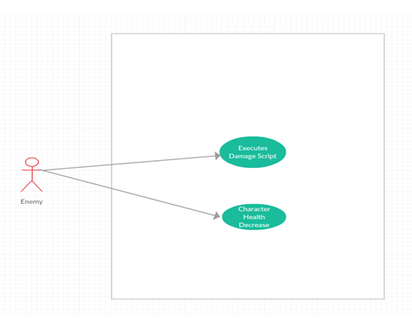

DamagePlayer Use Case Model
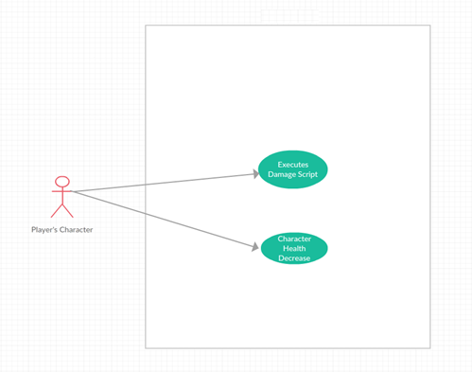

ChangeTDMGameStateToVictory Use Case Model
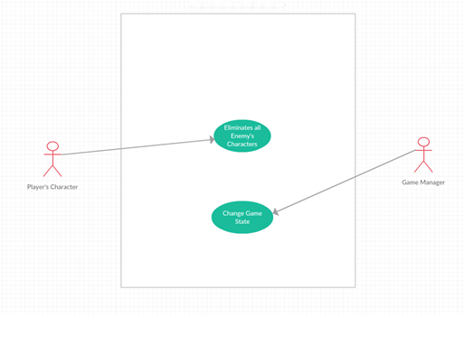

AbandonGame Use Case Model
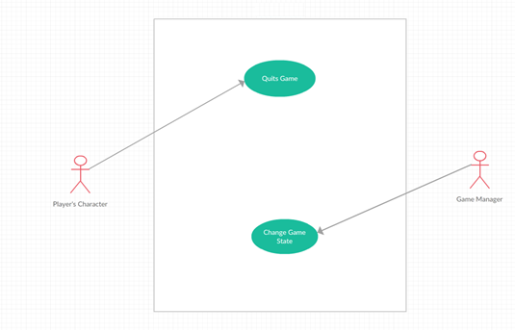

ChangeTDMGameStateToDefeat Use Case Model
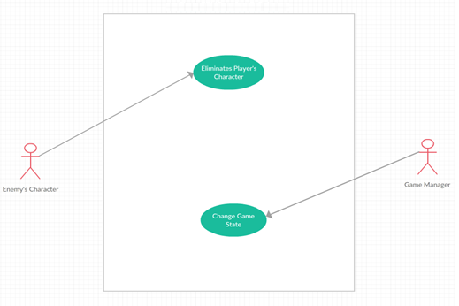

ExpireTime Use Case Model
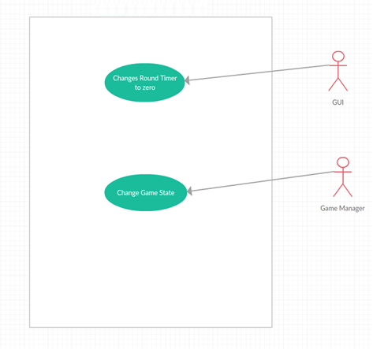

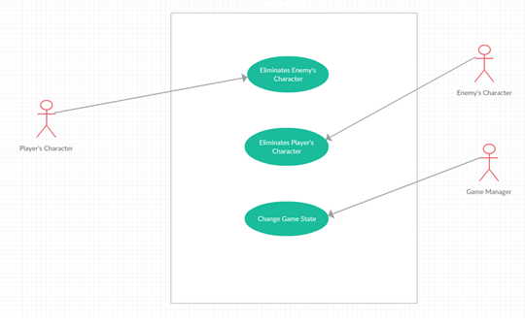
DrawMatch Use Case Model

ExitApplication Use Case Model
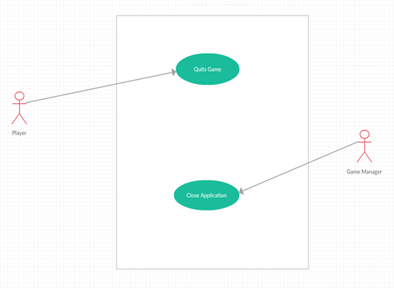

Sequence Diagram
Main Sequence Diagram

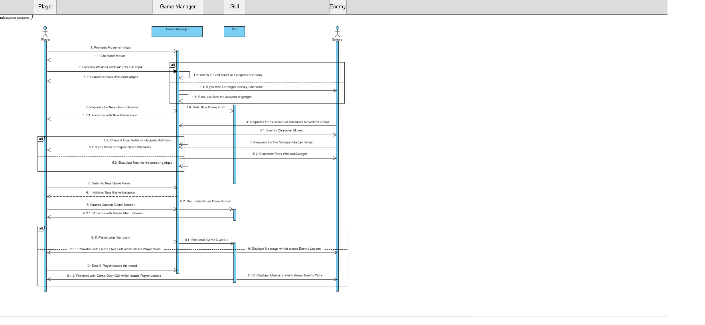
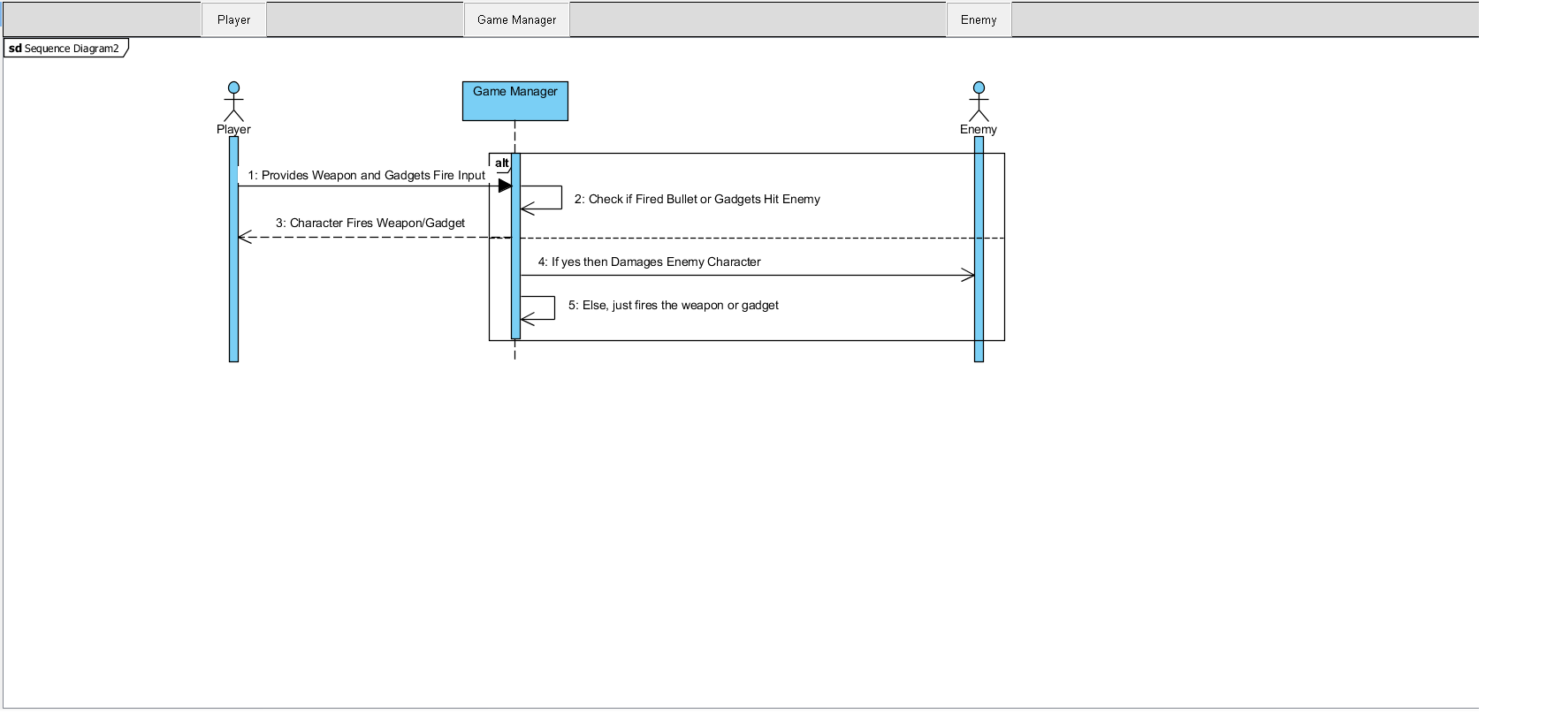
PlayerFire

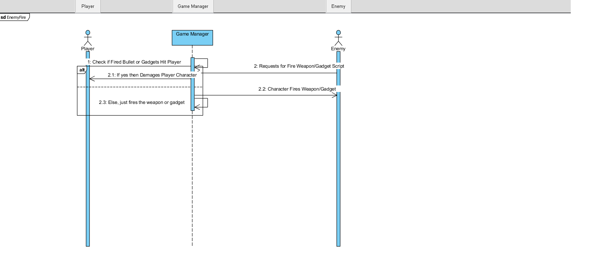
EnemyFire

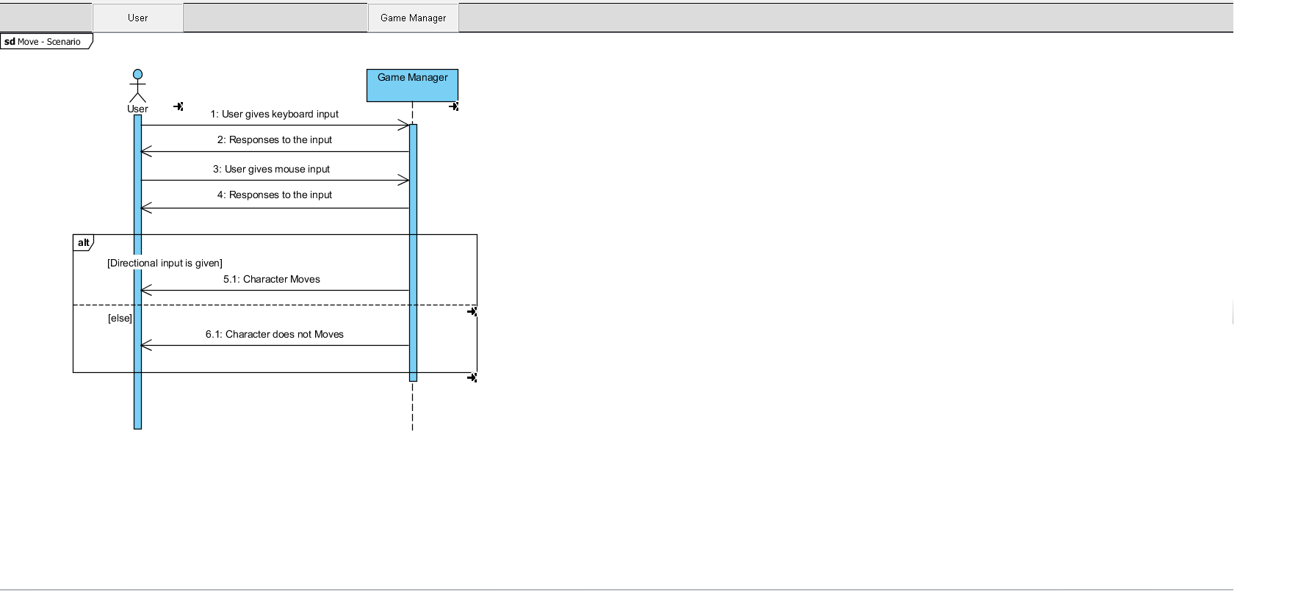
PlayerMovement

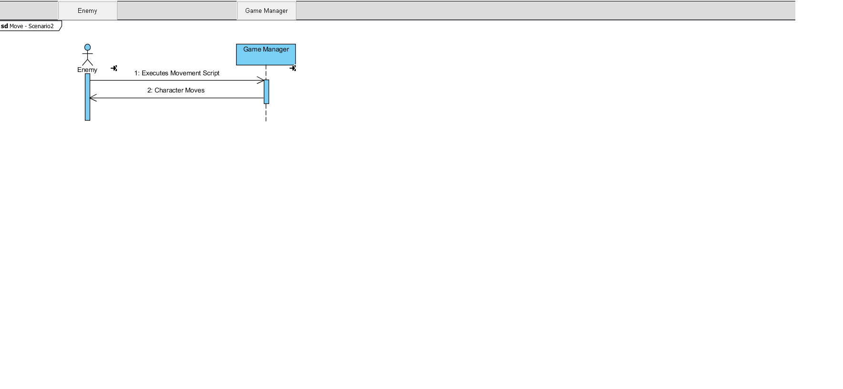
EnemyMovement
NewGame
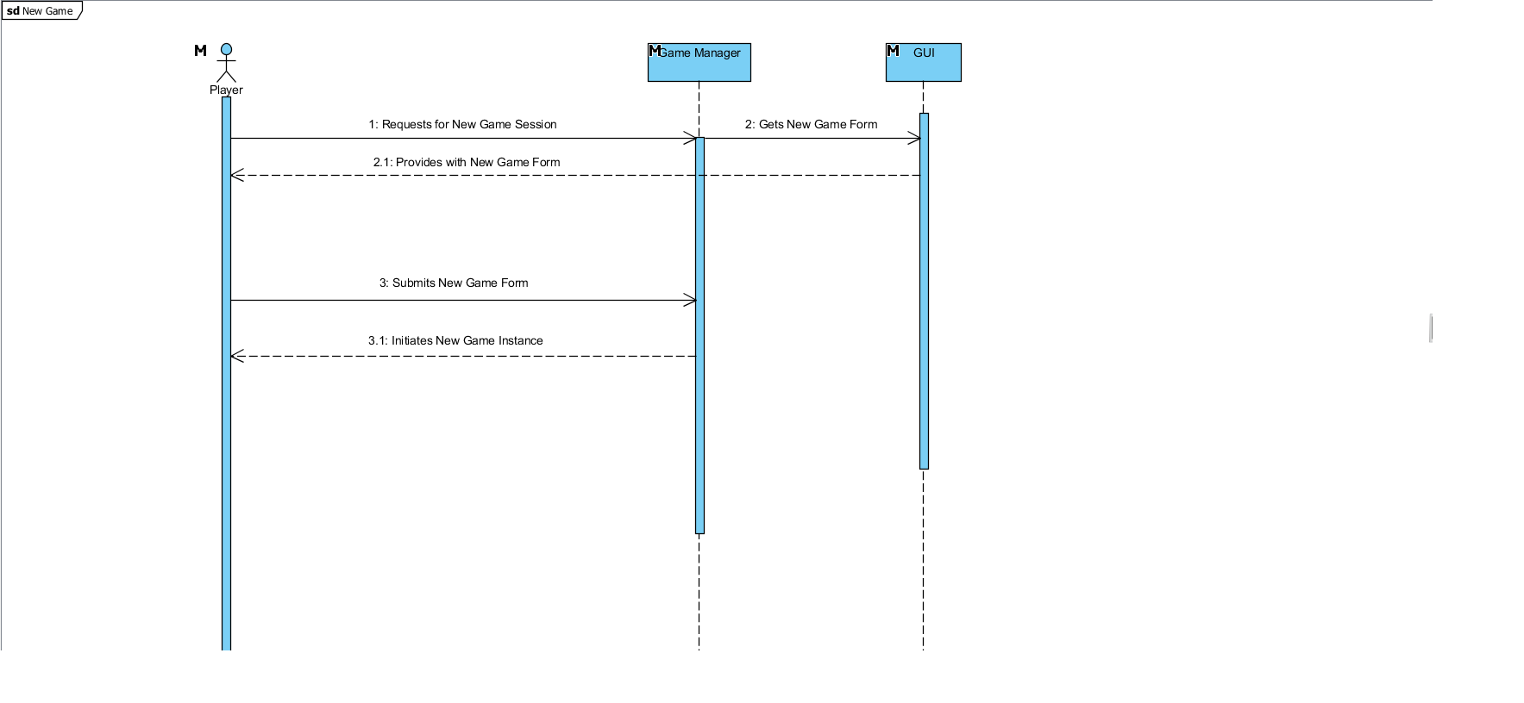

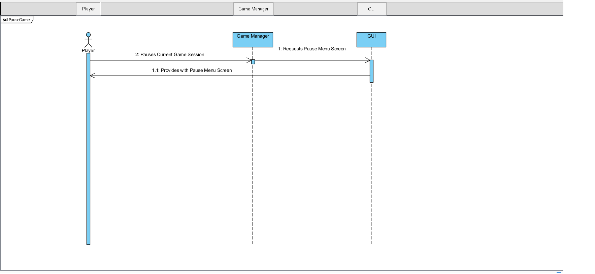
PauseGame

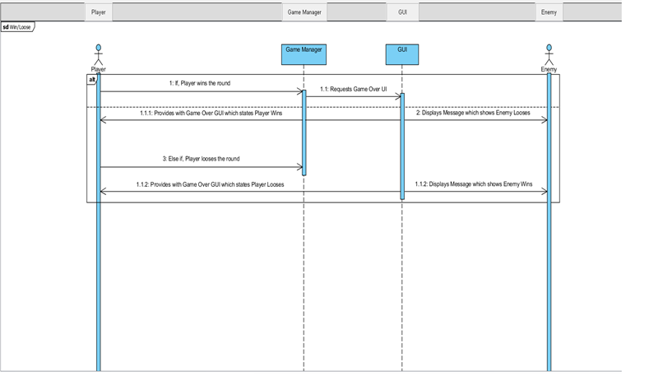
Win/Loose

Collaboration Diagram

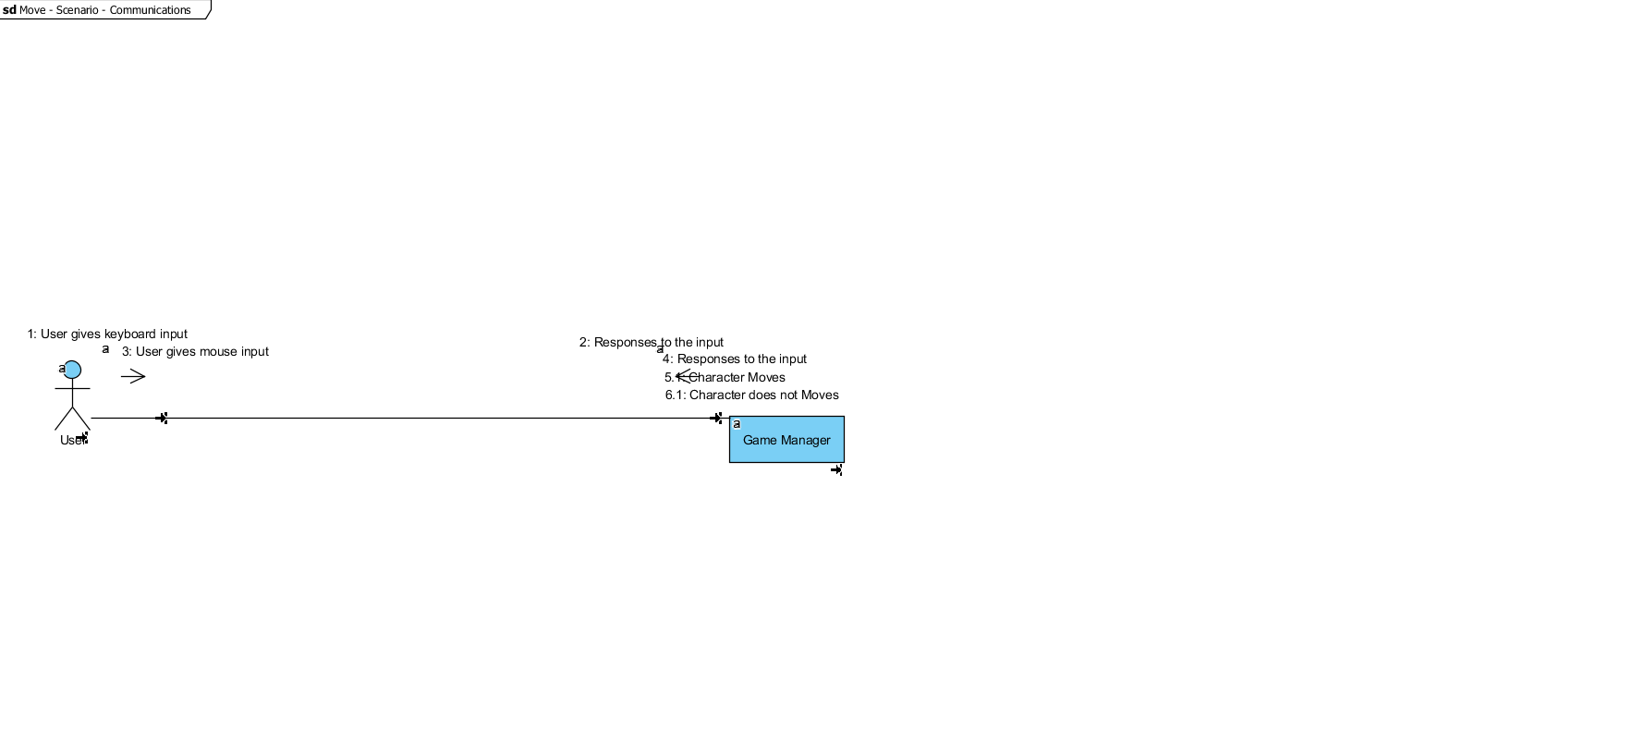
PlayerMovement
EnemyMovement
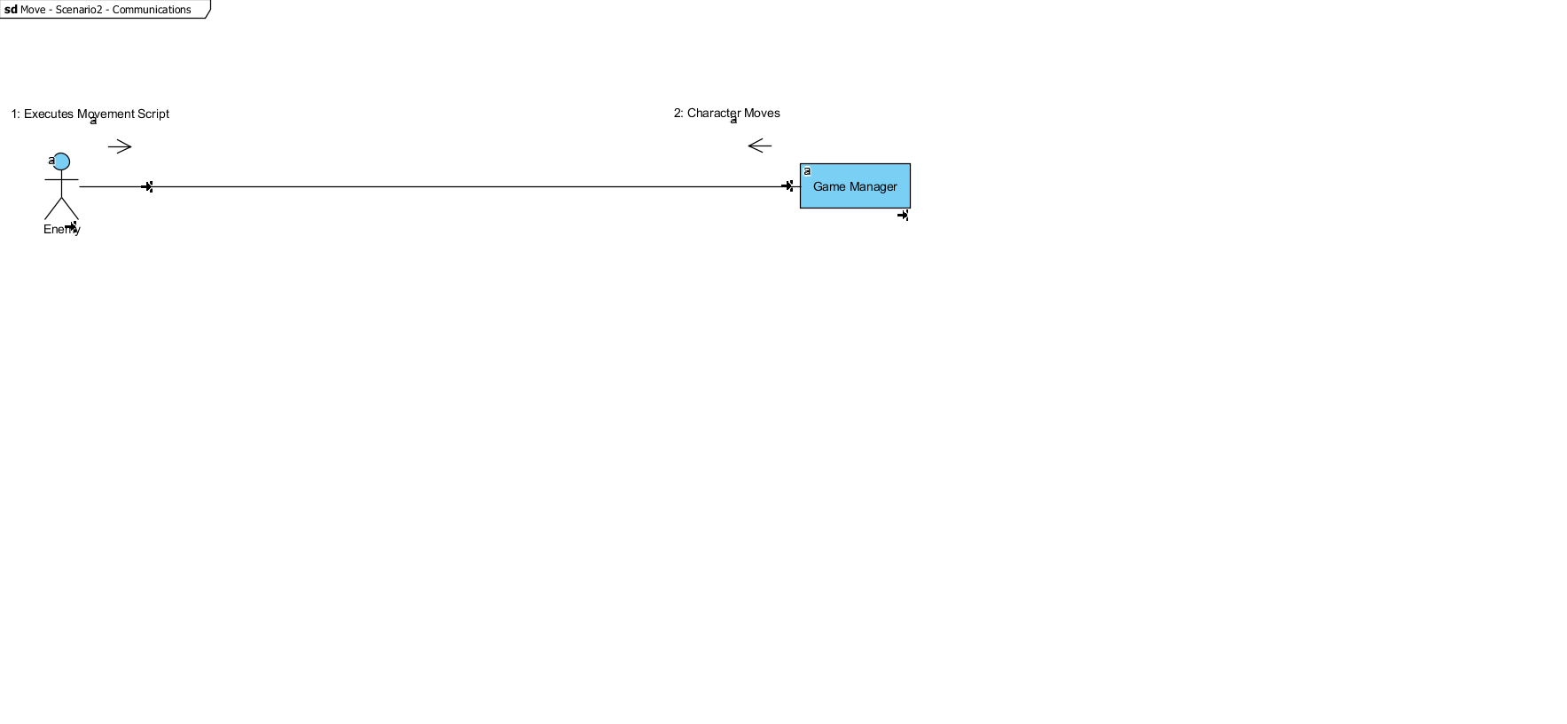

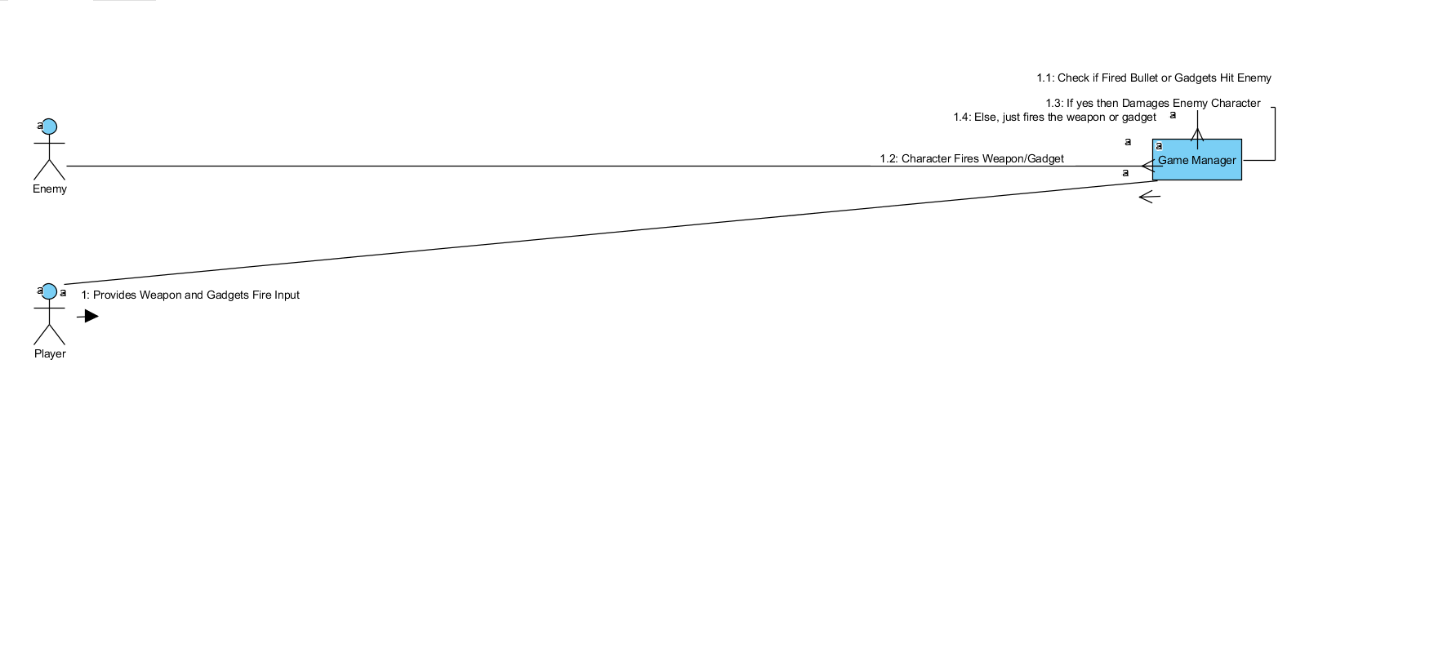
PlayerFire

EnemyFire
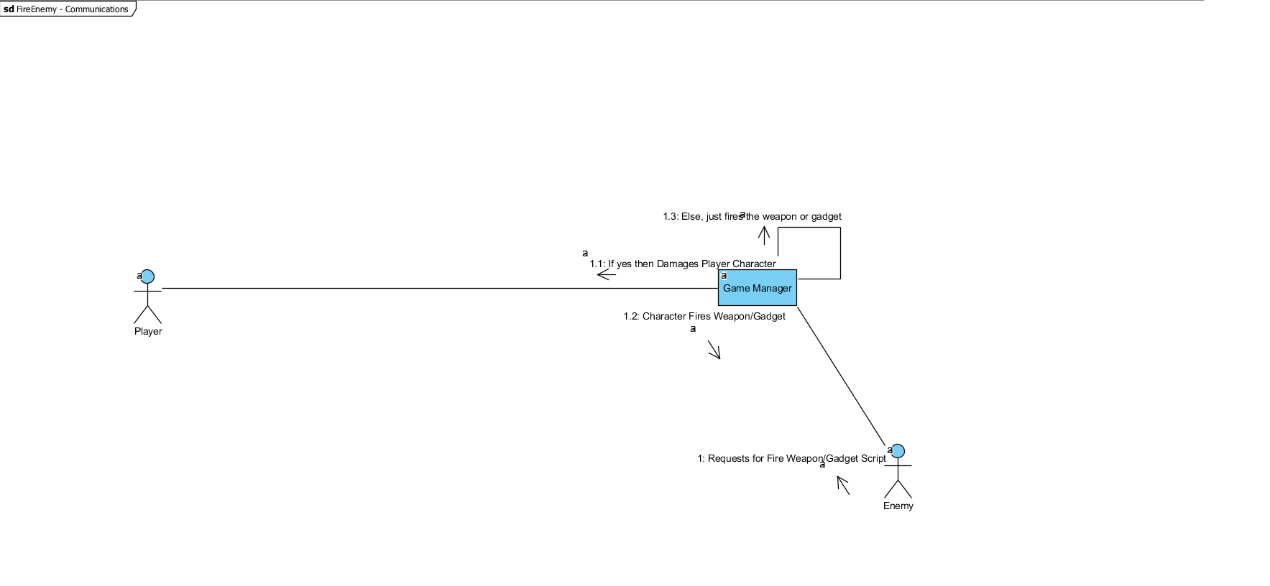
NewGame
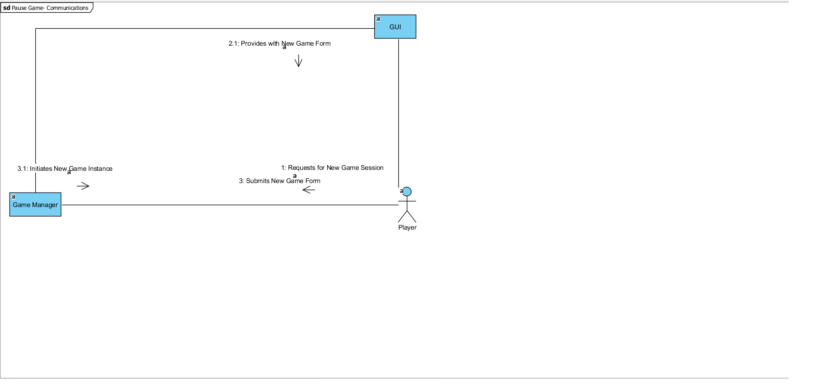
PauseGame

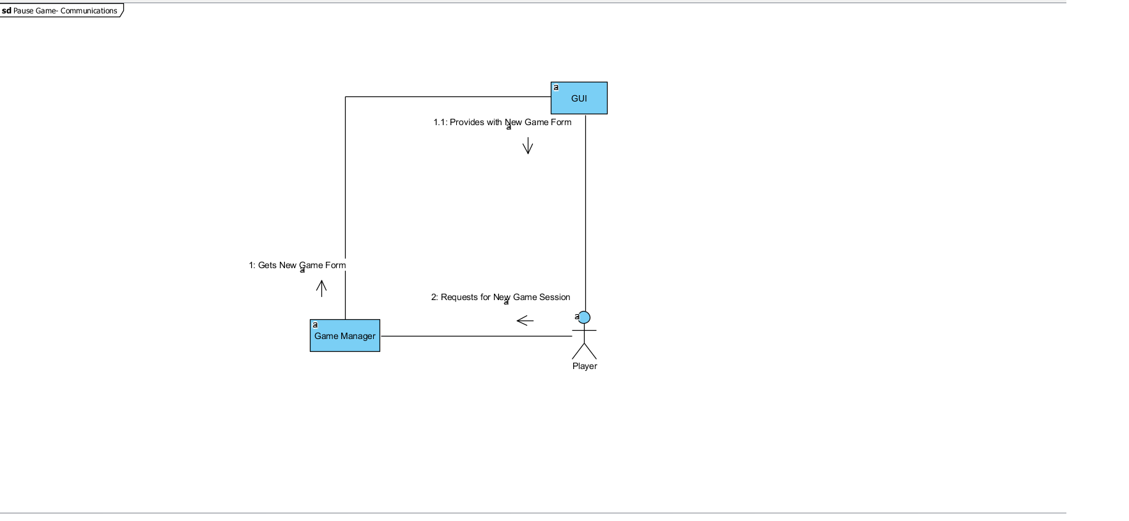
Win/LooseGame
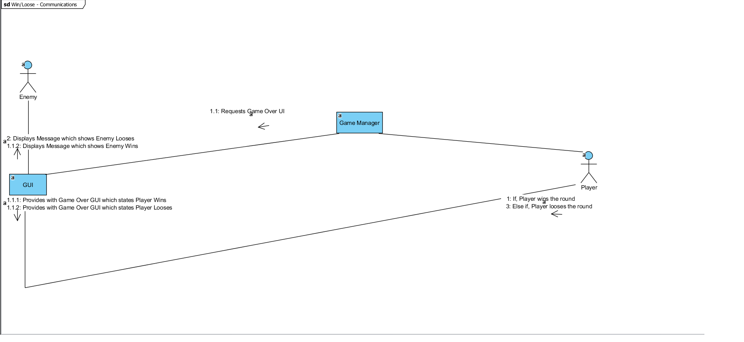

Data Flow Diagram

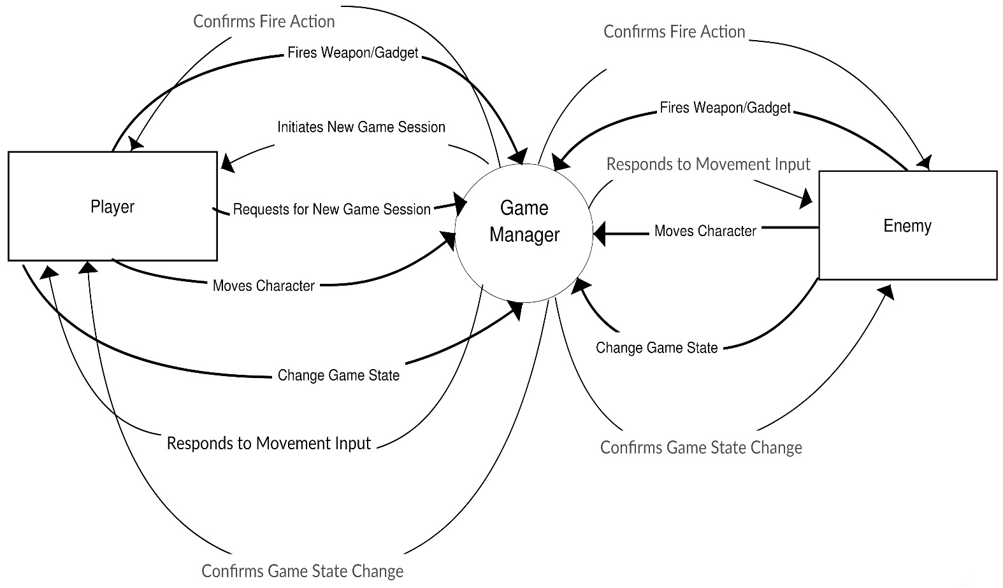

Figure 3.1 : Level 0 DFD
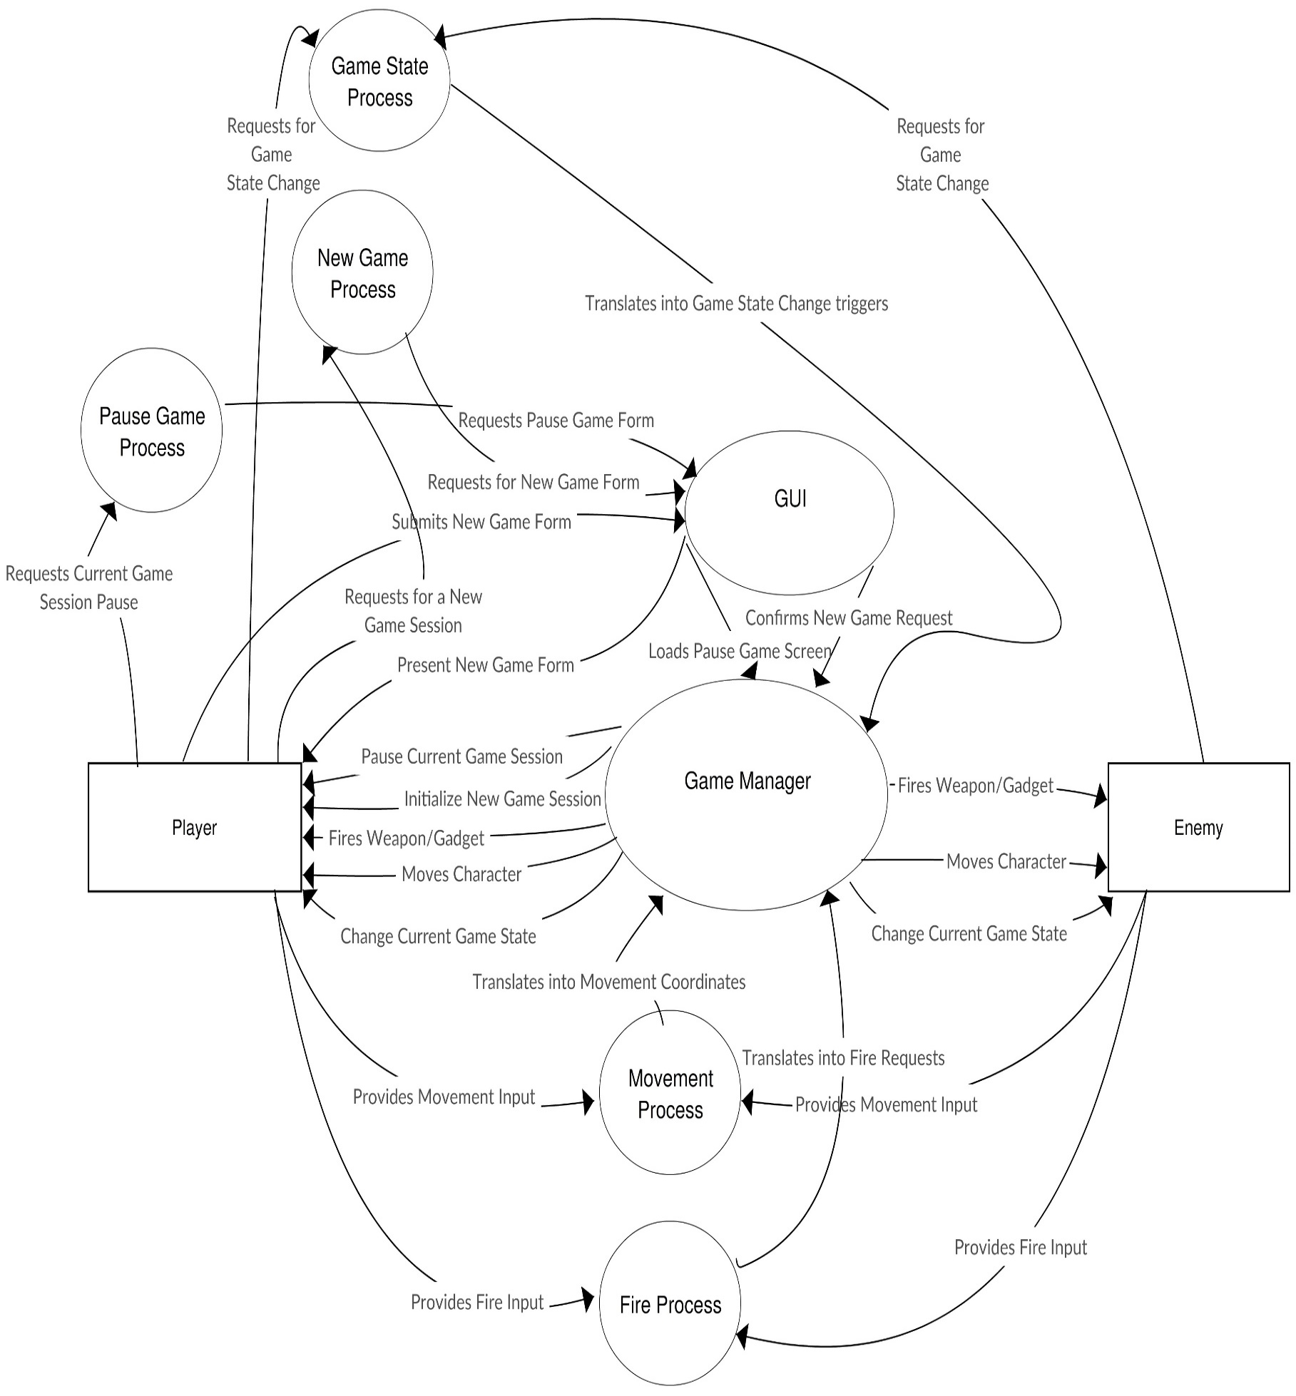
Figure 3.2 : Level 1
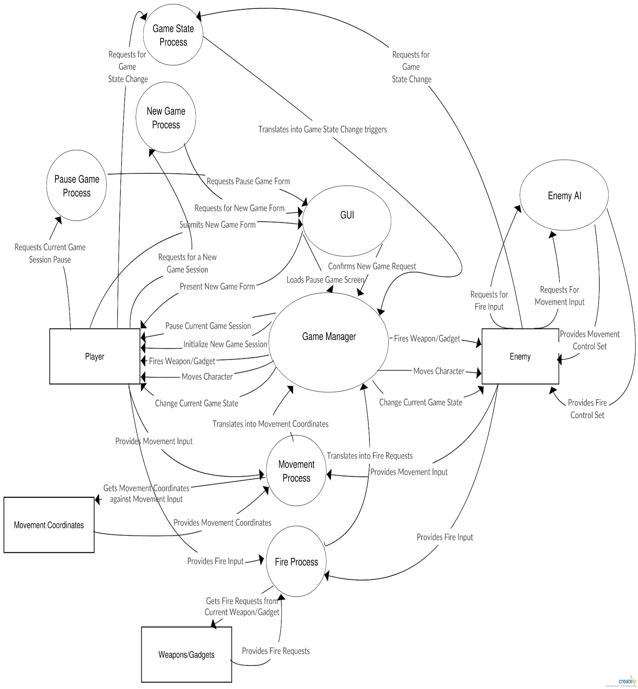
Figure 3.3 : Level 2 DFD

Design Class Diagram
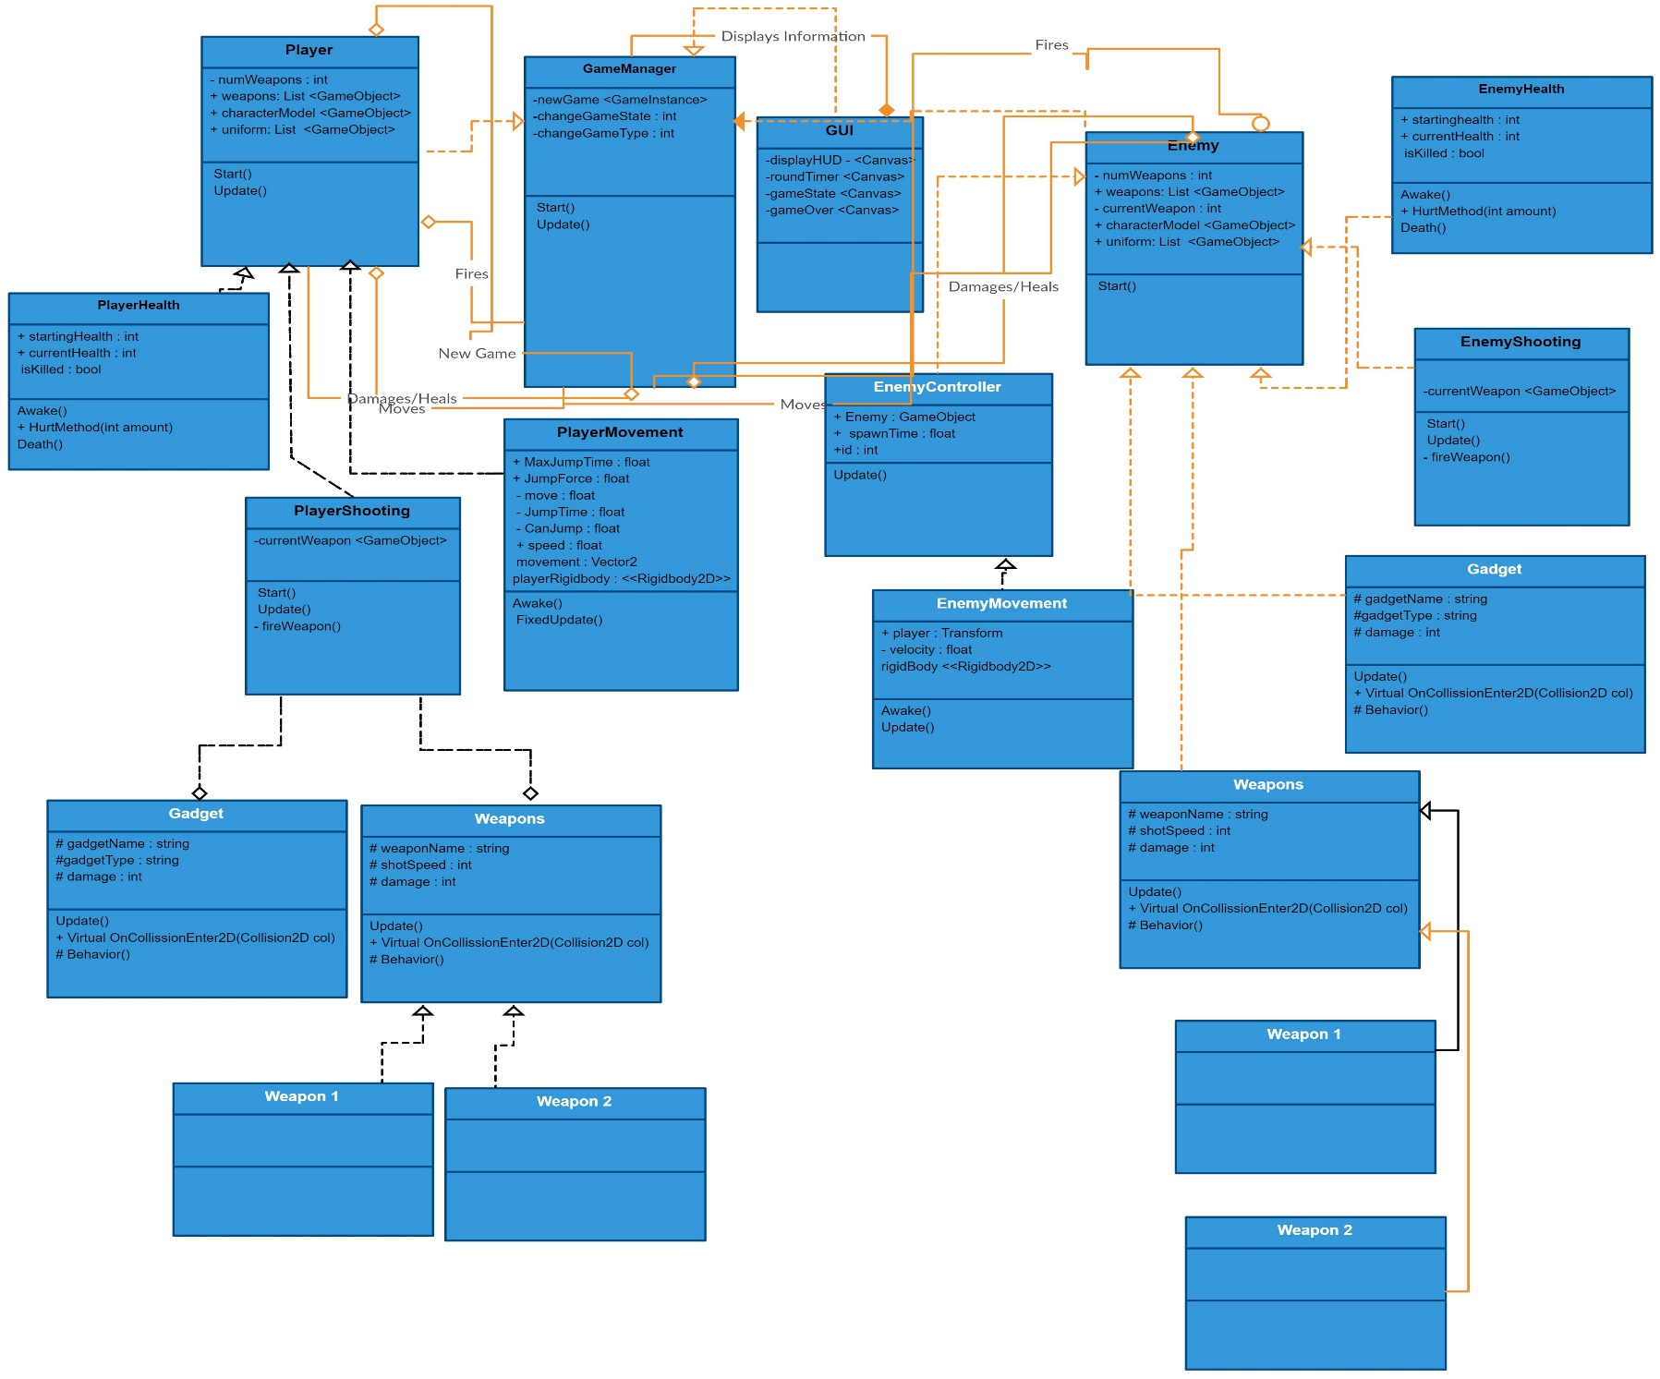
Figure 3.4 : Main Design Class Diagram

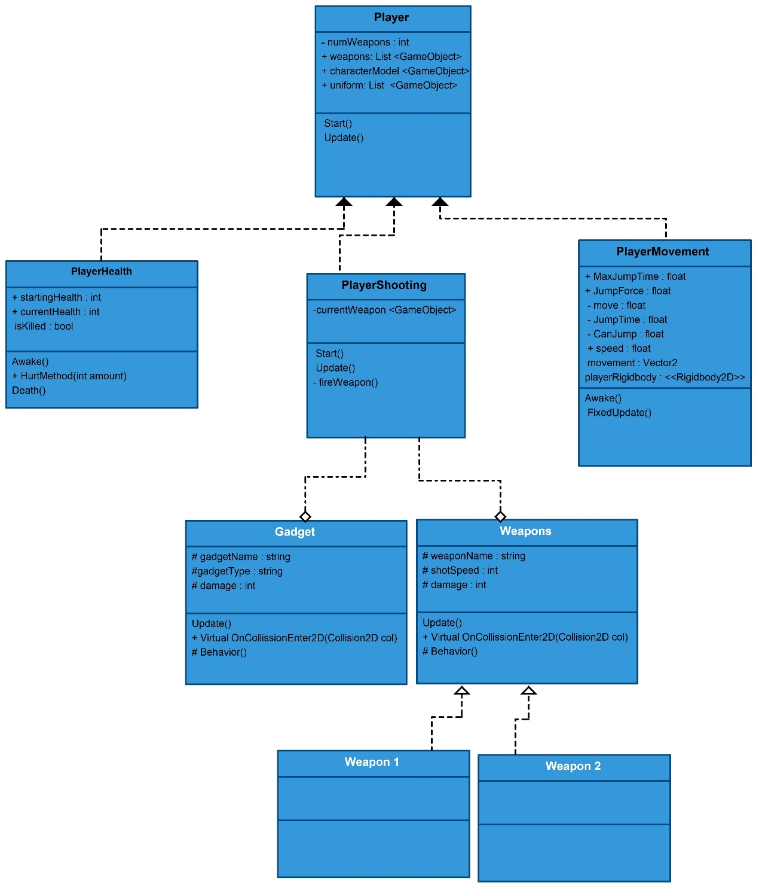

Figure 3.5 : Sub Design Class Diagram - Player-Class

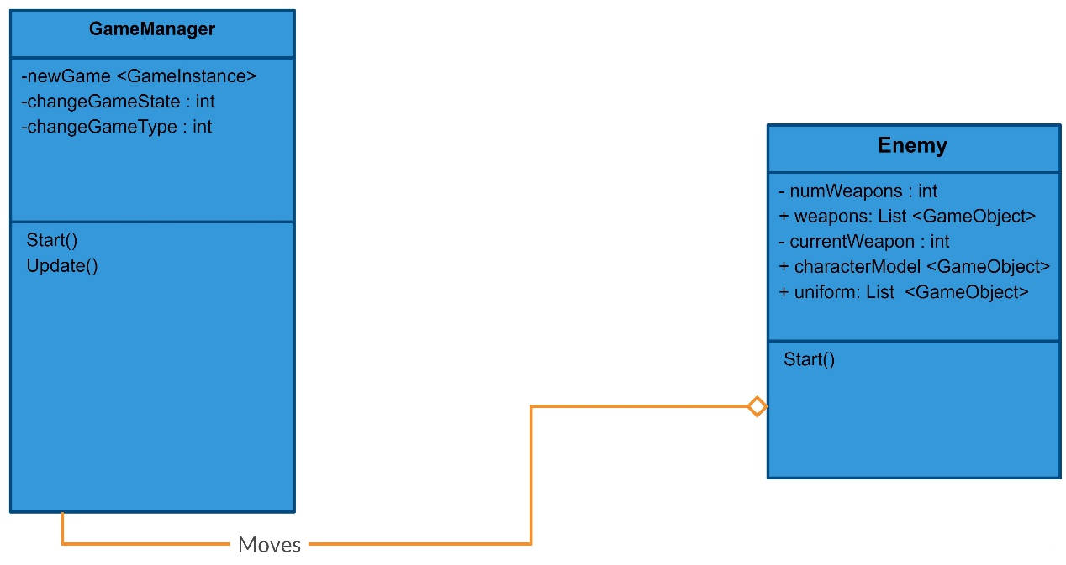

Figure 3.6 : Sub Design Class Diagram -Enemy Moves

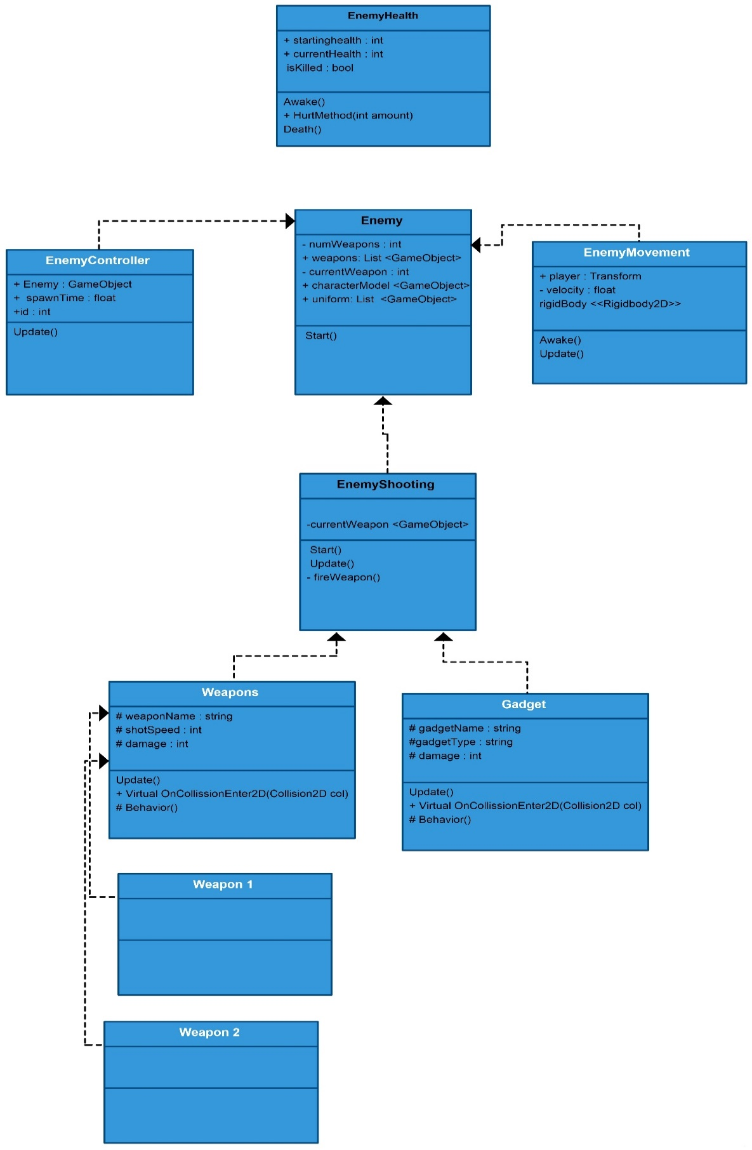

Figure 3.7 : Sub Design Class Diagram-Enemy-Class

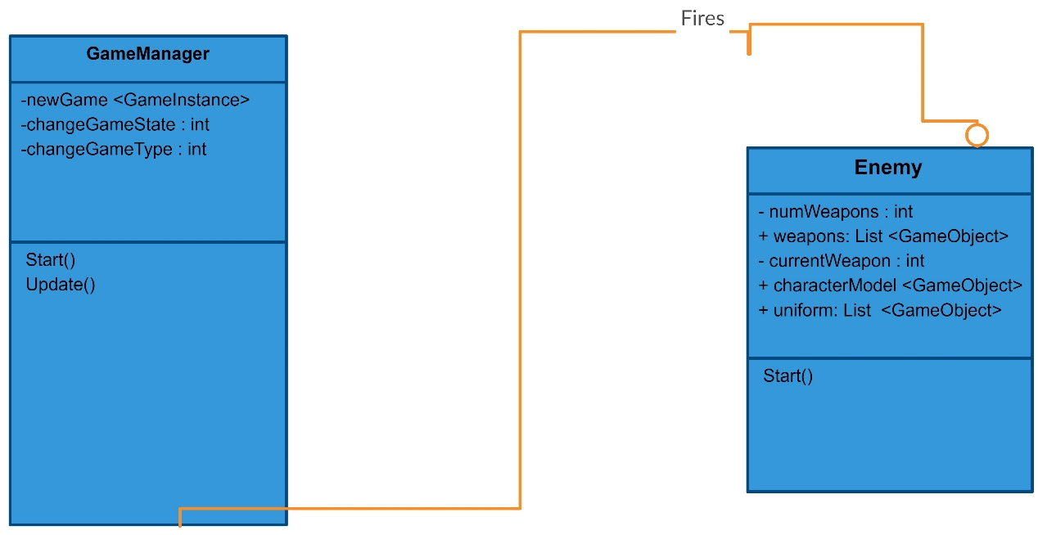

Figure 3.8 : Sub Design Class Diagram-Enemy-Fire

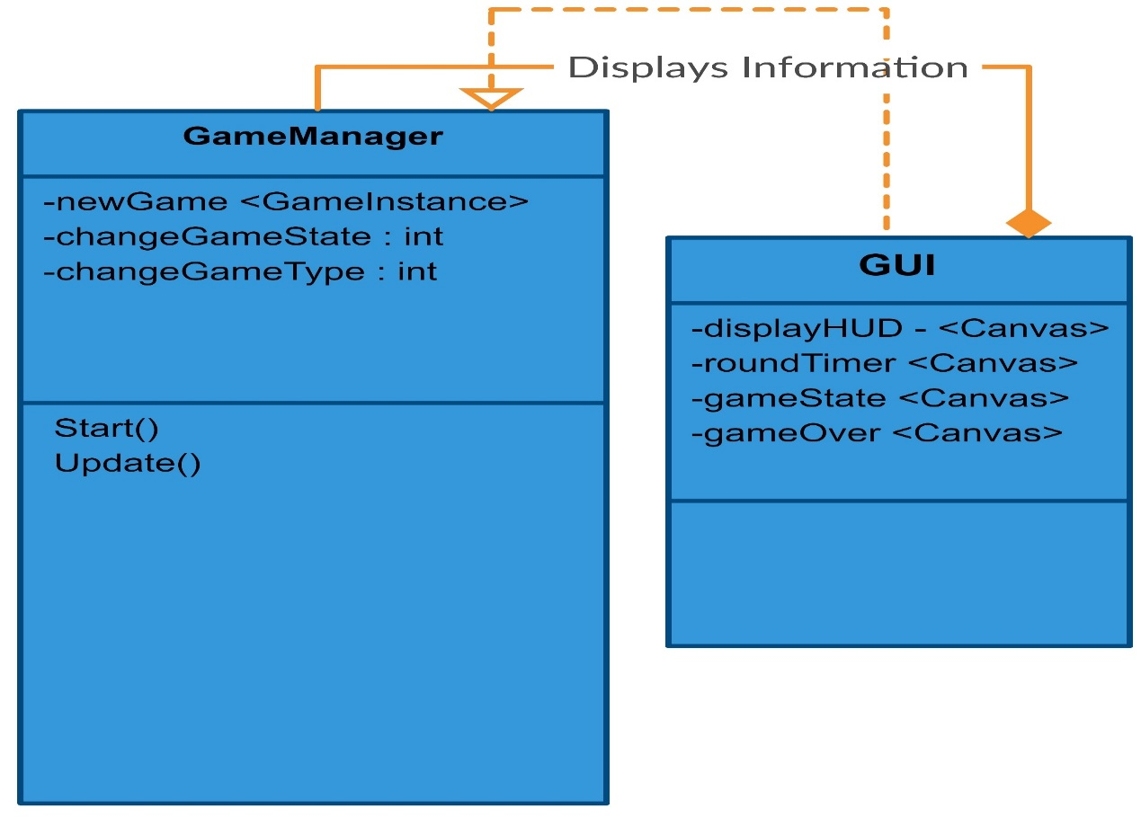

Figure 3.9 : Sub Design Class Diagram-GUI

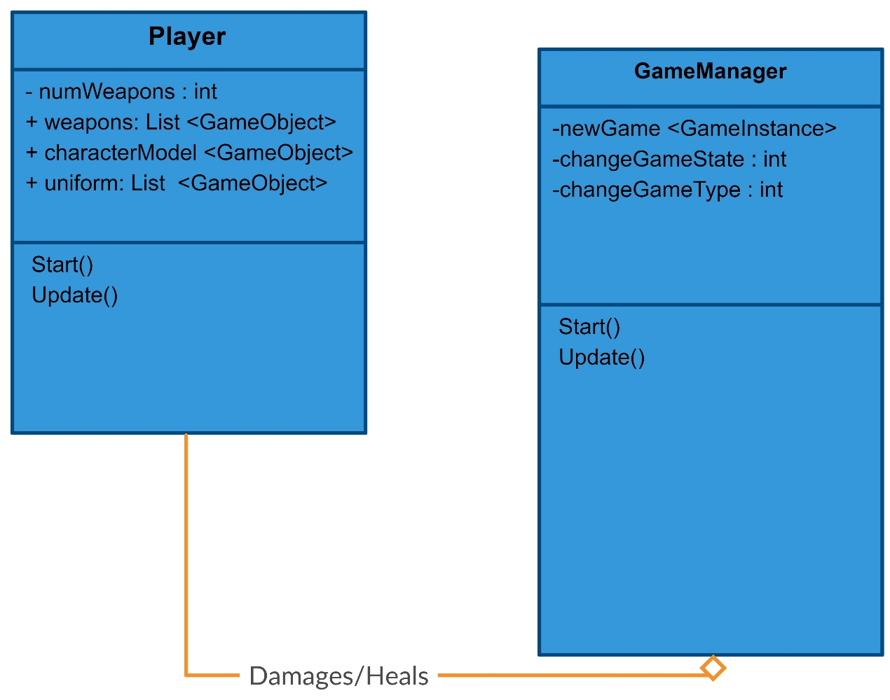

Figure 3.10 : Sub Design Class Diagram-Player-Damage

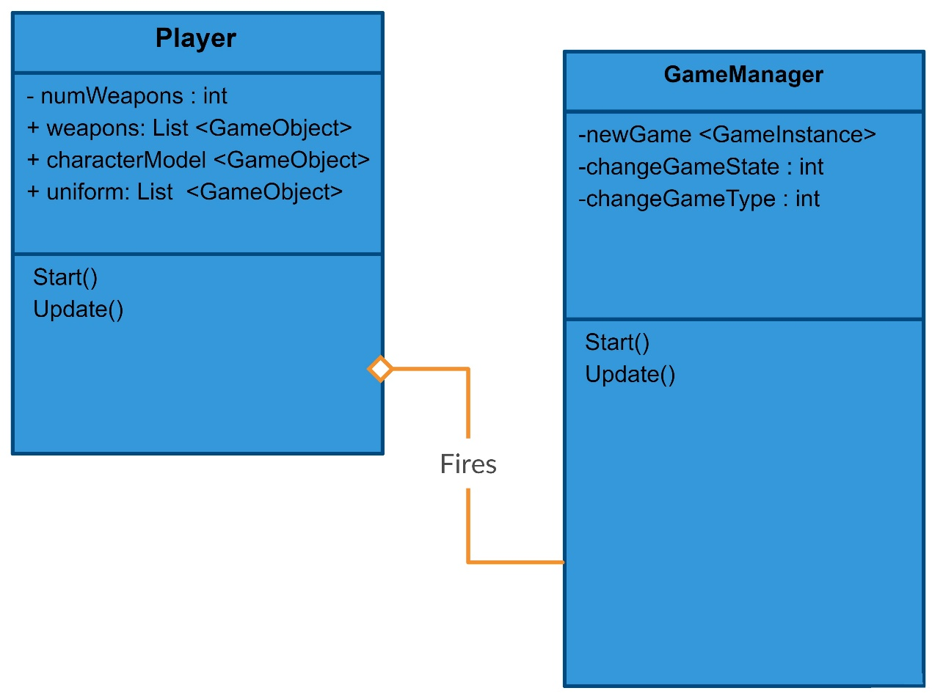

Figure 3.11 : Sub Design Class Diagram-Player-Fire

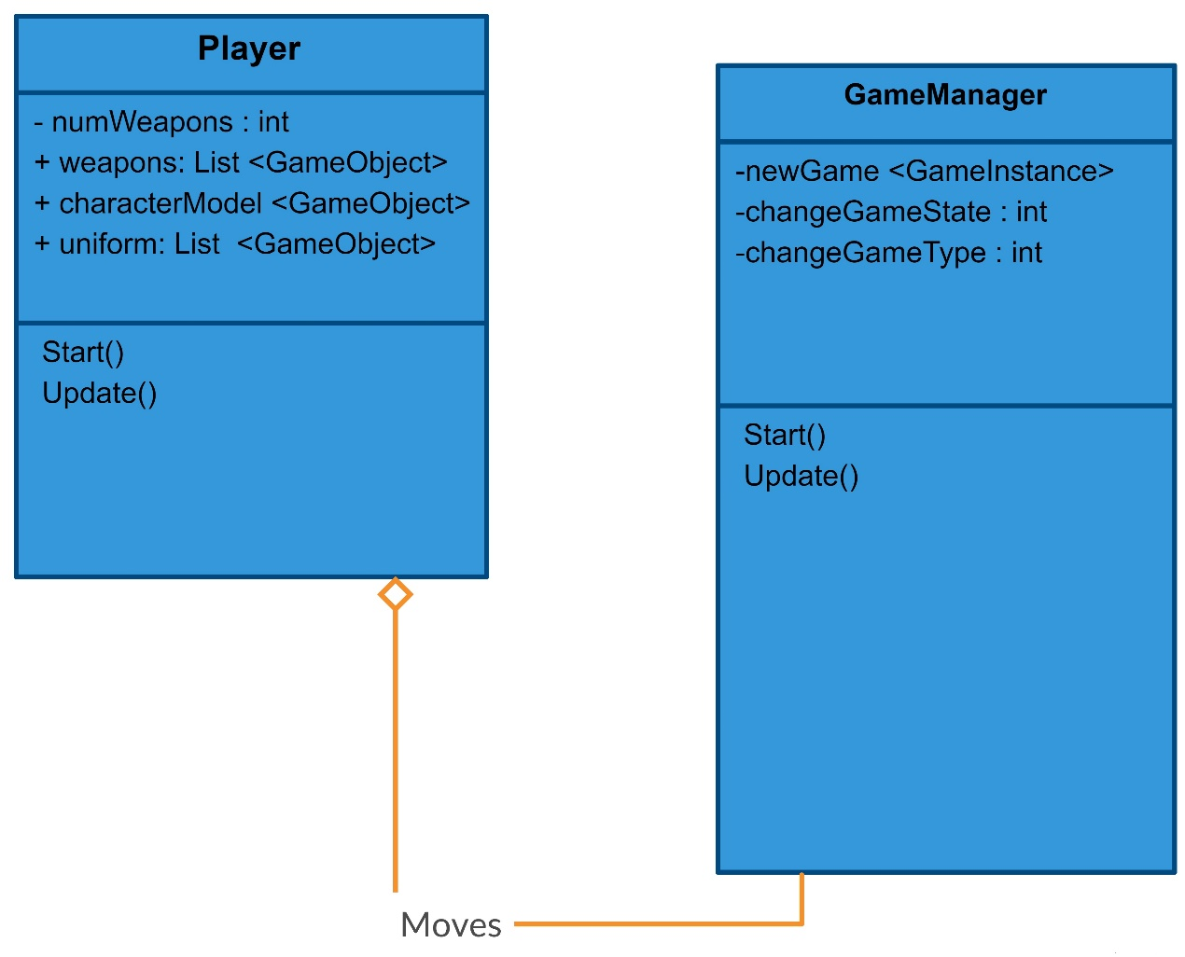

Figure 3.12 : Sub Design Class Diagram-Player-Move

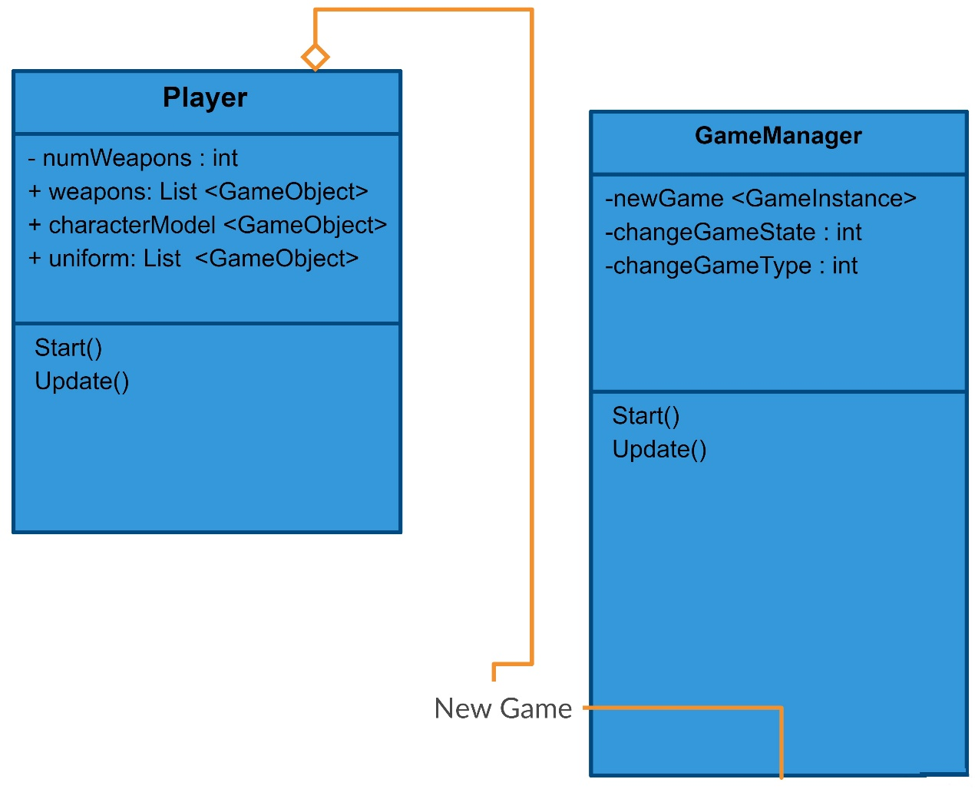

Figure 3.13 : Sub Design Class Diagram-Player-New Game

System Design Methodology

Use Case Diagrams Methodology

Name: | StartNewGame
Actor: | PLAYER  GAME MANAGER
Entry  Conditions: | Application is running.  A Game is not currently in progress.
Flow of  Events: | 1. PLAYER initiates new game function  2. GAME MANAGER presents PLAYER  with NewGameForm  3. PLAYER submits NewGameForm
Exit Conditions: | Game is now in a new state.

Name: | StartNewWhileGameInProgress
Actor: | PLAYER  GAME MANAGER
Entry  Conditions: | A Game is currently in progress
Flow of  Events: | 1. Player Pauses the current game  2. PLAYER initiates new game function  3. GAME MANAGER confirms that the  PLAYER wishes to continue.  4. GAME MANAGER presents PLAYER  with NewGameForm  5. PLAYER submits NewGameForm
Exit Conditions: | Game is now in a new state.

Name: | MovePlayer
Actor: | PLAYER
Entry  Conditions: | A NewGame instance is already loaded.  PLAYER’s Character model must be in ready state  Game is not finished
Flow of  Events: | - PLAYER provides movement input through keyboard and mouse .  2. Character responds to input accordingly.
Exit Conditions: | PLAYER’s Character’s current position is updated in the map.

Name: | FireFriendlyWeapon
Actor: | PLAYER
Entry  Conditions: | Current Ammo count must be greater than zero  Character should be holding a weapon not gadget  Game is not finished
Flow of  Events: | - PLAYER presses left mouse click.  2. Character presses weapon’s trigger and a shot is fired.
Exit  Conditions: | PLAYER’s character Current ammo count is decreased.

Name: | FireEnemyWeapon
Actor: | ENEMY
Entry  Conditions: | Current Ammo count must be greater than zero  Enemy should be holding a weapon not gadget.  Game is not finished
Flow of  Events: | - ENEMY senses PLAYER’s movement nearby.  2. ENEMY shots fire in PLAYER’s direction.
Exit  Conditions: | ENEMY’s character Current ammo count is decreased.

Name: | MoveEnemy
Actor: | ENEMY
Entry  Conditions: | - A NewGame instance is already loaded  - ENEMY’s Character model must be in ready state  - Game is not finished
Flow of  Events: | - ENEMY observes the environment.  2. ENEMY move its character within the allotted area.
Exit  Conditions: | ENEMY’s Character’s current position is updated in the map.

Name: | DamageEnemy
Actor: | ENEMY
Entry  Conditions: | - ENEMY’s character health must be greater than zero.  - Game is not finished
Flow of  Events: | - PLAYER give instruction to its in-game character to fire weapon or throw grenade or perform melee when nearby or sees ENEMY’s character.  - PLAYER’s character respond to instructions accordingly.
Exit Conditions: | ENEMY’s character health should decrease.

Name: | DamagePlayer
Actor: | PLAYER’s Character
Entry  Conditions: | - PLAYER’s character health must be greater than zero  - Game is not finished.
Flow of  Events: | - ENEMY’s character sense PLAYER’s character behind a destructible wall or or sees PLAYER’s character nearby.  - ENEMY give instruction to it’s in-game character to fire weapon or throw grenade or perform melee when nearby or sees PLAYER’s character.
Exit Conditions: | PLAYER’s character health should decrease.

Name: | ChangeTDMGameStateToVictory
Actor: | PLAYER’s Character  GAME MANAGER
Entry  Conditions: | - Game is not finished.  - PLAYER’s character health must be greater than zero
Flow of  Events: | PLAYER’s character eliminates all ENEMY’s characters before round timer ends.
Exit  Conditions: | - ENEMY’s characters count should be equal to zero.  - Round timer value should be greater than zero.  - PLAYER’s character health must be greater than zero.

Name: | ChangeConquestGameStateToVictory
Actor: | PLAYER’s Character  GAME MANAGER
Entry  Conditions: | - Game is not finished.  - PLAYER’s character health must be greater than zero
Flow of  Events: | - PLAYER’s in-game character reaches the objective location on map.  - PLAYER’s character remains alone in the objective for 10 seconds
Exit  Conditions: | - Round timer value should be greater than zero.  - PLAYER’s character health must be greater than zero.

Name: | ChangeConquestGameStateToSecuring
Actor: | PLAYER’s Character  GAME MANAGER
Entry  Conditions: | - Game is not finished.  - PLAYER’s character health must be greater than zero
Flow of  Events: | - PLAYER’s in-game character reaches the objective location on map.  - PLAYER’s character starts securing the objective.
Exit  Conditions: | - Round timer value should be greater than zero.  - PLAYER’s character health must be greater than zero.

Name: | ChangeConquestGameStateToContested
Actor: | PLAYER’s Character  ENEMY’s Character  GAME MANAGER
Entry  Conditions: | - Game is not finished.  - PLAYER’s character health must be greater than zero
Flow of  Events: | - PLAYER’s in-game character reaches the objective location on map.  - PLAYER’s character starts securing the objective.  - ENEMY’s character enters the objective area within 10 seconds of PLAYER’s character presence in the objective area.
Exit  Conditions: | - Round timer value should be greater than zero.  - PLAYER’s character health must be greater than zero.

Name: | AbandonGame
Actor: | PLAYER  GAME MANAGER
Entry  Conditions: | - A Game is currently in progress
Flow of  Events: | - PLAYER either pause the game and select Quit Game option to close the current session or presses alt + F4 on keyboard to initiate Windows Close Application function to close the game.
Exit  Conditions: | Current Game session is closed.

Name: | ChangeTDMGameStateToDefeat
Actor: | ENEMY’s Character  GAME MANAGER
Entry  Conditions: | - ENEMY’s character health must be greater than zero  - Game is not finished
Flow of  Events: | - ENEMY’s character eliminates all PLAYER’s characters before round timer ends.
Exit  Conditions: | - PLAYER’s character count should be equal to zero.  - Round timer value should be greater than zero.  - ENEMY’s character health must be greater than zero.

Name: | ChangeConquestGameStateToDefeat
Actor: | ENEMY’s Character  GAME MANAGER
Entry  Conditions: | - Game is not finished.  - ENEMY’s character health must be greater than zero
Flow of  Events: | - ENEMY’s character senses PLAYER’s character nearby objective.  - ENEMY’s character either kills PLAYER’s character or keep it away from objective till Round Timer reaches zero.
Exit  Conditions: | - Round timer value should be greater than zero.  - ENEMY’s character health must be greater than zero.

Name: | ExpireTime
Actor: | GAME MANAGER  GUI
Entry  Conditions: | - Round Timer value should be greater than zero.  - Both ENEMY and PLAYER’s character should be alive
Flow of  Events: | 1. TIMER expires and PLAYER loses the match.  2. GAME MANAGER through GUI displays Round Over message.
Exit  Conditions: | - GAME MANAGER plays the relevant sound.  - GAME MANAGER updates the main GUI with the appropriate message.  - PLAYER confirms the message and submit it.  - GAME MANAGER responds accordingly

Name: | DrawMatch
Actor: | PLAYER’s Character  ENEMY’s Character  GAME MANAGER
Entry  Conditions: | - Game is not finished.  - Both ENEMY and PLAYER’s character should be alive
Flow of  Events: | - ENEMY’s character and PLAYER’s character death occur simultaneously.
Exit  Conditions: | - Round will be over and considered a draw.  - Both ENEMY and PLAYER’s character will be in dead state.

Name: | ExitApplication
Actor: | PLAYER  GAME MANAGER
Entry  Conditions: | The application is running
Flow of  Events: | 1. PLAYER selects the Exit option  2. GAME MANAGER asks for confirmation with confirmation form.  3. PLAYER submits exit confirmation.
Exit  Conditions: | The application has been terminated.

Sequence Diagrams Methodology

Sequence diagrams describe interactions among classes in terms of an exchange of messages over time. They're also called event diagrams. A sequence diagram is a good way to visualize and validate various runtime scenarios. These can help to predict how a system will behave and to discover responsibilities a class may need to have in the process of modeling a new system.

There are Actors and Systems involved in a Sequence Diagram. Each of them has their own LifeLine which shows the sequence of actions being performed.

Following are the details of Actors and Systems involved in our Sequence Diagram.

Table 3.1: Sequence Diagram Methodology

Actor | System | Role
Player |  | Any user that interacts with the system.  Can initiate a New Game Session  Can pause a current Game Session  Responsible for generating Movement and Fire inputs
 | Game Manager | Main System who responds to all queries.  Responsible for initializing a New Game Session, maintains a current Game Session, Character’s Action, Terminating a current Game Session, changing Game State
 | GUI | Displays information like HUD  Responsible for displaying Game Over, Game Won, Game Lost, Game Draw screens
Enemy |  | Computer controlled Character  Responsible for generating Movement and Fire inputs  Responsible for changing Game State

Collaboration Diagram Methodology

A collaboration diagram resembles a flowchart that portrays the roles, functionality and behavior of individual objects as well as the overall operation of the system in real time. Objects are shown as rectangles with naming labels inside. These labels are preceded by colons and may be underlined. The relationships between the objects are shown as lines connecting the rectangles. The messages between objects are shown as arrows connecting the relevant rectangles along with labels that define the message sequencing.

Collaboration Diagram has Actors and Objects. Actors passes messages to objects which in return Responds to Actor’s requests.

An Actor in a collaboration diagram represents the person, software, hardware, or other agent external to the system that is interacting with the system.

An Object is an instance that owns a thread of control and can initiate control activity. For example, processes and tasks are objects. Objects can contain other symbols and links among them.

Following are the Actors and Objects in Collaboration Diagram

Table 3.2: Collaboration Diagram Methodology

Actor | Object | Role
Player |  | Any user that interacts with the system.  Can initiate a New Game Session  Can pause a current Game Session  Responsible for generating Movement and Fire inputs
 | Game Manager | Main System who responds to all queries.  Responsible for initializing a New Game Session, maintains a current Game Session, Character’s Action, Terminating a current Game Session, changing Game State
 | GUI | Displays information like HUD  Responsible for displaying Game Over, Game Won, Game Lost, Game Draw screens
Enemy |  | Computer controlled Character  Responsible for generating Movement and Fire inputs  Responsible for changing Game State

Data Flow Diagram Methodology

A data flow diagram (DFD) maps out the flow of information for any process or system. It uses defined symbols like rectangles, circles and arrows, plus short text labels, to show data inputs, outputs, storage points and the routes between each destination. Data flowcharts can range from simple, even hand-drawn process overviews, to in-depth, multi-level DFDs that dig progressively deeper into how the data is handled. They can be used to analyze an existing system or model a new one

External entity is an outside system that sends or receives data, communicating with the system being diagrammed. It is the sources and destinations of information entering or leaving the system. It might be an outside organization or person, a computer system or a business system. It is also known as terminator, source and sink or actor. It is typically drawn on the edges of the diagram.

Process is any process that changes the data, producing an output. It might perform computations, or sort data based on logic, or direct the data flow based on business rules. A short label is used to describe the process.

Data flow is the route that data takes between the external entities, processes and data stores. It portrays the interface between the other components and is shown with arrows, typically labeled with a short data name.

Following are the Entities and Process in our Data Flow Diagram

Table 3.3: Data Flow Diagram Methodology

Entity | Process | Role
Player |  | Any user that interacts with the system.  Can initiate a New Game Session  Can pause a current Game Session  Responsible for generating Movement and Fire inputs
 | Game Manager | Main System who responds to all queries.  Responsible for initializing a New Game Session, maintains a current Game Session, Character’s Action, Terminating a current Game Session, changing Game State
 | GUI | Displays information like HUD  Responsible for displaying Game Over, Game Won, Game Lost, Game Draw screens
Enemy |  | Computer controlled Character  Responsible for generating Movement and Fire inputs  Responsible for changing Game State

Design Class Diagram Methodology

Design class diagrams (DCD) show software class definitions. They are based on the collaboration diagram. Attribute visibility is shown for permanent connections. Classes are shown with their simple attributes and methods listed.

Some attributes are depicted using associations (relationships) rather than actually being listed in the class block. These associated attributes refer to complex objects which should also be shown in the diagram. The collaboration diagram indicates methods to be contained in a class with methods posted as relationships

Temporary visibility between classes is depicted using dashed lines. Methods to be included in the class will include:

Object creation methods with or without parameters

A message being sent to an object.
The following optional characters in front of class attributes or methods depict meaning as shown below:
- - Private
- # Protected
- + Public
If the method or attribute is listed in italics text, it is abstract. If text is underlined, the method or attribute is static.

Table 3.4: Design Class Diagram Methodology

Class | Role
Player | Any user that interacts with the system.  Can initiate a New Game Session  Can pause a current Game Session  Responsible for generating Movement and Fire inputs
Game Manager | Main System who responds to all queries.  Responsible for initializing a New Game Session, maintains a current Game Session, Character’s Action, Terminating a current Game Session, changing Game State
GUI | Displays information like HUD  Responsible for displaying Game Over, Game Won, Game Lost, Game Draw screens
Enemy | Computer controlled Character  Responsible for generating Movement and Fire inputs  Responsible for changing Game State

IMPLMENTATION

Overview

We have been using Unity3D for majority of tasks and animations. C# language is helping us achieve a smooth scripting flow of the project. Furthermore, Adobe Photoshop and Blender are being used for mapping and making textures according to our needs. Prototypes discussed in next section will demonstrate some of the examples.
Character animations and Character modelling are currently work in progress and will be delivered in coming weeks. The player often commands a squad of characters, which may be controlled by the game or by human teammates. [4]
Physics and world objects are almost on verge of completion.
AI and path finding algorithms are being worked on in parallel to Character modelling.

Prototypes

The images shown below are just for reference purposes. They may subject to change according to the needs of project and does not represent the final product.
Figure 4.1: Objective Room Prototype
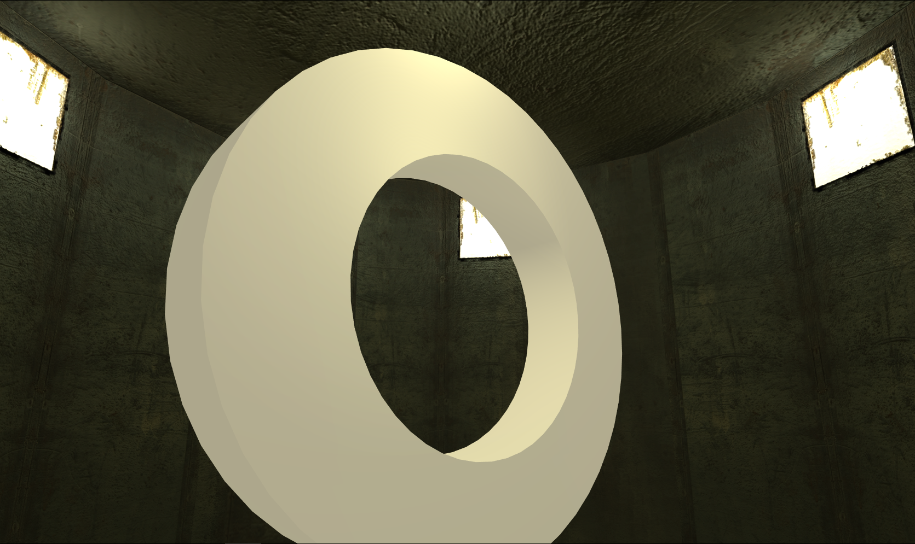
A work in progress prototype of Objective room, walls and other objects may change according to world map.

Figure 4.2: Soldier Prototype
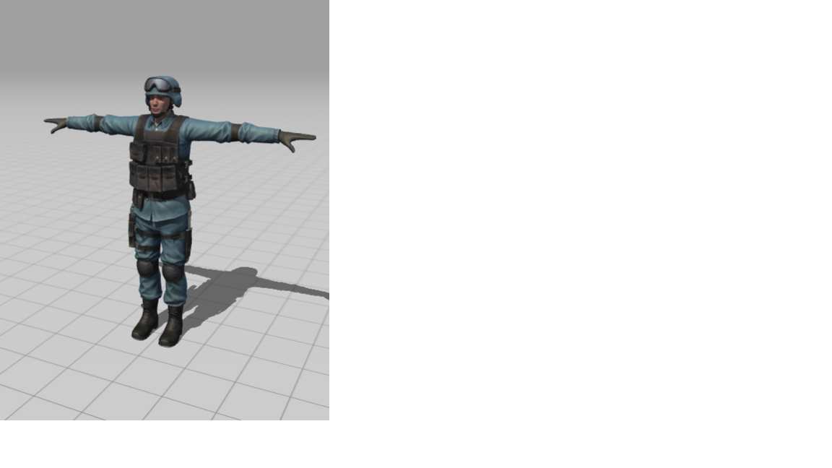

A work in progress prototype of a soldier, clothing and other physics may vary in final product than the one shown here.
In 2006, GamaSutra reported the first-person shooter as one of the biggest and fastest growing video game genres in terms of revenue for publishers. [5]
Figure 4.3: Sample for Wall Texture


A sample of wall and floor texture used in various parts of world map and objective room. Appearance may vary in final product.
Figure 4.4: Sample for Windows Texture

A work in progress prototype of several window textures to be used in game. They might change appearance and colour in final product.

REFERENCES

[1] J. Novak, Game Development Essentials: An Introduction, 3rd Edition, Cengage Learning, Clifton Park, NY., 2011
[2] J. Novak, Game Development Essentials: An Introduction, 3rd Edition, Cengage Learning, Clifton Park, NY., 2011
[3] E. Adams, “Andrew Rollings and Ernest Adams on Game Design”, pp. 290–296, 2003. Available at: https://goo.gl/AnENGQ. [Accessed 0-June-2018]
[4] A. Dunkin, “Tom Clancy's Rainbow Six Review”, 1998. Available at: https://archive.is/20120604092937/http://uk.gamespot.com/pc/action/tomclancysrainbowsix/review.html?om_act=convert&om_clk=gssummary&tag=summary;read-review. [Accessed 02-June-2018]
[5] F. Cifaldi, “Analysts: FPS 'Most Attractive' Genre for Publishers”, 2006. Available at: http://www.gamasutra.com/php-bin/news_index.php?story=8241. [Accessed 02-June-2018]

