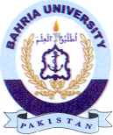
Bahria University Library Islamabad
Source: Daily Jang, Sunday July 21, 2024

