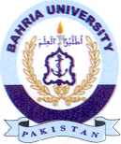
Bahria University Library Islamabad
Source: Daily Nawa-i-Waqt, Sunday July 14, 2024

