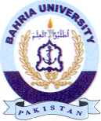
Bahria University Library Islamabad
Source: Jang, Monday July 15, 2024

