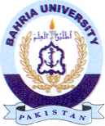
Bahria University Library Islamabad
Source: Jang & Nai Baat, Sunday Jul 07, 2024

