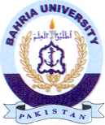
Bahria University Library Islamabad
Source: Jang, Sunday Jun 16, 2024

