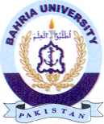
Bahria University Library Islamabad
Source: Pakistan Observer, Friday Jun 14, 2024

