
Bahria University Library Islamabad
Source: Express, Thursday Jun 13, 2024

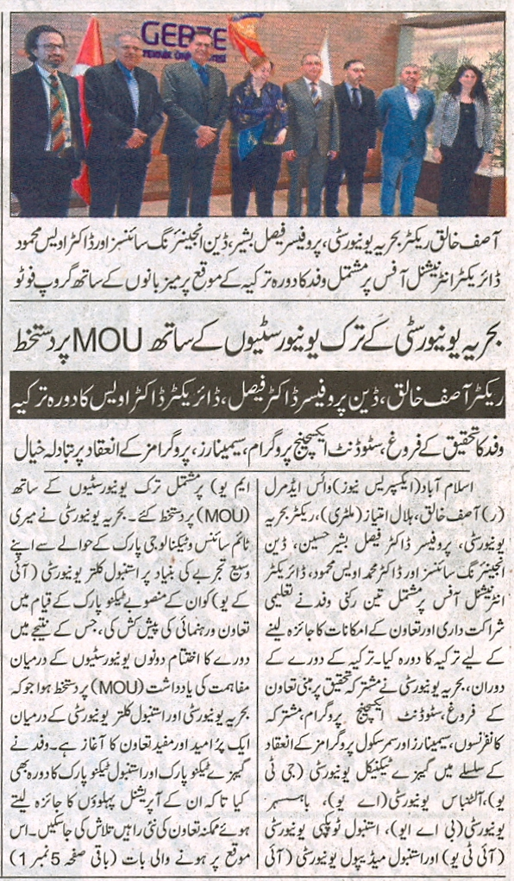
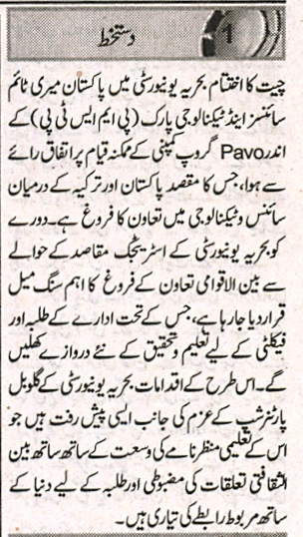

Bahria University Library Islamabad
Source: Dunya, Thursday Jun 13, 2024

