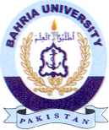
Bahria University Library Islamabad
Source: Express Tribune, Thursday Jun 13, 2024

