Bahria University Library Islamabad
Source: Dawn, Saturday Jun 08, 2024

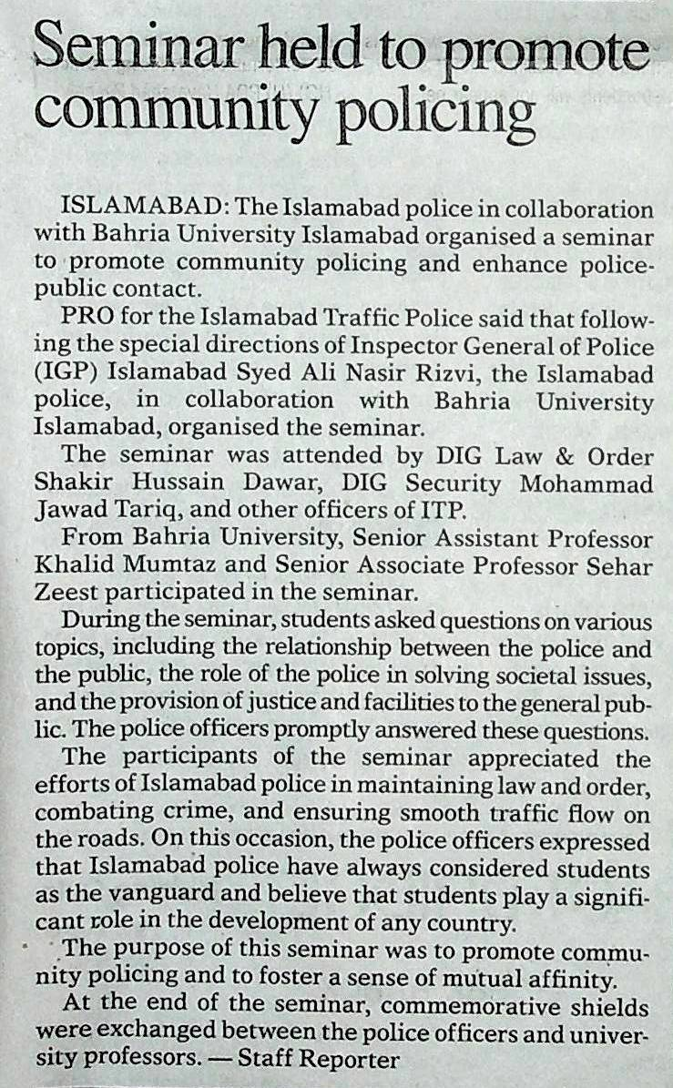

Bahria University Library Islamabad
Source: The Nation, Saturday Jun 08, 2024

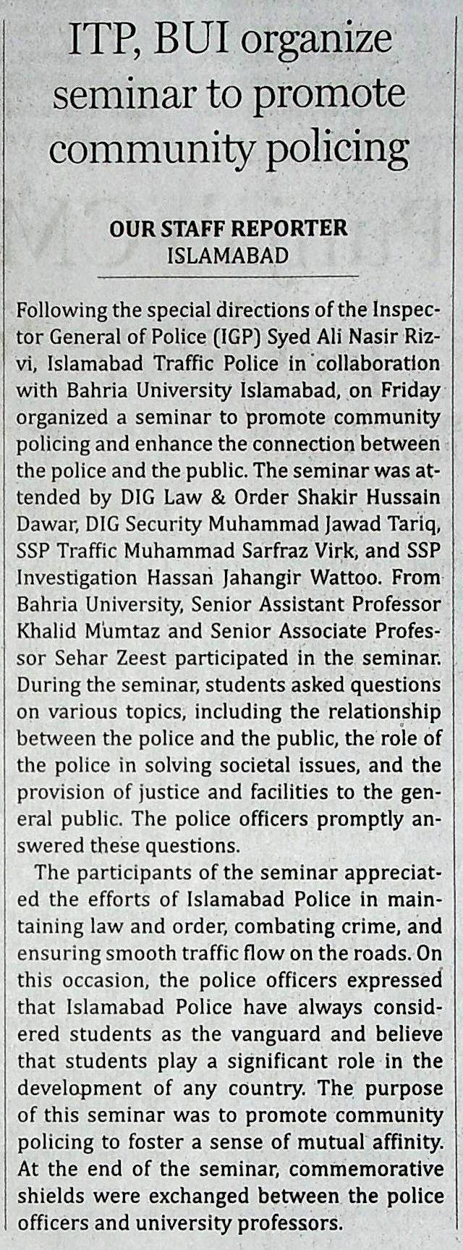

Bahria University Library Islamabad
Source: Daily Nawa-i-Waqt, Saturday Jun 08, 2024

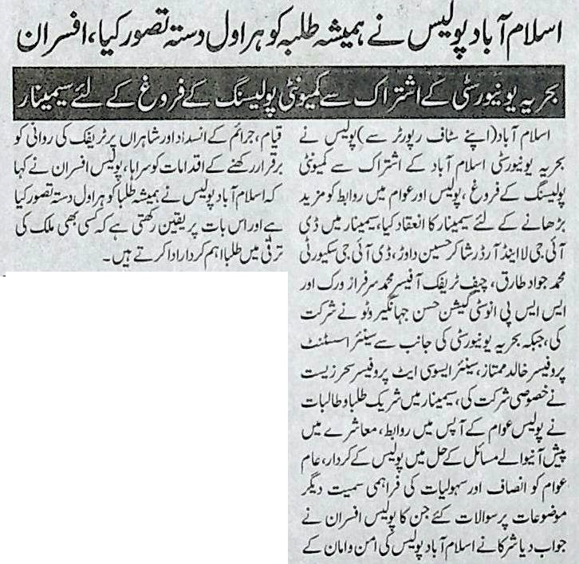

Bahria University Library Islamabad
Source: Daily Nai Baat, Saturday Jun 08, 2024

