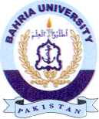Bahria University Library Islamabad
Source: The News, Sunday Jun 02, 2024

